01 / Chapter map and relevant tutorial questions
BBMS2006-4-Applied pulmonary physiology-25Sept2026.pdf | 12 source pages
Two environmental changes, different mechanisms
Altitude: barometric pressure ↓ → inspired PO₂ ↓ → hypoxic ventilatory drive and acclimatization.
Diving: ambient pressure ↑ → gas partial pressures / dissolved gas ↑; ascent also expands trapped gas.

Tutorial question | Relationship to this lecture | Notes page
Q4 | Altitude: hyperventilation and acidosis | Direct: hypoxic response versus respiratory alkalosis. | 3
Q7 | Hyperventilation at unchanged inspired O₂ | Application: alveolar ventilation can improve PAO₂. | 2
Q12 | CA inhibitor and HCO₃⁻ excretion | Cross-topic: pharmacology supports the renal acclimatization mechanism. | 3
Q13 | Diver: nitrogen fraction unchanged | Direct: total pressure, PN₂ and dissolved nitrogen. | 7
Q14 | Equal minute ventilation | Direct: dead-space volume and effective alveolar ventilation. | 5
Q3, Q5, Q6 | Content, affinity and hypoxia | Supporting Lecture 2 concepts; used here without repeating all three original answers. | 2–4
Q11 | Chronic hypercapnia | Lecture 3; adaptation is related but this is not the altitude stimulus. | —
Q1, Q2, Q8, Q9, Q10 | Mainly other lectures: mechanics, regional V/Q or CO poisoning. | —

Read the appropriate law for the question
Law | Quantity being explained | Main use here
Dalton | Partial pressure = fraction × total pressure. | Altitude PO₂ and diving PN₂.
Henry | Equilibrium dissolved concentration = α × partial pressure. | Dissolved gases in blood/tissue.
Boyle | P₁V₁ = P₂V₂ for a fixed gas amount at constant temperature. | Expansion of trapped gas during ascent.

Tutorial Q# preserves original wording/numbering from BBMS 2006 Tutorial.pdf, p. 1; answers are reasoned suggestions, not an official key. Original diagrams and visible annotations are retained for comparison, not automatically accepted as correct. Answer-check labels identify reviewed choices; CORRECTION flags misleading source claims. [Extension] marks supporting material beyond the slides. References use actual lecture PDF pages.

02 / Altitude: lower pressure, not less O₂ fraction
Lecture PDF p. 4 | Tutorial Q7 | Quantitative alveolar gas calculation is an extension
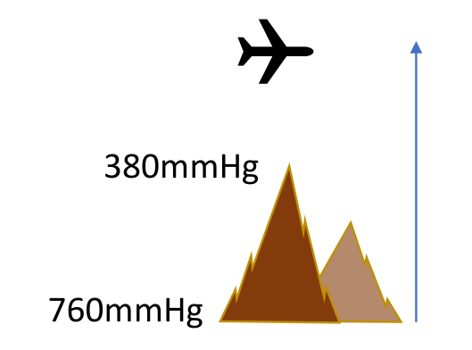
Original mountain/pressure illustration, lecture p. 4.
Primary causal chain
PB ↓ while FiO₂ stays about 0.21 → inspired PIO₂ ↓ → alveolar PAO₂ ↓ → arterial PaO₂ ↓
→ dissolved O₂ ↓ and Hb saturation can fall → arterial O₂ content ↓.
This is hypobaric hypoxia: reduced pressure, not a lower oxygen percentage in ordinary air.

Symbol / relationship | Meaning / condition
PB; FiO₂ | Barometric pressure; fraction of inspired oxygen.
Dry inspired PO₂ = FiO₂ × PB | At 760 mmHg: 159.6; at 380 mmHg: 79.8 mmHg.
PIO₂ = FiO₂ × (PB − 47) | Humidified inspired gas at 37°C; 47 mmHg is water-vapour pressure.
PAO₂ ≈ PIO₂ − PaCO₂/R | Simplified alveolar gas equation; R ~0.8. PA = alveolar, Pa = arterial.

Tutorial Q7 · Original tutorial question
Hyperventilation can increase arterial PO₂ even when oxygen concentration in inspired air remains unchanged.
True under usual gas-exchange conditions
More fresh alveolar ventilation relative to metabolic CO₂ production → PaCO₂ ↓ → PAO₂ ↑ → PaO₂ can rise.
FiO₂ remains 21%; it is the renewal of alveolar gas that changes. Improvement does not guarantee restoration of sea-level oxygenation.

Integrated practice 1 | Self-written; not an original exam question
At PB = 380 mmHg, FiO₂ = 0.21, PH₂O = 47 and R = 0.8, PaCO₂ falls from 40 to 25 mmHg. Calculate the predicted PAO₂ before/after hyperventilation. Does the inspired oxygen pressure change?
Reasoning: PIO₂ stays 0.21 × (380 − 47) ≈ 70 mmHg. PAO₂ rises from 70 − 40/0.8 ≈ 20 to 70 − 25/0.8 ≈ 39 mmHg. This predicts alveolar pressure, not an identical measured PaO₂. Ventilation improves the result but cannot remove the low-PIO₂ limit.

Source p. 4: “10% per 1000 m” is a rough rule, not an exact linear law; pressure is approximately half sea-level near 5–6 km. Aircraft may cruise at 10–12 km, but a pressurised cabin is not exposed to the full outside pressure [Extension].

03 / Acclimatization: ventilation, kidney and Hb
Lecture PDF p. 5 | Tutorial Q4, Q12 | Original choices checked; BPG mechanism corrected
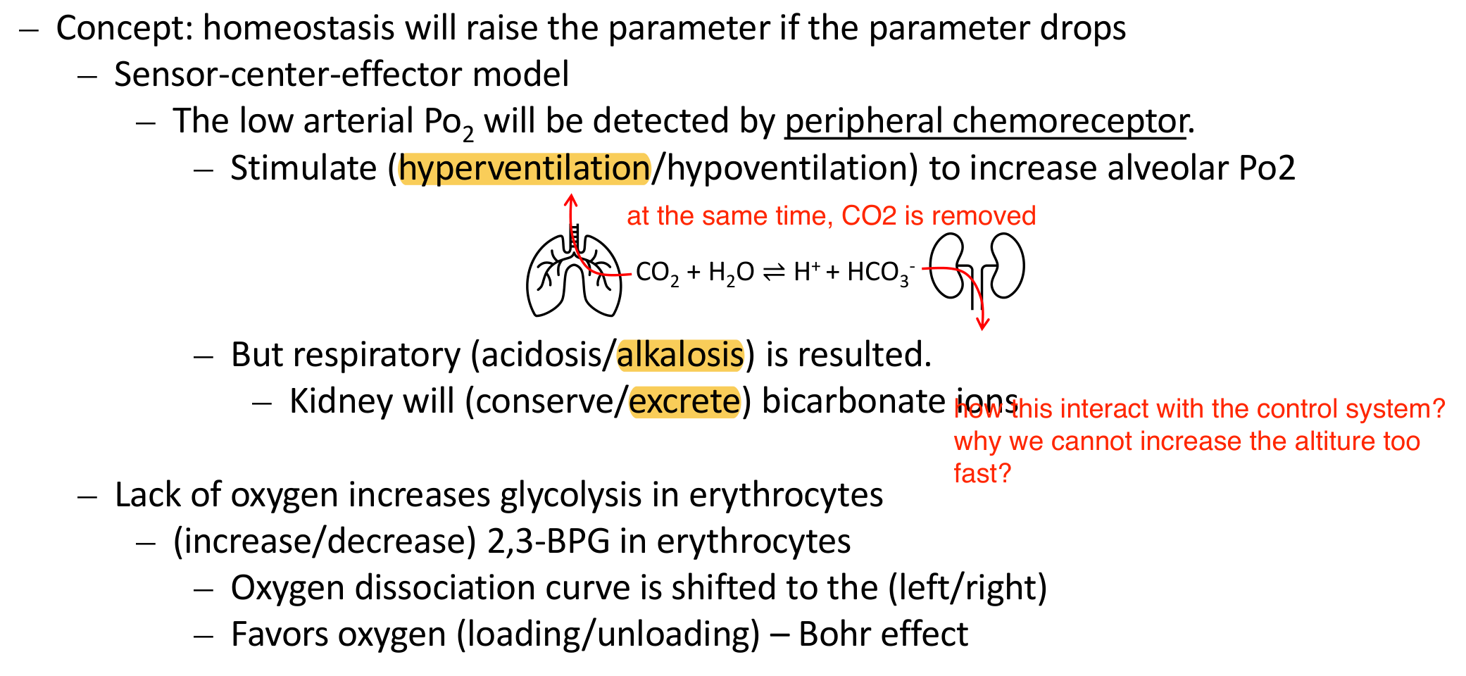
Original highlighted choices, lung/kidney sketch and prompts (lecture p. 5); reviewed answers below.
Prompt in original order | Checked completion / explanation
Low-PaO₂ response; acid–base change | Peripheral chemoreceptor stimulation → hyperventilation; respiratory alkalosis: PaCO₂ ↓ → H⁺ ↓ → pH ↑.
Kidney: conserve or excrete? | Excrete more HCO₃⁻: loss of base helps compensate for respiratory alkalosis.
RBC 2,3-BPG; curve; tissue effect | Increase via RBC glycolysis; right; unloading. 2,3-bisphosphoglycerate stabilises deoxyHb in the T state.

CORRECTION | BPG right shift is not the Bohr effect
Acute hypocapnia/alkalosis tends to shift the curve left; increasing 2,3-BPG tends to shift it right. The net shift depends on timing and conditions.
Bohr effect means CO₂/H⁺ changes alter Hb–O₂ affinity. PaCO₂ ↓ → CSF (cerebrospinal fluid) H⁺ ↓ → central drive ↓, opposing peripheral hypoxic drive. Renal bicarbonate loss reduces this alkalotic brake over time; it does not increase atmospheric PO₂.

Tutorial Q4 · Original tutorial question
Hyperventilation at high altitude helps improve oxygenation even though it causes respiratory acidosis.
False
The oxygenation benefit can be correct; the primary acute disturbance is respiratory alkalosis. Rapid ascent can outpace acclimatization and increase altitude-illness risk.

Tutorial Q12 · Original tutorial question
Carbonic anhydrase inhibitor stimulates hyperventilation by promoting bicarbonate ion excretion.
True | Renal mechanism [Extension]
Acetazolamide → renal CA inhibition → HCO₃⁻ recovery ↓ → urinary base loss ↑ → metabolic acidosis → ventilatory drive ↑. Normal altitude adaptation and the drug both involve bicarbonate loss, but drug-induced base loss is not the original respiratory disturbance.

04 / Hypoxia: pulmonary versus cerebral vessels
Lecture PDF pp. 6–7 | Highlighted directions checked with important conditions
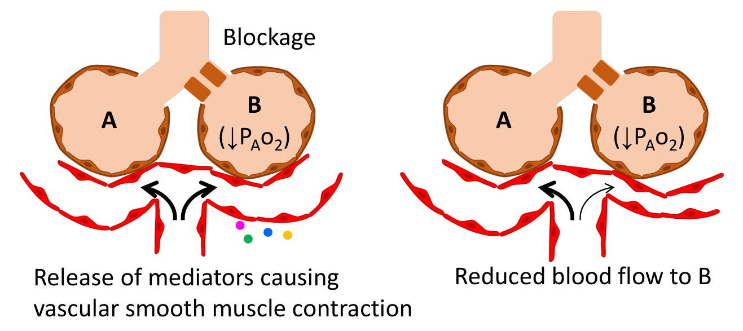
Original local airway-blockage / pulmonary vessel illustration (lecture p. 6).
Checked choices: pulmonary vasoconstriction; blood directed away
Low alveolar PO₂ → pulmonary arteriolar constriction. If only one region is affected, blood is diverted towards better-ventilated units.
At altitude, inspired PO₂ is low across much of the lung even when airways are open. Widespread constriction raises pulmonary vascular resistance and pressure; a local-blockage drawing cannot by itself explain whole-lung hypoxia.

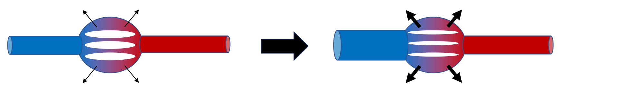
Original capillary fluid-leakage schematic (lecture p. 7); it is a simplified illustration.
Checked choice: cerebral vasodilation for the hypoxic stimulus
Hypoxia tends to dilate cerebral vessels to support O₂ delivery. Hypocapnia from hyperventilation tends to constrict them; the net response reflects both.
Cerebral edema is not an inevitable result of normal compensatory vasodilation. Severe altitude illness involves disturbed vascular/barrier function as well as pressure effects [Extension].

Distinguish the outcomes [Extension] | Physiological significance
Acute mountain sickness (AMS) | Rapid ascent can exceed adaptation; not synonymous with cerebral edema.
High-altitude pulmonary edema (HAPE) | Hypoxic pulmonary hypertension and uneven microvascular stress can promote lung fluid leakage.
High-altitude cerebral edema (HACE) | Severe brain swelling; more complex than simply “more blood causes edema”.

05 / Dead space: total air versus effective ventilation
Lecture PDF p. 9 | Tutorial Q14
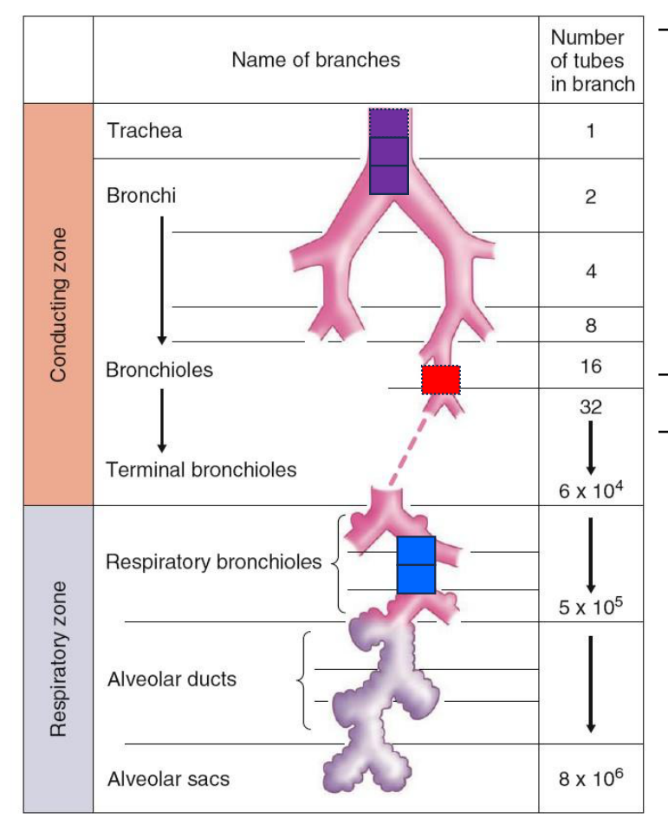
Original conducting/respiratory zone diagram, lecture p. 9.
Term | Definition / significance
Anatomical dead space | Conducting-airway volume: moves air but has no alveolar gas exchange.
Alveolar / physiological dead space [Extension] | Ventilated alveoli with inadequate perfusion / anatomical plus alveolar dead space.
Apparatus dead space [Extension] | Added equipment volume, such as a snorkel, that can increase rebreathing.

Keep volume and rate separate
VT (TV) = tidal volume; VD (DS) = dead-space volume per breath; f = breaths/min.
Minute ventilation V̇E = VT × f. Alveolar ventilation V̇A = (VT − VD) × f in the simplified model.

Tutorial Q14 · Original tutorial question
Slow deep breathing and rapid shallow breathing provide the same alveolar ventilation if minute ventilation is identical.
False | Equal minute ventilation can conceal different dead-space losses
With VD = 150 mL: 500 mL × 12/min gives V̇E = 6 L/min and V̇A = 4.2 L/min; 250 mL × 24/min gives the same V̇E but V̇A = 2.4 L/min.

Annotation check: “TV < DS, no ventilation” means little/no fresh convective alveolar ventilation in the idealised model, not no movement of air. Do not calculate a negative physical ventilation rate; real mixing and specialised ventilation modes are not captured by this simple model.

06 / Snorkel versus ambient-pressure gas supply
Lecture PDF p. 10; comparison with p. 11
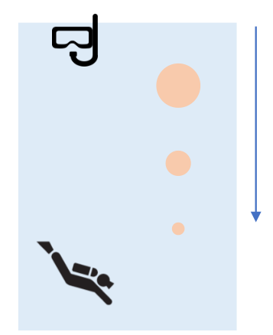  Original surface-air / depth sketch (p. 10). | 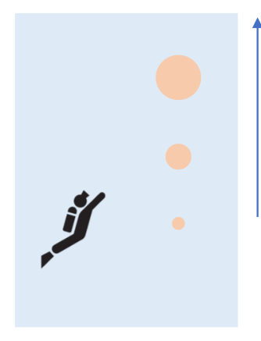  Original compressed-air diver sketch (p. 11).
Compare | Surface-air snorkel | Compressed-gas scuba
Inspired gas supply | Communicates with air near surface atmospheric pressure. | Regulator supplies gas approximately at local ambient water pressure [Extension].
Pressure around chest | Water pressure increases with depth; inspired pressure does not track it. | Gas delivery reduces this particular external-pressure mismatch; breathing work is not necessarily normal.
Mechanical consequence | Checked choice: harder to expand the lungs; inspiratory muscles have limited pressure-generating capacity. | Denser gas and equipment can increase respiratory resistance/work [Extension].
Dead space / CO₂ | Tube adds apparatus dead space, reducing effective fresh ventilation if VT and f are unchanged. | Depends on equipment and ventilation; compressed gas does not abolish dead-space effects.

What happens if effective ventilation falls?
At unchanged metabolism: CO₂ removal ↓ → PaCO₂ ↑; PAO₂ can fall → hypoxemia.
CO₂ stimulates central and peripheral pathways; low PaO₂ stimulates peripheral chemoreceptors. Increased drive is not proof the mechanical/equipment limitation has been overcome.

Pressure and dead space are separate problems
A longer surface-air tube does not solve the rising water pressure around the chest and can add dead space.
Example: VT 500 mL, f 12/min; raising effective VD from 150 to 300 mL reduces V̇A from 4.2 to 2.4 L/min, despite unchanged V̇E.

07 / Compressed air: pressure, N₂ and O₂
Lecture PDF p. 11 | Tutorial Q13
Fraction can stay constant while partial pressure rises
Increasing absolute ambient pressure → PN₂ = FN₂ × Ptotal ↑ → equilibrium dissolved N₂ ↑ (Henry).
Dissolved concentration = α × partial pressure. Uptake into tissues takes time; composition alone does not determine the dissolved load.

Illustrative seawater depth [Extension] | Absolute pressure | PN₂ at FN₂ = 0.78 | Dry-gas PO₂ at FiO₂ = 0.21
Surface | ~1 ATA | 0.78 ATA | 0.21 ATA
~10 m | ~2 ATA | 1.56 ATA | 0.42 ATA
~30 m | ~4 ATA | 3.12 ATA | 0.84 ATA

ATA = atmosphere absolute; use absolute pressure, not gauge pressure. These are dry-gas illustrative values, not a dive plan or identical arterial measurements.

Tutorial Q13 · Original tutorial question
A diver breathing 78% N2 and 21% O2 will have blood dissolved nitrogen level remains unchanged because the fraction of nitrogen is unchanged.
False | Total pressure is the missing variable
FN₂ unchanged does not mean PN₂ unchanged. Higher total pressure increases PN₂ and, after equilibration, dissolved nitrogen.

CORRECTION | More dissolved gas does not mean α has increased
“Normally poorly soluble has now become soluble” is misleading. At fixed temperature and medium, the solubility coefficient remains approximately fixed; concentration increases because partial pressure increases.

• O₂ partial pressure and dissolved O₂ also rise; this is not unique to nitrogen. Hb-bound O₂ has limited extra capacity when Hb is already nearly saturated.
• High nitrogen partial pressure can impair CNS function: nitrogen narcosis, compared with intoxication in the slide. This is distinct from bubble formation during decompression.
• [Extension] High oxygen partial pressure has separate toxicity effects; it is not the mechanism of nitrogen narcosis.

08 / Ascent: dissolved-gas bubbles versus trapped-gas expansion
Lecture PDF p. 11 | Mechanisms separated explicitly
Condition | Trigger / gas source | Relevant mechanism
Nitrogen narcosis | High nitrogen partial pressure at depth; no bubbles required. | High-pressure gas effect on CNS function.
Decompression sickness (DCS) | Pressure falls while tissues contain excess dissolved inert gas; gas can form bubbles in tissue/blood. | Henry-related supersaturation and gas elimination kinetics.
Pulmonary barotrauma / arterial gas embolism (AGE) | Trapped alveolar gas expands as external pressure falls; lung injury can permit gas to enter pulmonary veins and systemic arteries. | Boyle’s law: expansion of gas already present in a gas space.

Two ascent pathways
DCS: pressure ↓ → equilibrium dissolved-gas concentration ↓ → excess N₂ may come out of solution.
AGE from lung overexpansion: pressure ↓ → trapped alveolar gas volume ↑ → possible tissue rupture and entry of gas into arteries.
Ascent does not automatically rupture normal lungs: gas trapping / inability to vent expansion is an important condition.

Integrated practice 2 | Self-written; not an original exam question
A sealed 1 L gas pocket at 2 ATA is brought to 1 ATA at constant temperature. What volume does Boyle’s law predict? Why does that calculation not explain nitrogen decompression sickness?
Reasoning: P₁V₁ = P₂V₂ predicts 2 L if the pocket can freely expand; a constrained space may instead be injured. The calculation concerns trapped gas, not dissolved nitrogen. DCS concerns supersaturation/outgassing; AGE can arise from alveolar gas entering arteries. Both can follow ascent, but they need not share the same gas origin or mechanism.

[Extension] Decompression illness is an umbrella term that can include DCS and AGE. Their mechanisms should not be merged into “all bubbles are nitrogen leaving solution”.

09 / Source audit: what to correct or qualify
Lecture PDF pp. 4–12 | Original summary retained for comparison
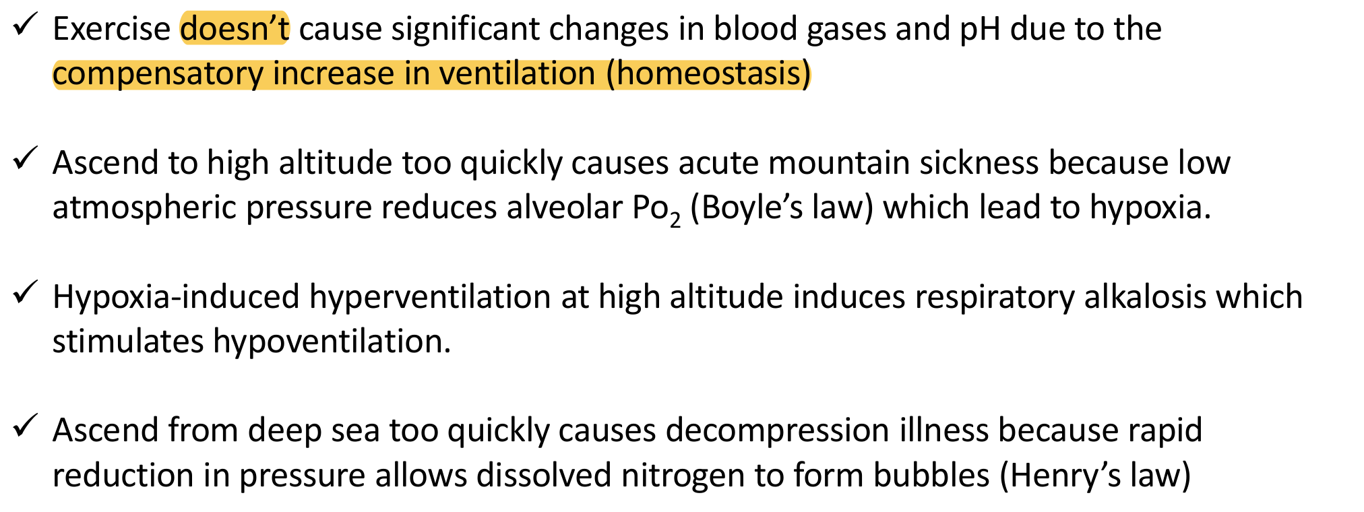
Original highlighted summary, lecture p. 12. Its claims are reviewed below; the Boyle attribution needs correction.
Source statement / selection | Reviewed interpretation
p. 5: hyperventilation / alkalosis / excrete | All three highlighted choices are correct. Remaining completions: increase BPG → right shift → unloading.
p. 5: calls BPG unloading “Bohr effect” | CORRECTION: BPG stabilises the T state; Bohr refers to CO₂/H⁺ effects. Acute hypocapnia and later BPG changes may oppose each other.
pp. 6–7: pulmonary constriction / away; cerebral dilation | Selected directions are correct for the stated local/hypoxic effects. Global altitude hypoxia, hypocapnia and edema need the qualifications on p. 4 of these notes.
p. 9: TV < DS, no ventilation | A limit of a simple fresh-gas model, not absence of all airflow or a physically negative ventilation rate.
p. 11: high pressure means high “solubility” | CORRECTION: dissolved concentration rises; α need not change.
p. 12: altitude hypoxia attributed to Boyle | CORRECTION: falling barometric pressure lowers inspired PO₂ through Dalton; Henry relates the dissolved component. Boyle explains volume changes.
p. 12: exercise does not change gases or pH | Often approximately true for moderate exercise with compensation; not universal at high intensity or in disease.
p. 12: alkalosis stimulates hypoventilation | An opposing inhibitory drive, not a guarantee that overall ventilation becomes lower than baseline at altitude.

Time matters: increased ventilation begins promptly; renal/CSF adaptation and RBC BPG changes develop over time. [Extension] Increased erythropoietin/RBC mass can improve carrying capacity over longer acclimatization, but is not an immediate correction of inspired PO₂. There are two self-written integrated problems; all other numbered questions come from the supplied tutorial.

