01 / Chapter map and source guide
Lecture PDF pp. 1–3 | Lecture by Dr Jian Yang; classroom physiology supplements supplied separately
One route, two levels of control
Kidneys produce urine → renal papillae → minor calyces → major calyces
→ renal pelvis → ureters → bladder → urethra.
Fluid-regulatory hormones change urine production; lower-tract anatomy controls transport, storage and voiding.

All lecture learning objectives | Study here
Describe fluid balance. | 2–8: intake, output, ADH, pressure reflexes, RAAS and classroom cases.
Understand morphology of kidneys, ureters, bladder and male urethra. | 9–30: dimensions, parts, tissue organisation and coverings.
Explain their blood supply, innervation and lymphatic drainage. | 16–17, 21, 27–30.
Describe topographical relationships with surrounding organs. | 9–13, 18–20, 22–26.

How the photographed material is integrated
Photograph | Knowledge / question | Notes page
Photos 1–2 | Same pressure / vasopressin supplement photographed twice; baroreflex and cardiovascular response. | 4
Photo 3 | Activity 3: small hypertonic-saline injection; AQP2 and UT-A1. | 3
Photo 4 | Activity 4: bilateral carotid occlusion; follow-up vagotomy; competing baroreceptor signals. | 5
Photo 5 | Activity 6: 48-year-old woman, water restriction, Na⁺ 160 and urine osmolarity 500. | 6
Photo 6 | Lucas: excessive water intake around a hot half-marathon; dilutional hyponatraemia. | 7

• PPT key text is retained in short sentences and tables; teaching arrows and labels are preserved in the original figures.
• Classroom photos are transcribed into clear English. Their questions and added mechanisms appear beside the relevant physiology, rather than in a detached answer appendix.
• [Extension] identifies explanatory material beyond the PPT / photographs. Source claims needing qualification are kept visible and explained.
All source page references mean actual PDF pages, including pp. 49–55 after “Thank you”. Identical repeated diagrams are cited together; images with different teaching annotations are retained separately. Cover logos / QR codes are decorative. Sources named by the lecture: Gray’s Anatomy for Students (2e); Clinically Oriented Anatomy (6e); Netter’s Atlas of Human Anatomy (5e). Classroom answers below are checked study interpretations, not an official answer key.

02 / Fluid balance: intake, output and numbers
Lecture PDF pp. 4–6
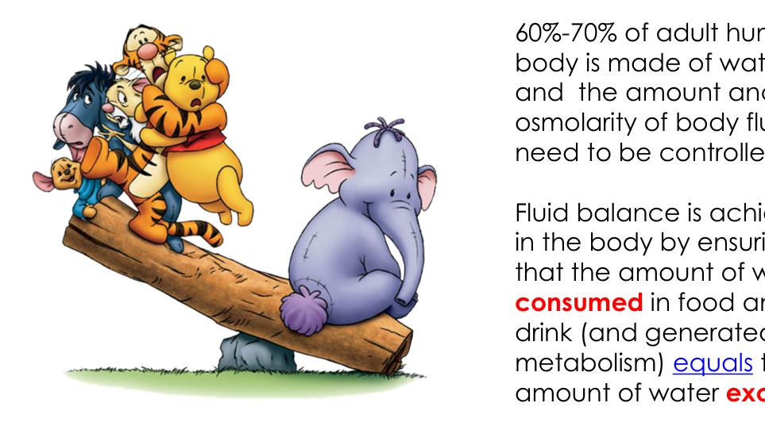  Original illustration, PDF p. 4. | 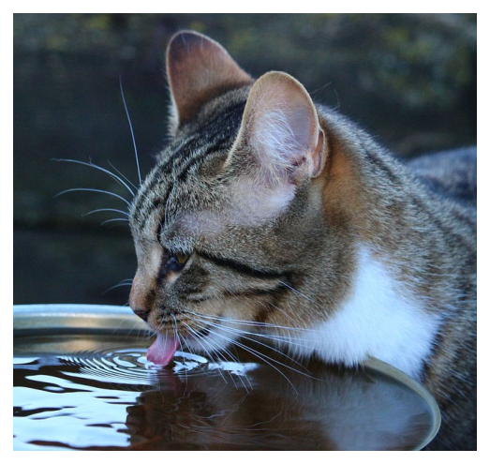  Original illustration, PDF p. 5. | 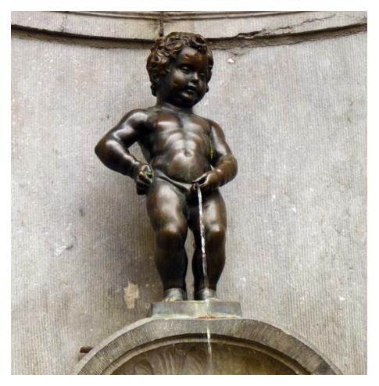  Original illustration, PDF p. 6.
Balance equation
Water from food + beverages / drinking water + metabolic production
= total water loss at steady state.
Both the amount AND the osmolarity of body fluid need control.

Written lecture point | Details retained
Body water | The slide gives 60%–70% of adult body mass as water. This is its teaching estimate; the actual fraction varies with age, sex and adiposity.
Three controls | Fluid intake + hormonal controls + fluid output jointly regulate body fluids.
Behavioural intake | Thirst and salt cravings regulate intake.
Reference daily intake: adult male | 3.7 L/day total water.
Reference daily intake: adult female | 2.7 L/day total water.
What the intake figures include | Water in food, beverages and drinking water; not an instruction to drink this volume as plain water alone.
Non-urinary output | About 1 L/day through skin, lungs and faeces in the lecture’s typical conditions.
Urinary output | About 1–2 L/day; the urinary system is the major site of REGULATED water excretion.
Homeostasis | Control mechanisms maintain a relatively constant internal environment despite changing intake and losses.

These daily figures are typical values, not fixed outputs to add into one universal prescription. Heat, exercise and illness change losses. Osmolarity = osmoles per litre of solution; osmolality = osmoles per kilogram of solvent. The photographed cases use mOsm/L, so their original units are retained.

03 / ADH, AQP2 and the hypertonic-saline question
Lecture PDF p. 7 | Classroom Photo 3: Activity 3
Lecture mechanism
ADH = antidiuretic hormone = vasopressin (VP / Vp).
ADH increases renal water reabsorption → water is retained
→ urine volume decreases → body-fluid osmolarity tends to fall.

Supplemental step | Mechanism and location
Osmotic stimulus | Plasma hyperosmolality activates hypothalamic osmoregulatory pathways and vasopressin neurons in PVN / SON.
Hormone source | VP is synthesised in hypothalamic neurons and released from their terminals in the posterior pituitary. PVN = paraventricular nucleus; SON = supraoptic nucleus.
AQP2 | VP promotes aquaporin-2 insertion into the APICAL membrane of collecting-duct principal cells → water permeability and reabsorption increase.
UT-A1 | VP promotes urea-transporter UT-A1 activity / membrane insertion in the INNER MEDULLARY collecting duct. UT-A1 transports urea, not water.
Medullary effect | Urea entry into medullary interstitium supports its high osmolality → supports further water reabsorption when the duct is water-permeable.

Original Activity 3 | Transcribed from classroom photo
What happens if we inject a small amount of hypertonic saline into the body? What is the immediate effect on urine output?
Answer approach:
• The photographed answer is a small volume of concentrated urine.
• Small hypertonic load → hyperosmolality, with relatively little direct volume loading in the question’s intended comparison.
• PVN / SON activation → posterior-pituitary VP release ↑ → apical AQP2 ↑ → renal water reabsorption ↑.
• UT-A1-mediated urea handling supports the medullary gradient → concentrating ability increases.
• Urine flow falls and urine concentration rises after the hormonal / renal response develops.

Condition check: “immediate” means the early physiological response, not a change in urine already inside the bladder. Hypertonic saline can also shift water from cells into ECF; a large sodium / volume load or later sodium excretion can change the net response. AQP2 still requires a medullary osmotic gradient to drive water movement. [Extension] VP acts through renal V₂ receptors; basolateral water exit uses other aquaporins.

04 / Pressure receptors: VP and cardiovascular control
Lecture PDF p. 7 | Classroom Photos 1–2: same supplemental slide
Teaching circuit reconstructed from the photos
Arterial stretch ↑ → baroreceptor firing ↑
→ CN IX / X → NTS → excitation of CVLM
→ inhibition of RVLM → less excitatory drive to hypothalamic PVN / SON
→ VP release tends to decrease.
This is the simplified teaching pathway; actual hypothalamic regulation has additional connections.

Abbreviation / site | Meaning / role
CN IX | Glossopharyngeal nerve: carotid-sinus baroreceptor afferents.
CN X | Vagus nerve: aortic-arch baroreceptor afferents.
NTS | Nucleus tractus solitarius, in the medulla oblongata; integrates incoming visceral signals.
CVLM | Caudal ventrolateral medulla; inhibits RVLM in the baroreflex circuit.
RVLM | Rostral ventrolateral medulla; important sympathetic premotor region, linked to cardiovascular and hypothalamic regulation.
PVN / SON | Hypothalamic nuclei containing vasopressin neurons; output reaches the posterior pituitary.

Original supplemental prompt | Transcribed from classroom photo
With ongoing baroreceptor activity under normal conditions / hypertension, what would happen to the cardiovascular system?
Answer approach:
• Sympathetic drive to blood vessels ↓ → vasodilation → vascular resistance and BP tend to fall.
• Sympathetic drive to the heart ↓ → ventricular inotropy / contractility ↓.
• Parasympathetic cardiac activity ↑ → heart rate ↓ (including reduced pacemaker funny-current drive) and conduction velocity ↓.
• Cardiac output ↓; vasodilation also lowers BP.
• VP inhibition → less renal water retention → larger volume of more dilute urine → blood volume tends to fall.
• Net teaching outcome: restoration of body-fluid and pressure homeostasis.

Two source statements need qualification
The photograph calls NTS “the CVC”. More precisely, NTS is a component of the medullary cardiovascular control network.
Its “no VP secretion” phrase illustrates inhibitory baroreceptor drive; it does not mean basal osmoregulated VP must be zero at every normal BP. Osmotic and volume signals are integrated.

BP = blood pressure; cardiac output = heart rate × stroke volume. “Reduced funny current” refers to slower pacemaker depolarisation, not reduced ventricular contractile force; sympathetic withdrawal accounts for the inotropy change. Pressure control can act rapidly; changes in water excretion and blood volume develop over a longer timescale.

05 / Carotid occlusion and vagotomy: read conditions
Lecture PDF p. 7 | Classroom Photo 4: Activity 4
Original Activity 4 | Transcribed from classroom photo
If implanted pneumatic cuffs perform bilateral carotid occlusion in an experimental animal, what changes would occur in urine output?
Answer approach:
The photo’s proposed chain is: carotid blockage → aortic BP ↑ → aortic-arch baroreceptors activated → CN X firing to NTS / CVLM ↑ → RVLM and PVN / SON suppressed → VP ↓ → urine output ↑.
This is an AORTIC-DOMINANT interpretation that assumes the rise in aortic pressure provides the dominant inhibitory input.

Keep the opposing carotid-sinus signal in the explanation
Signal / assumed experiment | Effect on reflex drive and VP
Occlusion below the carotid sinus | Pressure / stretch at the sinus falls → carotid-sinus afferent firing through CN IX falls → baroreceptor unloading tends to increase sympathetic and non-osmotic VP drive.
Resulting systemic pressure rise | If aortic pressure rises, aortic-arch afferents through CN X increase firing → this opposes the carotid-unloading effect.
Net response | Depends on cuff position, sinus pressure, aortic pressure and intact afferents. “Bilateral carotid occlusion always causes VP ↓ and diuresis” is not a general physiological rule.

Original follow-up | Transcribed from classroom photo
What happens if we perform vagotomy in this case?
Answer approach:
• In the photo’s setup, cutting vagal afferents removes the aortic-arch inhibitory signal.
• Relative to the intact-vagus, aortic-dominant state: VP drive can rise → water reabsorption ↑ → urine flow ↓.
• CN IX carotid-sinus afferents are not cut by vagotomy. With carotid unloading still present, removing aortic feedback can strengthen the low-pressure / sympathetic response.
• Vagotomy also affects other vagal functions; this question isolates the baroreceptor–VP component.

Exam answer structure
State the sensed pressure at EACH receptor → name the afferent nerve
→ compare opposing signals → state the resulting VP response
→ predict renal water handling and urine flow.

The photo labels carotid body and carotid sinus separately. The carotid SINUS contains arterial pressure receptors; carotid BODY is principally a chemoreceptor organ. Likewise, pressure receptors are in the aortic arch, whereas aortic bodies are chemoreceptors. No new pressure measurements are supplied, so retain the photograph’s conditional answer rather than invent a unique net experimental result.

06 / Water restriction: the diabetes-insipidus case
Lecture PDF p. 7 | Classroom Photo 5: Activity 6; photographed slide number 54 belongs to that class slide deck
Original Activity 6 — case and all options | Transcribed from classroom photo
Patient: a 48-year-old woman.
• Severe polyuria (high urine output) and polydipsia (excessive drinking); no urinary glucose.
• After overnight water restriction: lethargy and confusion.
• Plasma sodium: 160 mEq/L; source normal range 135–145.
• Urine osmolarity: 500 mOsm/L; source comparison >850.
Question: most likely diagnosis?
A. Hyperaldosteronism B. Renin-secreting tumour
C. Diabetes mellitus D. Diabetes insipidus E. SIADH
Answer approach:
• Best answer among the options: D, diabetes insipidus (DI).
• Plasma Na⁺ 160 indicates a marked water deficit relative to sodium. Continued polyuria and inadequate concentration during water restriction indicate impaired water conservation.
• No urinary glucose makes glucose-driven osmotic diuresis less likely in the given comparison.
• A urine value of 500 is not maximally dilute; it is INAPPROPRIATELY LOW for the hypernatraemic, water-deprived state. Partial DI / partial concentrating defects are possible.
• The data do not establish central versus nephrogenic DI.

Alternative | Why it is less suitable here
Diabetes mellitus | Usually causes this pattern through glycosuria and osmotic diuresis; the case explicitly says no glucose in urine.
SIADH | Inappropriate antidiuresis generally produces low plasma sodium and urine that remains concentrated despite low plasma osmolality; the case has hypernatraemia and polyuria.
Hyperaldosteronism / renin excess | Primarily alters sodium balance, extracellular volume and BP; does not best explain the impaired water-conservation pattern.

DI type [Extension] | Defect | Expected desmopressin response
Central DI | Insufficient VP production / release. | Urine concentration increases when the kidney can respond.
Nephrogenic DI | Kidney response to VP is impaired. | Little / reduced concentrating response; magnitude varies with partial defects.

The >850 mOsm/L figure is the photographed post-restriction teaching comparison, not a universal normal value for every random urine sample. Complete DI often has much lower urine osmolality; 500 alone is not diagnostic. Formal differentiation uses supervised evaluation / response testing, not this one number. The case is an interpretation exercise, not an instruction to continue water deprivation in an already hypernatraemic, symptomatic patient.

07 / Exercise and excess water: Lucas’s case
Lecture PDF pp. 4–7 | Classroom Photo 6: original case study
Original case — retain the clinical details | Transcribed from classroom photo
Patient: Lucas, a 20-year-old Art student and experienced marathon runner.
• Roommate finds him disoriented and brings him to a nearby A&E.
• He has just completed a half-marathon in extreme heat (34°C), from Tsing Ma Bridge to Victoria Park.
• To avoid dehydration: copious water before the race, plus about another 3 L of bottled water during it.
• Back at the Student Hall: nausea and confusion.
• Assuming heat stroke, he continues drinking lots of cold bottled water.
Question: what could be his problem?
Answer approach:
• The photographed answer is dilutional hyponatraemia. This is the leading intended explanation, not a sodium measurement supplied by the case.
• Large water intake over a short time without a matching electrolyte intake → water becomes excessive relative to exchangeable sodium / potassium.
• Sodium lost in sweat can contribute to the imbalance.
• [Extension] Exercise, stress and nausea can maintain non-osmotic VP secretion, limiting water excretion even as plasma sodium falls.
• Excess retained hypotonic fluid → extracellular osmolality ↓ → water enters cells; brain-cell swelling can explain nausea, confusion and disorientation.

Case clue | How to use it
Heat and prolonged running | Important context for sweating, salt loss and non-osmotic hormonal stimuli.
Water before + about 3 L during + more afterwards | The relevant exposure is cumulative water intake relative to losses and renal excretory capacity; do not treat 3 L as a universal toxicity threshold.
No proportional electrolytes, rapid intake | Supports dilution, rather than assuming every post-race symptom means dehydration.
Confusion / nausea | Compatible with exercise-associated hyponatraemia; heat illness is also a clinical differential, so sodium measurement is needed for confirmation.

Sweat loss alone is not the complete explanation
Sweat is usually hypotonic relative to plasma. Without replacement, sweat loss often removes proportionally more water than sodium. In this case, excessive hypotonic replacement plus limited water excretion is central; sweat sodium loss is a possible additional contributor.

A&E = Accident and Emergency department. Hyponatraemia describes low plasma sodium concentration, not automatically low total-body sodium or low total-body fluid volume. Contrast Activity 6: DI with water deficit gives HIGH Na⁺; excess retained water in Lucas’s intended case gives LOW Na⁺.

08 / RAAS: conserve sodium and circulating volume
Lecture PDF p. 7 | Connects fluid insufficiency to the kidney’s juxtaglomerular apparatus
Lecture trigger and outcome
Fluid insufficiency → renal / juxtaglomerular perfusion decreases
→ renin–angiotensin–aldosterone system (RAAS) activation
→ renal tubules reabsorb more sodium and water from tubular fluid
→ circulating volume is conserved.

Step [Extension where not spelt out in PPT] | Mechanism
Renin source | Juxtaglomerular granular cells of the kidney release renin when appropriate low-perfusion signals arrive.
Angiotensin sequence | Renin acts on angiotensinogen → angiotensin I; ACE converts it to angiotensin II.
Angiotensin II | Supports arterial pressure through vasoconstriction and promotes aldosterone, thirst and VP-related water conservation.
Aldosterone | Promotes distal-nephron sodium reabsorption; water retention depends on available water and segmental water permeability. It is not the hormone that inserts AQP2.

Compare | ADH / VP | RAAS / aldosterone
Main emphasis | Water permeability / water conservation. | Sodium balance and effective circulating volume.
Urinary effect | Less free-water loss; urine can become more concentrated. | Sodium retention; associated water retention helps restore volume.
Key trigger taught here | Hyperosmolality or a strong low-volume / low-pressure signal. | Reduced renal perfusion during fluid insufficiency.
Osmolarity | Water retention tends to lower it. | The slide says conserve volume while maintaining osmolarity: sodium and water responses must be coordinated; aldosterone alone does not guarantee a fixed osmolarity.

The lecture says “from the urine”; anatomically this is reabsorption from forming tubular fluid before final excretion. Osmotic and pressure / volume regulation overlap, but plasma sodium concentration, total sodium content, circulating volume and BP are different variables. JG cells and macula densa are visible in the histology figure on notes p. 14.

09 / Kidneys: position, asymmetry and dimensions
Lecture PDF pp. 8–9
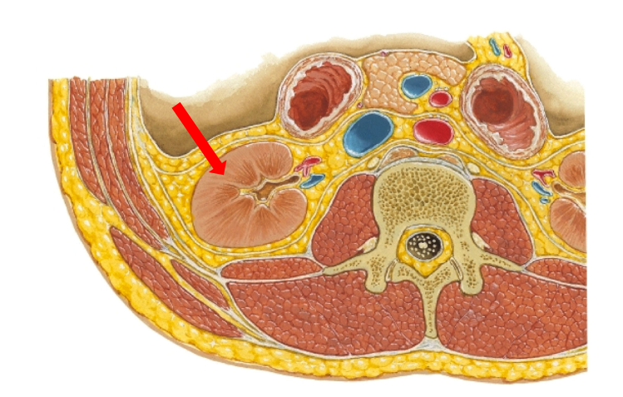  Original lecture figure, PDF p. 8. | 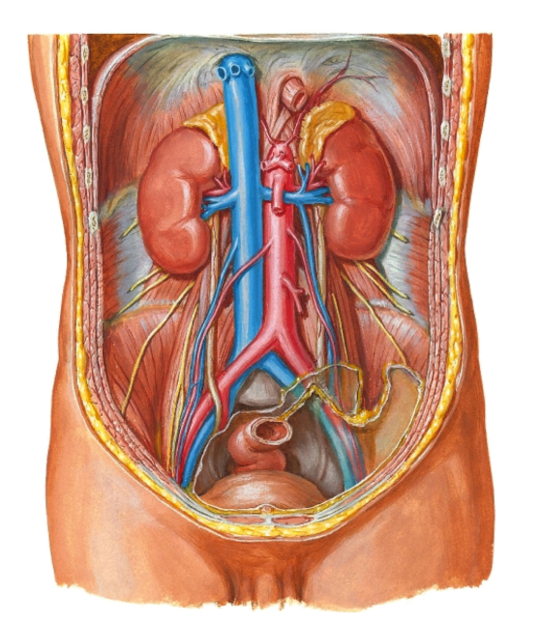  Original lecture figure, PDF p. 9.
Written point | Details retained
Compartment | Kidneys lie retroperitoneally on the posterior abdominal wall.
Retroperitoneal | Behind / outside the peritoneal cavity; they are not free intraperitoneal organs.
Right versus left | Right kidney is about 1 cm inferior to the left.
Reason for asymmetry | The lecture attributes the right-sided downward displacement to the bulk of the liver.
Each kidney: dimensions | About 10 cm long × 5 cm wide × 2.5 cm thick.

Use anatomical direction, not image position
Right / left describe the patient. In a frontal anatomical view, the patient’s right is often on the viewer’s left. The kidney’s medial border faces the great vessels; its lateral border is convex.

The source dimensions and side difference are approximate teaching values, not an exact size requirement for every adult. Peritoneal relationships are shown again in the renal coverings figure on notes p. 15.

10 / Renal hilum and surface landmarks
Lecture PDF pp. 10–11
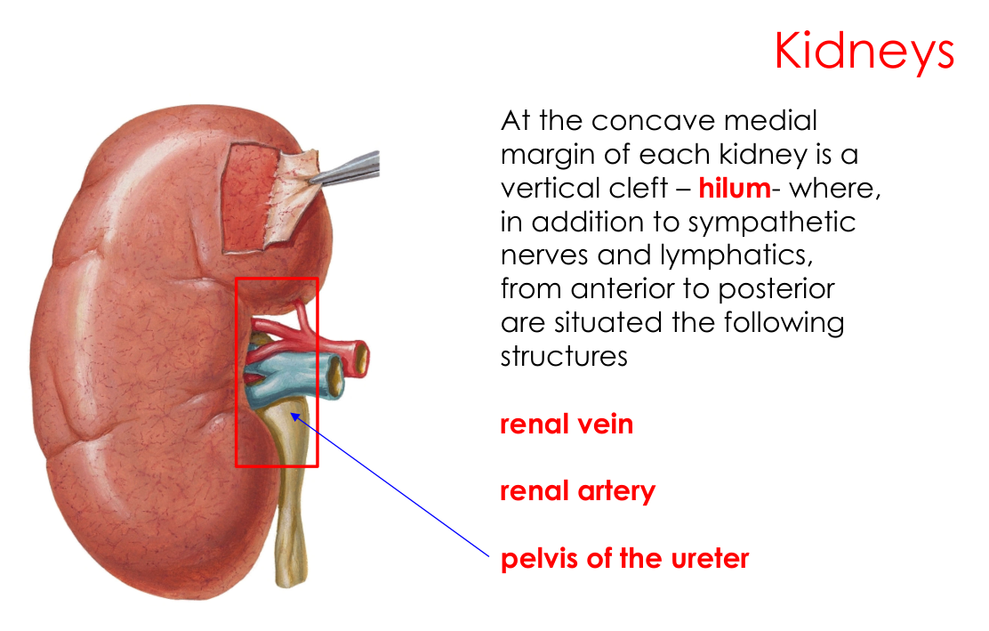  Original lecture figure, PDF p. 10. | 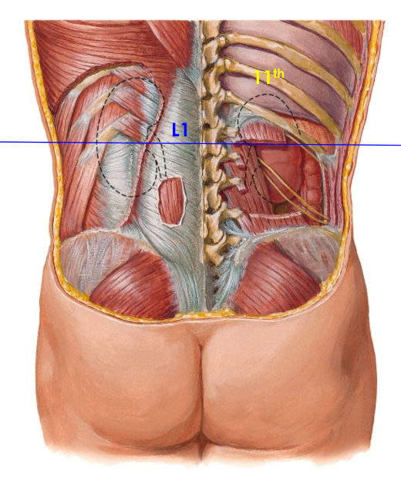  Original lecture figure, PDF p. 11.
Landmark | Complete lecture description
Hilum; plural hila | A vertical cleft on the concave medial margin of each kidney. The slide’s “pleural form” means plural form.
Additional structures at hilum | Sympathetic nerves and lymphatics accompany the major vessels / pelvis.
Anterior → posterior order | Renal VEIN → renal ARTERY → renal PELVIS / pelvis of the ureter. Memory aid: V–A–P.
Transpyloric plane | Hila lie near this plane at vertebral level L1.
Surface definition | The slide places it midway between suprasternal notch and pubic symphysis.
Left superior pole posteriorly | Lies deep to the 11th rib.
Right superior pole posteriorly | Lies deep to the 11th intercostal space.

Two different descriptions, both needed
Hilum: relation to the L1 / transpyloric plane.
Superior pole: relation to the 11th rib / intercostal space.
Do not substitute a pole landmark for a hilar landmark.

11 / Kidney posterior and medial relations
Lecture PDF p. 12
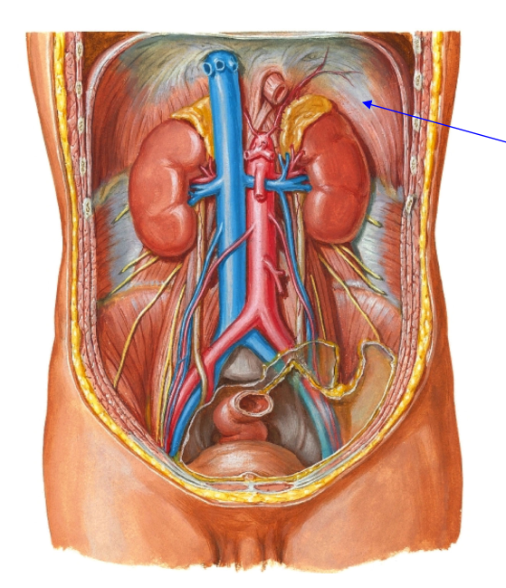
Original lecture image, including visible teaching annotations (PDF p. 12).
Direction / structure | Retained anatomical relation
Posterior: diaphragm | Related to the upper posterior kidney.
Posterior ribs: left | 11th AND 12th ribs.
Posterior ribs: right | 12th rib.
Posterior: back muscles | Posterior abdominal-wall muscle relationships must be recognised.
Posterior: lumbar nerves | Anterior rami of lumbar spinal nerves are related posteriorly; they supply abdominal-wall muscles and skin.
Medial | The renal hila face medially.

[Extension] Common named muscular relations are psoas major medially, quadratus lumborum and transversus abdominis more laterally. The subcostal nerve and L1 iliohypogastric / ilioinguinal nerves are useful named neighbours. The subcostal nerve is T12, so it should not be called a lumbar anterior ramus. Keep the source’s general “back muscles / lumbar anterior rami” statements as well as these supporting names.

12 / Kidney anterior relations: right versus left
Lecture PDF pp. 13–14
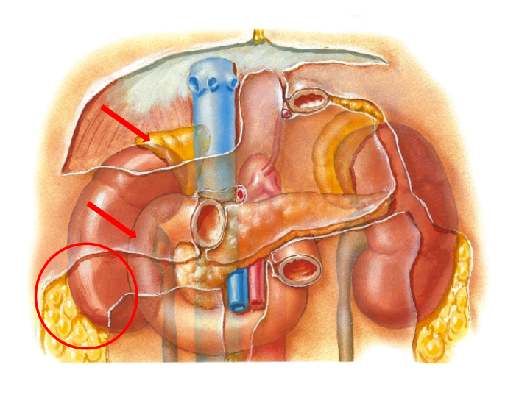  Original lecture figure, PDF p. 13. | 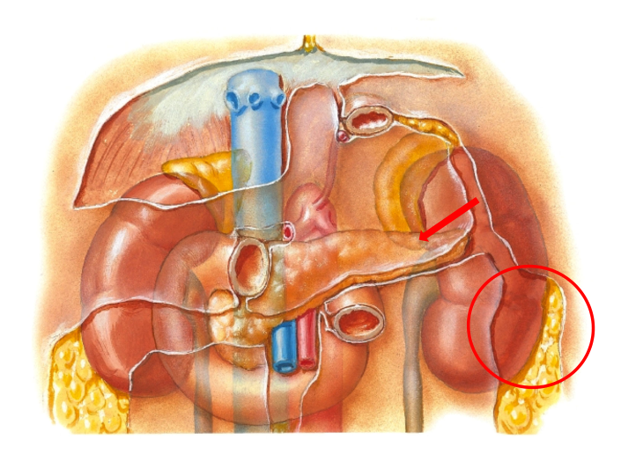  Original lecture figure, PDF p. 14.
Right anterior relations — all six | Left anterior relations — all seven
Suprarenal gland. | Suprarenal gland.
Liver. | Spleen.
Second part of duodenum. | Stomach.
Hepatic flexure of colon. | Pancreas.
Ascending colon. | Splenic flexure of colon.
Small intestine. | Descending colon.
— | Small intestine.

Learn the asymmetric neighbours
Right: liver + second part of duodenum + hepatic flexure / ascending colon.
Left: spleen + stomach + pancreas + splenic flexure / descending colon.
Both lists include suprarenal gland and small intestine.

The original pictures use red lines / circles to locate neighbours; these annotations are retained separately even though the underlying anatomical plate is shared. The table lists relationships, not a claim that every neighbour directly contacts every part of the renal surface.

13 / Kidney sections and CT orientation
Lecture PDF pp. 15–16
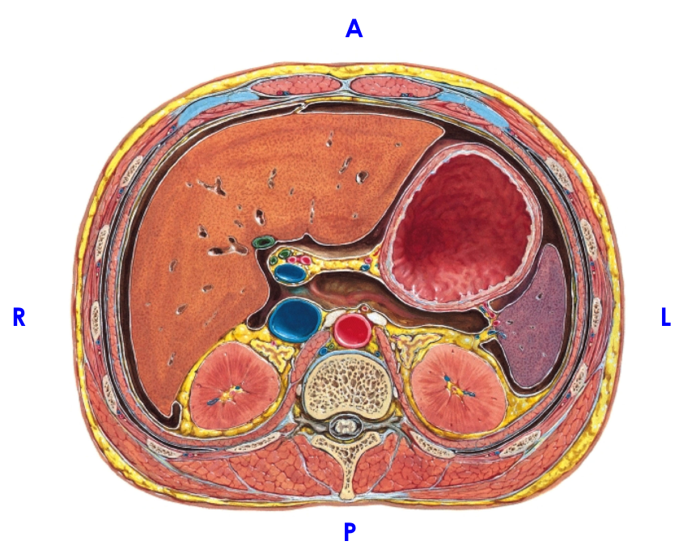
Original lecture image, including visible teaching annotations (PDF p. 15).
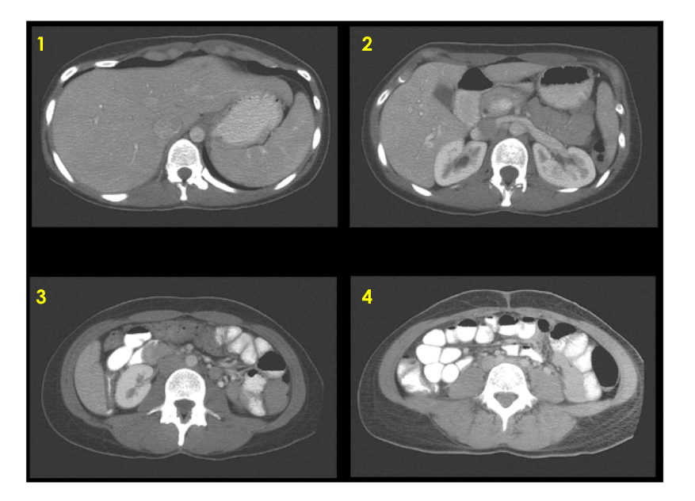
Original lecture image, including visible teaching annotations (PDF p. 16).
Source feature | What to recognise
A / P / R / L labels | A = anterior; P = posterior; R / L = patient’s right / left.
Kidneys in axial section | Posterior position relative to abdominal viscera; identify the vertebral body and psoas muscles as orientation landmarks.
Great vessels | Aorta is anterior to the vertebral body; inferior vena cava lies on the patient’s right.
Four CT panels: 1–4 | Retain all four source images. Compare renal appearance / location and neighbouring viscera across the views.

The source supplies panel numbers but no explicit scan-level or contrast-phase key. Do not assign invented vertebral levels or imaging phases. Standard axial display is viewed from the patient’s feet, so the patient’s right is on the viewer’s left; use the labelled plate to practise orientation.

14 / Inside the kidney: calyces and histology
Lecture PDF pp. 17–18 | Juxtaglomerular cells link to RAAS on notes p. 8
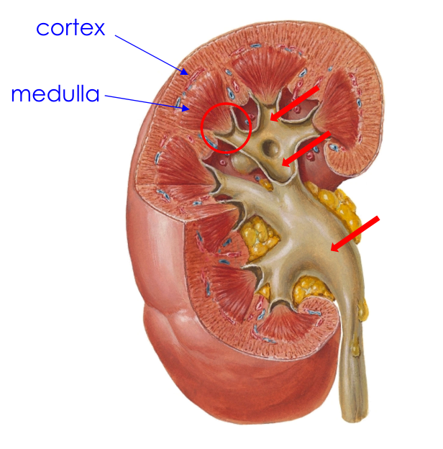
Original lecture image, including visible teaching annotations (PDF p. 17).
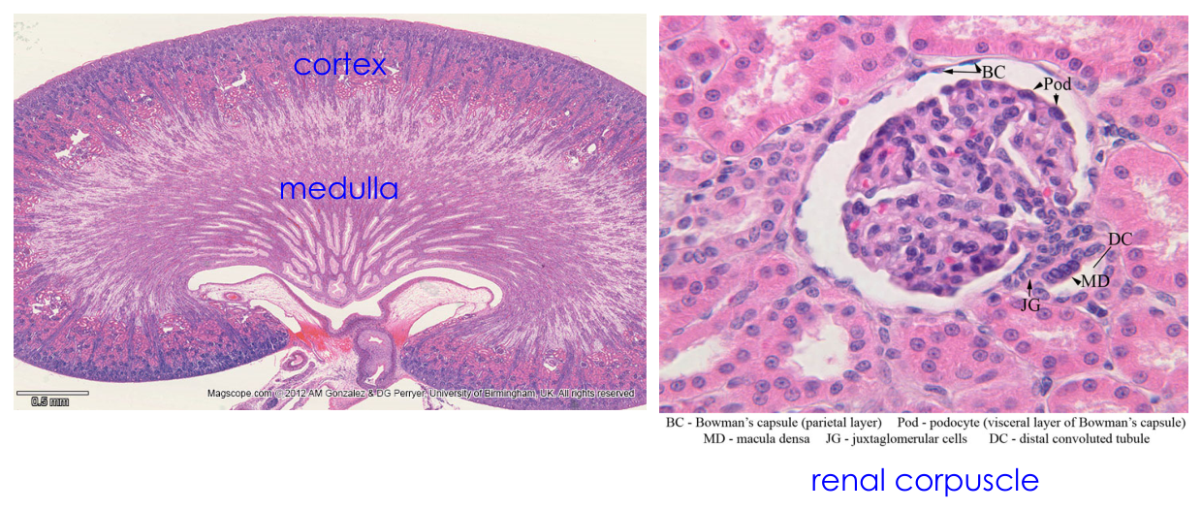
Original lecture image, including visible teaching annotations (PDF p. 18).
Written / figure detail | Full key content
Pelvis branching | Renal pelvis divides into TWO or THREE major calyces; each divides into multiple minor calyces.
Minor calyx and papilla | Each minor calyx receives a renal papilla, the projecting apex of a medullary pyramid. Collecting ducts empty at the papilla into the calyx.
Cortex / medulla | Both are labelled in the gross kidney and low-power histology.
Renal corpuscle | Glomerular capillary tuft enclosed by Bowman’s capsule; located in the cortex.
BC / Pod | BC = Bowman’s capsule, parietal layer; Pod = podocyte, visceral layer.
MD / JG / DC | MD = macula densa; JG = juxtaglomerular cells; DC = distal convoluted tubule.

Urine leaves, rather than enters, the pyramid
Collecting tubules / ducts → papilla at pyramid apex → minor calyx
→ major calyx → renal pelvis → ureter.
The papilla is the apex, not a separate receiver upstream of the pyramid.

15 / Renal capsule, fat and fascia
Lecture PDF pp. 19–20
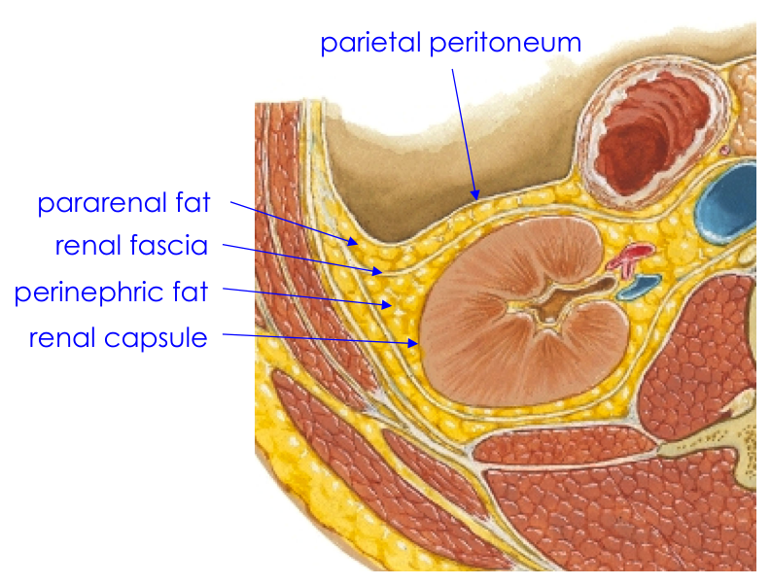  Original lecture figure, PDF p. 19. | 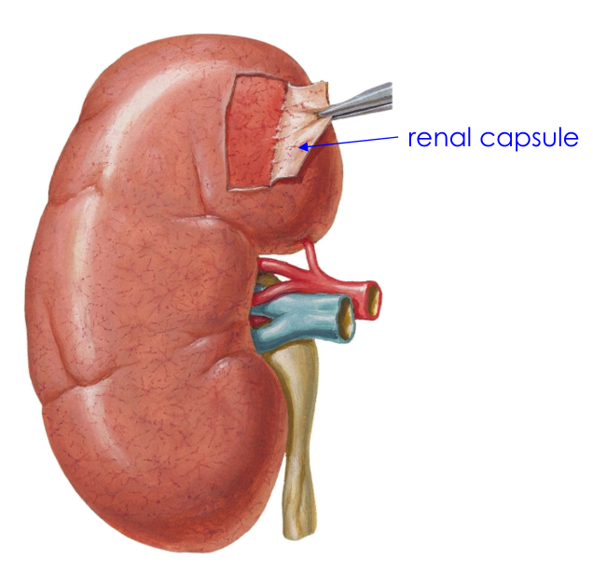  Original lecture figure, PDF p. 20.
From kidney outward | Lecture detail
True fibrous renal capsule | Immediately covers the kidney; lies deep to perinephric fat.
Perinephric fat | Fatty cushion around the kidney, contained within renal fascia.
Renal fascia | Surrounds the perinephric compartment.
Pararenal fat | Outside renal fascia.
Parietal peritoneum | Shown anterior to these retroperitoneal structures in the source figure.
Normal capsule | Strips readily from the normal kidney surface.
Inflamed kidney | The capsule does not strip as readily from an inflamed surface.

Do not exchange the two fat layers
Kidney → renal capsule → PERINEPHRIC fat → renal fascia → PARARENAL fat.
Perinephric = within the fascial enclosure; pararenal = external to it.

16 / Renal fixation, movement and great vessels
Lecture PDF pp. 21–22
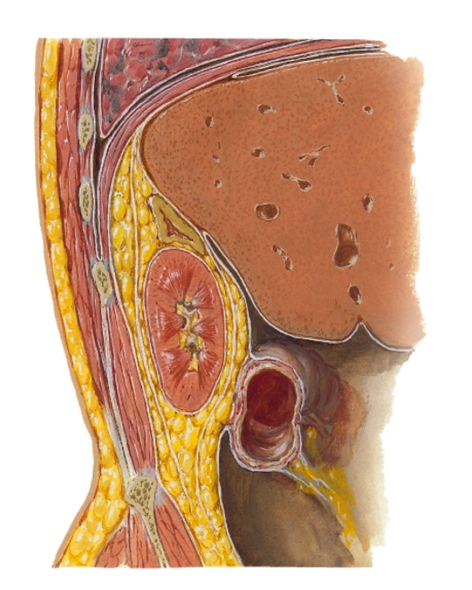  Original lecture figure, PDF p. 21. | 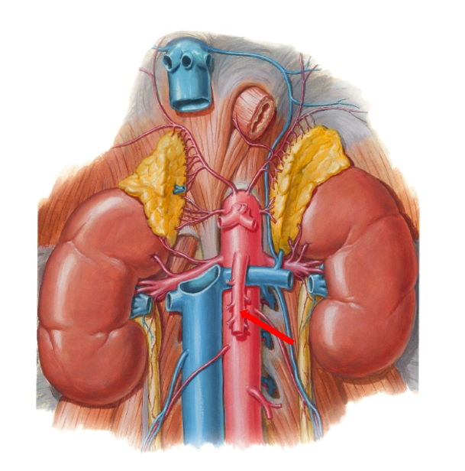  Original lecture figure, PDF p. 22.
Written point | Complete relation
Fixation | All the surrounding fat and fascia hold the kidneys in a relatively fixed position.
Respiratory mobility | Despite that support, a kidney can move about 3 cm during respiration.
Renal arteries | Arise directly from the descending ABDOMINAL aorta.
Renal veins | Drain directly into the inferior vena cava (IVC).
Left renal vein | Longer than the right; crosses in FRONT of the aorta, immediately below the origin of the superior mesenteric artery (SMA).
Right renal artery | Passes BEHIND the IVC.

Keep vessel and side together
LEFT renal VEIN: anterior to aorta, below SMA.
RIGHT renal ARTERY: posterior to IVC.
Hilar V–A–P order is a separate local relation, not a replacement for these great-vessel crossings.

[Extension] The left renal vein’s aorta–SMA relationship explains susceptibility to compression in the angle between them. This is an anatomical application, not a diagnosis supplied by the lecture.

17 / Kidney lymphatic drainage and nerves
Lecture PDF pp. 23–24
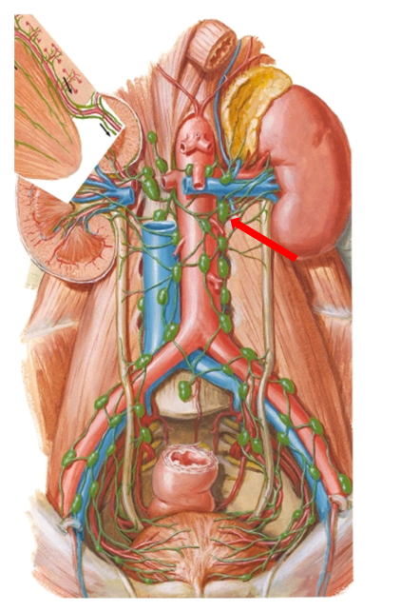  Original lecture figure, PDF p. 23. | 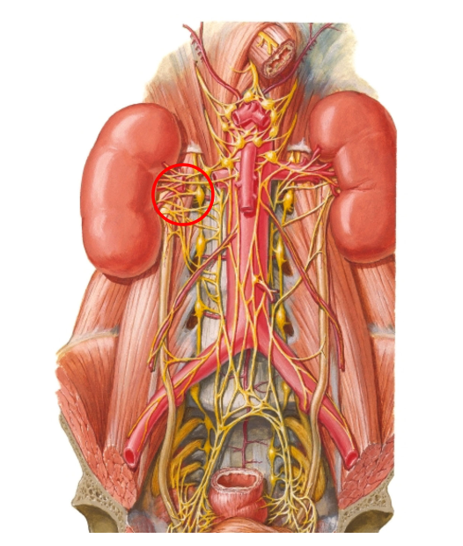  Original lecture figure, PDF p. 24.
System | Retained pathway
Lymphatic drainage | Renal lymphatics → paraaortic lymph nodes → cisterna chyli → thoracic duct.
Innervation | Renal plexus.
Fibre types in the slide | Both sympathetic and parasympathetic fibres are listed.

Separate artery, vein, lymph and nerve
Arterial blood: abdominal aorta → renal artery.
Venous blood: renal vein → IVC.
Lymph: paraaortic nodes → cisterna chyli → thoracic duct.
Nerve network: renal plexus.

Functional qualification: sympathetic regulation of renal vessels and renin release is well established; the slide’s listing of parasympathetic fibres does not justify assuming a simple equal-and-opposite parasympathetic effect on every renal function. [Extension] Sympathetic β₁ stimulation can increase renin release; this links anatomy to the low-perfusion RAAS response on notes p. 8.

18 / Ureter: segments and abdominal course
Lecture PDF pp. 25–26
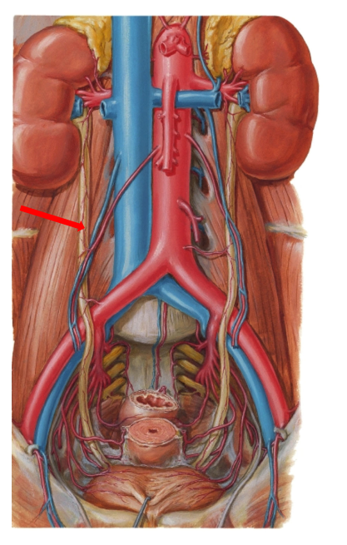  Original lecture figure, PDF p. 25. | 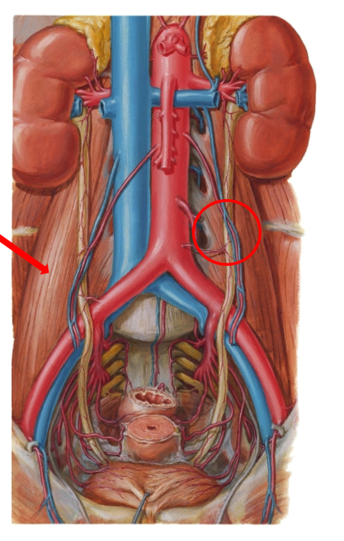  Original lecture figure, PDF p. 26.
Written point | Retained detail
Length / compartment | Approximately 25 cm long; retroperitoneal.
Four named portions | Pelvis of the ureter / renal pelvis; abdominal portion; pelvic portion; intravesical portion.
Lumbar relation | Abdominal ureter lies anterior to lumbar transverse processes, with psoas major separating it from them.
Anterior crossing in males | Testicular arteries cross in front of the abdominal ureters.
Anterior crossing in females | The slide names the suspensory ligament, which carries ovarian vessels; ovarian vessels cross anterior to the ureter.
Entry into pelvis | Crosses just lateral to the common iliac artery bifurcation, in front of the sacroiliac joint, in the source description.

The slide calls the crossing “water under bridge”: ureter = water; crossing vascular / ligamentous structure = bridge. The better-known pelvic version is ureter beneath the uterine artery (notes p. 19); specify which bridge is meant. Exact iliac crossing anatomy varies, so use the lecture’s landmark as an approximate course rather than a universal millimetric location.

19 / Pelvic ureter: shared and sex-specific relations
Lecture PDF pp. 27–29
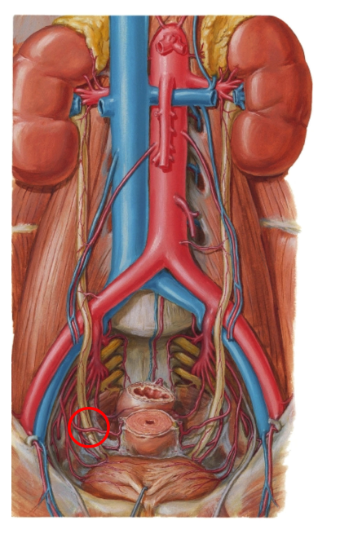  Original pelvic relation, PDF p. 27. | 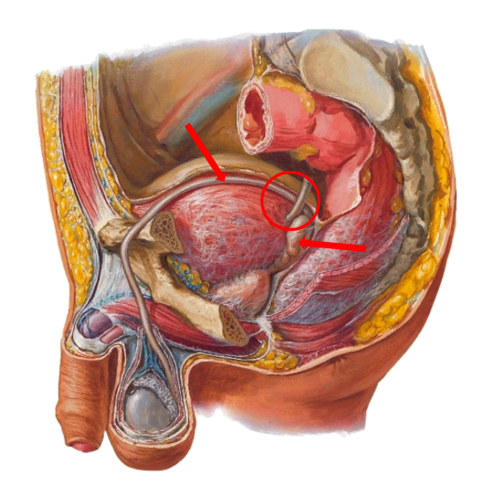  Original pelvic relation, PDF p. 28. | 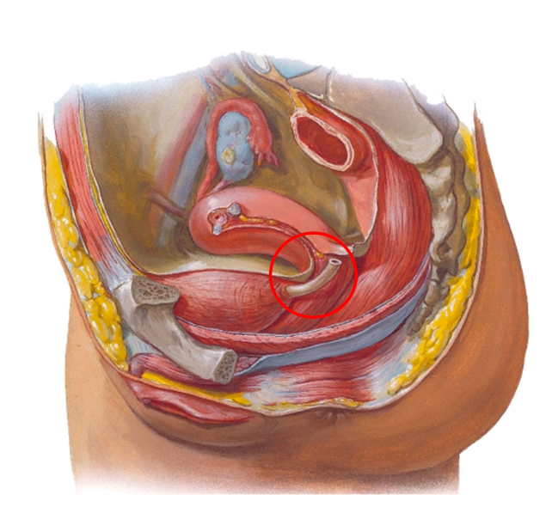  Original pelvic relation, PDF p. 29.
Location / sex | Every written relation
Shared course | Runs on lateral pelvic wall in FRONT of internal iliac artery, then turns forward and medially to enter bladder.
Female: arterial crossing | Uterine artery crosses anteriorly / superiorly to ureter: water under the bridge.
Male: seminal vesicles | Ureter lies above seminal vesicles.
Male: duct crossing | Just before bladder entry, vas deferens crosses the ureter; the duct passes superior / anterior to it as it courses medially. The slide describes it as crossed by the vas deferens medially.
Female: broad ligament | Pelvic ureter lies below the broad ligament.
Female: vaginal / cervical relation | Passes above the lateral fornix of the vagina and lateral to the cervix, then enters bladder.

Two pelvic bridges
Female: uterine artery OVER ureter near the cervix.
Male: vas deferens OVER ureter near bladder entry.
Ureter and urethra are different structures: kidney → bladder versus bladder → outside.

Fornix = recess around the projecting cervix at the upper vagina. The proximity of uterine artery, cervix and ureter explains ureteric injury risk during pelvic surgery; see the integrated anatomy practice on notes p. 31.

20 / Intravesical ureter and anti-reflux mechanism
Lecture PDF p. 30
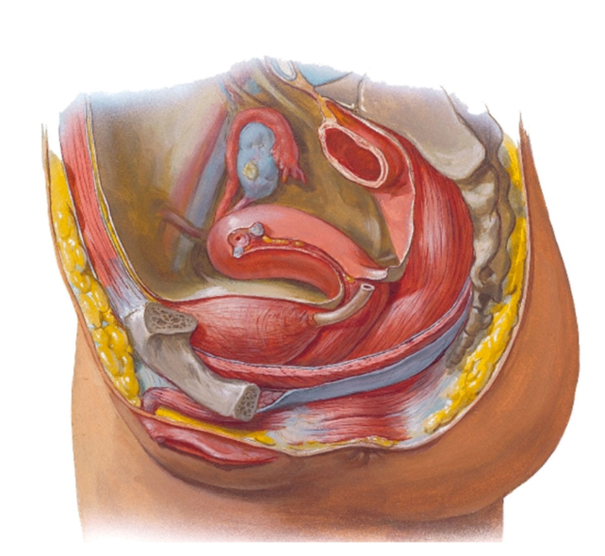
Original lecture image, including visible teaching annotations (PDF p. 30).
Retained lecture detail | Meaning
Oblique course | Intravesical ureter passes obliquely through the bladder wall.
Length in wall | Approximately 2 cm in the source.
Surrounding vesical muscle | Terminal ureter is surrounded by bladder muscle, creating a functional sphincteric arrangement.
During micturition | Bladder contraction / pressure compresses the oblique segment → helps prevent urine reflux from bladder into ureter.

Functional valve, not a new labelled ring
The oblique intramural tunnel provides the anti-reflux effect. Do not confuse it with the internal urethral sphincter at the bladder outlet.

[Extension] Common ureteric narrowing sites are the pelviureteric junction, crossing of the pelvic brim / iliac vessels and ureterovesical junction. These support obstruction / stone questions but are additional to this slide’s written text. Micturition means bladder emptying / urination.

21 / Ureter blood supply and nerve plexuses
Lecture PDF pp. 31–32
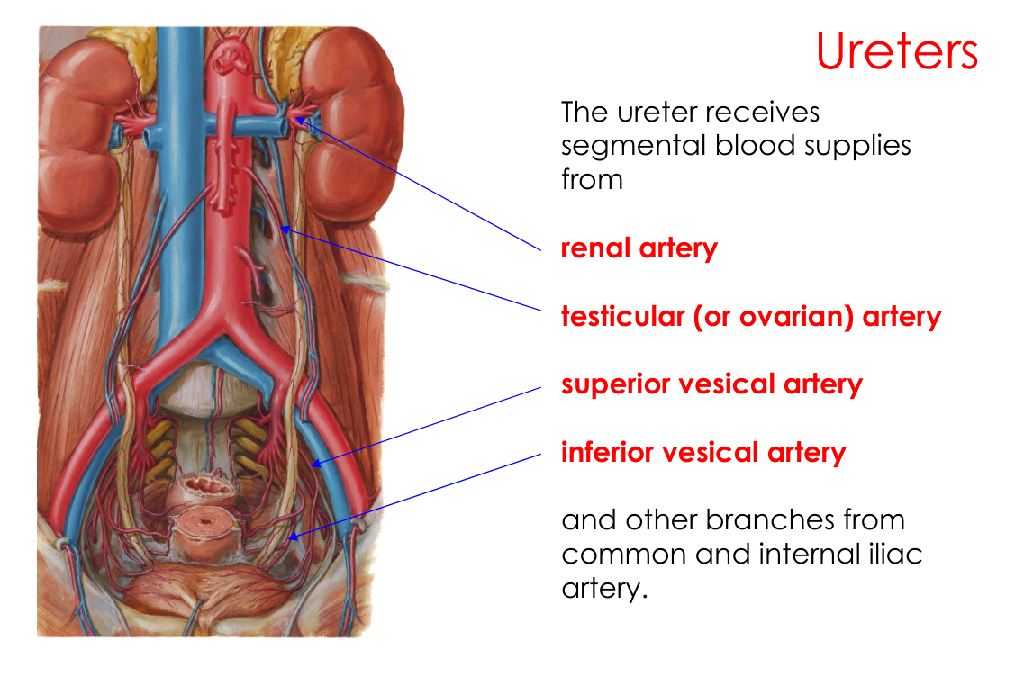  Original lecture figure, PDF p. 31. | 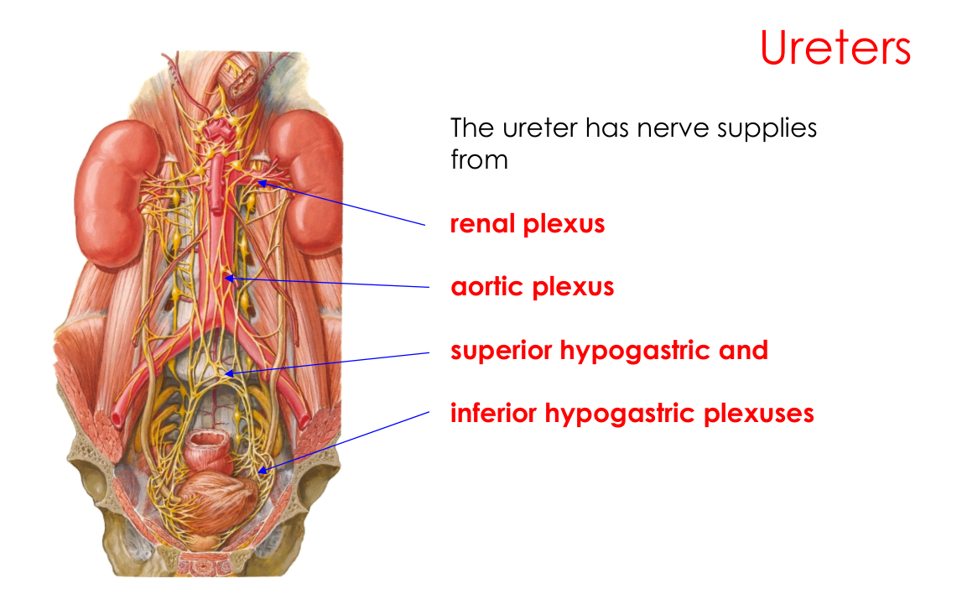  Original lecture figure, PDF p. 32.
Segmental arterial sources — all listed | Nerve sources — all listed
Renal artery. | Renal plexus.
Testicular artery OR ovarian artery. | Aortic plexus.
Superior vesical artery. | Superior hypogastric plexus.
Inferior vesical artery. | Inferior hypogastric plexus.
Other branches of common and internal iliac arteries. | Plexus contributions vary along the course.

Segmental means several levels supply it
The ureter is not supplied by one long, isolated artery. Proximal, middle and distal portions receive branches from neighbouring vessels along its retroperitoneal / pelvic course.

[Extension] Small longitudinal connections in the periureteric tissue are clinically important; extensive stripping can compromise blood supply. Autonomic innervation modulates ureteric function, but urine propulsion also depends on intrinsic smooth-muscle peristalsis.

22 / Bladder position, parts and muscle
Lecture PDF pp. 33–35
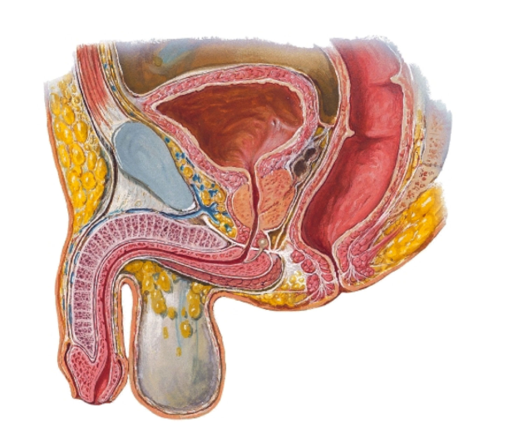  Original lecture figure, PDF p. 33. | 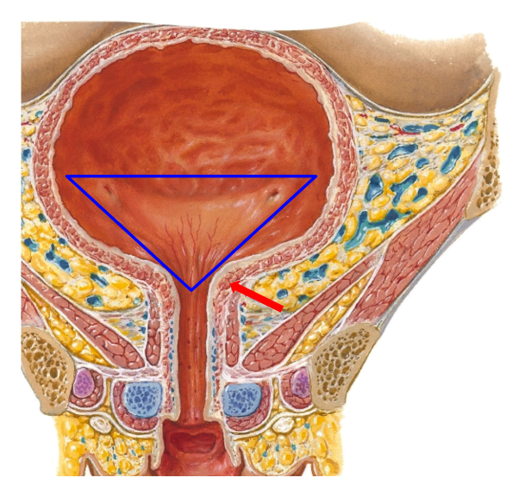  Original lecture figure, PDF p. 35.
Written point | Complete detail
Adult position | Pelvic, extraperitoneal bladder; the slide describes it as retroperitoneal. Its superior surface is covered by peritoneum.
Urinary retention / distension | Bladder can expand into abdomen, lifting / stripping peritoneum upwards.
Capacity | Lecture’s average figure: about 300 mL. This is an approximate teaching value, not a universal maximum.
Children up to 3 years | Bladder is an abdominal organ because the pelvis is relatively small.
Apex | Points towards the pubic symphysis.
Fundus / base | Posterior wall of bladder.
Body | Between apex and fundus.
Trigone | Triangle bounded by two ureteric orifices and the internal urethral orifice.
Detrusor | Bladder wall is chiefly detrusor smooth muscle.
Internal urethral sphincter | The slide describes circular muscle condensing around the internal urethral orifice as an involuntary sphincter.

Clinical precision: the discrete smooth-muscle bladder-neck sphincter is most clearly defined in males; female outlet anatomy is less well represented by a separate ring. This does not change the lecture’s distinction between involuntary outlet control and the voluntary external urethral sphincter. The repeated unmarked bladder plate on p. 34 is represented by p. 33 here; all p. 34 text is retained.

23 / Bladder anterior and inferolateral relations
Lecture PDF pp. 36–37
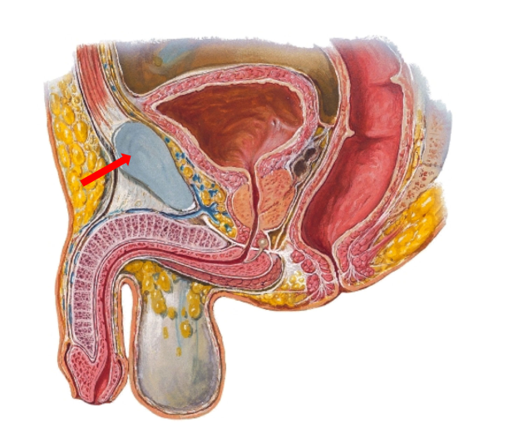  Original lecture figure, PDF p. 36. | 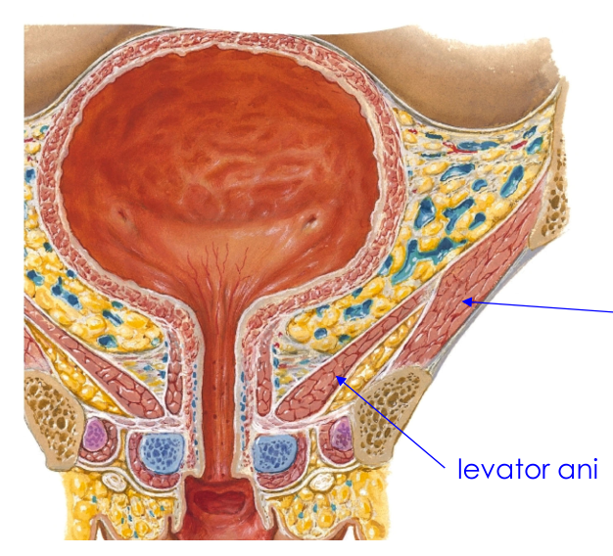  Original lecture figure, PDF p. 37.
Direction | Related structure
Anterior | Pubic symphysis.
Inferior / lateral | Levator ani.
Inferior / lateral | Obturator internus.

Use the view to reconstruct the relation
Sagittal view: bladder lies behind the pubic symphysis.
Coronal view: bladder is supported / bordered inferolaterally by pelvic-floor and lateral-wall muscles.
Do not put pubic symphysis into the posterior relation list.

[Extension] The retropubic space lies between the bladder and pubic region. The source’s red and blue arrows identifying pubic symphysis / levator ani are retained.

24 / Bladder superior relations: male and female
Lecture PDF pp. 38–39
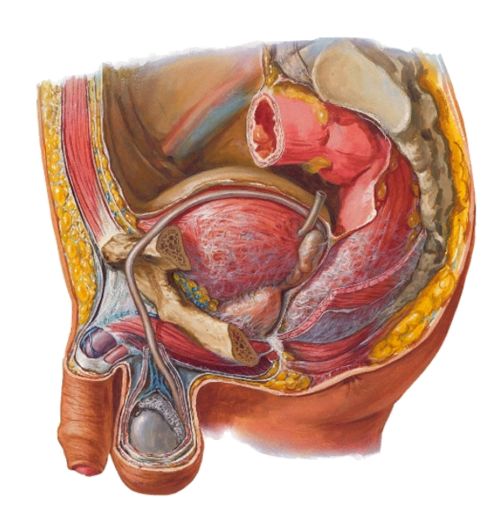  Original lecture figure, PDF p. 38. | 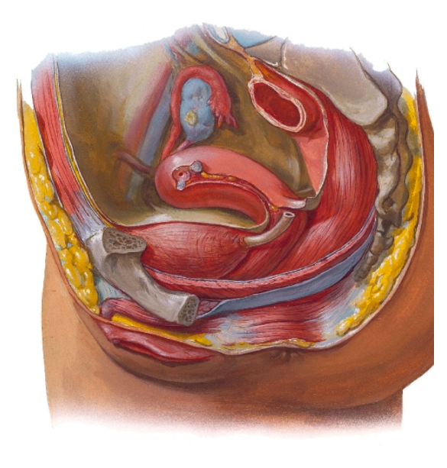  Original lecture figure, PDF p. 39.
Superior surface | Male | Female
Peritoneal covering | Superior surface is covered by peritoneum. | Superior surface is covered by peritoneum.
Relations listed | Loops of small intestine; sigmoid colon. | Body of uterus.

Position depends on neighbouring organs
The uterus changes the female bladder’s superior relation; it does not replace the cervix / vagina in the separate POSTERIOR relation list.

25 / Male bladder: all posterior relations
Lecture PDF pp. 40–41
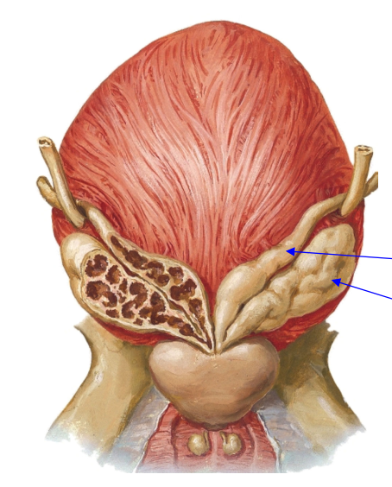  Original lecture figure, PDF p. 40. | 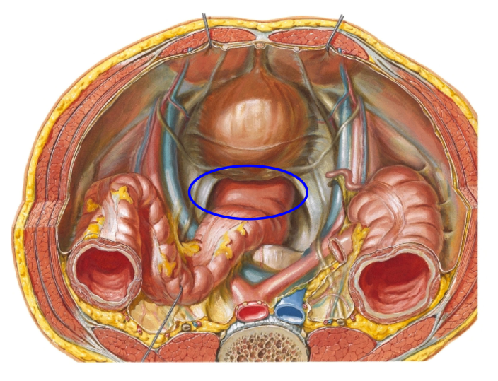  Original lecture figure, PDF p. 41.
Posterior relation — all four | Orientation / significance
Rectum | Posterior to the bladder / intervening genital structures.
Vas deferens | Terminal duct / ampullary region approaches behind bladder.
Seminal vesicles | Lie posterior to bladder base.
Rectovesical pouch | Peritoneal recess between rectum and bladder.

The two original views are both retained: the posterior external view and the pelvic view with the circled recess. A peritoneal pouch is a recess formed by reflection of peritoneum, not a cavity within the bladder wall.

26 / Female bladder: all posterior relations
Lecture PDF pp. 42–43
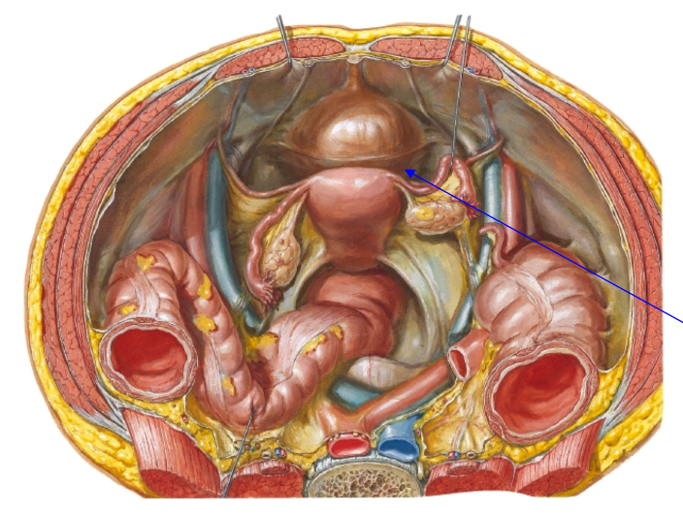  Original lecture figure, PDF p. 42. | 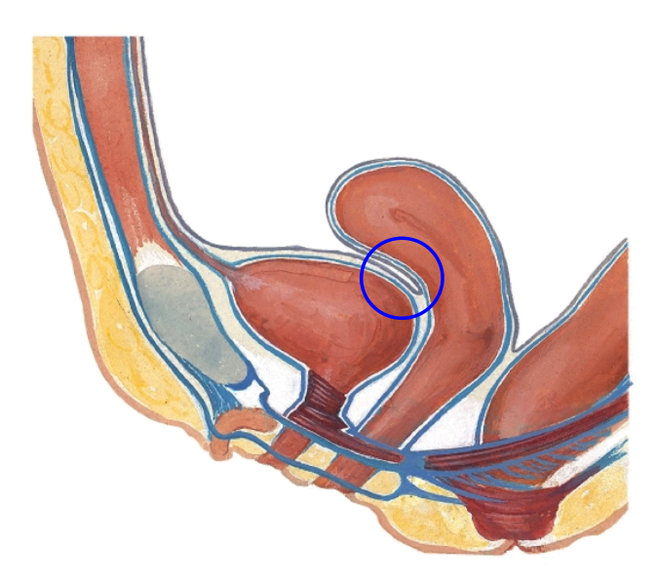  Original lecture figure, PDF p. 43.
Posterior relation — all three | Orientation / significance
Cervix | Posterior / posterosuperior relation near the bladder base.
Vagina | Anterior vaginal wall is behind bladder / urethral region.
Vesicouterine pouch | Peritoneal recess between bladder and uterus.

Male versus female pouch
Male: rectovesical pouch.
Female: vesicouterine pouch in this bladder relation list.
Do not substitute the rectouterine pouch (Douglas) for the vesicouterine pouch; it is behind the uterus, not the pouch between bladder and uterus.

Both source views are retained, including the blue circled vesicouterine reflection. The uterus BODY is the superior relation on p. 39; CERVIX and VAGINA are the posterior relations on pp. 42–43.

27 / Bladder arteries and lymphatic drainage
Lecture PDF pp. 44–45
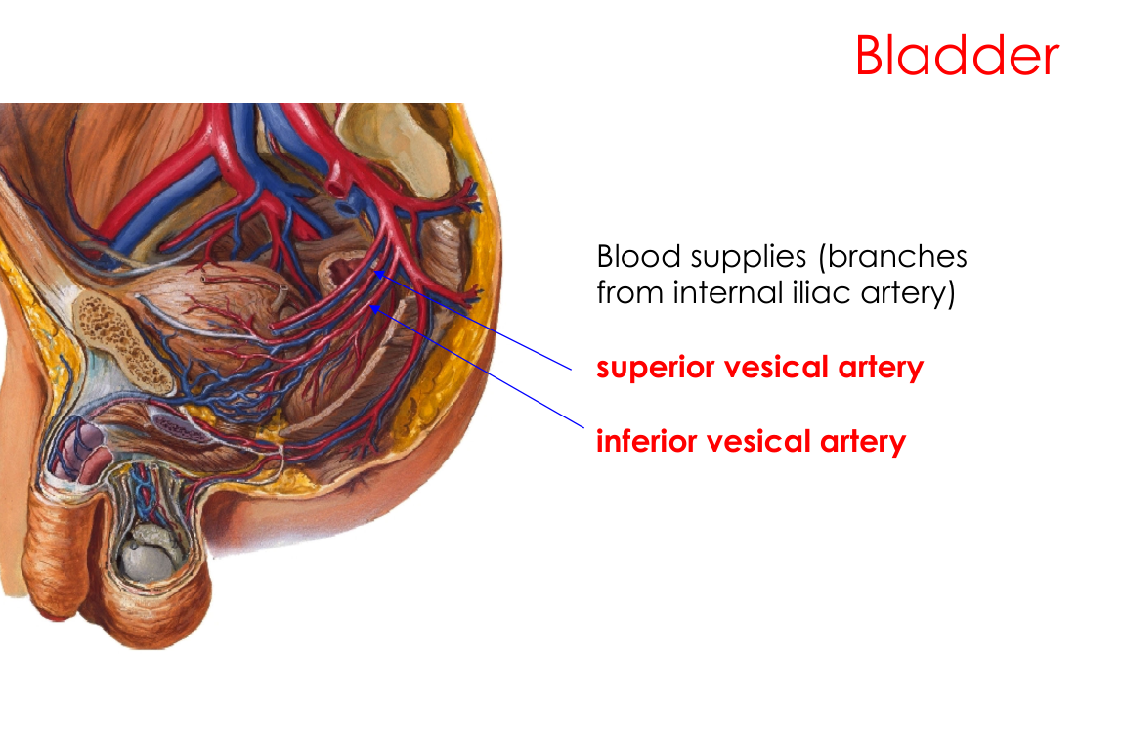  Original lecture figure, PDF p. 44. | 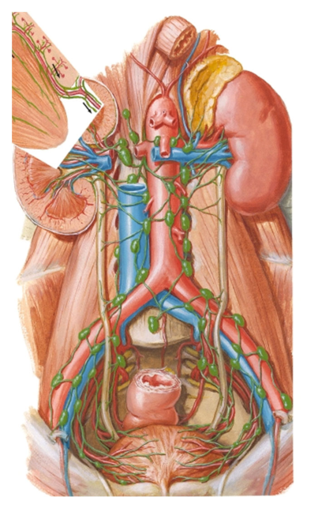  Original lecture figure, PDF p. 45.
System | Written lecture pathway
Arterial parent | Branches from the internal iliac artery.
Named bladder arteries | Superior vesical artery + inferior vesical artery.
Lymphatic route | Along vesical vessels → iliac lymph nodes → paraaortic nodes.

The source arterial image is male. [Extension] In females, vaginal / uterine branches commonly contribute to bladder supply, with the vaginal artery often replacing the male inferior-vesical pattern. This is a qualification to the general slide list, not a reason to omit either named vesical artery. The p. 45 lymphatic plate is retained here because it illustrates a different organ’s drainage from the renal use of the same anatomical plate on p. 23.

28 / Bladder nerves and the production–voiding distinction
Lecture PDF p. 46 | Functional links below are marked as extensions
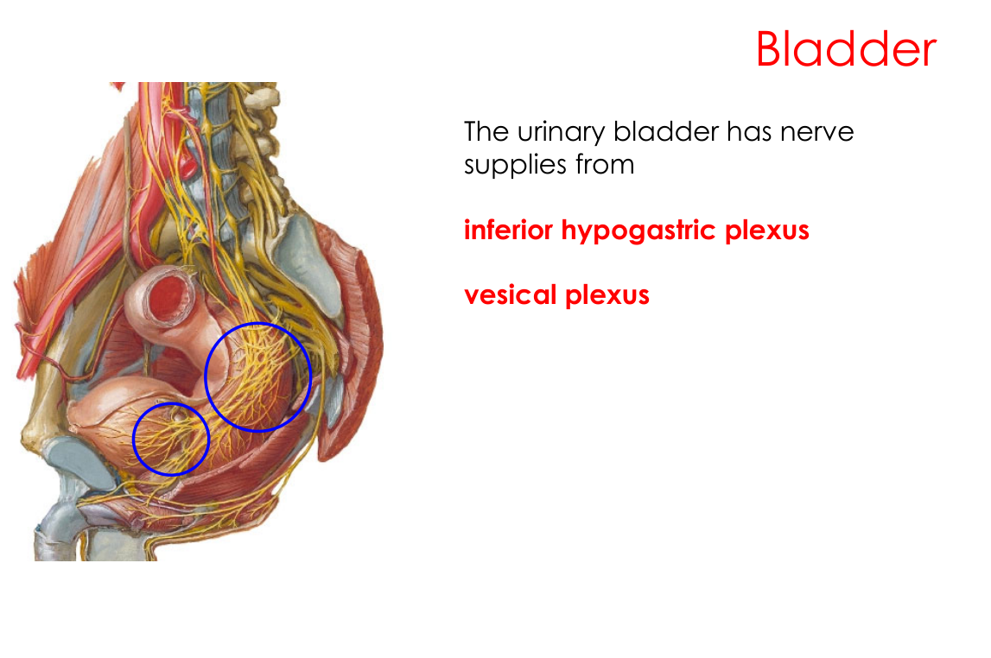
Original lecture image, including visible teaching annotations (PDF p. 46).
Written innervation sources | Details
Inferior hypogastric plexus | Pelvic autonomic network providing bladder connections.
Vesical plexus | Bladder-specific plexus; shown in the source image.

[Extension] Functional organisation
Pathway | Main role in the simplified storage / voiding comparison
Parasympathetic pelvic splanchnic pathways, S2–S4 | Promote detrusor contraction during voiding.
Sympathetic pathways | Promote storage through detrusor relaxation and outlet effects.
Somatic pudendal pathway, S2–S4 | Voluntary control of external urethral sphincter.

Low urine volume is not the same as retention
ADH changes water handling while NEW urine is produced in the kidney.
Bladder / urethral obstruction or impaired emptying can reduce voided volume while urine is still being formed.
Always distinguish renal production from observed passage of urine.

29 / Male urethra: lengths, parts and erectile bodies
Lecture PDF pp. 47–53 | Includes material after the p. 48 closing slide
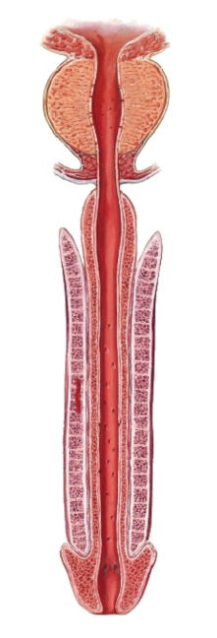  Original lecture figure, PDF p. 49. | 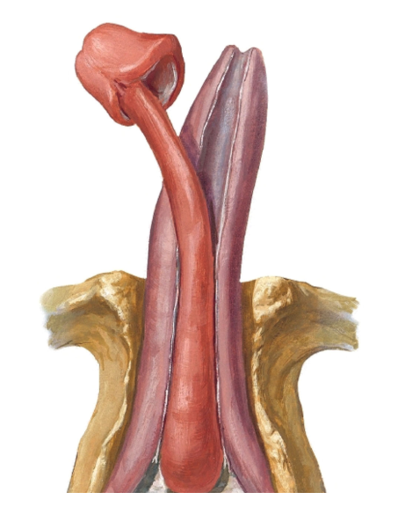  Original lecture figure, PDF p. 53.
Written point | Complete detail
Total male urethral length | About 20 cm.
Three parts | Prostatic → membranous → spongy.
Membranous part | About 2 cm; pierces voluntary external urethral sphincter and perineal membrane.
Spongy part | About 15 cm; runs throughout the corpus spongiosum.
Bulbous portion | Traverses bulb of penis at the root.
Pendulous portion | Traverses body AND glans of penis.
Two dorsal erectile bodies | Paired corpora cavernosa lie dorsal to the corpus spongiosum.

Terminology: singular corpus cavernosum; plural corpora cavernosa. The source misspells “corpus carvernosum”; the intended structures are retained with standard spelling. Identical unmarked urethral images on pp. 49–52 are shown once, with every written addition kept. The opening p. 47 says urethrae will be taught in genital lectures, but pp. 49–55 in this supplied PDF do contain examinable male-urethral material; those pages have been included.

30 / Penile coverings, arterial supply and nerves
Lecture PDF pp. 54–55
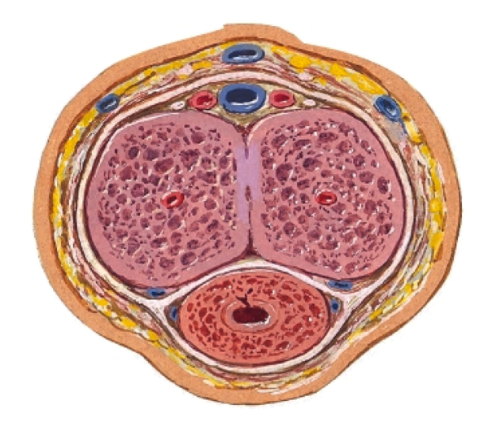  Original lecture figure, PDF p. 54. | Original lecture figure, PDF p. 55.
Superficial → deep covering | Retained / qualified relationship
Superficial fascia — Dartos | First named fascial layer in the source.
Deep fascia — Buck’s | Deep penile fascial layer investing erectile bodies.
Tunica albuginea | Fibrous coat around the erectile bodies. The source lists it as the deepest covering of the three cylinders; more precisely, the individual bodies have their own albugineal coverings, not one common outer albugineal bag.

Structure | Supply stated in the lecture
Membranous and spongy urethra | Branches of internal pudendal artery; pudendal nerve.
Penis: arteries | Deep artery of penis + dorsal artery of penis, both branches of internal pudendal artery.
Penis: named nerve | Dorsal nerve of penis, a branch of pudendal nerve.

The same cross-section is shown on pp. 54–55 beside different written material, so both source presentations are represented. [Extension] The dorsal penile nerve is principally somatic sensory; erection also needs autonomic cavernous pathways. Thus “dorsal nerve supplies the penis” should not be read as the only nerve controlling every penile function. Dartos here names the superficial fascial layer; it does not replace Buck’s fascia or tunica albuginea.

31 / Integrate anatomy with urine handling
Lecture PDF pp. 7–55 | One self-written integrated question; not an original tutorial item
Organ | Arterial supply | Lymph / nerve
Kidney | Renal arteries from abdominal aorta. | Paraaortic nodes → cisterna chyli → thoracic duct; renal plexus.
Ureter | Renal; gonadal; superior / inferior vesical; other iliac branches. | Renal / aortic / superior and inferior hypogastric plexuses. Ureteric lymphatic detail is not specified in this PPT.
Bladder | Superior / inferior vesical branches of internal iliac; female qualification on p. 27. | Along vesical vessels → iliac → paraaortic; inferior hypogastric / vesical plexuses.
Distal male urethra / penis | Internal pudendal branches; deep and dorsal penile arteries. | Pudendal nerve; dorsal penile nerve is its branch.

Integrated practice 1 | Self-written; not an original exam question
After pelvic surgery near the cervix and uterine artery, a woman develops unilateral collecting-system dilation and flank pain, while plasma sodium remains normal. Which structure / crossing is at risk? Would an AQP2 defect explain the unilateral pattern?
Answer approach:
• Ureter is vulnerable where the uterine artery crosses over it, lateral to the cervix and near the lateral vaginal fornix.
• Local ureteric injury / obstruction impairs drainage → upstream dilation. Kidney production and urine passage must be separated.
• A systemic VP–AQP2 defect causes a water-conservation problem, usually affecting both kidneys; it does not explain a focal unilateral obstruction.
• Normal plasma sodium does not exclude unilateral ureteric injury when the other kidney and water balance remain adequate.

Numerical facts retained from the source
Quantity | Lecture value
Daily total-water intake / urine | Male 3.7 L; female 2.7 L; urine about 1–2 L; non-urinary loss about 1 L.
Kidney / position / mobility | 10 × 5 × 2.5 cm; right about 1 cm lower; respiration about 3 cm.
Pelvis / ureter | 2–3 major calyces; ureter about 25 cm; intravesical course about 2 cm.
Bladder / male urethra | Bladder source average about 300 mL; male urethra about 20 cm; membranous about 2 cm; spongy about 15 cm.

Only one additional integrated practice question is added; the original photographed questions already provide the main physiology practice. The next pages map written source content and supplemental questions to their locations, rather than replacing detailed notes with a question-only summary.

32 / PPT coverage check: fluid balance and kidneys
Lecture PDF pp. 1–24
PDF pages | Written content and figures accounted for | Notes pages
1–3 | Title / lecturer; four learning objectives; textbook references. | 1
4 | Body-water estimate 60%–70%; amount AND osmolarity; food/drink/metabolic input equals losses; original illustration. | 2
5 | Intake/hormones/output; thirst and salt cravings; 3.7/2.7 L total-water figures and included sources; original illustration. | 2
6 | About 1 L non-renal loss; regulated urine 1–2 L; constant internal environment; original illustration. | 2
7 | ADH / vasopressin, water retention, urine ↓ / osmolarity ↓; fluid insufficiency, JG perfusion ↓, RAAS, sodium/water reabsorption, volume/osmolarity distinction. | 3–8
8–9 | Retroperitoneal posterior wall; right 1 cm lower / liver; 10 × 5 × 2.5 cm; both images. | 9
10–11 | Concave medial hilum; nerves/lymph; V–A–P; hila plural; L1/transpyloric surface plane; left 11th rib versus right 11th space; annotated images. | 10
12 | Diaphragm; left 11th/12th versus right 12th ribs; back muscles; lumbar anterior rami and abdominal wall; medial hila. | 11
13–14 | All six right and seven left anterior neighbours; both differently annotated plates. | 12
15–16 | Axial labelled plate; all four CT panels / source numbers, without invented level key. | 13
17–18 | 2–3 major calyces/minor calyces/papilla/pyramids/collecting ducts; cortex/medulla; both histology panels and BC/Pod/MD/JG/DC labels. | 14
19–20 | Capsule/perinephric fat/fascia/pararenal fat/peritoneum; normal versus inflamed capsule stripping; all labels. | 15
21–22 | Fixation despite 3 cm respiratory movement; artery/vein origins; left vein anterior to aorta below SMA; right artery behind IVC. | 16
23–24 | Renal lymph → paraaortic → cisterna chyli → thoracic duct; renal plexus and listed fibre types. | 17

33 / PPT coverage check: ureter and bladder
Lecture PDF pp. 25–46
PDF pages | Written content and figures accounted for | Notes pages
25–26 | 25 cm; retroperitoneal; four portions; lumbar transverse processes/psoas; testicular/ovarian crossing; common iliac bifurcation/sacroiliac entry. | 18
27–29 | Lateral pelvic wall/anterior internal iliac; forward/medial turn; uterine-artery bridge; male seminal vesicles/vas; female broad ligament/lateral fornix/cervix. All annotated images. | 19
30 | Oblique intravesical 2 cm course; surrounding muscle; sphincteric anti-reflux during micturition. | 20
31–32 | Every segmental artery and all four nerve plexuses; source labelled diagrams. | 21
33–35 | Adult pelvic position; retention/ascending peritoneum; 300 mL; abdominal bladder in children ≤3 years; apex/fundus/body/trigone; detrusor/internal sphincter. Repeated unmarked base image represented once. | 22
36–37 | Anterior pubic symphysis; inferolateral levator ani / obturator internus; source arrows. | 23
38–39 | Superior peritoneal covering; male bowel/sigmoid; female uterine body. Both views. | 24
40–41 | Male posterior rectum/vas/seminal vesicles/rectovesical pouch; both views retained. | 25
42–43 | Female posterior cervix/vagina/vesicouterine pouch; both views and marked reflection. | 26
44–45 | Superior/inferior vesical from internal iliac; lymph along vesical vessels → iliac → paraaortic. | 27
46 | Inferior hypogastric plexus + vesical plexus; original nerve diagram; functional additions separately labelled. | 28

34 / Final coverage: urethra and classroom photos
Lecture PDF pp. 47–55 | Includes all six photographs, with the first two recognised as duplicate views
PDF pages | Written key content accounted for | Notes pages
47–48 | Urethra deferral statement and closing slide recognised; appended material is still included. | 1, 29
49 | 20 cm; prostatic/membranous/spongy; membranous 2 cm; voluntary external sphincter and perineal membrane. | 29
50 | Spongy 15 cm; bulbous root; pendulous body AND glans. | 29
51–53 | Entire spongy urethra inside corpus spongiosum; two dorsal corpora cavernosa; frontal and dissected views. | 29
54 | Superficial Dartos → deep Buck’s → albugineal coverings; source terminology qualified anatomically. | 30
55 | Membranous/spongy internal pudendal/pudendal; deep and dorsal penile arteries; dorsal penile nerve branch; original cross-section. | 30

Photographed content | Retained details and necessary qualifications | Notes page
Photos 1–2 | CN IX/X → NTS → CVLM → RVLM → PVN/SON; VP inhibition; dilute urine/volume; cardiac sympathetic withdrawal, inotropy, parasympathetic HR/funny current/conduction; BP/homeostasis; “no VP” and “NTS = CVC” qualified. | 4
Activity 3 | Original small hypertonic-saline question; limited-volume assumption; hyperosmolality/PVN/SON/posterior pituitary; collecting-duct apical AQP2; inner-medullary UT-A1/urea; low-volume concentrated urine. | 3
Activity 4 + vagotomy | Original cuff experiment; photographed aortic-BP/CN-X inhibitory chain; competing carotid-CN-IX unloading explained; loss of aortic feedback after vagotomy; net response depends on conditions. | 5
Activity 6 | All symptoms, water-restriction context, sodium 160/135–145, urine 500/source >850 and all five options; D as best option; incomplete concentration versus complete DI; subtype not established. | 6
Lucas case | 20-year-old Art student; half-marathon, experienced runner, 34°C, route; copious pre-race water/another 3 L/more after; nausea/confusion/A&E; dilutional hyponatraemia, salt loss and non-osmotic VP context. | 7

Source credit: Dr Jian Yang, Fluid Balance and Anatomy of Urinary System, Urinary System 2026.pdf. References named in that PDF: Gray’s Anatomy for Students, Drake / Vogl / Mitchell, 2e (2011); Clinically Oriented Anatomy, Moore / Dalley / Agur, 6e (the slide prints 1999; bibliographic date should be checked rather than assumed); Netter, Atlas of Human Anatomy, 5e (2011). Original figure copyright labels remain where present. Photographed classroom material is transcribed and distinguished from the supplied PDF. No unseen class questions or missing photo text have been invented.

