01 / Renal physiology: scope and study route
Lecture PDF pp. 1, 15–16, 47 | Correct lecture: BBMS2006 (Renal - student version) (1).pdf, Dr J Chu
Follow three connected pathways
Juxtamedullary loop → medullary osmotic gradient → collecting-duct water / urea handling.
Body-fluid change → brain sensing → VP, thirst and RAAS responses.
Hormone deficiency / excess → altered water, sodium, potassium and clinical signs.

Lecture learning target | Notes pages
Nephron types; countercurrent exchange versus multiplication; medullary gradient and vasa recta. | 2–6
Dilute / concentrated urine; AQP2, AQP3/4; urea, UT-A1 / UT-A3; classroom hypertonic-saline question. | 7–10
Body-fluid distribution and ions; buffering; VP synthesis, storage and release. | 11–15
Osmotic / haemodynamic sensing; baroreflex; classroom cardiovascular / occlusion questions. | 16–20
V₂ / V₁a effects; thirst; all four ANGII actions; aldosterone transporters and integrated circuits. | 21–28
DI, SIADH, exercise-related hyponatraemia, aldosterone disorders and electrolyte manifestations. | 29–34

Classroom material remains beside its mechanism
Original photograph | Placement
Photos 1–2: duplicate views of pressure / VP supplement. | 19: baroreflex and cardiovascular effects.
Photo 3: Activity 3, small hypertonic-saline injection. | 9: VP, AQP2 and UT-A1.
Photo 4: Activity 4 plus vagotomy follow-up. | 20: opposing carotid and aortic signals.
Photo 5: Activity 6, water restriction and urine concentration. | 29: diabetes insipidus.
Photo 6: Lucas’s hot half-marathon and water intake. | 31: dilutional hyponatraemia.

This document uses the newly supplied RENAL lecture, not Urinary System 2026.pdf. All references are actual PDF pages. Classroom photos are transcribed; teaching figures from the PDF retain their labels and annotations. [Extension] identifies supporting physiology; source wording needing correction is explicitly quoted / qualified. Two integrated self-written questions are included; they are not predictions of actual exam content. Coverage checks are on pp. 35–37.

02 / Nephron structure and the two capillary beds
Lecture PDF pp. 2–3
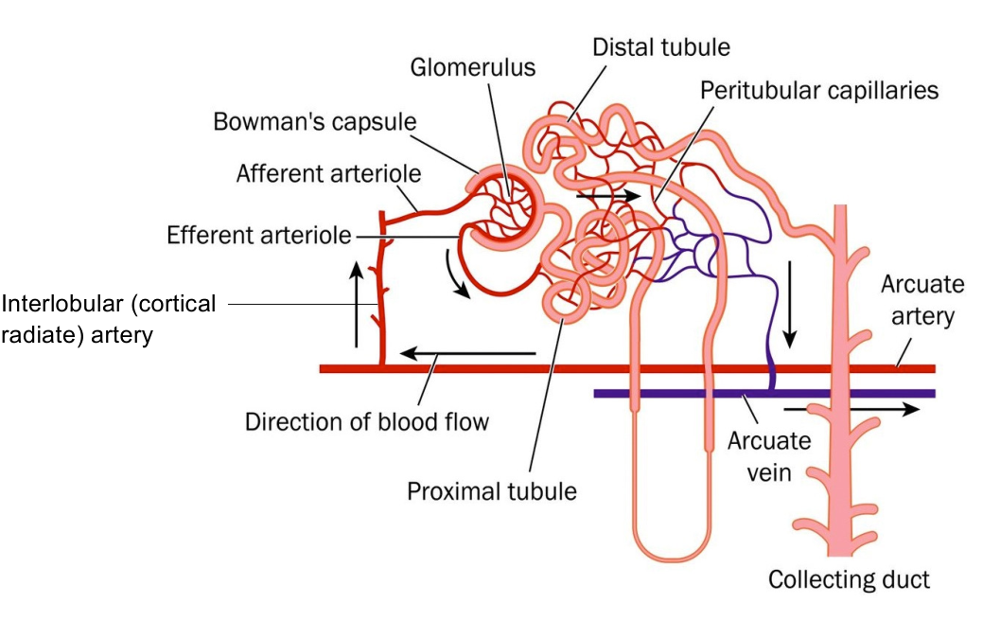  Original lecture figure, PDF p. 2. | 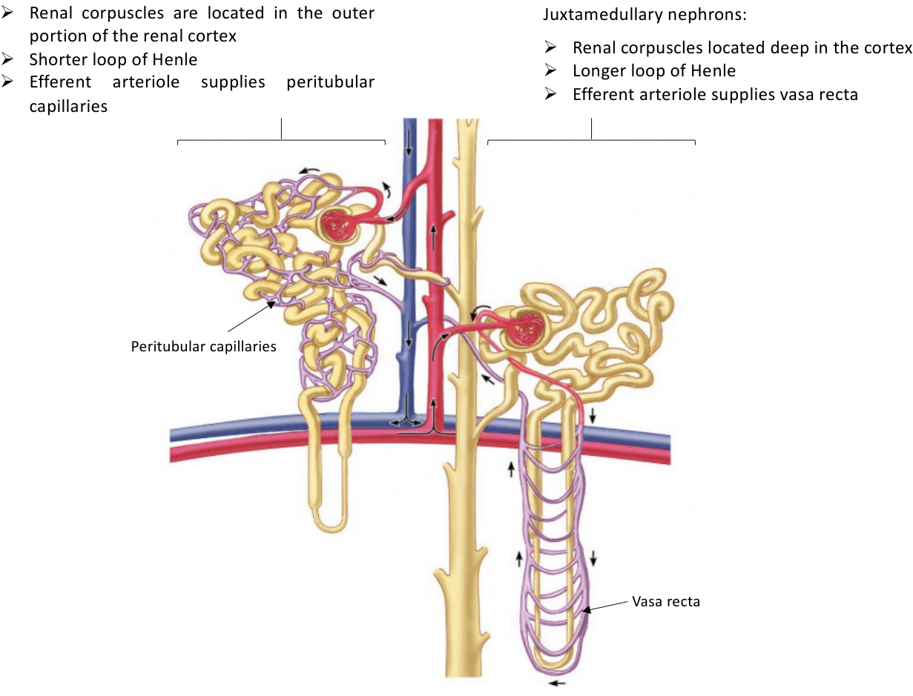  Original lecture figure, PDF p. 3.
Key written point | Detail
Functional units | Each kidney contains around ONE MILLION nephrons, held together by connective tissue.
Nephron components | Renal corpuscle = glomerulus + Bowman’s capsule. Nephron = renal corpuscle + renal tubule.
Two capillary beds in series | Afferent arteriole → glomerulus → efferent arteriole → peritubular capillaries / vasa recta.
Tubular labels | Proximal tubule → loop of Henle → distal tubule → collecting duct. Collecting ducts receive fluid from multiple nephrons.
Vascular labels | Interlobular / cortical radiate artery; arcuate artery and vein; afferent / efferent arterioles; direction of blood flow.

Compare | Cortical nephron | Juxtamedullary nephron
Corpuscle position | Outer renal cortex. | Deep cortex, near corticomedullary boundary.
Loop of Henle | Shorter. | Longer, extending deeply into medulla.
Efferent supply | Peritubular capillaries. | Vasa recta.
Concentration role | Less important for building the deep gradient. | Long-loop countercurrent multiplication is central to the concentrating gradient.

03 / Co-current versus countercurrent exchange
Lecture PDF p. 4
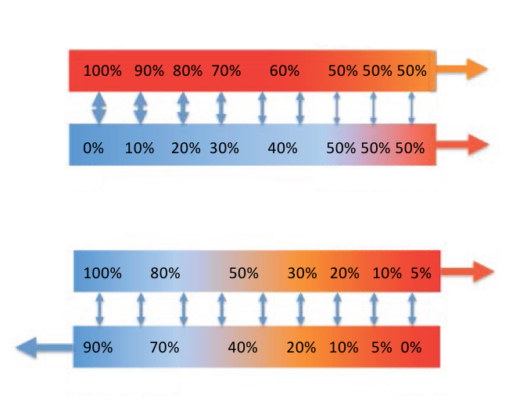
Original lecture image, including visible teaching annotations (PDF p. 4).
Feature | Co-current | Countercurrent
Flow directions | Same direction. | Opposite directions.
Exchange along the length | Driving difference diminishes; both streams approach the same composition. | A local difference can be maintained along successive positions.
Source example | 100% versus 0% approaches 50% / 50%. | Source outlet example approaches 5% in one stream and 90% in the other.
Amount transferred | Limited by early equilibration. | Higher maximum transfer under comparable conditions.

Retain the definition
Countercurrent EXCHANGE is passive equilibration of material between two streams moving in opposite directions.
The source says the systems “do not reach equilibrium”: read this as preservation of a local driving difference during flow, not a claim that thermodynamics forbids equilibrium.

Exchange preserves / transfers an existing concentration difference; multiplication uses energy plus differential permeability and repeated flow to build an axial gradient. Do not use these two terms interchangeably.

04 / Countercurrent multiplication: single effect
Lecture PDF pp. 5–6
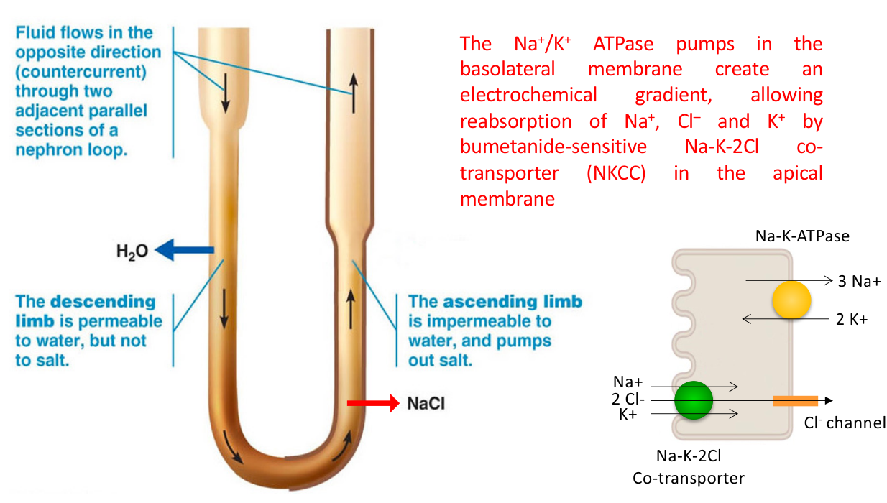  Original lecture figure, PDF p. 5. | 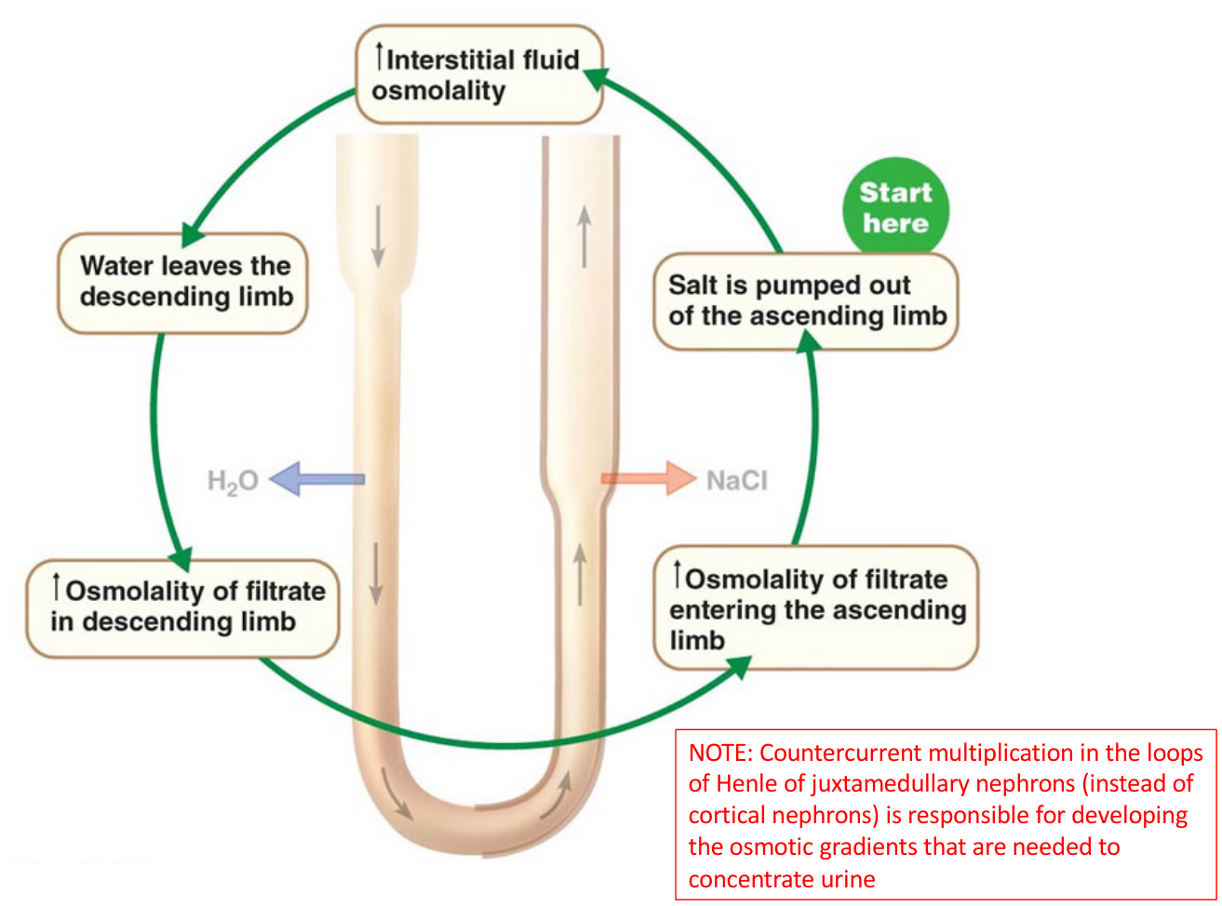  Original lecture figure, PDF p. 6.
Written / figure detail | Mechanism
Energy requirement | Countercurrent multiplication uses energy to generate a gradient that later enables tubular water reabsorption and concentrated urine.
Descending limb | Highly permeable to water; relatively low salt permeability in the simplified slide model.
Ascending limb | Low water permeability; the thick ascending limb reabsorbs salt while leaving water behind.
Apical transporter | Bumetanide-sensitive Na⁺–K⁺–2Cl⁻ cotransporter, NKCC2, moves these ions from lumen into thick-ascending-limb cells.
Basolateral energy source | Na⁺/K⁺-ATPase moves 3 Na⁺ out / 2 K⁺ in → electrochemical gradient supports NKCC2. Cl⁻ exits through basolateral channels.
Essential nephron type | Long loops of JUXTAMEDULLARY nephrons generate the deep gradient, rather than short cortical loops.

Repeat the cycle
Ascending salt reabsorption → interstitial osmolality ↑
→ descending water loss → descending tubular fluid concentrates
→ concentrated fluid reaches ascending limb → more salt available to remove.
Continuous flow repeats the single effect along the loop.

NKCC is a cotransporter, not a channel, despite “NKCC channels” in the source summary. The ATPase supplies energy indirectly: NKCC2 is secondary active transport. The thick ascending limb is the principal active salt-removing segment; not every ascending segment pumps salt in the same way.

05 / Why the loop concentrates, then dilutes filtrate
Lecture PDF pp. 7–8
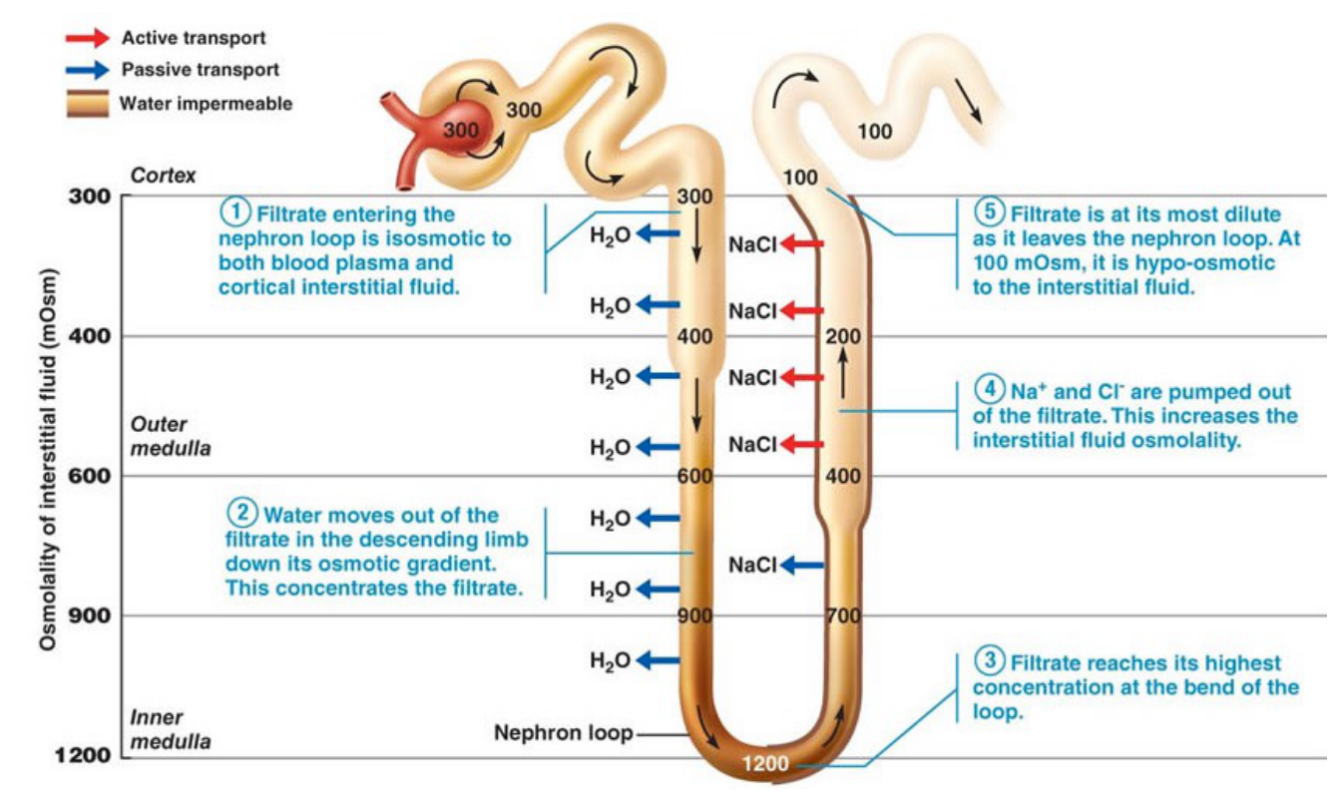  Original lecture figure, PDF p. 7. | 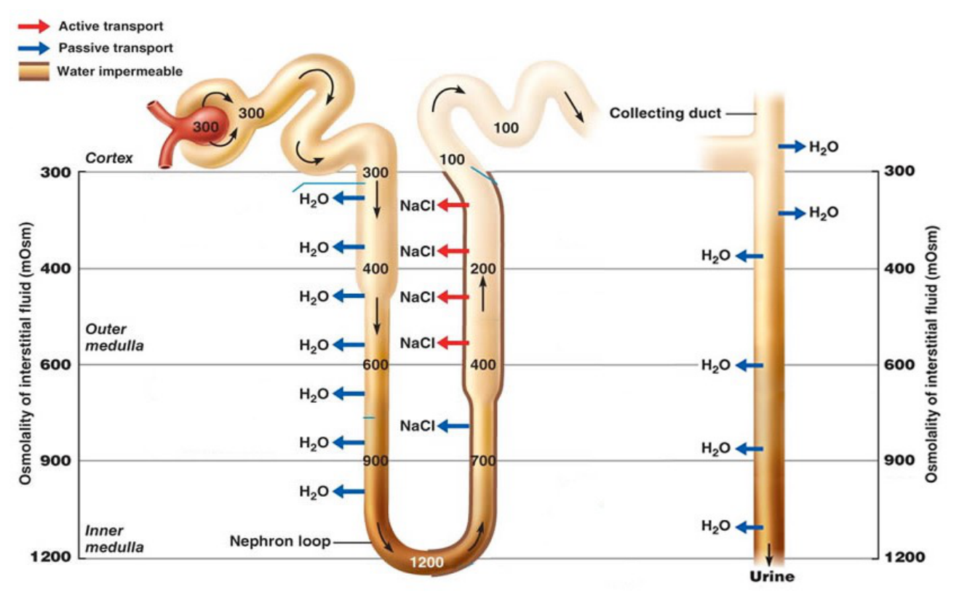  Original lecture figure, PDF p. 8.
Source sequence | What to follow
1. Entering loop | Filtrate initially roughly isotonic with blood / cortex, around 300 mOsm in the diagram.
2. Descending limb | Water leaves toward the increasingly hyperosmotic interstitium → tubular fluid concentrates.
3. Loop tip | Highest concentration, up to the illustrated 1200 near the deepest tip.
4. Ascending limb | NaCl leaves while little water follows → tubular fluid becomes progressively dilute.
5. Leaving loop | Illustrated minimum around 100 mOsm; fluid is hypo-osmotic to interstitium.

Read the longitudinal gradient, not just one cross-section
Cortex / corticomedullary region ~300 → outer-medullary levels ~400 and 600
→ deeper medulla ~900 → papillary tip ~1200 in the teaching figure.
Longer loop → larger potential corticomedullary osmotic gradient.

The figures distinguish active versus passive transport and water-permeable regions. These values illustrate a concentrating kidney and are not fixed at every hydration state. The collecting duct passes down the same gradient; its water permeability determines how much of that gradient it can use.

06 / Vasa recta preserve the medullary gradient
Lecture PDF p. 9
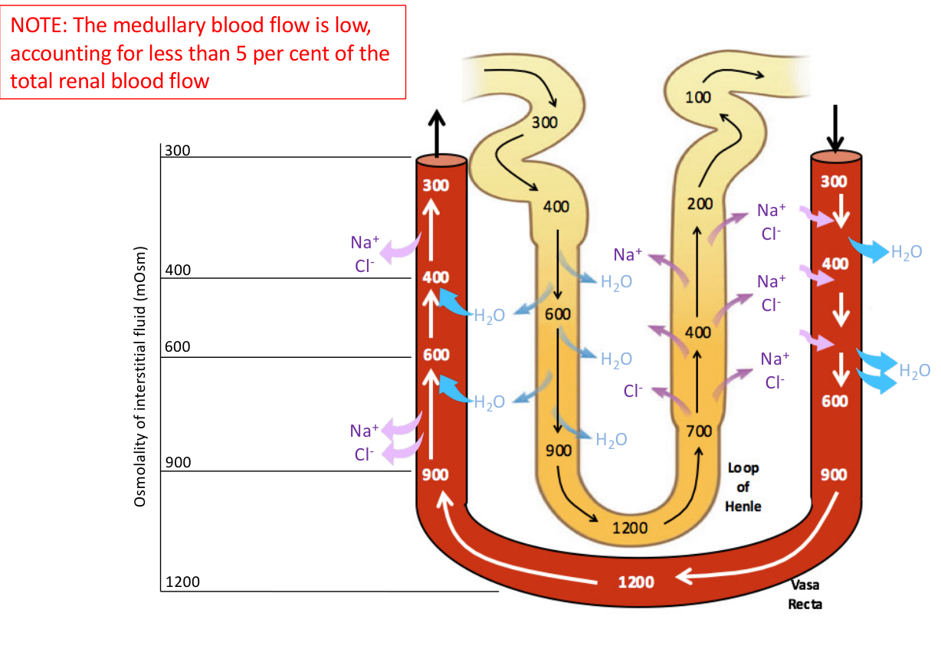
Original lecture image, including visible teaching annotations (PDF p. 9).
Direction in vasa recta | Passive exchange
Descending into medulla | Blood encounters higher interstitial osmolality → water leaves blood; NaCl / other solute enters blood.
Ascending out of medulla | Blood encounters lower osmolality → solute leaves blood and water re-enters.
Hairpin arrangement | Countercurrent exchange minimises net removal / washout of medullary solute while taking reabsorbed water away.
Blood-flow figure | Medullary blood flow is LOW: less than 5% of total renal blood flow in the slide.

Three different roles
Loop of Henle: builds the gradient.
Vasa recta: preserves the gradient.
Collecting duct: uses the gradient when water-permeable.
Vasa recta do NOT create medullary hyperosmolarity.

[Extension] Excessive medullary flow can wash out the gradient; very low flow also has oxygen-delivery consequences. The immediate teaching point is conservation of the solute gradient, not zero exchange of material.

07 / Collecting duct: dilute versus concentrated urine
Lecture PDF pp. 10–11
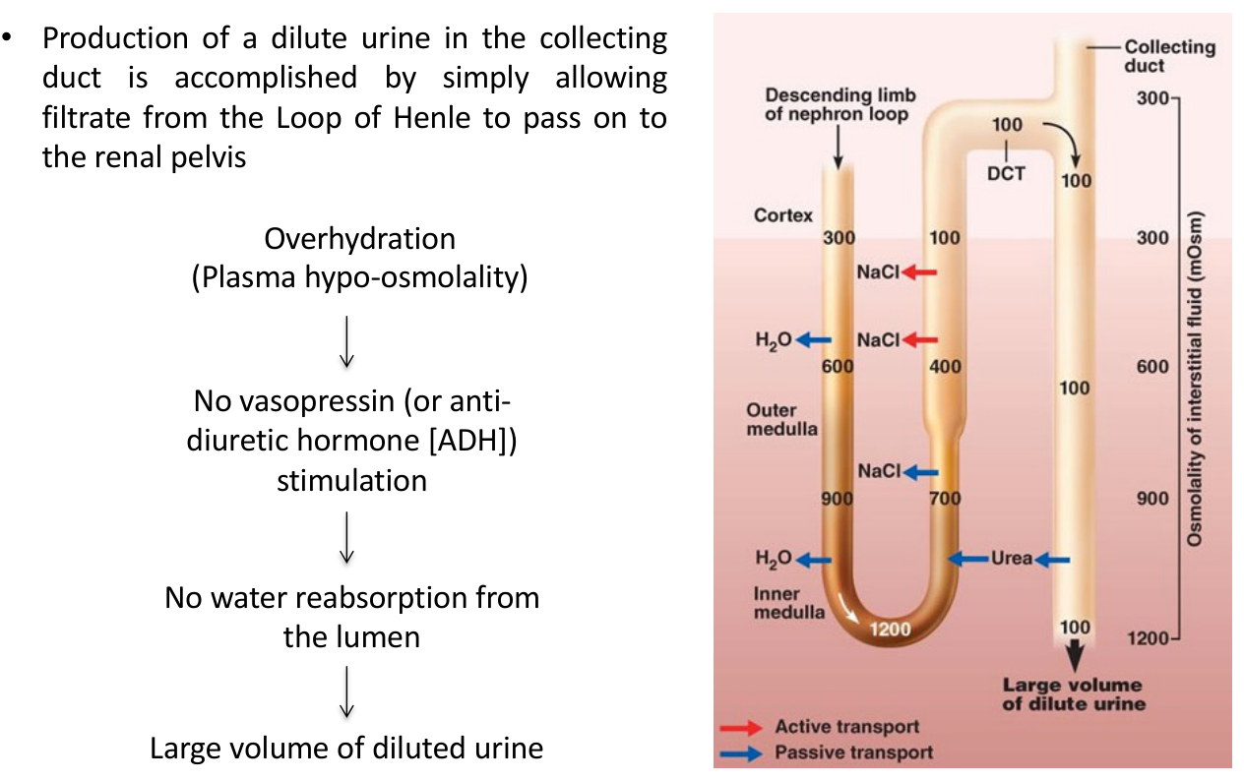  Original lecture figure, PDF p. 10. | 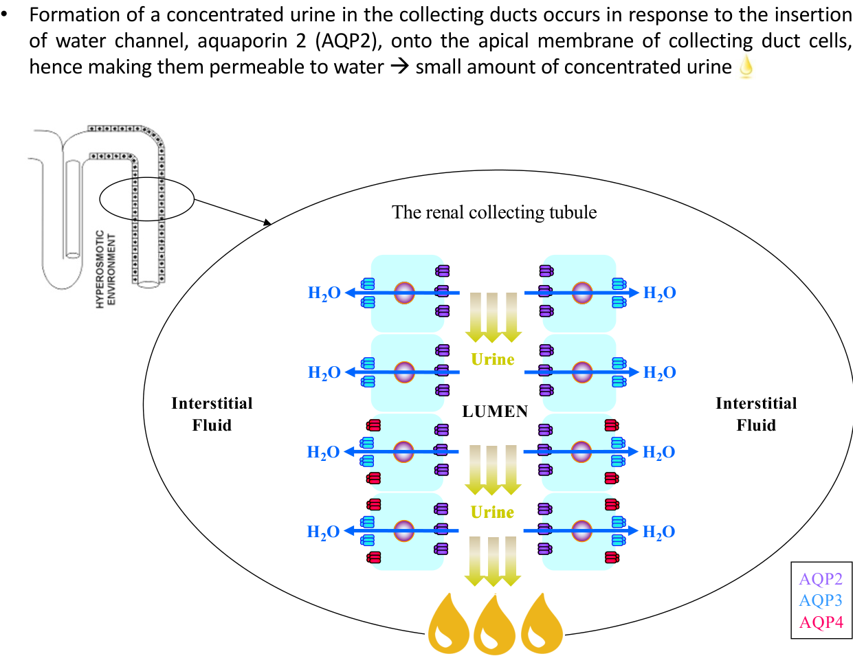  Original lecture figure, PDF p. 11.
State | Duct permeability and urine outcome
Overhydration / plasma hypo-osmolality | VP drive decreases → little apical AQP2 → low collecting-duct water permeability → a larger volume of dilute urine.
Source’s simplified chain | “No vasopressin stimulation → no water reabsorption from the lumen”: applies to the regulated collecting-duct component, not all nephron water reabsorption.
Concentrated urine | AQP2 is inserted into the apical membrane → collecting-duct cells become water-permeable → water follows medullary gradient → smaller volume of concentrated urine.
Basolateral exit | AQP3 and AQP4 provide routes out of the cell toward interstitial fluid; they are labelled separately from apical AQP2.

Trace water across the principal cell
Lumen → APICAL AQP2 → cell → BASOLATERAL AQP3 / AQP4
→ medullary interstitial fluid → blood.
AQP2 changes permeability; it does not actively pump water.

The loop has already delivered dilute fluid. Merely having a salty medulla does not force water through a water-impermeable collecting duct. Conversely, a permeable duct needs a functioning medullary gradient to concentrate effectively.

08 / Dehydration and the role of urea
Lecture PDF pp. 12–13
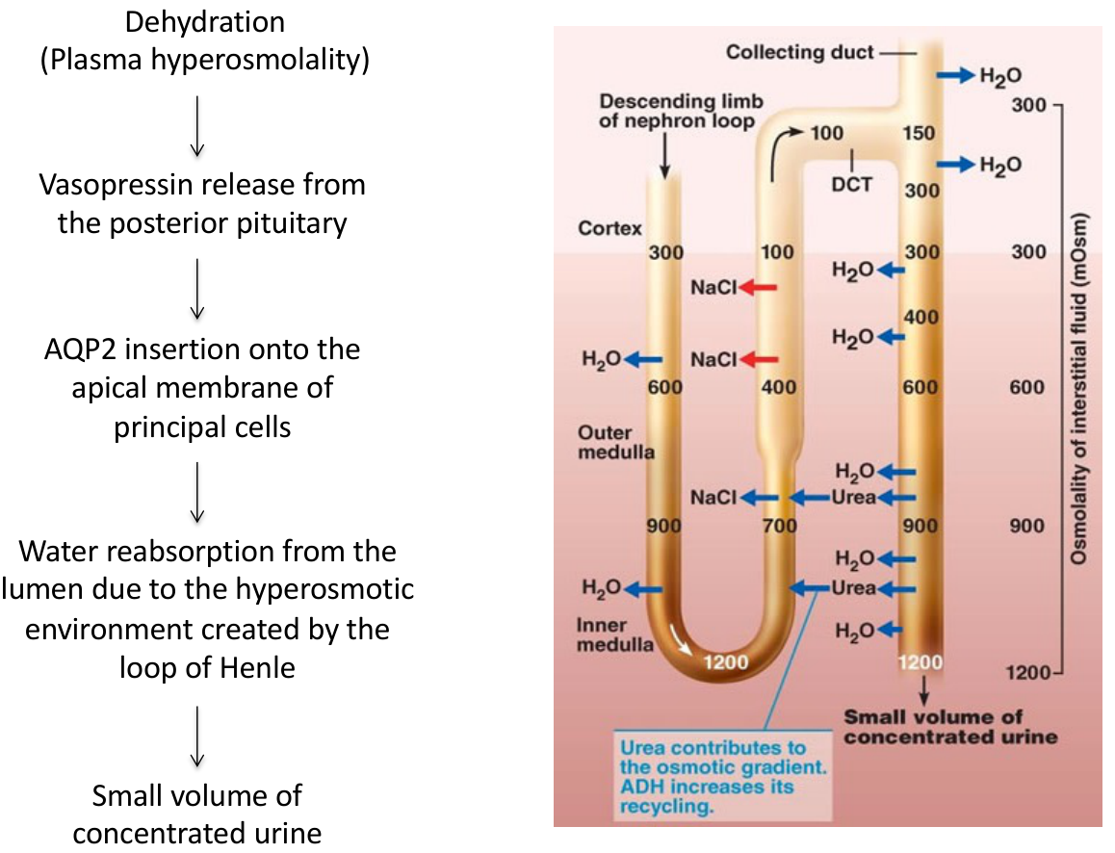  Original lecture figure, PDF p. 12. | 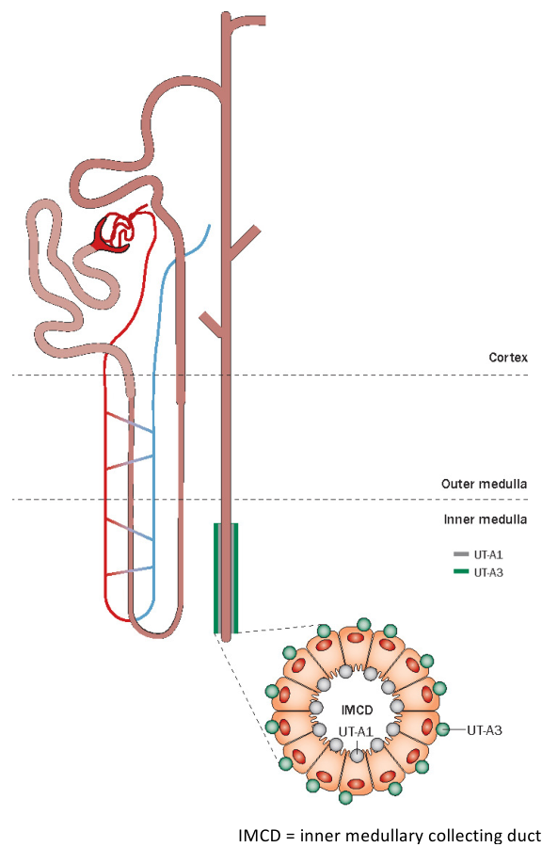  Original lecture figure, PDF p. 13.
Complete source step | Meaning
Dehydration → plasma hyperosmolality | Promotes VP release from posterior pituitary.
VP → AQP2 | AQP2 appears at the apical membrane of collecting-duct PRINCIPAL cells.
Hyperosmotic surroundings | Loop-generated medullary environment draws water from lumen → small volume of concentrated urine.
Urea source / elimination | Principal nitrogenous waste of protein metabolism; eliminated almost exclusively through kidneys in urine in the lecture’s description.
Concentration within duct | As water is reabsorbed, urea remaining in tubular fluid becomes more concentrated.
IMCD urea exit | In INNER MEDULLARY collecting duct, urea diffuses DOWN its concentration gradient through UT-A1 / UT-A3 → medullary interstitium.
Concentrating contribution | Medullary urea accumulation supplies part of the osmotic driving force extracting water from collecting ducts.

IMCD = inner medullary collecting duct. UT-A1 is apical; UT-A3 is basolateral in the later signalling figure. Urea is a nitrogenous waste AND a useful component of concentrating physiology; passive urea movement is distinct from ATP-driven salt transport.

09 / VP controls urea permeability: classroom Activity 3
Lecture PDF p. 14 | Original Photo 3 integrated with this lecture’s urea / AQP2 mechanisms
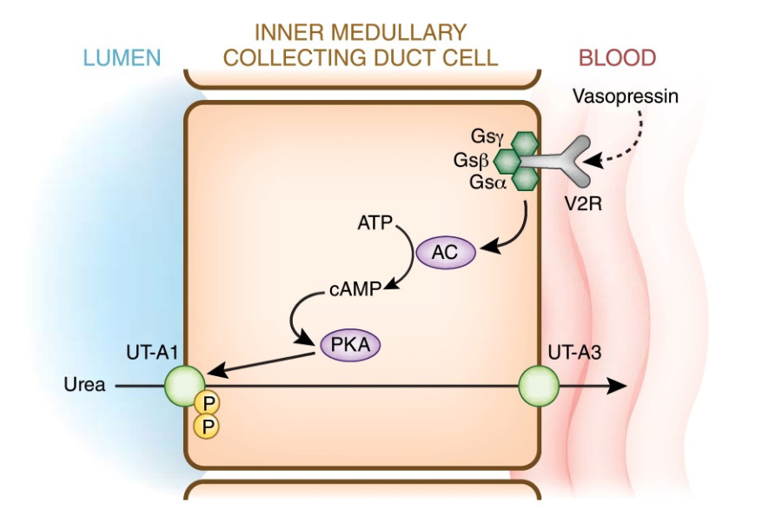
Original lecture image, including visible teaching annotations (PDF p. 14).
Written / diagram detail | Full mechanism
Fast VP effect | Increases IMCD urea permeability by phosphorylation and apical membrane accumulation of UT-A1.
Signal in figure | Blood-side VP → V₂ receptor → Gs → adenylyl cyclase → cAMP → PKA → UT-A1 phosphorylation / trafficking.
Across-cell route | Luminal urea → UT-A1 → cell → UT-A3 → interstitial / blood side.
Overall effect | Establishes / maintains high medullary urea → supports VP-dependent urine concentration.

Original Activity 3 | Transcribed from classroom photo
What happens if we inject a small amount of hypertonic saline into the body? What is the immediate effect on urine output?
Answer approach:
• The photographed answer is a small volume of concentrated urine.
• Small hypertonic load → hyperosmolality, with relatively little direct volume loading in the question’s intended comparison.
• PVN / SON activation → posterior-pituitary VP release ↑ → apical AQP2 ↑ → renal water reabsorption ↑.
• UT-A1-mediated urea handling supports the medullary gradient → concentrating ability increases.
• Urine flow falls and urine concentration rises after the hormonal / renal response develops.

Both parts of the photographed answer are retained: AQP2 enables water entry; UT-A1 supports the urea contribution to the inner-medullary gradient. Small hypertonic load is the stated condition; the effect is not a general prediction for every saline dose, time point or urine already in the bladder.

10 / Integrate the concentrating mechanism
Lecture PDF p. 15 | Summary of every written point; one self-written mechanism question
Source summary point | Retained explanation
Corticomedullary gradient | Osmolality increases from corticomedullary boundary toward the papillary tip.
Outer medulla | NaCl is the major gradient constituent; active salt reabsorption in thick ascending limbs is central.
Inner medulla | Both NaCl AND urea contribute; passive urea transport into interstitium is important.
Countercurrent arrangement | Nephron segments and vessels are arranged in opposite-flow configurations. Multiplication and exchange have different jobs.
Urine concentration | Requires interaction among medullary tubules, collecting-duct permeability, urea handling and the medullary circulation.

Integrated practice 1 | Self-written; not an original exam question
NKCC2 is blocked while VP release and AQP2 trafficking remain intact. Can high VP alone fully restore urine concentration? Predict the effect of increased vasa-recta washout as well.
Answer approach:
• NKCC2 blockade reduces ascending-limb salt removal → medullary gradient weakens; tubular fluid is also less effectively diluted.
• AQP2 still raises collecting-duct water permeability, but a weaker osmotic driving force limits water extraction.
• High VP alone cannot substitute for the lost gradient; urea may still contribute without fully replacing outer-medullary salt handling.
• Increased medullary washout further dissipates the gradient, even though the vasa recta were never its primary generator.

[Extension] This applies the bumetanide-sensitive transporter already named on slide 5. It is a self-written integrated exercise, not a new original class question.

11 / Body-fluid compartments and source percentages
Lecture PDF p. 17
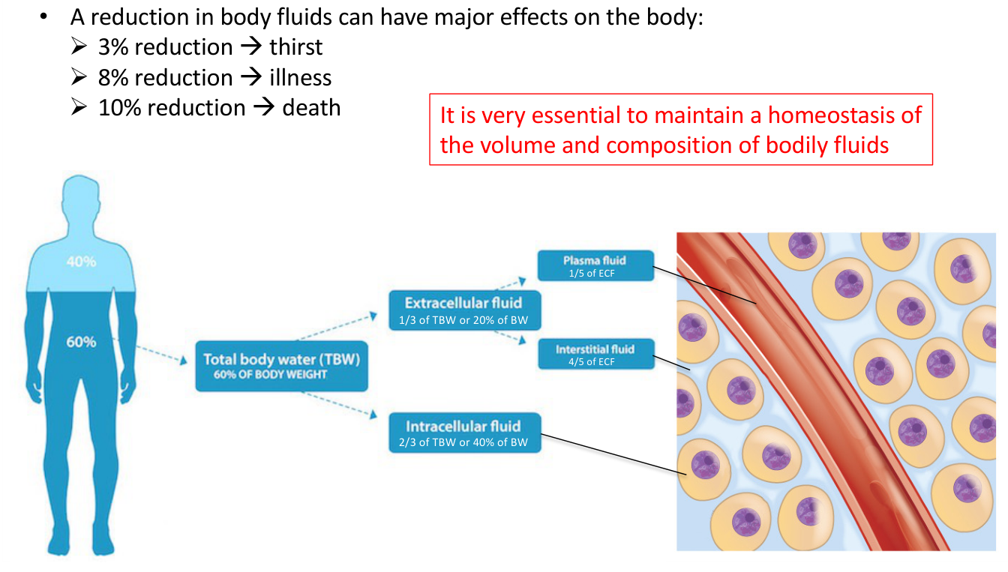
Original lecture image, including visible teaching annotations (PDF p. 17).
Compartment | Fraction of total body water (TBW) | Fraction of body weight (BW)
TBW | 100%. | About 60% in the adult teaching model.
Intracellular fluid (ICF) | 2/3 of TBW. | 40% of BW.
Extracellular fluid (ECF) | 1/3 of TBW. | 20% of BW.
Plasma | 1/5 of ECF. | About 4% of BW, derived from the slide fractions.
Interstitial fluid | 4/5 of ECF. | About 16% of BW, derived from the slide fractions.

Written dehydration figures — retain with their limitation
The source lists reduction in body fluids: 3% → thirst; 8% → illness; 10% → death.
These illustrate escalating severity, not guaranteed clinical thresholds. The slide does not clearly define the denominator for these losses; do not silently relabel them as percentage loss of body weight.

Maintain BOTH fluid volume and composition to protect cells. Approximate compartment fractions vary with age, sex and adiposity; do not combine the later cartoon’s “70% water” with this 60%-TBW calculation as if they were the same quantitative model.

12 / Major ions and what high osmolality means
Lecture PDF pp. 18, 23
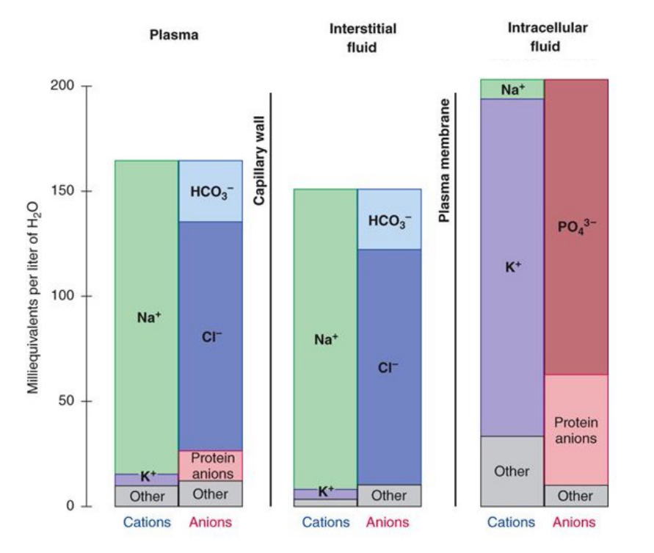
Original lecture image, including visible teaching annotations (PDF p. 18).
Compartment | Predominant positive ions | Predominant negative components
Plasma | Na⁺; much smaller K⁺ contribution. | Cl⁻, HCO₃⁻ and negatively charged plasma proteins.
Interstitial fluid | Na⁺ dominates. | Cl⁻ and HCO₃⁻; much less protein than plasma.
Intracellular fluid | K⁺ dominates; Mg²⁺ contributes. | Phosphate and protein anions dominate.

Term | Definition / significance
Osmolarity | Osmotically active particles per litre of solution; mOsm/L.
Osmolality | Particles per kilogram of WATER; mOsm/kg H₂O. Numerically close to osmolarity in dilute body fluids.
High value | More solute particles relative to water; it describes concentration, not fluid volume or total-body solute alone.
Osmotic water movement | Across a water-permeable membrane, a difference in effectively non-permeant solutes drives water toward the more concentrated side.
Tonicity [Extension] | Effect on cell volume depends on effective, non-penetrating osmoles; total osmolality alone does not describe every solute’s cell-volume effect.

The source calls osmolality “total amount of solutes” and says it is controlled “purely” by free water. Correction: it is a CONCENTRATION and can change through solute or water changes. The VP / thirst axis chiefly adjusts water; that does not make solute changes impossible. The ionic chart uses mEq/L water, an electrical-equivalent scale, not the same unit as mOsm/kg.

13 / Buffering fluid change and coordinating responses
Lecture PDF p. 19
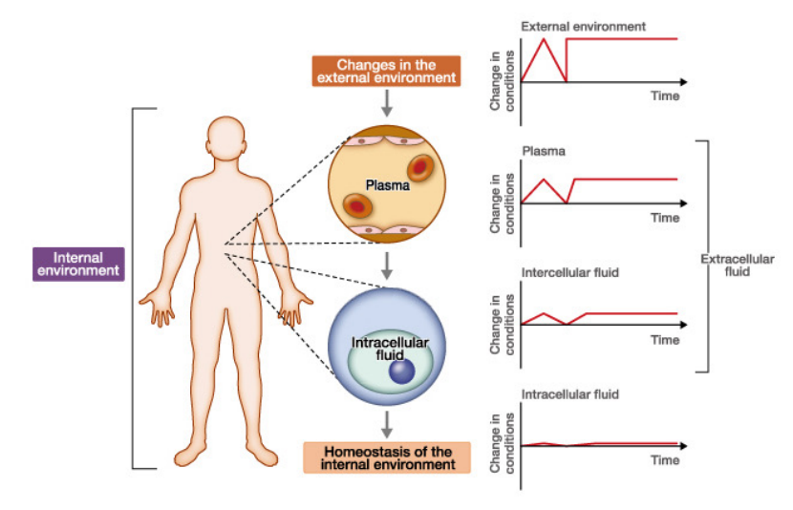
Original lecture image, including visible teaching annotations (PDF p. 19).
Source statement | Retained meaning
Sequence of buffering | A disturbance is first buffered by plasma, then dampened by interstitial fluid and finally by intracellular fluid in the source model.
Ultimate target | Maintenance of a stable INTRACELLULAR environment.
Physiological control centres | Brainstem, lamina terminalis and hypothalamo-pituitary axis.
Physiological outputs | VP / ADH; renin–angiotensin–aldosterone system.
Behavioural responses | Circumventricular organs and renin–angiotensin signalling participate in thirst / fluid intake.

Do not reduce homeostasis to one variable
Fluid volume, sodium concentration, total solute content and blood pressure are related but distinct.
A disturbance can activate renal / vascular physiology AND drinking behaviour.
The source graph shows progressively dampened fluctuations, rather than claiming that ICF never changes.

14 / VP synthesis, transport and storage
Lecture PDF pp. 20–21
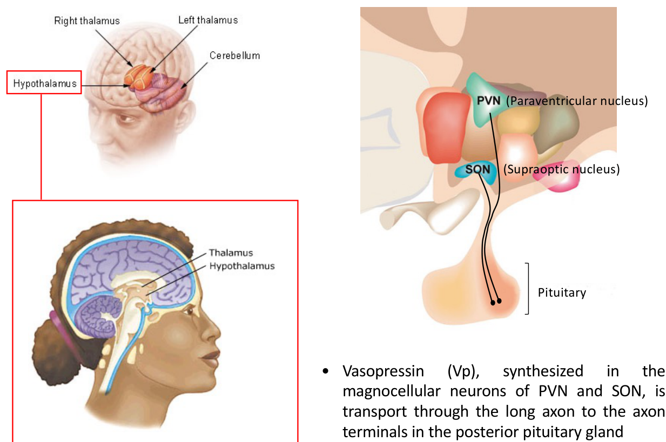  Original lecture figure, PDF p. 20. | 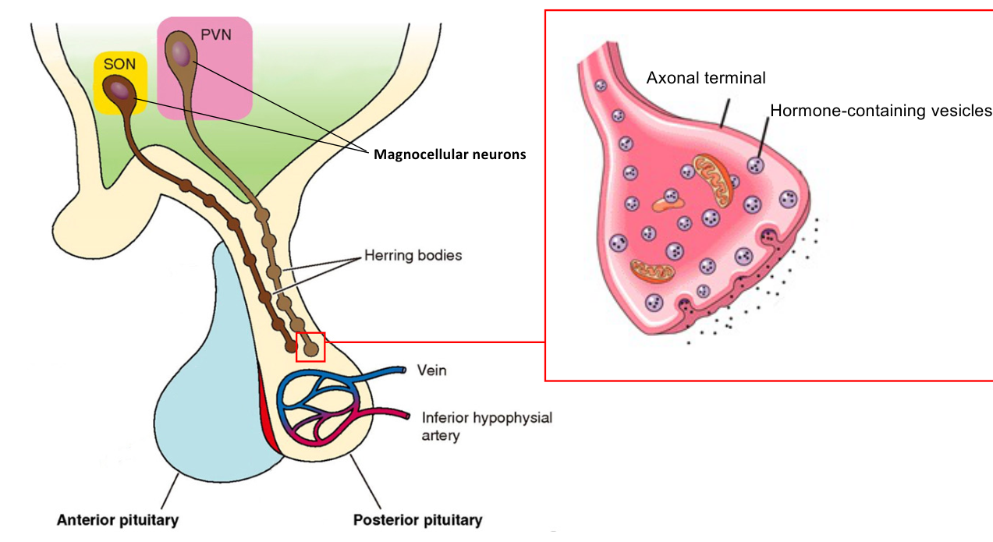  Original lecture figure, PDF p. 21.
Stage | All written details
Synthesis | VP is synthesised in MAGNOCELLULAR neurons in hypothalamic PVN and SON.
PVN | Paraventricular nucleus.
SON | Supraoptic nucleus.
Axonal transport | VP travels down long axons to terminals in the POSTERIOR pituitary.
Storage | Hormone-containing secretory vesicles occur in axons / axonal terminals until mobilised for secretion.
Herring bodies | Source calls the secretory granule a Herring body. More precisely, Herring bodies are neurosecretory axonal swellings containing accumulated granules.

Separate production from release
Hypothalamic cell body → synthesis.
Axon → transport and storage.
Posterior-pituitary terminal → release into blood.
The posterior pituitary does not synthesise VP as a separate endocrine cell population.

MNC = magnocellular neurosecretory neuron. The storage figure also labels anterior / posterior pituitary, vein and inferior hypophysial artery; the posterior-pituitary circulation receives the released hormone.

15 / A stimulus becomes circulating vasopressin
Lecture PDF p. 22
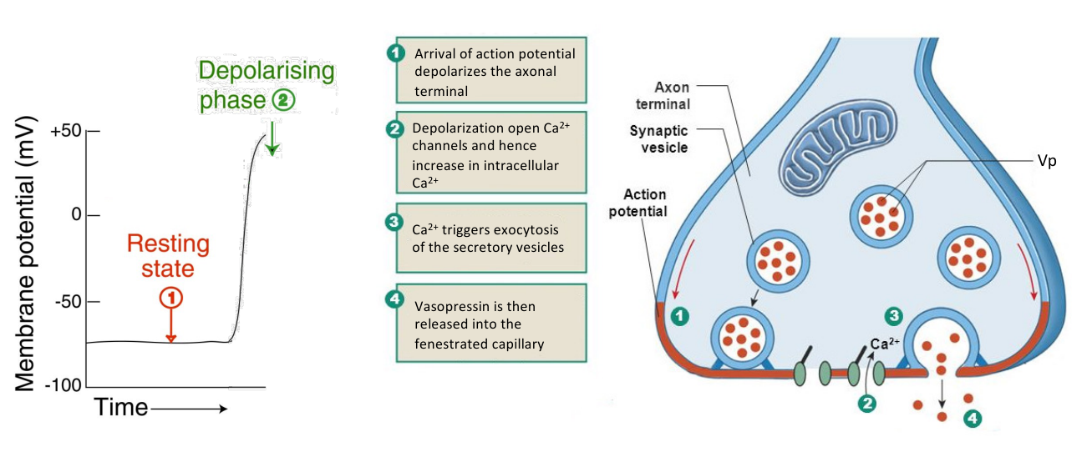
Original lecture image, including visible teaching annotations (PDF p. 22).
Step | Complete source mechanism
1. Detect / integrate stimulus | Signals are detected or integrated at the magnocellular cell bodies in hypothalamic SON / PVN.
2. Electrical response | Appropriate stimulus depolarises neurons → action potentials propagate down their axons.
3. Terminal depolarisation | Arriving action potential depolarises the axon terminal.
4. Calcium entry | Voltage-dependent Ca²⁺ channels open → intracellular Ca²⁺ increases.
5. Exocytosis | Ca²⁺ triggers fusion / exocytosis of VP-containing secretory vesicles.
6. Blood entry | VP enters the fenestrated capillaries at the posterior pituitary.

The source figure includes resting and depolarising phases of membrane potential. Releasing VP requires calcium-dependent vesicular exocytosis; transporting hormone down the axon and releasing it into circulation are separate steps.

16 / Osmotic sensing: sensitivity and brain sites
Lecture PDF pp. 23–24
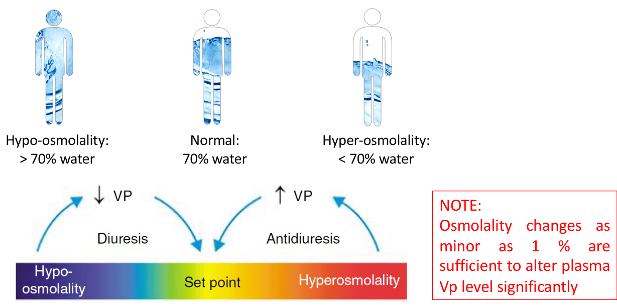  Original lecture figure, PDF p. 23. | 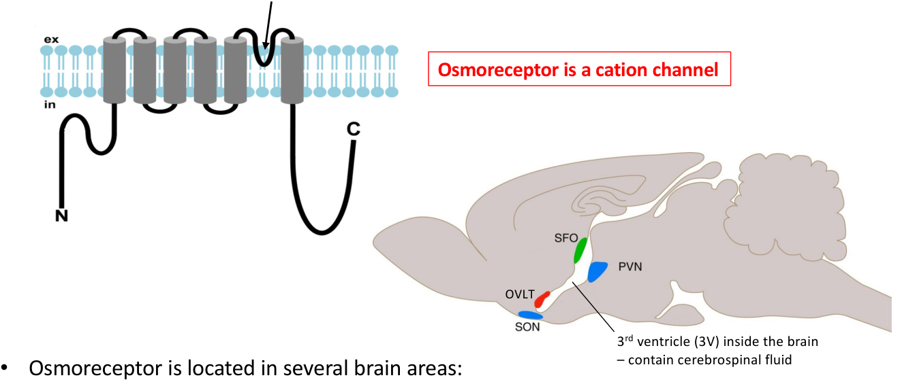  Original lecture figure, PDF p. 24.
Written / figure point | Detail retained and clarified
Sensitivity | A change in osmolality as small as 1% can significantly change plasma VP.
Negative feedback | Hyperosmolality → VP ↑ → antidiuresis; hypo-osmolality → VP ↓ → diuresis.
Water cartoons | Source illustrates normal 70%, >70% for hypo-osmolality and <70% for hyperosmolality. These are schematic relative-water cartoons, not a universal quantitative definition of normal TBW.
Receptor model | Mechanosensitive cation-channel / TRPV-family osmosensory mechanism converts osmotic cell-volume changes to electrical signals. Pore-loop segment is the cation-conducting pore.
Locations named | OVLT; SFO; hypothalamic PVN and SON.
OVLT / SFO | Organum vasculosum of the lamina terminalis / subfornical organ; circumventricular organs (CVOs) exposed to circulating ionic / hormonal signals through specialised barrier anatomy.
Third ventricle | 3V contains cerebrospinal fluid.

Qualification: OVLT and SFO are sensory CVOs with a weak / absent conventional blood–brain barrier. Do not extend that label to all PVN / SON tissue. TRPV mechanisms are part of the teaching model; an osmoreceptor is an osmosensitive neuron / sensing apparatus, not necessarily one universal receptor protein in every site.

17 / Hypertonicity versus hypotonicity: electrical chain
Lecture PDF p. 25
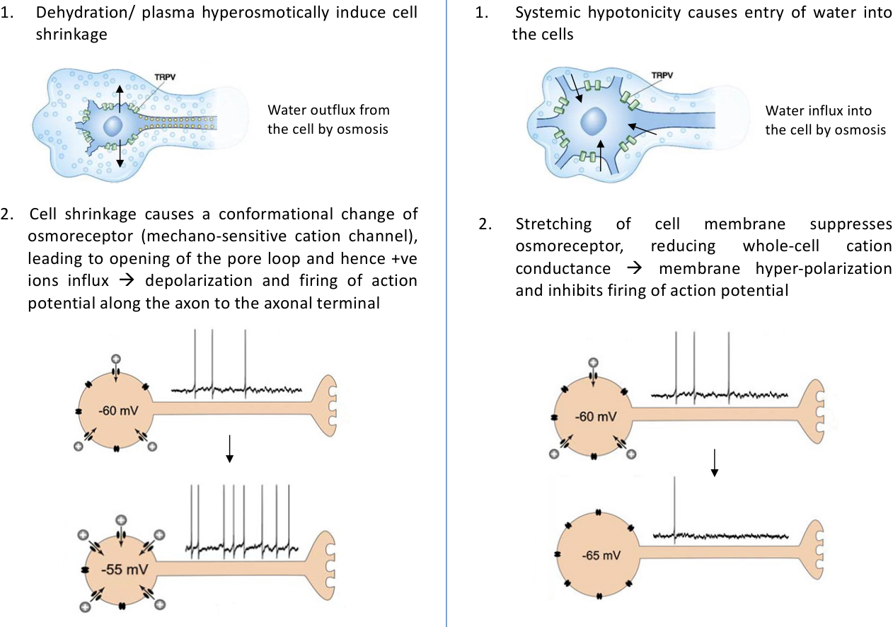
Original lecture image, including visible teaching annotations (PDF p. 25).
Step | Hyperosmolality / dehydration | Hypo-osmolality / excess water
Osmotic water shift | Water leaves osmosensitive cells. | Water enters cells.
Cell volume | Shrinkage. | Swelling / membrane stretch.
Mechanosensitive conductance | Source model: channel conformational change / pore opening → cation influx ↑. | Source model: cation conductance suppressed.
Electrical state | Depolarisation; illustrated change from about −60 toward −55 mV. | Hyperpolarisation / reduced depolarisation.
Firing / VP | Action-potential firing ↑ → VP release ↑. | Firing inhibited → VP release ↓.
Renal consequence | Water conservation; helps restore osmolality. | Water excretion; helps restore osmolality.

Water movement and channel response are sequential
Osmotic water shift → cell-volume / membrane-mechanical change
→ altered cation conductance → changed membrane potential
→ changed firing → changed hormone release.
Do not skip directly from “salty plasma” to “water channel opens in the brain”.

18 / Volume and pressure signals: different sensitivity
Lecture PDF pp. 26–27
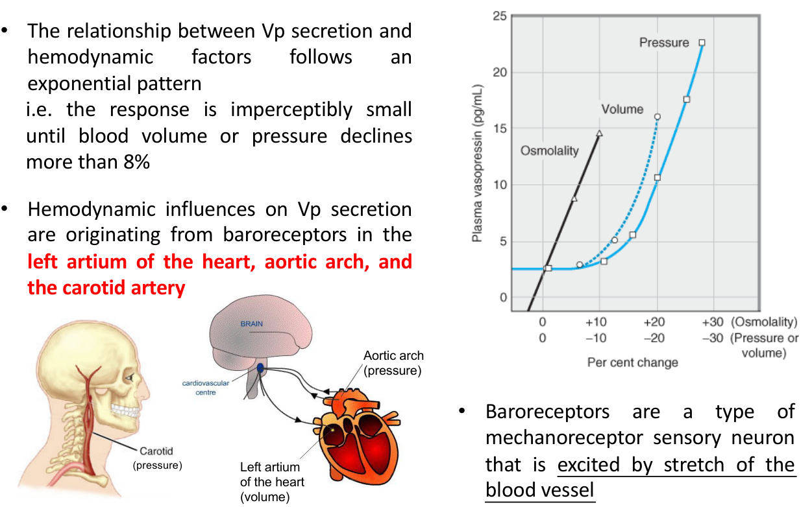  Original lecture figure, PDF p. 26. | 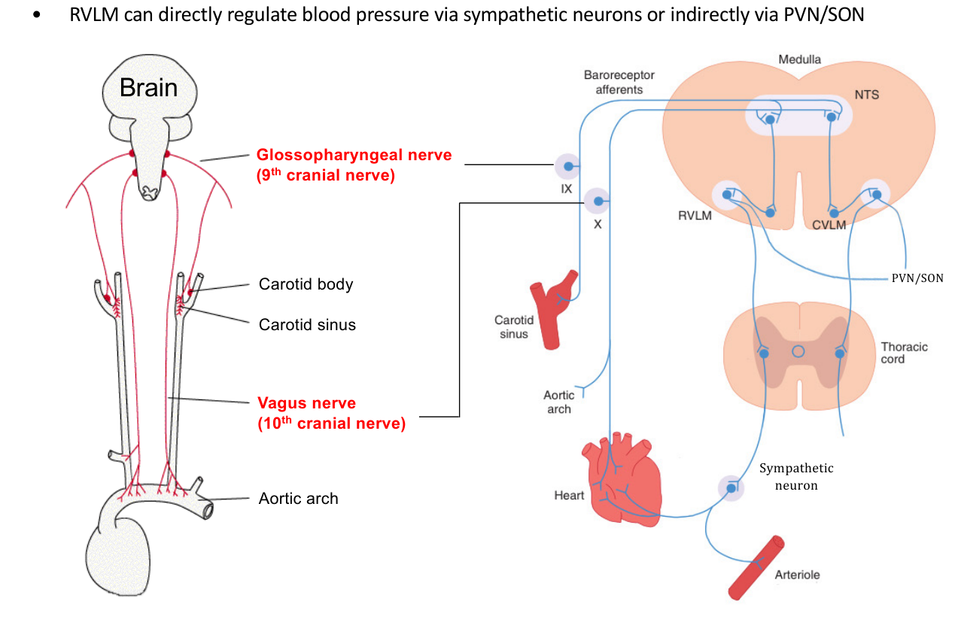  Original lecture figure, PDF p. 27.
Written point | All named sites / relationships
Response shape | Haemodynamic influence on VP is highly nonlinear / approximately exponential in the source graph.
Magnitude threshold | Source says response is small until blood volume or pressure declines by more than about 8%.
Volume-sensitive site | Left atrial stretch receptors.
Pressure-sensitive sites | Aortic arch and carotid-sinus arterial baroreceptors.
Receptor type | Mechanoreceptor sensory neurons excited by vessel / wall stretch.
Afferent route | Carotid-sinus signals via glossopharyngeal CN IX; aortic signals via vagus CN X → NTS in medulla.
Central relay | NTS → CVLM → RVLM; RVLM can regulate pressure via sympathetic neurons and influence hypothalamic PVN / SON.

Compare source sensitivities: ~1% osmotic change versus a larger ~8% haemodynamic decline. They are approximate teaching thresholds, not hard cutoffs in every person. Carotid BODY is principally a chemoreceptor organ; carotid SINUS contains the pressure receptors relevant here. NTS = nucleus tractus solitarius / nucleus of the solitary tract; CVLM / RVLM = caudal / rostral ventrolateral medulla.

19 / Baroreflex circuit and classroom cardiovascular effects
Lecture PDF pp. 28–29 | Photos 1–2 supplement this exact lecture pathway
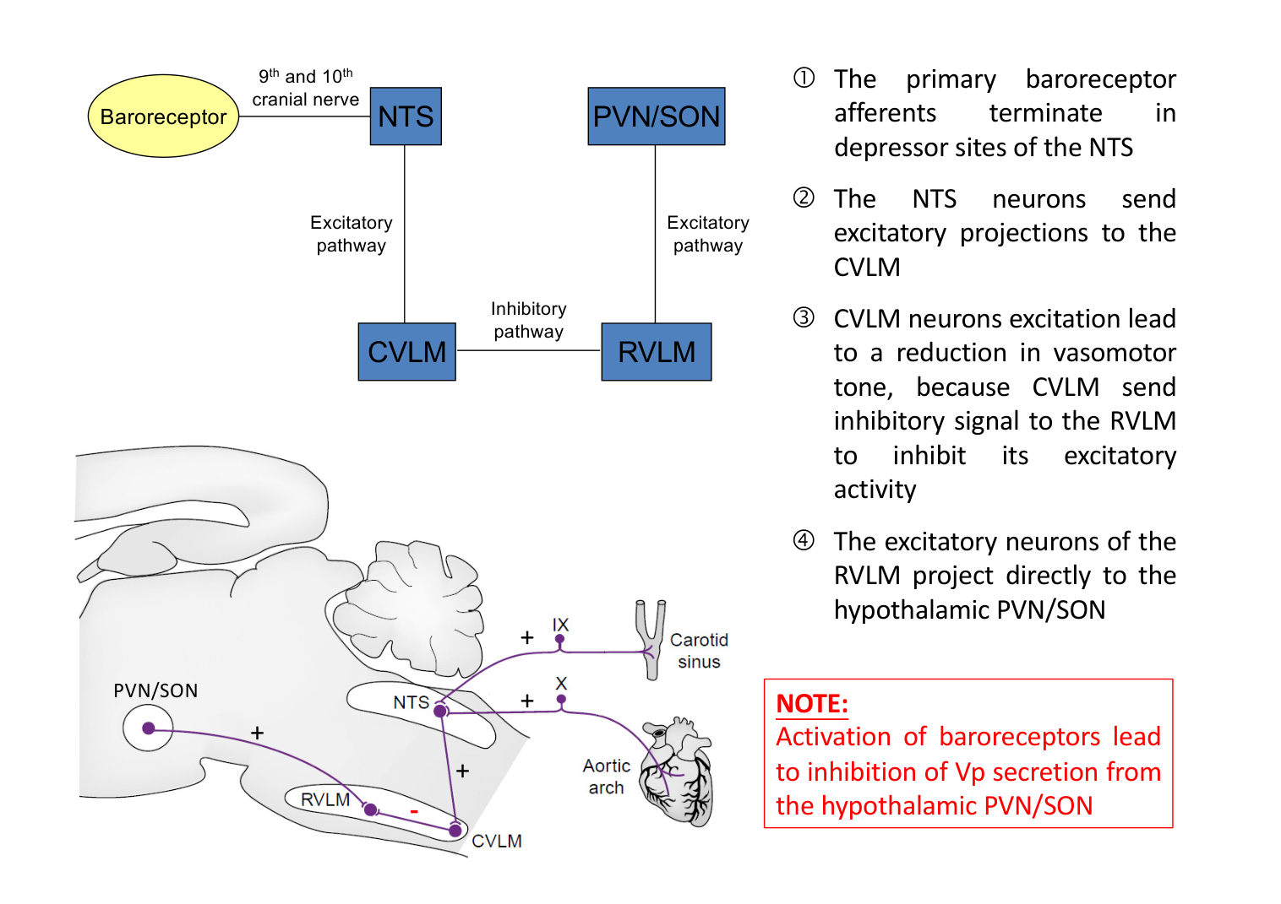  Original lecture figure, PDF p. 28. | 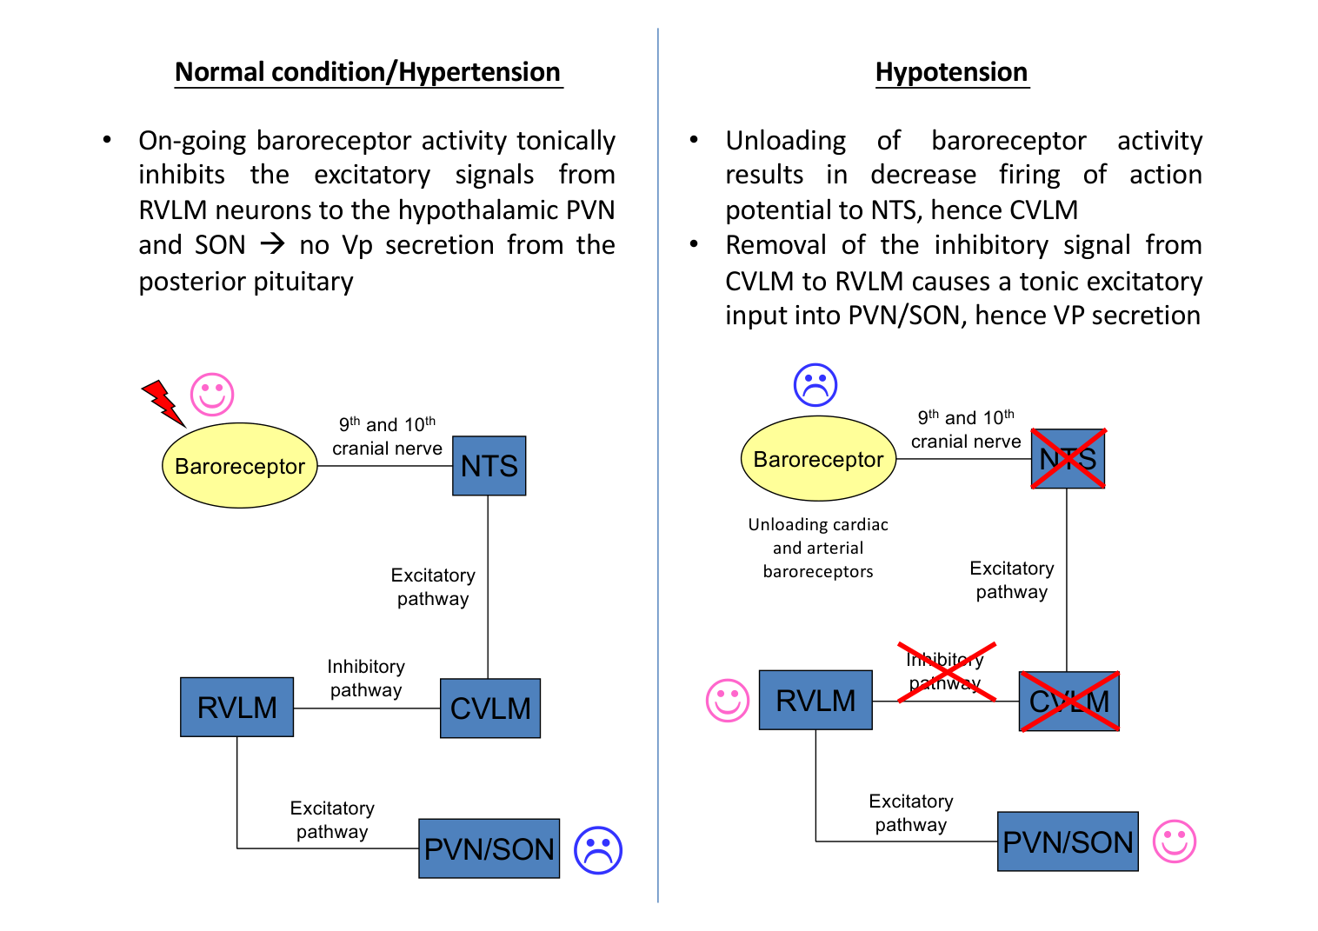  Original lecture figure, PDF p. 29.
Connection in the slide | Sign and net consequence
Baroreceptor → NTS | Primary afferents terminate at depressor regions.
NTS → CVLM | Excitatory.
CVLM → RVLM | Inhibitory; CVLM excitation lowers vasomotor drive.
RVLM → PVN / SON | Excitatory; reduced RVLM drive tends to reduce VP output.
Normal / hypertension | Ongoing baroreceptor firing provides a tonic inhibitory influence on the VP pathway.
Hypotension / unloading | Afferent firing ↓ → NTS / CVLM activation ↓ → RVLM disinhibited → hypothalamic excitatory drive ↑ → VP ↑.

Original supplemental prompt | Transcribed from classroom photo
With ongoing baroreceptor activity under normal conditions / hypertension, what would happen to the cardiovascular system?
Answer approach:
• Sympathetic drive to blood vessels ↓ → vasodilation → vascular resistance and BP tend to fall.
• Sympathetic drive to the heart ↓ → ventricular inotropy / contractility ↓.
• Parasympathetic cardiac activity ↑ → heart rate ↓ (including reduced pacemaker funny-current drive) and conduction velocity ↓.
• Cardiac output ↓; vasodilation also lowers BP.
• VP inhibition → less renal water retention → larger volume of more dilute urine → blood volume tends to fall.
• Net teaching outcome: restoration of body-fluid and pressure homeostasis.

The PPT’s “no VP secretion” depicts the inhibitory branch, not universal absence of basal VP at normal BP. Osmotic and haemodynamic inputs are integrated. The photo’s “NTS is the CVC” is shorthand: NTS is part of a broader medullary cardiovascular-control network. The cartoon wiring is the lecture’s simplified model rather than a complete map of all hypothalamic connections.

20 / Bilateral carotid occlusion and vagotomy
Lecture PDF pp. 26–29 | Classroom Photo 4: original Activity 4 and follow-up
Original Activity 4 | Transcribed from classroom photo
If implanted pneumatic cuffs perform bilateral carotid occlusion in an experimental animal, what changes would occur in urine output?
Answer approach:
The photo’s proposed chain is: carotid blockage → aortic BP ↑ → aortic-arch baroreceptors activated → CN X firing to NTS / CVLM ↑ → RVLM and PVN / SON suppressed → VP ↓ → urine output ↑.
This is an AORTIC-DOMINANT interpretation that assumes the rise in aortic pressure provides the dominant inhibitory input.

Competing input | Conditional physiological prediction
Carotid-sinus unloading | Occlusion BELOW the sinus reduces sinus pressure → CN IX firing ↓ → less reflex inhibition → sympathetic / VP drive tends to rise.
Higher aortic pressure | If systemic / aortic pressure rises sufficiently, aortic-arch firing via CN X rises → opposes carotid unloading.
Photo’s proposed answer | Aortic inhibition dominates → VP ↓ → urine flow ↑. Retain as the answer under that assumed state.
General answer | Net result depends on cuff location, sinus / aortic pressures and intact nerves; occlusion alone does not guarantee diuresis.

Original follow-up | Transcribed from classroom photo
What happens if we perform vagotomy in this case?
Answer approach:
• In the photo’s setup, cutting vagal afferents removes the aortic-arch inhibitory signal.
• Relative to the intact-vagus, aortic-dominant state: VP drive can rise → water reabsorption ↑ → urine flow ↓.
• CN IX carotid-sinus afferents are not cut by vagotomy. With carotid unloading still present, removing aortic feedback can strengthen the low-pressure / sympathetic response.
• Vagotomy also affects other vagal functions; this question isolates the baroreceptor–VP component.

State both sensors, both nerves and the assumed pressure changes. In the photographed aortic-dominant state, vagotomy removes aortic inhibitory feedback and can increase VP relative to the intact-vagus state. It does not cut glossopharyngeal carotid-sinus afferents. Renal urine formation changes after the physiological response develops; urine already in the bladder does not instantly change composition.

21 / Low VP: V₂, AQP2 trafficking and thirst threshold
Lecture PDF pp. 31–32
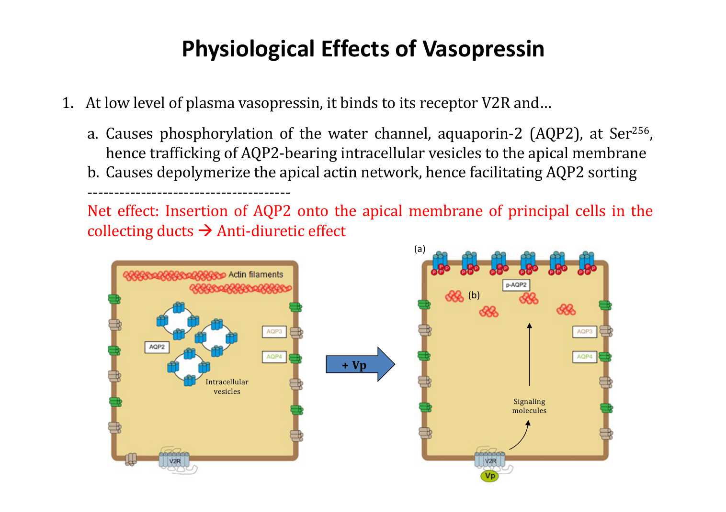  Original lecture figure, PDF p. 31. | 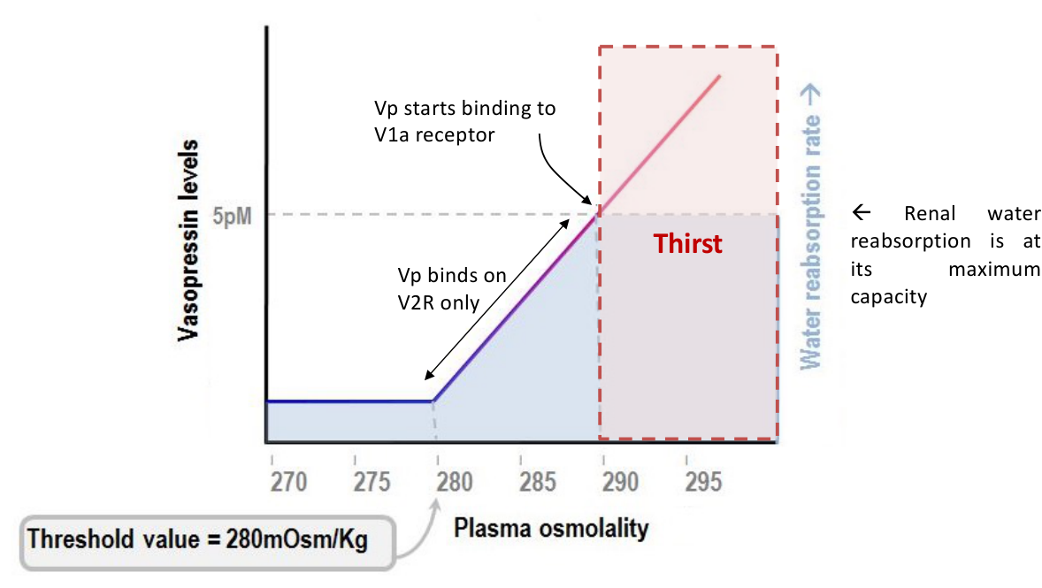  Original lecture figure, PDF p. 32.
Written detail | Mechanism
Low plasma VP | Renal V₂ receptors mediate antidiuresis.
AQP2 phosphorylation | AQP2 is phosphorylated at Ser²⁵⁶ → AQP2-bearing vesicles traffic to apical membrane.
Actin remodelling | Depolymerisation of apical actin network facilitates AQP2 sorting / delivery.
Net cellular effect | Apical AQP2 in collecting-duct principal cells ↑ → water permeability ↑ → antidiuresis.
Threshold graph | Source shows VP response starting around 280 mOsm/kg.
Thirst | Source says thirst is initiated above about 290 mOsm/kg, once maximal renal VP water-retaining effect is reached at about 5 pM plasma VP.
Further VP rise | Additional pressor / V₁a effects become increasingly important; the renal water-reabsorption curve has approached its plateau.

[Extension] Renal V₂ signalling uses Gs–cAMP–PKA. The graph’s “V₂ only / V₁a starts” separation is schematic, not absolute receptor exclusivity or a universal exact concentration threshold. Thirst is subjective drive to drink, adding behavioural intake when renal water conservation alone is insufficient.

22 / Higher VP: V₁a vessels and the renin link
Lecture PDF p. 33
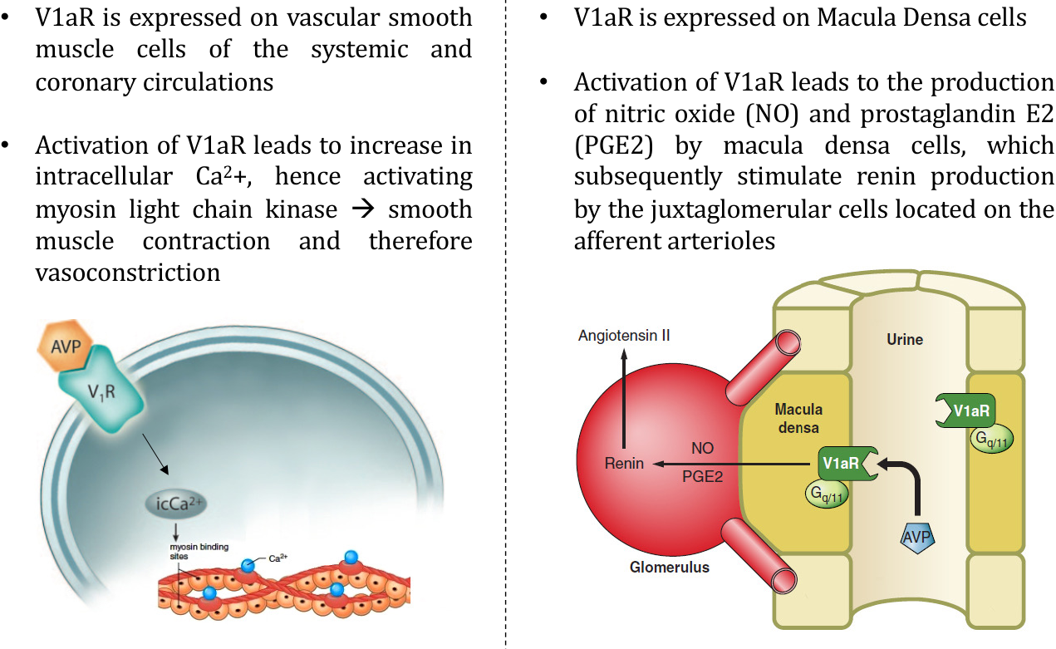
Original lecture image, including visible teaching annotations (PDF p. 33).
Route | All source steps
Direct vascular route | V₁a receptors on systemic AND coronary vascular smooth muscle → intracellular Ca²⁺ ↑ → myosin light-chain kinase (MLCK) activated → muscle contracts → vasoconstriction.
Indirect route taught in lecture | V₁a receptors on macula-densa cells → nitric oxide (NO) and prostaglandin E₂ (PGE₂) production → renin production / release from JG granular cells on afferent arterioles.
Later amplification | Renin–angiotensin system links to aldosterone, thirst, further VP secretion and vasoconstriction.

Keep the cell types and mediators separate
Vessel: V₁a → Ca²⁺ → MLCK → contraction.
Macula densa, in the source route: V₁a → NO / PGE₂ → neighbouring JG-cell renin.
JG cell is not the same cell as macula densa.

Qualification: retain this VP–macula-densa route as the lecture’s mechanistic model, not a universal prediction that VP always raises net circulating renin. Renin integrates perfusion, NaCl delivery and sympathetic inputs; VP’s pressure / volume effects can create opposing feedback. MLCK phosphorylates myosin light chains during smooth-muscle contraction.

23 / Renin–angiotensin cascade and all four outputs
Lecture PDF p. 34 | Also links the integrated trigger diagram on p. 42
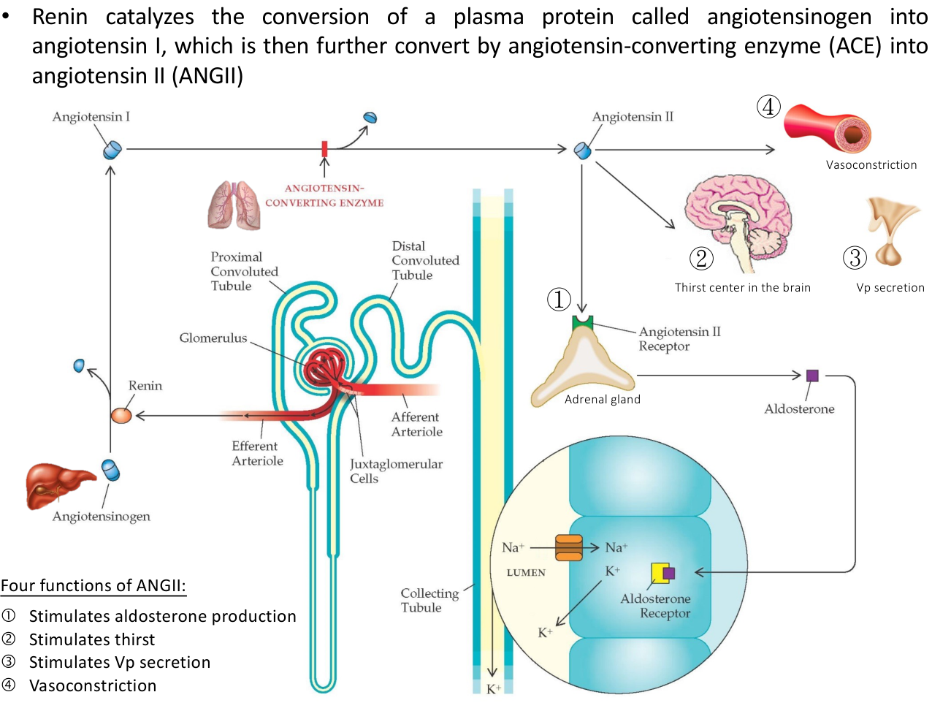
Original lecture image, including visible teaching annotations (PDF p. 34).
The enzymatic cascade
Liver-derived angiotensinogen —renin→ angiotensin I
—angiotensin-converting enzyme (ACE)→ angiotensin II (ANGII).
Renin comes from renal juxtaglomerular granular cells.

ALL four ANGII functions | Primary target / later detail
1. Aldosterone production | Adrenal cortex → distal-nephron sodium / potassium handling; notes p. 24.
2. Thirst | SFO / OVLT → MnPO → cortical circuits → drinking; p. 25.
3. VP secretion | SFO / OVLT → MnPO → magnocellular PVN / SON → posterior pituitary; p. 25.
4. Vasoconstriction | Vascular AT₁ plus central sympathetic routes; p. 26.

The final flowchart adds reduced afferent-arteriolar stretch, reduced NaCl delivery sensed at the macula densa and sympathetic activation as renin-stimulatory signals. Its wording “NaCl concentration in ascending limb” should be read at the macula-densa / end-thick-ascending-limb sensing region. ACE is prominent on vascular endothelium including pulmonary vessels; it is not confined to the lungs.

24 / ANGII → aldosterone → three transport proteins
Lecture PDF p. 35
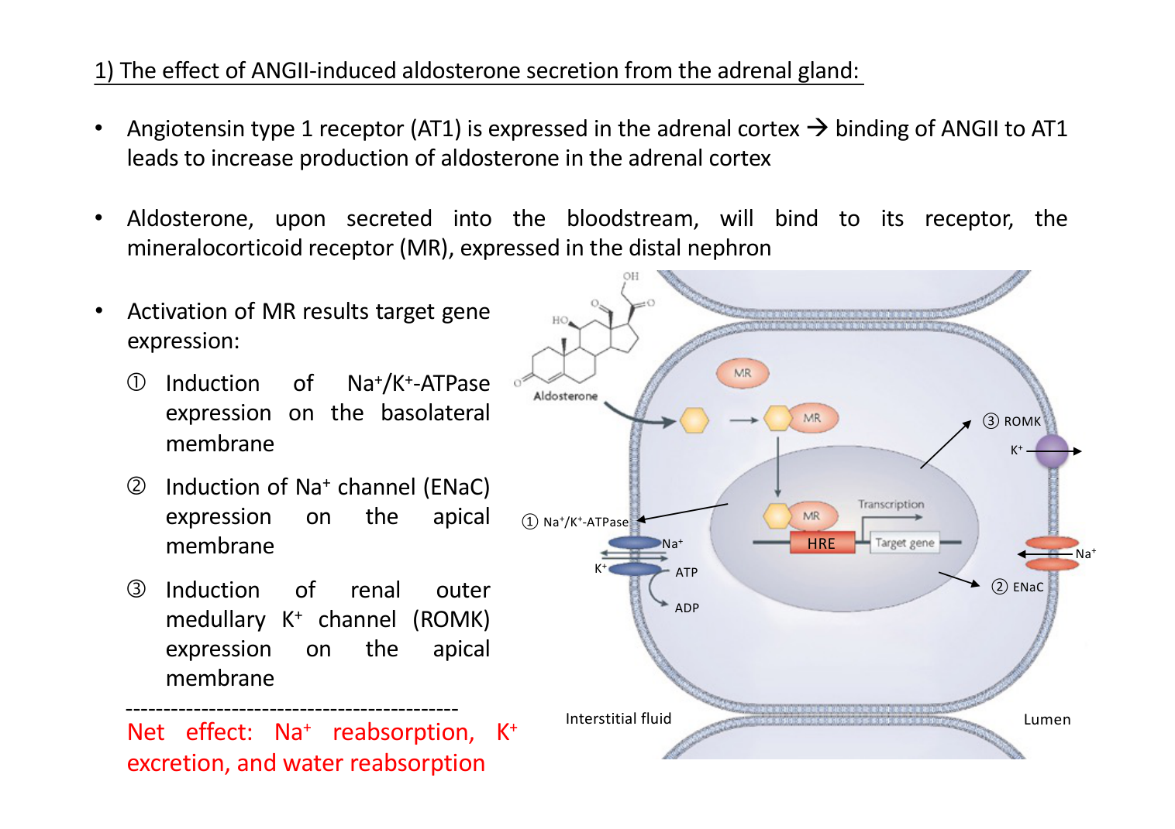
Original lecture image, including visible teaching annotations (PDF p. 35).
Stage | All written details
ANGII receptor | AT₁ in ADRENAL CORTEX → aldosterone production increases.
Hormone transport / target | Aldosterone enters blood → binds mineralocorticoid receptor (MR) in distal nephron.
Gene regulation | Activated MR alters target-gene expression; figure labels HRE, hormone-response element.
1. Basolateral Na⁺/K⁺-ATPase | Expression increases → Na⁺ moves into interstitium and K⁺ into cell; uses ATP.
2. Apical ENaC | Epithelial Na⁺ channel expression increases → luminal Na⁺ enters cell.
3. Apical ROMK | Renal outer-medullary K⁺ channel expression increases → K⁺ secreted into lumen.
Net effect | Na⁺ reabsorption ↑; K⁺ excretion ↑; associated water retention helps restore volume.

Lumen and interstitial sides are explicitly different. Aldosterone does not insert AQP2; water retention depends on available water and the segment’s water permeability / VP state. [Extension] MR is an intracellular steroid receptor; its transcriptional actions differ from rapid VP-controlled vesicle trafficking.

25 / ANGII: drinking and further VP release
Lecture PDF pp. 36–37
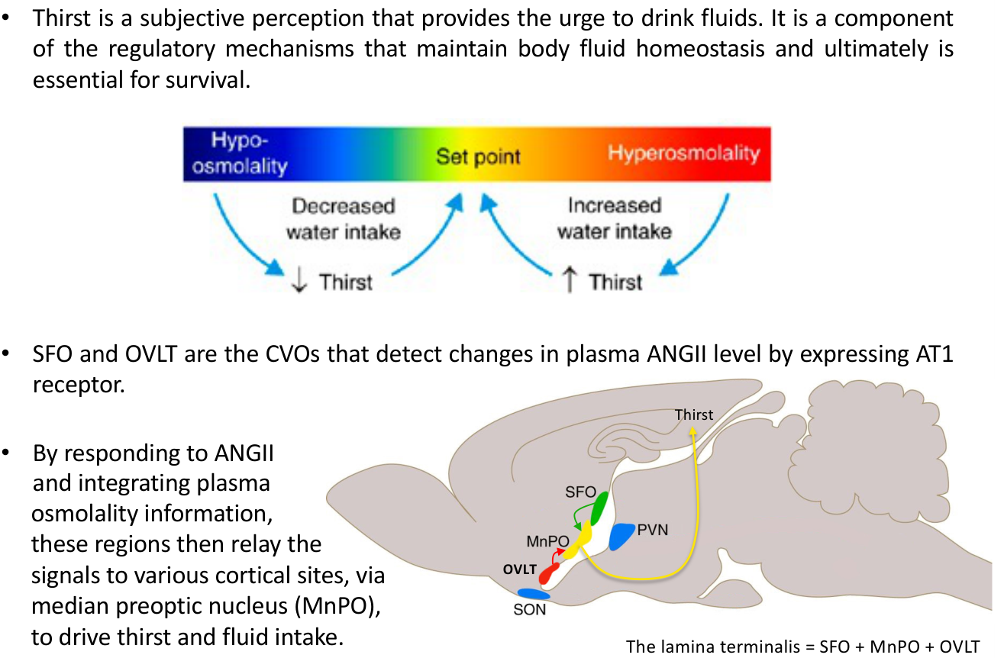  Original lecture figure, PDF p. 36. | 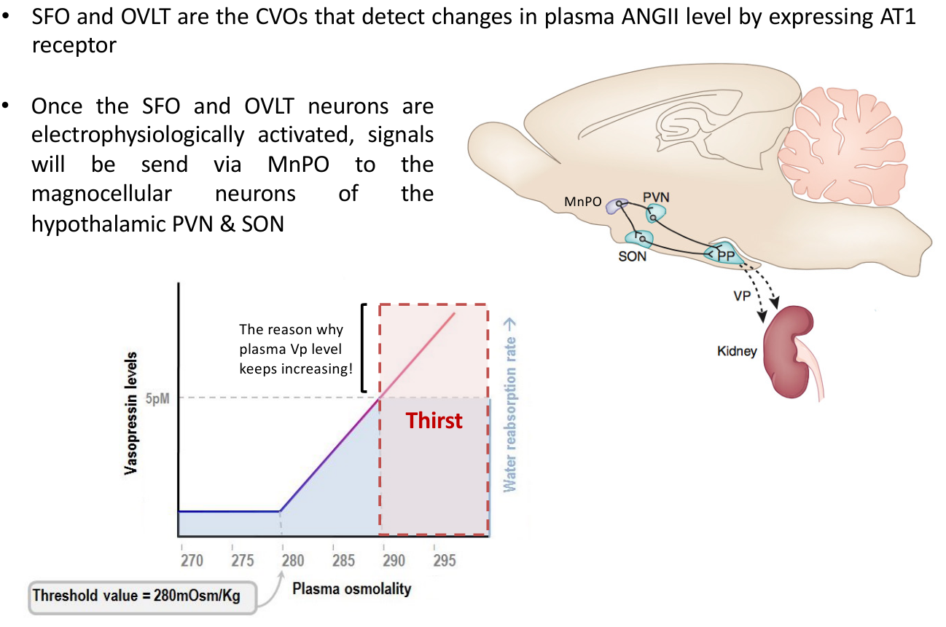  Original lecture figure, PDF p. 37.
Written point | Retained pathway
Thirst definition | Subjective perception generating the urge to drink; part of homeostasis and essential for survival.
ANGII detection | SFO and OVLT are sensory CVOs expressing AT₁ receptors; they detect circulating ANGII.
Integration | ANGII signals are integrated with plasma-osmolality information.
Drinking branch | Signals relay through MEDIAN PREOPTIC NUCLEUS (MnPO) to cortical sites → thirst and fluid intake.
Lamina terminalis | Source circuit: SFO + MnPO + OVLT.
VP branch | Electrophysiologically activated SFO / OVLT → MnPO → MAGNOCELLULAR neurons in PVN / SON → VP secretion.
Why VP can keep rising | Further endocrine / neural drive continues after the kidney’s water-retaining response is close to maximal; vascular and intake responses are additional outputs.

Retain the source’s nucleus names: median PREOPTIC nucleus, not a posterior-pituitary nucleus. Magnocellular PVN / SON cells project to the posterior pituitary; the parvocellular PVN branch to RVLM is a separate route on p. 26.

26 / ANGII vasoconstriction: direct and central
Lecture PDF pp. 38–39
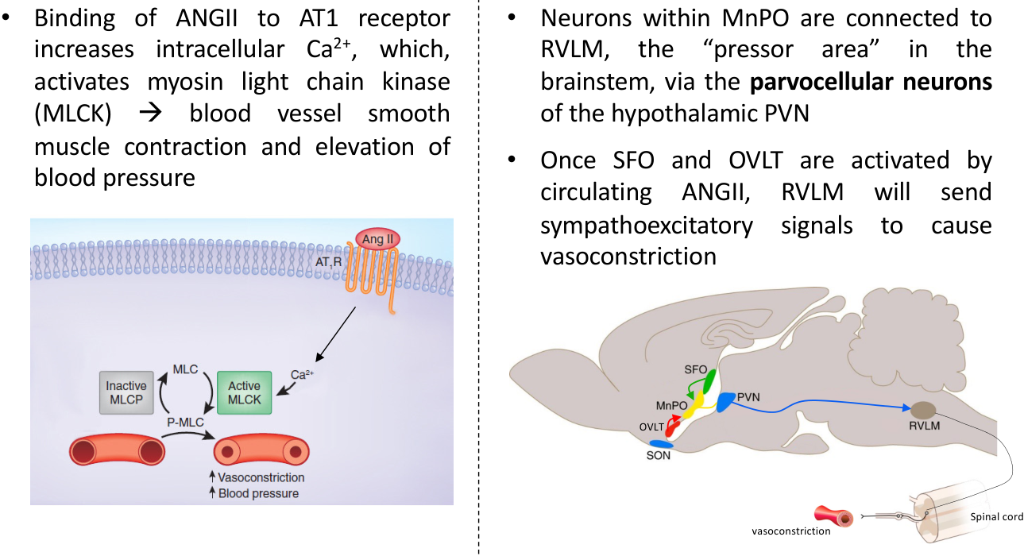  Original lecture figure, PDF p. 38. | 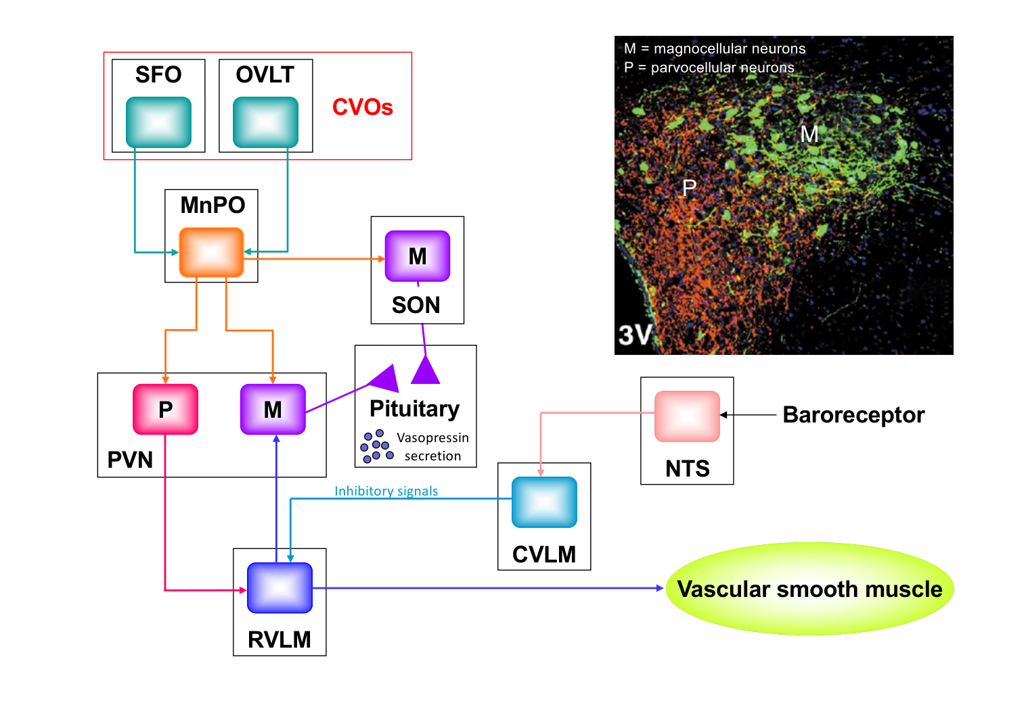  Original lecture figure, PDF p. 39.
Route | All source connections
Direct vascular | ANGII → AT₁ on vascular smooth muscle → intracellular Ca²⁺ ↑ → MLCK activation → contraction → BP ↑.
Central pressor route | Circulating ANGII → SFO / OVLT → MnPO → PARVOCELLULAR PVN → RVLM → sympathoexcitatory spinal output → vascular constriction.
Endocrine route in integrated map | MnPO → magnocellular PVN / SON → posterior pituitary → VP release.
Baroreceptor brake | Baroreceptors → NTS → CVLM → inhibitory signal to RVLM; integrates pressure feedback with the ANGII circuit.
M versus P | M = magnocellular; P = parvocellular. Both are labelled in the source schematic and micrograph.

PVN is not a single-output box
Magnocellular PVN → hormonal VP output.
Parvocellular PVN → autonomic / RVLM pressor pathway.
SON contributes magnocellular VP neurons.
Vascular AT₁ action is also direct; it does not require every ANGII effect to pass through the brain.

27 / Whole-system integration: water and pressure
Lecture PDF pp. 40–41 | Image-only slides transcribed here as mechanisms
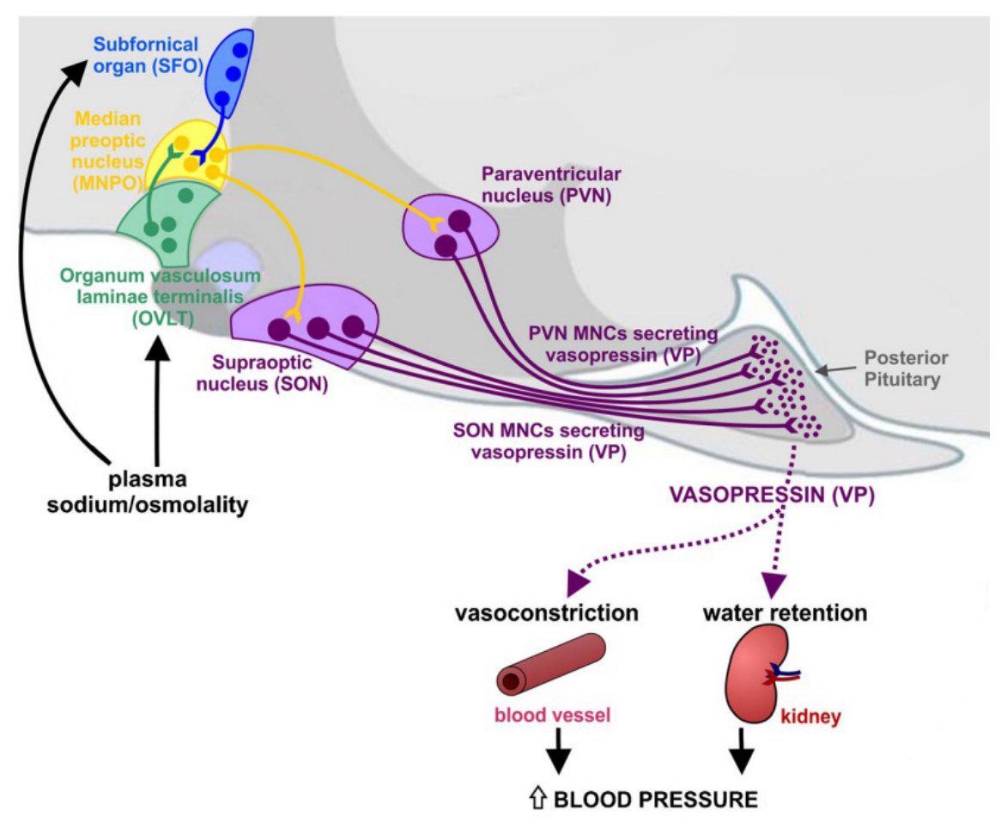  Original lecture figure, PDF p. 40. | 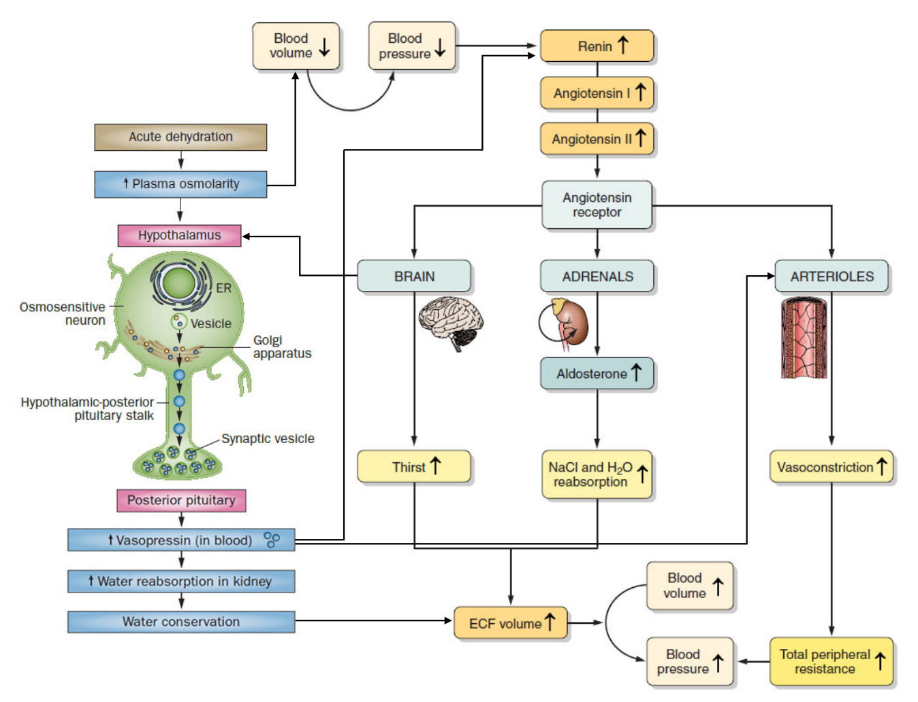  Original lecture figure, PDF p. 41.
Diagram component | Full pathway to read
Plasma sodium / osmolality | Sensory SFO / OVLT → MnPO → VP-secreting PVN / SON magnocellular neurons → posterior pituitary.
VP outputs | Kidney water retention + vascular vasoconstriction → support BP.
Acute dehydration | Plasma osmolarity ↑ and blood volume / pressure ↓ may occur together → activate hypothalamic and renin pathways.
ANGII branches | Brain thirst; adrenal aldosterone; arteriolar constriction; hypothalamic VP-related signalling.
Renal and intake outcomes | Water conservation + NaCl / water reabsorption + drinking → ECF / blood volume ↑.
Vascular outcome | Constriction → total peripheral resistance ↑; volume and resistance together support pressure restoration.

Source p. 40 also labels median preoptic nucleus, PVN / SON MNCs and posterior pituitary. Source p. 41 includes intracellular vesicles / Golgi / ER / axonal storage in its neurosecretory cartoon. The schematics combine branches; their arrows do not imply every dehydrating process changes sodium, volume and pressure by the same proportion.

28 / Integrated low-pressure flowchart and VP stimuli
Lecture PDF pp. 30, 42
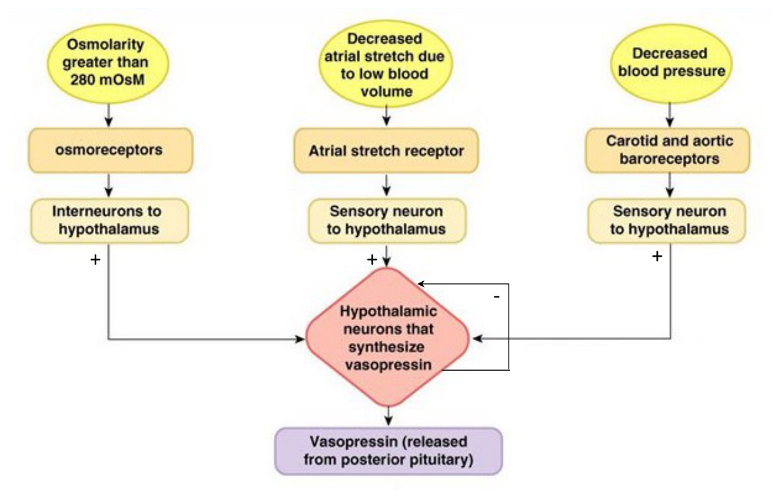  Original lecture figure, PDF p. 30. | 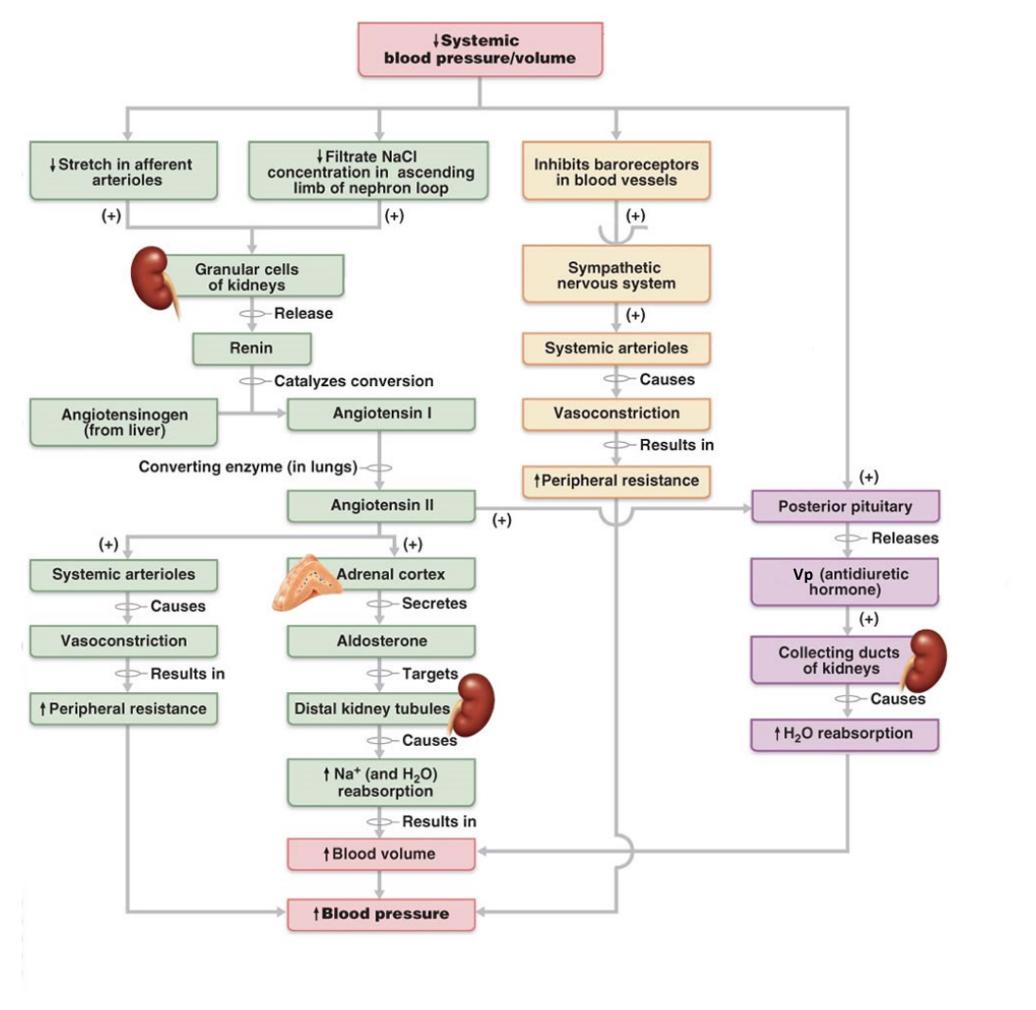  Original lecture figure, PDF p. 42.
Branch in the image-only summary | Retained causal chain
Renal pressure branch | Systemic pressure / volume ↓ → afferent-arteriolar stretch ↓ → granular-cell renin ↑.
Tubular branch | Reduced NaCl delivery sensed near macula densa → renin stimulation.
Neural branch | Arterial baroreceptor unloading → sympathetic activation → systemic arteriolar constriction and renal renin stimulation.
Hormonal cascade | Angiotensinogen from liver → renin → ANG I → ACE → ANG II.
Aldosterone branch | ANG II → adrenal cortex → aldosterone → distal tubular Na⁺ retention / associated water retention → blood volume ↑.
VP branch | Posterior pituitary → VP → collecting ducts → H₂O reabsorption ↑.
Final result | Blood volume and peripheral resistance increase → arterial pressure restored toward its target.

Source p. 30 additionally lists osmolarity >280 mOsm, decreased atrial stretch due to low blood volume, and decreased arterial pressure as convergent inputs to hypothalamic VP neurons. In the osmoregulatory graph, 280 refers to the VP threshold; ~290 refers to thirst. Low NaCl is sensed by macula-densa signalling, not by a direct “salt receptor” on the renin granule itself.

29 / Diabetes insipidus and classroom Activity 6
Lecture PDF p. 43 | Photo 5: water restriction, sodium 160, urine osmolarity 500
Disease / genetics | All source details
DI definition | Kidney cannot concentrate urine adequately under appropriate physiological stimulation. Not all DI means absent hormone.
Central DI | Defect of VP production or release.
Nephrogenic DI | Kidney fails to respond adequately to VP; source examples: V₂-receptor mutation or AQP2 defect with impaired plasma-membrane trafficking.
V₂ receptor gene | X-linked; source locus Xq28; protein vasopressin type-2 receptor (AVPR2 / V₂R).
AQP2 gene | Autosomal; source locus 12q13; protein AQP2.

Original Activity 6 — case and all options | Transcribed from classroom photo
Patient: a 48-year-old woman.
• Severe polyuria (high urine output) and polydipsia (excessive drinking); no urinary glucose.
• After overnight water restriction: lethargy and confusion.
• Plasma sodium: 160 mEq/L; source normal range 135–145.
• Urine osmolarity: 500 mOsm/L; source comparison >850.
Question: most likely diagnosis?
A. Hyperaldosteronism B. Renin-secreting tumour
C. Diabetes mellitus D. Diabetes insipidus E. SIADH
Answer approach:
• Best answer among the options: D, diabetes insipidus (DI).
• Plasma Na⁺ 160 indicates a marked water deficit relative to sodium. Continued polyuria and inadequate concentration during water restriction indicate impaired water conservation.
• No urinary glucose makes glucose-driven osmotic diuresis less likely in the given comparison.
• A urine value of 500 is not maximally dilute; it is INAPPROPRIATELY LOW for the hypernatraemic, water-deprived state. Partial DI / partial concentrating defects are possible.
• The data do not establish central versus nephrogenic DI.

Why the lecture says DI often has no hypernatraemia
Intact thirst + access to water can replace urinary water losses, keeping plasma sodium near normal.
Water restriction, inability to drink or impaired thirst removes that compensation → hypernatraemia can develop, as in this photographed case.

The source’s >850 mOsm/L is a post-restriction comparison, not a universal random-urine normal. Urine 500 is insufficiently concentrated for the sodium-160 water-deprived state, but is not maximally dilute; partial DI / other partial concentrating defects remain possible. Central versus nephrogenic disease needs more evidence, such as supervised desmopressin response testing. Source photo slide number 54 belongs to the classroom slide deck, not this 47-page PDF.

30 / SIADH: source causes and severity table
Lecture PDF p. 44
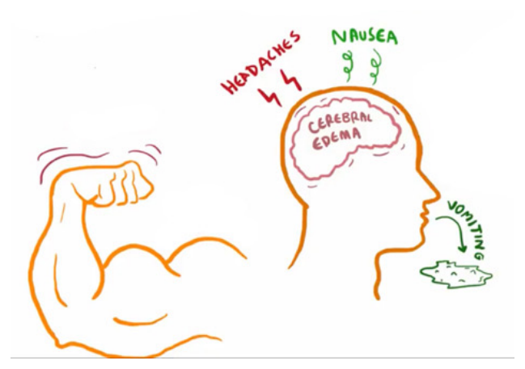
Original lecture image, including visible teaching annotations (PDF p. 44).
Source cause | Interpretation
Posterior-pituitary disease | Source describes slow constant VP leakage; inappropriate antidiuresis can occur with hypothalamic / pituitary or CNS disease, depending on the clinical setting.
Lung tumours | Small-cell lung carcinoma is the named example; ectopic production may be of actual AVP, rather than necessarily a merely “similar substance”.
Antidepressant medication history | Some drugs stimulate / potentiate inappropriate antidiuresis.

Source symptom grouping | Every listed feature
Mild to moderate | Weight gain, elevated BP, headache, nausea, vomiting, muscle weakness.
Advanced | Cerebral oedema → confusion, hallucination.
Grave | Seizures, coma, death.

Mechanism and qualification
VP remains inappropriately active for the osmotic state → kidney conserves too much water
→ plasma sodium diluted → extracellular hypotonicity → brain-cell water entry.
The source says “sodium deficit”, but dilutional hyponatraemia can reflect excess water relative to sodium without primary total-body sodium depletion.

Weight gain / elevated BP are retained from the source; typical established SIADH is often clinically euvolaemic, with no gross oedema and without obligatory hypertension. Severity depends on both the level and SPEED of sodium fall, not a rigid symptom sequence. Low sodium concentration and low total-body sodium content are different variables.

31 / Classroom case: Lucas and excess water
Lecture PDF pp. 23–25, 36–37, 44 | Original Photo 6 integrated with fluid regulation, not the anatomy PDF
Original case — retain the clinical details | Transcribed from classroom photo
Patient: Lucas, a 20-year-old Art student and experienced marathon runner.
• Roommate finds him disoriented and brings him to a nearby A&E.
• He has just completed a half-marathon in extreme heat (34°C), from Tsing Ma Bridge to Victoria Park.
• To avoid dehydration: copious water before the race, plus about another 3 L of bottled water during it.
• Back at the Student Hall: nausea and confusion.
• Assuming heat stroke, he continues drinking lots of cold bottled water.
Question: what could be his problem?
Answer approach:
• The photographed answer is dilutional hyponatraemia. This is the leading intended explanation, not a sodium measurement supplied by the case.
• Large water intake over a short time without a matching electrolyte intake → water becomes excessive relative to exchangeable sodium / potassium.
• Sodium lost in sweat can contribute to the imbalance.
• [Extension] Exercise, stress and nausea can maintain non-osmotic VP secretion, limiting water excretion even as plasma sodium falls.
• Excess retained hypotonic fluid → extracellular osmolality ↓ → water enters cells; brain-cell swelling can explain nausea, confusion and disorientation.

Mechanistic clue | Answer reasoning beside the relevant concept
Water before / about 3 L during / more afterwards | Cumulative hypotonic intake relative to losses and excretory capacity matters; 3 L is not a universal toxicity threshold.
Heat / sweating | Sweat sodium loss can contribute. Because sweat is usually hypotonic, sweating alone does not establish dilutional hyponatraemia.
Exercise / nausea / stress | Non-osmotic VP stimuli can limit water excretion despite falling osmolality.
Confusion / disorientation | Compatible with hypotonic brain swelling; sodium measurement is needed to confirm the intended diagnosis and distinguish other exertional illness.

This is exercise-associated dilutional hyponatraemia in the photographed answer; it should not automatically be labelled tumour-related SIADH. The original clinical details are preserved. Compare Activity 6: DI plus restricted water produces water deficit / high sodium; Lucas’s intended case produces relative water excess / low sodium.

32 / Hyperaldosteronism: causes, ions and symptoms
Lecture PDF p. 45
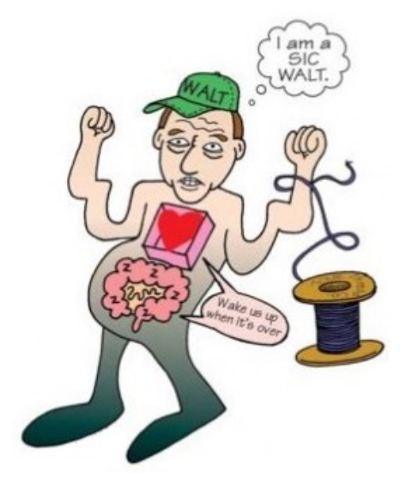
Original lecture image, including visible teaching annotations (PDF p. 45).
Written point | Complete source content
Definition | Excess aldosterone secretion.
Primary cause | Aldosterone-producing adenoma: Conn’s syndrome.
Secondary cause | Abnormal RAAS activation, e.g. renovascular disease.
Major manifestations | Hypertension and hypokalaemia.

Source mnemonic | All eight features
A – S | Alkalosis; shallow respiration.
I – C | Irritability; constipation due to reduced gut motility.
W – A | Muscle weakness; arrhythmia / irregular heart rate.
L – T | Lethargy / fatigue; thready / weak pulse.

Correct the source’s hypertension mechanism
Source: “hypertension due to hypernatremia”.
Better explanation: aldosterone-driven Na⁺ retention expands ECF / effective circulating volume → BP rises. Plasma sodium may stay near normal because water regulation and pressure natriuresis limit the concentration change.
Distal K⁺ wasting explains hypokalaemia; increased distal H⁺ secretion contributes to metabolic alkalosis.

[Extension] Primary autonomous aldosterone excess usually suppresses renin; secondary renovascular RAAS activation raises renin. The mnemonic is a teaching list of possible manifestations, not a requirement that every patient has all eight signs.

33 / Hypoaldosteronism: causes and consequences
Lecture PDF p. 46
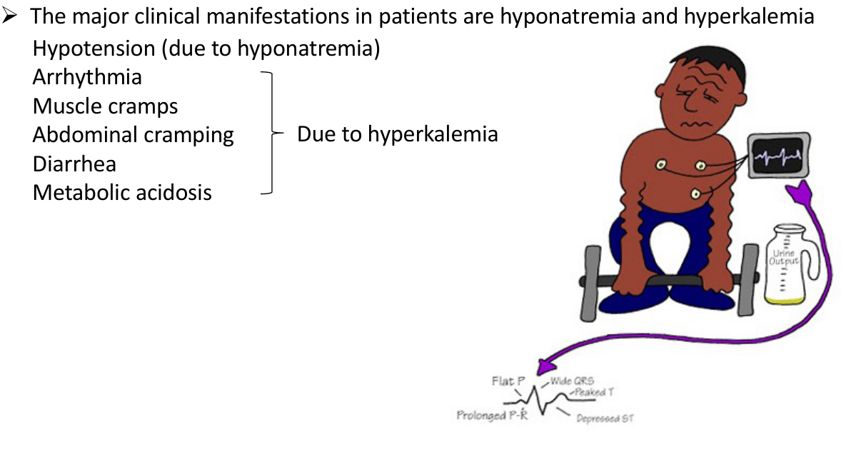
Original lecture image, including visible teaching annotations (PDF p. 46).
Written cause / outcome | Retained detail and qualification
Definition | Deficient aldosterone secretion / activity.
Adrenal insufficiency | Reduced adrenal hormone production.
Renal insufficiency | Source: chronic renal failure → low renin. This is relevant to hyporeninaemic hypoaldosteronism; not every chronic renal disease has low renin.
Drug causes | ACE inhibitors, ANGII-receptor blockers, renin inhibitors and related antihypertensive effects reducing aldosterone drive.
Major ion changes | Hyponatraemia and hyperkalaemia in the source.
Listed clinical manifestations | Hypotension; arrhythmia; muscle cramps; abdominal cramping; diarrhoea; metabolic acidosis.

Separate volume, potassium and acid–base effects
Na⁺ loss / reduced ECF volume can lower BP; “hypotension due to hyponatraemia” is an oversimplification.
Reduced distal K⁺ secretion → hyperkalaemia → cardiac / neuromuscular effects.
Reduced distal acid secretion and hyperkalaemia-related impaired ammonium handling contribute to metabolic acidosis; not every item is caused only by serum K⁺.

The source labels its symptom bracket “due to hyperkalaemia”; the mechanistic grouping above avoids assigning low BP or the entire acid–base disturbance to potassium alone. “ACE blockers” in the source is usually termed ACE inhibitors. Aldosterone changes act through ENaC / Na⁺–K⁺-ATPase / ROMK-related transport, not by replacing the VP–AQP2 pathway.

34 / Electrolyte manifestations and final learning check
Lecture PDF p. 47 | One additional self-written integrated case
Imbalance | Main physiological consequence / manifestations
Hypernatraemia | Water deficit relative to sodium → extracellular hypertonicity / cell shrinkage; thirst, weakness and neurological dysfunction. Severe / rapid changes can cause confusion, seizures or coma.
Hyponatraemia | When hypotonic, water enters cells → headache, nausea, confusion; severe / rapid falls can cause cerebral oedema, seizures or coma.
Hyperkalaemia | Changes membrane excitability / conduction; muscle weakness or cramps and potentially dangerous arrhythmias. Hypoaldosteronism may also involve metabolic acidosis.
Hypokalaemia | Muscle weakness, reduced gut motility / constipation, lethargy, arrhythmias; severe cases can impair respiratory muscle function. Aldosterone excess can also cause metabolic alkalosis.

Integrated practice 2 | Self-written; not an original exam question
With preserved renal perfusion and a responsive renin system, an ACE inhibitor causes reduced ANGII / aldosterone action. Predict renin feedback, K⁺ excretion and whether the defect is equivalent to a V₂-receptor mutation.
Answer approach:
• ANGII formation / signalling falls; loss of ANGII feedback tends to raise renin.
• Aldosterone drive falls → distal Na⁺ reabsorption and K⁺ secretion decrease → hyperkalaemia becomes more likely.
• This is not the same as renal VP resistance: V₂ / AQP2 responsiveness can remain intact.
• Urine volume / concentration still depend on VP, water intake, medullary gradient and filtration; do not infer a unique DI-like urine from an aldosterone effect alone.

All final learning objectives, retained
• State body-water distribution and identify major intracellular / extracellular electrolytes.
• Explain osmotic and haemodynamic sensing and BOTH physiological and behavioural responses.
• Explain how loop of Henle, collecting duct and VP coordinate urine concentration.
• List all FOUR ANGII functions and trace their target cells / circuits.
• Explain VP / aldosterone disorders and the clinical manifestations of all four electrolyte imbalances above.
This table synthesises the stated final objectives; supporting manifestations beyond the exact symptom mnemonics are explanatory extensions. Concentration, total-body content and extracellular volume must remain separate when interpreting sodium disorders.

35 / Coverage audit: nephron, gradient and body fluids
Lecture PDF pp. 1–19
PDF page | Key written content / source figures retained | Notes page
1 | Correct title, lecturer and scope: countercurrent multiplier and urine formation. | 1
2–3 | Million nephrons, corpuscle/tubule, two capillary beds; cortical versus juxtamedullary locations/loops/efferent vessels; all diagram labels. | 2
4 | Passive opposite-stream exchange; co-current equilibration; more countercurrent transfer; original numerical examples. | 3
5–6 | Energy, descending/ascending permeability, ATPase, 3Na/2K, NKCC2 and bumetanide, Cl channel, repeated cycle; long-loop juxtamedullary emphasis. | 4
7–8 | Concentrates then dilutes; five figure steps; 300/100/1200 and axial gradient; longer loops; collecting-duct water arrows. | 5
9 | Vasa recta preserve, do not generate gradient; water/solute directions; <5% medullary flow; all labels. | 6
10–11 | Overhydration/VP↓/dilute urine; apical AQP2 versus basolateral AQP3/4; concentration needs permeability. | 7
12–13 | Dehydration→VP→principal-cell AQP2; protein-derived urea; tubular water loss concentrates urea; IMCD UT-A1/3 passive diffusion; interstitial osmotic force. | 8
14 | UT-A1 phosphorylation/apical accumulation; V2/Gs/AC/cAMP/PKA; UT-A3 exit; VP-dependent urea concentration. | 9
15 | Corticomedullary-to-papillary gradient; outer NaCl; inner NaCl+urea; nephron/vascular interaction. | 10
16–17 | Body-fluid section; TBW60%, ICF2/3 or40%BW, ECF1/3 or20%BW, plasma1/5ECF/interstitium4/5; 3/8/10% loss statements qualified. | 11
18 | Plasma/interstitial/intracellular ion chart, proteins/phosphate/Na/K differences and chart units. | 12
19 | Plasma→interstitium→ICF buffering; stable intracellular environment; physiological/behavioural response centres and hormones. | 13

36 / Coverage audit: VP sensing and ANGII actions
Lecture PDF pp. 20–39
PDF page | Key written content / source figures retained | Notes page
20–21 | PVN/SON magnocellular synthesis, axonal transport, posterior-pituitary terminals, vesicles and Herring-body qualification. | 14
22 | Stimulus/depolarisation/AP propagation, terminal Ca entry, vesicle exocytosis, fenestrated-capillary release. | 15
23–24 | 1% sensitivity, water cartoon qualification, corrected osmolality definition, TRPV/pore/cation model, OVLT/SFO/PVN/SON, CVO barrier and 3V/CSF. | 12,16
25 | Cell shrink/swell, water out/in, cation conductance, depolarisation/hyperpolarisation, firing directions and figure voltages. | 17
26–27 | Exponential haemodynamic relationship, >~8% reduction, left atrial/arterial stretch, CNIX/X→NTS→CVLM/RVLM and direct sympathetic/hypothalamic outputs. | 18
28–29 | All excitatory/inhibitory circuit signs; normal/hypertension versus unloading; “no VP” qualification. | 19–20
30 | Osmolarity>280, atrial-volume/arterial-pressure input convergence on VP neurons. | 28
31–32 | V2, AQP2 Ser256, trafficking/actin depolymerisation; antidiuresis; 280/290mOsm,5pM,renal plateau/thirst/V1a graph qualified. | 21
33 | V1a systemic/coronary Ca/MLCK constriction; lecture macula-densa NO/PGE2→afferent JG renin route and feedback limitation. | 22
34 | Angiotensinogen/renin/ANGI/ACE/ANGII; all four output branches. | 23
35 | Adrenal cortical AT1→aldosterone→distal MR/HRE; basolateral ATPase, apical ENaC/ROMK; Na/water retention and K excretion. | 24
36–37 | Thirst definition, lamina terminalis=SFO/MnPO/OVLT; AT1/osmotic integration; cortical drinking and magnocellular PVN/SON VP routes. | 25
38–39 | Direct AT1/Ca/MLCK and central SFO/OVLT→MnPO→parvocellularPVN→RVLM; M/P distinctions and integrated schematic/micrograph. | 26

37 / Coverage audit: disorders and classroom questions
Lecture PDF pp. 40–47 | The classroom photographs remain those already supplied
PDF page | All key content accounted for | Notes page
40–42 | All image-only summaries: brain nuclei, posterior pituitary, dehydration, renin, ANGII, adrenal/brain/vessel/kidney branches; afferent stretch/NaCl/sympathetic triggers; final volume/resistance/BP outcomes. | 27–28
43 | CDI/NDI definitions; V2R/AQP2 membrane defect; X-linkedXq28/autosomal12q13; compensatory thirst and conditional hypernatraemia. | 29
44 | SIADH/posterior-pituitary disease/lung tumour/antidepressants; mild/advanced/grave symptom table; dilutional water excess and clinical qualifications. | 30
45 | Adenoma/Conn, renovascular activation, BP/K changes; all eight mnemonic features; hypertension mechanism corrected. | 32
46 | Adrenal/renal/drug causes, low-renin limitation, hypona/hyperK, all symptoms, acidosis and BP mechanisms qualified. | 33
47 | All final objectives and four electrolyte-imbalance manifestations. | 34

Classroom item | Original details / answer reasoning retained | Notes page
Photos1–2 | Baroreflex→VP, blood volume, vasodilation, cardiac sympathetic/inotropy and parasympathetic heart-rate/funny-current/conduction effects; NTS/CVC and zero-VP limitations. | 19
Activity3 | Small hypertonic saline; hyperosmolality, limited volume assumption, PVN/SON, posterior pituitary, apical AQP2, inner-medullary UT-A1, urea and concentrated small urine. | 9
Activity4+vagotomy | Photographed aortic-dominant answer retained; competing carotid unloading, CNIX/X distinction and experimental assumptions explicit. | 20
Activity6 | 48-year-old woman, no glycosuria, restricted water, lethargy/confusion, Na160/reference135–145, urine500/source>850, all five options, D best with subtype limitation. | 29
Lucas | 20-year-old Art student/experienced runner; half-marathon34°C/route; copious pre-race water/another3L/more after; all symptoms, intended dilutional diagnosis and sweating/VP qualifications. | 31

Sources: Dr J Chu, BBMS2006 Counter-current Multiplier & Urine Formation / Body Fluid Homeostasis & Related Disorders, supplied student-version PDF (47 pages), plus the six previously supplied classroom photos. This corrected set replaces the anatomy-based study set for the present task. Original source wording is preserved when correction is needed; the explanation makes its limits visible. The worked questions are study interpretations, not an official key. Decorative section / cover pages carry no omitted teaching mechanisms.

