01 / Lecture map and tutorial relevance
Gas diffusion & gas transport | Concise English edition | Lecture PDF: 19 pages; Tutorial PDF: 1 page
The lecture in one pathway
Environmental pressure → gas partial pressure → membrane diffusion → blood O₂ content
→ tissue O₂ delivery / unloading → CO₂ carriage → pulmonary CO₂ unloading.

Topic | Notes page | Original tutorial questions
Dalton + Henry; diving | 2 | Q13
Altitude + hyperventilation | 3 | Q4, Q7: cross-topic
Fick’s law + respiratory barrier | 4–5 | Lecture mechanisms and in-slide exercise
O₂ content + delivery | 6 | Q3
Anemia, cyanosis, hypoxemia / hypoxia | 7 | Q6: application
Dissociation curve, P₅₀ and shifts | 8–9 | Foundation for Q5 and Q10
Pulmonary loading + CO poisoning | 10 | Q5, Q10
CO₂ forms + carbonic anhydrase | 11 | Q12: renal mechanism is an extension
Tissue/lung exchange + Bohr/Haldane | 12 | Integrated CO₂ reasoning

Questions mainly belonging to other lectures
Question | Required topic
Q1 | Compliance, recoil and work of breathing.
Q2 | Regional V/Q ratios: apex versus base.
Q8, Q9 | Airway resistance; surfactant, surface tension and lung mechanics.
Q11, Q14 | Chemoreceptors and ventilatory control; dead space and alveolar ventilation.

The question pattern to watch
• Separate fraction from pressure, saturation from content, and content from delivery.
• Test each clause: a correct observation may be followed by the wrong mechanism.
• For “must”, “always” or “unchanged”, identify the missing condition or give a counterexample.
Tutorial Q# preserves the original question numbering and wording. Answers are reasoned suggestions, not an official key. [Extension] marks material needed for cross-topic questions but not fully covered in these slides. Lecture references use PDF page numbers. Original teaching figures and visible annotations are retained; decorative logos are omitted.

02 / Partial pressure, dissolution and diving
Lecture PDF pp. 4–5, 19 | Tutorial Q13
Law | Relationship | Condition / meaning
Dalton | Pgas = Fgas × Ptotal  Ptotal = sum of gas partial pressures | Gas fraction alone does not determine its partial pressure.
Henry | Cdissolved = α × Pgas | At equilibrium, with temperature, gas and solvent fixed.

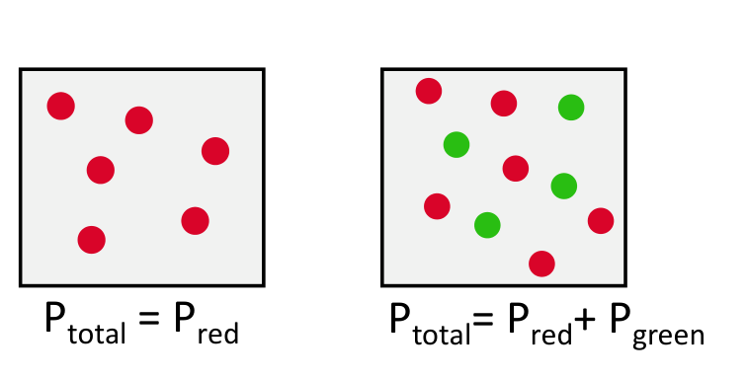  Original: Dalton’s law (lecture p. 4). | 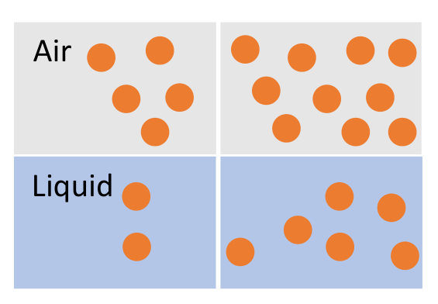  Original: Henry’s law (lecture p. 5).
• Dry-air PO₂: sea level 760 × 0.21 = 159.6 mmHg; lecture altitude example 250 × 0.21 = 52.5 mmHg. These are not arterial PO₂ values.
• Correction to slide wording: increasing Pgas raises dissolved concentration; it does not increase α at fixed temperature and medium.

Tutorial Q13 · Original tutorial question
A diver breathing 78% N2 and 21% O2 will have blood dissolved nitrogen level remains unchanged because the fraction of nitrogen is unchanged.
False | The missing variable is total pressure
Depth ↑ → absolute pressure ↑ → PN₂ ↑ despite unchanged FN₂ → equilibrium dissolved N₂ ↑.
[Extension] At about 10 m seawater: 1 → 2 ATA, so dry-gas PN₂ approximately doubles: 0.78 → 1.56 ATA. Uptake is time-dependent; tissues do not equilibrate immediately.

Reverse the process during ascent
Pressure ↓ → equilibrium dissolved amount ↓ → N₂ leaves solution. Rapid decompression can produce bubbles; slow ascent permits elimination through the lungs.

03 / Altitude and hyperventilation
Lecture PDF pp. 4–5 | Tutorial Q4, Q7 | Alveolar gas and acid–base equations are extensions
Altitude chain
PB ↓ at unchanged FiO₂ → PIO₂ ↓ → PAO₂ ↓ → reduced O₂ gradient into blood.

[Extension] Relationship | Interpretation
PIO₂ = FiO₂ × (PB − 47) | Humidified inspired gas at 37°C; pressures in mmHg.
PAO₂ ≈ PIO₂ − PaCO₂/R; R ≈ 0.8 | Simplified alveolar gas equation under usual room-air conditions.
Alveolar ventilation ↑ at fixed CO₂ production | PaCO₂ ↓ → PAO₂ ↑, without changing FiO₂.

Tutorial Q4 · Original tutorial question
Hyperventilation at high altitude helps improve oxygenation even though it causes respiratory acidosis.
False | Correct benefit, wrong acid–base label
Hyperventilation can improve oxygenation, but acutely PaCO₂ ↓ → H⁺ ↓ → pH ↑: respiratory alkalosis.
Later renal HCO₃⁻ loss is compensation; it does not change the name of the primary respiratory disturbance.

Tutorial Q7 · Original tutorial question
Hyperventilation can increase arterial PO₂ even when oxygen concentration in inspired air remains unchanged.
True under usual physiological conditions
FiO₂ unchanged → alveolar ventilation ↑ → PaCO₂ ↓ → PAO₂ ↑ → PaO₂ can rise.
PAO₂ = alveolar; PaO₂ = arterial. Shunt or severe gas-exchange impairment can limit the response.

Key comparison: hyperventilation may improve PaO₂ relative to less ventilation at the same altitude; it does not guarantee restoration of the sea-level value.

04 / Diffusion: apply Fick’s law
Lecture PDF pp. 7–9, 19
Equation and barrier
V̇gas = A × D × ΔP / T; D ∝ solubility coefficient / √molecular weight.
Gas must dissolve before crossing the barrier, and requires a partial-pressure gradient.
Alveolar epithelium → fused basement membrane / thin interstitium → capillary endothelium.

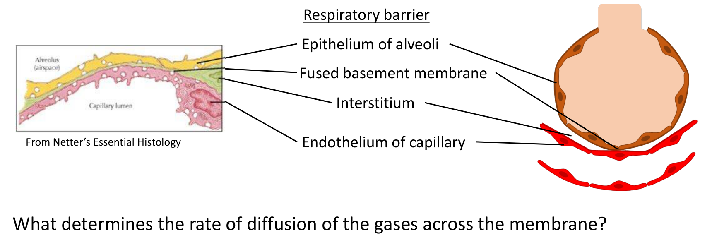
Original respiratory barrier (lecture p. 7; Netter’s Essential Histology).
Factor | Effect / application
A: effective surface area | Alveolar wall destruction in emphysema → A ↓ → diffusion ↓.
T: diffusion distance | T ↑ in fibrosis or edema → diffusion ↓.
ΔP: pressure gradient | ΔP ↑ → diffusion ↑; compare the same gas across the barrier.
D: diffusion coefficient | CO₂ diffuses about 20× more readily than O₂, mainly because it is more soluble.

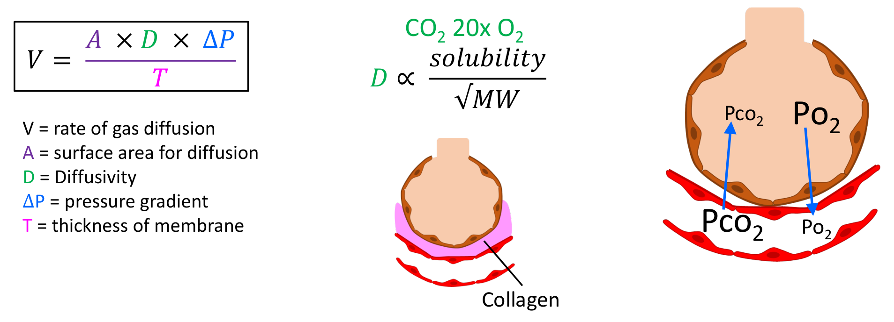
Original Fick diagram and pressure-gradient directions (lecture p. 8).
• Normal comparison: for a given gas and healthy barrier, D and T change relatively little; changes in A and ΔP therefore explain much of the change in transfer rate.
V̇ is diffusion rate, not minute ventilation. The molecular-weight term alone does not predict diffusivity: CO₂ is heavier than O₂ but much more soluble.

05 / Diffusion applications and slide exercise
Lecture PDF pp. 9, 19 | Original exercise with typed answers below
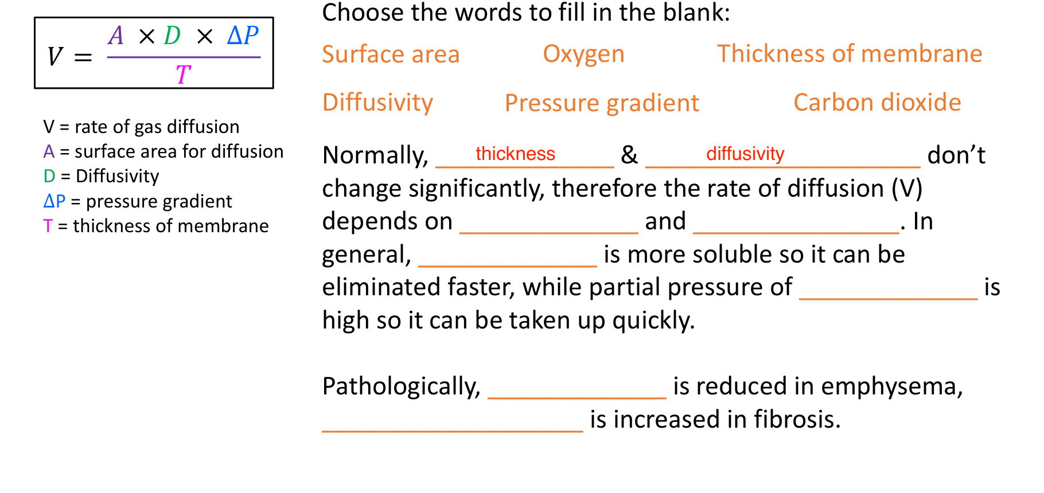
Answer check: the two entered answers, “thickness” and “diffusivity”, are correct (lecture p. 9).
Original blank / comparison | Answer and interpretation
Normally do not change significantly | Thickness; diffusivity. Fixed for the simplified comparison, not universal constants.
Main normal determinants | Surface area; pressure gradient.
More soluble; eliminated readily | Carbon dioxide: high solubility supports rapid exchange despite a smaller usual pressure gradient.
Taken up readily | Oxygen: a favourable alveolar-to-blood PO₂ gradient drives uptake.
Emphysema / fibrosis | Surface area decreases / membrane thickness increases; both lower diffusion capacity.

Use ratios rather than verbal guesses
V̇new/V̇old = (Anew/Aold) × (Dnew/Dold) × (ΔPnew/ΔPold) × (Told/Tnew).
If A halves and T doubles, with other factors fixed: V̇ falls to 1/4.
If ΔP then doubles as well, the final rate is 1/2 of baseline: combine all factors before judging.

06 / O₂: from saturation to delivery
Lecture PDF pp. 11–12 | Tutorial Q3 | Content and delivery equations are extensions
Variable | What it measures
PaO₂ | Partial pressure of dissolved arterial O₂; not total oxygen content.
SaO₂ / SpO₂ | Fraction of Hb O₂ sites occupied / pulse-oximeter estimate; not Hb quantity.
O₂ capacity | Maximum Hb-bound O₂ at full saturation; set by Hb concentration, not current saturation.
CaO₂ / DO₂ | O₂ per dL arterial blood / O₂ delivered per minute.

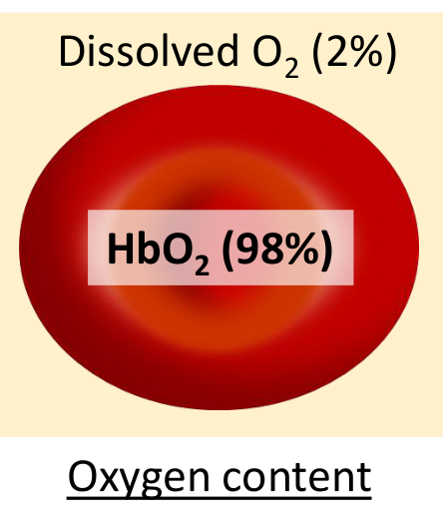  Original O₂ forms (p. 11). | 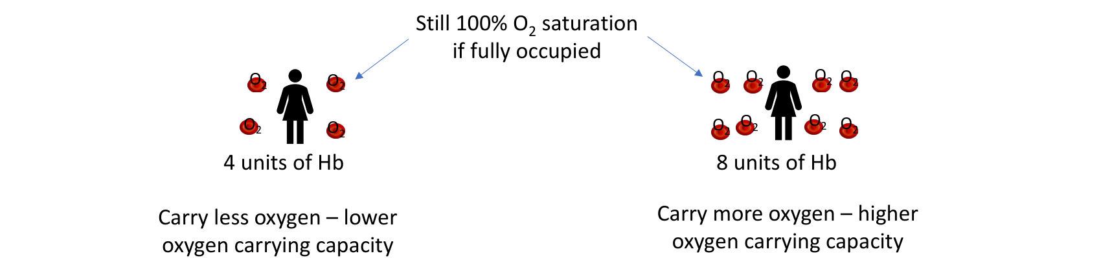  Original: Hb amount differs; saturation can stay 100% (p. 12).
• About 98% of blood O₂ is Hb-bound (oxyhemoglobin), ~2% dissolved; the proportions vary with conditions. Dissolved O₂ sets PO₂, which determines saturation along the dissociation curve.

Tutorial Q3 · Original tutorial question
A person with normal oxygen saturation must have normal oxygen delivery to tissues.
False | Saturation does not measure Hb quantity or blood flow
Hb ↓ → CaO₂ ↓; cardiac output ↓ → DO₂ ↓ even with normal CaO₂.
CaO₂ ≈ 1.34 × Hb × SaO₂ + 0.003 × PaO₂; DO₂ = CO × CaO₂ × 10.
Units: Hb g/dL; SaO₂ as a fraction; PaO₂ mmHg; CaO₂ mL/dL; CO L/min; DO₂ mL/min.

Integrated practice 1 | Self-written; not an original exam question
Hb falls from 15 to 8 g/dL. SaO₂ stays 0.98 and PaO₂ stays 100 mmHg; CO rises from 5 to 7 L/min. Has delivery been fully restored?
Reasoning: No. CaO₂: 20.0 → 10.8 mL/dL; DO₂: about 1,000 → 756 mL/min. The flow increase only partly compensates. CO would need to be about 9.3 L/min to restore baseline delivery.

• Each Hb has four heme groups containing Fe²⁺; each binds one O₂. Capacity ≈ 1.34 × Hb; actual content also depends on saturation.

07 / Anemia, cyanosis and hypoxia
Lecture PDF p. 13 | Tutorial Q6 | Hypoxia and compensation details are extensions
Term | Distinction
Anemia | Low Hb concentration → reduced carrying capacity. Common causes in the slide: iron or vitamin B₁₂ deficiency, and hemolysis.
Cyanosis | Blue/purple discoloration of lips, tongue or extremities. Lecture threshold: absolute deoxyHb approximately >5 g/dL, not a fixed saturation percentage.
Hypoxemia | Reduced arterial PaO₂.
Tissue hypoxia | Inadequate tissue O₂ supply or use; depends on content, perfusion and metabolic demand.

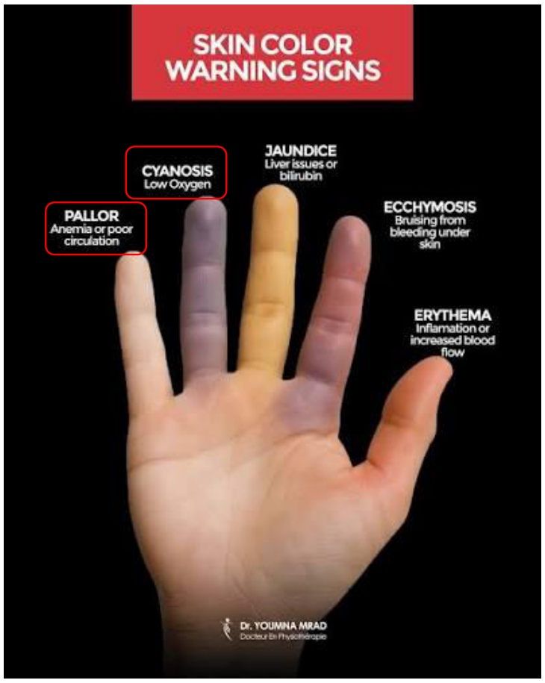
Original skin-colour illustration (lecture p. 13).

In-slide questions
• Anemia must cause cyanosis: False. Low total Hb may prevent enough absolute deoxyHb accumulating for visible cyanosis.
• Cyanosis must imply anemia: False. Poor oxygenation or slow local flow can cause cyanosis with normal Hb.

Tutorial Q6 · Original tutorial question
A person with hypoxemia will have hypoxia; But a person with hypoxia may not have hypoxemia.
Separate the two directions
• Hypoxia without hypoxemia: possible in anemia, low perfusion or impaired cellular O₂ use.
• Hypoxemia inevitably causing hypoxia: too absolute. Increased flow or extraction may compensate for mild hypoxemia.
Strict literal reading: the whole statement can be False. Introductory teaching may use True as a simplification; state the compensation caveat. No official answer key was supplied.

08 / Dissociation curve and P₅₀
Lecture PDF pp. 14–15
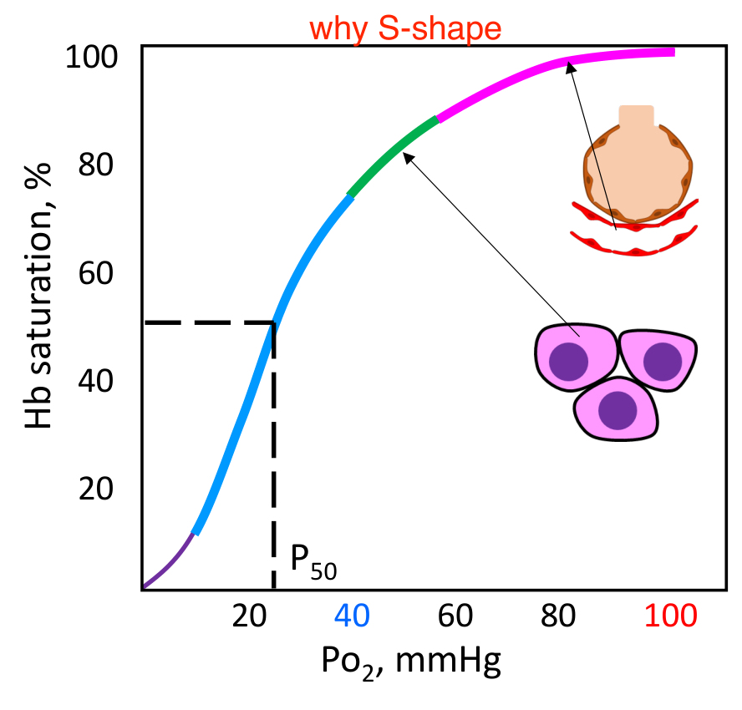  Original sigmoid O₂ curve and P₅₀ (p. 14). | 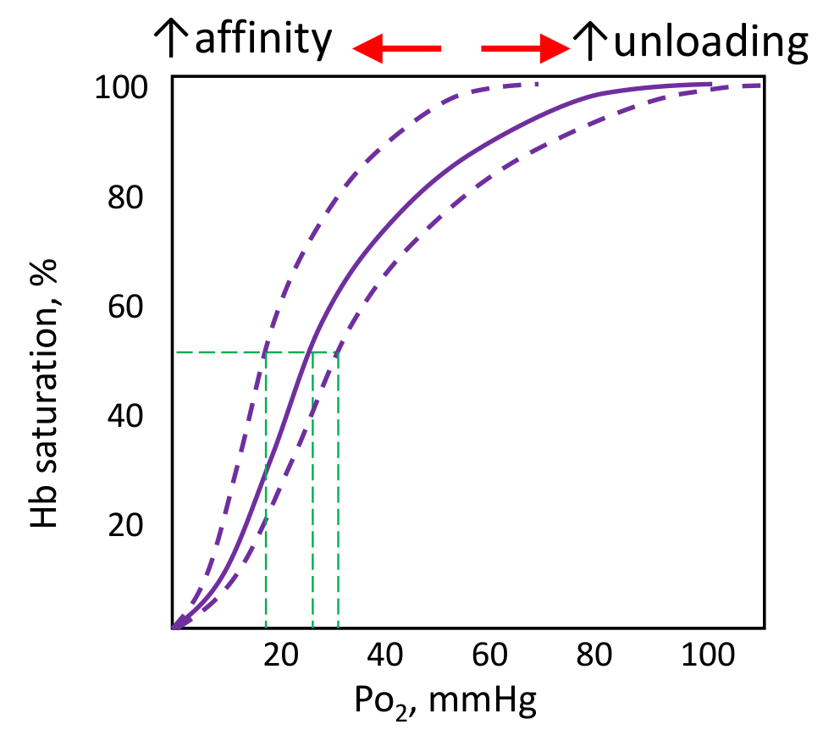  Original affinity / unloading shifts (p. 15).
Feature | Interpretation
Sigmoid shape | Positive cooperativity: binding one O₂ facilitates subsequent binding. Releasing O₂ also facilitates further unloading.
Pulmonary plateau: PO₂ ~60–100 | Moderate PO₂ falls cause relatively small saturation changes. Typical arterial point: PaO₂ ~100 mmHg, SaO₂ ~98%.
Middle region: PO₂ ~40–60 | Steeper than the plateau; decreasing PO₂ promotes O₂ unloading.
Steep lower region: PO₂ ~15–40 | A small PO₂ fall can release substantial O₂. Typical resting mixed venous point: PvO₂ ~40 mmHg, SvO₂ ~75%.
P₅₀ normally ~26.5 mmHg | PO₂ needed for 50% saturation; higher P₅₀ means lower affinity.
Right / left shift | Right: P₅₀ ↑, affinity ↓, easier unloading. Left: the reverse. Compare at the same PO₂.

Checked P₅₀ completions | The source lists options, not completed answers
P₅₀ increased → affinity decreased → easier unloading.
P₅₀ decreased → affinity increased → harder unloading.
P₅₀ is a pressure at 50% saturation, not a percentage of the normal PO₂.

09 / Curve shifts: factors and mechanisms
Lecture PDF p. 16 | Original annotated table preserved with corrections below
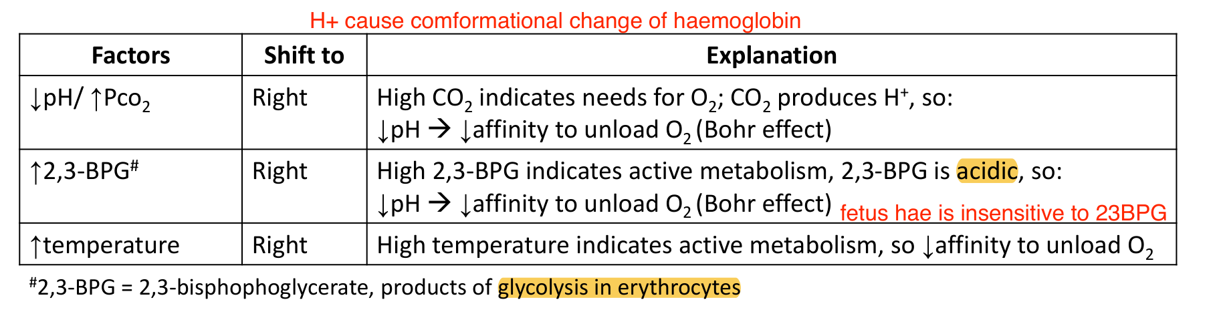
Source retained for comparison: the BPG mechanism and HbF annotation need correction (lecture p. 16).
Change | Shift / mechanism | Physiological meaning
PCO₂ ↑ / pH ↓ | Right; H⁺ changes Hb conformation and lowers O₂ affinity (Bohr). | Working tissues generate CO₂/H⁺, favouring unloading.
Temperature ↑ | Right; lower O₂ affinity. | Warm, metabolically active tissue can receive more O₂.
2,3-BPG ↑ | Right; binds deoxyHb and stabilises the T state. | 2,3-bisphosphoglycerate is a product of RBC glycolysis.
Opposite changes | Generally shift left: affinity ↑, P₅₀ ↓. | Facilitates binding at the same PO₂ but makes unloading harder.

CORRECTION | Right-shift direction is correct; the BPG explanation is not
• 2,3-BPG stabilises deoxyHb in the T state → right shift; it is not simply “acid causes Bohr effect”.
• [Extension] HbF binds 2,3-BPG less strongly → higher O₂ affinity; not complete insensitivity.

Use exercise to reconstruct the logic
Metabolic demand ↑ → CO₂/H⁺ and temperature ↑ → Hb affinity ↓ → right shift
→ more unloading at the same tissue PO₂. A shift describes affinity, not a change in Hb concentration.

10 / Curve applications: lung loading and CO
Lecture PDF pp. 14–16 | Tutorial Q5, Q10 | CO-specific mechanisms are extensions

Tutorial Q5 · Original tutorial question
A right shift of the oxygen dissociation curve reduces oxygen uptake by the lungs.
Condition-dependent | Specify pulmonary PO₂
At fixed PO₂, a right shift lowers saturation and can reduce loading.
On the normal pulmonary plateau, a moderate shift usually has a small loading penalty; enhanced tissue unloading is more prominent. At lower alveolar PO₂, the penalty matters more.
Do not claim “right shifts never reduce loading”. An unconditional T/F answer needs an assumed PO₂ and shift magnitude; no official key was supplied.

Tutorial Q10 · Original tutorial question
Carbon monoxide poisoning competes with O2 to bind to Hb. Therefore, it decreases Hb saturation and Hb affinity for O2.
False | The affinity direction is reversed
CO occupies heme sites → fewer sites available for O₂ → effective capacity and CaO₂ ↓.
Remaining available sites bind O₂ more strongly → left shift → impaired tissue unloading.
The combined problem is reduced carriage plus impaired release, not reduced affinity.

Measurement | Why it can mislead in CO poisoning
PaO₂ | May be normal: it measures dissolved O₂, not CO occupancy of Hb.
Conventional SpO₂ | Can appear normal/high; standard two-wavelength instruments cannot reliably distinguish COHb.
O₂ saturation | Functional and fractional saturation differ with COHb; a reassuring number does not guarantee normal CaO₂.

Connection to Q3: neither normal PaO₂ nor a normal-looking pulse-oximeter reading establishes adequate O₂ content or delivery.

11 / CO₂ forms and carbonic anhydrase
Lecture PDF p. 17 | Tutorial Q12 partly overlaps; renal drug mechanism is an extension
Form | Approximate share | Key point
Dissolved CO₂ | 7% | Determines blood PCO₂.
Carbamino-Hb: HbCO₂ | 23% | CO₂ binds globin amino groups, not heme iron.
Bicarbonate: HCO₃⁻ | 70% | Formed rapidly in RBCs; much is transported in plasma.

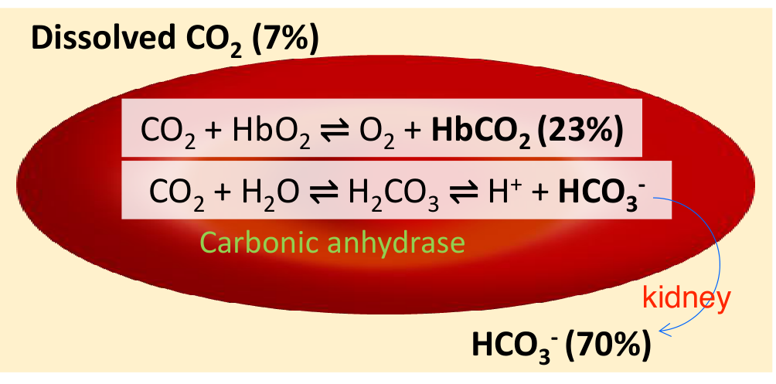
Original CO₂ forms (lecture p. 17); “kidney” is a link to acid–base regulation, not the route of CO₂ elimination.
Reversible reaction
CO₂ + H₂O ⇌ H₂CO₃ ⇌ H⁺ + HCO₃⁻.
Carbonic anhydrase accelerates reversible hydration/dehydration; it does not change the equilibrium constant.

• Carbamino-Hb = CO₂ bound to globin. Carboxy-Hb = CO bound to heme; the latter impairs O₂ transport.

Tutorial Q12 · Original tutorial question
Carbonic anhydrase inhibitor stimulates hyperventilation by promoting bicarbonate ion excretion.
True | Primarily a renal mechanism [Extension]
Acetazolamide → renal tubular CA inhibition → HCO₃⁻ reabsorption ↓ → urinary HCO₃⁻ loss ↑
→ metabolic acidosis → ventilatory drive ↑. At altitude, this can reduce the inhibitory effect of respiratory alkalosis.
The explanation is renal bicarbonate loss, not increased RBC CO₂ production.

12 / CO₂ exchange: Bohr versus Haldane
Lecture PDF pp. 16–18
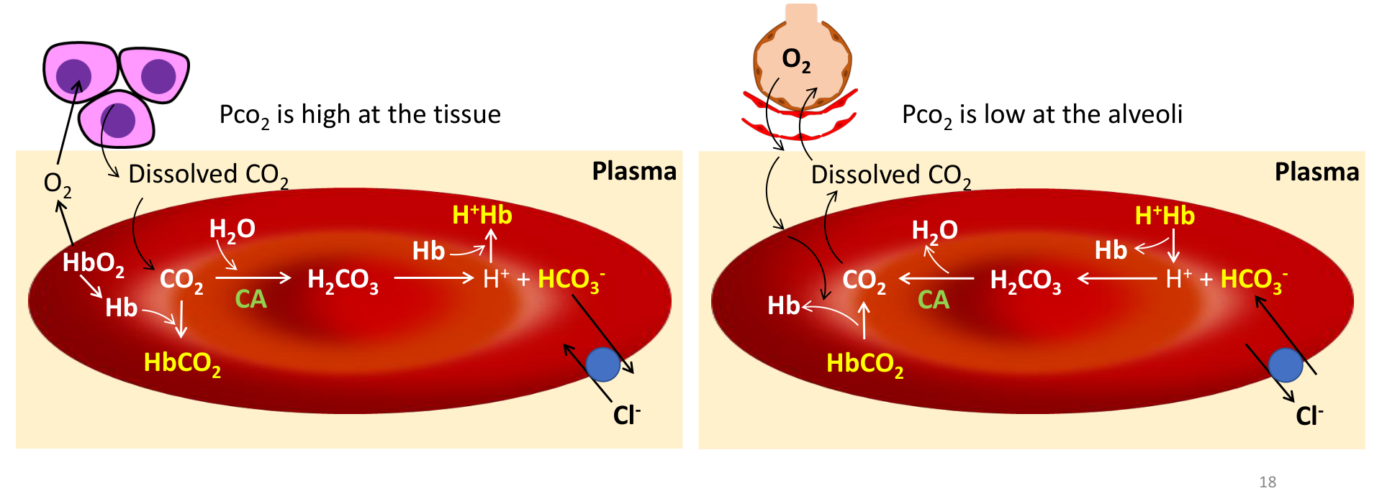
Original tissue end (left) and pulmonary end (right), lecture p. 18.
Process | Tissue capillaries | Pulmonary capillaries
CO₂ gradient | High tissue PCO₂ → CO₂ enters blood/RBC. | Lower alveolar PCO₂ → CO₂ leaves blood.
CA reaction | CO₂ + H₂O → H⁺ + HCO₃⁻. | H⁺ + HCO₃⁻ → CO₂ + H₂O.
Hb buffering | DeoxyHb binds H⁺ more readily. | Hb oxygenation promotes H⁺ release.
Chloride shift | HCO₃⁻ out of RBC; Cl⁻ in. | HCO₃⁻ into RBC; Cl⁻ out. The exchange preserves electroneutrality.
Carbamino transport | DeoxyHb favours CO₂ binding. | Oxygenation favours CO₂ release.

Name the effect by its input → output
Bohr: CO₂ / H⁺ ↑ → O₂ affinity ↓ → tissue O₂ unloading.
Haldane: Hb deoxygenation → greater CO₂/H⁺ binding; oxygenation → CO₂ unloading.
They cooperate at tissues and lungs, but describe different causal directions.

Integrated practice 2 | Self-written; not an original exam question
At the same PCO₂, oxygenated blood carries less total CO₂ than deoxygenated blood. Explain why this does not contradict Henry’s law, and predict the pulmonary chloride shift.
Reasoning: Henry fixes only dissolved CO₂ at fixed α and PCO₂. Oxygenation releases CO₂ from Hb and H⁺ that converts HCO₃⁻ to CO₂. Total CO₂ falls only if CO₂ can leave while the blood re-equilibrates; conversion alone does not remove CO₂ from sealed blood. In lungs, HCO₃⁻ enters RBCs while Cl⁻ leaves; lower alveolar PCO₂ drives CO₂ out. Oxygenation facilitates release, not the pressure gradient itself.

