01 / One system: what is being kept stable?
Source: correct RENAL lecture, PDF pp. 5–47
The complete control loop
DISTURBANCE → SENSORS → BRAIN / KIDNEY INTEGRATION
→ VP + RAAS + sympathetic output + THIRST
→ renal water / Na⁺ / K⁺ handling + vessel tone + drinking
→ correction of osmolality, circulating volume and pressure
→ reduced initiating stimulus: NEGATIVE FEEDBACK.

Regulated variable | Main control and physiological purpose
Water relative to solute | Osmoreceptors → VP + thirst. Preserve extracellular tonicity and cell volume.
Effective circulating volume / arterial pressure | Cardiac / arterial stretch inputs + renal perfusion → sympathetic activity, VP and RAAS. Preserve tissue perfusion.
Total-body Na⁺ and ECF volume | Renin → ANGII → aldosterone → distal Na⁺ retention. Associated water retention supports ECF volume.
K⁺ balance | Aldosterone-sensitive distal K⁺ secretion. Preserve membrane excitability and cardiac conduction.
Urine concentration | Loop-built gradient + vasa-recta preservation + urea handling + VP-controlled water permeability.

Use this document in three passes
Pass | Pages and purpose
1. Compare | 2–3: distinguish variables and memorise hormone production / release / action sites.
2. Explain | 4–15: trace each sensor, receptor, cellular mechanism, target and feedback loop.
3. Integrate | 16–20: compare disturbances, interpret classroom cases and locate failures. 21–23: quick comparison, glossary and source audit.

Source and scope
Uses BBMS2006 (Renal - student version) (1).pdf, Dr J Chu, 47 PDF pages, plus your renal classroom photographs. This is a consolidated companion to the detailed lecture notes. Original mechanism figures are retained at the relevant topics. [Extension] marks supporting physiology beyond explicit slide text; source claims needing qualification are identified beside the mechanism.

02 / Keep concentration, content and volume separate
Source: correct RENAL lecture, PDF pp. 17–19, 23, 47
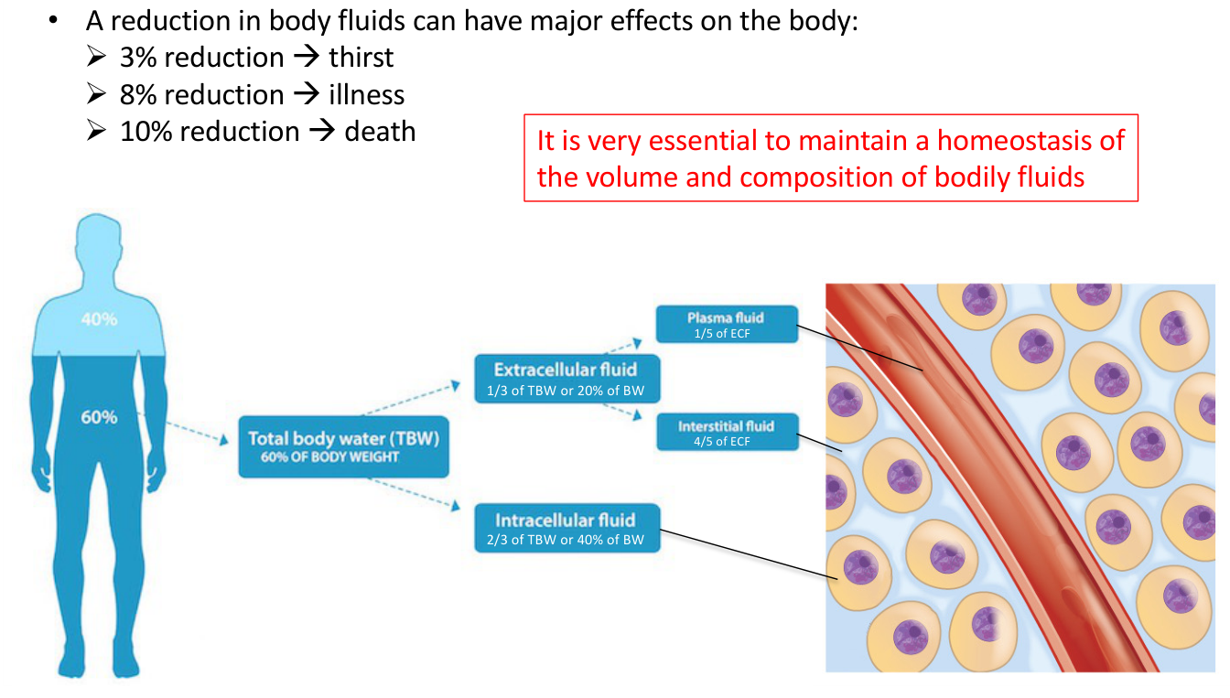  Original lecture figure, PDF p. 17. | 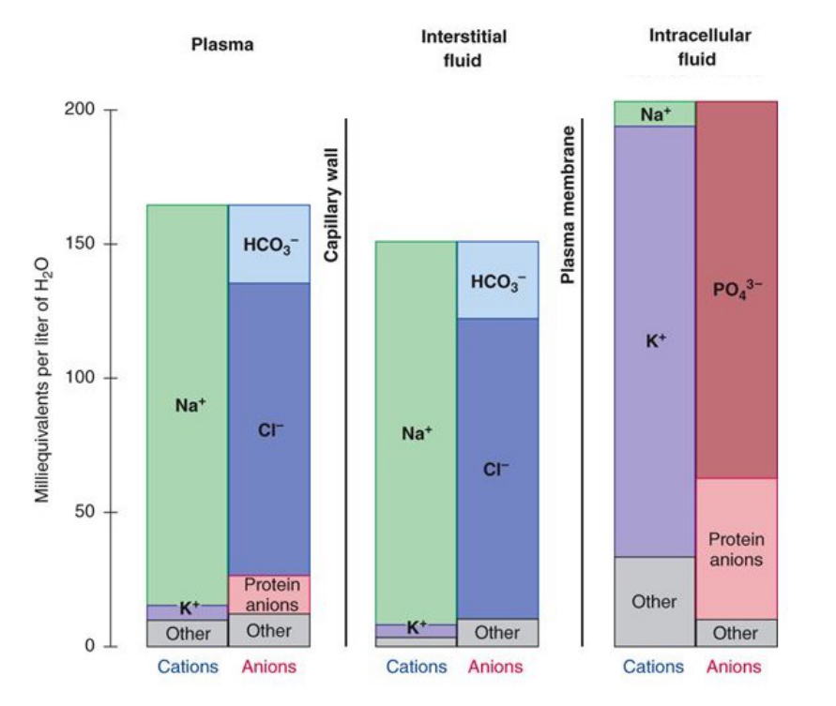  Original lecture figure, PDF p. 18.
Variable / compartment | Definition, reference and significance
Body-fluid distribution | Adult teaching model: TBW ≈60% body weight. ICF = 2/3 TBW ≈40% body weight; ECF = 1/3 TBW ≈20% body weight.
ECF subdivisions | Plasma = 1/5 ECF ≈4% body weight; interstitial fluid = 4/5 ECF ≈16% body weight. These are approximate fractions, not fixed for everyone.
Main ions | ECF: Na⁺, Cl⁻, HCO₃⁻. ICF: K⁺, phosphate and protein anions. Plasma has much more protein than interstitial fluid.
Osmolality / osmolarity | Particles per kg WATER: mOsm/kg H₂O / per litre SOLUTION: mOsm/L. Numerically close in dilute body fluids. High value = more particles relative to water.
Tonicity [Extension] | Cell-volume effect of effectively non-penetrating osmoles. Urea contributes to measured osmolality but is a less effective sustained osmole across many cell membranes.
Na⁺ concentration versus content | Plasma [Na⁺] reflects water relative to exchangeable solute. Total-body Na⁺ strongly influences ECF volume. Na⁺ retention does not require marked hypernatraemia.
Pressure versus volume | BP also depends on cardiac output and vascular resistance. Low volume often lowers BP, but they are not interchangeable variables.

The intracellular environment is the ultimate target
Source buffering sequence: plasma → interstitial fluid → intracellular fluid; fluctuations are dampened across these compartments. Physiological and behavioural responses then restore balance.

Source correction: osmolality is a CONCENTRATION, not “total amount of solutes”; either solute or water changes can alter it. Its 70%-water cartoon is qualitative, not the 60%-TBW compartment calculation. The ionic chart uses mEq/L water, not osmotic units. Source loss figures 3% → thirst, 8% → illness, 10% → death illustrate severity; the denominator is unclear and outcomes are not universal thresholds.

03 / Hormone atlas: origin, release and target
Source: correct RENAL lecture, PDF pp. 20–22, 33–38, 42
Signal | Production / release site | Main target and action
VP / ADH / AVP | Synthesised by MAGNOCELLULAR neurons in hypothalamic PVN and SON. Axonal transport → stored / released at POSTERIOR PITUITARY terminals. | Blood-side V₂ on collecting-duct cells → AQP2 and IMCD urea handling. V₁a on vessels → contraction. Lecture also gives a macula-densa V₁a route.
Renin | Juxtaglomerular GRANULAR cells, chiefly in afferent-arteriolar wall; released into blood. | Enzyme acting on circulating angiotensinogen → angiotensin I. Renin is not made by macula-densa cells.
Angiotensinogen | LIVER → blood [Extension clarifies source shown in integrated diagram]. | Circulating substrate for renin; not a receptor or an enzyme.
ACE | Vascular endothelial surface; prominent in pulmonary circulation, also other vascular beds [Extension]. | Converts angiotensin I → angiotensin II. ANGII is formed enzymatically, not released from one dedicated endocrine gland.
ANGII | Generated by the renin–ACE cascade in circulation / tissues. | AT₁: adrenal cortex, vessels, SFO / OVLT. Four outputs: aldosterone, thirst, VP secretion, vasoconstriction.
Aldosterone | ADRENAL CORTEX; zona glomerulosa [Extension]. Synthesised and secreted into blood. | Intracellular MR in aldosterone-sensitive distal nephron → gene expression → ENaC, Na⁺/K⁺-ATPase and ROMK. Retain Na⁺; secrete K⁺.

Neural output and behaviour are also effectors
• Sympathetic neurons: autonomic output to vessels / heart / kidney; not a hormone released from the posterior pituitary.
• Thirst: conscious urge to drink, generated through brain circuits. It supplies NEW water; VP conserves water already in the body.
Do not merge neighbouring sites
PVN / SON MAKE VP; posterior pituitary RELEASES it.
Macula densa SENSES / SIGNALS; JG granular cells RELEASE renin.
Adrenal cortex MAKES aldosterone; distal nephron RESPONDS to it.

04 / Osmotic sensing: water change becomes firing
Source: correct RENAL lecture, PDF pp. 23–25
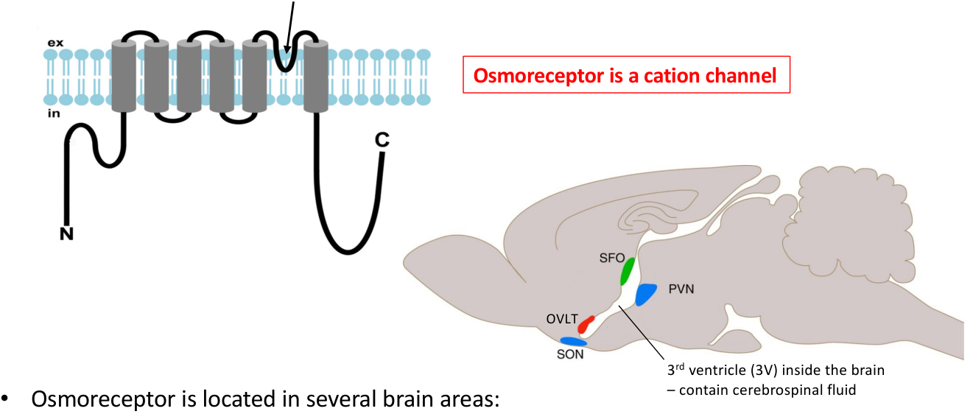  Original lecture figure, PDF p. 24. | 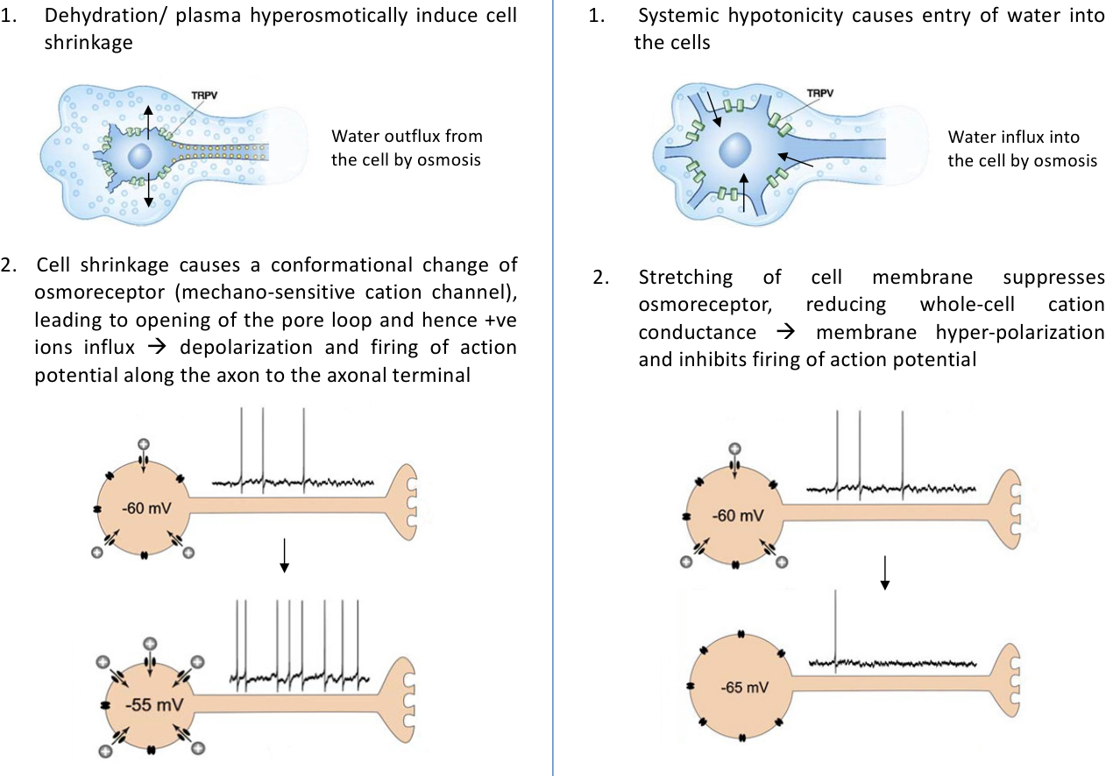  Original lecture figure, PDF p. 25.
Stage / location | Hyperosmotic state | Hypo-osmotic state
Initial disturbance | Water deficit relative to effective solutes; extracellular tonicity rises. | Water excess relative to effective solutes; extracellular tonicity falls.
Osmosensitive neurons | Water leaves cell → cell shrinks. | Water enters cell → cell swells.
Source channel model | Shrinkage changes mechanosensitive TRPV-related cation-channel conductance → cation influx ↑. | Swelling suppresses whole-cell cation conductance.
Electrical effect | Depolarisation; figure ~−60 toward −55 mV → action-potential firing ↑. | Hyperpolarisation → action-potential firing ↓.
Integrated output | Magnocellular PVN / SON activity ↑ → posterior-pituitary VP ↑; thirst also recruited. | Osmotic VP drive ↓ → less collecting-duct water permeability → more dilute urine.

Where is the stimulus detected?
OVLT + SFO are sensory circumventricular organs (CVOs), with a weak / absent conventional blood–brain barrier → access to circulating osmotic and hormonal information.
PVN / SON neurons also have intrinsic osmosensitivity. SFO / OVLT relay through MnPO to hypothalamic output neurons.

Source sensitivity: an osmolality change as small as ~1% can significantly change VP. TRPV = transient receptor potential vanilloid; the pore loop conducts cations in the teaching model. PVN / SON are not all “CVOs without a BBB”. 3V in the source = third ventricle, containing CSF. [Extension] Cell-volume responses depend on effective osmoles, not every solute that raises measured osmolality.

05 / Volume and pressure: two similar sensor routes
Source: correct RENAL lecture, PDF pp. 26–30
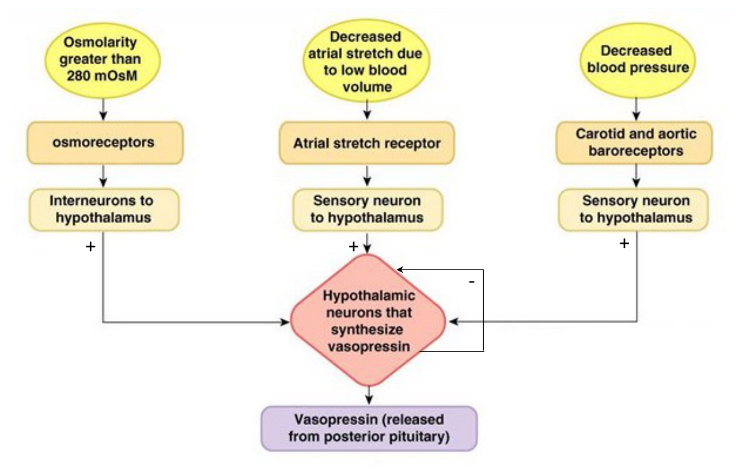
Original lecture image, including visible teaching annotations (PDF p. 30).
Feature | Low-pressure / volume pathway | High-pressure / arterial pathway
Sensor location | Left atrial stretch receptors; cardiopulmonary low-pressure receptors. | Carotid SINUS and aortic ARCH baroreceptors.
What is physically sensed? | Wall stretch reflecting cardiac filling. | Arterial-wall stretch reflecting pressure.
Trigger for VP increase | Blood volume / atrial filling ↓ → atrial stretch ↓. | Arterial pressure ↓ → arterial stretch ↓.
Afferent firing | DECREASES: unloading removes inhibitory input to VP pathways. | DECREASES: unloading reduces NTS–CVLM inhibition of RVLM.
Path toward brain | Predominantly vagal cardiopulmonary afferents [Extension]. The middle slide is a simplified net-effect pathway. | Carotid sinus → CN IX; aortic arch → CN X → NTS → CVLM / RVLM.
Common output | Less restraint on magnocellular PVN / SON → VP ↑ → renal water conservation. | Same net water-conserving output; also sympathetic cardiovascular responses.

Your comparison is correct
Both are stretch-receptor UNLOADING pathways. The difference is LOCATION and the physiological signal: filling / volume versus arterial pressure. “Baroreceptor decreases” should mean FIRING decreases, not fewer receptors. A fall in blood volume can activate both routes.

The source haemodynamic VP response is exponential: initially small, then much larger after volume / pressure declines by roughly >8% in its schematic. This is not a universal exact switch. Diagram “+” means the overall low-volume / low-pressure condition promotes VP; it does NOT mean receptor firing rises during unloading.

06 / Baroreflex signs, cardiovascular output and cuffs
Source: correct RENAL lecture, PDF pp. 27–29 | Classroom Photos 1–2 and Activity 4
Pressure falls: trace every sign
Arterial stretch ↓ → CN IX / X afferent firing ↓ → NTS activity ↓
→ CVLM activity ↓ → INHIBITION of RVLM ↓ → RVLM disinhibited ↑
→ excitatory drive to PVN / SON ↑ → posterior-pituitary VP ↑.
RVLM also promotes sympathetic outflow → vessels / heart / kidney.

Connection / site | Sign or consequence
NTS → CVLM | EXCITATORY. Both are medullary integration regions.
CVLM → RVLM | INHIBITORY. Less CVLM activity means less braking of RVLM.
RVLM → hypothalamic VP circuit | EXCITATORY in this lecture’s simplified model. Actual hypothalamic control has additional connections.
Pressure rises: reverse sequence | Baroreceptor firing ↑ → NTS / CVLM ↑ → RVLM inhibited → sympathetic / non-osmotic VP drive ↓.
Classroom cardiovascular supplement | Sympathetic vascular tone ↓ → vasodilation. Cardiac sympathetic drive ↓ → contractility ↓. Cardiac parasympathetic activity ↑ → reduced pacemaker funny-current drive, heart rate ↓ and conduction ↓. CO = HR × SV; CO and resistance fall → BP tends to fall.
Renal outcome of lower VP | AQP2-dependent water reabsorption ↓ → more dilute, larger-volume urine → blood volume tends to fall, after the renal response develops.

Activity 4 + vagotomy | Classroom question
Bilateral carotid occlusion using pneumatic cuffs: what happens to urine output? What if vagotomy is then performed?
Answer approach:
Photo answer ASSUMES aortic-pressure rise dominates: aortic baroreceptor firing ↑ via CN X → VP ↓ → urine flow ↑. Vagotomy removes this aortic inhibitory input → VP can rise and urine flow fall relative to that state.
But cuffs BELOW carotid sinuses lower sinus pressure: CN IX firing ↓ → sympathetic / VP drive ↑. Aortic feedback opposes it. Net output depends on cuff location and measured pressures; carotid occlusion does not invariably cause diuresis. CN IX remains intact after vagotomy.

Carotid BODY / aortic bodies are principally chemoreceptors; carotid SINUS / aortic ARCH contain the pressure receptors discussed here. NTS is a component of the medullary cardiovascular network, not its entire control centre. Source “no VP” at normal / high BP means inhibition of this drive, not obligatory absence of basal osmoregulated secretion.

07 / VP: synthesis, release, thresholds and stopping
Source: correct RENAL lecture, PDF pp. 20–22, 26, 31–32
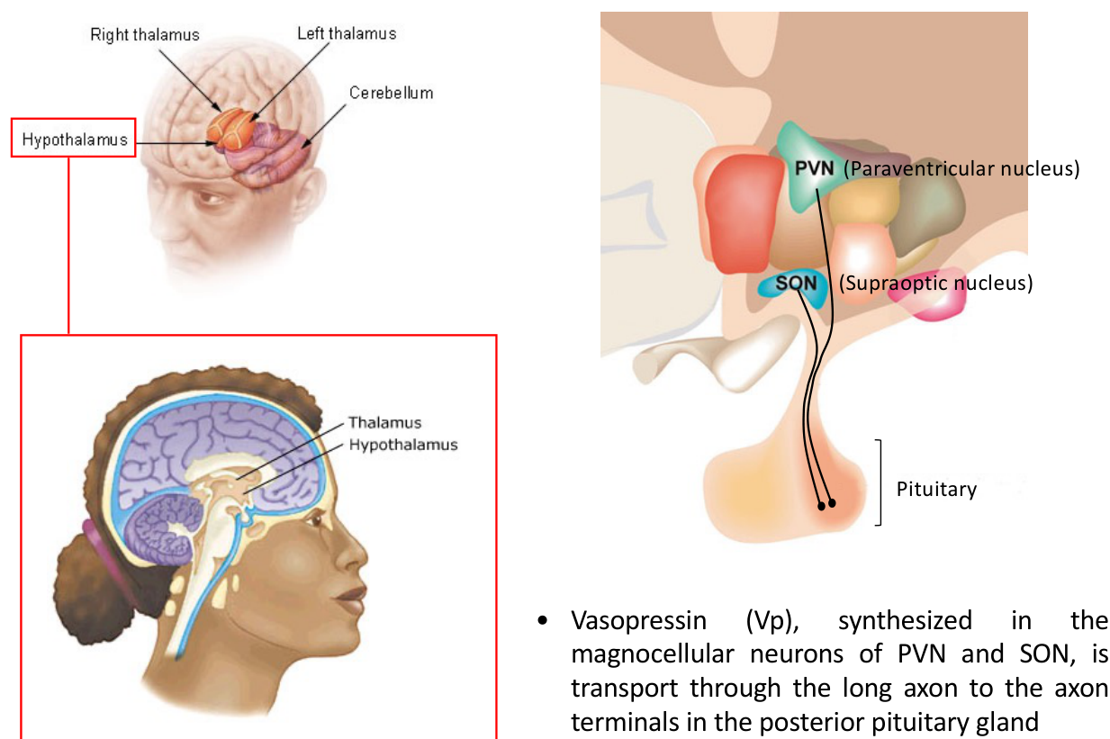  Original lecture figure, PDF p. 20. | 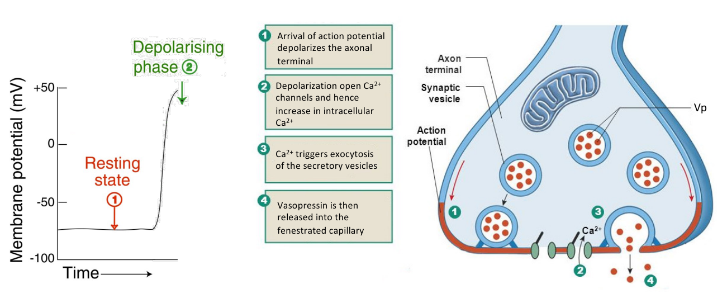  Original lecture figure, PDF p. 22.
Step / location | Mechanism
1. Make and transport | Magnocellular cell bodies in PVN / SON synthesise VP → packaged vesicles → long axons to posterior pituitary.
2. Store | Vesicles accumulate in axons / terminals. Herring bodies are neurosecretory axonal swellings containing granules; not the name of each single vesicle.
3. Activate neuron | Integrated osmotic / haemodynamic / ANGII inputs change firing at the cell body.
4. Release at terminal | Action potential → terminal depolarisation → voltage-dependent Ca²⁺ channels open → intracellular Ca²⁺ ↑ → vesicle exocytosis → VP enters fenestrated capillaries.
5. Reach effectors | Blood-borne VP reaches kidney V₂ and vascular V₁a receptors. Renal water conservation and, at higher levels, vascular actions support homeostasis.
6. Reduce the stimulus | Water retention / intake lowers high osmolality; restored filling / pressure reloads stretch receptors → non-osmotic drive falls.

Lecture reference | How to interpret it
~280 versus ~290 mOsm/kg | VP rises around 280; thirst around 290 in the slide. Osmotic VP control is more sensitive than the large-volume-loss response.
~5 pM VP | Renal water-retaining response approaches its schematic maximum. Additional VP rise can increasingly recruit vascular effects.

The “V₂ only / V₁a starts” graph is schematic, not absolute receptor exclusivity at one universal plasma concentration. [Extension] Severe volume depletion can drive VP despite low osmolality; pressure and osmotic thresholds are not independent rigid switches. Thirst and renal retention add different forms of water compensation.

08 / VP at the collecting duct: V₂ → AQP2
Source: correct RENAL lecture, PDF pp. 10–12, 31 | Classroom Activity 3, water-channel branch
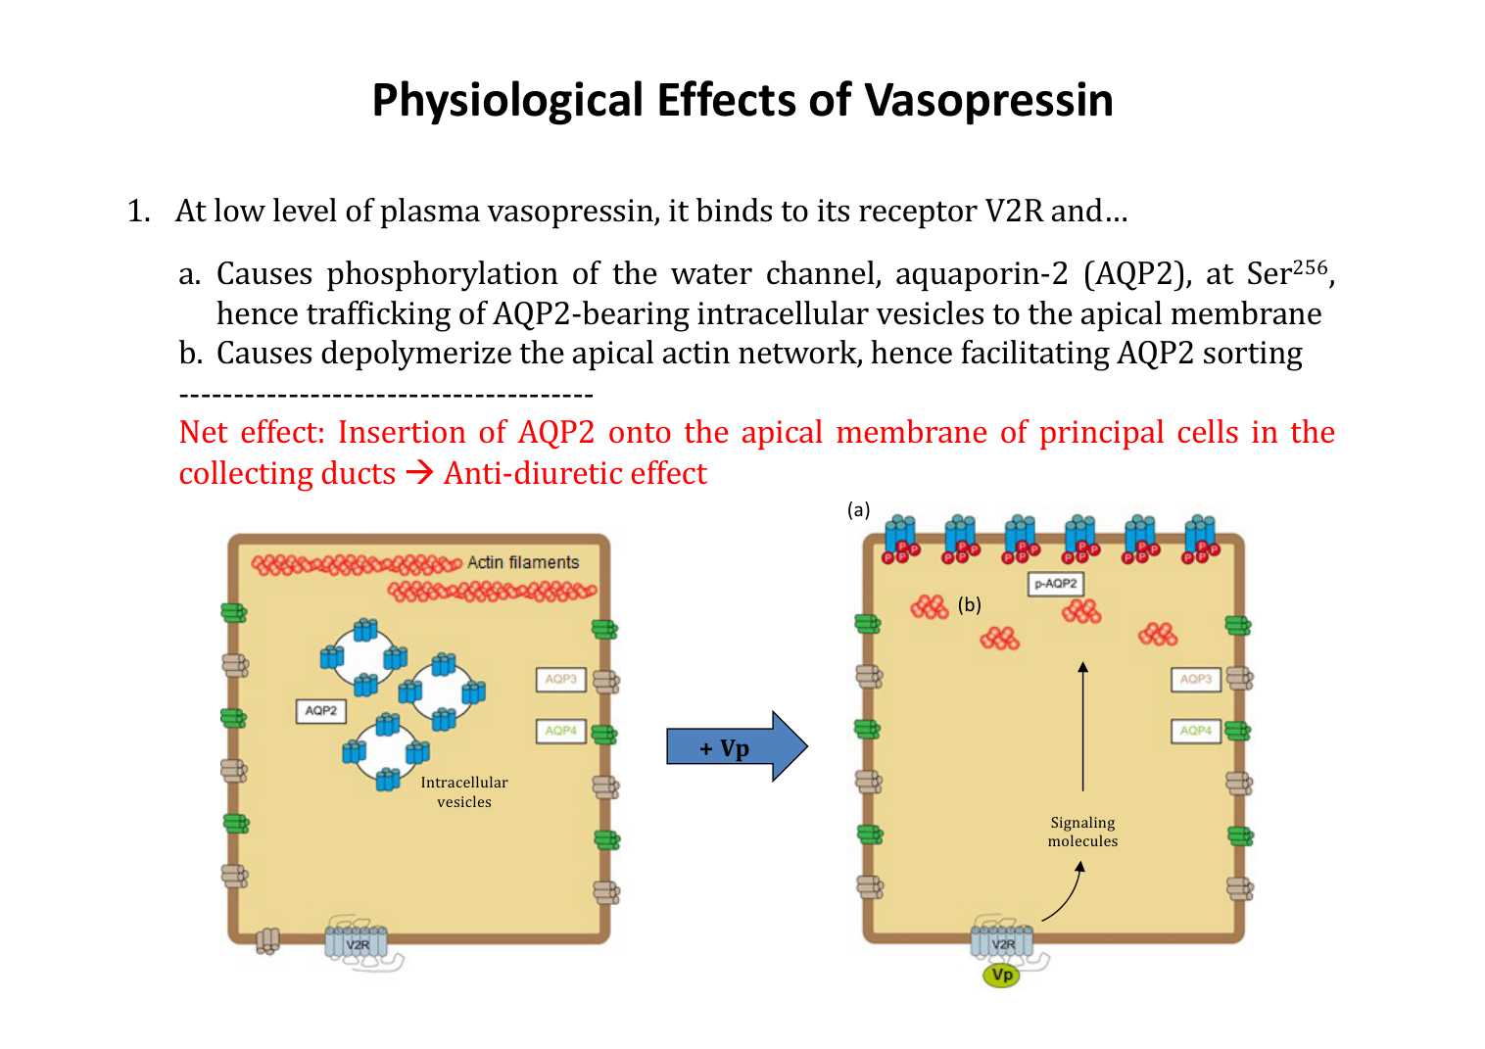
Original lecture image, including visible teaching annotations (PDF p. 31).
Where / step | Detailed mechanism and direction
Receptor and signal | Blood-side VP → BASOLATERAL V₂ receptor on collecting-duct principal cells → Gs → adenylyl cyclase → cAMP ↑ → PKA [signal expansion: Extension].
Water-channel trafficking | AQP2 Ser256 phosphorylation → AQP2-bearing intracellular vesicles move / fuse with APICAL membrane. Depolymerisation of the apical actin network helps sorting / delivery.
Water route | Tubular LUMEN → apical AQP2 → cell → basolateral AQP3 / AQP4 → medullary interstitium → circulation.
Driving force | Water follows an osmotic gradient; AQP2 provides permeability and does not pump water. A functioning hyperosmotic medulla is also required.
Net effect | Water reabsorption ↑ → urine volume ↓ and urine concentration ↑; body water conserved. The effect develops after signalling, not in urine already stored in the bladder.
When VP falls | [Extension] AQP2 is retrieved from apical membrane → regulated collecting-duct permeability falls → more free-water excretion. Earlier nephron water reabsorption still continues.

Activity 3 | Classroom question
A SMALL hypertonic-saline injection: what early change in urine output is expected?
Answer approach:
Intended condition: osmotic increase dominates relatively small direct volume load → osmoregulatory VP ↑ → apical AQP2 ↑ → smaller, more concentrated urine. VP also increases IMCD UT-A1-mediated urea handling (p. 10). A larger load / later natriuresis can change the balance; hypertonic saline also draws water from cells into ECF.

Source “no VP → no water reabsorption” refers to regulated collecting-duct permeability, not the whole kidney. Do not equate low urine flow with low GFR: this mechanism can reduce urine volume by changing REABSORPTION.

09 / The medullary gradient: generating the force
Source: correct RENAL lecture, PDF pp. 3–8, 15
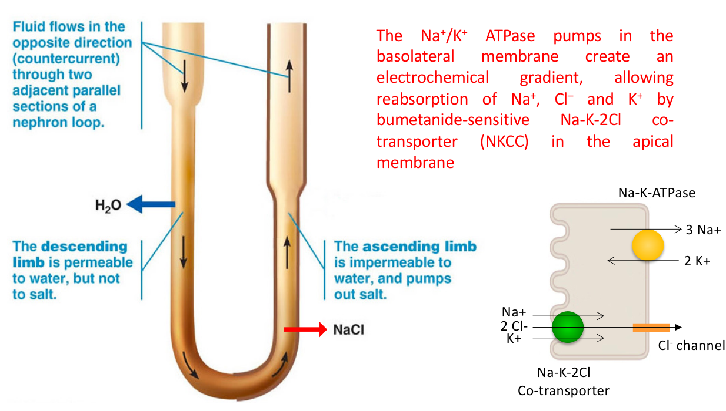  Original lecture figure, PDF p. 5. | 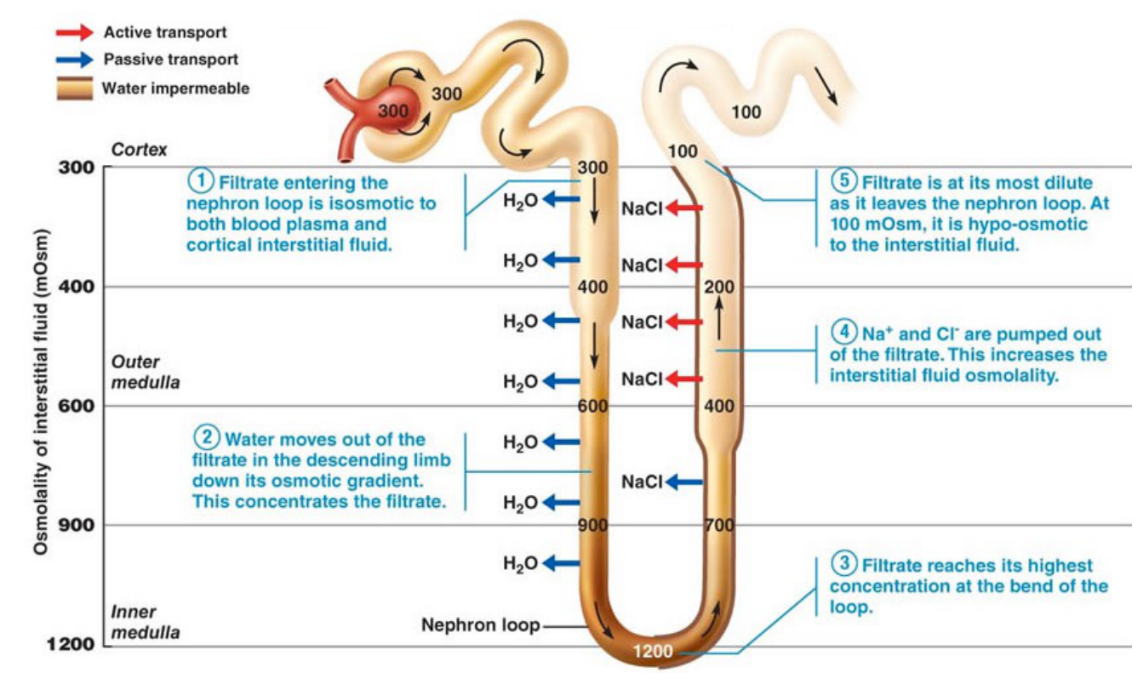  Original lecture figure, PDF p. 7.
Site / component | Mechanism and purpose
Juxtamedullary nephrons | Long loops enter deep medulla; key to the concentrating gradient. Cortical nephrons have shorter loops and peritubular capillaries; juxtamedullary efferent vessels supply vasa recta.
Descending limb | High water permeability; relatively low salt permeability in the simplified model. Hyperosmotic surroundings draw water out → tubular fluid concentrates.
Thick ascending limb: lumen side | NKCC2 cotransports 1 Na⁺ : 1 K⁺ : 2 Cl⁻ into cells. It is bumetanide-sensitive and SECONDARY active, not a channel or an ATPase.
Thick ascending limb: blood side | Na⁺/K⁺-ATPase uses ATP: 3 Na⁺ out / 2 K⁺ in → low intracellular Na⁺ supports NKCC2. Cl⁻ exits basolaterally. Low water permeability prevents water from following salt.
Multiplication | Salt removal → interstitial osmolality ↑ → descending water loss → concentrated fluid reaches ascending limb. Repeated single effects + opposite flow build the long-axis gradient.
Concentrate THEN dilute | Source teaching values: entering ~300 → deepest loop ~1200 → exiting loop ~100 mOsm. Longer loop permits a larger axial gradient; these are state-dependent examples.

What VP can and cannot supply
Gradient = osmotic driving force. AQP2 = water permeability.
Both are needed: high VP cannot fully compensate for a lost medullary gradient.
Outer medulla: mainly NaCl. Inner medulla: NaCl + urea.

Countercurrent EXCHANGE is passive transfer between opposite streams; countercurrent MULTIPLICATION uses energy and differential permeability to build a gradient. The source co-current 100/0 → 50/50 versus countercurrent ~90/5 example illustrates preserved local driving differences, not a universal numerical ratio.

10 / Vasa recta and urea: preserve and reinforce
Source: correct RENAL lecture, PDF pp. 9, 13–15 | Completes the Activity 3 answer
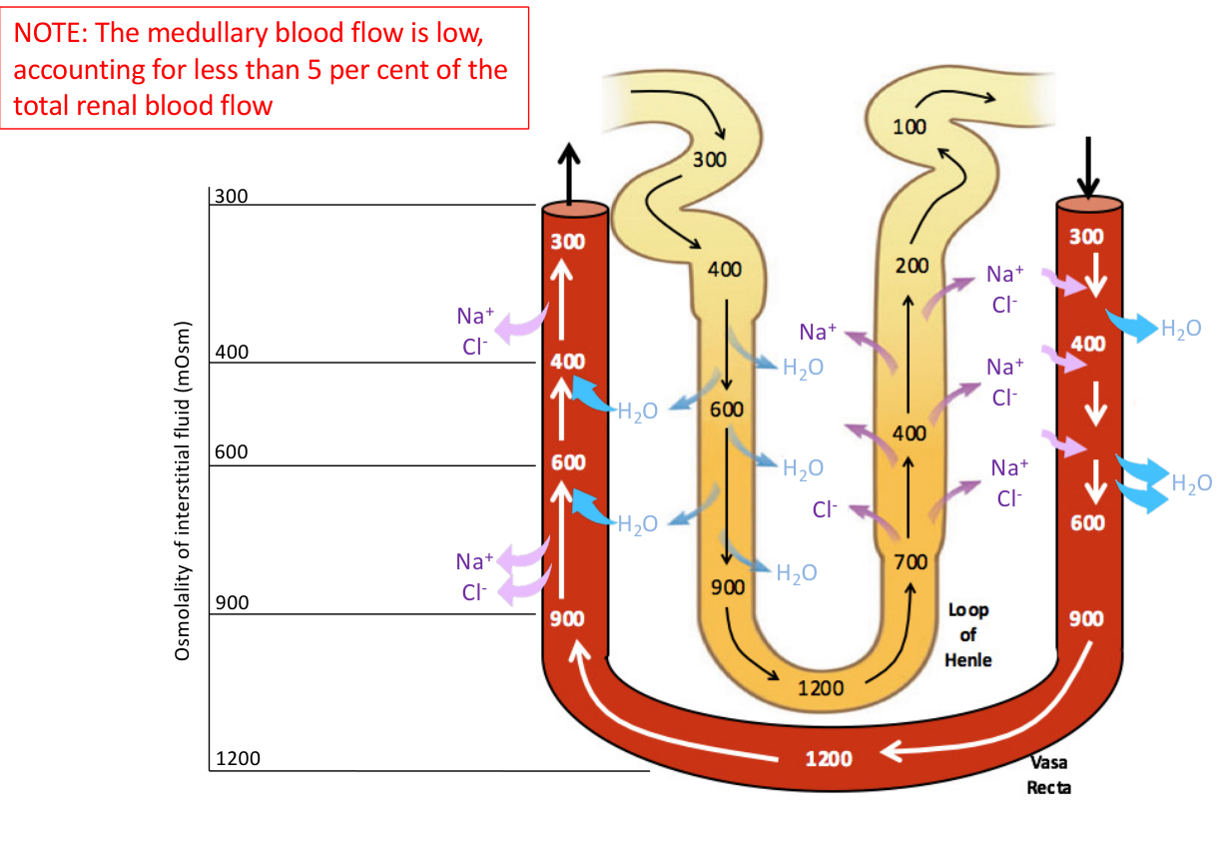  Original lecture figure, PDF p. 9. | 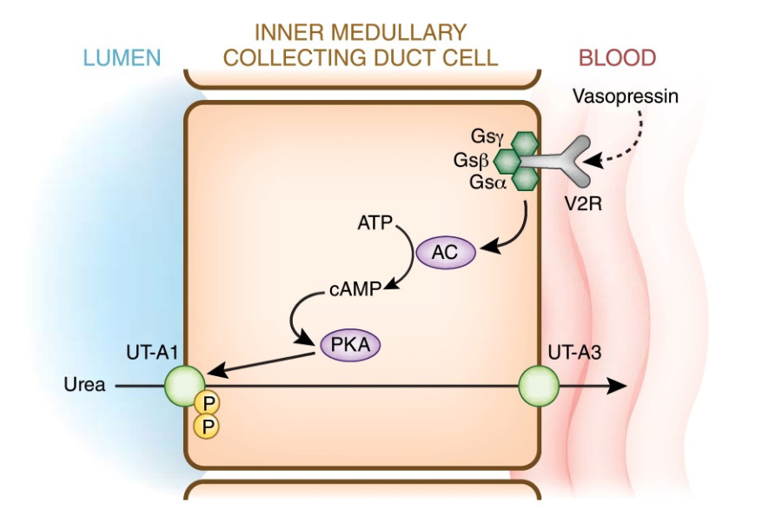  Original lecture figure, PDF p. 14.
Site / process | Mechanism and contribution
Descending vasa recta | Blood moves into increasingly concentrated medulla → water exits; solute enters blood.
Ascending vasa recta | Reverse concentration sequence → solute exits; water re-enters. Hairpin countercurrent EXCHANGE removes reabsorbed water with limited solute washout.
Low medullary flow | Source: <5% of total renal blood flow. Helps preserve the gradient; vasa recta do not generate it. Excess flow / washout can weaken concentration.
Urea origin [Extension clarifies site] | Protein nitrogen is converted to urea mainly by the LIVER. Urea is a principal nitrogenous waste; kidney eliminates it in urine. Not all filtered urea is immediately excreted.
Why urea leaves the IMCD | Water reabsorption first raises luminal urea concentration. Urea then diffuses down its gradient: lumen → APICAL UT-A1 → cell → BASOLATERAL UT-A3 → inner-medullary interstitium.
VP control of urea | VP → V₂ → Gs / AC / cAMP / PKA → UT-A1 phosphorylation and apical accumulation → IMCD urea permeability ↑ → supports high inner-medullary urea.

Your urea question: the indirect effect matters
UT-A1 transports UREA, not water. Urea leaving urine does not itself concentrate that urine: with water fixed, removing urea would LOWER its osmolality.
Urea in the MEDULLA strengthens the gradient → water can leave through AQP2 → less water remains in urine. The integrated VP response concentrates urine. Urea is recycled / partly excreted, not permanently trapped.

[Extension] Urea recycling helps maintain the inner-medullary solute pool. Its useful local medullary osmotic role differs from its relatively low sustained tonicity across many systemic cell membranes. A strong medullary gradient without AQP2, or AQP2 without a gradient, cannot produce a normal maximal concentrating response.

11 / Higher VP: vascular V₁a and a renin link
Source: correct RENAL lecture, PDF p. 33
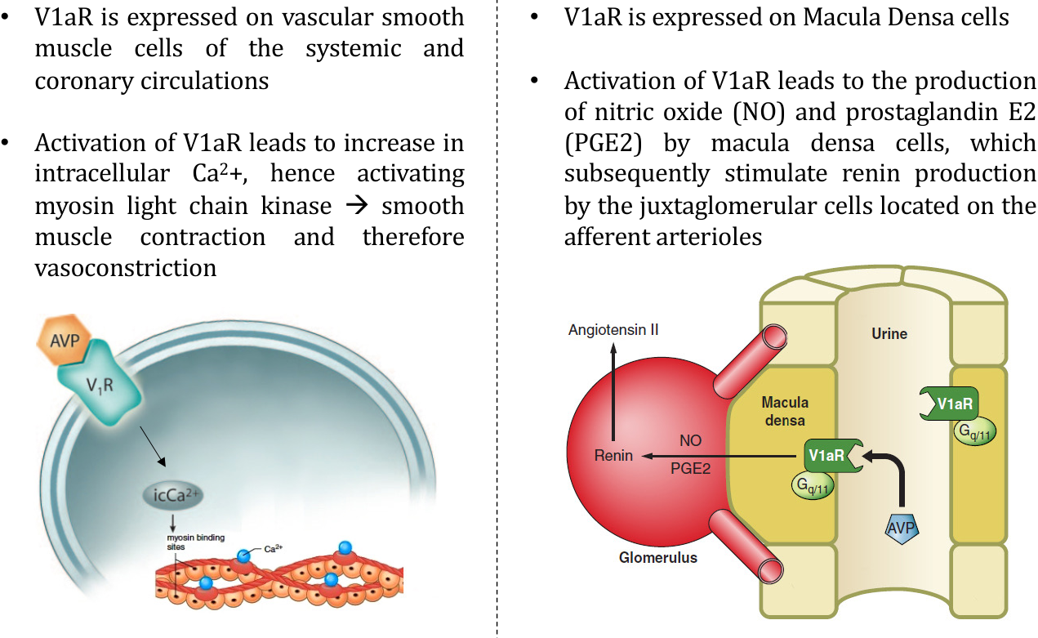
Original lecture image, including visible teaching annotations (PDF p. 33).
Branch / action site | Receptor → cell mechanism → outcome
DIRECT vascular action | V₁a on SYSTEMIC and CORONARY vascular smooth muscle → intracellular Ca²⁺ ↑ → Ca²⁺–calmodulin activates MLCK [calmodulin: Extension] → myosin-light-chain phosphorylation → contraction → vasoconstriction.
Pressure effect | Resistance-vessel contraction can increase total peripheral resistance (TPR) → supports arterial BP, especially with strong non-osmotic VP drive.
INDIRECT route in this lecture | Macula-densa V₁a → nitric oxide (NO) and prostaglandin E₂ (PGE₂) → signalling to JG granular cells in the afferent arteriole → renin production / release.
Downstream connection | Renin → ANGII → aldosterone + thirst + additional VP drive + vasoconstriction. These outputs support salt / water conservation and perfusion.
Counteracting feedback | Restored perfusion / pressure and volume reduce renin and non-osmotic VP drive. The lecture route does not mean every VP rise inevitably increases net circulating renin.

V₂ and V₁a are different outputs of the SAME hormone
V₂: collecting-duct water / urea handling → mainly antidiuresis.
V₁a: vascular smooth-muscle contraction → pressor action.
High VP CAN directly constrict vessels; aldosterone’s main acute role is distal electrolyte transport, not this V₁a–MLCK mechanism.

The macula-densa V₁a–NO/PGE₂ branch is retained as the slide’s specific mechanistic model, not asserted as a universal dominant human VP–renin response. Net renin depends on renal perfusion, NaCl delivery, sympathetic input and feedback. A macula-densa cell is distinct from a renin-secreting granular cell.

12 / RAAS: triggers, production sites and feedback
Source: correct RENAL lecture, PDF pp. 34, 41–42
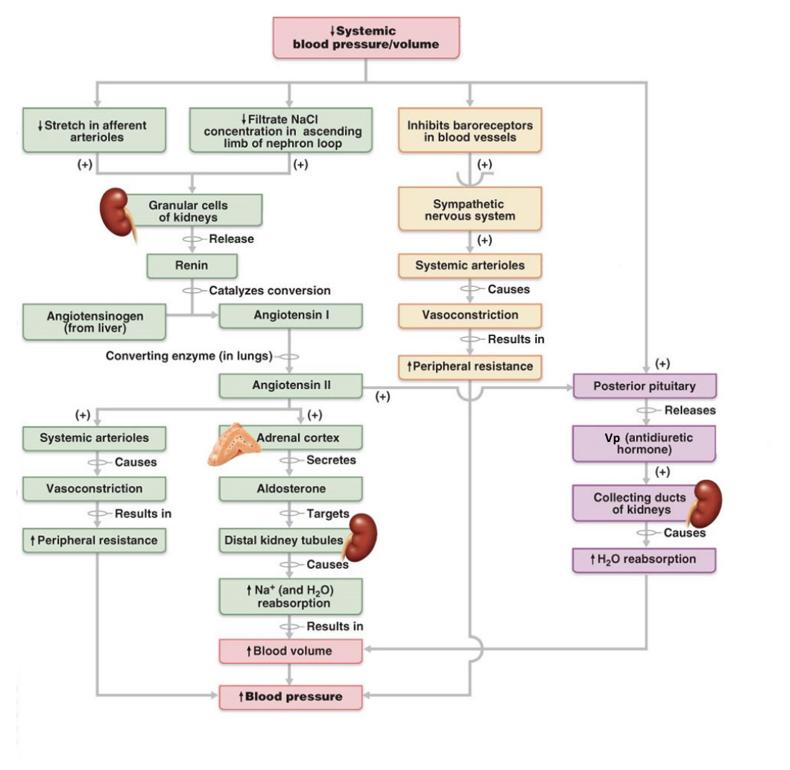
Original lecture image, including visible teaching annotations (PDF p. 42).
Trigger / source | How it stimulates the system
Renal perfusion falls | Afferent-arteriolar pressure / stretch ↓ → JG granular-cell renin release ↑.
NaCl delivery falls | Macula densa, at end of thick ascending limb / early distal tubule, senses reduced NaCl delivery → signals JG cells to increase renin. It does not itself secrete renin.
Renal sympathetic activity rises | β₁ stimulation of JG granular cells promotes renin [receptor detail: Extension].
Enzyme sequence | LIVER angiotensinogen —RENIN→ ANG I —endothelial ACE→ ANG II. ACE is prominent in lung vessels but is not restricted to lungs.

All FOUR ANGII outputs
1. ADRENAL CORTEX → ALDOSTERONE → distal Na⁺ retention / K⁺ secretion.
2. SFO / OVLT → MnPO → cortical circuits → THIRST / drinking.
3. SFO / OVLT → MnPO → magnocellular PVN / SON → VP.
4. Vascular AT₁ + central sympathetic pathways → VASOCONSTRICTION.

What stops RAAS?
Restored renal perfusion, less renal sympathetic drive and restored macula-densa NaCl delivery reduce the initiating signals. ANGII also inhibits renin through short-loop feedback [Extension].
The VP–renin–ANGII connection may reinforce a response while depleted; the whole control system is not an endless positive-feedback loop.

Purpose: preserve effective circulating volume and perfusion. Source image-only p. 42 supplies the three initiating branches. [Extension] Low macula-densa NaCl is sensed via transport-dependent signalling, including NKCC2; low plasma [Na⁺] alone is not equivalent to low NaCl delivery at this site.

13 / Aldosterone: Na⁺ retention and K⁺ secretion
Source: correct RENAL lecture, PDF p. 35 | Location and membrane direction are essential
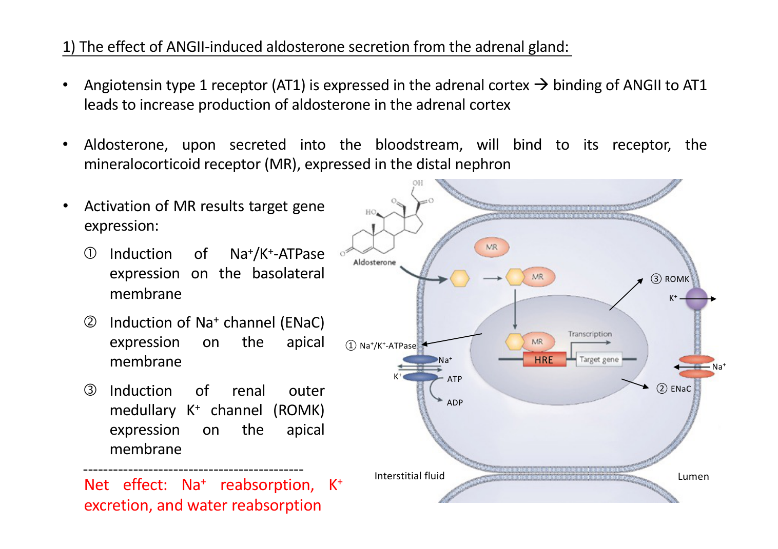
Original lecture image, including visible teaching annotations (PDF p. 35).
Stage / site | Mechanism
Production stimulus | ANGII → AT₁ on ADRENAL CORTEX → aldosterone synthesis / secretion. Zona glomerulosa is the specific layer [Extension]. High extracellular K⁺ also directly stimulates secretion [Extension].
Target receptor | Blood-borne steroid enters cells of aldosterone-sensitive distal nephron → intracellular mineralocorticoid receptor (MR) → hormone-response elements (HREs) / gene expression.
Distal target cells [Extension] | Late distal tubule, connecting tubule and collecting duct, especially principal cells for Na⁺ / K⁺ handling.
APICAL ENaC | Expression / activity ↑ → Na⁺ moves from LUMEN into cell. ENaC = epithelial sodium channel.
BASOLATERAL Na⁺/K⁺-ATPase | Expression ↑ → Na⁺ goes to INTERSTITIUM; K⁺ enters cell. ATP-dependent 3 Na⁺ out / 2 K⁺ in.
APICAL ROMK | Expression / secretory capacity ↑ → K⁺ exits cell into LUMEN → urinary K⁺ excretion ↑. ROMK = renal outer-medullary K⁺ channel.
Integrated effect | Na⁺ reabsorption ↑, K⁺ secretion ↑; associated water retention supports ECF volume / BP. K⁺ secretion also depends on distal delivery and flow [Extension].

Aldosterone does not replace VP
Aldosterone mainly changes Na⁺ / K⁺ transport through transcriptional regulation. VP rapidly changes collecting-duct WATER permeability through AQP2 trafficking. Water retention with aldosterone depends on available water and permeability; it is not an AQP2-inserting hormone.

[Extension] Aldosterone also promotes distal H⁺ secretion through intercalated-cell mechanisms; excess can favour metabolic alkalosis, deficiency metabolic acidosis. Full renal acid–base transport is not developed in this lecture. Aldosterone-related hypertension is chiefly an ECF-volume effect, not necessarily hypernatraemia.

14 / Thirst and ANGII-induced VP: two brain outputs
Source: correct RENAL lecture, PDF pp. 32, 36–37
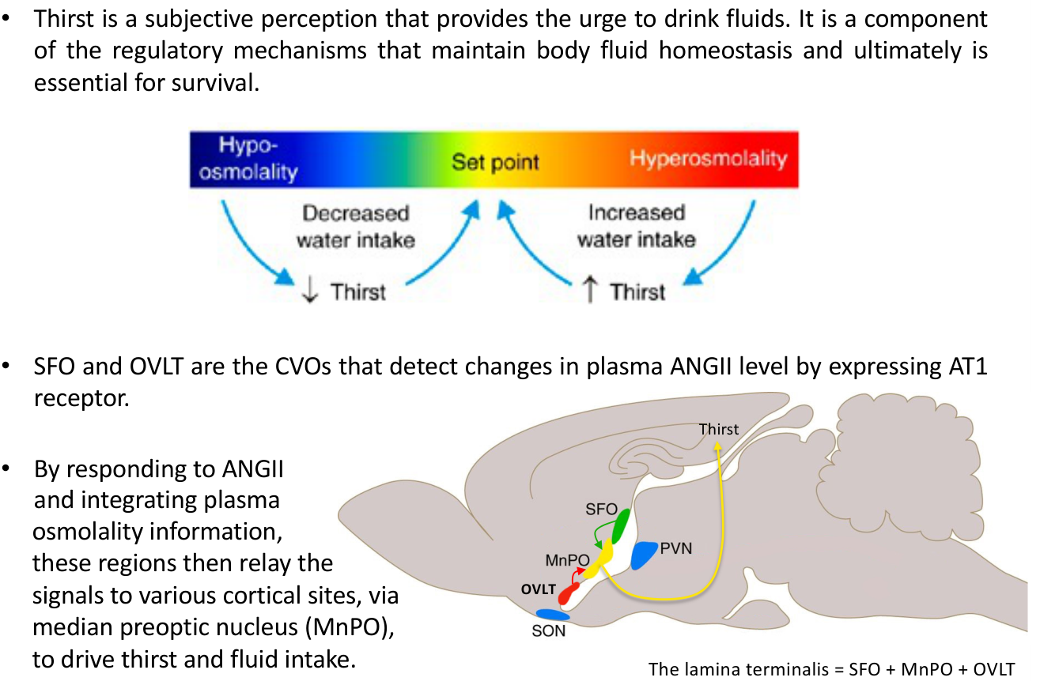  Original lecture figure, PDF p. 36. | 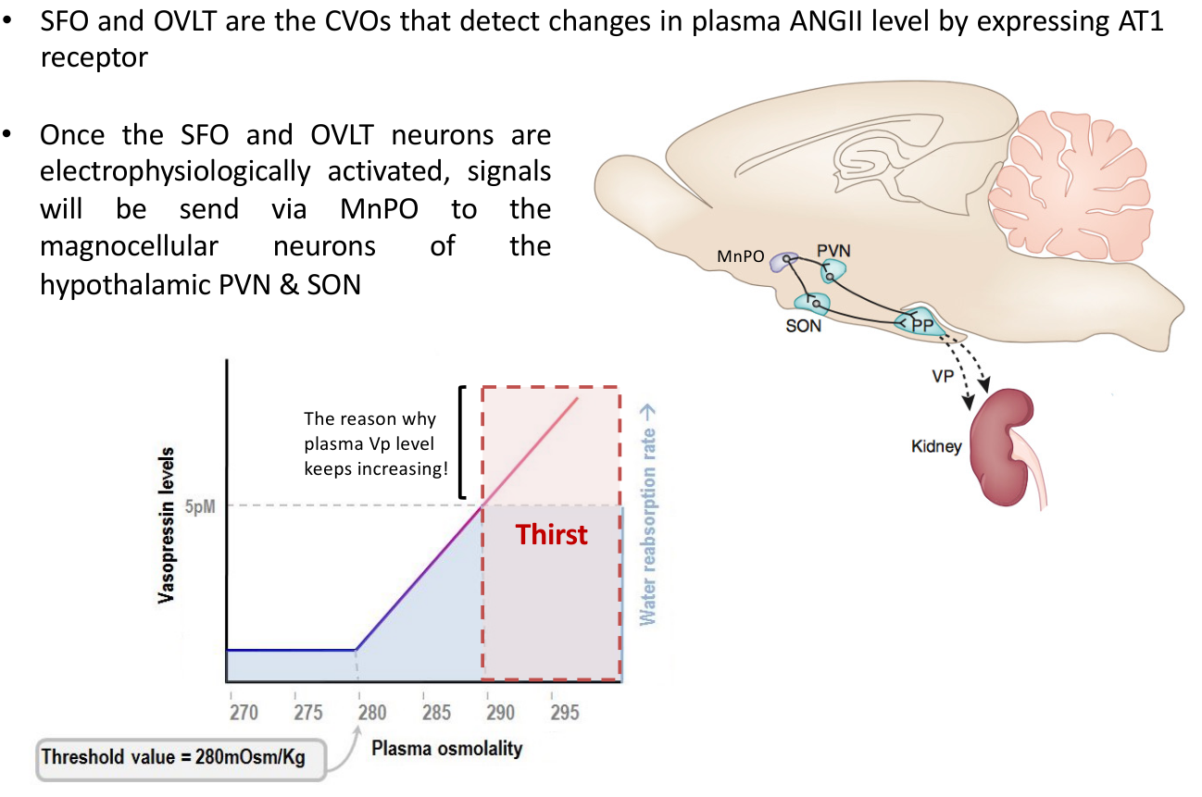  Original lecture figure, PDF p. 37.
Step / location | Behavioural branch: thirst | Endocrine branch: VP
Signal detected | SFO and OVLT detect circulating ANGII via AT₁ and integrate osmotic information. | Same sensory CVO inputs.
Relay | SFO / OVLT → MnPO, the MEDIAN PREOPTIC NUCLEUS. | SFO / OVLT → MnPO.
Output neurons / target | MnPO → various cortical sites → conscious urge to drink → fluid intake. | MnPO → MAGNOCELLULAR PVN / SON → axons to posterior pituitary → VP into blood.
How water balance changes | Adds new water by BEHAVIOUR; drinking is needed to replace a true water deficit. | Conserves water by renal REABSORPTION; cannot manufacture new water.
Feedback | Intake restores water relative to solute and circulating volume → stimuli diminish. | Retained water contributes to the same correction; target response can plateau while VP continues rising.

Anatomical map used by the lecture
Lamina-terminalis circuit = SFO + MnPO + OVLT.
Magnocellular PVN / SON = neuroendocrine VP pathway.
Parvocellular PVN = different autonomic output, detailed on p. 15.

Thirst is defined as a subjective urge to drink and is essential to fluid homeostasis. Source schematic: thirst ~290 mOsm/kg after renal VP effect nears maximum at ~5 pM; these are teaching reference points, not a rule that people cannot drink before maximum renal antidiuresis. CVO access to circulating ANGII avoids assuming it freely crosses an intact BBB everywhere.

15 / ANGII vasoconstriction and the integrated brain
Source: correct RENAL lecture, PDF pp. 28, 38–40
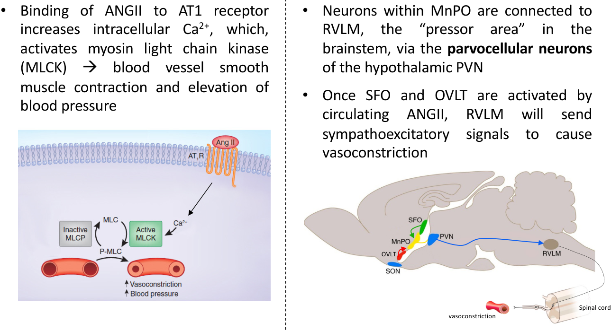  Original lecture figure, PDF p. 38. | 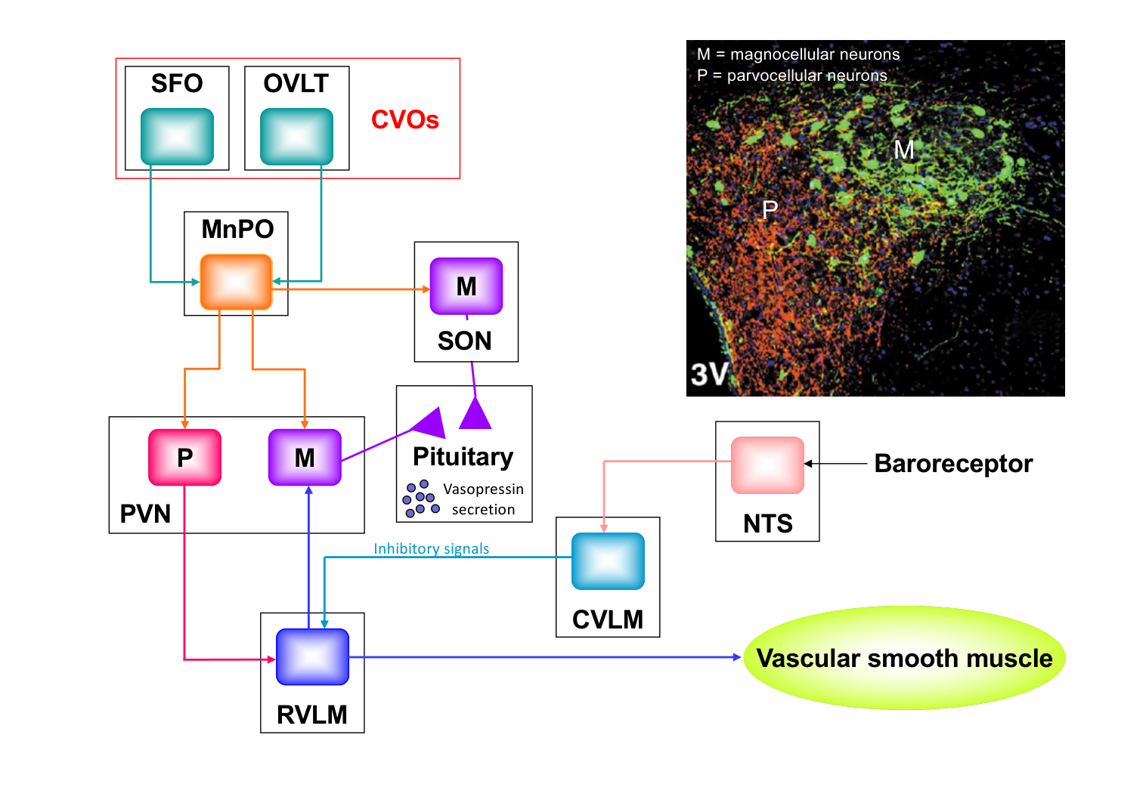  Original lecture figure, PDF p. 39.
Route | Receptors, cells and connection signs
1. DIRECT vascular | Circulating ANGII → AT₁ on vascular smooth muscle → intracellular Ca²⁺ ↑ → MLCK activation → contraction → vascular resistance / BP ↑.
2. CENTRAL sympathetic | ANGII → AT₁ in SFO / OVLT → MnPO → PARVOCELLULAR PVN → RVLM → descending spinal sympathetic output → vascular constriction.
Parallel endocrine route | MnPO → MAGNOCELLULAR PVN / SON → posterior-pituitary VP. It is not the same PVN neuron population as the RVLM-directed branch.
Baroreflex input to RVLM | Stretch-receptor firing → NTS excites CVLM → CVLM INHIBITS RVLM. Unloading reduces this brake and increases RVLM output.
RVLM → PVN / SON | The lecture’s baroreflex model gives excitatory RVLM input to VP neurons. This is compatible with PVN → RVLM in another circuit; PVN is not one cell with one output.

Your RVLM / PVN question
Low BP: baroreceptor firing ↓ → RVLM disinhibited → hypothalamic VP drive ↑.
ANGII: SFO / OVLT → MnPO → PARVOCELLULAR PVN → RVLM → sympathetic constriction.
Both directions can occur through distinct neurons / connections. SON supplies magnocellular hormonal output; do not label it the parvocellular pressor route.

M / P on source p. 39 = magnocellular / parvocellular. RVLM is a medullary sympathetic premotor / pressor region. BP support comes from multiple branches: rapid resistance changes plus slower volume conservation; the integrated figure does not imply all ANGII actions must pass through brain.

16 / Integrate depletion: dehydration versus haemorrhage
Source: correct RENAL lecture, PDF pp. 19, 26–30, 34–42
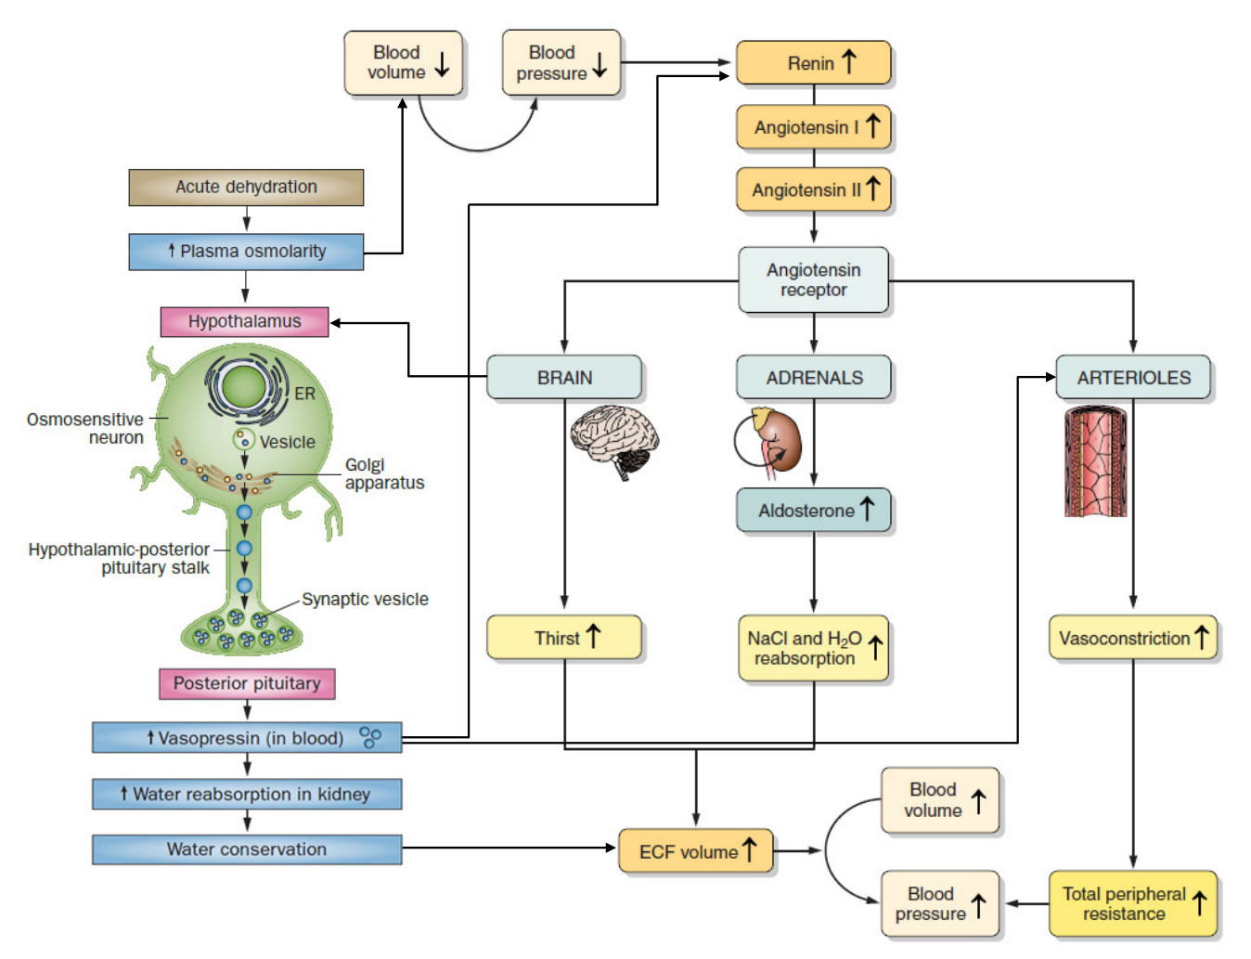
Original lecture image, including visible teaching annotations (PDF p. 41).
Compare | Predominantly water-loss dehydration | Acute approximately isotonic blood loss
Primary disturbance | Water relative to solute ↓ → osmolality / often [Na⁺] ↑; sufficient loss also lowers circulating volume. | Circulating volume ↓. Osmolality / [Na⁺] may be initially little changed.
Main initial sensing | Osmosensitive CVO / hypothalamic neurons; cardiac / arterial unloading if volume falls. | Atrial stretch ↓; arterial stretch ↓ if BP falls; renal perfusion ↓.
Neural / hormonal output | VP ↑; thirst ↑. RAAS / sympathetic activity rise if effective circulating volume declines. | Non-osmotic VP ↑, sympathetic drive ↑ and renin → ANGII / aldosterone ↑.
Kidney response | AQP2-dependent water reabsorption + IMCD urea contribution; Na⁺ conservation when RAAS engaged. | Water / Na⁺ conservation; urine flow often falls, but magnitude depends on filtration, perfusion and renal integrity.
Vascular / behavioural response | Thirst supplies water; ANGII / high VP support vascular tone when needed. | Sympathetic and ANGII vasoconstriction; strong VP may add V₁a action; thirst supports replacement.
Feedback goal | Correct concentration AND any associated volume deficit. | Restore perfusion / circulating volume even without an initial osmotic stimulus.

Which signal wins when they conflict? [Extension]
Severe low effective circulating volume can maintain high VP even when plasma osmolality is low. Protecting perfusion can outweigh the osmotic signal to excrete water. Thus “low osmolality always means low VP” is unsafe; read volume / pressure and osmotic inputs together.

[Extension] Haemorrhage is used as an integrated application of the lecture’s pressure / volume pathways; it is not a treatment protocol. Not every form of dehydration is hypernatraemic, and ECF volume is not identical to effective arterial filling.

17 / Integrate water excess: normal response and Lucas
Source: correct RENAL lecture, PDF pp. 10, 23–25, 36–37, 44 | Classroom case study
Normal response to a water load
Plasma effective osmolality ↓ → osmosensitive cells swell
→ cation conductance / firing ↓ → osmotic VP secretion ↓
→ apical AQP2 ↓ → collecting-duct water permeability ↓
→ increased dilute urine → excess water excreted → osmolality restored.

Condition | Why the final response differs
Water load with intact regulation | VP suppresses appropriately. Greater filling can also inhibit non-osmotic VP / RAAS drive. Kidney can increase water excretion, within its limits.
Small hypertonic-saline load | Opposite osmotic input: osmolality ↑ → VP ↑ → small concentrated urine in Activity 3’s intended condition. Direct volume load is assumed relatively small.
Persistent non-osmotic VP | Exercise, nausea, stress or low effective circulating volume may sustain VP despite water intake [Extension]. AQP2 remains available, limiting free-water excretion.
Large / later saline load | Cannot predict urine solely from “saline”: tonicity, dose, compartment shifts, volume feedback and subsequent Na⁺ excretion matter.

Lucas: hot half-marathon | Classroom question
Lucas, a 20-year-old Art student and experienced runner, finishes a half-marathon at 34°C (Tsing Ma Bridge → Victoria Park). Copious water before, ~3 L bottled water during. At the Student Hall he feels nauseated / confused; assuming heat stroke, he keeps drinking cold bottled water. Roommate finds him disoriented and brings him to A&E. What could explain this?
Answer approach:
Intended answer: exercise-associated DILUTIONAL HYPONATRAEMIA. Large cumulative hypotonic intake relative to losses + potentially sustained non-osmotic VP → retained water dilutes plasma Na⁺ → extracellular hypotonicity → brain-cell water entry → neurological symptoms. Sweat Na⁺ loss may contribute. Symptoms alone require biochemical confirmation; other exertional illness can coexist.

Why “he sweated out salt” is incomplete
Sweat is usually hypotonic: sweat loss alone often removes proportionally MORE water than salt. In this case, excess hypotonic replacement plus limited excretion is central. About 3 L is a case detail, not a universal toxicity threshold. Exercise-associated hyponatraemia is not automatically tumour-related SIADH.

A&E = Accident and Emergency. “High water intake” does not guarantee immediate high urine flow if VP is maintained or intake exceeds excretory capacity. Clinical examples here explain physiology; they do not supply patient-specific treatment instructions.

18 / Water excess failure: SIADH and sodium effects
Source: correct RENAL lecture, PDF pp. 44, 47
The inappropriate response
VP activity persists despite an osmotic state that should suppress it
→ collecting duct retains water → water excessive relative to solute
→ low plasma [Na⁺] / usually low effective osmolality
→ water enters brain cells → neurological dysfunction.

Source cause / symptom group | Details and mechanism
Pituitary / CNS context | Source: diseased posterior pituitary with slow constant VP leak. Inappropriate antidiuresis can follow hypothalamic / pituitary or CNS disease; the exact pattern depends on context.
Tumour context | Small-cell lung carcinoma: ectopic hormone production. Source says a “substance similar to VP”; actual AVP can be produced.
Drug context | Some antidepressants can stimulate / potentiate inappropriate antidiuresis.
Mild to moderate: all source features | Weight gain, elevated BP, headache, nausea, vomiting, muscle weakness.
Advanced / grave: all source features | Cerebral oedema → confusion, hallucination; severe cases → seizures, coma, death.
Interpretation | Typically clinically euvolaemic once established; gross oedema / hypertension are not obligatory. Symptom severity depends on speed and extent of sodium decline.

Sodium disturbance | Cell-volume direction and clinical consequences
HYPERnatraemia | Usually hypertonic: water leaves cells → shrinkage. Thirst, weakness, neurological dysfunction; severe / rapid change can cause confusion, seizures or coma.
HYPOna with hypotonicity | Water enters cells → swelling. Headache, nausea, confusion; severe / rapid decline can cause cerebral oedema, seizures or coma.

Do not interpret [Na⁺] as a sodium inventory
SIADH’s low sodium concentration is primarily dilution from water retention; it does not require primary total-body sodium depletion. The lecture’s “sodium deficit” phrase needs this qualification. Conversely, increased total-body Na⁺ can expand ECF volume while serum Na⁺ stays near normal.

[Extension] Not every hyponatraemia is hypotonic; the cell-swelling chain applies to HYPOTONIC hyponatraemia, including the intended SIADH / Lucas contexts. A source symptom list is not a fixed sequence every patient must follow.

19 / Water conservation failure: DI and compensation
Source: correct RENAL lecture, PDF p. 43 | Classroom Activity 6
Feature | Central DI | Nephrogenic DI
Failed site | VP synthesis / release: hypothalamic–posterior-pituitary pathway. | Renal response to VP, including V₂ receptor or AQP2 trafficking.
Signal at kidney | Insufficient VP for the physiological need. | VP may be present / high; kidney cannot respond adequately.
Net effect | Inadequate concentration → polyuria → thirst / polydipsia. | Same water-loss phenotype through a different defect.
Source genetic details | Not specified for central DI in these slides. | V₂R / AVPR2: X-linked, Xq28. AQP2: autosomal, 12q13; impaired plasma-membrane trafficking.
Desmopressin [Extension] | Urine concentration generally rises if renal response is intact. | Reduced / little response; partial forms can overlap.

Activity 6 | Classroom question
48-year-old woman: severe polyuria / polydipsia; no glucose in urine. After overnight water restriction: lethargy / confusion. Plasma Na⁺ 160 mEq/L (source normal 135–145); urine osmolarity 500 mOsm/L (source comparison >850). Most likely? A Hyperaldosteronism; B Renin-secreting tumour; C Diabetes mellitus; D Diabetes insipidus; E SIADH.
Answer approach:
Best listed answer: D. Water deprivation + Na⁺160 should strongly stimulate conservation, yet concentration is inadequate. 500 is not maximally dilute, but is INAPPROPRIATELY LOW for this hypernatraemic state: partial DI / other partial concentrating defects are possible. No glycosuria argues against the intended glucose-driven osmotic diuresis option. SIADH usually has low Na⁺, whereas this case has water deficit. These data do not establish central versus nephrogenic DI.

Why DI does not always cause hypernatraemia
Urinary water loss → osmolality / thirst drive ↑ → drinking replaces losses
→ sodium can remain near normal while polyuria persists.
Restricted access, impaired thirst or inability to drink removes this compensation
→ water deficit / hypernatraemia can develop.

DI means inability to concentrate urine appropriately; not every DI patient lacks VP. Source >850 is the photographed water-restriction comparison, not a universal normal random-urine value. Diagnostic response testing is supervised; these notes do not instruct continued water restriction in a symptomatic hypernatraemic person.

20 / Na⁺ / K⁺ failure: aldosterone disorders
Source: correct RENAL lecture, PDF pp. 45–47
Feature | Aldosterone EXCESS | Aldosterone DEFICIENCY
Source causes | Primary: aldosterone-producing adrenal adenoma (Conn’s syndrome). Secondary: RAAS activation, e.g. renovascular disease. | Adrenal insufficiency; hyporeninaemic renal disease; ACE inhibitors, ANGII-receptor blockers (ARBs), renin inhibitors.
Distal transport | ENaC / pump-driven Na⁺ reabsorption ↑; K⁺ secretion ↑. | Na⁺ conservation ↓; K⁺ secretion ↓.
Volume / pressure | Na⁺ retention → ECF volume ↑ → hypertension. Serum Na⁺ need not be high. | Na⁺ loss / ECF depletion can lower BP. Low [Na⁺] itself is not the full cause of hypotension.
Potassium | K⁺ loss → HYPOkalaemia. | K⁺ retention → HYPERkalaemia.
Acid–base [Extension] | Enhanced distal H⁺ secretion can favour metabolic alkalosis. | Reduced acid secretion + hyperkalaemia-associated impaired ammonium handling can cause metabolic acidosis.
Renin pattern [Extension] | Autonomous PRIMARY excess generally suppresses renin; secondary renovascular activation raises it. | Low renin in hyporeninaemic disease; renin may rise with adrenal failure or ACE inhibition if the renin system can respond.

Source clinical list | All listed details retained
Hyperaldosteronism / low K⁺ | A–S–I–C–W–A–L–T: Alkalosis; Shallow respiration; Irritability; Constipation (gut motility ↓); muscle Weakness; Arrhythmia; Lethargy; Thready / weak pulse.
Hypoaldosteronism / high K⁺ | Hypotension; arrhythmia; muscle cramps; abdominal cramping; diarrhoea; metabolic acidosis. These have volume, K⁺ and acid–base causes, not one potassium-only mechanism.
Why potassium is regulated | Extracellular K⁺ alters membrane potential / excitability and cardiac conduction. Both high and low K⁺ can produce weakness and dangerous arrhythmias.

Feedback and source corrections
[Extension] K⁺ ↑ → adrenal aldosterone ↑ → renal K⁺ excretion ↑ → K⁺ tends to fall: a negative-feedback loop.
Source “hypertension due to hypernatremia” is better explained by Na⁺-dependent VOLUME expansion. Not all chronic renal failure has low renin; the source renal example applies particularly to hyporeninaemic hypoaldosteronism.

Aldosterone is important for K⁺ excretion but not its only determinant: distal Na⁺ delivery / tubular flow and kidney function matter. Hypokalaemia can impair respiratory muscles / gut motility; hyperkalaemia can disrupt conduction. Full proximal HCO₃⁻ reabsorption and comprehensive acid–base homeostasis are outside this particular lecture.

21 / One comparison sheet: link sensor to correction
Source: correct RENAL lecture, PDF pp. 10–15, 23–42
Input / controller | Sensed / released where? | Acts where / how? | Correction / feedback
High effective osmolality → VP | OVLT / SFO and osmosensitive PVN / SON. VP made in magno PVN / SON; released posterior pituitary. | Collecting-duct V₂ → cAMP / PKA → apical AQP2; IMCD UT-A1 support. | Conserve water → high osmolality tends to fall → VP drive falls.
Low filling / BP → VP | Atrial / arterial receptor firing ↓; CN IX / X → NTS–CVLM–RVLM; PVN / SON output. | Same renal V₂; strong VP also vascular V₁a–Ca²⁺–MLCK. | Support volume / pressure → receptor stretch recovers → non-osmotic drive falls.
Low renal perfusion / NaCl delivery / SNS → renin | JG granular cells release renin; macula densa supplies NaCl-dependent signal. | Liver angiotensinogen → ANG I → ACE → ANGII. | ANGII outputs restore perfusion; initiating signals and renin feedback decline.
ANGII → aldosterone | AT₁ in adrenal cortex / zona glomerulosa. | Distal-nephron MR → ENaC + Na⁺/K⁺ pump + ROMK. | Retain Na⁺ / associated water; secrete K⁺; support ECF volume.
ANGII / high osmolality → thirst | SFO / OVLT → MnPO → cortical circuits. | Behavioural water intake. | Adds water, reduces osmotic drive and contributes to volume restoration.
ANGII → vascular output | AT₁ on vessels AND CVOs → MnPO → parvo PVN → RVLM. | Direct Ca²⁺ / MLCK contraction + sympathetic constriction. | TPR ↑ → BP supported → baroreceptor / renal feedback opposes depletion drive.

Every long answer can follow the same structure
What changed? → where is it sensed? → firing / hormone changes?
→ where is hormone MADE and RELEASED? → target receptor / cell?
→ membrane / intracellular steps? → urine / ion / vessel change?
→ which variable is restored, and what turns the response down?

Three checks before predicting urine
1. Is the collecting duct water-permeable (VP / AQP2)?
2. Is the medullary gradient intact (loop, urea, vasa recta)?
3. Are filtration, solute delivery and water intake sufficient / changing?
One hormone value alone rarely fixes an exact urine volume or osmolality.

22 / Glossary and the distinctions that prevent mistakes
Source: correct RENAL lecture, PDF pp. 20–42
Term | Meaning / location / role
PVN / SON | Paraventricular nucleus / supraoptic nucleus: hypothalamic nuclei. Magnocellular cells synthesise VP; parvocellular PVN provides an autonomic branch.
SFO / OVLT | Subfornical organ / organum vasculosum of the lamina terminalis: sensory CVOs for osmotic / circulating ANGII information.
MnPO / CVO / 3V | Median preoptic nucleus, integrating relay / circumventricular organ / third ventricle. MnPO is a brain nucleus, not posterior pituitary.
NTS / CVLM / RVLM | Nucleus of the solitary tract / caudal ventrolateral medulla / rostral ventrolateral medulla. NTS excites CVLM; CVLM inhibits RVLM.
V₂ / V₁a / AT₁ / MR | Vasopressin type-2 receptor / vasopressin type-1a receptor / angiotensin-II type-1 receptor / mineralocorticoid receptor.
AQP / IMCD / UT-A1 / UT-A3 | Aquaporin / inner medullary collecting duct / apical urea transporter / basolateral urea transporter.
NKCC2 / ENaC / ROMK | Na⁺–K⁺–2Cl⁻ cotransporter / epithelial Na⁺ channel / renal outer-medullary K⁺ channel.
cAMP / PKA / MLCK | Cyclic adenosine monophosphate / protein kinase A / myosin light-chain kinase.
JG / ACE / RAAS / HRE | Juxtaglomerular / angiotensin-converting enzyme / renin–angiotensin–aldosterone system / hormone-response element.
BP / CO / TPR | Blood pressure / cardiac output / total peripheral resistance. [Extension] Mean arterial pressure ≈ CO × TPR when central venous pressure is small.

Common mistakes → correct relationship
• More VP does not always mean more concentrating ability: AQP2 needs an intact medullary gradient.
• Urea transport is not water transport. Urea reinforces the surrounding gradient; AQP2 permits water movement.
• Normal BP does not mean zero VP; osmotic drive and basal secretion still matter.
• Aldosterone retains Na⁺; high VP and ANGII have direct vasoconstrictor receptor pathways.
• Low plasma Na⁺ is not automatically low total-body Na⁺; low volume is not automatically low osmolality.
• Baroreceptor unloading means reduced stretch / firing. Brain “disinhibition” means removing a brake, increasing downstream output.

23 / Coverage map: all homeostatic mechanisms together
Source: correct RENAL lecture, PDF pp. 3–47 | Audit against the supplied lecture and classroom material
Lecture PDF pages | Homeostatic content retained | This document
3–9 | Long-loop nephron; differential permeability; NKCC2 / ATPase; single-effect multiplication; axial values; passive exchange and vasa recta / low flow. | 9–10
10–15 | Dilute / concentrated urine; AQP2 / AQP3/4; water-dependent luminal urea concentration; UT-A1 / UT-A3; outer NaCl / inner NaCl + urea. | 8–10
17–19 | Body-water fractions, ICF / ECF ions, dehydration severity source caveat; compartment buffering, stable intracellular target; physiological / behavioural outputs. | 1–2
20–22 | VP synthesis / transport / vesicle storage, Herring-body clarification, action potential / Ca²⁺ / exocytosis at posterior pituitary. | 3, 7
23–25 | ~1% sensitivity, osmolality definition, TRPV-related osmosensing / CVO sites / BBB, shrink / swell and conductance / firing directions. | 2, 4
26–30 | Volume / arterial pressure distinction, ~8% response, receptor sites, CN IX / X, NTS–CVLM–RVLM signs and VP inhibition / unloading. | 5–7, 15
31–33 | V₂ / AQP2 Ser256 / apical actin; 280 / 290 / 5 pM graph; V₁a vascular Ca²⁺ / MLCK; lecture macula-densa NO / PGE₂–renin model. | 7–8, 11
34–35 | Renin / ACE cascade, all four ANGII functions, adrenal AT₁ / distal MR / HRE and membrane-specific pump / ENaC / ROMK. | 3, 12–13
36–39 | Thirst, SFO / OVLT / MnPO; magno PVN / SON VP versus parvo PVN / RVLM sympathetic output; direct vascular AT₁. | 14–15
40–42 | Image-only integration: osmosensing, VP, dehydration, renin triggers, Na⁺ / water retention, vascular resistance / BP and negative feedback. | 1, 12, 15–17, 21
43–47 | DI types / genetics / thirst compensation; SIADH causes / all source symptom groups; aldo disorders / all source causes and symptom lists; four electrolyte imbalances. | 18–20

Classroom source | Question / supplement placed beside mechanism
Photos 1–2 | Pressure / VP / cardiac and vascular effects → p. 6.
Activity 3 | Small hypertonic saline, AQP2 and UT-A1 → pp. 8, 10, 17.
Activity 4 + vagotomy | Aortic-dominant photo answer and opposing carotid signal → p. 6.
Activity 6 | Polyuria, water restriction, Na⁺160 / urine500; all options and interpretation → p. 19.
Lucas | Complete case facts; excess water, sweating, non-osmotic VP and brain swelling → p. 17.

Lecture pp. 1–2: title / basic nephron anatomy; p. 16: section divider. Relevant nephron specialisation is incorporated on p. 9; decorative material is not repeated. Original relevant figures retain their visible annotations; explanatory text corrects the source where needed. Classroom answers are reasoned study interpretations, not an official key. This integration adds no claim that other renal topics, such as a complete acid–base course or ANP physiology, were taught in this particular lecture.

