01 / Digestive physiology: complete study map
Expanded edition | Lecture: 28 PDF pages | Tutorial: 5 PDF pages | Slide references use PDF page numbers
Primary aim — retain all three substance groups
Move nutrients, water and electrolytes from the external environment into the body’s internal environment.

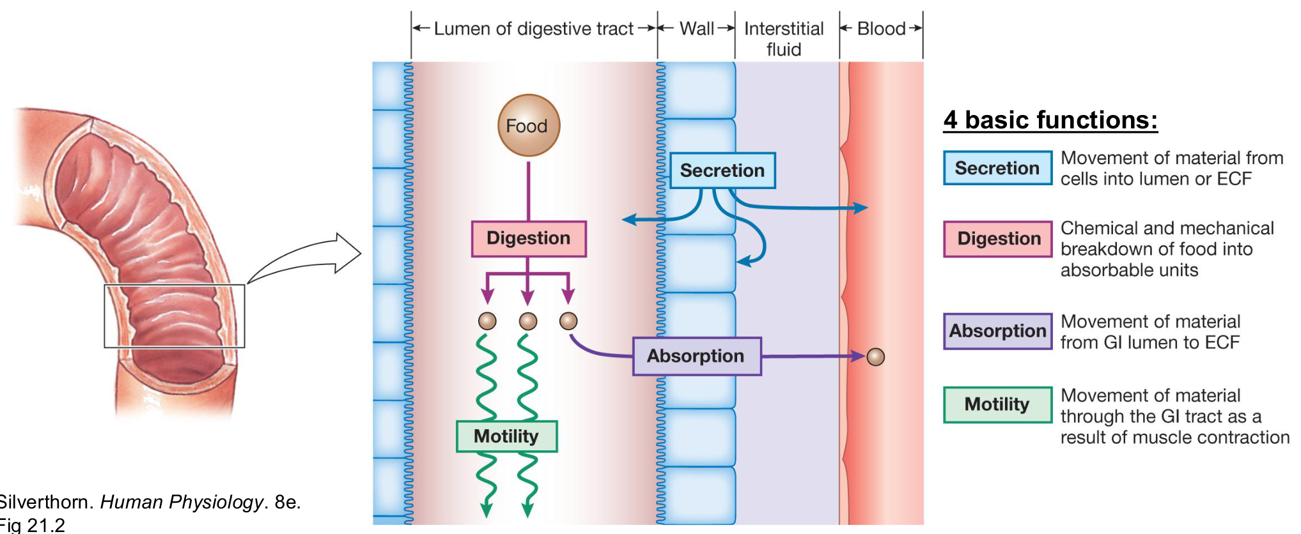
Original four-function diagram (lecture p. 3; Silverthorn, Human Physiology, 8e, Fig. 21.2).
Function | Full key meaning from the slide and figure
Secretion | Movement of material from cells into the lumen OR extracellular fluid (ECF). Luminal digestive juice and endocrine release toward blood have different destinations.
Digestion | Chemical AND mechanical breakdown of food into absorbable units.
Absorption | Movement from the GI lumen, across the epithelium, into ECF; materials then reach blood or lymph as appropriate.
Motility | Movement and mixing of contents through the GI tract as a result of muscle contraction.

The four lecture learning outcomes
Be able to explain… | Notes pages
ENS, parasympathetic and sympathetic regulation of GI secretion and motility. | 2–6
Neural, endocrine and paracrine control of gastric motility and acid secretion. | 7–13
Pancreatic enzyme secretion and bicarbonate-rich aqueous secretion. | 14–16
Carbohydrate and lipid digestion and absorption in the small intestine. | 17–21

GI = gastrointestinal. The lumen is continuous with the external environment; entering the lumen is not the same as entering the body’s internal environment. This edition retains the key written content of the teaching slides and expands important figure labels. [Extension] identifies supporting physiology beyond the slide text. Source corrections remain explicit.

02 / GI wall: every layer and plexus location
Lecture PDF p. 4 | Wall image repeated on source p. 7
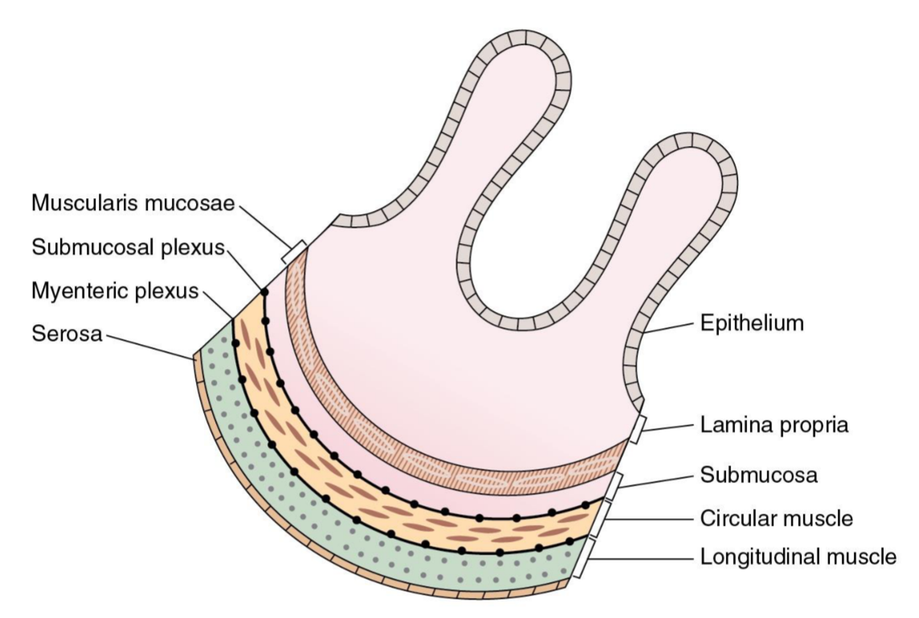
Original GI wall with serosa, both muscle layers and both plexuses (pp. 4/7; Costanzo Physiology, 7e, Fig. 8.1).
Structure | Location / distinction
Epithelium | Innermost lining, facing the lumen; forms the secretory / absorptive barrier.
Lamina propria | Connective tissue beneath the epithelium.
Muscularis mucosae | Thin smooth-muscle layer belonging to the mucosa.
Mucosa | Epithelium + lamina propria + muscularis mucosae.
Submucosa | Supportive layer outside the mucosa, before the main circular muscle layer.
Submucosal plexus | Located in the submucosal region, internal to circular muscle. The slide describes it as between the submucosa and circular muscle.
Muscularis externa | Two main smooth-muscle layers: inner circular, outer longitudinal.
Myenteric plexus | Between circular and longitudinal muscle layers.
Serosa | Outer covering labelled in the original figure.

Read the wall from the lumen outward
Epithelium → lamina propria → muscularis mucosae → submucosa
→ circular muscle → myenteric plexus → longitudinal muscle → serosa.

Do not replace “muscularis mucosae” with “muscularis externa”: they are different structures. The submucosal plexus is not the plexus between the two externa muscle layers.

03 / ENS and autonomic modulation
Lecture PDF p. 5 | Original MCQs 1–2
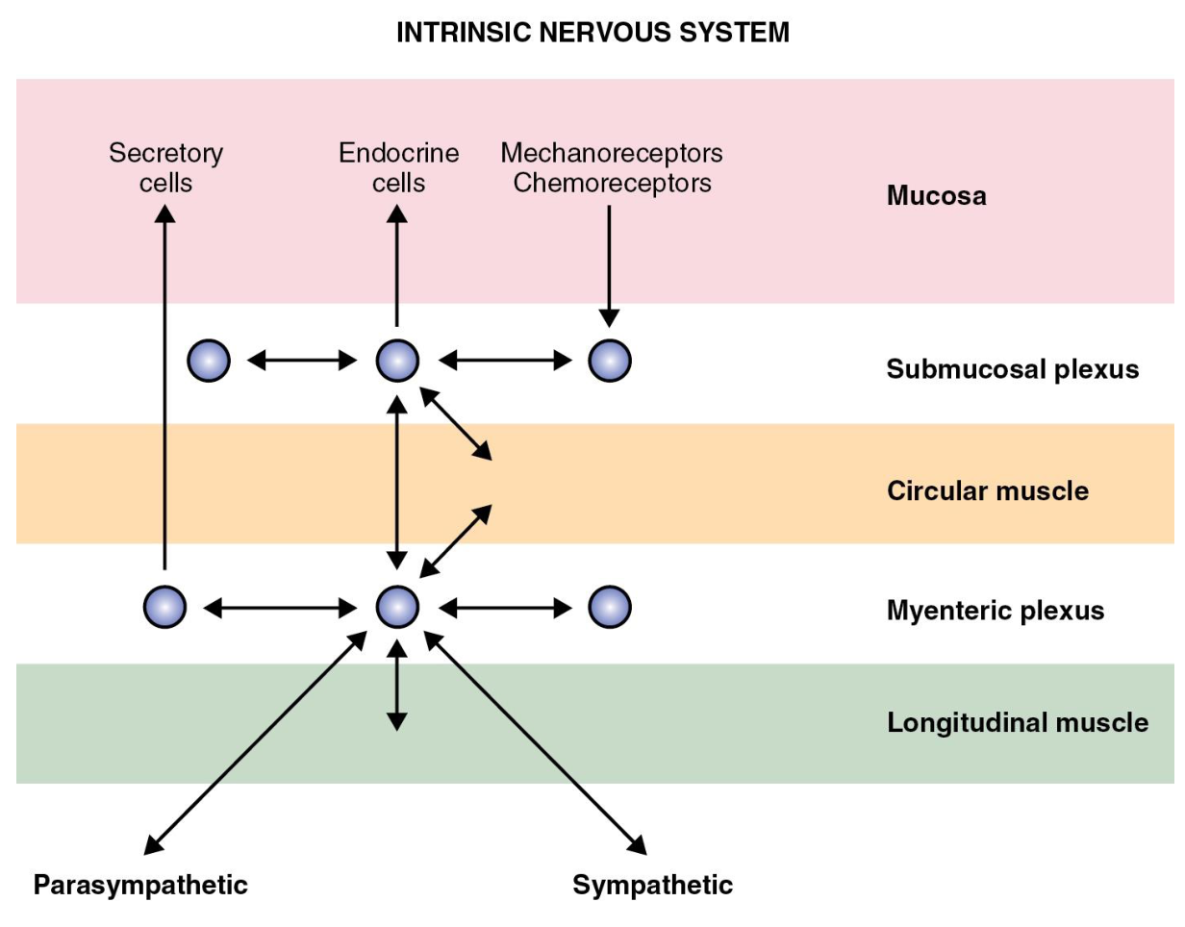
Original intrinsic neural circuit (p. 5; Costanzo Physiology, 7e, Fig. 8.3).
Control system | Retained key point
Myenteric plexus | Primarily controls GI motility.
Submucosal plexus | Primarily controls GI secretion.
ENS: enteric nervous system | Can function independently; autonomic activity modulates its circuits.
Parasympathetic activity | Generally increases BOTH GI motility and secretion.
Sympathetic activity | Generally decreases BOTH GI motility and secretion.

Figure detail: mucosal mechanoreceptors / chemoreceptors feed into local circuits. The two plexuses communicate; outputs reach secretory cells, endocrine cells and smooth muscle. Parasympathetic and sympathetic pathways modify this intrinsic network.

Original MCQ 1
Which component of the enteric nervous system primarily regulates GI motility?
A. Submucosal plexus B. Myenteric plexus C. Parietal cells D. ECL cells
Answer: B
Myenteric plexus is the principal motility plexus. Submucosal plexus mainly controls secretion; parietal and ECL cells are not nerve plexuses.

Original MCQ 2
Which of the following generally increases GI motility and secretion?
A. Sympathetic stimulation B. Somatostatin C. Parasympathetic stimulation D. Secretin
Answer: C
Parasympathetic activity generally promotes both. “Generally” does not mean that every individual sphincter must contract.

04 / Chemical messengers: route matters
Lecture PDF p. 6 | Neural, endocrine and paracrine regulation
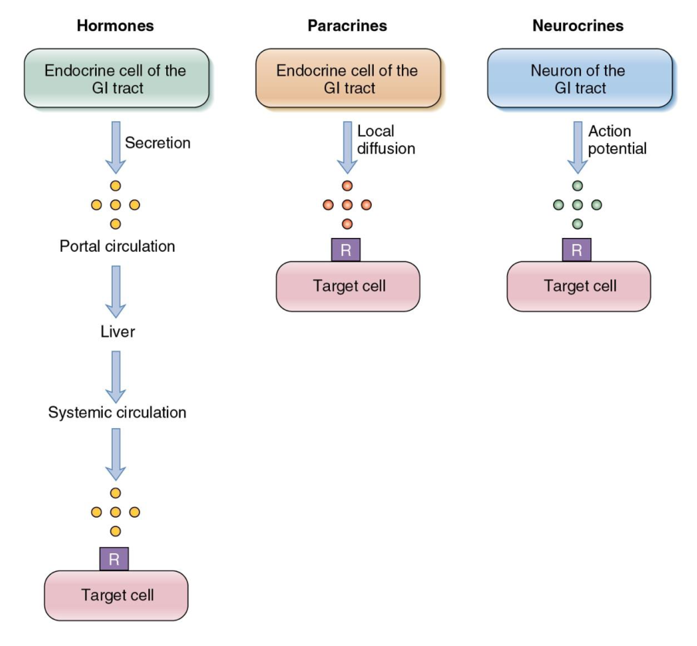
Original hormone, paracrine and neurocrine routes (p. 6; Costanzo Physiology, 7e, Fig. 8.4).
Pathway | Origin → route → target | Examples
Neurocrine | Enteric neuron releases a messenger → acts directly on nearby target cells. An action potential triggers neuronal release in the figure. | Acetylcholine (ACh); GRP in the later gastrin pathway.
Endocrine | Enteroendocrine cell releases hormone into blood → hormone reaches distant targets with the appropriate receptor. | Gastrin; CCK and secretin in later slides.
Paracrine | Local release → diffusion through the same tissue → neighbouring target cells. A systemic blood route is not required. | Histamine; gastric somatostatin.

Follow the endocrine arrows in the figure
GI endocrine cell → secretion → portal circulation → liver
→ systemic circulation → receptor (R) on target cell.
This is the route shown in the diagram, rather than a local diffusion route.

• These signalling molecules coordinate BOTH GI motility and secretion.
• The target needs the relevant receptor; transport in blood alone does not determine the response.
Terminology correction: the heading “GI peptides” is broader than the molecules listed. ACh and histamine are not peptides. Neurocrine / endocrine / paracrine describe signalling routes, not chemical composition. GRP = gastrin-releasing peptide; CCK = cholecystokinin.

05 / Smooth muscle and ICC pacemakers
Lecture PDF pp. 7–8
Written slide point | Meaning / example
Two externa layers | Circular and longitudinal smooth muscle act together.
Circular contraction | Decreases the diameter of a GI segment.
Longitudinal contraction | Shortens the length of the segment.
Phasic contraction | Periodic contraction followed by relaxation; e.g. muscles used for mixing.
Tonic contraction | A maintained baseline tone of contraction; e.g. sphincters.

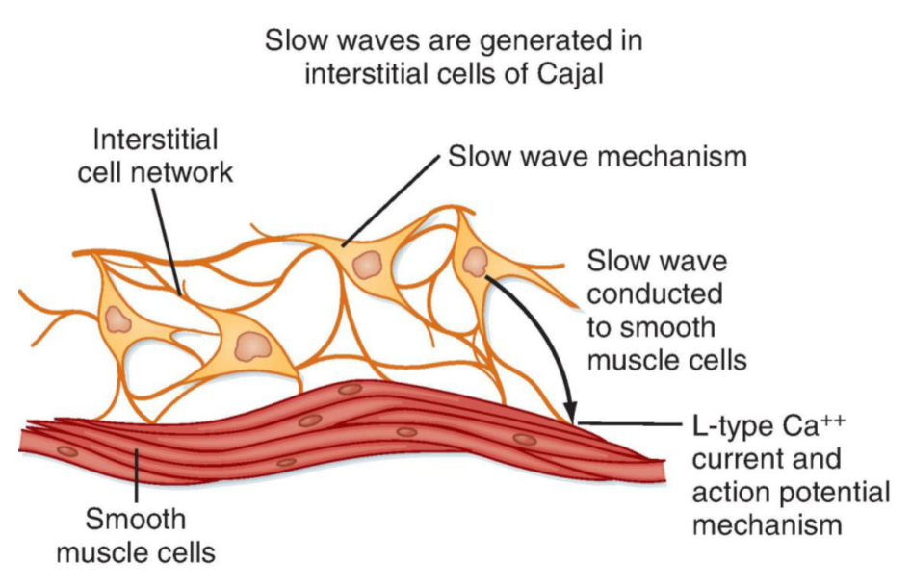
Original ICC network and smooth-muscle electrical coupling (p. 8; Berne & Levy Physiology, 8e, Fig. 29.12).
Pacemaker detail | Retained mechanism
Cell and location | Interstitial cells of Cajal (ICCs) are abundant in the myenteric region; the slide says “in the myenteric plexus”. They are pacemaker cells, not enteric neurons.
Spontaneous activity | ICCs spontaneously generate electrical activity that coordinates GI smooth-muscle contraction.
Electrical spread | ICCs couple to smooth-muscle cells through gap junctions → electrical activity spreads rapidly between cells.
Figure sequence | ICC network → slow waves → conduction to smooth muscle → L-type Ca²⁺ current / action-potential mechanism.
Autonomic regulation | Parasympathetic activity generally increases motility; sympathetic activity generally decreases motility.

[Extension] Slow waves set rhythmic changes in excitability. A slow wave does not automatically mean a strong contraction; adequate depolarisation permits Ca²⁺ spikes and force generation. This preserves the distinction between pacemaker timing and contractile strength.

06 / Gastric movement and intestinal segmentation
Lecture PDF pp. 9–10
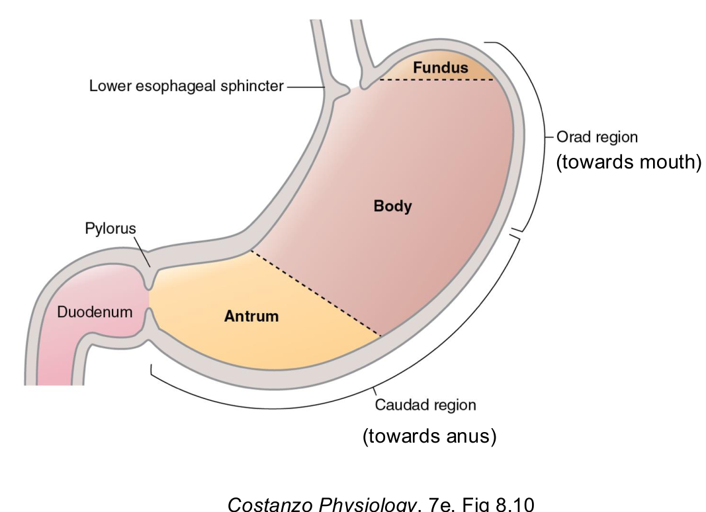  Original stomach regions (p. 9; Costanzo Fig. 8.10). | 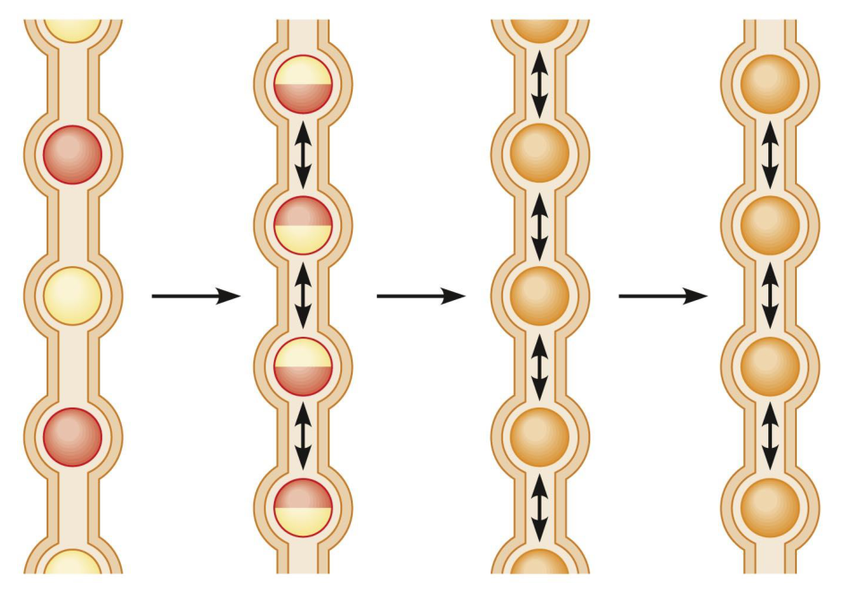  Original segmentation sequence (p. 10; Stanfield Fig. 20.30b).

All three gastric motor functions
Task | Full retained statement
1. Accommodation | The orad region relaxes to receive the food bolus from the oesophagus.
2. Grinding and mixing | Contractions reduce the size of the bolus and mix it with gastric secretions → digestion begins.
3. Gastric emptying | Propels chyme into the small intestine through the pylorus.

Figure label | How to locate it
Orad / caudad | Orad = toward the mouth; caudad = toward the anus.
Orad region | Fundus and proximal body; receives and stores the bolus.
Caudad region | Distal stomach, including antrum; important in mixing and delivery toward the pylorus.
Entry / exit | Lower oesophageal sphincter at the entry; pylorus leads to the duodenum. Body, fundus and antrum are all labelled.

Segmentation: retain the complete sequence
• Food in the small intestine → alternating contractions between intestinal segments.
• One circular-muscle segment contracts while segments on both sides relax.
• Chyme is split and displaced backward and forward; the portions merge again as the contraction pattern changes.
• Main result: mixing. The slide states that segmentation does not propel chyme along the intestine.
Precision: segmentation is primarily a mixing pattern, rather than sustained net propulsion; avoid treating “no propulsion” as an absolute statement about every intestinal movement. Bolus = swallowed mass of food; chyme = partly digested gastric contents.

07 / Gastric juice: cells, locations and products
Lecture PDF p. 11 | Case 2 Part 2, Q3–4
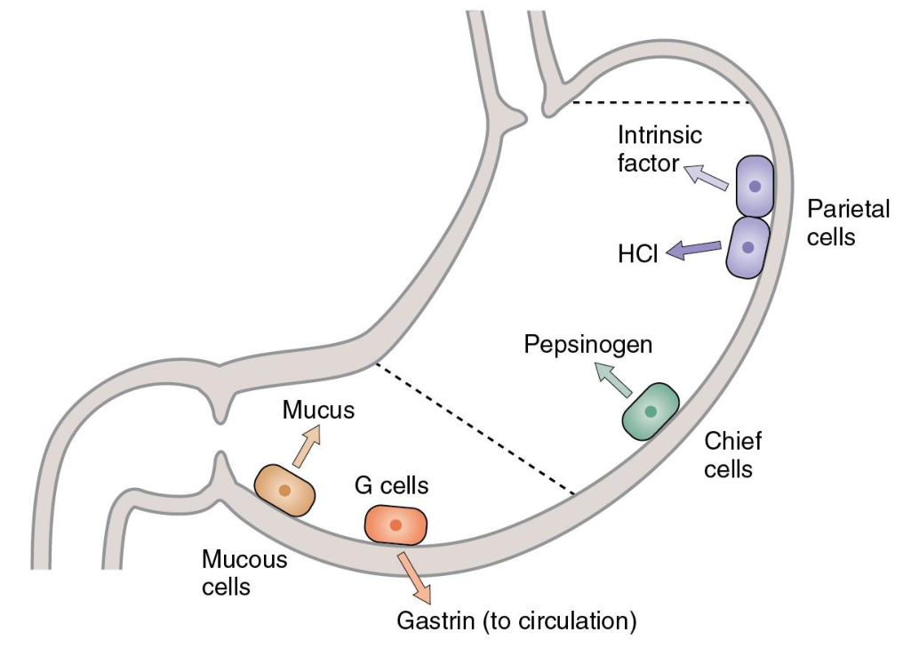  Original gastric glands (p. 11; Costanzo Fig. 8.14). | 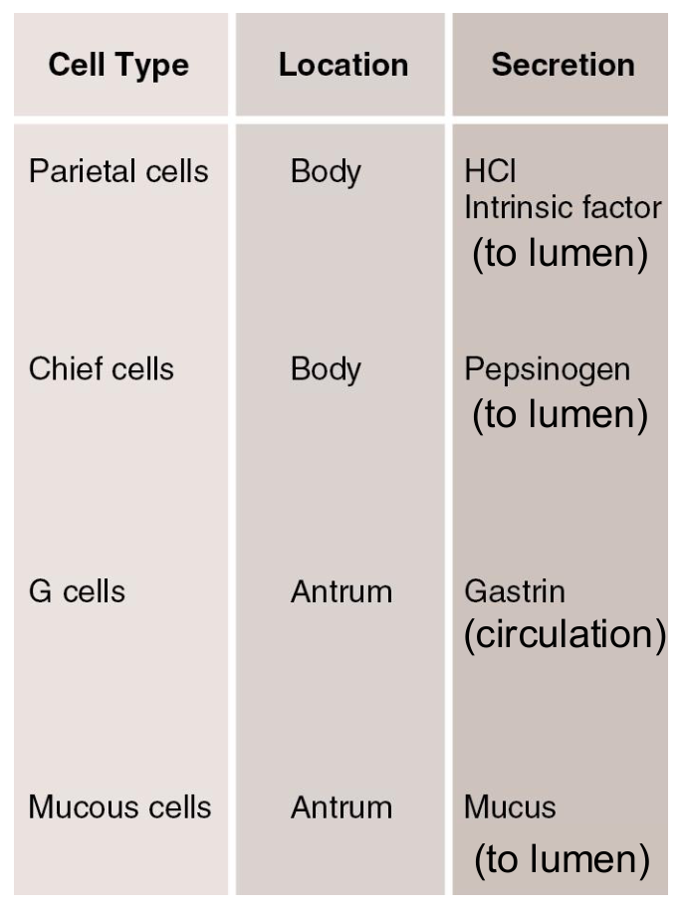  Original cell-location-product table and annotations (p. 11).
Cell / source location | Product and destination | Function
Parietal cells — body | HCl → lumen. | With pepsinogen / pepsin, initiates protein digestion. Acid supports pepsin activation and action.
Parietal cells — body | Intrinsic factor → lumen. | Facilitates vitamin B₁₂ absorption in the ileum.
Chief cells — body | Pepsinogen → lumen. | Inactive precursor of pepsin; contributes to the start of protein digestion.
G cells — antrum | Gastrin → circulation. | Endocrine control of acid secretion; not a luminal enzyme.
Mucous cells — antrum in source table | Mucus → lumen / surface layer. | Protects against HCl corrosion and lubricates the mucosa.

The written gastric-juice list
Gastric mucosa secretes gastric juice containing HCl + pepsinogen + intrinsic factor + mucus. Gastrin is shown separately going to blood, not into the juice.

Original Case 2 | Part 2: Gastric Acid Secretion
Original question / ID | Answer and reasoning
C2-P2-Q3 Which gastric cells secrete hydrochloric acid? | Parietal cells. Chief cells secrete pepsinogen.
C2-P2-Q4 State ONE physiological role of gastric acid. | One answer is sufficient: promotes pepsinogen activation / maintains conditions for pepsin. Alternatives include protein denaturation or antimicrobial action.

Cell locations reproduce the source table. Mucous cells are not restricted to the antrum throughout the whole stomach. [Clarification] HCl is acid; pepsin is the protein-digesting enzyme; pepsinogen is its inactive precursor.

08 / Cephalic phase: prepare before food arrives
Lecture PDF p. 12 | Original Case 1: Food Influencer Effect
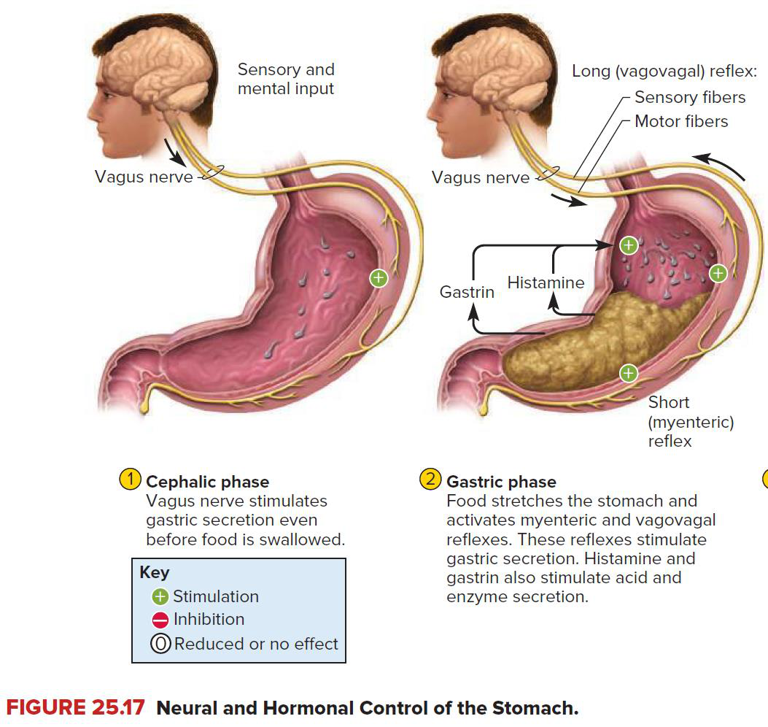
Original cephalic and gastric-phase reflex diagram (p. 12; Saladin, Anatomy & Physiology, 10e).
Cephalic phase — smaller role in the slide’s comparison
Smelling, tasting and anticipation of food → CNS activation
→ parasympathetic (vagal) output to the stomach
→ preparation of gastric secretion and motility before food enters.

The slide calls the cephalic phase a “minor role” and the gastric phase the “MAJOR ROLE”. Minor here means smaller contribution, not absence of physiological importance. The figure also includes sensory / mental input and vagal stimulation before swallowing.
Original case: a student watches Instagram videos of burgers, fried chicken and desserts, but has not eaten anything yet.

All six original Case 1 questions
Original question / ID | Answer and reasoning
C1-Q1 Which phase of gastric secretion is activated? | Cephalic phase: sensory / mental food cues arrive before food enters the stomach.
C1-Q2 Which branch of the autonomic nervous system is primarily responsible? | Parasympathetic, via the vagus nerve.
C1-Q3 Which neurotransmitter is released? | ACh is the expected general answer. GRP is the specific transmitter for neuronal stimulation of G-cell gastrin release (p. 10).
C1-Q4 What effect would this have on gastric motility? | Generally increases preparatory gastric motility.
C1-Q5 What effect would this have on gastric acid secretion? | Increases gastric acid secretion.
C1-Q6 State one physiological advantage of activating digestion before food enters the stomach. | Feedforward control prepares secretions and motor activity, reducing the delay when food arrives.

The handwritten “promote mobility” should read “promote motility”. The source’s feedforward-control idea is retained, with the advantage made explicit.

09 / Gastric phase: distension and local reflexes
Lecture PDF p. 12, compared with p. 15 | Original Case 2 Part 1
Gastric phase — the major phase in this lecture
A meal distends the stomach → mechanoreceptors are stimulated
→ long vagovagal reflexes + short local enteric reflexes
→ gastric secretion and motility increase.

Pathway from the slide / figure | Complete causal chain
Long vagovagal reflex | Stomach stimulus → sensory fibres in vagal pathways → CNS → motor vagal output to stomach → secretion and motor responses.
Short local reflex | Gastric distension → local ENS / myenteric circuit → more ACh release → gastric secretions AND motility increase.
Figure’s chemical mediators | Gastrin and histamine also participate in stimulation of gastric secretion; their cell-specific routes follow on p. 10.
Stimulatory food chemistry [Clarification] | Peptides and amino acids promote gastrin release. Meal buffering limits acid inhibition early after eating.

Retain the source statement, then correct its direction
Slide 12 wording requiring correction
The slide groups stomach distension and “low pH” as stimuli for a stimulatory vagovagal reflex. The buffet annotation also answers “low pH”.
Low gastric pH should not be memorised as the simple stimulatory trigger: strong gastric acidity stimulates D-cell somatostatin → gastric acid secretion decreases. Slide 15 provides this inhibitory feedback mechanism.

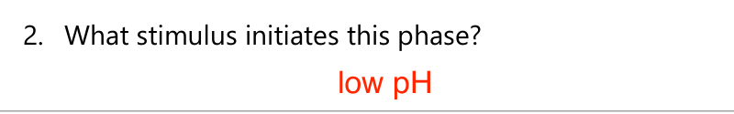
Original buffet annotation retained for comparison (tutorial p. 4); its “low pH” answer is corrected above.
Original buffet case: a large meal contains rice, steak, fried chicken, chips, ice cream and soft drinks.

Original Case 2 | Part 1: Gastric Phase
Original question / ID | Answer and reasoning
C2-P1-Q1 Which phase of gastric secretion becomes dominant after the meal? | Gastric phase.
C2-P1-Q2 What stimulus initiates this phase? | Stomach distension is the direct trigger emphasised by the reflex pathway. Food peptides / amino acids also stimulate secretion; “low pH” alone reverses the acid-feedback direction.
C2-P1-Q3 Which neurotransmitter promotes gastric motility and secretion? | ACh.

CNS = central nervous system; ENS = enteric nervous system. “Vagovagal” indicates a reflex using vagal sensory and motor limbs; a local ENS reflex does not need to travel to the brain first.

10 / Acid stimulation: all three routes
Lecture PDF pp. 13–14 | Original Case 2 Part 2, Q1
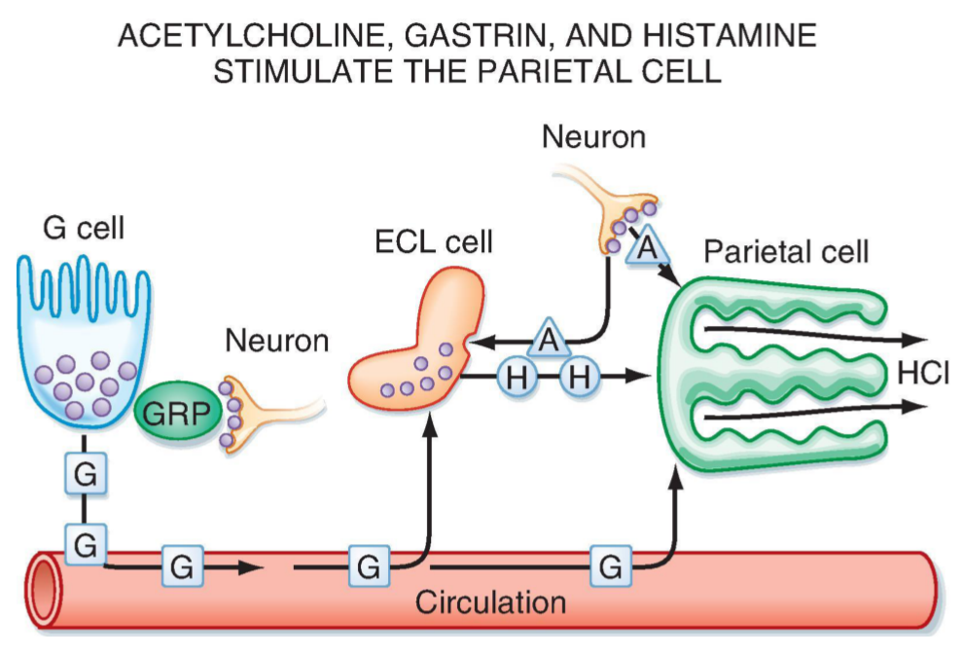
Original ACh, GRP, gastrin and histamine pathways (same image on pp. 13–14; Berne & Levy, 8e, Fig. 29.7).
Messenger and origin | Target / route | Effect retained from the slide
Histamine — ECL cells in gastric mucosa | Local paracrine action → H₂ receptors on nearby parietal cells. | Promotes proton-pump activity → H⁺ secretion increases.
ACh — enteric neurons | Direct neurocrine action → muscarinic M₃ receptors on parietal cells. | Promotes proton-pump activity → HCl secretion increases.
ACh — additional branch | Stimulates ECL-cell activity. | Histamine release provides an indirect acid-stimulatory route.
GRP — enteric neurons | Gastrin-releasing peptide → G cells. | Stimulates G cells to secrete gastrin.
Gastrin — G cells | Travels via circulation to ECL cells AND parietal cells. | Parietal proton-pump activity increases; ECL activity / histamine release also increases.

Direct and indirect gastrin effects
Gastrin → parietal stimulation → acid ↑.
Gastrin → ECL stimulation → histamine → H₂ on parietal cells → acid ↑.
The original figure’s A = ACh, G = gastrin, H = histamine; GRP is a different neuronal messenger.

Original Case 2 | Part 2, Q1
Original question / ID | Answer and reasoning
C2-P2-Q1 Name THREE stimulators of gastric acid secretion. | ACh + histamine + gastrin. The source annotation names gastrin and histamine; add ACh to complete all three.

ECL = enterochromaffin-like. Do not answer ACh when asked specifically for the neuronal transmitter that releases gastrin from G cells: that step uses GRP. Gastrin receptors are CCK₂ / CCK-B, distinct from the CCK₁ pathway on p. 14.

11 / Acid inhibition: buffering and somatostatin
Lecture PDF p. 15 | Original MCQ 3; Case 2 Part 2, Q2
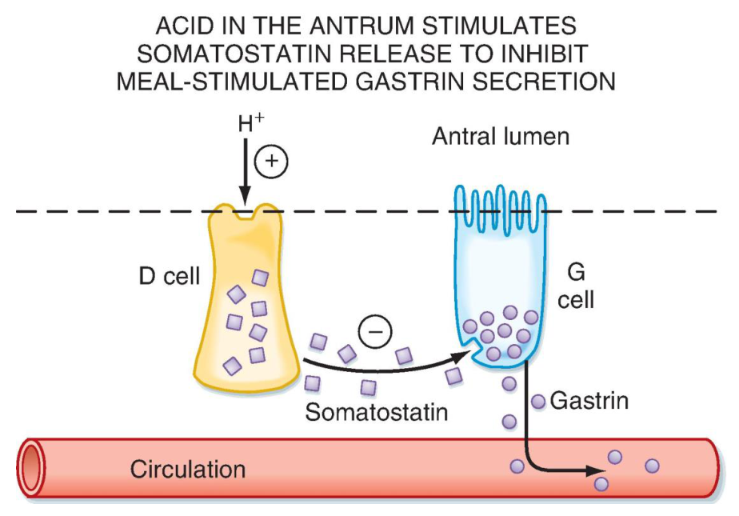
Original antral acid → D-cell somatostatin → G-cell inhibition (p. 15; Berne & Levy, 8e, Fig. 29.9).
Time / event | Retained sequence
Food present in stomach | Food contents buffer H⁺ → offset part of the fall in pH.
Food moves into small intestine | Gastric buffering capacity decreases → gastric pH can fall more substantially.
Low gastric pH | Stimulates gastric D cells → somatostatin release → local paracrine action.
Direct inhibition | Somatostatin → parietal cells → HCl secretion decreases.
Indirect inhibition: histamine | Somatostatin → ECL cells → histamine release decreases → parietal stimulation decreases.
Indirect inhibition: gastrin | Somatostatin → G cells → gastrin release decreases → parietal / ECL stimulation decreases.

One negative-feedback loop
Acid accumulates / buffering falls → gastric pH ↓ → D-cell somatostatin ↑
→ direct parietal inhibition + gastrin ↓ + histamine ↓ → further acid output ↓.

Original MCQ 3
Which regulator directly inhibits gastric acid secretion?
A. Gastrin B. Histamine C. Acetylcholine D. Somatostatin
Answer: D
Somatostatin directly inhibits parietal cells. It also has indirect effects through G and ECL cells; “directly” does not exclude additional indirect routes.

Original Case 2 | Part 2, Q2
Original question / ID | Answer and reasoning
C2-P2-Q2 Name ONE inhibitor of gastric acid secretion. | Somatostatin. State gastric D cells and low-pH negative feedback if explanation is requested.

12 / Acid receptors, signalling and drugs
Lecture PDF p. 16 | Expanded reading of all labelled pathways
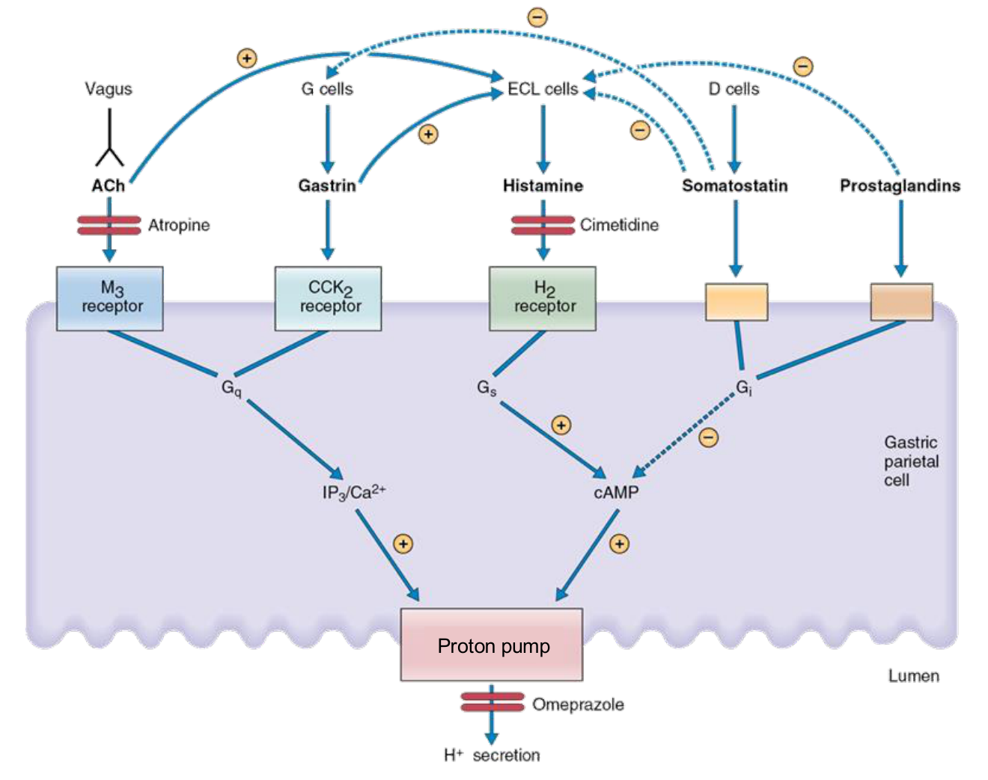
Original receptor diagram with the slide’s “Proton pump” label retained (p. 16; Costanzo Physiology, 7e, Fig. 8.17).
Input → receptor | Signal inside parietal cell | Acid effect
ACh → M₃ | Gq → IP₃ / Ca²⁺. | Pump stimulation; H⁺ secretion ↑.
Gastrin → CCK₂ | Gq → IP₃ / Ca²⁺. | Pump stimulation; H⁺ secretion ↑.
Histamine → H₂ | Gs → cAMP. | Pump stimulation; H⁺ secretion ↑.
Somatostatin / prostaglandins | Gi → cAMP decreases. | H⁺ secretion ↓; inhibitory arrows also reduce upstream stimulation in the figure.

Drug labelled in the figure | Blocked site
Atropine | Muscarinic receptor pathway, including parietal M₃ signalling.
Cimetidine | H₂ receptor: blocks the histamine route.
Omeprazole | H⁺/K⁺-ATPase: the final acid-secretory pump on the luminal side.

Gq / Gs / Gi = G-protein signalling classes; IP₃ = inositol trisphosphate; cAMP = cyclic adenosine monophosphate. The proton pump uses ATP to exchange H⁺ for K⁺. The upper diagram includes ACh / gastrin stimulation of ECL cells and inhibitory connections from somatostatin / prostaglandins.
Integrated practice 1 | Self-written; not an original exam question
Compare H₂-receptor blockade with proton-pump blockade. Can ACh and gastrin still signal, and why might gastrin rise after prolonged acid suppression?
Answer approach:
• H₂ blockade removes histamine input; M₃ and CCK₂ receptors remain available. The combined stimulatory effect is weakened.
• Pump blockade stops the final acid-secretory step despite upstream receptor activation.
• [Extension] Acid output ↓ → gastric pH ↑ → somatostatin feedback ↓ → G-cell inhibition ↓ → gastrin can rise. High gastrin need not mean high acid when the pump is inhibited.

13 / Duodenal feedback: the complete gastric brake
Lecture PDF p. 17 | Original MCQ 6; Case 2 Part 3, Q1–2 and Q5
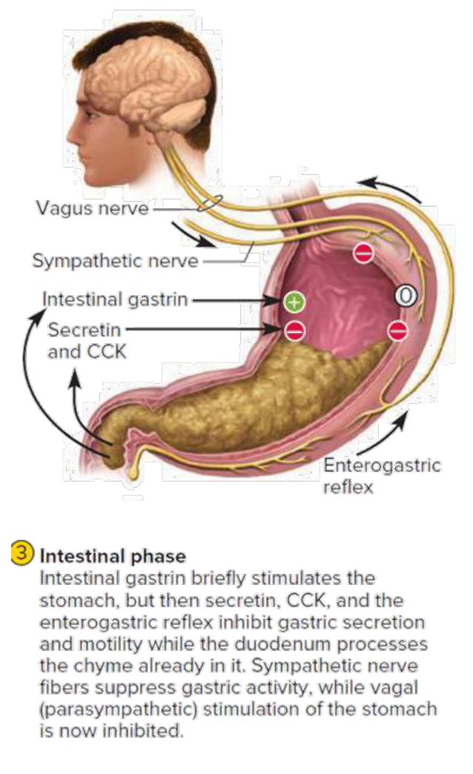  Original intestinal-phase diagram, including its brief stimulatory phase (p. 17; Saladin, 10e). | All three initiating duodenal stimuli  Lipids + low pH + duodenal distension can trigger the enterogastric reflex.  Both motor effects  Gastric motility is inhibited. Pyloric sphincter contraction increases → gastric emptying slows.  Diagram detail: neural inhibition  Sympathetic pathways suppress gastric activity; vagal parasympathetic stimulation of the stomach is inhibited.  Diagram detail: early intestinal gastrin  The caption describes brief stimulation by intestinal gastrin, followed by predominant inhibition by secretin, CCK and the enterogastric reflex. The later response limits secretion and motility while duodenal processing proceeds.
Stimulus and location | Source cell → hormone | Gastric response
Amino acids, peptides, fatty acids in duodenum AND jejunum | I cells → CCK. | Gastric motility / emptying decrease.
Low-pH chyme in duodenum | S cells → secretin. | Gastric motility / emptying decrease.

Original MCQ 6
Which of the following slows gastric emptying?
A. Parasympathetic stimulation B. Acetylcholine C. CCK D. Gastric distension
Answer: C
CCK is an intestinal brake. Gastric distension and duodenal distension have different reflex roles; keep the anatomical location in the answer.

Original Case 2 | Part 3: Fatty Chyme Enters the Duodenum
Original question / ID | Answer and reasoning
C2-P3-Q1 Which TWO hormones increase? | CCK for fat / protein products; secretin for low duodenal pH.
C2-P3-Q2 What effect do these hormones have on gastric emptying? | Both slow gastric delivery in the lecture’s scheme.
C2-P3-Q5 Why is slowing gastric emptying beneficial? | Provides time for acid neutralisation, digestion and absorption; limits the load arriving in the duodenum.

14 / Pancreatic enzyme secretion: CCK and ACh
Lecture PDF p. 18 | Original MCQ 4; Case 2 Part 3, Q3
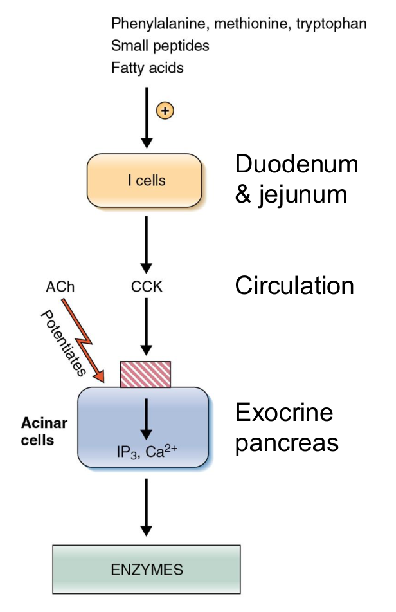  Original CCK–acinar-cell pathway (p. 18; Costanzo Physiology, 7e, Fig. 8.23). | Stimuli — do not drop the nutrient groups  Amino acids, peptides and fatty acids in the duodenum and jejunum stimulate I cells.  Specific examples named in the figure  Phenylalanine, methionine and tryptophan; small peptides; fatty acids.  Endocrine route  I cells → CCK → circulation → exocrine pancreas.  Receptor and effector cell  CCK₁-mediated stimulation promotes enzyme-rich secretion from pancreatic acinar cells.  Second messenger and neural cooperation  The figure labels IP₃ and Ca²⁺ in acinar cells. ACh also promotes enzyme secretion and potentiates the CCK response.
Complete enzyme-secretory chain
Luminal protein / fat products → I cells in duodenum / jejunum
→ CCK → CCK₁-mediated pathway → acinar IP₃ / Ca²⁺ signalling
→ pancreatic digestive enzyme secretion.
ACh provides an additional stimulatory / potentiating neural input.

Original MCQ 4
Which regulator primarily stimulates pancreatic enzyme secretion?
A. Gastrin B. Secretin C. CCK D. Histamine
Answer: C
CCK is the primary hormone for enzyme secretion in this comparison. Secretin mainly drives the bicarbonate-rich aqueous output.

Original Case 2 | Part 3, Q3
Original question / ID | Answer and reasoning
C2-P3-Q3 Which hormone stimulates pancreatic enzyme secretion? | CCK. If a mechanism is required, connect I cells, the blood route and acinar-cell enzyme secretion.

Acinar cells produce the enzyme-rich component of exocrine secretion. Ductal cells produce the major bicarbonate-rich aqueous component (p. 15). The CCK₁ wording follows the lecture’s receptor pathway; avoid confusing it with gastrin’s CCK₂ receptor.

15 / Pancreatic aqueous secretion: secretin
Lecture PDF p. 19 | Original MCQ 5; Case 2 Part 3, Q4
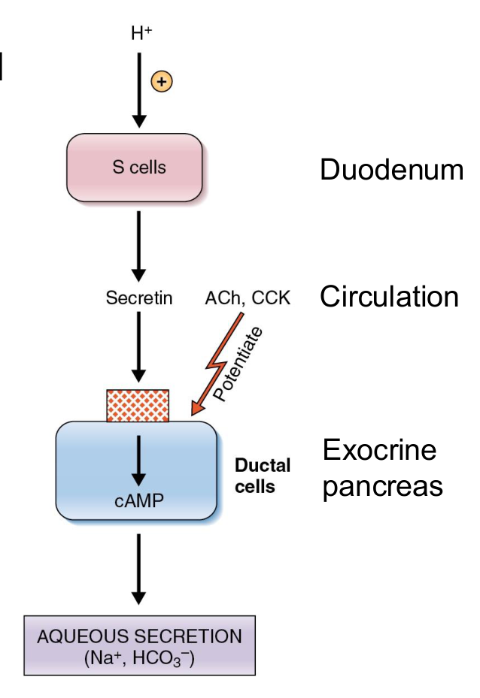  Original secretin–ductal-cell pathway (p. 19; Costanzo Physiology, 7e, Fig. 8.23). | Sensor and location  S cells in duodenal epithelium detect a decrease in pH of the duodenal contents.  Hormone and route  S cells → secretin → circulation → exocrine pancreas.  Cell, signal and output  Ductal cells → cAMP signalling → HCO₃⁻-rich aqueous secretion. Na⁺ and HCO₃⁻ are labelled in the figure.  Additional inputs  ACh and CCK BOTH upregulate / potentiate pancreatic aqueous secretion. “Secretin is primary” does not mean it acts alone.  Function  Alkaline fluid neutralises incoming gastric acid and supports small-intestinal digestion.
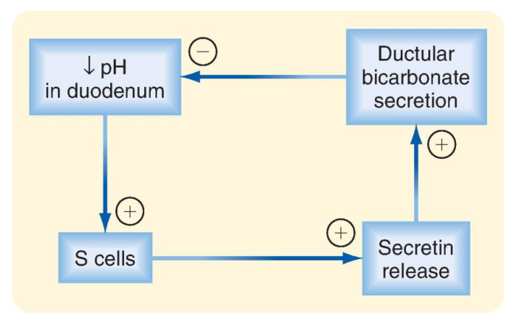
Original pH–secretin feedback loop (p. 19; Berne & Levy, 8e, Fig. 30.3).
Close the negative-feedback loop
Duodenal pH ↓ → S cells stimulated → secretin release ↑
→ ductal bicarbonate secretion ↑ → acid neutralised → the low-pH stimulus decreases.
The final inhibitory sign refers to removal of the low-pH stimulus, not inhibition of neutralisation.

Original MCQ 5
Which regulator primarily stimulates bicarbonate-rich aqueous secretion by the pancreas?
A. Secretin B. CCK C. Acetylcholine D. Gastrin
Answer: A
Secretin is primary for alkaline aqueous output; ACh and CCK can enhance that output.

Original Case 2 | Part 3, Q4
Original question / ID | Answer and reasoning
C2-P3-Q4 Which hormone stimulates bicarbonate-rich aqueous secretion? | Secretin. Connect low duodenal pH → S cells → ductal secretion.

16 / Digestive enzymes: preserve the complete table
Lecture PDF p. 20 | Includes protein enzymes even though the absorption outcomes focus on carbohydrate and lipid
Written emphasis from the slide
Pancreatic enzymes have the most vital role in digestion in this lecture’s overview.

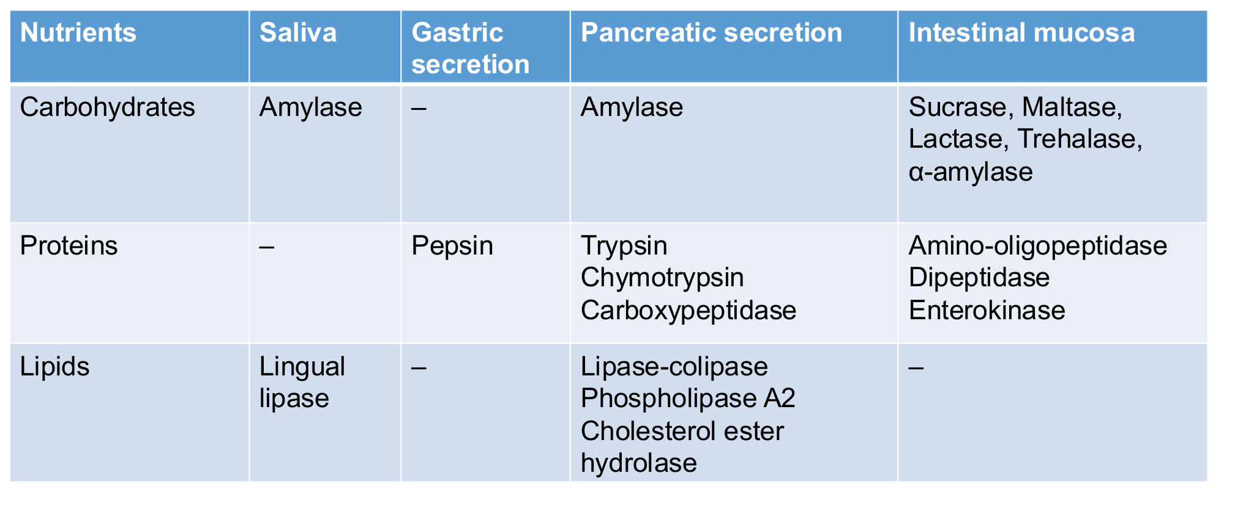
Original enzyme table, retained with its source wording (p. 20). The intestinal α-amylase entry is corrected below.
Nutrient | Saliva / oral | Gastric | Pancreatic secretion | Intestinal mucosa
Carbohydrate | Amylase. | — | Amylase. | Sucrase, maltase, lactase, trehalase; use α-dextrinase / isomaltase for the corrected final-digestion pathway.
Protein | — | Pepsin. | Trypsin; chymotrypsin; carboxypeptidase. | Amino-oligopeptidase; dipeptidase; enterokinase.
Lipid | Lingual lipase. | — in source table | Lipase–colipase; phospholipase A₂; cholesterol ester hydrolase. | — in source table

Explicit source correction — keep the original wording visible
The original table lists “α-amylase” under intestinal mucosa. The written slide 21 also attributes a major amylase role to intestinal mucosa.
Correct distinction: salivary / pancreatic α-amylase hydrolyses starch in the lumen; intestinal brush-border enzymes finish digestion, including α-dextrinase / isomaltase and disaccharidases.

Name / symbol | Clarification
Enterokinase | Also called enteropeptidase. Activates trypsinogen → trypsin; do not treat it as a bulk protein-digesting enzyme.
Lipase–colipase | Lipase is the hydrolytic enzyme. Colipase assists its action at the lipid interface.
Dash (—) | No enzyme is listed in that cell of this selective source table; do not turn it into a universal claim that no enzyme can ever act there.

17 / Carbohydrate digestion: all pathways
Lecture PDF p. 21 | Case 2 Part 4, Q1
Absorbable form
Only monosaccharides are absorbed by intestinal epithelial cells in this dietary carbohydrate pathway. Starch and disaccharides must first be hydrolysed.

Stage | Key written content retained
Initial starch digestion | Amylase in saliva contributes a minor role in this lecture’s comparison. Pancreatic amylase provides the major luminal contribution.
Intermediate products | Starch → oligosaccharides / starch fragments, including α-dextrins, maltose and maltotriose.
Final digestion | Enzymes on the intestinal brush border digest these products and dietary disaccharides into monosaccharides.
Original wording and correction | The slide also says amylase in “intestinal mucosa (major)”. Keep luminal α-amylase separate from mucosal α-dextrinase / isomaltase and disaccharidases; see the preserved original table on p. 16.

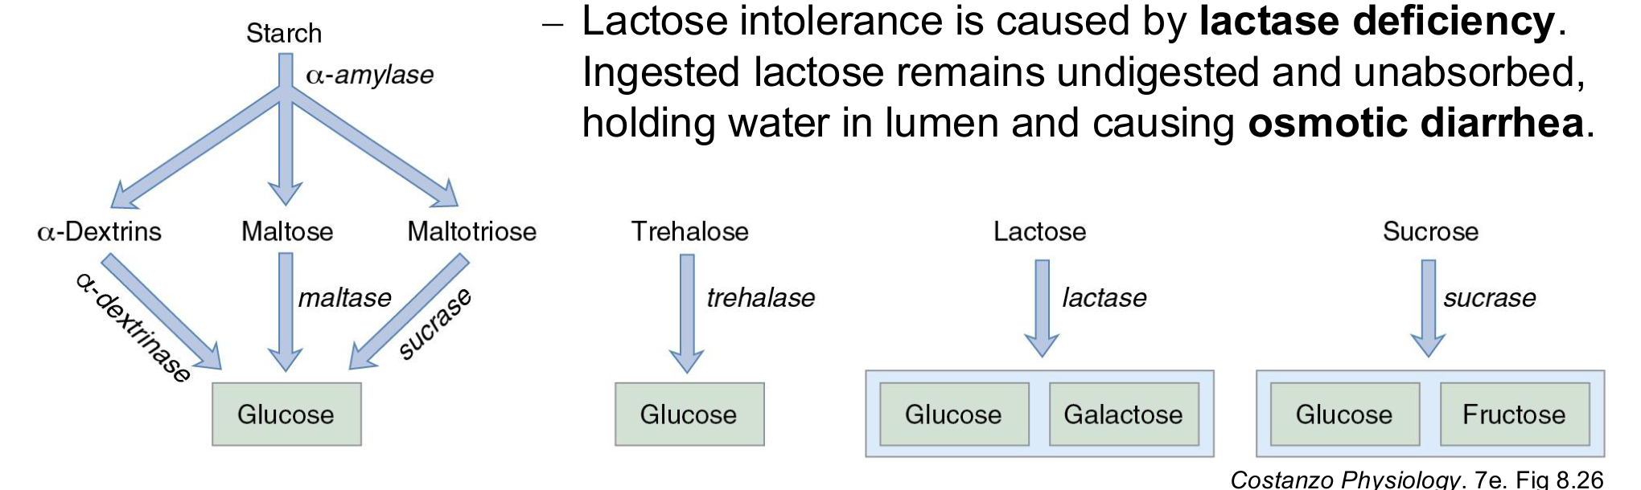
Original full carbohydrate pathway and lactase-deficiency statement (p. 21; Costanzo Physiology, 7e, Fig. 8.26).
Substrate in the figure | Enzyme label / final products
α-Dextrins | α-Dextrinase → glucose.
Maltose | Maltase → glucose.
Maltotriose | Sucrase is labelled on this arrow → glucose. Several brush-border α-glucosidases have overlapping activity.
Trehalose | Trehalase → glucose (two glucose units per trehalose).
Lactose | Lactase → glucose + galactose.
Sucrose | Sucrase → glucose + fructose.

Lactose intolerance — retain the whole cause-and-effect chain
Lactase deficiency → ingested lactose stays undigested AND unabsorbed
→ lactose holds water in the intestinal lumen → osmotic diarrhoea.
[Extension] Bacterial fermentation can add gas and bloating.

Original Case 2 | Part 4, Q1
Original question / ID | Answer and reasoning
C2-P4-Q1 In what form are carbohydrates absorbed? | Monosaccharides: glucose, galactose and fructose. Enzyme deficiency is a digestion problem upstream of their normal transporters.

18 / Monosaccharide absorption: full mechanism
Lecture PDF p. 22 | Case 2 Part 4, Q2
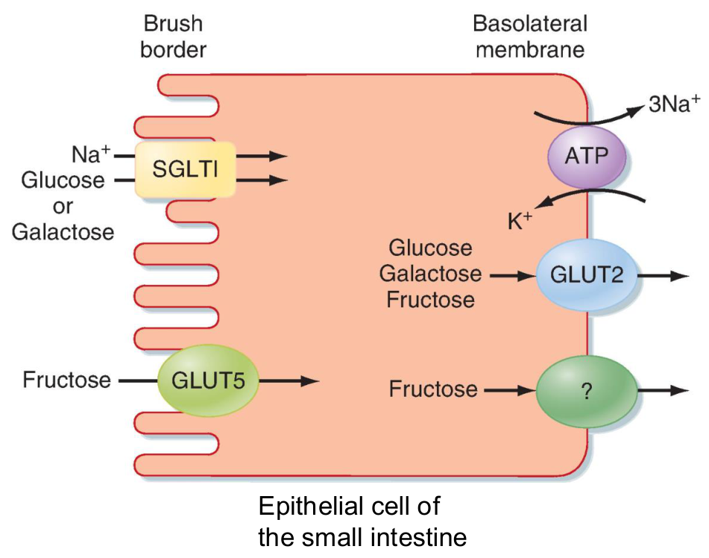
Original apical and basolateral enterocyte transport (p. 22; Berne & Levy Physiology, 8e, Fig. 30.9).
Site / transporter | Substrate and mechanism | What is essential?
Apical SGLT1 | Na⁺ / glucose symporter: glucose OR galactose enters together with Na⁺. | The Na⁺ gradient supplies energy; sugar can move against its own concentration gradient.
Basolateral Na⁺/K⁺-ATPase | Uses ATP to move Na⁺ out and K⁺ in, maintaining low intracellular Na⁺. | Creates the Na⁺ gradient used by SGLT1. The figure labels 3 Na⁺ moving outward.
Apical GLUT5 | Fructose uptake by facilitated diffusion; not coupled to Na⁺. | No Na⁺ cotransport. It does not use the Na⁺ gradient as SGLT1 does.
Basolateral GLUT2 | Glucose, galactose AND fructose leave across the basolateral pole. | Provides the sugar exit route toward interstitial fluid / blood.

Retain the slide’s comparison without overgeneralising
The slide links Na⁺-coupled glucose / galactose uptake to transport against their gradients and “higher efficiency”. It describes Na⁺-independent fructose uptake as “relatively inefficient”.
Use this as the mechanistic contrast taught here; it is not a universal numerical ranking of fructose absorption under every concentration or diet.

• Energy chain: ATP → Na⁺/K⁺-ATPase → Na⁺ gradient → SGLT1 uptake. SGLT1 itself does not hydrolyse ATP.
• Membrane terms: apical / brush border faces lumen; basolateral faces interstitium and blood. The extra “?” fructose-exit symbol in the image is not a named transporter to memorise; the written slide explicitly identifies GLUT2 for all three sugars.

Original Case 2 | Part 4, Q2
Original question / ID | Answer and reasoning
C2-P4-Q2 Which transporter absorbs glucose from the intestinal lumen? | Apical SGLT1. GLUT2 is the exit transporter, so “from the lumen” is a decisive phrase.

SGLT1 = sodium–glucose cotransporter 1; GLUT = glucose transporter family. A symporter moves coupled solutes in the same direction. Glucose / galactose uptake is secondary active; GLUT5 / GLUT2 transport is facilitated diffusion.

19 / Lipid digestion: bile salts and all three enzymes
Lecture PDF p. 23 | Case 2 Part 4, Q3
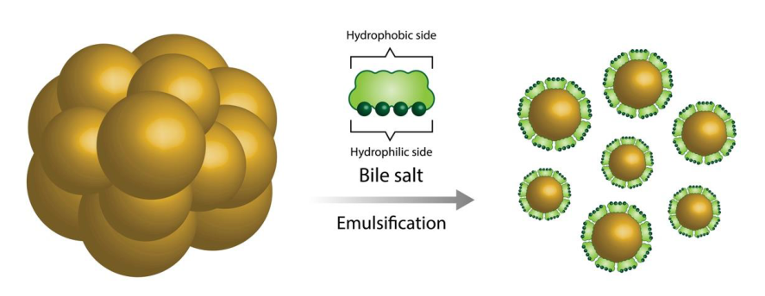
Original large-droplet → small-droplet emulsification, with both bile-salt faces labelled (p. 23).
All parts of the written bile-salt statement
Bile released by the gallbladder contains bile salts.
Bile salts emulsify dietary lipids into fine oil droplets
→ surface area available for contact with digestive enzymes increases.

• Figure detail: bile salts have a hydrophobic side and a hydrophilic side. Their amphipathic structure helps disperse lipid in the aqueous intestinal contents.
• [Clarification] The liver makes bile; the gallbladder stores / releases it. Emulsification disperses droplets; enzymatic hydrolysis breaks chemical bonds.
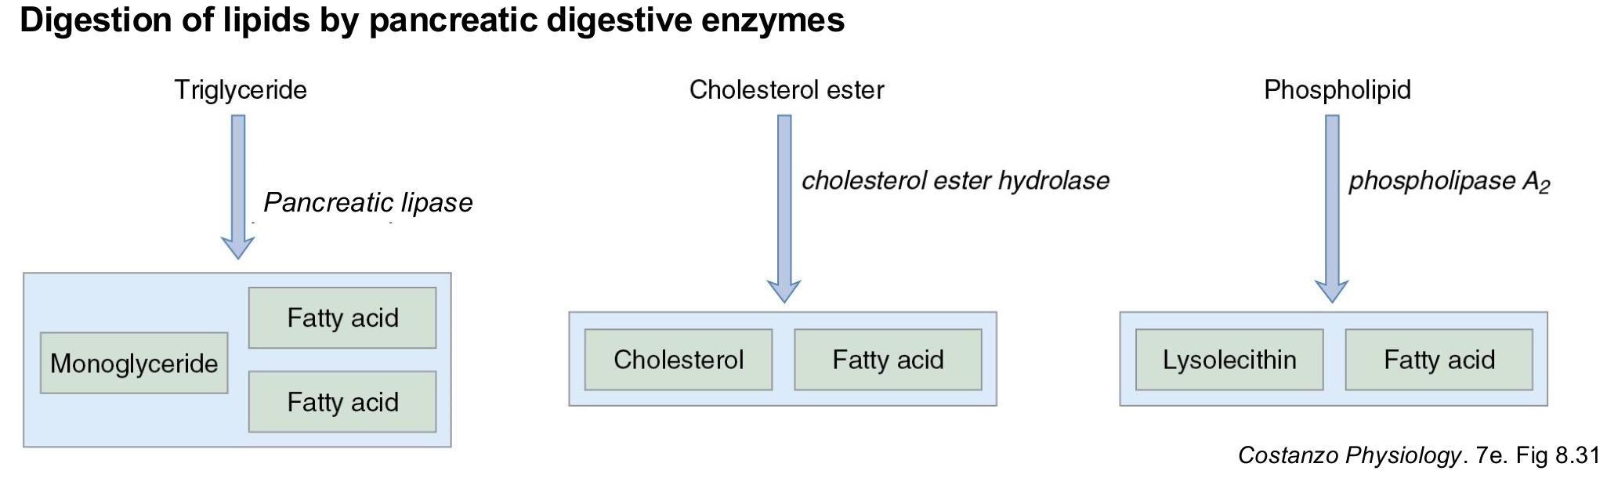
Original complete pancreatic lipid-hydrolysis diagram (p. 23; Costanzo Physiology, 7e, Fig. 8.31).
Substrate | Enzyme / associated factor | Digestion products
Triglyceride (TG) | Pancreatic lipase; colipase assists action at the interface. | Monoglyceride + two free fatty acids (FFAs); mainly 2-monoglyceride.
Cholesterol ester | Cholesterol ester hydrolase. | Cholesterol + FFA.
Phospholipid | Phospholipase A₂. | Lysolecithin / lysophospholipid + FFA.

Original Case 2 | Part 4, Q3
Original question / ID | Answer and reasoning
C2-P4-Q3 Into what products are dietary lipids digested? | FFAs and monoglycerides are the main expected pair. Include cholesterol and lysophospholipids when covering all lipid classes.

20 / Lipid absorption: every numbered arrow
Lecture PDF p. 24 | Original figure and its complete abbreviation key
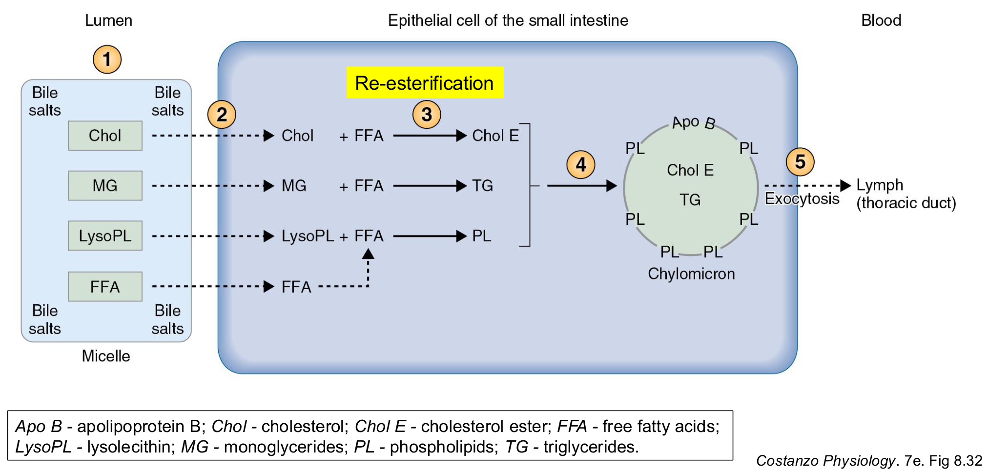
Original micelle → enterocyte → chylomicron → lymph diagram, with re-esterification highlight (p. 24; Costanzo Physiology, 7e, Fig. 8.32).
Number in figure | Location and event
1. Micelle | In the lumen: bile salts surround / solubilise Chol, MG, LysoPL and FFA.
2. Apical entry | Lipid digestion products leave the micelle and cross into the intestinal epithelial cell. Whole micelles do not enter.
3. Re-esterification | Inside the cell: lipid products are joined with fatty acids to re-form complex lipids.
4. Packaging | Re-esterified lipids associate with apoproteins, including Apo B → chylomicron.
5. Exocytosis | Chylomicron exits the enterocyte → lymphatic route / thoracic duct → blood.

All three intracellular rebuilding arrows
Incoming lipid product + fatty acid | Re-formed product
Chol + FFA | Chol E: cholesterol / cholesteryl ester.
MG + fatty acids | TG: triglyceride. The source uses “+ FFA” schematically; a monoglyceride needs two additional fatty-acid chains to become a triglyceride.
LysoPL + FFA | PL: phospholipid.

Label | Meaning | Label | Meaning
Apo B | Apolipoprotein B. | Chol | Cholesterol.
Chol E | Cholesterol / cholesteryl ester. | FFA | Free fatty acids.
LysoPL | Lysolecithin / lysophospholipid. | MG | Monoglycerides.
PL | Phospholipids. | TG | Triglycerides.

The original chylomicron drawing places TG / Chol E in the particle and PL / Apo B at its surface. Re-esterification rebuilds lipid classes inside the cell; it is distinct from luminal hydrolysis and from membrane transport.

21 / Lipid absorption: all five written steps
Lecture PDF p. 25 | Original MCQ 7; Case 2 Part 4, Q4
Written step | Complete key content retained
1. Solubilise digestion products | Cholesterol, monoglycerides, lysolecithin and FFAs are solubilised in micelles lined with bile salts.
2. Release at apical membrane | Lipids are released from the micelle and enter the cell. Micelles per se do not enter. Bile salts remain in the intestinal lumen and are subsequently absorbed in the ileum.
3. Re-esterify in the cell | In the cytoplasm, digestion products combine with fatty acids to re-form triglycerides, cholesterol esters and phospholipids.
4. Package | Re-esterified lipids are packaged with apoproteins into lipid-carrying particles called chylomicrons.
5. Export and transport | Chylomicrons are exocytosed → enter lacteals → lymphatic circulation → thoracic duct → bloodstream.

Micelle and chylomicron are different carriers
Compare | Micelle | Chylomicron
Where formed? | Intestinal lumen. | Inside enterocyte.
What is carried? | Lipid digestion products, associated with bile salts. | Re-esterified lipids packaged with apoproteins.
Function | Delivers lipid products to the absorptive surface. | Exports absorbed lipid and carries it onward.
Route | Cargo enters cell; bile salts stay in lumen until ileal reabsorption. | Lacteals → lymph → thoracic duct → blood.

Original MCQ 7
Dietary lipids are eventually transported in the circulation mainly as:
A. Micelles B. Chylomicrons C. Monoglycerides D. Fatty acids
Answer: B
Chylomicrons are the main post-absorption carriers for long-chain dietary lipids. Micelles act in the lumen before absorption.

Original Case 2 | Part 4, Q4
Original question / ID | Answer and reasoning
C2-P4-Q4 What structure transports absorbed lipids into the circulation? | Carrier particle: chylomicron. Anatomical route: lacteals → lymph → thoracic duct → blood. Give both if “structure” is ambiguous.

[Extension] Most bile salts are reabsorbed in the terminal ileum and return to the liver in portal blood for reuse. Short- and medium-chain fatty acids can enter portal blood more directly; the five-step chylomicron pathway describes the major long-chain dietary lipid route.

22 / Lecture summary and two location checks
Lecture PDF p. 26 | One further integrated practice question
Every written summary point | Mechanism / meaning
Motility moves AND mixes food | Parasympathetic activity and ACh promote gastric motility.
Motor inhibition | Sympathetic activity, CCK and secretin inhibit gastric motility / emptying.
Gastric secretion initiates digestion | ACh, histamine and gastrin stimulate gastric acid; somatostatin inhibits it.
Pancreatic secretions are vital | CCK stimulates enzyme secretion; secretin stimulates bicarbonate-rich aqueous secretion.
Digestion precedes absorption | Carbohydrates → monosaccharides. Lipids → fatty acids / monoglycerides → enterocyte processing → chylomicrons.

Same low-pH signal, different location | Cell and output | Functional result
Gastric low pH | D cells → somatostatin. | Gastric acid secretion decreases.
Duodenal low pH | S cells → secretin. | Pancreatic bicarbonate-rich output increases; gastric delivery slows.

Keep the complete route in an exam answer
Regulation: stimulus + LOCATION → sensor / source cell → messenger
→ receptor / target cell → secretion or movement.
Absorption: digested product → apical entry → cell processing
→ basolateral exit / exocytosis → blood or lymph route.

Integrated practice 2 | Self-written; not an original exam question
No bile reaches the duodenum, but pancreatic enzymes, bicarbonate secretion and the mucosa remain normal. Predict long-chain fat absorption, chylomicron output and glucose absorption. Would more lipase fully correct the defect?
Answer approach:
• Emulsification and mixed-micelle formation decrease → fat hydrolysis / delivery to the brush border becomes less effective.
• Long-chain fat absorption and chylomicron output fall.
• More lipase does not replace bile salts’ emulsifying / solubilising functions.
• Glucose absorption is largely preserved: amylase / brush-border digestion and SGLT1 / GLUT2 do not require micelles.
• Preserve the question’s stated normal pancreatic outputs when reasoning.

Only two self-written integrated questions are included: receptor / pump inhibition on p. 12 and the bile-loss case here. They follow the tutorial’s causal style and are not forecasts of the actual exam. All seven MCQs and both original cases are covered beside the mechanisms they test.

23 / Slide coverage check: the first half
Audit of the written key content and teaching figures | Source page → location in this edition
Lecture PDF page | Retained written content / important figure detail | Notes page
1 | Cover | Digestive Physiology; BBMS2006; lecturer Dr Enoch Chan. | Source identification
2 | Learning outcomes | All four outcomes: ENS / autonomic; gastric regulation; pancreatic secretion; carbohydrate / lipid digestion and absorption. | 1
3 | Basic functions | Nutrients + water + electrolytes; external → internal; secretion into lumen OR ECF; mechanical AND chemical digestion; absorption; motility. | 1
4 | Wall | All named layers; circular / longitudinal; both plexus locations; figure serosa. | 2
5 | ENS | Both plexus functions; independent ENS; parasympathetic ↑ / sympathetic ↓ motility AND secretion; sensory / effector circuit labels. | 3
6 | Messengers | Neurocrine / endocrine / paracrine definitions and examples; portal → liver → systemic pathway; local diffusion; neuronal action potential. | 4
7 | Smooth muscle | Circular ↓ diameter; longitudinal ↓ length; phasic periodic / mixing; tonic sustained / sphincter. | 5
8 | ICCs | Myenteric-region abundance; spontaneous activity; gap junctions and rapid spread; autonomic modulation; slow-wave / L-type Ca²⁺ labels. | 5
9 | Gastric motility | Receive oesophageal bolus by orad relaxation; reduce particle size / mix secretions; empty chyme. All region / sphincter labels. | 6
10 | Segmentation | Food present; alternating circular contraction with adjacent relaxation; split → backward / forward → merge; mixing / propulsion distinction. | 6
11 | Gastric juice | All four juice components and functions; cell types, body / antrum locations; lumen / circulation destinations. | 7
12 | Phases | Cephalic minor / gastric major; smell / taste / anticipation; CNS / vagus; distension / mechanoreceptors; long and local reflexes; ACh; explicit low-pH correction. | 8–9
13 | ACh / histamine | ECL origin / mucosal location, paracrine, H₂ / pump; enteric ACh, M₃ / pump; ACh stimulation of ECL. | 10
14 | Gastrin | Enteric GRP → G; gastrin via blood to both ECL and parietal cells; direct pump stimulation plus histamine release. | 10

This check follows the PPT’s written points rather than using the tutorial questions as the limit of lecture coverage. Original diagrams repeated across source slides are retained once, with both source pages credited.

24 / Slide coverage check: the second half
Audit continued | Original wording with physiological corrections explicitly distinguished
Lecture PDF page | Retained written content / important figure detail | Notes page
15 | Somatostatin | Food buffers H⁺; food leaves → buffering ↓ / pH ↓; D cells, paracrine; direct parietal and indirect ECL / G inhibition. | 11
16 | Acid summary | M₃ / CCK₂ / H₂; Gq / Gs / Gi; IP₃ / Ca²⁺ / cAMP; pump; upper feedback arrows; all three drug targets. | 12
17 | Duodenal brake | Lipids / low pH / distension; motility inhibition AND pyloric contraction; I-cell CCK in duodenum / jejunum; S-cell secretin; both motor inhibitors; figure’s brief intestinal-gastrin phase / neural inhibition. | 13
18 | Pancreatic enzymes | All three nutrient groups; I cells and location; CCK₁; ACh; acinar IP₃ / Ca²⁺; named amino-acid examples. | 14
19 | Pancreatic fluid | S cells in duodenal epithelium detect pH drop; secretin / blood / duct; HCO₃⁻ aqueous output; ACh AND CCK; cAMP; complete feedback loop. | 15
20 | Enzyme table | Original table retained; every row / column and named enzyme kept; pancreatic importance; incorrect intestinal α-amylase entry explicitly corrected. | 16
21 | Carbohydrates | Only monosaccharides; salivary minor / pancreatic major; mucosal final digestion and source correction; every figure substrate / enzyme / product; complete lactase-deficiency chain. | 17
22 | Sugar transport | SGLT1 glucose / galactose + Na⁺; ATPase gradient; uphill uptake; GLUT5 Na⁺ independent; original efficiency comparison retained / qualified; all three sugars via basolateral GLUT2. | 18
23 | Lipid digestion | Bile from gallbladder; bile-salt emulsification → fine droplets → enzyme-contact area; both bile-salt faces; all three enzyme–substrate–product routes. | 19
24 | Lipid figure | Every numbered step; three re-esterification reactions; Apo B / chylomicron; exocytosis / lymph; all eight abbreviations. | 20
25 | Five lipid steps | Four micelle products; no whole-micelle entry; ileal bile-salt uptake; cytoplasmic rebuilding; apoprotein packaging; lacteals / lymph / thoracic duct / blood. | 21
26 | Summary | All written motor, gastric, pancreatic and nutrient-form summary statements. | 22
27–28 | References / logo | Costanzo Physiology, 7e, Chapter 8; decorative closing logo has no additional teaching mechanism. | Credits below

Source: Dr Enoch Chan, BBMS2006 Digestive Physiology (2026–27) and GI Physiology Tutorial 2026–27. The lecture names Costanzo Physiology, 7e, Chapter 8 as its main reading. Other original figure sources: Silverthorn, Human Physiology, 8e; Berne & Levy Physiology, 8e; Saladin, Anatomy & Physiology, 10e; Stanfield, Principles of Human Physiology. Figure numbers are retained beside the teaching images.
Answer audit: MCQ 1–7 = B, C, D, C, A, C, B. Case 1: all six prompts; Case 2: all 16 prompts. Answers here are independently reasoned study answers, not an official key. Handwritten selections / fill-ins were checked rather than assumed correct. The low-gastric-pH buffet answer is corrected; the missing third acid stimulator is supplied. Source figures and annotations are retained; incorrect wording is identified beside the relevant mechanism.

