High Cortical Function
BBMS2006 • Integrated illustrated study notes
Central idea: sensory information is integrated by cortical and subcortical networks to support perception, voluntary action, arousal, cognition and motivated behaviour.

1. Neural organisation and information flow
- The central nervous system (CNS) consists of the brain and spinal cord. The peripheral nervous system (PNS) carries sensory information toward the CNS and motor commands away from it.
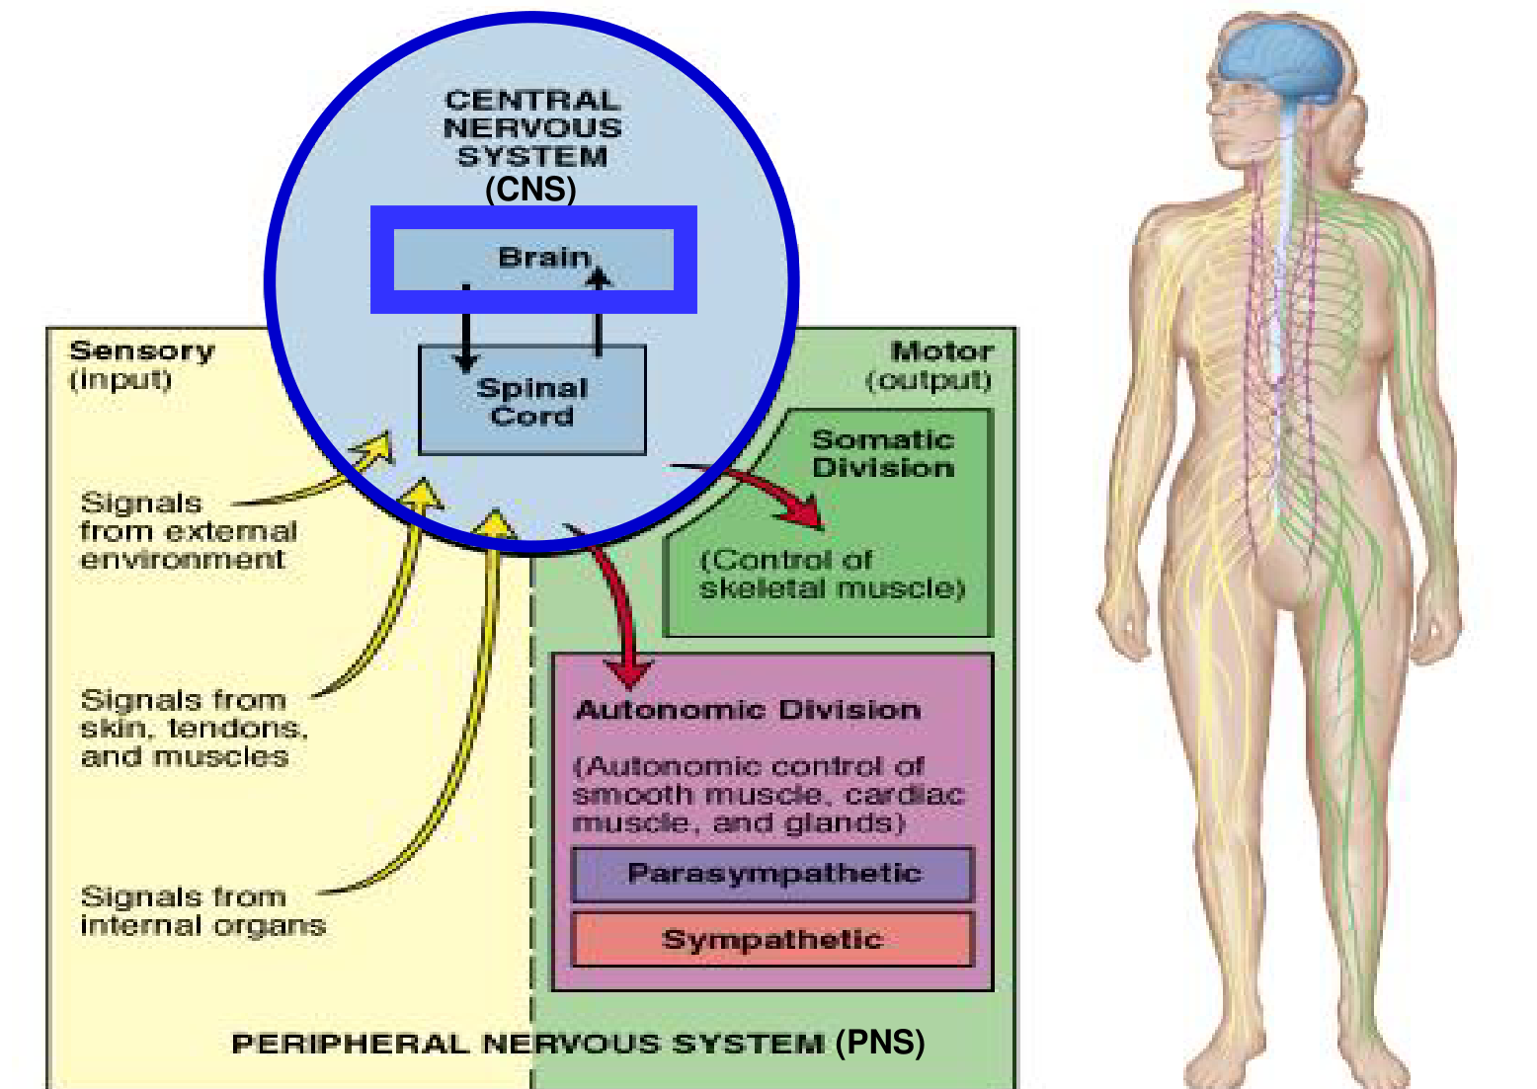
Sensory inputs converge on the CNS; somatic and autonomic outputs reach different effectors.
Division | Information or target
Sensory / afferent | External environment; skin, tendons and muscles; internal organs.
Somatic motor | Skeletal muscle; voluntary movement is a major function.
Autonomic motor | Smooth muscle, cardiac muscle and glands; sympathetic and parasympathetic divisions.

- Sympathetic activity commonly mobilises energy; parasympathetic activity commonly supports maintenance and conservation. These are broad functional tendencies.

1. Neural pathways: input to response
Stimulus → receptor → sensory neuron → CNS integration by association neurons → motor neuron → effector → response
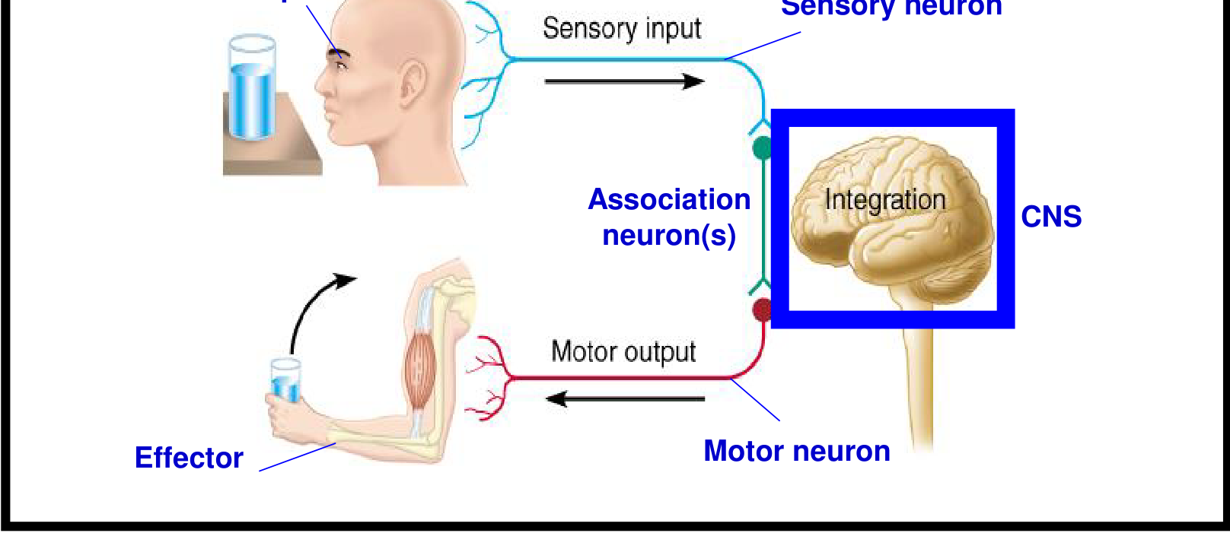
A receptor detects the stimulus; central processing links sensory input to an appropriate motor response.
- Sensory input: detection of a stimulus by receptors. Integration: interpretation of sensory input within the brain and spinal cord. Motor output: activation of an effector, such as muscle.
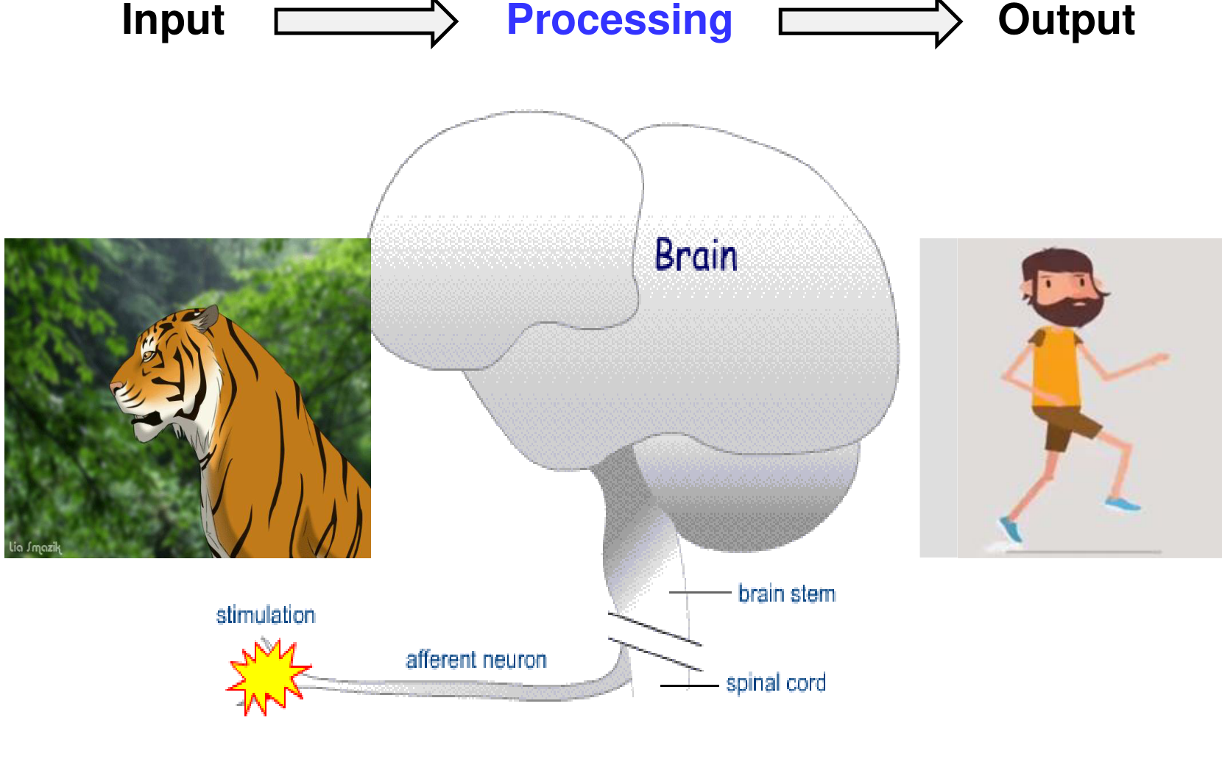
The tiger example links an external stimulus to brain processing and a behavioural response.
- An association neuron is an interneuron. Integration can involve several interneurons and multiple CNS regions; it is not necessarily a single synapse.

2. Cerebrum and anatomical landmarks
- The brain includes the cerebrum, diencephalon, brainstem and cerebellum. The diencephalon includes the thalamus and hypothalamus; the brainstem includes midbrain, pons and medulla.
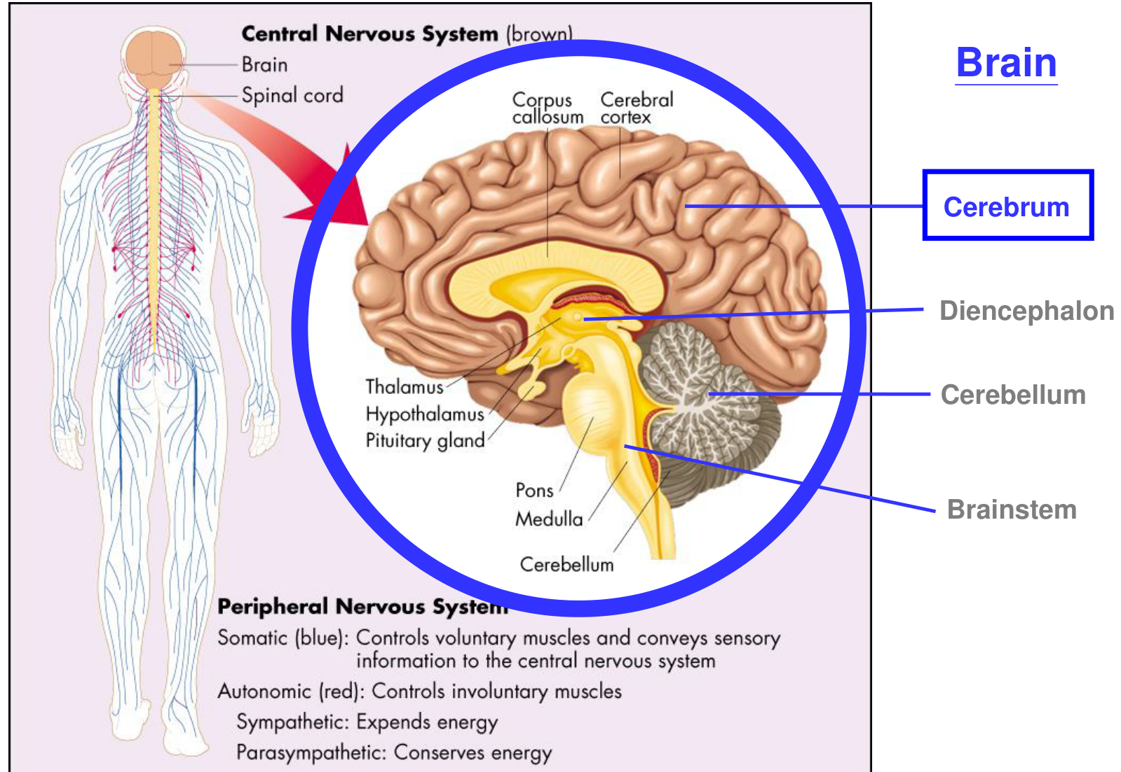
Sagittal orientation: cerebral cortex, corpus callosum, thalamus, hypothalamus, pituitary, pons, medulla and cerebellum.
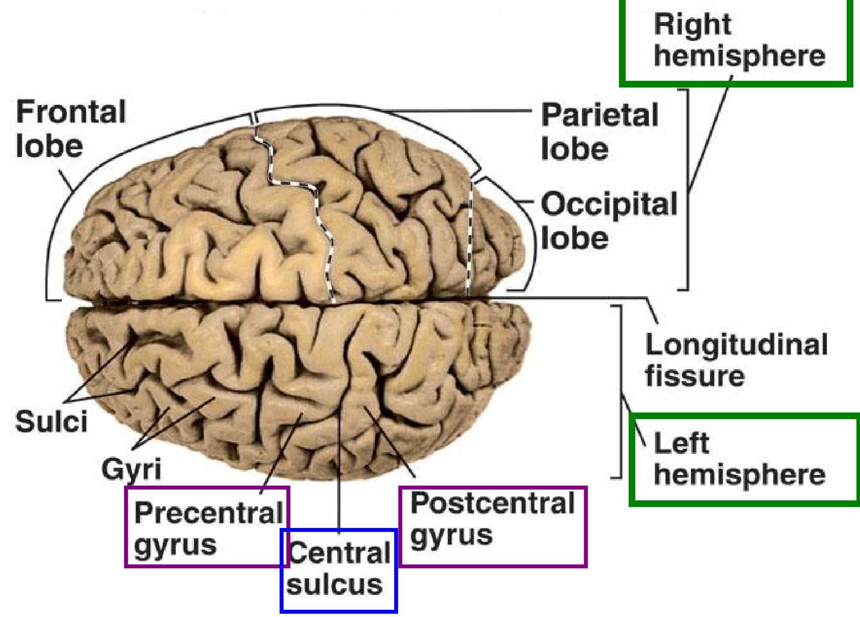
The longitudinal fissure separates the cerebral hemispheres; the central sulcus lies between the precentral and postcentral gyri.
- Gyri are cortical ridges; sulci are grooves. The cerebral cortex is the outermost layer of neural tissue of the cerebrum.

2. Gray matter, white matter and nuclei
Structure | Composition / role
Gray matter | Mainly neuronal cell bodies, with dendrites and synapses. The cerebral cortex is gray matter.
White matter | Predominantly myelinated axons connecting neural regions. The internal capsule is a major white-matter pathway.
Basal ganglia (basal nuclei) | Deep gray-matter nuclei involved in movement and motivation. The illustrated nuclei include caudate, putamen and globus pallidus.

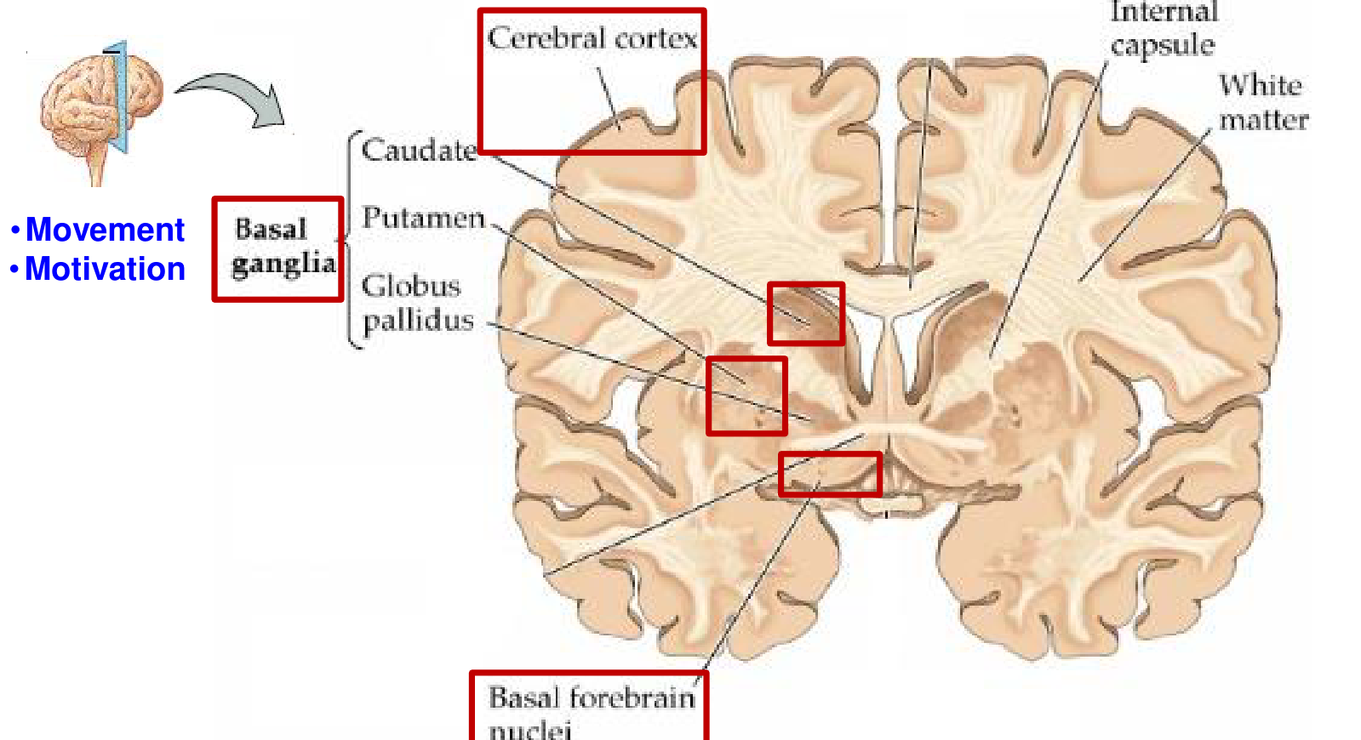
Gray-matter emphasis: cortex and deep nuclei. Basal forebrain nuclei are also labelled.
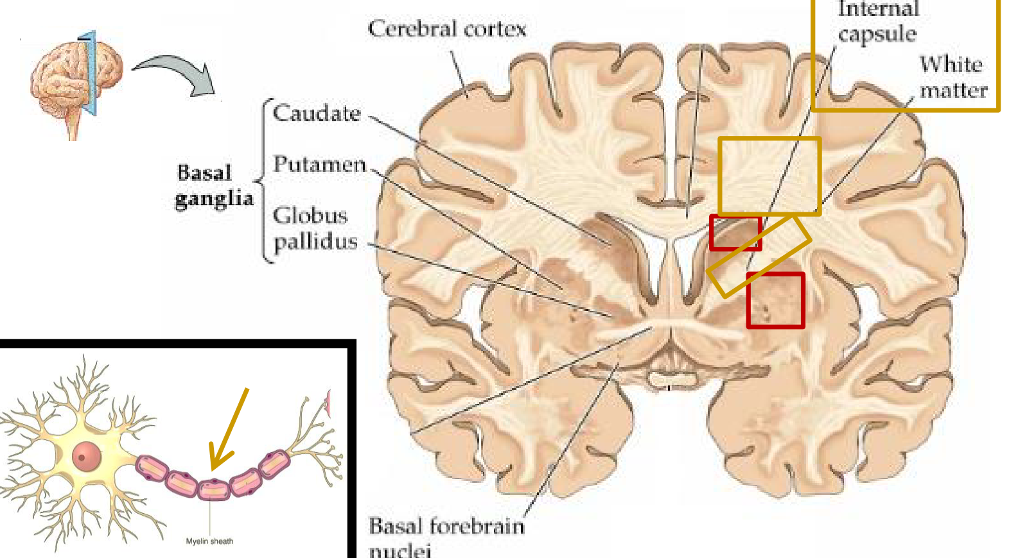
White-matter emphasis: internal capsule and myelinated axons; the altered highlighting is retained.
- Deep gray matter is not cortex. White matter carries connections between cell populations; the basal ganglia should not be confused with the nearby basal forebrain nuclei.

3. Cerebral lobes: a functional map
- The cerebral lobes collectively support sensation, communication, memory, understanding and voluntary movement.
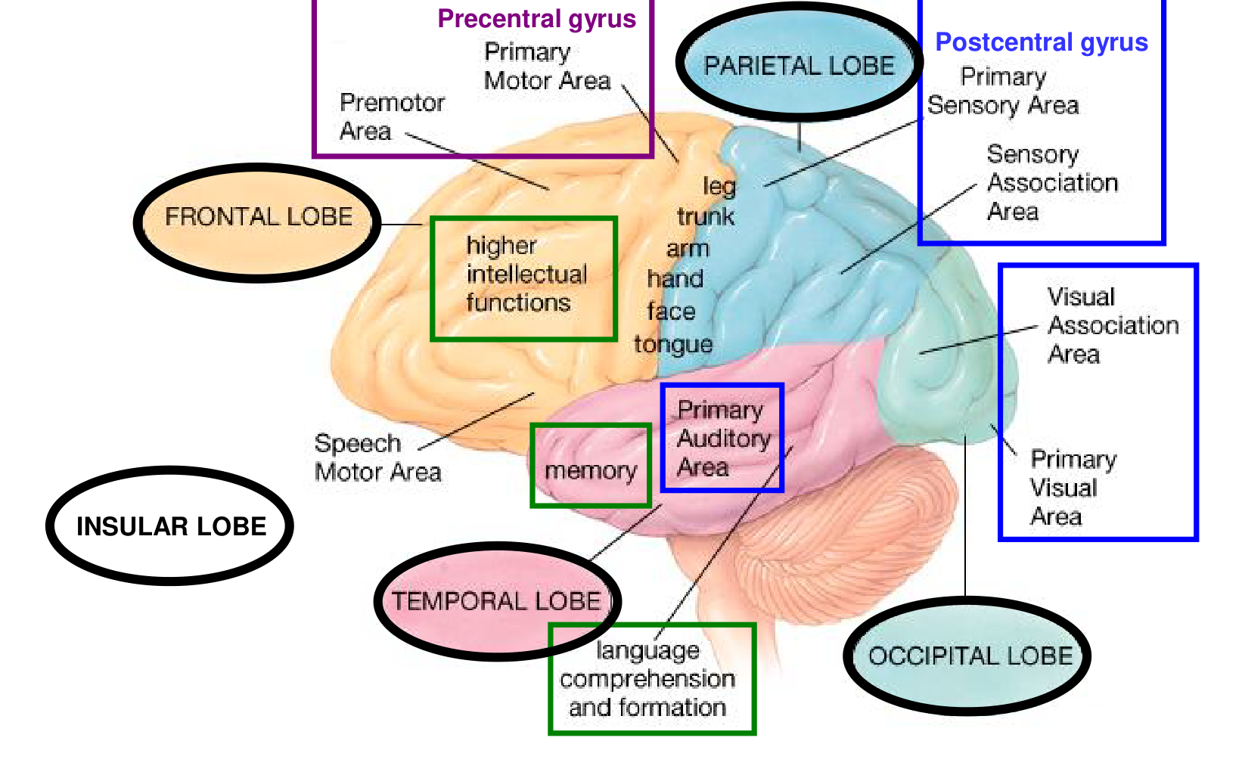
Cortical landmarks: motor and sensory strips, association areas, language-related areas and memory-related regions.
Lobe | Principal functions
Frontal | Judgment, planning, personality, concentration, speaking and movement.
Parietal | Somatosensation, such as touch; integration of information from different senses.
Occipital | Vision.
Temporal | Audition, olfaction, speech, declarative memory and high-level visual processing.
Insular | Gustation, vestibular and visceral sensation, and motor control; examples include swallowing, gastric motility and speech production.

- Declarative memory concerns consciously accessible facts and events. High-level visual processing supports recognition and interpretation, beyond initial visual detection.

3. Lobes and distributed cortical functions
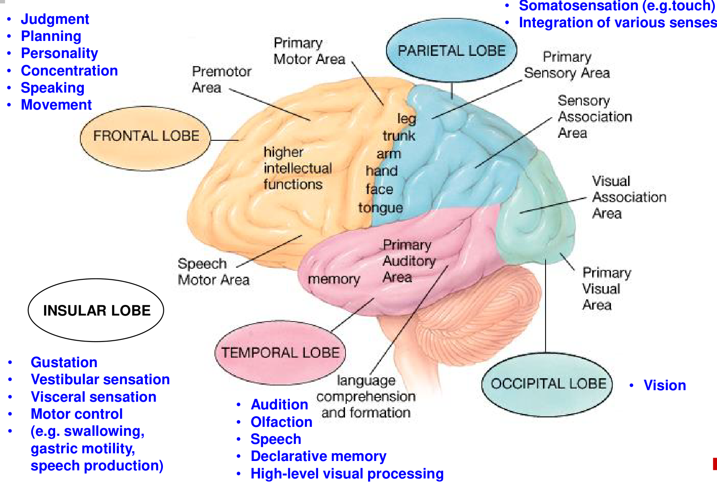
The annotated lobe map retains the full set of functional labels, including insular examples.
Functional category | Main contribution
Sensory areas | Conscious awareness of sensation.
Motor areas | Control of voluntary movement.
Association areas | Integration of diverse information and higher mental functions, including learning.

- A lobe contains several functional areas. A complex function such as speech or memory depends on interacting regions, rather than one isolated lobe.
- The insula lies deep to the lateral sulcus and is not exposed on a simple lateral surface view. Taste and vestibular functions also involve adjacent or distributed cortical regions.

4. Sensory cortex: location and meaning
Sensory area | Location / contribution
Primary somatosensory cortex | Postcentral gyrus, parietal lobe; conscious somatic sensation.
Visual cortex | Occipital lobe; vision.
Auditory cortex | Temporal lobe; hearing.
Olfactory cortex | Includes temporal-lobe regions; smell.
Gustatory cortex | Insula and adjacent opercular cortex; taste.
Vestibular cortex | A distributed network including insular and parietal regions; perception of head motion and orientation.

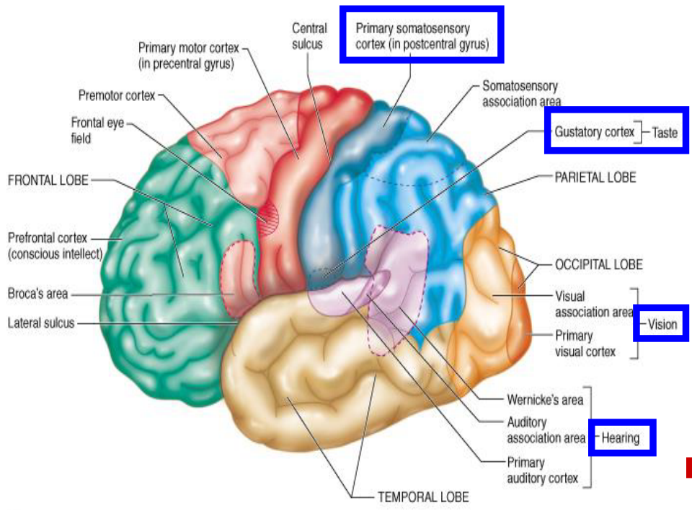
The cortical map locates the primary sensory areas and nearby association cortex.
Sensory input → primary sensory processing → association processing → recognition and interpretation
- Detection and recognition differ. Feeling contact is distinct from identifying an object by its shape or texture. Hearing a sound is distinct from understanding a word.

5. Motor cortex and speech
Frontal motor area | Role
Primary motor cortex | Precentral gyrus; contributes descending commands for voluntary movement.
Premotor cortex | Preparation and organisation of movements.
Frontal eye field | Control of voluntary eye movements.
Broca’s area | Motor aspects of speech: articulation and coordination of movements needed to produce speech.

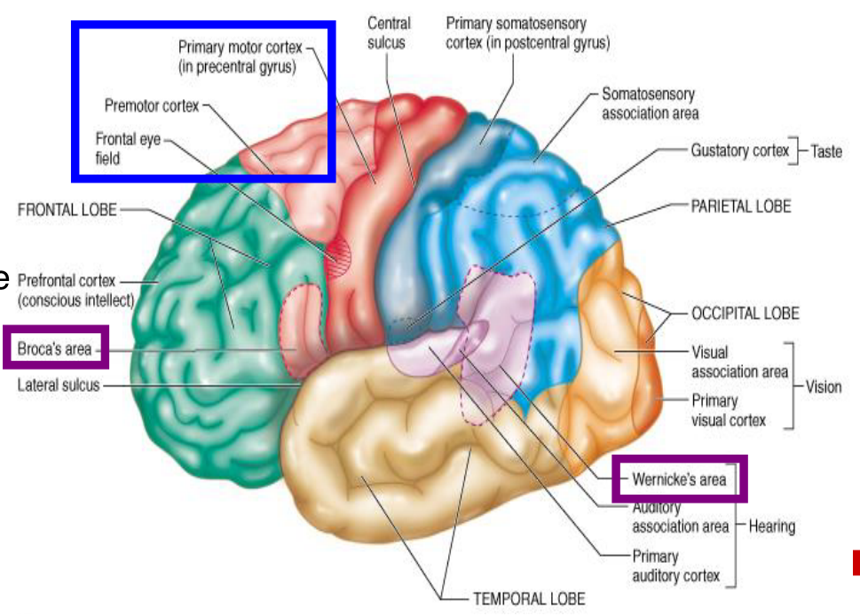
The highlighted frontal areas support movement; Wernicke’s area is shown separately for language comparison.
Language component | Main contribution
Broca’s area: motor speech | Organises speech production and the movements needed for articulation.
Wernicke’s area: sensory speech | Links recognisable spoken words to meaning; supports speech comprehension and selection of appropriate words for expression.

- “Sensory speech” refers to language comprehension, not merely hearing. Wernicke-related processing interprets word meanings and translates words into thoughts.

5. Corticospinal tract and crossing
Motor cortex → internal capsule → cerebral peduncle in midbrain → medullary pyramid → pyramidal decussation → lateral corticospinal tract → spinal motor circuitry → skeletal muscle
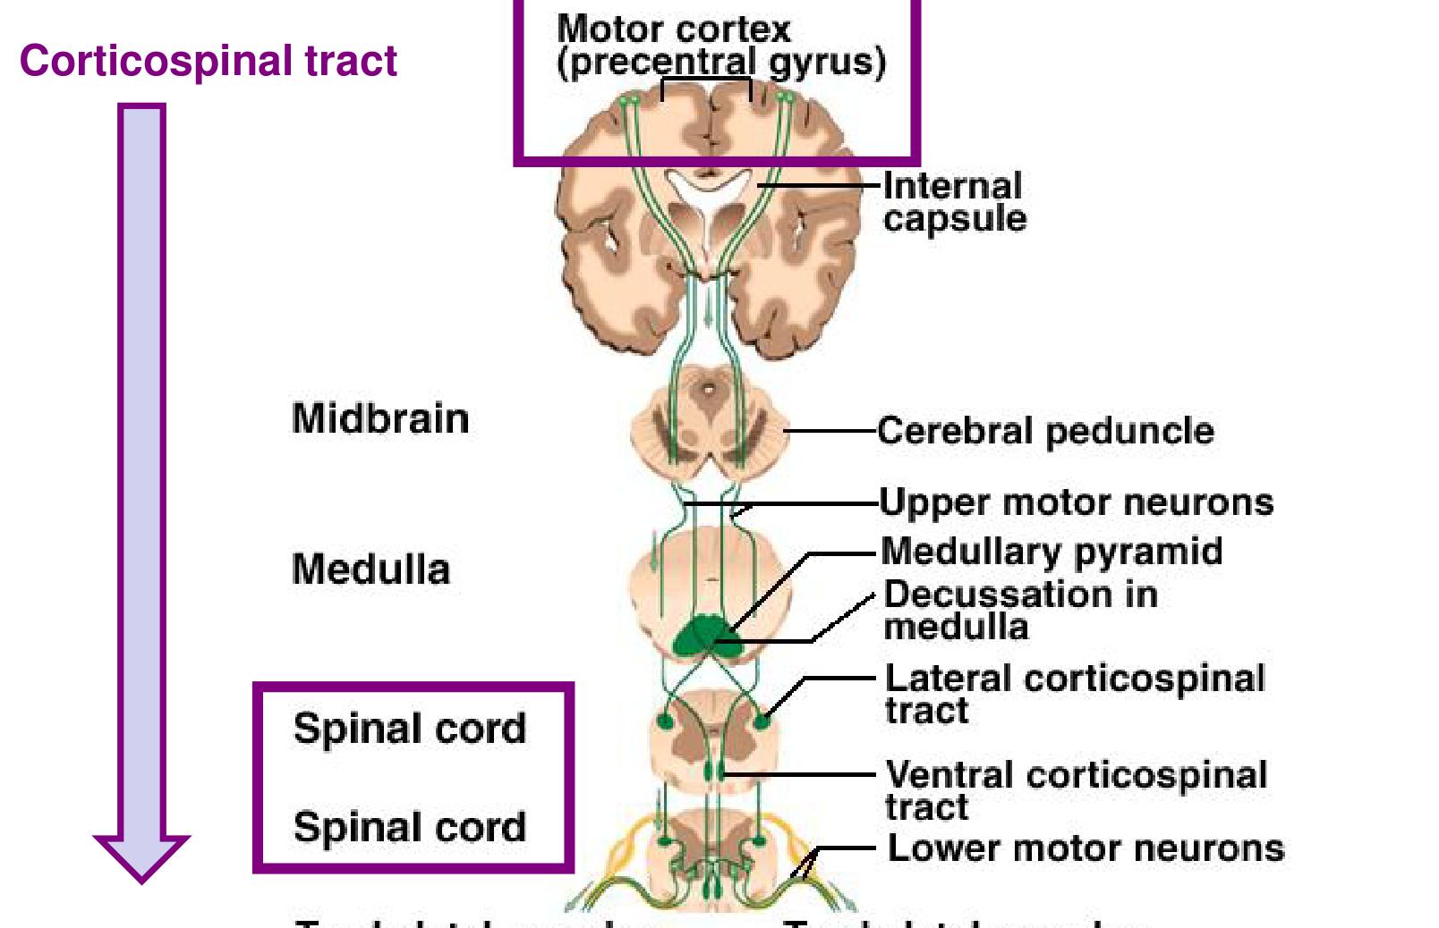
Descending upper motor neuron pathways and their connection to lower motor neurons.
- Upper motor neurons descend from the cortex. They influence lower motor neurons in the spinal cord, often through interneurons; lower motor neuron axons reach skeletal muscle.
- Most corticospinal fibres cross in the caudal medulla and enter the lateral corticospinal tract. This explains much of the contralateral control of the limbs.
- The anterior (ventral) corticospinal component initially descends without this crossing; many fibres cross near their spinal termination and influence axial muscles bilaterally.
- Consequently, a lesion above the main decussation tends to cause contralateral limb weakness; a lateral tract lesion below it tends to cause ipsilateral weakness below the lesion.

6. Cortical homunculi
- A cortical homunculus is a topographic representation of body regions in the cortex. There are sensory and motor maps.
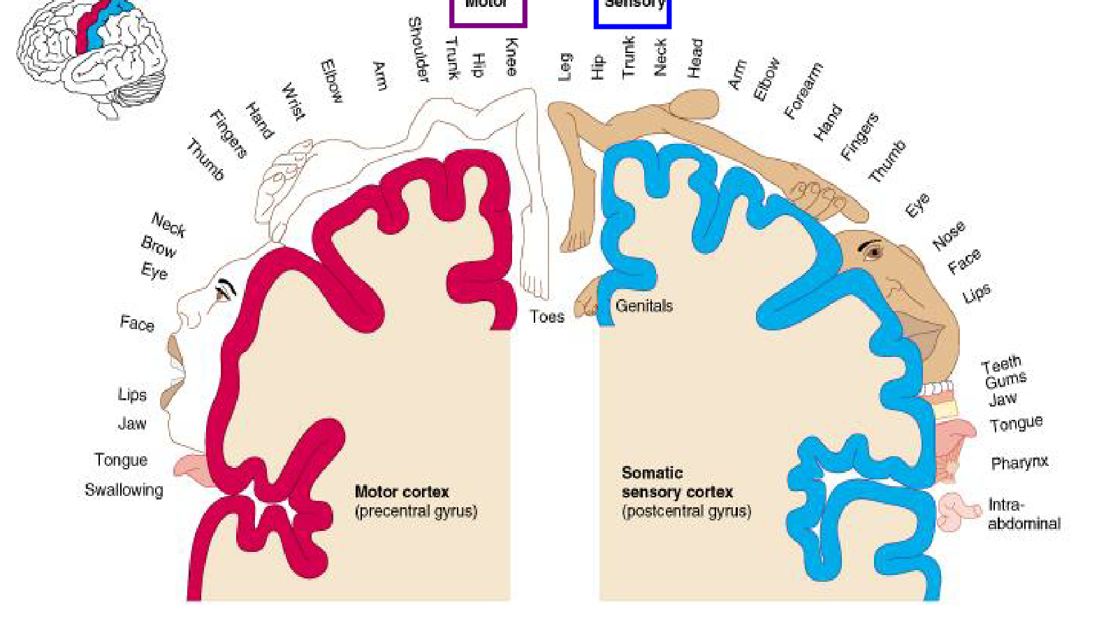
Motor map in the precentral gyrus; sensory map in the postcentral gyrus.
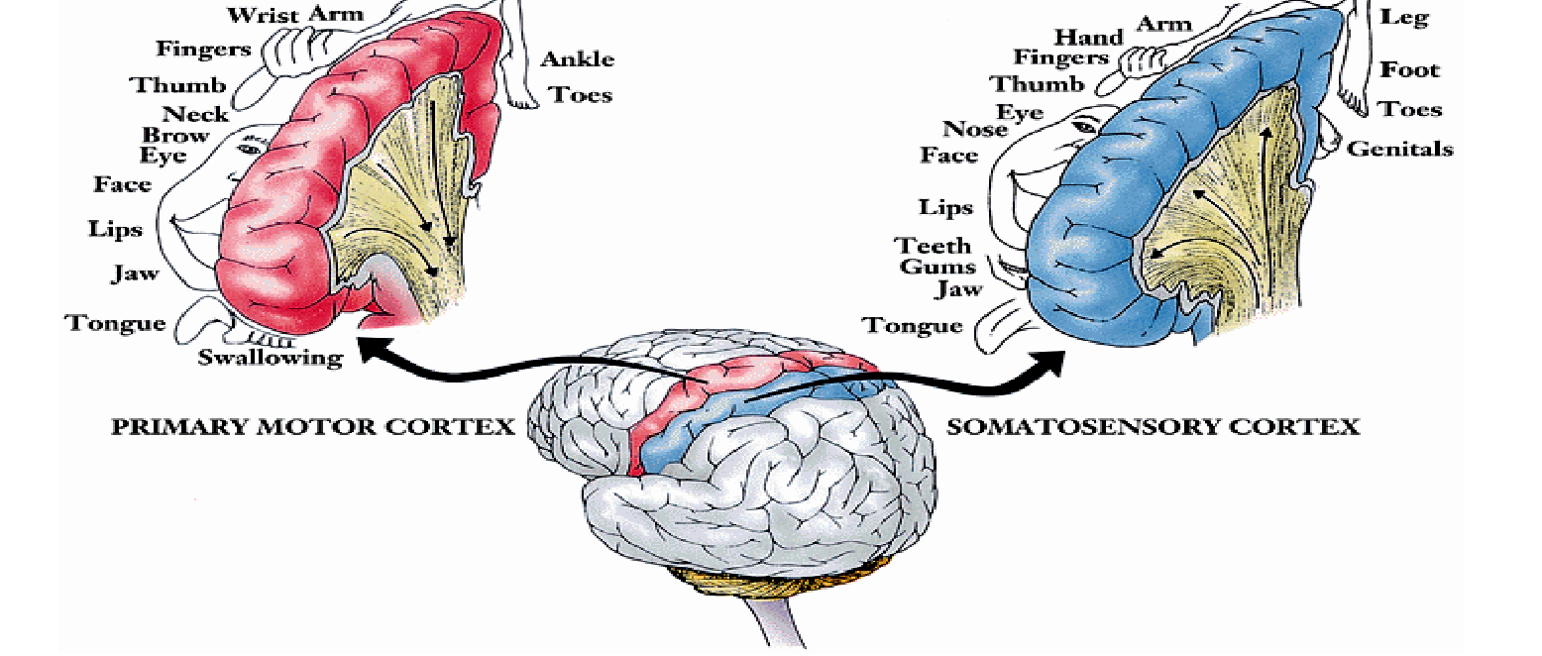
Adjacent cortical representations show disproportionately large hands, face and tongue.
- The leg and foot are represented mainly medially; the upper limb lies more superior-laterally; face and tongue lie more inferolaterally. The two maps are related but are not identical.
Cortical representation reflects processing demand, not physical body-part size.

6. Why the homunculus is distorted
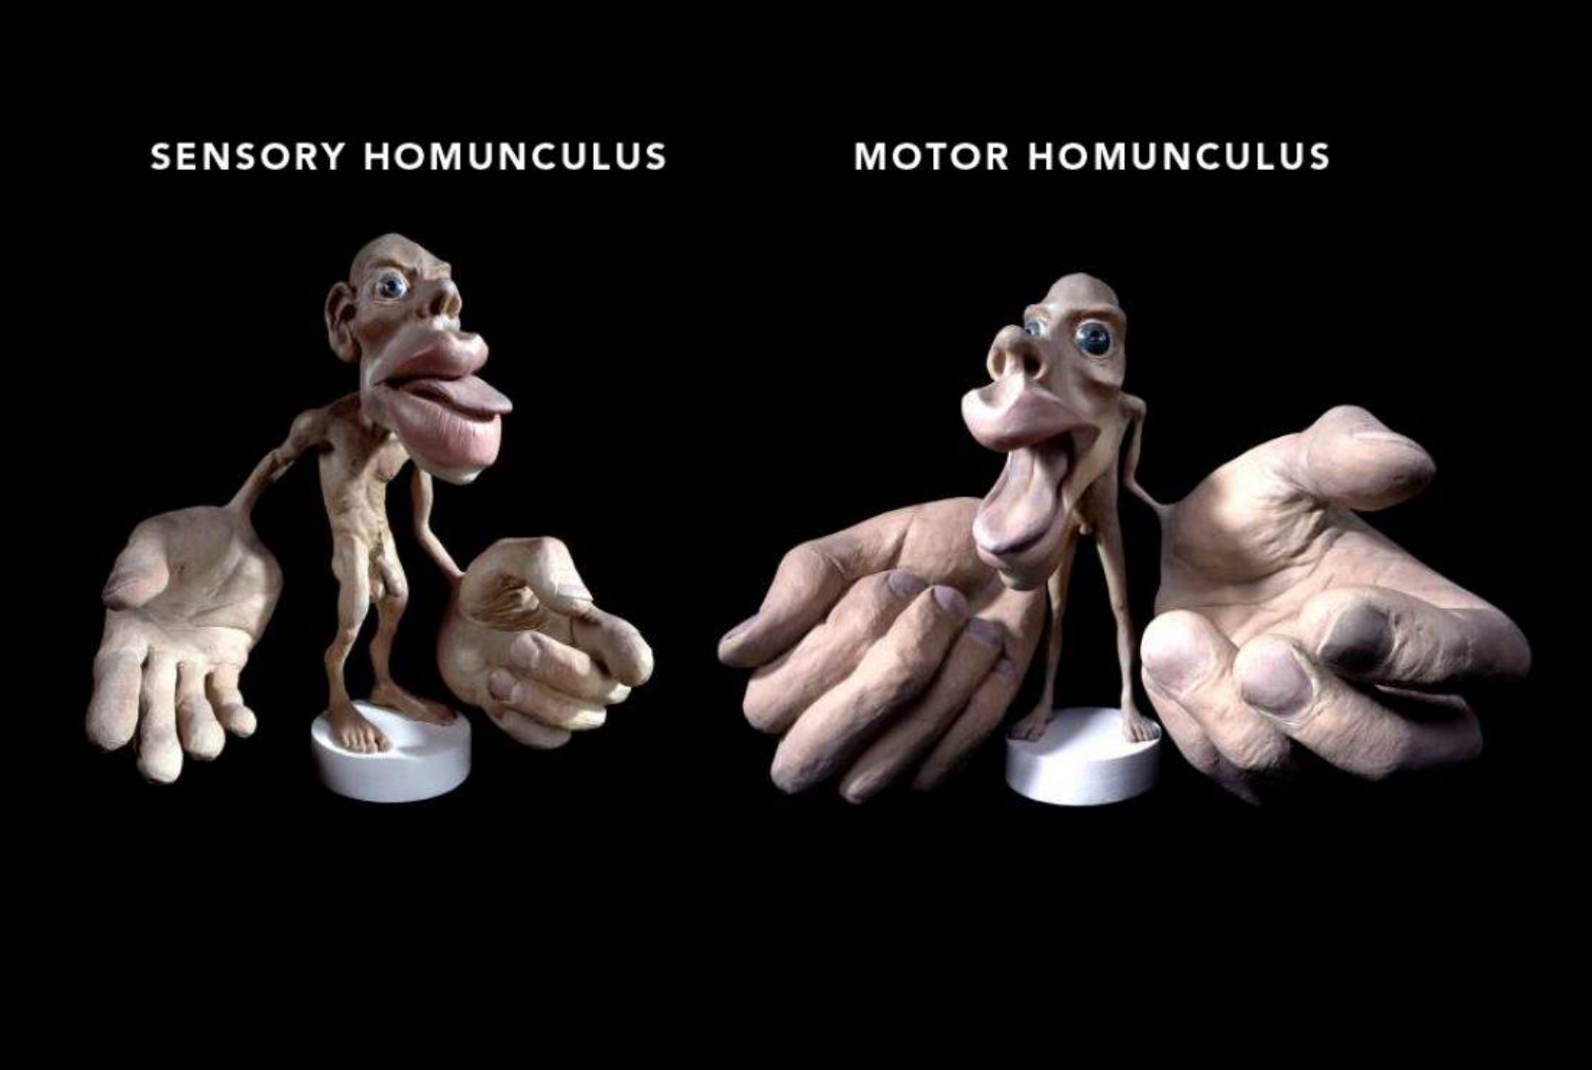
Three-dimensional sensory and motor homunculi make the unequal representations visible.

Classroom question: why is representation disproportionate?
- Sensory representation is related to sensory receptor density and discriminative resolution. A densely sampled region needs more processing capacity.
- Motor representation is related to fine control and the complexity of independent movements. The teaching shorthand “density of motor neurons” points toward innervation demands, but is not a literal universal scaling law.
- Large hands and lips in these models therefore indicate specialised sensory or motor processing. They do not mean that those body parts are physically largest.
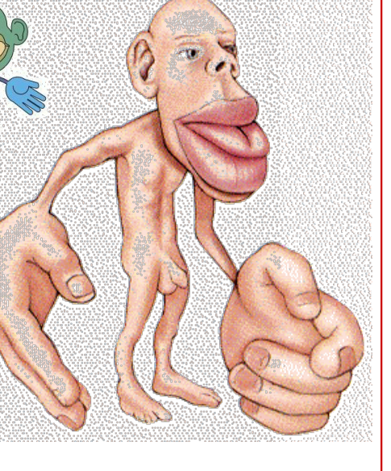
An additional homunculus illustration reinforces the same principle of cortical magnification.

6. Beyond a single motor strip map
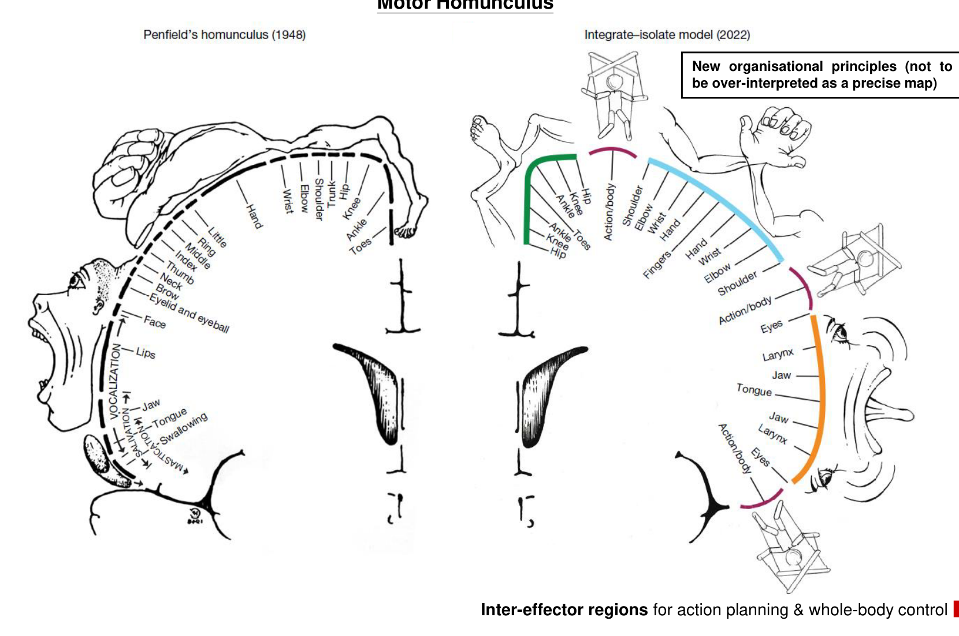
Classical Penfield map (1948) and the integrate–isolate model (2022), retaining the inter-effector regions.
- The classical homunculus is a useful orientation map, rather than a perfectly precise one-to-one assignment of each cortical point to one muscle.
- The newer organisational model includes inter-effector regions between effector-related representations. These regions contribute to action planning and whole-body control.
Effector-specific control + inter-effector integration → coordinated actions involving the whole body
- Read the new diagram as an organisational principle. Do not over-interpret it as an exact anatomical map or assume that motor control is a simple continuous list of isolated body parts.

7. Association cortex and higher functions
- Association areas are not primarily responsible for initial sensory reception or direct motor output. They integrate information for higher mental functions, including learning.
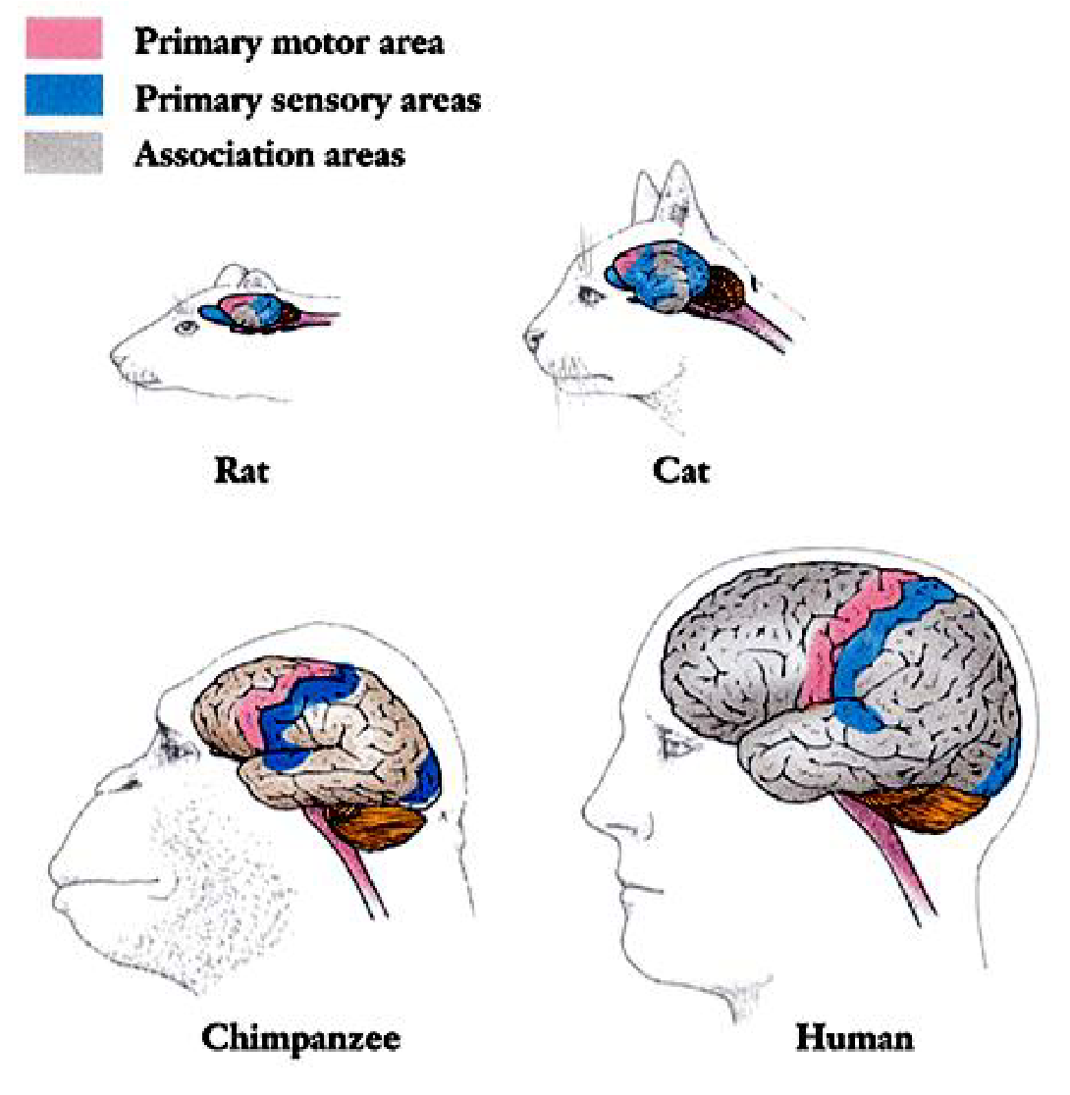
Comparative maps distinguish primary motor, primary sensory and association cortex in rat, cat, chimpanzee and human.
Association area | Processing contribution
Somatosensory | Identification of shape, texture and orientation.
Visual | Recognition and evaluation of what is seen.
Auditory | Differentiation of sound as speech, music or noise.
Wernicke’s | Interpretation of word meanings; translation of words into thoughts.
Integrative | Formation of thoughts from sensory inputs.

Sensory features → integrated representation → recognition / meaning → thought and appropriate action
- The comparative illustration emphasises the extensive association cortex in humans; complex cognition still depends on coordinated networks.

8. Hemispheric specialisation
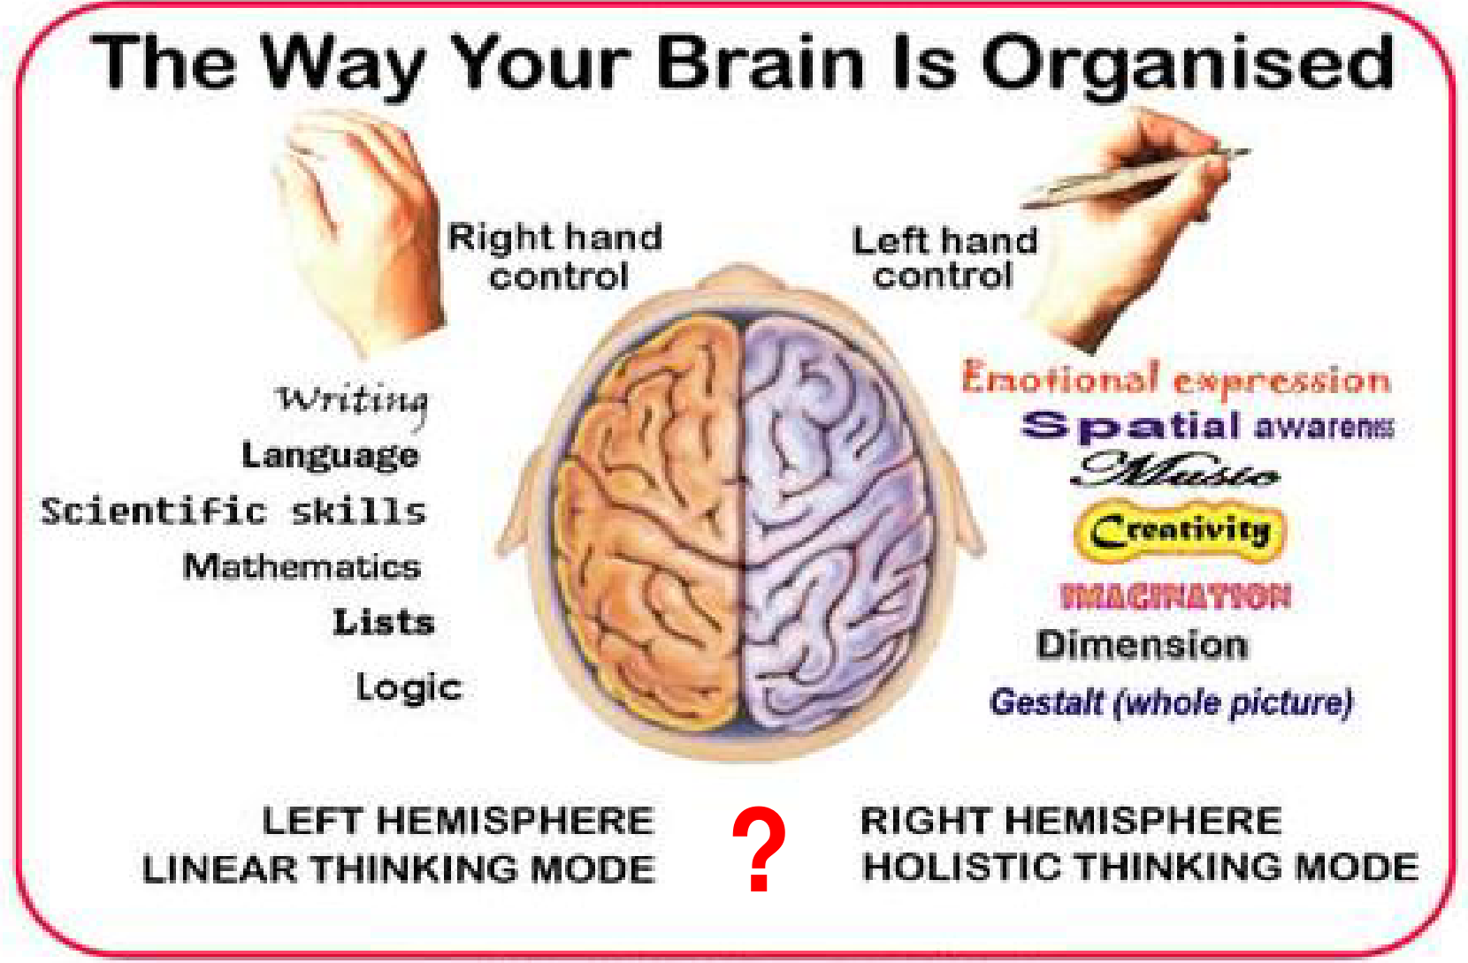
Popular left–right assignments are presented with a question mark: they require critical interpretation.
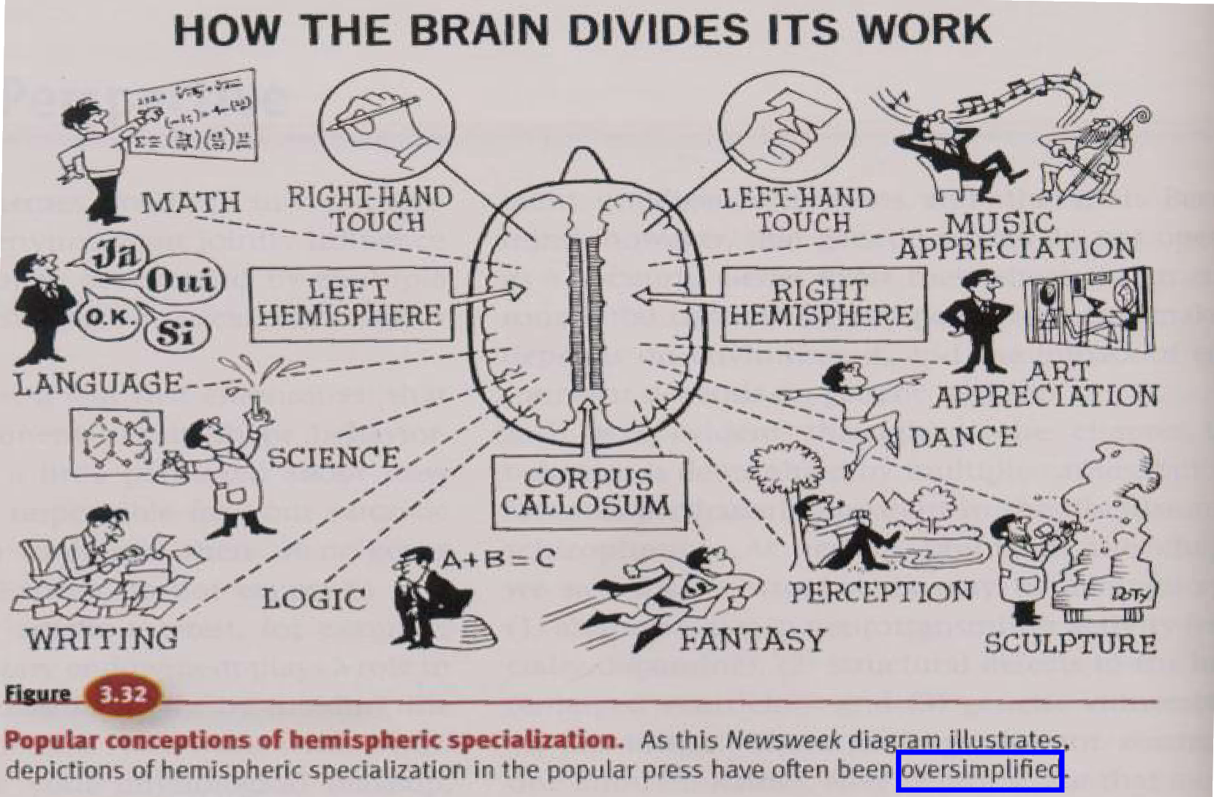
The companion illustration explicitly warns that popular descriptions are often oversimplified.
- Lateralisation means relative specialisation, not exclusive ownership. It does not divide people into a logical “left-brained” type and a creative “right-brained” type.

8. Lateralisation and interhemispheric links
General tendency | Interpretation
Left hemisphere | Language is left-dominant in most individuals; mathematical and logical processing often shows left-sided specialisation.
Right hemisphere | Often contributes strongly to visuospatial processing and aspects of emotion, music and artistic processing.
Both hemispheres | Work together; complex skills cannot be assigned exclusively to one side.

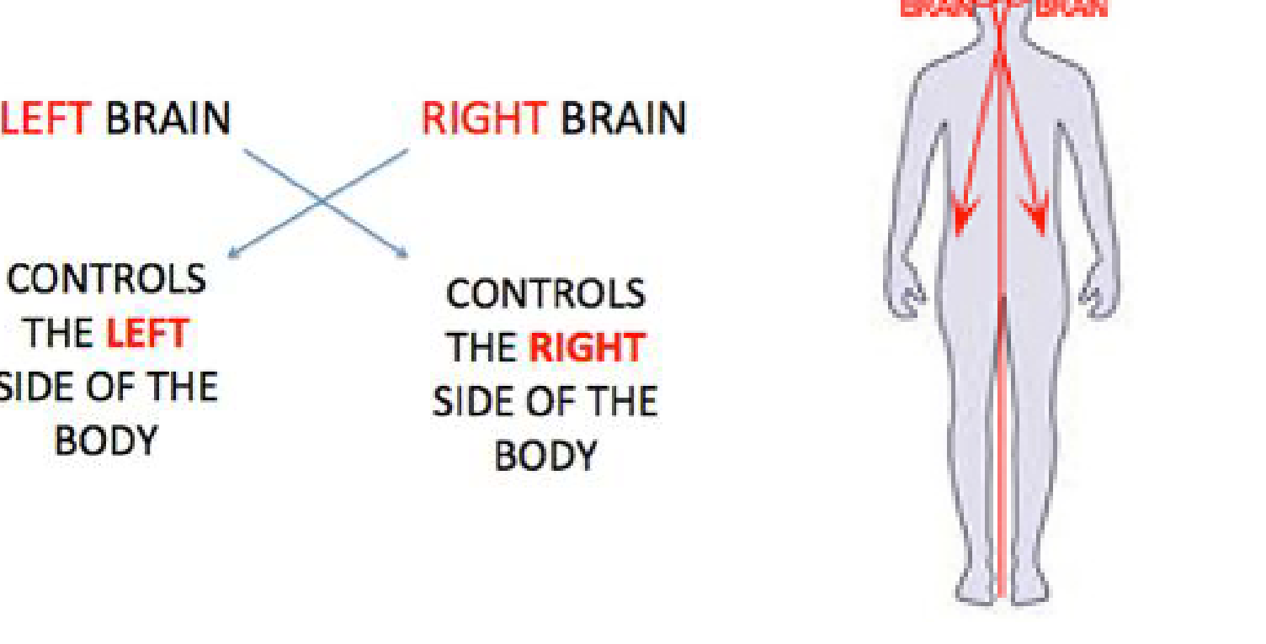
Crossed control: left hemisphere mainly controls the right body; right hemisphere mainly controls the left body.
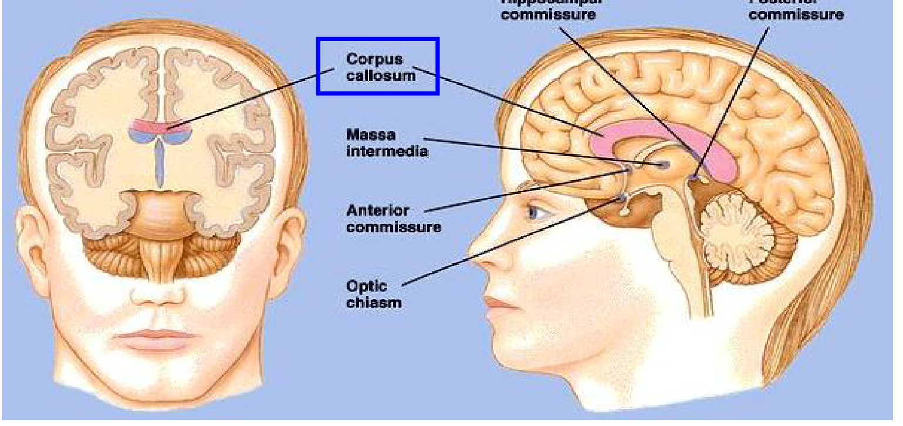
The corpus callosum is the main connection between corresponding cortical regions across hemispheres.
- The corpus callosum is a commissural white-matter bundle. The figure also labels anterior, posterior and hippocampal commissures, the optic chiasm and massa intermedia.
- Do not confuse these structures: the optic chiasm carries crossing visual fibres; the massa intermedia is an interthalamic adhesion, not the main cortical commissure.

9. Arousal and the limbic system
Reticular formation + limbic networks → an aroused brain with behaviour shaped by motivation and significance
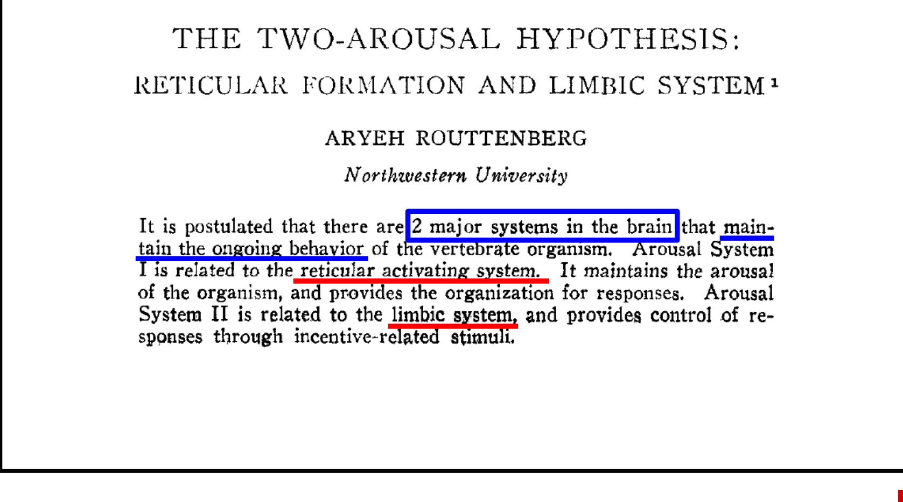
The two-arousal hypothesis (Aryeh Routtenberg, 1968): arousal and incentive-related control of responses.
- In this historical framework, one system is related to the reticular activating system: it maintains arousal and organises responses. The other is related to the limbic system: it influences responses to incentive-related stimuli.
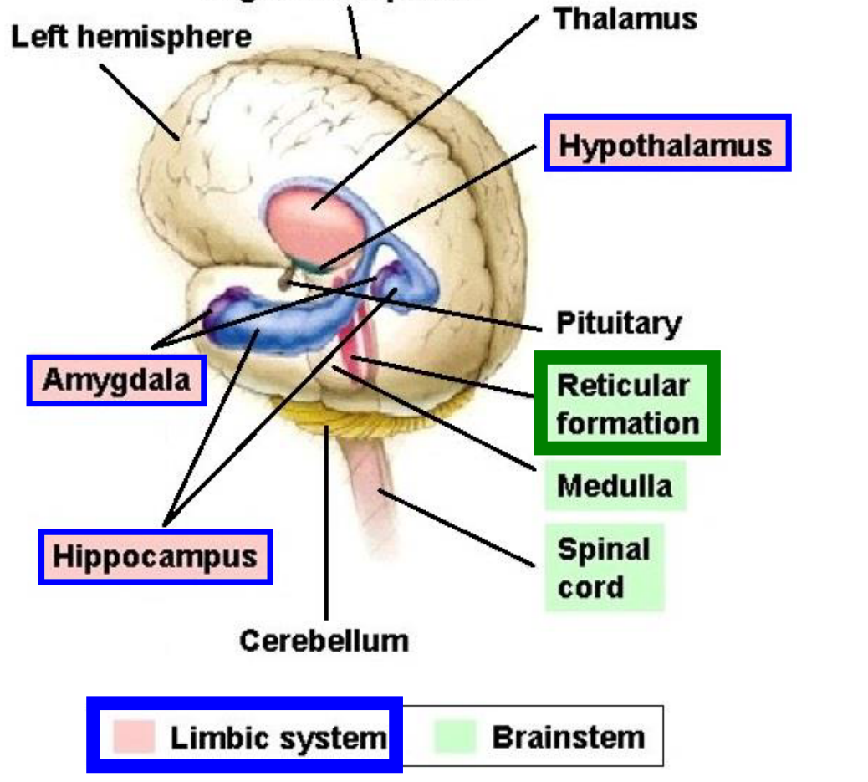
Anatomical context for interacting reticular and limbic systems, including thalamus, hypothalamus, amygdala and hippocampus.
- These systems function together. Arousal allows responsiveness, while emotional, memory and motivational context helps determine what matters and how to respond.

9. Limbic connections: reading the network
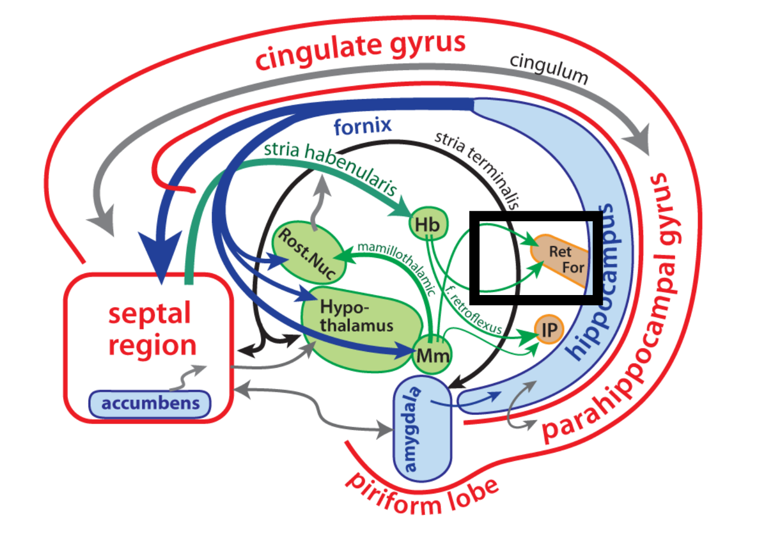
Interconnected cortical and subcortical limbic structures; the reticular formation connection is boxed.
Structures / tracts | How to read the diagram
Cortical and limbic regions | Cingulate gyrus, parahippocampal gyrus, piriform lobe, hippocampus, amygdala and septal region; the accumbens is also labelled.
Connecting tracts | Cingulum, fornix, stria terminalis, stria habenularis, mammillothalamic tract and tractus retroflexus.
Subcortical labels | Hypothalamus; mammillary bodies (Mm); habenula (Hb); interpeduncular nucleus (IP); rostral nuclear label (Rost. Nuc.); reticular formation (Ret. For.).

- Follow the arrowheads to identify direction. The multiple connections indicate network interaction; they should not be compressed into one linear pathway or all labelled as excitatory.
- The figure emphasises connectivity rather than neurotransmitter sign. A connection alone does not establish positive feedback.

10. Reticular formation: core organisation
- The reticular formation (RF) is a network of neurons and nerve fibres running through the central core of the brainstem.
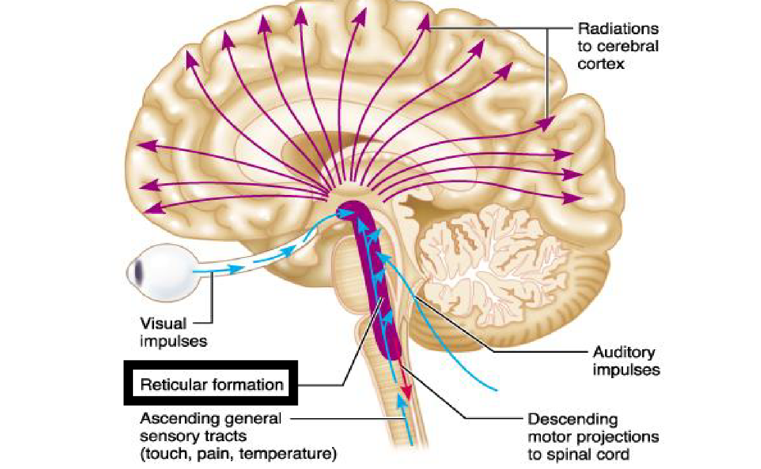
Visual, auditory and ascending general sensory inputs converge; outputs include broad cortical projections and descending spinal projections.
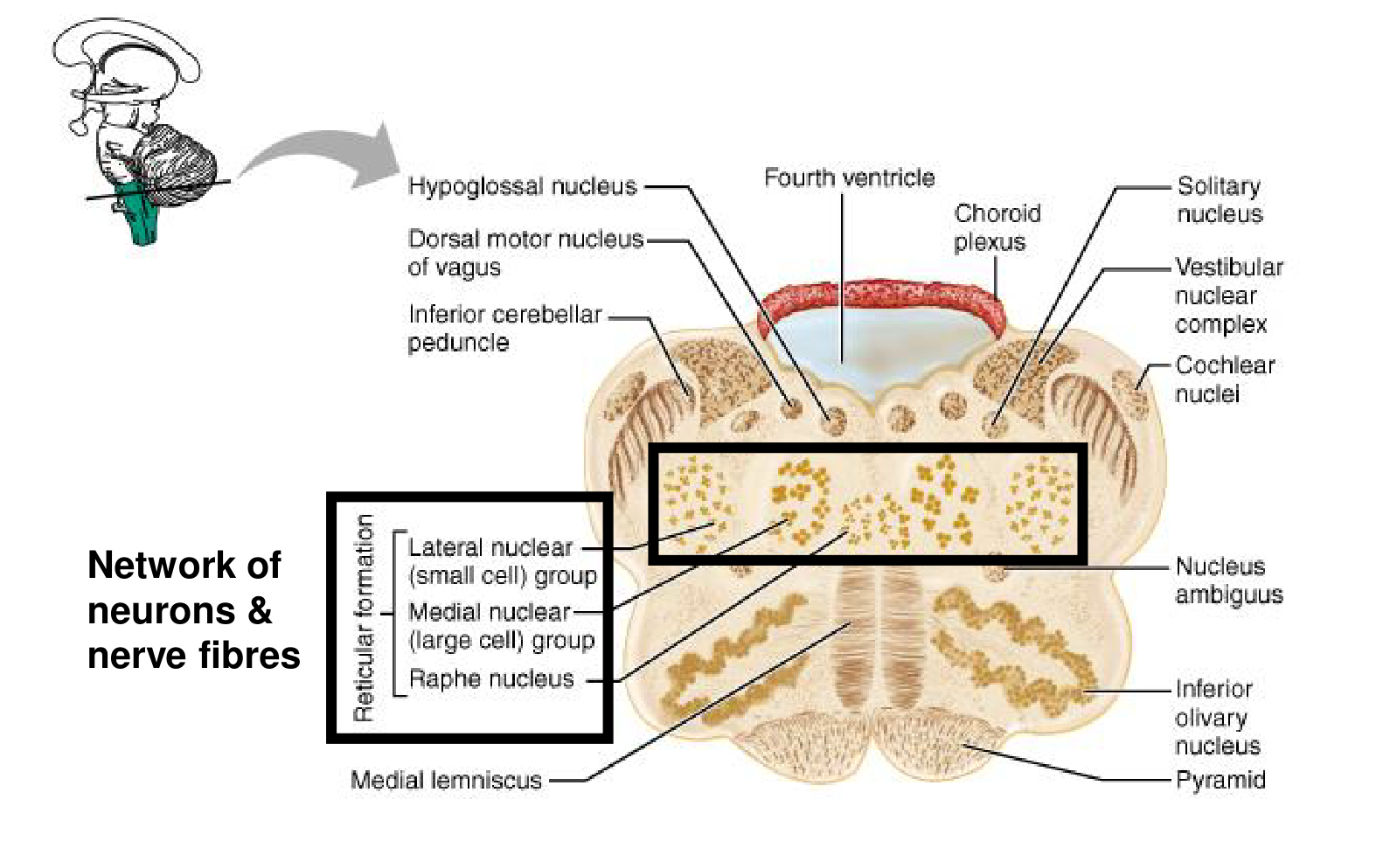
Cross-section: the RF occupies a central network among identifiable brainstem nuclei and tracts.
- Three major groupings are distinguished: lateral nuclear group (small cells), medial nuclear group (large cells), and midline raphe nuclei.
- The surrounding landmarks include hypoglossal, dorsal motor vagal, solitary, vestibular, cochlear and ambiguus nuclei, plus inferior olive, pyramid, medial lemniscus and inferior cerebellar peduncle.

10. Reticular nuclei and chemical diversity
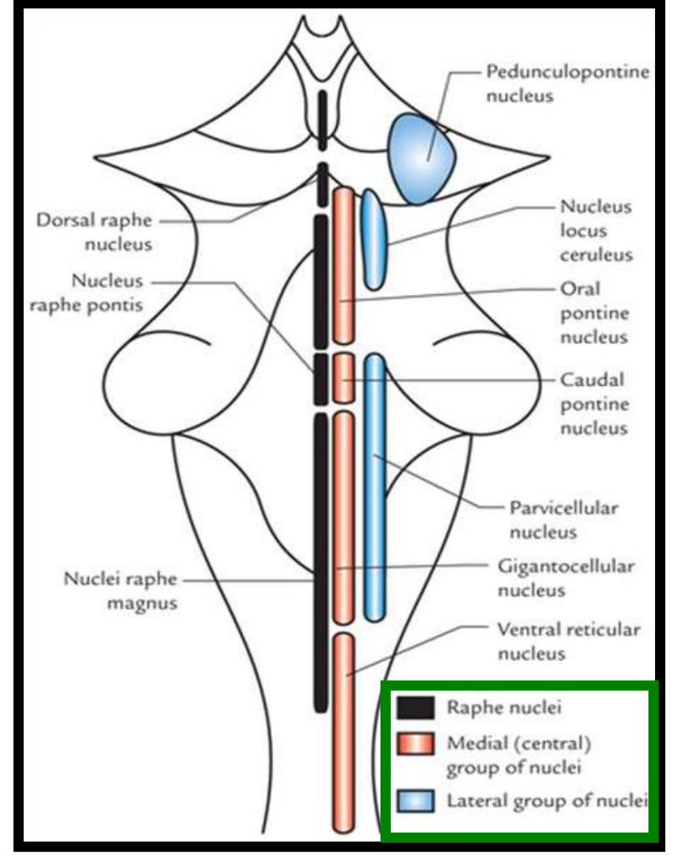
Longitudinal distribution of raphe, medial and lateral groups, with named pontine and medullary nuclei.
- The map labels dorsal raphe, nucleus raphe pontis, raphe magnus, oral and caudal pontine nuclei, parvicellular, gigantocellular and ventral reticular nuclei, locus coeruleus and pedunculopontine nucleus.
- Monoaminergic neurons make an important contribution to RF-related neural activity and behavioural state. Norepinephrine, dopamine and serotonin are the monoamines highlighted in the neurotransmitter chart.
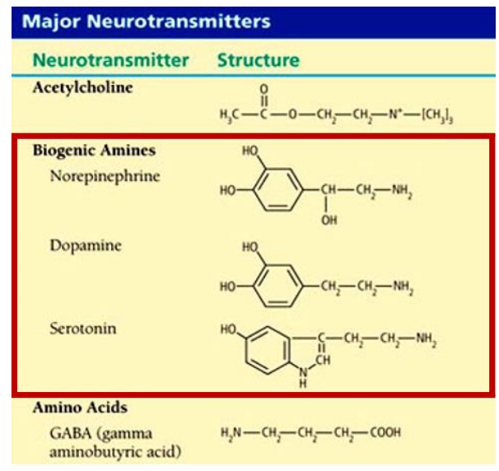
The chemical chart distinguishes biogenic amines from acetylcholine and the amino-acid transmitter GABA.
- Acetylcholine is not a monoamine. Gamma-aminobutyric acid (GABA) is also not a monoamine. Chemical diversity supports different modulatory roles; RF neurons are not all the same transmitter type.

10. Heterogeneous input, diffuse output
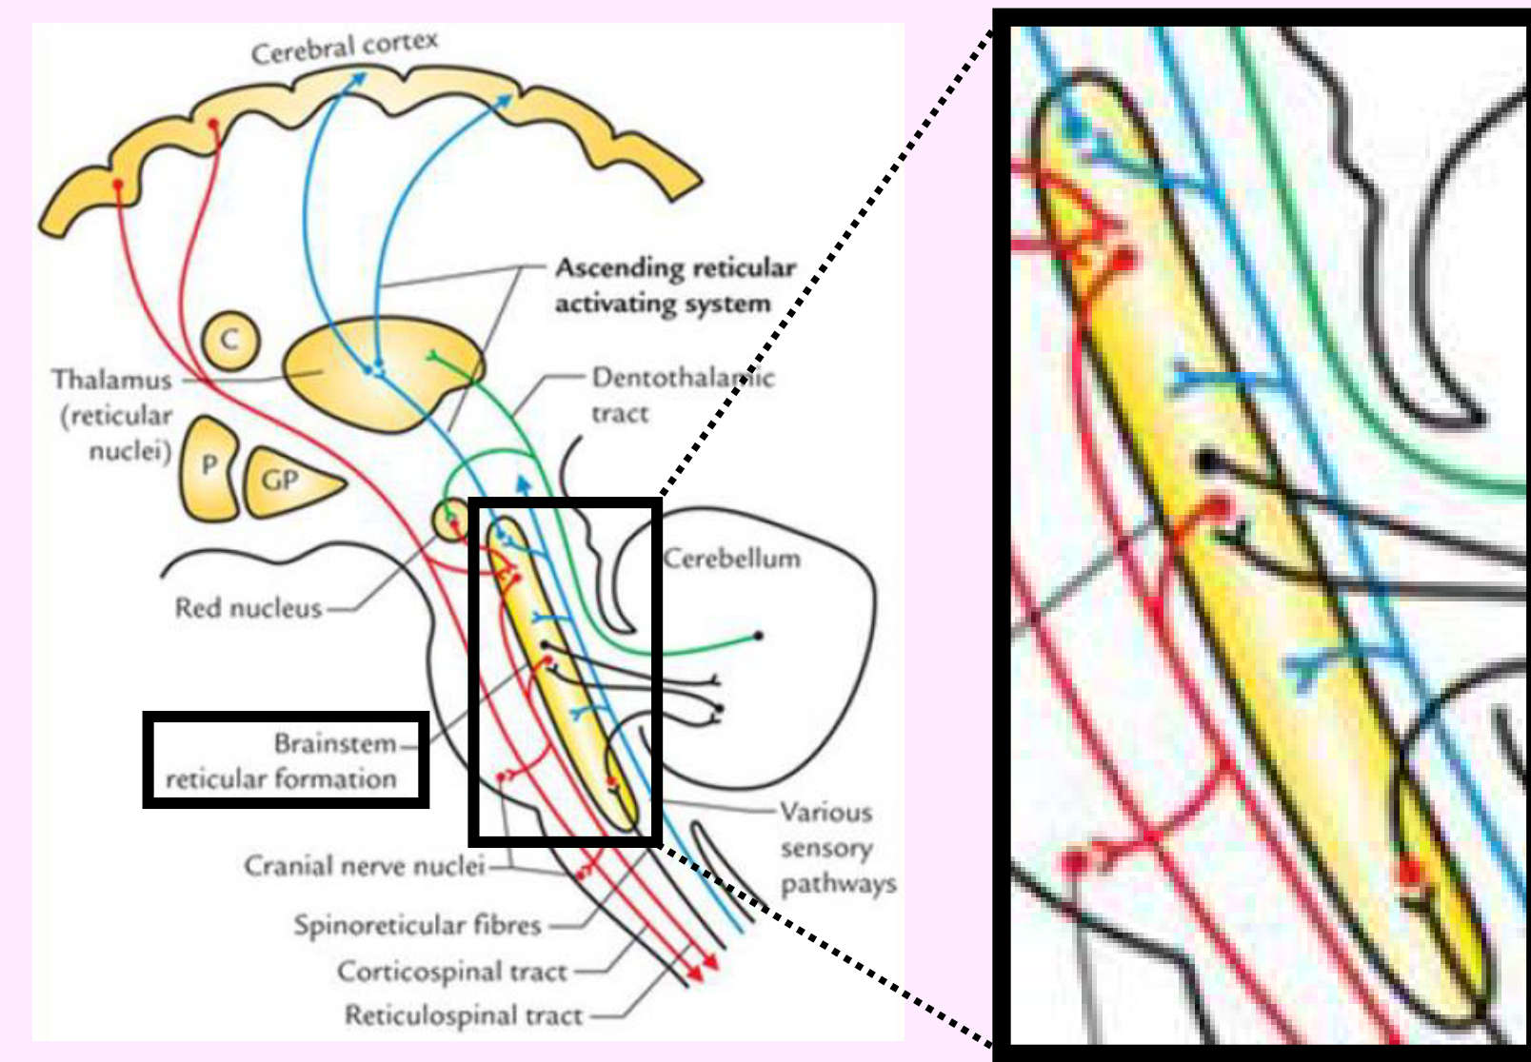
The overview shows sensory inputs, cranial nerve nuclei, spinoreticular fibres and ascending / descending reticular connections.
- RF receives a continuous stream of multimodal sensory information. Its inputs are heterogeneous: several modalities and pathways influence the network.
- Its outputs are widespread and diffuse. Changes in incoming activity alter outgoing activity and thereby change behavioural responsiveness.
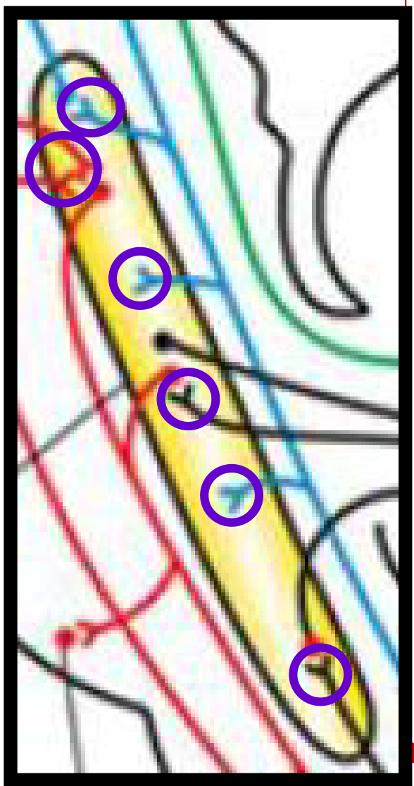  Diverse inputs | 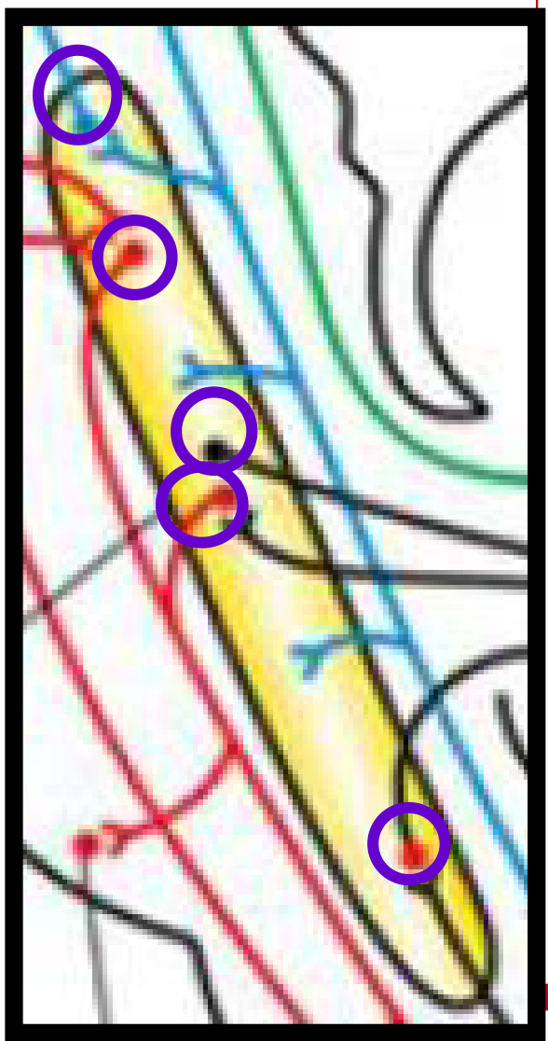  Diffuse outputs | 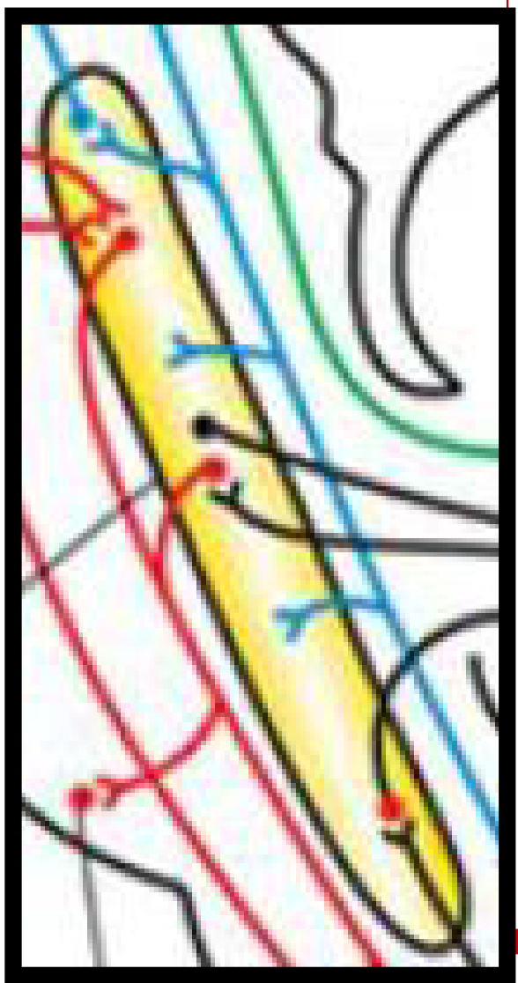  Network detail
Diverse inputs + interconnected neurons + chemical diversity → varied outputs and functions

11. Ascending reticular activating system
- The ascending reticular activating system (ARAS) includes RF nuclei with ascending projections that modulate the thalamus and cerebral cortex. It supports consciousness, alertness, attentiveness and awareness.
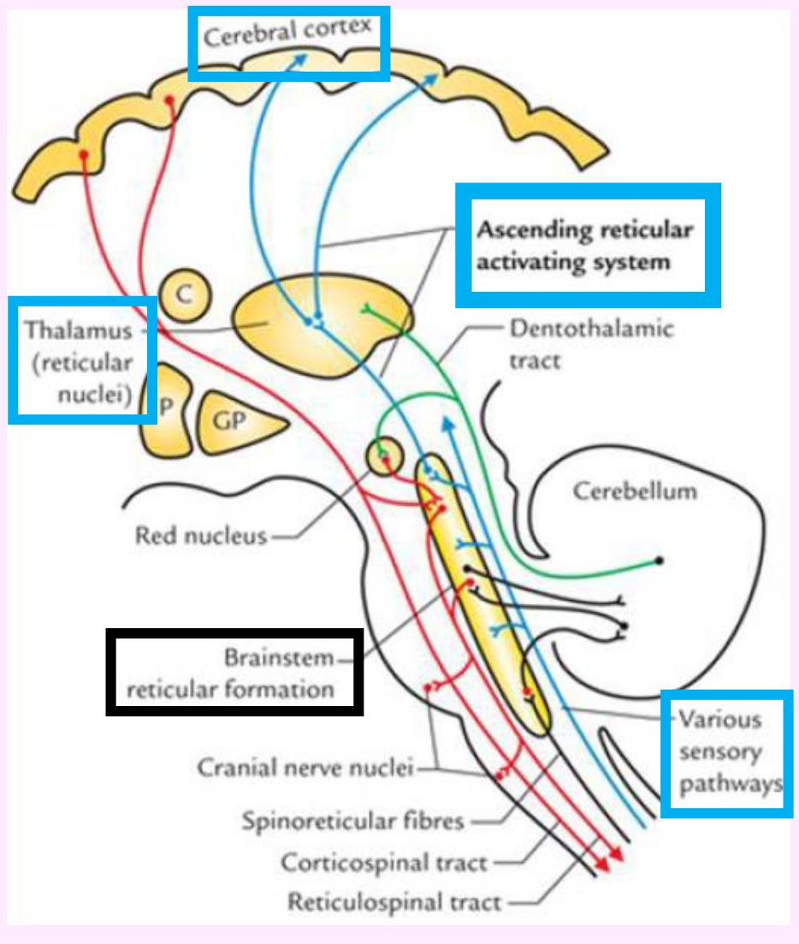
The highlighted ascending route links brainstem RF, thalamic regions and cerebral cortex.
Visual / acoustic / somatosensory impulses → RF and ascending arousal pathways → thalamic and cortical modulation → alertness and attention
- RF activation helps maintain normal wakefulness and awareness of environmental stimuli. It also influences the sensory threshold, affecting which inputs gain effective access to conscious processing.
- RF interacts with orexin neurons in the lateral hypothalamus to regulate sleep and wakefulness. Orexin helps stabilise wakefulness.
- The ascending arousal system has multiple routes; it should not be treated as a single obligatory relay through the thalamic reticular nucleus. Thalamic arousal relays and broader forebrain pathways contribute.
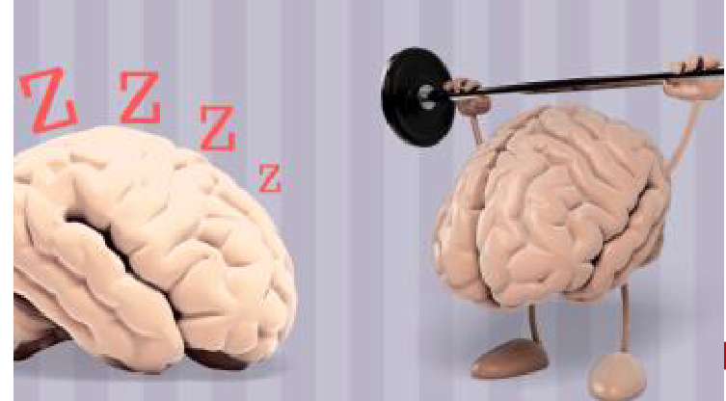
Sleep and wakefulness are regulated brain states.

11. Sleep, reduced arousal and coma
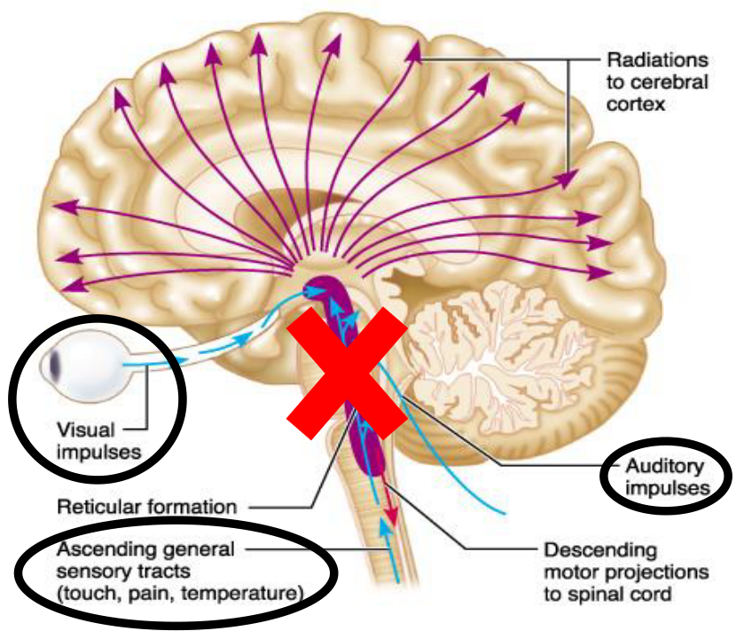
The red cross illustrates disrupted RF-dependent cortical activation; sensory inputs and descending projections remain labelled.
Condition | Mechanism / consequence
Strong sensory event | Bright light or a ringing alarm → stimulation of arousal pathways → increased alertness or awakening.
Reduced sensory stimulation | Removal of visual, auditory and somatosensory input may favour drowsiness and sleep.
Sleep | Reduced activity in several wake-promoting pathways contributes to sleep, within an actively regulated sleep–wake system.
RF / ARAS injury | Disrupted cortical activation → reduced consciousness; substantial injury may produce coma.
Severe brainstem injury | Can be fatal, especially when vital respiratory and cardiovascular systems are also affected.
General anaesthetics | Can alter arousal-system function and consciousness; their effects are not limited to one RF site.

- Coma is prolonged unconsciousness in which even strong external stimulation cannot produce arousal. Normal sleep remains reversible by an appropriate stimulus.
- Reduced ARAS activity is a useful simplification for sleep onset, not a claim that the whole system switches off throughout sleep. Severe ARAS damage does not inevitably imply death by itself.

11. Habituation and selective responsiveness
Repeated, insignificant stimulus → declining response to that stimulus → attention remains available for important or changing stimuli
- Habituation is a form of learning in which the brain increasingly ignores repetitive, meaningless input while remaining sensitive to other stimuli.
- Example: a person may sleep through familiar traffic noise but awaken promptly to an alarm. Repetition and behavioural significance matter, rather than loudness alone.
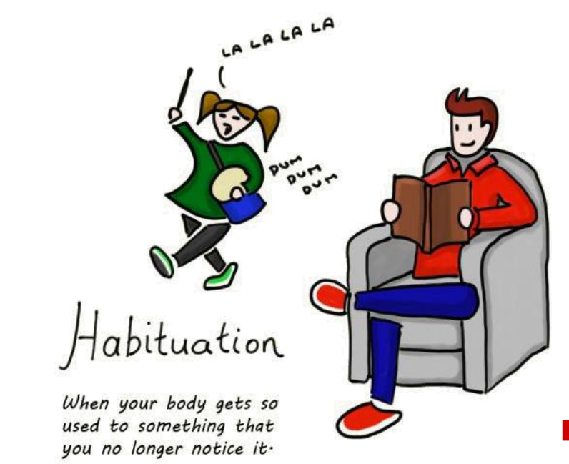
The habituation illustration shows reduced attention to a repeated background disturbance.
Concept | Key distinction
Habituation | A stimulus-specific reduction in behavioural response with repetition.
General reduction in arousal | A broader change in responsiveness, such as drowsiness.
Coma | A pathological inability to be aroused even by powerful stimuli.

- Habituation does not mean that all sensory receptors stop working or that every incoming signal is blocked. The brain can still respond to a novel or meaningful event.

12. Evidence linking RF to cortical activation
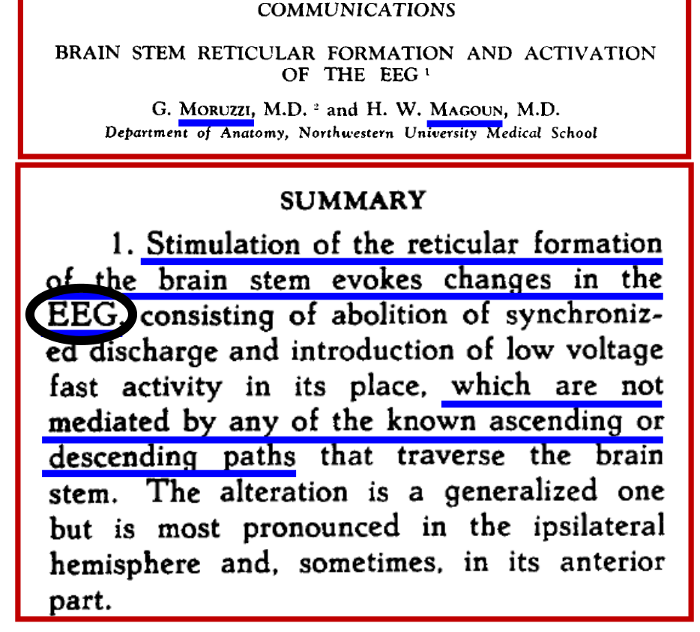
Moruzzi and Magoun (1949): brainstem RF stimulation changes the electroencephalogram.
- Stimulation of the brainstem RF changed the electroencephalogram (EEG) from synchronised activity toward low-voltage, fast activity. The reported change was generalised, often strongest ipsilaterally and sometimes anteriorly.
- The historical interpretation was that this activation was not simply mediated by the known ascending or descending tracts passing through the brainstem.
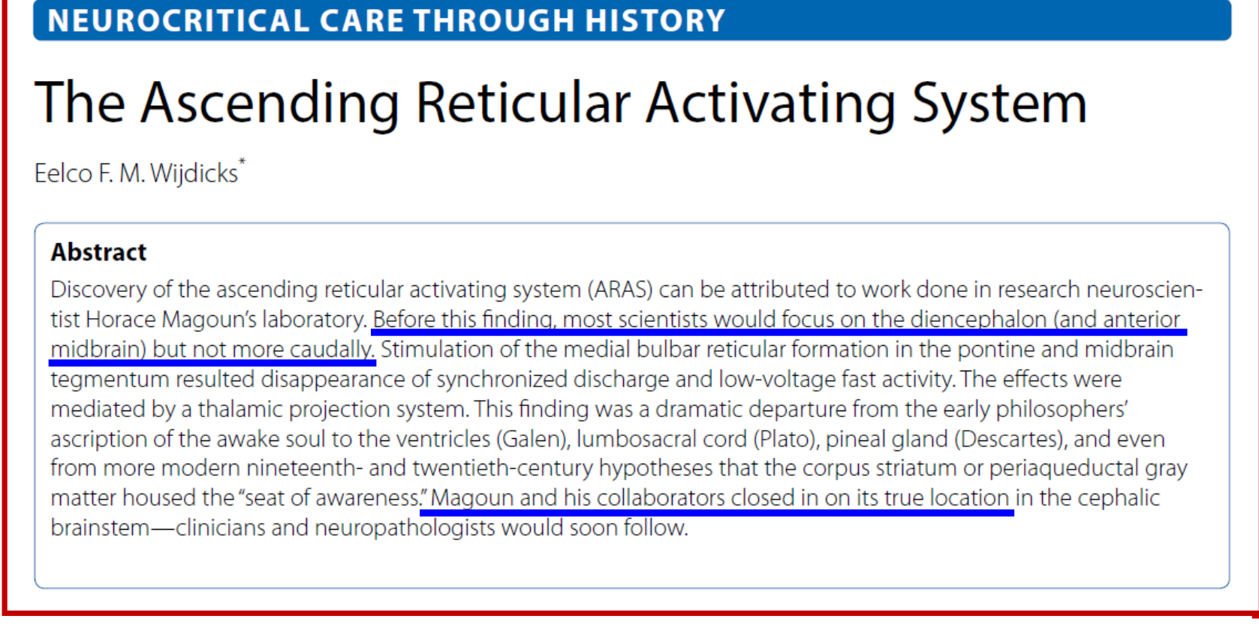
The 2019 historical review describes the shift toward recognising the brainstem contribution to arousal.
- Earlier attention focused mainly on diencephalon and anterior midbrain. Stimulation of medial bulbar RF and pontine / midbrain tegmentum helped reveal a brainstem arousal system, with thalamic projections contributing to cortical effects.
- The historical review contrasts these findings with earlier proposed seats of the mind or awareness, including ventricles, spinal cord, pineal gland, corpus striatum and periaqueductal gray.

12. Electroencephalography and brain rhythms
- Electroencephalography (EEG) records brain electrical activity non-invasively using scalp electrodes. The measured voltage differences arise mainly from summed synchronised postsynaptic currents in neuronal populations.
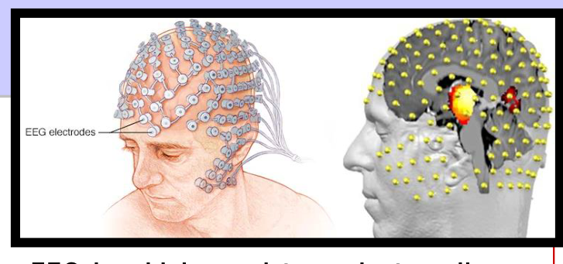
Scalp electrodes sample voltage differences associated with large populations of neurons.
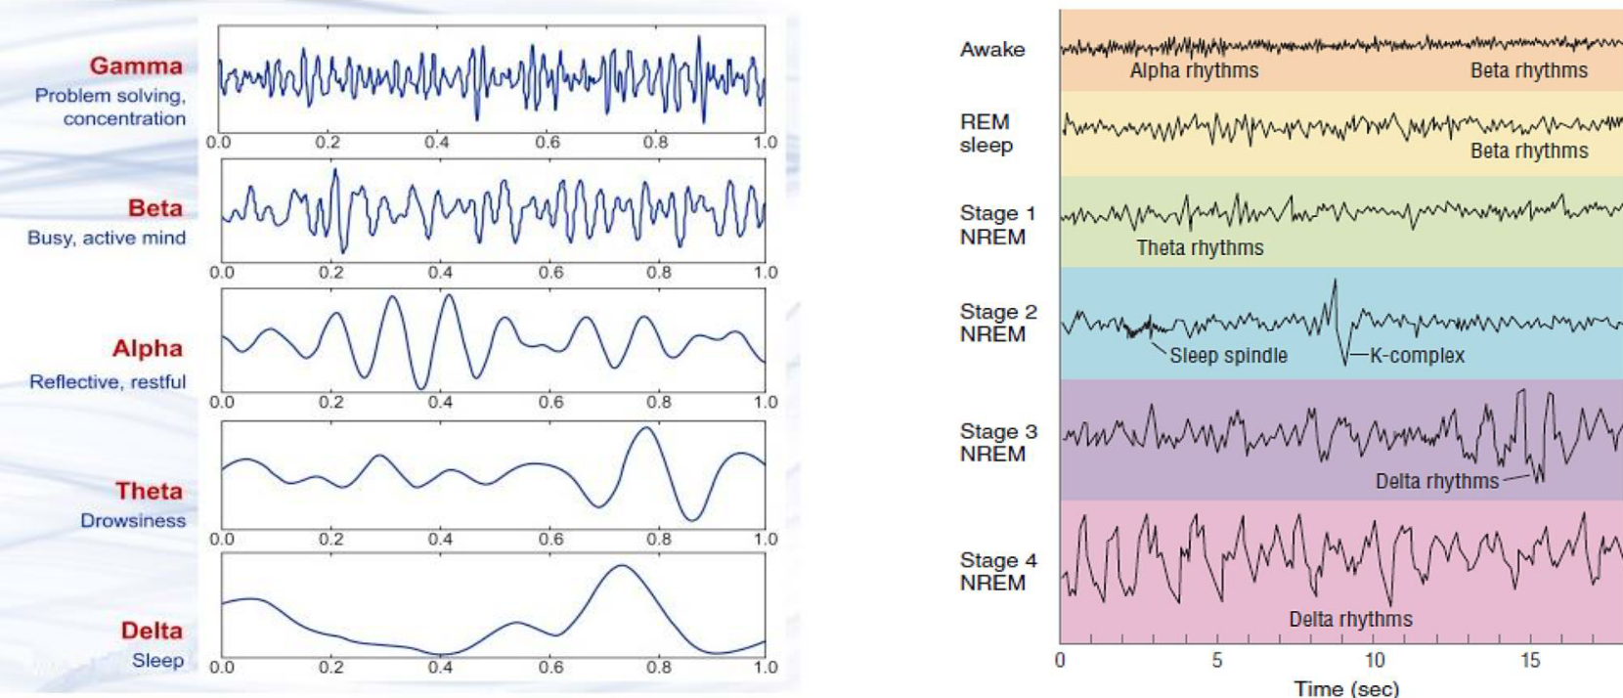
Example rhythms and sleep stages: the original waveforms, labels, sleep spindle and K-complex are retained.
Pattern | Typical association illustrated
Gamma / beta | Gamma: concentration and problem solving; beta: active mental activity. These are associations, not unique mental-state signatures.
Alpha / theta | Alpha: relaxed wakefulness; theta: drowsiness and light sleep.
Delta | Slow-wave, deep non-rapid eye movement sleep.
Sleep-stage features | Stage 2: sleep spindles and K-complexes. Rapid eye movement (REM) sleep: relatively fast, low-amplitude activity.

- Non-rapid eye movement (NREM) stages 3 and 4 in the older diagram are combined as N3 in current scoring. EEG patterns vary with state; no single waveform identifies every case.
- EEG is widely used to evaluate epilepsy and conditions associated with altered mental status or consciousness.

13. Cortico-limbic reward circuitry
- The mesocorticolimbic system is a reward-related network comprising mesocortical and mesolimbic pathways. It connects motivation and reinforcement with cognitive control.
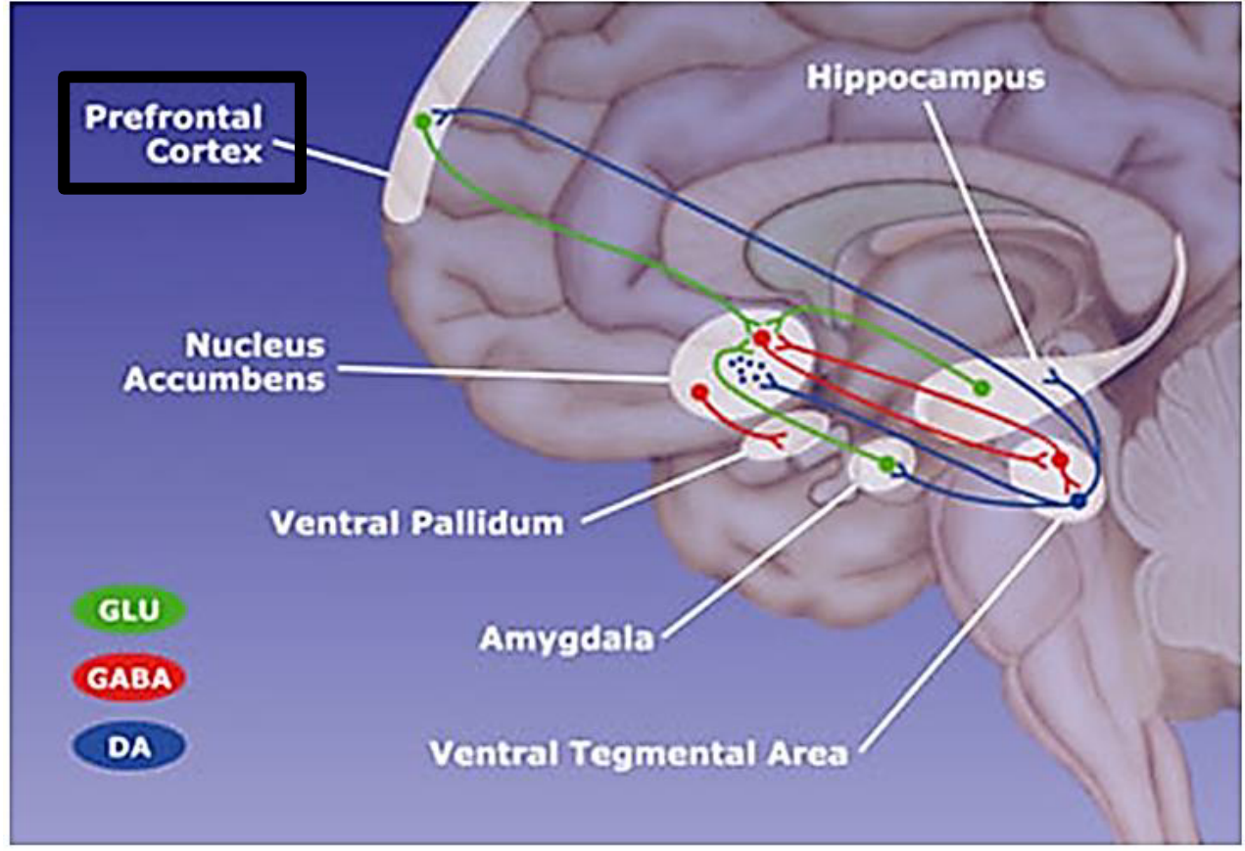
Reward-circuit anatomy and transmitter colours: cortex, nucleus accumbens, ventral pallidum, hippocampus, amygdala and ventral tegmental area.
- The prefrontal cortex (PFC) is directly connected to limbic circuitry and contributes to working memory, planning, decision-making, behavioural regulation and social cognition.
Signal / node | Role in reading the circuit
Ventral tegmental area (VTA) | A midbrain source of dopamine (DA) projections to cortical and limbic targets.
Glutamate (GLU; green) | Predominantly excitatory projections, including cortical and limbic inputs to reward circuitry.
GABA (red) | Predominantly inhibitory projections; accumbens, ventral pallidal and midbrain interactions regulate downstream activity.
Dopamine (blue) | Modulates target processing. Its effect depends on receptor and circuit; it is not universally excitatory.

- Memory and emotional context interact with valuation and cortical control to shape motivated behaviour. The network contains reciprocal influences; it is not simply a one-way “pleasure pathway”.

13. Mesocortical versus mesolimbic pathways
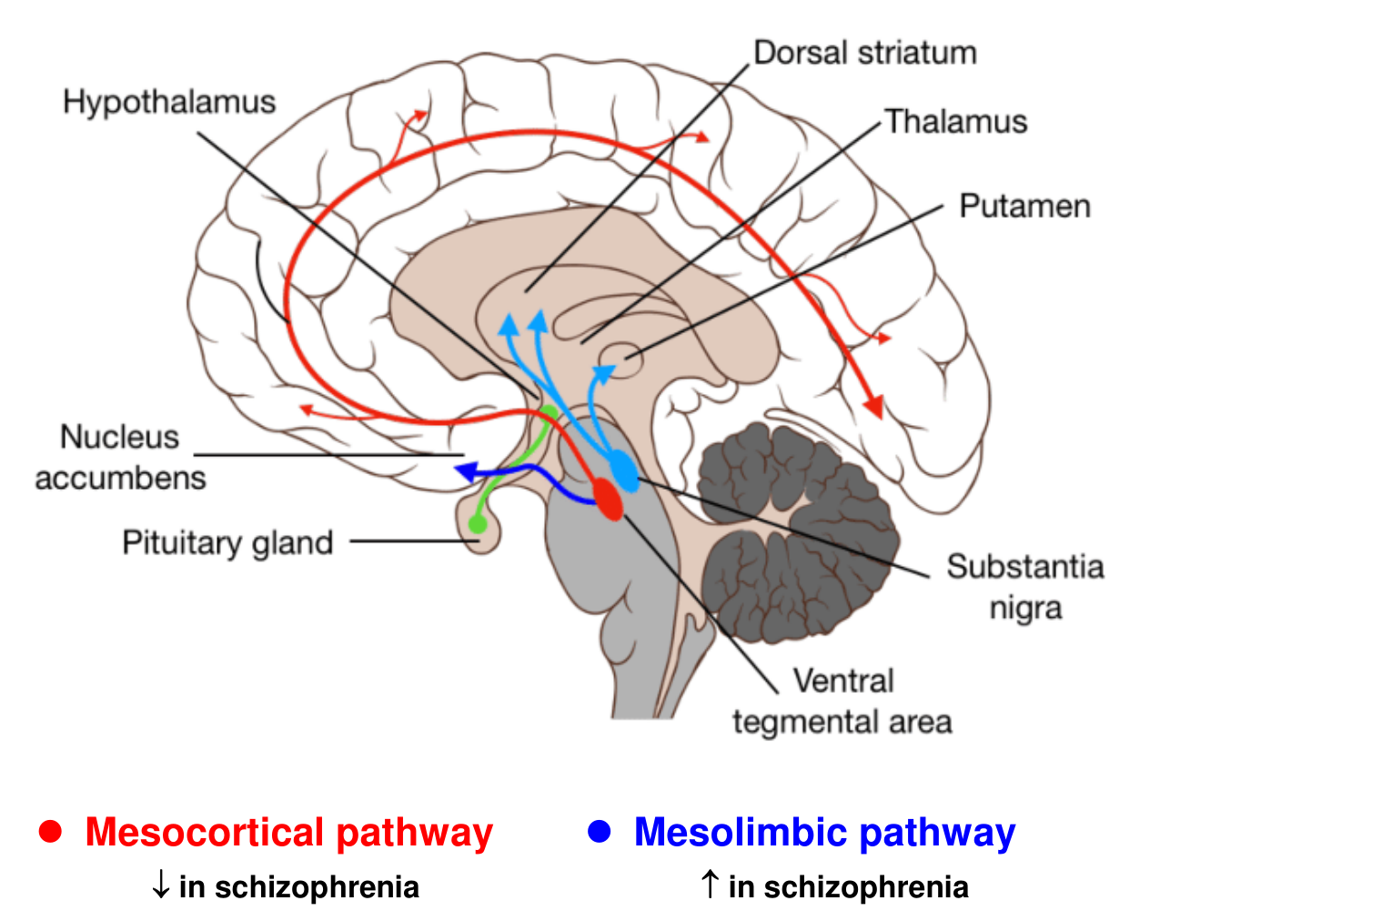
The original pathway diagram retains the schizophrenia arrows: mesocortical ↓; mesolimbic ↑.
Pathway | Projection / significance
Mesocortical | VTA dopamine neurons → PFC; contributes to cognitive and executive regulation. The classical schizophrenia model associates reduced cortical dopamine function with cognitive / negative symptoms.
Mesolimbic | VTA dopamine neurons → limbic targets, especially nucleus accumbens; reward and motivation. The classical model associates increased mesolimbic dopamine function with positive symptoms.

Mesocortical ↓ ≠ mesolimbic ↑ in the classical dopamine account of schizophrenia
- These are teaching-model associations, not a complete explanation or a diagnostic test. Dopamine abnormalities and schizophrenia involve more complex, heterogeneous circuits.
- The wider diagram also labels dorsal striatum, putamen, substantia nigra, hypothalamus, thalamus and pituitary. Do not assign every coloured route to the VTA–accumbens pathway; other dopamine systems have different origins and targets.

Integrated revision • 1 of 2

Structures, processing and behaviour
Structure | Function / distinction to remember
Cerebral cortex | Outermost cerebral gray matter; sensory, motor and association functions.
White matter / basal nuclei | Myelinated connections / deep gray matter for movement and motivation.
Frontal lobe | Judgment, planning, personality, concentration, speech and movement.
Parietal / occipital | Somatosensation and multisensory integration / vision.
Temporal / insula | Hearing, smell, language, declarative memory, visual recognition / taste, vestibular and visceral sensation, motor integration.
Precentral / postcentral gyri | Primary motor / primary somatosensory cortex; separated by central sulcus.
Broca’s / Wernicke’s | Motor speech / comprehension and word meaning.
Association cortex | Recognises sensory patterns and combines information into meaning and thoughts.
Corpus callosum | Communication between hemispheres; most people have left language dominance.
RF / ARAS | Brainstem network / ascending component supporting cortical activation and arousal.
PFC / mesocorticolimbic system | Executive functions / interaction of cortical control with reward and motivation.

Three core pathways
Stimulus → receptor → sensory neuron → CNS integration → motor neuron → effector → response
Motor cortex → internal capsule → cerebral peduncle → medullary pyramid → crossing → lateral corticospinal tract → spinal motor circuitry → muscle
Sensory impulses → RF / ARAS → thalamic and cortical modulation → alertness and attention
- Homunculus size reflects sensory resolution or motor control demands. The map is topographic but not an exact fixed one-muscle-per-point layout.

Integrated revision • 2 of 2

Distinctions, dysfunction and causal reasoning
Comparison / change | Meaning or consequence
Sensation vs association | Detect a stimulus vs recognise, evaluate and interpret it.
Lateralisation vs isolation | Relative hemispheric specialisation vs the incorrect idea that complex skills belong entirely to one side.
Contralateral control | Most limb corticospinal fibres cross in the medulla; side of weakness depends on lesion level.
RF input vs output | Heterogeneous, multimodal inputs vs widespread, diffuse outputs.
Reduced wake-promoting drive | Can favour drowsiness / sleep; sleep is actively regulated and remains arousable.
RF / ARAS injury | Reduced cortical activation → impaired consciousness → possible coma. Severe associated brainstem injury can be fatal.
Habituation vs coma | Selective reduced response to familiar input vs pathological failure to arouse.
EEG | Scalp voltage recording; used in epilepsy and altered mental status / consciousness.
Fast vs slow EEG patterns | Fast low-amplitude activity often accompanies activation; delta is prominent in deep NREM sleep. REM shows why “sleep = slow EEG” is incomplete.
Mesocortical vs mesolimbic | VTA → PFC vs VTA → limbic targets, especially accumbens. Classical schizophrenia model: cortical ↓, limbic ↑.

Mechanisms to explain aloud
- Why does an alarm wake someone who sleeps through traffic? Familiar repeated input is habituated; a meaningful change can recruit arousal pathways.
- Why are fingers and lips large in the homunculus? Their high sensory resolution and fine motor demands require disproportionate cortical processing.
- Why can brainstem injury impair consciousness? Ascending activation of thalamic and cortical networks is disrupted; stronger injury can prevent arousal.
- How does reward circuitry relate to cognition? Dopamine-related limbic signals interact with memory, emotion and PFC functions to influence planning, decisions and behavioural regulation.
End of integrated notes. Original teaching figures are retained beside their related topics; identical repeated artwork is consolidated.

