01 The sensory system: what enters the CNS
Sensory receptors detect the environment → neural pathways carry information
→ the central nervous system (CNS) interprets it.

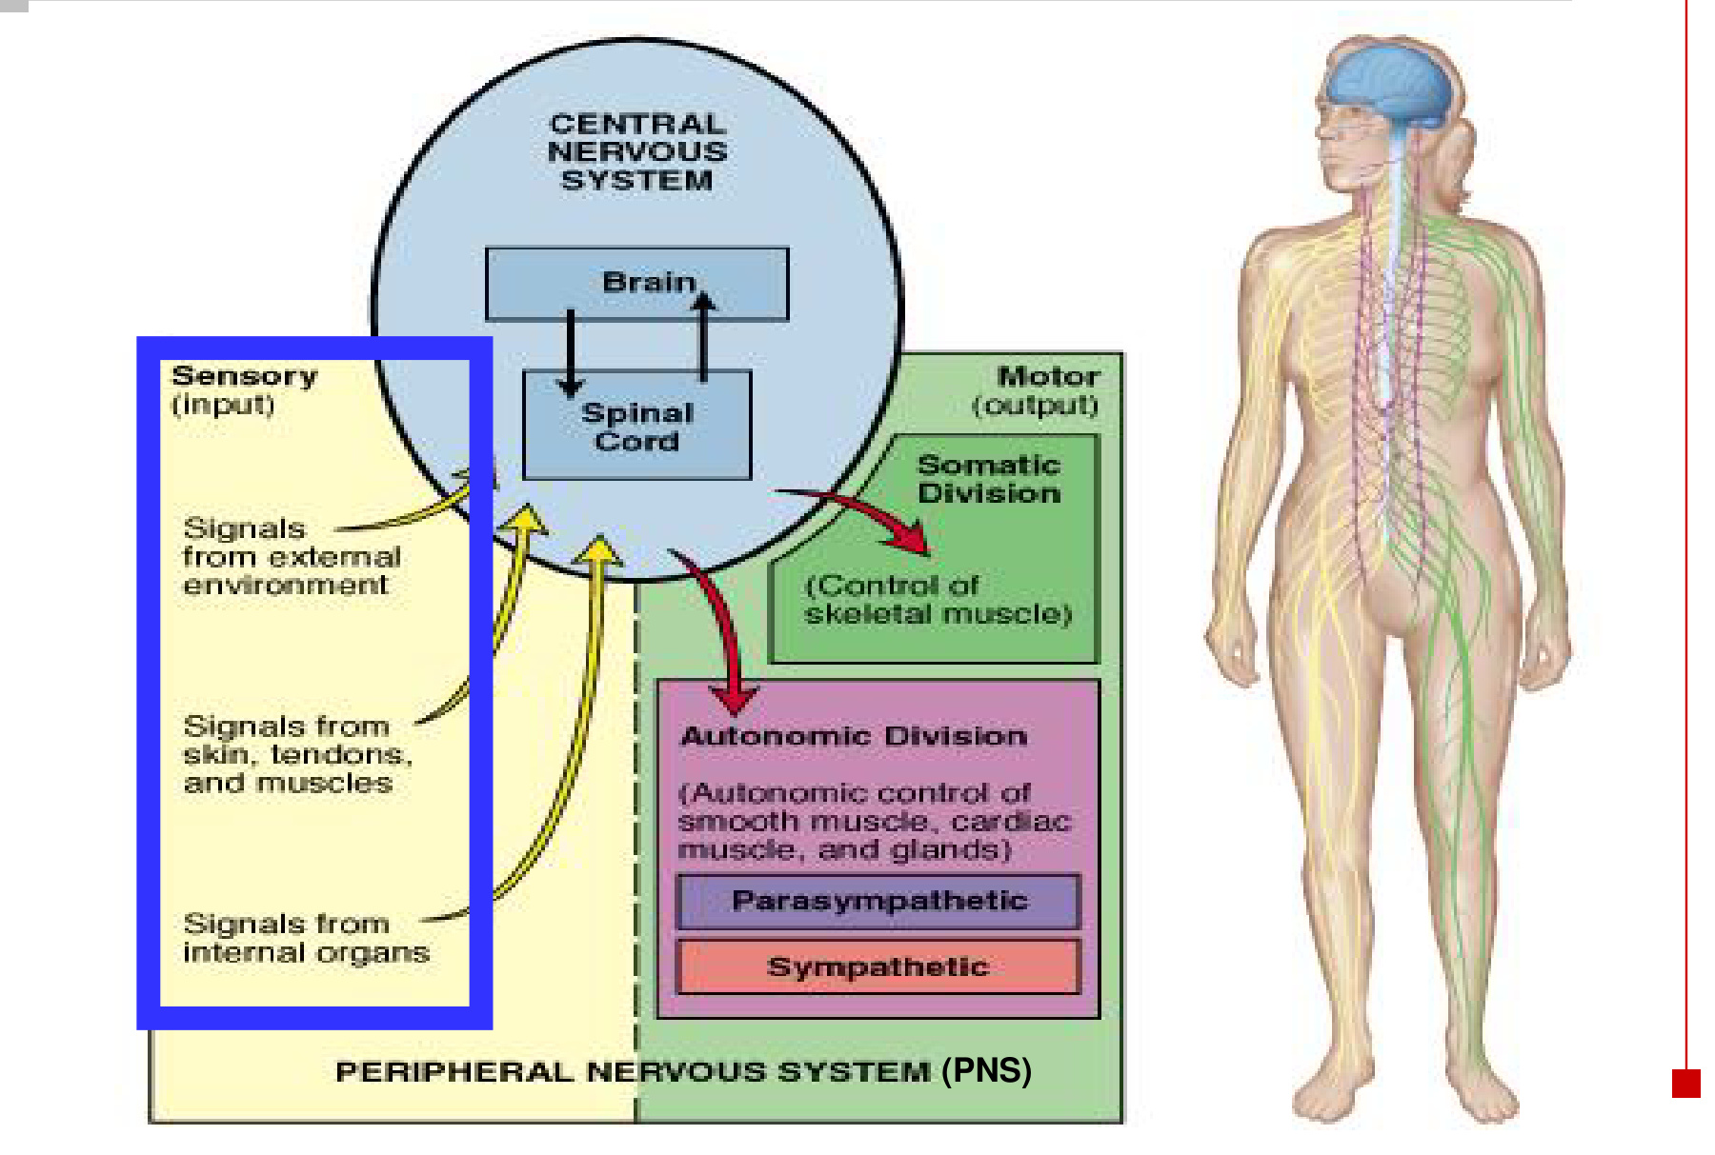  Sensory input and motor output | 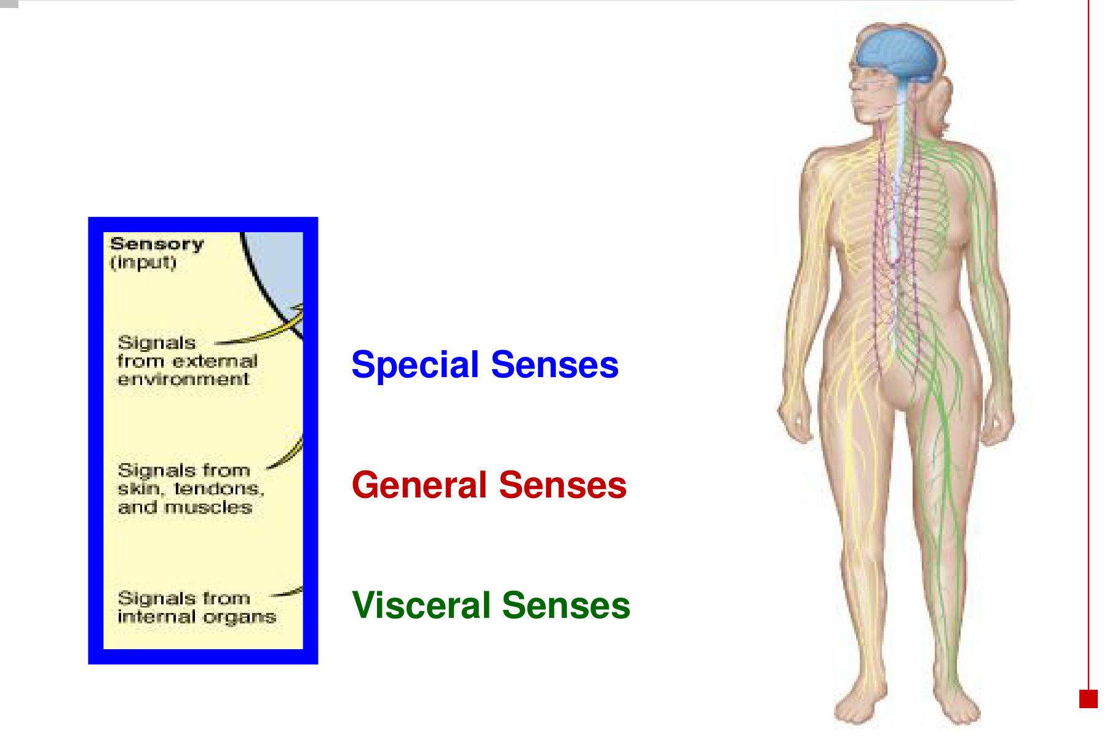  Three sources of sensory information

Group | Receptor distribution | Examples
General / somatic senses | Scattered throughout the body wall, including skin, muscles and tendons. | Touch, pressure, temperature, pain and proprioception.
Visceral senses  Splanchnesthesia | Internal organs within the thoracic and abdominal cavities. | Fullness of the bladder or stomach after a meal; visceral pain.
Special senses | Receptors concentrated in specialised organs or regions. | Vision, audition, vestibular sensation (balance), gustation and olfaction.

• The peripheral nervous system (PNS) carries sensory information toward the brain and spinal cord.
• Somatic motor output controls skeletal muscle. Autonomic motor output regulates smooth muscle, cardiac muscle and glands.
• Somatosensation describes sensation from the body; a visceral sensation concerns an internal organ.

02 Sensory receptors: stimulus specificity
A sensory receptor is a transducer: environmental energy
→ a change in electrical activity → a signal that the CNS can interpret.

Receptor class | Best stimulus | Examples
Mechanoreceptor | Compression, bending or stretching | Touch, pressure, proprioception, hearing and balance.
Thermoreceptor | Cooling or warming | Cold and warm sensations; temperature regulation.
Photoreceptor | Light | Rods and cones in the retina.
Chemoreceptor | Chemical substances | Taste, smell and blood O₂ / CO₂ sensing.
Nociceptor | Potentially damaging mechanical, chemical or thermal stimuli | Pain-related sensory input; free nerve endings.

• Specificity: each receptor type responds best to particular stimuli.
• Stimulus type and receptor location are different classifications: mechanoreceptors contribute to both general sensation and special senses.
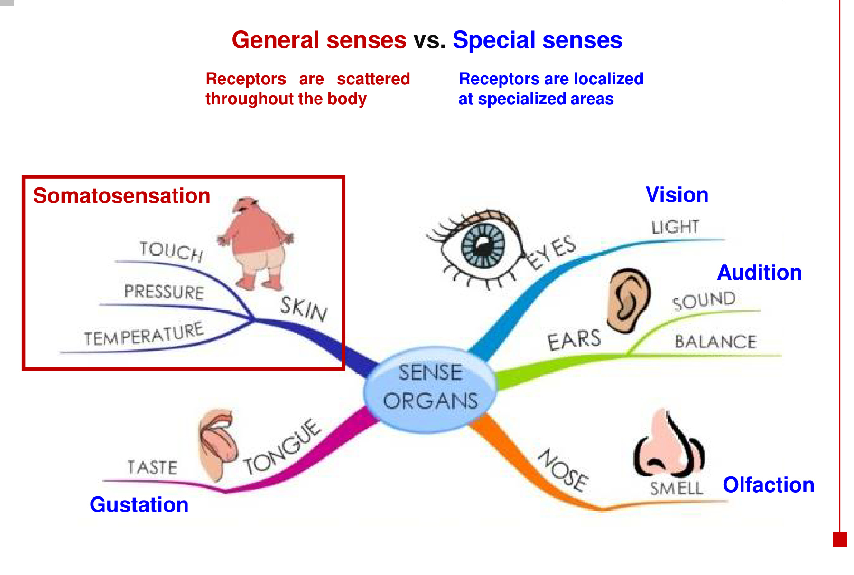
• General sensory receptors are distributed widely; special sensory receptors are localised in specialised areas.

03 Sensation vs perception
Sensation | Perception
Detection of a stimulus and transmission of the signal to the brain. | Interpretation of sensory input and recognition of what is sensed.
Begins at a receptor. | Depends on brain processing and is affected by experience.

Stimulus detected → electrical receptor response → sensory action potentials
→ impulses conducted to the brain → signals translated into information
→ information interpreted → awareness of the stimulus

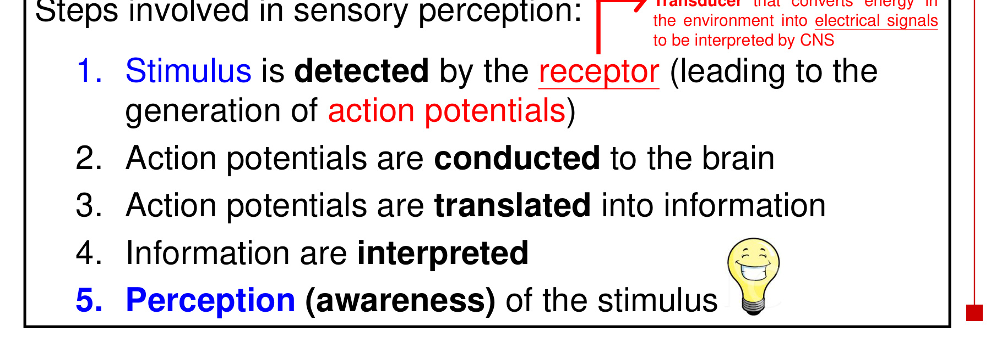
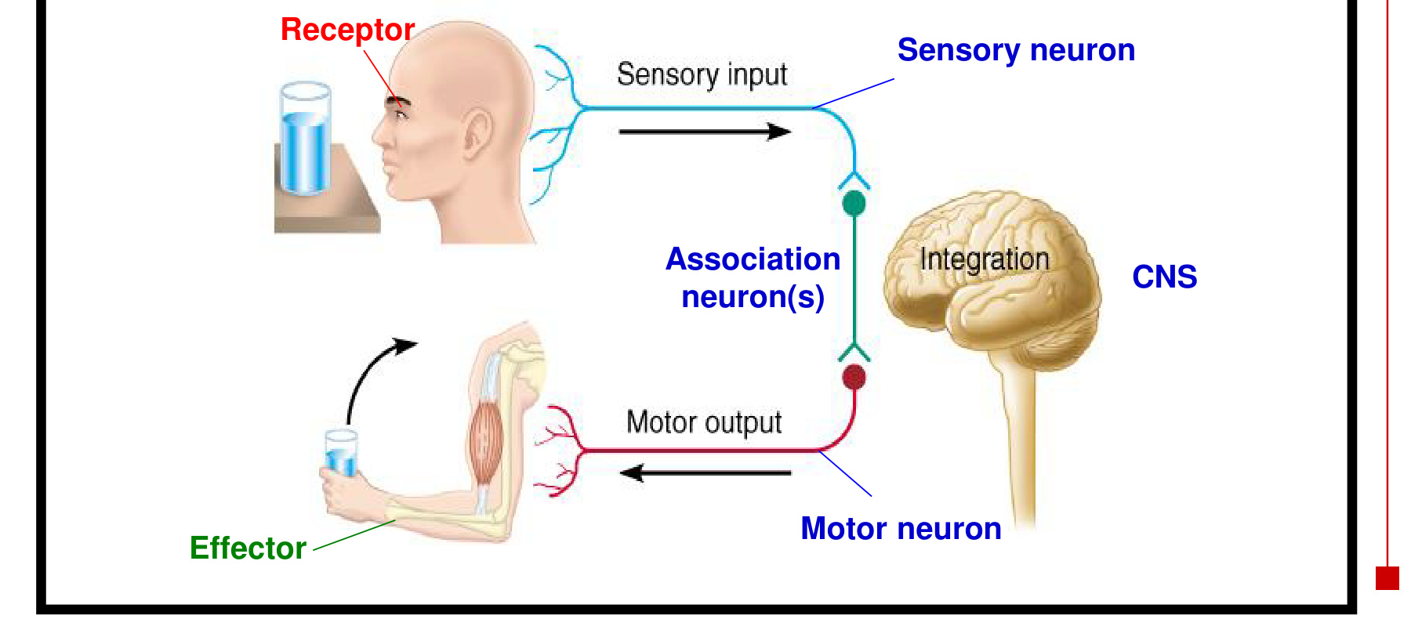  Input → integration → output | 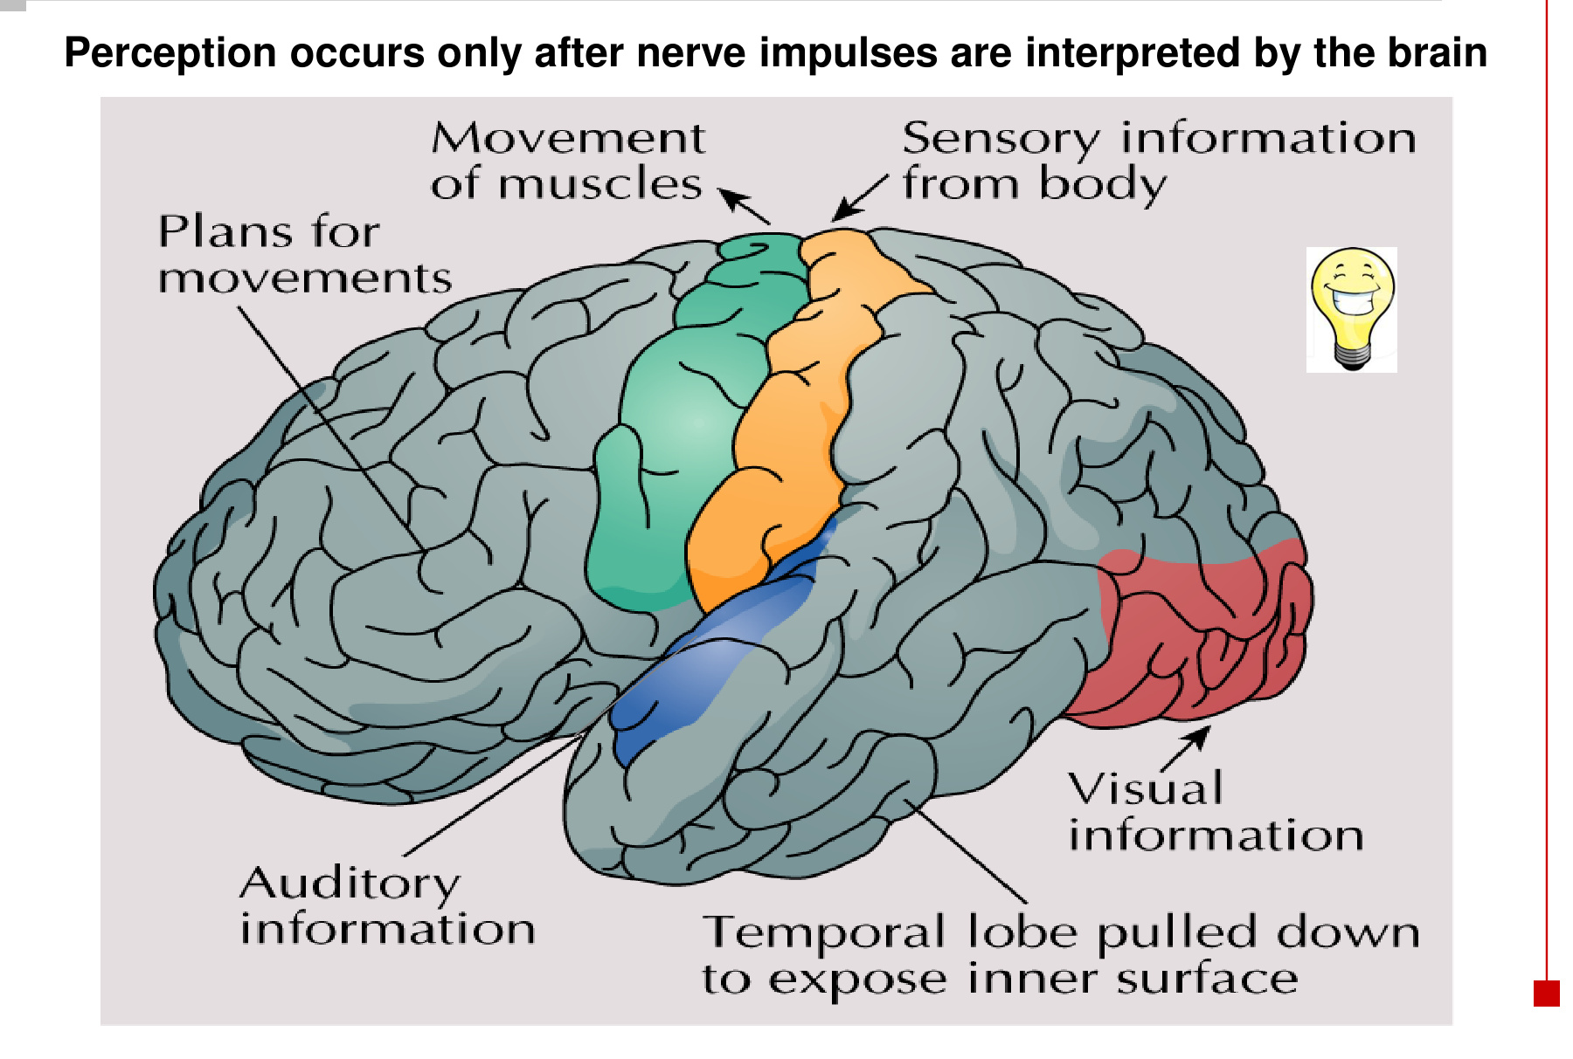  Different brain regions process different information.

• Perception occurs only after the brain interprets the sensory impulses.
• Receptor cells need not generate action potentials themselves: rods and cones produce graded signals, while retinal ganglion cells carry the output as action potentials.
• Sensory input can also initiate motor output through reflex circuits.

04 Skin receptors & temperature sensing
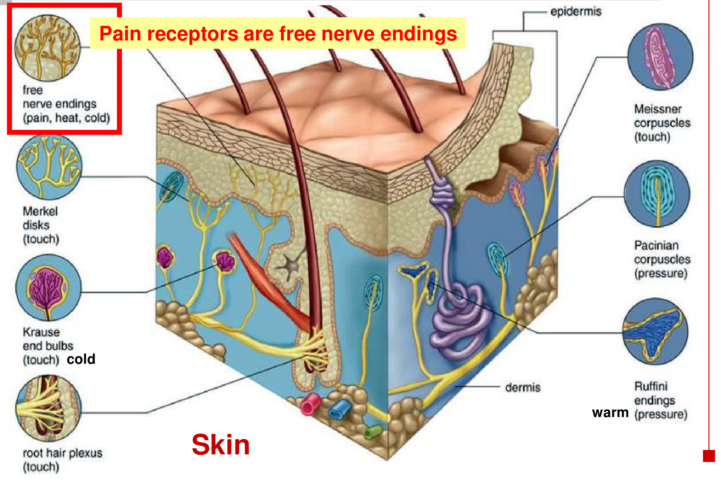
Cutaneous structure | Main association
Merkel discs / Meissner corpuscles / root hair plexus | Touch; hair movement is detected around the hair root.
Pacinian corpuscles | Pressure; deeper mechanical deformation and vibration.
Ruffini endings / Krause end bulbs | Named cutaneous endings in the receptor diagram. Ruffini endings detect skin stretch; Krause end bulbs are traditionally associated with touch / cold.
Free nerve endings | Pain, heat and cold. Nociceptors can respond to noxious mechanical, thermal or chemical stimuli.

Thermoreceptors | Location / role
Central | Hypothalamus → thermoregulation; operates without conscious temperature perception.
Cutaneous | Skin → conscious temperature sensation AND thermoregulation.
Cold / warm ranges | Cold: 10–35°C. Warm: 30–45°C. The response ranges overlap.

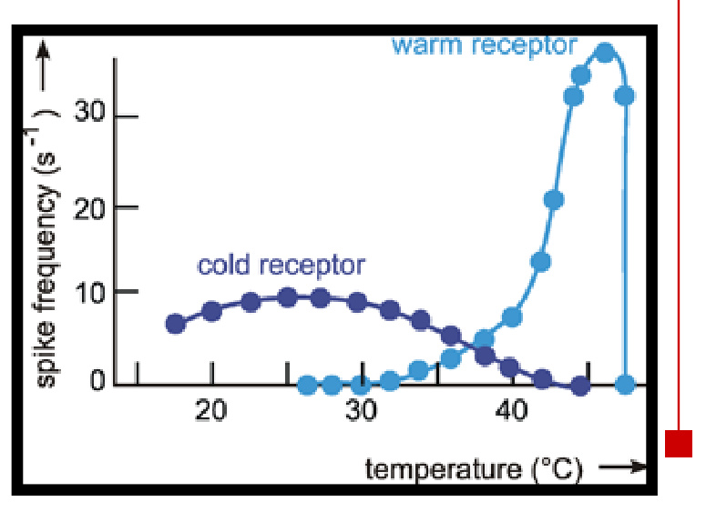
Temperature changes alter receptor firing. Modern temperature sensing centres on thermosensitive free endings; the traditional “Ruffini = warm / Krause = cold” labels are not exclusive functional identities.

05 Somatosensory pathways: where they cross
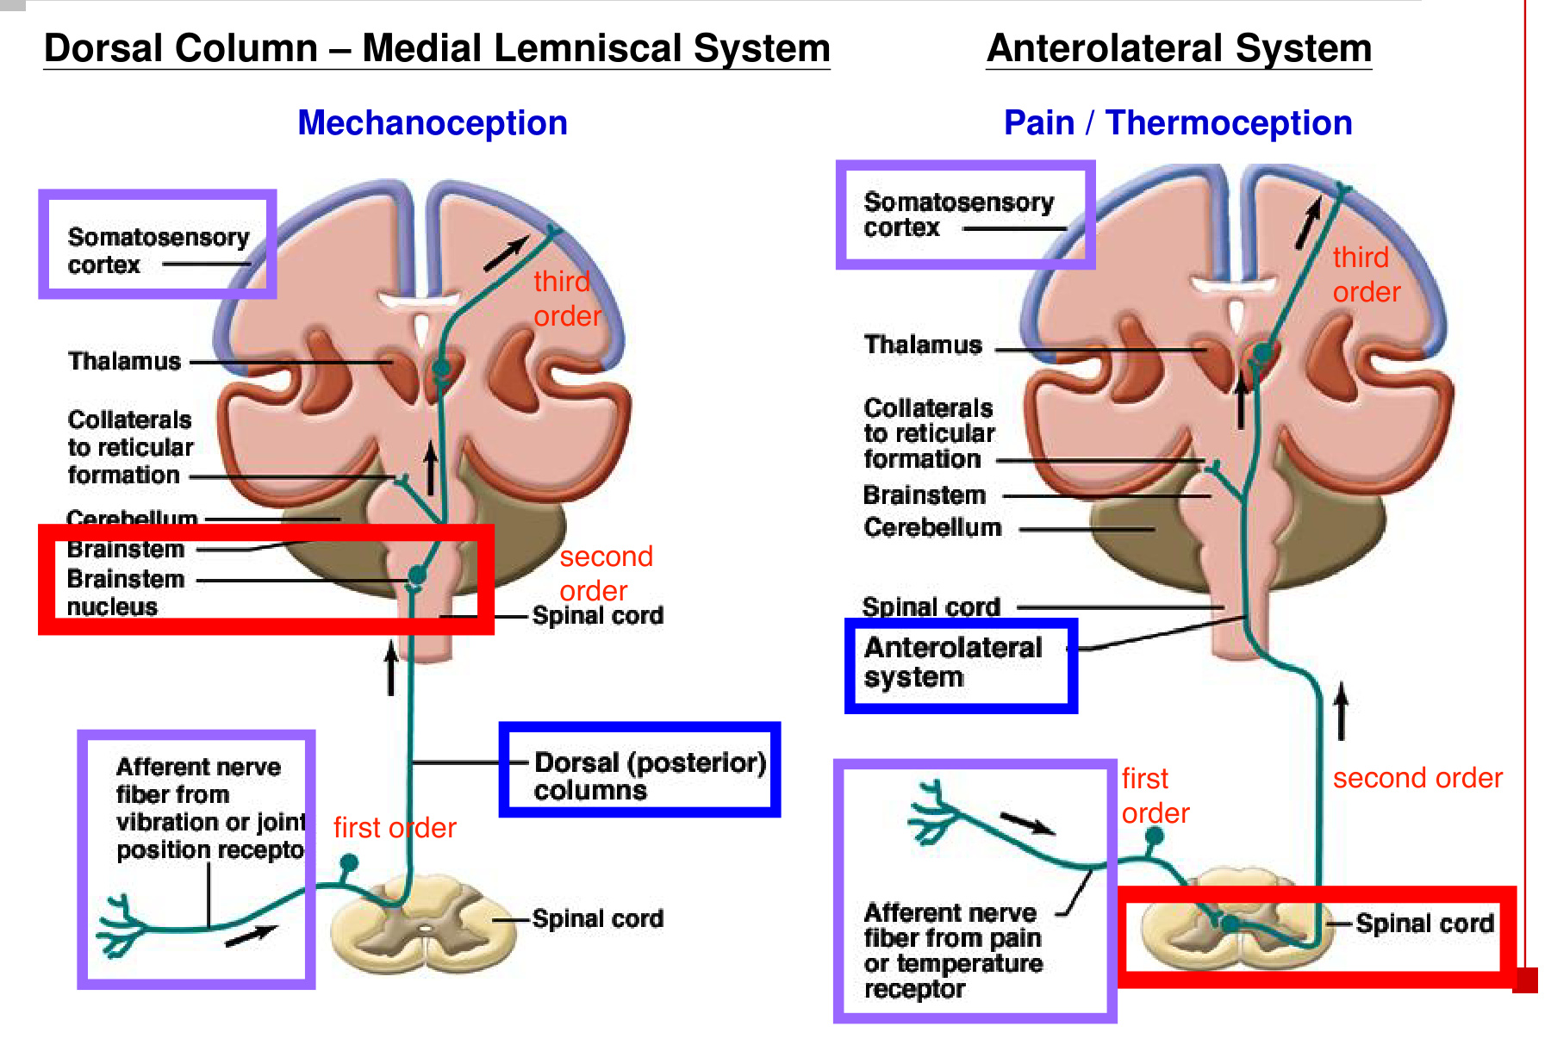
Feature | Dorsal column–medial lemniscal | Anterolateral / spinothalamic
Modalities | Mechanoception: discriminative touch, vibration and joint position. | Pain, thermoception and crude touch.
First-order neuron | Ascends on the same side in the dorsal (posterior) columns → brainstem nucleus. | Enters the spinal cord → synapses with a second-order neuron there.
Second-order neuron | Crosses in the brainstem / medulla, then ascends toward the thalamus. | Crosses in the spinal cord, then ascends in the opposite anterolateral pathway.
Third-order neuron | Thalamus → somatosensory cortex. | Thalamus → somatosensory cortex.

Dorsal column: ascend first, then cross in the brainstem.
Anterolateral: cross in the spinal cord, then ascend.

• Both pathways relay through the thalamus before reaching the somatosensory cortex. Collaterals also reach brainstem reticular circuits.

06 Vision: light & the eye
Stimulus: light (electromagnetic waves / photons).
Receptor organ: eye. Receptor cells: rods and cones. Receptor protein: opsin.

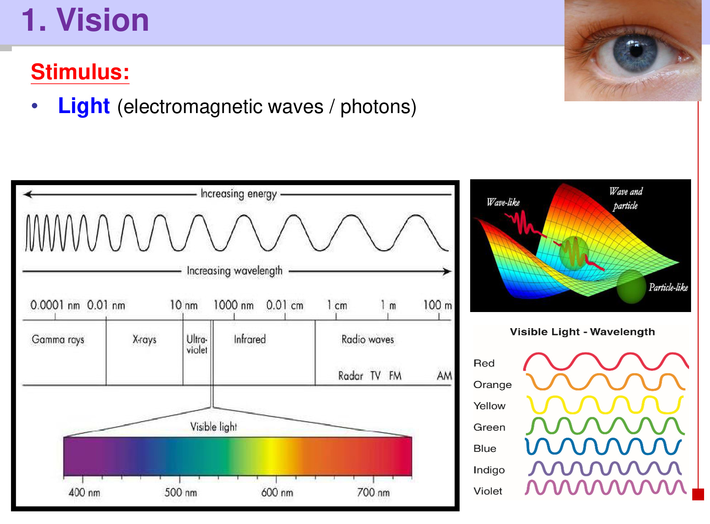
• Wavelength distinguishes different parts of the spectrum; visible light occupies approximately 400–700 nm. Shorter wavelength corresponds to higher photon energy.
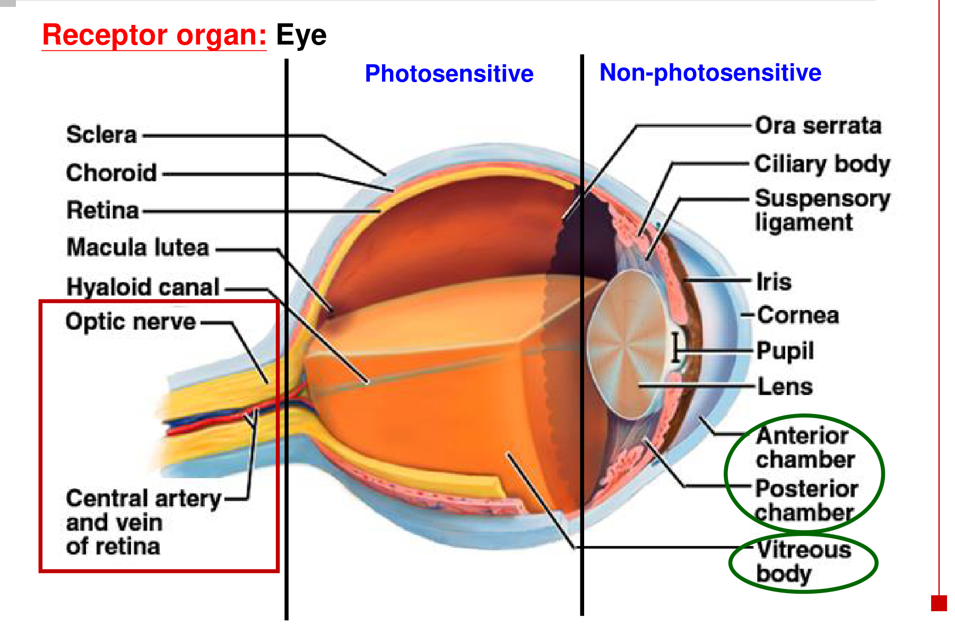
• The retina is the innermost sensory layer. Its posterior photosensitive region contains rods and cones; the anterior continuation is non-photosensitive.
• The ora serrata marks the anterior boundary of the photosensitive retina.

07 Eye structures: form supports function
Structure | Feature → function
Sclera | Tough outer coat → protects the eyeball and maintains its shape.
Choroid | Blood vessels → nutrient supply. Pigment → limits internal light reflection.
Cornea | Transparent anterior part of the outer layer → allows light to enter and contributes to refraction.
Pupil | Circular opening in the iris → admits light.
Iris | Coloured structure containing muscles → regulates pupil size.
Lens | Elastic and biconvex → focuses an image on the retina.
Ciliary body | Contains ciliary muscle → adjusts lens focusing through the suspensory ligaments.
Retina / optic nerve | Retina contains the sensory cells; ganglion-cell axons leave as the optic nerve.

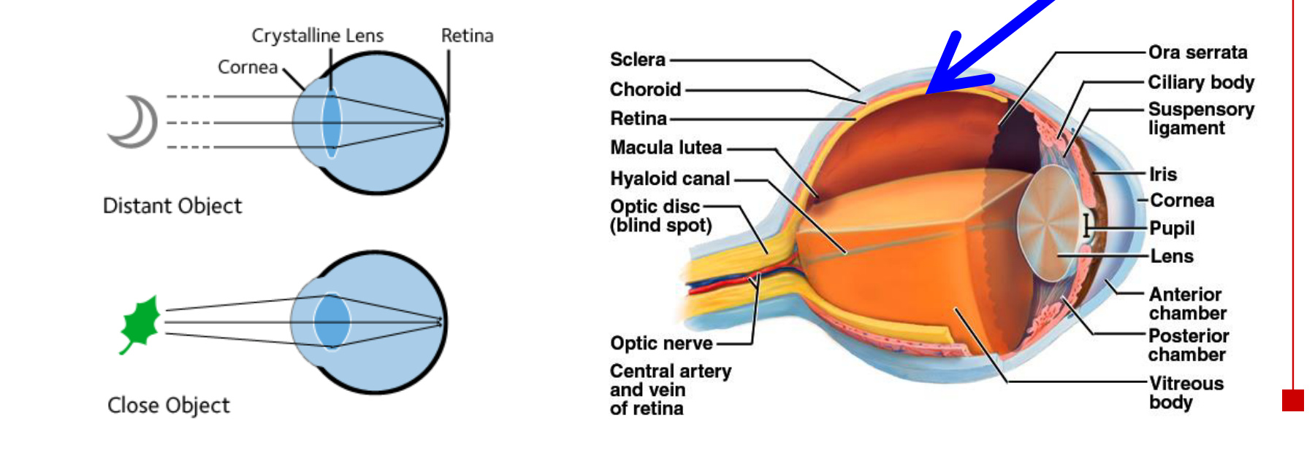
Light → cornea → aqueous-filled anterior chamber → pupil
→ lens → vitreous body → retina

• The posterior chamber lies behind the iris and in front of the lens; the large vitreous compartment is behind the lens.
• Accommodation changes lens shape: a more rounded lens helps focus near objects; a flatter lens helps focus distant objects.
• Other landmarks: macula lutea, optic disc, central retinal artery and vein, and hyaloid canal within the vitreous body.

08 Retina: light direction vs signal direction
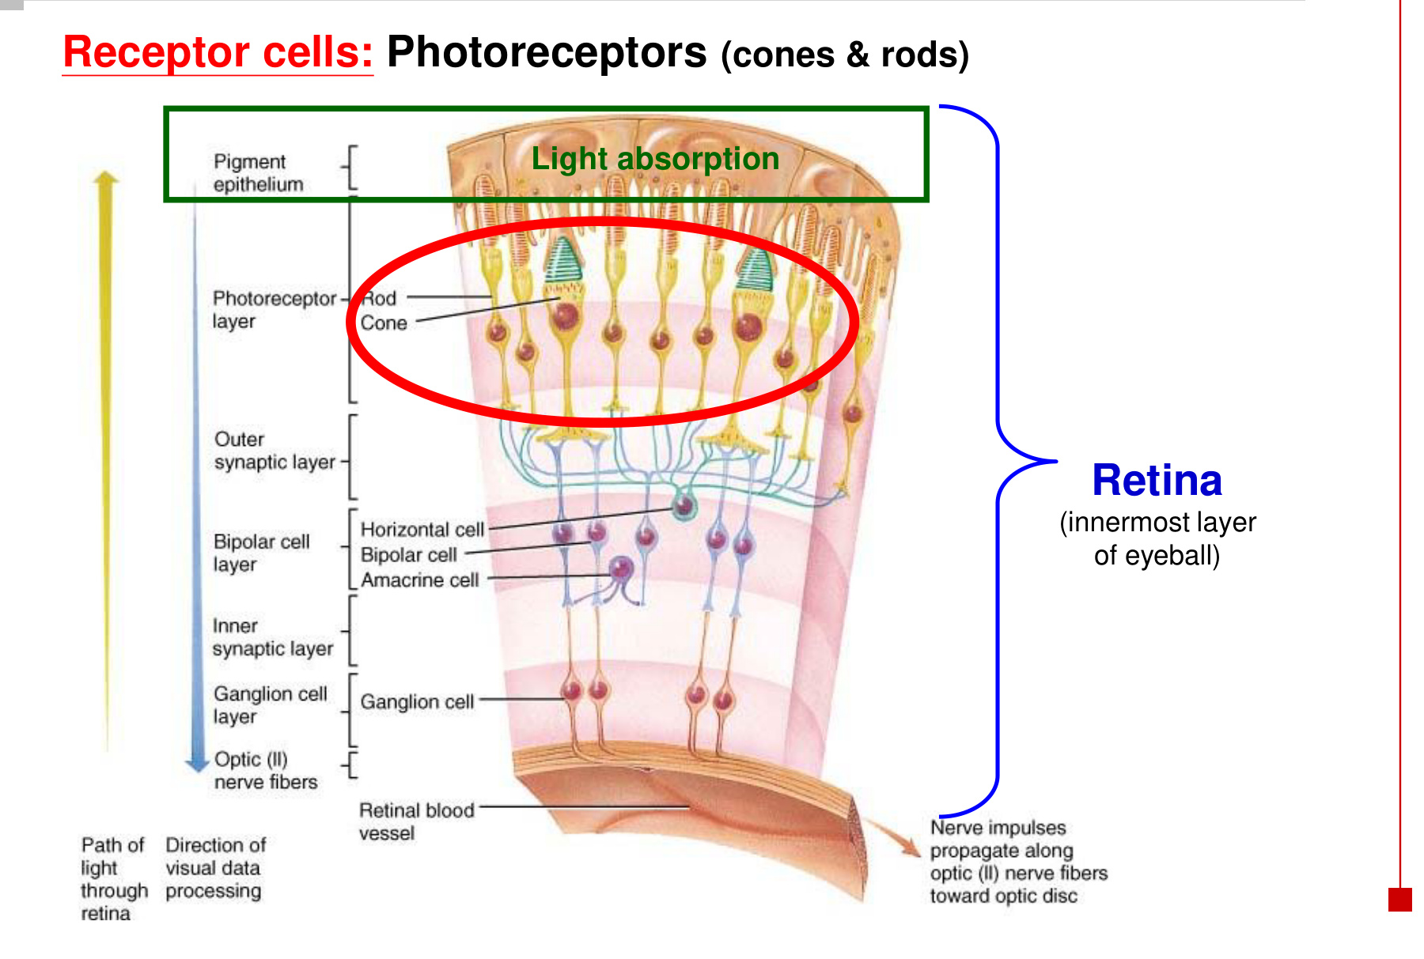
Light: passes through inner retinal layers → reaches rods and cones.
Neural signal: photoreceptors → bipolar cells → ganglion cells
→ ganglion-cell axons form the optic nerve.

Cell / layer | Role
Rods and cones | Photoreceptors; absorb light near the pigment epithelium.
Bipolar cells | Relay changes in photoreceptor output to ganglion cells.
Ganglion cells | Output neurons of the retina; their axons conduct toward the brain.
Horizontal / amacrine cells | Lateral retinal connections that modify the signal between neighbouring pathways.

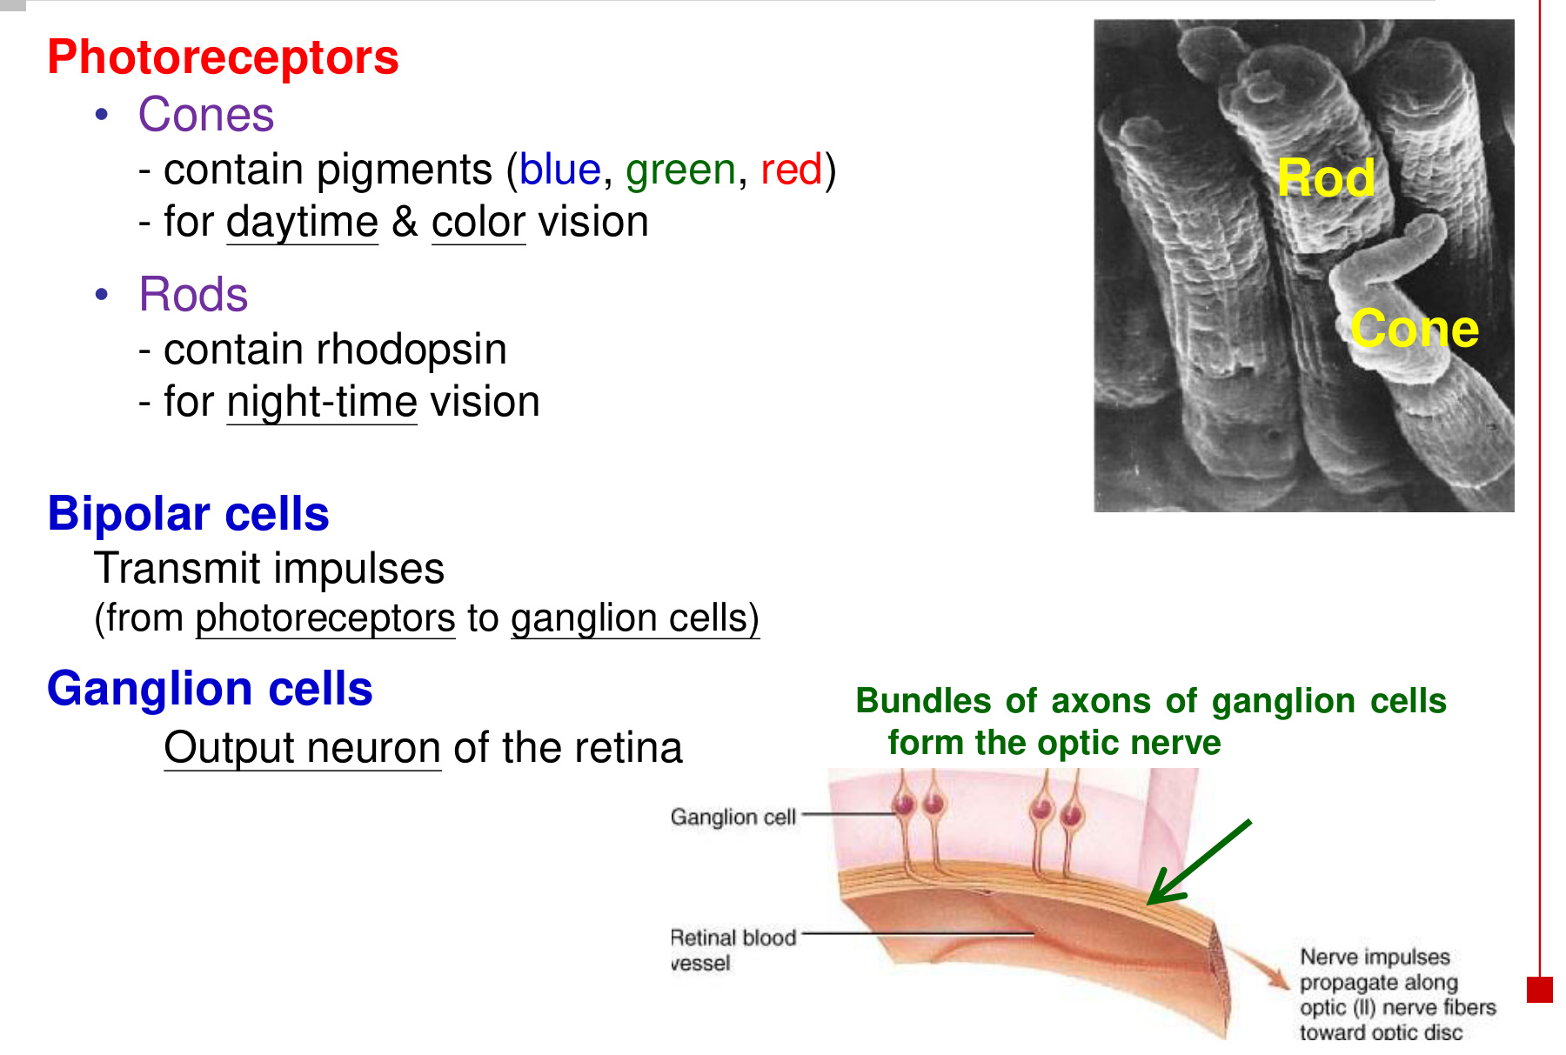
• The photoreceptor outer segment performs light transduction; the optic nerve carries processed retinal output.

09 Rods, cones & convergence
Feature | Rods | Cones
Vision | Night / dim-light vision | Daylight and colour vision
Photopigment | Rhodopsin | Cone pigments with blue-, green- and red-sensitive classes
Sensitivity | High sensitivity to weak light | Require brighter light for effective function
Convergence | Many rods feed into shared downstream pathways | Lower convergence, especially in the fovea
Spatial acuity | Lower acuity | Higher acuity

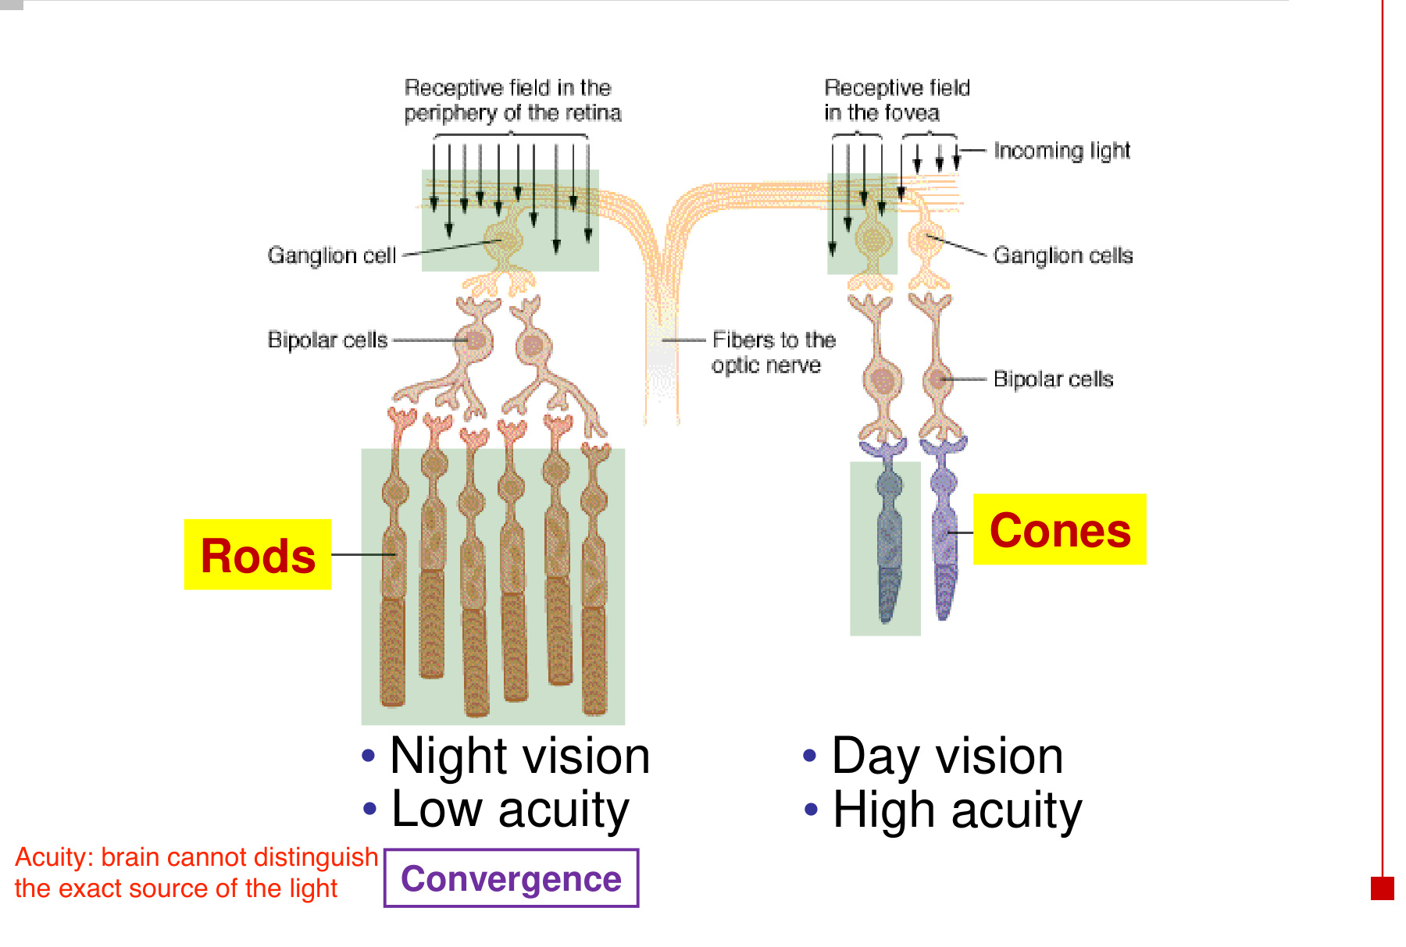
More convergence → signals from several receptors are pooled
→ better detection of weak input, but less certainty about its exact location.

• If several rods share one output pathway, the brain cannot identify which particular rod detected the light.
• Fewer converging receptors preserve spatial detail: neighbouring points can remain distinguishable.

10 Fovea, acuity & the blind spot
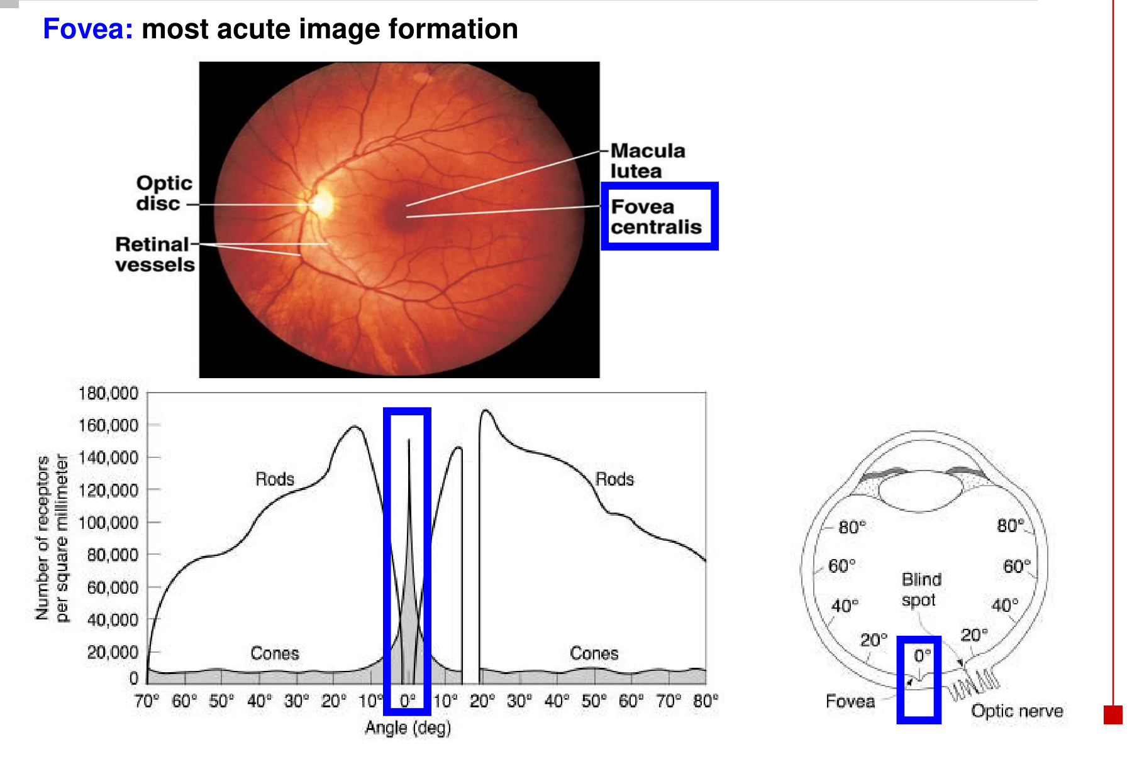
Landmark | What matters
Fovea centralis | Within the macula lutea; dense cones and low convergence → most acute image formation.
Peripheral retina | Rods are abundant outside the fovea; rod density peaks away from its centre.
Optic disc | Ganglion-cell axons leave the eye here. No rods or cones → physiological blind spot.

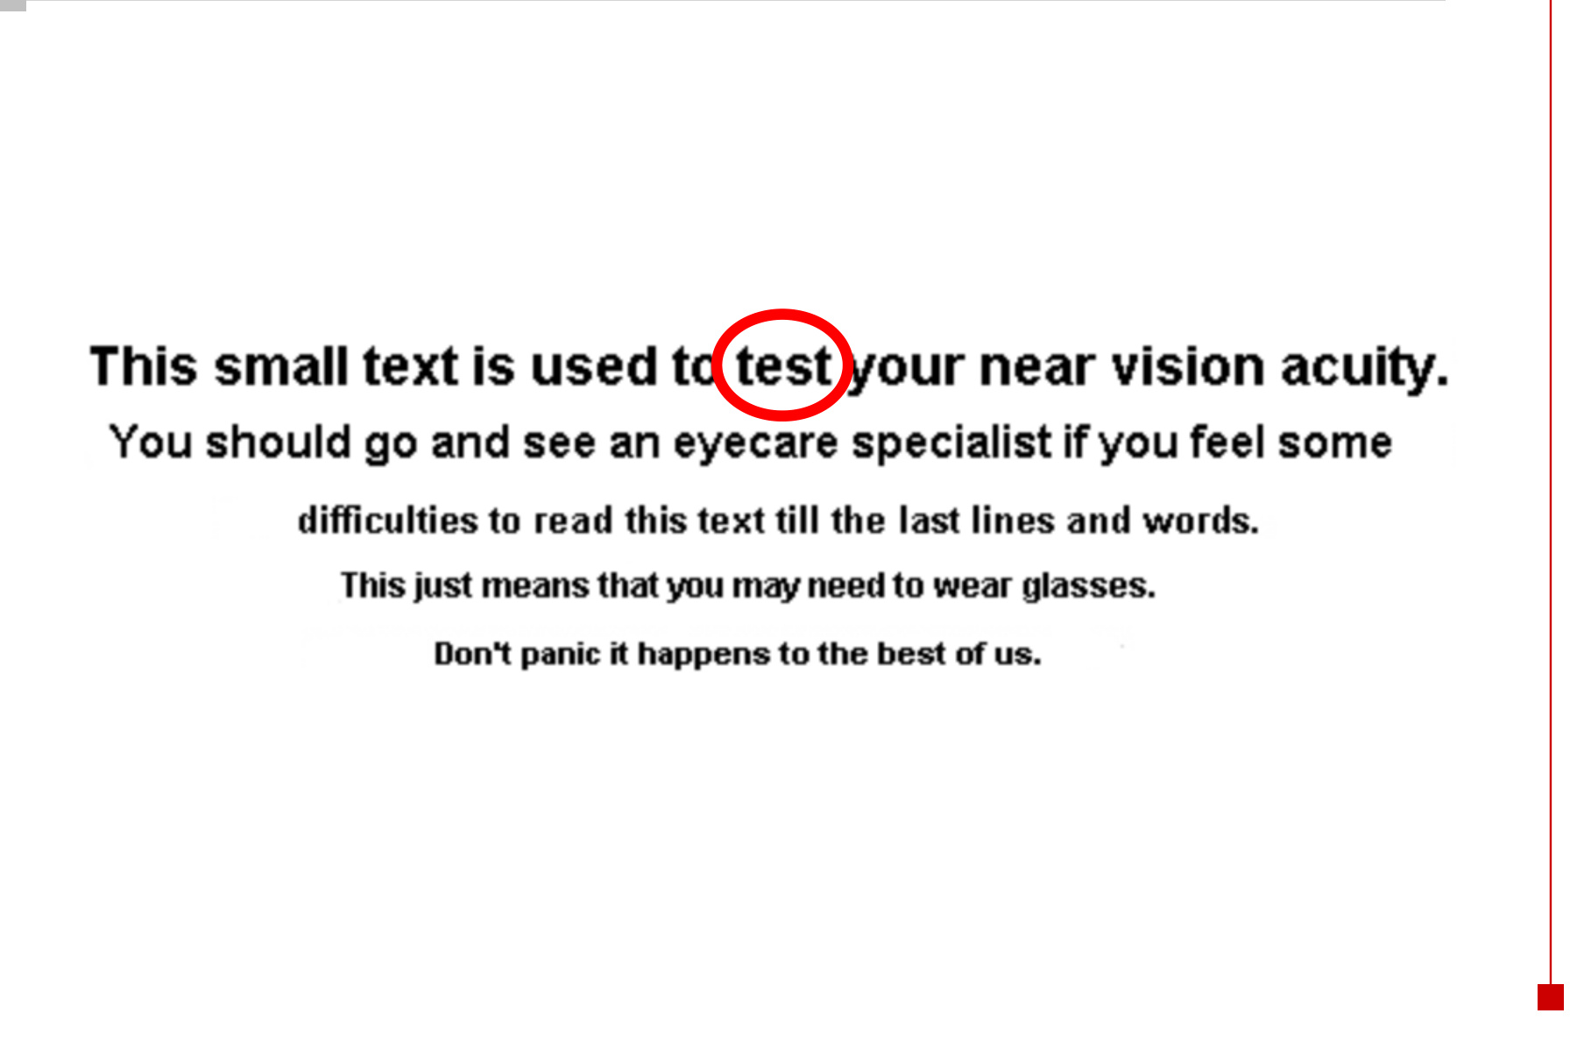
• Visual acuity means resolving fine spatial detail, such as small letters or neighbouring points.
• Image focus, illumination and viewing distance affect performance on a near-vision task.

11 Phototransduction: dark vs light
Dark: Na⁺ influx → photoreceptor depolarisation → ongoing glutamate release.
Light: photopigment activation / bleaching → Na⁺ channels close
→ Na⁺ influx ↓ → hyperpolarisation → glutamate release ↓.

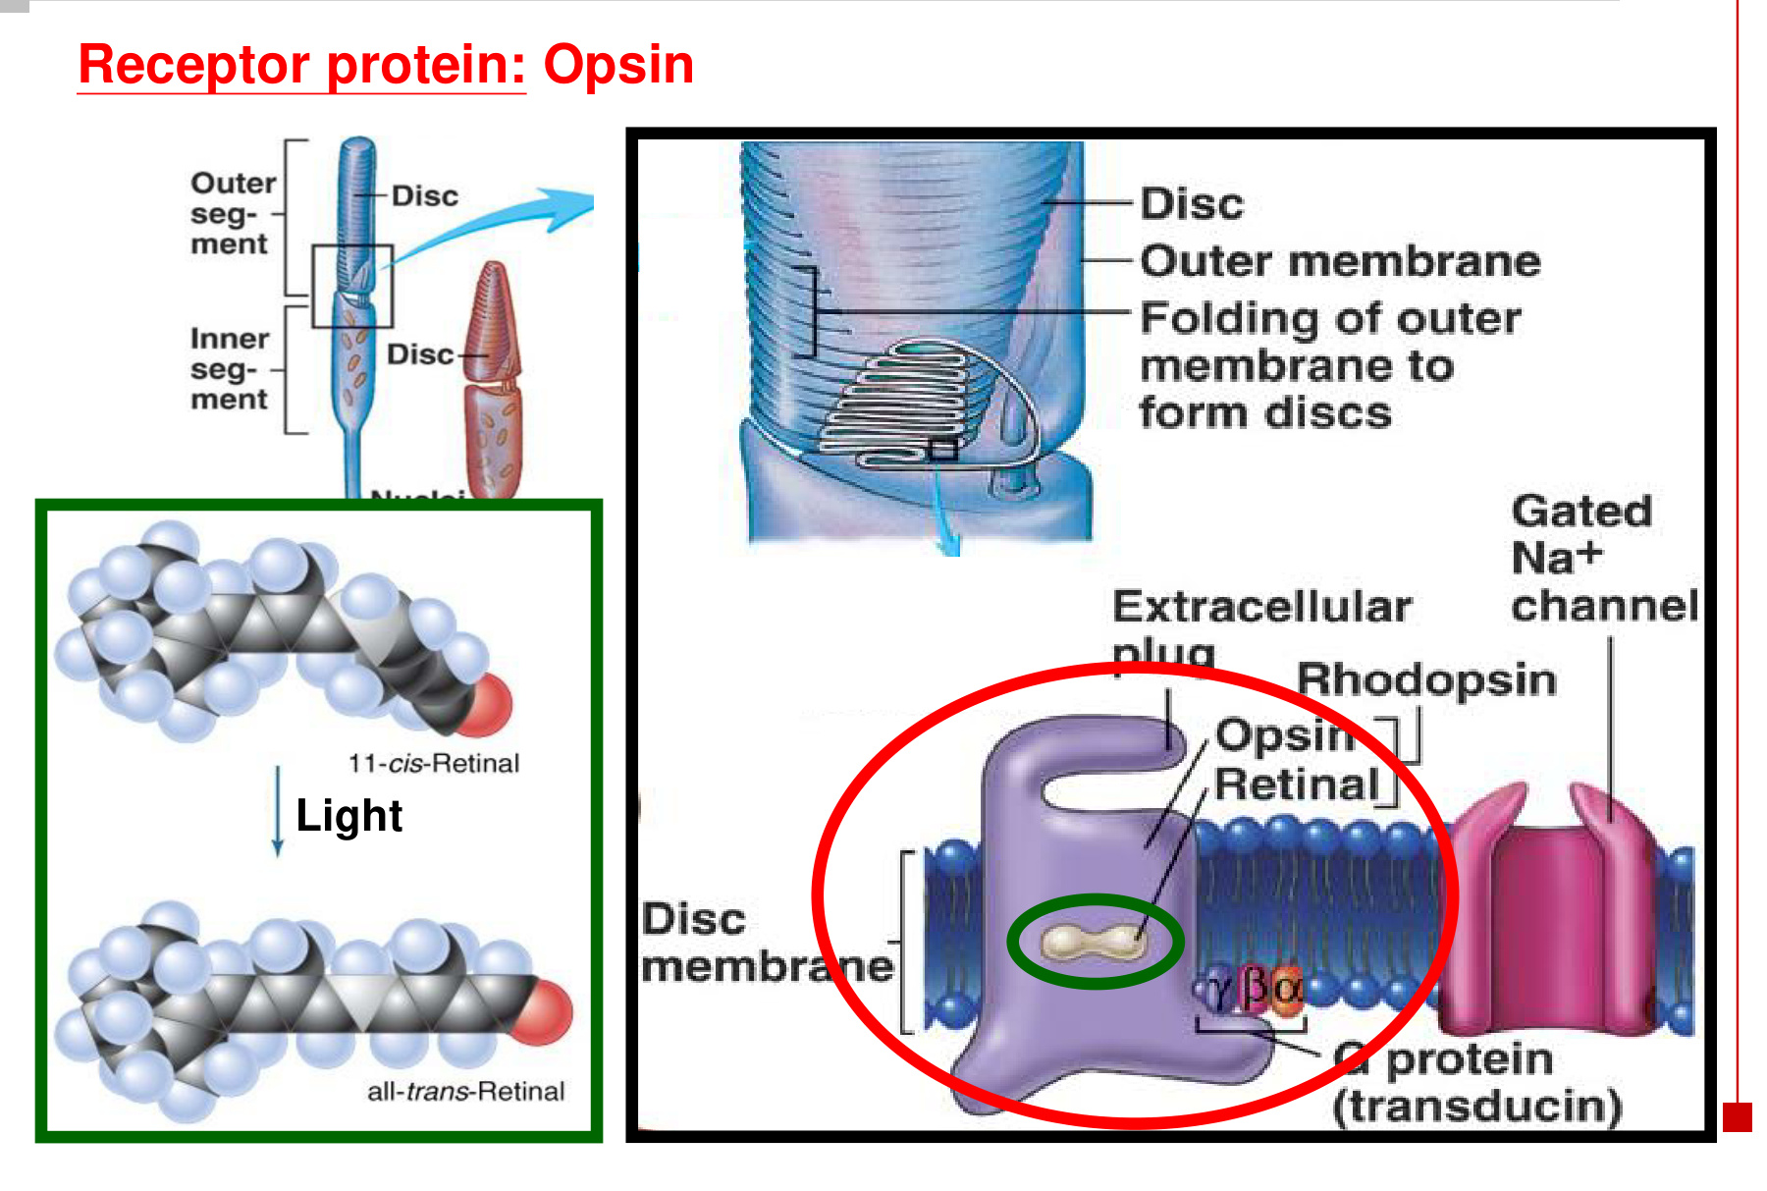  Opsin + retinal form the photopigment. | 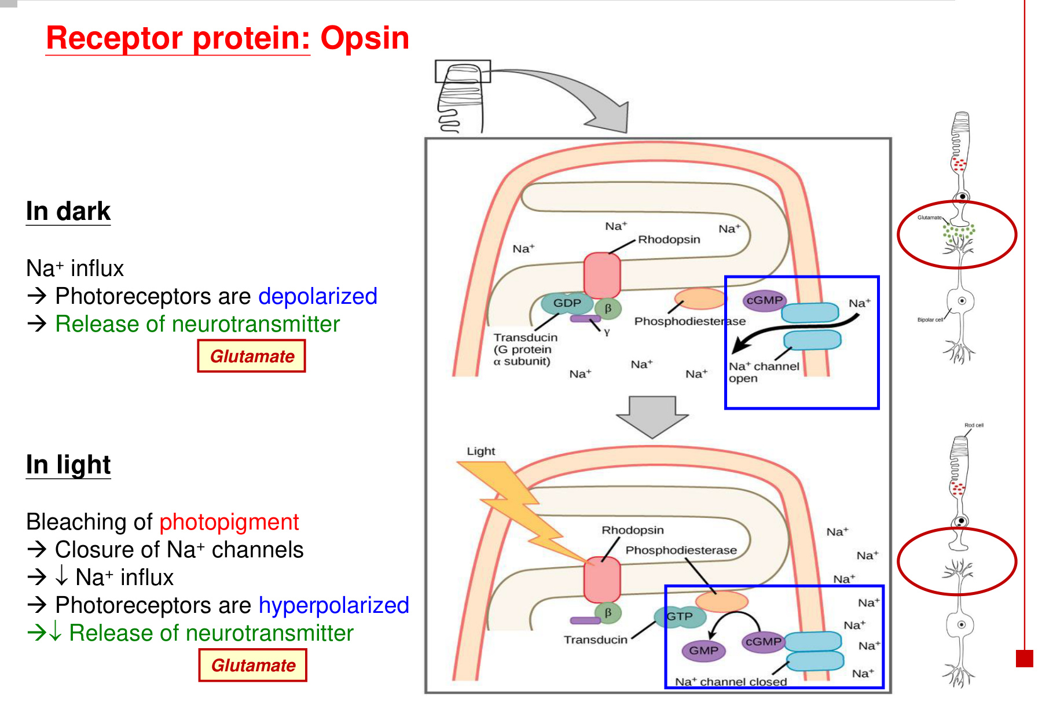  Light reduces inward current and transmitter release.

Key component | Role in the sequence
Outer-segment discs | Provide membrane area containing photopigment.
Opsin + retinal | Rhodopsin consists of rod opsin plus retinal. Light converts 11-cis retinal to all-trans retinal.
Transducin | G protein activated downstream of the light-sensitive pigment.
Channel closure | The signalling cascade activates phosphodiesterase → cGMP falls → cyclic-nucleotide-gated cation channels close.
Glutamate | Released at the photoreceptor synapse; release is lower in light than in darkness.

• Photoreceptors hyperpolarise in response to light. This is the opposite of a simple “stimulus opens inward channels → depolarisation” model.
• Photoreceptor voltage and transmitter release change gradually; retinal ganglion cells provide the action-potential output.

12 Visual pathway: retina to cortex
Rods / cones → bipolar cells → ganglion cells
→ optic nerve (CN II) → optic chiasm → optic tract
→ lateral geniculate nucleus (LGN) of the thalamus
→ optic radiations → visual cortex in the occipital lobe

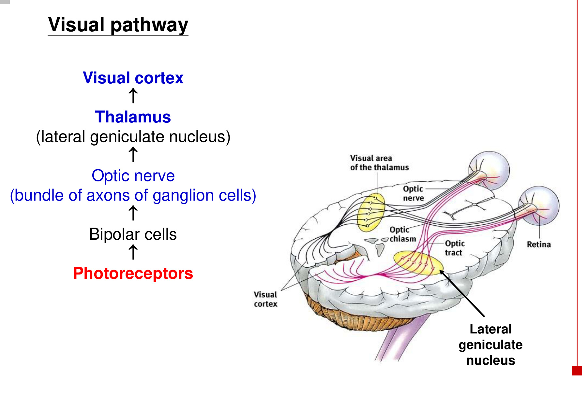
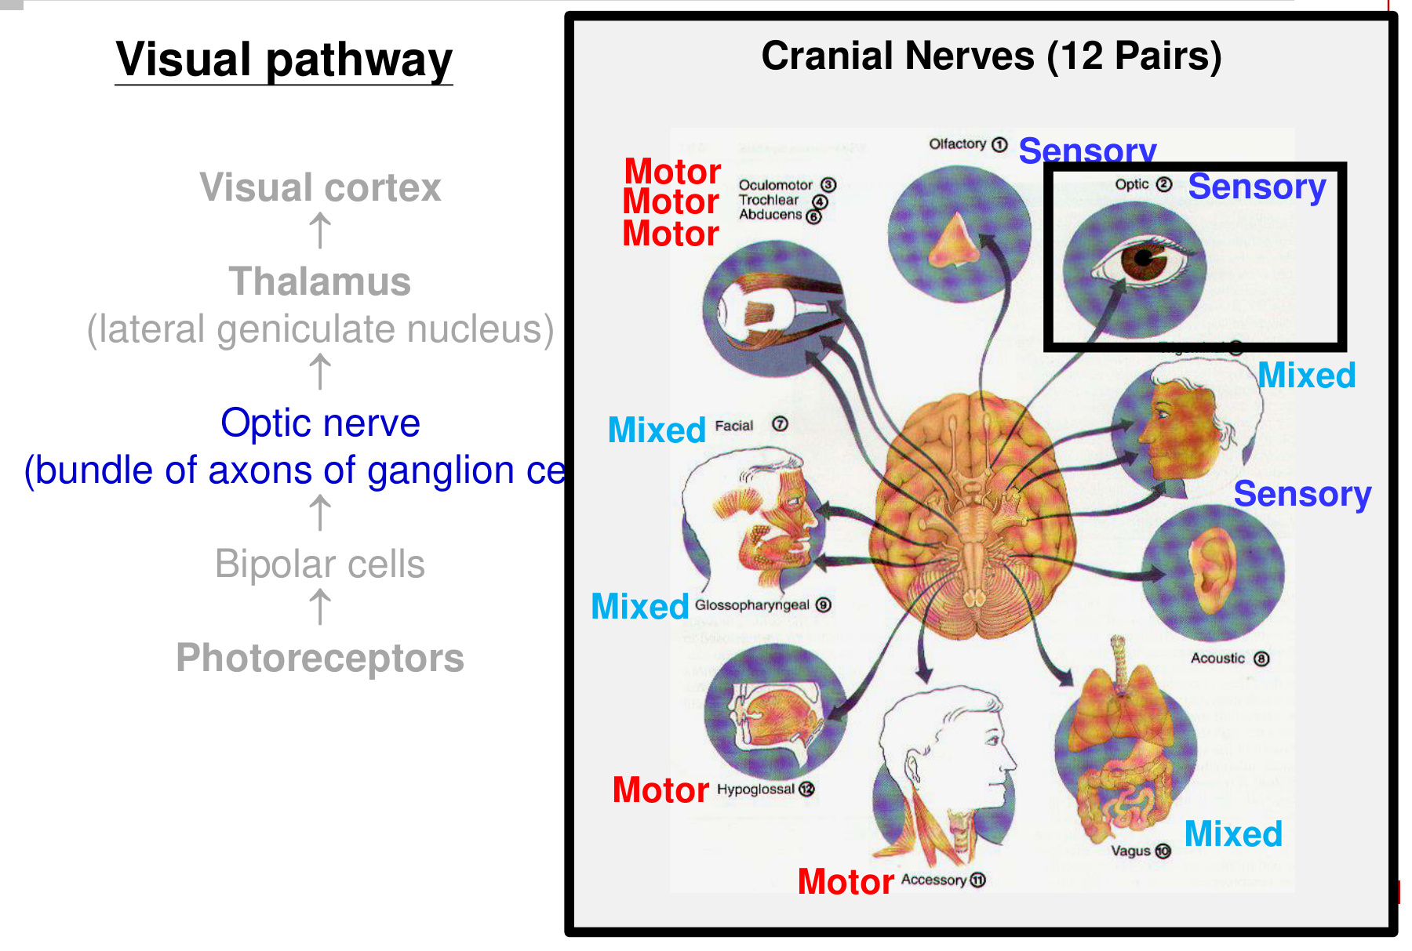
• The optic nerve is a bundle of ganglion-cell axons, not photoreceptor or bipolar-cell axons.
• CN II is sensory. The thalamic visual relay is the LGN.
• The optic nerve is before the chiasm; the optic tract is after it. Optic radiations connect the LGN to visual cortex.

13 Visual fields & retinotopic organisation
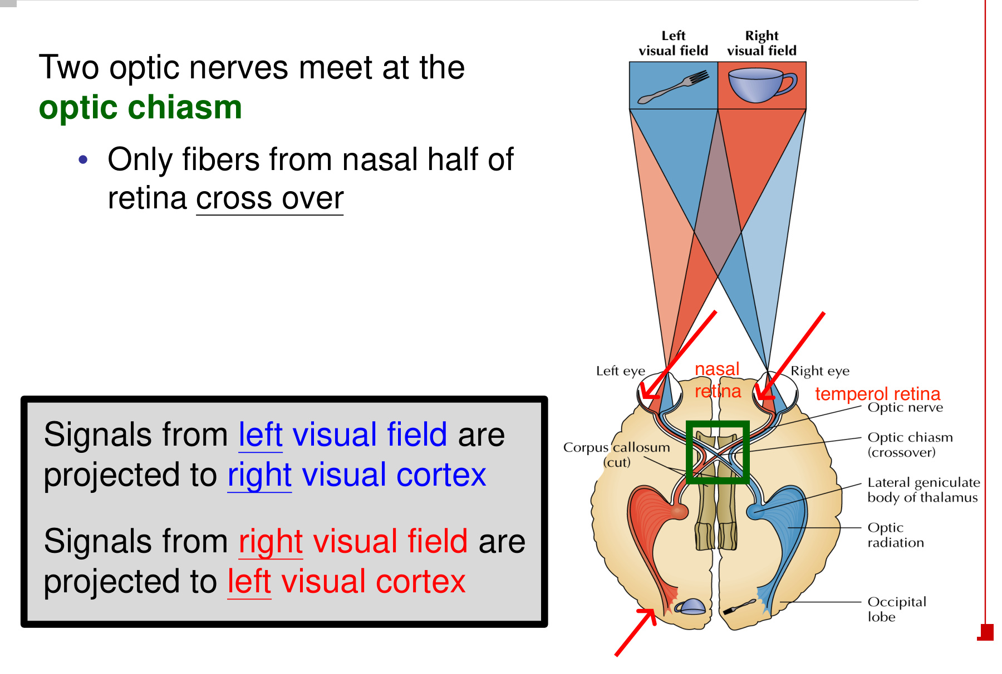  Only nasal retinal fibres cross at the chiasm. | 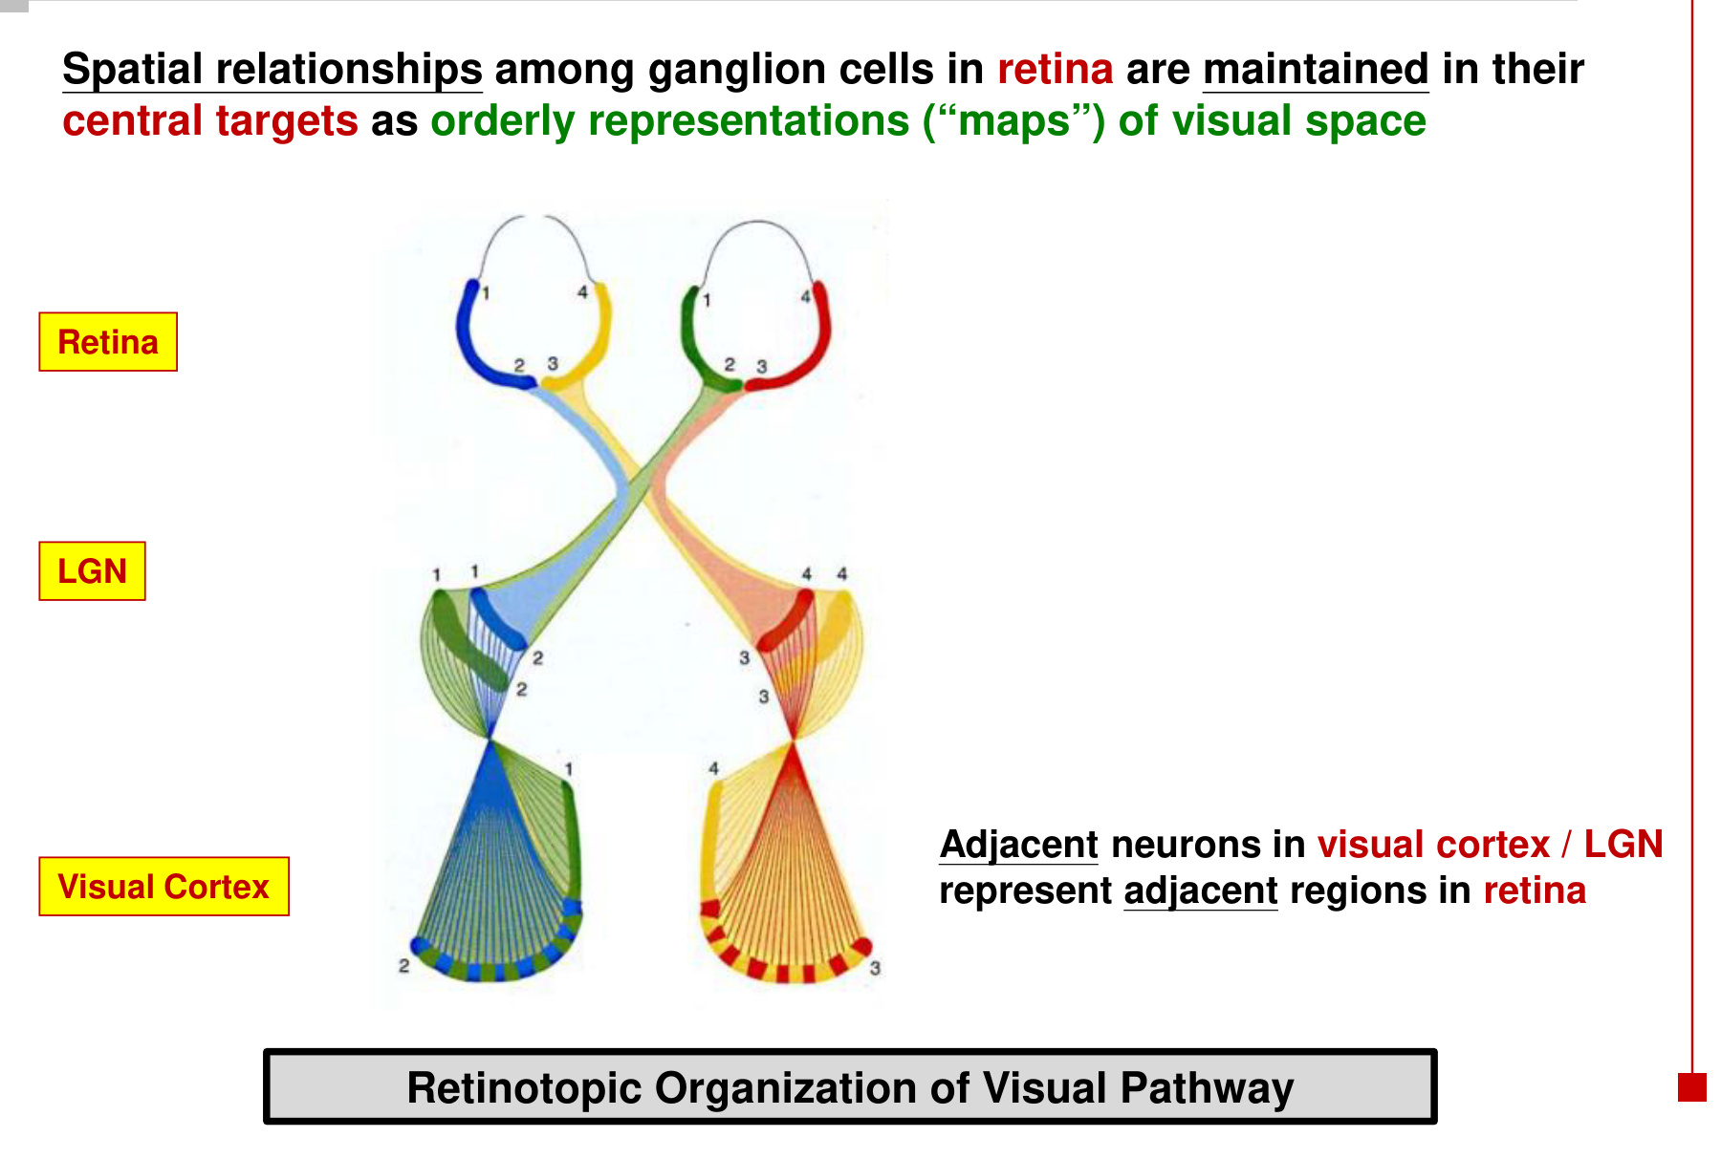  Spatial relationships are preserved in central maps.

Rule | Consequence
Two optic nerves meet at the optic chiasm. | Fibres from the nasal half of each retina cross; temporal retinal fibres remain on the same side.
Left visual field → right visual cortex. | Left-eye nasal retina and right-eye temporal retina supply the right-sided pathway.
Right visual field → left visual cortex. | Right-eye nasal retina and left-eye temporal retina supply the left-sided pathway.
Retinotopy | Spatial relationships among retinal ganglion cells are retained as orderly maps in the LGN and visual cortex.

• A visual field is a region of external space; it is not the same as “the left eye” or “the right eye”. Both eyes contribute to each side’s visual-field representation.
• Adjacent neurons in the LGN / visual cortex represent adjacent retinal regions.
Optic chiasm = selective crossing.
Retinotopic organisation = preservation of spatial relationships.

14 Taste buds & papillae
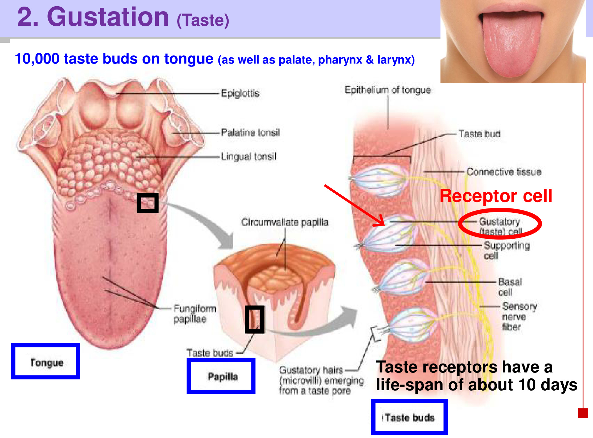
Structure / fact | Essential detail
Taste-bud distribution | Approximately 10,000 taste buds; located mainly on the tongue, with additional buds in the palate, pharynx and larynx.
Papillae | Surface structures of the tongue. Fungiform and circumvallate (vallate) papillae contain taste buds.
Filiform papillae | Contain mechanoreceptors but no taste buds → mechanical / tactile role rather than gustation.
Taste-bud cells | Gustatory receptor cells, supporting cells and basal cells; sensory nerve fibres contact the receptor cells.
Taste pore / gustatory hairs | Microvilli project through the pore to contact dissolved chemicals.
Continual turnover | Taste receptor cells have a lifespan of approximately 10 days and are continually replaced.

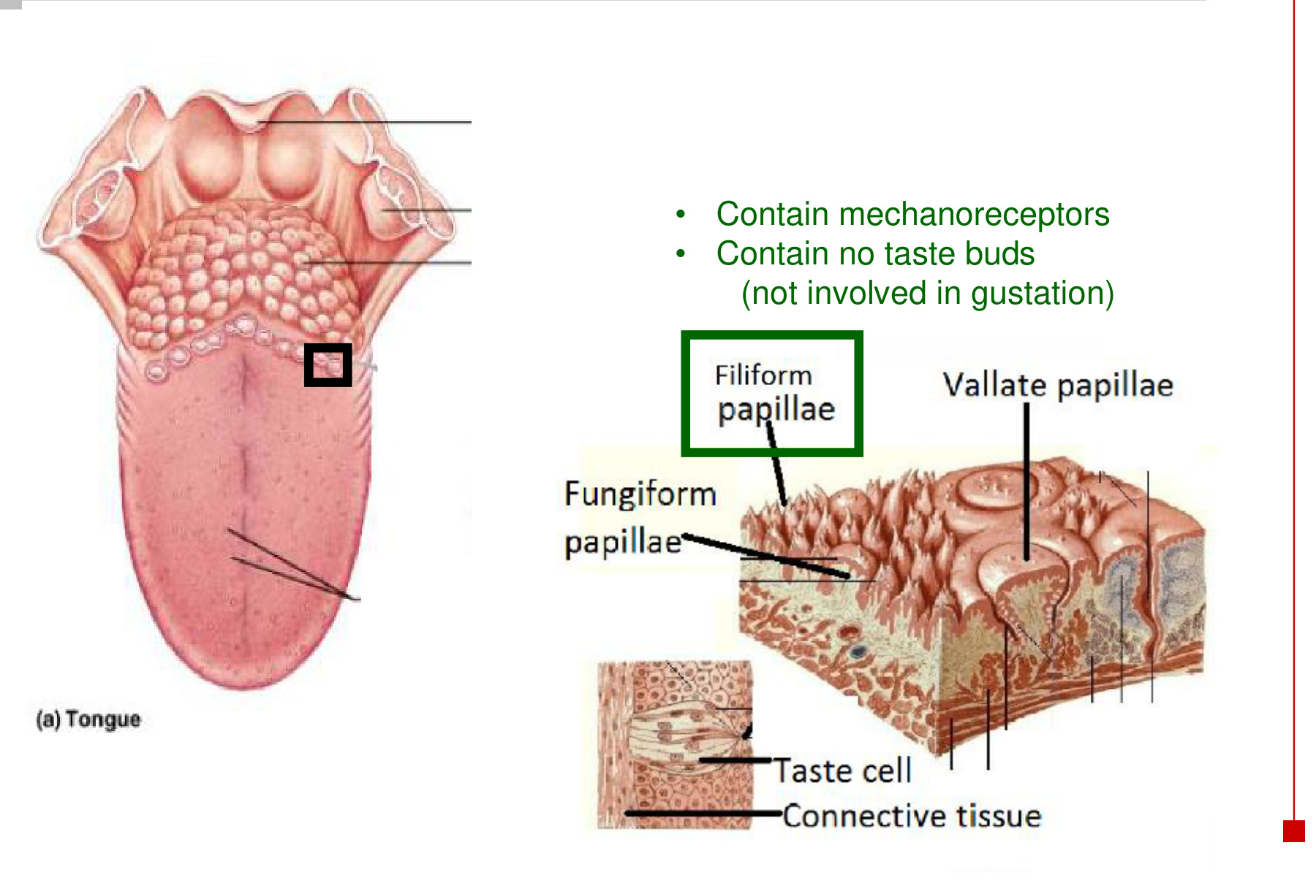

15 Five tastes: two entry mechanisms
Tastant → dissolves in saliva → reaches the receptor surface
→ interacts with an ion channel OR binds a G-protein-coupled receptor
→ receptor-cell electrical change → sensory signalling

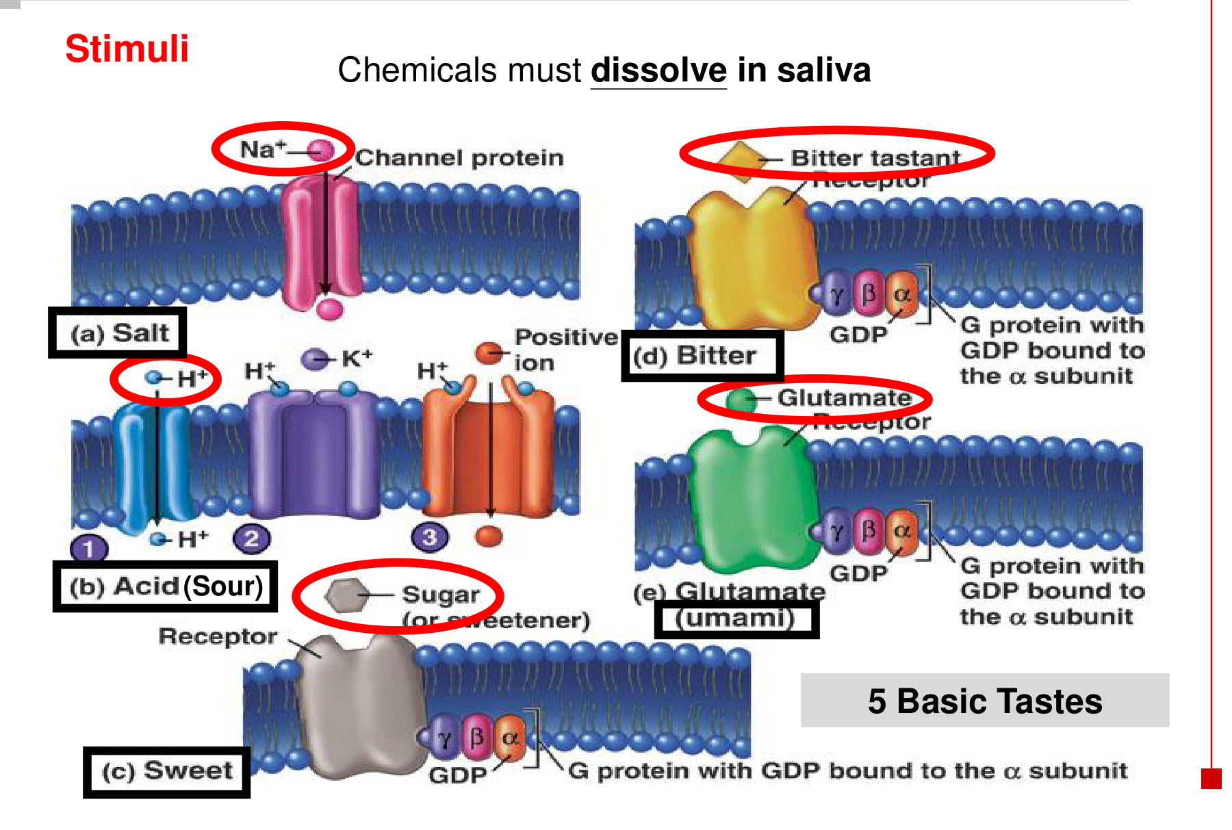
Taste | Example stimulus | Initial interaction
Salty | Na⁺ | Ion-channel pathway; inward positive charge promotes depolarisation.
Sour | H⁺ from acids | H⁺ entry, cation-channel opening or K⁺-channel inhibition.
Sweet | Sugar / sweetener | G-protein-coupled receptor (GPCR).
Bitter | Bitter tastant | GPCR.
Umami | Glutamate | GPCR; savoury taste.

• Taste quality depends on the receptor pathway activated, not simply on whether a cell depolarises.
• Glutamate is an umami tastant in food; in the retina it serves as a neurotransmitter. The location and role differ.

16 Sour & salty: ion movements

Three ways H⁺ can promote a sour response
H⁺ action | Electrical consequence
1. Passes through an ion channel | Positive charge enters → direct depolarisation.
2. Opens a cation channel | Inward cation current increases → depolarisation.
3. Blocks a K⁺ channel | Less K⁺ leaves the cell → less positive charge is lost → depolarisation.

Sour stimulus → taste receptor depolarises
→ voltage-gated Ca²⁺ channels open → Ca²⁺ enters
→ neurotransmitter release → primary sensory afferent activated

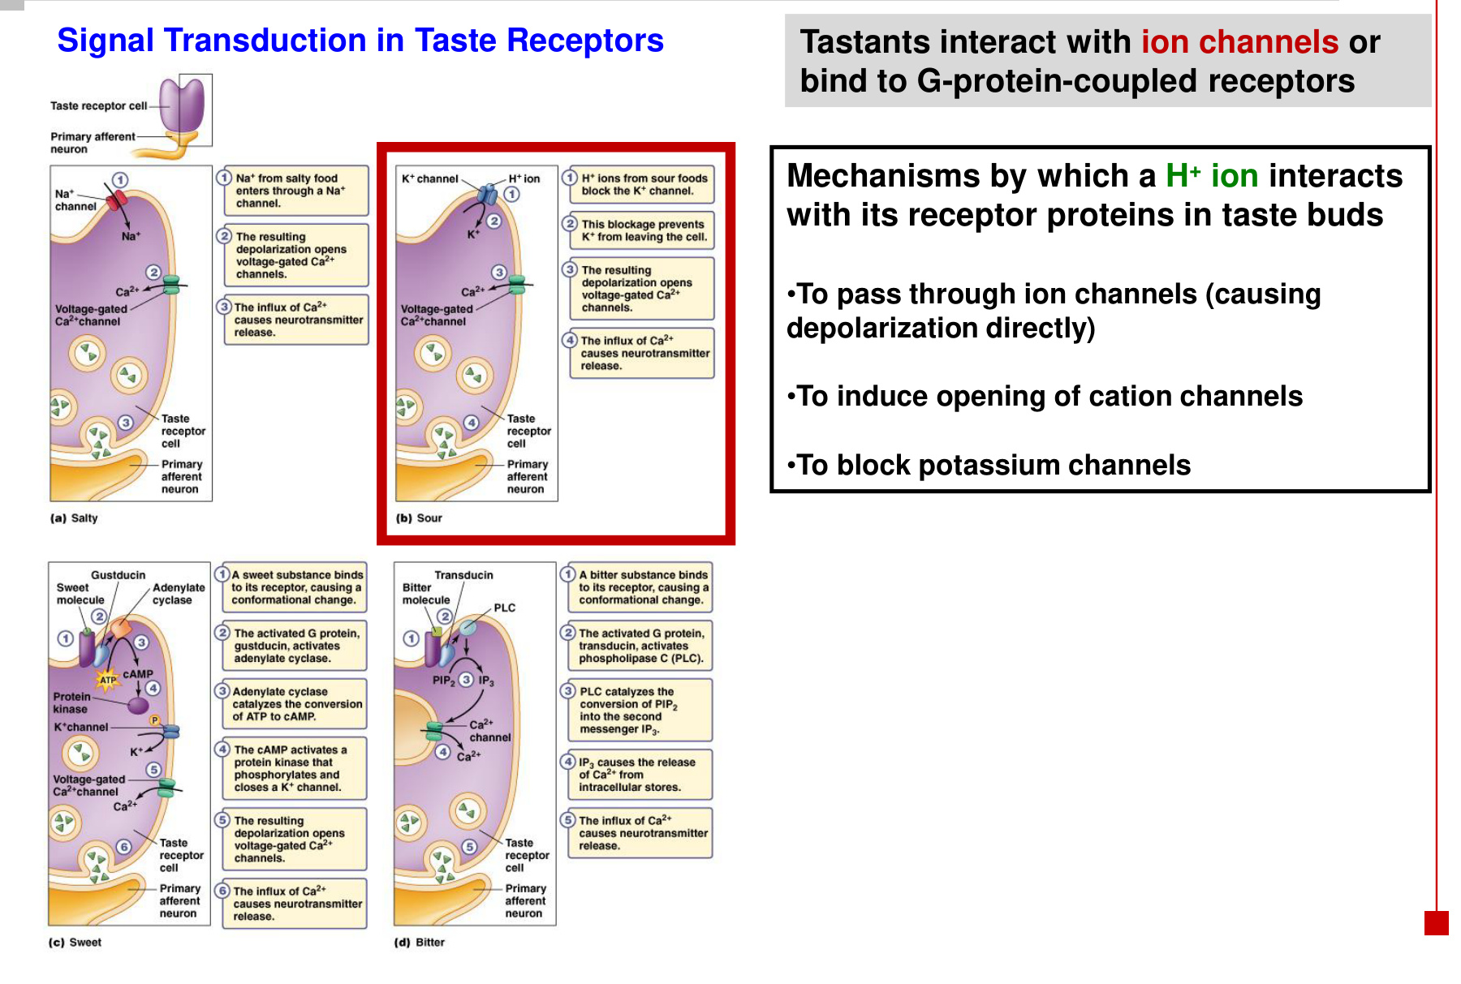

Salty pathway
Na⁺ from salty food enters through a Na⁺ channel → depolarisation
→ voltage-gated Ca²⁺ channels open → Ca²⁺ influx
→ neurotransmitter release → sensory afferent

• Blocking outward K⁺ movement and increasing inward positive charge can both make the membrane less negative.

17 Sweet taste: receptor to transmitter
Sweet molecule binds its receptor
→ intracellular G protein activated
→ downstream signalling depolarises the taste receptor cell
→ Ca²⁺ influx and/or intracellular Ca²⁺ ↑
→ neurotransmitter release → sensory afferent activation

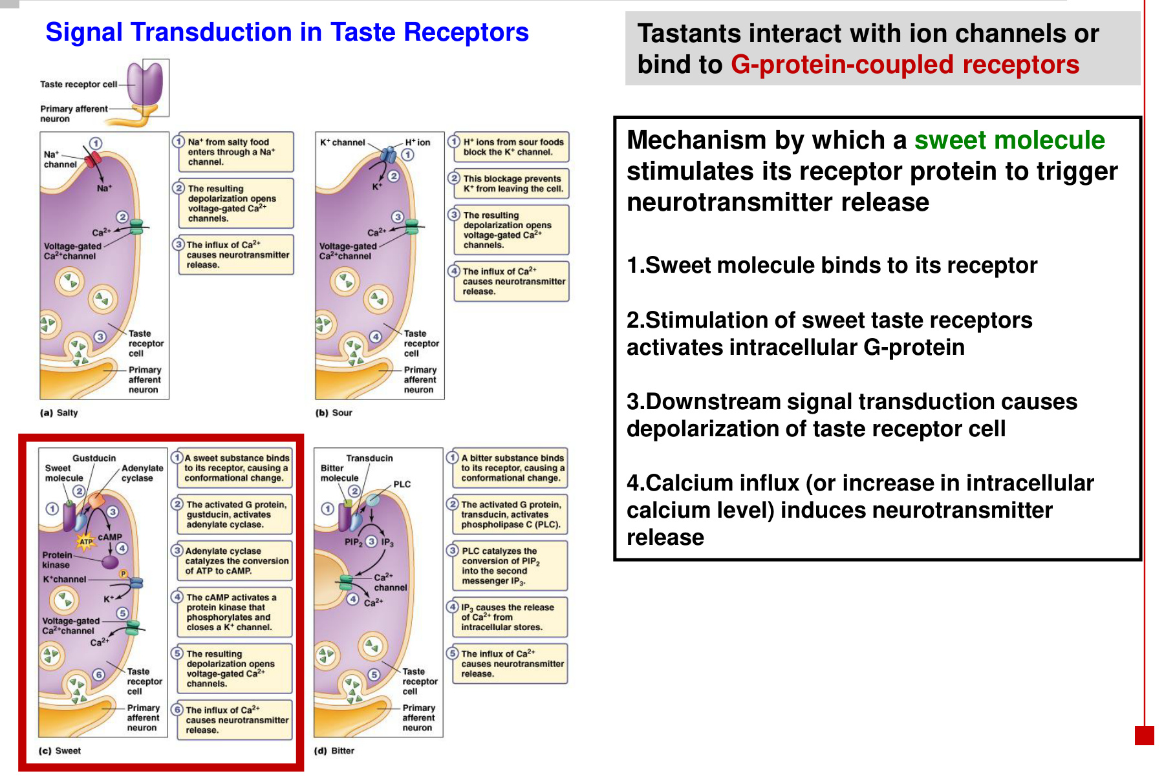
Stage | Meaning
Recognition | The extracellular tastant binds a membrane receptor.
Transduction | The receptor activates an intracellular G protein; downstream signalling changes ion-channel activity.
Electrical response | The taste receptor cell depolarises.
Output | A rise in intracellular Ca²⁺ supports transmitter release to the sensory pathway.

• Sweet, bitter and umami use GPCR-based detection. Salty and sour are introduced through ion-channel mechanisms.
• A G protein links receptor activation to intracellular signalling; the tastant itself does not need to enter the sensory nerve.

18 Gustatory pathway: tongue to insula
Gustatory receptor cells in taste buds
→ cranial nerves VII / IX / X
→ solitary nucleus in the medulla oblongata
→ ventral posterior medial nucleus (VPM) of the thalamus
→ gustatory cortex in the insula

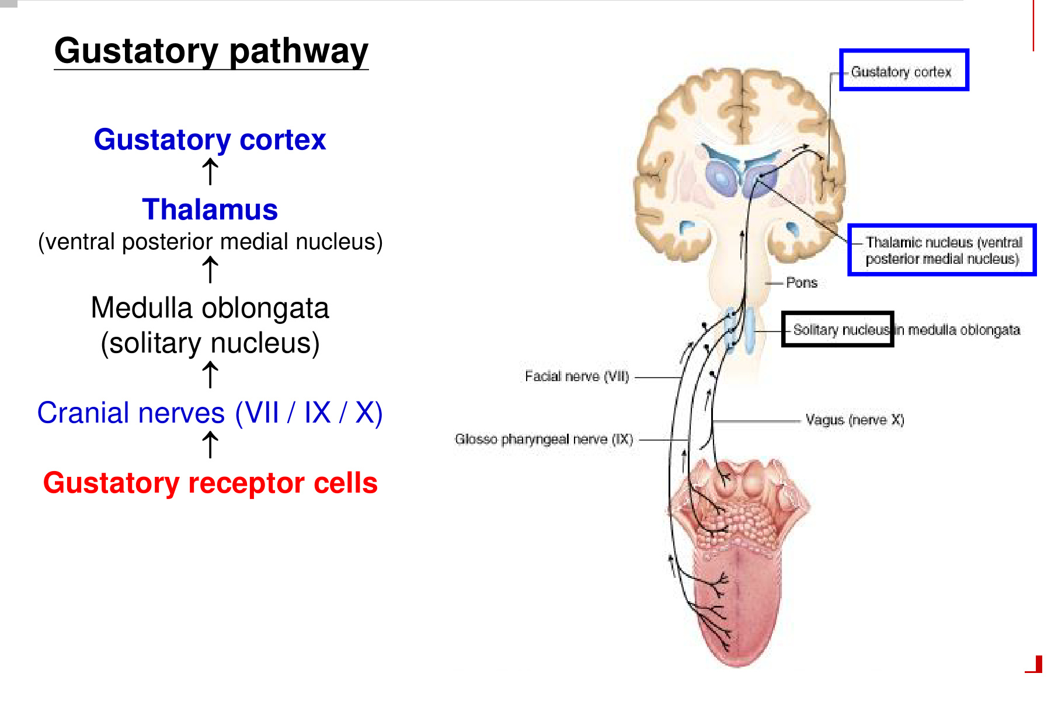  Brainstem → thalamus → gustatory cortex | 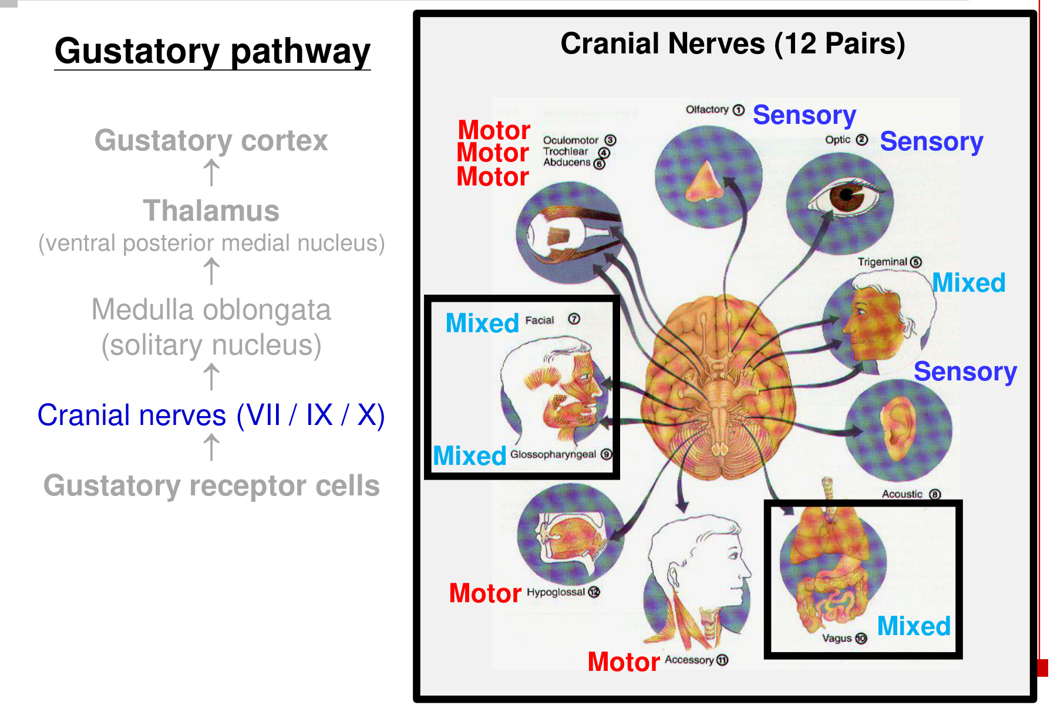  Taste information travels through VII, IX and X.

Cranial nerve | Name | Main taste territory
VII | Facial | Anterior part of the tongue.
IX | Glossopharyngeal | Posterior part of the tongue.
X | Vagus | Epiglottic / lower pharyngeal region.

• VII, IX and X carry sensory taste signals even though each nerve also has other functions and is classified as mixed.
• VPM = taste relay; LGN = visual relay. Both are thalamic nuclei, but they serve different sensory pathways.

19 Gustatory input & salivation
Taste chemicals / pressure in the mouth → oral receptors
→ sensory afferent input → brainstem salivary centre
→ autonomic nerves → salivary glands → salivary secretion ↑

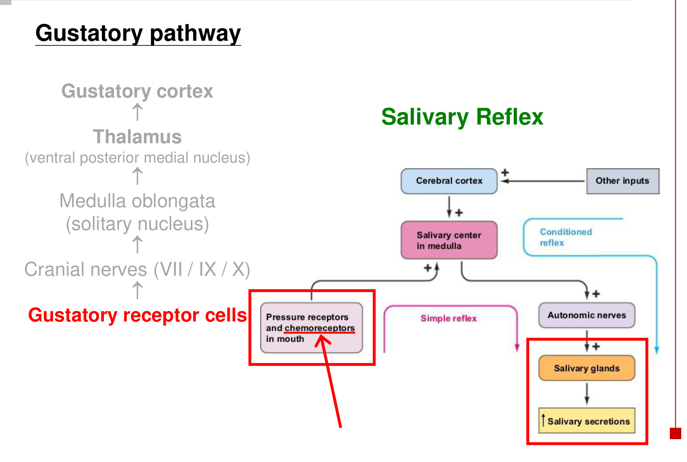
Route | Trigger → integration → effect
Simple salivary reflex | Oral chemoreceptors and pressure receptors → brainstem circuit → autonomic stimulation of salivary glands.
Conditioned salivary reflex | Other sensory / learned food-related inputs → cerebral cortex → salivary centre → glandular output.
Conscious taste perception | Receptor input → solitary nucleus → VPM thalamus → insular gustatory cortex.

• Gustatory input can produce both perception and a reflex response. The salivary reflex does not require the full cortical recognition step first.
• Saliva helps dissolve tastants so that they can contact taste receptors.

20 Olfaction: receptor & transduction
Volatile odorant → dissolves in nasal mucus
→ binds an olfactory GPCR on receptor-cell cilia
→ G-protein signalling → cation channels open → Na⁺ / Ca²⁺ entry
→ depolarisation → action potentials

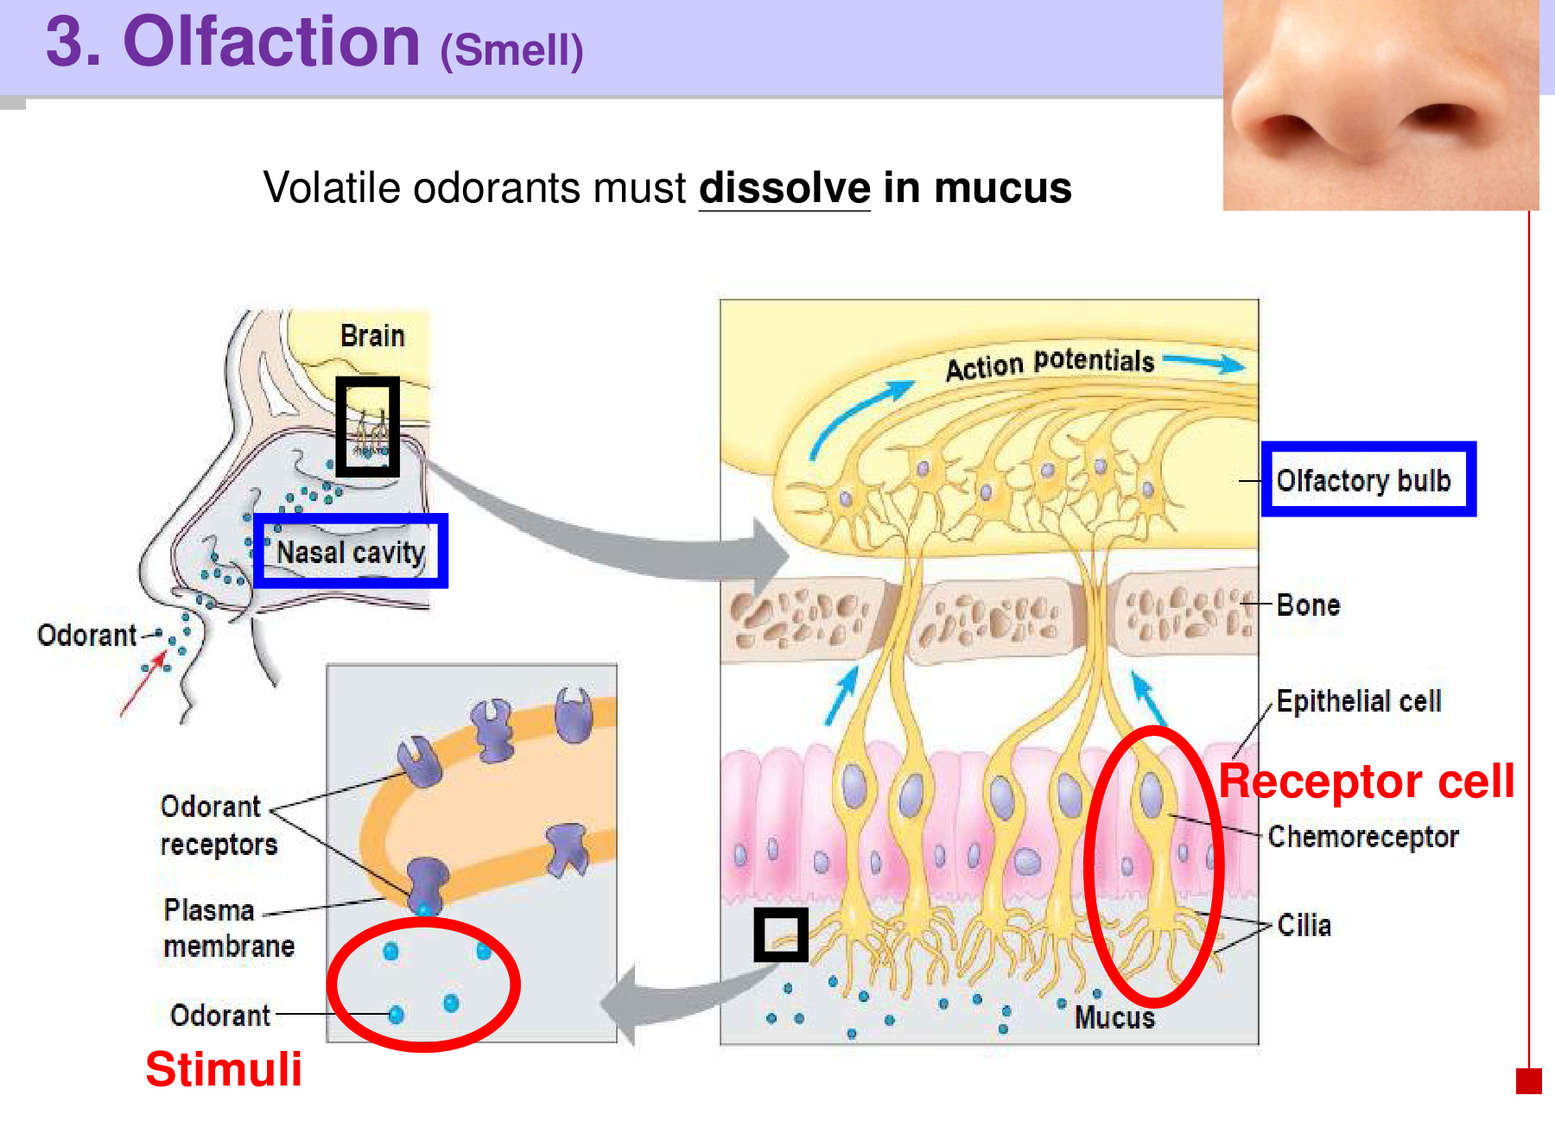  Receptor neurons lie in olfactory epithelium. | 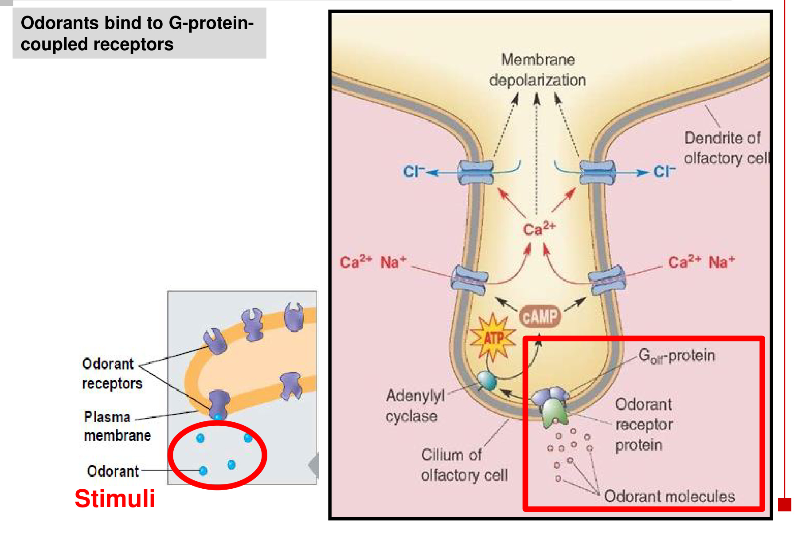  Chemical binding becomes an electrical signal.

Structure / molecule | Role
Olfactory epithelium | Located inside the nasal cavity; contains olfactory chemoreceptor neurons.
Cilia and mucus | Receptor-cell processes extend into mucus, where dissolved odorants contact receptor proteins.
Odorant receptor / G protein | GPCR activation starts the intracellular signal leading to channel opening.
Na⁺ and Ca²⁺ influx | Positive charge enters → depolarisation.
Ca²⁺-activated Cl⁻ current | Cl⁻ leaves these receptor cells → loss of negative charge further supports depolarisation.

• Taste requires dissolution in saliva; smell requires dissolution in mucus. Both are chemical senses.

21 Olfactory bulb: glomeruli & the odour map
Olfactory receptor neurons → axons pass toward the olfactory bulb
→ synaptic relay in glomeruli → mitral-cell output
→ olfactory tract → central olfactory targets

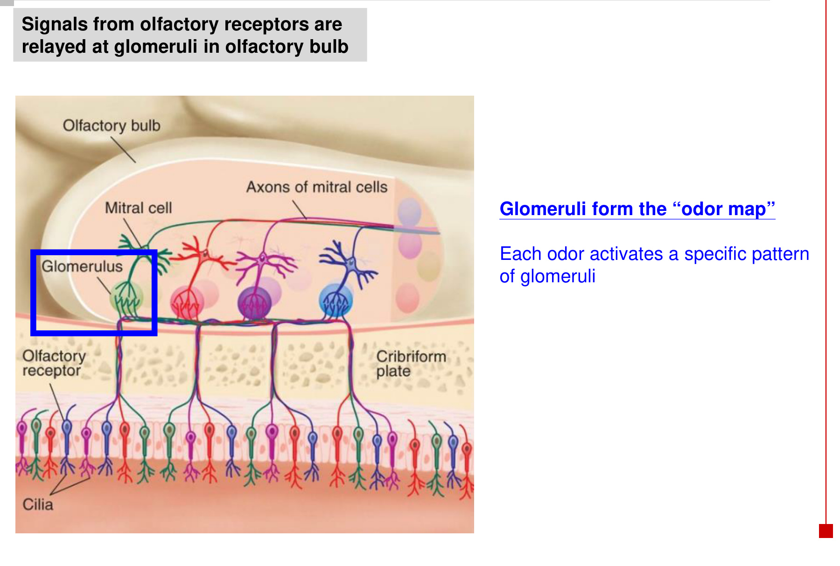
Component | What it contributes
Receptor neurons | Detect dissolved odorants; carry the signal from the nasal epithelium.
Glomeruli | Organised synaptic relay sites in the olfactory bulb; receive converging receptor-neuron input.
Mitral cells | Receive input in the bulb and send output axons into the olfactory tract.
Odour map | Each odour activates a characteristic pattern of glomeruli.

• Odour identity is represented by a pattern of activity, rather than requiring one isolated glomerulus for each whole odour.
• The glomerular relay is the first prominent central processing stage of the olfactory pathway.

22 Olfactory pathway, memory & emotion
Olfactory receptor cells → olfactory bulb → olfactory tract
→ primary olfactory cortex in the temporal lobe

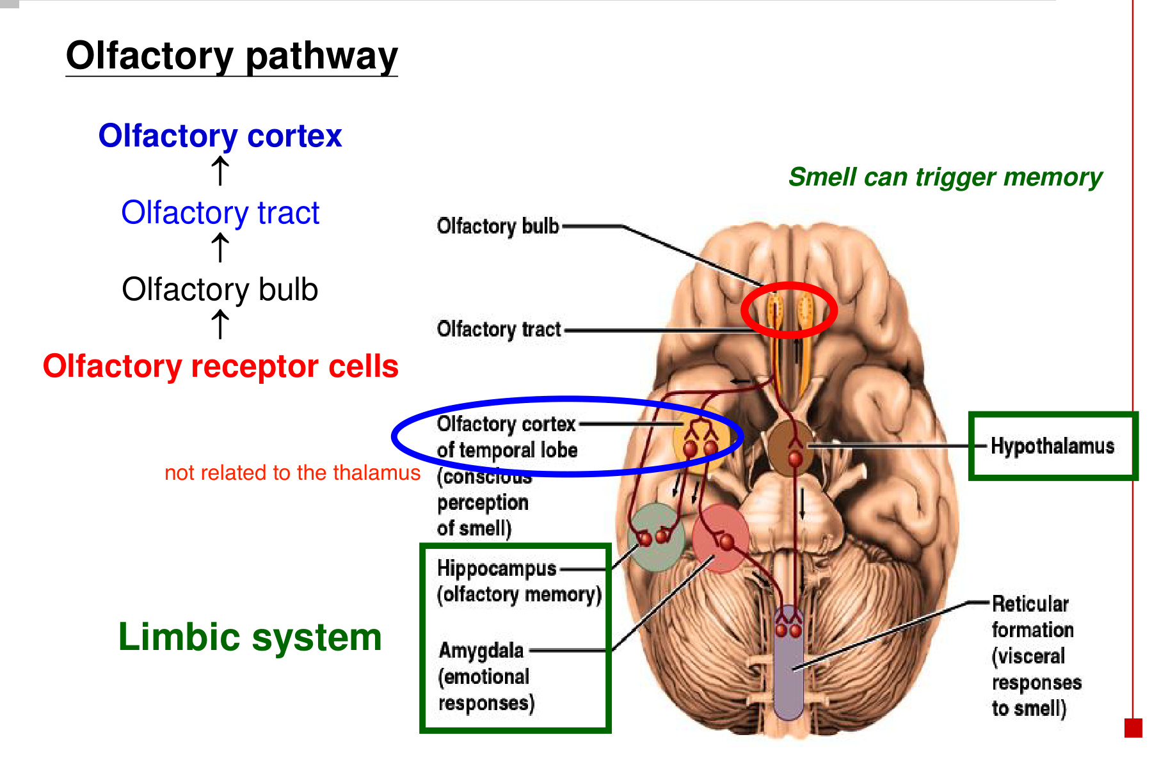  Cortical and limbic connections | 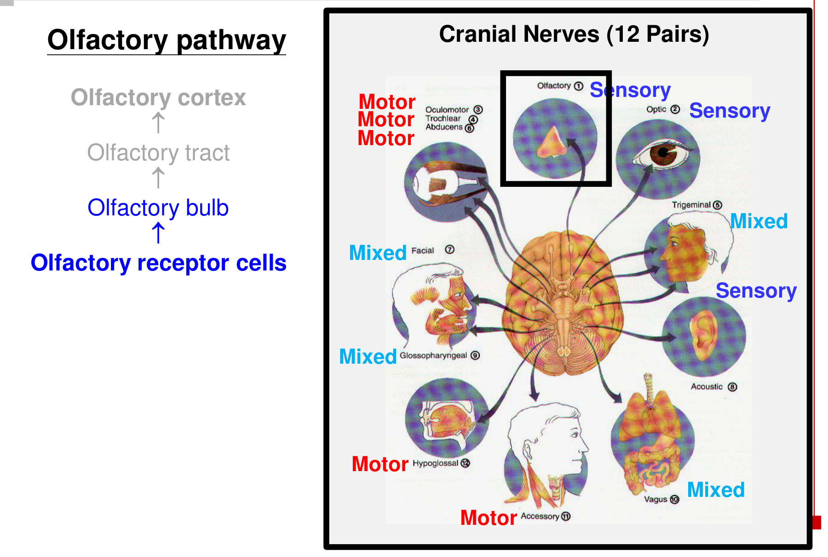  CN I is the sensory olfactory nerve.

Target / feature | Functional link
Olfactory cortex | Cortical processing of smell.
Limbic system | Links odour signals with memory and emotional responses.
Hippocampus | Olfactory memory associations.
Amygdala | Emotional responses to smell.
Hypothalamus / reticular formation | Visceral and autonomic responses associated with smell.
Thalamic distinction | There is no obligatory thalamic relay before primary olfactory cortex, unlike the visual and gustatory pathways.

• Smell can trigger a memory because olfactory processing communicates closely with limbic networks.
• CN I = olfactory, sensory. CN II = optic, sensory. Taste travels through VII / IX / X.

23 Nasal input & the sneeze reflex
Odorous irritants / other nasal irritants → nasal sensory nerve endings
→ sensory afferents → brainstem sneeze centre
→ coordinated motor output → respiratory and facial muscle activity
→ sneeze: forceful expulsion helps clear the irritant

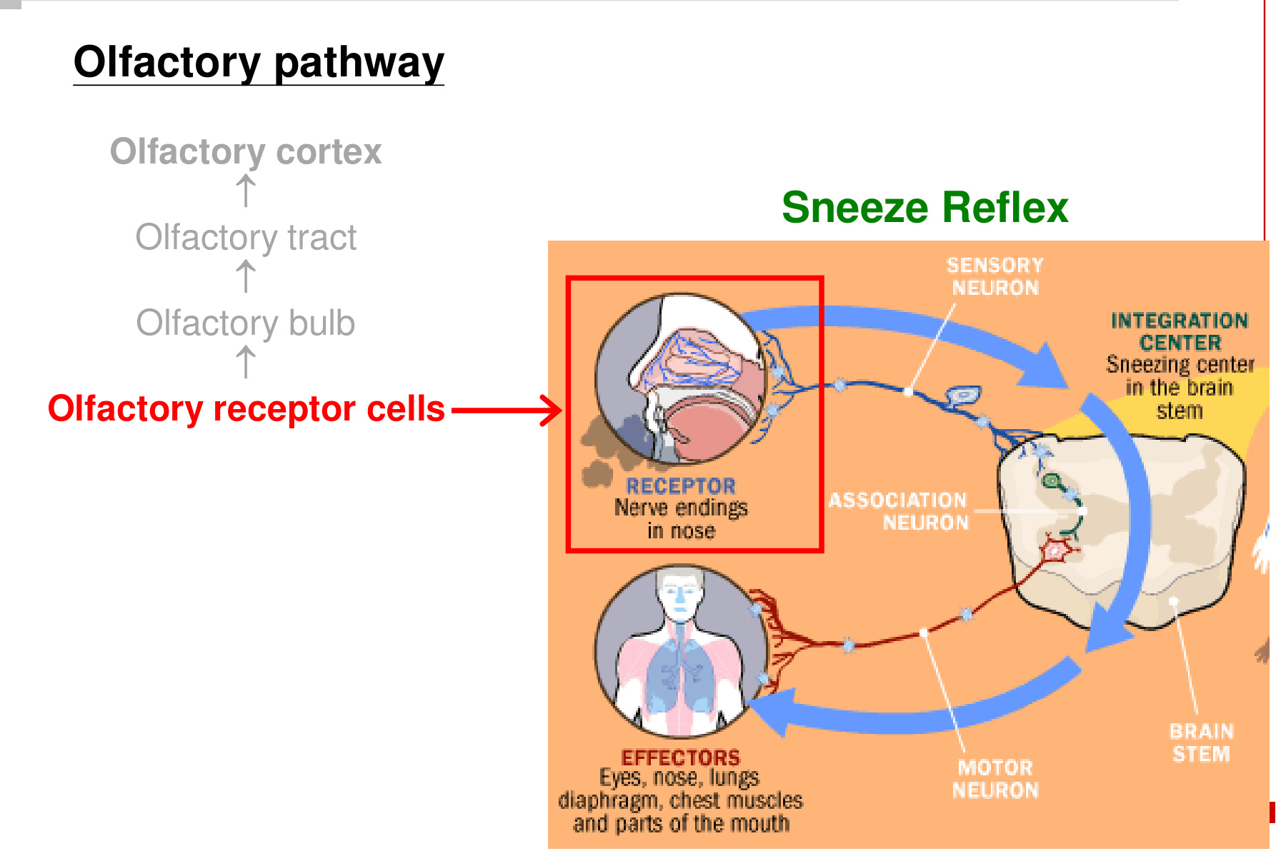
• Smell-associated nasal stimulation can accompany or trigger a protective sneeze response.
• The usual irritant afferent limb is mainly trigeminal (CN V); conscious smell is carried through CN I. Chemical irritation and olfactory perception are related experiences with distinct sensory pathways.
Sensory input | Conscious pathway | Reflex / related response
Taste | Brainstem → VPM → insular gustatory cortex | Salivary secretion.
Smell / nasal chemicals | Olfactory bulb → tract → olfactory cortex | Memory / emotion; nasal irritation can trigger sneezing.

• The sneeze circuit coordinates association neurons and motor outputs to respiratory muscles, including the diaphragm and chest muscles, with facial / upper-airway actions.

24 Integrated revision: follow each signal
Modality | Receptor / entry signal | Main central route
Mechanoception | Mechanical deformation → mechanoreceptor response | Dorsal column → brainstem crossing → thalamus → somatosensory cortex.
Pain / temperature | Nociceptor / thermoreceptor input | Spinal synapse and crossing → anterolateral pathway → thalamus → somatosensory cortex.
Vision | Light → rods / cones hyperpolarise → glutamate ↓ | Bipolar → ganglion → II → chiasm / tract → LGN → occipital cortex.
Taste | Dissolved tastant → channels / GPCRs → receptor-cell depolarisation and signalling | VII / IX / X → solitary nucleus → VPM → insula.
Smell | Odorant in mucus → olfactory GPCR → receptor-neuron depolarisation | I → bulb glomeruli → tract → temporal olfactory cortex; limbic connections.

Keep these distinctions clear
• Sensation: detect and transmit. Perception: interpret and recognise.
• Rods: dim light, convergence, lower acuity. Cones: daylight / colour, higher acuity.
• Fovea: highest acuity. Optic disc: no photoreceptors → blind spot.
• Light reduces photoreceptor glutamate release. It does not depolarise rods and cones.
• Only nasal retinal fibres cross. Each cerebral hemisphere represents the opposite visual field.
• Salty / sour: ion-channel mechanisms. Sweet / bitter / umami: GPCR mechanisms.
• Glomeruli encode odour patterns. They are in the olfactory bulb, not the thalamus.
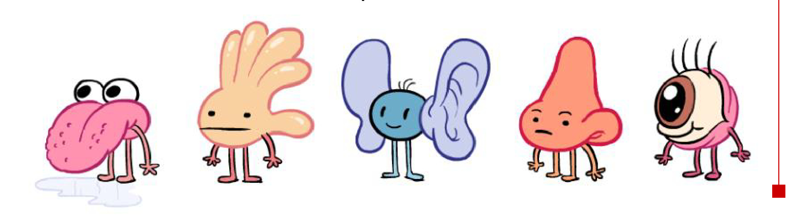
Audition and vestibular sensation belong to the special senses; the detailed mechanisms developed here are somatic sensation, vision, taste and smell.

