01 / Digestive physiology: the working map
Lecture: BBMS2006_2026-27_Digestive Physiology.pdf, 28 PDF pages | Tutorial: GI Physiology Tutorial 2026-27.pdf, 5 PDF pages
Follow the meal
Food cues → neural preparation → gastric mixing and acid secretion
→ duodenal feedback → pancreatic secretion → digestion → absorption.

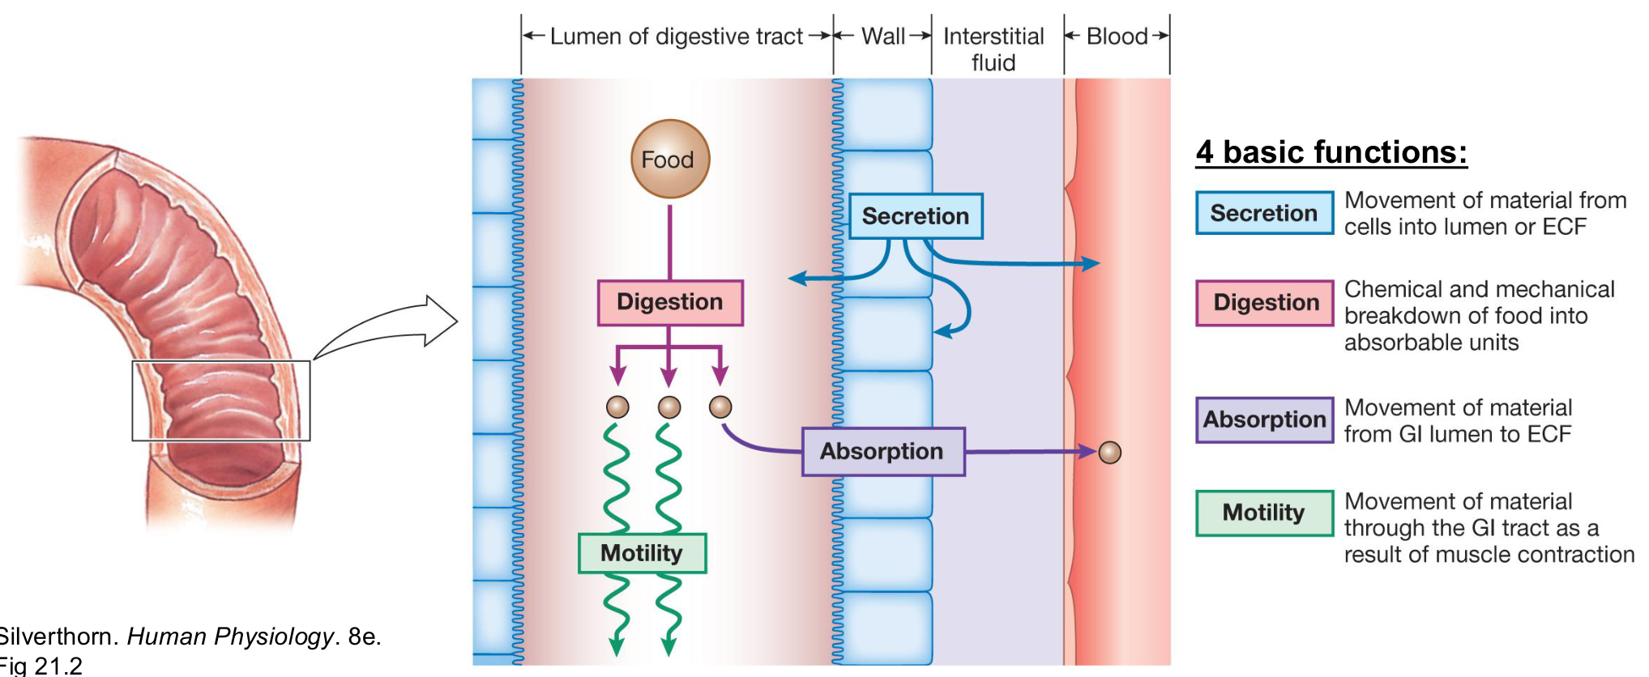
Original: four basic GI functions (lecture p. 3; Silverthorn, Human Physiology, 8e, Fig. 21.2).
Function | Meaning
Secretion | Move water, ions, acid, mucus or enzymes into the GI lumen.
Digestion | Break large nutrients into smaller absorbable products.
Absorption | Move substances from the lumen across epithelium into the internal environment.
Motility | Mix luminal contents and move them through the tract.

The lumen is continuous with the external environment. A nutrient is absorbed only after it crosses the epithelium. GI = gastrointestinal; ECF = extracellular fluid.

Where the supplied questions fit
Notes pages | Original questions integrated there
2–4 | Wall, ENS and motility | MCQ 1–2; foundations for both cases.
5–9 | Gastric secretion | Case 1, all six questions; Case 2 Parts 1–2; MCQ 3.
10–11 | Duodenum and pancreas | MCQ 4–6; Case 2 Part 3.
12–16 | Digestion and absorption | MCQ 7; Case 2 Part 4; two integrated practice questions occur on pp. 9 and 16.

Case context: Case 1 follows a student watching food videos before eating. Case 2 follows a mixed buffet meal: rice, steak, fried chicken, chips, ice cream and soft drinks.
All seven MCQs and both cases are relevant. Case 2 is headed “Part D” in the source; its four internal parts are retained here. Answers are independently reasoned suggestions, not an official answer key. [Extension] marks useful detail beyond the slide text. Original teaching figures are retained; duplicate figures appear once. Decorative logos are omitted. PDF page numbers refer to the supplied files.

02 / GI wall and muscle actions
Lecture PDF pp. 4 and 7 | Same wall figure appears on both source slides
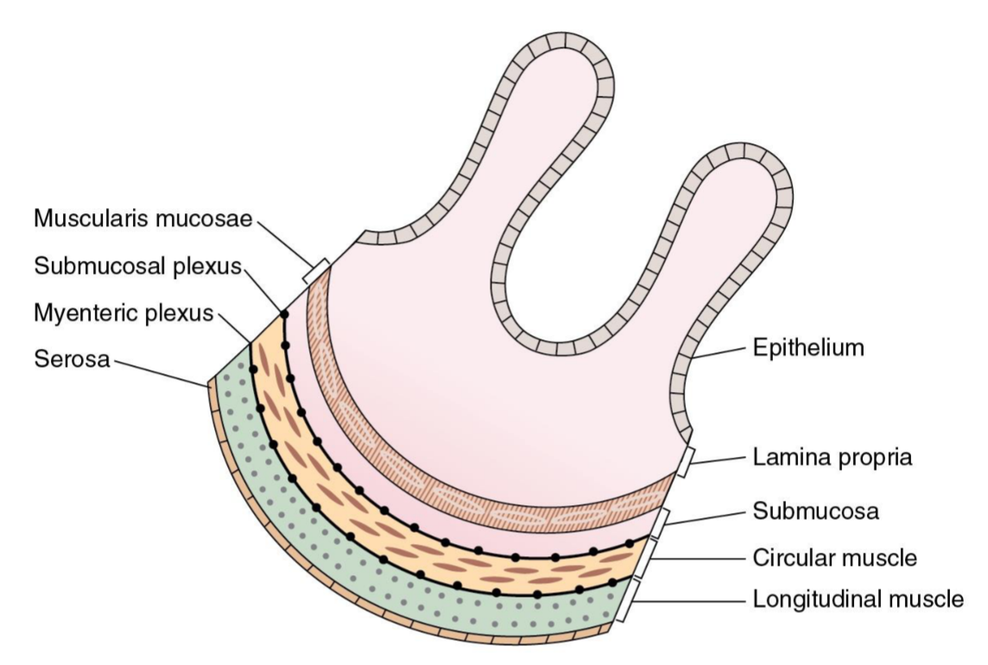
Original: GI wall, muscle layers and nerve plexuses (pp. 4/7; Costanzo Physiology, 7e, Fig. 8.1).
From lumen outward | Main role / location
Mucosa: epithelium | Barrier; secretion and absorption.
Mucosa: lamina propria | Supportive connective tissue beneath the epithelium.
Mucosa: muscularis mucosae | Thin local smooth-muscle layer; distinct from muscularis externa.
Submucosa | Support, vessels and submucosal nerve plexus.
Muscularis externa | Inner circular and outer longitudinal muscle; major mixing and propulsion.
Myenteric plexus | Between circular and longitudinal muscle; primarily regulates motility.

Contraction: direction and time course
Term | What changes? | Useful example
Circular contraction | Lumen diameter decreases. | Local narrowing splits / mixes contents.
Longitudinal contraction | Segment length decreases. | Shortening coordinates with circular muscle.
Phasic contraction | Contraction alternates with relaxation. | Repeated mixing contractions.
Tonic contraction | Sustained baseline tension. | Sphincter tone controls passage.

Do not mix up the two muscle layers
Muscularis mucosae is a thin part of the mucosa. Muscularis externa contains the circular and longitudinal layers shown around the myenteric plexus.

03 / ENS, autonomic input and messengers
Lecture PDF pp. 5–6 | Original MCQs 1–2
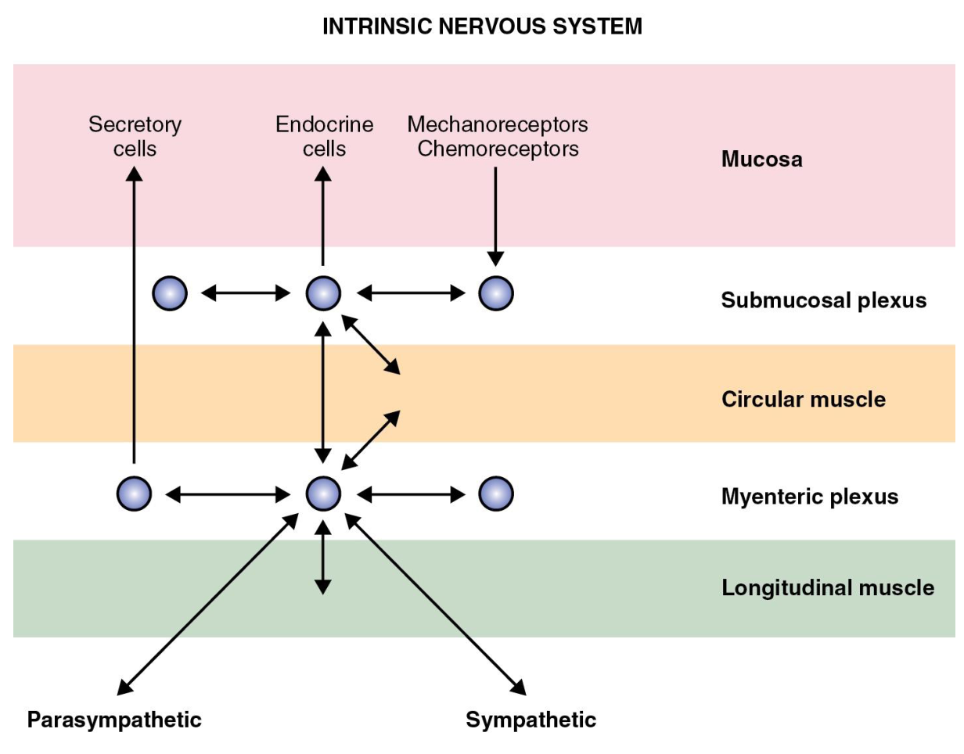  Original ENS pathways (p. 5; Costanzo Fig. 8.3). | 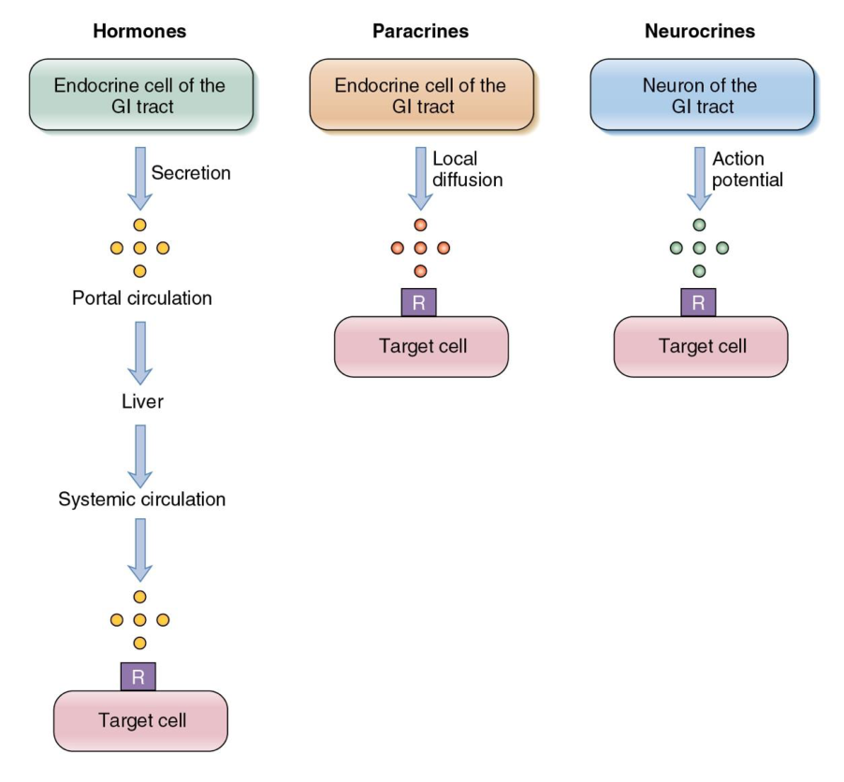  Original signalling routes (p. 6; Costanzo Fig. 8.4).
Control | Key effect
ENS = enteric nervous system | Local circuits can function independently; autonomic input modulates them.
Myenteric plexus | Mainly controls motility. Submucosal plexus mainly controls secretion and local mucosal function.
Parasympathetic input | Generally increases GI motility and secretion.
Sympathetic input | Generally decreases GI motility and secretion.

Route | How it reaches its target | Example
Neurocrine | Neuron → nearby target cell. | Acetylcholine (ACh).
Endocrine | Enteroendocrine cell → blood → target. | Gastrin, CCK, secretin.
Paracrine | Local release → neighbouring cells. | Histamine, somatostatin in the stomach.

ACh and histamine are not peptides, despite the slide heading “GI peptides”. Signalling route and chemical class are different classifications.

Original MCQ 1
Which component of the enteric nervous system primarily regulates GI motility?
A. Submucosal plexus B. Myenteric plexus C. Parietal cells D. ECL cells
Answer: B
Myenteric = motility. Submucosal = mainly secretion. Parietal and ECL cells are gastric secretory cells, not nerve plexuses.

Original MCQ 2
Which of the following generally increases GI motility and secretion?
A. Sympathetic stimulation B. Somatostatin C. Parasympathetic stimulation D. Secretin
Answer: C
Parasympathetic input generally promotes both. Individual muscle and sphincter responses can differ.

04 / Pacemakers, gastric movement and mixing
Lecture PDF pp. 8–10
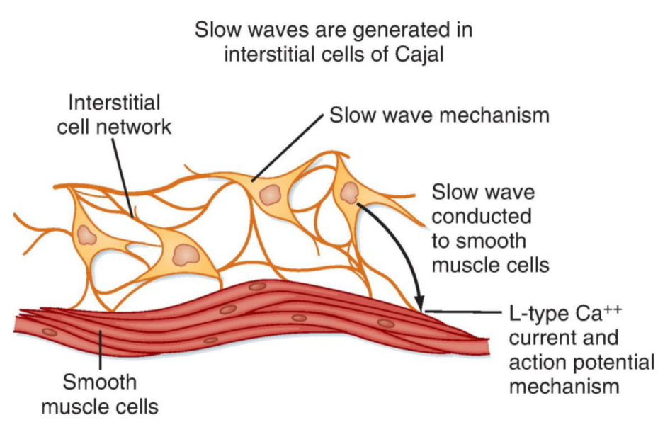  Original ICC–smooth-muscle coupling (p. 8; Berne & Levy, 8e, Fig. 29.12). | 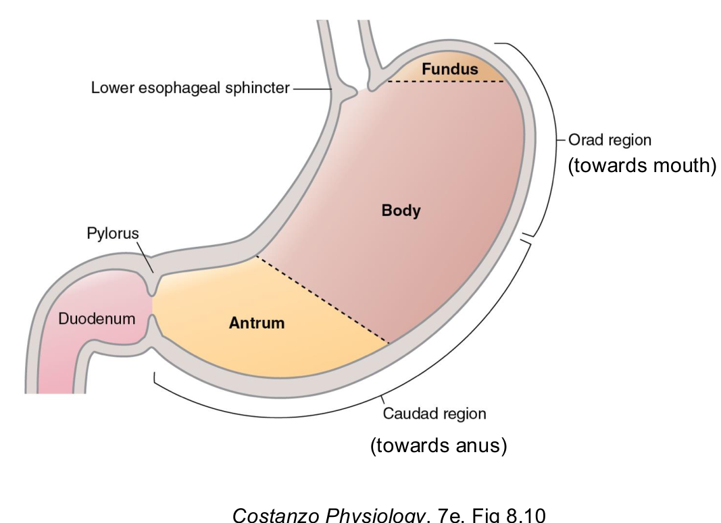  Original stomach regions (p. 9; Costanzo Fig. 8.10).
Electrical timing → muscle activity
Interstitial cells of Cajal (ICCs) generate slow-wave electrical activity.
Gap junctions spread activity to smooth muscle → coordinated contraction.
ICCs are pacemaker cells, distinct from enteric neurons.

[Extension] Slow waves set the timing of excitability. Not every slow wave produces a strong contraction; sufficient depolarisation permits Ca²⁺ spikes and contraction. Autonomic and enteric signals modify excitability and force.
Gastric task | Mechanism / result
1. Receive and store | Orad (toward the mouth; proximal stomach) relaxes to accommodate food.
2. Grind and mix | Contractions reduce particle size and mix food with gastric secretions.
3. Empty | Coordinated contractions deliver chyme through the pylorus into the small intestine.

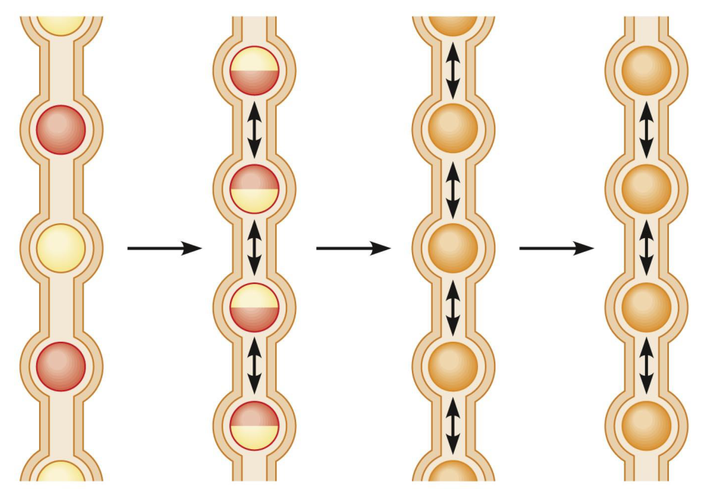
Original segmentation sequence (p. 10; Stanfield, Fig. 20.30b).
Segmentation: alternating circular contractions → split chyme → move it back and forth → rejoin and mix. It improves contact with enzymes and the absorptive surface.
Main role = mixing, rather than sustained net propulsion. The slide’s “does not propel” is a teaching simplification. Caudad means toward the anus; chyme is the partly digested mixture leaving the stomach.

05 / Gastric juice: match the cell to its product
Lecture PDF p. 11 | Case 2 Part 2, Q3–4
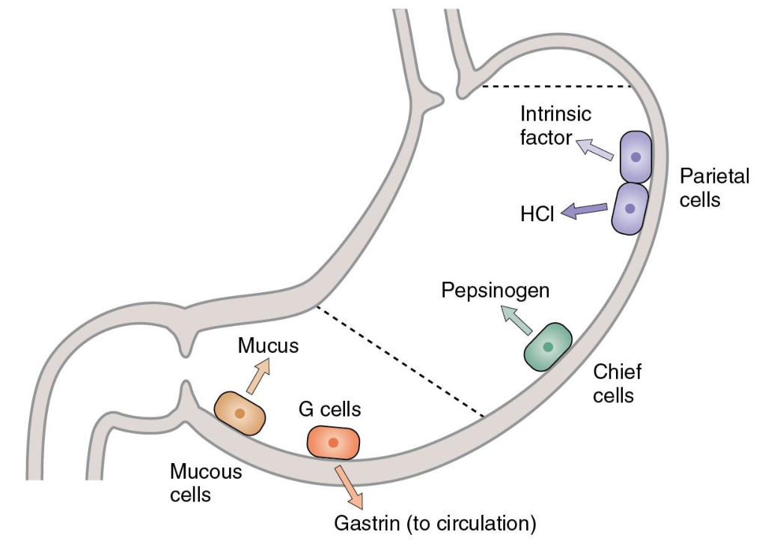  Original gastric glands (p. 11; Costanzo Fig. 8.14). | 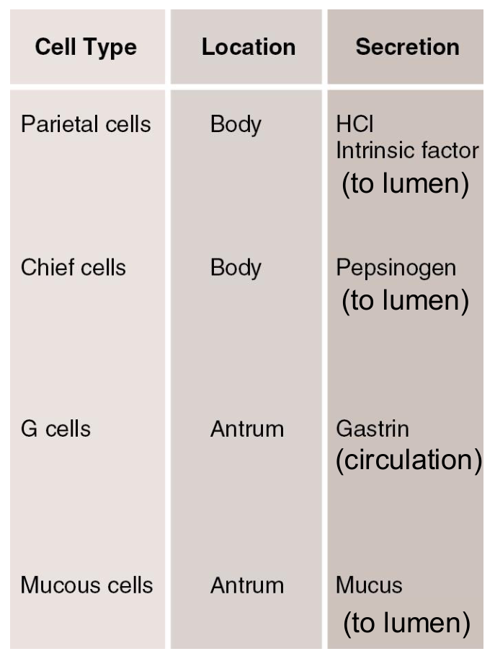  Original cell–product table with lumen / blood annotations (p. 11).
Cell / product | Destination and function
Parietal cells → HCl | Into the lumen. Acid denatures proteins and supports activation / action of pepsin.
Parietal cells → intrinsic factor | Into the lumen. Required for vitamin B₁₂ absorption in the ileum.
Chief cells → pepsinogen | Into the lumen. Inactive precursor converted to pepsin in acid; pepsin begins protein digestion.
Mucous cells → mucus | Into the lumen / mucus layer. Protection and lubrication; the mucosal barrier limits acid injury.
Antral G cells → gastrin | Into blood. Endocrine stimulation of gastric acid secretion; not a luminal digestive enzyme.

Original Case 2 | Part 2: Gastric Acid Secretion
Original question / ID | Answer and reasoning
C2-P2-Q3 Which gastric cells secrete hydrochloric acid? | Parietal cells. Do not substitute chief cells, which secrete pepsinogen.
C2-P2-Q4 State ONE physiological role of gastric acid. | One sufficient answer: promotes conversion of pepsinogen to pepsin. Alternatives: maintains acidic conditions for pepsin, denatures proteins, or helps kill ingested microbes.

Useful separation
HCl is acid; pepsin is the proteolytic enzyme; pepsinogen is its inactive precursor.
Intrinsic factor assists later vitamin B₁₂ absorption; it does not digest proteins.

06 / Cephalic and gastric phases: start signals
Lecture PDF p. 12, checked against p. 15 | Original Case 1; Case 2 Part 1
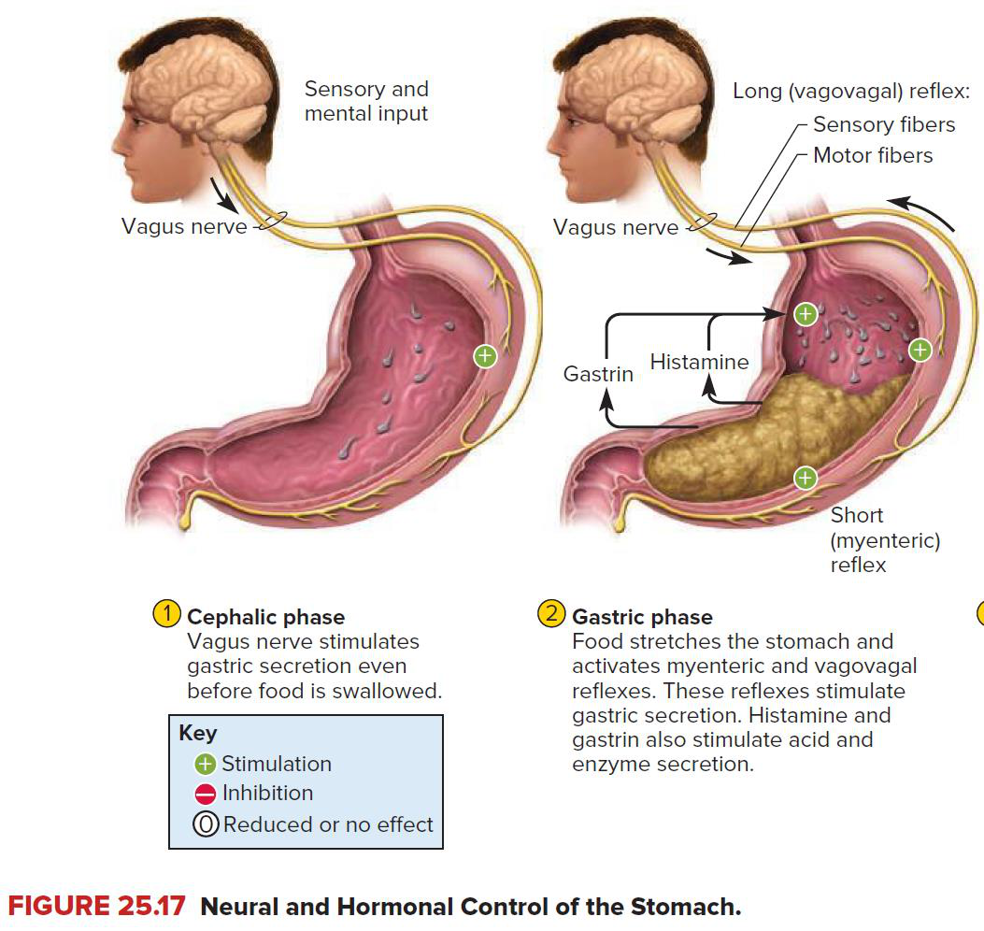  Original cephalic / gastric reflex diagram (p. 12; Saladin, Anatomy & Physiology, 10e). | Cephalic: before food arrives  Sight / smell / taste / anticipation → CNS (central nervous system) → vagal parasympathetic output → preparation of gastric secretion and motility.  Gastric: food in stomach  Distension → mechanoreceptors → local ENS and long vagovagal reflexes → ACh. Peptides / amino acids promote gastrin; meal buffering initially reduces acid inhibition.  Correction: low gastric pH inhibits  Slide 12 and the handwritten buffet answer are misleading. Strong gastric acidity → D-cell somatostatin → acid secretion falls. Distension and food peptides / amino acids stimulate the gastric phase.
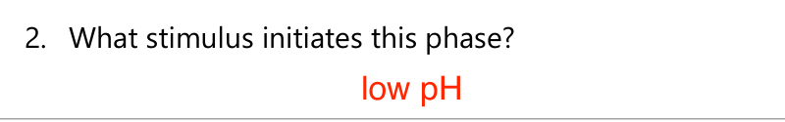
Original Case 2 annotation, retained for comparison; “low pH” is corrected above (tutorial p. 4).

Original Case 1 | Food Influencer Effect
Original question / ID | Answer and reasoning
C1-Q1 Which phase of gastric secretion is activated? | Cephalic phase: food cues are present, but no meal has entered the stomach.
C1-Q2 Which autonomic branch is primarily responsible? | Parasympathetic, chiefly via the vagus nerve.
C1-Q3 Which neurotransmitter is released? | ACh is the expected general answer. GRP specifically stimulates G-cell gastrin release (p. 7).
C1-Q4 Effect on gastric motility? | Generally increases preparatory gastric motility.
C1-Q5 Effect on gastric acid secretion? | Increases gastric acid secretion.
C1-Q6 One advantage of activation before food enters? | Feedforward control prepares secretions and motility, reducing the delay once food arrives.

Original Case 2 | Part 1: Gastric Phase
Original question / ID | Answer and reasoning
C2-P1-Q1 Which phase becomes dominant after the meal? | Gastric phase.
C2-P1-Q2 What stimulus initiates this phase? | Gastric distension; food peptides / amino acids also stimulate secretion. Do not answer simply “low pH”.
C2-P1-Q3 Which neurotransmitter promotes motility and secretion? | ACh.

07 / Three stimulators converge on acid secretion
Lecture PDF pp. 13–14 | Case 2 Part 2, Q1
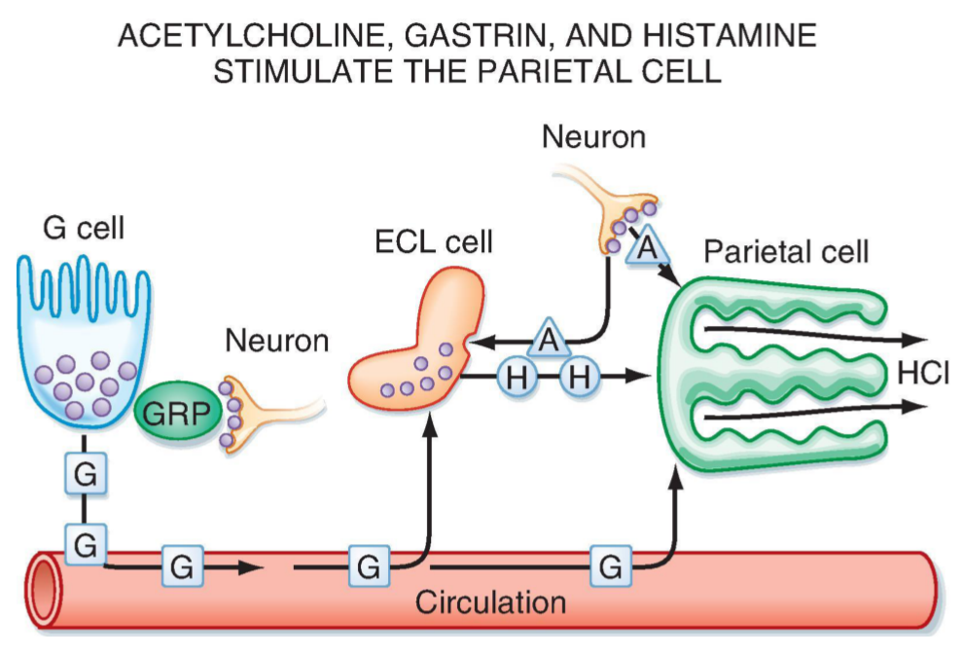
Original neural, gastrin and histamine pathways (same figure on pp. 13–14; Berne & Levy, 8e, Fig. 29.7).
Messenger / origin | Route and target | Effect
ACh: enteric neurons | Neurocrine → parietal M₃ receptors; also stimulates ECL-cell activity. | Promotes H⁺ secretion directly and through histamine.
Gastrin: antral G cells | Endocrine → blood → CCK₂ receptors on ECL / parietal cells. CCK₂ is also called CCK-B. | ECL histamine release ↑; parietal acid secretion ↑.
Histamine: ECL cells | Paracrine → nearby parietal H₂ receptors. | Proton-pump activity and acid secretion ↑.

Neural control has two relevant transmitters
Vagal pathways recruit enteric neurons.
ACh → parietal / ECL stimulation.
Gastrin-releasing peptide (GRP) → G cells → gastrin in blood.
Do not replace GRP with ACh when asked specifically how vagal input stimulates G-cell gastrin release.

Original Case 2 | Part 2, Q1
Original question / ID | Answer and reasoning
C2-P2-Q1 Name THREE stimulators of gastric acid secretion. | ACh + gastrin + histamine. The source annotation lists gastrin and histamine; ACh completes the required three.

ECL = enterochromaffin-like cell. Gastrin and CCK are distinct hormones even though their receptor names share “CCK”. H⁺/K⁺-ATPase is the parietal proton pump; it uses ATP to secrete H⁺ in exchange for K⁺.

08 / Somatostatin: the acid feedback brake
Lecture PDF p. 15 | Original MCQ 3; Case 2 Part 2, Q2
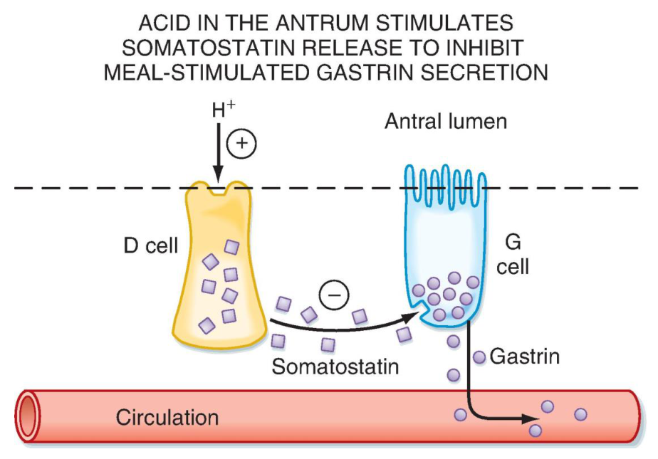
Original D-cell inhibitory pathways (p. 15; Berne & Levy, 8e, Fig. 29.9).
Follow the feedback loop
Food buffers secreted H⁺ → the fall in gastric pH is initially limited.
Food leaves → buffering decreases → gastric pH falls more.
Low gastric pH → D cells → somatostatin → acid secretion decreases.

Somatostatin target | Result
Parietal cells | Direct inhibition of HCl secretion.
ECL cells | Histamine release ↓ → less stimulation of parietal cells.
G cells | Gastrin release ↓ → less stimulation of ECL and parietal cells.

Original MCQ 3
Which regulator directly inhibits gastric acid secretion?
A. Gastrin B. Histamine C. Acetylcholine D. Somatostatin
Answer: D
Somatostatin inhibits parietal cells directly. It also inhibits gastrin and histamine release. The other three options stimulate acid secretion.

Original Case 2 | Part 2, Q2
Original question / ID | Answer and reasoning
C2-P2-Q2 Name ONE inhibitor of gastric acid secretion. | Somatostatin. Link it to gastric D cells and the low-pH negative-feedback loop.

“Direct” asks whether the mediator can act on the parietal cell itself. It does not mean the mediator has no additional indirect effects.

09 / Acid receptors: integrate inputs and feedback
Lecture PDF p. 16 | One integrated practice question based on the original diagram
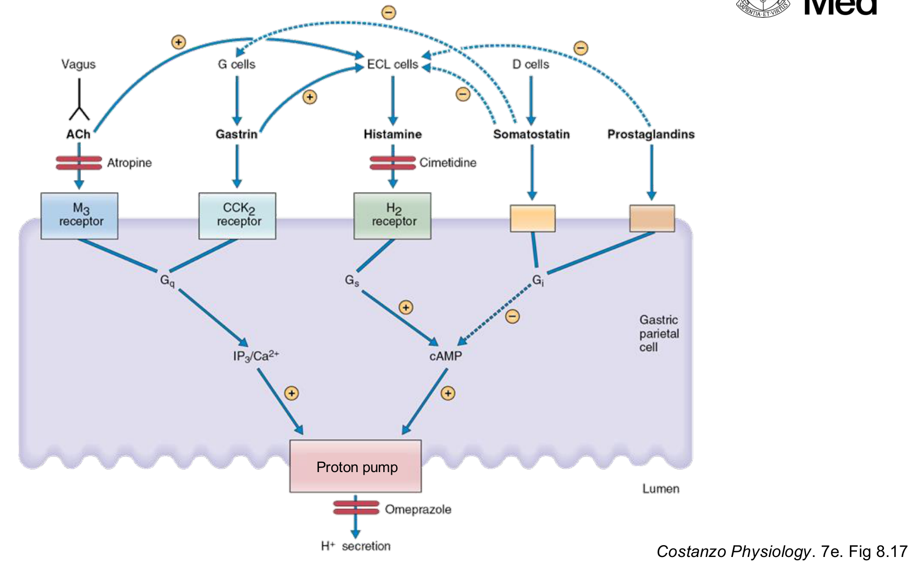
Original receptor and drug-target summary (p. 16; Costanzo Physiology, 7e, Fig. 8.17).
Stimulatory route | Intracellular signal → final step
ACh → M₃; gastrin → CCK₂ | Gq → IP₃ / Ca²⁺ → promote proton-pump activity.
Histamine → H₂ | Gs → cAMP → promote proton-pump activity.
Somatostatin / prostaglandins | Inhibitory Gi signalling lowers cAMP and acid secretion.

cAMP = cyclic adenosine monophosphate; IP₃ = inositol trisphosphate. Gq / Gs / Gi are intracellular G-protein signalling classes. The diagram shows atropine at muscarinic receptors, cimetidine at H₂ receptors and omeprazole at the proton pump.
Integrated practice 1 | Self-written; not an original exam question
Two treatments block either H₂ receptors or H⁺/K⁺-ATPase. Can ACh and gastrin still activate their receptors? Why can gastrin rise after sustained acid suppression?
Answer approach:
• H₂ blockade removes histamine signalling. ACh–M₃ and gastrin–CCK₂ inputs remain; loss of histamine also weakens their combined effect.
• Pump inhibition blocks the final acid-secretory step despite upstream receptor signals.
• [Extension] Acid suppression → gastric pH ↑ → D-cell somatostatin feedback ↓ → G-cell inhibition ↓ → gastrin can rise. High gastrin does not guarantee high acid when the pump is inhibited.

10 / Duodenal feedback slows gastric delivery
Lecture PDF p. 17 | Original MCQ 6; Case 2 Part 3, Q1–2 and Q5
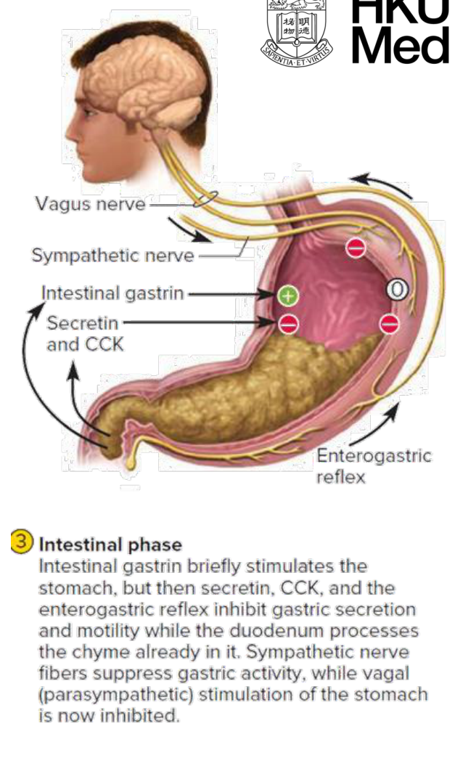  Original intestinal inhibitory phase (p. 17; Saladin, 10e). | Neural brake: enterogastric reflex  Duodenal lipids, acid or distension → gastric motor activity inhibited + pyloric resistance increased → gastric emptying slows.  Nutrient signal: CCK  Fatty acids, peptides and amino acids → I cells in duodenum / jejunum → cholecystokinin (CCK). Emptying slows; pancreatic enzyme secretion increases.  Acid signal: secretin  Low duodenal pH → S cells → secretin. Gastric delivery slows; pancreatic bicarbonate-rich secretion increases.

Original MCQ 6
Which of the following slows gastric emptying?
A. Parasympathetic stimulation B. Acetylcholine C. CCK D. Gastric distension
Answer: C
CCK provides intestinal feedback that slows delivery from the stomach. Distension of the stomach and distension of the duodenum are different signals.

Original Case 2 | Part 3: Fatty Chyme Enters the Duodenum
Original question / ID | Answer and reasoning
C2-P3-Q1 Which TWO hormones increase? | CCK in response to lipid / protein products; secretin in response to acid.
C2-P3-Q2 What effect on gastric emptying? | Both slow gastric emptying in this teaching model.
C2-P3-Q5 Why is slowing gastric emptying beneficial? | Limits acid / nutrient overload and allows time for neutralisation, digestion and absorption.

11 / Pancreas: enzymes versus alkaline fluid
Lecture PDF pp. 18–19 | Original MCQs 4–5; Case 2 Part 3, Q3–4
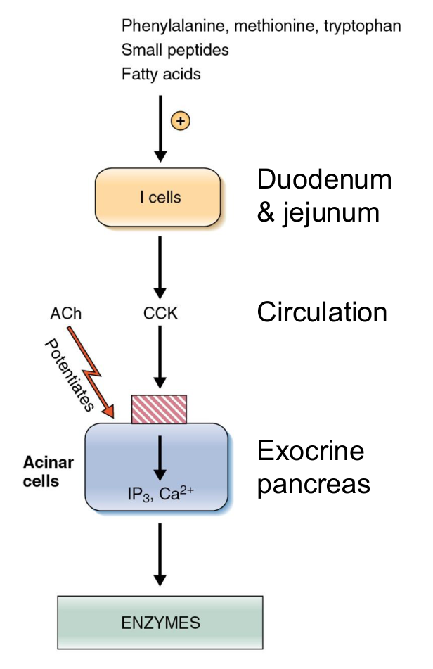  Original CCK pathway (p. 18; Costanzo Fig. 8.23). | 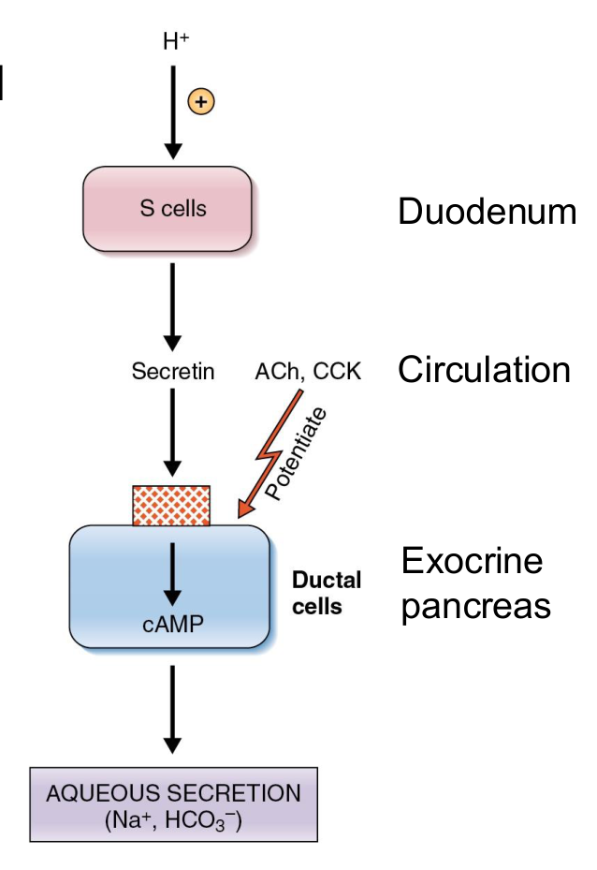  Original secretin pathway (p. 19; Costanzo Fig. 8.23). | 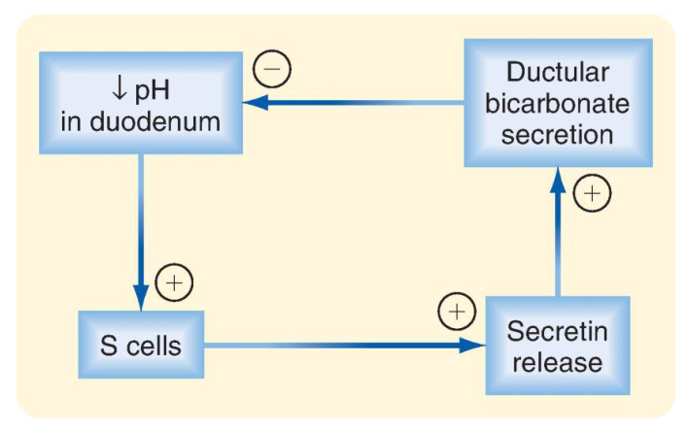  Original secretin negative feedback (p. 19; Berne & Levy, 8e, Fig. 30.3).
Compare | CCK | Secretin
Primary stimulus / source | Fatty acids, amino acids, peptides → I cells. | Low duodenal pH → S cells.
Main pancreatic output | Enzyme-rich secretion from acinar cells; CCK₁-mediated pathways. | HCO₃⁻-rich aqueous secretion from ductal cells.
Purpose | Hydrolyse nutrients into absorbable products. | Neutralise acid and provide a suitable environment for digestive enzymes.
Cooperation | ACh also stimulates enzyme secretion. | ACh and CCK potentiate aqueous secretion; the pathways are not exclusive.

Original MCQs 4–5 | Apply the comparison
Original question | Options | Answer and case link
MCQ 4: Which regulator primarily stimulates pancreatic enzyme secretion? | A. Gastrin  B. Secretin  C. CCK  D. Histamine | C — CCK → enzyme secretion.  Also answers C2-P3-Q3: Which hormone stimulates pancreatic enzyme secretion?
MCQ 5: Which regulator primarily stimulates bicarbonate-rich aqueous secretion by the pancreas? | A. Secretin  B. CCK  C. Acetylcholine  D. Gastrin | A — Secretin → bicarbonate-rich fluid.  Also answers C2-P3-Q4: Which hormone stimulates bicarbonate-rich aqueous secretion?

12 / Digestion: enzymes and carbohydrate products
Lecture PDF pp. 20–21 | Corrected enzyme-source table
Nutrient | Salivary / oral and gastric | Pancreas | Intestinal brush border
Carbohydrate | Salivary α-amylase begins starch digestion; no major gastric carbohydrase. | α-Amylase acts in the lumen. | Sucrase, maltase, lactase, trehalase; α-dextrinase / isomaltase.
Protein | Gastric pepsin begins digestion. | Trypsin, chymotrypsin, carboxypeptidases. | Amino-oligopeptidases and dipeptidases; enteropeptidase activates trypsinogen.
Lipid | Lingual lipase provides an early contribution; pancreatic digestion dominates here. | Lipase + colipase; phospholipase A₂; cholesterol ester hydrolase. | No major brush-border lipid hydrolase in this lecture’s pathway.

Correction: intestinal α-amylase versus brush-border enzymes
Slides 20–21 attribute a major α-amylase role to intestinal mucosa. Use this distinction: salivary / pancreatic α-amylase → luminal starch digestion; brush-border α-dextrinase / isomaltase and disaccharidases → final monosaccharides. The original pathway figure below correctly labels α-dextrinase.

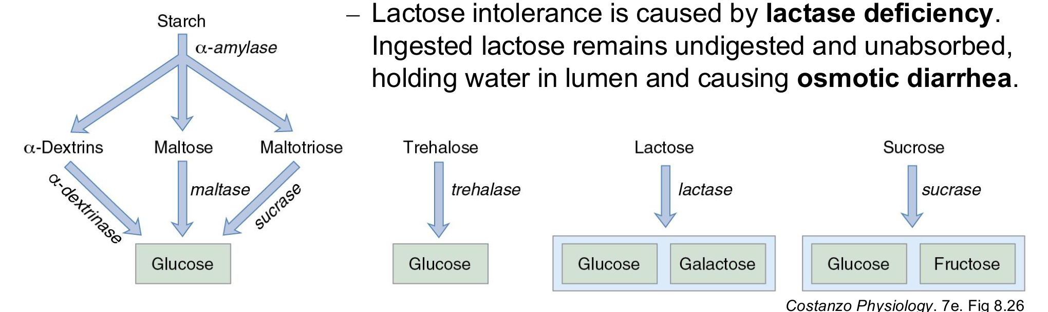
Original starch and disaccharide pathways, including the lactase-deficiency note (p. 21; Costanzo Physiology, 7e, Fig. 8.26).
Substrate | Enzyme → absorbable products
Starch | α-Amylase → maltose, maltotriose, α-limit dextrins → brush-border enzymes → glucose.
Lactose | Lactase → glucose + galactose.
Sucrose | Sucrase → glucose + fructose.
Trehalose | Trehalase → two glucose molecules.

Lactase deficiency → osmotic diarrhoea
Unhydrolysed lactose stays in the lumen → is not absorbed as a disaccharide → retains water → osmotic diarrhoea. [Extension] Bacterial fermentation can also cause gas and bloating.

Enterokinase = enteropeptidase: it activates trypsinogen rather than serving as a bulk protein-digesting enzyme. Protein transporter mechanisms are outside this lecture’s stated absorption outcomes.

13 / Sugar absorption: membrane and energy
Lecture PDF p. 22 | Case 2 Part 4, Q1–2
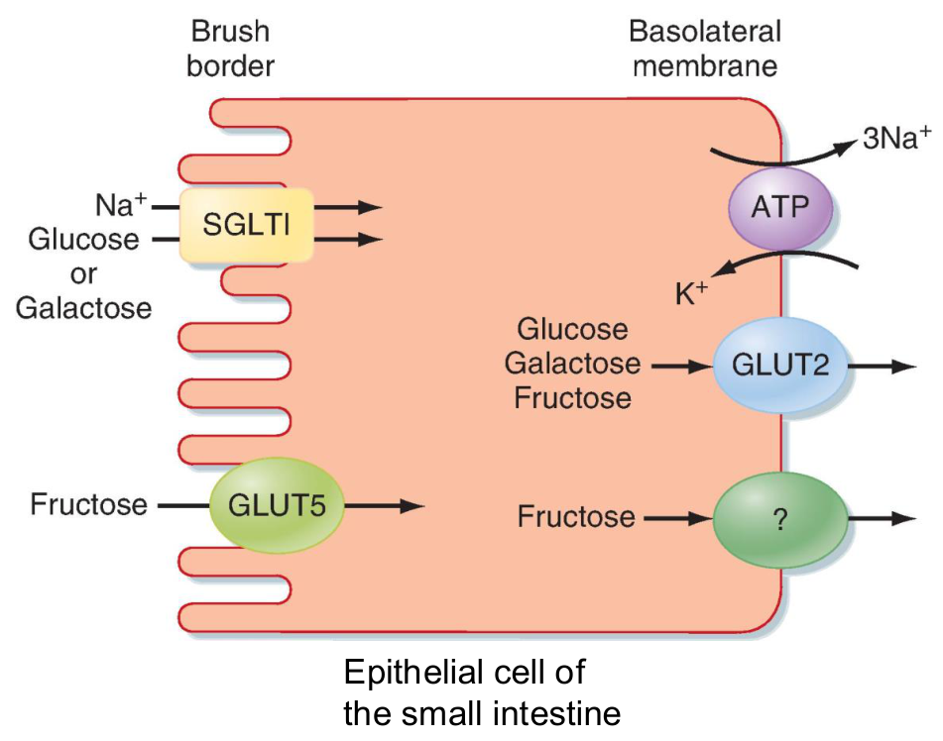
Original enterocyte transport diagram with epithelial-cell annotation (p. 22; Berne & Levy, 8e, Fig. 30.9).
Membrane / transporter | What moves? | Energy / direction
Apical SGLT1 | Glucose or galactose together with Na⁺, from lumen into enterocyte. | Secondary active transport: uses the Na⁺ electrochemical gradient.
Apical GLUT5 | Fructose from lumen into enterocyte. | Facilitated diffusion; Na⁺ independent.
Basolateral GLUT2 | Glucose, galactose and fructose leave toward blood. | Facilitated diffusion.
Basolateral Na⁺/K⁺-ATPase | Na⁺ out of cell, K⁺ into cell. | Uses ATP directly; keeps intracellular Na⁺ low to support SGLT1.

Trace the source of energy
ATP → Na⁺/K⁺-ATPase → low intracellular Na⁺
→ Na⁺ entry through SGLT1 pulls glucose / galactose into the cell.
SGLT1 itself does not hydrolyse ATP. GLUT5 does not use Na⁺ cotransport.

Original Case 2 | Part 4: Nutrient Absorption
Original question / ID | Answer and reasoning
C2-P4-Q1 In what form are carbohydrates absorbed? | Monosaccharides: glucose, galactose and fructose. Starch and disaccharides need prior digestion.
C2-P4-Q2 Which transporter absorbs glucose from the intestinal lumen? | Apical SGLT1. GLUT2 is the basolateral exit transporter, so membrane location determines the answer.

SGLT1 = sodium–glucose cotransporter 1; GLUT = glucose transporter family. Apical faces the lumen; basolateral faces interstitium / blood. The slide’s “fructose relatively inefficient” is not a universal quantitative rule: focus on Na⁺-independent diffusion versus Na⁺-coupled uptake.

14 / Lipid digestion: emulsification is not hydrolysis
Lecture PDF p. 23 | Case 2 Part 4, Q3
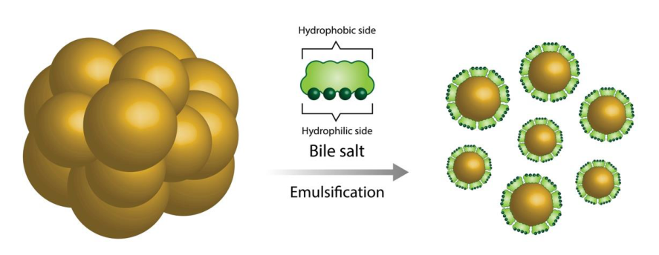
Original bile-salt emulsification diagram (p. 23).
Bile and enzymes have different jobs
Liver makes bile → gallbladder stores and releases bile.
Bile salts emulsify large fat droplets → smaller droplets → surface area increases.
Pancreatic enzymes hydrolyse lipid bonds at the droplet surface.
Bile salts are not digestive enzymes.

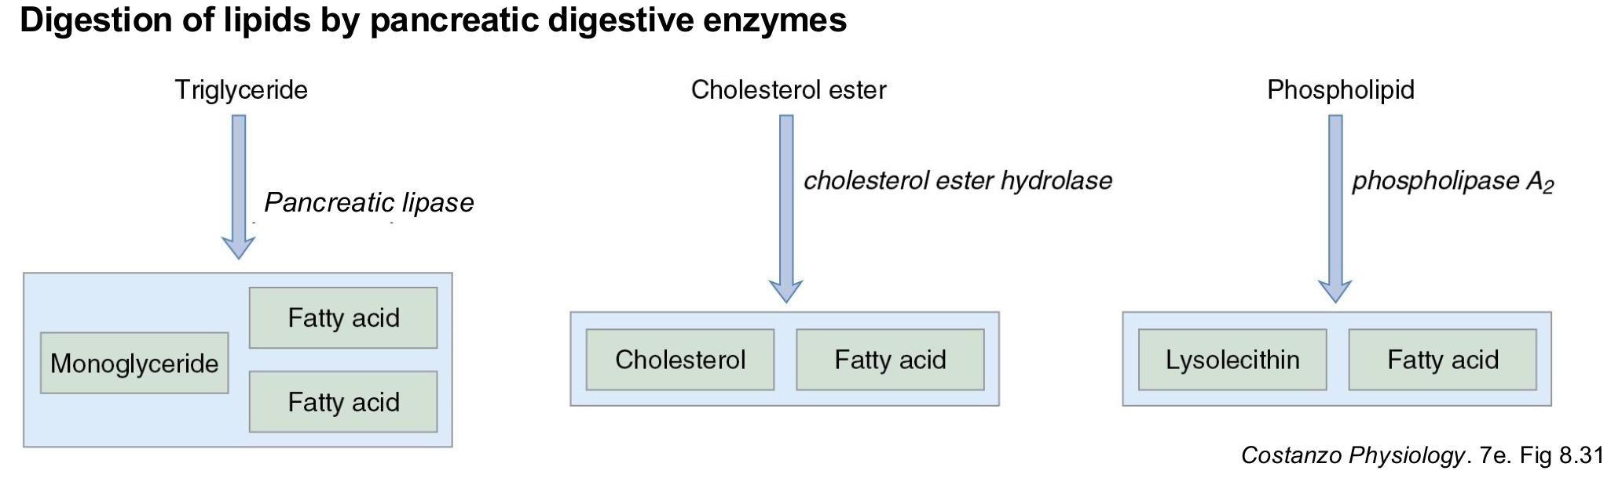
Original pancreatic lipid-enzyme pathways (p. 23; Costanzo Physiology, 7e, Fig. 8.31).
Dietary substrate | Enzyme / helper | Main products
Triglyceride (TG) | Pancreatic lipase; colipase helps lipase act at the lipid interface. | 2-monoglyceride (2-MG) + two free fatty acids (FFAs).
Cholesteryl ester | Cholesterol ester hydrolase. | Free cholesterol + FFA.
Phospholipid | Phospholipase A₂. | Lysophospholipid, e.g. lysolecithin + FFA.

Original Case 2 | Part 4, Q3
Original question / ID | Answer and reasoning
C2-P4-Q3 Into what products are dietary lipids digested? | Main expected answer: FFAs and monoglycerides. For all lipid classes, also include free cholesterol and lysophospholipids.

Digestion makes small lipid products; absorption then requires their delivery to the enterocyte surface. Mixed micelles solve that next luminal transport problem (p. 15).

15 / Lipid absorption: the complete route
Lecture PDF pp. 24–25 | Original MCQ 7; Case 2 Part 4, Q4
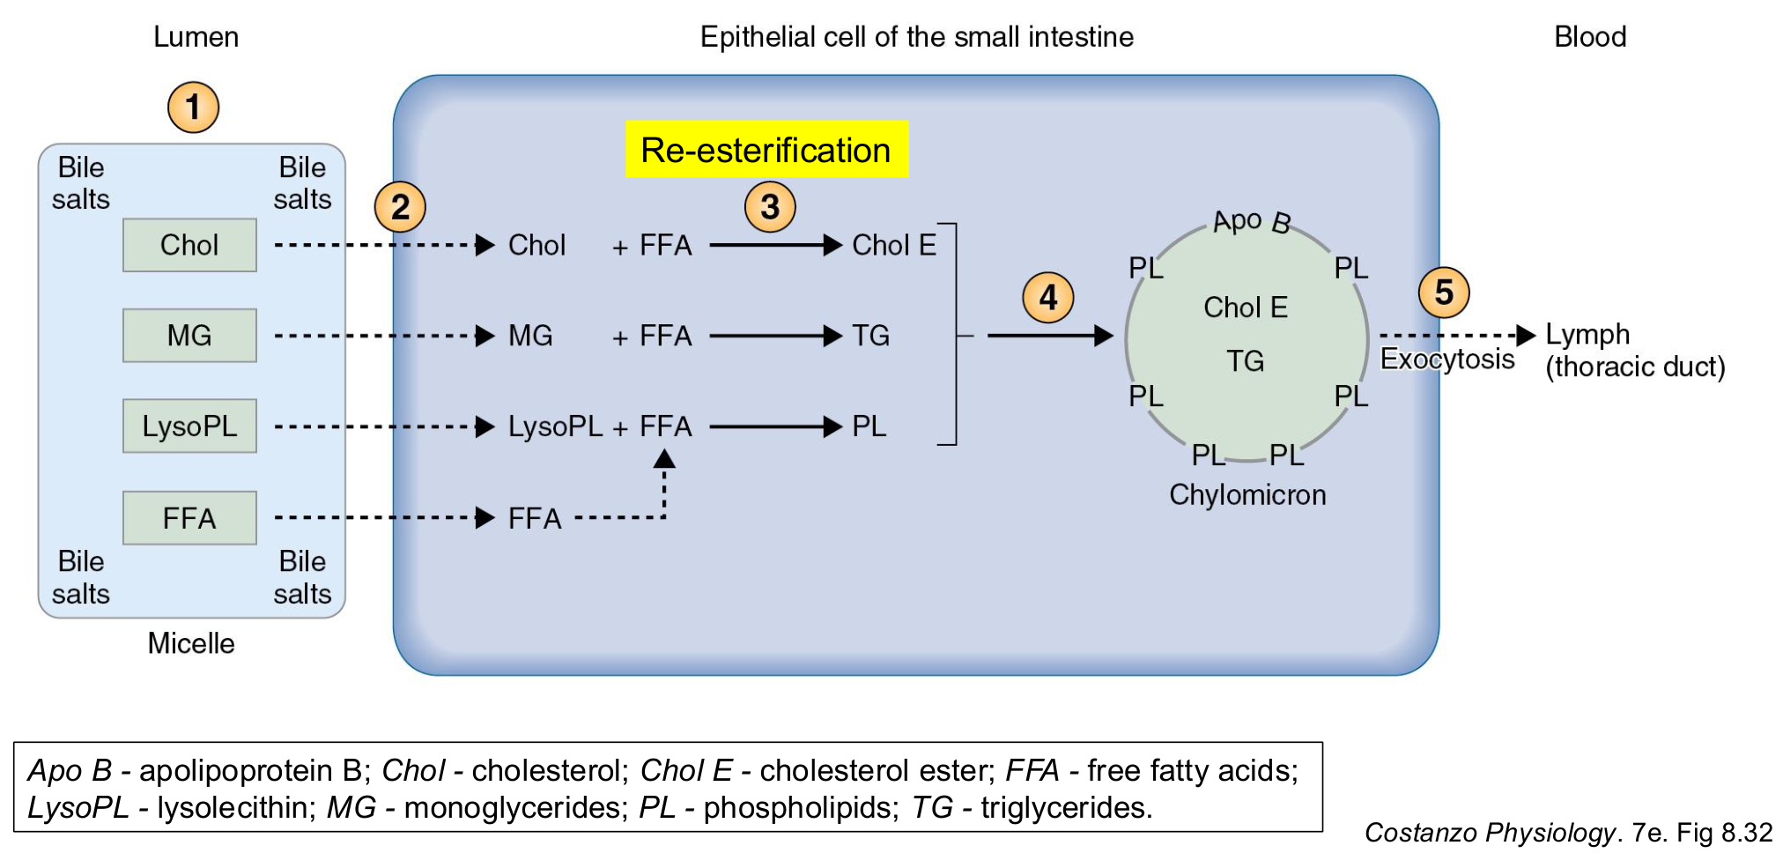
Original lipid absorption and re-esterification diagram, with its abbreviations retained (p. 24; Costanzo Physiology, 7e, Fig. 8.32).
Step / location | What happens?
1. Intestinal lumen | Bile salts form mixed micelles carrying FFAs, monoglycerides, cholesterol and lysophospholipids.
2. Apical membrane | Lipid cargo leaves the micelle and enters the enterocyte. Whole micelles do not enter; bile salts remain in the lumen.
3. Inside enterocyte | Lipid products are re-esterified → TGs, cholesteryl esters and phospholipids.
4. Inside enterocyte | Re-formed lipids + apoproteins, including Apo B → chylomicrons.
5. Exit route | Exocytosis → lacteals (intestinal lymphatic vessels) → lymph → thoracic duct → systemic blood.

Original MCQ 7
Dietary lipids are eventually transported in the circulation mainly as:
A. Micelles B. Chylomicrons C. Monoglycerides D. Fatty acids
Answer: B
Chylomicrons carry absorbed long-chain dietary lipids after enterocyte processing. Micelles act in the intestinal lumen, before absorption.

Original Case 2 | Part 4, Q4
Original question / ID | Answer and reasoning
C2-P4-Q4 What structure transports absorbed lipids into the circulation? | Particle: chylomicron. Route: lacteals → lymph → thoracic duct → blood. Give both if “structure” is ambiguous; do not answer “micelle”.

Apo B = apolipoprotein B; Chol = cholesterol; Chol E = cholesteryl ester; PL = phospholipid. “Re-esterification” means joining digestion products back into complex lipids inside the cell; it is not reversal of absorption.

16 / Keep the locations straight: final integration
Lecture synthesis | One further integrated practice question; supporting exceptions are marked [Extension]
Compare | Micelle | Chylomicron
Where formed? | Intestinal lumen. | Inside enterocyte.
Main components | Bile salts + lipid digestion products. | Re-esterified lipids + apoproteins.
Main task | Deliver poorly water-soluble lipids to the apical surface. | Export and carry absorbed dietary lipids.
Does it enter the cell intact? | No; lipid cargo leaves first. | Formed in the cell, then exocytosed.
Next destination | Bile salts stay in lumen, then are largely reabsorbed in ileum. | Lacteals → lymph → thoracic duct → blood.

Bile salts are recycled; chylomicrons take a different route
Bile salts → terminal ileal reabsorption → return to liver → secretion into bile again.
[Extension] This enterohepatic circulation uses portal blood. Long-chain dietary lipids initially leave the intestine in chylomicrons through lymph. Short- and medium-chain fatty acids can enter portal blood more directly.

Location of low pH | Cell / mediator | Response
Stomach | D cells → somatostatin. | Gastric acid secretion decreases: feedback inhibition.
Duodenum | S cells → secretin. | Pancreatic bicarbonate-rich secretion increases; gastric delivery slows.

Integrated practice 2 | Self-written; not an original exam question
No bile reaches the duodenum, but pancreatic enzyme secretion, bicarbonate secretion and the intestinal mucosa remain normal. Explain the effects on long-chain fat absorption, chylomicron output and glucose absorption. Would simply increasing lipase fully fix the problem?
Answer approach:
• Emulsification and mixed-micelle formation are impaired → lipid hydrolysis / delivery to the brush border becomes less effective → long-chain fat absorption and chylomicron output fall.
• Lipase cannot replace bile salts’ luminal functions; more enzyme does not fully correct the defect.
• Glucose absorption is largely preserved: starch hydrolysis and SGLT1 / GLUT2 transport do not require bile micelles.
• The question explicitly preserves pancreatic outputs; do not assume every digestive pathway has failed.

Use the tutorial’s reasoning pattern
Stimulus → sensor / source cell → neural or hormonal messenger → target → function.
For absorption: final digestion product → apical entry → intracellular processing → exit route.
Source check: the selected MCQs are consistent (B, C, D, C, A, C, B). Case 1 annotations are broadly consistent; use “motility”. Buffet “low pH” is corrected on p. 6; its stimulator list is completed on p. 7. Intestinal enzyme-source wording is corrected on p. 12. Figures / highlights are source material, not an official key. The two self-written questions do not predict actual exam content. Main reference named by the lecture: Costanzo Physiology, 7e, Chapter 8; figure sources are credited beside each image.

