01 Reflexes & the reflex arc
Rapid responses • Defined circuits • Predictable effects
Reflex = a rapid, automatic and predictable reaction to a specific stimulus.

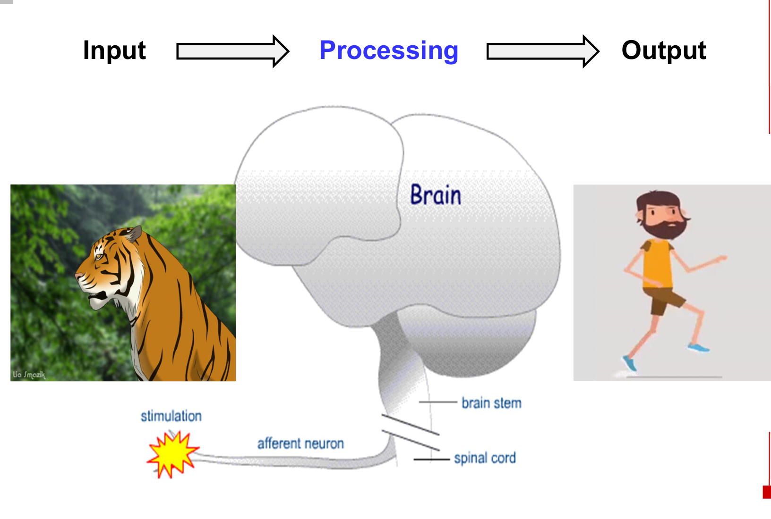  Input → processing → output | 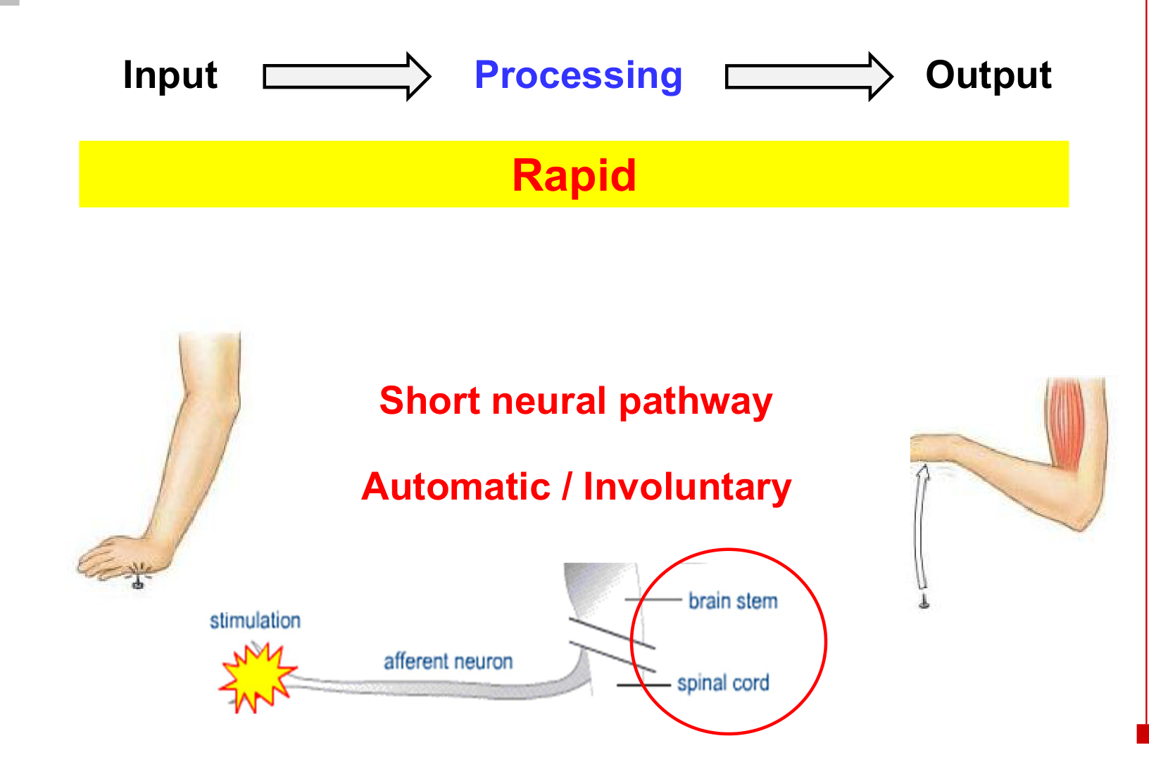  A short neural pathway produces a rapid, involuntary response.

The five components
Receptor → sensory (afferent) neuron → integration centre
→ motor (efferent) neuron → effector

Component | Role
Receptor | Detects the stimulus.
Sensory neuron | Carries sensory impulses from the receptor toward the CNS.
Integration centre | Processes the input and coordinates the response; usually within the CNS for a typical reflex arc.
Motor neuron | Carries motor commands from the CNS to the effector.
Effector | A muscle or gland produces the response.

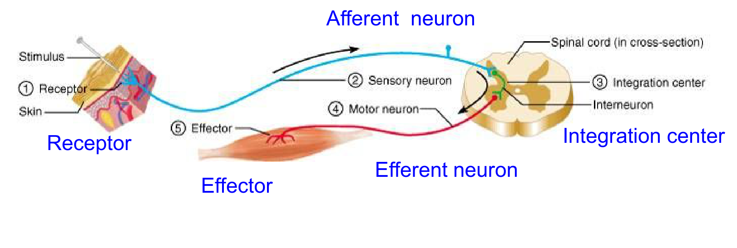
Afferent = toward the integration centre. Efferent = away from it. Short enteric reflexes use a peripheral integration centre.

02 Classifying reflexes
The same reflex can be classified on several independent axes.
Classification | Meaning / example
Innate vs acquired | Innate: inborn; withdrawal from pain.  Acquired: learning-dependent; braking when a red traffic light appears.
Spinal vs cranial | Spinal: processing in the spinal cord; withdrawal from pain.  Cranial: processing in the brain; movement in response to a sudden loud noise.
Somatic vs autonomic | Somatic: skeletal muscle effectors.  Autonomic: smooth muscle, cardiac muscle or gland effectors.
Monosynaptic vs polysynaptic | Monosynaptic: one central synapse, directly linking sensory and motor neurons.  Polysynaptic: two or more central synapses; interneuron(s) intervene.

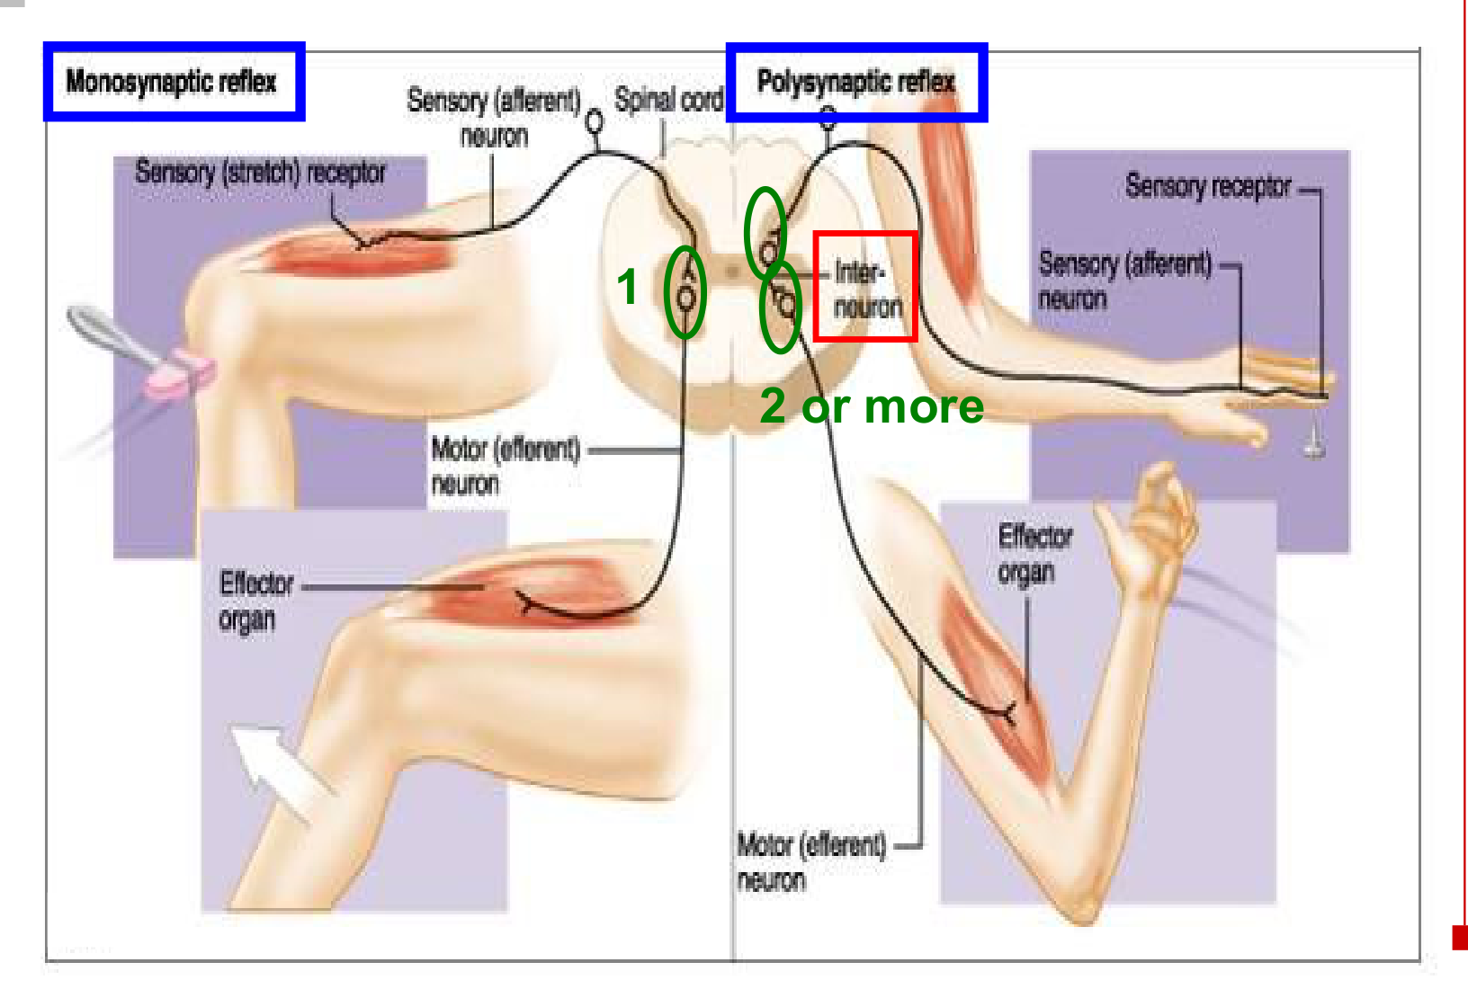
• Count the synapses in the reflex integration pathway, not the number of muscles or the neuromuscular junction.
• A monosynaptic pathway has no intervening interneuron between its sensory neuron and motor neuron.
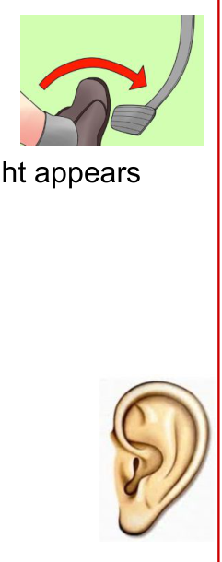
Learned braking and an auditory stimulus are examples used to classify reflexes.

03 Somatic vs autonomic motor output
Feature | Somatic | Autonomic
Effectors | Skeletal muscle | Smooth muscle, cardiac muscle and glands
Control | Voluntary actions and involuntary somatic reflexes | Involuntary visceral control and autonomic reflexes
Efferent pathway | One somatic motor neuron from CNS to skeletal muscle | Preganglionic neuron → autonomic ganglion → postganglionic neuron → effector

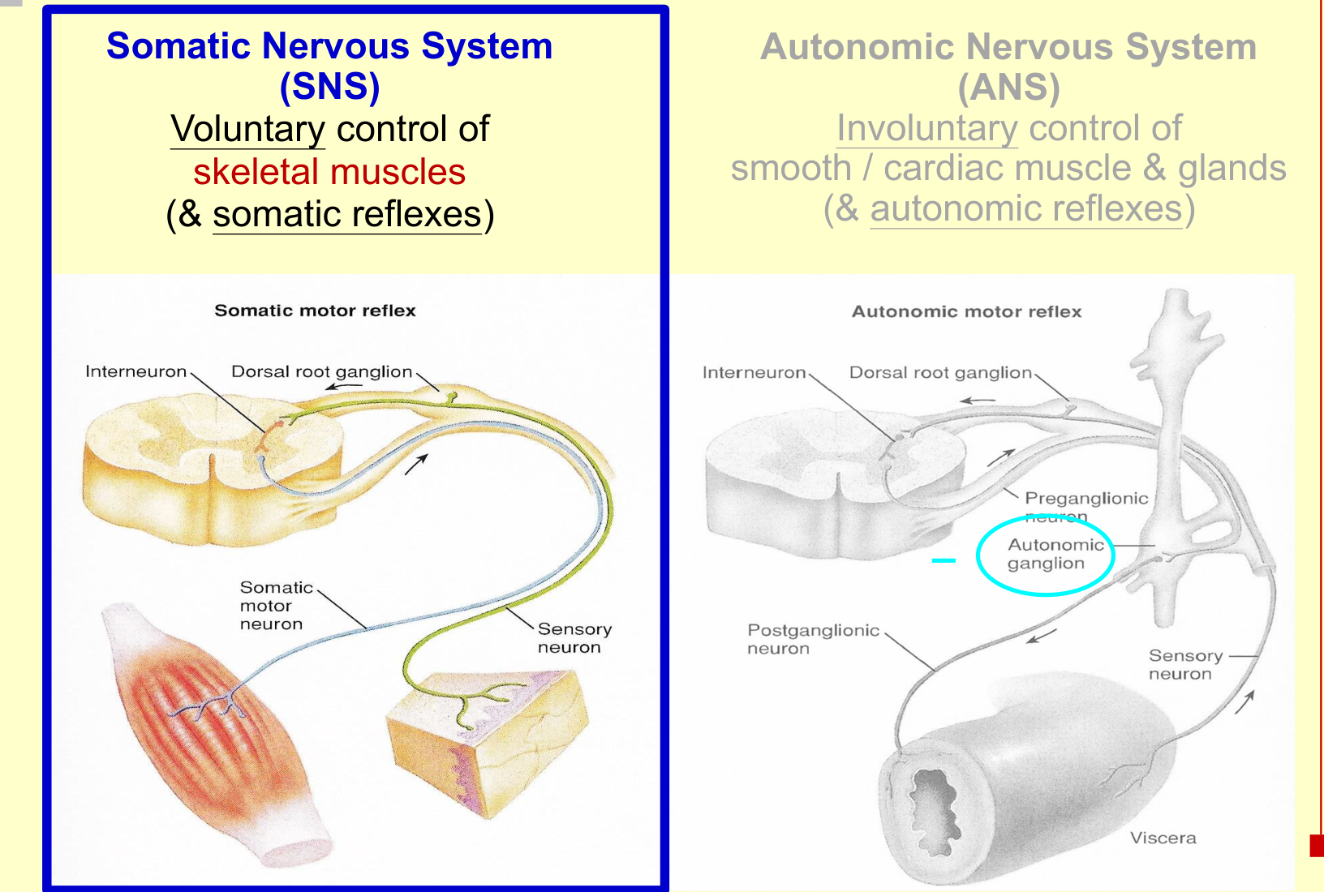  Somatic motor pathway | 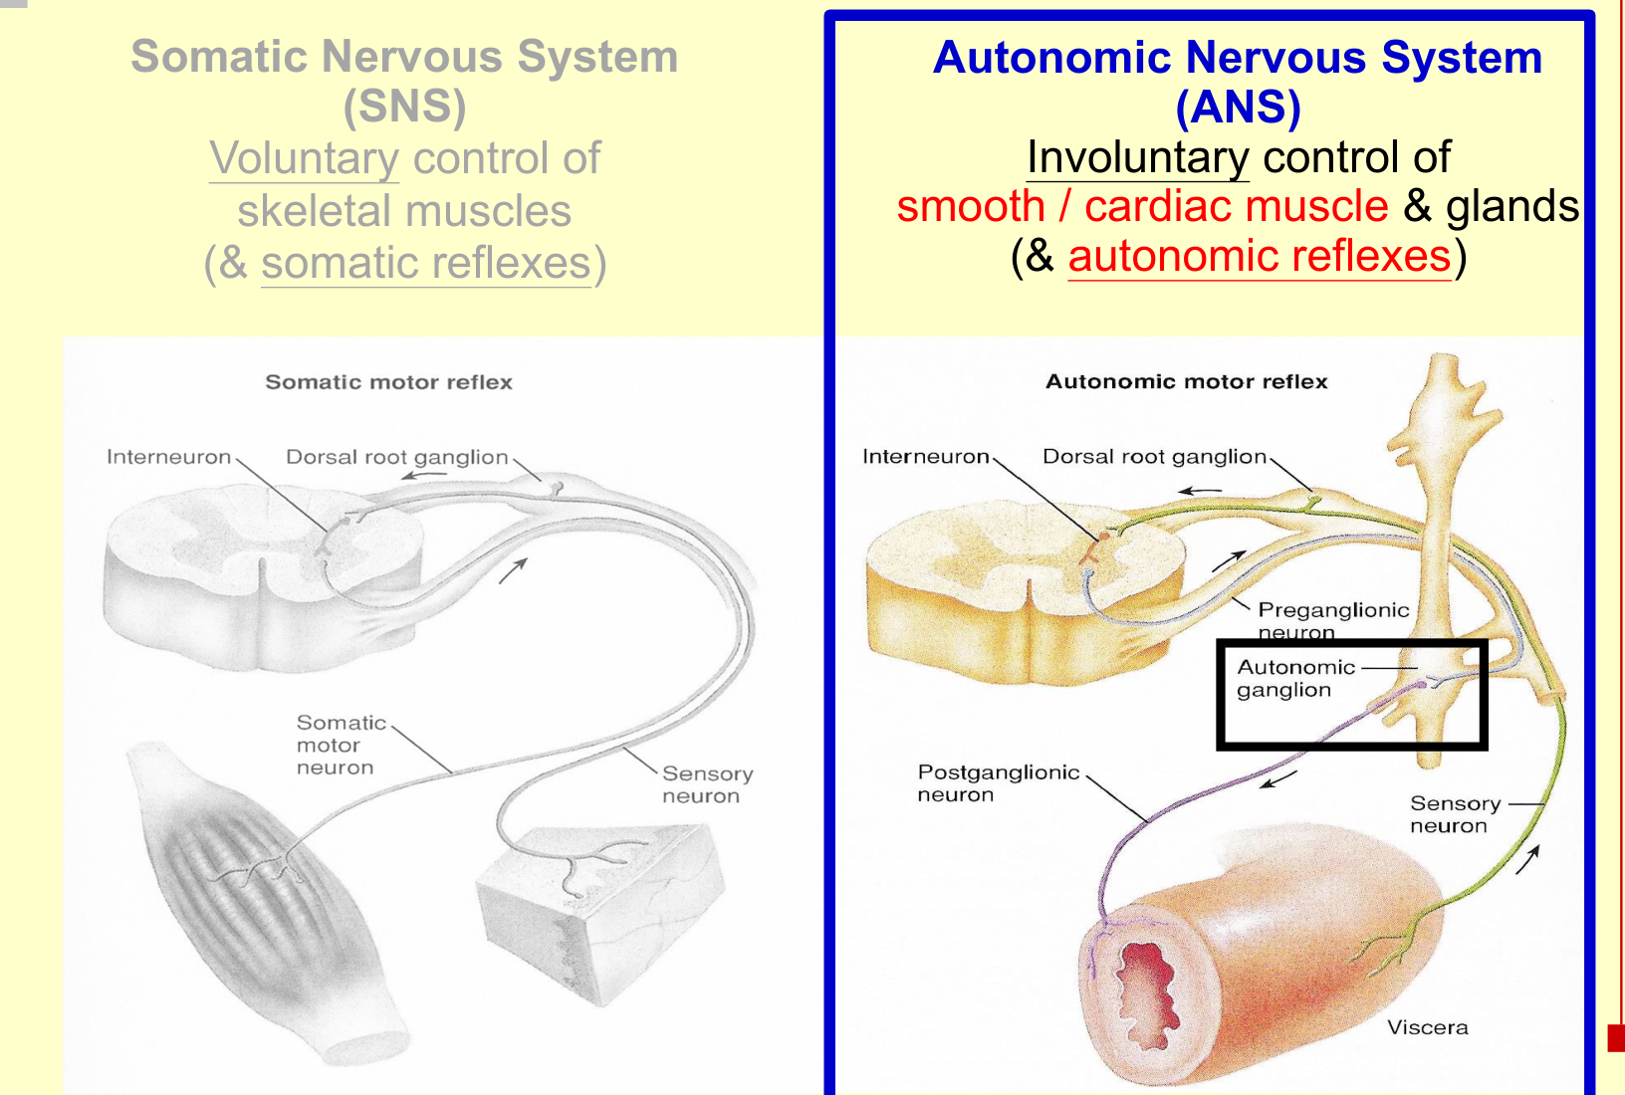  Autonomic motor pathway

Autonomic organisation
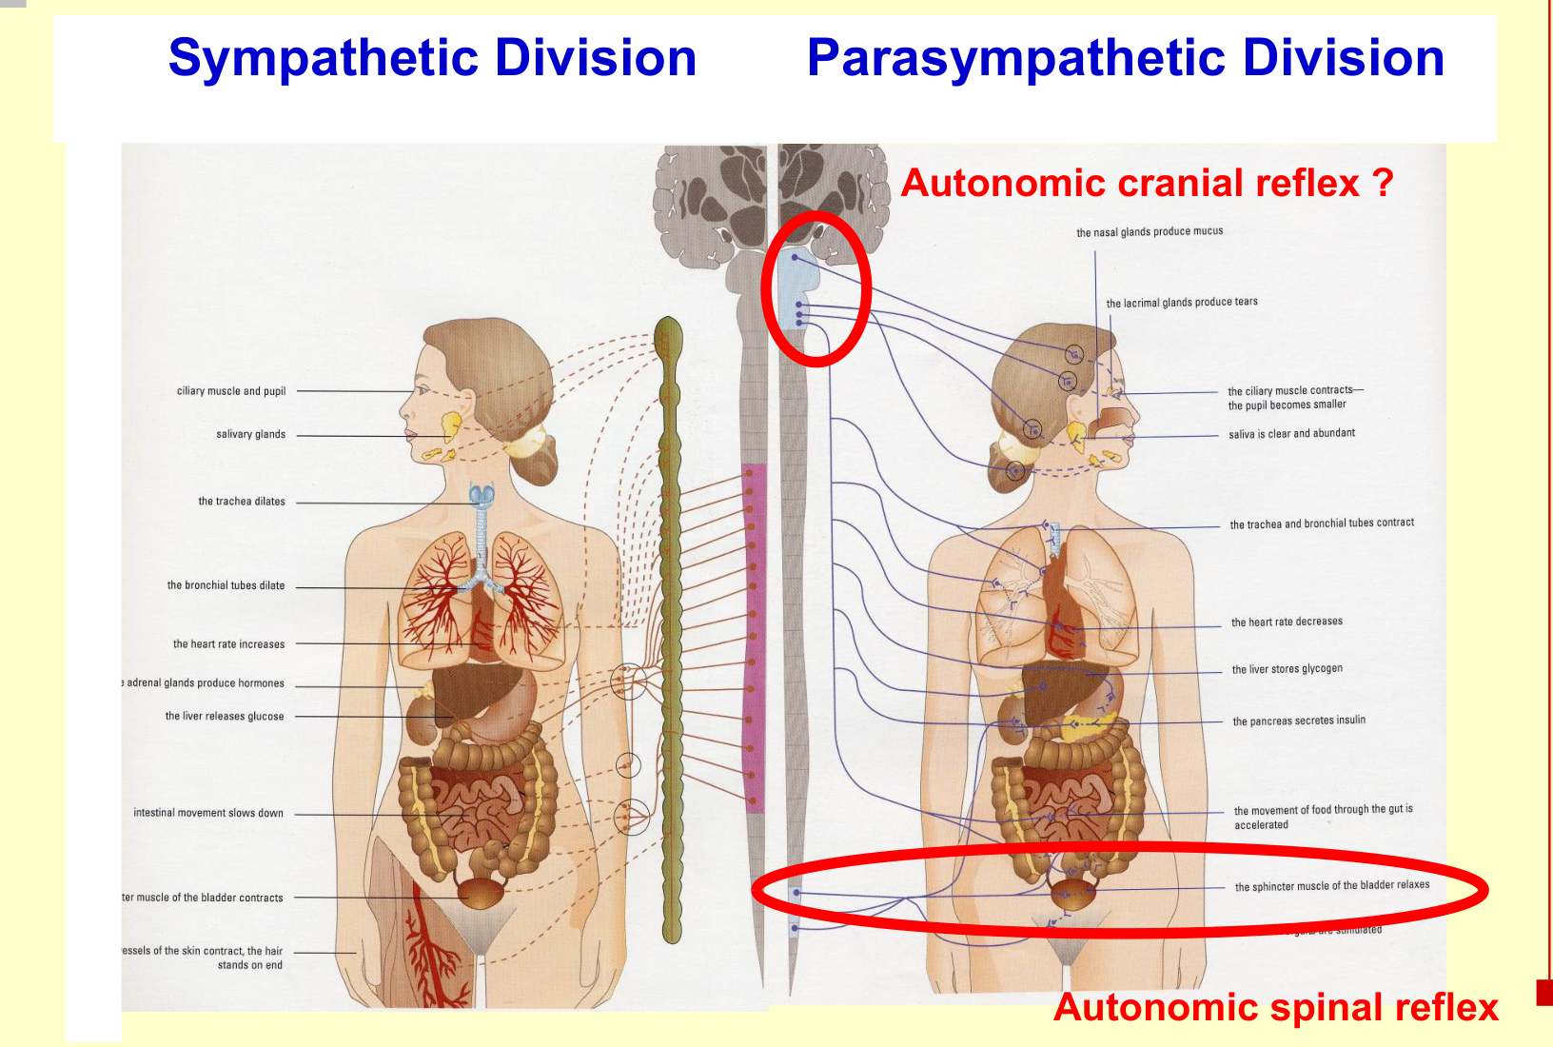
• Parasympathetic output has cranial and sacral components: pupillary light reflex is cranial; defecation and micturition include spinal autonomic circuits.
CNS = central nervous system; ANS = autonomic nervous system. Here, “somatic” identifies the skeletal-muscle pathway; it does not mean that every action is voluntary.

04 Stretch reflex: the knee jerk
Patellar tendon tap → quadriceps stretches → muscle spindle activated
→ Ia sensory firing ↑ → spinal cord (L2–L4; monosynaptic excitation)
→ α-motor neuron firing ↑ → the same quadriceps contracts → knee extension

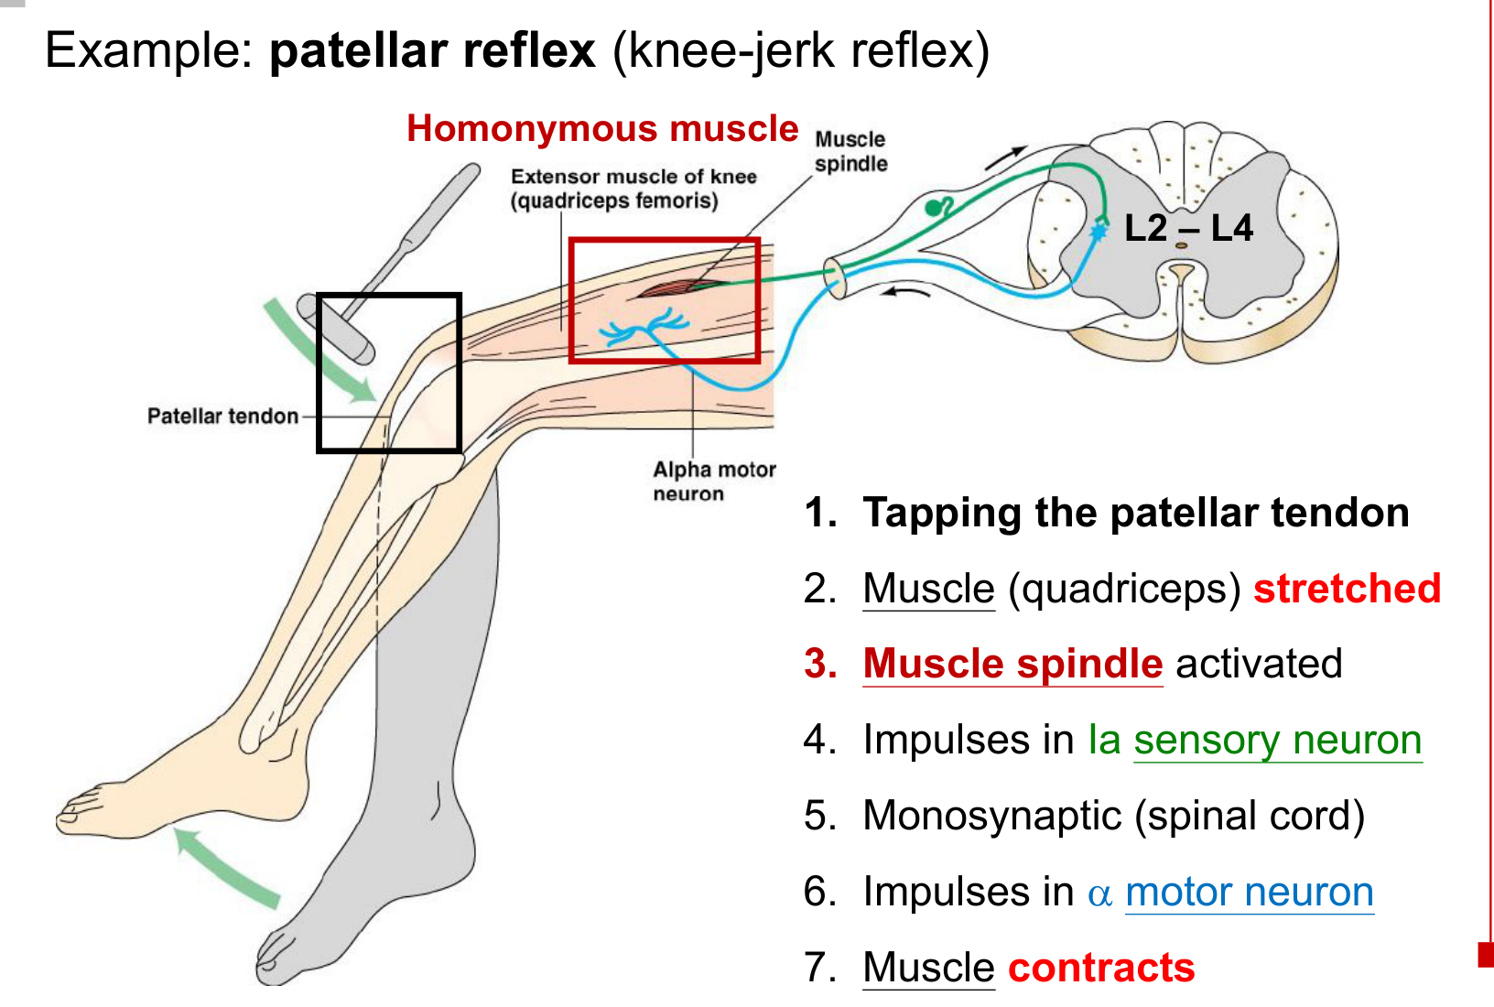
• Homonymous muscle = the same muscle that contains the stimulated receptor.
• The receptor is the muscle spindle; tapping the tendon mechanically stretches the muscle.
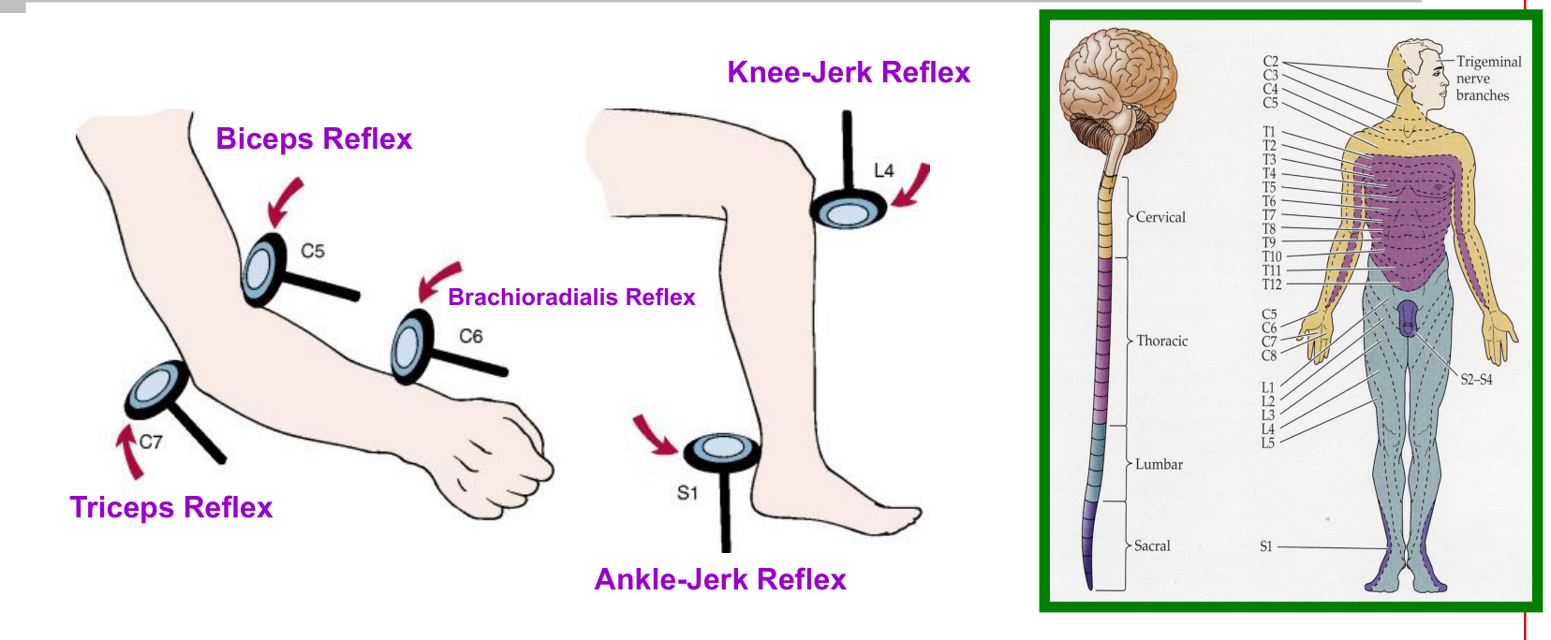
Reflex | Key segment emphasis
Biceps / brachioradialis / triceps | C5 / C6 / C7, respectively
Knee jerk / ankle jerk | L4 emphasis within the L2–L4 knee-jerk circuit / S1 emphasis

Different reflexes use different spinal segments → comparing reflex responses helps localise a lesion or neuropathy.

05 Muscle spindle: structure & innervation
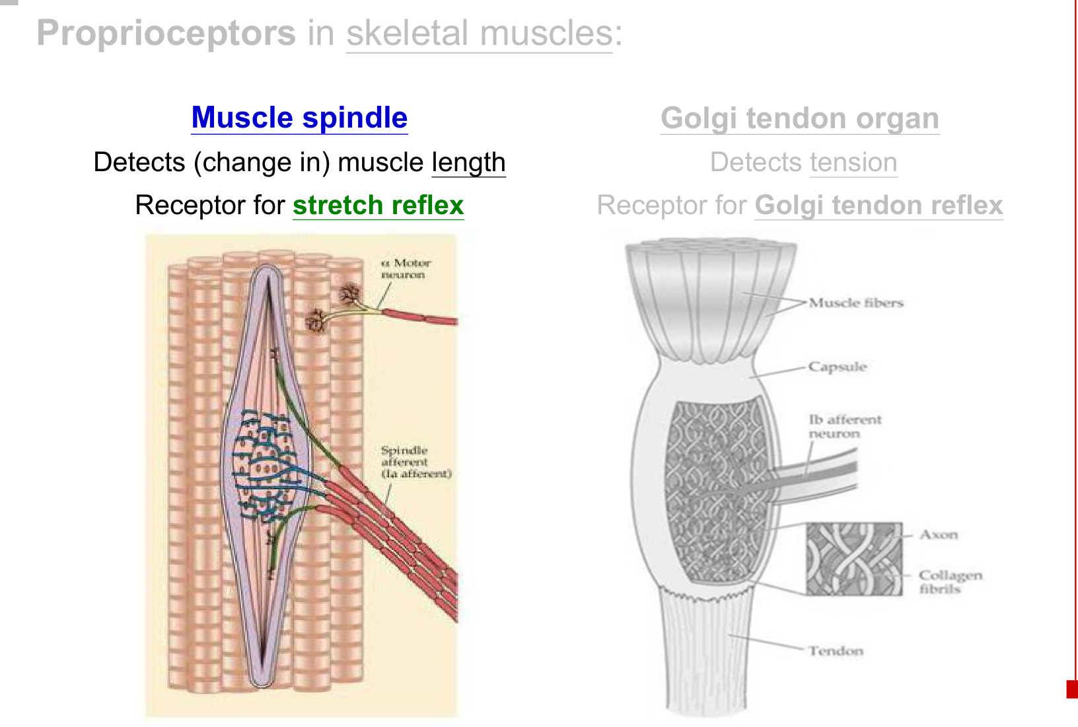
Structure / neuron | Key role
Muscle spindle | Proprioceptor within skeletal muscle; detects muscle length and changes in length.
Intrafusal muscle fibres | Specialised fibres inside the spindle. Contractile polar ends flank a non-contractile sensory region.
Extrafusal muscle fibres | Ordinary force-producing skeletal muscle fibres outside the spindle.
Ia sensory ending | Reports stretch of the spindle’s sensory region to the spinal cord.
α-motor neuron | Innervates extrafusal fibres → produces muscle contraction.
γ-motor neuron | Innervates contractile intrafusal ends → adjusts tension on the spindle’s sensory region.

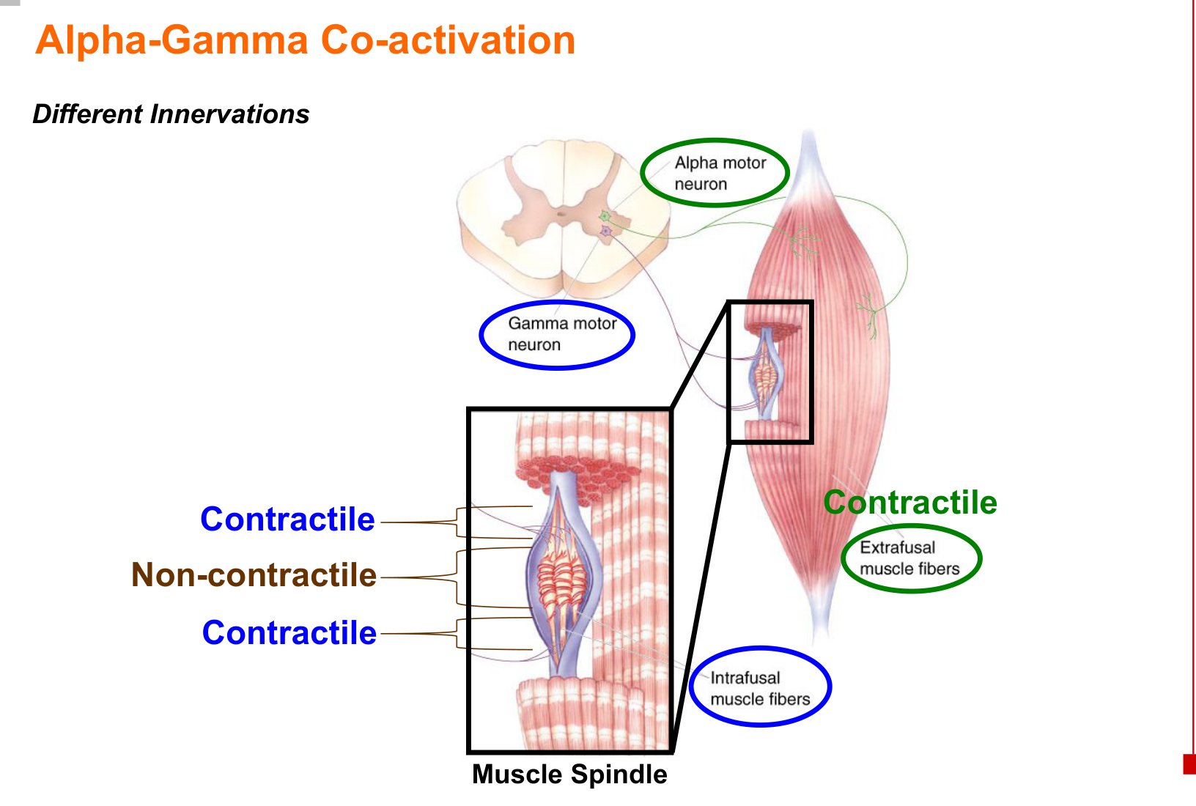
α acts on extrafusal fibres; γ acts on intrafusal fibres. The spindle senses stretch; the Golgi tendon organ senses tension.

06 α–γ coactivation: preserve sensitivity
Descending command → α and γ motor neurons activated together
α → extrafusal fibres shorten
γ → intrafusal poles contract → central sensory region stays taut
→ spindle remains responsive during muscle contraction

α activation alone | α + γ coactivation
Extrafusal fibres shorten. | Extrafusal fibres and intrafusal poles shorten together.
Intrafusal fibres do not shorten accordingly → spindle becomes slack. | Intrafusal polar contraction maintains tension on the sensory region.
Sensory reporting is reduced or lost: spindle is “off the air”. | Length changes can still be detected: spindle remains “on the air”.

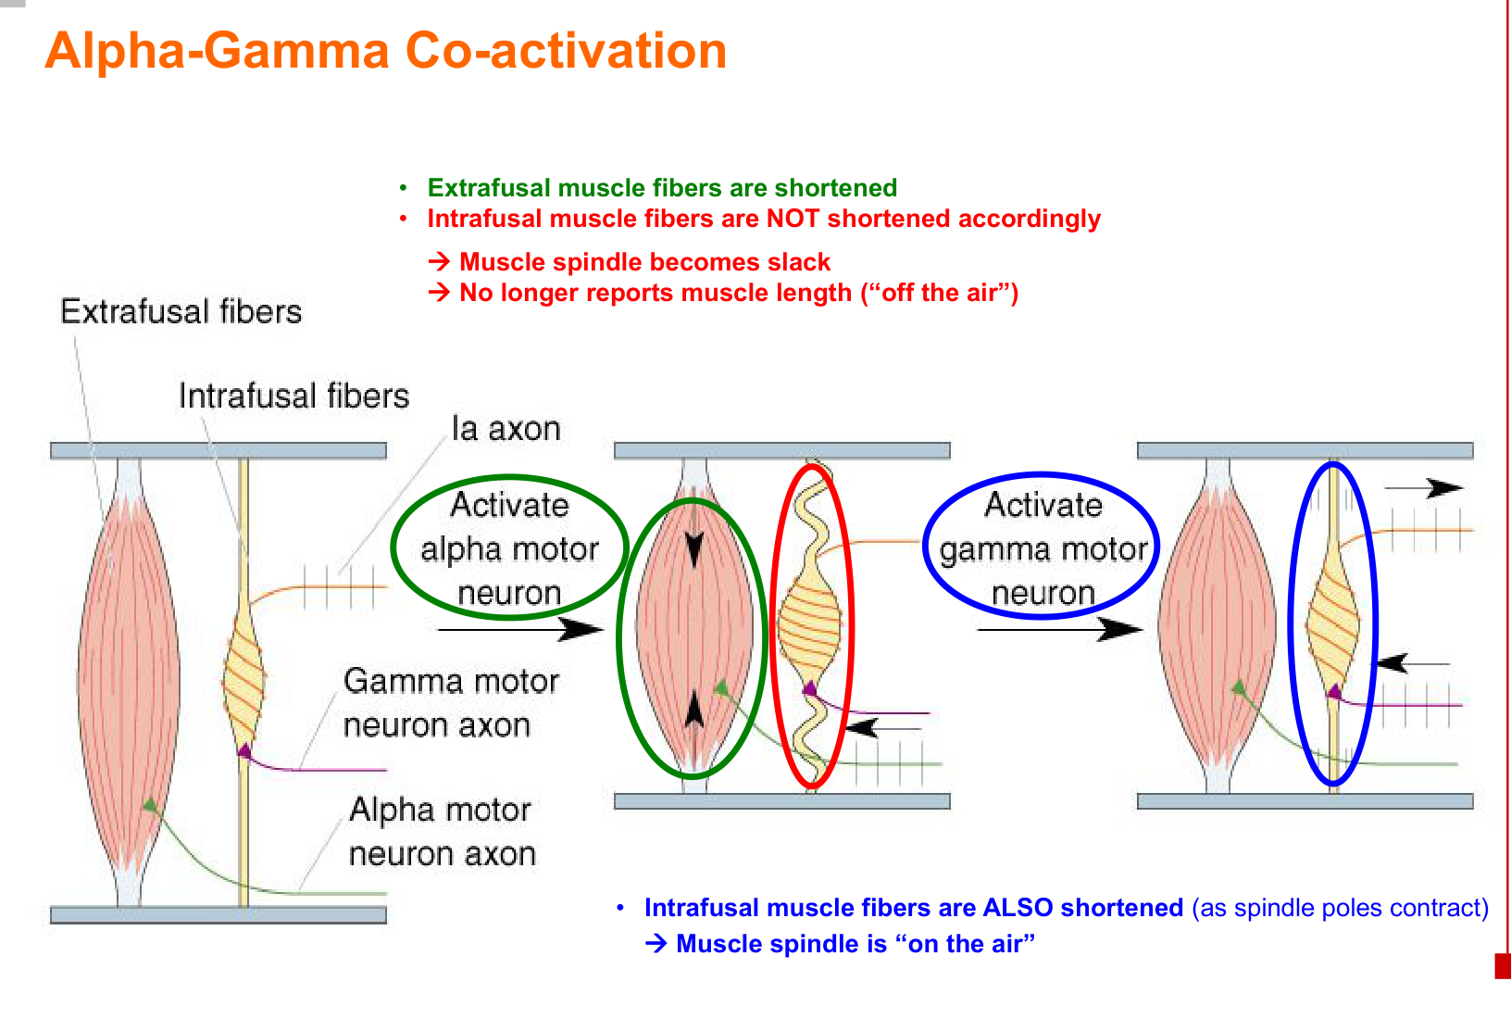
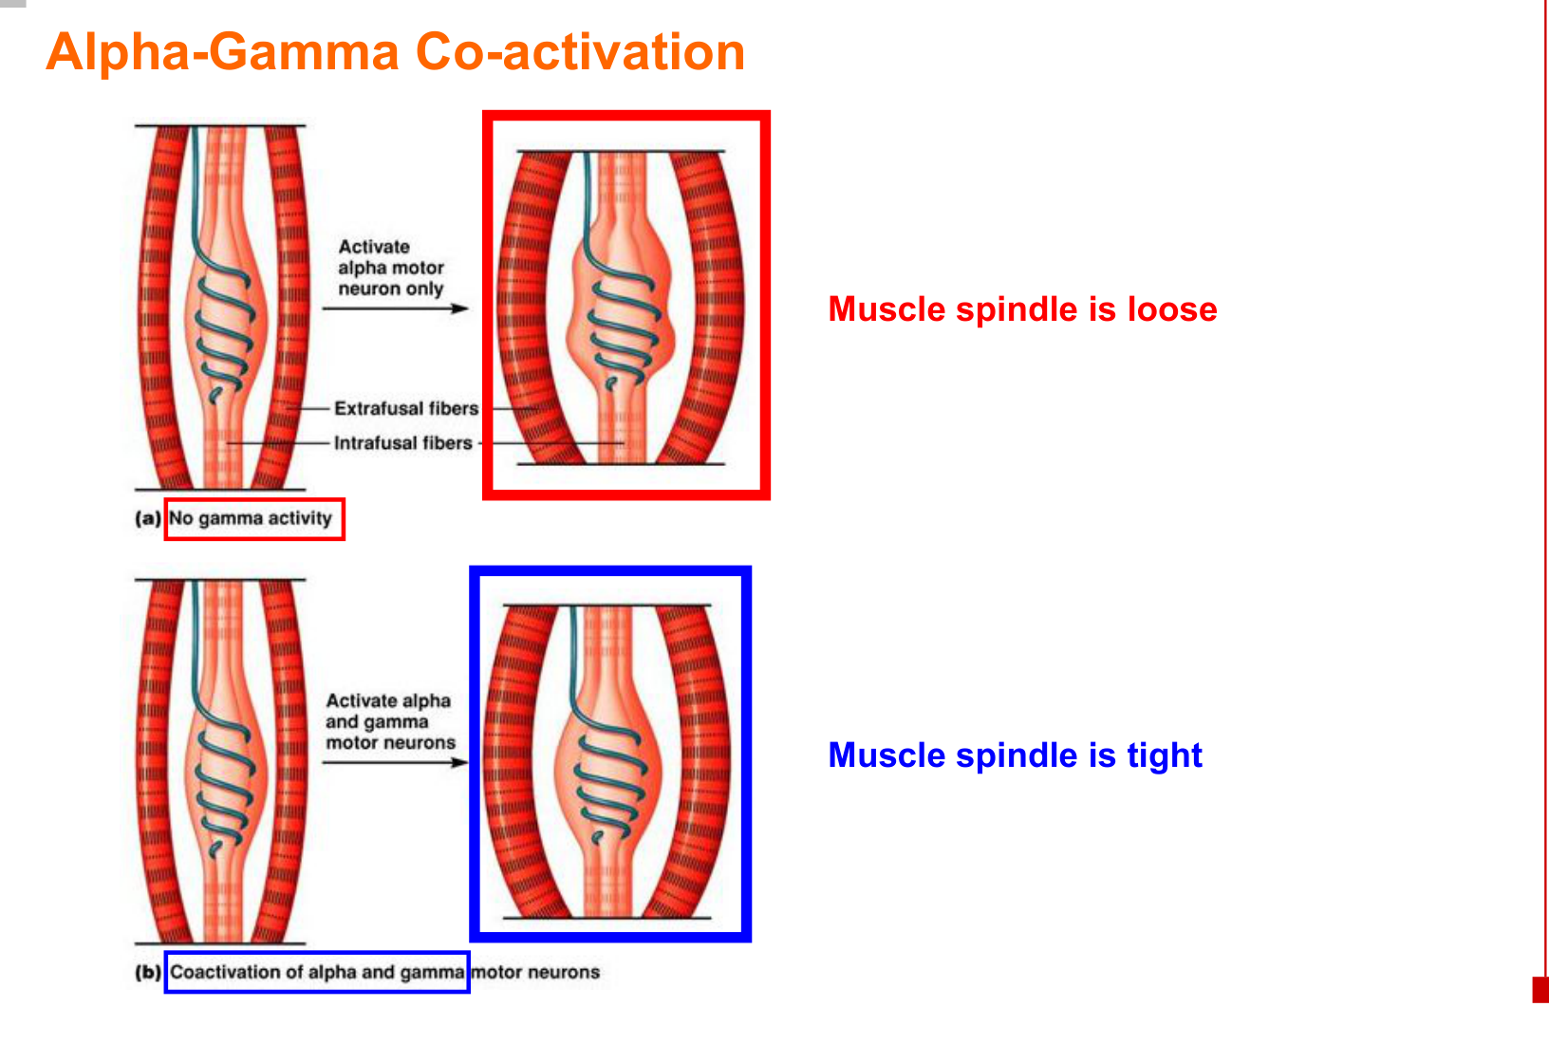  Loose vs taut spindle | 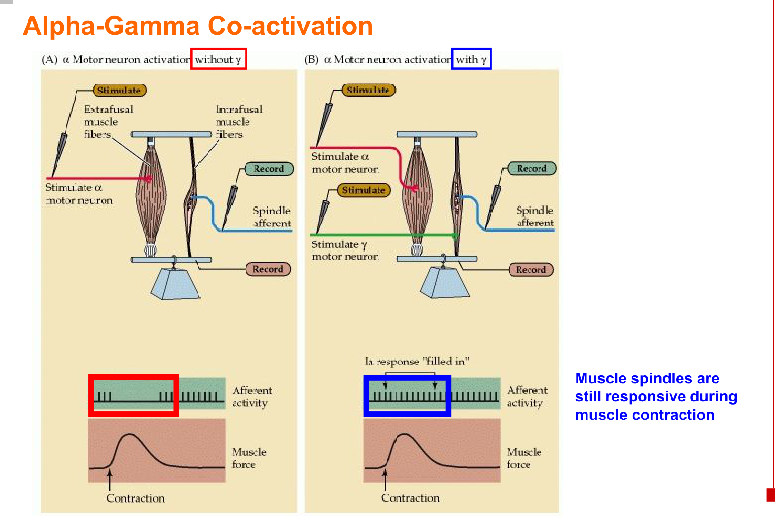  Sensory activity is maintained with coactivation.

• Purpose: maintain spindle sensitivity while the force-producing muscle shortens.

07 α–γ loop: generate muscle tone
Descending input → γ-motor neuron activity ↑
→ intrafusal polar ends contract → spindle sensory region stretched
→ Ia afferent firing ↑ → monosynaptic excitation in spinal cord
→ α-motor neuron firing ↑ → extrafusal contraction → muscle tone

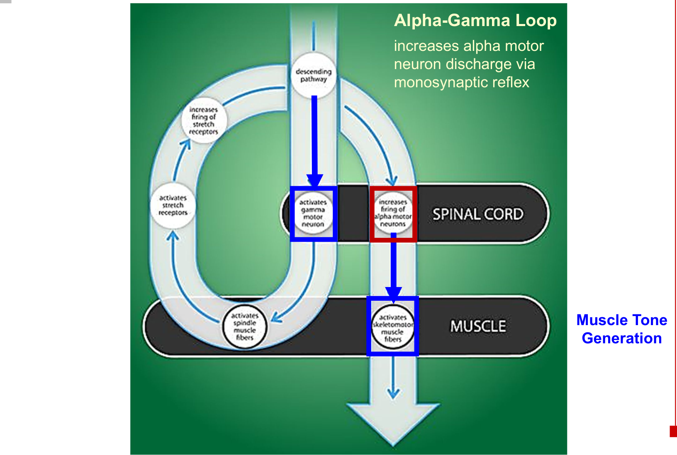
Mechanism | What to remember
α–γ coactivation | α and γ receive descending activation together → spindle sensitivity is maintained during contraction.
α–γ loop | γ activity increases α activity via the spindle–Ia stretch-reflex pathway → contributes to muscle tone.

• γ-motor neurons do not directly provide the motor supply to ordinary extrafusal muscle fibres.
• Muscle tone supports posture and readiness for movement.

08 Golgi tendon reflex: tension control
Muscle contracts → tension ↑ → Golgi tendon organ activated
→ Ib sensory firing ↑ → spinal interneuron pathway (polysynaptic)
→ α-motor firing to the same muscle ↓ → muscle relaxes

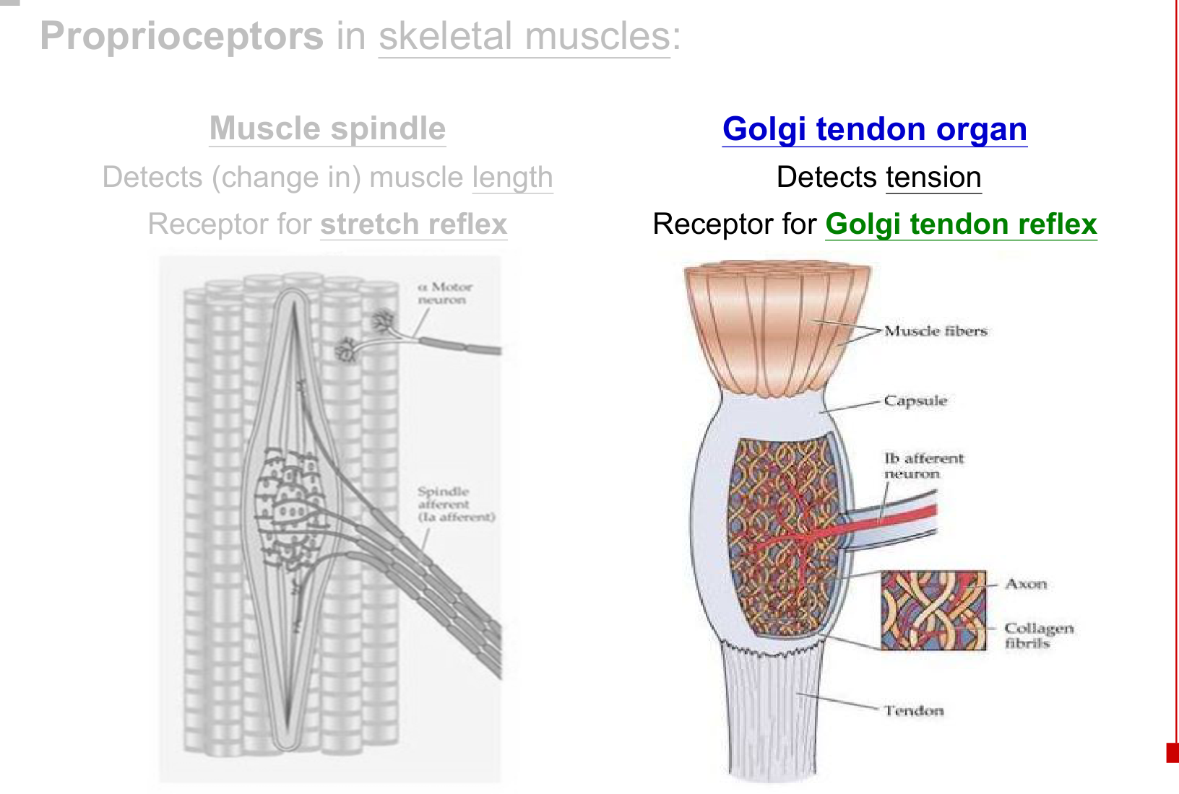  Tendon organ detects tension. | 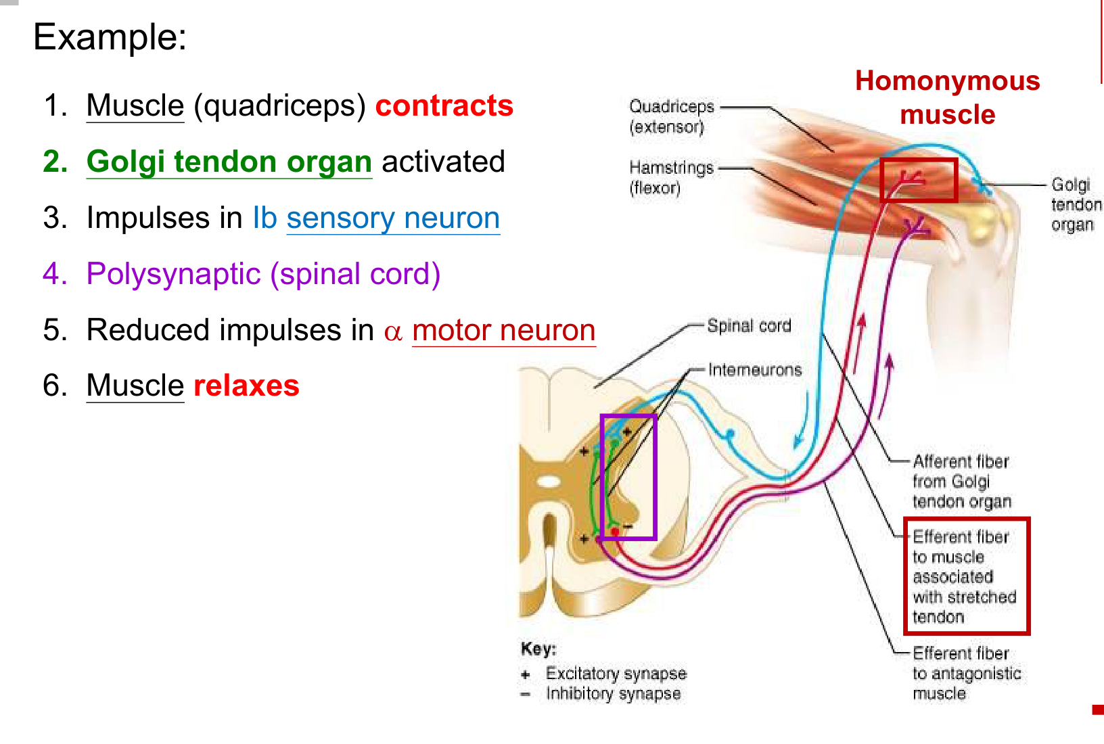  Inhibitory control of the homonymous muscle.

Feature | Stretch reflex | Golgi tendon reflex
Stimulus | Muscle length / stretch ↑ | Muscle tension ↑
Receptor | Muscle spindle | Golgi tendon organ
Sensory fibre | Ia | Ib
Main spinal connection | Monosynaptic excitation | Polysynaptic inhibition
Same-muscle response | α firing ↑ → contraction | α firing ↓ → relaxation
Function | Maintains length, posture and tone | Regulates tension; protective role

• The inhibitory interneuron decreases output to the contracting muscle. An excitatory pathway to the antagonist is also shown in the circuit.
Length → spindle → Ia → contraction.
Tension → tendon organ → Ib → relaxation.

09 Withdrawal & crossed extension
Noxious stimulus (e.g. stepping on a nail) → pain receptor
→ pain afferent → spinal cord (polysynaptic)
→ ipsilateral flexor α-motor firing ↑ → flexor contraction → withdrawal

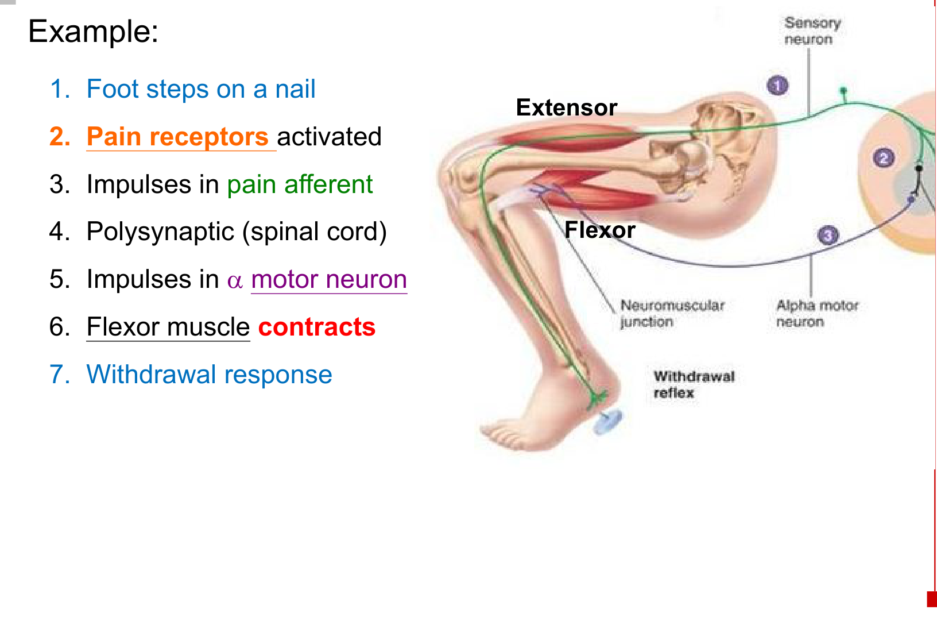  Withdrawal of the stimulated limb | 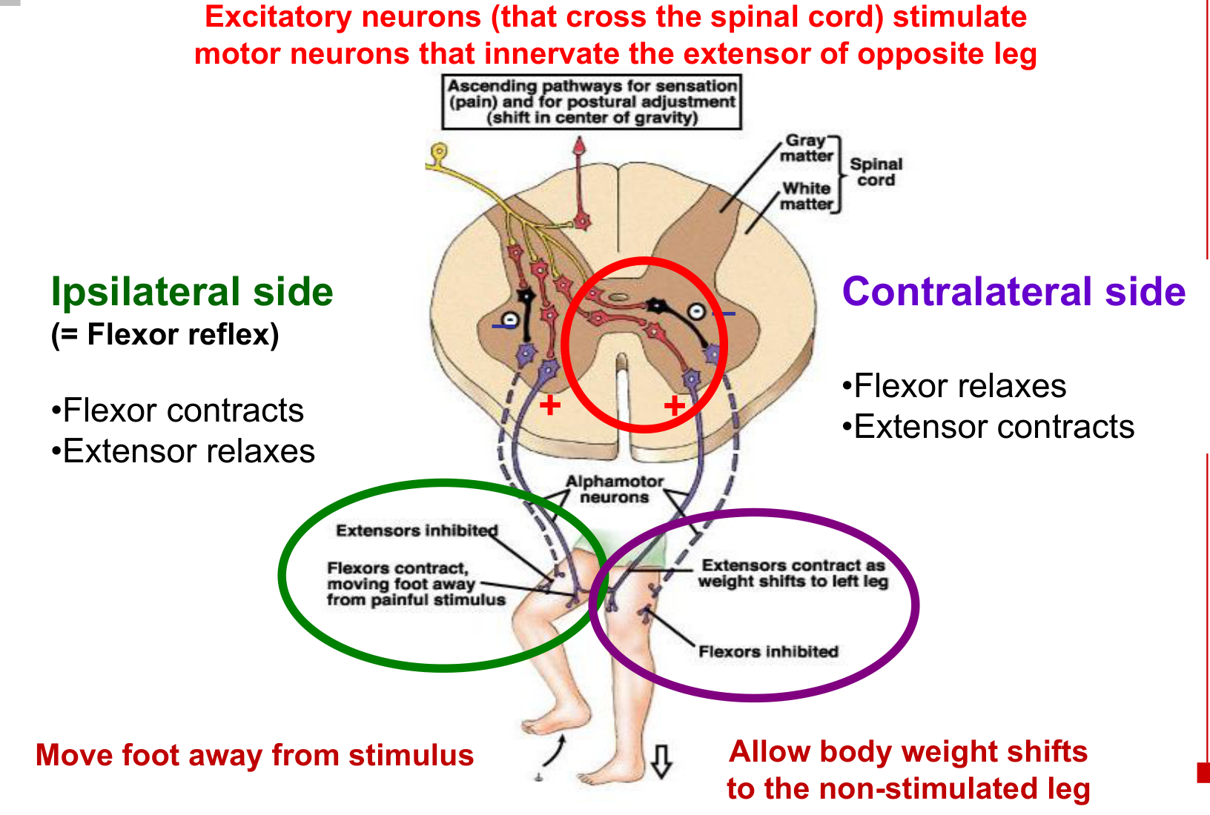  Opposite limb supports the body.

Side | Flexor | Extensor | Outcome
Ipsilateral  Stimulated side | Contracts | Relaxes | Foot moves away from the painful stimulus.
Contralateral  Opposite side | Relaxes | Contracts | Body weight shifts to the non-stimulated leg.

• Ipsilateral reciprocal inhibition relaxes the extensor while the flexor contracts.
• Interneuronal pathways cross the spinal cord → excite motor neurons supplying the opposite extensor and inhibit the opposite flexor.
• Sensory information can also ascend to the brain; spinal processing produces the withdrawal response.
Withdrawal protects the stimulated limb.
Crossed extension maintains balance and posture.

10 Superficial reflex: plantar response
Gentle cutaneous stimulation: stroke the lateral sole of the foot
→ sensory input → locally organised spinal circuit → toe response

Pattern | Response | Interpretation
Normal adult plantar response | Flexion of all toes | Negative Babinski response.
Positive Babinski response | Great toe extends; other toes fan out | Can occur normally in infants; pathological in adults.

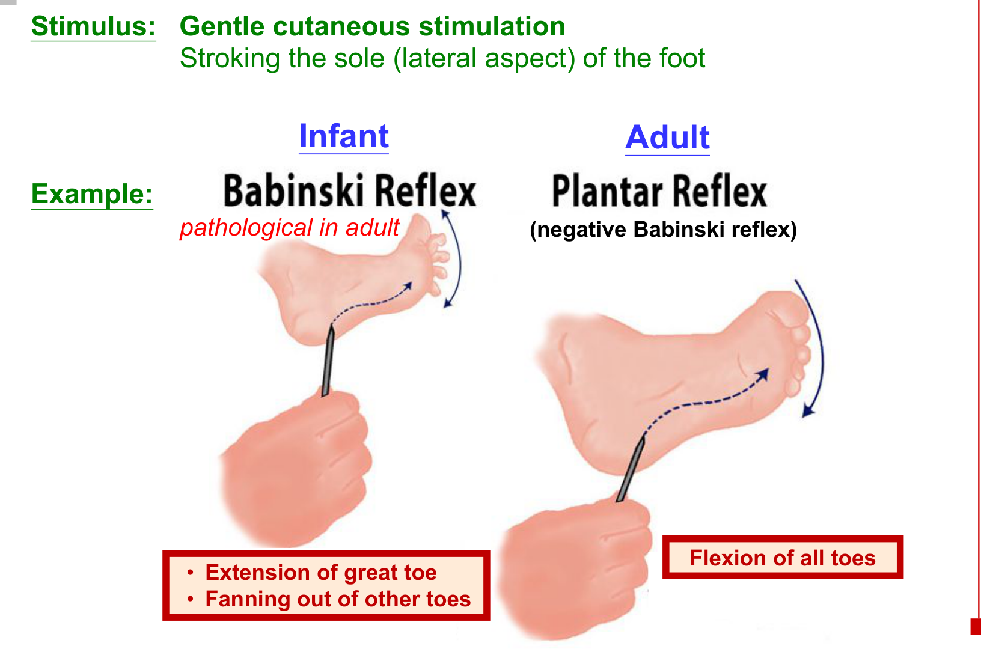  Compare the adult and infant patterns. | 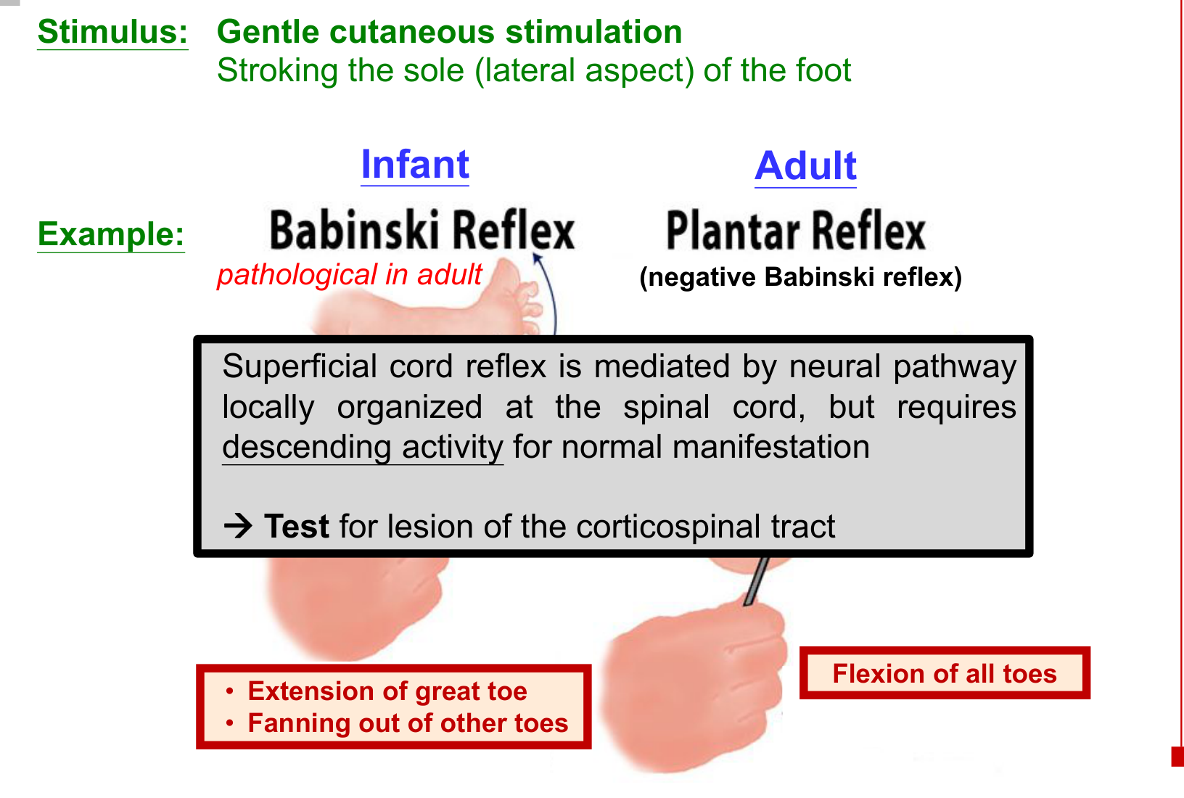  Normal expression requires descending control.

• The circuit is organised locally in the spinal cord, but normal manifestation requires descending activity.
• An abnormal adult plantar response helps identify a corticospinal tract lesion.
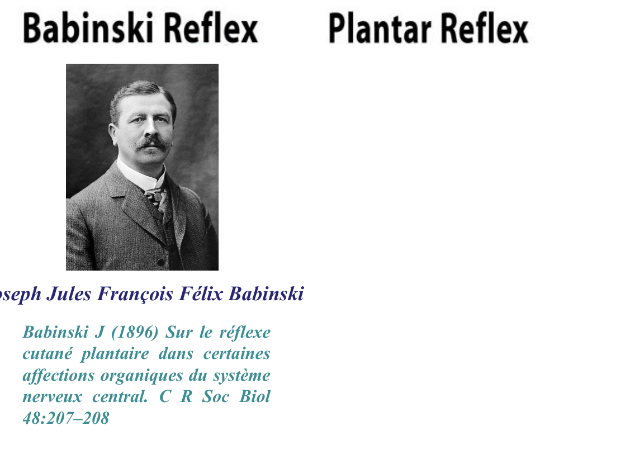
Joseph Jules François Félix Babinski • plantar response

11 Defecation reflex
Faeces enter and distend the rectum → rectal stretch receptors
→ sensory afferents → spinal cord → parasympathetic efferents
→ rectum + sigmoid colon contract
+ internal anal sphincter relaxes

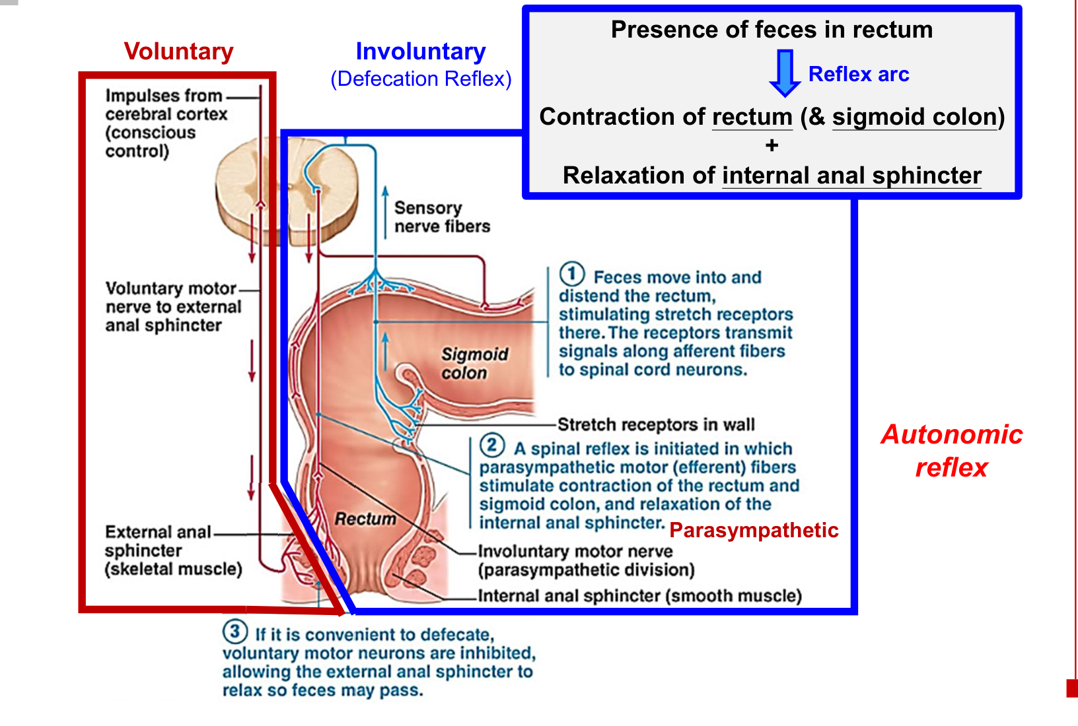
Component | Muscle / control | Action
Internal anal sphincter | Smooth muscle; autonomic | Relaxes as part of the involuntary defecation response.
External anal sphincter | Skeletal muscle; somatic / voluntary | Conscious control can postpone passage. When appropriate, motor activity is reduced → sphincter relaxes → faeces pass.

• Spinal autonomic reflex + voluntary control of the external sphincter coordinate the final action.

12 Micturition reflex
Urine fills and distends the bladder → bladder stretch receptors
→ sensory afferents → spinal cord → parasympathetic efferents
→ bladder wall contracts + internal urethral sphincter relaxes
→ promotes bladder emptying

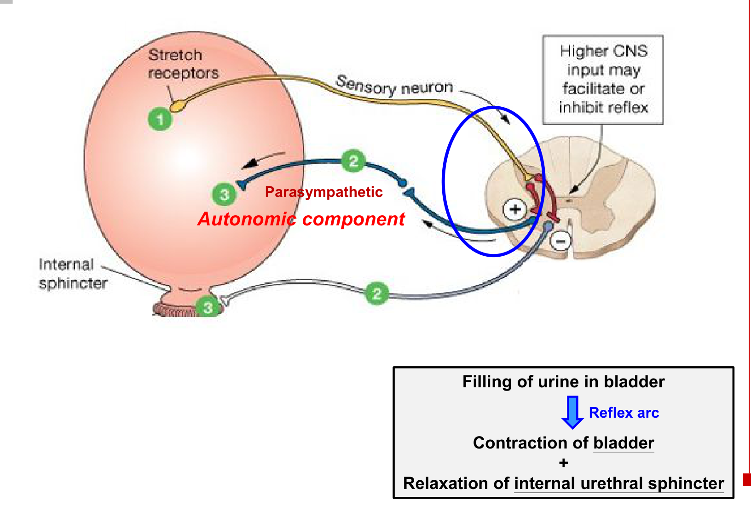
• Higher CNS input can facilitate or inhibit the reflex.
• Bladder contraction and outlet relaxation must be coordinated for effective emptying.
Shared feature | Defecation | Micturition
Filling stimulus | Faeces distend rectum | Urine distends bladder
Receptor / centre | Stretch receptor / spinal cord | Stretch receptor / spinal cord
Autonomic output | Parasympathetic | Parasympathetic
Visceral response | Rectum and sigmoid contract | Bladder contracts
Internal outlet | Anal sphincter relaxes | Urethral sphincter relaxes

Distension → spinal parasympathetic reflex → organ contraction + internal outlet relaxation.

13 Pupillary light reflex: sensory input
Light → retinal photoreceptive system
→ optic nerve (CN II) → midbrain integration
→ parasympathetic output through oculomotor nerve (CN III)
→ circular pupillary constrictor contracts → pupil size ↓

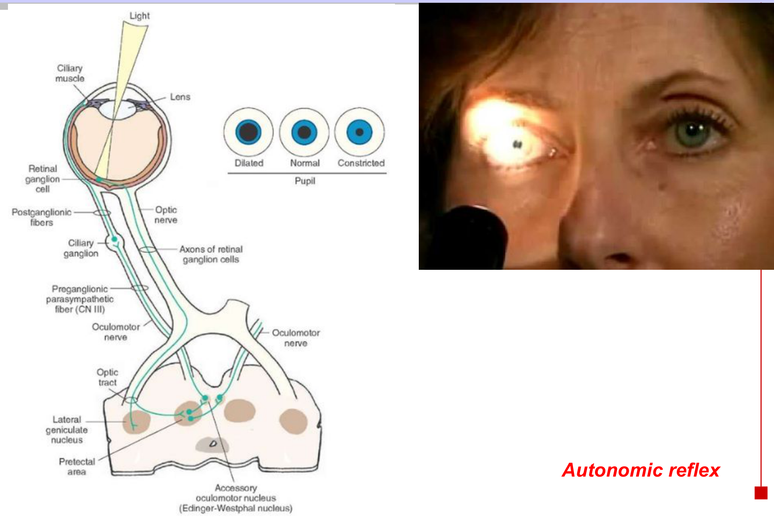
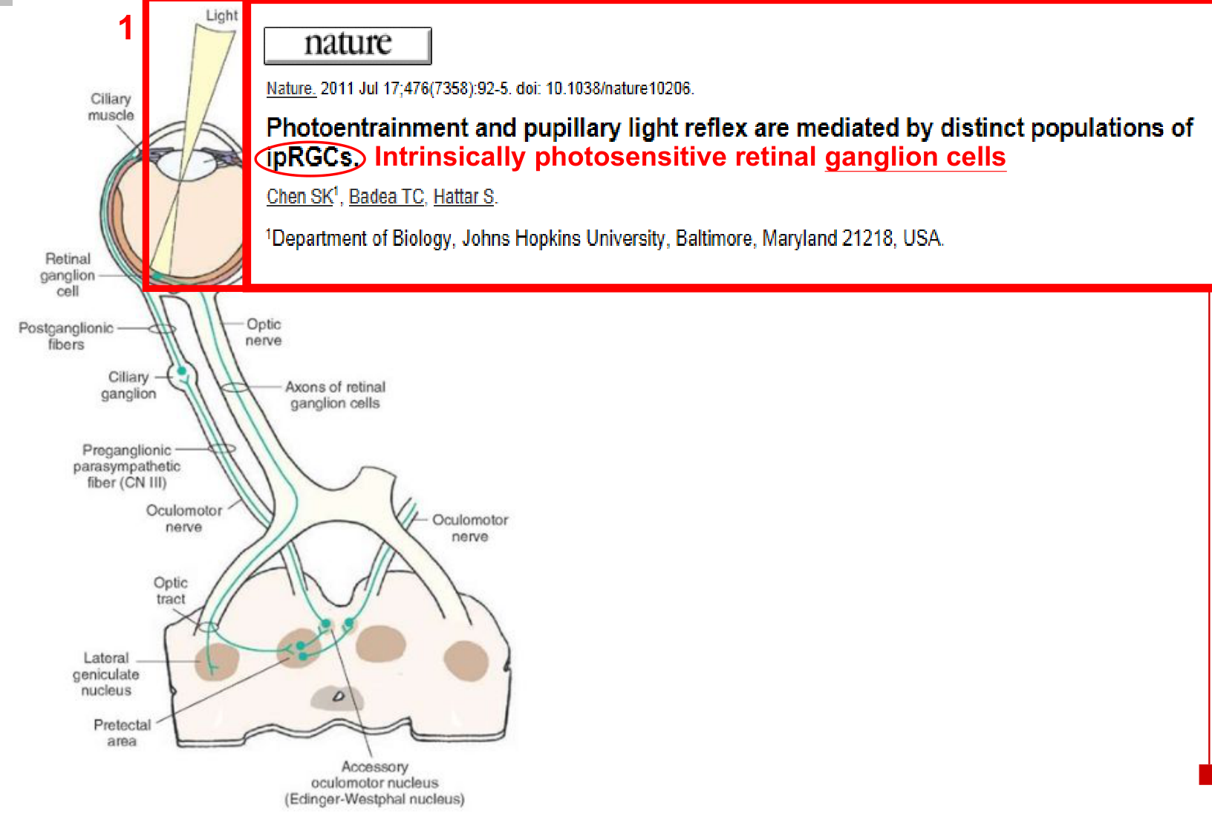
• Intrinsically photosensitive retinal ganglion cells (ipRGCs) contribute to the light signal controlling the pupil.
• The effector is the pupillary constrictor (sphincter pupillae), the circular muscle of the iris.
• Circular muscle contraction constricts the pupil; radial muscle contraction dilates it.

14 Pupillary circuit: why both eyes respond
Light in one eye → retina → CN II → optic chiasm / optic tract
→ pretectal nucleus in midbrain
→ BOTH Edinger–Westphal nuclei (accessory oculomotor nuclei)
→ each CN III carries preganglionic parasympathetic fibres
→ ciliary ganglion → postganglionic fibres through short ciliary nerves
→ sphincter pupillae contracts in both eyes

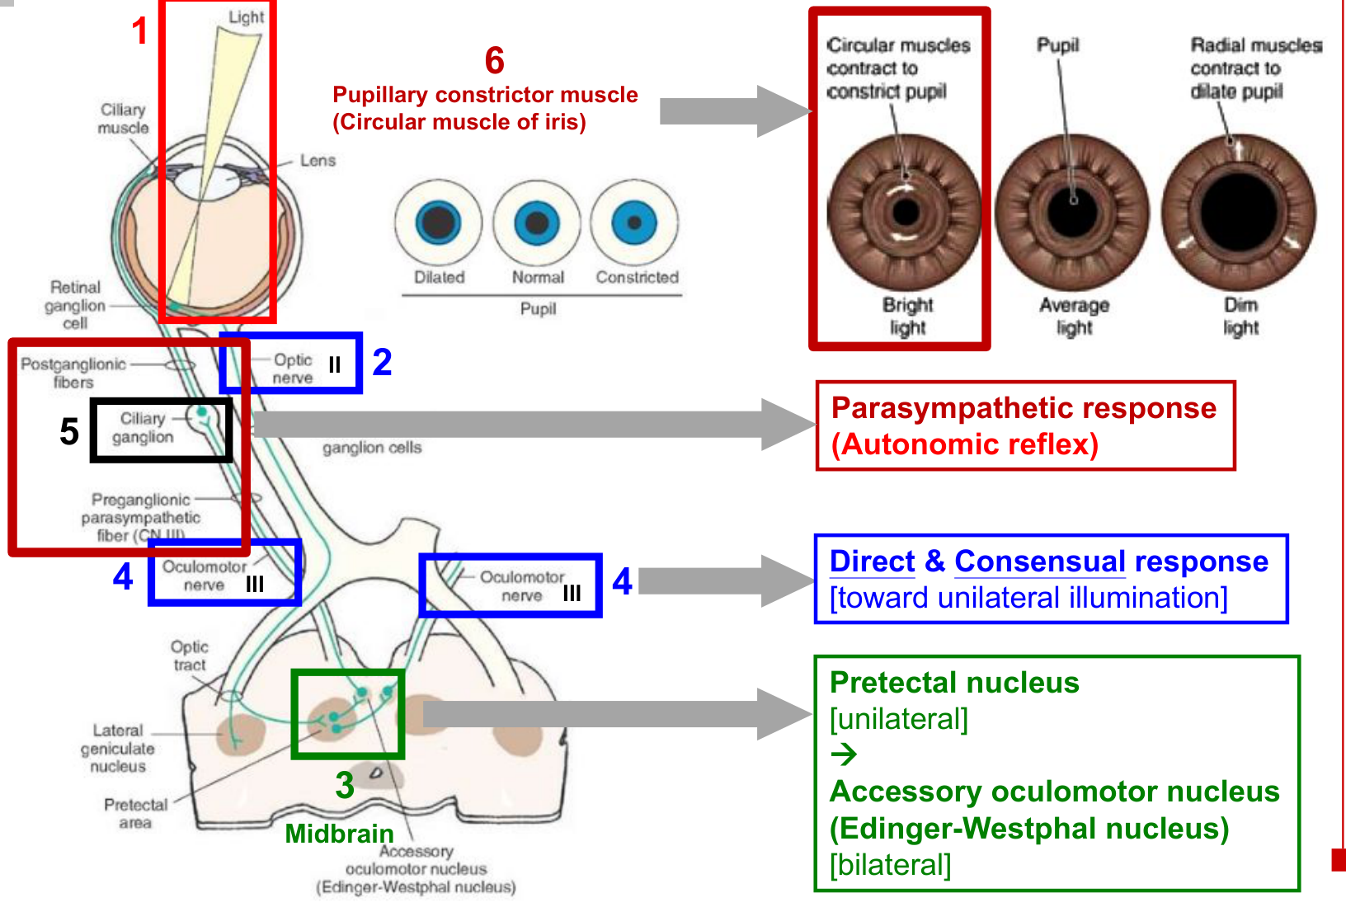
Response | Meaning
Direct response | Constriction of the illuminated eye.
Consensual response | Constriction of the opposite, non-illuminated eye.

• The bilateral projection to Edinger–Westphal nuclei explains the paired response to unilateral illumination.
• CN II is the afferent limb; CN III is the efferent parasympathetic limb. The ciliary ganglion is the peripheral relay before the iris.

15 Pupillary defects: test each eye
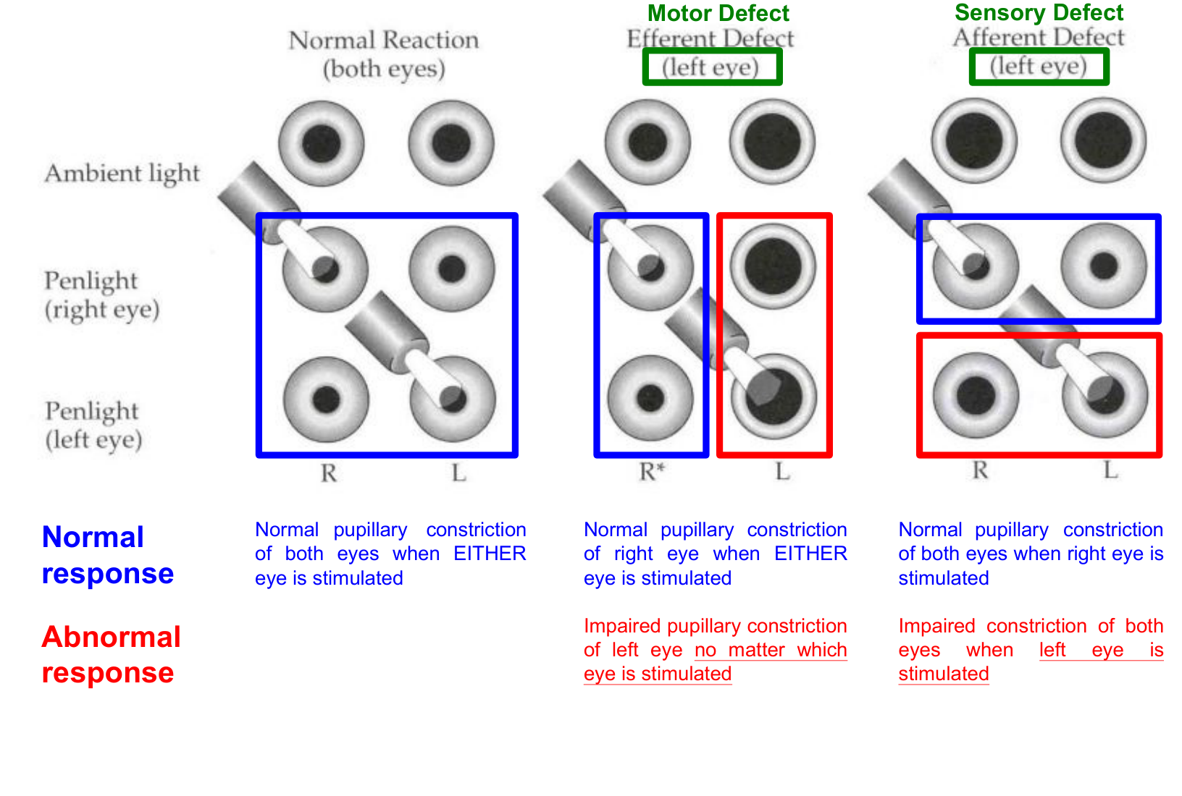
Condition | Light in RIGHT eye | Light in LEFT eye
Normal | Both pupils constrict. | Both pupils constrict.
LEFT sensory / afferent defect | Both pupils constrict: right input reaches both motor pathways. | Constriction of both pupils is impaired: left sensory input is defective.
LEFT motor / efferent defect | Right pupil constricts; left constriction is impaired. | Right pupil constricts; left constriction is impaired.

Reason through the circuit
• Afferent defect: the effect depends on which eye receives the light. Input from the affected eye cannot adequately drive either side.
• Efferent defect: the effect depends on which pupil must constrict. The affected pupil responds poorly regardless of the illuminated eye.
Both pupils fail when one eye is illuminated → suspect that eye’s sensory limb.
One pupil fails whichever eye is illuminated → suspect that pupil’s motor limb.

These patterns describe an isolated left-sided defect; a partial lesion may impair rather than completely abolish constriction.

16 Chemoreceptor reflex
Blood CO₂ ↑ / O₂ ↓ / pH ↓ → chemoreceptor activation
→ carotid body via glossopharyngeal nerve (CN IX)
+ aortic body via vagus nerve (CN X)
→ medullary cardiovascular centres
→ parasympathetic activity ↓ + sympathetic activity ↑
→ heart rate ↑ + contraction force ↑ + vasoconstriction

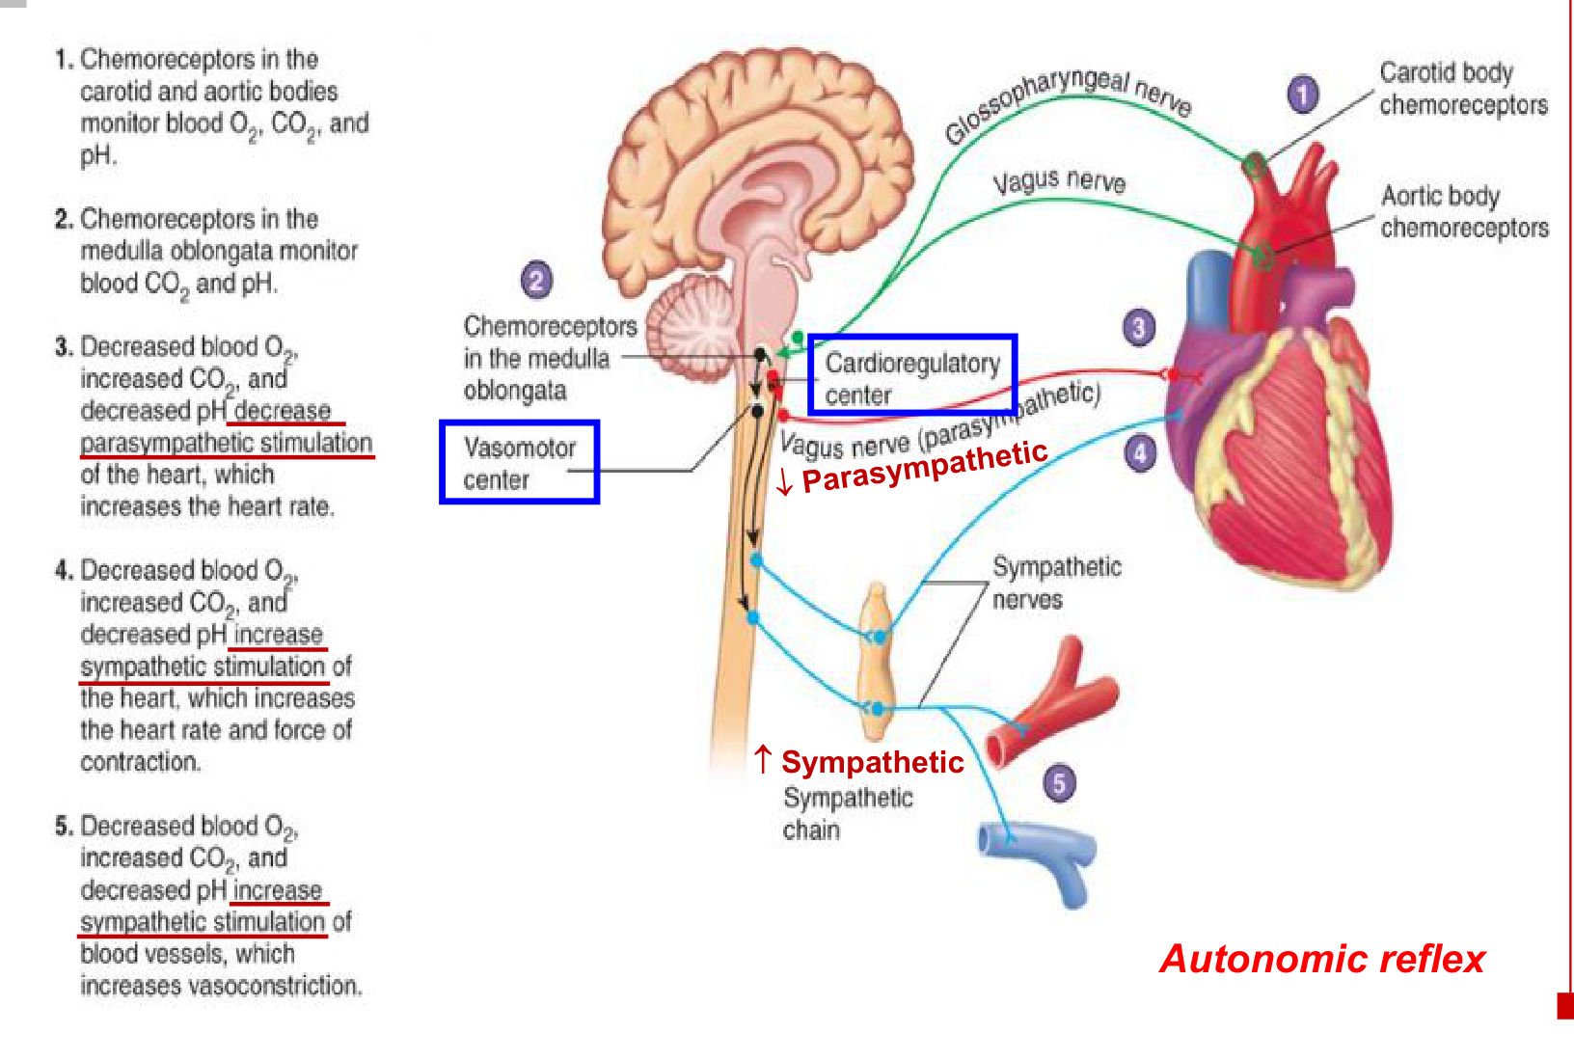
Sensor / centre | Key distinction
Peripheral chemoreceptors | Carotid and aortic bodies detect changes in blood gases / pH.
Central chemoreceptors | Located in the medulla; respond mainly to CO₂-driven changes in local H⁺ / pH.
Medullary output | Cardioregulatory centre controls cardiac autonomic activity; vasomotor centre controls vascular sympathetic activity.

Body = chemical sensing; carotid sinus / aortic arch = pressure sensing. Cardiovascular and respiratory responses together support blood-gas homeostasis.

17 Baroreceptor reflex: negative feedback
Blood pressure ↑ → arterial wall stretch ↑ → baroreceptor firing ↑
→ carotid sinus via CN IX + aortic arch via CN X
→ medulla → parasympathetic activity ↑ + sympathetic activity ↓
→ heart rate ↓ + vasodilation → blood pressure ↓ toward normal

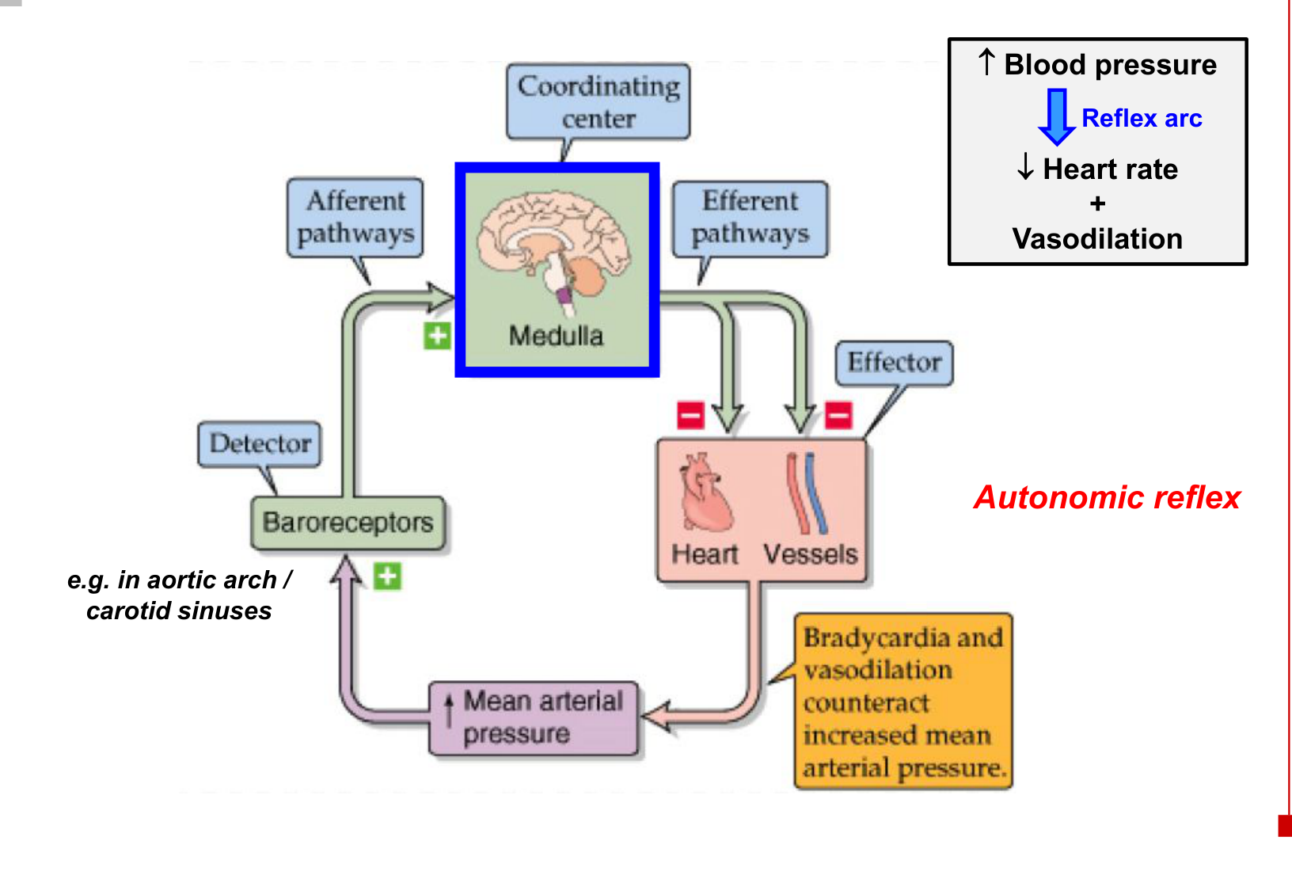
Negative feedback: pressure returns toward normal
→ excessive receptor stretch / afferent firing subsides
→ the corrective autonomic response diminishes.

Compare | Chemoreceptor reflex | Baroreceptor reflex (BP rise)
Initial stimulus | CO₂ ↑ / O₂ ↓ / pH ↓ | Blood pressure / stretch ↑
Autonomic change | Parasympathetic ↓; sympathetic ↑ | Parasympathetic ↑; sympathetic ↓
Cardiovascular effect | Heart rate ↑; vasoconstriction | Heart rate ↓; vasodilation

• Vasodilation here follows reduced sympathetic vasoconstrictor drive; increased parasympathetic activity slows the heart.

18 Short reflexes & the enteric nervous system
Internal GI stimulus → chemoreceptor / osmoreceptor / mechanoreceptor
→ sensory neuron → local intrinsic nerve plexus (“gut brain”)
→ local motor output → smooth muscle or gland
→ contractile or secretory activity changes

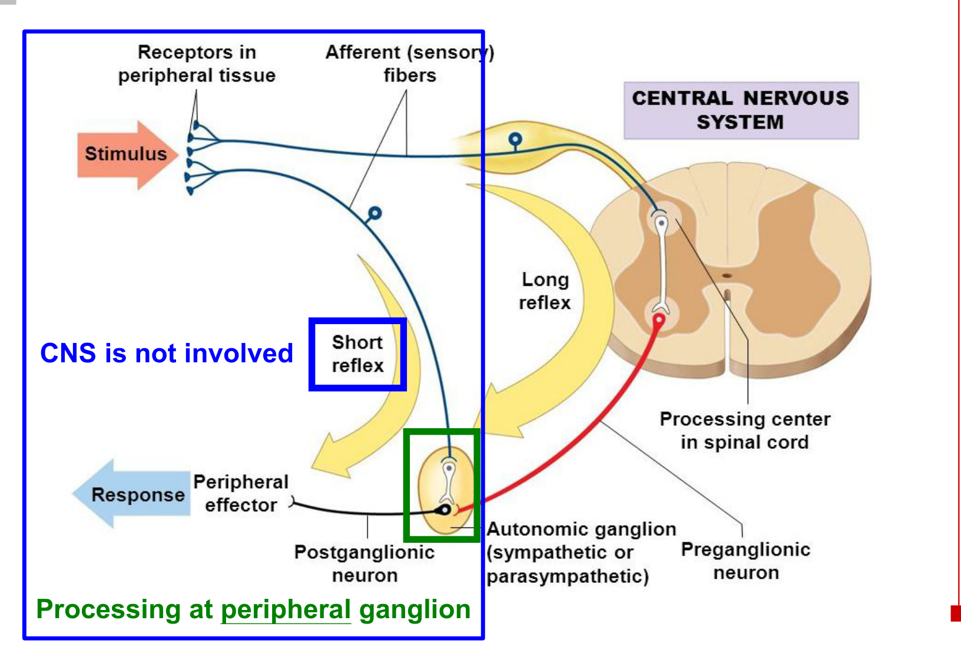  Peripheral integration vs a CNS loop | 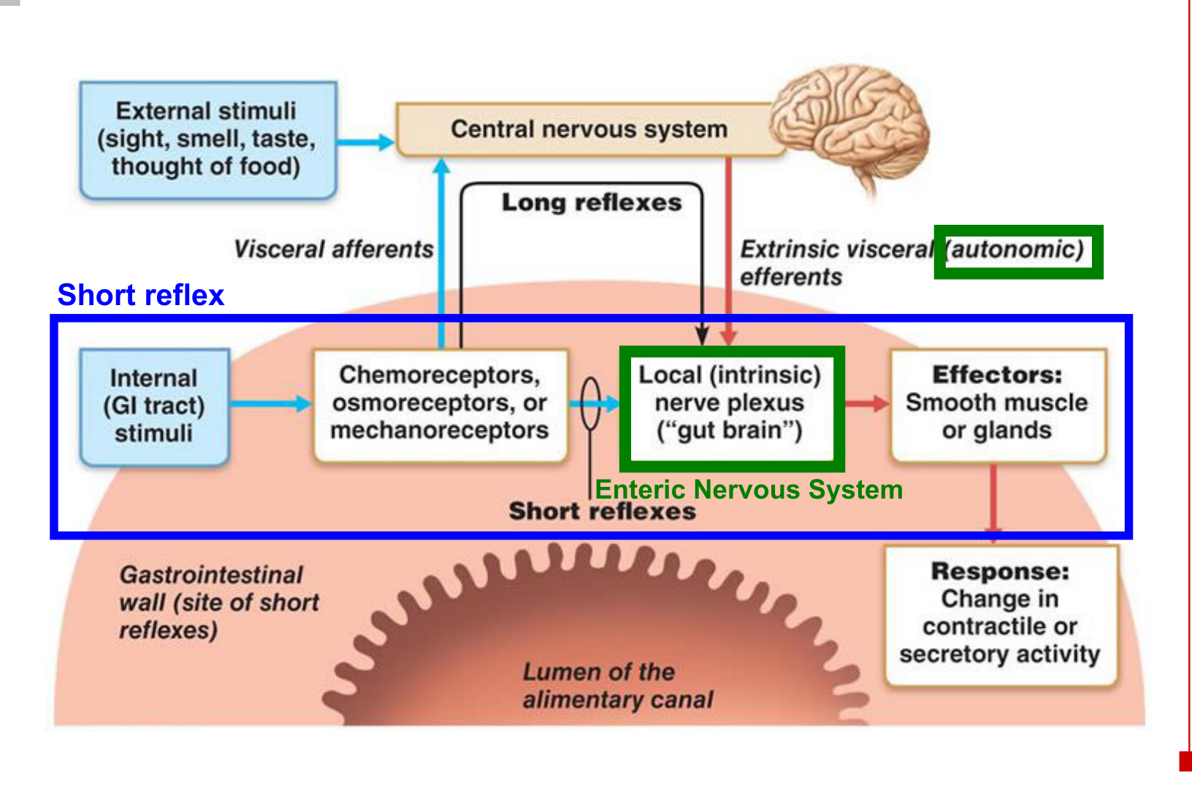  Local enteric control and long reflex inputs

Feature | Short reflex | Long reflex
Integration | Peripheral ganglia / local nerve plexus | CNS
CNS required in the reflex arc? | No | Yes
GI examples of input | Local mechanical, osmotic or chemical changes | Visceral afferents; external stimuli such as sight, smell, taste or thought of food
Output | Local enteric neurons → smooth muscle / glands | Extrinsic autonomic output → enteric circuits / effectors

• An enteric short reflex can be completed locally while longer autonomic pathways modulate GI activity.

19 Functions of reflexes
Function | Examples and outcome
Balance & posture | Stretch reflex; flexor and crossed-extensor reflexes; vestibulospinal reflex → maintain position and support.
Protection | Golgi tendon reflex; withdrawal reflex → regulate tension and withdraw from harmful stimulation.
Digestive & renal functions | Defecation reflex; micturition reflex → coordinate visceral emptying.
Automatic actions | Pupillary light reflex; reflexes involved in deglutition (swallowing), coughing and sneezing.
Homeostasis | Chemoreceptor and baroreceptor reflexes → support blood-gas and blood-pressure control.
Coordination of complex movements | Vestibulo-ocular reflex → coordinates eye movement.

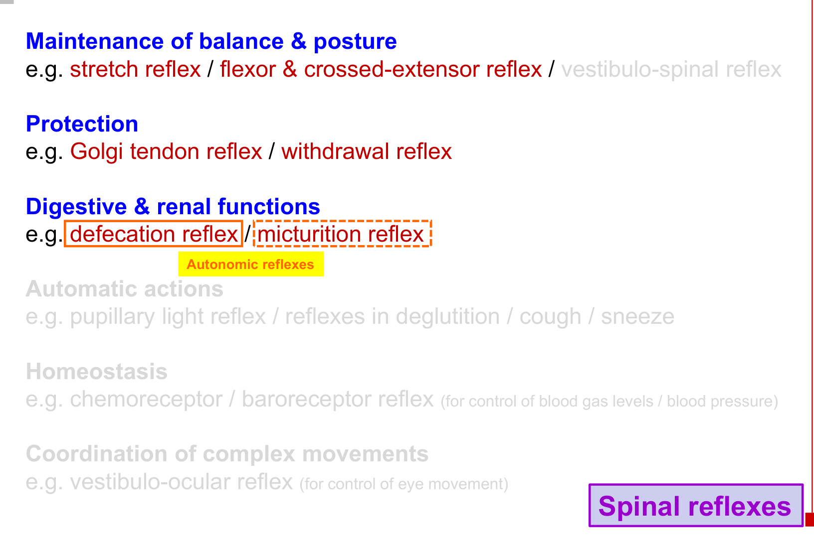  Spinal reflex examples | 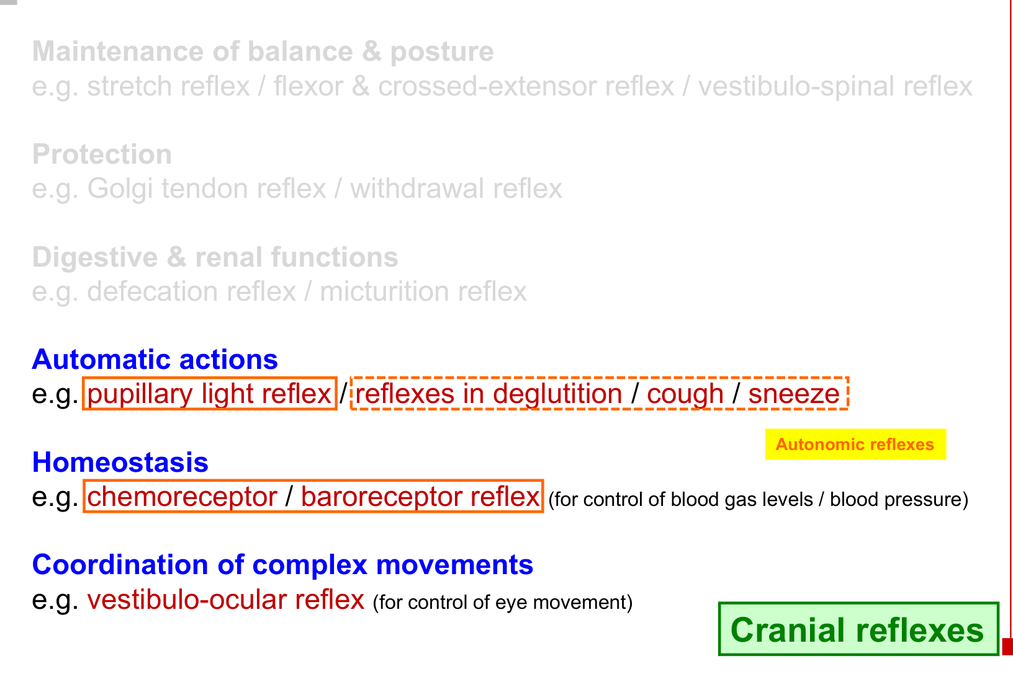  Cranial reflex examples

Keep the classification axes separate
• “Spinal / cranial” describes the integration site.
• “Somatic / autonomic” describes the motor system and effector.
• A spinal reflex can include autonomic output: defecation and micturition.
• A reflex can be automatic even when its effector is skeletal muscle: stretch and withdrawal reflexes.

20 Integrated pathway revision
Reflex | Receptor → integration → output | Key effect
Stretch | Muscle spindle → Ia → spinal monosynaptic excitation → α motor neuron ↑ | Same muscle contracts.
Golgi tendon | Golgi tendon organ → Ib → spinal interneuron circuit → α motor neuron ↓ | Same muscle relaxes.
Withdrawal | Pain receptor → spinal polysynaptic circuit → ipsilateral flexor ↑ / extensor ↓ | Stimulated limb withdraws.
Crossed extensor | Pain input → crossing spinal interneurons → contralateral extensor ↑ / flexor ↓ | Opposite limb supports weight.
Plantar | Cutaneous input → spinal circuit under descending control | Adult toes flex normally.
Defecation | Rectal stretch → spinal cord → parasympathetic output | Rectum / sigmoid contract; internal anal sphincter relaxes.
Micturition | Bladder stretch → spinal cord → parasympathetic output | Bladder contracts; internal urethral sphincter relaxes.
Pupillary light | Retina → II → midbrain → bilateral III / ciliary ganglia | Direct + consensual constriction.
Chemoreceptor | Blood-gas / pH change → IX / X → medulla → autonomic adjustment | Heart rate ↑; vasoconstriction.
Baroreceptor | Pressure ↑ → IX / X → medulla → vagal ↑ / sympathetic ↓ | Heart rate ↓; vasodilation.
Enteric short | Local GI receptors → intrinsic plexus → smooth muscle / glands | Local motility / secretion changes.

Six distinctions to retain
• Ia vs Ib: spindle stretch input vs tendon tension input.
• α vs γ: extrafusal force vs intrafusal sensitivity.
• Coactivation vs loop: simultaneous descending drive vs γ → spindle → Ia → α.
• Ipsilateral vs contralateral: withdrawal side vs supporting side.
• Sensory vs motor pupil defect: illuminated eye determines failure vs affected pupil determines failure.
• Short vs long: peripheral integration vs CNS integration.

