STRATEGIC RESEARCH REPORT
Why the Traditional MSP and TSP Business Model Is Becoming Obsolete
An evidence-based strategic assessment of viability, value migration and reinvention through 2030–2036

Prepared for
MSP owners • Microsoft partners • technology-service executives • boards • private-equity investors
Evidence cutoff
30 September 2026
Board conclusion: managed services remains viable; the labor-dependent, task-centric delivery model does not remain strategically safe. The likely future is value migration, margin divergence and consolidation—not universal extinction.

Contents
1. Executive Summary
2. Research Methodology
3. Key Findings
4. Evidence and Source Citations
5. Market Analysis
6. Financial Analysis
7. Microsoft Strategy Analysis
8. AI Impact Analysis
9. Future Industry Scenarios
10. Transformation Framework
11. Recommended Actions
12. Risks and Counterarguments
13. Final Conclusions
14. Complete Reference List
1. Executive Summary
1.1 Board-level answer
The traditional MSP/TSP model is not yet obsolete as a category, and the available evidence does not support a forecast of universal failure by 2030. Participating MSPs in Service Leadership's 2026 benchmark reported 9.6% revenue growth and 17.1% adjusted-EBITDA growth for 2025, while Omdia forecast global managed-services spending growth of 13% in 2025. Those observations are inconsistent with a blanket collapse thesis. [1] [3]
The evidence does support a more important and investable thesis: economic value is migrating away from repetitive administration, human ticket handling, first-line troubleshooting, routine monitoring and undifferentiated product resale. Gartner forecasts only 5.3% growth in IT-services spending in 2026 versus 15.5% for software and 29.3% for infrastructure as a service. ISG's Q2 2026 index likewise reported managed-services annual contract value up 2.7%, compared with 65% growth in cloud-based as-a-service ACV; its population is large contracts, not SMB MSPs, but the reallocation signal is clear. [4] [5]
The central conclusion is therefore selective obsolescence. A per-user contract can remain attractive if delivery is automated and the customer is buying resilience, security, governance and business outcomes. The vulnerable model is a fixed-fee promise whose cost base still behaves like time and materials, whose differentiation is ticket volume and responsiveness, and whose gross margin depends on repeatedly selling scarce human attention.
1.2 What changes the economics
AI assistance has already demonstrated material productivity effects in customer support. A field study of 5,179 support agents found 14% more issues resolved per hour overall and 34% among novice and lower-skilled agents. That is evidence of task augmentation at one company, not proof that 14% of MSP payroll disappears. Gartner separately forecasts that agentic AI could autonomously resolve 80% of common customer-service issues by 2029 and reduce operational costs by 30%, but those are analyst forecasts with different denominators, not MSP staffing forecasts. Gartner also expects more than 40% of agentic-AI projects to be cancelled by the end of 2027 because of cost, unclear value or inadequate risk controls. [6] [7] [8]
This combination matters. If automation raises throughput while customer prices remain unchanged, a well-run fixed-fee MSP can expand gross margin. If competitors and customers demand the productivity dividend through lower prices, if the provider fails to remove or redeploy capacity, or if AI consumption and oversight costs rise, the same automation can compress revenue faster than cost. AI is thus a margin opportunity and a price-reset mechanism.
Microsoft, AWS, Google Cloud, ServiceNow and security vendors are building capabilities directly into the platforms customers already buy. Microsoft is integrating Copilot, agents, security and business applications; AWS's generally available DevOps Agent investigates and triages operational events; Google Cloud is adding proactive Cloud Assist capabilities; and ServiceNow is productizing Level-1 service-desk work. These products do not eliminate configuration, identity, data readiness, change management, exception handling or accountability. They do, however, move the boundary between product and service. [18] [20] [25] [27] [28]
1.3 The skeptical owner's decision
A successful conventional MSP should not abandon a profitable recurring book. It should stop treating current profitability as proof that the operating model is durable. The correct response is a measured transition:
- instrument service-line economics, including cost per correctly resolved ticket, automation cost, reopen rate and price retention;
- automate internally before selling AI transformation externally;
- narrow commodity scope and standardize aggressively;
- build repeatable security, identity, compliance, data and AI-governance services;
- change commercial architecture so customers buy managed outcomes and platforms rather than evidence of human effort;
- preserve cash for a two- to three-year transition J-curve.
The illustrative financial model in this report starts with a $5.0 million net-service-revenue MSP, 30 employees and 16.0% EBITDA. By 2030, the no-change case remains profitable but falls to 7.7% EBITDA; staged transformation reaches $6.58 million revenue and 16.9% adjusted EBITDA; successful transformation reaches $7.87 million and 22.6%; severe disruption produces $3.73 million and negative EBITDA. These are conditional planning cases, not industry forecasts.
2. Research Methodology
2.1 Research question and definitions
The question is whether a traditional MSP/TSP model becomes economically or strategically unsustainable over the next three to ten years. Traditional means meaningful dependence on per-user or per-device bundles, human help-desk throughput, reactive support, infrastructure administration, monitoring, fixed-fee support and resale economics. The definition does not assume that per-seat pricing itself is defective; it separates the billing unit from the delivery engine and value proposition.
The evidence cutoff is 30 September 2026. The near-term horizon is 2030 and the strategic horizon is 2033–2036. Geography is mixed because the best evidence includes global vendor strategy, global analyst forecasts, US labor data, OECD SME surveys and EU regulation. Each statistic retains its own population.
2.2 Evidence hierarchy
Priority was given to original corporate financial releases, official product documentation, government statistics, regulation, peer-reviewed or working-paper research with an identifiable design, and analyst releases that state their forecast. Vendor sources are used to establish product capability and commercial direction, not independent savings. Surveys are used with their sample and self-report limitations. Gated analyst abstracts are not treated as if the full paid report had been reviewed.
The report distinguishes six evidence classes:
- observed results, such as reported company or benchmark performance;
- empirical studies with a stated sample and design;
- surveys of expectations or adoption;
- analyst forecasts;
- vendor capabilities and product status;
- analytical assumptions used in the financial and cohort models.
2.3 Analytical discipline and limitations
Task automation is not payroll reduction. The chain is: technical task exposure, successful automation, quality-adjusted time saved, released capacity, realized cash savings or new revenue, customer repricing, and net margin after software, governance and transition costs. Every model output in this report follows that chain conceptually.
No verified longitudinal global census was found that tracks MSP entries, failures, acquisitions and exits. The percentage estimates in section 9 are explicitly an analyst planning illustration. They are not measured failure rates. Similarly, no representative study was found that links MSP AI adoption to audited service quality, staffing, renewal pricing and realized cash margin over time. That is the most important evidence gap.
3. Key Findings
Finding | Evidence | Board implication
Managed services is not disappearing | Participating MSP revenue grew 9.6% in 2025; Omdia forecast 13% global managed-services spending growth in 2025. [1] [3] | Do not confuse model disruption with market extinction.
Value is migrating faster than demand | Gartner forecasts 2026 software and IaaS spending growth far above IT services; ISG shows much faster XaaS than managed-services ACV growth. [4] [5] | Revenue growth can coexist with declining relevance and pricing power.
Routine support work is economically exposed | NBER support productivity rose 14% overall and 34% for novice/lower-skilled agents; vendors now offer bounded autonomous service and operations functions. [8] [25] [28] | L1, triage, documentation and monitoring should be redesigned now.
The pricing unit is not the real problem | Fixed-fee economics improve when the provider keeps efficiency; they deteriorate when price falls before cost. | Replace a labor story with an outcome and risk story; retain simple billing where useful.
Microsoft both enables and disintermediates | Copilot, Agent 365, security integration and platform governance create partner work while absorbing administration. [17] [18] [20] [23] [24] | Build around the control plane; do not compete with it on commodity tasks.
Security is attractive but not automatically defensible | Security spending is growing, security labor demand is strong, and vendor MDR is increasingly packaged. [10] [29] [38] | Sell accountable response, identity and assurance, not alert forwarding.
Transformation has a cash J-curve | New capabilities require training, tooling, product management and sales before recurring revenue scales. | A weak balance sheet can fail during the right strategy.
The likely outcome is bifurcation | Standardized, automated specialists and scaled consolidators gain; labor-heavy generalists lose margin or sell. | Strategy should be judged by service mix, automation capture and defensibility, not revenue alone.

4. Evidence and Source Citations
4.1 Evidence anchors
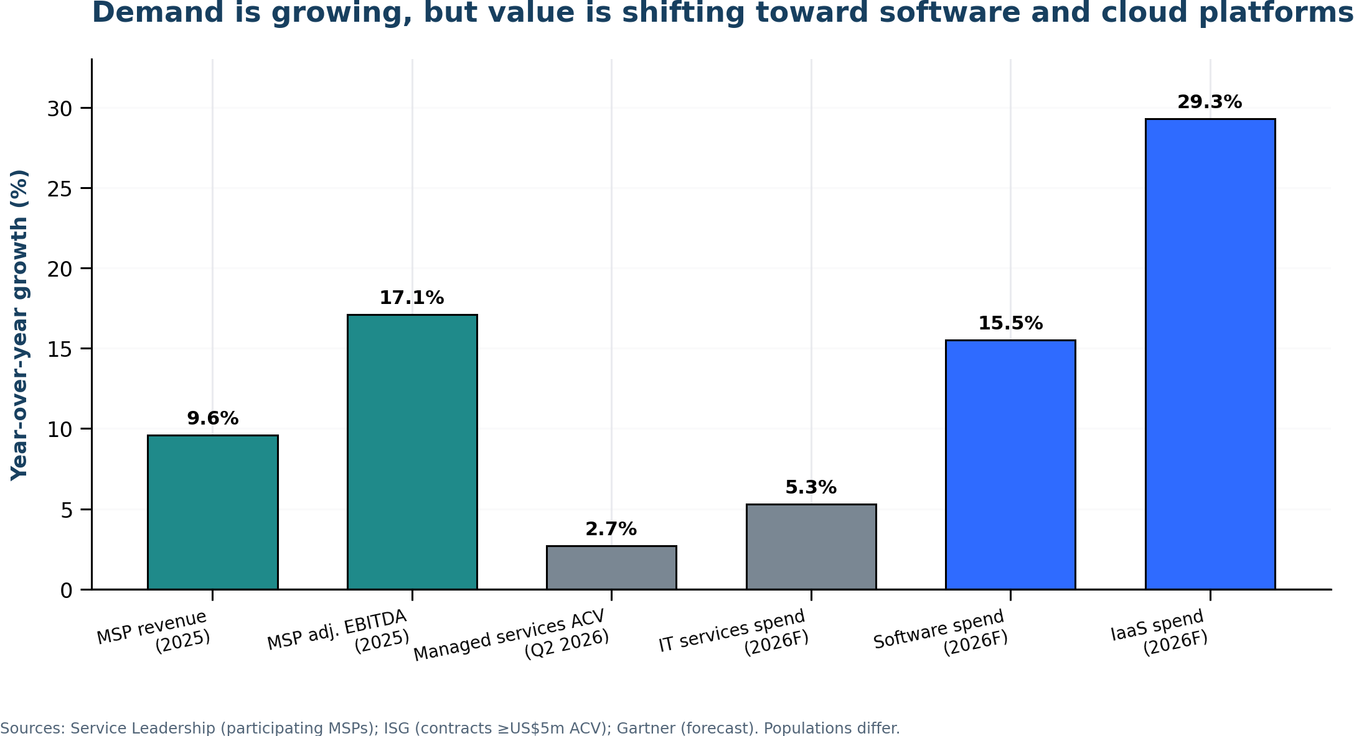
Figure 1. Demand remains positive, but published growth rates point toward value concentration in software and cloud platforms.
The metrics in Figure 1 are not directly comparable populations. Service Leadership reports participating providers; ISG tracks commercial outsourcing contracts with ACV of at least $5 million; Gartner publishes global spending forecasts. The chart is a directional mosaic, not a pooled estimate. [1] [4] [5]
Other evidence anchors are similarly bounded:
- The NBER study demonstrates assistance in one customer-support environment, not autonomous multi-client IT operations. [8]
- Gartner's 80% common-issue forecast is about issue resolution, not the share of a provider's revenue or payroll. [6]
- The US Bureau of Labor Statistics projects computer-support-specialist employment down 3% and information-security-analyst employment up 21% over 2025–2035; both are economy-wide occupations, not MSP-specific headcount forecasts. [9] [10]
- OECD found generative AI in use at 31% of surveyed SMEs across seven countries in 2024, with performance benefits and skills, legal and regulatory concerns. The survey did not include the United States and did not measure MSP displacement. [12]
- McKinsey's 2026 survey reports that 37% of respondents attribute some EBIT impact to AI; 14% reported workforce reductions in the prior year while 39% expected reductions in the next year. Expectations should not be substituted for realized outcomes. [13]
4.2 What the evidence does not establish
The source base does not establish that every MSP will face price deflation, that security specialists universally earn higher margins, that autonomous agents can safely run every customer estate, or that partner channels will be eliminated. It does establish that the technical boundary is moving, that customers can compare providers against platform-native capabilities, and that AI economics are creating new price and productivity expectations. The investment case must therefore be conditional.
5. Market Analysis
5.1 Is the traditional model fundamentally broken?
Not in the accounting sense today. A standardized MSP with disciplined scope, mature tooling, strong customer retention and fixed fees can still produce attractive recurring cash flow. Service Leadership's participating-provider results are the strongest counter-evidence to universal obsolescence. [1] [2]
The model is increasingly vulnerable in five structural ways.
5.1.1 Labor dependence
Service delivery scales by adding scarce people when processes and tools do not. Revenue per employee can rise through price, product pass-through or acquisition without true productivity. The important metrics are net service revenue per employee, direct labor as a share of service revenue, correct resolutions per paid hour, and gross margin by line.
US labor projections reinforce the direction of travel: support employment is projected to contract modestly while information-security employment grows rapidly. The market is not eliminating technical labor; it is repricing the mix of technical labor. [9] [10]
5.1.2 Commoditization and standardization
Remote monitoring, patching, endpoint policy, backup alerts, password resets, routine Microsoft 365 administration and common troubleshooting are increasingly standardized. Standardization benefits efficient MSPs first, but it also makes tasks easier for vendors and new entrants to automate. What once required proprietary process knowledge can become a platform feature.
5.1.3 Fixed-fee asymmetry
Fixed fees create operating leverage in both directions. Automation that reduces cost while price holds creates margin. Wage inflation, scope creep, security obligations and rising tool costs create negative leverage if price is fixed. The risk is highest when contracts promise broad outcomes but delivery remains manual and exception-heavy.
5.1.4 Competitive reset
Gartner's 2026 spending forecast describes a market in which growth is concentrated in software, infrastructure and AI. Bain argues that AI has repriced the technology-services sector as buyers expect providers to deliver more efficiently and tie value to outcomes. Forrester's 2026 technology-services outlook similarly emphasizes AI/data services, relationships and outcome-oriented commercial models. [5] [15] [36]
5.1.5 Scale limitations
A generalist MSP must cover an expanding control surface: identity, endpoint, cloud, SaaS, data, security, compliance and now agents. Small providers cannot economically own deep 24x7 expertise in every domain. They must standardize a narrow stack, partner for pooled capabilities, specialize by vertical or consolidate.
5.2 Customer buying behavior
Customer expectations are moving from labor to measurable outcomes, but the pace differs by segment. Large buyers already demand automation credits, productivity commitments, benchmarked pricing and access to provider intellectual property. SMEs often continue to value trust, responsiveness and a single accountable party; OECD's 31% adoption rate shows meaningful GenAI use but also a large adoption gap. [12] [15]
The practical customer shift is:
From | Toward | Commercial consequence
Ticket closure | Prevented incidents and business availability | Price on service level, risk and resilience.
Device administration | Automated policy and lifecycle management | Bundle platform operations, not technician activity.
Infrastructure strategy | Data, AI, identity and business-process strategy | Add advisory and transformation capacity.
Security tooling | Managed detection, response and assurance | Accept defined response authority and evidence obligations.
Training events | Continuous adoption and workflow change | Sell managed adoption with usage and outcome metrics.
Projects billed by hour | Repeatable deployment and outcome packages | Convert methods into productized intellectual property.

Customers will not universally demand pure outcome pricing; many outcomes depend on customer behavior and external events. The more durable architecture is hybrid: a platform or access fee, consumption or complexity bands, service-level commitments, and outcome incentives with explicit exclusions.
5.3 Hyperscaler and SaaS disintermediation
Hyperscalers are not simply replacing MSPs; they are absorbing bounded layers of the stack.
AWS DevOps Agent is generally available and is described as investigating incidents, triaging operational events and handling defined SRE tasks. AWS Managed Services separately offers monitoring, incident management, patching and other infrastructure operations within a documented responsibility model. Those offerings reduce the space for undifferentiated cloud operations while leaving architecture, application ownership, governance and multi-cloud integration. [25] [26]
Google Cloud's Gemini Cloud Assist supports investigation and proactive modes, with availability and permissions varying by capability. At the evidence cutoff, important proactive functions were still bounded by preview or support-tier conditions. That is meaningful substitution, not proof of universal autonomous remediation. [27]
ServiceNow's Autonomous Workforce includes domain-specific AI specialists and has explicitly targeted Level-1 service-desk work. A customer with mature knowledge, workflow and identity data can increasingly buy resolution from the platform. The provider's opportunity moves to process design, data quality, integration, governance and exception ownership. [28]
The result is progressive disintermediation: product vendors capture more of the routine execution margin while capable partners capture integration, control, assurance and adoption value. Providers that sell access to vendor features without adding measurable service are most exposed.
5.4 Security as a managed service
Security is the strongest adjacent growth opportunity and one of the easiest to misprice. Gartner expects worldwide information-security spending to reach $244 billion in 2026, up 11.6% in constant currency. US information-security-analyst employment is projected to grow 21% from 2025 to 2035. [10] [38]
Demand does not guarantee provider advantage. Microsoft and other vendors are embedding AI-assisted triage; CrowdStrike sells a 24x7 MDR service that combines machine-speed automation and human experts; and platform vendors can sell managed response directly or through partners. Basic alert forwarding and quarterly report generation are therefore vulnerable. [22] [29] [42]
Defensible managed security has five characteristics:
- pooled expertise and continuous coverage that the customer cannot economically reproduce;
- defined authority to investigate, contain or coordinate response;
- identity, endpoint, cloud and SaaS telemetry integration;
- detection engineering, threat hunting and evidence preservation;
- contractual accountability, tested runbooks and board-level assurance.
CISA's joint advisory highlights the systemic risk created by MSP privileged access and recommends controls including MFA, logging, access restriction and clear contractual responsibilities. NIS2 explicitly includes managed service providers in its definitions and sector scope, reinforcing governance and management accountability in applicable jurisdictions. [30] [32]
A small provider should not build a 24x7 SOC merely to claim differentiation. It should compare build, buy and partner models, then own customer context, identity design, governance, incident coordination and assurance. There is no robust evidence that security specialists universally outperform generalists financially; the strategic case is conditional on real capability and accountability.
5.5 Lessons from other industries
Historical parallels support adaptation, not deterministic analogy.
- Hosting providers lost undifferentiated server-management value as IaaS and managed cloud services absorbed provisioning and operations. Rackspace's 2025 results show how mix, debt, pricing and execution can constrain a recognized managed-cloud brand; the filing does not prove AI or cloud automation was the sole cause. [34]
- VARs that depended on product margin migrated toward recurring services, cloud marketplaces and specialization. The survivors changed where they captured value rather than defending resale margin.
- Managed print providers saw device fleets, automation and document digitization reduce traditional volume. Xerox's services-led and IT-solutions transition illustrates the use of acquisition and portfolio change, but acquisition-driven reported growth should be separated from pro-forma organic performance. [40]
- Telecommunications providers survived platform shifts, but voice and access became increasingly commoditized. Value moved to data, enterprise services, managed security and platforms.
- Blockbuster's bankruptcy and later asset sale show how debt and transition timing can turn a strategic shift into an ownership failure. The filings do not establish streaming as the sole cause, but they demonstrate that recognizing a platform shift late is costly when the balance sheet is inflexible. [41]
The MSP lesson is not that every incumbent disappears. It is that category survival can mask severe value migration between layers and owners.
6. Financial Analysis
6.1 Baseline economics
The model represents a currently successful conventional MSP in 2026. Net service revenue excludes $2.0 million of assumed license and hardware pass-through so that service productivity is not flattered by resale accounting.
2026 baseline input | Value
Net service revenue | $5.00m
Direct delivery labor | $1.80m
Tools and subcontractors | $1.00m
Gross profit | $2.20m (44.0%)
Operating expense | $1.40m
Adjusted EBITDA | $0.80m (16.0%)
Total / direct FTE | 30 / 20
Net service revenue per FTE | $166,700

The baseline is a planning input, not an industry median. Its direct labor equals 36% of net service revenue and total delivery cost equals 56%. A company with more pass-through revenue, metropolitan wages, owner add-backs or contractor delivery will not be directly comparable.
The starting service mix is 31% help desk, 18% infrastructure/cloud management, 15% monitoring/RMM/backup, 9% endpoint management, 10% projects/break-fix, 12% security and 5% AI/data/automation. That mix is intentionally conventional.
6.2 Economic mechanism
The model uses five linked drivers:
1. legacy-service price and gross revenue retention;
2. new and expansion volume;
3. growth of security, compliance, AI, data and automation lines;
4. quality-adjusted delivery efficiency and the share converted to cash or new capacity;
5. transition, consumption and governance costs.
The exact assumptions are analyst choices. Their direction is anchored to positive current MSP trading, slower IT-services growth than software/IaaS, observed AI support productivity, agentic execution risk and wage pressure. [1] [4] [5] [7] [8] [9]
6.3 2030 scenarios
Scenario | Revenue | Gross margin | Adjusted EBITDA | Reported EBITDA margin | Interpretation
2026 baseline | $5.00m | 44.0% | $0.80m / 16.0% | 16.0% | Starting input.
Legacy / no change | $5.02m | 39.4% | $0.39m / 7.7% | 7.7% | Still viable, but wage/tool inflation and weak pricing halve profit dollars.
Base / staged transformation | $6.58m | 46.5% | $1.11m / 16.9% | 16.3% | New services reach 36% of revenue after a transition J-curve.
Bull / successful transformation | $7.87m | 51.6% | $1.78m / 22.6% | 22.0% | Strong adoption, price retention and repeatable IP.
Bear / severe disruption | $3.73m | 29.6% | -$0.09m / -2.5% | -3.3% | Price deflation and churn arrive faster than cost removal and new growth.

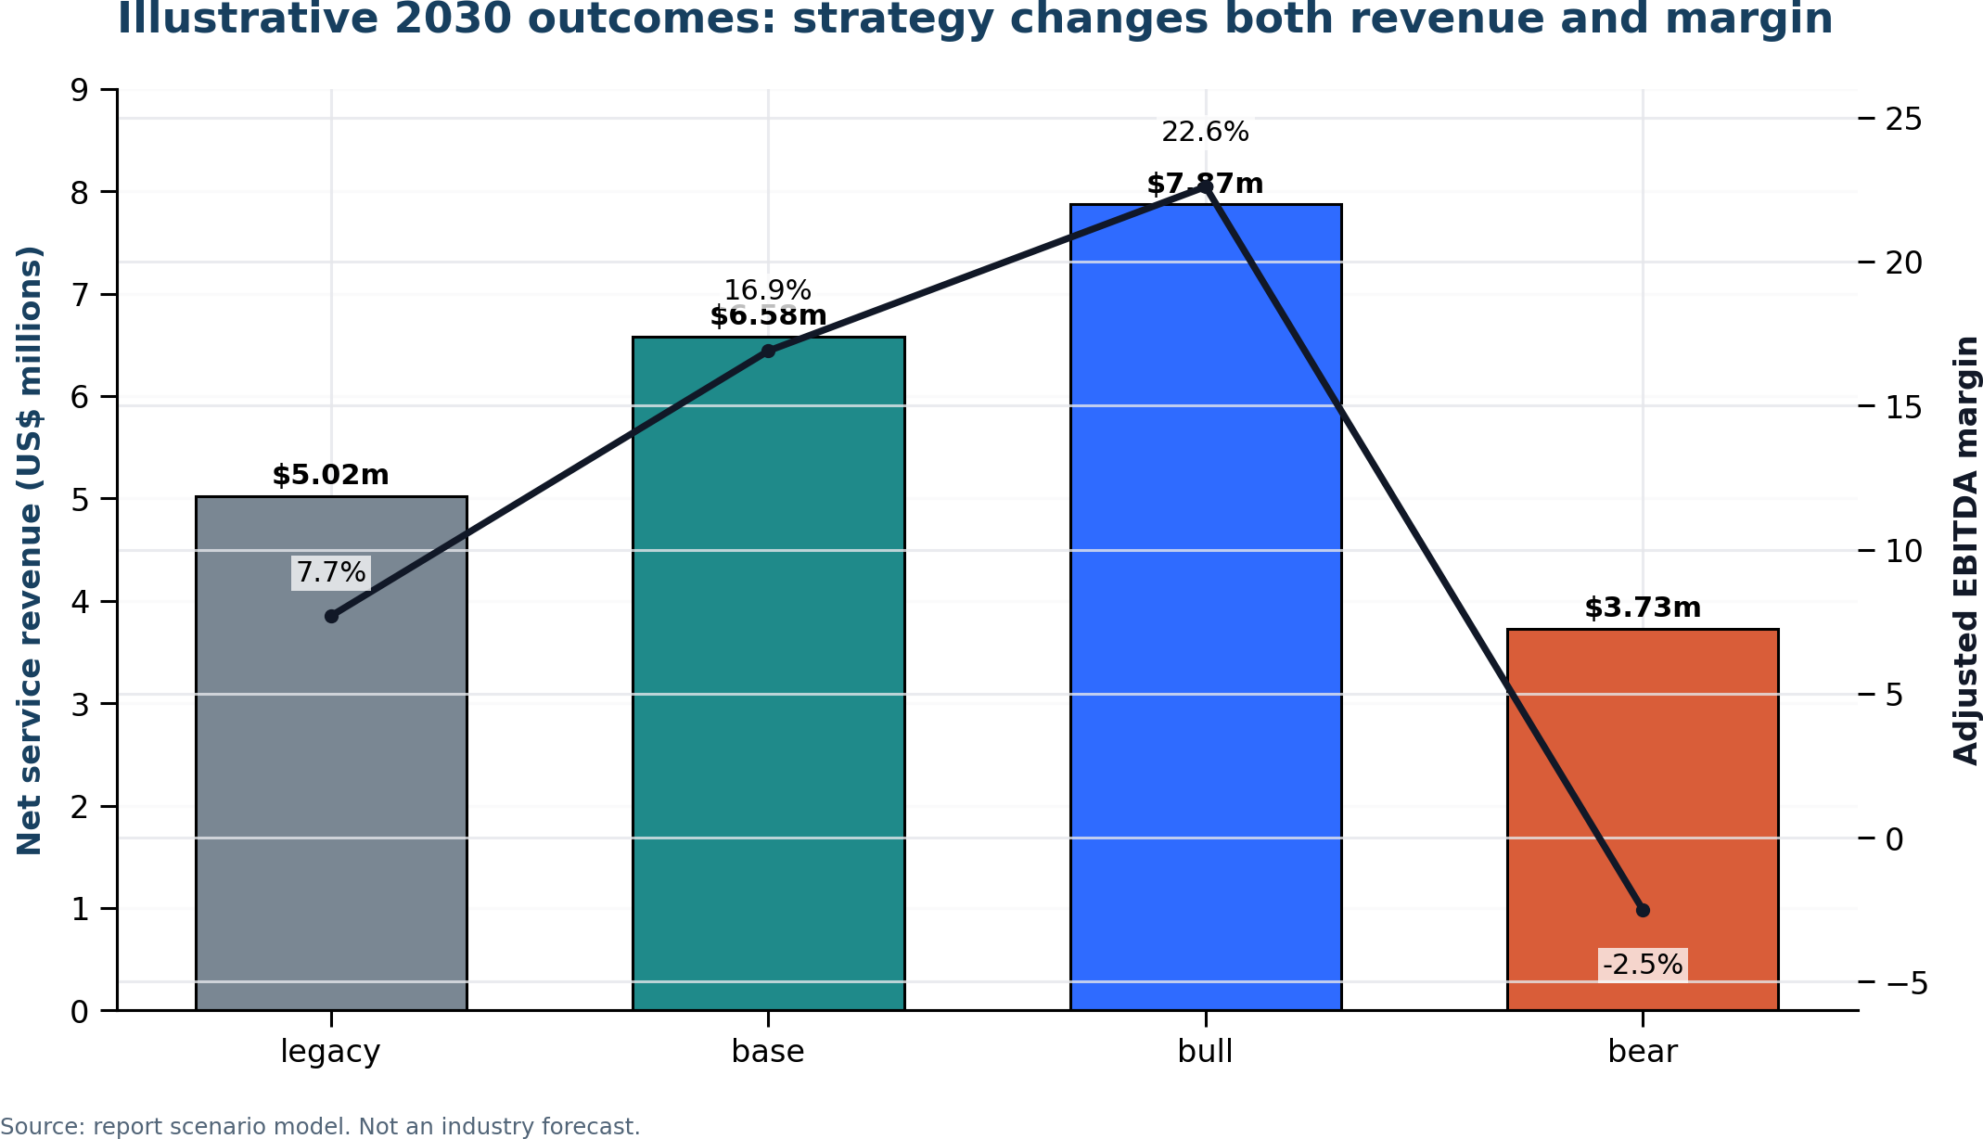
Figure 2. The illustrative 2030 model shows why current revenue alone is a weak indicator of future enterprise value.
The status-quo case is the most important skeptical-owner result: the business does not vanish. It remains profitable, but EBITDA falls by roughly half in dollars. A successful business can therefore become strategically impaired without an abrupt revenue collapse.
6.4 Best-case and worst-case AI economics
Best case
- AI attempts 36% of tickets by 2030 and successfully completes 86% of attempted work within approved scope.
- Assisted work improves technician throughput 20% where applied.
- The provider converts 75% of released capacity into avoided hiring, redeployment or new revenue.
- Customers accept hybrid outcome/platform pricing; commodity price pressure is offset by higher-value services.
- AI consumption, review and governance costs remain controlled.
Under these assumptions, gross margin reaches 51.6% and adjusted EBITDA 22.6%. The model does not assume mass layoffs: FTE increases as revenue grows, while revenue per employee rises to about $241,000.
Worst case
- AI attempts 22% of tickets, but autonomous completion is only 75% and exceptions require expensive review.
- Legacy prices fall 16.9% cumulatively through 2030, retention weakens and growth services remain subscale.
- Only half of released capacity becomes cash or productive growth.
- Consumption, security, insurance and transformation costs rise.
The result is negative EBITDA despite some automation. This is the core warning: technical adoption without commercial capture does not rescue the model.
6.5 Revenue-per-employee and utilization
Revenue per employee is useful only on a consistent net/gross basis. In the model it moves from $166,700 in 2026 to $176,000 in the legacy case, $216,000 in the base case and $241,000 in the bull case. The bear case can also show apparent productivity if headcount is cut after revenue falls. Boards should pair revenue per employee with gross margin, customer retention, service quality and cash conversion.
Traditional utilization metrics become less informative as agents perform work. A better operating set is:
- cost per correctly resolved request;
- incidents prevented per managed unit;
- percentage of work completed without human touch and without reopen;
- human review minutes per automated action;
- customer outcome attainment;
- gross profit per technical labor hour;
- freed capacity converted to cash or growth.
6.6 Valuation implications
No single authoritative private-MSP multiple applies across size, geography, customer concentration, recurring mix and quality. The report therefore uses valuation sensitivity rather than presenting a market multiple as fact.
At the 2026 baseline, applying an illustrative 6.0x EBITDA planning multiple produces enterprise value of $4.8 million. A 2030 legacy case at $0.39 million EBITDA and an illustrative 4.5x multiple produces $1.76 million. The base case at $1.11 million and 7.0x produces $7.77 million; the bull case at $1.78 million and 8.5x produces $15.13 million. These multiples are assumptions used to show operating and quality sensitivity, not observed transaction benchmarks.
The direction is supported by current deal logic: PwC's 2026 M&A outlook emphasizes fewer, larger and more strategic transactions in the AI era, while Service Leadership reported higher enterprise value for the average participating IT solution provider as operating performance improved. Neither source supplies a universal MSP multiple. [1] [35]
Buyers are likely to pay more for repeatable IP, low customer concentration, documented automation, strong net retention, credible security operations, vertical knowledge and clean recurring gross profit. They should discount commodity resale, owner-dependent relationships, unsupported EBITDA add-backs, weak cyber controls, unpriced AI consumption and contracts that make the provider liable for outcomes it cannot control.
6.7 M&A implications
Consolidation is a rational response to capability breadth and 24x7 scale. It can also disguise weak organic economics. Diligence should separate:
- organic service growth from acquired revenue;
- price, seats and product pass-through from volume;
- adjusted EBITDA from cash after capitalized development and restructuring;
- security revenue from actual response capability;
- AI claims from audited workload and margin evidence;
- customer retention from contract duration.
The most attractive targets will not necessarily have the most technicians or tickets. They will have the best data, process control, customer context, vertical distribution and measurable outcome capability.
7. Microsoft Strategy Analysis
7.1 Strategic direction
Microsoft's direction is AI-first, cloud-first and control-plane-centric. Its 2025 annual report described AI as a platform shift across Azure, Microsoft 365, security and business applications. FY2026 revenue reached $331.839 billion; management said Azure exceeded $100 billion in annual revenue and Microsoft 365 Copilot surpassed 30 million paid seats. Management also described a business model combining seats with consumption. [16] [17] [18]
This scale matters because Microsoft can bundle capabilities into existing control planes faster than an MSP can defend a manual service line. The strategic stack is converging around:
- Microsoft 365 Copilot for user assistance and work context;
- Copilot Studio for low-code agent creation and orchestration;
- Agent 365 for agent identity, governance and administration;
- Microsoft Security Copilot and security agents;
- Azure AI/Foundry capabilities and consumption economics;
- Dynamics 365, Power Platform and Dataverse for business-process execution.
7.2 Autonomous operations and service substitution
Copilot Studio guidance supports event-triggered autonomous agents, actions and approval patterns. Microsoft security products increasingly classify, summarize and triage incidents. Administration agents and integrated controls reduce some repetitive setup, investigation and documentation. [20] [21] [22] [42]
The traditional work exposed includes password and access workflows, onboarding checklists, common support answers, policy deployment, phishing triage, service documentation, adoption assistance and selected security investigations. Product availability does not mean every tenant is ready. Identity design, permissions, knowledge quality, data loss prevention, environment strategy, testing and oversight remain material.
7.3 Does Microsoft enable customer self-management?
Yes, at bounded layers. Natural-language interfaces, guided configuration, packaged security and autonomous workflows reduce the expertise required for common actions. Customers with mature internal IT can self-serve more; small customers can obtain more capability from the license bundle.
No, in the sense of eliminating the need for accountable operations. More agents create more identities, permissions, data pathways, consumption, exceptions and governance obligations. The customer still needs someone to design the operating model, integrate systems, supervise automation, measure outcomes and respond when controls fail.
The effect on partners is therefore simultaneous enablement and disintermediation:
Microsoft movement | Traditional work pressured | Partner value that can expand
Copilot embedded in work | Training events, content drafting, basic assistance | Adoption, workflow redesign, measurement, change management
Copilot Studio / agents | Manual workflow execution, simple service requests | Agent design, integration, testing, lifecycle management
Agent 365 control plane | Ad hoc agent inventory and permissions | Managed agent governance, identity, compliance, chargeback
Security integration | Alert review, basic triage and reporting | Detection engineering, incident command, assurance, multi-vendor integration
Seats plus consumption | Static license-only margin | FinOps, capacity management, optimization and managed AI operations
Business-app convergence | Siloed Microsoft 365 administration | Cross-functional process transformation and data services

7.4 Partner-program direction
Microsoft's 2026 partner communications explicitly frame Agent 365 and Microsoft 365 E7 as service opportunities around advisory, adoption, governance, integration and managed services. Partner Center updates also continue to move commerce toward marketplace, consumption, specializations and net-new workload incentives. [23] [24] [39]
The implication is not that Microsoft is abandoning partners. It is changing what a valuable partner does. Routine renewal and administration are less strategically protected than demand creation, deployment quality, security, governance and consumption growth. A partner that remains a license intermediary plus help desk is aligned with the least differentiated layer of the strategy.
7.5 Board conclusion on Microsoft
Microsoft increases the addressable market for capable MSPs while reducing the standalone value of traditional MSP tasks. The winners will make the Microsoft control plane operational for customers; the losers will charge for labor that the control plane increasingly performs.
8. AI Impact Analysis
8.1 Task exposure, not job replacement
The most defensible method is to decompose services into tasks. Technical exposure is the share that tools can plausibly perform; realized labor impact is lower because of exceptions, quality review, customer-specific context and demand growth.
Service activity | 2030 task exposure, analyst range | Likely human role retained | Confidence
Level-1 support and common requests | 70–90% | Exception handling, empathy, approvals, novel diagnosis | High direction / medium magnitude
Level-2 diagnosis | 35–60% | Cross-system reasoning, remediation authority, customer context | Medium
Monitoring and alert triage | 50–80% | Signal engineering, policy, escalation, complex incident ownership | High
Documentation and knowledge maintenance | 60–85% | Validation, architecture decisions, accountability | High
Standard user onboarding/offboarding | 50–75% | Identity design, exception approval, HR/process integration | Medium-high
User training | 30–60% | Change leadership, role-specific workflow redesign, coaching | Medium
Security alert enrichment and phishing triage | 40–70% | Detection engineering, containment authority, forensics | Medium-high
Threat hunting and incident command | 20–40% | Adversarial judgment, legal coordination, executive decisions | Medium-low

These ranges are report judgments informed by empirical support productivity, analyst forecasts and current vendor capabilities; they are not measured industry percentages. [6] [8] [22] [25] [28]
8.2 Level 1 and Level 2 support
Level 1 is exposed because requests are repetitive, documented and permission-bounded. AI can classify, retrieve knowledge, generate communications, execute workflows and update records. The limiting factors are identity, knowledge quality, approval design and the cost of a wrong action.
Level 2 is less exposed but will change materially. Agents can correlate telemetry, search prior incidents, propose root causes, generate scripts and execute approved runbooks. Technicians move from searching and typing toward supervising, validating and handling ambiguity. The number of people required per customer can fall even if job titles remain.
8.3 Monitoring, AIOps and autonomous operations
AIOps compresses the classic monitor-triage-escalate chain by correlating events, suppressing noise, recommending root causes and executing remediation. AWS, Google Cloud and Microsoft product direction demonstrates this progression. [20] [25] [27]
The strategic risk for the MSP is not that every alert disappears. It is that the platform performs first interpretation and the customer no longer pays separately for the same layer. A provider should therefore own policy, cross-platform context, service-level risk, exception handling and continual improvement.
8.4 AI-driven security operations
AI can enrich alerts, summarize incidents, classify phishing, prioritize exposure and recommend response. It can also expand the attack surface through prompt injection, agent identities, data leakage and uncontrolled actions. Deloitte reports agent adoption scaling faster than governance in many organizations, while NIST's GenAI profile emphasizes lifecycle risk management, testing, monitoring and human oversight. [14] [31]
Security operations will not become human-free. The economically valuable human work moves toward detection design, validation, containment decisions, forensics, legal/regulatory coordination and customer accountability. Commodity triage becomes less valuable; high-consequence judgment becomes more valuable.
8.5 Organizational impact
The likely organizational changes are:
- fewer pure dispatch and L1 roles per customer base;
- more service automation, knowledge engineering and agent-operations roles;
- smaller generalist teams supported by specialist pools;
- product management for repeatable services and intellectual property;
- tighter integration of security, identity, data and compliance;
- compensation based less on utilization and more on quality, automation and customer outcomes.
The WEF Future of Jobs 2025 survey anticipates substantial task and skill change, with AI/big data and cybersecurity among the fastest-growing skill areas. This supports reskilling, not a simple labor-elimination narrative. [11]
8.6 Internal adoption controls
Before selling managed AI, an MSP should operate its own agent program with:
- an agent inventory and named business owner;
- least-privilege identity and separate production credentials;
- approved data sources and DLP policy;
- evaluation datasets and change control;
- human approval for high-impact actions;
- logging, cost allocation and incident response;
- customer-specific legal, privacy and residency assessment;
- quality-adjusted economic measurement.
An internal AI program is not a back-office project. It is the proof that the provider can govern what it intends to sell.
9. Future Industry Scenarios
9.1 Bull case: slow substitution, strong partner capture
In the bull case, platform capability advances but SME adoption remains constrained by skills, data and trust. Customers continue to value a single accountable provider; automation savings are retained; security and compliance demand expands; and partners monetize adoption, governance and managed agents. Most well-run conventional MSPs remain viable through 2030, while transformed providers widen margins.
Signposts include stable like-for-like renewal pricing, MSP EBITDA growth at least matching revenue, limited autonomous remediation in SMB license tiers, and strong attach rates for governance and security services.
9.2 Base case: selective automation and repricing
The base case is the most likely. Routine tasks become progressively embedded in platforms between 2027 and 2030. Customers expect some productivity benefit at renewal. Security, identity, compliance, data and agent governance grow, but not every provider can sell them. Industry revenue remains positive; margin dispersion and M&A increase.
A conventional provider can remain profitable, but the valuation gap widens between automation-mature specialists and labor-heavy generalists. Managed services survives as a category while its economic content changes.
9.3 Bear case: platform absorption and rapid price reset
In the bear case, autonomous support and operations reach SMB tiers quickly, AI-native entrants price aggressively, vendors expand direct managed services, and customers demand lower per-user prices. Providers carry duplicated tools and people during transition; weak balance sheets force distressed sales or exits.
Even in this case, some providers survive through vertical specialization, regulated assurance, complex integration and trusted incident ownership. The bear case is not zero MSPs; it is a much smaller share of value accruing to undifferentiated intermediaries.
9.4 100-firm planning cohort
Because no authoritative longitudinal MSP census exists, the following is an explicit planning estimate. The base-case starting mix assumes 40 labor-dependent/task-centric firms, 40 hybrid generalists and 20 security/compliance/vertical specialists.
State | End-2030 | End-2036 | Definition
Continuity | 31 | 15 | Independent and operating without material model change.
Transformed | 25 | 28 | Independent with material change in revenue mix, pricing or delivery.
Acquired / merged | 27 | 38 | Ownership change; not automatically a failure.
Distressed | 10 | 6 | Still operating but with material financial or strategic impairment.
Exited | 7 | 13 | No longer operating as an MSP, excluding acquisition; includes retirement, pivot and insolvency.

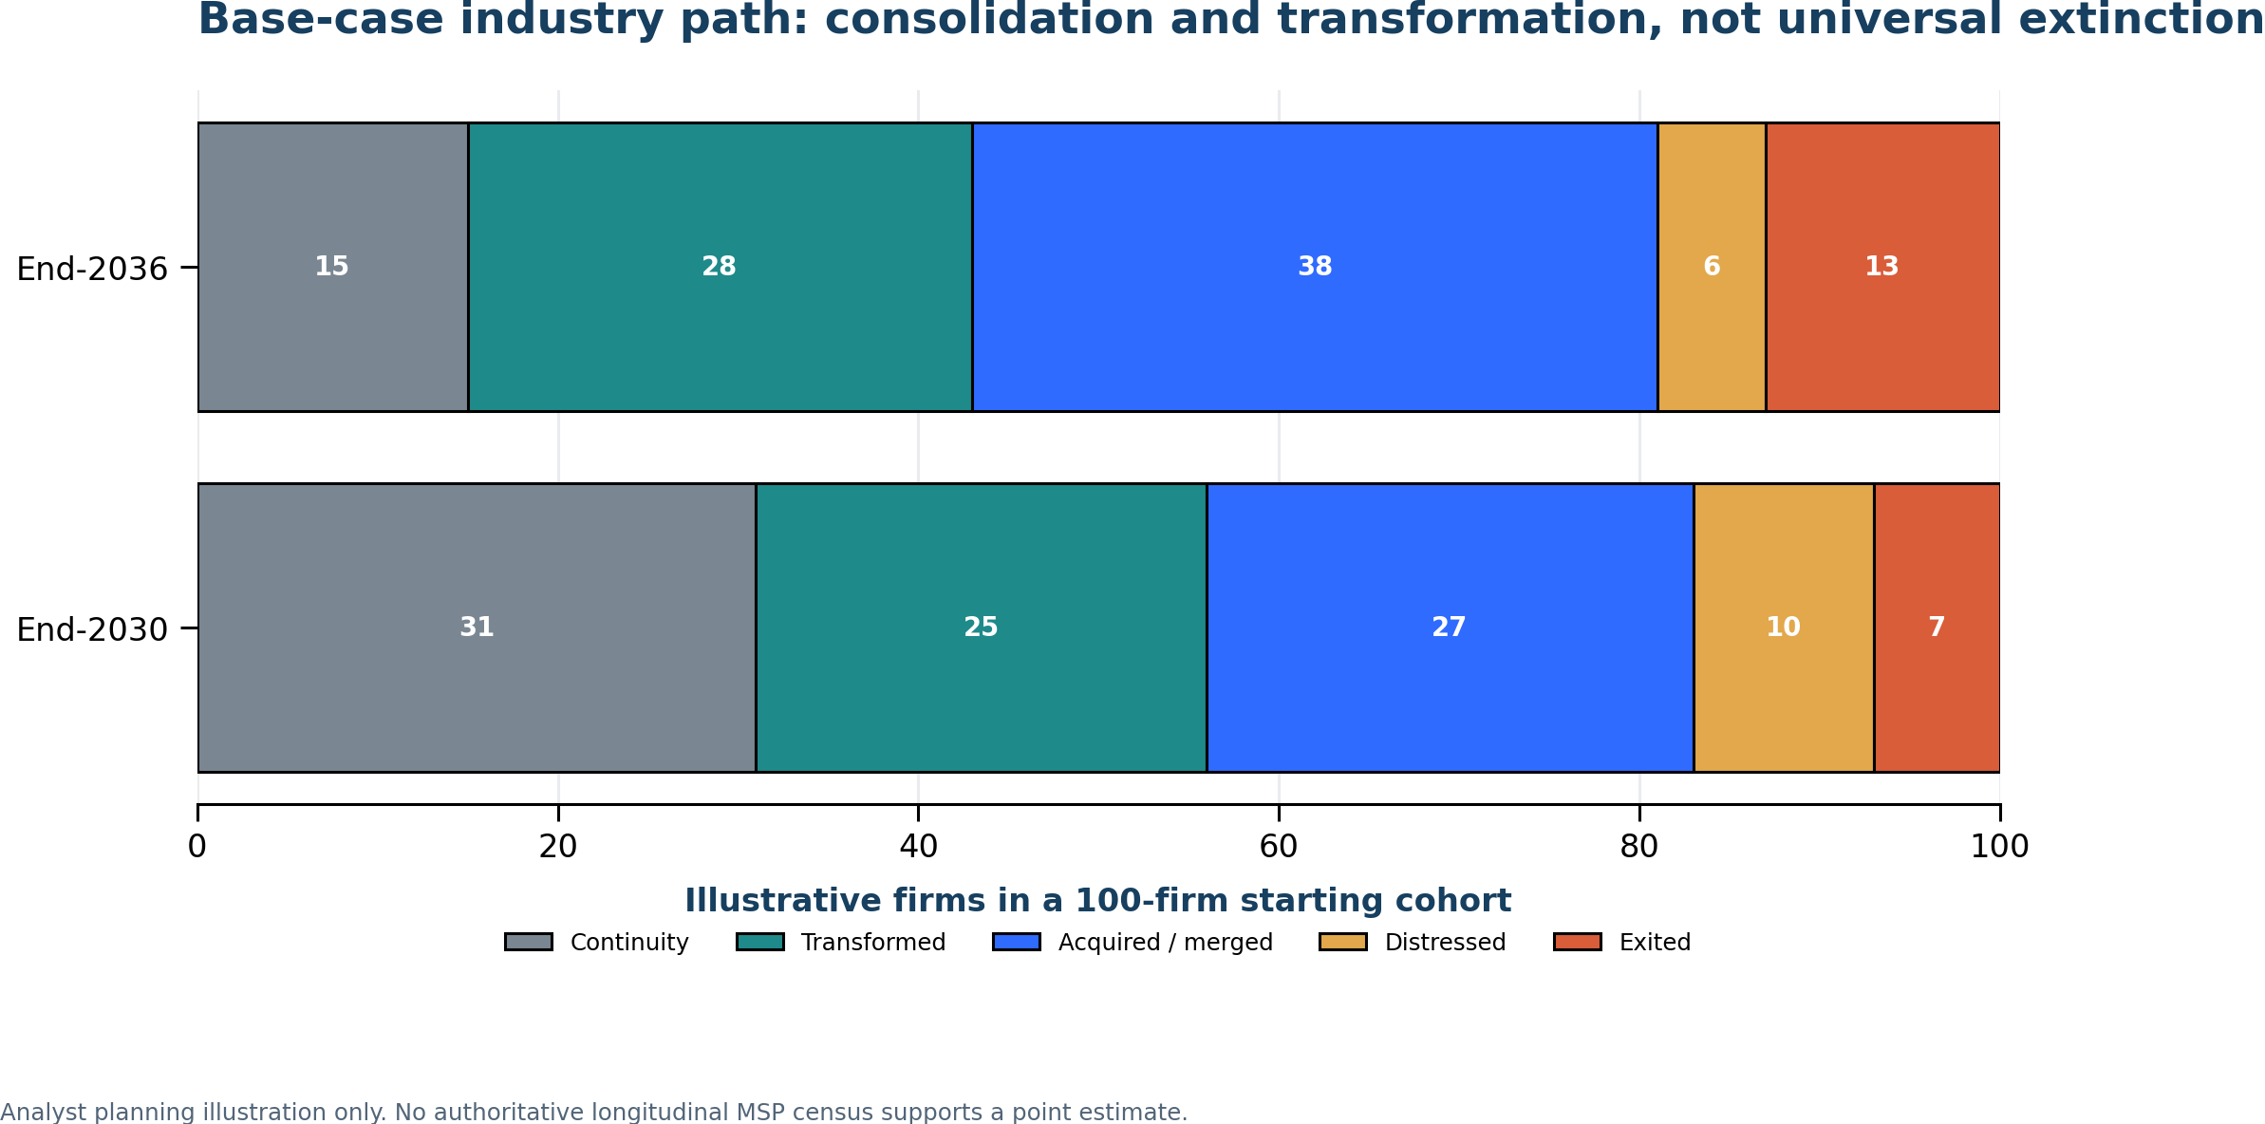
Figure 3. The base-case cohort is a non-empirical planning illustration; consolidation is more likely than universal failure.
A reasonable range around the 2036 base case is 10–25% continuity, 25–45% transformed independent, 25–45% acquired/merged, 5–15% distressed and 5–20% exited. The categories are mutually exclusive at the horizon. These ranges are not confidence intervals; they express scenario uncertainty.
9.5 Which MSPs are most at risk?
Highest risk:
- high ticket volume with low standardization and poor knowledge;
- undifferentiated Microsoft 365 administration and license resale;
- broad fixed-fee scope with manual delivery and weak contract controls;
- small generalist teams attempting to own a 24x7 SOC;
- high customer concentration, weak balance sheets or owner dependency;
- no service-line P&L and no evidence of automation capture.
Lower risk:
- standardized platforms with high automation and disciplined scope;
- vertical specialists with workflow and regulatory context;
- security providers with real response authority and pooled scale;
- data, integration, governance and business-process specialists;
- firms with repeatable IP, clean telemetry, low concentration and strong cash conversion.
10. Transformation Framework
10.1 Strategic design principles
1. Preserve profitable recurring revenue while redesigning its delivery.
2. Automate internally before promising external transformation.
3. Standardize the stack and narrow exceptions.
4. Own customer context, identity, governance and accountability.
5. Productize methods into repeatable services and IP.
6. Use partners for capabilities that require uneconomic scale.
7. Price for platform, complexity, risk and outcomes—not technician activity.
8. Fund the transition as a portfolio with stage gates.
10.2 Opportunity ranking
Scores are analytical judgments on a 1–5 scale, not market forecasts.
Opportunity | Urgency | Revenue potential | Margin potential | Defensibility | Strategic note
Identity and security-first managed services | 5 | 5 | 4 | 5 | Foundation for all other automation and agents.
Compliance and assurance | 5 | 4 | 4 | 5 | Strong where evidence, vertical knowledge and executive accountability matter.
Internal AI-enabled delivery | 5 | 3 | 5 | 4 | Prerequisite for price and margin resilience.
AI governance and managed agent operations | 5 | 5 | 4 | 5 | New control-plane service aligned with Microsoft direction.
Business-process automation | 4 | 5 | 4 | 4 | High value when verticalized and repeatable.
Data readiness, integration and quality | 4 | 5 | 4 | 5 | Necessary for reliable AI; difficult to commoditize fully.
AI advisory and implementation | 4 | 4 | 3 | 3 | Attractive but project-heavy unless converted to managed operations.
Continuous adoption and training | 3 | 3 | 4 | 3 | Defensible when tied to role outcomes and telemetry.
Standalone 24x7 SOC build | 2 | 4 | 2 | 3 | Often better through partnership unless scale is already present.
Commodity device/help-desk expansion | 1 | 2 | 2 | 1 | Harvest and automate; do not make it the growth thesis.

10.3 Portfolio migration
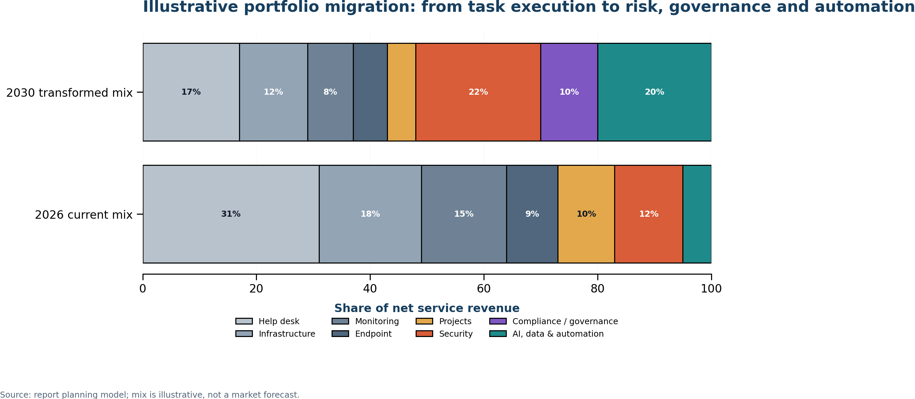
Figure 4. An illustrative transformed portfolio reduces commodity task concentration and expands security, governance, data and automation.
The target is not to rename current services. It is to move gross profit toward managed risk and managed change. Every new service should have a defined customer problem, repeatable scope, measurable outcome, delivery design, unit economics, legal boundary and renewal mechanism.
10.4 Commercial evolution
Transition away from ticket-count value and unlimited scope. Retain per-user or per-device units only where they are simple proxies for platform access or risk surface.
Recommended architecture:
- a base platform and governance subscription;
- managed security/identity tiers based on risk, telemetry and response scope;
- managed AI/agent tiers based on environments, agents, consumption and control requirements;
- fixed-price implementation packages for repeatable outcomes;
- consumption pass-through with optimization and caps;
- outcome incentives only where baselines and customer responsibilities are measurable.
Avoid pure outcome contracts for outcomes the provider cannot control. Use shared responsibilities, exclusions, approval thresholds and service credits rather than unlimited liability.
10.5 Operating-model evolution
The future delivery organization resembles a software-enabled operations company:
- service product managers own scope, economics and roadmap;
- automation/agent engineers own orchestration and evaluation;
- security and identity specialists set control patterns;
- service-desk staff supervise automation and exceptions;
- customer-success teams manage adoption and outcome reviews;
- finance tracks consumption, gross profit and cash by service line.
The durable competitive asset is not the number of technicians. It is the combination of customer context, standardized telemetry, reusable automation, specialist judgment and accountable operating routines.
11. Recommended Actions
11.1 First 90 days: establish facts and control
Action | Owner | Deliverable | Decision gate
Recast financials by service line | CFO / COO | Net revenue, labor, tools, gross profit and cash by line | No strategic investment without a comparable baseline.
Instrument service operations | Service leader | Correct resolution cost, reopen rate, automation rate, review time | Automation must improve quality-adjusted unit cost.
Map contract exposure | Commercial / legal | Scope, caps, exclusions, renewal dates, concentration | Identify contracts where price or liability can move faster than cost.
Create AI and agent governance | CIO / CISO | Inventory, owners, identities, DLP, approval policy, logs | No production agent without a named owner and rollback path.
Standardize privileged access | CISO | MFA, least privilege, separate admin identity, audit evidence | Treat MSP access as systemic risk. [30]
Define target portfolio | CEO / board | Three to five services to build, partner or retire | Fund only offers with repeatable scope and a renewal path.

11.2 Months 3–12: prove capture
- Automate three high-volume workflows such as onboarding, access requests and common service-desk resolution.
- Use controlled cohorts and compare cost per correct resolution, customer satisfaction, reopen rate and human review time.
- Redeploy released capacity deliberately; record whether it becomes avoided hiring, new revenue or improved service.
- Productize security posture, identity hardening, compliance evidence and incident readiness.
- Launch a managed AI-governance offer covering inventory, identity, DLP, evaluations, consumption and incident response.
- Build one vertical business-process automation package with a fixed scope and named customer outcome.
- Redesign proposals around platform, risk and outcome; stop using ticket volume as the primary value proof.
Gate: proceed to scale only when at least two customer cohorts show paid renewal demand, positive contribution margin after full tooling/review cost, and no material quality deterioration.
11.3 Months 12–24: scale what works
- Convert pilots into standard operating procedures, templates, connectors, test suites and reusable IP.
- Establish a partner-led MDR/SOC model unless internal continuous coverage is already economic.
- Build customer success and adoption telemetry into recurring reviews.
- Reduce overlapping tools and automate evidence collection.
- Reprice or exit chronically unprofitable legacy contracts.
- Train account teams to sell business and risk outcomes, not labor categories.
- Tie leadership incentives to gross-profit mix, automation capture, net retention, service quality and cash.
Gate: new services should represent at least 20–25% of net service revenue, show improving cohort margin and cover the full cost of the transformation team before broad expansion.
11.4 Months 24–36: reposition the company
- Target 35–45% of net service revenue from security, compliance, data, automation and managed AI.
- Package proprietary assessment, policy, workflow and evaluation assets as subscription IP.
- Use M&A selectively to acquire distribution, vertical context or scarce capability—not to hide weak organic growth.
- Retire services where the platform has absorbed execution and the provider adds no measurable outcome.
- Evaluate strategic options: remain independent specialist, become a platform within a vertical, join a consolidator or acquire smaller firms into a standardized operating system.
11.5 Board dashboard
The board should review quarterly:
- organic net-service-revenue growth and gross retention;
- gross margin by service line and customer cohort;
- revenue and gross profit per FTE on a consistent net basis;
- correct resolutions per paid hour and reopen rate;
- automated completion rate and human review minutes;
- AI/tool consumption per managed user, device, agent and ticket;
- legacy versus growth-service mix;
- renewal price change on a like-for-like basis;
- security/compliance incidents and privileged-access exceptions;
- transformation cash spend, payback and remaining liquidity.
12. Risks and Counterarguments
12.1 Arguments supporting MSP survival
Customers still need accountability
SMEs often lack internal breadth and value a trusted party that integrates products, explains tradeoffs and responds during incidents. Platform complexity and agent proliferation can increase the need for governance and integration.
Adoption is slower than product announcements
Gartner expects a high cancellation rate for agentic projects, and OECD identifies skills, legal and regulatory barriers among SMEs. Many customers will not have the knowledge, data or process maturity required for safe autonomy. [7] [12]
Fixed fees can capture automation upside
An MSP with strong contracts and internal automation can keep efficiency gains, improve response and grow without proportional headcount. Per-user pricing can remain a convenient metric when it prices platform access and risk rather than labor.
Security and regulation create durable demand
Cybersecurity spending and employment are growing; NIS2, AI governance and contractual accountability create work that cannot be reduced to a product toggle. [10] [31] [32] [38]
The channel remains strategically useful
Microsoft continues to invest in partner specializations, incentives, marketplace motions and services opportunities around Copilot, Agent 365 and security. [23] [24] [39]
12.2 Arguments supporting disruption
The platform absorbs the easiest margin
Native agents and managed services perform more triage, investigation, configuration and workflow execution. Customers can compare MSP charges with capabilities already in the license or cloud support tier. [20] [25] [27] [28]
AI productivity becomes a price benchmark
Bain's technology-services analysis describes an AI-driven repricing of services. Even providers that do not adopt AI can face customers who expect AI-level efficiency. [15]
Labor economics are asymmetric
Wages, security obligations and tool costs rise before providers can always reprice fixed-fee contracts. AI savings remain theoretical unless headcount growth is avoided, capacity is redeployed or new revenue is won.
Security can disintermediate generalists
Vendor MDR, embedded XDR and AI triage can replace low-value alert handling. A generalist MSP that resells security without response authority may be squeezed between vendor platforms and scaled specialists. [22] [29]
Transition can fail financially
The company must fund old and new operating models simultaneously. Weak cash conversion, debt or customer concentration can force a sale before the new portfolio scales.
12.3 Principal transformation risks
Risk | Failure mode | Mitigation
AI quality and autonomy | Wrong actions, reopened tickets, customer harm | Bounded permissions, evaluation, human approval, rollback and insurance review.
Consumption economics | Tool and model costs erase labor savings | Metering, budgets, routing, caps and FinOps by workflow.
Customer repricing | Savings passed through faster than costs decline | Hybrid pricing, differentiated outcomes, contract sequencing.
Talent gap | Technicians do not become consultants or product engineers | Role redesign, selective hiring, partnerships and protected learning time.
Sales-model mismatch | Project pipeline grows but recurring revenue does not | Attach managed operations and renewal at design stage.
Security concentration | MSP access becomes a systemic attack path | Zero standing privilege, segmentation, logging, incident drills. [30]
Platform dependency | Vendor bundling removes service scope or margin | Multi-layer value, customer context, portable IP, multi-vendor capability.
Liability creep | Outcome promises exceed control | Shared responsibility, baselines, exclusions and approval thresholds.
M&A overreach | Acquisitions add revenue but not standardized economics | Integration thesis, service-line P&L and organic-growth disclosure.

12.4 Most likely outcome
Managed services remains viable by 2030. The unchanged labor-heavy model becomes less viable, especially where scope is broad, delivery is manual and differentiation is weak. The likely industry outcome is a larger market with fewer strategically relevant independent providers, wider margin dispersion, more consolidation and a smaller human share of routine delivery.
The strongest counterargument is current profitability. The strongest rebuttal is that platform shifts usually compress the value of a layer before they eliminate its revenue. Owners should watch like-for-like price, labor share, gross margin, renewal scope and customer willingness to pay for the retained human work.
13. Final Conclusions
The evidence rejects the broad claim that MSPs and TSPs are becoming universally obsolete. Demand for managed technology, security and transformation remains substantial, and well-run providers continue to grow.
The evidence supports the narrower thesis that the traditional operating model is becoming obsolete. The exposed model monetizes repetitive human effort, uses tickets as proof of value, relies on product and administration opacity, and treats automation as a tool rather than a redesign of economics and commercial architecture.
By 2030, a conventional provider can still be profitable. That does not make it strategically safe. In the illustrative model, no change produces 7.7% EBITDA and a sharp valuation impairment; transformation can preserve or expand margin, but only after a cash and execution J-curve. Severe disruption is survivable only with early cost action, differentiated services and balance-sheet capacity.
Microsoft and other hyperscalers are not abolishing the partner ecosystem. They are redrawing it. They will increasingly own productized execution; customers and vendors will still need partners to own context, integration, identity, governance, assurance, adoption and high-consequence judgment. The partner's strategic choice is therefore to operate the platform on the customer's behalf, not to compete with the platform's commodity functions.
The recommended posture is disciplined adaptation, not panic:
- keep the profitable current book while it remains worth serving;
- prove internal automation with quality and cash metrics;
- build security, identity, compliance, data and agent-governance capabilities;
- productize vertical workflows and intellectual property;
- move pricing toward platform, risk, complexity and outcomes;
- preserve liquidity and use gates before scaling.
The MSP/TSP business model is likely to remain viable through 2030 and beyond. The traditional labor-dependent version is not. The next decade will reward providers that convert automation into customer outcomes and retained cash while accepting explicit accountability for risk.
14. Complete Reference List
Accessed 30 September 2026 unless otherwise stated. Publication dates, data periods and forecast horizons are distinct.
[1] Service Leadership / ConnectWise. “Service Leadership Report Reveals Historic Growth for IT Solution Providers and the Operational Factors Defining This Economic Shift.” 23 June 2026. Participating-provider benchmark; detailed report is gated. https://www.connectwise.com/company/press/releases/service-leadership-report-reveals-historic-growth-for-it-solution-providers-and-the-operational-factors-defining-this-economic-shift
[2] Service Leadership / ConnectWise. “Service Leadership Announces Findings of its Annual IT Solution Provider Industry Profitability Report.” 8 May 2025. https://www.connectwise.com/company/press/releases/service-leadership-announces-findings-of-its-annual-it-solution-provider-industry-profitability-report
[3] Canalys / Omdia. “MSP Trends and Predictions 2025.” 2025. Public landing page; full report registration-gated. https://omdia.tech.informa.com/insights/2025/canalys-msp-trends-and-predictions-2025
[4] Information Services Group. “Global Tech Services Market Grows at Fastest Pace Ever in Q2, Propelled by Soaring AI Demand: ISG Index.” 9 July 2026. Scope: contracts with ACV of at least $5 million. https://ir.isg-one.com/news-market-information/press-releases/news-details/2026/Global-Tech-Services-Market-Grows-at-Fastest-Pace-Ever-in-Q2-Propelled-by-Soaring-AI-Demand-ISG-Index/default.aspx
[5] Gartner. “Worldwide IT Spending to Grow 14.2% in 2026, Totaling $6.37 Trillion.” 27 July 2026. Forecast. https://www.gartner.com/en/newsroom/press-releases/2026-07-27-gartner-forecasts-worldwide-it-spending-to-grow-14-point-2-percent-in-2026-totaling-6-point-37-trillion
[6] Gartner. “Agentic AI Will Autonomously Resolve 80% of Common Customer Service Issues Without Human Intervention by 2029.” 5 March 2025. Forecast. https://www.gartner.com/en/newsroom/press-releases/2025-03-05-gartner-predicts-agentic-ai-will-autonomously-resolve-80-percent-of-common-customer-service-issues-without-human-intervention-by-20290
[7] Gartner. “Over 40% of Agentic AI Projects Will Be Canceled by End of 2027.” 25 June 2025. Forecast. https://www.gartner.com/en/newsroom/press-releases/2025-06-25-gartner-predicts-over-40-percent-of-agentic-ai-projects-will-be-canceled-by-end-of-2027
[8] Brynjolfsson, Erik; Li, Danielle; Raymond, Lindsey. “Generative AI at Work.” NBER Working Paper 31161, revised November 2023; later published in the Quarterly Journal of Economics in 2025. https://www.nber.org/papers/w31161
[9] US Bureau of Labor Statistics. “Computer Support Specialists.” Occupational Outlook Handbook, updated 27 August 2026; projection 2025–2035. https://www.bls.gov/ooh/computer-and-information-technology/computer-support-specialists.htm
[10] US Bureau of Labor Statistics. “Information Security Analysts.” Occupational Outlook Handbook, updated 27 August 2026; projection 2025–2035. https://www.bls.gov/ooh/computer-and-information-technology/information-security-analysts.htm
[11] World Economic Forum. “The Future of Jobs Report 2025.” 7 January 2025. https://www.weforum.org/publications/the-future-of-jobs-report-2025/digest/
[12] OECD. “Generative AI and the SME Workforce: New Survey Evidence.” 2025. Representative 2024 survey of more than 5,000 SMEs in seven countries. https://www.oecd.org/en/publications/generative-ai-and-the-sme-workforce_2d08b99d-en/full-report.html
[13] McKinsey & Company. “The State of AI in 2026: On the Road to ROI.” 25 August 2026. Global survey; self-reported outcomes. https://www.mckinsey.com/capabilities/quantumblack/our-insights/the-state-of-ai
[14] Deloitte. “Agentic AI Is Scaling Faster Than Guardrails.” 24 April 2026. Uses Deloitte's 2025 fieldwork for the 2026 State of AI report. https://www.deloitte.com/us/en/insights/topics/emerging-technologies/ai-agents-scaling-faster.html
[15] Bain & Company. “Tech Services: Cracking the Code on AI-led Growth.” 29 September 2026. Buyer expectations and analytical potential, not audited MSP savings. https://www.bain.com/insights/tech-services-cracking-the-code-on-ai-led-growth-technology-report-2026/
[16] Microsoft. Annual Report 2025. Fiscal year ended 30 June 2025. https://www.microsoft.com/investor/reports/ar25/index.html
[17] Microsoft. “Microsoft Cloud and AI Strength Fuels Fourth Quarter Results.” FY2026 Q4, 29 July 2026. Earnings release; statements marked unaudited. https://www.microsoft.com/en-us/Investor/earnings/FY-2026-Q4/press-release-webcast
[18] Microsoft. Fiscal Year 2026 Fourth Quarter Earnings Conference Call. 29 July 2026. https://www.microsoft.com/en-us/investor/events/fy-2026/earnings-fy-2026-q4
[19] Microsoft. “Ignite 2025: Copilot and Agents Built to Power the Frontier Firm.” 18 November 2025. https://www.microsoft.com/en-us/copilot/blog/2025/11/18/microsoft-ignite-2025-copilot-and-agents-built-to-power-the-frontier-firm/
[20] Microsoft Learn. “Build Agents with Copilot Studio and Agent 365.” Updated 1 May 2026. https://learn.microsoft.com/en-us/microsoft-agent-365/builder/overview
[21] Microsoft Learn. “Design Autonomous Agent Capabilities.” Copilot Studio guidance. https://learn.microsoft.com/en-us/microsoft-copilot-studio/guidance/autonomous-agents
[22] Microsoft Security Blog. “Ambient and Autonomous Security for the Agentic Era.” 18 November 2025. https://www.microsoft.com/en-us/security/blog/2025/11/18/ambient-and-autonomous-security-for-the-agentic-era/
[23] Microsoft Partner Blog. “What's New for Microsoft Partners: July 2026 Edition.” 2 July 2026. https://partner.microsoft.com/en-us/blog/article/whats-new-for-partners-2026-issue-3
[24] Microsoft Partner Blog. “Leading Frontier Firm Transformation with Microsoft 365 E7: The Partner Opportunity.” 2026. https://partner.microsoft.com/en-us/blog/article/agent-365-announcement
[25] Amazon Web Services. “AWS DevOps Agent Is Now Generally Available.” 31 March 2026. https://aws.amazon.com/about-aws/whats-new/2026/03/aws-devops-agent-generally-available/
[26] Amazon Web Services Documentation. “Using the AMS Accelerate Operations Plan.” https://docs.aws.amazon.com/managedservices/latest/accelerate-guide/acc-what-is.html
[27] Google Cloud. “Gemini Cloud Assist: Proactive Cloud Operations That Work for You, Even Before You Ask.” 22 April 2026, read with product documentation and release-status limits. https://cloud.google.com/blog/products/application-development/gemini-cloud-assist-at-next26
[28] ServiceNow. “ServiceNow Brings Autonomous Workforce to Every Major Business Function.” 5 May 2026. Vendor capability and internal claims. https://newsroom.servicenow.com/press-releases/details/2026/ServiceNow-brings-Autonomous-Workforce-to-every-major-business-function/default.aspx
[29] CrowdStrike. “Falcon Complete MDR: 24/7 Expert Protection.” Vendor product page. https://www.crowdstrike.com/en-us/services/falcon-complete-mdr/
[30] CISA and Five Eyes cyber authorities. “Protecting Against Cyber Threats to Managed Service Providers and Their Customers.” Advisory AA22-131A, 11 May 2022. https://www.cisa.gov/news-events/cybersecurity-advisories/aa22-131a
[31] NIST. “Artificial Intelligence Risk Management Framework: Generative Artificial Intelligence Profile.” NIST AI 600-1, 26 July 2024. https://nvlpubs.nist.gov/nistpubs/ai/NIST.AI.600-1.pdf
[32] European Union. Directive (EU) 2022/2555 (NIS2), 14 December 2022. https://eur-lex.europa.eu/eli/dir/2022/2555/oj/eng
[33] Accenture. “Second-Quarter Fiscal 2026 Results.” 19 March 2026. Diversified enterprise provider; company-wide margins are not MSP service-line margins. https://newsroom.accenture.com/content/2qfy26-earnings/accenture-reports-second-quarter-fiscal-2026-results.pdf
[34] Rackspace Technology. “Fourth Quarter and Full Year 2025 Results.” 26 February 2026. https://ir.rackspace.com/news-releases/news-release-details/rackspace-technology-reports-fourth-quarter-and-full-year-2025
[35] PwC. “Global M&A Industry Trends: 2026 Mid-year Outlook.” 23 June 2026. https://www.pwc.com/gx/en/services/deals/trends.html
[36] Forrester. “The State of Technology Services, 2026.” Public abstract; paid body not reviewed. https://www.forrester.com/report/the-state-of-technology-services-2026/RES192217
[37] Microsoft / IDC. “IDC Study on Partner Profitability with Microsoft AI.” 19 September 2024. Microsoft-sponsored; revenue multipliers are not causal profit measures. https://partner.microsoft.com/blog/article/AI-value-for-partners
[38] Gartner. “Forecast Analysis: Information Security, Worldwide, 2026.” 5 February 2026. Public abstract; forecast of $244 billion and 11.6% constant-currency growth. https://www.gartner.com/en/documents/7408930
[39] Microsoft Learn. “September 2026 Announcements: Partner Center.” Updated 25 September 2026. https://learn.microsoft.com/en-us/partner-center/announcements/2026-september
[40] Xerox Holdings Corporation. “Fourth-Quarter and Full-Year 2025 Results.” 29 January 2026. Acquisition effects should be separated from pro-forma performance. https://investors.xerox.com/news-releases/news-release-details/xerox-releases-fourth-quarter-and-full-year-results-2
[41] Blockbuster Inc. Form 8-K, bankruptcy filing, 23 September 2010; asset-sale approval release, 7 April 2011. https://www.sec.gov/Archives/edgar/data/1085734/000119312510215765/d8k.htm and https://www.sec.gov/Archives/edgar/data/1085734/000119312511095325/dex991.htm
[42] Microsoft Learn. “Microsoft Security Copilot Phishing Triage Agent in Microsoft Defender.” Product documentation; classification is not complete incident response. https://learn.microsoft.com/en-us/defender-xdr/phishing-triage-agent
[43] Microsoft Security Blog. “Microsoft Build 2026: Securing Code, Agents and Models Across the Development Lifecycle.” 2 June 2026. https://www.microsoft.com/en-us/security/blog/2026/06/02/microsoft-build-2026-securing-code-agents-and-models-across-the-development-lifecycle/

