Is the Traditional MSP and TSP Business Model Becoming Obsolete?
A strategic research report on the economics, disruption and transformation of managed service providers and technology service providers, 2026–2035

Prepared for MSP owners, Microsoft partners, partner executives, boards and private-equity investors evaluating technology service providers.
29 July 2026
All monetary figures are US dollars unless otherwise noted. Every material statistic in this report is attributed to a named source in the text and listed with publication details in Section 14.

Table of contents (updates when the document opens)

1. Executive Summary
This report examines whether the traditional managed service provider (MSP) and technology service provider (TSP) business model, built on per-user and per-device pricing wrapped around a reactive help desk, endpoint monitoring, patching and infrastructure management, remains economically and strategically sustainable over the next three to ten years. The analysis was conducted without assuming the conclusion. Four independent research streams examined MSP unit economics, the impact of AI and agentic automation, Microsoft and hyperscaler strategy, and buyer behaviour together with historical platform shifts. Findings were cross-checked against primary sources wherever possible.
The evidence does not support the simple claim that the MSP is dying. It supports a harder and more actionable conclusion: the industry is bifurcating. The traditional labour-based operating model is structurally deteriorating even while the managed services category grows at double digits, and the gap between transformed and untransformed providers is already the difference between record profits and operating losses.
Four facts frame the paradox. First, the market is booming: Canalys puts channel-delivered managed services above half a trillion dollars in 2024, growing 9.7 per cent, with a forecast of roughly $608 billion in 2025 [4][5]. Second, the average existing MSP is stalling inside that boom: Service Leadership recorded worldwide organic managed-service revenue growth of just 1.0 per cent in Q4 2024, with 18 per cent of MSPs operating at a loss [2]. Third, profitability has split: 2024 was a record fifth consecutive year of 19 per cent plus adjusted EBITDA for best-in-class TSPs, while unfocused generalists earn roughly 7 per cent [1][4]. Fourth, capital has already priced the split: sub-$5 million MSPs change hands at about 5.2 times EBITDA against 11.2 times for scaled platforms, a discount of roughly 55 per cent [10].
AI sharpens rather than creates this divide. The strongest research evidence shows AI is most capable in exactly the task categories where MSP labour concentrates: level-1 support, monitoring and triage, documentation and tier-1 security operations. Gartner projects that agentic AI will autonomously resolve 80 per cent of common customer service issues by 2029 [19], yet also predicts that over 40 per cent of agentic AI projects will be cancelled by the end of 2027 [20]. Weighing measured field results against forecasts, this report estimates that roughly 25 to 40 per cent of current L1/L2 task-hours become automatable by about 2030 in the base case. Critically, the near-term threat is economic before it is operational: AI breaks per-seat and per-hour pricing anchors before it removes technicians.
Microsoft's strategic direction compounds the pressure on traditional work while expanding the opportunity for a different partner profile. The platform is productising the classic MSP task list: Windows Autopatch aims to update 95 per cent of devices natively [37], Defender XDR automatically contains compromised assets [38], and Security Copilot agents autonomously triage phishing and identity alerts [39]. Microsoft now sells managed detection and response directly through Defender Experts for XDR [40], and its partner economics have been rewired away from resale margin and legacy benefits toward AI, security and consumption [41][42]. The partner bull case is genuine, with IDC estimating $8.45 of partner services revenue per Microsoft dollar [43], but Canalys's own analysis warned that the near-term AI services opportunity accrues to systems integrators and software builders, advising that traditional MSPs and VARs would largely miss the first wave [44].
On the core question, the report concludes: the traditional MSP operating model will not remain viable as a growth business by 2030, but the MSP as a business category will remain viable and can prosper for owners who transform. In the base case, judged the most likely outcome at roughly 60 per cent probability, the decade to 2035 delivers a slow squeeze rather than a cliff: an estimated 30 to 50 per cent of today's sub-$5 million generalists are absorbed, wound down or exit through consolidation, while security-led, AI-capable and vertically specialised providers capture a disproportionate share of a still-growing market. This estimate is a reasoned synthesis of the sourced trend lines, not a single cited figure, and Section 9 details the bull, base and bear cases.
The recommended response is a three-move transformation executed inside a window this report estimates at 2027 to 2032: specialise around security, compliance or a vertical; industrialise delivery with AI so that margin no longer scales with headcount; and reprice from per-user and per-device contracts toward outcomes, platforms and subscription intellectual property. Sections 10 and 11 set out the roadmap, ranked by urgency, revenue potential, margin potential and competitive defensibility.

2. Research Methodology
The research was organised as four parallel, independent streams: first, the economics of the traditional MSP model, covering pricing, margins, labour dependence, scale and valuations; second, the impact of AI and agentic automation on IT service delivery; third, Microsoft's strategic direction, partner program economics, hyperscaler disintermediation and the security services market; and fourth, customer buying behaviour, industry structure forecasts and historical parallels from other disrupted service industries. Each stream produced a findings dossier with per-claim citations, and the streams were cross-checked against one another before synthesis.
Sources were weighted by authority. Primary and issuer sources were preferred: SEC-filed annual reports and earnings calls (Microsoft, Palo Alto Networks, Accenture, Rackspace, DXC), official product documentation, Gartner press releases, US Bureau of Labor Statistics data, and peer-reviewed research such as the Brynjolfsson, Li and Raymond study published in the Quarterly Journal of Economics. Analyst houses (Gartner, IDC, Forrester, Canalys, Omdia, ISG, McKinsey, Deloitte) form the second tier. Industry benchmarks (Service Leadership Index, Kaseya/Datto and ConnectWise surveys) are used with an explicit vendor-proximity flag, since these firms sell tools to MSPs and sample their own customer bases. Vendor performance claims, for example advertised AI ticket-resolution rates, are treated as marketing until corroborated by independent field data, and the report reproduces contradicting field evidence alongside them.
Four limitations should be read alongside the findings. First, the richest profitability benchmark, the Service Leadership Index, is owned by ConnectWise; its data is the industry standard but its best-in-class framing can flatter the aggregate picture. Second, market sizing is definitionally noisy: published figures for the managed services market range from roughly $311 billion to $608 billion depending on scope, and global MSP counts range from about 150,000 to 340,000; this report states the definition alongside the number. Third, no audited MSP-specific benchmark exists for AI automation of L1/L2 work, so the automation bands in Section 8 are reasoned estimates that map task-exposure research and vendor deployments onto MSP workflows. Fourth, several convenient statistics circulating in the channel press were checked and rejected where they conflicted with primary data; where a figure could not be verified beyond a compilation source it is either excluded or flagged. Research was completed on 29 July 2026 and reflects sources published up to that date.

3. Key Findings
Finding 1. The market is growing while the number of providers shrinks. Channel-delivered managed services exceeded $500 billion in 2024 (up 9.7 per cent) while the global partner count fell 0.6 per cent to 335,385 MSPs, the definitional signature of a consolidating, scale-driven industry [4]. Canalys forecast the category at roughly $608 billion in 2025, larger than the entire SaaS industry [5].
Finding 2. Organic growth for existing MSPs has stalled. Worldwide managed-service revenue growth fell to 1.0 per cent in Q4 2024, the lowest of the year, and 18 per cent of MSPs reported a loss, up from 14 per cent the prior quarter [2]. The dollar growth of the category is being captured by security and cloud add-ons and by consolidation, not by organic expansion at the median generalist.
Finding 3. Profitability has bifurcated, and the split is the central fact of the industry. Best-in-class TSPs posted a record fifth consecutive year of 19 per cent plus adjusted EBITDA in 2024, with valuations up roughly 22 per cent [1]. At the same time, focused MSPs achieve 15 to 30 per cent EBITDA against about 7 per cent for unfocused generalists [4], and labour-heavy project gross margins collapsed from 23 per cent to 12.9 per cent in a single year on weak utilisation [2].
Finding 4. Labour is the structural constraint of the traditional model. MSP revenue per employee runs at roughly $100,000 to $150,000, against a median of $283,000 for public SaaS companies, and growth is linear with headcount. The US Bureau of Labor Statistics projects computer support specialist employment to decline 3 per cent between 2024 and 2034, a signal that automation is already eroding demand for the tier-1 role, even as IDC values the broader IT skills gap at $5.5 trillion by 2026 [12][13].
Finding 5. AI is most capable exactly where MSP billable labour concentrates. Measured results include a 14 to 15 per cent productivity gain for support agents (34 per cent for novices) in peer-reviewed research [23], roughly 20 to 54 per cent ticket deflection at ServiceNow's own service desk [65], and Klarna's assistant performing the work of 700 agents before a partial, quality-driven reversal [21][22]. In the base case, this report estimates 25 to 40 per cent of current L1/L2 task-hours become automatable by about 2030. The pricing model breaks before the labour model does.
Finding 6. Microsoft is productising the MSP task list and rewiring partner economics. Autopatch, Intune, Defender XDR attack disruption and Security Copilot agents convert recurring, labour-priced MSP services into platform features [37][38][39], while the retirement of Action Pack and legacy tiers, the removal of Azure CSP margin, and the FY26 benefits refresh redirect partner incentives toward AI, security and consumption [41][42].
Finding 7. Platform vendors now sell the managed layer directly. Microsoft Defender Experts for XDR, AWS Managed Services and Google's Mandiant Managed Defense put hyperscalers in direct competition with their partners for managed operations and managed SOC revenue, capping the premium an intermediary can charge for running the platform [40][45][46].
Finding 8. Security-focused providers are outgrowing and out-valuing generalists. Managed detection and response is forecast to grow at roughly 23.5 per cent CAGR to $15.3 billion by 2030, about twice the pace of generalist managed services [47]. Specialists command premium capital: Huntress raised at a $1.55 billion valuation, Sophos paid $859 million for Secureworks to lead pure-play MDR, and Palo Alto's XSIAM generates over $1 million in ARR per customer [49][50][51]. Breach economics (59 per cent of organisations hit by ransomware; $2.73 million average recovery cost) and insurer mandates keep pulling buyers toward specialists [52].
Finding 9. Buyers are shifting from labour to outcomes, security and AI advice. Co-managed IT is now offered by 83 per cent of MSPs [16]; 78 per cent of MSPs report cybersecurity as clients' top challenge and 73 per cent call it a top revenue driver [15]; and 70 per cent of middle-market firms using generative AI say they need external help, with 47 per cent of AI budgets flowing to consulting [53]. Enterprise contract data shows as-a-service spend growing roughly seven times faster than managed services (14 per cent versus 2 per cent forecast for 2024) [17], and Canalys projects the channel's share of total IT spend falling from above 75 per cent historically to about 66.7 per cent by 2026 [7].
Finding 10. History is consistent: platform shifts sort intermediaries rather than sparing them. Across seven prior cases (video rental, film, PBX dealers, ISPs, hosting, hardware VARs, systems integrators and travel agencies), the platform absorbed the commodity layer, laggards failed or were absorbed, and specialists who moved up-market survived and often prospered. The closest analogies for MSPs are travel agencies, where employment fell about 60 per cent from peak while surviving specialists thrived [60], and the Accenture-versus-DXC divergence, where reinvention returned +70 per cent over five years while defending legacy labour returned −60 per cent [58].

4. Evidence and Source Citations
Every material statistic in this report carries a bracketed reference to the numbered source list in Section 14, which includes publisher, date and URL. Sources are tiered: verified primary (issuer filings, official documentation, government statistics, peer-reviewed research), analyst (Gartner, IDC, Canalys, Omdia, ISG, McKinsey), secondary (credible reporting of a primary source) and vendor (surveys and performance claims by firms with a commercial interest, flagged accordingly). Claims that could not be traced past a compilation source were excluded. The table below lists the ten most load-bearing pieces of evidence and their reliability.
Claim | Figure | Source | Reliability
Channel managed services market size and growth | >$500B in 2024, +9.7%; ~$608B forecast 2025 | Canalys, via Business of Tech (2025) [4][5] | Analyst, secondary relay
Organic managed-service revenue growth | 1.0% in Q4 2024 | Service Leadership Index Q4 2024 [2] | Verified primary
MSPs operating at a loss | 18% in Q4 2024, up from 14% | Service Leadership Index Q4 2024 [2] | Verified primary
Best-in-class TSP adjusted EBITDA | 19%+ for a record fifth straight year (2024) | Service Leadership 2025 Annual Report [1] | Verified primary
Focused vs unfocused MSP EBITDA | 15–30% vs ~7% | Canalys/N-able, via Business of Tech [4] | Secondary
MSP valuation multiples by size | 5.2x (<$5M) to 11.2x ($500M+) EV/EBITDA | Aventis Advisors, 120 transactions [10] | Secondary (M&A data)
Agentic AI resolution of common service issues | 80% autonomously by 2029; −30% operational cost | Gartner press release, Mar 2025 [19] | Analyst forecast
Agentic AI project failure rate | >40% cancelled by end of 2027 | Gartner press release, Jun 2025 [20] | Analyst forecast
MDR market growth vs generalist managed services | ~23.5% CAGR to $15.3B by 2030 | Grand View Research [47] | Moderate (third-party estimate)
Channel share of total IT spend | From >75% historically to ~66.7% by 2026 | Canalys (Jay McBain), Apr 2026 [7] | Analyst
Where sources disagree, both figures are reported with their definitions. The most consequential disagreements are market size (enterprise-contract trackers versus channel-wide analyst estimates), global MSP counts (definition-dependent), and 2025 MSP deal counts (466 per Drake Star's global tracker versus 267 in a narrower Canalys-attributed tally); all parties agree consolidation is accelerating and private-equity led [9][11].

5. Market Analysis

5.1 A growing market with fewer winners
Any honest analysis must begin with the strongest fact against the obsolescence thesis: the managed services market is large and growing. On Canalys's broad channel definition, revenue topped half a trillion dollars in 2024 (up 9.7 per cent) and was forecast to reach roughly $608 billion in 2025, growing 13 per cent, which would make managed services roughly 1.5 times larger than the entire SaaS industry and more than 15 per cent of business and government IT budgets [4][5]. Narrower research-firm definitions put the market at $311 to $401 billion with 10 to 15 per cent compound growth forecasts, and Drake Star models an $850 billion market by 2034 [9][10]. The table below reconciles the definitions; the defensible takeaway is that the pie grows 9 to 15 per cent a year, however it is cut.
Source and date | Size and growth | Scope measured
Canalys, Sep 2025 [4] | >$500B in 2024, +9.7% | All channel-delivered managed services, worldwide
Omdia/Canalys, Jan 2025 [6] | ~$595–608B in 2025, +13% | Channel IT managed services, global (~341,000 partners)
ISG Index, 2024 [17][18] | $40.7B record ACV in 2023; +2% forecast 2024 | Enterprise outsourcing contracts of $5M+ annual value only
Aventis Advisors, 2025 [10] | $312B (2023) to $658B (2030), 11.4% CAGR | MSP sector, research-firm definition
The growth, however, is not evenly distributed, and its composition is the heart of the strategic problem. Organic managed-service revenue growth at existing MSPs slowed to 1.0 per cent worldwide in Q4 2024 [2], enterprise managed-services contract value is forecast to grow just 2 per cent against 14 per cent for as-a-service consumption [17], and the fastest-growing service lines are the newest: managed detection and response at roughly 23.5 per cent CAGR [47] and partner-delivered AI services at roughly 35.3 per cent CAGR [7]. The figure below contrasts these growth rates. A market can boom while its incumbent operating model stalls; that is precisely what the data shows.
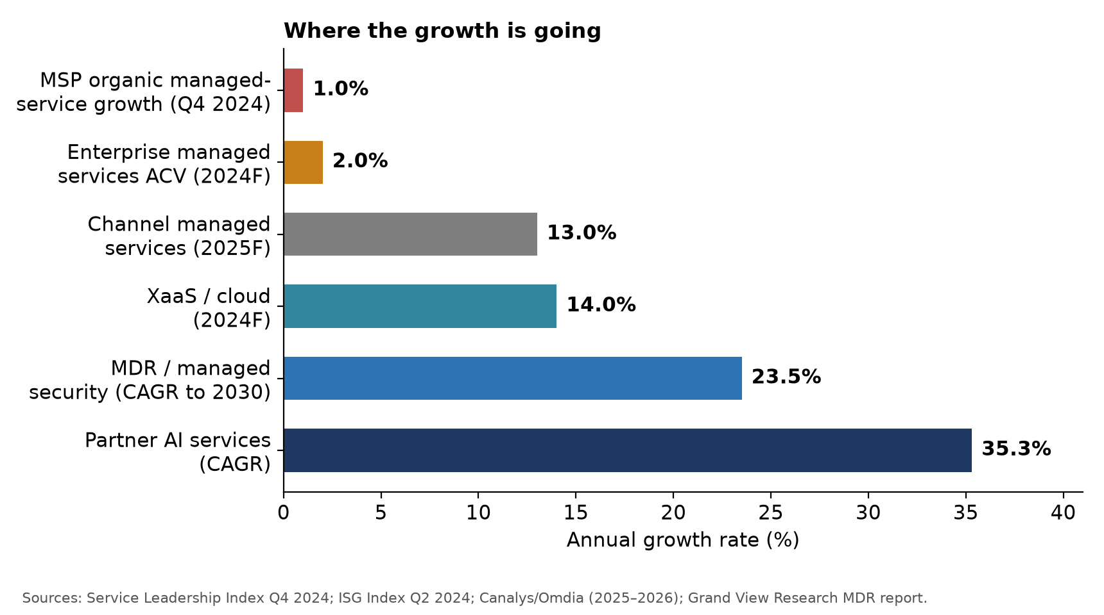
Figure 1. Growth is migrating from traditional managed services to as-a-service, security and AI lines. Sources: Service Leadership Index [2]; ISG [17]; Canalys/Omdia [5][7]; Grand View Research [47].

5.2 Consolidation is the defining structural force
The industry remains extraordinarily fragmented: Canalys tracks over 335,000 companies offering managed services, and nearly half of surveyed MSPs report revenue below $5 million [4][70]. Consolidation of that long tail is now the dominant structural motion. Aventis Advisors recorded 1,680 MSP acquisitions worldwide between 2015 and 2025, with a pronounced surge from 2023 as private equity poured in [11]; Drake Star counted 466 MSP deals worth $4.3 billion in 2025 alone, up roughly 20 per cent year on year, with 113 deals in the fourth quarter [9]. The buyers are overwhelmingly private-equity-backed permanent-hold platforms, led by Evergreen Services Group (27 deals), The Twenty (24) and Thrive (19) [11]. N-able's chief executive captured the ground truth: what was seventeen MSPs a year ago is now one MSP [4].
Scale is rewarded operationally as well as financially. Service Leadership found private-equity-backed MSPs earning 18.7 per cent adjusted EBITDA and growing revenue roughly four times faster than non-PE peers [3]. Most large buyers only consider MSPs above $5 million in revenue, which strands sub-scale generalists below the acquisition floor [4]. One material dissent belongs in any board pack: Canalys's then chief executive warned that private equity itself may be the next big bust, since portfolio valuations rest on prior purchase prices rather than independent marks; the roll-up thesis works only while the wheel keeps turning [11 note; see Section 12].

5.3 The channel is losing share of a growing pie
Even as total IT spend heads toward $6.07 trillion in 2026, Canalys projects the indirect channel's share of it declining from above 75 per cent historically to roughly 66.7 per cent by 2026, because AI infrastructure capital expenditure concentrates in hyperscalers with little flow-down to partners [7]. Omdia's independent measurement corroborates the direction: since 2022, channel revenues grew 27 per cent while the direct-sales market surged 97 per cent [8]. The structure is also top-heavy: the United States represents 41 per cent of global IT spending but only 11.5 per cent of partners by count, meaning the largest partners capture most of the revenue [8]. Canalys now formally distinguishes influence partners (advisory, co-sell, consulting) from execution partners (transactional resale), and its prescription is explicit: pivot away from thin-margin resale toward higher-value services [7].

5.4 Customer buying behaviour: outcomes, security and AI advice
Buyer behaviour has moved in three directions, each unfavourable to the traditional bundle. First, from outsourced labour to co-managed outcomes: 83 per cent of MSPs now offer co-managed services alongside internal IT teams [16], and Canalys describes the emerging model as MSP 3.0, with customers pushing a co-managed, cloud-first buying path in which cybersecurity, compliance and vertical expertise are standard rather than add-ons, warning that MSPs that do not offer these things may not be able to operate in the near future [6].
Second, security has become the centre of gravity. Kaseya's benchmark of roughly 1,000 MSPs found 78 per cent of respondents rating cybersecurity a top client challenge (up from 67 per cent) and 73 per cent calling it a top revenue driver [15]; among the highest-earning MSPs, 97 per cent offer managed security services [16]. Security-inclusive packages command a substantial pricing premium over basic bundles, and regulation (such as the EU's DORA) compounds the pull [6].
Third, AI advisory demand is real and unmet. RSM's 2025 survey of 966 middle-market decision-makers found generative AI use at 91 per cent of firms, with 70 per cent of adopters recognising the need for external support and 47 per cent of dedicated AI budgets flowing to consulting services [53]. On the supply side, a Canalys poll found 61 per cent of partners still struggle to get AI projects beyond proof of concept [6]. The demand signal and the capability gap together define the largest greenfield opportunity available to MSPs, examined in Section 10.

6. Financial Analysis

6.1 The unit economics of a labour business
The traditional MSP charges a flat fee per user per month for support of all of that user's devices, typically $100 to $250 per user depending on inclusions, with security-inclusive tiers at the top of the range [14][71]. Recurring revenue now represents roughly three quarters of the mix at mature MSPs [70]. Gross margins tell the underlying story: recurring managed services held around 46.2 per cent gross margin in mid-2024 while product resale ran at 26.3 per cent [3], but project and professional services gross margins collapsed from 23 per cent to 12.9 per cent in the year to Q4 2024 as utilisation fell, a ten-point deterioration in the most labour-exposed line [2].
The deeper constraint is that revenue scales with people. An average MSP generates roughly $100,000 to $150,000 of revenue per employee, against a median of about $130,000 for private SaaS companies, $283,000 for public SaaS and roughly $500,000 at scaled software firms; even giant labour-based consultancies fare no better, with Accenture at roughly $84,000 per employee [62][72]. Service delivery labour is the dominant cost of an MSP, wages for the underlying roles run near $61,550 median for computer support specialists [12], and hiring is chronically hard, with IDC putting the cost of the IT skills shortage at $5.5 trillion by 2026 [13]. The double bind is precise: the model cannot grow without hiring into a tight labour market, yet the tier-1 roles it hires for are the ones automation is eroding, which is why the Bureau of Labor Statistics projects support-specialist employment to decline 3 per cent over 2024 to 2034 [12].

6.2 The profitability distribution: record highs and a loss-making tail
Aggregate profitability data looks reassuring at first glance and alarming on inspection. For MSPs overall in 2024, adjusted EBITDA grew 13.0 per cent against 7.1 per cent revenue growth, and best-in-class TSPs recorded their fifth straight year above 19 per cent adjusted EBITDA, the longest such run in industry history [1]. Yet the worldwide average sat at just 11.1 per cent in Q4 2024, 18 per cent of MSPs ran at a loss, and unfocused generalists earn roughly 7 per cent [2][4]. Service Leadership itself attributes part of the 2024 strength to unusually low wage inflation, a cyclical tailwind that will not persist indefinitely [1]. The distribution below is the single most important exhibit for a board: the same industry contains record-profit specialists and a growing loss-making tail, and the difference is business model, not effort.
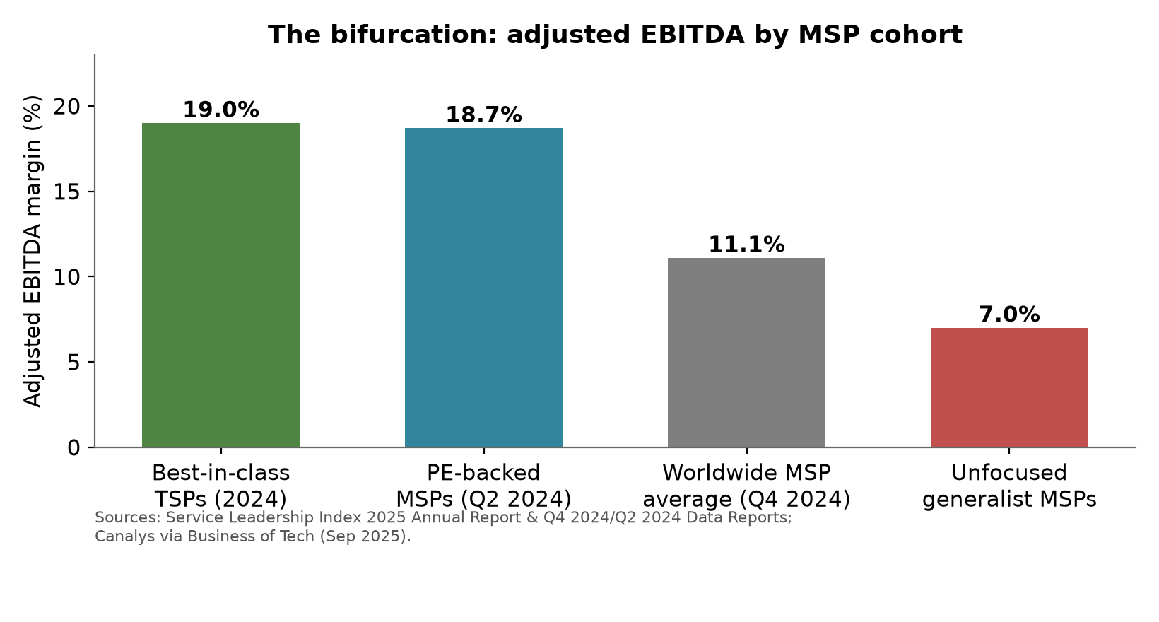
Figure 2. Adjusted EBITDA by cohort. Sources: Service Leadership Index [1][2][3]; Canalys via Business of Tech [4].

6.3 Valuation: the market has already priced the thesis
Across 120 disclosed MSP transactions, the median valuation was about 8.9 times EV/EBITDA, but the size gradient is steep: deals under $5 million average roughly 5.2 times while $500 million plus platforms command 11.2 times, and the smallest businesses can drop to 3 to 4 times [10]. Cybersecurity-focused firms command premium multiples while VAR-like resellers are discounted; for MSPs above $1 million of EBITDA there are consistently more buyers than sellers [10]. Best-in-class valuations rose roughly 22 per cent in 2024 [1]. The message to owners is uncomfortable but clear: the exit market already distinguishes commodity books from specialised platforms, and the discount for staying small and generalist is roughly half the multiple.
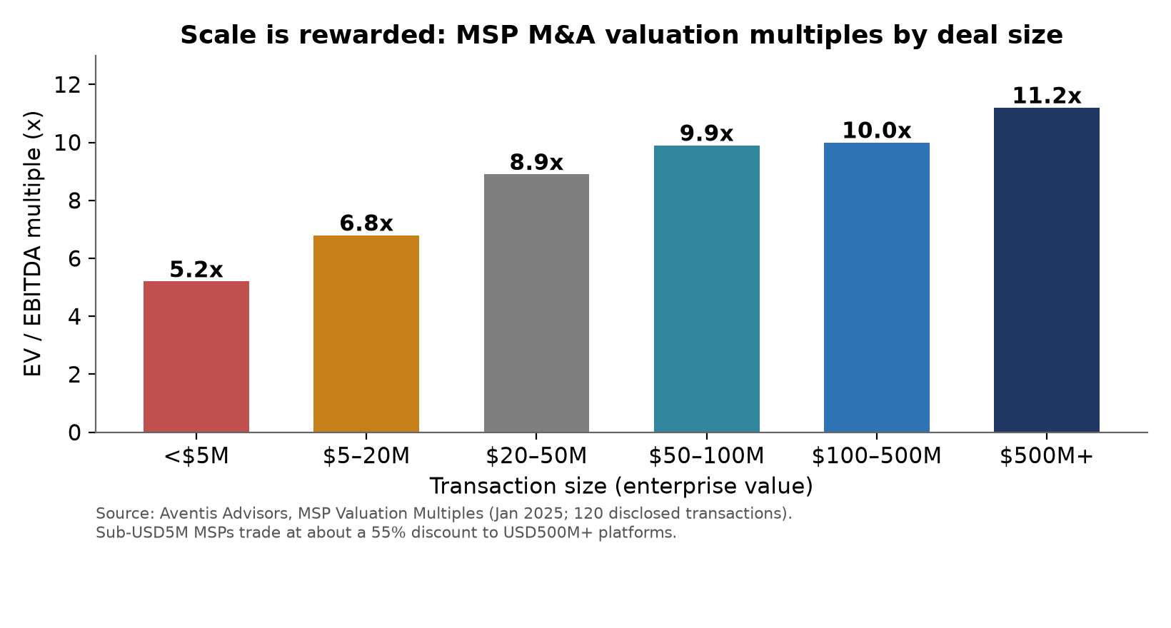
Figure 3. MSP M&A valuation multiples by deal size. Source: Aventis Advisors [10].

6.4 An illustrative five-year model: status quo versus transformation
To make the stakes concrete, the report models a representative $5 million generalist MSP over 2026 to 2031 under two paths. The model is illustrative, and every anchor is sourced. The status quo path assumes 2 per cent annual revenue growth (generous against the 1.0 per cent organic rate recorded in Q4 2024 [2]) and adjusted EBITDA eroding from 10 per cent toward 6.25 per cent as per-seat pricing loses its anchor and clients internalise AI-deflected ticket volumes, consistent with the unfocused-generalist band around 7 per cent [4]. It exits at the sub-$5 million multiple of 5.2 times [10]. The transformed path assumes growth ramping from 6 to 14 per cent as security, AI advisory and productised services compound (a blended 10 per cent CAGR, below the category's 13 per cent growth [5]), margins ramping to 16 per cent (the bottom of the focused-MSP band of 15 to 30 per cent [4]), and an exit at 9.0 times, below the scaled-platform multiples of 9.9 to 11.2 times [10].
Metric | 2026 baseline | 2031 status quo | 2031 transformed
Revenue ($M) | 5.00 | 5.52 | 8.04
Revenue CAGR (2026–2031) | — | 2.0% | 10.0%
Adjusted EBITDA margin | 10.0% | 6.25% | 16.0%
Adjusted EBITDA ($M) | 0.50 | 0.35 | 1.29
Assumed EV/EBITDA multiple | 5.2x | 5.2x | 9.0x
Implied enterprise value ($M) | 2.60 | 1.79 | 11.58
Change in owner value vs 2026 | — | −31% | +345%
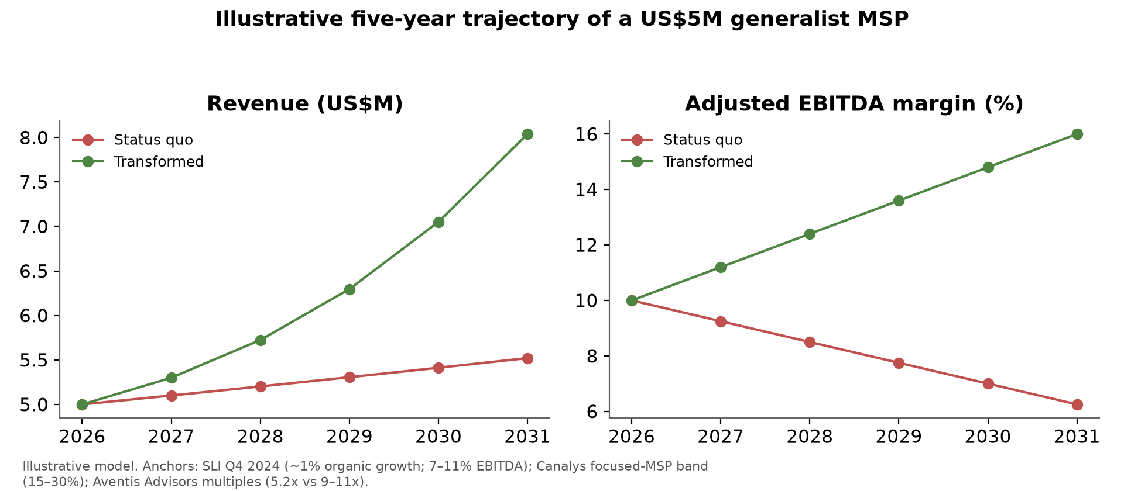
Figure 4. Illustrative trajectories for a $5 million generalist MSP, 2026 to 2031. Assumption anchors: Service Leadership Index [1][2]; Canalys [4][5]; Aventis Advisors [10].
The implications compound. On EBITDA, the status quo path loses roughly $155,000 of annual earnings by 2031 while the transformed path adds about $786,000. On valuation, the same business is worth $1.8 million on one path and $11.6 million on the other, a difference of roughly 6.5 times driven as much by the multiple re-rating as by earnings. On M&A, the status quo owner drifts below the $5 million acquisition floor that most large buyers apply [4], progressively narrowing exit options toward distressed tuck-ins, while the transformed owner enters the segment where buyers outnumber sellers [10]. For private-equity readers, the same arithmetic is the roll-up thesis itself: buy commodity books at 4 to 6 times, industrialise delivery and re-rate the platform toward 9 to 11 times.

7. Microsoft Strategy Analysis

7.1 An AI-first, agent-centric platform
Microsoft's direction is unambiguous in its own primary disclosures. In FY25 the Microsoft Cloud surpassed $168 billion in annual revenue (up 23 per cent) and Azure passed $75 billion (up 34 per cent) [30]. Copilot apps passed 100 million monthly active users, customers created 3 million agents using SharePoint and Copilot Studio in a year, and 230,000 organisations, including most of the Fortune 500, had used Copilot Studio [30][32]. By the April 2026 earnings call, Microsoft reported more than 20 million paid Microsoft 365 Copilot seats, including single deals such as Accenture's 740,000 seats [31]. The stated vision from the executive who runs Copilot and agents is that every employee will have Copilot and will be supported by many agents that operate autonomously on behalf of a process or company [30 related disclosures], and the 2025 Work Trend Index formalised the destination as the Frontier Firm, an organisation built on human-agent collaboration in which digital labour substitutes for headcount-based work [34]. Ignite 2025 extended the same framing across the stack [33]. The corporate messaging deserves discounting as vision; the product and program facts below do not.

7.2 Partner program economics have been rewired
Since 2022 Microsoft has retired gold and silver competencies in favour of performance-based Solutions Partner designations under the renamed Microsoft AI Cloud Partner Program. It stopped selling Microsoft Action Pack and legacy silver and gold benefits as of 22 January 2025, closing the low-cost on-ramp thousands of small resellers used for internal-use licences [41]. The FY26 benefits refresh, effective 13 February 2026, explicitly modernises benefits toward Microsoft 365 Copilot, Copilot Studio, Security Copilot, the Defender, Intune and Entra suites, and removes outdated items [41]. On the commerce side, the New Commerce Experience removed incentives and partner margin from the legacy Azure CSP offer, pricing it at estimated retail [42]. Individually each change is administrable; collectively they are a consistent signal about which partners Microsoft intends to fund: AI adopters, security specialists, software builders and consumption drivers, not reactive resale generalists.

7.3 The platform is absorbing MSP-billable work
Product by product, Microsoft is converting recurring, labour-priced MSP services into native platform features. Windows Autopatch, embedded in Intune, aims to update 95 per cent of devices by their target compliance date, with hotpatching that avoids restarts [37]. Defender XDR's automatic attack disruption contains compromised assets and limits lateral movement without an analyst in the loop [38]. Security Copilot ships agents designed to autonomously assist with phishing triage, data security and identity management [39], and Intune now includes an AI vulnerability remediation agent [30 related documentation]. Windows 365 makes the managed desktop itself a first-party cloud subscription [33]. AWS and Google mirror the pattern: AWS Managed Services advertises monitoring, incident management, security, patching and backup with 80 per cent of incidents proactively detected and up to 97 per cent automated [45]. When the platform performs the task natively, an intermediary can no longer charge a premium simply for performing it.

7.4 Vendors now sell the managed layer directly
The disintermediation extends beyond features to services. Microsoft sells Defender Experts for XDR, an always-on, AI-accelerated managed detection and response service natively integrated in Defender, with 24/7 expert coverage and proactive remediation [40]. Google sells Mandiant Managed Defense with expert triage in minutes [46], and AWS sells first-party managed operations [45]. All three hyperscalers therefore compete directly with their own partners for managed-operations and managed-SOC revenue on their home platforms, reframing partners as co-delivery and last-mile providers rather than sole operators. The answer to whether Microsoft is enabling customers to self-manage more of their environment is yes, progressively: automation defaults, admin-centre Copilots and first-party managed services all reduce the surface that once justified a generalist MSP's monthly fee.

7.5 The partner bull case, captured fairly
Microsoft-commissioned IDC research across 638 partners found that for every dollar of Microsoft revenue, services partners generate $8.45 and software-building partners $10.93, with generative AI forecast to grow 86 per cent over 2022 to 2027, thirteen times the overall IT market [43]. Canalys sized the channel AI opportunity at $15.4 billion in 2023 rising to $158.6 billion by 2028 [44]. Both figures are genuine and both are redistributive rather than protective: the multiplier rewards services depth and intellectual property, and Canalys's chief channel analyst stated bluntly that MSPs can stand down for the moment because the near-term opportunity accrues to global systems integrators and ISVs rather than MSPs or VARs [44]. Marketplace-centred selling, which Microsoft reports doubling year over year, points the same way [30]. The conclusion for this report's question is that Microsoft's direction decisively lowers the value of traditional, reactive MSP services while raising the value of AI-enablement, security specialisation and productised IP, and the partner archetypes it rewards are not the archetypes most MSPs currently embody.

8. AI Impact Analysis

8.1 What is measured, what is forecast, what is failing
The measured evidence is strong and specific. The peer-reviewed Brynjolfsson, Li and Raymond study of 5,179 support agents found generative AI assistance lifted issues resolved per hour by 14 to 15 per cent on average and 34 per cent for novice workers, with minimal impact on experienced staff [23]. Microsoft's randomised experiment across more than 6,000 workers at 56 firms, and its early-user telemetry showing users 29 per cent faster on search, writing and summarisation tasks, point the same direction for knowledge work [35][34]. ServiceNow reports roughly 20 per cent case avoidance and a 54 per cent deflection rate on its own internal service desk [65]. The most cited automation case, Klarna's assistant doing the work of 700 full-time agents with resolution times cut from 11 minutes to under 2 [21], also supplies the most important caution: Klarna subsequently rehired human agents after conceding the all-AI push degraded quality on complex cases [22].
The forecasts are aggressive. Gartner projects that agentic AI will autonomously resolve 80 per cent of common customer service issues by 2029 with a 30 per cent reduction in operational costs [19], that 15 per cent of day-to-day work decisions will be made autonomously by 2028, and that a third of enterprise software will embed agentic AI by 2028 [20]. McKinsey sizes generative AI's economic potential at $2.6 to $4.4 trillion annually, concentrated in customer operations among other functions [24]; Goldman Sachs estimates 300 million jobs globally are exposed [25]; and the World Economic Forum expects 92 million roles displaced and 170 million created by 2030 [26].
The failure data is equally real and must temper every projection. Gartner itself predicts over 40 per cent of agentic AI projects will be cancelled by the end of 2027 and estimates only about 130 of the thousands of self-described agentic vendors are genuine, coining the term agent washing [20]. MIT's NANDA research found roughly 95 per cent of enterprise generative AI pilots deliver no measurable return [27]. Anthropic's usage data shows augmentation still outweighing automation, 57 to 43 [28]. Field deflection rates for AI service agents commonly land at 10 to 20 per cent against advertised rates of up to 80 per cent [68], and Deloitte expected only a quarter of generative-AI-using companies to even pilot agents in 2025 [29]. The honest synthesis is augmentation first, automation compounding later.

8.2 Which MSP work is automatable
MSP task category | Automation potential | Key evidence
L1 help desk (password resets, access, how-to) | High | Klarna 700-agent equivalent [21]; Atera guarantees 50% autonomous resolution [68]; ServiceNow 20–54% deflection [65]
Monitoring, triage and alert noise | High | XSIAM incident volume −75%, remediation from days to minutes [67]; CrowdStrike triage saving 40+ hours weekly [66]
Documentation, ticket summaries, knowledge base | High | Copilot users 29% faster on writing and summarising [34]
Patching and vulnerability remediation | Medium-high | Windows Autopatch 95% device target [37]; Intune remediation agent [30]
Security operations, tier 1 | Medium-high | Security Copilot autonomous agents [39]; SentinelOne hunts 80% faster [67]
User onboarding and provisioning | Medium | Copilot Studio agents and RPA in MSP tooling [32][66]
L2/L3, architecture, client advisory and trust | Low to medium | Minimal gains for experienced workers [23]; Klarna reversal on complex cases [22]; augmentation dominant [28]
Synthesising the exposure research, measured productivity anchors, field deflection data and the failure evidence, the report estimates the following bands for automation of current L1/L2 task-hours: roughly 15 to 25 per cent within three years, 25 to 40 per cent within five, and 40 to 55 per cent within ten in the base case, with best and worst cases shown below. Confidence declines with horizon. These are task-hour figures, not one-for-one headcount or revenue losses, because demand expands and work shifts up-stack.
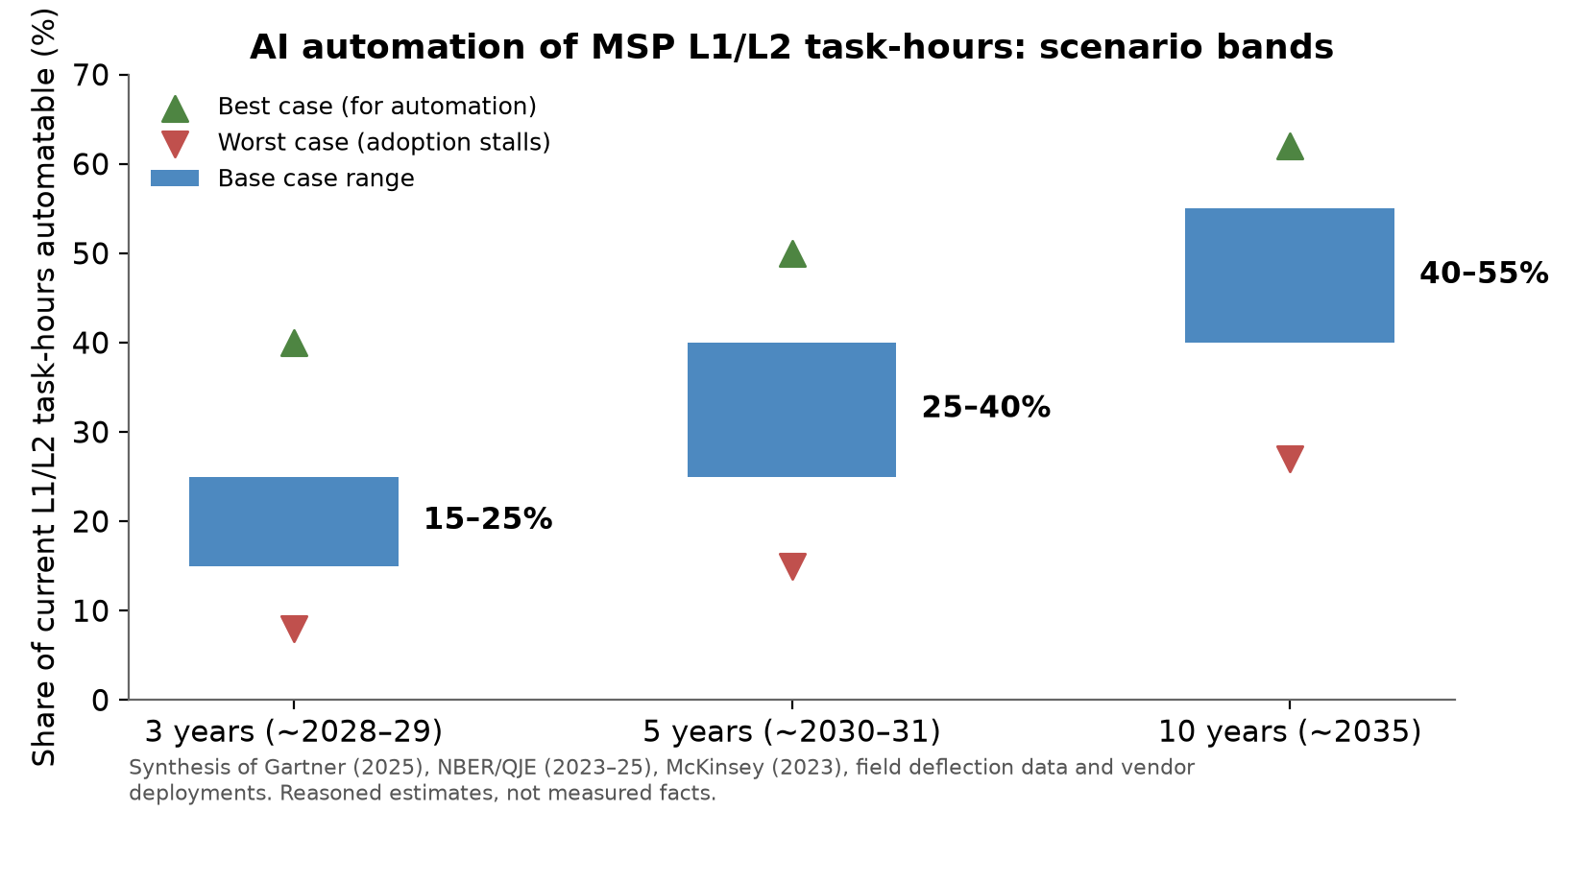
Figure 5. Estimated automatable share of current L1/L2 task-hours. Synthesis of Gartner [19][20], NBER/QJE [23], McKinsey [24], field data [65][68] and vendor deployments [66][67].

8.3 Revenue, margin, staffing and organisational impact
The revenue impact arrives through pricing before volume. As deflection removes billable ticket volume and AI vendors meter by consumption or outcome, the per-seat anchor weakens; Zendesk already bills per verified resolution rather than per seat [68], and channel analysis in 2026 described token-based pricing as breaking MSP bundle economics outright [64]. MSPs on flat per-seat contracts capture AI savings as margin only until clients demand repricing. The margin impact is therefore front-loaded and positive for early adopters: junior-technician uplift of around 34 per cent [23] lets a well-run MSP raise endpoints per technician and expand gross margin for two to three years before competitive repricing arrives.
The staffing impact is a flattening pyramid rather than a purge. The Bureau of Labor Statistics projects a modest 3 per cent decline in support-specialist employment over a decade [12], but the leading indicator is starker: India's top IT firms hired fewer than 5,000 people in the June 2025 quarter, down over 90 per cent from 2021, as automation reset the junior-heavy delivery pyramid [63]. The MSP staffing model, many L1 technicians under few seniors, is the same pyramid. Organisationally, the winners redeploy people up-stack; Accenture tripled generative AI revenue to $2.7 billion in FY25 with $5.9 billion of bookings while flattening its own pyramid, converting the disruption into a growth service [62].
Best case for MSPs: AI is absorbed as a productivity multiplier, technicians cover more endpoints, and the MSP upsells Copilot deployment, security and governance into a market still growing 13 per cent [5], holding pricing long enough to fund the transition. Worst case: clients self-serve L1 through platform agents, deflection guts the billable base, token and outcome pricing plus private-equity consolidation compress margins faster than the MSP can move up-stack, an India-IT-style reset applied to the SMB channel [63][64]. Both scenarios are live today; which one an individual MSP experiences is substantially a function of its own pricing model and speed.

9. Future Industry Scenarios
The core question is whether the MSP/TSP business model remains viable by 2030. The answer depends on which model is meant. Three scenarios bound the outcome; the probabilities are this report's judgment, stated so they can be challenged, and each scenario is anchored to observable evidence.
Bull case (around 20 per cent likelihood). Agentic AI underdelivers on the Gartner curve: the 40 per cent project-cancellation prediction [20] proves conservative, field deflection stays near today's 10 to 20 per cent [68], and SMB stickiness keeps reactive support contracts renewing. The market grows toward $850 billion by 2034 [9], wage inflation stays benign, and even generalists ride security attach rates to stable margins. Traditional MSPs remain viable through 2030 with gradually thinning margins. Evidence consistent with this case already exists: record best-in-class profitability [1], record enterprise managed-services contract value in 2023 [18], and the Klarna reversal [22].
Base case (around 60 per cent likelihood). The slow squeeze. The category grows 9 to 13 per cent while organic growth at undifferentiated MSPs stays near zero [2][4]; AI automates 25 to 40 per cent of L1/L2 task-hours by about 2030 (Section 8); platforms keep absorbing patching, monitoring and tier-1 security [37][38][39]; and consolidation accelerates past the 2025 record of 466 deals [9]. By 2030 the traditional model survives mainly as the harvested tail of private-equity platforms and lifestyle businesses, no longer an independent growth model. An estimated 30 to 50 per cent of today's sub-$5 million generalists are absorbed or exit by 2030 to 2035, mirroring the travel-agency precedent of a 60 per cent workforce contraction with a prosperous specialist core [60].
Bear case (around 20 per cent likelihood). The Gartner curve lands on time or early: 80 per cent of common issues resolve autonomously by 2029 [19], Microsoft's agent stack matures into genuine self-managing SMB IT [33][34], insurers and platforms channel security spend to a handful of scaled MDR providers [47][49], and token-priced service economics [64] collapse per-seat pricing within three renewal cycles. Generalist MSP books re-rate toward run-off economics; even solid mid-market MSPs face DXC-style grinding decline, losing most of their enterprise value over five years as the laggard systems integrators did [58].
Scenario | Likelihood (judgment) | Traditional model by 2030 | Transformed MSPs by 2030 | Key evidence anchors
Bull | ~20% | Viable; margins thin gradually | Outperform, but gap narrows slowly | Record profits [1]; AI project failures [20][27]; Klarna reversal [22]
Base | ~60% | Marginal: harvested tails and roll-up feedstock; 30–50% of small generalists exit by 2030–35 | Capture disproportionate share of a growing market at 15–30% EBITDA | 1% organic growth [2]; 7% vs 15–30% EBITDA [4]; consolidation records [9][11]; travel-agency precedent [60]
Bear | ~20% | Run-off economics within 3 renewal cycles | Survive if scaled or specialised early | Gartner 80%/2029 [19]; token pricing [64]; DXC trajectory [58]
Across all three scenarios, one conclusion is invariant: the transformed MSP outperforms the untransformed MSP. The scenarios disagree only about how quickly the untransformed model deteriorates. That asymmetry is what makes transformation a rational strategy even for readers who assign the bull case a higher probability than this report does.

10. Transformation Framework
History supplies the playbook. Across seven prior platform shifts, the survivors made the same four moves: they moved up the value chain from execution to advisory, they specialised instead of staying generalist, they redeployed core capabilities into productised intellectual property, and they shifted the profit mix before the legacy line collapsed. Fujifilm grew revenue 57 per cent through the same decade in which Kodak fell 48 per cent and ultimately filed for bankruptcy, by redeploying film chemistry into new markets [56]. CDW made cloud, software and managed services the engine of its gross profit while hardware commoditised [59]. Accenture folded its delivery into Reinvention Services and returned +70 per cent over five years while DXC, defending legacy outsourcing labour, returned roughly −60 per cent [58]. Travel agencies contracted about 60 per cent by headcount, yet the specialists who moved up-market ended with 2.8 per cent unemployment in 2025 [60]. The pattern, not the panic, is the lesson.
Applied to MSPs, the framework ranks eight opportunities by urgency, revenue potential, margin potential and competitive defensibility. Rankings synthesise the growth and margin evidence cited throughout this report; the ordering is this report's judgment.
Opportunity (ranked) | Urgency | Revenue potential | Margin potential | Defensibility
1. Security-first services: MDR co-delivery, identity, managed SOC | Immediate | High (23.5% CAGR [47]) | High (~42% package premium [14]) | Medium-high; trust and 24/7 capability are barriers
2. Internal AI adoption and automated service delivery | Immediate | Indirect (protects base) | High (+34% junior productivity [23]) | High; operational moat compounds
3. AI advisory and implementation: Copilot deployment, agent build | Immediate | High (~35% CAGR [7]; 70% of midmarket seeks help [53]) | High (advisory rates) | Medium; crowded, moves fast
4. Commercial repricing: outcome, platform and subscription models | Immediate | Protects and re-rates existing base | High (captures AI efficiency) | Medium; contracts and trust dependent
5. AI governance, risk and compliance services | Near-term (6–18 months) | Medium-high; regulation-driven [6] | High | High; trust and audit relationships persist
6. Business process automation and managed agents | Near-term | High (3M agents built in a year [30]) | High once productised | Medium-high; process IP accumulates
7. Data readiness and data services | Near-term | Medium-high; prerequisite for client AI | Medium-high | Medium
8. Vertical specialisation with productised IP | 12–24 months | Medium-high within niche | High (15–30% EBITDA band [4]) | High; compliance depth is sticky
Two notes on sequencing. Security and internal AI adoption rank first because they defend the existing revenue base while everything else is built; an MSP that loses its clients to a breach or its margins to a faster competitor never reaches the later opportunities. Vertical IP ranks last on urgency only because it takes longest to build; its margin and defensibility scores are among the highest, and firms that begin now will own the niches by 2030.

11. Recommended Actions

11.1 Service evolution
Lead every client conversation with security and risk rather than device counts. Build or partner for MDR rather than reselling point tools: co-delivery with a specialist platform gives a mid-size MSP credible 24/7 coverage without SOC capital, and the market data shows security specialists growing at twice the generalist rate with premium funding [47][49][50]. Stand up an AI advisory practice around the demand that already exists: Copilot readiness, deployment and adoption; agent design in Copilot Studio; and AI governance, which pairs naturally with existing compliance work [53][6]. Add data services (tenant hygiene, information architecture, Purview governance) as the prerequisite engagement for every client AI project. Retain the help desk, but treat it as an automated product line rather than a labour pool.

11.2 Operational evolution
Adopt AI internally before selling it: deploy an AI-assisted service desk and measure deflection honestly against the 10 to 20 per cent field baseline rather than vendor claims [68]; instrument endpoints-per-technician and gross margin per service line monthly. Redesign the delivery pyramid on the assumption that L1 hiring falls toward zero over five years, mirroring the reset already visible in global IT services [63], and create explicit progression paths from L1 into security operations, automation engineering and client advisory. Productise: convert the ten most repeated engagements into fixed-scope, fixed-price offers with written runbooks, then convert the runbooks into agents. Track revenue per employee as the primary scale metric, targeting movement from the $100,000 to $150,000 labour band toward software-assisted economics [72].

11.3 Commercial evolution
Move deliberately off per-user, per-device and ticket-denominated value before clients force the issue. The replacement structures are already visible in the market: outcome-based pricing (fees tied to resolution, uptime, risk posture or audit results, as Zendesk now bills per verified resolution [68]); platform pricing (a base subscription for the automated service platform plus consumption for exceptions); subscription intellectual property (vertical compliance packs, governance frameworks, reporting products); and managed AI offerings (agent estates operated for a monthly fee under governance the client can audit). Reprice at renewal with a value narrative, not a discount: the client keeps faster resolution and better security posture; the MSP keeps the efficiency gain that funds its transformation. Owners should also make a deliberate capital decision within 24 months: commit to building toward the 15 to 30 per cent EBITDA specialist band, or sell into the consolidation while buyers still outnumber sellers above $1 million of EBITDA [10].

12. Risks and Counterarguments

12.1 Arguments supporting MSP survival
The bull case deserves a fair hearing, because parts of it are measurably true. Profitability at the top of the industry is at record highs, with best-in-class TSPs above 19 per cent adjusted EBITDA for five straight years and aggregate MSP EBITDA growing faster than revenue in 2024 [1]; enterprise managed-services contract value hit a record $40.7 billion in 2023 even as cloud spending wobbled [18]; and the category is growing faster than most of the technology industry [4][5]. The AI threat may be slower than forecast: Gartner expects over 40 per cent of agentic projects to be cancelled [20], MIT found roughly 95 per cent of generative AI pilots deliver no return [27], field deflection runs far below advertised rates [68], augmentation still outweighs automation in real usage [28], the official employment projection for support specialists is a mild 3 per cent decline [12], and the flagship replace-humans case partially reversed on quality grounds [22].
Demand-side arguments also favour survival. SMBs demonstrably cannot self-operate their technology estates: the IT skills shortage is valued at $5.5 trillion by 2026 [13], co-managed arrangements are growing rather than shrinking [16], and even Microsoft's own SMB economics case for Copilot, a Forrester study finding up to 353 per cent ROI, presumes skilled deployment of the kind partners provide [36]. The partner ecosystem economics remain large: IDC's multiplier puts $8.45 of partner services revenue against every Microsoft dollar [43], and Canalys sizes the channel AI opportunity at $158.6 billion by 2028 [44]. Finally, MSP client relationships carry real switching costs and trust, the same asset that let specialised travel agents prosper after the platforms took ticketing [60].

12.2 Arguments supporting MSP disruption
Against that stands a structurally consistent body of evidence. Organic growth at existing MSPs has stalled at 1 per cent with a growing loss-making tail [2]. The platforms are absorbing the billable task list natively and selling the managed layer directly [37][38][39][40][45][46]. AI is strongest precisely in the L1, triage and documentation work that anchors MSP labour, and it is already dissolving per-seat pricing through deflection and consumption-metered economics [19][23][64][65]. Microsoft has withdrawn the program economics that subsidised small generalist resellers [41][42], while the channel's share of total IT spend declines toward two-thirds [7][8]. Security demand is being captured by fast-growing, well-capitalised specialists rather than generalists [47][49][50][51], reinforced by breach costs and insurer mandates [52], and Gartner's guidance that half of organisations would use MDR services by 2025 pointed buyers at exactly that specialist category [48]. Consolidation compounds it all: record deal volumes, a rising acquisition floor near $5 million, and permanent-hold buyers absorbing the long tail [9][11][69]. Seven historical platform shifts ended the same way for undifferentiated intermediaries [54][55][56][57][58][60].

12.3 Most likely outcome
Weighing both columns, the report's base-case estimate for today's population of roughly 335,000 MSPs over the decade to 2035 is as follows; these percentages are reasoned judgments anchored to the sourced trend lines, not published figures. Roughly 20 to 25 per cent transform successfully into security-led, AI-capable, specialised or scaled providers and capture most of the category's profit pool. Roughly 30 to 50 per cent of the sub-$5 million generalist tail is absorbed by consolidators, merges defensively or exits, consistent with 466 deals in 2025 growing 20 per cent annually [9] and the travel-agency contraction precedent [60]. Roughly 25 to 30 per cent struggle on as stagnating lifestyle businesses with thinning margins, the missing middle that is too small to be a platform and too undifferentiated to command premium pricing [69]. Perhaps 10 per cent fail outright, concentrated among providers that are loss-making today [2]. The categories most at risk, in order: pure resale VARs and licence-margin-dependent CSPs; sub-$5 million generalist break-fix and RMM shops with no security or vertical depth; on-premises-centric infrastructure and telephony providers, where the platform has already absorbed the box, as the PBX market's terminal decline shows [54]; and labour-arbitrage staff augmentation, the segment most exposed to Gartner's 2029 automation curve [19]. Least at risk: security-led MSSPs, vertical compliance specialists, AI-enablement practices and scaled platforms with productised IP.

12.4 What would falsify this report's thesis
Boards should monitor five indicators that would signal the bear or bull case overtaking the base case: worldwide organic managed-service revenue growth (a sustained return above 5 per cent would weaken the thesis; further decline would strengthen it) [2]; the share of MSPs operating at a loss [2]; independently measured AI deflection rates crossing 40 per cent in SMB service desks [68]; the channel's share of IT spend stabilising rather than falling [7]; and MSP deal multiples for small generalists, where a narrowing discount would suggest commodity books retain value. One further risk cuts across every scenario: Canalys's leadership has warned that private equity itself may be the next big bust, since roll-up valuations rest on prior purchase prices rather than independent marks [11]. A PE freeze would slow consolidation, depress exit multiples for everyone, and strand undifferentiated sellers, an argument for optionality sooner rather than later.

13. Final Conclusions
Is the traditional MSP and TSP business model becoming obsolete? On the evidence assembled here: yes, as an operating model, on a five-to-ten-year horizon, and no, as a business category, for owners who act. Per-user and per-device pricing wrapped around reactive support, monitoring and patching is being squeezed simultaneously from four directions: its economics (labour-bound revenue near $100,000 to $150,000 per employee and a loss-making tail), its technology (AI automating the exact task categories it bills for), its platform (Microsoft and the hyperscalers productising the task list and selling the managed layer), and its buyers (who now purchase outcomes, security and AI advice rather than labour). None of these forces is speculative; each is visible in primary data today.
The sceptical owner's strongest objection, that their own P&L looks healthy, is precisely what the historical record predicts. Blockbuster's peak, 9,100 stores and $6 billion of revenue, came in 2004, years after Netflix had launched; sixteen years later 9,099 of those stores were closed [55]. Kodak's engineers invented the digital camera in 1975 and management buried it to protect film margins [56]. Rackspace built a premium managed-hosting brand and still watched hyperscalers take the compute layer beneath it, forcing a wrenching pivot [57]. The channel itself has already lived one full cycle of this pattern, evolving from hardware resellers into today's MSPs as product margin evaporated [61]. Disruption of intermediaries does not announce itself in the incumbents' financials until the repricing arrives; it announces itself in the growth-rate divergence, the valuation discount and the platform roadmap, all of which are already observable.
The decision, therefore, is not whether the industry changes but which side of its bifurcation each provider lands on. The transformed path is well-lit: security-first services, AI advisory and governance, productised vertical IP, AI-industrialised delivery and outcome-based pricing, executed within a window this report estimates at 2027 to 2032. The financial asymmetry is stark even under conservative assumptions: for a representative $5 million MSP, the modelled difference between the status quo and transformation is roughly $1.8 million versus $11.6 million of enterprise value by 2031. The traditional MSP will not disappear overnight. It will simply become a business that is harder to grow, harder to staff, harder to price and harder to sell, every year, while a different kind of technology partner takes the growth. The evidence says: choose deliberately, and choose soon.

14. Complete Reference List
[1] Service Leadership (ConnectWise). 2025 Annual IT Solution Provider Industry Profitability Report. 8 May 2025. https://www.connectwise.com/company/press/releases/service-leadership-announces-findings-of-its-annual-it-solution-provider-industry-profitability-report
[2] Service Leadership Index. Q4 2024 Data Report. 13 February 2025. https://www.einpresswire.com/article/785715002/
[3] Service Leadership Index. Q2 2024 Data Report. 6 August 2024. https://www.connectwise.com/company/press/releases/2024-08-06-service-leadership-q2-data-report
[4] Canalys data, reported in Business of Tech. MSP Market Expands to $500B as Provider Count Shrinks Amid Rapid Consolidation. 4 September 2025. https://businessof.tech/2025/09/04/msp-market-expands-to-500b-as-provider-count-shrinks-amid-rapid-consolidation/
[5] Canalys data, reported in Business of Tech. MSP Sector Surges to $608B as Platform Wars Reshape PSA-RMM Landscape. 23 June 2025. https://businessof.tech/2025/06/23/msp-sector-surges-to-608b-as-platform-wars-reshape-psa-rmm-landscape/
[6] Omdia/Canalys (Robin Ody). MSP Trends and Predictions 2025, Executive Summary. 15 January 2025. https://omdia.tech.informa.com/blogs/2025/jan/msp trends and predictions 2025 - executive summary
[7] Canalys (Jay McBain), via ChannelPartners.net. AI Spending Impact, Channel Share Decline, and MSP Growth Strategies. 10 April 2026. https://channelpartners.net/ai-msp-jay-mcbain/
[8] Omdia, via Channel Dive. US Channel Pivots to Services, AI Deployment. 11 June 2026. https://www.channeldive.com/news/us-channel-pivots/822675/
[9] Drake Star. 2025 MSP M&A Report. 27 January 2026. https://www.drakestar.com/news/2025-msp-ma-report-launch
[10] Aventis Advisors. MSP Valuation Multiples. 22 January 2025 (data to July 2025). https://aventis-advisors.com/msp-valuation-multiples/
[11] Aventis Advisors. Who Is Buying MSPs? Top Acquirers of Managed Services. 22 March 2026. https://aventis-advisors.com/who-is-buying-msps/ (Canalys private-equity caution: ChannelE2E, Canalys State of the Channel, 14 November 2023, https://www.channele2e.com/news/canalys-state-of-the-channel-msp-markets)
[12] US Bureau of Labor Statistics. Occupational Outlook Handbook: Computer Support Specialists. May 2024 data, modified 28 August 2025. https://www.bls.gov/ooh/computer-and-information-technology/computer-support-specialists.htm
[13] IDC, reported in CIO Dive. What's the Cost of the IT Skills Gap? IDC Says $5.5 Trillion by 2026. 17 May 2024. https://www.ciodive.com/news/tech-talent-skills-gaps-cost-trillions-idc/716523/
[14] Kaseya. Key Findings from Kaseya's 2025 Global MSP Benchmark Report. 4 April 2025. https://www.kaseya.com/blog/key-findings-from-kaseyas-2025-global-msp-benchmark-report/
[15] Kaseya/Datto. 2024 MSP Benchmark Report press release. 5 March 2024. https://www.datto.com/news/press-releases/kaseyas-2024-msp-benchmark-report-finds-that-cybersecurity-is-a-top-revenue-driver-for-three-quarters-of-managed-service-providers/
[16] Kaseya. Kaseya's State of MSP Shows What Makes a Top-Performing MSP. 7 January 2025. https://www.kaseya.com/press-release/kaseyas-state-of-msp-shows-what-makes-a-top-performing-msp/
[17] ISG. Global Market for Managed IT, Business Services Remains Sluggish Amid Growing Cloud Demand: Q2 ISG Index. 11 July 2024. https://ir.isg-one.com/news-market-information/press-releases/
[18] ISG. Global Spending on IT, Business Services Down in Q4 Amid Signs of a Rebound: Full-Year 2023 ISG Index. 18 January 2024. https://ir.isg-one.com/news-market-information/press-releases/
[19] Gartner. Gartner Predicts Agentic AI Will Autonomously Resolve 80% of Common Customer Service Issues Without Human Intervention by 2029. 5 March 2025. https://www.gartner.com/en/newsroom/press-releases/2025-03-05-gartner-predicts-agentic-ai-will-autonomously-resolve-80-percent-of-common-customer-service-issues-without-human-intervention-by-20290
[20] Gartner. Gartner Predicts Over 40% of Agentic AI Projects Will Be Canceled by End of 2027. 25 June 2025. https://www.gartner.com/en/newsroom/press-releases/2025-06-25-gartner-predicts-over-40-percent-of-agentic-ai-projects-will-be-canceled-by-end-of-2027
[21] OpenAI. Klarna's AI Assistant Does the Work of 700 Full-Time Agents. February 2024. https://openai.com/index/klarna/
[22] Forbes (Bernard Marr). How Klarna's AI Agent Strategy Backfired, But Became a Useful Lesson. 16 July 2026. https://www.forbes.com/sites/bernardmarr/2026/07/16/how-klarnas-ai-agent-strategy-backfired-but-became-a-useful-lesson/ ; Entrepreneur. Klarna CEO Reverses Course by Hiring More Humans, Not AI. 2025. https://www.entrepreneur.com/business-news/klarna-ceo-reverses-course-by-hiring-more-humans-not-ai/491396
[23] Brynjolfsson, E., Li, D. and Raymond, L. Generative AI at Work. NBER Working Paper 31161 (2023); Quarterly Journal of Economics 140(2), 2025. https://www.nber.org/papers/w31161 ; https://academic.oup.com/qje/article/140/2/889/7990658
[24] McKinsey & Company. The Economic Potential of Generative AI: The Next Productivity Frontier. June 2023. https://www.mckinsey.com/capabilities/tech-and-ai/our-insights/the-economic-potential-of-generative-ai-the-next-productivity-frontier
[25] Goldman Sachs Research. How Will AI Affect the US Labor Market? 2023. https://www.goldmansachs.com/insights/articles/how-will-ai-affect-the-us-labor-market
[26] World Economic Forum. Future of Jobs Report 2025. 8 January 2025. https://www.weforum.org/press/2025/01/future-of-jobs-report-2025-78-million-new-job-opportunities-by-2030-but-urgent-upskilling-needed-to-prepare-workforces/
[27] MIT NANDA. The GenAI Divide: State of AI in Business 2025, reported in Forbes. 26 August 2025. https://www.forbes.com/sites/jasonsnyder/2025/08/26/mit-finds-95-of-genai-pilots-fail-because-companies-avoid-friction/
[28] Anthropic. Anthropic Economic Index, September 2025 report. https://www.anthropic.com/research/anthropic-economic-index-september-2025-report
[29] Deloitte. Autonomous Generative AI Agents: Still Under Development. Technology, Media and Telecom Predictions 2025. November 2024. https://www.deloitte.com/us/en/insights/industry/technology/technology-media-and-telecom-predictions/2025/autonomous-generative-ai-agents-still-under-development.html
[30] Microsoft. FY25 Q4 Earnings Conference Call and investor materials. 30 July 2025. https://www.microsoft.com/en-us/investor/events/fy-2025/earnings-fy-2025-q4
[31] TechCrunch. Microsoft Says It Has Over 20M Paid Copilot Users. 29 April 2026. https://techcrunch.com/2026/04/29/microsoft-says-it-has-over-20m-paid-copilot-users-and-they-really-are-using-it/
[32] CX Today. Microsoft Hits 1MN Custom AI Agent Milestone with 230,000 Organizations Using Copilot Studio. January 2025. https://www.cxtoday.com/contact-center/microsoft-hits-1mn-custom-ai-agent-milestone-with-230000-organizations-using-copilot-studio/
[33] Microsoft 365 Blog. Microsoft Ignite 2025: Copilot and Agents Built to Power the Frontier Firm. 18 November 2025. https://www.microsoft.com/en-us/microsoft-365/blog/2025/11/18/microsoft-ignite-2025-copilot-and-agents-built-to-power-the-frontier-firm/
[34] Microsoft WorkLab. Work Trend Index 2024 (AI at Work Is Here) and 2025 Annual Work Trend Index (The Frontier Firm); Copilot's Earliest Users research. https://www.microsoft.com/en-us/worklab/work-trend-index/ ; https://news.microsoft.com/annual-work-trend-index-2025/
[35] Microsoft Research. The Early Impacts of Microsoft 365 Copilot (randomised experiment, 6,000+ workers at 56 firms). arXiv:2504.11443. April 2025. https://arxiv.org/abs/2504.11443
[36] Microsoft/Forrester. Microsoft 365 Copilot Drove Up to 353% ROI for Small and Medium Businesses (Total Economic Impact study). 17 October 2024. https://www.microsoft.com/en-us/microsoft-365/blog/2024/10/17/microsoft-365-copilot-drove-up-to-353-roi-for-small-and-medium-businesses-new-study/
[37] Microsoft Learn. Windows Autopatch documentation. https://learn.microsoft.com/en-us/windows/deployment/windows-autopatch/prepare/windows-autopatch-start-using-autopatch
[38] Microsoft Learn. Automatic Attack Disruption in Microsoft Defender XDR. https://learn.microsoft.com/en-us/defender-xdr/automatic-attack-disruption
[39] Microsoft Security Blog. Microsoft Unveils Microsoft Security Copilot Agents and New Protections for AI. 24 March 2025. https://www.microsoft.com/en-us/security/blog/2025/03/24/microsoft-unveils-microsoft-security-copilot-agents-and-new-protections-for-ai/
[40] Microsoft. Microsoft Defender Experts for XDR (managed detection and response). https://www.microsoft.com/en-us/security/business/services/microsoft-defender-experts-mdr
[41] Microsoft Learn. Microsoft AI Cloud Partner Program Benefits FAQ (Action Pack retirement, 22 January 2025; FY26 benefits refresh, 13 February 2026). https://learn.microsoft.com/en-us/partner-center/benefits/benefits-faq-new
[42] Microsoft. The New Commerce Experience in CSP: Azure. Updated 19 May 2022. https://www.microsoft.com/en-us/licensing/news/new-azure-experience-in-csp
[43] IDC study #US52483124, published via Microsoft Partner Blog (Nicole Dezen). AI Value for Partners. 19 September 2024. https://partner.microsoft.com/en-rs/blog/article/ai-value-for-partners
[44] Canalys, via ChannelE2E. The Generative AI Opportunity for MSPs and the Channel. 29 August 2023. https://www.channele2e.com/news/the-generative-ai-opportunity-for-msps-and-the-channel
[45] Amazon Web Services. AWS Managed Services. https://aws.amazon.com/managed-services/
[46] Google Cloud. Mandiant Managed Defense. https://cloud.google.com/security/products/managed-defense
[47] Grand View Research. Managed Detection and Response Market Report, 2024–2030. https://www.grandviewresearch.com/industry-analysis/managed-detection-response-market-report
[48] Gartner. Market Guide for Managed Detection and Response Services (50% of organisations using MDR by 2025 prediction, relayed via vendor whitepaper). https://www.bankinfosecurity.com/whitepapers/gartners-market-guide-for-managed-detection-response-services-w-9711
[49] Sophos. Sophos Completes Secureworks Acquisition ($859 million). 3 February 2025. https://www.sophos.com/en-us/press/press-releases/2025/02/sophos-completes-secureworks-acquisition
[50] Huntress. Series D Funding Announcement ($150M at a $1.55B valuation). https://www.huntress.com/company/series-d
[51] Palo Alto Networks. Fiscal Fourth Quarter and Fiscal Year 2025 Financial Results. 18 August 2025. https://www.paloaltonetworks.com/company/press/2025/palo-alto-networks-reports-fiscal-fourth-quarter-and-fiscal-year-2025-financial-results ; CRN. Palo Alto Networks CEO: SIEM's Days Are Numbered. 20 May 2025. https://www.crn.com/news/security/2025/palo-alto-networks-ceo-nikesh-arora-siem-s-days-are-numbered
[52] Sophos. The State of Ransomware 2024. 30 April 2024. https://www.sophos.com/en-us/blog/the-state-of-ransomware-2024 ; Verizon. 2024 Data Breach Investigations Report. https://www.verizon.com/business/resources/reports/2024-dbir-data-breach-investigations-report.pdf
[53] RSM US. 2025 Middle Market AI Survey. 11 June 2025. https://rsmus.com/newsroom/2025/middle-market-firms-rapidly-embracing-generative-ai-but-expertise-gaps-pose-risks-rsm-2025-ai-survey.html
[54] Metrigy. Global UCaaS Market Up 6.1% in 2025 as Businesses Continue to Migrate from On-Premises Solutions. 23 March 2026. https://www.metrigy.com/press-release-global-ucaas-market-up-6-1-in-2025-as-businesses-continue-to-migrate-from-on-premises-solutions-led-by-market-leader-microsoft-teams/
[55] Cato Institute/FEE (Dalton and Logan). Lessons from the Rise of Netflix and the Fall of Blockbuster. 26 October 2024. https://www.cato.org/commentary/lessons-rise-netflix-fall-blockbuster
[56] Quartr (Kasper Karlsson). The Dilemma That Brought Down Kodak. 21 August 2025. https://quartr.com/insights/edge/the-dilemma-that-brought-down-kodak ; PetaPixel. Why Kodak Died and Fujifilm Thrived. Updated December 2022. https://petapixel.com/why-kodak-died-and-fujifilm-thrived-a-tale-of-two-film-companies/
[57] StockAnalysis.com (from SEC filings). Rackspace Technology (RXT) Revenue 2017–2026. https://stockanalysis.com/stocks/rxt/revenue/ ; Rackspace Technology IR. Q4 and Full-Year 2025 Results. 26 February 2026. https://ir.rackspace.com/
[58] KoalaGains (from filings). DXC Technology Past Performance Analysis. 30 October 2025. https://koalagains.com/stocks/NYSE/DXC/past-performance ; Accenture Newsroom. Accenture Changes Growth Model to Reinvent Itself for the Age of AI. 20 June 2025. https://newsroom.accenture.com/news/2025/accenture-changes-growth-model-to-reinvent-itself-for-the-age-of-ai
[59] Futurum Research. Cloud Services Power CDW's Q4 Outperformance Amid Hardware Uncertainty. 9 February 2026. https://futurumgroup.com/insights/cloud-services-power-cdws-q4-outperformance-amid-hardware-uncertainty/
[60] Ernie Tedeschi (BLS data), via Macro Roundup. Analysis of the Structural Decline in Demand for Travel Agents. 21 April 2026. https://www.edwardconard.com/macro-roundup/
[61] CompTIA. IT Industry Outlook 2025. December 2024. https://www.comptia.org/en-us/resources/research/it-industry-outlook-2025/
[62] Accenture. FY2024 and FY2025 Annual Reports (revenue, headcount, generative AI revenue and bookings). https://investor.accenture.com/
[63] Times Now. AI Is Replacing Freshers: Why India's IT Giants Are Freezing Entry-Level Hiring. 2025. https://www.timesnownews.com/business-economy/industry/ai-is-replacing-freshers-not-just-jobs-why-indias-it-giants-are-freezing-entry-level-hiring-article-152361660 ; Business Standard. TCS, Infosys Layoffs Signal Shift to Automation, Pyramid Reset. July 2025. https://www.business-standard.com/industry/news/tcs-infosys-lay-off-indian-it-sector-job-cuts-automation-ai-reskilling-125072800505_1.html
[64] Business of Tech. Agentic AI Breaks MSP Bundle Economics as Token Pricing Replaces Per-Seat Models. 30 April 2026. https://businessof.tech/2026/04/30/agentic-ai-breaks-msp-bundle-economics-as-token-pricing-replaces-per-seat-models/ ; AI Metering Kills Seat Revenue. 29 April 2026. https://businessof.tech/2026/04/29/ai-metering-kills-seat-revenue-expands-variable-costs-msp-math-breaks-without-scoped-contracts/
[65] ServiceNow. Now on Now: Generative AI Use Cases. https://www.servicenow.com/workflow/now-on-now/generative-ai-use-cases.html ; ServiceNow Q2 2025 Earnings Call Transcript (Motley Fool). 23 July 2025. https://www.fool.com/earnings/call-transcripts/2025/07/23/servicenow-now-q2-2025-earnings-call-transcript/
[66] CrowdStrike. Charlotte AI Detection Triage. February 2025. https://www.crowdstrike.com/en-us/blog/agentic-ai-innovation-in-cybersecurity-charlotte-ai-detection-triage/ ; CrowdStrike Unleashes the Agentic Security Workforce. 16 September 2025. https://www.businesswire.com/news/home/20250916797981/en/
[67] SentinelOne. Purple AI Announcement. 9 April 2024. https://www.businesswire.com/news/home/20240409476688/en/ ; Palo Alto Networks. Cortex XSIAM: The Precision AI-Powered SOC Platform. May 2024. https://www.paloaltonetworks.com/cortex/modernize-siem
[68] Atera. Robin Autonomous Resolution Guarantee. 2026. https://www.beri.net/article/atera-robin-50-percent-ticket-resolution-guarantee-2026 ; Zendesk. Outcome-Based Pricing. https://www.zendesk.com/newsroom/articles/zendesk-outcome-based-pricing/ ; Richpanel. Zendesk AI Agents Guide (field resolution data). 2026. https://www.richpanel.com/learn/zendesk-ai-agents-guide
[69] BizTechReports. As MSPs Mature, Consolidation and Operational Discipline Drive the Next Wave of Growth. 13 June 2025. https://www.biztechreports.com/news-archive/2025/6/13/as-msps-mature-consolidation-and-operational-discipline-drive-the-next-wave-of-growth-biz-advisory-board
[70] TechPartner 2025 State of the MSP, reported in Business of Tech. 31 October 2025. https://businessof.tech/2025/10/31/techpartners-2025-msp-report-small-firms-chase-ai-while-consolidation-accelerates/
[71] MSSP Alert. 2024 MSSP Benchmark Pricing Report (sponsored by LimaCharlie). 13 January 2025. https://www.msspalert.com/native/mssp-pricing-report-maps-path-for-2025 ; Kaseya. MSP Pricing: A Guide to Managed IT Services Pricing. https://www.kaseya.com/resource/msp-pricing-managed-it-services-pricing/
[72] Cognizant. 2024 Annual Report. https://www.cognizant.com/us/en/about-cognizant/2024-annual-report ; SaaS Capital and SEC 10-K revenue-per-employee benchmarks, via peppereffect. Revenue Per Employee by Industry. 30 June 2026. https://peppereffect.com/blog/revenue-per-employee-benchmarks

