Why the Traditional MSP and TSP Business Model Is Becoming Obsolete
Strategic research report on economic viability, AI disruption, platform strategy and transformation priorities, 2026-2036
4 August 2026
Prepared for MSP owners, Microsoft partners, technology service providers, boards, executives, investors and advisers
Evidence cut-off: 4 August 2026. Forecasts beyond 2030 are scenario estimates, not third-party predictions.

Contents
Table of contents (updates when the document opens)

Executive Summary
The evidence supports a precise conclusion: the traditional MSP and TSP pricing and delivery model is becoming obsolete, but the MSP as an institution is not. Per-user, per-device, ticket-driven and labour-linked services are being repriced by automation, software bundling and maturing competition. At the same time, demand for outsourced accountability, security, compliance, AI governance and business transformation is expanding. The most likely outcome is not industry extinction; it is a hard bifurcation between providers that change what they sell and how they price it, and providers that remain efficient operators of increasingly commoditised work.
The disruption thesis is supported by unusually consistent evidence across analysts, public companies and government data. ISG reported that traditional labour-intensive work is increasingly displaced by large language models, with pricing deflation and provider-funded AI transformation entering managed-service contracts. Gartner forecast 2026 growth of 5.3% for IT services, compared with 15.5% for software, 29.3% for infrastructure as a service and 62.5% for data-centre systems. This is not a shrinking technology market; it is a shift in where value and growth accumulate (ISG Index, January and July 2026; Gartner IT Spending Forecast, July 2026).
Traditional economics are vulnerable because revenue is linked to seats, devices and effort while cost and capability are moving into software. A per-seat contract is partly a derivative of the client's headcount. It loses revenue if AI reduces entry-level and administrative roles, even when retention is perfect. A fixed-fee contract can briefly improve margin when the provider automates delivery, but competitive renewals and visible vendor metering can transfer those savings to the customer. Gartner expects agentic AI to autonomously resolve 80% of common customer-service issues by 2029, while the US Bureau of Labor Statistics projects computer support specialist employment to decline 3% from 2024 to 2034 (Gartner, March 2025; BLS, August 2025).
AI therefore creates both an operating dividend and a revenue threat. Microsoft, ServiceNow and other platforms now ship autonomous or semi-autonomous capabilities for provisioning, triage, phishing assessment, remediation, knowledge capture and reliability operations. The first providers to automate may gain four to eight margin points for several years, but the durable benefit depends on commercial design. If customers continue buying a managed outcome, the provider can retain productivity gains. If customers believe they are buying labour, tickets or tools, the gain will be competed away.
Microsoft's direction is strategically decisive for its partner ecosystem. In its FY2026 results Microsoft reported more than 30 million paid Microsoft 365 Copilot seats and stated that its business model is evolving from per-seat to per-seat-plus-consumption. Agent 365, Microsoft 365 administration agents, Security Copilot agents and Azure SRE Agent move operational capability into the platform. The FY2027 Cloud Solution Provider model also separates base margin from growth margin and rewards acquisition, expansion and AI adoption rather than passive renewal administration (Microsoft FY2026 Q4 results and earnings call, July 2026; Microsoft Partner Growth Margins, July 2026).
Security is the strongest current growth engine, but it is not a permanent safe harbour. Gartner's public segment data show security services rising from US$77.1 billion in 2024 to US$92.8 billion in 2026, while security software rises faster, from US$95.0 billion to US$121.2 billion. Omdia expects managed security to outgrow managed services overall, yet the market contains more than 600 self-described MDR providers and platform vendors are absorbing XDR, MDR and threat-intelligence functions. The defensible position is consequence-bearing security: identity, machine and agent governance, compliance evidence, complex investigation and named accountability (Gartner, July 2025; IDC, September 2025; Omdia MSP Predictions 2026).
Capital markets are already pricing this divergence. Indicative private-market bands published by M&A advisers range from 3-5x EBITDA for break-fix and project-heavy firms to 10-14x for cybersecurity-first firms. These bands are not audited market indices and must be treated cautiously, but the direction is consistent with operating evidence: best-in-class providers have sustained adjusted EBITDA above 19% for six consecutive years, while the share of unprofitable MSP respondents in Kaseya's 2026 survey doubled from 5% to 10% (Service Leadership, June 2026; Kaseya, April 2026; N2M Capital, June 2026).

Board-level answer
Is the MSP/TSP business model likely to remain viable by 2030? Yes, but not in its conventional form. A provider can remain viable while retaining per-seat billing as an administrative convention, but it cannot rely on helpdesk labour, endpoint administration, licence handling and reactive infrastructure support as its primary sources of differentiation and value. By 2030, top-quartile providers are likely to bundle or hide Level 1 support, operate materially more automated delivery platforms, and earn a much larger share of gross profit from security, compliance, AI, data, automation and advisory services.

Most likely industry outcome
This report's base-case planning estimate for mature markets through 2036 is: about 30% of current providers transform and outperform; about 35% consolidate or sell into larger platforms; about 20% remain viable as low-growth, lower-multiple utility providers; and about 15% disappear through closure, distress or absorption. These are analytical estimates with low confidence, because no authoritative source forecasts the population of independent MSPs to 2036. The more defensible conclusion is directional: 30-50% fewer independent providers is plausible while aggregate managed-service revenue continues to grow.

Research Methodology
This report evaluates the thesis rather than assuming it. It tests three competing hypotheses: the conventional model is becoming unsustainable; the industry is bifurcating and surviving in a reconstituted form; or the existing model remains broadly sound and AI disruption is overstated. Evidence was gathered across industry analysts, technology vendors, government statistics, academic research, public-company disclosures, partner-program documentation, customer and MSP surveys, and M&A market commentary.
The source hierarchy gives greatest weight to audited financial results, official vendor documentation, government statistics and academic research. Tier-one analyst research is used for market sizing and forecasts. Vendor surveys and M&A adviser reports are included because public MSP data are limited, but their commercial interests are disclosed and their findings are treated as directional unless corroborated.
The analysis separates observed facts, third-party forecasts and report estimates. Observed facts include revenue, margin, employment and programme changes. Analyst forecasts are presented with publisher and date. Figures for 2031-2036, automation shares by task, provider-population outcomes and the illustrative MSP financial model are scenario assumptions calculated for strategic planning, not claims made by the cited sources.
Contradictory evidence was retained rather than averaged away. ISG reports slow enterprise managed-services growth and pricing deflation, while Service Leadership reports record profitability among best-in-class solution providers. Kaseya reports smaller customer spend and more unprofitable firms. The most coherent explanation is dispersion: pressure is arriving unevenly, with enterprise outsourcing and weak SMB providers affected first, while operationally mature MSPs capture an automation dividend.
Material limitations remain. There is no authoritative per-user or per-device price index, no pure-play listed MSP benchmark, limited public data on revenue per employee and service gross margin, and no credible market forecast to 2036. Vendor-reported automation outcomes frequently represent best cases. Private-market valuation bands are supplied by advisers with a transaction incentive. The report therefore places more confidence on direction and mechanism than on precise timing or magnitude.

Key Findings
The findings below combine measured evidence, forecasts and explicitly labelled report estimates. Confidence is highest where multiple independent sources point in the same direction and lowest for long-range population and valuation scenarios.
Table 1. Summary of the strategic evidence
Finding | Evidence | Implication | Confidence
Model verdict | Labour-priced services face deflation; best providers remain profitable | The model bifurcates rather than disappears | High
Growth divergence | IT services 5.3%; software 15.5%; IaaS 29.3% in 2026 | Value shifts toward platforms and AI infrastructure | High
Pricing pressure | ISG cites pricing deflation and provider-funded AI transformation | Productivity savings will be shared with customers | High
SMB bifurcation | Best-in-class EBITDA above 19%; unprofitable share doubled to 10% | Operational maturity separates winners and laggards | Moderate-high
Automation | Agents now triage, provision, document and remediate bounded tasks | Level 1 becomes bundled; governance becomes billable | Moderate-high
Microsoft direction | Per-seat-plus-consumption; Agent 365; CSP base plus growth margin | Renewal administration loses value; AI adoption gains value | High
Security | Services grow 10.7%; software grows 14.4%; MDR supply is crowded | Security grows, but platforms capture more of the wallet | High
Demand gap | 48% cite AI as top need; only 13% earn meaningful AI revenue | The largest near-term opportunity is under-monetised | Moderate
Valuation | Indicative 3-5x for break-fix vs 10-14x for security-first | Service mix can outweigh modest revenue growth | Moderate
2036 structure | Report estimate: 30-50% fewer independent providers | Consolidation rises while aggregate revenue can still grow | Low

Market Analysis

Is the traditional model fundamentally broken?
Per-user and per-device pricing remain commercially convenient, particularly for small customers, but they increasingly misdescribe the value delivered. They link revenue to customer headcount and endpoint volume when the provider's work is becoming less labour-intensive. They also make platform bundling visible: when Microsoft or another vendor adds security, analytics, support and automation features to an existing subscription, customers can challenge the separate service line rather than paying for the accountability that sits above the feature.
Helpdesk-centric and reactive support services have the highest exposure. Gartner's customer-service forecast is not a direct forecast for IT support, but it demonstrates the maturity direction for high-volume, repeatable work. BLS projects a net decline in computer support specialist employment, and Omdia states that traditional helpdesk and IT support face significant commoditisation pressure. The service does not vanish; it becomes bundled, automated and difficult to defend as a premium line item (Gartner, March 2025; BLS, August 2025; Omdia MSP Predictions 2026).
Infrastructure management and monitoring show the same pattern at enterprise scale. DXC's Global Infrastructure Services revenue fell 7.2% organically in FY2026 and bookings fell 13.3%, while Kyndryl's constant-currency revenue declined 3% even as consulting grew 18% and hyperscaler-related revenue grew 59%. Both companies used automation and mix improvement to defend profit. The evidence does not prove that every SMB MSP will follow the same path, but it provides a leading indicator for lower-complexity infrastructure services (DXC and Kyndryl FY2026 results, May 2026).
Fixed-fee contracts are not inherently obsolete. They can be attractive when automation reduces delivery cost faster than competition reduces price. The vulnerability is that they often bundle a static service catalogue and hide a labour-based operating model. ISG's description of provider-funded AI transformation inside contracts means the provider may be required to finance the customer's productivity gain. The strategic requirement is to contract for a defined outcome, risk transfer and governance responsibility, not for an implied volume of human effort.

Labour dependence and the revenue-per-employee problem
Large technology service providers show that revenue and headcount can decouple. TCS reported FY2026 constant-currency revenue down 2.4% while operating margin reached 25%, its highest in four years. Kyndryl expanded adjusted EBITDA on declining constant-currency revenue through AI-enabled automation. These are not clean MSP comparisons, but they demonstrate the likely sequence: lower hiring, better utilisation and margin expansion appear before material headcount reduction (TCS, April 2026; Kyndryl, May 2026).
The talent problem changes rather than disappears. Kaseya reported that 16% of MSPs found it difficult to hire skilled technicians, up from 9% in the prior year. ISC2 stopped emphasising a single global cybersecurity workforce-gap number and focused instead on critical skills. Automation removes repetitive entry-level work, but that work has traditionally trained future senior engineers and investigators. Providers that eliminate Level 1 labour without redesigning apprenticeships may create a more severe Level 3 shortage later in the decade.

Scale limits, commoditisation and competitive intensity
Managed services is growing, but it is capturing a smaller share of the technology growth pool. Gartner's July 2026 forecast places IT services growth at 5.3%, well below software, IaaS and data-centre systems. ISG forecast managed-services growth of 2.1% for 2026, compared with 20% for as-a-service contracts. Figure 1 illustrates the change in value concentration. Source: Gartner, July 2026.
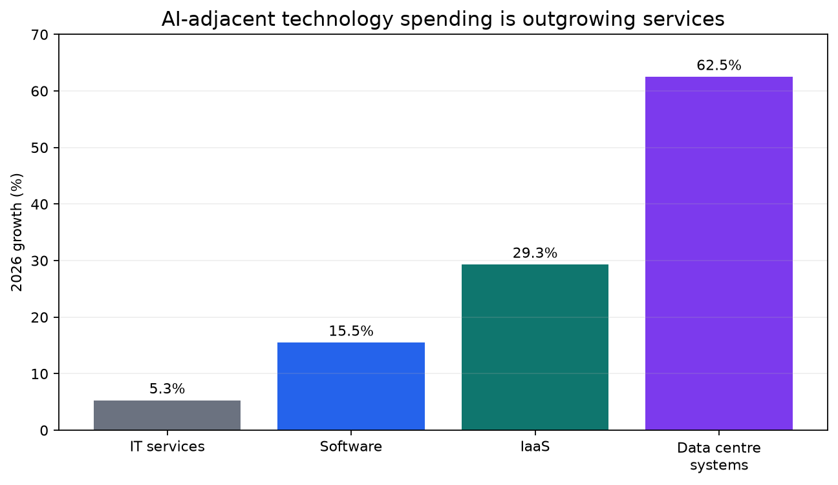
The SMB market also appears mature. In Kaseya's 2026 survey, 71% of MSPs named customer acquisition as their largest challenge, one-third said new clients were mainly competitive takeaways, and only a small minority were first-time outsourcers. The reported fall in customers spending at least US$25,000 per year, from 75% to 41%, is probably affected by sample changes and should not be read as a market index. Directionally, however, the data align with ISG's pricing-deflation language: growth increasingly comes from replacing another provider rather than expanding the category.

Changing customer buying behaviour
Customers increasingly want outcomes without a traditional sales process. Gartner's B2B buying research reports that a large majority of buyers prefer rep-free experiences, while also finding that self-service purchases are more likely to create regret. This combination strengthens advisory value but weakens transactional value. The winning provider is not the organisation that provisions a licence; it is the organisation that resolves uncertainty, integrates the decision across stakeholders and accepts responsibility for the result (Gartner B2B Buying Report, 2025-2026).
The demand mix is moving faster than the average MSP revenue mix. Kaseya reported that 48% of MSPs viewed AI and automation as the leading client need for 2026, ahead of security at 42%, yet only 13% identified AI and automation as a meaningful revenue source. Cybersecurity revenue grew for 71% of respondents, while formal compliance services are offered by only about 36% of providers in ScalePad's 2026 survey. This reveals both the disruption and the opportunity: customers are asking for capabilities that many conventional MSP catalogues do not monetise.

Lessons from other industries
Travel agencies and managed print services provide the clearest analogies. Online platforms removed routine ticketing but did not eliminate complex travel advice and exception handling. Print providers faced declining unit volumes, hardware commoditisation and margin pressure, then repositioned around workflow, security and identity. In both cases the transaction-processing tier contracted while the judgement-bearing tier survived at higher value (BLS Travel Agents; Quocirca Print Industry Trends 2026).
Hosting, VAR and offshore IT services show related patterns. Rackspace's private-cloud revenue declined while public-cloud management grew, illustrating survival as a platform-dependent service layer. CDW grew sales while gross margin fell on mix. NASSCOM reported that Indian technology providers are moving away from FTE delivery toward outcome-based and risk-sharing constructs as AI productivity materialises. The relevant lesson is not that intermediaries disappear; it is that volume growth in a commodity line can coexist with lower margin and lower strategic control.

Microsoft Strategy Analysis

AI-first economics and platform direction
Microsoft's FY2026 results show the scale and capital intensity of the AI transition. Revenue reached US$331.8 billion, operating income US$155.2 billion and Azure exceeded US$100 billion for the first time. Microsoft 365 Copilot passed 30 million paid seats, and commercial remaining performance obligation rose to US$678 billion. These figures establish that AI is not a side programme; it is becoming the organising principle for Microsoft's product, infrastructure and commercial strategy (Microsoft FY2026 Q4 results, July 2026).
The most important commercial signal for partners is Microsoft's stated move beyond per-seat to per-seat-plus-consumption. Usage-based billing in Copilot, Dynamics, GitHub and agent platforms expands Microsoft's addressable market while reducing the centrality of the seat as the unit of value. For MSPs this creates token and agent FinOps opportunities, but it also weakens businesses whose economics depend on licence administration and a stable per-user annuity (Microsoft FY2026 Q4 earnings call, July 2026).

Autonomous operations and embedded administration
Microsoft has shipped or announced agents that perform work traditionally found in managed-service catalogues. Teams Admin Agent can execute provisioning workflows; SharePoint Admin Agent can identify inactive, ownerless or overshared sites and apply policy actions; Security Copilot agents triage phishing, optimise conditional access and support remediation; Agent 365 provides a cross-cloud registry and governance control plane. These capabilities reduce routine effort while creating a new requirement for policy, assurance, integration and continuous agent governance (Microsoft Ignite 2025; Agent 365 GA, May 2026).
Azure SRE Agent is a particularly clear reference model for future operations. Microsoft describes an always-on service that can recommend or execute restart, scale and rollback actions within guardrails, with metered baseline and task consumption. Defender Experts also offers first-party MDR for defined workloads. Microsoft is therefore both a supplier to and a competitor of service providers, but its managed scopes remain bounded, leaving cross-platform, compliance, mobile, IoT, custom detection and business-accountability work to partners (Azure SRE Agent; Microsoft Defender Experts MDR).

Partner programme and CSP economics
Effective 1 October 2026, Microsoft's FY2027 CSP approach introduces base margin for ongoing subscriptions and growth margin for qualifying growth motions. Public materials emphasise new-customer acquisition, seat expansion and AI adoption, while the precise rates remain partner-gated. The direction is clear even without the percentages: passive renewal administration is being separated from active demand creation and transformation value (Microsoft Partner Growth Margins, July 2026).
The programme change arrives alongside material Microsoft 365 price and packaging changes and wider access to AI and security capabilities. This creates a difficult customer conversation: the licence invoice may rise while the platform absorbs functionality previously sold as a separate service. It also creates a larger wallet for capable partners, including AI adoption, governance, data readiness, security operations and consumption optimisation. The economic effect depends on whether the partner can attach these services faster than renewal margin and commodity service value decline.

Hyperscaler and SaaS vendor disintermediation
Microsoft, AWS, Google Cloud and ServiceNow are converging on a similar channel model. They fund partners for growth and AI adoption, place vendor engineers inside important accounts and embed more self-service automation in the platform. Microsoft's US$2.5 billion Frontier Company and Google's US$750 million partner commitment focus heavily on global systems integrators, not the SMB long tail. ServiceNow reported ninefold growth in agentic deployments and customer examples of large support-cost reductions. The likely outcome is partner re-selection rather than partner elimination: fewer providers will be paid for administration, and more will be paid for measurable outcomes.

Implications for the traditional MSP
Microsoft's direction decreases the value of basic tenant administration, licence handling, standard policy configuration and repetitive support. It increases the value of agent governance, identity design, secure adoption, data remediation, integration, compliance, cross-platform accountability and consumption management. The strategic danger is not that Microsoft directly serves every SMB. It is that Microsoft defines, meters and bundles the work, causing the customer to reprice the MSP before the MSP redesigns the contract.

AI Impact Analysis

Task-level automation potential
Level 1 password, access and how-to support is the most exposed category. The report estimates that 25-40% of effort can be machine-executed in 2026 and 65-80% by 2030 in well-standardised environments. The residual work is identity proofing, exceptions, high-risk resets, executive support and poorly documented line-of-business applications. These ranges are report estimates based on current Microsoft, ServiceNow and Gartner capabilities, not independently audited industry averages.
Monitoring, triage, documentation, onboarding and routine remediation are also highly automatable. AIOps and SRE agents can correlate signals and execute bounded actions; knowledge tools can draft runbooks and incident summaries; workflow agents can provision users and devices. The practical constraint is not model intelligence alone. It is data quality, access control, change authority, heterogeneity and the commercial consequence of a wrong action.
Security operations will automate unevenly. Phishing and alert triage, enrichment and false-positive closure are well suited to agents, but complex investigation, incident command, legal notification and business-impact decisions remain human-accountable. Gartner expects AI applications to drive 50% of enterprise cybersecurity incident-response effort by 2028 because AI creates new attack surfaces as well as efficiencies. The net effect is fewer repetitive analyst tasks and more demand for cross-domain judgement (Gartner, March 2026).
Task domain | 2026 autonomous share | 2030 autonomous share | Residual human work | Commercial effect
L1 access and how-to | 25-40% | 65-80% | Identity proofing and exceptions | Bundle into platform service
Ticket triage and routing | 30-50% | 70-85% | Ambiguous cross-system incidents | Lower price; higher capacity
Monitoring and remediation | 20-35% | 60-75% | Hybrid, physical and high-risk change | NOC repriced against agent metering
Patching and vulnerability work | 35-55% | 75-85% | Legacy and regulated systems | Commodity unless tied to risk
Security alert triage | 30-45% | 70-85% | Novel threats and incident command | Move value to investigation
Documentation and runbooks | 40-60% | 80-90% | Accuracy attestation | Near-zero standalone value
User and device onboarding | 30-45% | 70-85% | Policy and HR integration | Sell lifecycle assurance
Training and adoption | 20-35% | 55-70% | Behaviour change and leadership | Advisory remains valuable

Staffing and organisational impact
The likely staffing path is compositional rather than a simple headcount collapse. Level 1 hiring slows, attrition is not fully replaced and technician-to-user ratios improve. New roles grow in automation engineering, identity, AI governance, data, security investigation, compliance and customer success. For a conventional MSP, the report's base estimate is a 40-60% reduction in Level 1 FTE per 1,000 managed users by 2032, offset partly by higher-skilled roles.
Two second-order effects deserve board attention. First, automation can break the apprenticeship pipeline that produces senior engineers and investigators. Second, the remaining labour is more expensive: agent architects, incident leaders, governance specialists and regulated-industry advisers. Automating cheap labour while retaining scarce expert labour does not guarantee lower total labour cost unless the service catalogue and pricing model change with the workforce.

Revenue and gross-margin impact
Early adopters can create a temporary margin window. ConnectWise's vendor model claims five to twelve points of margin uplift, but its methodology is not public and Kaseya's survey found profit margin among the least commonly reported automation benefits. This report therefore uses a more conservative base assumption: four to eight points of potential gross-margin improvement for two to three years, followed by competitive give-back unless contracts are priced on outcomes and accountability.
Revenue risk is more persistent than the initial margin gain. Platform bundling removes upsells; customer headcount may reduce the seat denominator; visible consumption pricing creates a reference price; and buyers can demand that provider-funded automation lower the renewal price. A median provider that keeps its current mix may achieve only flat to low-single-digit nominal growth through 2030. A provider that shifts at least 20% of revenue into security, compliance, AI governance, data and automation can plausibly sustain high-single-digit or low-double-digit growth.

Best-case and worst-case operational scenarios
In the best case, the MSP owns the agent operating layer, retains productivity gains, expands capacity without equivalent headcount and sells new governance subscriptions. In the worst case, vendor features absorb service scope, customers benchmark the MSP against machine pricing, licence inflation forces contract renegotiation and the provider's largest revenue lines decline before new offers reach scale. The difference is determined less by the AI model than by service design, contract language, customer segment and speed of execution.

Security as a Managed Service

Market structure and growth
Security remains a large and growing market. Gartner projected worldwide information-security spending of about US$240 billion in 2026. Its public segment table shows security services growing 10.7% from 2025 to 2026, while security software grows 14.4%. Figure 2 shows that services rise in absolute terms but lose share of the security wallet. Source: Gartner, July 2025.
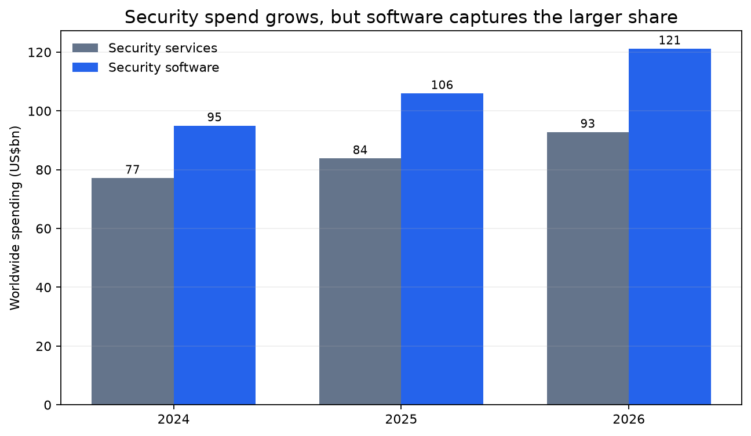
Managed security is likely to outperform general managed services, but MDR and XDR are already crowded and vulnerable to platform absorption. IDC describes a crowded field of MDR providers and systems integrators. Gartner's market-guide commentary, as reproduced by vendors, counts more than 600 providers and warns that technology-first offerings without human-led outcomes do not meet buyer needs. Independent providers are also squeezed by software vendors acquiring MDR capability.

Where defensibility is strongest
Identity, machine identity and AI-agent governance are the most attractive gaps. Gartner identifies human and machine identities as a primary attack surface, and vendor summaries of Gartner research report rapid growth in machine identities driven by AI. Kaseya shows identity is widely offered but rarely a top revenue source, suggesting that MSPs often give away an important capability as hygiene rather than sell it as managed risk.
Security-focused providers should outperform generalists only when specialisation produces consequence-bearing outcomes. Compliance evidence, incident accountability, complex investigation, insurance eligibility and vertical regulatory expertise are difficult to self-serve. An undifferentiated alert-forwarding MSSP is not automatically defensible. The evidence supports 'security-attached and operationally mature' more strongly than 'security specialist at any cost'.

Risks to the security thesis
Security can commoditise. Software is growing faster than services, vendor consolidation reduces integration complexity, AI can enable some mid-market customers to insource triage, and rapid vCISO adoption may erode differentiation. The UK Cyber Security Breaches Survey also found that the median perceived cost of the most disruptive breach was zero for the broad business population. SMB security is therefore sold more credibly through compliance, insurance, customer requirements and continuity than through undifferentiated fear.

Financial Analysis
The model below is illustrative, not a benchmark. It starts with a US$10 million revenue MSP at 15% adjusted EBITDA and a 7x enterprise-value multiple. The starting margin is deliberately below Service Leadership's 19%+ best-in-class level. Scenario growth, margin and multiple assumptions are anchored to ISG pricing pressure, Service Leadership profitability, Gartner and Omdia growth rates, and indicative N2M valuation bands. All calculated figures were produced programmatically and rounded.

Current model
A conventional MSP typically derives most revenue from recurring endpoint, user, helpdesk, infrastructure and monitoring services, with smaller contributions from licence resale, projects and basic security. Its strengths are predictable recurring revenue, high customer retention and operational familiarity. Its weaknesses are concentration in automatable work, a large labour cost base, limited differentiation, exposure to vendor programme changes and valuation dependence on EBITDA quality rather than revenue alone.

Future model
The future model keeps recurring revenue but changes its source. Core managed services become an automated platform and customer-acquisition foundation rather than the principal margin story. Growth comes from AI advisory and implementation, agent operations, identity and security, compliance, data readiness, business-process automation, governance and subscription intellectual property. Human effort concentrates in architecture, judgement, risk transfer and industry-specific change.

Illustrative scenario economics
Table 2 and Figure 3 compare a status-quo path with transformed, bull and bear cases. The base transformed case assumes 7% annual revenue growth to 2030, a 20% EBITDA margin and a 10x multiple. The status-quo case grows revenue 2% annually but loses margin and multiple, producing lower enterprise value than the 2026 starting point. These outcomes are scenario mathematics, not valuation advice.
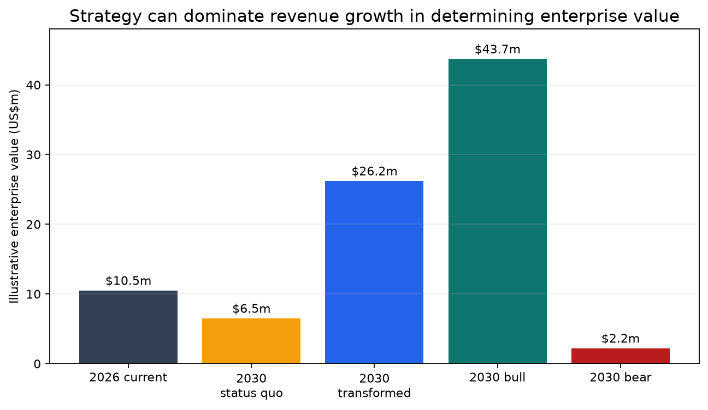
Scenario | 2030 revenue | Revenue CAGR | EBITDA margin | EBITDA | EV multiple | Enterprise value
2026 current | $10.00m | 0.0% | 15% | $1.50m | 7x | $10.50m
2030 status quo | $10.82m | 2.0% | 12% | $1.30m | 5x | $6.49m
2030 transformed | $13.11m | 7.0% | 20% | $2.62m | 10x | $26.22m
2030 bull | $15.18m | 11.0% | 24% | $3.64m | 12x | $43.72m
2030 bear | $9.22m | -2.0% | 8% | $0.74m | 3x | $2.21m

EBITDA and valuation implications
In the model, the transformed base case reaches US$13.11 million revenue and US$2.62 million EBITDA by 2030, implying US$26.22 million enterprise value at 10x. The status-quo case reaches US$10.82 million revenue but only US$1.30 million EBITDA and US$6.49 million value at 5x. The result is intentionally stark: service mix, margin quality and strategic defensibility can dominate modest revenue growth. Figure 4 shows indicative valuation bands reported by N2M Capital; they should be treated as directional because the source is a sell-side adviser.
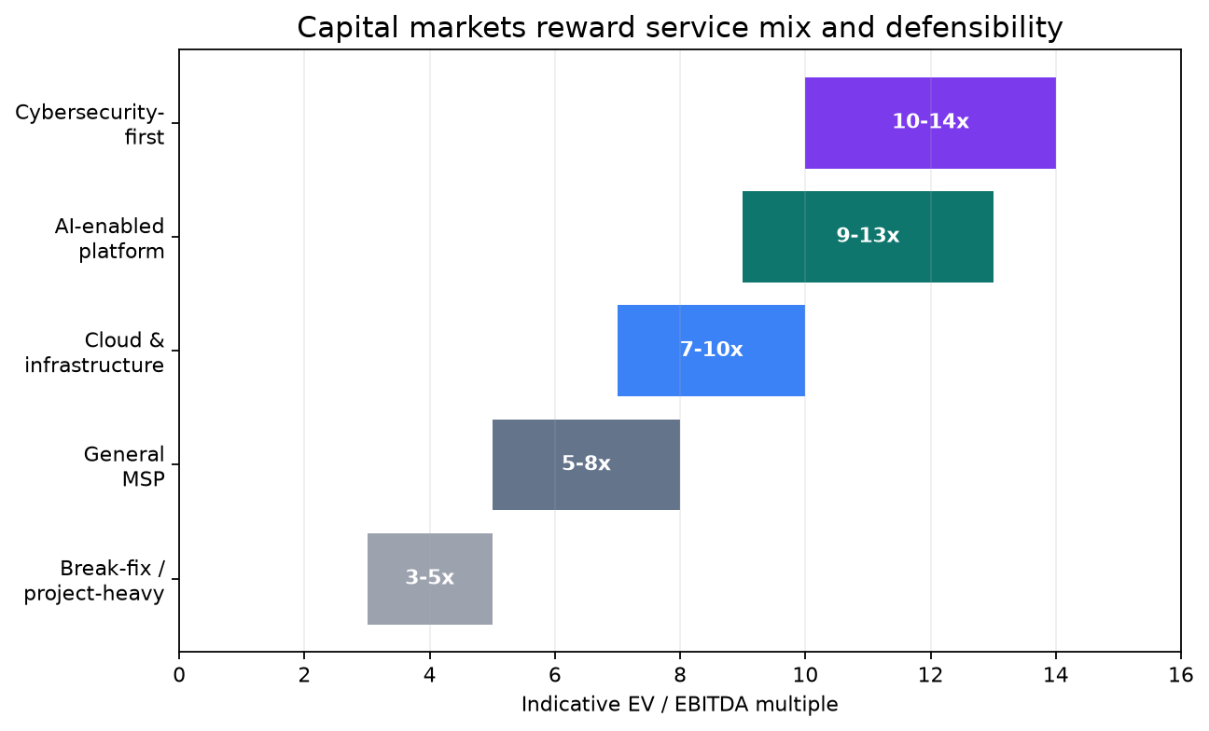

M&A implications
Private equity remains active, with N2M reporting 466 MSP transactions in 2025 and PE participation in 69% of disclosed deals. The risk is not an immediate absence of buyers. It is multiple dispersion and integration burden. Platforms assembled around undifferentiated per-seat revenue may face lower exit multiples while paying premium prices for security and AI capability. Buyers should diligence revenue by automatability, platform absorption, customer concentration, contract repricing rights, service gross margin, technician dependency and the share of gross profit derived from consequence-bearing work.

Future Industry Scenarios

Bull case: the automation dividend accrues to providers
In the bull case, SMBs cannot operationalise agents alone, regulation requires accountable oversight and MSPs reprice before competition gives away the productivity benefit. Managed services re-accelerates, best-in-class EBITDA reaches the mid-20s, agent governance becomes a material subscription category and high-quality multiples expand. The report assigns a 25% probability. A key falsifier would be two consecutive years in which Service Leadership shows EBITDA-dollar growth falling below revenue growth.

Base case: bifurcation becomes permanent
In the base case, commodity managed services grows slowly while security, compliance and AI-enabled providers grow two to three times faster. Level 1 support disappears as a separately valued line, the multiple spread widens and consolidation removes a material share of independent providers. Per-seat billing survives mainly as a simple invoice convention. The report assigns a 55% probability because this case requires no new trend; it extends patterns already visible in pricing, programme design, automation and valuation.

Bear case: the annuity breaks
In the bear case, platform bundling removes service scope faster than providers create new categories, customer seat counts shrink and growth-margin changes reduce passive resale economics. Commodity revenue declines in nominal terms, EBITDA compresses five to ten points and sub-scale multiples fall below 3x. Distressed consolidation accelerates between 2028 and 2031. The report assigns a 20% probability, with Microsoft CSP rates, customer seat counts and autonomous-operations reliability as the leading indicators.

Viability by 2030
The traditional MSP is likely to remain operationally viable by 2030 but strategically weaker. The business can still generate cash, especially in the SMB segment where customers lack internal IT. The more important question is whether it remains investable and valuable. A provider growing 2% with declining margin and a lower multiple can be viable yet destroy enterprise value. Table 3 summarises the scenario ranges and the conditions that separate them.
Case | Probability | 2030 revenue pattern | EBITDA range | Independent-provider effect | Critical condition
Bull | 25% | 10-15% growth for leaders | 24-28% | Modest consolidation | Providers retain automation value
Base | 55% | Commodity 2-3%; leaders 8-15% | 18-21% leaders | 20-35% fewer by 2030 | Bifurcation and M&A
Bear | 20% | Commodity revenue declines | 8-15% | 35-50% fewer by 2030 | Seat decline plus platform absorption

Transformation Framework
The transformation principle is to move revenue from transaction processing to consequence bearing. Transaction-processing revenue is repeatable, automatable, platform-absorbable and easy to compare. Consequence-bearing revenue requires judgement, integration, attestation, liability, industry knowledge and executive trust. Every service line should be classified by these characteristics and given an explicit grow, automate, bundle, partner or exit decision.

Ranked opportunity priorities
Table 4 ranks the most attractive opportunities by urgency, revenue potential, margin potential and defensibility. The rankings combine market demand, platform direction and current supply gaps. They are strategic recommendations rather than market forecasts.
Opportunity | Urgency | Revenue potential | Margin and defensibility | First commercial offer
AI governance | Very high | High | Very high | Agent inventory, policy and roadmap
Compliance and assurance | Very high | High | Very high | Framework readiness and evidence
Identity and machine identity | Very high | High | High | Identity posture and governance service
Business-process automation | High | Very high | High | Workflow discovery and managed automation
Data readiness and governance | High | High | High | Data-quality and control assessment
AI adoption advisory | High | High | Medium | Use-case portfolio and value plan
Managed agent operations | Medium-high | Very high | High | Govern, optimise and report agents
Internal service automation | Immediate | Defensive | Medium | Triage, documentation and remediation

Service evolution
AI advisory and governance should begin as paid diagnostics, policy and roadmap services, then convert into implementation and managed agent operations. The provider should inventory agents, classify data and risk, define guardrails, establish human-approval policies, control consumption and report value. Microsoft explicitly describes workshops, governance, managed services, advisory and integration as Agent 365 partner motions.
Security-first evolution should prioritise identity, machine and agent identity, exposure reduction, compliance evidence and incident accountability. Commodity endpoint security and alert forwarding should be standardised and automated. Compliance offers should be aligned to a defined framework, industry or insurer requirement so that the service produces auditable evidence rather than generic advice.
Data and business-process automation create the largest long-term revenue pool. Most AI initiatives fail because of poor data, unclear process ownership, inadequate controls and weak change management. MSPs already understand customer systems and operational pain, but must add process analysis, data governance, integration and value measurement. Reusable connectors, templates, agents and industry workflows can become subscription intellectual property rather than one-off project labour.

Operational evolution
Internal AI adoption is a prerequisite, not a marketing project. Providers should measure automation by avoided effort, resolution quality, risk and customer outcome rather than by the number of tools deployed. Service desks should adopt agent-assisted triage, documentation, knowledge management, quality assurance and bounded remediation. Human approval should be reserved for material-risk decisions rather than every task.
The talent model must protect the apprenticeship pipeline. Junior staff need structured rotations through investigation, automation review, customer communication and controlled incident work. Compensation and career paths should favour engineering, security, governance, data and consulting capability. Revenue per employee should rise, but the board should also monitor gross profit per delivery FTE, recurring revenue per automation asset and the proportion of work requiring named expert judgement.

Commercial evolution
Pricing should move away from units that proxy labour. Outcome-based pricing does not require vague guarantees; it can use measurable service units such as protected identities, compliant workloads, governed agents, recovery objectives, automated processes, resolved risk and consumption budgets. Hybrid contracts can retain a platform subscription, add usage or complexity bands and include defined success measures.
Commercial defensibility also requires owned assets and a different go-to-market motion. Providers should package repeatable assessments, policy libraries, controls, workflows, agent templates, dashboards and industry-specific evidence packs. Sales must shift from tool comparison to business-case creation, internal stakeholder alignment and risk ownership. Customer success and quarterly value reviews become more important as routine administration becomes less visible.

Recommended Actions

First 90 days
Re-segment the entire P&L by automatability, platform absorption and consequence bearing. Establish a baseline for revenue, gross margin, tickets, labour hours and customer seats by service line. Identify the ten services most likely to be bundled or automated. Select two internal automation use cases, one customer AI-governance offer and one compliance or identity offer. Rewrite board reporting to show service-mix transition, not only total recurring revenue.

Months 4-12
Deploy agent-assisted delivery across triage, documentation and bounded remediation; create a governed automation library; train sales and account teams on outcome discovery; launch paid AI-readiness, identity and compliance assessments; revise new contracts to separate platform, outcome and consumption components; and establish strategic partnerships for specialist SOC, legal, audit or data capability where building internally is uneconomic.

Months 12-36
Scale the offers that generate repeatable gross profit, convert project assets into subscription IP, reduce commodity service cost and price, acquire capability selectively, and exit low-margin bespoke work. Target at least 20% of revenue from security, compliance, AI governance, data or automation by 2030, with a higher target for providers seeking premium valuation. Make every acquisition thesis explicit about automation exposure and platform dependency.

Board dashboard
The board should monitor: percentage of revenue and gross profit from consequence-bearing services; revenue and gross profit per delivery FTE; tickets and human minutes per managed user; automated resolution quality; customer seat-count change; AI and security attach rates; recurring revenue from owned IP; service gross margin by line; renewal price realisation; Microsoft and hyperscaler programme exposure; and the valuation multiple supported by the actual service mix rather than the company's historical label.

Risks and Counterarguments

Arguments supporting MSP survival
SMBs still need accountable operators. Most lack the staff, process maturity, security expertise and change capacity to run complex environments. Platform capabilities require configuration, integration, monitoring, judgement and responsibility. Microsoft, AWS and Google are investing in partners rather than attempting to serve the entire market directly. Microsoft also explicitly identifies managed agent services as a partner opportunity.
Current performance is not uniformly weak. Service Leadership reports six consecutive years of best-in-class adjusted EBITDA above 19% and a 9.6% revenue-growth rebound for MSPs. Cybersecurity and backup continue to grow. Gartner expects many agentic projects to be cancelled because of cost, unclear value and inadequate controls. Failed self-service AI projects can increase demand for capable advisers and managed operators (Service Leadership, June 2026; Gartner, June 2025).

Arguments supporting disruption
The counterevidence does not protect the conventional model. Pricing deflation is explicit in ISG's enterprise data; helpdesk and support are identified as commoditising; software and cloud growth materially outpace services; vendor platforms perform more operational work; customer acquisition is increasingly zero-sum; and capital-market indications reward security and IP over break-fix and labour. A currently profitable model can still be structurally declining if its growth pool, pricing power and multiple are eroding.
AI adoption may also proceed unevenly, but delay can worsen strategic risk. Forrester expects some AI spend to be deferred and Gartner expects more than 40% of agentic projects to be cancelled by the end of 2027. This gives providers time, but it can create false comfort. The platform capabilities, consumption economics and partner-programme changes continue even when individual customer projects fail.

Most likely outcome
The best-supported thesis is bifurcation. Operationally mature generalists with strong automation and security attachment can remain highly profitable. Security, compliance, identity, AI governance and data specialists can achieve premium growth. Sub-scale providers concentrated in helpdesk, endpoint administration, project labour, licence resale and undifferentiated MDR are most at risk. The market is likely to grow in aggregate while the number of independent firms declines and the spread between good and weak assets widens.

Final Conclusions
The traditional MSP/TSP model is not becoming obsolete because customers no longer need technology help. It is becoming obsolete because the units used to price and organise that help are losing economic meaning. Seats, devices, tickets and technician hours are proxies for effort. AI and platforms reduce effort, bundle capability and expose reference prices. A provider that continues to sell those proxies will eventually be forced to give the productivity gain to the customer.
The durable MSP sells a different product: accountable outcomes. It governs agents, identities, data and risk; automates routine operations; integrates platforms; produces evidence; carries escalation responsibility; and helps the customer change the business. It may still issue a per-user invoice, but the strategic value is no longer the number of people on the helpdesk. The value is the provider's operating system for secure, compliant and productive technology use.
For a successful conventional MSP owner, the most dangerous response is neither panic nor denial. It is incrementalism that improves the existing factory without changing what the factory produces. The evidence supports immediate, staged transformation: defend the cash-generating base, automate it aggressively, stop presenting it as differentiation, and redirect talent and capital into consequence-bearing recurring services before customers and acquirers reprice the business.

Decision tests for owners, boards and investors
- If more than 60% of gross profit depends on automatable support, endpoint, monitoring or administration, the business is structurally exposed.
- If productivity gains cannot be retained under current contracts, automation will shrink revenue faster than it expands margin.
- If the provider cannot name a paid AI, identity, compliance, data or automation offer with repeatable delivery, the transformation is not yet commercial.
- If the board reports recurring revenue without service-line gross margin, platform dependency and customer seat trends, it cannot see the disruption early enough.
- If the company can move at least 20% of revenue into consequence-bearing services by 2030 while sustaining operational discipline, the evidence supports continued viability and potentially higher valuation.

Complete Reference List
References below are the principal sources used in the report. Commercially interested sources are included where public alternatives do not exist and are identified in the methodology.
- Gartner. Gartner Forecasts Worldwide IT Spending to Grow 14.2% in 2026, Totaling $6.37 Trillion. 27 July 2026. https://www.gartner.com/en/newsroom/press-releases/2026-07-27-gartner-forecasts-worldwide-it-spending-to-grow-14-point-2-percent-in-2026-totaling-6-point-37-trillion
- Information Services Group. Global Technology Demand Reaches Record High in Q4, Fueled by AI, ISG Index Finds. 15 January 2026. https://ir.isg-one.com/news-market-information/press-releases/news-details/2026/Global-Technology-Demand-Reaches-Record-High-in-Q4-Fueled-by-AI-ISG-Index-Finds/default.aspx
- Information Services Group. Technology Industry Update: Services and Software, Fourth Quarter and Full Year 2025. 15 January 2026. https://isg-one.com/docs/default-source/default-document-library/4q25-isg-index.pdf?sfvrsn=3ad0af31_1
- Information Services Group. Global Tech Services Market Grows at Fastest Pace Ever in Q2, Propelled by Soaring AI Demand. 9 July 2026. https://www.financialcontent.com/article/bizwire-2026-7-9-global-tech-services-market-grows-at-fastest-pace-ever-in-q2-propelled-by-soaring-ai-demand-isg-index
- Gartner. Gartner Unveils Top Predictions for IT Organizations and Users in 2026 and Beyond. 21 October 2025. https://www.gartner.com/en/newsroom/press-releases/2025-10-21-gartner-unveils-top-predictions-for-it-organizations-and-users-in-2026-and-beyond
- Gartner. Gartner Predicts Agentic AI Will Autonomously Resolve 80% of Common Customer Service Issues Without Human Intervention by 2029. 5 March 2025. https://www.gartner.com/en/newsroom/press-releases/2025-03-05-gartner-predicts-agentic-ai-will-autonomously-resolve-80-percent-of-common-customer-service-issues-without-human-intervention-by-20290
- Gartner. Gartner Predicts Over 40% of Agentic AI Projects Will Be Canceled by End of 2027. 25 June 2025. https://www.gartner.com/en/newsroom/press-releases/2025-06-25-gartner-predicts-over-40-percent-of-agentic-ai-projects-will-be-canceled-by-end-of-2027
- Gartner. Gartner B2B Buying Report. https://emt.gartnerweb.com/ngw/globalassets/en/sales-service/documents/trends/gartner-b2b-buying-report.pdf
- Forrester Research. Forrester's 2026 Technology and Security Predictions: AI's Hype Fades. 28 October 2025. https://investor.forrester.com/news-releases/news-release-details/forresters-2026-technology-security-predictions-ais-hype-fades
- McKinsey and Company. Is That AI Agent Worth It? Agentic Economics and the Modern Operating Model. 13 July 2026. https://www.mckinsey.com/capabilities/quantumblack/our-insights/is-that-ai-agent-worth-it-agentic-economics-and-the-modern-operating-model
- US Bureau of Labor Statistics. Computer Support Specialists, Occupational Outlook Handbook. Updated 28 August 2025. https://www.bls.gov/ooh/computer-and-information-technology/computer-support-specialists.htm
- Brynjolfsson, E.; Chandar, B.; and Chen, R. Canaries in the Coal Mine? Six Facts about the Recent Employment Effects of Artificial Intelligence. Stanford Digital Economy Lab. 13 November 2025. https://digitaleconomy.stanford.edu/publication/canaries-in-the-coal-mine-six-facts-about-the-recent-employment-effects-of-artificial-intelligence/
- Service Leadership and ConnectWise. Service Leadership Report Reveals Historic Growth for IT Solution Providers. 23 June 2026. https://www.connectwise.com/company/press/releases/service-leadership-report-reveals-historic-growth-for-it-solution-providers-and-the-operational-factors-defining-this-economic-shift
- Kaseya. 2026 State of the MSP Report. April 2026. https://www.kaseya.com/wp-content/uploads/dlm_uploads/2026/04/Kaseya_2026-State-of-the-MSP_report_2026.pdf
- ScalePad. 2026 MSP Trends Report. 29 January 2026. https://www.scalepad.com/blog/2026-msp-trends-report-launch
- N2M Capital Advisors. MSP M&A Valuation Report 2026. June 2026. https://n2mcap.com/msp-ma-valuation-report-2026/
- Aventis Advisors. MSP Valuation Multiples. 22 January 2025. https://aventis-advisors.com/msp-valuation-multiples/
- DXC Technology. Fourth Quarter and Full Fiscal Year 2026 Results. 7 May 2026. https://investors.dxc.com/investor-news/news-details/2026/DXC-Technology-Reports-Fourth-Quarter-and-Full-Fiscal-Year-2026-Results/default.aspx
- Kyndryl. Fourth Quarter and Full Year 2026 Results. 6 May 2026. https://investors.kyndryl.com/news-releases/news-release-details/kyndryl-reports-fourth-quarter-and-full-year-2026-results
- Tata Consultancy Services. TCS Closes FY26 with Improving Sequential Growth Momentum and Strong Deal Wins. 9 April 2026. https://www.tcs.com/who-we-are/newsroom/press-release/tcs-financial-results-q4-fy-2026
- N-able. Fourth Quarter and Full Year 2025 Results. 19 February 2026. https://investors.n-able.com/news/news-details/2026/N-able-Announces-Fourth-Quarter-and-Full-Year-2025-Results/
- Microsoft. 2025 Annual Report. https://www.microsoft.com/investor/reports/ar25/index.html
- Microsoft. Microsoft Cloud and AI Strength Fuels Fourth Quarter Results. 29 July 2026. https://www.microsoft.com/en-us/Investor/earnings/FY-2026-Q4/press-release-webcast
- Microsoft. Fiscal Year 2026 Fourth Quarter Earnings Conference Call. 29 July 2026. https://www.microsoft.com/en-us/investor/events/fy-2026/earnings-fy-2026-q4
- Microsoft. Ignite 2025 Book of News. November 2025. https://news.microsoft.com/ignite-2025-book-of-news/
- Microsoft. Microsoft Build 2026: Be Yourself at Work. 2 June 2026. https://blogs.microsoft.com/blog/2026/06/02/microsoft-build-2026-be-yourself-at-work/
- Microsoft. Microsoft Agent 365 Now Generally Available. 1 May 2026. https://www.microsoft.com/en-us/security/blog/2026/05/01/microsoft-agent-365-now-generally-available-expands-capabilities-and-integrations/
- Microsoft. Microsoft Unveils Security Copilot Agents and New Protections for AI. 24 March 2025. https://www.microsoft.com/en-us/security/blog/2025/03/24/microsoft-unveils-microsoft-security-copilot-agents-and-new-protections-for-ai/
- Microsoft. Azure SRE Agent. https://azure.microsoft.com/en-us/products/sre-agent/
- Microsoft. Microsoft 365 Pricing and Packaging Updates. 16 February 2026. https://www.microsoft.com/en-us/licensing/news/2026-M365-Packaging-Pricing-Updates
- Microsoft Partner. Growth Margins Partner Resources. Updated 17 July 2026. https://partner.microsoft.com/en-us/asset/collection/growth-margins-partner-resources
- Microsoft. Frontier Company: AI Engineering That Amplifies and Protects Your Intelligence. 2 July 2026. https://blogs.microsoft.com/blog/2026/07/02/microsoft-frontier-company-ai-engineering-that-amplifies-and-protects-your-intelligence/
- ServiceNow. Second Quarter 2026 Financial Results. 22 July 2026. https://investor.servicenow.com/news/news-details/2026/ServiceNow-Reports-Second-Quarter-2026-Financial-Results/default.aspx
- Amazon Web Services. Updates to AWS Channel Partner Programs to Drive Growth in 2026. 11 November 2025. https://aws.amazon.com/blogs/apn/updates-to-aws-channel-programs-to-drive-growth-in-2026/
- Google Cloud. Google Cloud Commits $750 Million to Accelerate Partners' Agentic AI Development. 22 April 2026. https://www.googlecloudpresscorner.com/2026-04-22-Google-Cloud-Commits-750-Million-to-Accelerate-Partners-Agentic-AI-Development
- Gartner. Worldwide End-User Spending on Information Security to Total $213 Billion in 2025. 29 July 2025. https://www.gartner.com/en/newsroom/press-releases/2025-07-29-gartner-forecasts-worldwide-end-user-spending-on-information-security-to-total-213-billion-us-dollars-in-2025
- Gartner. Top Cybersecurity Trends for 2026. 5 February 2026. https://www.gartner.com/en/newsroom/press-releases/2026-02-05-gartner-identifies-the-top-cybersecurity-trends-for-2026
- Gartner. AI Applications Will Drive 50% of Cybersecurity Incident Response Efforts by 2028. 17 March 2026. https://www.gartner.com/en/newsroom/press-releases/2026-03-17-gartner-predicts-ai-applications-will-drive-50-percent-of-cybersecurity-incident-response-efforts-by-2028
- IDC. Worldwide Managed Security Services Forecast, 2025-2029. September 2025. https://my.idc.com/getdoc.jsp?containerId=US53101826
- Ody, Robin; Omdia. MSP Predictions Report 2026, public key findings. 2026. https://www.linkedin.com/posts/robin-ody_its-the-one-youve-all-been-waiting-for-activity-7422946910296166401-th6H
- UK Department for Science, Innovation and Technology and Home Office. Cyber Security Breaches Survey 2025/2026. 30 April 2026. https://www.gov.uk/government/statistics/cyber-security-breaches-survey-20252026/cyber-security-breaches-survey-20252026
- ISC2. 2025 Cybersecurity Workforce Study. 4 December 2025. https://www.isc2.org/insights/2025/12/2025-ISC2-Cybersecurity-Workforce-Study
- NASSCOM. Technology Sector in India: Strategic Review 2026. 24 February 2026. https://nasscom.in/knowledge-center/publications/technology-sector-india-strategic-review-2026
- Quocirca. Print Industry Trends, 2026. 12 December 2025. https://quocirca.com/content/print-industry-trends-2026/
- US Bureau of Labor Statistics. Travel Agents, Occupational Outlook Handbook. Updated 28 August 2025. https://www.bls.gov/ooh/Sales/Travel-agents.htm

