Why the Traditional MSP and TSP Business Model Is Becoming Obsolete
A strategic research report for MSP owners, partner executives, boards and investors
Research date: 10 August 2026 | Evidence emphasis: 2023-2026
Purpose: Test the thesis objectively and identify the operating model most likely to create durable relevance and value through 2030.

Contents
Table of contents (updates when the document opens)

1. Executive Summary
Direct answer. The evidence does not support a claim that managed services will disappear by 2030. It does support a more consequential conclusion for conventional providers: the undifferentiated model built on licence resale, per-user or per-device support, reactive tickets, manual monitoring and linear technician capacity is losing economic distinctiveness. Omdia/Canalys forecast managed services growth of 13% in 2025 to US$595 billion globally, while describing a shift in the services partners provide and how they package them [1, 2].
The central strategic risk is profit-pool migration, not demand destruction. Platforms are packaging routine support, triage, monitoring, provisioning, security controls and self-service into their products. That lowers the cost-to-serve of a well-automated competitor and reduces a customer's reason to pay separately for predictable human activity [5, 7, 8].
Recommendation. Treat the next 12-24 months as a transformation window. Protect the recurring base, but measure and progressively automate every repeatable task; use the resulting capacity to build security, cloud, governance, compliance, data and AI workflow offers. The goal is a managed-outcomes business, not a larger ticket factory.

Board decision tests
Table 1. Evidence-led answers to the decision questions
Board question | Evidence-led answer | Implication | Confidence
Is the market disappearing? | No. Managed-services demand is growing [1, 2]. | Do not exit recurring services; change the mix. | High
What is at risk? | Undifferentiated resale, L1/L2 and manual operations [5, 7, 8]. | Measure profit dependent on repeatable labour. | High
Is AI impact immediate? | Material capability, uneven production adoption [9, 10]. | Pilot, control and re-price. | Moderate
Where is value moving? | Security, cloud, governance, automation and vertical outcomes [2-4, 24]. | Transform the portfolio and operating model. | High

2. Research Methodology
This report uses public, verifiable original sources. Priority was given to official vendor programme and product documentation, public-company filings and investor material, government and multilateral research, established analysts and consultancies, and published survey research. Where a source is vendor-sponsored or a survey, it is treated as directional evidence rather than a market census.
The analysis separates observed facts from inferences. A platform feature or programme rule demonstrates capability or direction; it does not by itself prove customer adoption, technician displacement or an MSP's margin outcome. The financial scenarios are therefore labelled management sensitivities, not market forecasts.
A key limitation is material: the research did not identify a representative, public time series for conventional-MSP gross margin, labour productivity, utilisation or AI-caused workforce displacement. Any owner should replace the report's indexed scenario inputs with their own service-line data before making pricing, workforce or acquisition decisions.

3. Evidence and Citation Approach
Citations in square brackets refer to the complete reference list. Quantitative statements are attributed at the point of use. The report privileges primary sources and explicitly identifies source limitations, especially for vendor-sponsored surveys, partner commentary and valuation commentary.
The conclusion is intentionally falsifiable. It should be revised if company data demonstrate that a labour-led support model can preserve price, gross margin, retention and valuation without automation, vertical expertise, security depth or superior outcomes.
Table 2. Evidence hierarchy and interpretation rules
Evidence type | Examples | What it establishes | Qualification
Primary policy and filings | Microsoft, AWS, Google, SEC [3, 4, 14, 18] | Programme rules, product direction and financial results. | Vendor-specific.
Government and multilateral | CISA, OECD, WEF [12, 16, 17] | Security and labour context. | Not MSP margin data.
Analyst and consultancy | Gartner, McKinsey, Deloitte [5, 6, 9, 13] | Technology trajectory and adoption signals. | Methods vary.
Partner and vendor surveys | N-able/Canalys, Riverbed [2, 10] | Directional buyer and partner signals. | Self-reported; not a census.

4. Key Findings
Finding 1: The MSP market can grow while a conventional MSP's value proposition erodes. Growth in cloud, security, AI, regulatory demand and managed operations is compatible with commoditisation of generalist support. The strategic question is which service line captures the growth, not whether technology outsourcing survives [1, 2, 4, 24].
Finding 2: AI is credible enough to change procurement and operating assumptions, but adoption is not yet universal. McKinsey reported 23% of surveyed organisations scaling an agentic system somewhere and 39% experimenting, while no function exceeded 10% scaling. Riverbed reported 87% AIOps ROI meeting or exceeding expectations but only 12% of AI initiatives fully rolled out [9, 10].
Finding 3: Hyperscalers are not eliminating partners. They are raising the capability floor and reserving premium roles for partners that can prove cloud, security, automation and governance competence. That is disintermediation of simple brokerage, not of accountable specialist delivery [3, 4, 24].

5. Market Analysis: Is the Traditional MSP Model Fundamentally Broken?
The traditional model remains commercially viable where local trust, customer intimacy, legacy complexity and service quality are strong. Its vulnerability is structural: revenue is often correlated with managed endpoints, licences, tickets and technical headcount, while customers increasingly expect self-service, integrated platforms and measurable resilience. That creates a mismatch between how the provider earns and how the customer wants to buy.
The strongest evidence is not a single margin statistic. It is the convergence of product capabilities and buying signals. ServiceNow markets autonomous operations that resolve L1 work such as password resets and software provisioning; Microsoft has introduced employee self-service capabilities for IT needs; and Gartner frames agentic AI as goal-driven systems that plan and act [5, 7, 8].
Customer buying behaviour reinforces the pressure. Riverbed reported 96% of surveyed organisations consolidating ITOps tools and vendors; respondents used an average of 13 observability tools from nine vendors, and 93% were considering new strategic vendors. The study is vendor-sponsored and directional, but it is consistent with a preference for fewer platforms, clearer accountability and less tool-layer complexity [10].
The implication is not that fixed-fee support must end. It is that a fixed fee becomes fragile if it conceals a large manual workload that a platform, customer or competitor can automate. Providers need unit economics by workflow, not only by client or contract.
Table 3. Structural pressure map for the legacy service stack
Legacy component | Pressure | Economic change | Exposure
Per-user/device support | Self-service and native management. | Lower willingness to pay for standard activity. | High
Reactive help desk | AI assistance, agents and knowledge retrieval [7, 8]. | Repeatable demand can be deflected or resolved. | High
Manual monitoring | AIOps and alert correlation [6, 10]. | Fewer low-value alerts; faster triage. | High
Licence resale | Direct purchase and CSP thresholds [3]. | Margin without differentiated service is exposed. | High
Fixed-fee bundle | Unseen repeatable workload. | Cost-to-serve can diverge from price. | Moderate-high
Generalist security | Threat complexity and liability [11, 12]. | Capability and governance premium increases. | High

6. AI Impact Analysis: From Assistance to Agentic Operations
AI affects MSP economics through three channels. First, it can remove or accelerate repeatable labour. Second, it creates a new set of design, integration, governance and assurance needs. Third, it changes customer expectations: if a platform can classify, answer, provision, document or triage instantly, customers will compare their support experience with that benchmark.
Level 1 work is the clearest early exposure, particularly access requests, password resets, software requests, ticket summarisation, routing and knowledge retrieval. ServiceNow explicitly positions autonomous service operations around routine ticket handling, and Microsoft describes Copilot Studio self-service agents for IT needs [7, 8]. This is capability evidence, not a claim that all L1 positions will disappear.
Level 2 operations, monitoring, triage, documentation, onboarding and security operations are also exposed, but less uniformly. The durable human contribution moves to exception handling, root-cause engineering, service design, control review, customer communication and accountable decision making. Gartner identifies automation of alert triage and exposure assessment in SecOps; those functions still require governance and escalation design [6].
The organisational risk is a half-transformation: buying Copilot licences or an AIOps tool while preserving ticket metrics, escalation paths, incentive models and customer contracts built for manual work. The organisational opportunity is a capacity release that funds higher-value work without sacrificing service quality.

AI service-delivery map
Table 4. Where automation changes delivery economics and where humans remain essential
Activity | Automation evidence | Near-term effect | Human role | MSP response
Password and access | Self-service IT agents [7, 8]. | Deflect routine contacts. | Exception and risk approval. | Automate with identity controls.
Ticket triage | Agentic planning and routing [5, 9]. | Faster classification. | Escalation and quality review. | Redesign queues and SLAs.
Monitoring | AIOps ROI and low full rollout [10]. | Signal reduction. | Root-cause engineering. | Measure alert-to-incident ratio.
Documentation | Generative summarisation. | Lower documentation effort. | Accuracy and knowledge curation. | Govern retrieval sources.
Onboarding | Workflow orchestration [19]. | Standardise provision and training. | Design and exception ownership. | Build reusable runbooks.
Security operations | Alert triage and exposure assessment [6]. | Faster prioritisation. | Investigation and accountability. | Pair with MDR/SOC governance.

7. Microsoft Strategy Analysis
Microsoft's published direction is AI-first, platform-integrated and security-centred. Its 2025 Annual Report describes AI as a platform shift affecting every layer of the technology stack; reported FY2025 revenue of US$281.7 billion, operating income of US$128.5 billion and Azure revenue above US$75 billion, up 34% [18]. The FY2025 Q4 release reports the same annual results and provides the investor record [21].
At Build 2025, Microsoft announced Copilot Studio capabilities including multi-agent orchestration, computer use, model choice and governance features. Its examples include agents coordinating work across IT, communications and vendor systems from detection to resolution [19]. This reduces the technical barrier for customers and partners to automate cross-system work.
Microsoft's CSP direction is equally important. Direct-bill applicants must meet a US$1 million trailing-12-month eligible revenue threshold and maintain technical, security, support and managed-services capability, including MFA for administration, a security contact, 24-hour alert response, a Solutions Partner designation and annual reassessment [3]. The programme favours capable operators over simple resale.
At Ignite 2025, Microsoft presented an ambient and autonomous security strategy, including Agent 365 as a control plane to observe, manage, secure and govern AI agents. Microsoft said the related Defender, Entra, Intune, Purview and Sentinel solutions were used by more than 1.5 million customers; this is vendor evidence and should not be read as a measure of agent adoption [20].
The Microsoft 365 Roadmap formally tracks estimated releases and commercial feature descriptions for core applications, Copilot and agents [22]. For an MSP, roadmap monitoring is no longer optional product awareness. It is a pricing, service-design and disintermediation discipline.
Assessment. Microsoft increases the value of a traditional MSP only where the MSP turns platform capability into secure, governed adoption and measurable business outcomes. It decreases the value of undifferentiated administration performed manually or sold as an opaque recurring layer.

8. Hyperscaler and SaaS Vendor Disintermediation
The platforms are simultaneously competitors, enablers and channels. AWS validates MSPs across planning, migration, operations and optimisation through a rigorous third-party audit, while reporting that 52% of customers indicate a managed-services need in partner procurement [4]. Google Cloud positions MSPs around consultation, migration, modernisation, support, automation and AI/ML stacks [24].
That evidence rejects the simple claim that hyperscalers will remove partners. The more defensible claim is that native automation, self-service administration, integrated security and AI interfaces absorb low-complexity tasks. The partner must therefore own architecture, integration, operational assurance, commercial accountability, vertical process knowledge or risk outcomes that the platform cannot commoditise.
SaaS vendors make the same move at application level: embedded security controls, admin portals, configuration guides, AI assistants and vendor-delivered success services reduce the scarcity value of basic administration. A provider that merely forwards licences and requests is exposed; a provider that governs identity, data, integration, cost, controls and adoption remains relevant.

9. Security as a Managed Service
Security is the most compelling growth engine and the sharpest liability boundary. Verizon's 2025 DBIR analysed 22,052 incidents, including 12,195 confirmed breaches, and again highlighted third-party involvement [11]. CISA and partner agencies note that MSPs commonly have trusted connectivity and privileged access, making a compromised provider an access path to multiple customers [12].
This makes a generic security add-on insufficient. A credible managed-security offer requires clear responsibility boundaries, identity hygiene, logging, incident pathways, tested recovery, threat-detection coverage, contractual alignment and customer reporting. It may be delivered through an internal SOC, a specialist MDR partnership or a hybrid model; the critical distinction is accountable capability, not brand ownership.
N-able/Canalys reported that security-related services were the four leading expected contributors to managed-services revenue over the next three years and that third-party MDR was the leading planned addition among survey respondents [2]. This is directional partner-survey evidence, but it supports a security-first transformation hypothesis. Generalist MSPs that cannot set and enforce a security operating standard face both growth risk and liability risk.

10. Customer Buying Behaviour
The customer is increasingly buying an outcome: uptime, secure access, recovery readiness, compliant evidence, a successful migration, an AI workflow in production or a measured business-process improvement. Customers are less likely to attach premium value to a ticket, an endpoint or an opaque bundle when those units do not reveal the business result.
Commercial design should therefore make outcomes visible. Contracts should distinguish platform cost, service availability, incident response, security control coverage, automation ownership, change scope, data responsibilities and measurable service-level or business-level results. This also reduces the operational and contractual ambiguity that CISA identifies as a risk in MSP relationships [12].

11. Lessons From Other Industries
The closest analogue is the transition from value-added resale and on-premises hosting to cloud platforms. The intermediary did not vanish; its role moved from procurement and infrastructure administration to migration, architecture, integration, FinOps, security, governance and managed application outcomes. The firms that retained only the old intermediary margin faced the most pressure.
Telecommunications and print services provide a second parallel. When the underlying product becomes standardised, margin migrates to managed experience, networked workflow, analytics, finance, compliance or specialist field execution. Scale alone does not preserve pricing power when the customer can compare a standardised unit easily.
The lesson for MSPs is not to abandon recurring revenue. It is to convert recurring revenue from a charge for opaque activity into a subscription for a managed platform, specialist capability and accountable outcome.

12. Financial Analysis
The evidence base does not justify a universal prediction of MSP margin collapse. Public data are heterogeneous: N-able, for example, reported FY2025 revenue of US$511.4 million, but it is a multi-tenant channel software vendor rather than a representative service provider [14]. Management should resist importing a software-company margin profile into an MSP plan.
The appropriate model is a service-line contribution view. It should isolate revenue, direct labour, tools, third-party SOC/MDR cost, vendor incentives, project labour, churn and gross profit for support, resale, cloud, security, compliance, automation, data and advisory. It should then connect ticket category and handling time to the cost of the service promise.
Table 5. Current model versus future model economics
Revenue driver | Legacy economics | Future economics | Board metric
Support | Technician time and ticket volume. | Automated resolution plus exceptions. | Cost per resolved outcome.
Resale | Vendor incentive and administrative stickiness. | Route to managed platform and advisory. | GP after vendor concentration.
Cloud operations | Infrastructure administration. | Reliability, FinOps, security and governance. | Outcome retention and margin.
Security | Add-on tooling and response. | Managed risk, MDR and compliance evidence. | Control coverage and liability.
AI/data | Ad hoc project work. | Governed agents, data and workflow subscriptions. | Recurring IP revenue.
Talent | Scale through FTE additions. | Scale through platforms, IP and specialists. | GP per technical FTE.
The scenario model below is a transparent planning sensitivity. It uses a 2026 revenue index of 100, a 15% EBITDA margin and a 7x EBITDA enterprise-value baseline. Growth, margin and multiple assumptions are management inputs, not externally validated MSP forecasts. The underlying evidence supports the direction of the scenarios, not their exact numerical values [1, 2, 4, 7-10, 12, 24].
Table 6. Illustrative 2030 scenario sensitivity
Scenario | Revenue CAGR | 2030 revenue index | EBITDA margin | 2030 EBITDA index | EBITDA multiple | 2030 EV index
Bear: legacy defended | 3% | 112.55 | 11% | 12.38 | 5x | 61.90
Base: transformation | 8% | 136.05 | 17% | 23.13 | 8x | 185.03
Bull: outcome leader | 13% | 163.05 | 22% | 35.87 | 10x | 358.70
Figure 1. Illustrative 2030 revenue outcomes
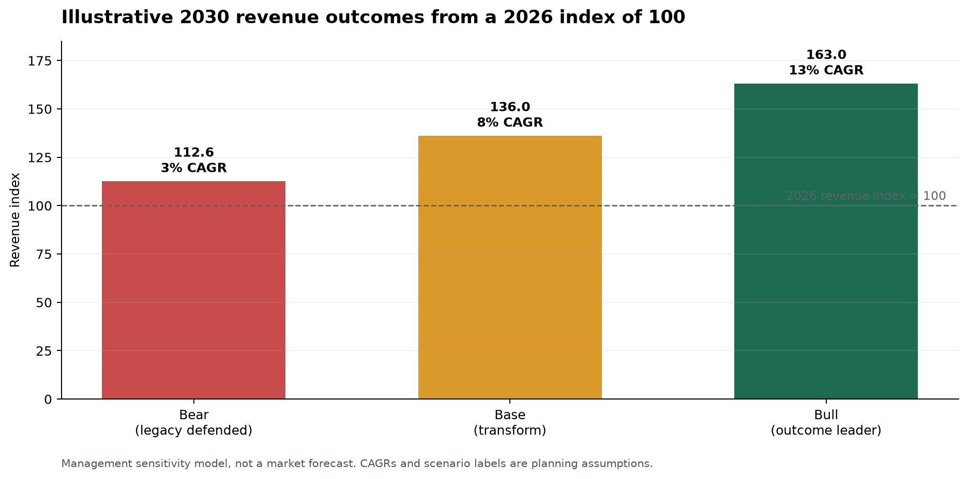
Figure 2. Illustrative profitability and valuation sensitivity
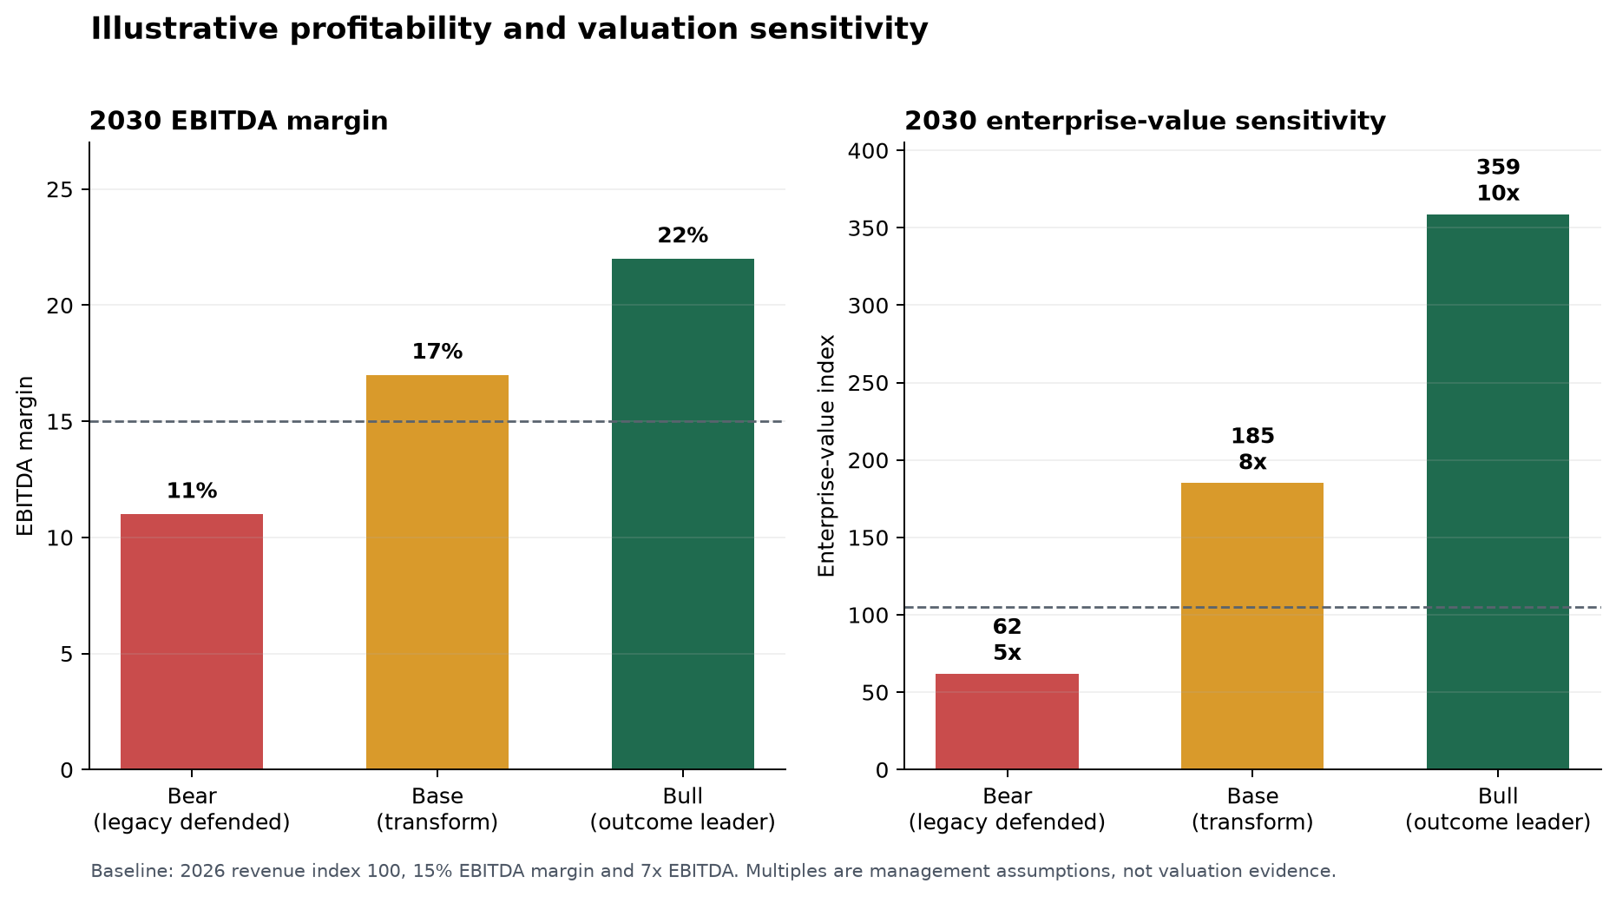
Interpretation. On the indexed model, a legacy-defence case grows to 112.55 revenue-index points but falls to 12.38 EBITDA-index points and 61.90 enterprise-value-index points. A successful outcome-led transformation grows to 136.05 revenue-index points, 23.13 EBITDA-index points and 185.03 enterprise-value-index points. These are arithmetic consequences of stated assumptions, not a valuation forecast.
M&A implication. Quality is likely to matter more than size. N-able/Canalys reported that 90% of surveyed partners expressed M&A interest, primarily to acquire skills or regions [2]. Solganick reported premium valuations for MSPs with growth, scalable operations and strong client relationships and mentioned approximately 20x EBITDA exits for some larger platforms, but its deal-methodology disclosure is insufficient for use as a benchmark [15].

13. Future Industry Scenarios and 2030 Outlook
Bull case. Managed services grow, and a provider that standardises delivery, deploys AI safely, packages MDR/security, becomes a trusted cloud and AI-governance partner, and builds vertical intellectual property compounds recurring revenue and earns a premium quality narrative. This is consistent with vendor partner programmes, security demand and agent-enabled workflow opportunities [2-4, 19, 20, 24].
Base case. The market remains viable, but bifurcates. Conventional support remains needed, particularly in smaller and regulated businesses, while pricing power and valuations favour providers with automation, security depth, cloud capability and measured outcomes. Most established MSPs can survive, but not all will preserve their current gross-profit mix.
Bear case. The provider maintains reactive support and reseller economics while platforms and better-automated competitors improve self-service, pricing transparency and security integration. Revenue may remain nominally stable, but manual cost-to-serve, customer procurement pressure, vendor concentration and technology debt reduce EBITDA and strategic relevance.
Answer to the 2030 question. MSP/TSP businesses are likely to remain viable, but the traditional model is unlikely to remain attractive in its current form. The evidence supports a transformation exposure, not a sector-death thesis. This report cannot credibly estimate the percentage of today's MSPs that will fail, consolidate or transform because no robust public dataset was found. It can identify the high-risk archetype: generalist, labour-led, resale-dependent and weak in security, automation, cloud governance and vertical differentiation.

14. Transformation Framework
The transformation priority is to move from selling technology administration to owning a defined, governed business outcome. Opportunities are ranked below using urgency, revenue potential, margin potential and competitive defensibility. Rankings are strategic judgements informed by the cited evidence; they should be validated against the provider's client base, capabilities and local regulation.
Table 7. Opportunity priority matrix
Opportunity | Urgency | Revenue potential | Margin potential | Defensibility
Automated service delivery | Immediate | Medium | High | Medium
Security-first managed services | Immediate | High | High | High
Cloud governance and FinOps | High | High | High | High
AI advisory and governance | High | High | Medium-high | Medium-high
Managed AI workflow | Medium | High | High | High with IP
Vertical compliance packages | Medium | Medium-high | High | High

Service evolution

Operational evolution

Commercial evolution

15. Recommended Action Roadmap
Table 8. 0-24 month transformation roadmap
Horizon | Management action | Target outcome | Decision metric
0-30 days | Baseline service-line GP and workflow cost. | Expose legacy profit pool. | GP, tickets, AHT and renewals.
31-90 days | Pilot controlled service automation. | Measured self-service and quality. | Resolution, exceptions, CSAT, risk.
3-12 months | Launch security, cloud and governance offers. | New recurring profit pools. | Mix, NRR and gross margin.
12-24 months | Re-price, productise and consider capability M&A. | Outcome-led operating model. | GP/FTE, IP revenue and retention.
The first decision is diagnostic, not organisational: expose the legacy profit pool. Build a client-by-service-line view of gross profit, ticket volume, repeatability, automation candidacy, vendor dependency, security obligations and renewal risk. The second is to run controlled automation pilots with an audit trail and exception ownership, then re-price the promise rather than simply absorb lower effort.
Prioritise AI advisory, AI governance, implementation and managed AI only where the provider can tie them to data boundaries, security controls, process ownership and realised outcomes. Avoid a standalone 'AI strategy' offer that is merely product resale or ungoverned experimentation.
- Automate the repeatable work first: access requests, common tickets, routing, knowledge retrieval, alert correlation, documentation and standard onboarding. Retain human approval and escalation where business, security or regulatory risk requires it.
- Productise a security baseline: identity, endpoint, logging, response paths, recovery, reporting and clear accountability. Use a specialist partner where the required SOC capability cannot be built credibly.
- Repackage contracts around outcomes: secure cloud operations, recovery readiness, governance evidence, managed AI controls, automation throughput or a defined vertical workflow. Preserve service boundaries and avoid unpriced bespoke demand.
- Build reusable intellectual property: policy packs, assessment methods, agent templates, vertical integrations, compliance evidence packs and automated runbooks. Intellectual property is the bridge between labour leverage and platform leverage.
- Change incentives and metrics. Reward first-contact resolution, self-service completion, auto-remediation quality, customer outcome attainment, gross profit per technical FTE, recurring-revenue quality and security-control coverage, not ticket volume.

Management dashboard
Track the proportion of gross profit exposed to repeatable labour; automated resolution and exception rates; ticket-to-alert and alert-to-incident ratios; security-control coverage; net revenue retention by service line; recurring revenue from security, cloud, compliance, data and AI; gross profit per technical FTE; customer outcomes; and direct-vendor migration risk.

16. Risks and Counterarguments
The survival case is substantial. Demand for managed services, cloud support, security, compliance and transformation is growing. AWS reports continuing managed-services need in partner procurement, and Google Cloud explicitly positions specialist MSPs as partners for the full cloud lifecycle [4, 24]. OECD finds no clear overall relationship between AI exposure and employment growth, while noting that task redesign can create higher-value work [16].
The disruption case is equally material. Routine service work is increasingly a platform feature; buyers can consolidate tools; security requires a higher operating standard; and programme rules reward validated capabilities. The balancing conclusion is that change is a strategic choice now, but may become a forced response later.
Counterargument | Evidence supporting survival | Disruption reply | Board test
MSP market is growing | Omdia/Canalys growth outlook [1]. | Growth can bypass legacy service lines. | Service-line growth and GP.
AI augments people | OECD labour evidence [16]. | Task mix and willingness to pay still shift. | Pilot cost and quality.
Customers want trusted operators | AWS procurement signal [4]. | Trust requires visible competence and outcomes. | Retention and win/loss reasons.
Local service preserves value | Plausible company-specific advantage. | It may not offset platform capability forever. | Price and margin by cohort.
Automation is immature | Low full production rollout [9, 10]. | Maturity gap is transformation time, not immunity. | Adoption and competitor benchmark.
Table 9. Counterarguments, risks and board tests
Pre-mortem. This analysis would be wrong for a particular MSP if vendor demonstrations overstate reliable autonomy, customer preference for high-touch support remains resilient, governance and AI cost exceed productivity, or local trust and service quality preserve margins. Reduce that risk with audited pilots, a unit-cost baseline, customer willingness-to-pay tests and no irreversible workforce or M&A decision until the data are measured.

17. Final Conclusions
Verdict. The managed-services industry is not obsolete. The legacy economic formula is becoming obsolete in its undifferentiated form. AI, native cloud operations, embedded security, self-service and partner-programme thresholds shift value away from activity-based support and towards automated, specialised and accountable outcomes.
Board call to action. Defend the installed base while converting it. Measure the manual profit pool, automate the repeatable work, establish a credible security operating model, develop governed AI and data services, specialise where the business can win, and use outcome-led commercial design. The provider that treats this as a revenue and operating-model redesign can be among the consolidators; the provider that treats it as a tool purchase is more likely to be consolidated.

18. Complete Reference List
All URLs are original public sources. Source limitations described in the body remain part of the interpretation.
[1] Omdia/Canalys (2025), MSP Trends and Predictions 2025. https://omdia.tech.informa.com/insights/2025/canalys-msp-trends-and-predictions-2025
[2] N-able and Canalys (4 March 2025), N-able's Second Annual MSP Horizons Report. https://www.n-able.com/press/press-releases/n-ables-second-annual-msp-horizons-report-shows-significant-growth-opportunity-for-global-msps-with-cybersecurity-leading-the-way
[3] Microsoft (updated 7 October 2025), Requirements for CSP Direct-Bill Partners. https://learn.microsoft.com/en-us/partner-center/enroll/direct-partner-new-requirements
[4] Amazon Web Services (accessed 10 August 2026), AWS Managed Services Provider Program. https://aws.amazon.com/partners/programs/msp/
[5] Gartner (21 October 2024), Top Strategic Technology Trends for 2025: Agentic AI. https://www.gartner.com/en/documents/5850847
[6] Gartner (25 June 2025), Key AI Automation Trends Shaping the Future of SecOps. https://www.gartner.com/en/documents/6647134
[7] Microsoft (15 December 2025), What's New in Microsoft Copilot Studio: November 2025. https://www.microsoft.com/en-us/microsoft-copilot/blog/copilot-studio/whats-new-in-microsoft-copilot-studio-november-2025/
[8] ServiceNow (accessed 10 August 2026), Autonomous Service Operations. https://www.servicenow.com/solutions/enterprise-it/autonomous-service-ops.html
[9] McKinsey (5 November 2025), The State of AI in 2025: Agents, Innovation, and Transformation. https://www.mckinsey.com/capabilities/quantumblack/our-insights/the-state-of-ai
[10] Riverbed and Coleman Parkes (July 2025), Global Survey 2025: The Future of IT Operations in the AI Era. https://www.riverbed.com/riverbed-wp-content/uploads/2025/09/riverbed-aiops-survey-global-report2025.pdf
[11] Verizon (2025), 2025 Data Breach Investigations Report. https://www.verizon.com/business/resources/T4c8/reports/2025-dbir-data-breach-investigations-report.pdf
[12] CISA, NSA, FBI and partners (11 May 2022), Protecting Against Cyber Threats to MSPs and their Customers. https://www.cisa.gov/sites/default/files/publications/AA22-131A_Protecting_Against_Cyber_Threats_to_MSPs_and_their_Customers.pdf
[13] Deloitte (21 October 2025), Cybersecurity Trends 2025 Mid-Year Report. https://www.deloitte.com/us/en/services/consulting/articles/cybersecurity-trends-report.html
[14] N-able (FY ended 31 December 2025), Fiscal Year 2025 Annual Financial Report. https://www.sec.gov/Archives/edgar/data/1834488/000183448826000016/a2025n-ablears.pdf
[15] Solganick (25 August 2025), M&A Update: Managed Services Providers and Managed Security Services Providers, YTD 2025. https://solganick.com/msp-mssp-mergers-acquisitions-report-2025/
[16] OECD (accessed 10 August 2026), Artificial Intelligence and Employment. https://www.oecd.org/en/publications/artificial-intelligence-and-employment_c2c1d276-en.html
[17] World Economic Forum (7 January 2025), The Future of Jobs Report 2025. https://www.weforum.org/publications/the-future-of-jobs-report-2025/digest/
[18] Microsoft (2025), Microsoft 2025 Annual Report. https://www.microsoft.com/investor/reports/ar25/index.html
[19] Microsoft (19 May 2025), Multi-agent orchestration and more: Copilot Studio announcements at Microsoft Build 2025. https://www.microsoft.com/en-us/microsoft-copilot/blog/copilot-studio/multi-agent-orchestration-maker-controls-and-more-microsoft-copilot-studio-announcements-at-microsoft-build-2025/
[20] Microsoft Security (18 November 2025), Ambient and autonomous security for the agentic era, Microsoft Ignite. https://www.microsoft.com/en-us/security/blog/2025/11/18/ambient-and-autonomous-security-for-the-agentic-era/
[21] Microsoft (30 July 2025), FY25 Q4 Press Release and Webcast. https://www.microsoft.com/en-us/investor/earnings/fy-2025-q4/press-release-webcast
[22] Microsoft (accessed 10 August 2026), Microsoft 365 Roadmap. https://www.microsoft.com/en-us/microsoft-365/roadmap
[23] Microsoft (accessed 10 August 2026), Drive Profitability as a Cloud Solution Provider. https://partner.microsoft.com/en-us/partnership/cloud-solution-provider
[24] Google Cloud (accessed 10 August 2026), Partner Advantage Managed Services Providers. https://cloud.google.com/partners/msp-initiative

