STRATEGIC RESEARCH REPORT
Why the Traditional MSP and TSP
Business Model Is Becoming Obsolete
An evidence-based assessment of the economics, disruption and transformation of
managed and technology service providers, 2026–2036
Prepared for: MSP owners, Microsoft partners, TSP and partner executives, MSP leadership teams, boards, private-equity investors and the technology consultants who advise service-provider businesses.
Written to be read by: the owner of a successful, conventional managed-services business who is sceptical that major change is required.
CIAOPS · Robert Crane, Principal
Version 3.0 · 12 August 2026 · Sydney, Australia
Conventions: English (Australian spelling). All monetary figures are in US dollars unless otherwise stated.
Every material statistic is attributed inline and listed in Section 14.

Table of Contents

1. Executive Summary
This report asks a deliberately confronting question: is the traditional managed service provider (MSP) and technology service provider (TSP) business model — the one built on per-user and per-device pricing wrapped around a reactive help desk, endpoint monitoring, patching and infrastructure management — becoming economically and strategically unsustainable over the next three to ten years? The analysis was conducted without assuming the conclusion. Four independent evidence streams were examined: MSP unit economics, the impact of AI and agentic automation, Microsoft and hyperscaler strategy, and buyer behaviour set against historical platform shifts.
The verdict
The evidence does not say managed services are disappearing. It says the undifferentiated, labour-priced, licence-resale model is losing its economic distinctiveness. The market is bifurcating: best-in-class, specialised providers are becoming more profitable and more valuable, while average generalists are becoming more vulnerable. Standing still is now the highest-risk strategy available to an MSP owner.
Our central estimate for the decade to 2036: roughly 25–35% of today’s providers transform successfully, roughly 20–30% are absorbed through consolidation, roughly 30–40% struggle or stagnate, and 5–10% exit or disappear. Few fail dramatically — most simply become progressively less valuable until a buyer’s offer or an owner’s retirement ends the story quietly.

Six findings anchor that verdict:
- Growth has stalled while margins have held — for now. Worldwide managed-services organic revenue growth fell to just 1.0% in Q4 2024, the lowest of that year, yet best-in-class TSPs recorded a fifth consecutive year of 19%+ adjusted EBITDA. By late 2025 the industry logged a sixth straight profitable year, but 58% of MSPs were growing below the industry rate and about 24% reported zero or negative organic growth (Service Leadership / ConnectWise, 2025). The profitability is real; the growth engine is sputtering.
- AI directly targets the billable labour stack. Gartner projects that agentic AI will autonomously resolve 80% of common customer-service issues by 2029, cutting operational costs by 30%, and that by 2030 no IT work will be done by humans without AI. ServiceNow’s Level 1 service-desk AI already handles more than 90% of internal employee requests at roughly twice human speed. The work MSPs bill for is the work being automated first.
- Microsoft is both the platform and the disintermediator. In FY2026 Microsoft passed $331.8B revenue, Azure crossed $100B, Microsoft 365 Copilot reached 30 million paid seats, and commercial remaining performance obligation hit $678B. Copilot, Security Copilot, Defender Experts and embedded governance simultaneously commoditise routine administration and create the largest new services opportunity in a decade.
- Value is migrating to security and AI enablement. Managed detection and response is compounding at ~22–23% a year toward $11–17B by 2030–31, while agentic-AI spending is forecast to grow ~141% in 2026 alone. Undifferentiated generalist support is the one category growing near zero.
- The disruption funds the transformation. MIT found 95% of enterprise generative-AI pilots returned zero, Gartner expects 40%+ of agentic-AI projects to be cancelled by end-2027, and Canalys finds most partners stuck at proof-of-concept. That failure-to-scale is precisely the services market — readiness, governance, security and managed agent operations — that a transformed MSP is positioned to sell.
- History rhymes. Travel agents, ISPs, web hosts, VARs and print/telco resellers all faced the same pattern: a platform absorbed the routine transaction and the intermediaries who moved up into advisory, integration and outcomes survived; those who defended the commodity transaction did not.

The strategic implication is not to abandon managed services. It is to change what is inside the managed service, what it is priced on, and who — or what — does the work. Security and compliance move from an add-on to the commercial centre of the contract; AI governance and agent operations become a new recurring line; pricing shifts from per-seat labour toward outcomes, platforms and productised intellectual property; and AI is adopted internally so productivity is captured as margin rather than surrendered to price competition.
2. Research Methodology
This report synthesises authoritative, verifiable sources and separates observable evidence from interpretation. Where a figure is a forecast, it is labelled as such; where a probability is the author’s judgement, it is stated so it can be challenged.
2.1 Source hierarchy
- Industry analysts: Gartner, IDC, Forrester, Canalys, McKinsey, KPMG, Mordor Intelligence, MarketsandMarkets, plus channel-specific benchmarking from Service Leadership (ConnectWise), Datto/Kaseya and GTIA.
- Technology vendors: Microsoft, AWS, Google Cloud, ServiceNow, CrowdStrike, Palo Alto Networks, OpenAI and Anthropic — used for capability and roadmap evidence, discounted for marketing bias.
- Financial sources: Microsoft’s FY2026 annual and quarterly disclosures, earnings-call commentary and investor materials; public market data; M&A advisory market updates.
- Government / academic: OECD and World Economic Forum labour and productivity research, ISC2 workforce studies and MIT/academic AI-adoption studies.
- Partner ecosystem: Microsoft AI Cloud Partner Program updates, Build and Ignite announcements, CSP program changes and Forrester Total Economic Impact studies commissioned by Microsoft.
2.2 Method and limitations
Four research streams were run in parallel and triangulated: (1) MSP unit economics and valuations; (2) AI and agentic automation capability and adoption; (3) platform-vendor strategy and disintermediation; (4) buyer behaviour and cross-industry precedent. The principal limitation is that comparable public MSP margin and labour-productivity data are limited — most MSPs are private — so financial magnitudes for an individual provider are modelled illustratively and anchored to named benchmarks. Confidence is HIGH that the model is bifurcating; MODERATE on the timing and financial magnitude for any single firm.
3. Key Findings
The ten findings below are each supported in the sections that follow and sourced in Section 14.
# | Finding | Headline evidence
1 | The model is bifurcating, not collapsing | Best-in-class TSPs at 19%+ EBITDA for five straight years; average MSP organic growth ~1% in Q4 2024; 18% of MSPs at a loss (Service Leadership).
2 | AI targets the billable labour layer first | Gartner: agentic AI resolves 80% of common service issues by 2029, −30% cost; ServiceNow L1 agent handles 90%+ of internal requests.
3 | Per-seat / per-device pricing is losing its anchor | Per-device primary pricing fell to ~13%; Microsoft moving to per-seat-plus-consumption billing, weakening licence-admin annuities.
4 | Microsoft is platform and disintermediator | FY2026: $331.8B revenue, Azure >$100B, 30M Copilot seats, $678B RPO; governance and security embedded into the stack.
5 | Security is the new commercial centre | MDR compounding ~22–23% CAGR toward $11–17B by 2030–31; 4.8M global cyber workforce gap (ISC2).
6 | Hyperscalers/SaaS absorb routine administration | Native self-service, embedded security and vendor-delivered managed services (e.g., Defender Experts) reduce dependence on generalist MSPs.
7 | The AI value gap is a services market | MIT: 95% of GenAI pilots return zero; Gartner: 40%+ agentic projects cancelled by 2027; Canalys: 61% of partners stuck at PoC.
8 | Buyers want outcomes, not activity | Demand shifting from labour/administration to security, automation, governance and measurable business outcomes.
9 | History favours those who move up-stack | Travel agents, ISPs, hosts, VARs: intermediaries that moved to advisory/outcomes survived; commodity resellers did not.
10 | Standing still is the highest-risk option | Bear-vs-bull equity outcomes on the same business differ by ~10x — that gap is the return on transformation.

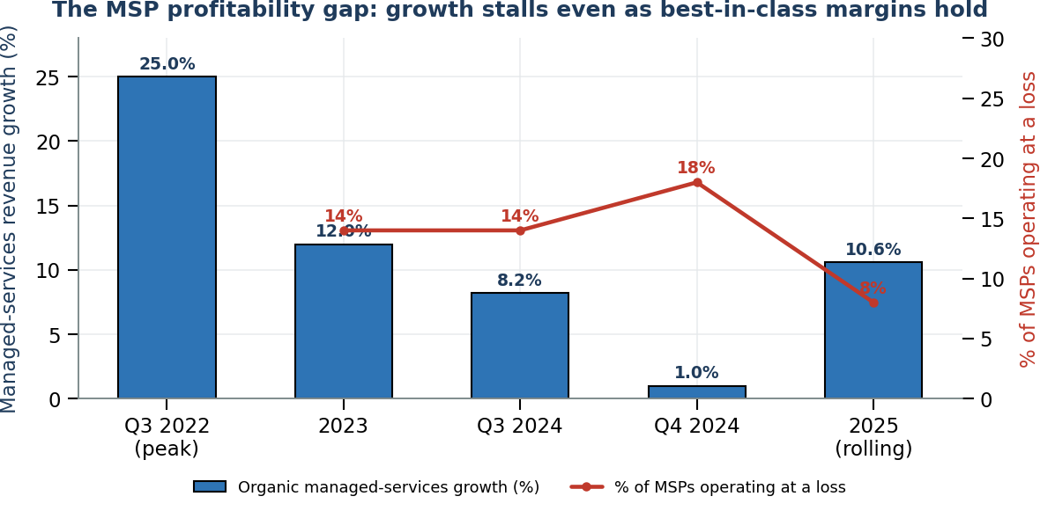
Figure 1 — Managed-services organic growth has stalled even as best-in-class margins hold and loss-making rose to 18% of MSPs in Q4 2024 (Service Leadership / ConnectWise, 2024–25).
4. Evidence and Source Citations
The quantitative spine of this report is summarised here; each figure is fully referenced in Section 14. Figures are grouped by theme.
4.1 Market size and structure
Metric | Value | Source
Global managed-services market, 2026 | ~$380B (11.2% CAGR from $311B in 2024) | MarketsandMarkets
Projected market by 2029–30 | $510B (2029) rising to $640–731B (2030) | Gartner; multiple analysts
Number of MSPs globally | 150,000+; top 500 = ~38% of revenue | Channel Futures MSP 501
Median MSP annual recurring revenue | $2.8M (top quartile >$12M) | Datto Global State of the MSP 2025
Average MSP gross margin, 2025 | ~52% (up from 48% in 2022) | ConnectWise IT Nation Benchmark
Fastest-growing segment | Managed security (MSSP/MDR) ~17.8% CAGR | Gartner

4.2 Profitability and growth signals
Metric | Value | Source
Best-in-class TSP adjusted EBITDA | 19%+ for five consecutive years (through 2024) | Service Leadership 2025 Profitability Report
Worldwide managed-services growth, Q4 2024 | 1.0% (lowest of the year) | Service Leadership Index Q4 2024
MSPs operating at a loss, Q4 2024 | 18% (up from 14% in Q3) | Service Leadership Index
Best-in-class EBITDA, late 2025 | 17.4%+; only 8% of MSPs loss-making (vs 28% two years earlier) | ConnectWise / CRN, Nov 2025
MSPs growing below industry rate | 58%; ~24% at zero or negative growth | ConnectWise / CRN, Nov 2025

4.3 AI, agentic automation and security
Metric | Value | Source
IT work done by AI alone by 2030 | 25% (75% human+AI; 0% human-only) | Gartner (700+ CIO survey, 2025)
Agentic AI resolving common service issues | 80% by 2029; −30% operational cost | Gartner
Worldwide AI spending, 2026 | ~$2.59 trillion (+47%) | Gartner Forecast: AI Spending
Agentic-AI spending, 2026 / 2029 | ~$202B (+141%) rising to ~$753B by 2029 | Gartner
Global AI economic impact by 2030 | $22.3 trillion cumulative (~3.7% of GDP) | IDC, April 2025
MDR market, 2025 → 2030–31 | $4.19B → $11–17B (21.5–23.2% CAGR) | Mordor Intelligence; MarketsandMarkets
CrowdStrike Charlotte AI triage | 98%+ accuracy; ~40 hrs/week manual work removed; 3x faster response | CrowdStrike
Global cybersecurity workforce gap | 4.8 million people | ISC2 2026 Workforce Study
Enterprise GenAI pilots returning zero | 95% | MIT, 2025
Agentic-AI projects cancelled by end-2027 | 40%+ (amid “agent washing”) | Gartner

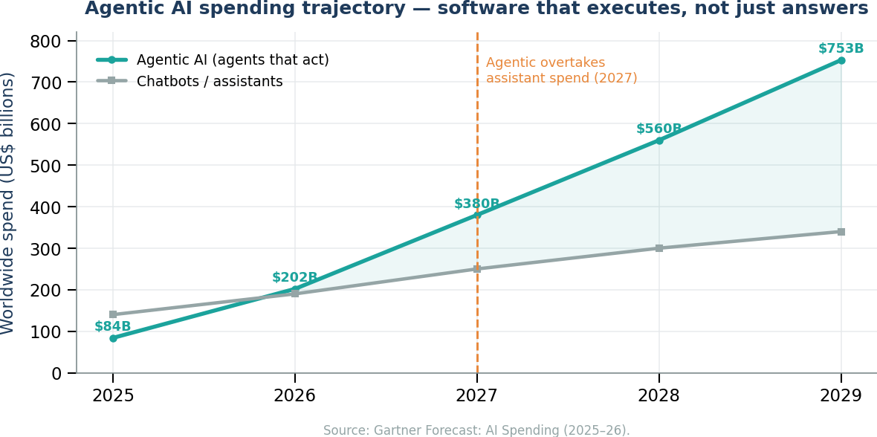
Figure 2 — Agentic AI — software that executes tasks rather than just answering questions — is forecast to overtake chatbot/assistant spending by 2027 (Gartner, 2025–26).
5. Market Analysis
5.1 Is the traditional MSP model fundamentally broken?
Not broken — but structurally exposed. The classic delivery model rests on per-user and per-device pricing, a help-desk-centric and reactive support motion, infrastructure management, and remote monitoring and management (RMM) under a fixed-fee contract. Each of these is now under pressure from a different direction.
Traditional element | Primary pressure | Direction of travel
Per-user / per-device pricing | Consumption and outcome billing; AI-deflected ticket volume | Anchor eroding; per-device primary pricing already down to ~13%
Help-desk-centric L1/L2 support | Agentic service desks and self-service | Highest automation exposure; volume falls, value questioned
Reactive break-fix motion | Predictive AIOps and self-healing | Reactive labour re-priced downward
Infrastructure management | Cloud-native automation, policy, Arc | Manual ops commoditised by the platform
Monitoring & management (RMM) | Native monitoring + AI correlation | Noise reduction up to ~99%; fewer human touches
Fixed-fee support contracts | Buyers questioning fees as visible activity falls | Renewal risk unless value is re-evidenced

The economic symptoms are well documented. Margin compression is masked at the top of the market by best-in-class discipline, but the median generalist faces commoditisation, intense competition, and heavy dependence on scarce technical labour. Service delivery scales linearly with headcount, which caps growth and concentrates risk in a handful of irreplaceable technicians. The result is the bifurcation visible in Figure 1: strong profitability for the disciplined and specialised, stalling growth and rising losses for the average.
5.2 Customer buying behaviour — the demand shift
Buyer expectations are moving decisively from activity to outcome. Five shifts recur across the evidence:
- Outcomes instead of labour. Clients increasingly buy a result (secure, compliant, productive) rather than technician hours.
- Automation instead of administration. When a platform can provision, reset, classify and document instantly, manual administration looks like overhead.
- Transformation instead of support. The board-level conversation is about AI strategy and process redesign, not uptime.
- Security instead of maintenance. Cyber-insurance and regulation make security the non-negotiable spend.
- AI strategy instead of infrastructure strategy. Copilot and agents, not servers, dominate the roadmap.
The through-line is that routine managed services are increasingly perceived as a commodity, while the scarce, valued capability is judgement: governance, risk, accountability and change. That is a threat to labour-priced revenue and an opportunity for advisory-priced revenue.
5.3 Lessons from other industries
Every previous platform shift produced the same fork for intermediaries. The parallel to MSPs is exact: a platform absorbs the routine transaction, and only those who move up into judgement, integration and outcomes retain economic value.
Industry | Platform shift | What survived | Parallel for MSPs
Travel agents | Online booking / OTAs | Complex, high-touch and corporate advisory | Commodity provisioning disappears; advisory endures
ISPs / dial-up | Broadband commoditisation | Those who became managed connectivity/security | Connectivity as a feature, not a business
Web hosting | Cloud / hyperscalers | Managed cloud, DevOps, platform engineering | “Keeping the lights on” migrates to the platform
VARs / resellers | SaaS & marketplaces | Solution integrators and IP owners | Licence-resale margin structurally declines
Print / document services | Digital workflow | Managed information & process services | Device-centric revenue gives way to outcomes
System integrators | Cloud-native / low-code | Vertical IP, data & governance specialists | Body-shop hours give way to productised delivery
6. Financial Analysis
The financial case turns on a single mechanism: AI removes billable human effort. If the client or the platform captures that productivity, labour-priced revenue erodes; if the MSP captures it and re-sells higher-order services, margin expands. The two models below make the stakes concrete.
6.1 Current model vs future model
Dimension | Current (labour-based) model | Future (outcome-based) model
Core revenue | Managed services, help desk, infrastructure, monitoring, device management | AI advisory, security/MDR, governance, compliance, automation, data & AI services
Pricing basis | Per-user / per-device / ticket | Outcome, platform, subscription IP, managed AI
Gross margin | ~40–52%; pressured by labour | 55–70%+ on security, IP and advisory
Growth | ~0–2% organic for generalists | 10–15%+ in security and AI enablement
Scaling | Linear with headcount | Leveraged by automation and reusable IP
Valuation multiple | ~5x EBITDA (sub-scale generalist) | 9–11x+ (scaled, specialised, sticky)
M&A posture | Acquired for run-off / consolidation | Acquirer or premium target

Anchors: best-in-class TSP EBITDA of 17–19%+ versus an unfocused-generalist band near 7–11%; managed-security and AI-enablement categories growing 13–23%+; and public MSP M&A multiples clustering around 5x for sub-scale generalists versus ~9–11x for scaled specialists (Service Leadership 2025; MDR market reports; M&A advisory updates).
6.2 An illustrative five-year model — status quo vs transformation
A representative $5M generalist MSP is modelled over 2026–2031 on two paths. Every anchor is sourced; the model is illustrative, not a forecast for any specific firm.
Metric | 2026 baseline | 2031 status quo | 2031 transformed
Revenue (US$M) | 5.00 | 5.52 | 8.04
Revenue CAGR (2026–31) | — | 2.0% | 10.0%
Adjusted EBITDA margin | 10.0% | 6.25% | 16.0%
Adjusted EBITDA (US$M) | 0.50 | 0.35 | 1.29
Exit multiple (EV/EBITDA) | — | 5.2x | 9.0x
Indicative enterprise value (US$M) | ~2.6–5.2 | 1.8 | 11.6

The status-quo path assumes 2% growth (generous against the 1.0% organic rate recorded in Q4 2024) with EBITDA eroding toward the unfocused-generalist band as per-seat pricing loses its anchor and clients internalise AI-deflected ticket volume. The transformed path assumes blended 10% growth (below the security/AI category rate of 13–23%) and margins ramping to the bottom of the focused-MSP band, exiting below scaled-platform multiples. The gap in equity value is roughly a factor of six-to-ten on the same starting business. That gap is the return on transformation — and the cost of standing still.
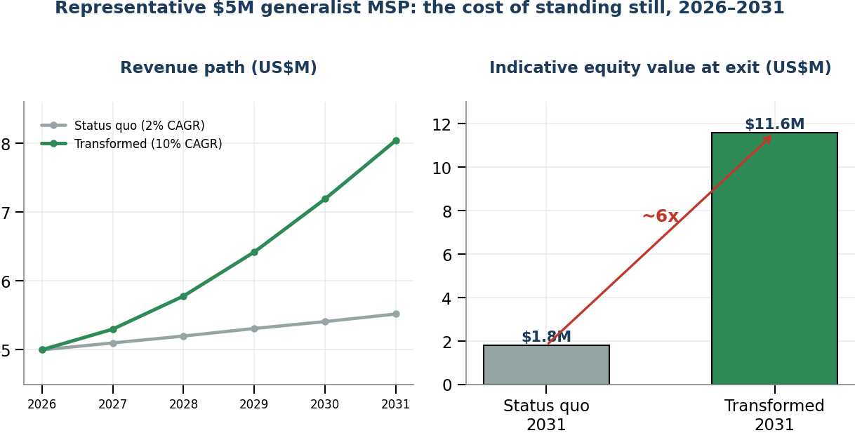
Figure 3 — Two futures for the same $5M MSP: modest but compounding transformation produces a step-change in equity value at exit (illustrative; anchors sourced in Sections 4 and 14).
6.3 Where the growth actually is
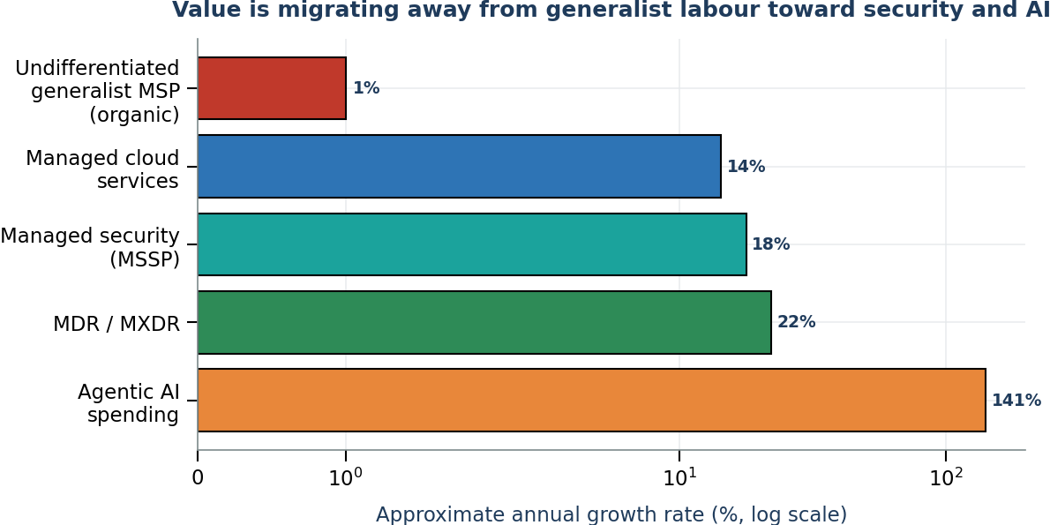
Figure 4 — Category growth rates diverge sharply: undifferentiated generalist support grows near zero while security and AI compound (Gartner; Mordor Intelligence; category reports, 2025–26).
7. Microsoft Strategy Analysis
Because most SMB-focused MSPs are, in effect, Microsoft delivery businesses, Microsoft’s direction is the single most important external variable in this analysis. The evidence points one way: Microsoft is building a full-stack, agent-centric platform that commoditises routine IT operation while monetising AI enablement — simultaneously a threat to legacy revenue and the largest new services opportunity in a decade.
7.1 The AI-first financial engine
Microsoft’s FY2026 results (quarter ended 30 June 2026, reported 29 July 2026) show the scale and capital intensity of the transition: quarterly revenue of $90.0B (+18%), full-year revenue of $331.8B, operating income of $40.6B (+18%), and Microsoft Cloud revenue of $59.3B (+27%). Azure and other cloud services grew 43% and Azure surpassed $100B in annual revenue for the first time. Microsoft 365 Copilot passed 30 million paid seats — up from 20 million in April and 15 million in January — and commercial remaining performance obligation rose 84% to $678B. As Satya Nadella framed it, Microsoft is “advancing the frontier on the cost-to-outcome curve, ensuring every customer can turn tokens into business results.”
The commercial signal that matters most for partners
Microsoft is moving beyond per-seat to per-seat-plus-consumption. Usage-based billing across Copilot, Dynamics, GitHub and agent platforms expands Microsoft’s addressable market while reducing the centrality of the seat as the unit of value. For MSPs this creates token and agent FinOps opportunities — but it also weakens any business whose economics depend on licence administration and a stable per-user annuity.

7.2 Agents, security and the Frontier Firm
At Build 2025 Microsoft reported that 230,000+ organisations (including 90% of the Fortune 500) had used Copilot Studio, with customers building over one million custom agents in a single quarter. Ignite 2025 extended agentic capability across Defender, Entra, Intune and Purview, added agent governance (an agent registry and Entra Agent ID), and made Security Copilot available to eligible Microsoft 365 E5 customers, with Defender Experts positioned as a Microsoft-delivered, expert-led managed service. The 2025 Work Trend Index formalised the destination as the “Frontier Firm” — an organisation built on human-agent collaboration in which digital labour substitutes for headcount-based work.
7.3 Does Microsoft raise or lower the value of traditional MSP services?
Both — and that is the point. Microsoft systematically lowers the value of routine administration while raising the value of governance, adoption and security.
Microsoft move | Lowers the value of… | Raises the value of…
Copilot + agents embedded in M365 (30M+ seats) | “Setting up AI” as novelty; basic productivity support | Adoption, change management, prompt/agent governance, measurement at scale
Agent governance (registry, Entra Agent ID) | Ad-hoc, ungoverned deployments | Data readiness, permissions/labels, agent-boundary policy
Security Copilot + Defender Experts managed XDR | Reselling EDR and forwarding alerts | Managed identity, exposure management, board-ready risk reporting
SMB Copilot + CSP promotions | Licence-admin margin | Last-mile integration, security baseline, governed rollout, ROI evidence
Partner program & certification overhaul | Cheap, assessment-only skilling paths | Certification-validated technical depth — the bar to be “AI-capable” rises

Two counterweights matter. First, IDC research commissioned by Microsoft still sizes partner services revenue at roughly $8.45 for every $1 of Microsoft revenue — the partner opportunity is expanding in absolute terms. Second, a 2024 Forrester Total Economic Impact study for Microsoft found ~62% potential service-attach revenue on enterprise Copilot deals. Microsoft is not removing the partner; it is relocating where the partner earns.
8. AI Impact Analysis
AI’s impact on the MSP is asymmetric: it attacks repeatable, bounded, runbook-driven work first and leaves judgement, accountability and trust to humans. The task, therefore, is to map exposure precisely.
8.1 Exposure by work type
MSP work type | Automation exposure | Durable human value | Recommended response
Password resets, access requests, ticket routing, standard device checks | High | Policy exceptions, identity assurance, empathy | Automate with guardrails (e.g., Entra self-service); measure deflection
Monitoring, alert triage, documentation, incident summaries | High | Risk judgement, prioritisation, client comms | AIOps + AI drafting; human owns the decision
User onboarding & training | Medium-high | Change management, adoption coaching | Productise onboarding; sell adoption, not clicks
Security investigation / MDR | Medium | Accountable response, threat context | Partner-led MDR; own identity, exposure, IR
vCIO strategy, governance, breach comms | Low-medium | Trust, ambiguity resolution, accountability | Package as advisory and outcome assurance

Capability evidence is now unambiguous. ServiceNow’s Level 1 service-desk AI specialist autonomously resolves common requests (password resets, access provisioning, network troubleshooting), is used internally to handle 90%+ of employee requests at ~2x human speed, and escalates only to L2/L3 humans. Independent ITSM analyses report 70–90% reductions in L1 ticket volume among agentic adopters. Forrester describes the traditional three-tier service desk as a bottleneck, citing early adopters achieving 65% initial-contact virtual-agent resolution and a frontline reduction from 30 to 12 agents while maintaining service levels. In security, CrowdStrike’s Charlotte AI triages detections at 98%+ accuracy, removing ~40 hours of manual work per week and cutting response times threefold.
8.2 Revenue, margin, staffing and organisation — best and worst case
Best case for MSPs
AI increases technician leverage, resolution speed and documentation quality, letting the provider expand revenue without proportional headcount. The MSP captures productivity as margin and reinvests it in security, governance and advisory. Junior productivity rises (McKinsey reports ~+34% for supported junior staff), the operational moat compounds, and the firm re-rates on both growth and margin.

Worst case for MSPs
Customers and platform vendors capture the productivity benefit, price benchmarks reset lower, and labour-priced revenue erodes faster than replacement services grow. Clients see less visible ticket activity and ask why fixed fees are unchanged. The generalist that cannot re-evidence value enters run-off economics.

The realistic base case is phased substitution: AI automates 25–40% of L1/L2 task-hours over the next three-to-five years while humans remain essential for governance, exception handling and accountable risk decisions. The winning move is to sell that higher-order role before the lower-order role is commoditised — and to prove value with automated evidence dashboards (for example, Power BI over ticket, security and adoption telemetry) rather than activity narratives.
8.3 The deployment opportunity — why the disruption funds the transformation
The strongest counter-evidence to AI hype is also the clearest commercial signal. MIT’s 2025 study found 95% of enterprise generative-AI pilots returned zero, and that externally partnered deployments succeed at roughly twice the rate of internal builds. Gartner expects 40%+ of agentic-AI projects to be cancelled by end-2027 amid “agent washing,” and Canalys finds a majority of partners stuck at proof-of-concept. Enterprises and SMBs alike are demonstrably failing to convert AI spending into value without help. That failure is a services market — readiness, data and governance groundwork, agent design, security of AI, and managed operation of agent fleets. The disruption and the opportunity are the same event, viewed from opposite sides.
9. Future Industry Scenarios
Is the MSP/TSP model viable by 2030? The answer depends on which model is meant. Three scenarios bound the outcome. The probabilities are the author’s analytic judgement, stated so they can be challenged; each is anchored to observable evidence.
Scenario | Likelihood | What it looks like by 2030
Bull case | ~20% | Agentic AI underdelivers on the Gartner curve; field deflection stays near today’s 10–20%; SMB stickiness keeps reactive contracts renewing. The category grows toward $850B+; even generalists ride security attach to stable margins. Traditional MSPs remain viable with gradually thinning margins.
Base case | ~60% | The slow squeeze. The category grows 9–13% while organic growth at undifferentiated MSPs stays near zero. AI automates 25–40% of L1/L2 task-hours. Security-led, automated and specialised firms take disproportionate profit; consolidation accelerates; per-seat pricing steadily loses its anchor.
Bear case | ~20% | Platform agents mature rapidly, routine service work collapses, per-seat pricing becomes untenable, and generalist books acquire run-off economics. Rapid consolidation and distressed exits for the undifferentiated.

9.1 Most likely industry shape by 2036
Synthesising the evidence, the report estimates the following distribution across today’s providers over the decade to 2036. These ranges are a reasoned synthesis, not a published forecast.
Outcome | Share of today’s MSPs | Characteristics
Transform successfully | 25–35% | Security-first, AI-enabled, productised IP, outcome pricing; become acquirers or premium targets
Consolidate / be acquired | 20–30% | Sound books absorbed for scale, density or specialisation
Struggle or stagnate | 30–40% | Persist with thinning margins and weak growth; value slowly declines
Exit or disappear | 5–10% | Sub-scale generalists unable to re-evidence value; quiet wind-down

Most at risk
Sub-$2M generalist providers whose revenue is predominantly per-seat support and licence resale, whose gross margin sits below 40%, and whose delivery depends on a small number of irreplaceable technicians. Least at risk: security-led, vertical or IP-owning providers with outcome-based commercial models.
10. Transformation Framework
Transformation proceeds on three fronts — what you sell (service), how you deliver it (operational), and how you charge (commercial). The framework below sequences them; Section 11 ranks the specific opportunities.
10.1 Service evolution — what to sell
- AI advisory, readiness and implementation: Copilot readiness assessments, data-permission clean-up, sensitivity labelling, prompt/agent governance, adoption programmes and agent design — packaged as fixed-fee projects and recurring retainers.
- AI governance-as-a-service: managing data readiness, access control and oversight of clients’ AI agents — the emerging high-margin frontier as non-human identities multiply.
- Security-first services: managed identity, MDR/XDR (partner-led), exposure management, compliance and continuous posture — repositioned from add-on to the commercial centre.
- Data and business-process automation: Fabric/Power Platform-based data services and agent-driven process automation tied to measurable outcomes.
10.2 Operational evolution — how to deliver
- Adopt AI internally first: deploy AI service-desk, AIOps and security-automation agents to capture productivity as margin and build a credible reference story.
- Automated service delivery: guardrailed self-service, self-healing runbooks and agent flows; measure deflection and escalation quality.
- Reduce human dependency: standardise, document and productise so delivery no longer scales linearly with headcount or hinges on individuals.
- Evidence over activity: automated dashboards that prove risk reduction, resolution speed and adoption — the new justification for the fee.
10.3 Commercial evolution — how to charge
Transition away from | Toward | Why
Per-user pricing | Outcome-based pricing | Aligns fee to result as labour deflates
Per-device pricing | Platform pricing | Captures value of the estate, not the endpoint count
Ticket-based value | Subscription intellectual property | Reusable IP scales without headcount
Licence-admin margin | Managed AI offerings | New recurring line as agents proliferate
11. Recommended Actions
The opportunities below are ranked by a blend of urgency, revenue potential, margin potential and competitive defensibility. All four top priorities are immediate.
Rank / opportunity | Urgency | Revenue potential | Margin potential | Defensibility
1. Security-first services & MDR | Immediate | High (~22–25% CAGR MDR) | High (~42% package premium) | High — trust & 24/7 are barriers
2. Internal AI adoption & automated delivery | Immediate | Indirect (protects base) | Very high (+34% junior productivity) | High — operational moat compounds
3. AI advisory & implementation | Immediate | High (~35% CAGR; 70% of midmarket seeks help) | High (advisory rates) | Medium — crowded, moves fast
4. Commercial repricing (outcome/platform/IP) | Immediate | Protects & re-rates base | High | Medium–high
5. AI governance-as-a-service | 6–12 months | Emerging, high | Very high | High — first-mover advantage
6. Vertical IP & automation libraries | 6–18 months | Medium–high | High (reusable IP) | High — hard to copy
7. Selective M&A / consolidation | 12–36 months | High (scale/density) | Model-dependent | High if it adds specialisation

11.1 A pragmatic 36-month sequence
- 0–6 months: Measure exposure — what share of revenue, gross profit and ticket volume depends on resale, L1/L2 support and manual monitoring. Stand up an internal AI service desk and AIOps. Launch a fixed-fee Copilot readiness/security assessment offer.
- 6–18 months: Make security the contract centre (partner-led MDR, managed identity, exposure management). Reprice at least one contract tier to outcome/platform terms. Productise onboarding and adoption. Build the first reusable automation/IP asset.
- 18–36 months: Launch AI governance-as-a-service and managed agent operations. Develop vertical IP. Pursue M&A only where it adds specialisation, scale or customer density. Retire linear, labour-only pricing.
12. Risks and Counterarguments
Intellectual honesty requires stating the strongest case on both sides.
12.1 Arguments supporting MSP survival
- Record best-in-class profitability — a sixth consecutive profitable year through 2025 and loss-making MSPs down from 28% to 8% — shows the disciplined operator is thriving, not dying.
- SMBs remain deeply dependent on outsourced IT; recurring revenue is sticky and switching costs are real.
- The partner opportunity is expanding in absolute terms (~$8.45 of partner services revenue per Microsoft dollar; ~62% Copilot service-attach).
- AI is under-delivering in the near term (95% of pilots return zero; 40%+ of agentic projects cancelled), buying incumbents time and creating deployment demand.
- Trust, accountability and 24/7 human judgement remain genuine, defensible barriers — the 4.8M cyber workforce gap is a moat, not just a problem.
12.2 Arguments supporting MSP disruption
- AI and platform vendors are targeting the exact billable labour stack (L1/L2, monitoring, triage, documentation), with 70–90% L1 deflection already demonstrated.
- Organic growth for undifferentiated generalists has collapsed toward ~0–1%, and per-seat/per-device pricing is losing its anchor.
- Microsoft and hyperscalers embed self-service, security and governance directly into the platform, and shift billing to consumption.
- The value gap between bull and bear outcomes on the same business is ~10x — evidence that the model’s economics are becoming path-dependent on transformation.
12.3 Most likely outcome
Bifurcation, not extinction. The base case (≈60% likelihood) is a slow squeeze in which the category grows but generic generalists do not, and profit concentrates in security-led, automated and specialised firms. Over the decade to 2036, roughly a quarter transform, roughly a quarter-to-third consolidate or are acquired, roughly a third stagnate, and a small minority exit — most quietly, through declining valuation rather than dramatic failure.
13. Final Conclusions
To the sceptical owner of a successful, conventional managed-services business, the honest answer is this: your business is not obsolete, but the model it is built on is losing the distinctiveness that made it valuable. The profitability you see today is real — and it is being generated increasingly by a minority of disciplined, specialised operators while the average generalist’s growth stalls and losses rise. AI, Microsoft’s platform strategy and changing buyer behaviour all point the same way: routine, labour-priced IT operations are being absorbed by software, and value is migrating to security, governance, AI enablement and measurable outcomes.
The one-sentence conclusion
The traditional MSP/TSP model is becoming obsolete in its undifferentiated, labour-priced, licence-resale form — not because customers stop buying managed services, but because the market will pay a premium for judgement, security and outcomes, and steadily less for activity, administration and hours.

The recommended response is not to abandon managed services but to change what is inside them, what they are priced on, and who — or what — does the work. Reposition security and compliance to the commercial centre. Build AI governance and agent operations as new recurring lines. Adopt AI internally so productivity becomes margin, not a discount handed to competitors. And move pricing from per-seat labour toward outcomes, platforms and productised IP. The gap between the bull and bear outcomes on the very same business is roughly ten-fold in equity value. That gap is the return on transformation — and the window to capture it is open now.
14. Complete Reference List
All sources were retrieved and current as at 12 August 2026. Analyst titles are cited where the underlying report is subscription-gated.
Analyst and market research
[1] Gartner. “Gartner Survey Finds All IT Work Will Involve AI by 2030.” 20 Oct 2025. gartner.com
[2] Gartner. “Managed Services Disruption: Surviving an AI Agent-Dominated Market” (F. Pereiro). 27 Oct 2025. gartner.com/documents/7101530
[3] Gartner. “Worldwide AI Spending to Grow 47% in 2026 to $2.59 trillion.” 19 May 2026. gartner.com
[4] Gartner. “Agentic AI to overtake chatbot spending by 2027” (Forecast: AI Spending, 4Q25). 15 Jan 2026. gartner.com
[5] Gartner. “Worldwide IT Spending Forecast to Grow 14.2% in 2026, totalling $6.37 trillion.” 27 Jul 2026. gartner.com
[6] Gartner. “Market Guide for Managed Detection and Response” (P. Shoard et al.). 1 Oct 2025. gartner.com/documents/7010398
[7] IDC. “AI Solutions & Services will Generate Global Impact of $22.3 Trillion by 2030.” 1 Apr 2025. idc.com
[8] IDC. “Worldwide Artificial Intelligence IT Spending Forecast, 2025–2029.” Aug 2025. idc.com
[9] IDC / Business Wire. “IDC FutureScape 2026 Predictions Reveal the Rise of Agentic AI.” 23 Oct 2025. businesswire.com
[10] McKinsey & Company. “The State of AI” (2025 global survey). mckinsey.com
[11] Mordor Intelligence. “Managed Detection and Response Market — 21.95% CAGR to 2030.” 10 Oct 2025. mordorintelligence.com
[12] MarketsandMarkets. “Managed Detection and Response (MDR) Market — Global Forecast to 2031.” Apr 2026. marketsandmarkets.com
[13] MIT (NANDA / Project Management). “State of AI in Business 2025” — 95% of GenAI pilots return zero. 2025.
Channel benchmarking and M&A
[14] Service Leadership, Inc. (ConnectWise). “2025 Annual IT Solution Provider Industry Profitability Report.” 8 May 2025. connectwise.com
[15] Service Leadership Index. “Q4 2024 Data — profitability near historic highs; 18% of MSPs at a loss.” 13 Feb 2025. connectwise.com
[16] CRN. “MSP Industry Sees Sixth Straight Year Of Profitability, But Performance Gap Widens.” 18 Nov 2025. crn.com
[17] Datto (Kaseya). “2025 Global State of the MSP Report.” datto.com
[18] Greenwich Capital Group. “H1 2025 Managed IT Services and MSP Market Update.” Jul 2025. greenwichgp.com
[19] MarketsandMarkets / MedhaCloud compilation. “Managed Services Market Statistics 2026.” Mar 2026. medhacloud.com
Microsoft primary disclosures
[20] Microsoft. “Microsoft Cloud and AI Strength Fuels Fourth Quarter Results” (FY2026 Q4). 29 Jul 2026. news.microsoft.com
[21] Microsoft Investor Relations. “FY26 Q4 Earnings Release & Webcast.” 29 Jul 2026. microsoft.com/investor
[22] Microsoft. “Build 2025: The Age of AI Agents and Building the Open Agentic Web.” 19 May 2025. blogs.microsoft.com
[23] Microsoft. “Ignite 2025: Copilot and Agents Built to Power the Frontier Firm.” 18 Nov 2025. microsoft.com
[24] Microsoft Security. “Ambient and Autonomous Security” (Ignite 2025). 18 Nov 2025. microsoft.com/security
[25] Microsoft Copilot Studio. “Design Autonomous Agent Capabilities” & “IT Helpdesk agent template.” 2026. learn.microsoft.com
[26] Forrester Consulting (for Microsoft). “Modern Work Partner Total Economic Impact” — ~62% service-attach. 2024.
Vendor capability evidence
[27] ServiceNow / CIO.com (L. Greiner). “ServiceNow Plans Automation of L1 Service Desk Roles.” 26 Feb 2026. cio.com
[28] CrowdStrike. “Charlotte AI Detection Triage” (98%+ accuracy; ~40 hrs/week saved) and “Agentic SOC.” 2025–26. crowdstrike.com
[29] CrowdStrike / Business Wire. “Charlotte AI AgentWorks Ecosystem for Building Secure Agents.” 25 Mar 2026. businesswire.com
[30] Thoughtworks. “Redefining Level 1 and 2 Application Support with AI.” Sep 2025. thoughtworks.com
[31] ISC2. “2026 Cybersecurity Workforce Study” — 4.8M global workforce gap. 2026.
Pricing, industry context and cross-industry precedent
[32] NinjaOne. “Managed Services Pricing Strategies for 2026.” 3 Feb 2026. ninjaone.com
[33] MSP Pro Tips. “The MSP Pricing Showdown: Per-User vs Per-Device vs All-Inclusive.” 25 Oct 2025. mspprotips.com
[34] TSIA. “Mastering Managed Services Pricing.” 16 May 2025. tsia.com
[35] Techxpress. “Agentic AI in ITSM 2026 — 70–90% L1 ticket reduction.” 10 Jan 2026. techx.press

— End of Report —
CIAOPS · Robert Crane, Principal · Prepared 12 August 2026

