- /etc/timezone file on the server
- the server’s MAC address
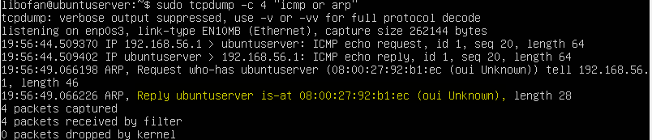
- MAC of the source and destination，response time of ping
Src:服务器
Des:桌面
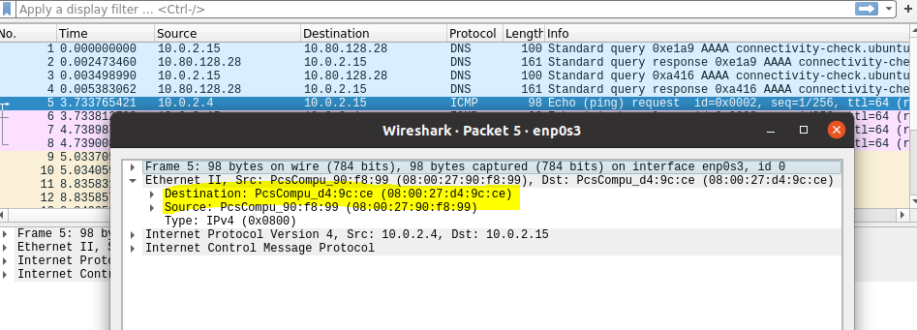
Response time:
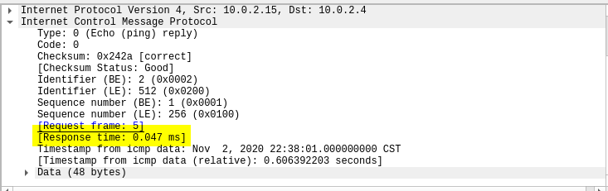
- IP addr of www.baidu.com
