- finding out the count of GET /dokuwiki requests from 10.0.2.200
- Finding out NTP servers your server VM has found
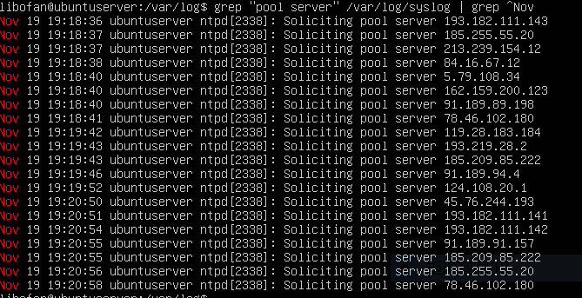
- the sorted username entries starting with [aeiou]
- find out which accounts are in the odds group

