Team Steele
Defect Database Design

Since we already have our main repository on Github.com, we will make use of Github's integrated issue tracking system.

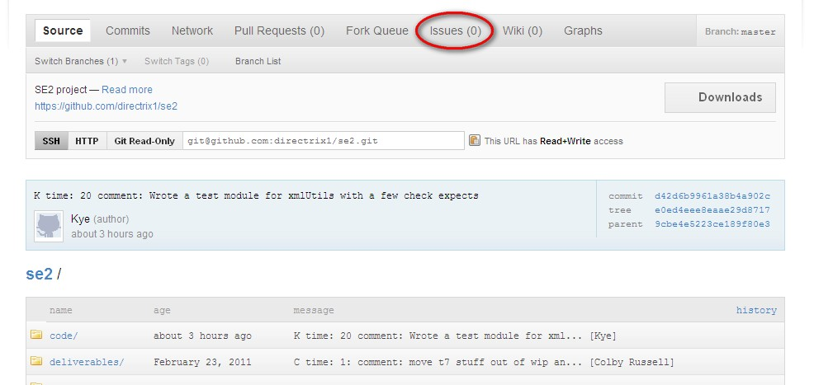
Github Issues Tab on Repo page

Whenever a defect is discovered, an issue will be created on Github and labeled as one of the following categories:

- Edge – Fails on edge case
- Logical – erroneous logic
- Design – anytime function signatures need editing
- Misc. – all else

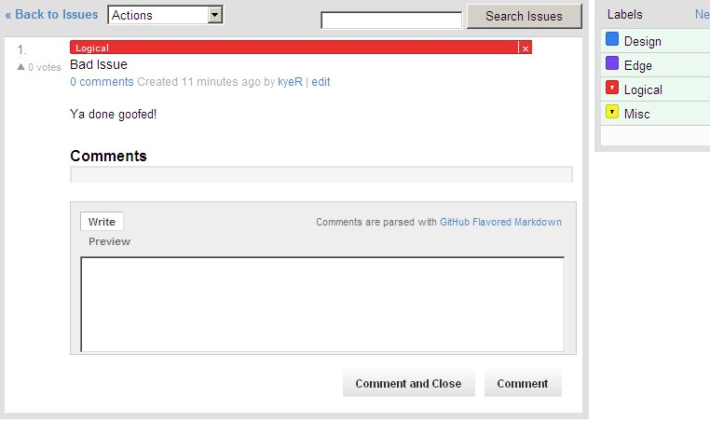
Use comments to track issues

Included in the comments will be reproduction instructions and any attempts to resolve the issue. All issues may be prioritized and sorted by their priority as seen below..

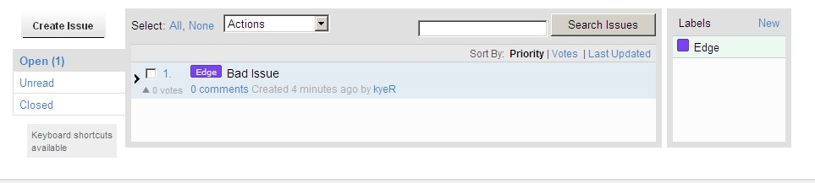
Issue list with our first (fake) issue

Issues may be closed on Github or by using the following command while doing a commit:

git commit -a -m “K|B time: 30 comment: Fixed the bad issue. Closes #1”

where 1 is the issue number in the Github issue tracking database.

