Overview
Animated Portable Network Graphic is a file format similar to an animated GIF. The Portable Network Graphic Animator will construct an APNG file from a collection of PNG image files and XML meta data. The XML entries will be provided by the user. The meta data will be combined with the PNG image data to construct an APNG file that can be viewed using the Mozilla Firefox web browser. In addition, the Portable Network Graphic Animator will be able to accept an existing APNG file and convert its frames into individual PNG image files, along with XML data with the information for each frame. Overall, this will allow creation of new APNG animations as well as modification of existing APNG animations.

PNGA XML Schema
<pnga frames="5" plays="2">
<image src="bob0.png" length="1/12"></image>
<image src="bob1.png" length="1/14"></image>
<image src="bob2.png" length="1/14"></image>
<image src="bob3.png" length="1/14"></image>
<image src="bob4.png" length="1/10"></image>
</pnga>

Modules

IO
main (apngxml, apngoutput, state) → Given an apngxml filename parses through the XML which adheres to the pnga XML schema to create an apng file which is saved to apngoutput. The animated image is composed of individual PNG frames referenced in the apngxml file along with their time offsets.
writeXML (frames plays imagesWithLength) → Given the appropriate information, writes an XML document for the newly created APNG.
writeAPNG ( apngfiledata filename ) → Given apng file data, writes the APNG file.

BasicLex – 154 Base LOC
(base from previous project)
split-at-delimiter (ds xs) → ds = delimiters to look for (list)
xs = object to search in (list)
(split-at-delimiter ds xs) = (before at+)
where before = longest prefix of xs with no values from ds (list)
at+ = rest of xs (list)

span (ps xs) → ps = list of signals to pass by (no constraints on signals)
xs = list of signals (no constraints on signals)
(span ps xs) = list of two elements
1 longest prefix of xs containing only signals from ps
2 rest of xs

splitoff-prefix (ps xs) → ps = prefix to look for (list)
xs = object to search in (list)
(splitoff-prefix ps xs) = (ps-matching ps-af-match xs-af-match)
where ps-matching = longest ps prefix matching xs prefix (list)
ps-af-match = rest of ps (list)
xs-af-match = non-matching suffix of xs (list)
Note: ps-af-match = nil means ps is a prefix of xs

splitoff-prefix-upr (ps xs) → ps = prefix to look for (list of standard, upper-case characters)
xs = object to search in (list)
(splitoff-prefix-upr ps xs) = (ps-matching ps-af-match xs-af-match)
where ps-matching = longest ps prefix matching xs prefix (list)
ps-af-match = rest of ps (list)
xs-af-match = non-matching suffix of xs (list)
Notes: 1. search is not sensitive to case of letters in xs
2. ps-af-match = nil means ps is a prefix of xs
Implementation issue: combining general and case-insensitive search
in one function simplifies maintenance, but complicates
formulation of software properties and their proofs

splitoff-prefix-chr (tok-str xs) → tok-str = characters to look for (string, standard characters)
chrs = object to search in

split-on-token-gen (tok xs) → tok = object to search for (list)
xs = object of search (list)
(split-on-token-gen tok xs) = (prefix match suffix)
where
prefix = elems of xs before 1st sublist matching tok (list)
= xs if no match
match = tok if match (list)
= nil if no match
suffix = elems of xs after 1st sublist matching tok (list)
= nil if no match

split-on-token-chr (tok xs) → tok = object to search for (list of upper-case standard characters)
xs = object to search in (list containing no non-standard chars)
Note: matching is not case-sensitive
(split-on-token-chr tok xs) = (prefix match suffix)
where
prefix = elems of xs before 1st sublist matching tok (list)
= xs if no match
match = tok if match (list)
= nil if no match
suffix = elems of xs after 1st sublist matching tok (list)
= nil if no match

split-on-token (tok xs) → tok = object to search for (string or list)
xs = object to search in (list, no non-standard chars if tok is string)
Note: search is not case-sensitive if tok is a string
Warning! Neither tok nor xs may contain non-standard characters
if tok is a string
Implementation issue: combining general and case-insensitive search
in one function simplifies maintenance, but complicates
formulation of software properties and their proofs

MinidomParser – 317 Base LOC
(base from previous project)
xml-readnodeproperties (xmlchars) → returns (mv attributes remainingxmlstring)
xml-skipdontcares (xmlchars) → returns next xmlchars sans don't cares
xml-readnodes (xmlchars) → returns (mv nodes remainingxmlstring)
xml-readnode (xmlchars) → returns the root node from xmlstring
xml-getnodes (node nodename) → returns children of node with type nodename
xml-getdeepnodes (node nodename) → returns children of node with type nodename searching recursively using DFS with node as root.
xml-getnode (node nodename) → returns first child node with type nodename
xml-getdeepnode (node nodename) → returns first child node with type nodename searching recursively using DFS with node as root.
xml-getattribute (node attributename) → returns the value of node's attribute with name attributename
xml-gettext (node) → returns the composite of all text inside of a node
xml-isattribute (attribute) → returns true iff attribute is an mv of length 2 with both elements of the mv being strings
xml-isattributelist (attributes) → returns true iff attributes is nil or a list of attributes
xml-isnode (node) → returns true iff node is actually a node
xml-isnodelist (nodes) → returns true iff nodes is a list of nodes

MinidomSerializer – 125 Base LOC
(base from previous project)
xml-escape (unescapedchars) → returns string with bad chars replaced with entities
xml-serialize-attributes (attributes) → Returns a string that is xml that represents the passed in attribute list.
xml-serizlize-nodes (xmlnodes) → Returns a string containing xml nodes that represents the node list, xmlnodes.
xml-serizlize-dom (xmlnode) → Returns a string containing an xml document that represents the dom passed in through xmlnode.
xml-unescape (escapedchars) → string with entities replaced

PNGFileParser
readChunk (pngfiledata) → Given pngfiledata which is a sequence of PNG data chunks, this function returns (mv chunktype chunkdata remainingdata) where chunktype is the type of chunk, chunk data is all the data contained in this chunk and remainingdata is the rest of the unparsed PNG chunks.
getWidth ( chunkdata ) → Given the chunk data of a IHDR chunk type returns the width.
getHeight ( chunkdata ) → Given the chunk data of a IHDR chunk type, returns the height.
getBitDepth ( chunkdata ) → Given the chunk data of a IHDR chunk type, returns the bit depth.
getColorDepth ( chunkdata) → Given the chunk data of a IHDR chunk type, returns the color depth.
getCompMethod ( chunkdata ) → Given the chunk data of a IHDR chunk type, returns the compression method.
getFilterMethod ( chunkdata ) → Given the chunk data of a IHDR chunk type, returns the filter method.
getILMethod (chunkdata) → Given the chunk data of a IHDR chunk type, returns the interlace method.
readIHDR (chunkdata) → Given the chunkdata of a IHDR chunktype chunk returns the corresponding (mv width height bitdepth colordepth compressionmethod filtermethod interlacemethod) where the different values are those specified in the chunkdata.

PNGDatParser (Optional)

APNGBuilder

doChunk (chunkname, chunkdata) → Generic function to write any type of chunk to the given file.
doIHDR (width, height, bitdepth, colordepth, compressionmethod, filtermethod, interlacemethod) → Specialized function to write an IHDR chunk.
doACTL (numframes, numplays) → Specialized function to write an aCTL chunk.
doFCTL (sequencenum, width, height, xoffset, yoffset, delaynum, delayden, disposeop, blendop) → Specialized function to write an fCTL chunk.
writeFdAT (sequencenum, framenum) → Specialized function to write an fdAT chunk.

APNGExploder

explodeAPNG (apnginput, apngxml, pngnamebase, state) → Splits up the given APNG into its constituent frames, outputting them to files beginning with pngnamebase prepended to the frame sequence number. Additionally the XML configuration file is output to a file with the name given by apngxml.
chopFrame ( apngfiledata ) → Given apngfiledata, returns the data for the first frame found.
makePNG ( framedata ) → Given APNG frame data, returns PNG file data for an individual frame.

XMLConfigReader
numPlays ( xml ) → Given the xml data, returns the number of times the animation plays.
numFrames ( xml ) → Given the xml data, returns the number of frames in the animation.
getImg ( xml ) → Given the xml data, returns the first frame for the animation.
getLength ( xml ) → Given the xml data, returns the length for the first frame in the animation.
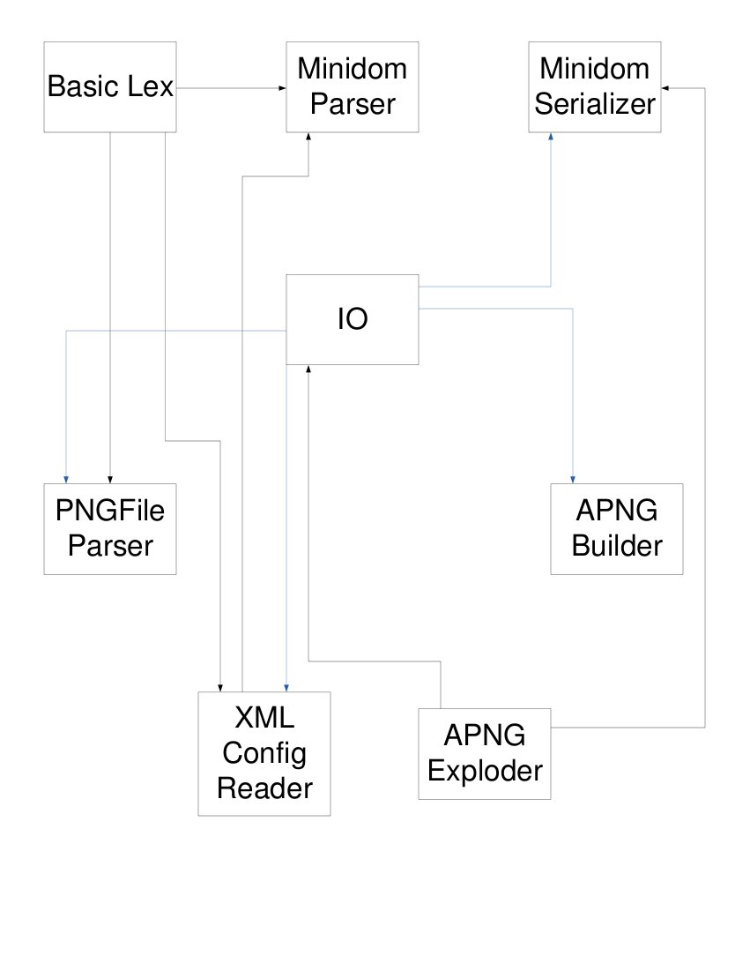

PROBE Estimate

Base LOC:
MindomParser 317
MinidomSerializer 125
BasicLex 154
New LOC:
main(Huge) 43 doChunk(Huge) 43
readChunk(Large) 18 doIHDR(Large) 18
getWidth(Huge) 43 doACTL(Large) 18
getHeight(Huge) 43 doFCTL(Large) 18
getBitDepth(Huge) 43 writeFDAT(Huge) 43
getColorDepth(Huge) 43 explodeAPNG(Huge) 43
getCompMethod(Huge) 43 writeXML(Huge) 43
getFilterMethod(Huge) 43 writeAPNG(Large) 18
getILMethod(Huge) 43 chopFrame(Huge) 43
readIHDR(Large) 18 makePNG(Huge) 43
numPlays(Medium) 7 numFrames(Medium) 7
getImg(Medium) 7 getLength(Medium) 7

Contracts
IO – 2 Large cons – 36
PNGFIleParser – 9 Huge cons – 387
APNGBuilder – 5 Huge cons – 215
APNGExploder – 3 Huge cons – 129
XMLConfigReader – 4 Large cons - 72

Total Estimated LOC: 2137

