Overview
Animated Portable Network Graphic is a file format similar to an animated GIF. The Portable Network Graphic Animator will construct an APNG file from a collection of PNG image files and XML meta data. The XML entries will be provided by the user. The meta data will be combined with the PNG image data to construct an APNG file that can be viewed using the Mozilla Firefox web browser. In addition, the Portable Network Graphic Animator will be able to accept an existing APNG file and convert its frames into individual PNG image files, along with XML data with the information for each frame. Overall, this will allow creation of new APNG animations as well as modification of existing APNG animations.

PNGA XML Schema
<pnga frames="5" plays="2">
<image src="bob0.png" length="1/12"></image>
<image src="bob1.png" length="1/14"></image>
<image src="bob2.png" length="1/14"></image>
<image src="bob3.png" length="1/14"></image>
<image src="bob4.png" length="1/10"></image>
</pnga>

Modules

IO
- animate (xmlfilename, state)
Writes an animated portable network graphic file to disk.
xmlfilename = (string) the name of the XML document containing information on number of frames, number of plays, PNG filenames, and the length of time each frame is displayed.

- suspend (apngfilename, state)
Writes a series of portable network graphic files to disk, along with an XML document. These image files are the individual frames of the APNG file in the parameter, and the XML document contains information on the number of frames, number of plays, PNG filenames, and length of time each frame is displayed.
apngfilename = (string) the name of the animated portable network graphic to be broken into individual frames. This will be used as the base file name for the PNGs and the XML document. For PNG frames, it will be suffixed by the frame number. E.g., if apngfilename is “ball”, the XML file will be written to ball.xml, and the frames will be written to ball1.png, ball2.png, et cetera.

- writeFiles (filelist, state)
Helper function for suspend. Writes PNG files to disk.
filelist = list of list (filename filedata).

XMLUtils
- parseXML (domXML)
Parses XML data and delivers the number of frames, number of plays, and a list of filenames with their corresponding time length.
domXML = XML data as a document object model

- getFrames (framelist)
Delivers frame data for the files included in framelist.
framelist = list of the filenames from which data will be retrieved.

- writeXML (numPlays, numFrames, framedata)
Delivers a string that is an XML document containing the information for an APNG file.
numPlays = the number of times the animation will play.
numFrames = the total number of frames that make up the animation.
framedata = a list of list (PNG filename (frame), corresponding time length).

- writeFrames (frameData)
Delivers a list of filenames with their time lengths for APNG frame data.
FrameData = APNG file data

BasicLex – 154 Base LOC
- split-at-delimiter (ds xs) → ds = delimiters to look for (list)
xs = object to search in (list)
(split-at-delimiter ds xs) = (before at+)
where before = longest prefix of xs with no values from ds (list)
at+ = rest of xs (list)

- span (ps xs) → ps = list of signals to pass by (no constraints on signals)
xs = list of signals (no constraints on signals)
(span ps xs) = list of two elements
1 longest prefix of xs containing only signals from ps
2 rest of xs

- splitoff-prefix (ps xs) → ps = prefix to look for (list)
xs = object to search in (list)
(splitoff-prefix ps xs) = (ps-matching ps-af-match xs-af-match)
where ps-matching = longest ps prefix matching xs prefix (list)
ps-af-match = rest of ps (list)
xs-af-match = non-matching suffix of xs (list)
Note: ps-af-match = nil means ps is a prefix of xs

- splitoff-prefix-upr (ps xs) → ps = prefix to look for (list of standard, upper-case characters)
xs = object to search in (list)
(splitoff-prefix-upr ps xs) = (ps-matching ps-af-match xs-af-match)
where ps-matching = longest ps prefix matching xs prefix (list)
ps-af-match = rest of ps (list)
xs-af-match = non-matching suffix of xs (list)
Notes: 1. search is not sensitive to case of letters in xs
2. ps-af-match = nil means ps is a prefix of xs
Implementation issue: combining general and case-insensitive search
in one function simplifies maintenance, but complicates
formulation of software properties and their proofs

- splitoff-prefix-chr (tok-str xs) → tok-str = characters to look for (string, standard characters)
chrs = object to search in

- split-on-token-gen (tok xs) → tok = object to search for (list)
xs = object of search (list)
(split-on-token-gen tok xs) = (prefix match suffix)
where
prefix = elems of xs before 1st sublist matching tok (list)
= xs if no match
match = tok if match (list)
= nil if no match
suffix = elems of xs after 1st sublist matching tok (list)
= nil if no match

- split-on-token-chr (tok xs) → tok = object to search for (list of upper-case standard characters)
xs = object to search in (list containing no non-standard chars)
Note: matching is not case-sensitive
(split-on-token-chr tok xs) = (prefix match suffix)
where
prefix = elems of xs before 1st sublist matching tok (list)
= xs if no match
match = tok if match (list)
= nil if no match
suffix = elems of xs after 1st sublist matching tok (list)
= nil if no match

- split-on-token (tok xs) → tok = object to search for (string or list)
xs = object to search in (list, no non-standard chars if tok is string)
Note: search is not case-sensitive if tok is a string
Warning! Neither tok nor xs may contain non-standard characters
if tok is a string
Implementation issue: combining general and case-insensitive search
in one function simplifies maintenance, but complicates
formulation of software properties and their proofs

MinidomParser – 317 Base LOC
(base from previous project)
- xml-text (text) → returns a text node with specified text.
- xml-node (nodetype attributes children) → returns a node with specified nodetype attributes and children.
- xml-attribute (attrname attrvalue) → returns an attribute with specified name and value.
- xml-getnodetype (node) → return the type of the node
- xml-getattrlist (node) → return the list of attributes of the node
- xml-getchildren (node) → return the children of the nodes
- xml-getattrname (attribute) → return the name of the attribute
- xml-getattrvalue (attribute) → return the value of the attribute
- xml-getnodes (node nodename) → returns children of node with type nodename
- xml-getdeepnodes (node nodename) → returns children of node with type nodename searching recursively using DFS with node as root.
- xml-getnode (node nodename) → returns first child node with type nodename
- xml-getdeepnode (node nodename) → returns first child node with type nodename searching recursively using DFS with node as root.
- xml-getattribute (node attributename) → returns the value of node's attribute with name attributename
- xml-gettext (node) → returns the composite of all text inside of a node
- xml-isattribute (attribute) → returns true iff attribute is a list of length 2 with both elements of the list being strings
- xml-isattributelist (attributes) → returns true iff attributes is nil or a list of attributes
- xml-isnode (node) → returns true iff node is actually a node
- xml-isnodelist (nodes) → returns true iff nodes is a list of nodes

MinidomSerializer – 125 Base LOC
(base from previous project)
- xml-readnode (xmlchars) → returns the root node from xmlstring
- xml-readnodes (xmlchars) → returns (list nodes remainingxmlstring)
- xml-unescape (escapedchars) → string with entities replaced
- xml-readnodeproperties (xmlchars) → returns (list attributes remainingxmlstring)
- xml-skipdontcares (xmlchars) → returns next xmlchars sans don't cares
- xml-escape (unescapedchars) → returns string with bad chars replaced with entities
- xml-serizlize-dom (xmlnode) → Returns a string containing an xml document that represents the dom passed in through xmlnode.
- xml-serialize-attributes (attributes) → Returns a string that is xml that represents the passed in attribute list.
- xml-serizlize-nodes (xmlnodes) → Returns a string containing xml nodes that represents the node list, xmlnodes.

APNGBuilder
- buildAPNG (numPlays, numFrames, framedata)
Returns an APNG as a string that has the following playtime properties:
* contains in order the frames and amount of time to display each frame from framedata
* loops the frames numPlays times
* contains the number of frames as specified in numFrames
numPlays = number of times to loop the animation
numFrames = number of frames in the animation
framedata = frame and time display information of the type (list (list frame displaytime)... ) where frame is a byte-list representing a PNG's contents and displaytime is a string representing the amount of time in seconds to display that frame as a rational number (i.e. 100/2997 for NTSC standard)
- preparePNGs (framedata)
This function formats the raw PNG file data into more conveniently utilized chunks, and returns a list of (list IHDR IDAT displaytime) where IHDR is the IHDR chunk IDAT is the IDAT chunk and time is the displaytime is the corresponding value from the framedata parameter.
framedata = frame and time display information of the type (list (list frame displaytime)... ) where frame is a byte-list representing a PNG's contents and displaytime is a string representing the amount of time in seconds to display that frame as a rational number (i.e. 100/2997 for NTSC standard)
- validateIHDR (prepdPNGs, baseIHDR)
Scan the list returned from preparePNGs for inconsistencies between PNG files' IHDR and the first frame's IHDR. APNG requires all frames to have the same compression, filter method, and bit depth, and for the width and height to be less than or equal to the first frame. This filter returns true if and only if all frames in prepdPNGs satisfy this property in relation to baseIHDR. If baseIHDR is null then the IHDR is extracted from the first PNG in the list and the function is recalled passing in this IHDR.
prepdPNGs = prepared list of PNGs in the form described as the output of preparePNGs
baseIHDR = the reference IHDR or if null the IHDR of the first PNG in the list to which all comparisons of consistency are made.
- buildFrames (prepdPNGs, frameNum)
Convert the prepdPNGs parameter into a byte-list representation of the APNG frames with their associated fcTL, IDAT and fdAT chunks using prepdPNGs as a source for the framedata. This does not include the file signature, IHDR or acTL chunk.
prepdPNGs = prepared list of PNGs in the form described as the output of preparePNGs
frameNum = if 0 then the image data of the first PNG of the list will be output as an IDAT chunk all other frames are fdAT chunks
- buildACTL (numPlays, numFrames)
Returns a byte-list representing the acTL chunk described by the parameters.
numPlays = number of times the animation is intended to be played
numFrames = the number of frames in the animation
- buildFCTL (sequenceNum, width, height, xOffset, yOffset, delayTime, disposeOp, blendOp)
Returns a byte-list representing the fcTL chunk described by the parameters.
sequenceNum = the sequence number in the animation
width = width of the frame
height = height of the frame
xOffset = xOffset of the frame
yOffset = yOffset of the frame
delayTime = frame delay string in the form of a rational number (i.e. 100/2997) in seconds
disposeOp = after display do 0 = nothing, 1 = transparent black, 2 = revert to previous frame
blendOp = 0 = overwrite all color components including alpha, 1 = blend over

PNGUtils
- bytep (x)
Returns true if x is a byte value
x = what to check
- byte-listp (x)
Returns true if x is a list of byte values
x = what to check
- chunktypep (x)
Returns true if x is a 4 character string representing a chunk type
x = what to check
- chunkp (x)
Returns true if x is a chunk (list chunktypep byte-listp)
x = what to check
- chunk-listp (x)
Returns true if x is a list of chunks
x = what to check
- crc32Lookup (index)
Returns the crc32 lookup table value for a given index.
index = the key for the value to lookup
- blowChunks (pngdata)
After being given a lot of PNG image data, blowChunks processes this data on a chunk by chunk basis and subsequently returns the list of list pairs of chunk type (ascii string) and chunk data (byte list). This function drops any chunk with an invalid crc32.
For example:
*PNG Image → ( (list IHDR ihdr_data) (list IDAT idat_data)
… … )
*APNG Image → ( (list IHDR ihdr_data) (list acTL actl_data)
(list fcTL fctl_1) (list fdAT fdat_1)
(list fcTL fctl_2) (list fdAT fdat_2)
… … )
pngdata = raw, unprocessed png data bytes
- makeChunk (chunktype, chunkdata)
Given a chunk type and correctly formatted chunkdata, makeChunk returns the correctly formatted chunk including the chunk length, type, data, and CRC (using calcCRC32).
chunktype = type of the chunk to be created, a length 4 ascii string
chunkdata = raw data portion of the chunk to be created as byte list
- makeNum (num, signed, numbytes)
Converts the given number into an unsigned int or other options to be used in chunk processing / creating.
num = number to be converted
signed = true means make it two's complement
numbytes = number of bytes used in representation
- parseNum (bytes, signed, numbytes)
Parses a number given in a non-standard type.
bytes = number to be parsed
signed = true means make it two's complement
numbytes = number of bytes used in representation
- updateCRC32 (crc32 bytes)
Given a previously calculated crc32 value and raw data bytes, such as that found in the data portion of a PNG Image chunk, returns an updated CRC value based on the new bytes.
crc32 = previously computed CRC32
bytes = raw data from PNG Image or other source
- calcCRC32 (bytes)
Given raw data bytes, such as that found in the data portion of a PNG Image chunk, returns the calculated CRC.
bytes = raw data from PNG Image or other source
- ascii->bytes (string)
Turns an ascii string into it's equivalent in bytes.
string = a string containing only ascii characters
- bytes->ascii (bytes)
Turns ascii bytes into it's equivalent string.
bytes = a list of bytes that represent only ascii characters

APNGExploder
- explodeAPNG (apngdata) → (numFrames, numPlays (framedata time) … … )
Given an APNG file, breaks the APNG into its constituent PNG Images. This process involves looking at the acTL chunk to determine number of frames and number of plays, as well as looking at the fcTL and fdAT pairs to reconstruct the IHDR and IDAT chunks of the PNG Images that comprise the APNG input.
Output is as follows:
APNG → ( numFrames numPlays
(framedata1 time_for_frame1)
(framedata2 time_for_frame2)
… )
apngdata = raw apng byte-list given from the IO Module.
- getIHDR (chunks) → IHDR
Given APNG chunks, returns the IHDR chunk contained within.
chunks = processed (or raw) data chunks contained within the input APNG
- getAcTL (chunks) → numFrames numPlays
Given APNG chunks, returns the numFrames and numPlays contained within the acTL chunk following the IHDR chunk. These two elements completely comprise the acTL chunk.
chunks = processed (or raw) data chunks contained within the input APNG
- getFrames (chunks lastFCTL ihdr) → (PNG time)
Given the APNG chunks from input, the last found fcTL chunk, and the IHDR chunk for the APNG, constructs from the next fdAT chunk the PNG Signature, IHDR, IDAT, and IEND chunks necessary to create a complete PNG file.
chunks = processed (or raw) data chunks contained within the input APNG
lastFCTL = last found fcTL chunk, or the fcTL for which the next fdAT chunk is defined
ihdr = ihdr for entire APNG file, data contained herein will be used to reconstruct all PNG files

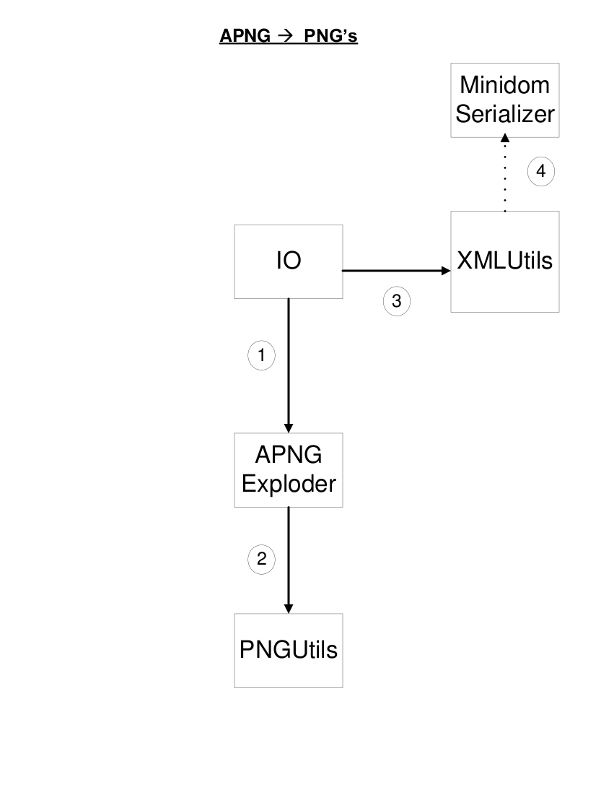

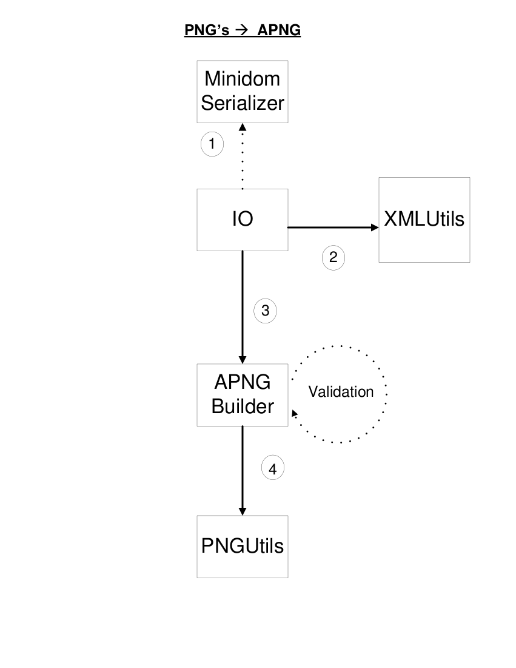

PROBE Estimate

Base LOC:
MindomParser 317
MinidomSerializer 125
BasicLex 154
New LOC:
animate(Huge) 43 suspend(Huge) 43
writeFiles(Large) 18 parseXML(Large) 18
getFrames(Med) 7 writeXML(Large) 18
writeFrames(Large) 18 buildAPNG(Huge) 43
preparePNGs(Large) 18 validateIHDR(Large) 18
buildFrames(Large) 18 buildACTL(Med) 7
buildFCTL(Large) 18 blowChunks(Huge) 43
makeChunk(Huge) 43 makeNum(Med) 7
parseNum(Med) 7 calcCRC32(Large) 18
updateCRC32(Large) 18 bytep(Tiny) 2
byte-listp(Small) 4 chunktypep(Tiny) 2
chunkp(Small) 4 chunk-listp(Small) 4
crc32Lookup(Tiny) 2 ascii->bytes(Small) 4
bytes->ascii(Small) 4 explodeAPNG(Huge) 43
getIHDR(Med) 7 getAcTL(Medium) 7
getFrames(Medium) 7

Contracts
IO – 2 Large cons – 36
XMLConfigReader – 4 Large cons - 72
PNGUtils – 9 Huge cons – 387
APNGBuilder – 5 Huge cons – 215
APNGExploder – 3 Huge cons – 129
Optional: Compression Module → 500 LOC

*Appendix:

PNG and APNG Specifications

PNG Specifications
Structure of a very simple PNG file
89 50 4E 47 0D 0A 1A 0A  PNG signature | IHDR  Image header | IDAT  Image data | IEND  Image end
Source: http://en.wikipedia.org/wiki/APNG
IHDR (source):
IHDR Chunk defined as follows:
Width | 4 bytes
Height | 4 bytes
Bit depth | 1 byte
Colour type | 1 byte
Compression method | 1 byte
Filter method | 1 byte
Interlace method | 1 byte

-Bit Depth and Color Type

Table 11.1 — Allowed combinations of colour type and bit depth
PNG image type | Colour type | Allowed bit depths | Interpretation
Greyscale | 0 | 1, 2, 4, 8, 16 | Each pixel is a greyscale sample
Truecolour | 2 | 8, 16 | Each pixel is an R,G,B triple
Indexed-colour | 3 | 1, 2, 4, 8 | Each pixel is a palette index; a PLTE chunk shall appear.
Greyscale with alpha | 4 | 8, 16 | Each pixel is a greyscale sample followed by an alpha sample.
Truecolour with alpha | 6 | 8, 16 | Each pixel is an R,G,B triple followed by an alpha sample.

-Compression Method (zlib)
The only compression method currently used in PNG is 0, or zlib deflate/inflate compression with a sliding window. This compression uses a combination of LZ77 compression with Huffman Coding.
zlib data format is as follows:
zlib compression method/flags code | 1 byte
Additional flags/check bits | 1 byte
Compressed data blocks | n bytes
Check value | 4 bytes

-Filter Method
x | the byte being filtered;
a | the byte corresponding to x in the pixel immediately before the pixel containing x (or the byte immediately before x, when the bit depth is less than 8);
b | the byte corresponding to x in the previous scanline;
c | the byte corresponding to b in the pixel immediately before the pixel containing b (or the byte immediately before b, when the bit depth is less than 8).
Table 9.1 — Filter types
Type | Name | Filter Function | Reconstruction Function
0 | None | Filt(x) = Orig(x) | Recon(x) = Filt(x)
1 | Sub | Filt(x) = Orig(x) - Orig(a) | Recon(x) = Filt(x) + Recon(a)
2 | Up | Filt(x) = Orig(x) - Orig(b) | Recon(x) = Filt(x) + Recon(b)
3 | Average | Filt(x) = Orig(x) - floor((Orig(a) + Orig(b)) / 2) | Recon(x) = Filt(x) + floor((Recon(a) + Recon(b)) / 2)
4 | Paeth | Filt(x) = Orig(x) - PaethPredictor(Orig(a), Orig(b), Orig(c)) | Recon(x) = Filt(x) + PaethPredictor(Recon(a), Recon(b), Recon(c)

APNG Creation Diagram

Source: http://en.wikipedia.org/wiki/APNG#Technical_details

