Student Course Registration System - ERD Project
Student Name: Mohamed Abdi Dirie
Registration #: 4585-FOC/BSSE/F23(A)

Entity Relationship Diagram
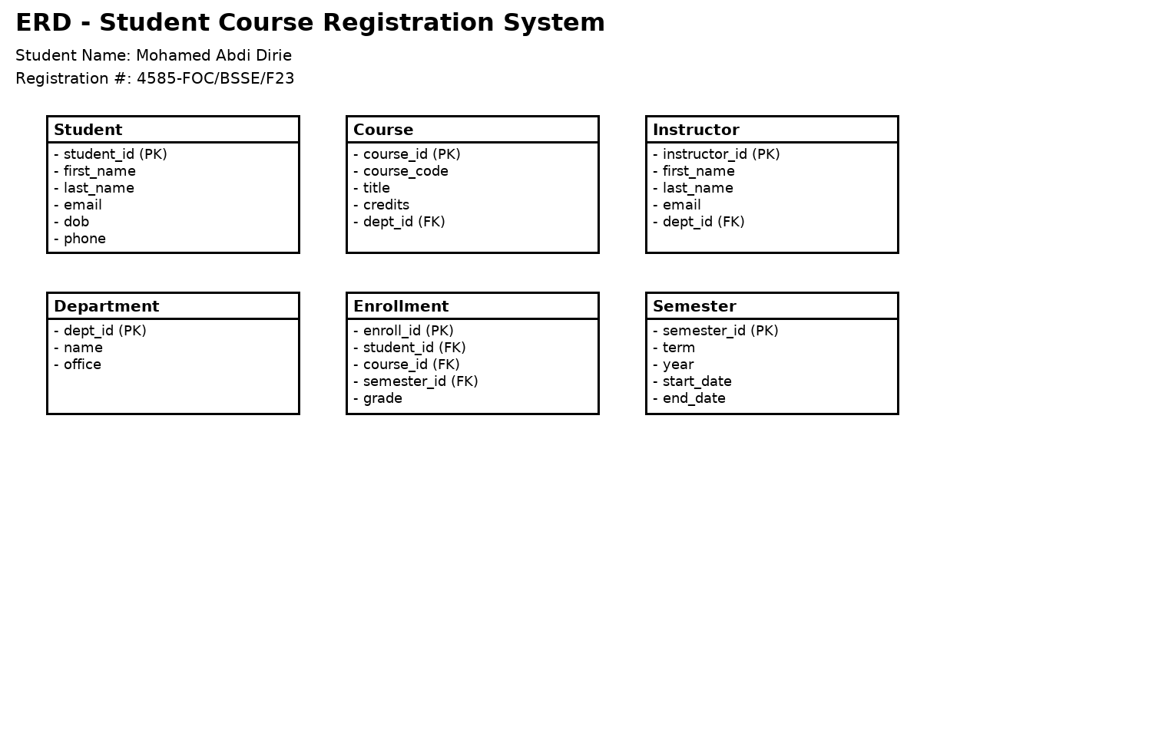

Project Explanation
This ERD represents a Student Course Registration System. It includes Students, Courses, Instructors, Departments, Semesters, and Enrollment records. Each entity has attributes, primary keys, and foreign keys that establish relationships between the tables.

