UTS_ CommMini
Purpose 2
Function 3
50: Open Assigned COM Port 3
52: Query 5
53: Send Cmd String 7
54: Read one Report 9
55: Read string by Length 9
58: DTR_ON_OFF 10
59: RTS_ON_OFF 10
60: Open and search Comm 11
61: Search and Open ROOT2 12
62: Send Cmd and Read Cmd Echo 14
63: Root2 Read one report 17
64: Root2 Read Buffer By Length 18
65: Purge RxBuf 18
66: Bytes of Buffer used 19
67: Search ROOT2 Report 19
68: Execute Parse DLL 20
69: EQUIP_QUERY 22
70: Close_Root2Comm 22
80: KeyForce Analysis 23
81: Find KeyForce by distance 24

.

Purpose
FOR ROOT 2
This DLL was designed to support the UTS to use the ROOT2 (USB HOST Tester) for MSE and receiver device testing. In normal case, test USB device was using the BH driver and go through the HID++ command for testing. Due to found some issues on multiple testing, to use ROOT2 could solve it.

The interface of ROOT2 is using RS232 115200bps. By using the ROOT2 could recognize the device plugging/unplugging very faster. It benefit on multiple test system. And also can connect a USB HUB on ROOT2 for multiple device testing.

A new dll UTS_CommRoot2.dll was design to improve the communication performance on multiple testing to replace the UTS_ROOT1.dll since any test command go through the ROOT2 need to wrap as a packet with ROOT2 format. In order to improve the performance, this dll provides function 61~69 can fully support testing

FOR others RS232 Comm port
Function 52 ~ 60 provide the comm port access functions to support RS232 types equipment access except the ROOT2.

For the purpose to support a new COMM dll on XP, Win7, Win8 and Win10 platform. And also to simplify the function parameter that used on old UTS_Comm.dll , This UTS_CommMini.dll provides a simple and essential function for COMM port access.

Function

50: Open Assigned COM Port
This function will not auto search COM port to open,

Test plan parameter Field | Name of Field |  | Description
Value1 | Min
Value2 | Max
Value3 | COM Index | n | 1
Value4 | Command | 50: Open Assigned COM Port (no Auto Search)
Value5 | ComPort | COM12 | Assign COM to Open
Value6 | ComString | 115200,N,8,1

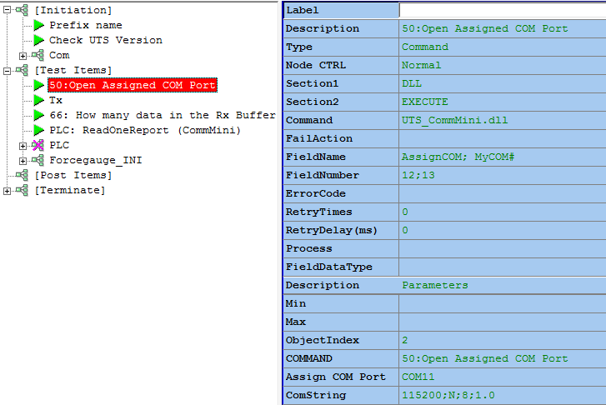

52: Query
This command will send command string and read back echo

Test plan parameter Field | Name of Field |  | Description
Value1 | Min
Value2 | Max
Value3 | COM Index | n | 1
Value4 | Command | 52:Query
Value5 | TxCmd String | ‘*idn?’0d0a | String ABC --> ‘ABC’  Out side the ‘’ will treat as HEX such as 0a0d
Value6 | TxCmd String Type  1: String  2: Hex | Tx cmd is string or Hex | Type=1  ‘ABC’0d0a  Type=2  41 42 43 0d 0a  Type=3  Dedicated for Riotec scanner.
Value7 | Timeout |  | Default=500 ms
Value8 | Echo EndString |  | End of echo string
Value9 | Purge Rx buf before Tx Cmd
Value10 | Change Format

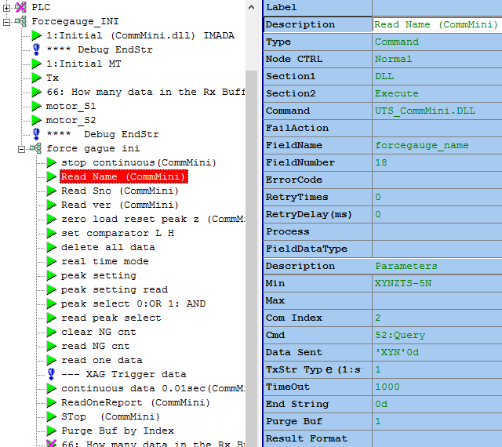

53: Send Cmd String
This command will send command string without read back and echo

Test plan parameter Field | Name of Field |  | Description
Value1 | Min
Value2 | Max
Value3 | COM Index | n | 1
Value4 | Command | 53:Send Cmd
Value5 | TxCmd String | ‘*idn?’0d0a | String ABC --> ‘ABC’  Outside the ‘’ will treat as HEX such as 0a0d
Value6 | TxCmd String Type  1: String  2: Hex | Tx cmd is string or Hex | Type=1  ‘ABC’0d0a  Type=2  41 42 43 0d 0a

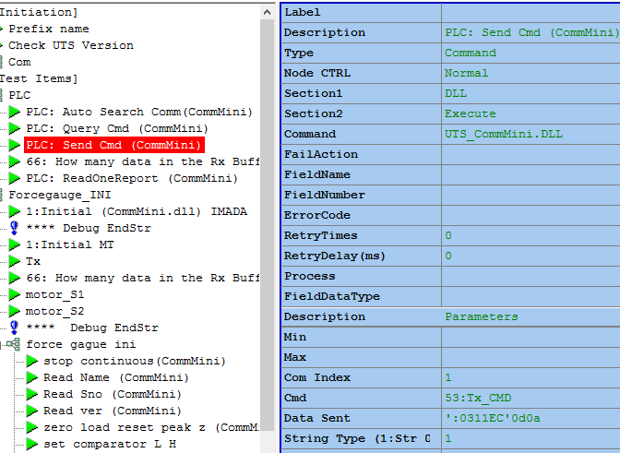

54: Read one Report
This command will read one report string from Rx Buffer (read string from buffer until encounter the delimiter)

Test plan parameter Field | Name of Field |  | Description
Value1 | Min
Value2 | Max
Value3 | COM Index | n | 1
Value4 | Command | 54:Read one report
Value5 | Echo delimiter String |  | Default=500 ms
Value6 | Timeout |  | End of echo string
Value7 | Change Format

55: Read string by Length
This command will read characters from Rx Buffer by specified length

Test plan parameter Field | Name of Field |  | Description
Value1 | Min
Value2 | Max
Value3 | COM Index | n | 1
Value4 | Command | 55:Read by length
Value5 | Length to read
Value6 | Timeout |  | ms
Value7 | Change Format
Value7 | Transfer Chr to HEX string |  | Chr(05)Chr(07)Chr(1A) →  05 07 1A

58: DTR_ON_OFF
This command use to turn On/Off DTR Signal

Test plan parameter Field | Name of Field |  | Description
Value1 | Min
Value2 | Max
Value3 | COM Index | n | 1
Value4 | Command | 58:DTR On/Off
Value5 | DTR | ON  OFF | ON: DTR ON  OFF: DTR OFF

59: RTS_ON_OFF
This command use to turn On/Off RTS Signal
Test plan parameter Field | Name of Field |  | Description
Value1 | Min
Value2 | Max
Value3 | COM Index | n | 1
Value4 | Command | 59:RTS On/Off
Value5 | RTS | ON  OFF | ON: RTS ON  OFF: RTS OFF

60: Open and search Comm
This command will auto search comm port to open

Test plan parameter Field | Name of Field |  | Description
Value1 | Min
Value2 | Max
Value3 | COM Index | n | 1
Value4 | Command | 60:Search and Open Comm
Value5 | ComString | 115200,N,8,1 | Open Com String
Value6 | QueryString | ‘ABC’0d0a
Value7 | EchoString | ‘XYZ’  ‘XYZ’0d0a
Value8 | CmdString Type  0: HEX  1: String
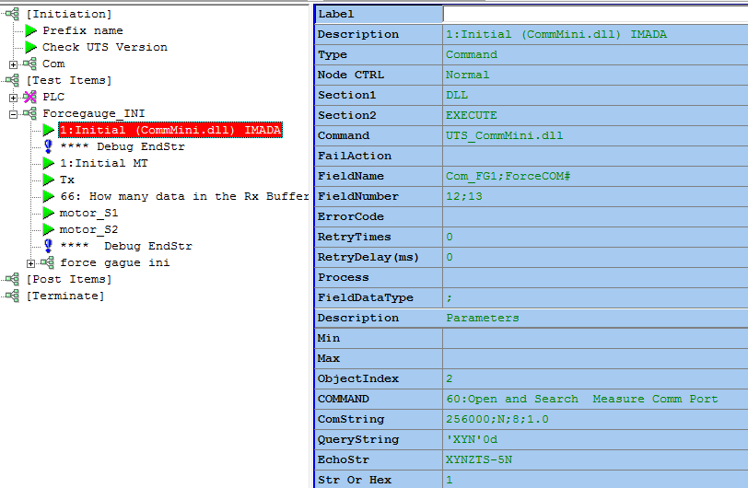

61: Search and Open ROOT2
This command will help to search Root2 and return the com index.(1 ~5)

Test plan parameter Field | Name of Field |  | Description
Value1 | Min
Value2 | Max
Value3 | COM Index | n | 1
Value4 | Command | 61:Search and Open root2
Value5 | ComString | 115200;N;8;1 | Open Com String
Value6 | QueryString | 1B 53 02 00 1B 45
Value7 | EchoString | 1B 53 82 1B 45
Value8 | CmdString Type  0: String  1: HEX | 2 | Hex type

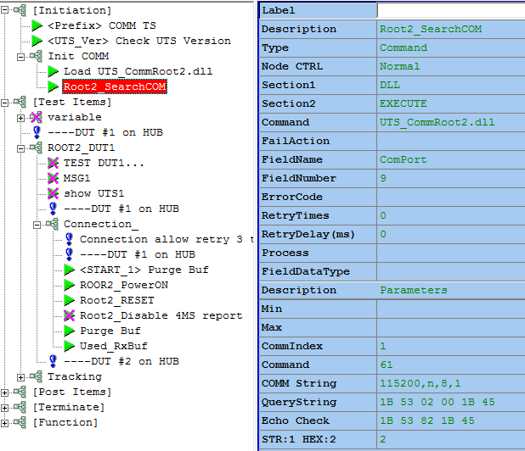

ROOT2 by default baud rate set 115200bps None parity, 8 data bit and 1 stop bit.

62: Send Cmd and Read Cmd Echo
The function can send command to bridge and receive the feedback from bridge.
It can delay to wait for response, or set the length of feedback string that need to collect the data.

Test plan parameter Field | Name of Field |  | Description
Value1 | Min
Value2 | Max
Value3 | Com Index | 1
Value4 | Command | 62:Query
Value5 | Cmd String | 1B 53 88 1B 45 | Send hex code (1B 53 88 1B 45) to device
Value6 | Cmd Type  0: String  1: Hex
Value7 | Record nb of Cmd echo+response | =0 Tx only  =1 Cmd Echo  =2 Cmd Echo + Cmd Response | 1:read Cmd echo first
Value8 | 1: Purge Buffer before send out Cmd. |  | 1:Purge Buf before send Cmd.
Value9 | Search Cmd Echo String | If Value7 >1 it will search Cmd Echo first then read following one response
Value10 | Change Format |  | Change the Result Format

Query string , compare string and end string allow ascii code or hex code.
The echo string always is hex code.
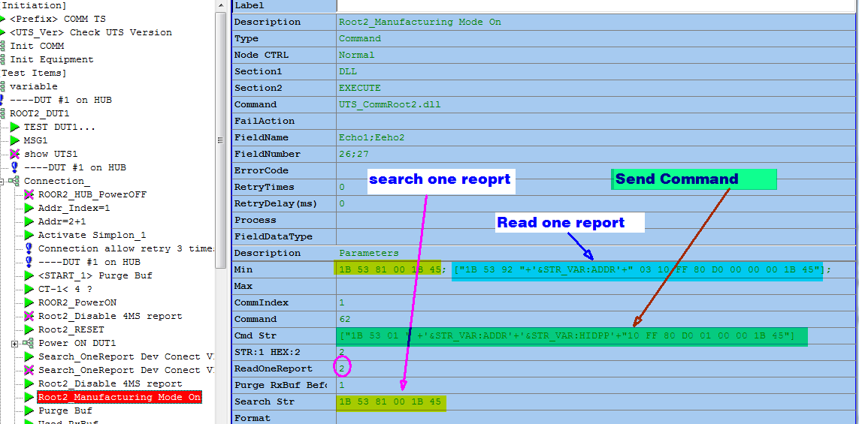
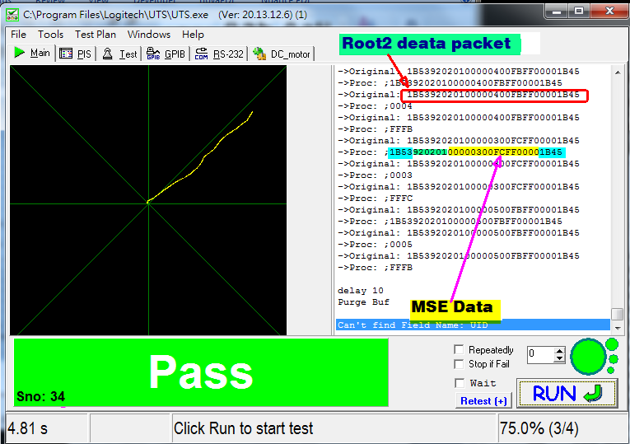

Value 10: Ini Section
Sample 1:
"[Data]"
["TopX="+'&Image_Pos_X']
["TopY="+'&Image_Pos_Y']
DataLen=15
XPos=S([17][18][15][16])
YPos=S([21][22][19][20])
TimeTick_us=1
"[Parameter]"
FormPos=0,0,336,336
Testcase=1
TrackTime=1000
TrackSpeed=2
TrackAngle=45
Scale=25
NewForm=0
SkipData=0
inverseX=0
inverseY=1
XY_LogFile=1
Bridge_TimeStamp=4
Timeout=6000

Sample2:
"[Data]"
["TopX="+'&Image_Pos_X']
["TopY="+'&Image_Pos_Y']
DataLen=15
;BtnPos=2
;XPos=S([7][8][5][6])
;YPos=S([11][12][9][10])
XPos=S([17][18][15][16])
YPos=S([21][22][19][20])
TimeTick_us=1

"[Parameter]"
FormPos=0,0,336,336
Testcase=1
;.... if using Air Cylinder¡@MTRK_Mannually=0
;MTRK_Mannually=1

MTRK_RefDPI=1000
;; Tracking distance(inch)
MTRK_DPIbyDistance=5
Timeout=3500
MTRK_CalSpeed=1

;... here even using Air cylinder , due to no Btnkey to start/stop so
;... need to set a big traclking time just to accumulate by it will be done by Timeout
;... so need to set proper timeout value
;
TrackTime=10000
TrackAngle=45
Scale=25
NewForm=0
SkipData=5
inverseX=0
inverseY=1

XY_LogFile=1
Debug_LogTitle=id,BL,BH,XL,YH/XH,YL,Minfo.X,Minfo.Y,TimePeriod,TotalTime,Avg_MSpeed

63: Root2 Read one report
Test plan parameter Field | Name of Field |  | Description
Value1 | Min
Value2 | Max
Value3 | Comm Index | 1
Value4 | Command | 63: Root2_ReadOneReport
Value5 | Read N Reports |  | 50
Value6 | Interval Timeout |  | 1000
 | Change Format |  | S([7..14])
 | Save log fn |  | C:\lee_RPT.txt
 | Task Timeout |  | 6000

64: Root2 Read Buffer By Length

Test plan parameter Field | Name of Field |  | Description
Value1 | Min
Value2 | Max
Value3 | COM index | n | 1:default
Value4 | Command | 64: ReadByLength
Value5 | Length

65: Purge RxBuf
Test plan parameter Field | Name of Field |  | Description
Value1 | Min
Value2 | Max
Value3 | COM Index | n
Value4 | Command | 06: Purge RxBuf

66: Bytes of Buffer used
Zero means of Buffer empty

Test plan parameter Field | Name of Field |  | Description
Value1 | Min
Value2 | Max
Value3 | COM Index | n
Value4 | Command | 66: BufUsed

67: Search ROOT2 Report
Test plan parameter Field | Name of Field |  | Description
Value1 | Min
Value2 | Max
Value3 | COM Index | n
Value4 | Command | 67: Search Root2 Report
Value5 | Timeout
Value6 | Search String
Value7 | Change Format

68: Execute Parse DLL
Perform data report parser such as support MSE Tracking test
The function can execute another DLL (Parse type DLL). But the DLL need to provide 6 function for main program.

Test plan parameter Field | Name of Field |  | Description
Value1 | Min
Value2 | Max
Value3 | COM Index | n
Value4 | Command | 68: Execute Parse DLL
Value5
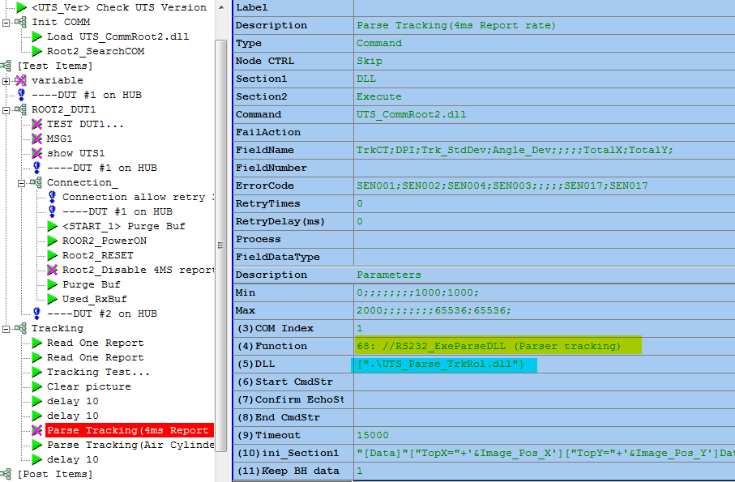

By the functions of DLL, it can provide the solution defined by DLL.

The 5 functions is :
InitFun : it will be called first, it can initial status you need.
GetParameter : it will return the value string from Sub_Parse DLL.
SetRawData : it will set the raw data from main program, you can use the raw data to analyse or calculate.
GetResultData : it will return the result to main program.
IsFinished : it will return the true or false for main program to decide that it finished or not.

This function will return string.(for example the TrkTest.DLL will return string include TrkCount;DPI,;tdDev;AngDev;MaxDev;Squal;Sutter in tracking and SQST)

69: EQUIP_QUERY
Test plan parameter Field | Name of Field |  | Description
Value1 | Min
Value2 | Max
Value3 | COM Index | n
Value4 | Command | 69: EQUIP_QUERY
Value5 | Command String
Value6 | String Type  0 String  1: HEX
Send command and read echo from assigned COM index.

70: Close_Root2Comm
Test plan parameter Field | Name of Field |  | Description
Value1 | Min
Value2 | Max
Value3 | COM Index | n
Close assigned Root2 COM index.

Note: due to RS232 component issue cannot close automatically on dll so need added this on test plan [terminate] section before close all DLL

80: KeyForce Analysis
Test plan parameter Field | Name of Field |  | Description
Value1 | Min
Value2 | Max
Value3 | How many force Gauge to query | 2 | 1 or 2 force gauge
Value4 | Command | 80: KeyForce Analysis
Value5 | CommIndex1 | 1 or 9999 | Gauge1 com object index  9999: analysis from force file
Value6 | CommIndex2 | 2 | Gauge2 com object index
Value7 | LoopCT | 5000 | Query 5000 times
Value8 | End Str | 0d
Value9 | Speed(mm) | 0.05
Value10 | Save csv fn | C:\forceTS.csv | Full path and fn
Value11 | TaskTimeout(ms) | 12000 | ms
Value12 | Skip start up check | 0 | 1: Skip Start_up Check 0: need check start up (by Default)
Output field:
StartUp index, StartUp_force, Operation Key Index, Operation Key distance, Operation Key force, CLK Key Index, CLK distance, CLK force
Note1 : Value12 1: Skip Start_up Check 0: need check start up (by Default)
Note2: If Value5 =9999 , this function will analysis force from c:\F1_TMP.csv and c:\F2_TMP.csv , it use for debug and verify from existing force data csv file. If link to analysis force file, can copy to C:\ root directory and change file name to F1_TMP.csv and F2_TMP.csv
Note3: In normal case function 80 will always create c:\F1_TMP.csv and c:\F2_TMP.csv files. The old file will be replace by new test.

81: Find KeyForce by distance
Test plan parameter Field | Name of Field |  | Description
Value1 | Min
Value2 | Max
Value3 | Whice force Gauge to query | 1 | 1 or 2 force gauge
Value4 | Command | 81:Find KeyForce
Value5 | Distance | 0.06 | distance
Output field:
Force ; Index

82: Turn off motor when reach to the target force
Test plan parameter Field | Name of Field |  | Description
Value1 | Min
Value2 | Max
Value3 | force Gauge Index | 1 | 1 or 2 force gauge
Value4 | Command | 82: MotorOff by ForceValue
Value5 | Motor Comm Index | 1
Value6 | Target Force to turn off Motor | 2 | Motor com object index
Value7 | Motor Speed |  | for future calculation
Value8 | Force Gauge Line End | 0d
Value9 | Stop Motor Command String
Value10 | Save csv fn | C:\forceTS.csv | Full path and fn
Value11 | TaskTimeout(ms) | 12000 | ms

