Master Thesis

**How to Distribute New Solar Systems in Europe to Reduce Power Generation Variability**

Department Environmental Systems Science / Earth Sciences, ETH Zürich

Institute for Atmospheric and Climate Science

Supervisors:

Dr. Jan Wohland, Institute for Environmental Decisions, ETH Zürich

Dr. Doris Sylvia Folini, Institute for Atmospheric and Climate Science, ETH Zürich

Dr. Stefan Pfenninger, Institute for Environmental Decisions, ETH Zürich

Prof. Dr. Martin Wild, Institute for Atmospheric and Climate Science, ETH Zürich

Submitted by

Dirk Mühlemann

13-732-037

Uster, 01/05/2021

Summary

* Still from proposal

To reduce greenhouse gas emissions and combat climate change, the electrical power production sector is facing a fundamental transition from conventional fossil to renewable technologies. The transition has already started, which can be seen by the great effort and ambitious targets of many nations around the globe. Installed power production capacities of solar photovoltaics (PV) are increasing every year and are already capable of producing around 5.5% of the Europeans electricity demand. Since PV power output depends on weather and climate, it exhibits a highly variable production pattern. This variability challenges the electricity grids because the stability of the grids depends on balanced supply and demand. Further massive deployment of PV systems could lead to an increase of the variability and therefore add to this challenge. Different studies suggest strategies to reduce the PV power output variability on rather short (minutes to hours) or long (seasonal) timescales. However, weather regimes lasting several days influence the PV power output across Europe as well, and knowledge of its impact on multiday PV power output variability is still limited. In this thesis, we aim to identify spatial distributions of newly installed PV systems that minimize the multiday power output variability within Europe. To quantify the variability, we will perform empirical orthogonal function (EOF) analyses of solar downward radiation, which influences the PV power output directly, and geopotential height at 500hPa which reflects weather regimes and therefore has an indirect effect on the PV power output. Both fields will be taken from the ERA5 reanalysis dataset which covers the time period from 1979 to present. The resulting subspace spanned by the leading EOFs of our analysis will be grouped in different weather regimes with the k-mean clustering techniques. To assess the PV power output variability the resulting regimes will be related to country/region specific PV capacity factors, which are defined as the quotient of actual power output and installed PV capacities. We will use hourly PV capacity factors provided by the simulation of renewable.ninja from 1985-2019. Connecting the regimes with the PV capacity factors will lead to an overview of under- and overproduction (relative to the mean) per country/region and weather regime. The current installed capacity of PV systems in Europe will then be used together with our findings to assess the current multiday PV power output variability in Europe. Furthermore, an optimal distribution of additional PV systems will be proposed with the goal to minimize the multiday variability.

Contents

1. Introduction 4

2. Data & Methods 6

2.1 Data 6

2.1.1 ERA5 6

2.1.2 Renewables.ninja and the Global Solar Energy Estimator (GSEE) 6

2.1.3 Installed PV capacities 9

2.2 Method 10

2.2.1 ERA5 data pre-processing 10

2.2.2 Weather regime classification 10

2.2.3 Capacity factors 12

2.2.4 Variability reduction with optimal IC distribution 13

2.2.5 Scenarios 14

3. Results 17

3.1 Weather regimes and capacity factor anomalies 17

3.1.1 Weather regime 0 / NOA+ 20

3.1.2 WR1 - European trough 21

3.1.3 WR2 – NOA- 21

3.1.4 WR3 - Atlantic ridge 21

3.1.5 WR4 - Atlantic trough 22

3.1.6 WR5 - European blocking 22

3.1.7 WR6 - Scandinavian blocking 22

3.2 Current and planned situation (2030) 24

3.3 Scenarios for IC distribution 25

4. Conclusion 25

6. References 26

# Introduction

Many governments undertake ambitious climate mitigation efforts to reduce the adverse effect of global warming and thereby try to meet the 1.5°C goal from the Paris agreement (Hulme, 2016). To achieve this goal a transition from conventional fossil to renewable energy technologies is substantial. Solar power generating photovoltaic (PV) systems, as one of the major renewable technologies, has seen a tremendous growth in recent years. According to the PV status report (2019) by the European commission, there was a global installed capacity of 520GW by the end of 2018. By the end of 2019, the installed capacity is expected to reach 650GW, which allows the PV systems to produce roughly 4% of the global electricity demand. Europe's share of installed PV capacity at the end of 2018 was about 117GW, which allowed to produce 5.5% of Europeans electricity demand. Furthermore, recent scenarios for the necessary installed PV capacity if the world is to reach 100 % renewable electricity production in 2050, suggest that the PV installed capacity must rise to more than 4TW by 2025 and 21.9TW by 2050. For Europe this would imply an PV installed capacity of 630GW by 2025 and 1.94TW by 2050 (Jäger-Waldau, 2019).

🡪 plan from NCEP for 2030

-🡪 other studies i.e. IRENA 🡪 0.8TW

PV power output depends on weather and climate and therefore challenges the current power grid by variable power input (Graabak and Korpås, 2016; Stram, 2016). 🡪 Drücke 2020 James 2007

Within minutes, the power production from a PV system can vary by as much as 80% due to passing broken cloud cover (Mills and Wiser, 2010). There is also a diurnal cycle with highest power production during the day and no production during night. By analysing multiday fluctuation, a relation between long lasting weather regimes and PV power production can be observed. During one weather regime the PV production pattern varies substantially to the next weather regime (Grams *et al.*, 2017). Furthermore, variability in the PV power production is caused by the seasonal cycle (Heide *et al.*, 2010). The efficiency of a PV panel is mainly dominated by the available surface solar radiation and the panel temperature (Huld *et al.*, 2010). Since the seasonal cycle affects both, a direct effect can be observed. Even decadal to multidecadal analyses suggest that global warming and solar brightening/dimming influences the PV power output. Solar brightening/dimming is often caused by air pollution patterns, which influences the available surface solar radiation and therefore affects the PV power output. Global warming leads to an increase of panel temperatures and reduces the efficiency of the panels (Wild *et al.*, 2015; Sweerts *et al.*, 2019).

A stable power grid depends on balanced electrical supply and demand (Stram, 2016).

Frequency example 🡪 what happens if not!?? 🡪 Hirth and Ziegenhagen 2015, Garnier and Madlener 2015

* Energy balancing Kiviluoma 2012

Short time scale variability due to passing broken cloud cover can affect one PV system substantially. But wider geographical distribution of multiple interconnected PV systems can significantly smooth this short time PV power output variability (Delucchi and Jacobson, 2011; Graabak and Korpås, 2016). Co-deployment of renewable energy system (water, wind and solar) can counteract the variable power output caused by diurnal and seasonal cycles. The basis for these approaches is the different diurnal and seasonal production pattern of water, wind and solar power plants. For example, wind power output exhibits highest production rates during winter whereas solar power production is highest in summer. Co-deployment of wind and solar can therefore reduce the seasonal power production variability. Other combination are possible as well (Heide *et al.*, 2010; Santos-Alamillos *et al.*, 2015; Graabak and Korpås, 2016). To summarize, different studies already have proposed methods to reduce short, diurnal or seasonal solar power production variability.

Fewer studies have investigated in reduction of multiday solar power output variability from a meteorological standpoint. 🡪 expalain how? 🡪 500hPa gph anomalies Cassou etc.

* Bloomfiled 2020 TCTs
* Thornton 2017

Grams *et al.* (2017) did but rejected the idea to further invest in it, based on their findings that it would need a tenfold increase of installed PV capacity in Europe to be comparable to the variability of wind power output. Therefore, they focused their study on wind and concluded, that spatial deployment of wind fleets based on information of different weather regimes can reduce the wind power output variability within Europe substantially. Nevertheless, they showed that connecting weather regime to PV power output variability is also possible. Even though the decision to focus on wind rather than solar power output variability is comprehendible, calculations of necessary future installed PV capacities gives reason to do the investigations anyway. Ram *et al.* (2017) estimated that the installed PV capacity for a 100% renewable scenario in Europe must rise to 1.94TW by 2050. The International Renewable Energy Agency (IRENA) estimated Europa’s share a bit lower to 0.89TW. This is roughly a ten to twentyfold increase of installed PV capacity compared to the 87.19GW installed PV capacity used in Grams *et al.* (2017) study. Therefore, the impact of multiday PV power output variability caused by different weather regimes could also become substantial, which makes investigation of the optimal spatial deployment of future PV systems in Europe before further massive deployment of great interest. The results could support current planning activities and could help to reduce future grid balancing problems.

* Timescale discussion necessary?
* Stress events 🡪 example? Bloomfield 2018 2020 and der Wiel 2019
* Demand and production pattern 🡪 countries with highest demand and production

IRENA 0.784TW EU and 0.107 rest of Europe

# Data & Methods

This section first describes the datasets which are the underlying sources of this thesis. Afterwards it illustrates how the datasets are used to achieve the objective of reducing PV power output variability in Europe.

## Data

### ERA5

The reanalyse dataset, ERA5, which is published by the European Centre for Medium-Range Weather Forecasts (ECMWF), is used as source for the weather regime definition. It provides atmospheric, land and oceanic variables from 1979 to present with a temporal resolution of an hour. The grid of ERA5 has a horizontal spatial resolution of 0.28 degrees (~31km) and 37 pressure levels in the vertical. A detailed documentation about ERA5 reanalyse dataset can be found on the ECMWF confluence web page (Hennermann and Yang, 2018).

We use the 500hPa geopotential height variable from ERA5 in the domain 80°W to 40°E, 30°N to 90°N. Geopotential height is commonly used for weather regime classification (Michelangeli, Vautard and Legras, 1995; Cassou, 2008; Grams *et al.*, 2017). The domain specification is reasonable for our meteorological field investigates since it captures the largescale circulation that affects Europe. The hourly dataset covers the time from 01.01.1979 until 31.05.2020, which yields in 363’048 datapoints. Additionally, the ERA5-Land hourly data from 01.01.1981 until 31.05.2020 are used to get an overview of 2m temperature and surface solar radiation of the classified weather regimes. ERA5-Land has a spatial resolution of 0.1 degrees (~9km) but since we do not need such a high spatial resolution for our investigations, we took the possibility provided by ECMWF to download them with a higher resolution of 0.25 degrees.

### Renewables.ninja and the Global Solar Energy Estimator (GSEE)

Renewables.ninja ([www.renewables.ninja](http://www.renewables.ninja/)) is an interactive web platform that simulates hourly power output of wind and solar power plants all over the world. To calculate the PV power output, it uses the so-called Global Solar Energy Estimator (GSEE). The source code of the GSEE is freely available on [GitHub](https://github.com/renewables-ninja/gsee) and a detailed description of the GSEE can be found in Pfenninger and Staffell (2016). The theoretical background of the GSEE is based on Huld *et al.* (2010). The following variables are the key input parameter of this method to estimate the energy yield of PV modules:

1. Direct and diffuse irradiance at the PV panel
2. Panel temperature

Pfenninger and Staffell (2016) used two data sources to estimate these variables: First the reanalysis dataset Modern-Era Retrospective analysis for Research and Applications (MERRA and MERRA-2) and second the Surface Solar Radiation Data Set - Heliosat (SARAH). Figure 1 shows the general approach of GSEE.

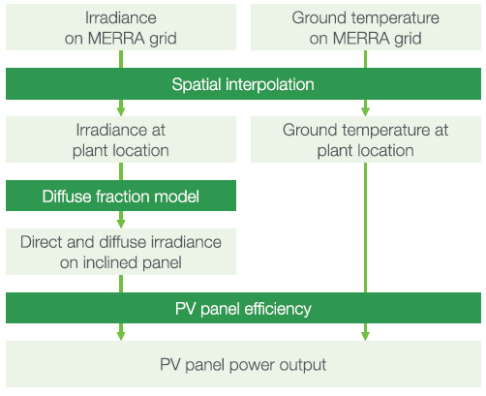

**Figure 1:** Overview of the approach used to model PV power output (Pfenninger and Staffell, 2016).

Both data sources provide the variables in hourly intervals. The spatial resolution of MERRA-2 is 0.5° latitude and 0.625° longitude. SARAH has a higher spatial resolution of 0.05° × 0.05°. MERRA only provides direct irradiance, but diffuse irradiance is needed as well. Therefore, they used the Boland-Ridley-Lauret model to estimate the diffuse irradiance (Ridley *et al.* 2010; Lauret *et al.* 2013). Since SARAH provides direct and global irradiance no further estimates were needed. Additionally, they use T2M (temperature at 2m above ground level) from MERRA-2 as estimates for the ambient temperature. To get the panel temperature they used the ambient temperature of MERRA-2 and additionally considered the effect of the irradiance on the panel temperature. This relation was estimated with site measurements of one of their sources (DTI see below). This dataset provides ambient and panel temperature for each site with which they derived an empirical relationship.

It is more common and easier to make comparison and analyses of PV power output with capacity factors rather than with absolute power output and we use this approach as well. The unit-less capacity factor CF is defined as:

|  |  |  |
| --- | --- | --- |
|  |  | Eq. 1 |

where P is power output [W] and IC is the installed capacity [W].

To evaluate the results obtained with the method described above, Pfenninger and Staffell (2016) compared it with capacity factors based on site measurements. To obtain the measured capacity factors they used three sources: DTI, PVLog.de and PVOutput.org. Over 1000 site data (measurements from PV systems) were collected from these three sources. Figure 2 shows a histogram of the difference between measured capacity factors and capacity factors simulated with the GSEE.

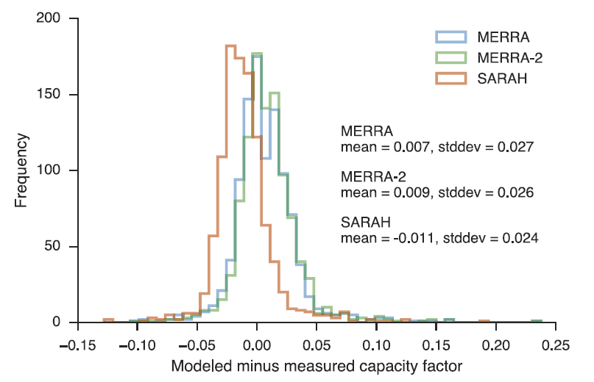**Figure 2**: Histogram of the difference between the three modelled and measured capacity factors. Negative values infer underestimates of the capacity factor and positive values overestimates. The blue graph corresponds to modelled data with MERRA, the green graph to MERRA-2 and the red graph to SARAH. (Pfenninger and Staffell, 2016)

The mean of this differences is taken by Pfenninger and Staffell (2016) as basis for a bias correction. They used it to calculate one correction factor for each simulation (MERRA, MERRA-2 and SARAH).

Additionally to the power output simulation of a wind or solar plant at a specific location, renewables.ninja also provides capacity factors per country. Pfenninger and Staffell (2016) have performed randomized (tilt and azimuth angel) national-scale simulations with MERRA and SARAH data to estimate averaged capacity factors per country. Also, these data were analysed against the measured site data. The measured capacity factor per country was then calculated as the mean of all capacity factors per site in one country. Transmission Network Operator (TNO) reports were used as a further data source of the national aggregated capacity factors. Figure 3 shows an example of the results for Great Britain.

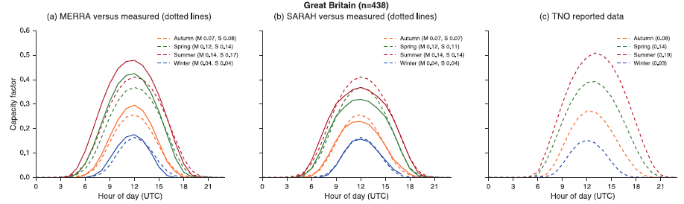

**Figure 3:** Capacity factors per season for Great Britain from aggregated measurements site data (solid line, a and b), from simulation with MERRA and SARAH (dotted line, a and b) and from Transmission Network Operator (TNO) reports (c).

### Installed PV capacities

Data from the International Renewable Energy Agency (IRENA) are used to gather the current installed PV capacities (2019) for each country in Europe. *“IRENA is an intergovernmental organisation that supports countries in their transition to a sustainable energy future, and serves as the principal platform for international co-operation, a centre of excellence, and a repository of policy, technology, resource and financial knowledge on renewable energy”* (IRENA, 2020b). The used data can be found in the “Renewable Capacity Statistics 2020” report by IRENA and together with the capacity factors by renewables.ninja (section 2.1.2) the PV power output for each country are calculated (Eq. 1). Furthermore, the estimates “where we need to be” in 2050 presented in the “Energy Transformation Roadmap to 2050” by IRENA are used as one source for the PV installed capacity in Europe 2050. In their “Transforming Energy Scenario” the PV installed capacity in the European Union must increase to 784GW and to 107GW in the rest of Europe (IRENA, 2020a).

To further analyse where the PV power output variability is heading to, the National Energy and Climate Plans (NECPs) of each country in the EU are used. Within the NECPs each country defines the amount of PV systems they plan to install until the year 2030. For the rest of Europe individual national plans are considered or if not found the average PV installed capacity growth rate until the year 2030 from all EU countries is multiply with the current PV installed capacity to get an estimate.

### Electricity consumption data

Electricity consumption data are taken from the open-power-system-data ([opsd](https://open-power-system-data.org/)) and from the statistical office of the European Union (Eurostat) for countries which are missing in the opsd dataset. Since the availability of the data per year differs per country, we take the latest fully reported year for each country as current total electricity consumption per year.

* Table with all IC per country? Consumption? Only countries?

## Method

### ERA5 data pre-processing

Since we investigate in weather regime which last several days, the ERA5 dataset is resampled by calculating daily means of the geopotential heights. Furthermore, a 10-day lowpass filter is applied to smooth the data. To perform an EOF analysis the dataset with the lowpass filtered daily means is used to calculate standardized anomalies:

|  |  |  |
| --- | --- | --- |
|  |  | Eq. 2 |

where zd are the lowpass filtered daily means of the geopotential height, zd,mean is the climatological mean with a running window of 30 days, and zd,std is the standard deviation of the geopotential height with a running window of 30 days. The running window is defined such as the respective day acts as centre of the window. For instance, to derive the reference climatology for the 15th of January the mean of the first to the 30th January is calculated for every year and grid point. This results in 41 means per grid point since our dataset covers 41 years. These 41 means per grid point are taken again to calculate a mean, so that we finally have one reference climatology for the 15th of January for every grid point. This is done analogous for every day of the year, which yields in 366 sperate reference climatology and standard deviations. The standardized anomaly is used because we want to define weather regimes year around. Since the standardized anomaly includes normalization with the standard deviation, the amplitude in the anomaly caused by the seasonal cycle is removed prior to the weather regime classification. We here use 30-days for our reference climatology and standard deviation calculation which differs to other studies. Often, investigations are only made for weather regime in winter where a correction for the seasonality is not needed (REF). Others (GRAMS) are using 90-day but since our interest focus on multiday timescale this is rather long and increases the probability that the impact of the signal of the seasonal cycle is rather high.

EVTL PICTURES WITH COMPARISON

### Weather regime classification

For the weather regime classification, the well-known method of empirical orthogonal function analysis and k-means clustering is used (Michelangeli, Vautard and Legras, 1995; Cassou, 2008). An EOF analyses decomposes a dataset into statistically orthogonal modes that describe the variability of the data. For metrological datasets, a few modes are often sufficient to explain a large fraction of the total variability in the data, which is helpful to assess the key patterns of the variability and to further analyse them. We perform the EOF analysis on our pre-processed data with the eofs python package by Dawson (2016).

The resulting first 16 principal components of our EOF analyses which explained ~90% of the variance are used to cluster the data into weather regimes. We use the clustering method k-means which is implemented in the python package sklearn.cluster by Pedregosa *et al.* (2011). Generally, clustering techniques are used to group data with similar characteristics by minimizing the variance within the clusters. The difficulty lies in the definition of the number of clusters. For the Euro-Atlantic region often four clusters are used to define the weather regimes (Michelangeli, Vautard and Legras, 1995; Cassou, 2008; Van Der Wiel *et al.*, 2019). The well-studied four weather regimes which are received with this approach are the negative and positive phase of the North Atlantic Oscillation, the Scandinavia high and the Atlantic ridge (EVTL FIG). But most these studies focus only on wintertime weather regime classification. According to Grams *et al.* (2017) the optimal number of clusters to define weather regime year around is seven which seems to be plausible by a simple check with the elbow and silhouette method (EVTL FIG). Therefore, we use 7 clusters as well which additionally make a comparison/combination with the study by Grams *et al.* (2017) easier. Furthermore, we sort all days out where the weather regime does not last for at least 3 days and assign these days to a separate weather regime hereafter called “no-regime”.

To summaries, we use EOF analyses and k mean clustering to derive an assignment for each day of the ERA5 dataset to one of 7 weather regime or to no-regime.

### Capacity factors

The national aggregated CF by renewable.ninja are used, which are provided in hourly intervals. The advantage of this dataset is the included bias correction described in section 2.1.2. But one must consider that this is strongly depended on the amount and position of measurement sites in a country. For example, for Spain they only have 14 available measurement sites that are mostly located at the northern coast. This leads to a statistically unrepresentative sample (Pfenninger and Staffell, 2016). Nevertheless, a further advantage of this approach is to be in line with the study of Grams *et al.* (2017) which makes further comparison or combination analyses of wind and solar power output variability easier.

The CF dataset is resampled analogously to the ERA5 dataset to get daily means. Since the CF are highly influenced by the seasonal cycle, they are analysed separately for each season (winter, spring, summer, autumn) (EVTL FIG OF HISTOGRAMM). Together with the weather regime classification, the capacity factor can now be attributed to different weather regimes. The attributed capacity factors are used to calculate a mean capacity factor per weather regime, season, and country. The difference between this mean capacity factors and the mean capacity factors for the whole season of a country determines whether the impact of the weather regime exhibits over- or underproduction (Eq. 3).

|  |  |  |
| --- | --- | --- |
|  |  | Eq. 3 |

where CFwr,country,season is the mean capacity factor of a specific weather regime, country and season [unitless] and CFcountry,season is the mean capacity factor of a country for the whole season [unitless].

Multiplication of capacity factors with installed capacities yields power output (Eq. 1). This can be used to expand Eq. 3 which gives the total deviation of solar power output of Europe per weather regime and season.

|  |  |  |
| --- | --- | --- |
|  |  | Eq. 4 |

where ICcountry is the installed capacity per country [W] and is the deviation of CF per weather regime, country and season to the seasonal mean [unitless].

Eq. 4 is used as an expression for the variability. If the result of this equations is zero, the PV power production of the respective weather regime and season is equal to the mean PV power production of the respective season and therefore the variability is maximally reduced.

### Variability reduction with optimal IC distribution

To determine an IC distribution which distinctive reduces the PV power generation variability, Eq. 4 for every country, season and weather regime is used as a linear least-square problem with an upper and lower bound on the variables. This is done with the scipy.optimize.lsq_linear python package which solves the following optimization problem:

|  |  |  |
| --- | --- | --- |
|  |  | Eq. 5 |

where A is the coefficient matrix, x is the solution found, b is the target vector, lb is the lower bound of the solution x and ub is the upper bound of the solution x.

The coefficient matrix A is defined with from Eq. 3 the following:

|  |  |  |
| --- | --- | --- |
|  |  | Eq. 6 |

where the first element of the matrix is the capacity factor anomaly of weather regime 0, in the Albanian winter. The country stays the same per column, but it goes through all weather regimes (0-6) and seasons, which gives a total of 28 rows. In one row the matrix goes through all countries, from Albania to Slovakia, which results in 34 columns for our considered countries (🡪 define somewhere above).

The target vector is set to zero to reduce the variability within one weather regime and season as much as possible and therefore also reduces the variability from one weather regime to other:

|  |  |  |
| --- | --- | --- |
|  |  | Eq. 7 |

where has the same length as the number of rows of matrix A.

The result of this method is the vector which contains then the IC for each country:

|  |  |  |
| --- | --- | --- |
|  |  | Eq. 8 |

The method to perform the minimization is the Trust Region Reflective (TRF) algorithm (Branch, Coleman and Li, 1999).

The lower bound is always set to the current PV IC per counter (unless something else is mentioned in the scenarios below). The upper bound is always set to the potential PV IC which is taken from the study by 🡪 JAN FRAGEN/NACHSHAUEN PAPER

### Scenarios

This chapter describes the expansion of the method in section 2.2.4 to depict different scenarios for future PV IC distributions which reduces the PV power output variability. The underlying goal of all scenarios is to reduce the PV power generation variability but with different constraints. The different constraints are added row wise to the coefficient matrix A and the target vector (Eq. 6). The newly added rows act as additional equations within our linear least-square problem and are therefore also minimized. To meet the requirements of the different scenarios described below and get a better control over our linear least-square problem, we introduce a weighting vector :

|  |  |  |
| --- | --- | --- |
|  |  | Eq. 9 |

where the elements of the vector are the weightings for each of our equations defined with the coefficient matrix A and the target vector . The weighting vector is also useful to consider the various orders of magnitudes of our equations. I.e., the first 28 rows are of the same order of magnitude because they all describe the PV power output variability. But this is not the case if we introduce an equation/row which constrains our system to a minimum total European PV power production. Additionally, it must be considered that the method used to minimize the linear least-square problem, minimized the sum of the residuals of the equations. Since our first 28 rows/equations are all about the variability they are already relatively highly weighted compared to one equation we add. With the introduced weighting vector, it is possible to counteract and give more weight to the one added equation if necessary.

To apply the weighting vector to the linear least square problem we use the square root of its elements as elements of a diagonal matrix and multiplied it with the coefficient matrix A and the target vector before we minimize the problem. 🡪 EQ AUFSCHREIBEN!?

#### Scenario 1 (S1) – PV power production and installed capacities from NECPs 2030

The objective of S1 is to minimize the PV power production variability but the total installed capacities and power production with PV systems in Europe must equal (+/- 1GW) to the ones we estimate if the NECPs for 2030 are fulfilled. This gives a direct comparison of the variability we estimate with the plans from the countries in Europe for 2030 with the variability reduction potential we have if distribute the same additional amount optimally to reduce the variability.

To realize S1 two rows/elements are added to the coefficient matrix A and the target vector , respectively. The first row adds the constrain that the total IC must be equal to the total IC planed for 2030. This is achieved by adding a row with ones to the coefficient matrix A and the total IC planned for 2030 as element to the target vector . The second row considers for the total PV power production. PV power production is calculated by multiplying IC with the CF (Eq. 1). Therefore, we add all the mean CF per country as row to the coefficient matrix A. The total PV power production is added to the target . It is calculated as sum of the CF per country multiplied by the planned IC per country for 2030.

|  |  |  |
| --- | --- | --- |
|  |  | Eq. 10 |

where is the coefficient matrix for S1 and and are the mean capacity factors for Albania and Slovakia which represent the mean capacity factors for all countries.

|  |  |  |
| --- | --- | --- |
|  |  | Eq. 11 |

where is the target vector for S1, is the total installed capacity planned for 2030 and is the total PV power production estimated with the planned IC 2030.

The weighting vector for S1 is chosen such that all the equations which consider the variability are set to one. The weighting of the equation which considers for the total IC are set to XY and the equation which considers for the total PV production is set to XY.

#### Scenario 2 (S2) –PV IC for 2050

In S2 we take an estimate of PV IC for the year 2050 and use it, similar as in S1, as additional equation in our linear least-square problem. This is again achieved by adding a row with ones to the coefficient matrix A and the total PV IC estimated for 2050 as element to the target vector . 2 TW is used as total PV IC for the year 2050 which is roughly estimated with the data from table XY as sources.

|  |  |  |
| --- | --- | --- |
| Source | PV IC 2050 estimate [TW] | Comment / Scenario |
| Solarpowereurope | 4.7 – 8.8 | 4.7 TW in the Laggard scenario, 7.7 TW in the Moderate scenario and 8.8 TW in the Leadership scenario |
| IRENA | 0.891 | REmap Case |
| Energy Watch Group | 1.94 | 100% RES scenario of the Energy |

The weighting vector for S1 is chosen such that all the equations which consider the variability are set to one and the equation for the total PV IC is set to XY.

COMPARISON WITH EQUAL PROZENTUAL DISTI??

#### Scenario 3 (S3) – Cost minimization 2030

Additionally, to the PV power output variability reduction, S3 focuses on minimizing the costs. This is done by minimizing the amount of PV IC with the constraint that they must produce the same amount of electricity as estimated with the PV IC planed in the NECPs for 2030. This leads to the to same expansion of our method as described in S1 but instead of adding the total IC planned for 2030 as element to the target vector we now set it to 0.

The weighting vector for S3 is chosen such that all the equations which consider the variability are set to one. The weighting of the equation which considers for the total IC are set to XY and the equation which considers for the total PV production is set to XY.

#### Scenario 4 (S4) – Cover XY% of country specific consumption with PV systems

The objective of S4 is to minimize the PV power production variability but each country must generate XY% of its electricity consumption with PV systems. The latest (between 2016 and 2019) available yearly electricity consumption data (see DATA section) is taken as source for this purpose. Projections of electricity consumption to for the year 2030 are neglected. S4 is constructed like S1 but instead of the current PV IC for each country as lower bound, S4 uses XY% of the consumption per country divided by the CF per country as lower bound.

|  |  |  |
| --- | --- | --- |
|  |  | Eq. 12 |

where is the lower bound for PV IC per country [W], is the electricity consumption per country [W] and is the capacity factor per country [unitless].

# Results

First WR and CF then Distribution for scenarios

## Weather regimes and capacity factor anomalies

|  |  |
| --- | --- |
| WR0 | NOA+ |
| WR1 | European trough |
| WR2 | NAO- |
| WR3 | Atlantic ridge (AR) |
| WR4 | Atlantic trough |
| WR5 | European blocking |
| WR6 | Scandinavian blocking |

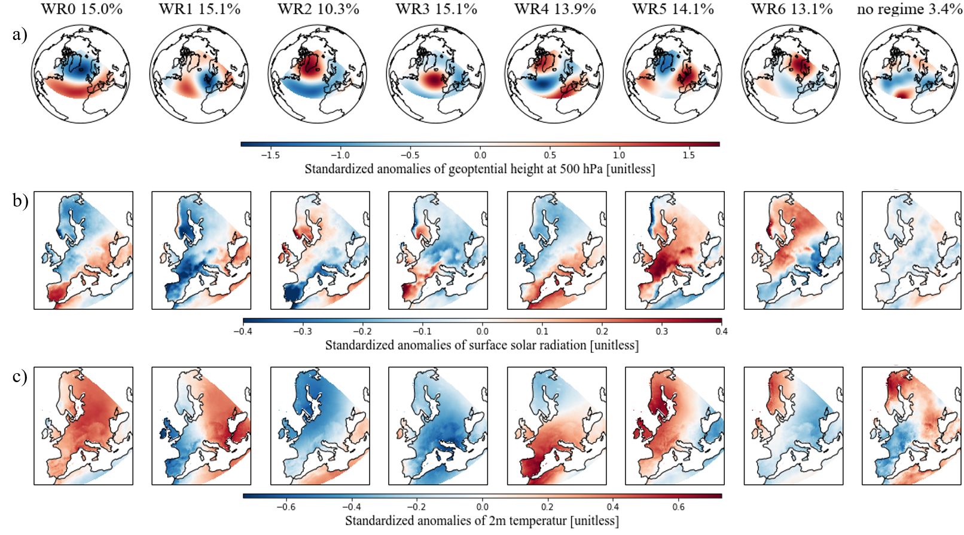

Figure 4: Standardized anomalies of geopotential height at 500 hPa, surface solar radiation and temperature

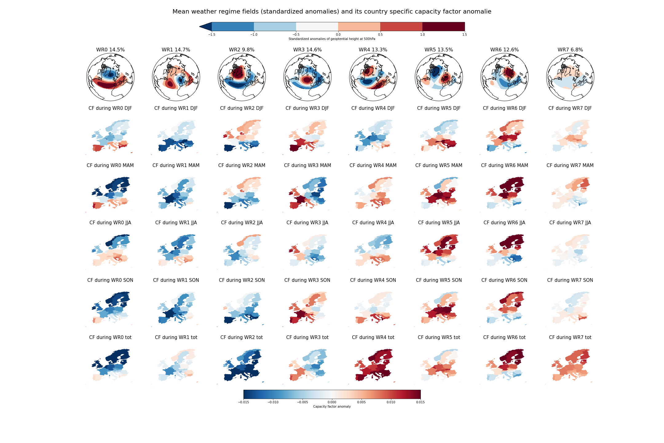

The first row of Figure XY shows again the seven weather regimes plus no regimes. Beneath the weather regimes, in the same column, the corresponding country specific capacity factor anomalies can be found Whereas the different season are separated from winter (DJF second row), to spring (MAM), to summer (JJA), to autumn (SON). The anomalies are calculated as difference to the seasonal mean.

Figure 5 shows the derived seven weather regime and the separately defined no regime. The relation between the weather regime number and the ordinary names, which are often used in literature, can be found in table XY. Weather regime 0, 2, 3 and 6 which are known as the positive and negative phase of the North Atlantic Oscillation (NAO), the Atlantic ridge and the Scansdinavian blocking are the typical weather regimes which are found in many studies that focus on wintertime weather regime classification (CASSOU, VAUTARD EVTL MEHR ANGEBEN). And in line with that the seasonal frequency (FIG XY) of theses weather regimes shows us that they occur more in winter than in the other seasons (nicht 100% NOAs schon aber andere nicht so).

Weather regime 1 and 4 are more difficult to assign wo well known weather regime. Weather regime 1 a mostly similar to the Scandinavian blocking also fined by GRAMS. But the low pressure field located a bit more southwar over the western coast of Europe. Weather regime 4 is most likely comparable with the Atlantic through. But one can clearly identify an high pressure filed in the Southern par of Europe which would be more typical fo a blocking situation. Finally, weather regime 5 is the European blocking situation which is often associated with warmen than seasonal average temperature over central Europe

Weather regime 5 is characterized by a blocking high pressure field like weather regime 5.

EVTL. Generally high surface solar radioation positive geopotenatil height anomaly and visverca.

### Weather regime 0 / NOA+

WR0, the positive phase of the NOA, shows a negative geopotential height anomaly over the Northern part of the Atlantic and a positive geopotential height anomaly over the Atlantic/Mediterranean sector (**Fehler! Verweisquelle konnte nicht gefunden werden.**). During this conditions, the Atlantic storm tracks are displaced north-eastward, and the zonal flow is enhanced. This increases the strength of the westerlies and brings maritime air (warm and moist) to central and northern Europe (ROGERS 1997, HURRELL 2003, Buch Wallace). Consequently, the storm track activity over Northern Europe is enhanced, which implies a larger cloud clover fraction and therefore less available surface solar radiation. Studies by Pozo-Vázquez *et al.* (2004; 2011) indeed have shown that that the NOA index is negatively correlated with the solar irradiance in Northern Europe and positively correlated with solar irradiance in southern Europe. Our results agree with the studies mentioned above with negative surface solar radiation anomalies in Northern Europe, positive surface solar radiation in Southern Europe and positive temperature anomalies all over Europe during weather regime 0 (first column in **Fehler! Verweisquelle konnte nicht gefunden werden.**, row b) and c)).

🡪 disupted by Colantuono 2014 and francois 2016 🡪 nachlesen!

The capacity factor anomalies during the positive phase of the NOA exhibit a clear North to South discrepancy. Northern Europe shows negative CF anomalies whereas Southern Europe is dominated by positive CF anomalies. This is in line with the surface solar radiation and temperature anomalies described above but its limpidity changes throughout the season. I.e., in spring (MAM) the results show a strong and clear difference between Southern and Northern Europe. But in autumn (SON) only the Iberian Peninsula and a few Countries in South-eastern Europe exhibit positive CF anomalies.

### WR1 - European trough

WR1, the European through, is characterized by a meridional dipole of a positive and negative geopotential height anomaly in the Atlantic and Western Europe, respectively. South-eastern Europe shows enhanced surface solar radiation anomalies and higher temperature. Whereas Western Europe shows lower temperature and surface solar radiation values than normal expect the Northern part of the British Isles and the Western coast of Norway.

The CF anomalies during the European trough are mostly negative. Especially in winter where Southern and South-eastern Europe exhibit a larger negative impact than Northern Europe. Interestingly, this weakens in spring even turns to positive CF anomalies in summer which is more in line with our surface solar radiation anomalies for the whole year.

### WR2 – NOA-

WR2, the negative phase of the NOA, exhibits contrary geopotential height anomaly fields than the positive phase of the NOA. It is characterized by a negative geopotential height anomaly over the Atlantic/Mediterranean sector and positive geopotential height anomaly over Greenland. This also yields in reversed surface weather variables than the positive phase of the NOA. More available surface solar radiation than the climatological average in Northern Europe and lower surface solar radiation in Southern Europe. The temperature anomalies are negative all over Europe.

The contrary pattern to the positive NOA is also reflected in the CF anomalies with positive CF anomalies in Northern Europe and negative CF anomalies in the South. But we can see here as well that this discrepancy between North and South is clear in winter and spring but weakens in summer and autumn where more negative CF anomalies are present in Northern regions.

### WR3 - Atlantic ridge

WR3, the Atlantic ridge, exhibits a strong positive geopotential height anomaly over the Atlantic. Enhanced surface solar radiation anomalies can be seen in Western Europe, mainly over the Iberian Peninsula. and over the Southern Scandinavia. Negative surface solar radiation occurs over Eastern Europe. The temperature anomalies show negative values all over Europe expect the Western coast of Iberian Peninsula and the British Isles.

According to Wiel et al the impact of the Atlantic ridge on 2m temperature and wind are close to normal and therefore have a small impact on the energy sector. Nevertheless, his results also showed that the surface solar radiation over the Iberian Peninsula is higher than on average and over north-eastern Europe the surface solar radiation is slightly reduced.

The East-West gradient is also visible in the CF anomalies. With positive anomalies in the West and negative anomalies in the East. But the seasonal differences are substantial. In spring one can observe a strong East-West gradient. In winter and autumn one can still see a discrepancy between East and West but the anomalies are weaker and more positive. The opposite is the case for summer where one can see more but weaker negative anomalies but still with an East-West gradient.

### WR4 - Atlantic trough

WR4, the Atlantic, trough, shows a meridional dipole pattern of the geopotential height anomaly reversed to WR1. The negative anomaly is located over the Atlantic and the positive anomaly is located over South-eastern Europe. It can be best compared with the Atlantic trough weather regime (i.e. GRAMS) but the positive geopotential height anomaly over South-eastern Europe does not fit well to this association. WR4 exhibits greatly increased temperature anomalies over Southern and Central Europe and slightly negative temperature anomalies over Scandinavia. The surface solar radiation anomalies show a clear gradient from South-Eastern to North-Western Europe. Positive values are located over the Mediterranean region and negative values anomalies over Scandinavia and British Isles.

The CF anomalies of the countries in the Mediterranean region are alike to the surface solar radiation anomalies and show mostly slightly positive values. In Northern Europe, the difference between the season is more pronounced. In winter and summer, they are negative but in autumn and especially in spring more Northern countries exhibits positive CF anomalies.

### WR5 - European blocking

WR5, the European blocking, shows a positive geopotential height anomaly over central Europe. This is associated with descending air which brings clear skies over central Europe and therefore enhanced surface solar radiation anomalies can be observed in Figure 5b, WR5. Only in the Scandinavian region and in Eastern Spain it is less pronounce or even negative. The temperature is also enhanced especially in North-Western Europe which is the region where the Anticyclone brings warm air from the South northwards.

With the clear sky and warm temperature, the CF are also higher than normal. Greatly increased CF anomalies can be observed especially in central Europe. In winter the CF anomalies are only negative for Scandinavia and the British Isles. Towards summer these changes to positive CF anomalies whereas Southern countries exhibits negative CF anomalies.

### WR6 - Scandinavian blocking

Like the European blocking the positive geopotential height anomaly over Scandinavia leads to descending air, which results in clear sky and therefore enhanced surface solar radiation (Figure 5b, WR6). Since the geopotential height anomaly is now located more to the North, Southern countries exhibit less surface solar radiation than normal. The positive temperature anomalies have now also slightly moved Northwards to the Scandinavian region, whereas an negative temperature anomaly can be seen in South-East Europe.

The CF anomalies behave similarly and show greatly increased values over Northern Europe throughout the whole year whereas the CF anomalies in Southern Europe are lower than normal.

No regime!!!???

* Again maybe generally low CF with low gopotential height ano and vice versa

## Current and planned situation (2030)

To meet the EU’s energy and climate targets for 2030, EU Member States need to establish a 10-year integrated national energy and climate plan (NECP) for the period from 2021 to 2030. I

2030 data 🡪 IRENA 🡪 plus missing countries!!?? 🡪 CH, UK

CF pro land vergleichen --> Doris Ide --> wie viel PV brauche ich für gleiche proiduktion in zb sweden than greece

CF pro land vergleichen --> Doris Ide --> wie viel PV brauche ich für gleiche proiduktion in zb sweden than greece

## Scenarios for IC distribution

### S1

* + Einzelne ländern nullen

# Conclusion

# Appendix

# References

Branch, M. A., Coleman, T. F. and Li, Y. (1999) ‘Subspace, interior, and conjugate gradient method for large-scale bound-constrained minimization problems’, *SIAM Journal of Scientific Computing*, 21(1), pp. 1–23. doi: 10.1137/S1064827595289108.

Cassou, C. (2008) ‘Intraseasonal interaction between the Madden-Julian Oscillation and the North Atlantic Oscillation’, *Nature*, 455(7212), pp. 523–527. doi: 10.1038/nature07286.

Dawson, A. (2016) ‘eofs: A Library for EOF Analysis of Meteorological, Oceanographic, and Climate Data’, *Journal of Open Research Software*, 4, pp. 4–7. doi: 10.5334/jors.122.

Delucchi, M. A. and Jacobson, M. Z. (2011) ‘Providing all global energy with wind, water, and solar power, Part II: Reliability, system and transmission costs, and policies’, *Energy Policy*. Elsevier, 39(3), pp. 1170–1190. doi: 10.1016/j.enpol.2010.11.045.

Graabak, I. and Korpås, M. (2016) ‘Variability Characteristics of European Wind and Solar Power Resources—A Review’, *Energies*, 9(6), pp. 1–31. doi: 10.3390/en9060449.

Grams, C. M., Beerli, R., Pfenninger, S., Staffell, I. and Wernli, H. (2017) ‘Balancing Europe’s wind-power output through spatial deployment informed by weather regimes’, *Nature Climate Change*, 7(8), pp. 557–562. doi: 10.1038/NCLIMATE3338.

Heide, D., von Bremen, L., Greiner, M., Hoffmann, C., Speckmann, M. and Bofinger, S. (2010) ‘Seasonal optimal mix of wind and solar power in a future, highly renewable Europe’, *Renewable Energy*, 35(11), pp. 2483–2489. doi: 10.1016/j.renene.2010.03.012.

Hennermann, K. and Yang, X. (2018) *ERA5 data documentation*, *European Centre for Medium-Range Weather Forecasts*. Available at: https://confluence.ecmwf.int/display/CKB/ERA5+data+documentation (Accessed: 22 April 2020).

Huld, T., Gottschalg, R., Beyer, H. G. and Topič, M. (2010) ‘Mapping the performance of PV modules, effects of module type and data averaging’, *Solar Energy*, 84(2), pp. 324–338. doi: 10.1016/j.solener.2009.12.002.

Hulme, M. (2016) ‘1.5 °C and climate research after the Paris Agreement’, *Nature Climate Change*. Nature Publishing Group, 6(3), pp. 222–224. doi: 10.1038/nclimate2939.

IRENA (2020a) *Global Renewables Outlook: Energy transformation 2050*, *International Renewable Energy Agency*. Available at: https://www.irena.org/publications/2020/Apr/Global-Renewables-Outlook-2020.

IRENA (2020b) *Renewable capacity statistics 2020 International Renewable Energy Agency (IRENA)*. Abu Dhabi.

Jäger-Waldau, A. (2019) *PV Status Report 2019*, *EUR 29938 EN, Publications Office of the European Union*. Luxembourg. doi: 10.2760/326629.

Lauret, P., Boland, J. and Ridley, B. (2013) ‘Bayesian statistical analysis applied to solar radiation modelling’, *Renewable Energy*, 49, pp. 124–127. doi: 10.1016/j.renene.2012.01.049.

Michelangeli, P. A., Vautard, R. and Legras, B. (1995) ‘Weather regimes: recurrence and quasi stationarity’, *Journal of the Atmospheric Sciences*, pp. 1237–1256. doi: 10.1175/1520-0469(1995)052<1237:WRRAQS>2.0.CO;2.

Mills, A. and Wiser, R. (2010) *Implications of Wide-Area Geographic Diversity for Short- Term Variability of Solar Power*, *Energy*. Berkeley, CA (United States). doi: 10.2172/986925.

Pedregosa, F., Varoquaux, G., Gramfort, A., Michel, V., Thirion, B., Grisel, O., Blondel, M., Prettenhofer, P., Weiss, R., Dubourg, V., Vanderplas, J., Passos, A., Cournapeau, D., Brucher, M., Perrot, M. and Duchesnay, E. (2011) ‘Scikit-learn: Machine Learning in {P}ython’, *Journal of Machine Learning Research*, 12, pp. 2825–2830.

Pfenninger, S. and Staffell, I. (2016) ‘Long-term patterns of European PV output using 30 years of validated hourly reanalysis and satellite data’, *Energy*, 114, pp. 1251–1265. doi: 10.1016/j.energy.2016.08.060.

Pozo-Vazquez, D., Santos-Alamillos, F. J., Lara-Fanego, V., Ruiz-Arias, J. A. and Tovar-Pescador, J. (2011) *Hydrological, Socioeconomic and Ecological Impacts of the North Atlantic Oscillation in the Mediterranean Region*, *Hydrological, Socioeconomic and Ecological Impacts of the North Atlantic Oscillation in the Mediterranean Region*. doi: 10.1007/978-94-007-1372-7.

Pozo-Vázquez, D., Tovar-Pescador, J., Gámiz-Fortis, S. R., Esteban-Parra, M. J. and Castro-Díez, Y. (2004) ‘NAO and solar radiation variability in the European North Atlantic region’, *Geophysical Research Letters*, 31(5), p. n/a-n/a. doi: 10.1029/2003gl018502.

Ram, M., Bogdanov, D., Aghahosseini, A., Oyewo, S., Gulagi, A., Child, M. and Breyer, C. (2017) ‘Global Energy System based on 100% Renewable Energy – Power Sector’, *LUT Scientific and Expertise Publications : Raportit ja selvitykset - Reports*.

Ram, M., Bogdanov, D., Aghahosseini, A., Oyewo, A., Gulagi, A., Child, M. and Fell, H.-J. (2019) ‘Global Energy System based on 100% Renewable Energy – Power, Heat, Transport and Desalination Sectors’, *Study by Lappeenranta University of Technology and Energy Watch Group*. Berlin, 1(March), pp. 1–321.

Ridley, B., Boland, J. and Lauret, P. (2010) ‘Modelling of diffuse solar fraction with multiple predictors’, *Renewable Energy*, 35(2), pp. 478–483. doi: 10.1016/j.renene.2009.07.018.

Santos-Alamillos, F. J., Pozo-Vázquez, D., Ruiz-Arias, J. A., Von Bremen, L. and Tovar-Pescador, J. (2015) ‘Combining wind farms with concentrating solar plants to provide stable renewable power’, *Renewable Energy*, 76(2015), pp. 539–550. doi: 10.1016/j.renene.2014.11.055.

Stram, B. N. (2016) ‘Key challenges to expanding renewable energy’, *Energy Policy*, 96, pp. 728–734. doi: 10.1016/j.enpol.2016.05.034.

Sweerts, B., Pfenninger, S., Yang, S., Folini, D., van der Zwaan, B. and Wild, M. (2019) ‘Estimation of losses in solar energy production from air pollution in China since 1960 using surface radiation data’, *Nature Energy*, 4(8), pp. 657–663. doi: 10.1038/s41560-019-0412-4.

Van Der Wiel, K., Bloomfield, H. C., Lee, R. W., Stoop, L. P., Blackport, R., Screen, J. A. and Selten, F. M. (2019) ‘The influence of weather regimes on European renewable energy production and demand’, *Environmental Research Letters*, 14(9). doi: 10.1088/1748-9326/ab38d3.

Wild, M., Folini, D., Henschel, F., Fischer, N. and Müller, B. (2015) ‘Projections of long-term changes in solar radiation based on CMIP5 climate models and their influence on energy yields of photovoltaic systems’, *Solar Energy*, 116, pp. 12–24. doi: 10.1016/j.solener.2015.03.039.

Comments/Notes

**Solarpowereurope** 🡪

In 2050, solar PV alone has installed capacities between 4.7 TW in the Laggard scenario, 7.7 TW in the Moderate scenario and 8.8 TW in the Leadership scenario.

**IRNEA**

* + Solar PV could cover a quarter of global electricity needs by mid-century, becoming the second largest generation source after wind.
  + Global capacity must reach 18 times current levels, or more than 8 000 gigawatts by 2050.
  + Asia would continue to dominate solar PV use, with over 50% of installed capacity, followed by North America (20%) and Europe (10%).
  + 8000gigawatts*0.1 = 800gigawatts 🡪 in excel from IRENA 891

**Large-scale integration of renewable energies and impact on storage demand in a European renewable power system of 2050**

The results for the base scenario show a total installed generation capacity of 4,550 GW, which splits up into PV and WT in a ratio of 60:40 on global scale for the EUMENA regions. 🡪 2730GW

**Zappa**

603-926GW je nach Szenario 🡪 Is a 100% renewable European power system feasible by 2050?

**Ec.europe.eu**

According to a recent 100% RES scenario of the Energy Watch Group, the EU needs to increase its PV capacity from 117 GW to over 630 GW by 2025 and 1.94 TW by 2050 in order to cover 100% of its electricity needs by renewable energy.

This is approximately half of the estimates (1.95TW) by Ram et al. (2017) whose study highlights the feasibility and the socio-economic viability of a transition to a 100% renewable electricity generation electricity system. 🡪 SCHNITT WIRD GEBRAUCHT???