Creative, More Creative, Most Creative
Dirk Engel, info@engel-internet.de, July 20, 2023
https://github.com/dirkengel/

Introduction
In this article, I want to analyze the characteristics of creativity in a SW engineerish way. Are there any prerequisites for achieving creativity and which creative processes can be distinguished? And finally, is AI creativity comparable to human creativity?

Disclaimer
This is not a research paper. The presented model as well as the discussion are my conclusions after pondering over the topic for a while, occasionally backed by some Wikipedia research. That is to say, I have not tracked down the references to the original sources. On the one hand, this kind of sloppiness can lead to a lack of background information, on the other hand, it leaves more room for own creativity (see Discussion).

Model
Fig. 1 shows the graphical representation of my creativity model, which is explained in the following:
- Creativity comes from inspiration, which can be triggered by a fresh impression or new (unconscious) thoughts on old knowledge, or both. Inspiration can be boosted or blocked by intrinsic and extrinsic factors. An impression can be a feeling or an input that is captured by our senses.
- Knowledge is the superset of all available ideas and their implementations. The core of ideas is the set of ideas that cannot be reduced to each other. In contrast, all non-core ideas can be reduced to combinations of the core ideas. This conception is inspired by the computational complexity theory and the notion of complexity classes. Consequently, this is apparently a reused idea and therefore not a core idea.
- When creativity arises as a result of inspiration, it produces an outcome in one of four possible categories; Otherwise, if nothing was created, it wasn't creativity:
  - Innovative: Some definitions focus on the implementation of ideas when it comes to innovation [Creativity]. In this model, the decisive factor for classifying an idea as innovative is the fact that it is based on an earlier idea. However, it does not matter if this earlier idea is implemented or combined/composed with other ideas, or if another idea is derived from it. I consider this category to be the most common result. Referring to the Four-C Model, it is in the little-c to Pro-C range [Creativity, Kreativität].
  - Inventive: It is like being innovative, but in a more complex or valuable way. However, the starting point is still existing core ideas that are combined, refined or further developed. The outcome is not in the category of a new physical theory, but something in the Pro-C to Big-C range.
  - Visionary: That is a real Big-C, something complex that helps to understand the world. Such a big thing is usually not based on a single new idea but is based on several ideas that have been developed over a period of. However, perhaps the theory has a central idea that got the ball rolling.
  - Brilliant: This represents such a central, fundamental, or disruptive idea. It could enable something completely new and lay the foundation for something great. Maybe not immediately but looking back from the future.
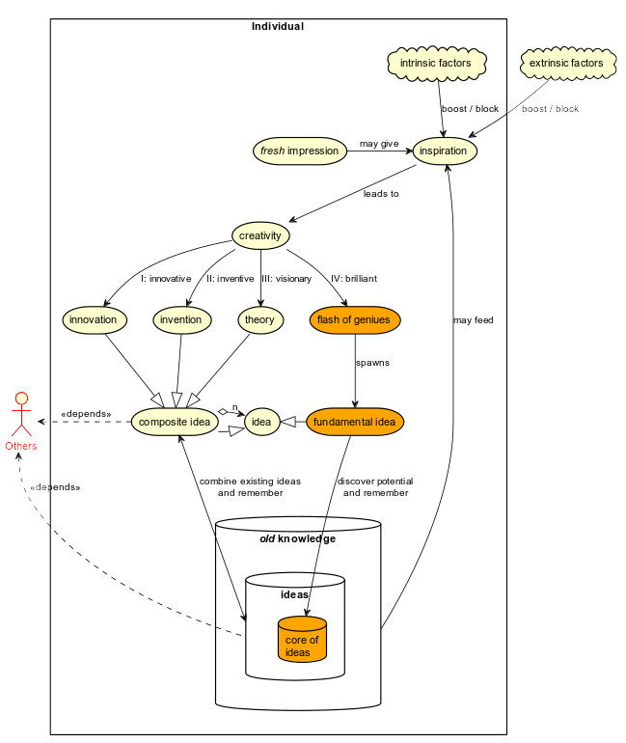Fig. 1: Diagram of the creativity model.
- Whether it is a basic or composite idea, to be become a permanent and influential factor and not just a fleeting thought you have to:
  - Discover the potential of the idea.
  - Remember it.
- The individual must be distinguished from the others. To assess the level of creativity and the resulting impact of the idea on society, the initial amount of available old knowledge is important.

Discussion
If the container of ideas and core ideas was not initialized by some other, earlier intelligence, it must have been empty at the beginning of mankind. This also means that people can develop ideas out of nothing, i.e., purely from fresh impressions.
Now assuming that the knowledge database was empty in the beginning, one can also speculate about the very first fundamental idea that made it into the knowledge database: In order to recognize and store good ideas, it is necessary to know what is important. So, you must at least have an idea of how to decide. As far as I know, AI systems are usually given a specific reinforcement strategy. Leaving it open can lead to unwanted and potentially threatening results.
It is crucial to recognize the potential of an idea and to remember it. For example, it is worth nothing if you proved P = NP in a dream but cannot remember it the next day. Remembering is certainly not a problem that an AI struggles with, but what about recognition?
Ideas are worth less if you do not share them. Each shared piece can become part of a larger new theory developed by someone else. Sharing ideas also reduces the likelihood of ideas being lost, it is like committing them to a distributed version control system.
A larger theory is based on many ideas. It will take time to complete and likely there will be a phase where the whole development process gets stuck as some parts cannot be immediately evaluated, verified, or proven due to lack of data. In these situations, it seems important to believe and trust in the overall idea and pursue it over time until the missing pieces are available. Is it possible for an AI to drop a promising idea because there are still too many uncertain aspects, and the reward function therefore yields poor values?
If new impressions and old knowledge can lead to inspiration and stimulate creativity, the right balance of both could be the key. At first glance it seems to be easier to come up with new ideas when the knowledge is almost empty, i.e., in the past it would have been easier for individuals to be creative. Too much old knowledge about what is possible and what is not could limit the space for new contributions and perspectives. So, will the number of newly found ideas decrease as more ideas are found?
Otherwise, it could be quite difficult for an individual to create something from nothing, as a solid education is usually seen as a good foundation for future creativity. So which of the two people can be considered more creative: The individual with little or no knowledge, or the individual with a lot of knowledge? This in turn raises the question of how creativity can be measured and compared without a common reference point.
When it comes to AI, will access to almost unlimited knowledge be a boon or bane to creativity? What kind of knowledge facilitates creativity more: Knowing a little about everything or having deep knowledge about something? However, much but one-sided education and culture can lead to less creativity, and biased training sets are already a well-known problem of AI systems.
Impression can be misinterpreted and human memories fade or are automatically/ unconsciously adjusted to personal thinking over time. An AI like ChatGPT does not suffer from such human shortcomings, even if its patterns obtained from training are not always trustworthy, since data can overlap and influence each other. But what if the human imperfection is the decisive factor for a new idea? Think of the little errors called mutations that made all of evolution possible. So, the questions remains whether artificially randomized or blurred data could lead to similar effects.
Assessing creativity is a matter of perspective. What seems creative to one may be irrelevant to another individual. However, an individual's creative output can only achieve a Big-C when it is relevant to others, an isolated individual can only produce Little-Cs.
In contrast, an isolated individual may, force to do so, show more creativity than as a part of broader society. On the one hand, when this kind of creativity that the individual can produce is already part of the old knowledge and is therefore no longer considered particularly creative. On the other hand, one's creativity might be inhibited by social loafing.
In general, the others seem to have a great influence on the knowledge base and thus on the creative process of the individual. The early others, let's call them families, provide the first ideas like the reward function, and the later others, let's call them society, are the source of ideas on which to build one's creativity.
Extrinsic and intrinsic factors such as pressure and emotions can keep individuals from being creative. But just as these factors can hamper or block creativity, they can also encourage creativity. Neither has any effect on an AI system.
Finally, can mimicking the human creative process lead only to recombinations and derivative creativity, or also to something entirely new?

Conclusion
The Model and Discussion sections are based on a thought experiment only and raise more questions than answers. However, some of the questions did not come to mind until I started designing the model. And although it is already obvious that an AI can be innovative and inventive, I am still not convinced that an AI can generate a new complex theory and fundamental new ideas.
Anyway, conducting this small thought experiment and writing this paper was at least a little-c creative work for me as an individual but of course I have no idea whether there is any key takeaway for you as one of the others.

References
Creativity | https://en.wikipedia.org/wiki/Creativity, last access 2023-07-16.
Kreativität | https://de.wikipedia.org/wiki/Kreativität, last access 2023-07-16.

