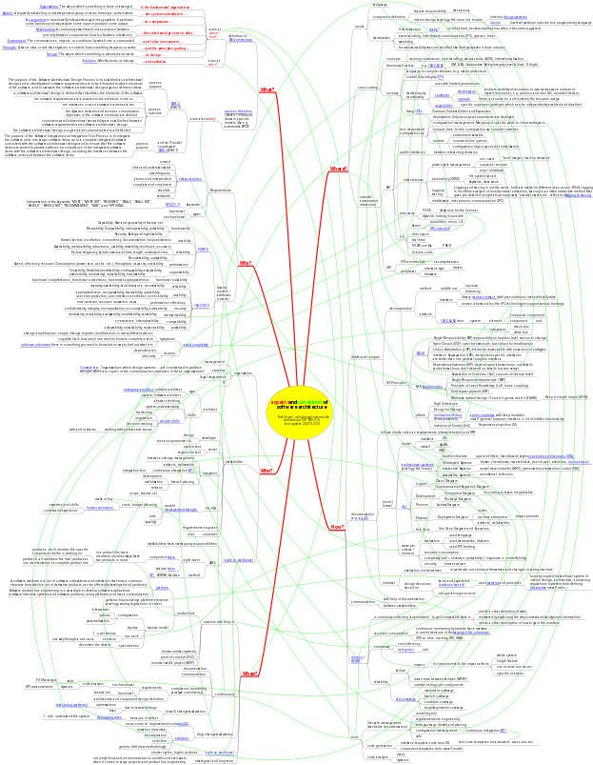
Aspects and correlations of (embedded) software architecture in a mind map
Dirk Engel, info@engel-internet.de – first version 2019/01/26, last update 2021/12/25

Bibliography – General
O. Vogel et al., “Software-Architektur / Grundlagen – Konzepte – Praxis”, Spektrum Akademischer Verlag, 2005, ISBN 3-8274-1534-9
Mahbouba Gharbi et al., “Basiswissen für Softwarearchitekten”, dpunkt.Verlag GmbH, 2018, ISBN 978-3-86490-499-8
Bibliography – Mind Map Links
4+1 | https://www.cs.ubc.ca/~gregor/teaching/papers/4+1view-architecture.pdf (2019/01/14)
agile vs. traditional | https://agilemanifesto.org/ (2019/01/14)
aim42 | https://www.aim42.org/using (2019/01/26)
arc42 | https://arc42.org/ (2021/11/27)
architectural patterns | Frank Buschmann et al., “Pattern-Oriented Software Architecture / A System of Patterns”, John Wiley & Sons, Ltd, 1996, ISBN 978-0-471-95869-7
ATAM | https://resources.sei.cmu.edu/library/asset-view.cfm?assetid=5177 (2021/12/18)
avoid complexity | John Ousterhout, “A Philosophy of Software Design”, Yaknyam, 2018, ISBN 978-1-7321022-0-0
capabilities | http://man7.org/linux/man-pages/man7/capabilities.7.html (2019/01/14)
categories | Johannes Siedersleben, “Moderne Softwarearchitektur”, dpunkt.verlag GmbH, 2004, ISBN 3-89864-292-5
CFI | https://source.android.com/devices/tech/debug/cfi (2019/01/14)
cgroups | https://en.wikipedia.org/wiki/Cgroups (2019/01/14)
characteristics | http://www.informit.com/articles/article.aspx?p=1152528&seqNum=4 (2019/01/14)
component | https://www.techopedia.com/definition/3217/component (2019/01/07)
concentric architectures | https://blog.cleancoder.com/uncle-bob/2012/08/13/the-clean-architecture.html (2020/12/26)
container | https://jvns.ca/blog/2016/10/10/what-even-is-a-container/ (2019/01/15)
Conway's law | https://en.wikipedia.org/wiki/Conway%27s_law (2019/01/14)
CVEs | https://cve.mitre.org/ (2019/01/04)
debugging rules | David J. Agans, “Debugging”, AMACOM, 2002, ISBN 0-8144-7168-4
design | https://dictionary.cambridge.org/de/worterbuch/englisch/design (2019/01/07)
design patterns | Erich Gamma et al., “Design Patterns / Elements of Reusable Object-Oriented Software”, Addison-Wesley, 1994, ISBN 0-201-63361-2
enterprise architect | Wolfgang Goebl et al., “Enterprise Design Patterns / 35 Ways to Radically Increase Your Impact on the Enterprise”, Intersection Group, 2020.
environment | https://www.merriam-webster.com/dictionary/environment (2019/01/07)
evidence-based | http://www.knosof.co.uk/ESEUR/ESEUR-mobile.pdf (version 1.0 from 2020/11/08)
evolution | http://nectunt.bifi.es/to-learn-more-overview/mechanisms-of-evolutionary-change/ (2019/01/14)
FURPS | https://en.wikipedia.org/wiki/FURPS (2019/01/14)
GPL infected | https://yarchive.net/comp/linux/gpl_modules.html (2019/01/14)
human resources | https://github.com/dirkengel/articles/blob/main/FTEbasedPlanning.pdf (2018/10/11)
idioms | https://www.oreilly.com/library/view/pattern-oriented-software-architecture/9781118725269/OEBPS/9781118725269_c04.htm (2019/01/14)
Information Hiding | https://en.wikipedia.org/wiki/Information_hiding (2019/01/14)
IODA | https://leanpub.com/ioda-architektur-im-vergleich-dnp (2020/12/15)
ISO-25010 | https://iso25000.com/index.php/en/iso-25000-standards/iso-25010 (2019/01/14)
ISO-26262 | https://www.iso.org/standard/43464.html (2019/01/14)
organization | https://dictionary.cambridge.org/de/worterbuch/englisch/organization (2019/01/07)
obstructive | Stefan Toth, “Wie Architektur agile Zusammenarbeit fördert oder behindert”, OBJEKTspektrum 01/2018
patterns | Christopher Alexander et al., "A Pattern Language: Towns, Buildings, Construction", Oxford University Press, 1977, ISBN 0-19-501919-9
people skills | https://www.oreilly.com/ideas/4-essential-skills-software-architects-need-to-have-but-often-dont (2019/01/04)
platform | Klaus Pohl et al.,“Software Product Line Engineering”, Springer, 2005, ISBN 978-3540243724
principle | https://dictionary.cambridge.org/dictionary/english/principle (2019/01/07)
process definition | https://en.wikipedia.org/wiki/ISO/IEC_15504 (2019/01/14)
key principles | https://docs.microsoft.com/en-us/previous-versions/msp-n-p/ee658124(v=pandp.10)#KeyDesignPrinciples (2021/11/12)
leaky | https://www.joelonsoftware.com/2002/11/11/the-law-of-leaky-abstractions/ (2021/11/12)
logging vs. tracing | https://en.wikipedia.org/wiki/Tracing_(software)#Event_logging_versus_tracing (2019/01/08)
management triangle | https://github.com/dirkengel/articles/blob/main/QualityAndTheProjectManagementTriangle.pdf (2021/10/24)
metrics tracking | https://github.com/dirkengel/articles/blob/main/TheOzoneHoleMetric.pdf (2021/10/24)  https://www.thoughtworks.com/insights/articles/fitness-function-driven-development (2021/10/24)
namespace | http://man7.org/linux/man-pages/man7/namespaces.7.html (2019/01/15)
narrow contract | http://www.open-std.org/jtc1/sc22/wg21/docs/papers/2019/p1743r0.pdf (2021/12/03)
microservices | Mark Richards, “Software Architecture Patterns”, O'Reilly Media, Inc., 2015, ISBN 9781491924242
refactoring (patterns) | Martin Fowler, “Refactoring”, Addison-Wesley, 1999, ISBN 0-201-48567-2
relationship | https://www.collinsdictionary.com/de/worterbuch/englisch/relationship (2019/01/07)
RFC2119 | https://www.ietf.org/rfc/rfc2119.txt (2019/01/14)
SOLID | https://en.wikipedia.org/wiki/SOLID (2019/01/14)
SW architecture | http://www.iso-architecture.org/ieee-1471/defining-architecture.html (2019/01/14)
SWE.2 | https://flecsim.de/images/download/AutomotiveSpice/Automotive%20Spice%203.0/SWE.2.html (2019/01/14)
SWE.5 | https://flecsim.de/images/download/AutomotiveSpice/Automotive%20Spice%203.0/SWE.5.html (2019/01/14)
system | https://www.merriam-webster.com/dictionary/system (2019/01/07)
team | Thorsten Janning, “Scaling Agility: Wie führt man 100 agile Teams?” OBJEKTspektrum, Ausgabe Agility/2014
test coverage | Peter Liggesmeyer, “Sofware-Qualität”, Spektrum Akad. Verlag 2002, ISBN 3-8274-1118-1
tragedy of the commons | https://en.wikipedia.org/wiki/Tragedy_of_the_commons (2020/12/26)
unknown unknowns | The Five Orders of Ignorance: http://www.corvusintl.com/CACM002-5OI.htm (2021/10/24)
XP | Kent Beck, “Extreme Programming Explained”, Addison-Wesley, 2000, ISBN 0-201-61641-6

