Machine Learning Engineer Nanodegree

House Prices: Advanced Regression Techniques
Dirk Honda
March 9th 2018

Project Overview
For most individuals, home ownership is the largest and most important financial decision they will make. With approximately 64% of Americans owning a home [1] determining the fair market value of a home is critical. Historically, the value of homes has been predicated on the sale of homes in the area with similar features (e.g., beds, baths, living square footage). This approach is susceptible to outliers and variances that could skew the value of homes. The Kaggle competition, House Prices: Advanced Regression Techniques provides a dataset to which feature engineering, feature selection, and machine learning techniques can be applied to gain intuition and develop a model capable of producing future fair market values with greater accuracy. With over 12 years of residential real estate software experience, most dealing with this type of data, I have always been fascinated with the pricing of real estate. It is my intention to gain more real-world experience with the analysis of datasets, specifically those in real estate, as this will be invaluable to future employers.
Zillow, Inc. a leader in real estate analytics, has demonstrated that modeling with machine learning techniques can successfully be applied to the real estate domain. Zillow's Chief Analytics Officer, Stan Humphries outlined the approach and metrics in an article written at the end of July of 2017 [2]. The article states, "...2006 when we launched, we were at about 14% median absolute percent error on ... homes [prices]." Mr. Humphries is quoted as saying,"So maybe it's a decision tree, thinking about it from what you may call a 'hedonic' or housing characteristics approach, or maybe it's a support vector machine looking at prior sale prices." when speaking about the types of machine learning algorithms used to predict home prices.

Problem Statement
As stated in the project overview, house prices are generally modeled on recently sold comparable homes (sales comps). This approach is based on the opinions and experience of brokers and Realtors. As such it is susceptible to fluctuations, outliers, and human bias. By applying machine learning algorithms, a more robust and accurate regression model can be developed which can be evaluated by making sale price predictions on data prior to sale and then comparing them to their respective future purchase price.

Metrics
The objective of this Kaggle competition is to predict the sales price for each house in the dataset and submit the results for evaluation on the Kaggle site. Submissions are evaluated on Root-Mean-Squared-Error (RMSE) between the logarithm of the predicted value and the logarithm of the observed sales price. (Taking logs means that errors in predicting expensive houses and cheap houses will affect the result equally.)[3]
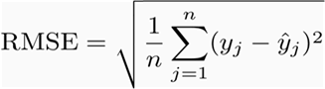

Data Exploration
The housing dataset includes four files for use in the challenge: train.csv, test.csv, data_description.txt, and sample_submission.csv [4]. The train.csv contains a mixture of categorical and numerical data features for training models comprised of 1,460 data points and 81 features.
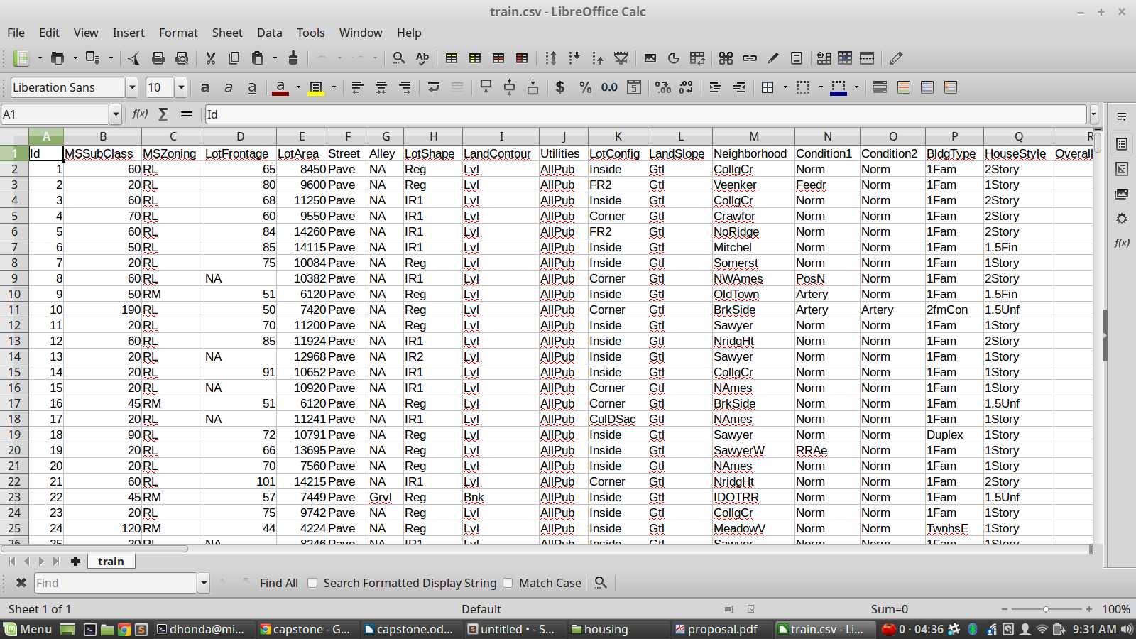
Figure 1: Data from the train.csv file

The test.csv, which will be used to evaluate how well we have modeled the data, has the same structure as train.csv. The SalePrice is removed and applied only after submission of the predicted Sale Price is uploaded to the Kaggle website.
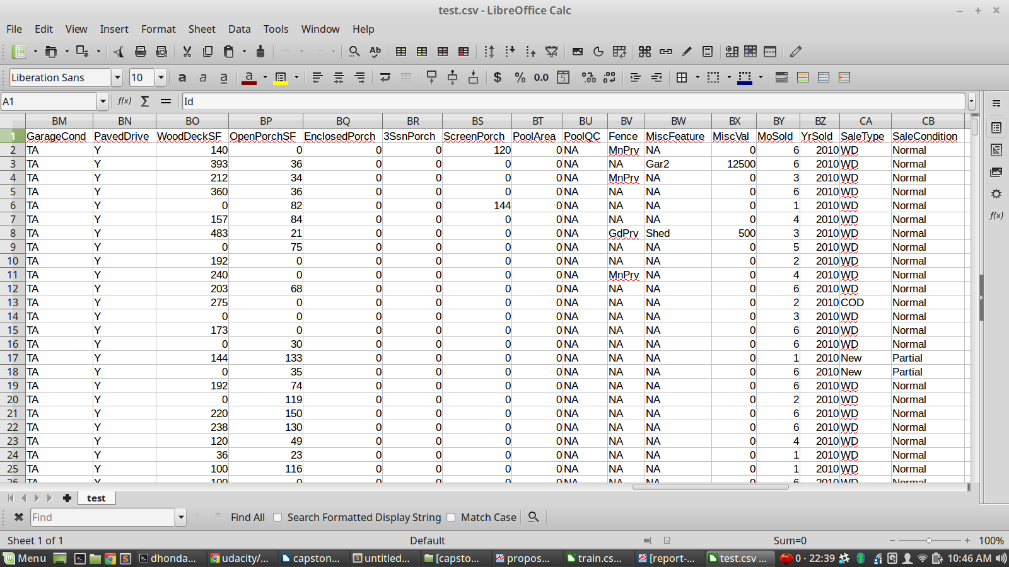
Figure 2: Data from the test.csv file
An additional document, data_description.txt, is a full description of each column, originally prepared by Dean De Cock but lightly edited to match the column names used here.
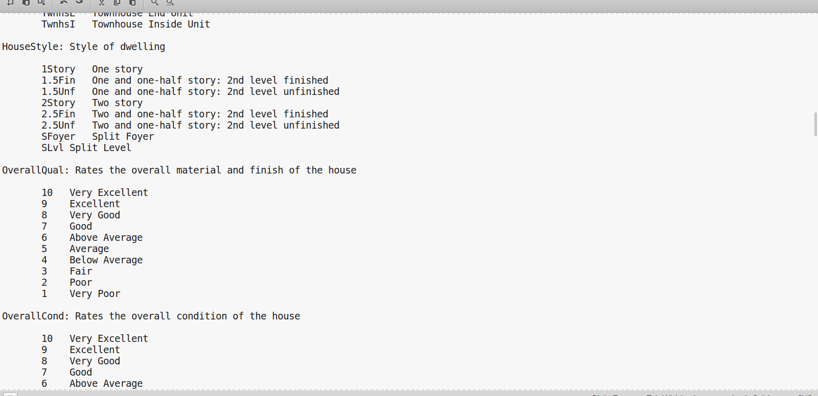
Figure 3: Data from data_descriptions.txt
The last document included is the sample_submission.csv. It is a benchmark submission from a linear regression on year and month of sale, lot square footage, and number of bedrooms. The submission serves a dual purpose in demonstrating the format in which submissions must be uploaded to be evaluated by the Kaggle API.
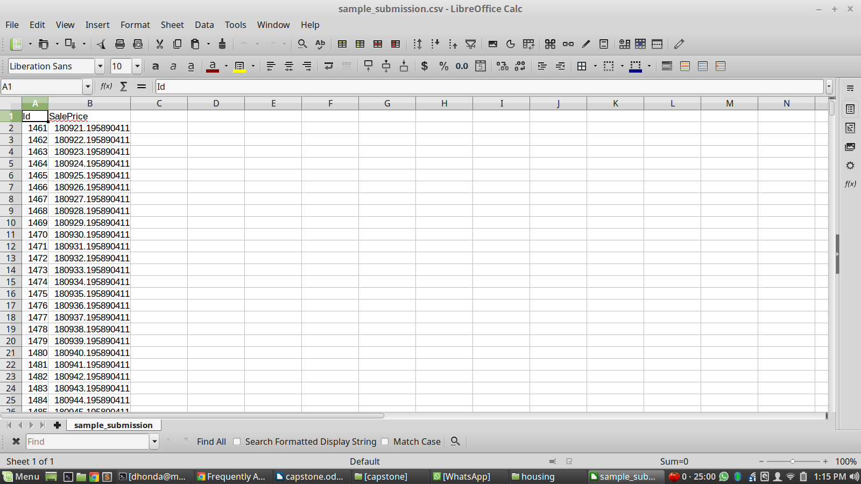
Figure 4: sample_submission.csv
Figure 4: Sample submission
With all datasets, certain abnormalities and characteristics germane to the dataset need to be addressed. In the case of the housing dataset three areas were addressed: categorical data, outliers, and missing values. The categorical data is incompatible with machine learning algorithms so to alleviate the issue, one hot encoding was employed. This increased the number of dimensions per record from 80 to 290, but allowed for the application of many different models. Outliers were identified by scatter plot diagrams which plotted SalePrice against the top 10 correlated features. Obvious outliers were removed if and only if they improved the test score as ranked by the Kaggle website. The third area of concern was missing data. To ensure that data was balanced and as normally distributed as possible, the median value was used for each feature to backfill any NaN or missing values.

Exploratory Visualization
The feature space after one hot encoding included 290 different dimensions. In order to explore the correlation and patterns associated with those features, correlation values were found between each feature and the target variable (i.e., SalePrice). T he rational being the greatest impact on the SalePrice would be those features with the strongest correlation. In the interest of time, the results were limited to the top 10 strongest correlations and then plotted. See figures 5 and 6 below.
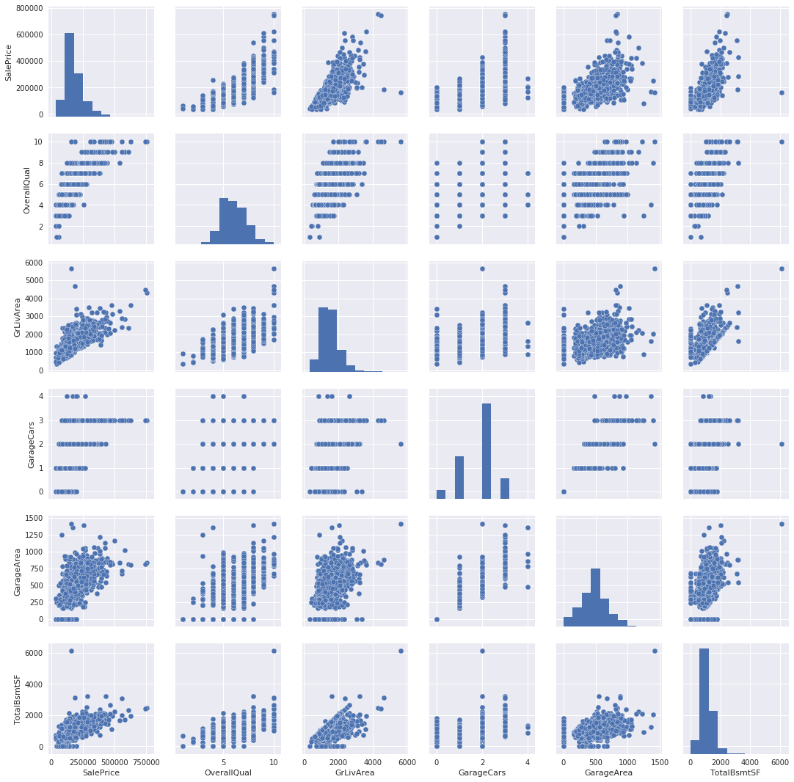
Figure 5: Scatter-plot of top 5 features correlated to SalePrice

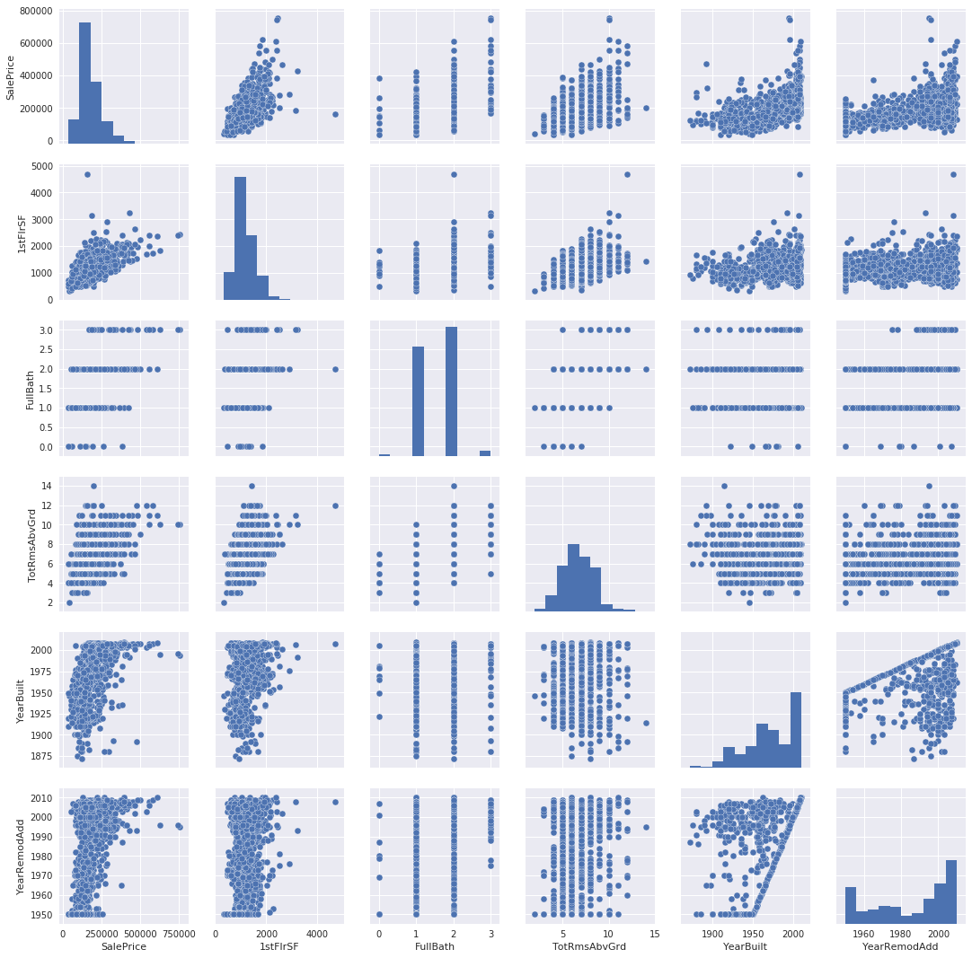
Figure 6: Scatter-plot of top 10 features correlated to SalePrice

Examination of the scatter-plots identified some areas with likely outliers. These features were individually compared against SalePrice to give a visual scatter-plot with greater granularity. All figures below are before any removal of outliers.
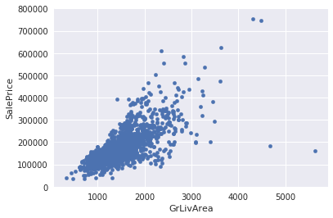
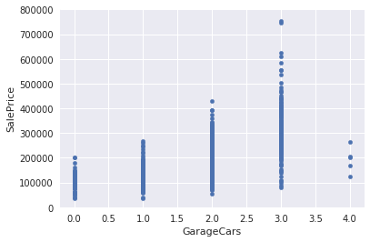
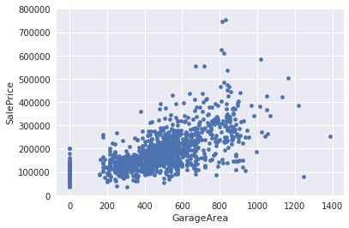
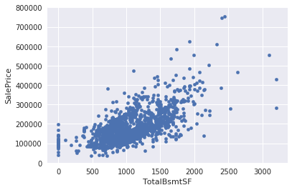
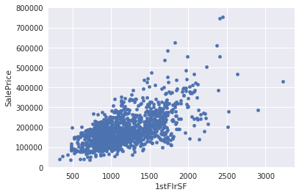
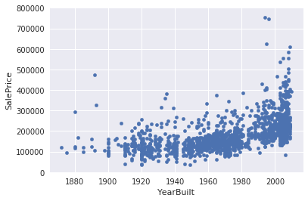

Figure 7: Scatter-plots with possible outliers

Algorithms and Techniques
The capstone project employed four different learning models: linear regression, SVM, Decision Tree, Random Forest, and XGBoost. The learning models were selected to provide a diverse and robust set of learners ranging from simplistic and fast (e.g., linear regression) to the more complicated ensemble methods with boosting (e.g. XGBoost). Initial evaluation was based on default parameter values of each learner and scoring was done with RMSE evaluation of 20% of the training data which was held back.

Benchmark
Zillow was to be the benchmark in evaluating the effectiveness of the learning model. Unfortunately, the test.csv does not include the SalePrice information. This would be necessary calculate the median absolute percent error. Instead the benchmark will be a RMSE of 0.43045 which was obtained by taking the mean of all the properties in the dataset and using that value for all records. Ultimately, the goal is to improve this score and rank in the top 20% of the public leader board on Kaggle. In order to rank successfully in the top 20% the submission would require a RMSE of 0.12049.

Data Preprocessing
The data preprocessing consisted of the following steps:
- One hot encoded training and test data to remove categorical data
- Identified the strongest correlations between features and SalePrice
- Scatter plot strongest correlated features and SalePrice and remove outliers which negatively impacted score of models
- Backfill NaN values with mean value for ta given attribute

Implementation
Pandas, Numpy, Scikitlearn, Seaborn, and Math packages were used extensively in the processing and exploration of the housing data. Certain tasks required supplemental functions and algorithms. These areas include both model evaluation and data preprocessing.
rmlse(y_true, y_pred) – implements the root mean log square error for model evaluation purposes. In some cases, linear regression would fail to converge resulting in “nan” scenarios. These cases will cause issues with the rmlse result.
evaluate_model(model, X_train, X_test, y_train, y_test) – implements model fitting with the test_train_split parameters. Additionally, it will automatically score the results and return the model and score as a tuple
feature_cat_conversion(column, data, debug=0) – implements a custom one hot encoding approach. After many iterations, this effort was abandoned as the default Pandas encoding produced more consistent and reliable results.
detect_outliers(column, data) – implements analysis to find outliers based on a a given column and dataset. Informative statistics are also displayed in addition to having a list of record identifiers returned.
grid_search_cv(model, params, X_train, X_test, y_train, y_test, verbose=False) – implements grid search cross validation on a given model with the training and testing data of a train_test_split dataset. The function also scores the models based on the defined function rmlse().

Refinement
As previously stated several models were evaluated in baseline form with both training and test data. The evaluation was performed with the root mean log squared error of data. After which, each model was parameterized and run through grid search cross validation. The best of each model configuration was then evaluated against the other “tuned” models. Further refinement required the removal of outliers and the predicted price data uploaded to the Kaggle site for evaluation. In some cases, efforts to generalize the data better by removing outliers actually resulted in lower scores. These cases have been documented in the notebook for completeness.

Model Evaluation and Validation
Model evaluation and validation have been two-fold. Initial evaluation was done with 20% of the training data being excluded from the model fitting and later used as a ground truth in a root mean log squared error (RMLSE) evaluation function. After final model selection and tuning, a second test dataset was used to predict 1,060 property prices. The true value is not visible, but results can be obtained by uploading the predicted prices to the Kaggle site. The Kaggle website evaluation scores were sufficiently close to feel confident that the model is generalized well enough to unseen data. The RMSLE results in some cases are only 3% off from the Kaggle score.

Justification
The best performing model was XGBRegressor. The model performed significantly better than other models; in some cases performing 3.4x better. These results are based on the localized RMLSE scoring system with the train test split approach. Further, these findings were consistent when evaluated by the Kaggle site. The best score obtained on the site, .13007, falls short of the goal of .12049. These findings are significant and do suggest that this approach could be feasible for solving this problem. Unfortunately the amount of error is too large to say that this project has done so. After viewing other submissions on the Kaggle site, it’s clear that very accurate (< .01 RMSE) predictions can be made with the correct model, feature selection, and feature engineering.

Reflection

Data Exploration: Familiarize myself with the data through an explorative process including statistical analysis and data visualization.
- Data Cleansing: Remove outliers, fill null values with mean, one hot encode categorical values, check relevance of every feature to the target feature.
- Train Model: Train several supervised machine learning models and tune with techniques such as cross validation and GridSearchCV.
- Test Model And Optimize: Optimize the model offline with the test dataset until satisifactory RMSE is achieved.
- Submit: Finally submit results to Kaggle for evaluation.
- Repeat as needed to meet appropriate benchmark.

Improvement

