Assignment Brief |UG | AY25-26



Assignment submission Marks and feedback
Assessment deadline | Marks and feedback
To be submitted Before 10 a.m. on: | 20 working days after deadline (L3,4, 5,6 and 7)
 | 15 working days after deadline (block delivery)
03/11/2026 | 01/12/2026
Please note, for Exams the date is arranged centrally aligned to the academic calendar. Exams timetables will be released 6 weeks before the exam period.

Key assignment details
Unit title & code | Object Oriented Programming and Software Engineering CIS016-2  Desktop Application Development and Software Engineering CIS0116-2
Assignment number & title | Assignment 1: Control an Elevator - A C# Project
Assignment type (including exams)  Clearly indicate if an exam | WR-I (Individual Coursework)
Weighting of assignment | 30%
Size or length of assessment or exam duration  Clearly indicate if an exam | No more than 2000 words
Use of generative AI | < not permitted>
Use of self-plagiarism | < not permitted>

Understanding the assignment brief
Assignment brief to be discussed during an in-class session with students within the first 2 weeks of the unit. | 25/09/2026  Date this discussion is to take place
Uploaded screen/podcast explaining the assessment, the rubric and marking criteria. | Enter link on the BREO shell


Completing your assignment

What am I required to do in this assignment?
Aim
This assignment aims to develop students’ capabilities and skills of solving real-world problems with C# programming language.
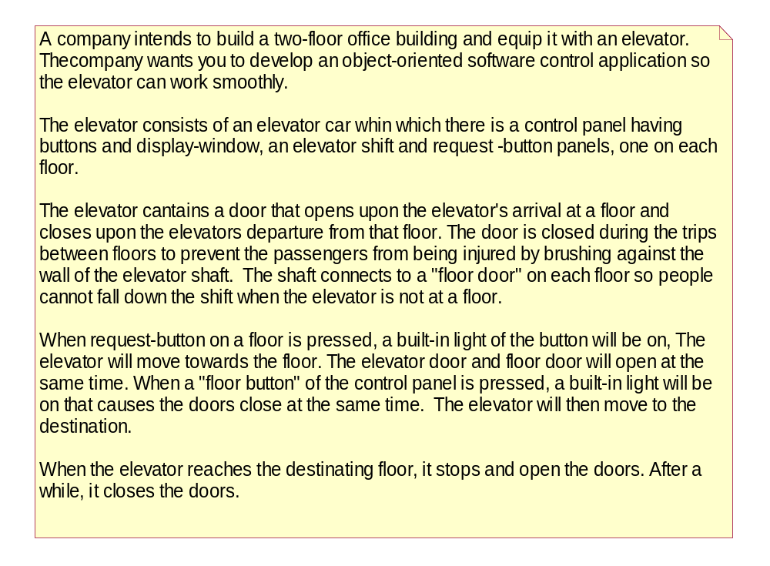
A simple version of the elevator is illustrated below:
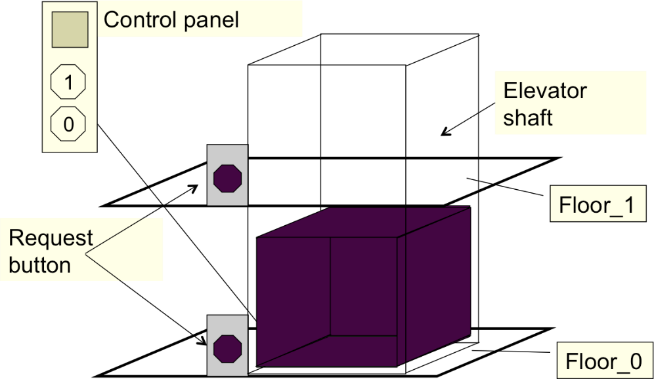
Task description:

Task 1: Design and Implement the GUI (20 marks)
Create a graphical user interface (GUI) that includes the following components:
- Request buttons out of the elevator, each corresponding to one of the two floors.
- One control panel, containing:
  - Two floor selection buttons.
  - One display window showing the current floor.
- Two floor status displays, one for each floor, indicating the elevator’s current location.
- One log button, which displays the historical operation records of the elevator.

Task 2: Implement the Control Logic (10 marks)
Develop a control program to handle events triggered by the GUI:
- When a request button is pressed:
  - The elevator moves to the requested floor.
  - All display areas (floor status displays and control panel display window) update to show the current floor.
- When a floor button on the control panel is pressed:
  - The elevator moves to the selected floor.
  - All display areas update accordingly.

Task 3: Implement Logging and Data Management (30 marks)
Create a logging system to record elevator operations:
- Store elevator status and timestamps in a database (e.g., MS Access or equivalent).
- Display the stored information on the GUI.
- Enhance portability by using relative paths instead of absolute paths.
- Improve maintainability by avoiding code duplication in event handlers related to database operations.
- Increase robustness by eliminating logical errors and handling exceptions gracefully.

Task 4: Animate Elevator Movement (10 marks)
Use delegates and timers to animate the elevator’s movement in response to events described in Task 2.

Task 5: Advanced Optimization (Additional Marks)
5.1: Concurrent Task Execution (5 marks)
- Improve application efficiency by separating GUI and database operations using BackgroundWorker.
5.2: Revise the Control Logic for a Multi-Elevator System (15 marks)
- Extend the system to support two elevators.
- Apply the State Design Pattern and Observer Pattern to manage elevator logic:
  - Requests from outside the elevator should be handled by the elevator that is most readily available—based on the shortest estimated response time—while ensuring that ongoing tasks are not disrupted.
  - Each elevator should have its own control panel to simulate internal requests. Requests made from inside an elevator are handled exclusively by that elevator.
Task 6: Testing and Self-Assessment (10 marks)
Prepare a test report that includes the Marking Matrix with Self-Assessment table provided at the end of the document.

What do I need to do to pass? How do I achieve a good grade?
Submission Guidelines
What to Submit:
- A complete C# project, including all folders, files, and the associated database.
- A testing report detailing your validation and evaluation process.
Naming Convention:
- Name your submission using the following format:
studentID_AssignmentOne.zip
Where to Submit:
- Upload your submission to the Assignment 1 folder under the Assessment section of this unit’s BREO site, titled:
“Assignment One C#”

You are required to demonstrate and explain your project and source code in person. The demonstration will take place in Week 7, with the exact date and time to be announced on BREO.
- Clearly walk through your source code and explain its functionality.
- Note: The demonstration is mandatory. Failure to attend and present will result in an automatic fail for the assignment.
Refer to the marking matrix at the end of the brief for detailed assessment criteria.


How will my assignment be marked?
Your assignment will be marked according to the threshold expectations (see the Unit Information Form uploaded on BREO) and the specific marking criteria below (marking rubric). Please read carefully as they will help you prepare and evaluate your own work before you submit. They will also help you understand the grade and feedback received once marked.

 | 70%+  (1st Class) | 60-69%  (2:1) | 50-59%  (2:2) | 40-49%  (3rd Class)  Threshold Standard | 30-39%  (Fail) | 0-29%  (Fail)
1
2
3
4
5

Marking Criteria Matrix with Self-Assessment
Task Number | Sub-tasks | Possible Marks | Self-assessment (completed Yes/No) | Reference to your testing report | Mark Awarded
Task 1 | Complete GUI for Task 1 | 10
Task 1 | Event handler skeleton implemented for all GUI buttons | 10
Task 2 | All event handlers function as specified | 10
Task 3 | Database designed and successfully connected | 5
Task 3 | Log information retrieved from DB and displayed in GUI | 5
Task 3 | Log information stored in DB | 5
Task 3 | Disconnected model used (via DataAdapter.Update() instead of ExecuteNonQuery()) | 5
Task 3 | Relative paths used; logical errors eliminated; exceptions handled with try-catch | 5
Task 3 | No duplication in DB-related event handlers | 5
Task 4 | Events described in Task 2 animated using delegation and timer | 10
Task 5 | Application efficiency improved by separating GUI and DB operations using BackgroundWorker | 5
Task 5 | System extended to support two elevators; State and Observer Patterns applied to manage elevator logic | 15
Task 6 | Testing report includes all expected content | 10
Total |  | 100

Additional information

How does this assignment relate to ‘my learning in this unit and help me develop knowledge and skills that I will need for my future?
“How does this assignment relate to what we are doing in the scheduled sessions” - To be completed by the unit coordinator.
Within the University of Bedfordshire, graduate competencies refer to the skills, knowledge, attributes, and abilities that individuals are expected to possess upon completing their education at the graduate level. Our graduate competencies are the fundamental building blocks in preparing you for the future world of work. They form the foundation for learning outcomes within and beyond your course. They are relevant for every subject, and you can work towards them in different ways, so that you can attain and benefit from them even if you have lots going on outside university. These competencies will be integrated across your course and units.

The table below indicates graduate competencies gained relevant to this assessment.
Graduate competencies; Tick (✔) ones relevant to this assessment (further guidance for staff Graduate competencies | University of Bedfordshire (beds.ac.uk)
Digital Literacy | ✔
Collaboration and Communication
Problem solving and critical thinking | ✔
Creativity and Entrepreneurship
Adaptability and Resilience | ✔
Global Citizenship
Course specific competencies.  Please outline: | ✔  Categorize key concepts, principles, and techniques in object-oriented desktop application development and software engineering. Apply object-oriented analysis and design to build desktop applications, integrating appropriate methods throughout the development process.

What should I be aware of when preparing my work? How and where should I submit my work? (May need WISEflow info for exams)
To submit assignments at the University of Bedfordshire, you will typically use the BREO (Bedfordshire Resources for Education Online) platform. Within BREO, locate the specific assessment you need to submit, and then follow the instructions provided to upload your work.
The University has produced a guide that is designed to help you understand the processes we use to deliver and manage assessment-related processes, what support is available to you and how we agree and approve your results. It also provides you with an explanation of the codes we use when we issue results and transcripts.
When submitting work for assessment, you must ensure that it is all your own work. Failure to do this could result in sanctions, including removal from your course. The Academic Integrity Resource (AIR) has been designed to introduce you to academic integrity and how to demonstrate this during your studies. Remember to use the self-help resources to support your skills in academic writing. You could also Improve your assignment grades by accessing free university support to develop a wide range of relevant and valuable academic skills.
For exams, you should familiarise yourself with the guidance information available here: https://www.beds.ac.uk/exams/
Practice exams can be taken for all exam types before exams week. Please see section Prepare for your exam.

