Bradley Johnson
ITAI 4374
Professor Patricia McManus
5 February 2026

Part 1: From Biological to Artificial Neural Networks
Biological neurons inspired the foundational design of artificial neural networks by demonstrating how complex behavior can emerge from simple processing units connected in large networks. In a biological neuron, dendrites receive incoming electrical signals, the cell body (soma) integrates those signals, and the axon transmits the output to other neurons through synapses. Artificial neurons mirror this structure by using input connections, weighted summation, an activation function, and an output signal.
Despite this inspiration, significant differences exist. Biological neurons operate using electrochemical signals, adapt continuously through synaptic plasticity, and function asynchronously. Artificial neurons rely on mathematical operations, predefined activation functions, and discrete training phases. Biological systems are extremely energy-efficient and adaptable but difficult to model precisely. Artificial neural networks are faster, scalable, and easier to optimize but lack the flexibility, robustness, and contextual understanding of biological intelligence. Each approach has strengths: biological neurons excel in adaptability and generalization, while artificial neurons excel in speed, precision, and large-scale computation.
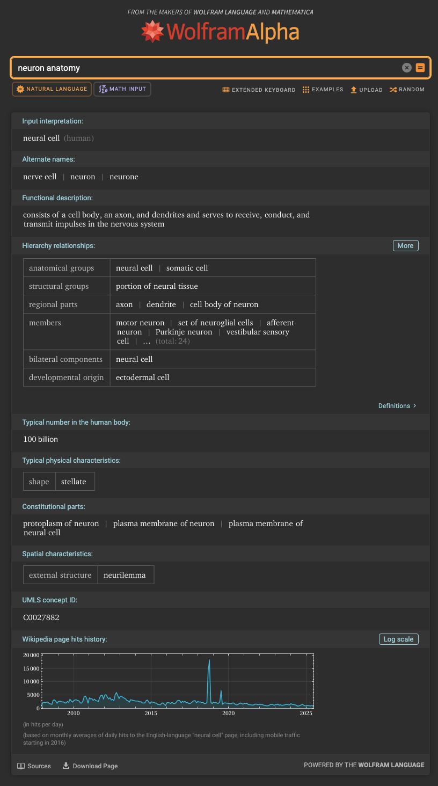

Biological Component / Characteristic | Biological Function | Artificial Neural Network Equivalent | Example in AI Architectures (CNNs, RNNs, etc.)
Cell body (Soma) | Integrates incoming signals and determines neuron activation | Processing unit / activation function | Neuron activation in dense layers of MLPs and CNNs
Dendrites | Receive signals from other neurons | Input connections / input nodes | Input feature maps in CNN convolution layers
Axon | Transmits output signal to other neurons | Output connection | Output passed to next layer in CNNs and RNNs
Synapses | Adjust signal strength between neurons | Weights | Learnable weights updated via backpropagation
Synaptic plasticity | Strengthening or weakening of connections over time | Weight updates during training | Gradient descent in CNNs and RNNs
Hierarchical organization | Information flows from simple to complex processing | Layered network structure | CNN feature hierarchy (edges → shapes → objects)
Temporal signal transmission | Processes information over time | Recurrent connections | RNNs and LSTMs for sequence modeling
Parallel processing | Multiple neurons fire simultaneously | Parallel computation | GPU-based training of deep networks
Specialized brain regions | Dedicated functional areas | Task-specific architectures | CNNs (vision), LSTMs (memory), Transformers (attention)

Part 2: Understanding the Brain’s Architecture
The human brain is hierarchically organized, with lower-level regions handling basic sensory input and higher-level regions managing reasoning, memory, and decision-making. Specialized areas perform distinct tasks: the visual cortex processes visual information, the auditory cortex handles sound, and the hippocampus manages memory formation. This organization closely resembles modern AI architectures.
Convolutional Neural Networks (CNNs) parallel the visual cortex by processing information in layers, extracting edges, shapes, and increasingly complex features. Long Short-Term Memory (LSTM) networks mirror aspects of hippocampal function by maintaining and updating information over time, enabling learning from sequences. Attention mechanisms in transformer models resemble biological attention systems by prioritizing relevant information while filtering out noise.
The amygdala plays a key role in emotion processing, especially fear, risk evaluation, and threat detection. Insights from biological emotion processing can inform AI systems by improving decision-making under uncertainty, enhancing risk assessment, and strengthening pattern recognition in high-stakes environments. Emotion-inspired mechanisms may also enable adaptive learning by assigning priority to critical experiences, improving responsiveness and resilience in AI models.
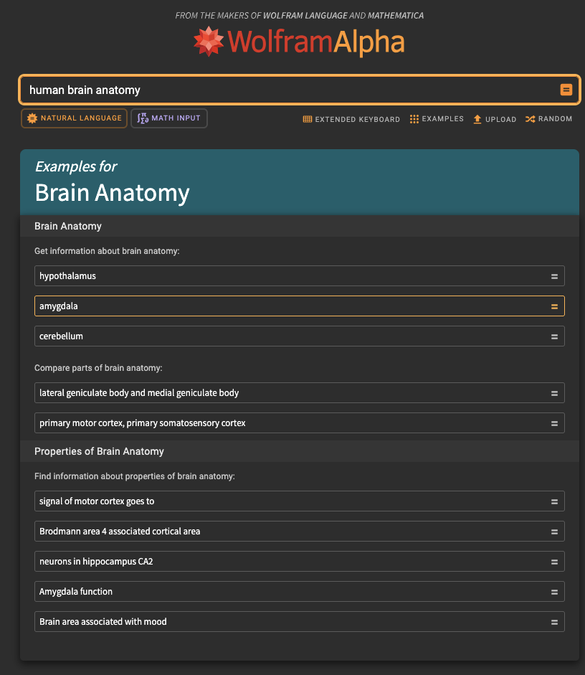

Part 3: Integration Analysis and Future Implications
Understanding biological neural networks provides valuable guidance for improving artificial intelligence design. Biological systems demonstrate how intelligence can emerge from massively parallel, adaptive, and energy-efficient architectures. These insights may inspire new AI models that move beyond rigid layer-based designs toward more dynamic, self-organizing systems. For example, biologically inspired learning rules such as Hebbian learning could complement or replace backpropagation, addressing limitations in scalability and biological plausibility.
A critical comparison reveals key trade-offs. Biological systems are remarkably energy-efficient, operating on approximately 20 watts, while modern AI models require vast computational resources. Biological learning is continuous, adaptive, and robust to noise, whereas artificial systems often require large labeled datasets and retraining. However, artificial systems excel in processing speed, precision, and the ability to scale across massive datasets. In terms of generalization, biological intelligence remains superior, adapting to novel situations with minimal prior exposure.
Future directions in AI research may involve neuromorphic computing, spiking neural networks, and hybrid systems that integrate biological principles with digital computation. Insights from emotion processing, attention, and memory could help overcome current AI limitations in reasoning, adaptability, and context awareness. Ultimately, deeper integration between biological understanding and artificial design may lead to more efficient, resilient, and human-like intelligent systems capable of learning and adapting in complex real-world environments.

References
Kandel, E. R., Koester, J. D., Mack, S. H., & Siegelbaum, S. A. (2021). Principles of neural science (6th ed.). McGraw-Hill.
Wolfram Alpha. Neuron anatomy. https://www.wolframalpha.com
Wolfram Alpha. Human brain anatomy. https://www.wolframalpha.com

