**PeerJ Permission Letter**

**All items (1-5) are required**:

1. Title of PeerJ submission: **Nectar larceny in the trainbearers (*Lesbia*, Trochilidae)**
2. Printed name of copyright holder: **Diego Emerson Torres**
3. Select copyrighted item: **photographs**.
4. 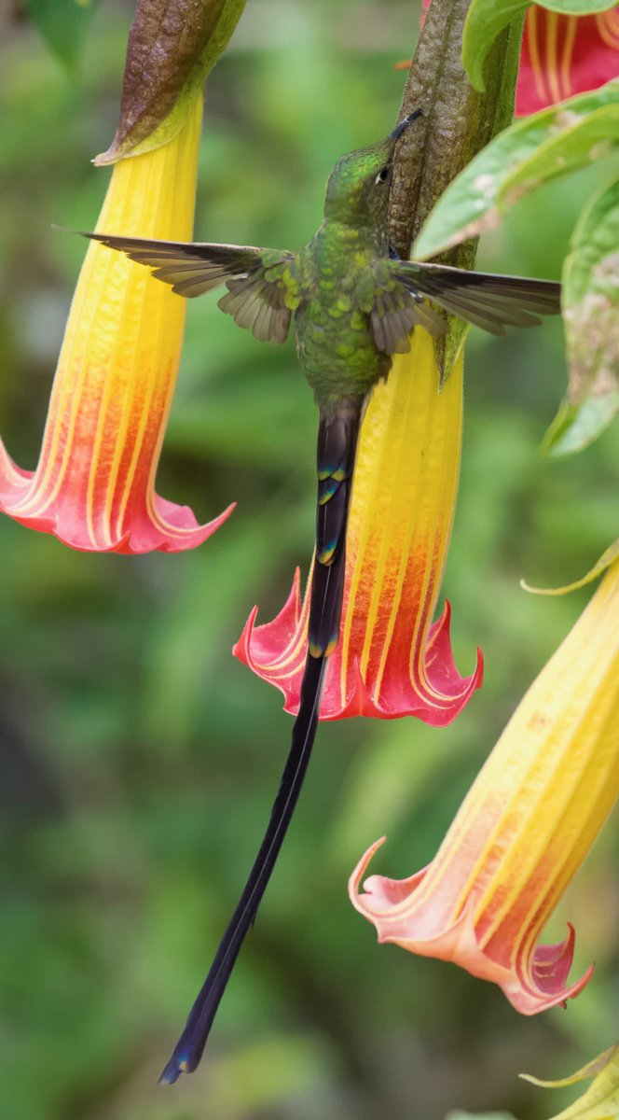*For figures*: Supply the approved images(s) including the figure number(s) as they appear in the PeerJ submission OR A complete description of the image(s):

***Lesbia victoriae* (male) robbing *Brugmansia sanguinea* in Monserrate, Bogota, Colombia. Used in Figure 1 of the Igić, Nguyen, & Fenberg manuscript entitled, "Nectar larceny in the trainbearers (*Lesbia*, Trochilidae)," currently accepted pending revisions in PeerJ.**

1. I give my permission to PeerJ to publish my work, as described and/or appear below, under the CC-BY 4.0 license.

_______________________________

***Signature of copyright holder***