Dear Dr. Hedrick

We thank you and reviewers for their valuable time and critiques of the manuscript, for which we are particularly grateful under these extraordinary circumstances. We extensively edited the manuscript to address their concerns, and added some clarifications, all visible in the attached "tracked changes" document.

Here, we append the original reviews by both reviewers (*in* *black italics*) and our replies (interspersed in red) can be found below.

We hope that you will agree that the manuscript is now suitable for publication, and eagerly await the final decision.

Boris Igic, Ivory Nguyen, and Phillip Fenberg

**Reviewer 1**

(Anonymous)

***Basic reporting***

*The authors report the occurrence of nectar larceny in both currently recognized species of trainbearers (Lesbia nuna and L. victoriae). They observed and photographed a male Green-tailed Trainbearer (L. nuna), which nectar-robbed several flowers of Fuchsia boliviensis (Onagraceae) in Ollantaytambo (Peru) and then followed the same individual on a 50 m foraging bout, while it nectar-robbed flowers of Brugmansia sanguinea (Solanaceae; with 30cm-long tubular flowers, and then legitimately visiting Salvia leucantha (Lamiaceae). The observations occurred in an area in which flowerpiercers (Diglossa sittoides and D. brunneiventris) occur at relatively high densities. Based on these observations, the authors then did a literature search and examined photo records on public online photo services. After they carefully examined the photo records, they scored the observed "behavior" in each photo by species and individual sex (if possible) and the plant-hummingbird interaction in the photo assigned to the following categories: primary nectar robbing, secondary nectar-robbing, nectar thieving, and pollination. Based on their results, the authors estimated conservatively that ca. 40% of the recorded nectar foraging "visits" involves nectar robbing, and males seem to engage more frequently in nectar robbing than females (marginal differences). The authors then discussed the significance of their findings, linked to original observation of nectar robbing and limited available data to be compared with. There are few important issues that must be considered before this manuscript is recommended for publication in PeerJ. I offer broad areas of criticism and suggestions for improvement in the various sections of my report.*

We appreciate your general critical and useful approach, which improved the manuscript.

*The English language is clear and professional throughout. However, there are some instances in which the terms used are misleading. An example where the language could be improved includes line 56---the use of "meta-analysis" is misleading because it does not use meta-analysis in the statistical sense. Also, "…a larger meta-analysis…"; it is not clear what do you mean by "larger", as compared to what "smaller" meta-analysis? The phrasing and use of meta-analysis makes comprehension difficult and it might be misleading. Please revise the whole manuscript for clarity.*

Agreed--we rephrased and removed both instances of "meta-analysis" (lines 54, 100).

*Also, there are some instances that I get the feeling that the manuscript is more a narration of a species account than a scientific paper (e.g., lines 80–88). Please revise the whole manuscript and ask whether or not this gut feeling applies to your manuscript.*

We now place these eight lines (80–88) in their own sub-subsection "Description of original observation" (it was previously under subsection "Species and site description"), to unambiguously clarify that this is intended to be a narrative description. We think that the description of the observation may be useful for any future collection or analyses by others.

*Your Introduction and background is adequate, I do not think needs more detail. Although the literature on nectar robbing by insects is ample, there is only few studies on nectar robbing by birds and specifically for hummingbird species.*

We completely agree, there are few studies; moreover we do not believe any studies in birds exist, which estimate the proportion of nectaring visits by mode.

*However, it would be useful if you at least compare the % of nectar robbing from your observations to those observed and reported for insect species and flowerpiercers. I then do suggest that you revise the literature on flowerpiercers and bumblebees in which the described behaviors by Inouye (1980) regarding the various "types" of floral larceny occur and see whether the high percentage that you are reporting is also found in other systems in which other than hummingbirds are the pollinators.*

First, we added a number of comparisons from Snow and snow (1980), as well as not directly comparable, but instructive, percentages of robbing on individual plant hosts.

Second, Gonzales and Loiselle (2016) report that 100% flower visits by flowerpiercers (Diglossa spp.) and conebills in their study were illegitimate (they report theft at the sole mode of visitation and exclude those species from their networks). We are unaware of any publications that specifically report individual-level percentages of illegitimate vs. legitimate visits from flowerpiercers. This does not, of course, mean that they do not exist, but in our extensive searches, nearly all are either simple descriptions of robbing (Species A obtains pollen/nectar illegitimately) or plant-level percentages (see below), which are not comparable (i.e. we do not have plant-level data). If the reviewer can recommend such a paper, we will happily include it. We also believe that the incentive and strategy set by other species may be wholly different. For example, flowerpiercers (as the name indicates) are highly specialized flower robbers; bumblebees often collect pollen, in addition to nectar, and many studies are conducted on non-native plants and in un-naturally uncompetitive experimental conditions, complicating inference (e.g. Richman et al. 2017).

Finally, while we agree with a strong need for a critical review, our focus (hummingbird foraging) and the scope of our paper (original report of robbing in *Lesbia* spp. and aggregation of data on robbing for these species) are far lesser than such an expansive aim. Adjacent reviews, such as Irwin et al. (2010) and Maloof and Inouye (2000) exist, however, and it is not clear to us that any future review should arbitrarily stop at the inclusion of insects and flowerpiercers. Many other birds (sunbirds, bananaquits, etc.), mammals, and lizards are known to make illegitimate visits. Either way, we hope the author also agrees that a comprehensive review would be an enormous task, worthy of a separate publication as a different article type in PeerJ, or in a review journal, and that our manuscript could contribute a datapoint to such a review.

*For instance, Arizmendi (2001) found that the frequency of nectar robbery by flowerpiercers at the individual-plant level varied from 5 to 58% (you cite this study and one of the main findings, line 217), a lower range from other studies of hummingbird-plant species at the community level in which the percentage of flowers robbed represented about 70% of the total number of flowers per plant (Navarro 2000, 2001). That sort of comparisons would provide more justification for your study and would let you to compare your findings reaching a broader audience.*

As the reviewer correctly points out, these are all plant-level observations, so they are not directly comparable to our data, but they do provide some potential insight for readers.We expanded the discussion of plant-level robbing data (lines 218-234)

*I do suggest you review and cite the paper by Rojas-Nossa et al. (2016) Oikos 125, 1044–1055. Arizmendi (2001) Can J Zool 79, 997–1006. Navarro (2000) AJB 87, 980–985. Navarro (2001) Pl Ecol 152, 59–65.*

Of the recommended additions to the citations, we already cited Arizmendi (2001) as the reviewer noted above, as well as Rojas-Nossa et al. (2016). We now also include Navarro (2001). That paper can also lead the readers to similar data from Navarro (1999), and neither was included in the Maloof and Inouye (2000) review.

*Figures are relevant, high quality, well labelled & described. Yes.*

(Thank you!)

*Raw data supplied (see PeerJ policy). 26]. All data generated in this study is deposited in iNaturalist (https://www.inaturalist.org/observations/37206000) and checked that it was publicly available.*

We also include a supplementary table with all the data (please see below).

***Experimental design***

*I commend the authors for presenting the manuscript to be published. We have much to learn on nectar robbing, particularly among hummingbirds. If there is a weakness, it is the very few observations of nectar robbing in the field (in fact, one individual performing this behavior in different flowers and plant species) and the use of photos for the rest of the study. You indicate the limitations of such an approach.*

Unfortunately, we agree. And yet, this seems to be the most comprehensive study of robbing frequency in hummingbirds to date! We hope that it will spur studies that overcome our limitations.

*I believe it would be useful for the reader to have an additional figure with photos showing each of the categories used for quantification of floral larceny. Although some of the photos were deposited in iNaturalist (https://www.inaturalist.org/observations/37206000) and are publicly available, I believe the reader needs to check the assigned category to each of the photos deposited.*

We agree that this would be a terrific illustrative and aesthetic feature of the manuscript, and so much so that we spent approximately 45 days, right up to the deadline, trying to secure individual rights for each photo. We did not receive responses from all photographers in time. Although many of the photos are legally usable (we identified a set that are under attribution-based Creative Commons licenses), *PeerJ* requires signed agreements with each author, which we could not secure by the deadline. If we receive them before publication, we will include them, because this will clearly improve the aesthetic value and allow more rapid assessment of data calling.

We do include the Supplementary Table with links ALL original observations and calls made, which were used in the paper, so that the results can be completely reproduced, as well as critiqued (e.g. someone may disagree and re-code the data, or reuse the data for a plant host study, etc.).

*I do see you have added a supplementary appendix in which for each of the photos used as numbered in iNaturalist you provide by columns the species identity (plant and hummingbird species), individual sex, and the nectar robbing category you assigned, as to have an idea on the certainty and difficulties in your decision making, but it is not indicated whether the same person did that part of the job. In the corresponding section, you have indicated that all three authors performed the experiments, but what you need to explain is in Methods who did it.*

This is a clear omission--we apologize. Briefly, two of us flowers (BI and PF) searched for and reviewed all 1557 photos to select those with birds near flowers. We then both scored each instance and merged the nectaring mode calls. We now include this explanation in the Materials and Methods. (interspersed in lines 115-125)

***Validity of the findings***

*There is not way how the study can be replicated, unless you provide in the supplementary appendix how many observers of photos participated.*

We provide Supplementary Materials with all data used. We clarify that BI and PF both reviewed calls for each nectar foraging mode (see comment immediately above and lines 115-125)).

*Please also explain whether you have the permission from authors of all photos to be deposited in iNaturalist and used by the public*

Of course--yes, this is important. For the photo included, we provide PeerJ with the required documentation including author consent from Diego Emerson Torres.

***Comments for the author***

*I agree with you that we badly need more field studies as to document the various foraging modes described for floral larceny, particularly in plant-hummingbird communities.*

The citizen science data from sites like eBird and iNaturalist, especially after some curation, has an enormous potential to shape future experimental work.

**Reviewer 2**

(Dr. Rainee Kaczorowski)

***Basic reporting***

*This manuscript is basically an analysis of posted photographs of trainbearer hummingbirds (Lesbia sp.) to gauge the prevalence of nectar robbing in the group, with some additional investigation into patterns. The bulk of the study is rather preliminary, but it does provide some useful information that could inform future studies.*

*The manuscript is well-written, and there are minimal issues with the Table/Figures provided (see below).*

*Although previous studies have documented nectar robbing in other hummingbird genera, this study is the first to document the occurrence of nectar robbing in trainbearer hummingbirds, which could be useful information for those that consider the foraging habits of these species. This study also provides limited data that suggests a lack of tomial serration in these species, which may be relevant in the consideration of primary versus secondary robbing habits.*

***Experimental design***

*It is clear that more information is needed on the floral visitation patterns of trainbearers. This study attempts to fill this gap using the many “citizen science” photographs that can be found online, with minimal data collected by the authors themselves. This type of data has limitations, and the authors recognize those limitations, while providing a preliminary model analysis with the data they were able to extract from the photographs.*

(This is an excellent critical summary of the work.)

***Validity of the findings***

*This study attempts to recognize patterns of visitation for the different sexes and species. I feel this interpretation can be problematic with this form of data. However, it seems the authors sufficiently caution readers to the limitations of the study and seem to present results as more of a preliminary analysis to inform further studies.*

*Although the authors do well to highlight the limitations in the analysis investigating visitation patterns based on sexes and species, caveats should also be attributed to the conclusion that floral larceny is “common” since this depends upon which photographs were uploaded to the sites, which could be biased in some way as well.*

The reviewer is, of course, correct. We cannot know the exact relationship between the sample population (pictured) and the population of inference. We included a cryptic sentence about this previously, which we now expand and clarify. (lines 134-140)

***Comments for the Author***

*If possible, I would suggest highlighting any quantification of nectar robbing/larceny in other hummingbird genera if it exists. Otherwise, the statements made at the beginning of the discussion should suffice to clarify that nectar robbing has been documented in other hummingbird species.*

We conducted a number of extensive searches and, finding nothing, consulted staff at the Field Museum of Natural History. We ultimately located one such paper (Snow and Snow 1980, Bull. Brit. Mus. Nat. Hist (Zool.)). Although not without limitations, it is a fantastic study and provides a good comparative basis. [Lines 100-109, 221-224]

*A clarification can be made in the abstract if “both” in line 15 is changed to “the two” to clarify that there are two species.*

Done. (line 15; not highlighted due to formatting)

*Perhaps “minimally” could be changed to “at least” or something else in Line 104, since “minimally” may suggest to some that the bulk of the diet is made up by something other than arthropods and nectar.*

We rephrased this to read, "Therefore, as generally holds for hummingbirds, the trainbearers’ diet at a minimum contains arthropods and nectar." (lines 108-109)

*Line 187: two “whether” at the end of the line.*

Fixed.

*Table 1: Legend says “Larceny,” but the table says “Robbing,” which I think is more appropriate if you are focused on the two different modes of robbing without considering potential larceny.*

Done.

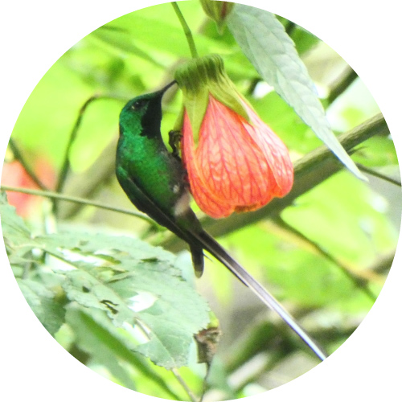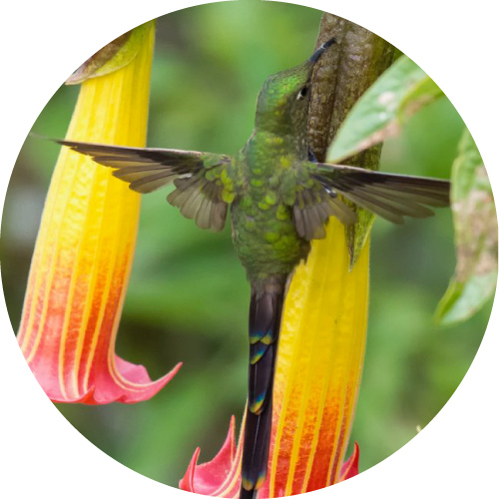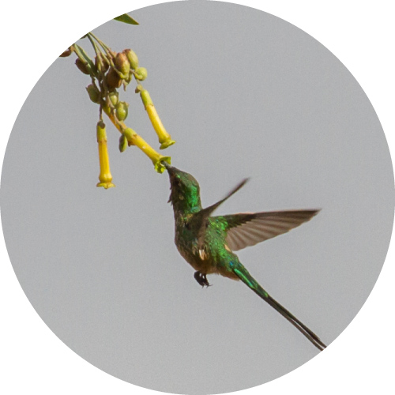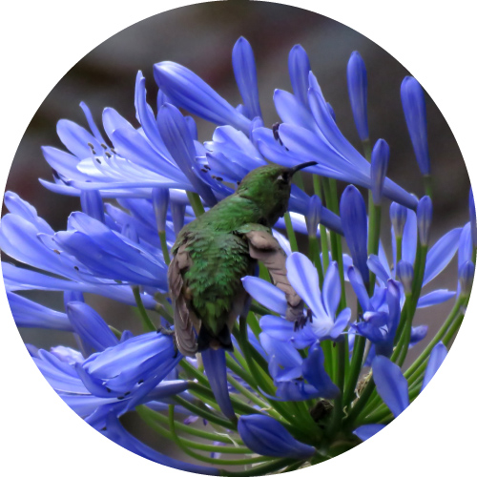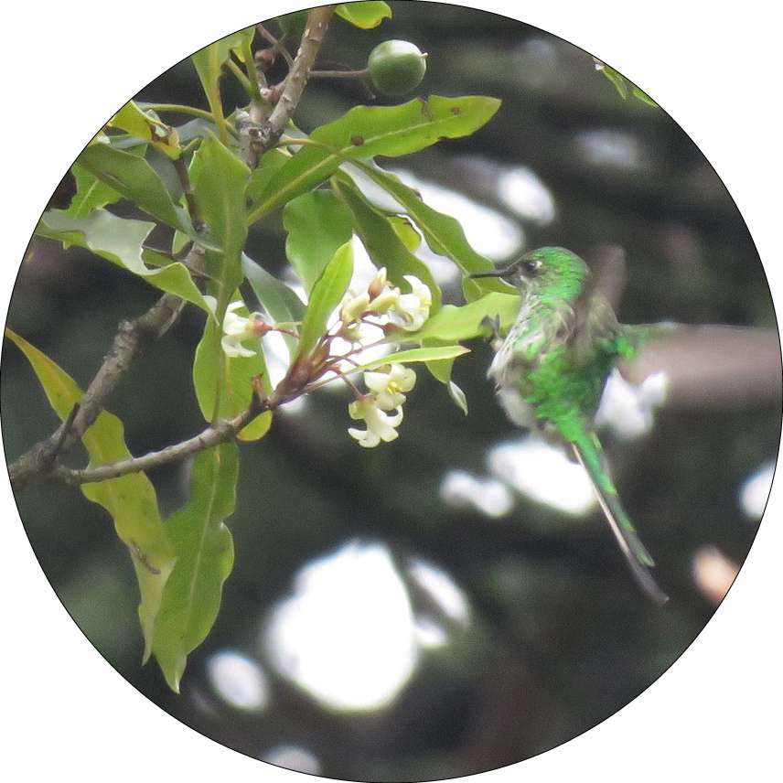**Example photos (extract from Supplementary Tables)**

Our manuscript-included photograph from Diego Emerson Torres, Secondary robbing (NR2) of *Brugmansia sanguinea.*

<https://www.inaturalist.org/observations/4133555> pollination (P) *of Nicotiana glauca.*

<https://www.inaturalist.org/observations/31208388> thieving (T) from *Agapanthus sp*.

<https://www.inaturalist.org/observations/33044598> visit that cannot be classified (NA), near *Pittosporum undulatum.*

<https://www.inaturalist.org/observations/25395388> robbing (NR) *Abutilon pictum. (There are no confirmed instances of primary robbing (NR1).*