Transmission Media/Network media

Transmission medium is a media over which communication takes place in computer networks. It mediates the propogation of signals for telecommunication purposes.

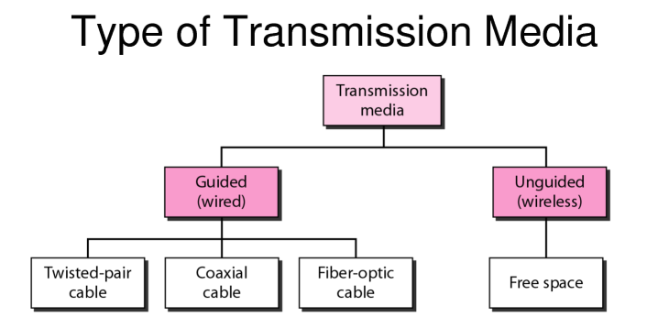
Transmission media are broadly classified into 2 types based on the medium of propogation i.e wired or wireless.

1) Guided Media/ Wires media:

Signals being transmitted are directed and confined in a narrow pathway by using physical links.

Features:
- High Speed
- Secure
- Used for shorter distances

a) Twisted Pair Cable-
Most widely used transmission media. Contains two pais bundled together in a protective sheath.They are of two types:

i) Unshielded Twisted Pair(UTP):
Ability to block interference and no physical shield. Used in telephonic applications.

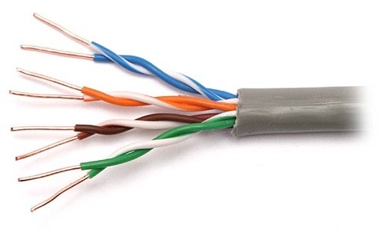

ii)Shielded Twisted Pair(STP):

Has special jacket to block external interference. Used in fast-data-rate ethernet and in voice and data channels.

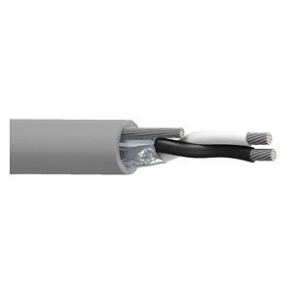

b) Coaxial Cable:
Has two parallel coductors having insulated cover. Has two modes: Baseband and Broadband. Cable TV and analog use Coaxial cables.

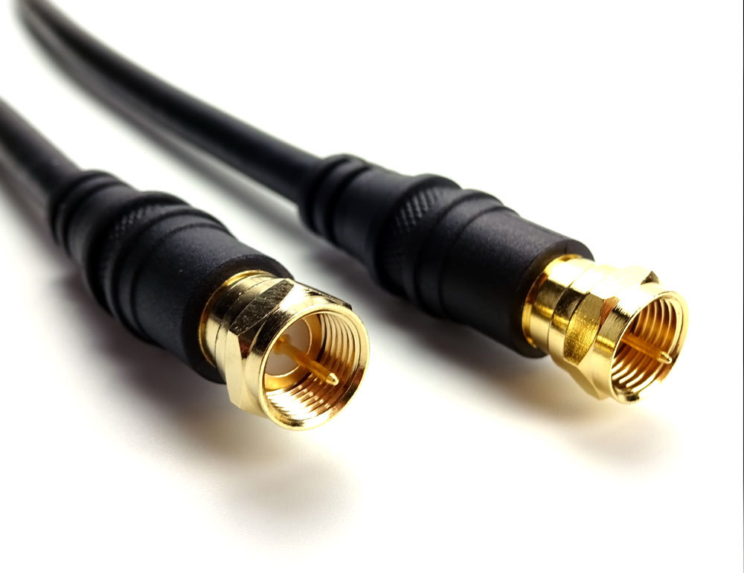

https://www.lifewire.com/ethernet-and-network-hubs-816358

c) Optical Fibre Cable:
Uses concept of reflection to pass light through a core made of glass or plastic. The density is varied to let the light travel by using refraction and core is surrounded by less dense material called cladding.
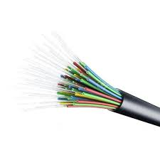

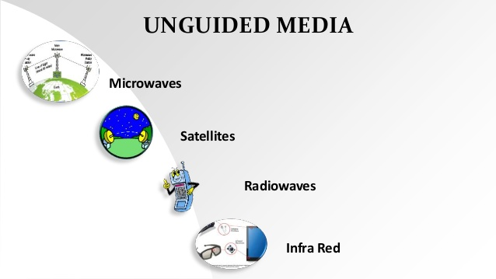

2) Unguided Media:
It refers to wireless mode of transmission through electromagnetic signals.

a) Radia waves:
Can penetrate through buildings and antennas need not be aligned for transmission. Has a range of: 3KHz – 1GHz.

b)Microwaves:
Has line of sight transmission. Frequency range: 1GHz – 300GHz. Used for mobile communication.

c)Infrared:
Used for short distance communication, cannot penetrate and prevents interference between systems. Frequency range: 300GHz – 400THz.

Network Devices:

Network devices are hardware/ physical devices that are required for communication in a computer network.

TYPES:

HUBS

It is the most basic networking device that connects multiple computers. It doesn’t have logic to it and just connects any number of devices to another. It broadcasts across each connection. This leads to network errors such as collisions and huge security risk.
Speed: 10-100 Mbps
There are 3 types of hubs ; Passive Active and Intelligent.

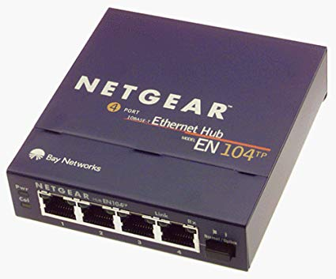

https://www.lifewire.com/ethernet-and-network-hubs-816358

Hubs send the a message to a node A it’s response also goes to every other node connected to the hub.

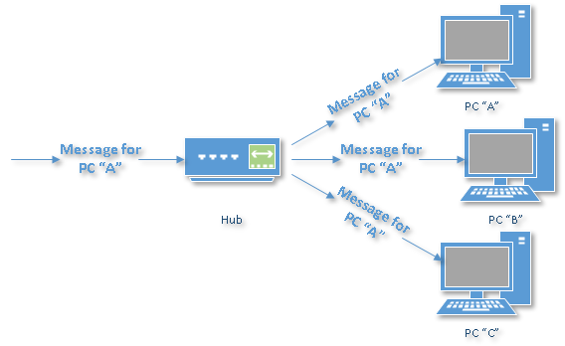

Hub sending the message to node A

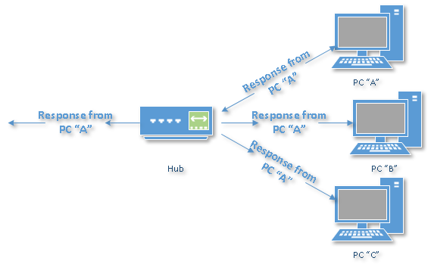
Response of Node A reaching all other nodes connected.

SWITCHES

- A switch is a piece of component that governs the signal flow. It allows the power/signal to flow through the connection.
- It filters and forwards the network packets. It pays attention to the traffic across it, it can learn which computer are connected to which port.

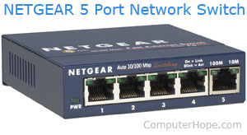

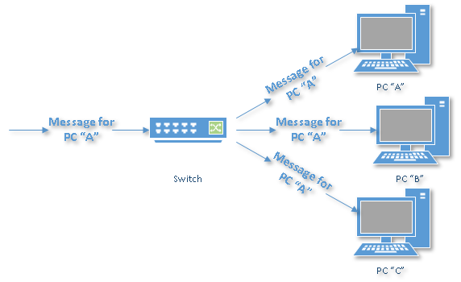

First, switch won’t be able to identity whom which message is.

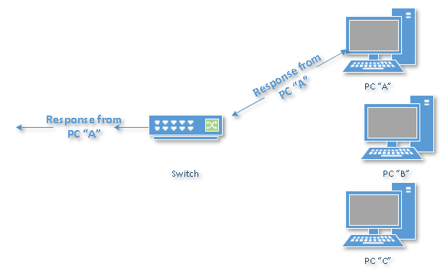
By processing the response, the switch has learned something else: it now knows on which connection machine “A” is located. That means subsequent messages destined for machine “A” need only be sent to that one port.

ROUTER

- A router is the smartest and most complicated of the three. Routers come in all shapes and sizes, from small, four-port broadband routers to large industrial-strength devices that drive the internet itself.
- Apart from being smart generally routers offer other services such as DHCP and NAT.
- Types of routers are:
  - Wifi router
  - Brouter: acts as bridge and router
  - Core router : works only within a network
  - Edge router

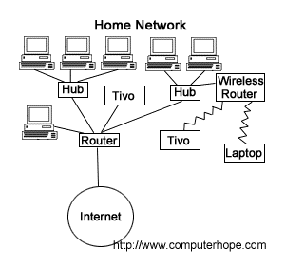

REPEATER

- A repeater is an object that increases a signal's strength, so it can be transmitted and received over a greater distance without a loss in quality. These devices are commonly used with networks to help the lines running between network devices reach farther destinations.

- They do not amplify the signal, they just copy the signal but by bit and regenerate it at original strength.



BRIDGE

- It is a device which connects two LANs or two segments of same LAN.
- They are protocol independent.
- There are two type of bridge:
  - Transparent : Bridge whose existence/status is not known to network.
  - Source Routing: Uses special frame to help in routing.



GATEWAY

- It acts as a passage through which two networks with different networking models can interact.
- They are also called protocol converters.
- It is the entry and exit point for a network as all data must be communicated through gateway before being routed.

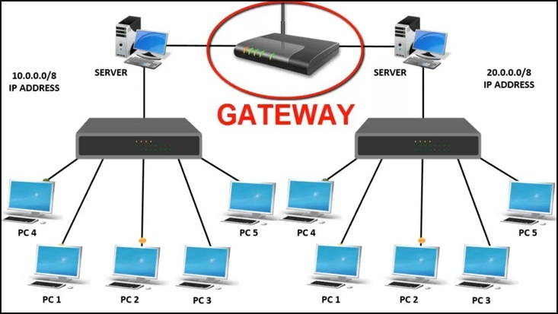

REFERENCES:

- https://www.computerhope.com/jargon/h/hub.htm
- https://whatismyipaddress.com/ip-address
- https://askleo.com/whats_the_difference_between_a_hub_a_switch_and_a_router/
- https://whatismyipaddress.com/hide-ip
- https://www.iplocation.net/public-vs-private-ip-address
- https://www.geeksforgeeks.org/network-devices-hub-repeater-bridge-switch-router-gateways/
- https://internetofthingsagenda.techtarget.com/definition/gateway

