Transmission Media/Network media

Transmission medium is a media over which communication takes place in computer networks. It mediates the propogation of signals for telecommunication purposes.

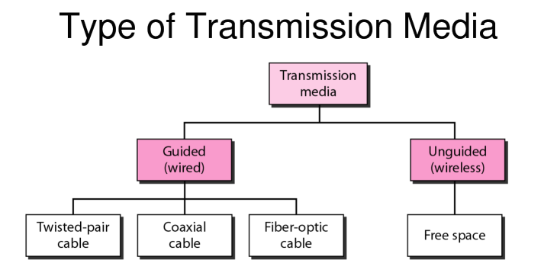
Transmission media are broadly classified into 2 types based on the medium of propogation i.e wired or wireless.

1) Guided Media/ Wires media:

Signals being transmitted are directed and confined in a narrow pathway by using physical links.

Features:
- High Speed
- Secure
- Used for shorter distances

a) Twisted Pair Cable-
Most widely used transmission media. Contains two pais bundled together in a protective sheath.They are of two types:

i) Unshielded Twisted Pair(UTP):
Ability to block interference and no physical shield. Used in telephonic applications.

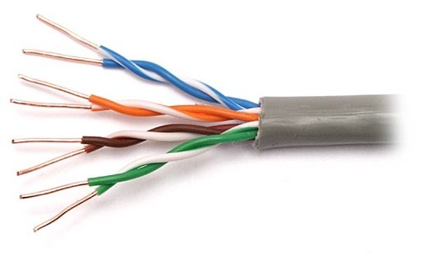

ii)Shielded Twisted Pair(STP):

Has special jacket to block external interference. Used in fast-data-rate ethernet and in voice and data channels.

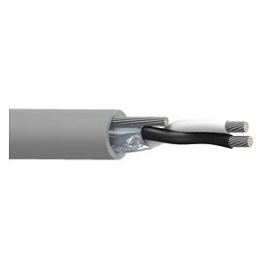

b) Coaxial Cable:
Has two parallel coductors having insulated cover. Has two modes: Baseband and Broadband. Cable TV and analog use Coaxial cables.

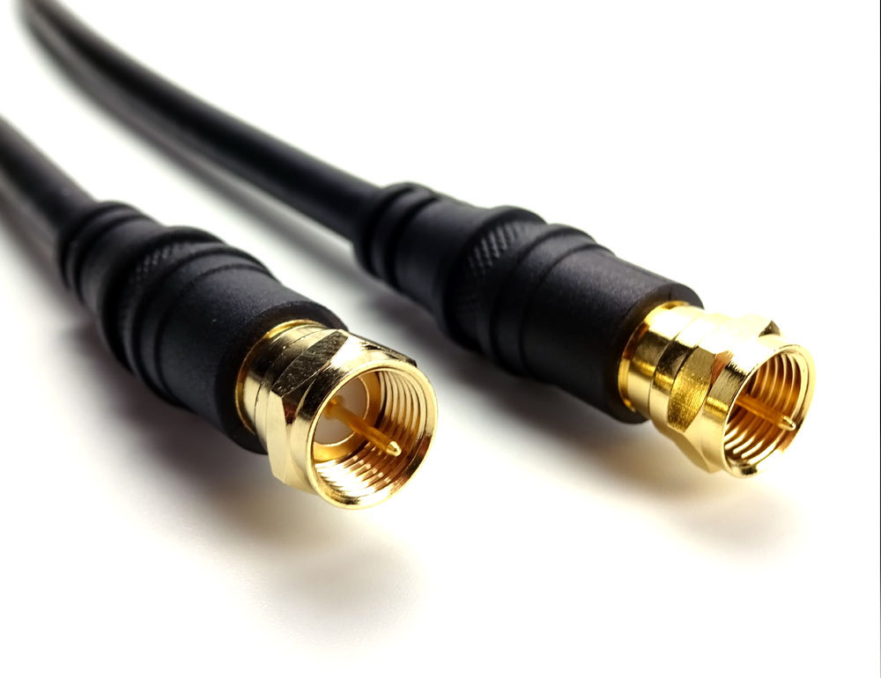

https://www.lifewire.com/ethernet-and-network-hubs-816358

c) Optical Fibre Cable:
Uses concept of reflection to pass light through a core made of glass or plastic. The density is varied to let the light travel by using refraction and core is surrounded by less dense material called cladding.
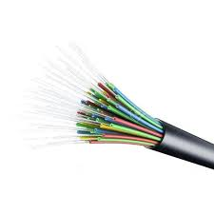

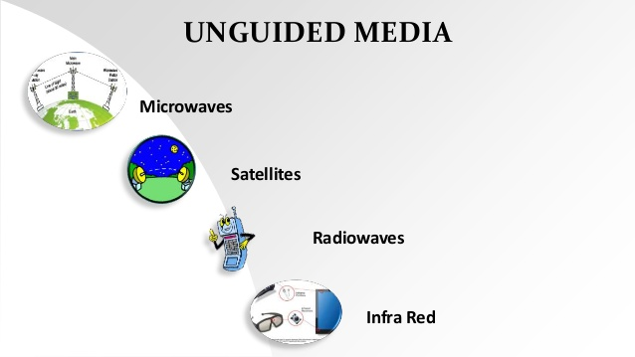

2) Unguided Media:
It refers to wireless mode of transmission through electromagnetic signals.

a) Radia waves:
Can penetrate through buildings and antennas need not be aligned for transmission. Has a range of: 3KHz – 1GHz.

b)Microwaves:
Has line of sight transmission. Frequency range: 1GHz – 300GHz. Used for mobile communication.

c)Infrared:
Used for short distance communication, cannot penetrate and prevents interference between systems. Frequency range: 300GHz – 400THz.

Network Devices:

Network devices are hardware/ physical devices that are required for communicaton in a computer network.

https://www.computerhope.com/jargon/h/hub.htm

TYPES:

HUBS
https://www.lifewire.com/ethernet-and-network-hubs-816358

SWITCHES
ROUTER
https://whatismyipaddress.com/ip-address
https://askleo.com/whats_the_difference_between_a_hub_a_switch_and_a_router/
https://whatismyipaddress.com/hide-ip
https://www.iplocation.net/public-vs-private-ip-address

REPEATER
BRIDGE
GATEWAY
https://internetofthingsagenda.techtarget.com/definition/gateway

BROUTER

