NAME-ABHAY SINGH BALORIA
ROLL NO-160117733061

EXPERIMENT -1
Q1-What are the major differences between MS-Windows and GNU/Linux?
Ans- DIFFERENCES-:
1. Linux is free and open source operating system whereas Windows is a commercial operating system whose source code is inaccessible.
2. Windows is not customizable as against Linux is customizable and a user can modify the code and can change its the look and feel.
3. Linux provides high security than windows because Linux is open source.
4. Windows must boot from the primary partition. In contrast, there is no such constraint in Linux it can be booted from either primary or logical partition.
5. The separation of the directories is done using a backslash in windows. On the contrary, in Linux, these are separated by using forward slash.
6. In Linux, file names are case sensitive while windows file name are case-insensitive.
7. Linux uses the monolithic kernel which consumes more running space whereas Windows uses the micro kernel which takes less space but system running efficiency is lower than Linux.

Q2. LINUX COMMANDS?
Ans- COMMANDS-:
a. FILE AND DIRECTORY COMMANDS-:

1. LS-It will tell all files and directories present in system.
SYNTAX-: ls
output-
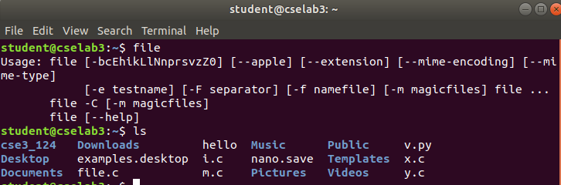
2. FILE- File command is used to determine the type of file.
Syntax-:file [option] [filename]
output-

3. MOVE- Move command is a command line utility that moves files or directories from one place to other
Syntax-: mv [oldname] [newname]

output-
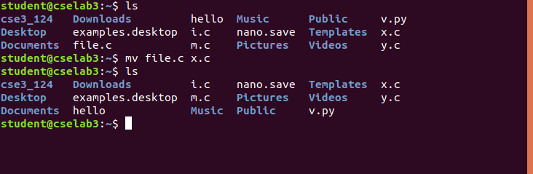
4. COPY- This copies the content of file or directory of first into second file or directory
Syntax-: cp file1 file2
or cp dir1 dir2
output-
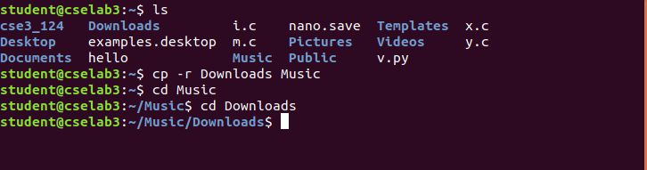
5. RM- RM Stands for remove here and is used to remove objects such as files,directories,symbolic links and so on.
Syntax – rm [option] [file]
output-
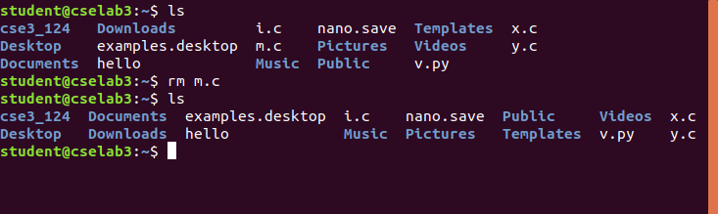
6 HEAD- Head command is used to print the first 10 lines of a file
Syntax-: head filename

output-
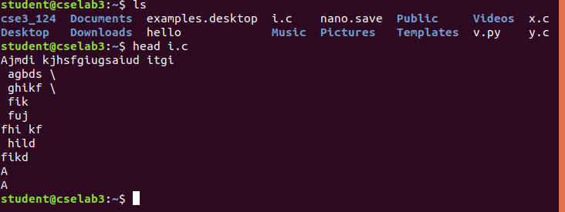
7. pwd- it is used to print present working directory.
Syntax-: pwd
output-
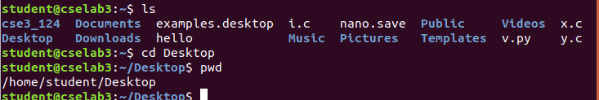
8. tail-This command is used to print last 10 lines of a file.
Syntax-: tail filename
outpiut-
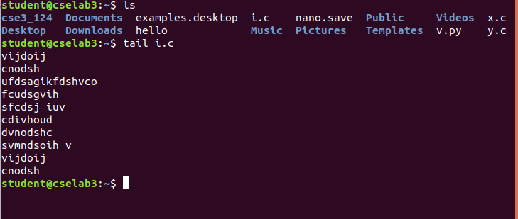
9. touch – This command is used to create a new file.
Syntax-: touch filename

output-
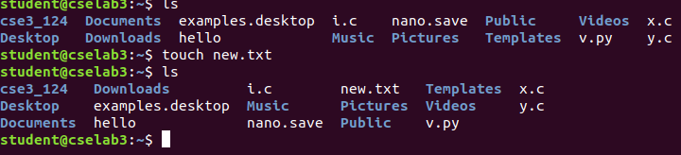
10. mkdir- This command is use to make a new directory, provided it doesn’t exist.
Syntax-: mkdir dirname
ouput-
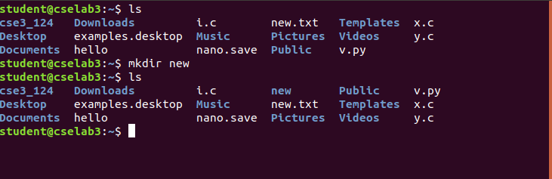
b. PROCESS MANAGEMENT COMMANDS-;

1.PS- The ps command lists all running process.
Syntax-: ps [option]
output-
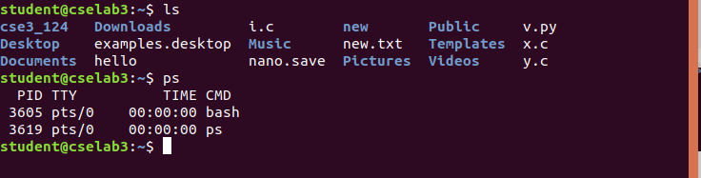
2. TOP- The top command is a traditional way to view your system resource usage and see the processes that sre taking of the most system resources.
Syntax-: top

output-
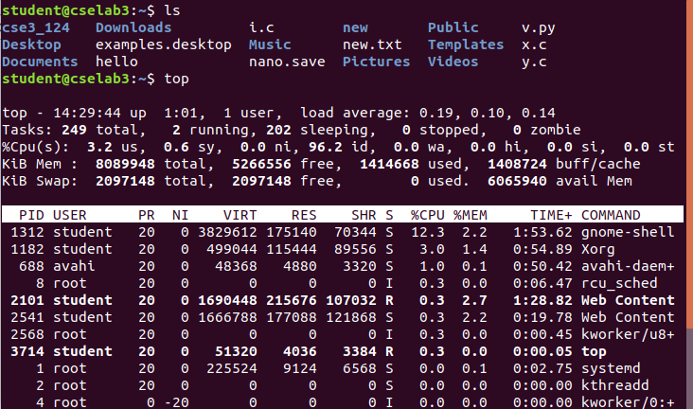
3. kill- The kill command can kill a process, given its process id.
Syntax-:kill processid
output-
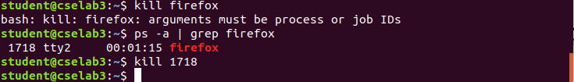
4. pgrep-Given a search term, pgrep returns the process IDs that match it.
Syntax- pgrep processid
output
C. SEARCH COMMANDS
COMMANDS:
1.GREP:The grep command search the line from given file.
Syntax: grep ‘word’ filename

output:
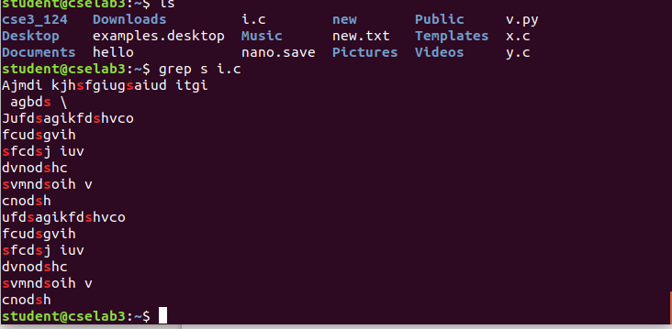
2.FIND: The find command in UNIX is a command line utility for walking a file hierarchy. It can be used to find files and directories and perform subsequent operations on them. It supports searching by file, folder, name, creation date, modification date, owner and permissions. By using the ‘-exec’ other UNIX commands can be executed on files or folders found.
Syntax: find [where to start searching from]
output-

3.LOCATE : it is the simplest way to find loaction of files
Syntax : locate file

output:
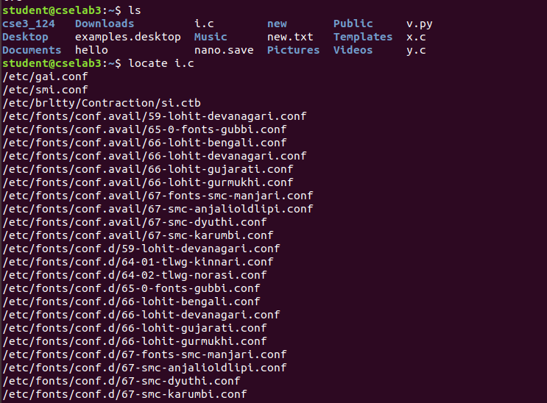
D.SYSTEM INFORMATION COMMANDS
COMMANDS
1.UNAME:To know only system name, you can use uname command without any switch will print system information .
SYNTAX: uname [option]
output:
2.LSHW:Here you can use the lshw tool to gather vast information about your hardware components such as cpu, disks, memory, usb controllers etc.
SYNTAX:sudo lshw [option]
To print information about your Linux system hardware, run this command.
Output:
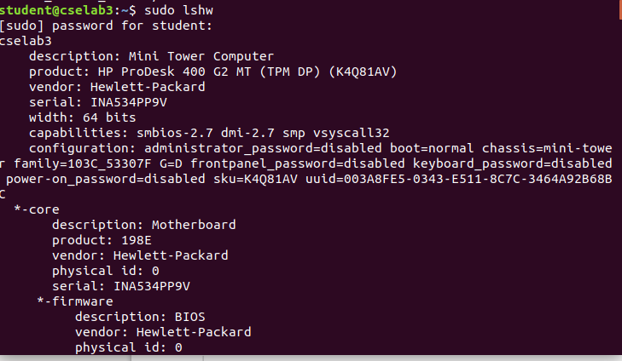
You can print a summary of your hardware information by using the -short option.

Output:
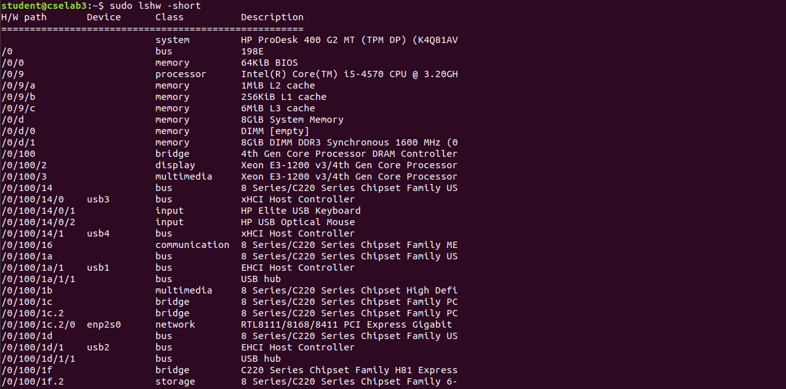
3.LSCPU:To view information about your CPU, use the lscpu command as it shows information about your CPU architecture such as number of CPU’s, cores, CPU family model, CPU caches, threads, etc from sysfs and /proc/cpuinfo.
Syntax:lscpu

output:
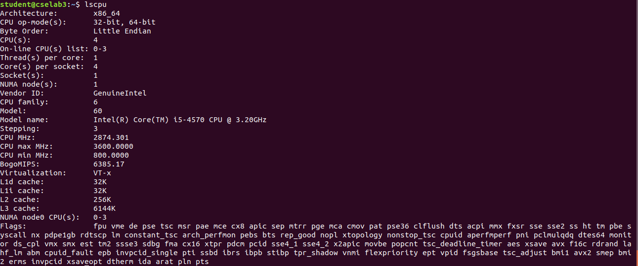
E. NETWORK RELATED COMMANDS:

COMMANDS:

1) Ping : ping command is used to ensure that a computer can communicate to a specified device over the network. ping command sends Internet Control Message Protocol(ICMP) Echo request messages in the form of packets to the destination computer and waits inorder to get the response back.

Syntax: ping sitename

output:
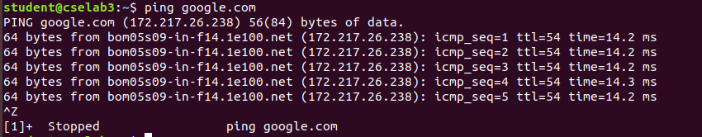

2) nslookup: nslookup command queries the DNS in order to fetch the IP address or the domain name from DNS records.
Syntax: nslookup sitename

output:

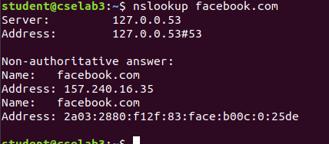

3) host: host command is used to find domain name associated with the IP address or find IP address associated with domain name. The returned IP address is either IPv4 or Ipv6.
Syntax: host sitename

output:

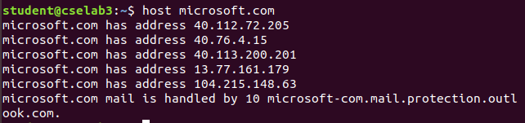

E. INSTALLATION RELATED COMMANDS:

COMMANDS:

1) Install : used to install various softwares and stuff.

Syntax: apt get install something

output:

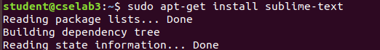
F. SYSTEM CONFIGURATON COMMANDS:

1. CAT/PROC/VERSION- It will tell the version present in system.
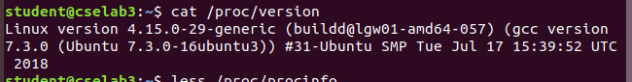

2 DF- command that displays the amount of disk space available on the file system containing each file name argument.

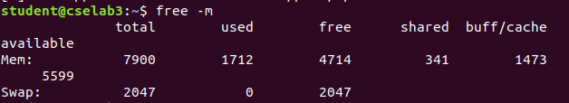
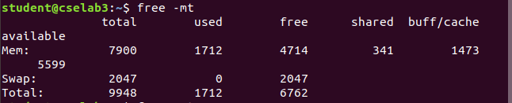
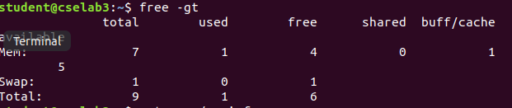
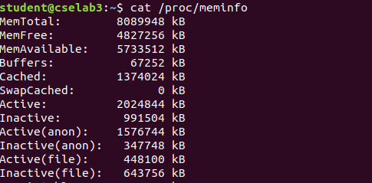
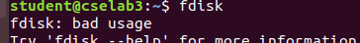
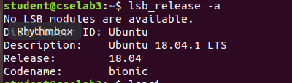
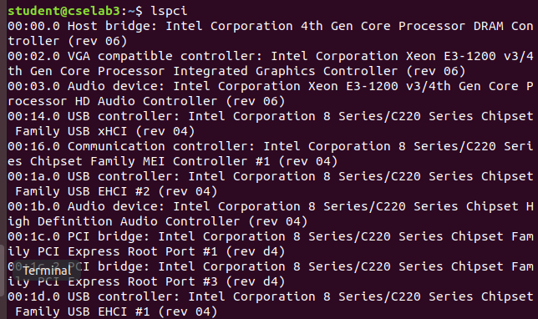
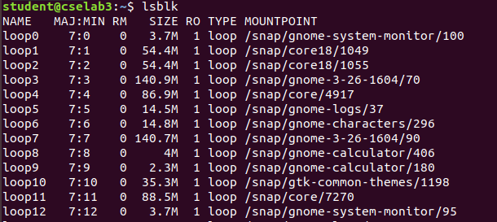
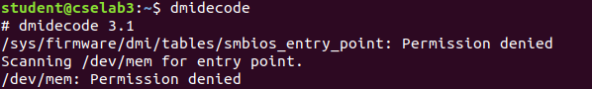
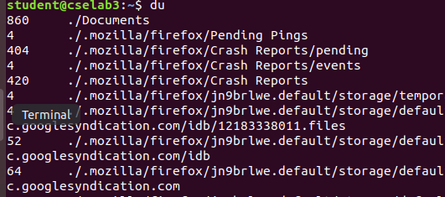
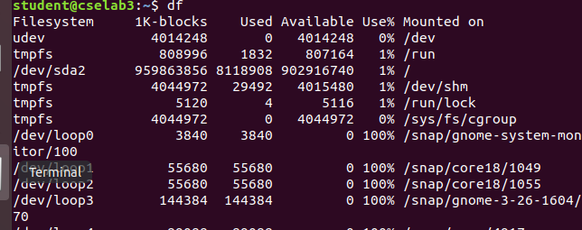

3. du-du command, short for disk usage, is used to estimate file space usage.
4. dmidecode-command which is used to retrieve the useful information of your system's hardware components in human readable format

5. lsblk-The lsblk command in Linux lists block devices.
6. lspci-lspci is a utility for displaying information about all PCI buses in the system and all devices connected to them.

7. lsb_release -a - how to check what version of CentOS is running on your system.

8. fdisk-With the help of fdisk command you can view, create, resize, delete, change, copy and move partitions on a hard drive using its own user friendly text based menu driven interface.

9. cat/proc/meminfo-‘/proc/meminfo‘ is used by to report the amount of free and used memory (both physical and swap) on the system as well as the shared memory and buffers used by the kernel.

10. free -gt -it will tell memory used,free,shared and buffer in gigabytes.

11. free -mt -It will tell available memory,total,used,free,shared and buffer memory in megabytes.

12. less/proc/cpuinfo-The /proc/cpuinfo file contains details about individual cpu cores. Output its contents with less or cat.

Experimental results:
System (Host name, Desktop Environment, Kernel, OS name, bits):
hostname-cselab3-02
desktop environment-ubuntu
kernel-4.13.0-46-generic
os name-linux
bits-64
Machine (Type, Brand, Model)
:type-x86_64
brand-intel (R) core i5
model-60
Battery (If applicable)
:
CPU
:cpu (s)-4

Speed
:3600 mhz
RAM
:
Drives
:
Partition
:
Graphics
:
Audio
:
Network
:
Sensors
:
Information :

