INTERPROCESS COMMUNICATION IN LINUX

Aim: To identify and understand various Inter Process Communication methods in Linux

Description:
The Linux IPC (Inter-process communication) facilities provide a method for multiple processes to communicate with one another. There are several methods of IPC available to Linux C programmers:
- Half-duplex UNIX pipes
- FIFOs (named pipes)
- SYSV style message queues
- SYSV style semaphore sets
- SYSV style shared memory segments
- Networking sockets (Berkeley style) (not covered in this paper)
- Full-duplex pipes (STREAMS pipes) (not covered in this paper)
These facilities, when used effectively, provide a solid framework for client/server development on any UNIX system (including Linux).
Pipes: A pipe is a method of connecting the standard output of one process to the standard input of another. Pipes are the eldest of the IPC tools, having been around since the earliest incarnations of the UNIX operating system. They provide a method of one-way communications (hence the term half-duplex) between processes.
This feature is widely used, even on the UNIX command line (in the shell).
ls | sort | lp
The above sets up a pipeline, taking the output of ls as the input of sort, and the output of sort as the input of lp. The data is running through a half duplex pipe, traveling (visually) left to right through the pipeline.
A pipe can be created by the pipe() system call
Syntax:
int pipe(int fd[2]);
When a process creates a pipe, the kernel sets up two file descriptors for use by the pipe. One descriptor is used to allow a path of input into the pipe (write), while the other is used to obtain data from the pipe (read). At this point, the pipe is of little practical use, as the creating process can only use the pipe to communicate with itself. Consider this representation of a process and the kernel after a pipe has been created:
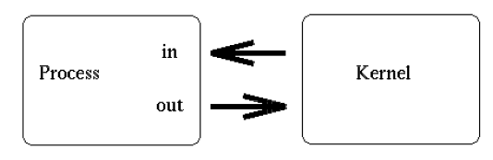
From the above diagram, it is easy to see how the descriptors are connected together. If the process sends data through the pipe (fd0), it has the ability to obtain (read) that information from fd1.
Whenever a process creates a child process, the child process will inherit any open file descriptors from the parent, so it forms the basis for multiprocess communication (between parent and child). Consider this updated version of our simple sketch:
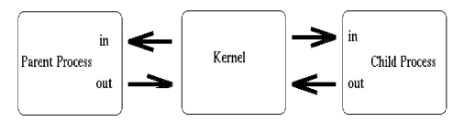
Above, we see that both processes now have access to the file descriptors which constitute the pipeline. It is at this stage, that a critical decision must be made. In which direction do we desire data to travel? Does the child process send information to the parent, or vice-versa? The two processes mutually agree on this issue, and proceed to ``close'' the end of the pipe that they are not concerned with. For discussion purposes, let's say the child performs some processing, and sends information back through the pipe to the parent. Our newly revised sketch would appear as such:
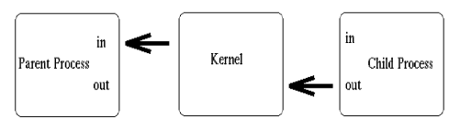
Construction of the pipeline is now complete! The only thing left to do is make use of the pipe. To access a pipe directly, the same system calls that are used for low-level file I/O can be used (recall that pipes are actually represented internally as a valid inode).
To send data to the pipe, we use the write() system call, and to retrieve data from the pipe, we use the read() system call.

Example1:
#include <stdio.h>
#include <unistd.h>
#include <sys/types.h>

int main(void)
{
int fd[2], nbytes;
pid_t childpid;
char string[] = "Hello, world!\n";
char readbuffer[80];

pipe(fd); //creates a pipe

if((childpid = fork()) == -1)
{
perror("fork");
exit(1);
}

if(childpid == 0)
{
/* Child process closes up input side of pipe */
close(fd[0]);

/* Send "string" through the output side of pipe */
write(fd[1], string, (strlen(string)+1));
exit(0);
}
else
{
/* Parent process closes up output side of pipe */
close(fd[1]);

/* Read in a string from the pipe */
nbytes = read(fd[0], readbuffer, sizeof(readbuffer));
printf("Received string: %s", readbuffer);
}
return(0);
}

Named Pipe
Program of reader and writer in Named pipe.
A named pipe works much like a regular pipe, but does have some noticeable differences.
- Named pipes exist as a device special file in the file system.
- Processes of different ancestry can share data through a named pipe.
- When all I/O is done by sharing processes, the named pipe remains in the file system for later use.
There are several ways of creating a named pipe. The first two can be done directly from the shell.
mknod MYFIFO p
mkfifo a=rw MYFIFO
The above two commands perform identical operations, with one exception. The mkfifo command provides a hook for altering the permissions on the FIFO file directly after creation. With mknod, a quick call to the chmod command will be necessary.

Program(Writer):-
#include<stdio.h>
#include<sys/types.h>
#include<sys/stat.h>
#include<unistd.h>
#include<fcntl.h>
void main(int argc,char *argv[])
{
char *s="/tmp/testfifo";
int fd;
mkfifo(s,0666);
fd=open(s,O_WRONLY);
write(fd,argv[1],sizeof(argv[1]));
close(fd);
unlink(s);
}

Program(Reader):-

#include<stdio.h>
#include<sys/types.h>
#include<sys/stat.h>
#include<unistd.h>
#include<fcntl.h>
#define BUF 1024
void main(int argc,char *argv[])
{
char r[BUF];
char *s="/tmp/testfifo";
int fd;
fd=open(s,O_RDONLY);
read(fd,r,BUF);
printf("\n%s",r);
close(fd);
}

TASK:To implement Echo Server using pipes

