Formulation-

**Metahuristic technique**-

* Evaluation of Objective function- Due to the nature of the decision variable denoting the city travelled in sequential order. There are a total of N+1 trips distance travelled I each trip is looked up with help of adj matrix and added to total.
* The last trip would be from city visited at Nth day back to the depot city.
* No of variable – N for TSP(single objective and multi objective) and N*M for mTSP





X(I,j) -N*N binary variable

U(I) – N Integer varable

X(I,j) -N*N binary variable

U(I) – N Integer varable

**Mathematical programming**

TSP

Miller–Tucker–Zemlin formulation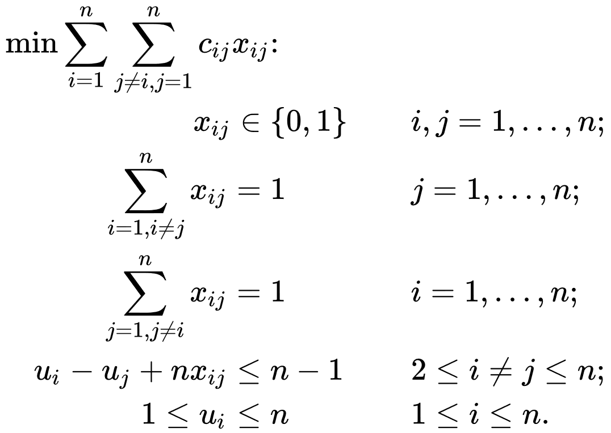

MTSP