**Setup**

You will need to create a JavaScript file to write our code in, and an HTML file so that we can execute our JavaScript in the browser. Open Visual Studio Code, and select ‘File > New File’ at the top to create files. The two files that you create should be saved to the same location, and should be named “worksheet.js” and “index.html”. Applying the correct extension to the file name (.js/.html) will create these files *as* JavaScript and HTML files respectively. Add the following code to your .html file:

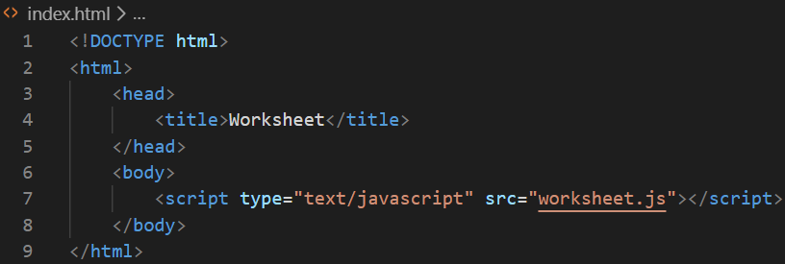

**Conditionals**

1. Driving Age
   1. Declare a variable and assign it the value of the legal driving age in the United States.
   2. Declare a variable to store a user's age. Use the built-in JavaScript *prompt()* function to retrieve the user’s age via user input.
   3. If the user’s age is greater than or equal to the legal driving age in the United States, then print to the console “You are legally able to drive.”
   4. If the user’s age is less than the legal driving age in the United States, print to the console “You are not old enough to drive yet.”
2. Random Number
   1. Declare a variable to store a random number between 0 and 10. You will need to do some research to determine how to generate a random number in JavaScript.
      1. A good search term to use: “random number JavaScript”
   2. If the number is between 0 and 2, print to the console “0 or 1 or 2”
   3. If the number is between 3 and 5, print to the console “3 or 4 or 5”
   4. If the number is between 6 and 8, print to the console “6 or 7 or 8”
   5. If the number is equal to 9 or 10, print to the console “9 or 10”
3. NFL Teams Switch-Case
   1. Declare a variable and assign it the value of “Packers”. This variable will be used for the “switch”.
   2. Build out a case for “Bears”, in which if selected it will print to the console “Quarterback much?”
   3. Build out a case for “Vikings”, in which if selected it will print to the console “Loud noises!”
   4. Build out a case for “Lions”, in which if selected it will print to the console “LOL! They bad!”
   5. Build out a case for “Packers” in which if selected it will print to the console “Best team in the world, actually the universe!”
   6. Reassign the switch variable to a different value other than “Packers” and see what prints to the console.