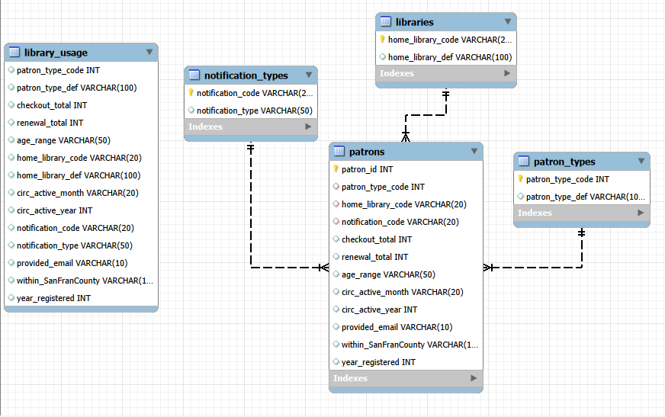

This is a diagram of how the database is structured and the relations that exist within it. The table on the left is the initial table that I used for importing all of the data. I didn’t modify this at all as I wanted the data to be as it was from the original file without any changes being made. It isn’t really a component of the final product, just here for reference on how it was created. The patron table is the primary table that is connected to the patron_types, libraries and notification_types with the use of foreign keys. One interesting thing I discovered during this was the best way to import large data sets. Initially I tried using MySQL Workbench to import the data. I let it run for over an hour before coming back to it and the progress bar hardly moved. Then I utilized Command Line and this went significantly faster, only taking a couple of minutes to import the entire dataset. After this initial importation, I used Workbench to split up into tables and bringing the data over. Each split from the library_usage table only took approximately 20-30 seconds. Workbench was then used for the data manipulation and creation of the diagram as well.

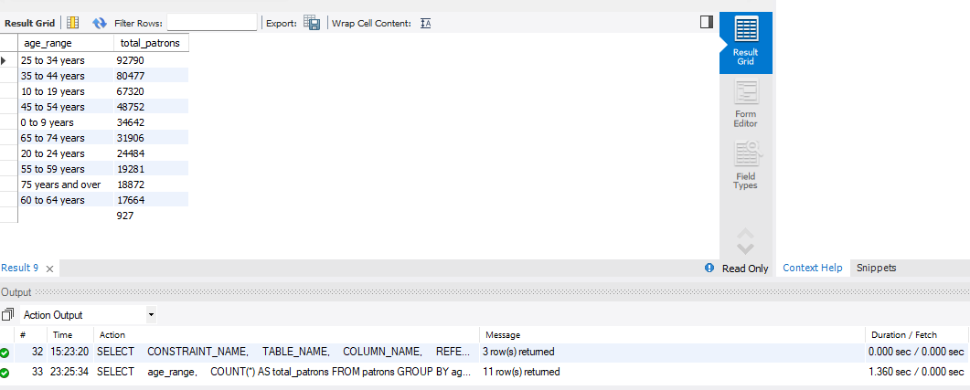

Here is a small example of the data findings. I quiried the database to find out how many patrons were in each age bracket. The total runtime for this script was about 1.4 seconds.

