1. **Future development study case: Manchester disabled people accessibility within the Transport Strategy 2040**

**1.1 Design**

The main objective of this section is to visualize the future interventions such as projects and plans that tackle the accessibility aspect within the Manchester Transport Strategy for 2040. This was made by finding within each policy and intervention any objective focussing the urban access issue.

Accessibility in relation to public transportation has a very wide literature, urban transport systems around the world have faced the challenges to bring everyone the possibility to move, both under the social lenses (Bocarejo and Oviedo, 2012), (Preston and Raje’ 2007) and disabled people accessibility (Hine, 2016). The urban environment in most of the developed countries faces also a strong increase in ageing population which demand for accessible ramps, safe pedestrian facilities, all urging an incorporation of accessibility plans into the strategic agenda (Sze and Christensen, 2017).

Recently, the Great Britain Department for Transport (2018) has released the *Inclusive Transport Strategy* which aims is to “improve accessibility across all types of travel for those with both visible and visible disabilities”. The ambition of this national initiative is to achieve a fully accessible transport system by 2030.

Under this light is was very interesting to investigate the Greater Manchester direction when is about transport accessibility (Transport for Greater Manchester, 2019). The strategy, specially focused to improve connectivity at regional and local level, sizes its 2040 goal to support long-term, sustainable economic growth and access to opportunity for all. The document states two sub-sections when is about accessibility, one regards the social aspect of “Access to Employment, Service and Leisure” and the other a more infrastructural value of ‘Improving Access’. The visualization in this case will be referred to this last sub-section, which tends to answer the needs of people commuting day by day, especially with public transport modes through the provision of more effective interchanges options from cycle parking to bus links and even car parking. The Strategy last section “Policies and Interventions” identifies a series of projects to be carried out by the 2040 term, figure 1. shows the interventions which contain access or accessibility as objectives.

*Figure 1. Interventions and Projects related to the accessibility objectives*

|  |  |  |  |  |  |  |
| --- | --- | --- | --- | --- | --- | --- |
|  | Intervention | Rationale | Cost (Low/ | 2040 Ref. | Completed | Type |
| 1 | Salford Bolton Network improvements, including bus priority at junctions | To create shorter, more reliable journey times for all road users and deliver better access to employment and local facilities for bus passengers. | M | W.02.01 | 2020 | Public Transport: Bus |
| 2 | Mobility Hubs/Park & Ride upgrades along the Bury Line (Radcliffe and Whitefield) | To provide better access to public transport through Mobility Hub/Park & Ride facilities. This in turn will encourage a modal shift in Greater Manchester. | L | N.01.07 | 2040 | Public Transport: Metrolink and Bus Rapid Transit |
| 3 | Additional Metrolink vehicles (27 new trams) and associated infrastructure - enabling the use of more double unit vehicles between Bury and Altrincham, and Shaw and East Didsbury. | To increase Metrolink capacity into and through the Regional Centre, in order to facilitate continuing economic growth and access to services and encourage mode shift. | M | RC.03.01 | 2020 | Public Transport: Metrolink and Bus Rapid Transit |
| 4 | Station accessibility improvements at Mills Hill | To maximise existing rail assets to provide better facilities, particularly for passengers with limited mobility. | L | N.01.02 | 2040 | Rail |
| 5 | Rail Station Accessibility Programme to deliver accessibility improvements at rail stations | To maximise existing rail assets to provide better facilities, improve transport integration and deliver community benefits. | M | N.01.01 | 2040 | Rail |
| 6 | Carrington Relief Road | To support growth in the Carrington area by improving accessibility to new developments. | M | W.09.13 | 2020 | Streets for All: Local Highways |
| 7 | City Centre Salford infrastructure improvement: New Bailey | To support the redevelopment and growth of Central Salford by delivering public realm and environmental improvements, alongside enhancements to public transport access and improvements to bus reliability. | L | RC.10.04 | 2020 | Streets for All: Walking and Cycling |
| 8 | Stockport Town Centre Access Plan | To tackle congestion in and around Stockport town centre and remove barriers to movement for all modes. | M | W.04.01 | 2020 | Integration: Town Centres & Interchanges |
| 9 | Ashton Interchange redevelopment | To increase the accessibility of Metrolink, bus and rail from nearby destinations, and increase the attractiveness of the Interchange as the focal point for intra-urban growth in Ashton town centre. | M | W.03.01 | 2020 | Integration: Town Centres & Interchanges |
| 10 | Stockport Interchange redevelopment | To increase the accessibility of bus and rail from nearby destinations and increase the attractiveness of the Interchange as the focal point for intraurban growth in Stockport town centre. | M | W.03.02 | 2020 | Integration: Town Centres & Interchanges |

The next step consisted in filtering all the projects that could have a better visualization. For this reason, Intervention 1 “Salford Bolton Network improvements”, Intervention 2 “Mobility Hubs/Park & Ride upgrades” and Intervention 8 “Stockport Town Centre Access Plan” were excluded as they have a more visionary value that would make their design complicated.

In order to import into MapBox all the interventions as “tilesets” and code the interactive features, an intermediate passage was needed to create the shapefiles. Since the Manchester Council has not released any of the vector file related to these projects, the only feasible way was to create them on the ArcMap software, helped also by OpenStreetMap database covering the Manchester area.

*Figure 2. ArcMap intermediate step to extract the shapefiles*

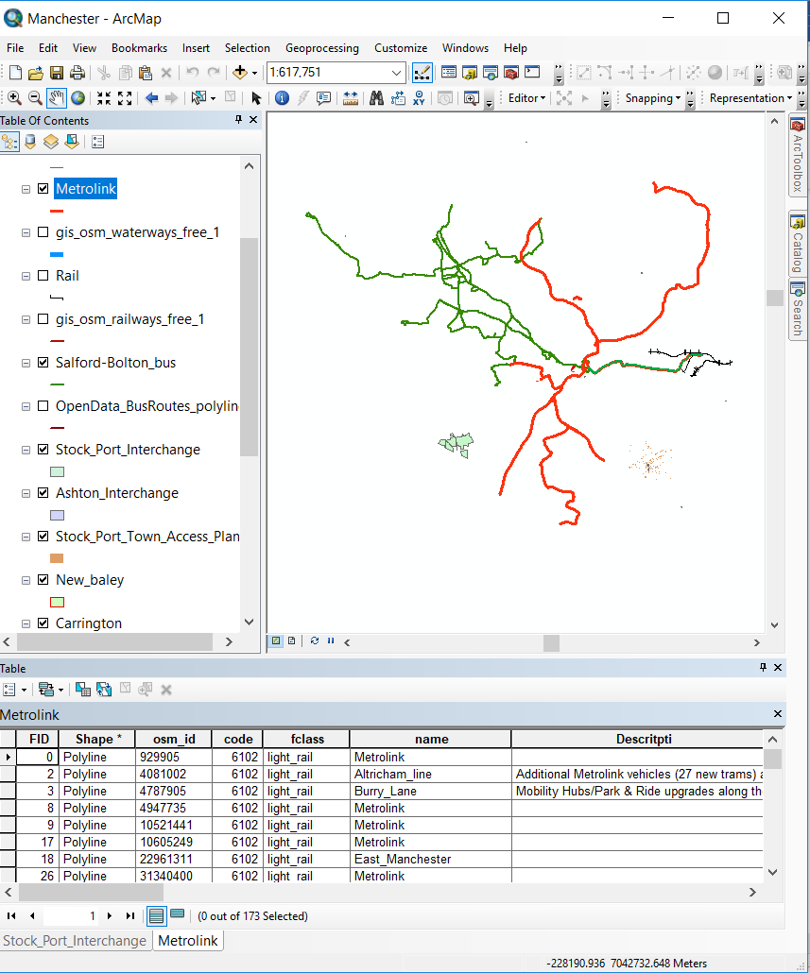

The zipped shapefiles then have been uploaded into Mapbox and added as layers to the map visualisation. Subsequently, a javascript file was creating adding all the codes required using the Mapbox GL libraries. Secondly for each layer (representing the interventions) a popup function was applied adapting the code from “Mapbox Examples” webpage (Mapbox, 2019a). Finally, adapting the code from the webpage “Fly to a location based on scroll position” (Mapbox, 2019b), a sliding bar was designed to show more information about each layer, the interactive aspect was guaranteed by using the “map.flyTo” function which zooms-in to each layer.

**1.2 Results**

The maps want to communicate the future projects related to the accessibility improvements, the web-page design is composed by two sliding columns and the central map showing the Greater Manchester area and the seven layers showing the above-mentioned interventions.

*Figure 3. Final visualization of the strategic interventions*

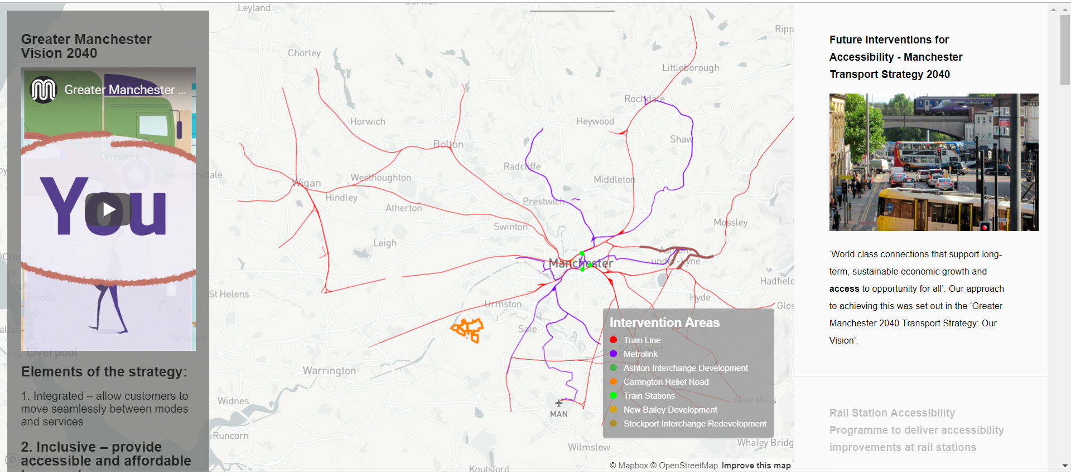

The left column gives some general indications about the Manchester 2040 Strategy and emphasize the second pillar about inclusive-accessible idea. The right-hand-side column give more information about each intervention, the vertical sliding bar jumps to each of the intervention areas when scrolling down to the next section.

**Bibliography**

Bocarejo S., J.P., Oviedo H., D.R., (2012) Transport accessibility and social inequities: a tool for identification of mobility needs and evaluation of transport investments. Journal of Transport Geography, Special Section on Theoretical Perspectives on Climate Change Mitigation in Transport 24, 142–154. <https://doi.org/10.1016/j.jtrangeo.2011.12.004>

Great Britain. Department for Transport (2018) ‘Inclusive Transport Strategy’ Available at: <https://assets.publishing.service.gov.uk/government/uploads/system/uploads/attachment_data/file/728547/inclusive-transport-strategy.pdf> (Accessed: 10 May 2019)

Hine, J., (2016) Mobility and Transport Disadvantage [WWW Document]. Mobilities: New Perspectives on Transport and Society. <https://doi.org/10.4324/9781315595733-7>

Mapbox (2019a) ‘Display a popup on click’ Available at: <https://docs.mapbox.com/mapbox-gl-js/example/popup-on-click/> (Accessed: 10 May 2019)

Mapbox (2019b) ‘Fly to a location based on scroll position’ Available at: <https://docs.mapbox.com/mapbox-gl-js/example/scroll-fly-to/> (Accessed: 10 May 2019)

Preston, J., Rajé, F., (2007) Accessibility, mobility and transport-related social exclusion. Journal of Transport Geography 15, 151–160. <https://doi.org/10.1016/j.jtrangeo.2006.05.002>

Sze, N.N., Christensen, K.M., (2017) Access to urban transportation system for individuals with disabilities. IATSS Research, Safe and Sustainable Transport for All 41, 66–73. <https://doi.org/10.1016/j.iatssr.2017.05.002>

Transport for Greater Manchester (2019) ‘The Greater Manchester Transport Strategy 2040’ Available at: <https://downloads.ctfassets.net/nv7y93idf4jq/7FiejTsJ68eaa8wQw8MiWw/bc4f3a45f6685148eba2acb618c2424f/03._GM_2040_TS_Full.pdf> (Accessed: 10 may 2019)