  - DIPLOMA PROJECT

Development of an Electronic Document Flow System
  - Analysis and design package for the first pre defense

Project team
Qazybai Ali
SE-2424
Saqyp Dias
SE-2417

Supervisor
Askar Khaimuldin

Submission
24 October 2026
Prepared 19 October 2026
Updated 22 October 2026
Proposed requirements baseline 0.1
This package contains the project proposal, source review, comparisons, testable requirements, architecture, prototype, evaluation plan and management materials. User discussions and supervisor feedback remain pending until their actual evidence is recorded.

Reading guide
The proposed solution is a small departmental document approval system. The current deliverable is analysis, design and an interactive browser prototype. The full application belongs to the later implementation phase. All assumptions, unmeasured targets and missing real-world evidence are identified in the relevant sections.
1 Project proposal
2 Evidence of relevance
3 Literature review
4 Existing system comparison
5 Technology comparison and decisions
6 Requirements specification
7 Architecture and diagrams
8 UX and prototype
9 Verification and evaluation plan
10 Project management and risks
11 Supervisor feedback and submission readiness
12 References

Package navigation
README.md explains how to run the prototype and tests. docs/ contains editable section sources. diagrams/ contains .drawio sources and readable exports. management/ contains backlog, interview and supervisor forms, study templates and the submission record. evidence/ records sources and actual verification. config/ holds the proposed schema and safe configuration example.

Project proposal

Project identity
Title: Development of an Electronic Document Flow System. Students: Qazybai Ali, SE-2424, and Saqyp Dias, SE-2417. Supervisor: Askar Khaimuldin. Submission stage: first pre-defense, 24 October 2026. Working product name: EDFS.
This package proposes a departmental web system that keeps a document, its versions and the decisions made about it together. It includes analysis, a proposed architecture, an interactive browser prototype and an evaluation plan. The organisation and its actual process have not yet been selected. The small-department setting is a design assumption that requires confirmation through interviews.

Problem and target users
The working problem hypothesis is that employees who coordinate documents through separate files and messages can lose track of the current version, responsible reviewer and final decision. This has not been demonstrated in a real client organisation. Published EDMS and BPM studies justify investigating this class of problem, but do not verify the hypothesis for our users [S01–S03, S06].
Primary users are employees who prepare internal memoranda, requests and policies, reviewers who decide on assigned documents, and an administrator who manages access and archives approved records. The intended pilot is one department with 10–30 users. This range is a capacity assumption, not an observed client count.

Aim and objectives
The aim is to design and evaluate a web system that makes departmental document approval traceable and reduces the effort required to identify document status and complete routine processing.
1. Validate the problem through 3–5 discussions with representatives of the proposed user roles, or a substantive client agreement.
2. Review scientific approaches and compare four existing products before confirming the project requirements.
3. Specify testable functional and non-functional requirements and a consistent architecture.
4. Prototype the author, reviewer and administrator journeys, including failed and returned reviews.
5. Implement the later backend with controlled versions, server-side permissions and an audit trail.
6. Compare the implemented system with a shared-folder and message baseline under the evaluation protocol in this package.

Scope and engineering complexity
In scope: internal documents, metadata search, immutable version snapshots, one assigned reviewer per submission, return with a reason, resubmission, approval of a specific version, archive, role and relationship checks, activity export and planned in-app notifications. Complexity comes from coordinating permissions, version consistency, concurrent decisions, durable audit events and recoverable storage.
Out of scope for the initial system: legally qualified electronic signatures, state-service integration, public document exchange, OCR, AI classification, simultaneous editing, complex parallel or multi-level routes, and automated legal retention decisions. Approval is an operational decision, with no claim of legal signature equivalence. Existing approved records remain read-only. A later amendment creates a separate document linked to its predecessor.
Expected outcomes: an evidence-backed requirements baseline, a documented architecture, a tested implementation in the later diploma phase, a usable prototype now, reproducible test materials and a measured comparison. Target improvements are hypotheses until measured.

Working assumptions
The department can use a modern browser and nominate a reviewer and administrator. A single-stage route is sufficient for the first pilot. English labels are acceptable for the prototype. The team can learn the proposed backend stack. Each assumption must be accepted, revised or rejected in the evidence log after user and supervisor review.

Evidence of relevance

Current evidence status
Verified inputs are the supplied committee checklist, the project title, the two students and their groups, and the supervisor name supplied by the user. External publications and official product documentation support the analysis. No interviews, client agreement, organisational observations or operational dataset were provided. Local relevance is therefore not yet verified and this criterion remains open.

Findings and assumptions register
ID | Statement | Evidence status | Effect on the project
E01 | EDMS adoption involves organisational and human factors | Literature synthesis [S01, S02] | Include onboarding and adoption questions
E02 | Existing products support document automation | Official documentation [S09–S15] | Compare configuration before proposing custom development
A01 | Users struggle to identify the latest version | Untested local hypothesis | Ask for a recent concrete example
A02 | One reviewer per submission is sufficient | Untested scope assumption | Confirm route and exceptions
A03 | A department needs 10–30 accounts | Planning assumption | Revise pilot capacity after discussions
A04 | Status lookup and routing can become faster | Evaluation hypothesis | Measure matched tasks against baseline

Discussion protocol
Recruit 3–5 distinct representatives, ideally two document authors, one or two reviewers and one administrator or records officer. A substantive agreement with an actual client is an alternative allowed by the checklist, but it must define the workflow and requirements in enough detail. No participant identities or findings should be invented.
Explain the student project, request voluntary participation and permission for notes, and use participant codes instead of names in the repository. Do not collect confidential documents. Each discussion should last approximately 20–30 minutes and use an anonymised example supplied with permission or a synthetic example.
1. Describe the last internal document you prepared or reviewed and each step it followed.
2. How did you identify the latest version, reviewer and final decision?
3. Where did delays, duplicate versions or missing information arise? Ask for an example rather than suggesting an answer.
4. Which document types, metadata and deadline rules are essential?
5. Who may view, modify, approve and archive a document? What happens when someone is absent?
6. What happens after requested changes, an incorrect approval or an expired deadline?
7. Which existing tools do you use and what would make configuration of those tools sufficient?
8. Perform the prototype tasks. Which steps are unclear and what is missing?

Evidence and requirement conversion
Record participant code, role, date, consent, process description, anonymised supporting example, observation or short quotation, confidence and candidate requirement IDs. Separate what the participant said from the team's interpretation. Compare accounts across roles and record contradictions. Promote a hypothesis to a confirmed requirement only after its evidence reference and acceptance criterion are recorded. A single person's preference does not establish organisation-wide policy.
The prepared interview form, blank evidence log and decision register are in management/. Their empty status is intentional. After collection, amend FR priorities, architecture and prototype, then request supervisor review. Raw identifiable notes remain outside the public repository.

Literature review

Review questions and selection
This targeted scoping review asks which EDMS adoption issues matter, how workflow correctness should be represented, and how access control affects document processing. Searches on 19 October 2026 used combinations of electronic document management system, electronic records, workflow, business process management, digital transformation, authorization and access control. Publisher pages, author-hosted papers and official technical documentation were preferred.
The scientific core contains eight publications. Six date from 2022–2024 and fall within the preceding five years. Two foundational papers from 1996 and 1998 explain RBAC and explicit workflow reasoning. Technical documentation supports implementation decisions but does not count toward the eight scientific publications. The complete register contains 25 meaningfully used sources.
Selection required identifiable authors, a scholarly venue and a direct connection to the review questions. Broad promotional articles and unverifiable papers were excluded. This is not a claimed exhaustive database search or a PRISMA systematic review. Some publisher pages expose only abstracts and selected sections. The table states the inspected evidence, and no detailed findings beyond that evidence are asserted. Before final diploma submission, deepen the review with full texts and record any changed conclusions.

Structured analysis of scientific publications
Source | Method and inspected material | Finding and limitation | Design consequence
S01 2024 | Cross-sector EDMS literature synthesis. Publisher abstract and citation record. | Adoption depends on technical, individual and organisational factors as well as trust. Heterogeneous sectors cannot establish the needs of the proposed department. | Add adoption questions to interviews and test the complete review journey.
S02 2022 | Review of ten EDMS studies from 2015–2020. Publisher abstract and method summary. | Document storage, distribution and security support knowledge work alongside capable staff. Two databases and an older evidence window restrict coverage. | Use searchable metadata and onboarding tasks rather than treating storage alone as success.
S03 2024 | Systematic review selecting 34 articles. Publisher abstract and author manuscript identification. | Process management and digital transformation interact at organisational and technical levels. Broad BPM findings do not prove a particular document approval design will help. | Model the existing and proposed process and evaluate task time against a baseline.
S04 2022 | Classification of access control models. Publisher abstract and findings summary. | Policy models and enforcement mechanisms need distinct definitions. A classification cannot establish that one implementation enforces its policy. | Specify role plus ownership checks and test direct access to each protected resource.
S05 2023 | Bibliometric analysis of 326 papers from 2007–2022. Publisher abstract and methods sections. | BPM and transformation form a broad growing research field. Citation networks describe research attention rather than measured organisational benefit. | Keep the project contribution narrow and evaluate observable workflow outcomes.
S06 2024 | Review of 40 process redesign case studies. Publisher abstract and conclusion excerpts. | Capabilities can inform process redesign beyond replacing existing technology. Cross-case mappings need local validation and do not predict our effect size. | Use explicit ownership, a frozen review version and visible next action as redesign hypotheses.
S07 1996 | Family of RBAC reference models. Author paper hosted by NIST. | Permissions attach to roles and users receive role memberships. Basic role membership alone cannot express every document relationship. | Combine a small role set with ownership and assignment predicates. Retained as a foundation.
S08 1998 | Formal workflow modelling and verification. Author paper and academic bibliographic record. | Explicit process logic supports reasoning about valid progress and termination. The proposed finite-state workflow is simpler and has not undergone a Petri-net proof. | Enumerate transitions and test invalid paths and completion. Retained as a foundation.

Critical synthesis
EDMS reviews [S01, S02] support treating adoption and staff capability as part of the problem. They do not establish a local frequency of lost documents or a numerical efficiency gain. Accordingly, we retain usability and onboarding requirements and leave local relevance open until discussions occur.
BPM work [S03, S05, S06] supports analysing a process before automating it. Bibliometric activity is not evidence that our system improves performance. The project therefore selects concrete tasks and a baseline rather than claiming innovation because it uses a web interface. The custom-system hypothesis is a small, visible approval journey with ownership, a frozen review version and a recorded next action.
The access-control review and RBAC foundation [S04, S07] motivate a distinction between role membership and document relationships. A reviewer role does not grant permission to decide every document. Ownership and reviewer assignment must be checked for read, edit and decision operations. The architecture uses one policy service and negative tests for object-level access.
Explicit workflow logic [S08] informs a transition table and tests for forbidden paths. This project uses a finite-state model and does not claim formal Petri-net verification. Its key invariants are that a decision references a fixed version, only the assigned reviewer can decide, and archived documents cannot be edited.
The resulting contribution is an engineering design and evaluation for a bounded departmental setting. The publications do not prove that a new product is commercially superior to established systems. That decision remains conditional on local evidence and a build-versus-configure checkpoint.

Existing system comparison

Selection and evidence basis
Four relevant systems cover hosted collaboration, self-hosted file collaboration and dedicated document management: SharePoint with Power Automate, Nextcloud with Flow, Mayan EDMS and Paperless-ngx. The same eight criteria apply to all. Documentation was checked on 19 October 2026. This is a documentation review, not a hands-on benchmark, security audit or price quotation.
Legend: D means documented capability, C means configuration or an additional component is needed, and U means the exact behaviour was not verified in the inspected pages. U does not mean absent. Product configuration, edition and future versions can change results.
Criterion | SharePoint and Power Automate | Nextcloud and Flow | Mayan EDMS | Paperless ngx
Document lifecycle automation | C approval flow [S09] | C Flow rules [S11] | D workflow feature [S13] | D pipeline workflows [S14]
Human approval pinned to version | D ETag in documented flow [S09] | U exact approval semantics | U exact version binding | U human review semantics
Version history | D library version history [S10] | D versions with expiry rules [S12] | D document versions [S13] | U authoring version semantics
Access control | C library and approver permissions [S09] | C file access rules [S11] | D granular permissions [S13] | D user and object permissions [S14]
Metadata organisation | D library and item context [S09] | D tagging through Flow [S11] | D metadata and indexes [S13] | D tags and custom fields [S14]
Decision or activity evidence | D flow outcome and comments [S09] | U complete decision history | D event tracking [S13] | D document audit log [S14]
Automation interface | D SharePoint connector [S09] | C Flow configuration [S11] | D HTTP REST API [S13] | D REST API [S15]
Deployment and administration | C Microsoft 365 environment | C self-hosted server or provider | C dedicated deployment | C dedicated deployment

Interpretation and build versus configure decision
The comparison shows substantial overlap with the proposed project. It does not justify claims that alternatives lack permissions, workflows or audit features. SharePoint provides an explicit example of version-aware approval. Mayan is a strong candidate for a configuration trial. Paperless focuses on ingestion and document organisation in the inspected workflow documentation, so equivalence to an author–reviewer lifecycle needs testing. Nextcloud's automatic version expiry requires checking against the desired record policy.
Our provisional reason to build is educational engineering work around a narrow approval workflow with inspectable rules, a consistent user journey and an evaluation baseline. Commercial necessity is unproven. After interviews, spend one time-boxed session configuring the mandatory scenario in SharePoint or Mayan. Record route setup effort, version binding, access isolation and recovery from requested changes. If configuration satisfies the mandatory requirements with acceptable administration, recommend adaptation or narrow the custom contribution with supervisor agreement.
The proposed prototype illustrates a design choice; it is not a fifth production competitor and has not met production security or storage requirements. No product price, compliance certification or unsupported absence claim forms part of the comparison.

Technology comparison and decisions

Decision method
The proposed production design is a modular Django web application using PostgreSQL and HTTP requests with JSON where asynchronous browser actions are needed. The delivered browser prototype deliberately uses plain HTML, CSS and JavaScript with local browser storage. It explores interaction and transition rules and does not implement the proposed backend.
Scores below are team planning judgements on a scale from 1, weak fit, to 5, strong fit. They are not performance measurements or objective product rankings. Weighted totals equal the sum of score multiplied by criterion weight. Team familiarity has not been demonstrated, so learning effort is provisional. Revisit after a small implementation spike and supervisor review.

Server platform decision ADR 001
Requirements driving this decision are authenticated sessions, role and object checks, transactional updates, simple administration and a two-person scope. Django provides integrated authentication and security facilities [S16]. FastAPI provides validation and dependencies but needs choices for persistence and administration [S17]. NestJS provides structured modules and authorization patterns [S18]. None automatically enforces our document ownership policy.
Criterion and weight | Django | FastAPI | NestJS
Integrated authentication and security 30 percent | 5 | 3 | 4
Delivery effort for this scope 30 percent | 5 | 4 | 3
Transactional workflow implementation 20 percent | 4 | 4 | 4
Estimated learning effort 20 percent | 4 | 4 | 3
Weighted total out of 5 | 4.60 | 3.70 | 3.50

Decision: Django, provisionally using the documented 5.2 LTS line with an updated patch selected at implementation. Use server templates initially and small browser scripts. Consequence: fewer separately deployed components, with explicit application-level object checks. Reconsider if the team demonstrates substantially stronger TypeScript capability or an API integration dominates the requirements. Package versions and patch support must be checked and pinned before implementation.

Data storage decision ADR 002
PostgreSQL supports explicit row locks and text search [S19, S20]. SQLite simplifies a small local deployment but has a different write-concurrency profile [S21]. MongoDB supports transactions [S22], so it is not excluded for lacking them; its document model offers less benefit for our relational version and review model.
Criterion and weight | PostgreSQL | SQLite | MongoDB
Relational integrity fit 40 percent | 5 | 5 | 3
Concurrent approval control 30 percent | 5 | 2 | 4
Search fit 20 percent | 5 | 3 | 4
Operational simplicity 10 percent | 3 | 5 | 3
Weighted total out of 5 | 4.80 | 3.70 | 3.50

Decision: PostgreSQL with document, version, review and audit tables. Use a private object store for binary content and keep hashes and storage keys in the database. An upload remains quarantined until validation succeeds. Database transactions alone do not atomically commit an object-store write, so staged upload and cleanup are necessary. PostgreSQL 17 is the design baseline, pending environment confirmation and a supported patch choice.

Component interaction decision ADR 003
The browser needs immediate confirmation of a small number of commands. HTTP request and response semantics are adequate [S23]. gRPC is a reasonable typed service-to-service alternative but adds client and transport tooling for this scope. RabbitMQ is appropriate for asynchronous messaging but introduces acknowledgements, retries and duplicate handling [S24].
Criterion and weight | HTTP and JSON | gRPC | RabbitMQ messages
Fit for browser commands 40 percent | 5 | 3 | 2
Implementation simplicity 30 percent | 5 | 2 | 2
Inspection and debugging 20 percent | 4 | 3 | 3
Future distribution 10 percent | 4 | 5 | 5
Weighted total out of 5 | 4.70 | 2.90 | 2.50

Decision: synchronous HTTP for commands and queries within a modular monolith. A database outbox records planned notifications in the same transaction as a decision. A periodic worker retries delivery with a unique event key. RabbitMQ remains a later option if throughput or external integrations justify it. Failure of email must not roll back an already committed approval. In-app state is the source of truth.

Requirements specification

Baseline and priorities
Version 0.1 is a proposed baseline awaiting user and supervisor validation. Must requirements define the mandatory later implementation, and Should requirements may be deferred with a recorded decision. Prototype coverage is stated explicitly. Neither client-side role simulation nor passing local model tests proves server security.

Functional requirements
ID and priority | Requirement | Acceptance criterion | Test and component | Current coverage
FR01 Must | Authenticate and terminate a session | Given valid credentials, create a session. Invalid credentials reveal no account detail. Logout invalidates the session. | T01 Identity | Planned backend
FR02 Must | Enforce document access | An unrelated employee cannot list, read, download, search or export another document. An assigned reviewer sees it after submission. Administrator can inspect records. | T02 Policy | Prototype simulation
FR03 Must | Create an internal document | An employee saves a title of 1–120 characters, type, content and optional deadline. Blank title or content fails without a record. | T03 Documents | Prototype text
FR04 Must | Upload a validated binary version | Accept PDF or DOCX up to 20 MiB only after extension, content, size and malware checks. Invalid or unscanned files cannot be downloaded. | T04 Storage | Planned backend
FR05 Must | Keep version snapshots | Saving a revision creates the next version and preserves older content. Only the owner can edit Draft or Changes requested. | T05 Documents | Prototype text
FR06 Must | Submit a frozen version | The owner assigns a different active reviewer and creates one pending review tied to the current version. Submitted content is locked. | T06 Workflow | Prototype
FR07 Must | Decide an assigned review | Only the assigned reviewer can approve or return an In review document. Return requires a nonblank reason. Duplicate decisions fail. | T07 Workflow | Prototype
FR08 Must | Revise and resubmit | Returned content remains in history. The owner must save a new version before resubmission. A new decision references that version. | T08 Workflow | Prototype
FR09 Must | Search within access scope | Case-insensitive title, ID and type search plus status filter returns only visible documents. Search does not disclose hidden counts. | T09 Search and Policy | Prototype
FR10 Must | Record and inspect activity | Each successful mutation records actor, time, document, version and action. Return records its reason. Protected export matches visible history. | T10 Audit | Prototype simulation
FR11 Must | Archive an approved record | Only administrator can archive Approved. Archived content and decisions are read-only. No hard delete exists in the initial scope. | T11 Records | Prototype
FR12 Must | Reject stale updates | A stale revision token receives 409 in the backend, with no mutation or extra event. A decision cannot refer to a changed version. | T12 Workflow and DB | Model simulation
FR13 Should | Notify the next participant | Successful submission or decision creates an in-app event. Planned delivery retries are deduplicated. Notification failure cannot lose the decision. | T13 Outbox | Planned backend
FR14 Must | Administer accounts and roles | Administrator can activate or deactivate users and assign approved roles. Deactivated users lose sessions and cannot receive new reviews. | T14 Identity | Planned backend
FR15 Should | Export a document and its context | An authorised user downloads a current binary version or text prototype and exports history including version and decision identity. | T15 Documents and Audit | Prototype text and JSON

Non functional requirements
ID and priority | Quality | Acceptance criterion | Tests
NFR01 Must | Server enforced security | For each protected backend endpoint, unauthenticated requests fail and unrelated users fail. Test tampered IDs and exports. HTTPS and secure cookies required for deployment. | T02,T16
NFR02 Must | Atomic decisions | Across 20 simultaneous attempts to decide one pending review, exactly one decision and corresponding audit event commit. Other requests return a conflict. | T12,T17
NFR03 Must | Response time | With 30 concurrent sessions and 10000 metadata records on 2 vCPU and 4 GiB RAM, 95th percentile metadata search and command latency is at most 2 seconds after warm-up. File transfer excluded. | T18
NFR04 Must | Recoverability | Daily encrypted backup with a 24-hour recovery point target and a 4-hour recovery time target. Restore database and file objects in a rehearsal and verify hashes and references. | T19
NFR05 Must | Usability and accessibility | At least 90 percent of the defined critical tasks succeed without moderator intervention in the exploratory study. Core controls support keyboard access, labelled fields and visible focus at 390 and 1366 pixel widths. | T20,T21
NFR06 Must | Audit protection | Application users cannot edit or delete audit events through any API. Restrict database permissions and verify mutation rejection. Browser demo history is mutable by its local owner. | T10,T16
NFR07 Must | Input and file safety | Escape user-controlled text, check CSRF for session mutations and quarantine all uploaded binaries until validated. Reject scripts, oversized files and misleading types. | T04,T16
NFR08 Should | Maintainability and deployment | A clean checkout with documented configuration can start and run automated tests. CI checks forbidden transitions and protected-object scenarios. No credentials or real participant data are tracked. | T22

Business rules and permissions
An employee can create documents and read their own records. The owner can edit and submit only Draft or Changes requested. A reviewer can read assigned submitted records and decide only a pending review. Administrator can manage accounts, inspect records and archive Approved, but cannot approve on behalf of the reviewer. No role may edit approved or archived content in place. All backend checks must use authenticated identity, never a client-provided role field.
Current state | Command and authorised actor | Next state | Guard
Draft | Save by owner | Draft | Valid content, new version
Draft | Submit by owner | In review | Active different reviewer, frozen version
In review | Return by assigned reviewer | Changes requested | Reason required
Changes requested | Save by owner | Changes requested | New immutable version
Changes requested | Resubmit by owner | In review | Version newer than returned review
In review | Approve by assigned reviewer | Approved | Pending review and matching version
Approved | Archive by administrator | Archived | Read-only content preserved
Any other pair | Any actor | No change | Reject command and do not emit success event

A review cycle is a distinct record with an immutable version ID, reviewer, submission time, decision and decision time. The database permits at most one pending review per document. A return starts a new cycle only after revision. Dates are stored in UTC and presented in the department timezone, provisionally Asia/Almaty. Retention duration and delegation on reviewer absence remain open policy questions.

Architecture and diagrams

Architectural overview
The target system is a modular monolith. Browser pages communicate over HTTPS with Django views and a small JSON command interface. Identity and policy checks precede each protected operation. Documents, workflow, audit and notifications use explicit service boundaries inside one deployment. PostgreSQL stores metadata and workflow state. Private object storage holds version bytes. This proposed architecture is separate from the delivered browser-only prototype.
The editable .drawio files and readable SVG and PNG exports in diagrams/ are part of this package. Context, UML use case and draft UML component diagrams correspond to the same roles and components as the requirements. A supplementary state diagram documents the permitted lifecycle.

System context diagram
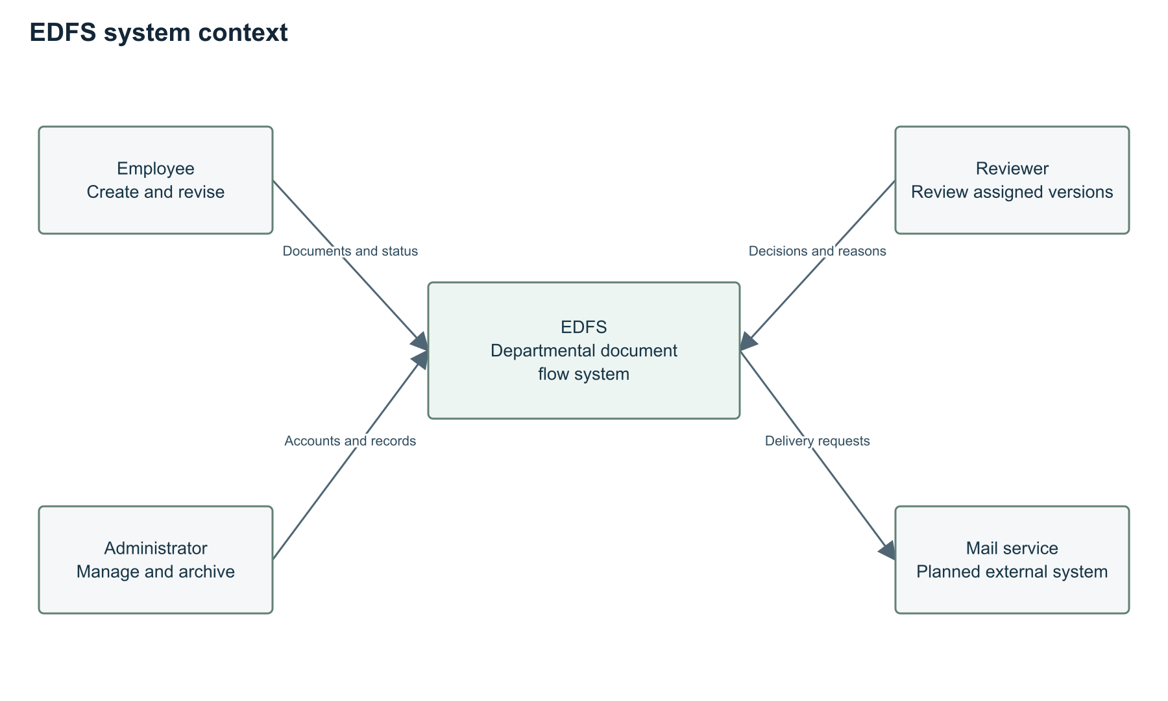
Employees create and revise documents, reviewers decide assigned reviews and administrators manage users and archive approved records. A planned mail service receives delivery requests; a delivery failure cannot invalidate a completed decision. Committee and supervisor access the project repository and documentation rather than becoming production workflow roles.

Use case diagram
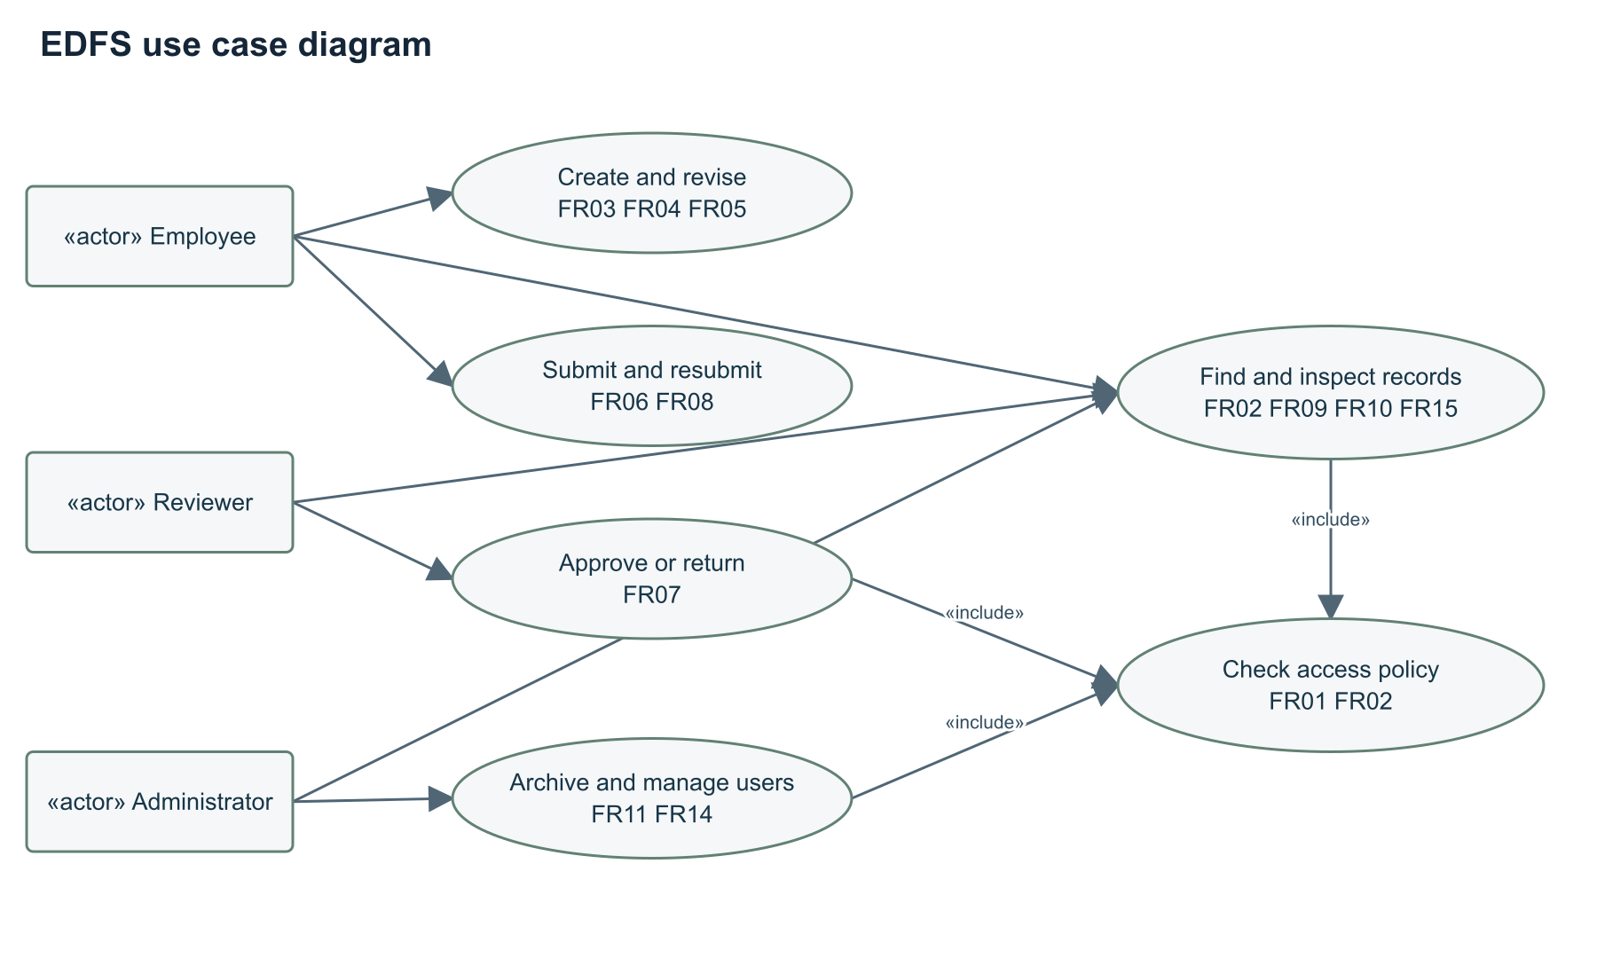
The use cases include access-policy checking as a shared condition. Reviewing requires a frozen version and reviewer assignment. Download and history inspection reuse the same visibility policy as document reading. FR identifiers in the diagram link it to the requirements table.

Draft component diagram
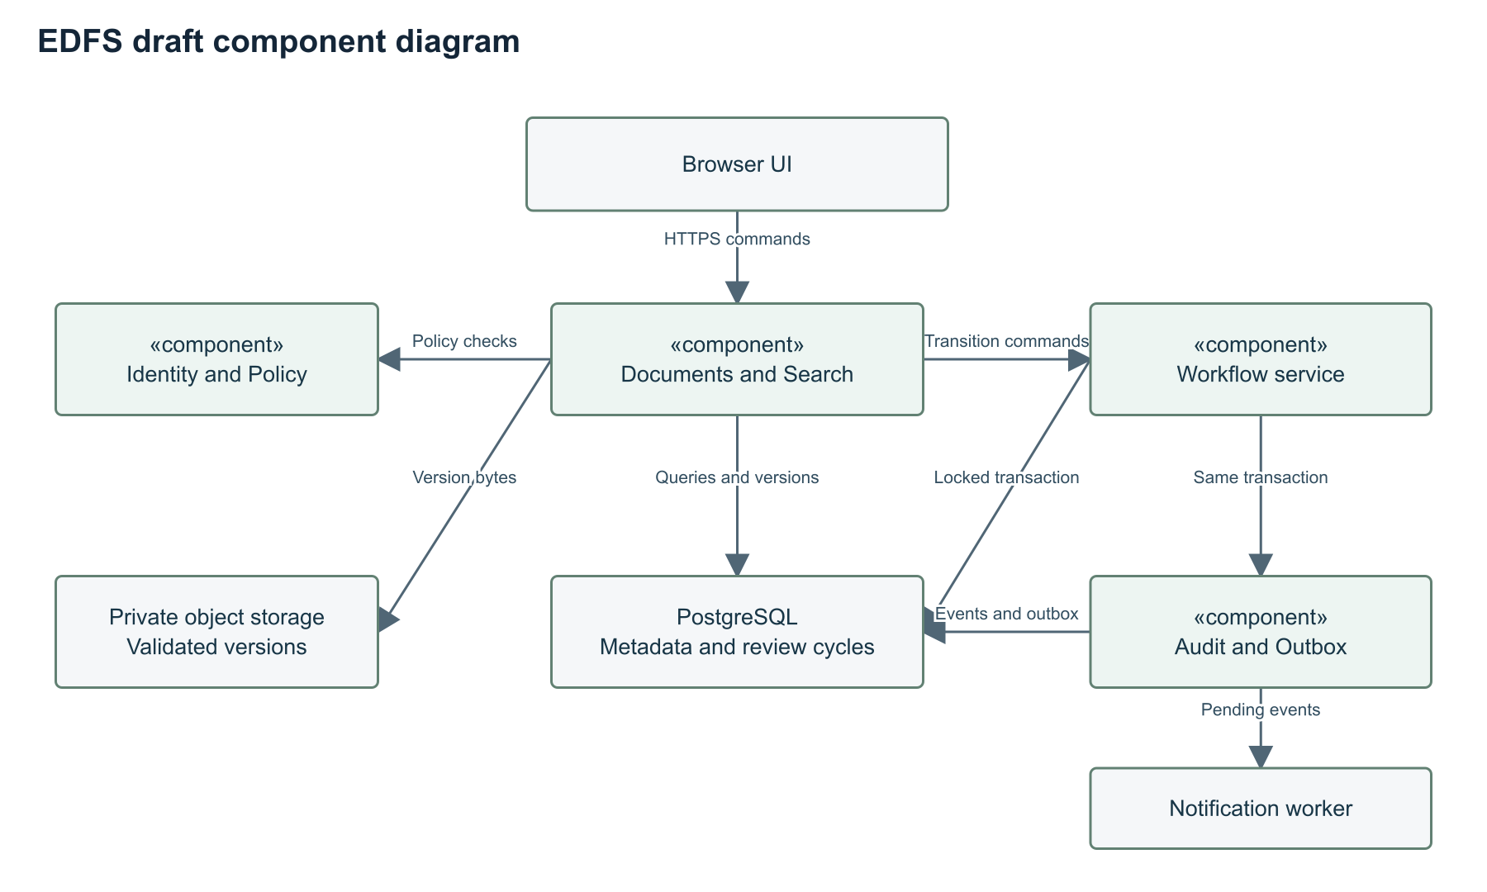
Identity implements FR01 and FR14. Policy implements FR02 and NFR01. Documents and storage implement FR03–FR05 and FR15. Workflow implements FR06–FR08, FR11 and FR12. Search, audit and notification components implement FR09, FR10 and FR13 respectively. The component diagram is a draft for the later server implementation.

Data and consistency model
User has a role and active flag. Document stores owner, type, status, current version ID and revision counter. DocumentVersion stores a unique document and version number, immutable storage key, SHA-256 hash, content type and creation time. ReviewCycle references exactly one version and reviewer. AuditEvent stores event ID, actor, document, version, action, timestamp and safe context. NotificationOutbox stores an event key, recipient, status, attempt count and next retry time.
The schema draft in config/schema.sql expresses core keys and constraints. Cross-table rules require service validation in a transaction. It is a design artifact, not an executed database migration. A decision transaction locks the document and pending review, verifies identity and the revision token, changes state, inserts the audit event and enqueues notification. A unique decision per review and an optimistic revision check prevent duplicate or stale decisions. Test this on PostgreSQL; browser state cannot demonstrate multi-user atomicity [S19].

Storage and security boundaries
The server accepts only allowed PDF or DOCX inputs within the configured size limit, checks content independently of the browser header and scans in quarantine [S25]. Only after validation does it publish a version reference. Downloads require an authenticated policy check and attachment disposition. Database backup and object backup must use a consistent manifest. Unreferenced staged objects are cleaned after a safe interval. Audit access avoids storing file bytes or authentication secrets.

Proposed API examples
POST /documents creates a draft and returns 201 with document ID and revision. POST /documents/{id}/versions creates an immutable version after validation. POST /documents/{id}/submit accepts reviewer ID and If-Match revision. POST /reviews/{id}/decision accepts approve or return and a comment. GET /documents?q=...&status=... applies policy before returning results. GET /documents/{id}/events exports authorised history. Invalid input returns 400, absent authentication 401, denied access 403 or a non-disclosing 404, and stale commands 409. These endpoints are proposed and are not hosted backend routes in this delivery.

UX and prototype

Prototype purpose and coverage
The interactive prototype in prototype/index.html can run without a build step. It contains only synthetic data. Demo personas are Alex Morgan, employee; Jordan Lee, reviewer; Taylor Reed, another employee; and Casey Park, administrator. These are fictional users and do not represent interviews or team contributions. The persona picker simulates role boundaries and is deliberately not an authentication mechanism.
Implemented interactions include creation of a text document, metadata search, state filters, version snapshots, frozen review content, return with a reason, mandatory revision before resubmission, version-aware approval, archive and authorised activity export. A text download illustrates export. Browser storage retains the demonstration between reloads on the same origin.

Scenario A author and reviewer
1. Select Alex Morgan and create a document with a title, type, deadline and text.
2. Save a new version if needed and inspect the original version snapshot.
3. Assign Jordan Lee and submit. Editing controls disappear while the review is pending.
4. Switch to Jordan Lee, open the submitted document and request changes with a reason. A blank reason must fail.
5. Switch to Alex Morgan. Revise the content, save a new version and resubmit. Resubmission without a new version must fail.
6. Switch to Jordan Lee and approve the frozen version. Inspect the complete activity trail.

Scenario B isolation and archive
1. Switch to Taylor Reed. Alex's private draft must not appear in search or the list.
2. Switch to Casey Park and open an approved record. Archive it and verify read-only content.
3. Export the activity JSON and download the current text. Confirm the event version matches the approved version.

Interaction design
The document list shows status, version and deadline without opening each record. The detail dialog displays the current author and assigned reviewer, a visible next action, version history and activity in one place. Returned documents remain visibly distinct from drafts. Required form labels, focus outlines, native dialogs and responsive layouts support a keyboard walkthrough and smaller screens.

Limits of this prototype
There is no real login, server authorization, durable shared database, binary upload validation, malware scanner, role administration, notification worker or backup. The browser owner can modify local storage and the apparent audit trail. The revision guard illustrates a stale update rule in one state model; it does not provide transactional isolation across browsers. Multiple-tab changes require a reload. Do not use real or confidential documents.
The screenshots and executed verification record in evidence/ describe what was actually inspected. Production requirements remain planned where the requirements table says so. The next implementation increment should reproduce the same scenarios with server-authenticated identities and PostgreSQL transactions.

Verification and evaluation plan

Verification strategy
Prototype tests verify state transitions and observable interaction. Later backend tests must verify enforcement at the server and persistence boundary. Tests use synthetic documents until explicit permission exists for anonymised organisational examples. Every Must requirement has a test identifier below. A passing prototype test covers only the corresponding simulated behaviour.
Test | Procedure and expected evidence | Requirement
T01 | Valid and invalid login, session expiry and logout tests | FR01
T02 | Role and relationship matrix for list, read, search, download and events with tampered IDs | FR02, NFR01
T03 | Create valid content, blank title and oversized text with no side effects on failure | FR03
T04 | Valid PDF and DOCX, size boundary, renamed executable, misleading type, unsafe content and failed scanner | FR04, NFR07
T05 | Save two versions, compare preserved snapshots and reject edits in locked states | FR05
T06 | Submit to active different reviewer and confirm immutable version binding | FR06
T07 | Approve and return, missing reason, unrelated reviewer and duplicate decision | FR07
T08 | Return, revise, resubmit and decide the new version | FR08
T09 | Case-insensitive search and combined status filter under each role | FR09
T10 | Compare events with successful commands and reject event mutation | FR10, NFR06
T11 | Archive approved as administrator and reject other states and actors | FR11
T12 | Submit stale revision and mismatching version with no state or event change | FR12, NFR02
T13 | Simulate delivery outage, retry and duplicate outbox key | FR13
T14 | Role changes, deactivate reviewer and invalidate active sessions | FR14
T15 | Authorised text or binary download and JSON export, then denied counterpart | FR15
T16 | CSRF, stored text injection, anonymous endpoint access and audit mutation checks | NFR01, NFR06, NFR07
T17 | Twenty simultaneous backend decisions with one commit and nineteen conflicts | NFR02
T18 | Ten-minute metadata load run after two-minute warm-up, 30 sessions and 10000 records | NFR03
T19 | Restore matched database and object manifest, compare hashes and measure elapsed time | NFR04
T20 | Paired task study using baseline and implemented system | NFR05
T21 | Keyboard-only core journey and layouts at 390 and 1366 pixels, labels and focus | NFR05
T22 | Fresh checkout setup, configuration validation and CI run | NFR08

Evaluation questions and baseline
The primary question is whether the system helps users identify a document's state and complete a controlled approval journey with less effort. The baseline is an explicitly prepared shared folder with versioned filenames, a spreadsheet status log and message templates. This baseline is synthetic and must later be checked against the actual department's process. It does not assume that the client currently works this way.
Recruit 8–12 volunteer representatives for an exploratory paired study if available. Record the actual sample and limitations if recruitment is smaller. Provide equal brief training and equivalent synthetic document sets. Counterbalance order: half use baseline first and half use EDFS first. Avoid reusing the exact content across conditions. Use the same device, browser, network, document count and tasks.
Tasks are to create and route a request, find the current status and responsible reviewer, process a return and resubmit, and retrieve the approved version with its decision evidence. The observer starts timing after presenting the task and stops at the verified success condition. Record errors, requests for help, completion, abandonment and task time. Use a five-minute task cap and report capped or failed tasks explicitly rather than removing them.

Outcome measures and targets
Metric | Computation and condition | Proposed success target
Task completion | Successful tasks without moderator help divided by attempted tasks | At least 90 percent on critical tasks
Processing effort | Per-participant paired change in task time, then median across participants | At least 30 percent median reduction for routing and status tasks
Version identification errors | Wrong version selections divided by relevant attempts | No wrong-version final decision in the scripted study
Trace completeness | Successful mutations with actor, time, version and action divided by successful mutations | 100 percent in integration fixtures
Access isolation | Denied unauthorised operations divided by attempted negative cases | 100 percent in the defined matrix
Metadata latency | 95th percentile server request duration under T18 | At most 2 seconds

The 30 percent goal is a design target, not a published result. Compute time reduction for each matched participant and task as (baseline time minus EDFS time) divided by baseline time. Report condition medians, paired differences, failures and the full anonymised task-level table. Small convenience samples support exploratory conclusions only. Do not infer a general productivity gain from the browser demo or state-model tests.

Execution status
The delivery includes executable prototype model tests and a separate actual verification record. Security, concurrency, performance, recovery and user outcomes remain unmeasured on a production backend. The blank study CSV in management/ provides the fields needed for later collection. Failed acceptance criteria become tracked tasks before the next release tag.

Project management and risks

Responsibilities and review
The following allocation is a proposal for team confirmation. Qazybai Ali owns workflow and backend design, server policy, database consistency and integration tests. Saqyp Dias owns user discovery coordination, UX, prototype refinement, comparisons and usability study preparation. Both students review the literature, requirements and architecture. Each student must use their own identifiable account and review the other's substantial changes. Askar Khaimuldin reviews scope, requirements, architecture and evaluation at agreed checkpoints.
The package was prepared with assistance. Prepared files and any assistant commits do not establish progressive individual student contributions. Actual student review, edits, pull requests and supervisor feedback must be recorded from this point forward. No backdated history or invented reviews form part of the submission.

Milestones
Date | Deliverable | Owner and dependency | Exit condition
19 October 2026 | Initial analysis, diagrams and prototype package | Both, assisted preparation | Internal consistency and executable prototype checks
20 October 2026 | User discovery and client scope | Dias with Ali | 3–5 discussions or substantive client agreement recorded
21 October 2026 | Requirements and architecture revision | Ali with Dias review | Every Must has evidence or explicit agreed assumption
22 October 2026 | Supervisor checkpoint and build versus configure review | Both and supervisor | Real comments logged with decisions and revisions
23 October 2026 | Repository, tasks and rehearsal | Both | Trace task to branch and PR, check access, rehearse demo
24 October 2026 | First pre-defense | Both | Tag reviewed submission, disclose open limitations
After first pre-defense | Authenticated vertical slice | Ali, approved baseline | End-to-end backend test of creation through approval
Later agreed checkpoint | Usability and load evaluation | Dias and Ali | Raw anonymised results and reproducible conditions

The future dates are proposed scheduling targets rather than promises from the supervisor. Repository history begins with actual preparation. Maintain the same repository through later submissions. Links and actual remote state are recorded in management/online_status.md.

Risk register
Risk | Likelihood and impact | Owner | Mitigation and trigger
No accessible user representatives | High and high | Dias | Recruit across all roles immediately; disclose gap if unavailable by 21 October
Scope exceeds a two-person project | Medium and high | Ali | Freeze one reviewer route; defer OCR, signatures and parallel routes
Existing tools already satisfy the need | Medium and high | Both | Run configuration spike and discuss revised contribution
Wrong-version or duplicate decision | Medium and high | Ali | Immutable review version, row locks, revision tokens and concurrent tests
Unsafe binary upload or access leak | Medium and high | Ali | Quarantine, policy checks and negative endpoint matrix before real data
Browser prototype mistaken for production | Medium and high | Both | Visible demo notice and explicit implementation status
Missing supervisor review | High and high | Both | Schedule substantive review with this package and log actual comments
Lost records after storage failure | Medium and high | Ali | Matched DB and object backup, restore rehearsal and hash checks
Git history does not show individual work | High and high | Both | Own accounts, real task branches and reciprocal PR reviews from now

Git and YouTrack workflow
Use the YouTrack project linked in the README. Each task needs an actual assignee, priority, expected artifact, acceptance criteria and due date. The prepared backlog contains these fields. Only mark a task Done when its acceptance criteria have been reviewed. Unknown account mappings remain explicit rather than assigning work to a fictional identity.
Use task IDs in branch names such as EDFS-12-approval-policy and in commit or PR descriptions. Add the resulting commit or PR link back to the task. Keep main as the reviewed baseline and submit coherent changes through PRs. Documentation and diagrams require review too. The repository includes PR and issue templates, a CI workflow and an ignore file. Do not commit passwords, API keys, real participant notes or runtime data.
Before submission, grant the committee and supervisor appropriate access, confirm the repository and YouTrack links, merge reviewed work and create pre-defense-1 at the actual reviewed commit. Do not move submitted tags. Later stages use pre-defense-2 and final-pre-defense. Do not tag an unreviewed package as approved merely because the date has arrived.

Supervisor feedback and submission readiness

Supervisor review status
Supervisor: Askar Khaimuldin. No supervisor feedback was provided during preparation. Naming the supervisor is not evidence that they reviewed the work. This criterion remains open until a substantive review occurs and its resulting decisions or revisions are recorded.
The ready-to-use review form asks the supervisor to assess problem specificity, the proposed user group, the build-versus-configure decision, single-stage scope, the evidence behind mandatory requirements, version and access invariants, evaluation validity and the next implementation increment. The form includes fields for actual comment, decision, owner, due date, changed artifact and verification link.
Suggested checkpoint: provide proposal, relevance log, comparison, requirements, diagrams and evaluation plan together. Record the real date and medium, request concrete comments, and create separate tasks for substantive revisions. A statement that the supervisor has approved the project must not be added before that approval exists.

Checklist for the committee
Component | Prepared evidence | Remaining real-world action
1 Project proposal | Scope, roles, aim, objectives and outcomes | Validate departmental setting
2 Relevance | Literature context, protocol and blank evidence register | Conduct 3–5 discussions or obtain client agreement
3 Literature | Eight scientific publications and 25-source register | Deepen abstract-level sources before final thesis
4 Existing systems | Four systems with eight consistent criteria | Configuration spike after user validation
5 Technology | Three key decisions and three alternatives each | Confirm team and environment assumptions
6 Requirements | Fifteen functional and eight quality requirements with tests | Review and baseline with users and supervisor
7 Architecture | Context, use case, draft component and state diagrams | Revise after feedback
8 UX | Interactive prototype and demonstration script | Test with actual representative users
9 Verification | Tests, metrics, baseline and study protocol | Run backend and user evaluation later
10 Management | Backlog, responsibilities, milestones, risks and repository structure | Confirm accounts, contributions and remote review activity
11 Supervision | Review packet and comment form | Obtain real feedback and implement changes

First pre defense submission statement
This version supplies analysis and design artifacts plus an interactive text-document prototype. It does not provide a production application or measured organisational benefit. It discloses missing local validation, unexecuted backend tests and absent supervisor feedback. The original checklist allows an incomplete application at this stage, but does require actual analysis, planning, supervision and progressive contributions. Templates prepare that work but cannot substitute for its occurrence.
The final submission record must include repository URL, immutable submission tag, YouTrack URL, prototype location, completed-work summary, limitations and outstanding tasks. An unsigned template in management/submission_record.md avoids inventing approval or evidence. During the demonstration, select one real task and trace its acceptance criteria to an artifact, commit, review and verification result. Each student should explain their own changes and the workflow invariants.

References
[S01] D. Anggraini, K. Adi and J. E. Suseno (2024). Electronic document management systems implementation across industries systematic analysis. Indonesian Journal of Electrical Engineering and Computer Science 36(1), 264–273. https://doi.org/10.11591/ijeecs.v36.i1.pp264-273. Inspected: Publisher abstract and citation record.
[S02] A. Anas and T. A. Salim (2022). Tinjauan literatur sistematis pemanfaatan electronic document management system bagi organisasi dalam menunjang manajemen pengetahuan. Berkala Ilmu Perpustakaan dan Informasi 18(2), 259–275. https://doi.org/10.22146/bip.v18i2.5649. Inspected: Publisher abstract and method summary.
[S03] H. Putra and M. Er (2024). The Role of Business Process Management in Digital Innovation and Digital Transformation A Systematic Literature Review. Procedia Computer Science 234, 829–836. https://doi.org/10.1016/j.procs.2024.03.069. Inspected: Publisher abstract and author manuscript identification.
[S04] A. K. Y. S. Mohamed, D. Auer, D. Hofer and J. Küng (2022). A systematic literature review for authorization and access control definitions strategies and models. International Journal of Web Information Systems 18(2/3), 156–180. https://doi.org/10.1108/IJWIS-04-2022-0077. Inspected: Publisher abstract and findings summary.
[S05] B. Q. Truong, A. Nguyen-Duc and N. T. C. Van (2023). A Quantitative Review of the Research on Business Process Management in Digital Transformation A Bibliometric Approach. Software 2(3), 377–399. https://doi.org/10.3390/software2030018. Inspected: Publisher abstract and methods sections.
[S06] F. Milani, K. Kubrak and J. Nava (2024). Strategic redesign of business processes in the digital age A framework. Data and Knowledge Engineering 154, 102367. https://doi.org/10.1016/j.datak.2024.102367. Inspected: Publisher abstract and conclusion excerpts.
[S07] R. S. Sandhu, E. J. Coyne, H. L. Feinstein and C. E. Youman (1996). Role Based Access Control Models. Computer 29(2), 38–47. https://doi.org/10.1109/2.485845. Inspected: Author paper hosted by NIST.
[S08] W. M. P. van der Aalst (1998). The Application of Petri Nets to Workflow Management. Journal of Circuits Systems and Computers 8(1), 21–66. https://doi.org/10.1142/S0218126698000043. Inspected: Author paper and academic bibliographic record.
[S09] Microsoft. Require approval of documents in SharePoint using Power Automate. https://learn.microsoft.com/en-us/sharepoint/dev/business-apps/power-automate/guidance/require-doc-approval. Accessed 19 October 2026. Used for: Approval workflow and version ETag comparison.
[S10] Microsoft. Restore a previous version of an item or file in SharePoint. https://support.microsoft.com/en-us/sharepoint/documents-and-library/restore-a-previous-version-of-an-item-or-file-in-sharepoint. Accessed 19 October 2026. Used for: Version history comparison.
[S11] Nextcloud. Flow administration manual. https://docs.nextcloud.com/server/stable/admin_manual/file_workflows/index.html. Accessed 19 October 2026. Used for: Flow and access rules comparison.
[S12] Nextcloud. Version control user manual. https://docs.nextcloud.com/server/stable/user_manual/en/files/version_control.html. Accessed 19 October 2026. Used for: Versions and automatic expiry comparison.
[S13] Mayan EDMS. Features. https://docs.mayan-edms.com/chapters/features.html. Accessed 19 October 2026. Used for: Versions, metadata, permissions, workflows and API comparison.
[S14] Paperless ngx. Basic Usage. https://docs.paperless-ngx.com/usage/. Accessed 19 October 2026. Used for: Workflow triggers, permissions and audit comparison.
[S15] Paperless ngx. REST API. https://docs.paperless-ngx.com/api/. Accessed 19 October 2026. Used for: API comparison.
[S16] Django Software Foundation. Security in Django and authentication system. https://docs.djangoproject.com/en/5.2/topics/security/. Accessed 19 October 2026. Used for: Framework choice and security design.
[S17] FastAPI. Dependencies. https://fastapi.tiangolo.com/tutorial/dependencies/. Accessed 19 October 2026. Used for: Backend alternative.
[S18] NestJS. Authorization. https://docs.nestjs.com/security/authorization. Accessed 19 October 2026. Used for: Backend alternative.
[S19] PostgreSQL. Explicit Locking. https://www.postgresql.org/docs/17/explicit-locking.html. Accessed 19 October 2026. Used for: Transactional approval and concurrency design.
[S20] PostgreSQL. Full Text Search Introduction. https://www.postgresql.org/docs/current/textsearch-intro.html. Accessed 19 October 2026. Used for: Database search alternative.
[S21] SQLite. Appropriate Uses For SQLite. https://www.sqlite.org/whentouse.html. Accessed 19 October 2026. Used for: Database concurrency tradeoff.
[S22] MongoDB. Transactions. https://www.mongodb.com/docs/manual/core/transactions/. Accessed 19 October 2026. Used for: Database alternative and transaction support.
[S23] MDN. Overview of HTTP. https://developer.mozilla.org/en-US/docs/Web/HTTP/Guides/Overview. Accessed 19 October 2026. Used for: Request and response interaction design.
[S24] RabbitMQ. Reliability Guide. https://www.rabbitmq.com/docs/reliability. Accessed 19 October 2026. Used for: Asynchronous interaction tradeoff.
[S25] OWASP. File Upload Cheat Sheet. https://cheatsheetseries.owasp.org/cheatsheets/File_Upload_Cheat_Sheet.html. Accessed 19 October 2026. Used for: Upload validation, quarantine and storage design.

