Unuseless music designs: a seriously absurd hackathon

***(Dis)claim Form***

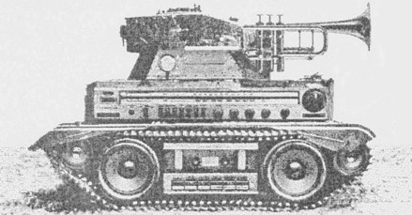

|  |  |
| --- | --- |
| **Name** |  |
| **Email** |  |
| **Background - Skills**  (tell us something about you) |  |
| **Motives - Catalysts**  (why are you interested in the workshop and what would you like to get out of it) |  |
| **Unuseless ideas**  (any absurd, surreal or silly music design you would like to build during the workshop) |  |
| **Useful materials**  (any material or tool you will bring over to be used during the workshop) |  |
| **Gender\*** |  |

*Leave blank if prefer not to say