Moral Foundations Questionnaire

Part 1. When you decide whether something is right or wrong, to what extent are the following considerations relevant to your thinking? Please rate each statement using this scale:

[0] = not at all relevant (This consideration has nothing to do with my judgments of right and wrong)
[1] = not very relevant
[2] = slightly relevant
[3] = somewhat relevant
[4] = very relevant
[5] = extremely relevant (This is one of the most important factors when I judge right and wrong)

______1. Whether or not someone suffered emotionally
______2. Whether or not some people were treated differently than others
______3. Whether or not someone’s action showed love for his or her country
______4. Whether or not someone showed a lack of respect for authority
______5. Whether or not someone violated standards of purity and decency
______6. Whether or not someone was good at math
______7. Whether or not someone cared for someone weak or vulnerable
______8. Whether or not someone acted unfairly
______9. Whether or not someone did something to betray his or her group
______10. Whether or not someone conformed to the traditions of society
______11. Whether or not someone did something disgusting
______12. Whether or not someone was cruel
______13. Whether or not someone was denied his or her rights
______14. Whether or not someone showed a lack of loyalty
______15. Whether or not an action caused chaos or disorder
______16. Whether or not someone acted in a way that God would approve of

Part 2. Please read the following sentences and indicate your agreement or disagreement:
[0] [1] [2] [3] [4] [5]
Strongly Moderately Slightly Slightly Moderately Strongly
disagree disagree disagree agree agree agree

______17. Compassion for those who are suffering is the most crucial virtue.
______18. When the government makes laws, the number one principle should be ensuring that everyone is treated fairly.
______19. I am proud of my country’s history.
______20. Respect for authority is something all children need to learn.
______21. People should not do things that are disgusting, even if no one is harmed.
______22. It is better to do good than to do bad.
______23. One of the worst things a person could do is hurt a defenseless animal.
______24. Justice is the most important requirement for a society.
______25. People should be loyal to their family members, even when they have done something wrong.
______26. Men and women each have different roles to play in society.
______27. I would call some acts wrong on the grounds that they are unnatural.
______28. It can never be right to kill a human being.
______29. I think it’s morally wrong that rich children inherit a lot of money while poor children inherit nothing.
______30. It is more important to be a team player than to express oneself.
______31. If I were a soldier and disagreed with my commanding officer’s orders, I would obey anyway because that is my duty.
______32. Chastity is an important and valuable virtue.

---------------------------------------------------------------------------------------------------------------------------------

To score the MFQ yourself, you can copy your answers into the grid below. Then add up the 6 numbers in each of the five columns and write each total in the box at the bottom of the column. The box then shows your score on each of 5 psychological “foundations” of morality. Scores run from 0-30 for each foundation. (Questions 6 and 22 are just used to catch people who are not paying attention. They don't count toward your scores).

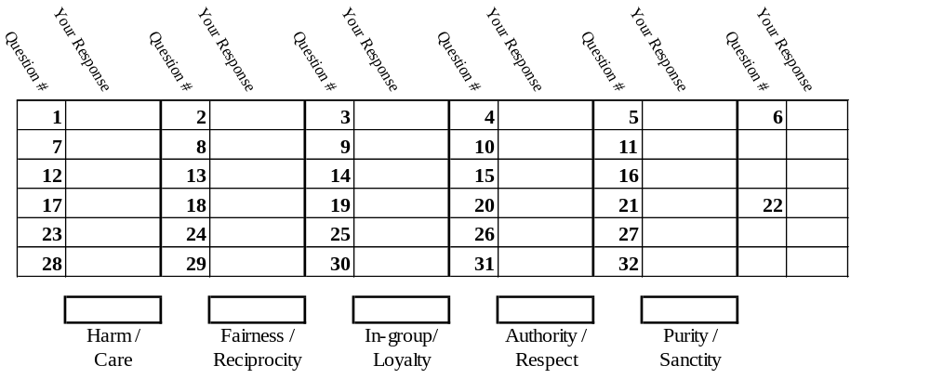

The average politically moderate American’s scores are: 20.2, 20.5, 16.0, 16.5, and 12.6.
Liberals generally score a bit higher than that on Harm/care and Fairness/reciprocity, and much lower than that on the other three foundations. Conservatives generally show the opposite pattern.

The Moral Foundations Questionnaire (MFQ-30, July 2008) by Jesse Graham, Jonathan Haidt, and Brian Nosek.
For more information about Moral Foundations Theory, scoring this form, or interpreting your scores, see: www.MoralFoundations.org. To take this scale online and see how you compare to others, go to www.YourMorals.org

