Transcriptomic Profiling of Drug-Resistant Cancer Cells
Differentially Expressed Genes, Biological Pathways, and Machine-Learning Biomarkers of Cisplatin Resistance in Ovarian Cancer

A reproducible cross-dataset bioinformatics and machine-learning study
of two independent human bulk RNA-seq datasets

Team of 3
Member 1 — Data Acquisition, Preprocessing & Quality Control
Member 2 — Differential Expression, Cross-Dataset Validation & Pathways
Member 3 — Machine Learning & Biomarker Discovery

[Your Names / Registration Numbers]
[Course / Institution]
[Supervisor]
10 October 2026

Table of Contents
Table of Contents 2
Abstract 5
1. Introduction 6
1.1 Ovarian cancer and platinum-based therapy 6
1.2 The problem of acquired cisplatin resistance 6
1.3 Objectives 6
1.4 Scope and significance 6
1.5 Contributions and novelty 7
2. Literature Review 7
2.1 Cisplatin mechanism of action and resistance 7
2.2 Epithelial–mesenchymal transition and ECM remodelling 7
2.3 Epigenetic mechanisms 7
2.4 Metabolic rewiring 8
2.5 Inflammation and immune evasion 8
2.6 Validated candidate biomarkers 8
2.7 Convergent signalling pathways 8
2.8 Cross-dataset validation and reproducibility 8
2.9 Machine learning in transcriptomic biomarker discovery 8
2.10 Research gap 9
3. Methodology 9
3.1 Study design and data sources 9
3.2 Preprocessing and quality control 9
3.3 Differential expression analysis 10
3.4 Cross-dataset comparison 10
3.5 Functional enrichment analysis 10
3.6 Machine-learning feature matrix 10
3.7 Classifiers 10
3.8 Validation design and leakage control 11
3.9 Evaluation metrics and biomarker ranking 11
3.10 Software, reproducibility and dashboard 11
3.11 Ethical considerations 11
4. Analysis 12
4.1 Differential expression — Dataset 1 (SKOV-3) 12
4.2 Differential expression — Dataset 2 (OVCAR5) 13
4.3 Cross-dataset overlap 15
4.4 Gene Ontology enrichment 17
4.5 KEGG pathway enrichment 19
4.6 Within-cell-line LOOCV 20
4.7 Cross-dataset external validation — target_z 21
4.8 Cross-dataset external validation — train_stats (strict) 24
4.9 Feature importance and panel construction 25
5. Result 26
5.1 Summary of differential expression 26
5.2 Cross-dataset core signature 26
5.3 Enrichment results 27
5.4 Machine-learning performance summary 27
5.5 Candidate biomarker panel 27
5.6 Integrated result 28
6. Discussion 28
6.1 Biological interpretation 28
6.2 Proposed mechanistic model 28
6.3 Machine-learning interpretation 29
6.4 Comparison with the literature 29
6.5 Limitations 29
6.6 Future work 29
7. Conclusion 30
8. References 30
Appendix A. Data availability 32
Appendix B. Key output files 32
Appendix C. Software 33

Abstract
Ovarian cancer is the most lethal gynaecological malignancy, and platinum-based chemotherapy with cisplatin remains the cornerstone of first-line treatment. Acquired cisplatin resistance is a multifactorial process driven by epigenetic reprogramming, metabolic rewiring, epithelial–mesenchymal transition (EMT), inflammatory signalling and drug efflux, yet reproducible transcriptomic signatures that generalise across independent resistance models remain scarce. This study integrated two independent human bulk RNA-seq datasets of cisplatin-resistant versus cisplatin-sensitive ovarian cancer cells — GSE303889 (SKOV-3; 3 sensitive vs 3 resistant) and GSE283381 (OVCAR5; 3 sensitive vs 3 resistant) — into a fully reproducible end-to-end pipeline.
Differential expression analysis with DESeq2 (FDR < 0.05 and |log2 fold change| > 1) identified 5,212 significant differentially expressed genes (DEGs) in SKOV-3 (2,983 up, 2,229 down) and 2,572 in OVCAR5 (912 up, 1,660 down), confirming extensive transcriptomic reprogramming. Cross-dataset comparison revealed 913 consistently differentially expressed genes (198 up, 220 down, 495 with opposite direction) that form a core cisplatin-resistance signature. Functional enrichment converged on extracellular matrix (ECM) organisation, cell–substrate adhesion, and the PI3K-Akt, focal-adhesion, integrin and cadherin signalling pathways, with EMT as the dominant shared mechanism.
Supervised classifiers (ridge logistic regression, random forest and radial SVM) were trained on the full 57,357-gene intersected matrix with nested, leakage-free feature selection. Within-cell-line leave-one-out cross-validation separated the phenotypes almost completely (ROC-AUC 0.889–1.000), whereas leave-one-dataset-out external validation showed only partial, strongly asymmetric transfer (best AUC 1.00 under batch-corrected target_z normalisation; mean AUC 0.61 under the strict, leak-free train_stats scheme). A 30-gene ranked candidate panel headed by MAL2 and GALNT6 was nominated for follow-up. All analyses are exploratory given n = 12, but the pipeline, figures, interactive dashboard and candidate panel provide a reproducible foundation for larger validation studies.

1. Introduction

1.1 Ovarian cancer and platinum-based therapy
Ovarian cancer accounts for a disproportionate share of gynaecological cancer mortality because most patients present at an advanced stage, when the disease has already disseminated within the peritoneal cavity. Standard first-line management combines cytoreductive surgery with platinum-based chemotherapy, most commonly cisplatin or its analogue carboplatin, frequently together with a taxane. Platinum agents form covalent DNA adducts that stall replication and transcription and ultimately trigger apoptosis, so an intact DNA-damage response is central to their cytotoxicity. Despite high initial response rates, the majority of patients relapse with platinum-resistant disease, and the emergence of resistance is the principal obstacle to long-term survival.

1.2 The problem of acquired cisplatin resistance
Acquired resistance is not a single event but an adaptive, polyclonal process. Documented mechanisms include reduced drug uptake and increased efflux, enhanced nucleotide-excision repair and homologous recombination, altered apoptotic thresholds, epigenetic silencing or activation of resistance programmes, metabolic rewiring that buffers oxidative stress, and a shift toward a mesenchymal, stem-like phenotype. Because these mechanisms differ between cell-line models and between patients, single-dataset studies tend to recover model-specific signatures that do not reproduce elsewhere. Identifying genes and pathways that are consistently dysregulated across independent resistance models is therefore a prerequisite for robust biomarkers and rational therapeutic targeting.

1.3 Objectives
- Identify differentially expressed genes between cisplatin-resistant and cisplatin-sensitive human ovarian cancer cells using DESeq2.
- Validate candidate DEGs across two independent GEO datasets to reduce dataset-specific bias and identify a consistent core signature.
- Characterise the biological processes and signalling pathways affected, using Gene Ontology (GO) and KEGG enrichment analysis.
- Build supervised machine-learning classifiers on the transcriptome and evaluate their ability to distinguish resistant from sensitive samples under leakage-free cross-validation.
- Rank a compact, biologically interpretable candidate biomarker panel from feature importance across models and feature-set sizes.
- Deliver a fully reproducible end-to-end pipeline, including an interactive results dashboard.

1.4 Scope and significance
This work is a computational, hypothesis-generating study based on public data. It does not perform wet-lab validation and is explicitly framed as exploratory biomarker discovery rather than clinical diagnostic validation. Its significance lies in demonstrating a reproducible workflow that (i) derives a cross-dataset resistance signature, (ii) connects that signature to interpretable biology, and (iii) quantifies honestly how far such a signature transfers between cell-line models — an issue frequently glossed over in small transcriptomic machine-learning studies.

1.5 Contributions and novelty
- Integration of two independent ovarian cancer cisplatin-resistance RNA-seq datasets with a consistent, scripted analysis pipeline.
- A cross-dataset core signature of consistently regulated DEGs, reducing reliance on any single model.
- Combined statistical differential expression and supervised machine learning, with feature selection nested strictly inside each training fold to prevent leakage.
- Explicit reporting of cross-dataset generalisation under both a batch-corrected (transductive) and a strictly non-transductive normalisation scheme.
- Delivery of an interactive web dashboard and a reproducible code repository.

2. Literature Review

2.1 Cisplatin mechanism of action and resistance
Cisplatin exerts cytotoxicity by forming intra- and inter-strand DNA crosslinks that activate the DNA-damage response and, when damage is irreparable, intrinsic apoptosis. Resistance can arise at every step of this cascade: decreased uptake via the copper transporters CTR1/SLC31A1, increased efflux through ATP-binding cassette transporters, enhanced DNA repair, and defective apoptotic signalling. Transcriptomic studies consistently report large-scale reprogramming, but the specific genes implicated vary widely across models, motivating cross-dataset validation.

2.2 Epithelial–mesenchymal transition and ECM remodelling
EMT is among the most reproducible features of platinum-resistant ovarian cancer. Loss of the epithelial markers E-cadherin (CDH1) and EpCAM, together with up-regulation of collagens and matrix metalloproteinases, accompanies resistance and invasion. Hypermethylation of the CDH1 promoter has been demonstrated in chemoresistant ovarian cancer lines, linking epigenetic silencing to EMT. Collagen genes such as COL1A1 are up-regulated in drug-resistant ovarian cancer lines and are associated with ECM-receptor interaction and focal-adhesion pathways. Reduced miR-29, a negative regulator of collagens, further contributes to cisplatin resistance. These observations establish ECM remodelling and adhesion as core, cross-model resistance biology.

2.3 Epigenetic mechanisms
Methylome and expression profiling of isogenic sensitive/resistant ovarian cancer pairs has identified DNA-methylation drivers of acquired cisplatin resistance, including silencing of apoptosis-related genes. Histone-modifying enzymes of the KDM5 (lysine demethylase) family have been implicated in maintaining a drug-tolerant state in several cancers, providing context for the SKOV-3 model analysed here. Because epigenetic programmes are plastic and reversible, they are attractive targets for resensitisation strategies.

2.4 Metabolic rewiring
Metabolic dependency is an emerging theme in platinum resistance. A recent study demonstrated that platinum-resistant ovarian cancer develops a targetable dependency on de novo pyrimidine synthesis, underpinning one of the datasets (OVCAR5 Cis-R) analysed in this work. Such metabolic reprogramming supplies nucleotides for repair and buffers redox stress, and it can dominate the transcriptional landscape of a given model — explaining why metabolic and epigenetic resistance models may share relatively few DEGs.

2.5 Inflammation and immune evasion
Chronic, low-grade inflammation supports resistance. Interleukin-1 signalling (IL1A/IL1B) is elevated in resistant ovarian cancer models and is linked to inflammasome activation, with higher caspase-1 activity and IL-1β secretion. Separately, the tryptophan–kynurenine pathway, in which kynureninase (KYNU) converts kynurenine, acts as an immune checkpoint: tumour-derived kynurenine activates the aryl-hydrocarbon receptor (AhR) to suppress anti-tumour immunity. KYNU up-regulation has been documented in ovarian and other cancers, linking metabolism to immune evasion and chemoresistance.

2.6 Validated candidate biomarkers
NDRG1 has been identified as a hub gene across multiple independent ovarian cancer datasets, and its knockdown inhibits proliferation of cisplatin-resistant SKOV-3 cells, making it a validated resistance-associated biomarker. SERPINE1, a plasminogen-activator inhibitor that promotes invasion and metastasis, recurs in resistance signatures. EpCAM-based circulating markers have also been explored as predictors of platinum sensitivity. These genes provide external anchors against which computationally derived signatures can be contextualised.

2.7 Convergent signalling pathways
Across studies, resistance converges on a limited set of pathways: PI3K-Akt signalling (survival and apoptosis suppression), MAPK signalling (proliferation and efflux), focal-adhesion and integrin signalling (adhesion, migration, Wnt/β-catenin activation), cadherin signalling (loss of adhesion during EMT) and p53 signalling (damage response). Their recurrence in enrichment analyses of independent cohorts supports the notion of shared therapeutic nodes.

2.8 Cross-dataset validation and reproducibility
Single-dataset signatures are notoriously unstable. Cross-dataset validation — requiring a gene to be significant in independent cohorts, ideally with a consistent direction of change — increases confidence and reduces batch-specific artefacts. Directional consistency is a simple but effective filter, and reporting the degree of overlap honestly is more informative than tuning thresholds to maximise it.

2.9 Machine learning in transcriptomic biomarker discovery
Supervised classifiers are widely used to derive gene panels from expression data. However, high-dimensional, small-sample settings (n << p) are highly prone to overfitting and to optimistic performance estimates. Two well-known pitfalls are selection bias — performing feature selection outside the cross-validation loop — and leakage through preprocessing that uses held-out data. Rigorous designs nest feature selection and normalisation inside each training fold, and evaluate generalisation on truly external data. Transductive preprocessing, in which test samples are standardised using their own statistics, is common in cross-study batch correction but does not correspond to a deployable model; reporting a strictly non-transductive result alongside it brackets the achievable range.

2.10 Research gap
Despite extensive mechanistic literature, there is a shortage of studies that combine (i) rigorous cross-dataset differential-expression validation, (ii) interpretable pathway enrichment, and (iii) leakage-controlled machine learning with honest external generalisation reporting, within a single reproducible pipeline for ovarian cancer cisplatin resistance. This project addresses that gap using two independent models with distinct resistance mechanisms.

3. Methodology

3.1 Study design and data sources
Two independent human bulk RNA-seq datasets were retrieved from the NCBI Gene Expression Omnibus (GEO). Each provides a paired comparison between a cisplatin-sensitive and a cisplatin-resistant ovarian cancer cell line, with three biological replicates per condition. Dataset-specific resistance mechanisms were intentionally allowed to differ, so that any consistently regulated genes reflect mechanism-independent resistance biology rather than a single model.
Attribute | Dataset 1 | Dataset 2
GEO accession | GSE303889 | GSE283381
Cell line | SKOV-3 | OVCAR5
Resistance model | SKOV-3 CDDP (chronic cisplatin; KDM5-associated) | OVCAR5 Cis-R (repeated cisplatin; de novo pyrimidine dependency)
Sensitive group | Parental (wild-type), n = 3 | Cis-S control, n = 3
Resistant group | CDDP, n = 3 | Cis-R control, n = 3
Platform | Illumina NovaSeq 6000 | Illumina NextSeq 500
Total samples | 6 | 6
Table 1. Overview of the two independent GEO datasets (n = 12 samples total).

3.2 Preprocessing and quality control
Raw gene-level count matrices and sample metadata were assembled for each dataset. For the OVCAR5 dataset, per-sample count files were merged and non-messenger features (e.g. small RNAs) were removed. Lowly expressed genes were filtered by requiring a total count of at least ten across samples (rowSums ≥ 10). Counts were normalised using DESeq2 size factors, and expression values were transformed to log2(counts per million + 1) for the machine-learning feature matrix. Duplicate gene symbols were collapsed by summation (rowsum, reorder = TRUE) and the two datasets were intersected on shared symbols, yielding a common feature space of 57,357 genes across 12 samples. Quality was assessed by principal-component analysis and hierarchical sample clustering. A fixed random seed (42) was used throughout to ensure reproducibility.

3.3 Differential expression analysis
Each dataset was analysed independently with DESeq2 using a negative-binomial generalised linear model with design ~ condition. The sensitive group was set as the reference level and the contrast was Resistant versus Sensitive. Significance was defined a priori as an adjusted p-value (Benjamini–Hochberg FDR) below 0.05 and an absolute log2 fold change greater than 1. Outputs per dataset included a full DEG table, up- and down-regulated gene lists, volcano and MA plots, and a heatmap of the top DEGs.

3.4 Cross-dataset comparison
Gene symbols (Ensembl identifiers mapped to symbols for Dataset 1) were intersected to identify genes significant in both datasets. Shared genes were classified as up (up in both), down (down in both) or mixed (opposite direction). Genes with a consistent direction in both datasets constitute the higher-confidence core signature. Agreement in magnitude was assessed by Spearman correlation of shared log2 fold changes, and overlap was visualised with a Venn diagram and a log2FC scatter plot.

3.5 Functional enrichment analysis
Functional enrichment was performed with clusterProfiler against the human annotation database org.Hs.eg.db. Gene Ontology enrichment (enrichGO; Biological Process focus) and KEGG pathway enrichment (enrichKEGG, organism hsa) were run separately on the shared DEGs, on each dataset's DEGs, and on the shared up- and down-regulated subsets, using Benjamini–Hochberg adjustment and a significance threshold of p < 0.05. Results were visualised as dot plots.

3.6 Machine-learning feature matrix
The classifier feature matrix comprised the 57,357 shared genes (log2 CPM + 1) across the 12 samples, with labels indicating dataset (cell line) and condition (resistant/sensitive). Crucially, the full gene space was used rather than a pre-selected DEG panel; any DEG-based pre-filtering would allow test information to leak into feature selection. The 913 shared DEGs were retained only as a reference panel.

3.7 Classifiers
- Logistic regression with L2 (ridge) regularisation (glmnet), tuned by inner leave-one-out cross-validation. Lasso (L1) was found to be degenerate at n = 6 and was not used.
- Random forest (ranger) with min.node.size = 1 (the default of 10 forbids any split at n = 6).
- Support vector machine with a radial-basis kernel (e1071), on standardised inputs (scale = FALSE), with a fallback for probability estimation.

3.8 Validation design and leakage control
Two complementary validation schemes were used. First, within-cell-line leave-one-out cross-validation (LOOCV) holds out one sample inside a single cell line, leaving five training samples per fold, with feature selection and normalisation recomputed from the training samples only. Second, cross-dataset external validation trains on all six samples of one cell line and predicts the six samples of the other (SKOV3→OVCAR5 and OVCAR5→SKOV3). Feature selection was nested strictly inside every training fold: the top K genes by the absolute two-sample t-statistic were selected with K ∈ {20, 50, 100, 200, 500}. No test fold ever informed feature or model selection.
Because the two studies were normalised independently, their expression scales differ; test rows were therefore standardised with respect to cell-line statistics in two ways. Under target_z (the primary, transductive scheme) the held-out cell line is standardised with its own mean and standard deviation, batch-correcting the two datasets. Under train_stats (the strict scheme) the held-out cell line is standardised with the training cell line's statistics, using no information whatever from the test set; this is the fully leak-free number. The model is fit once per fold on identically normalised training rows, so only test-row normalisation differs between the two schemes.

3.9 Evaluation metrics and biomarker ranking
Model performance was summarised by accuracy, precision, recall, F1-score and ROC-AUC. External metrics are reported per direction and per normalisation; the two directions have opposite probability scales, so pooling them into a single 'External' row is not interpretable and was deliberately avoided. Under train_stats the probabilities are miscalibrated with respect to the 0.5 threshold, so ROC-AUC (rank-based) is the meaningful metric there. Candidate biomarkers were ranked by how often each gene was selected across the grid of models and K values, with mean absolute log2 fold change used as a tie-breaker.

3.10 Software, reproducibility and dashboard
All analysis code is R, organised as three scripts (DEG analysis, ML matrix construction, ML biomarkers) with a project-root auto-detection mechanism. The ML stage uses a fast RDS feature matrix (load time ~0.03 s) and completes in approximately 25 seconds. Console output is captured to a run log, and two consecutive runs produce byte-identical predictions and metrics. Results are served through a FastAPI backend that exposes the artefacts as a read-only REST API and a browser dashboard with a normalisation toggle, an AUC-by-K chart, an external-metrics table and a prediction explorer.

3.11 Ethical considerations
Only de-identified, publicly available data were used; no new human or animal subjects were involved, and no ethical approval was required. All primary studies are cited in Section 8.

4. Analysis

4.1 Differential expression — Dataset 1 (SKOV-3)
After low-count filtering, DESeq2 tested 22,372 genes in the SKOV-3 dataset. At FDR < 0.05 and |log2FC| > 1, 5,212 genes were significantly differentially expressed: 2,983 up-regulated and 2,229 down-regulated. The volcano plot (Figure 1) shows a broad dispersion of both up- and down-regulated genes, indicating extensive transcriptomic reprogramming. The heatmap of the top DEGs (Figure 2) separates the sensitive and resistant replicates cleanly, and down-regulation of the epithelial marker CDH1 is evident among the top changes, consistent with an EMT-like shift.
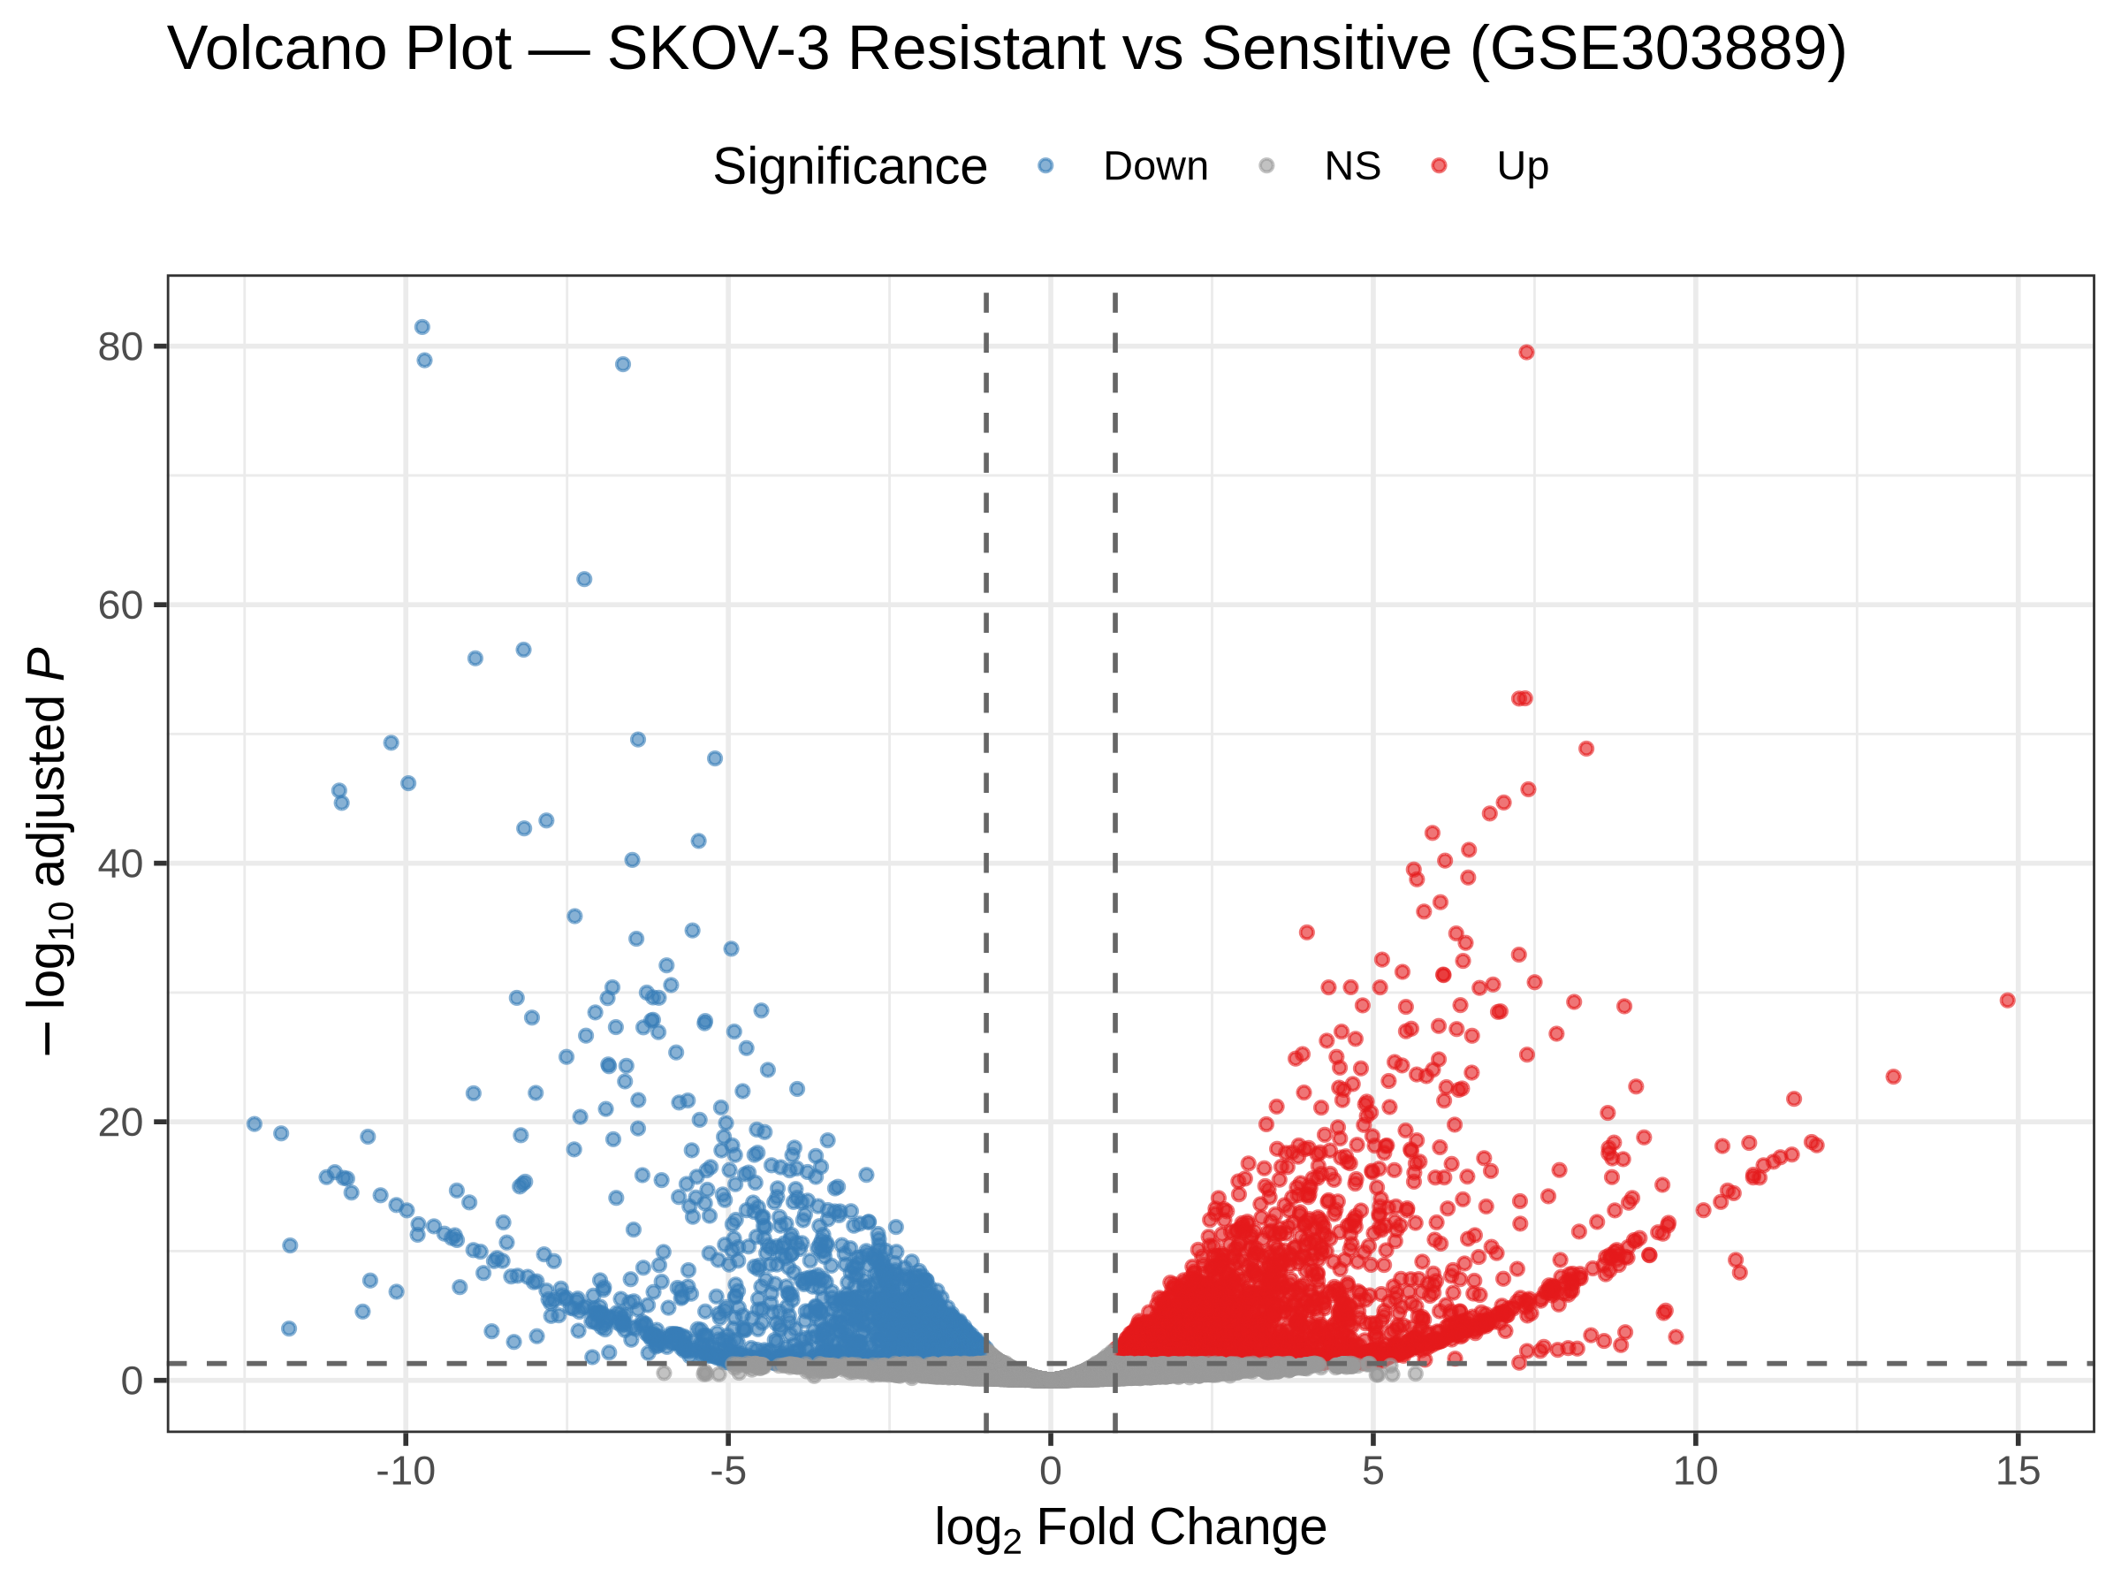
Figure 1. Volcano plot of differential expression in SKOV-3 (GSE303889). Red, significant up-regulated; blue, significant down-regulated; grey, not significant.
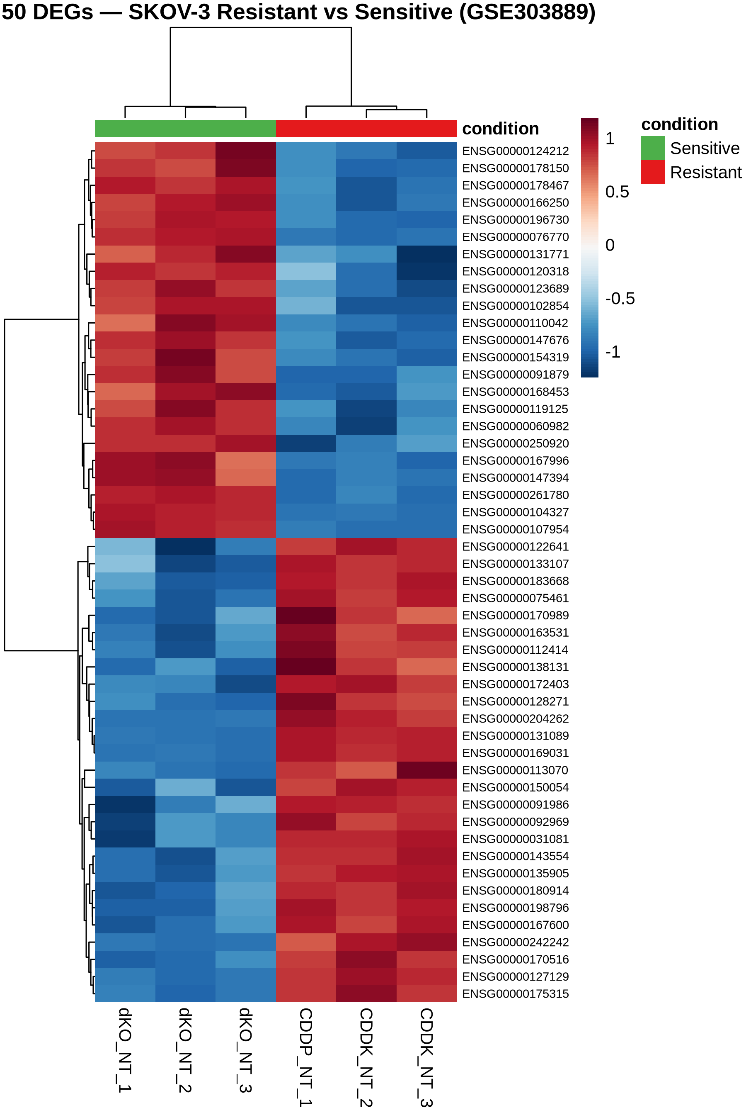
Figure 2. Heatmap of the top differentially expressed genes in SKOV-3, showing clear separation of sensitive and resistant replicates.

4.2 Differential expression — Dataset 2 (OVCAR5)
In the OVCAR5 dataset, 20,959 genes were tested and 2,572 were significant (912 up, 1,660 down). The volcano plot (Figure 3) shows the distribution of effects, and the top up-regulated genes include the inflammatory cytokines IL1A and IL1B, with a large log2 fold change, reflecting the inflammatory component of this resistance model. As expected from the distinct mechanism, the magnitude and composition of the DEG set differ from Dataset 1.
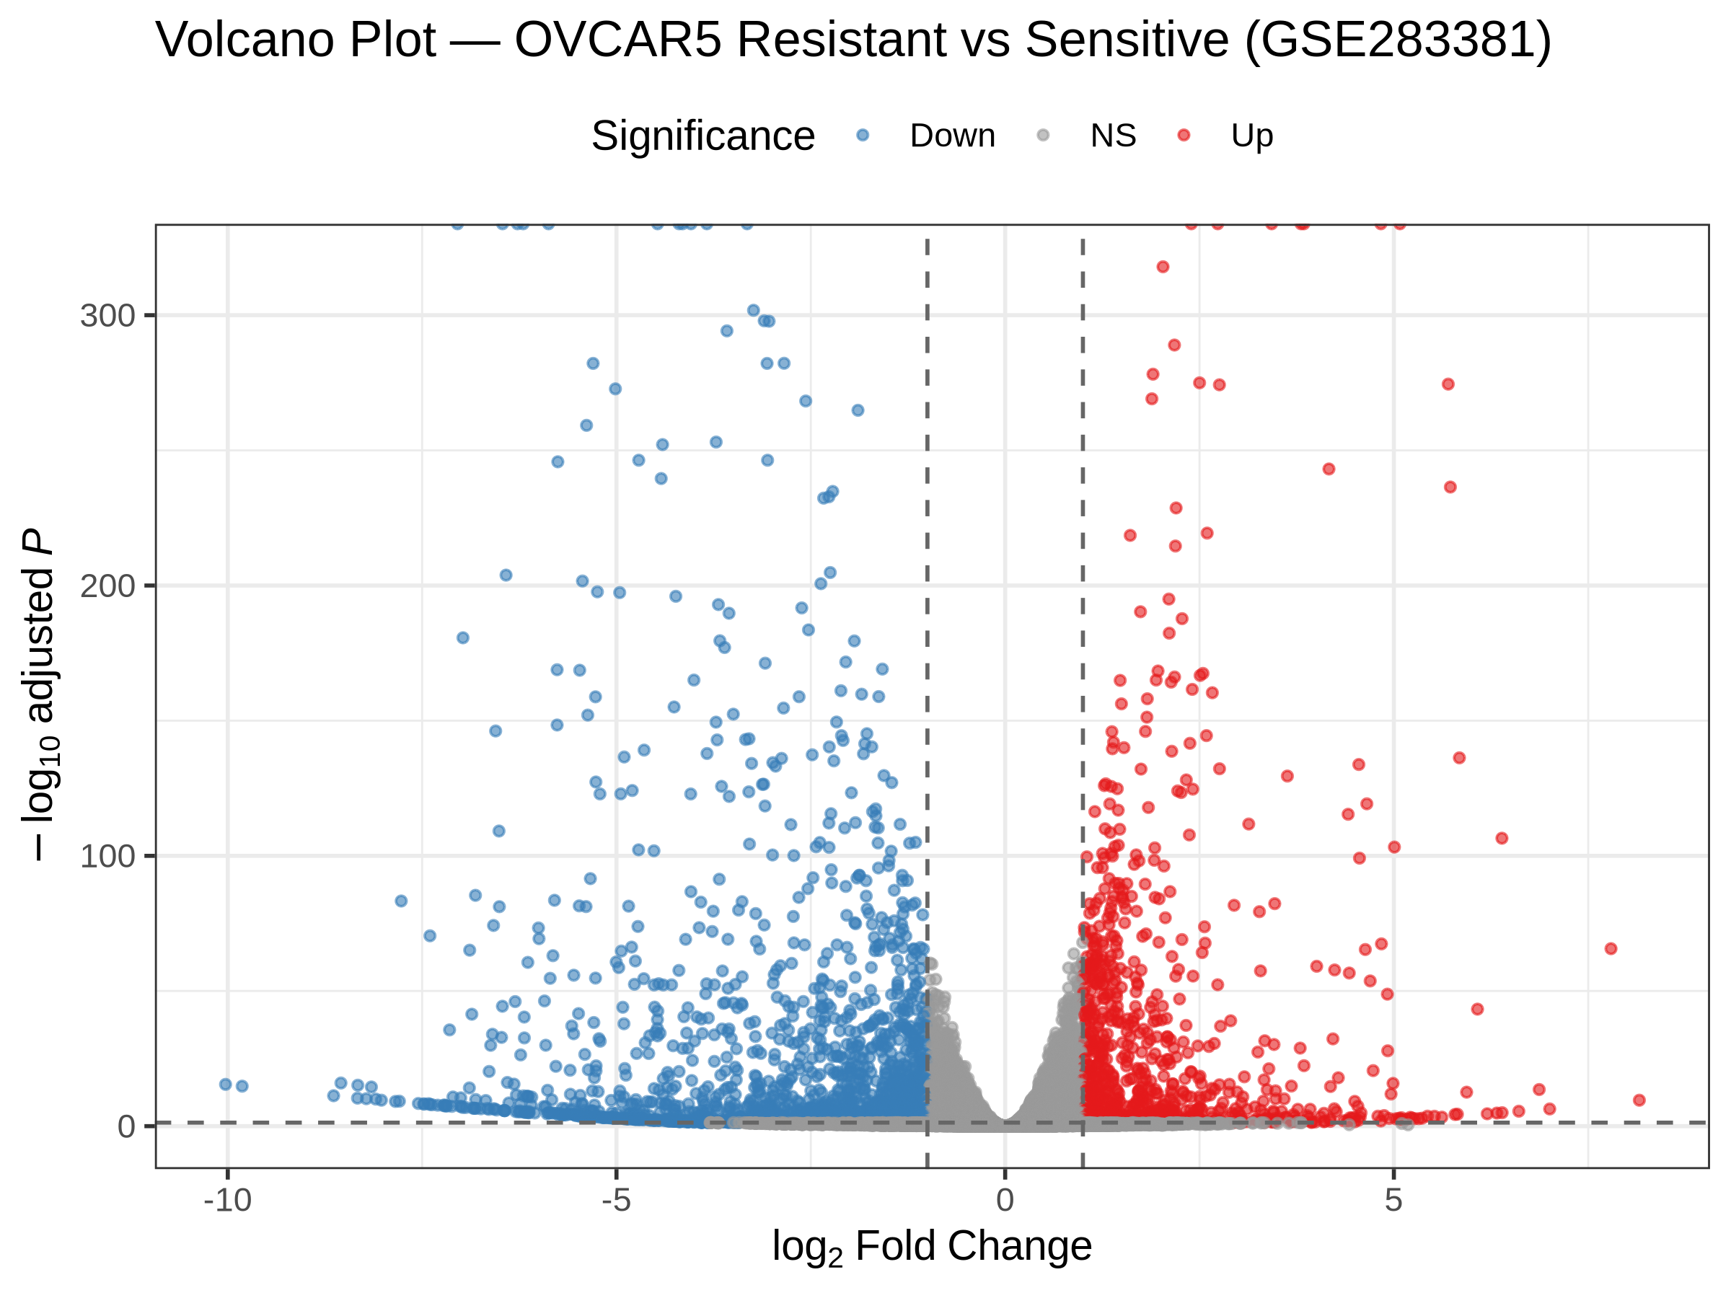
Figure 3. Volcano plot of differential expression in OVCAR5 (GSE283381).
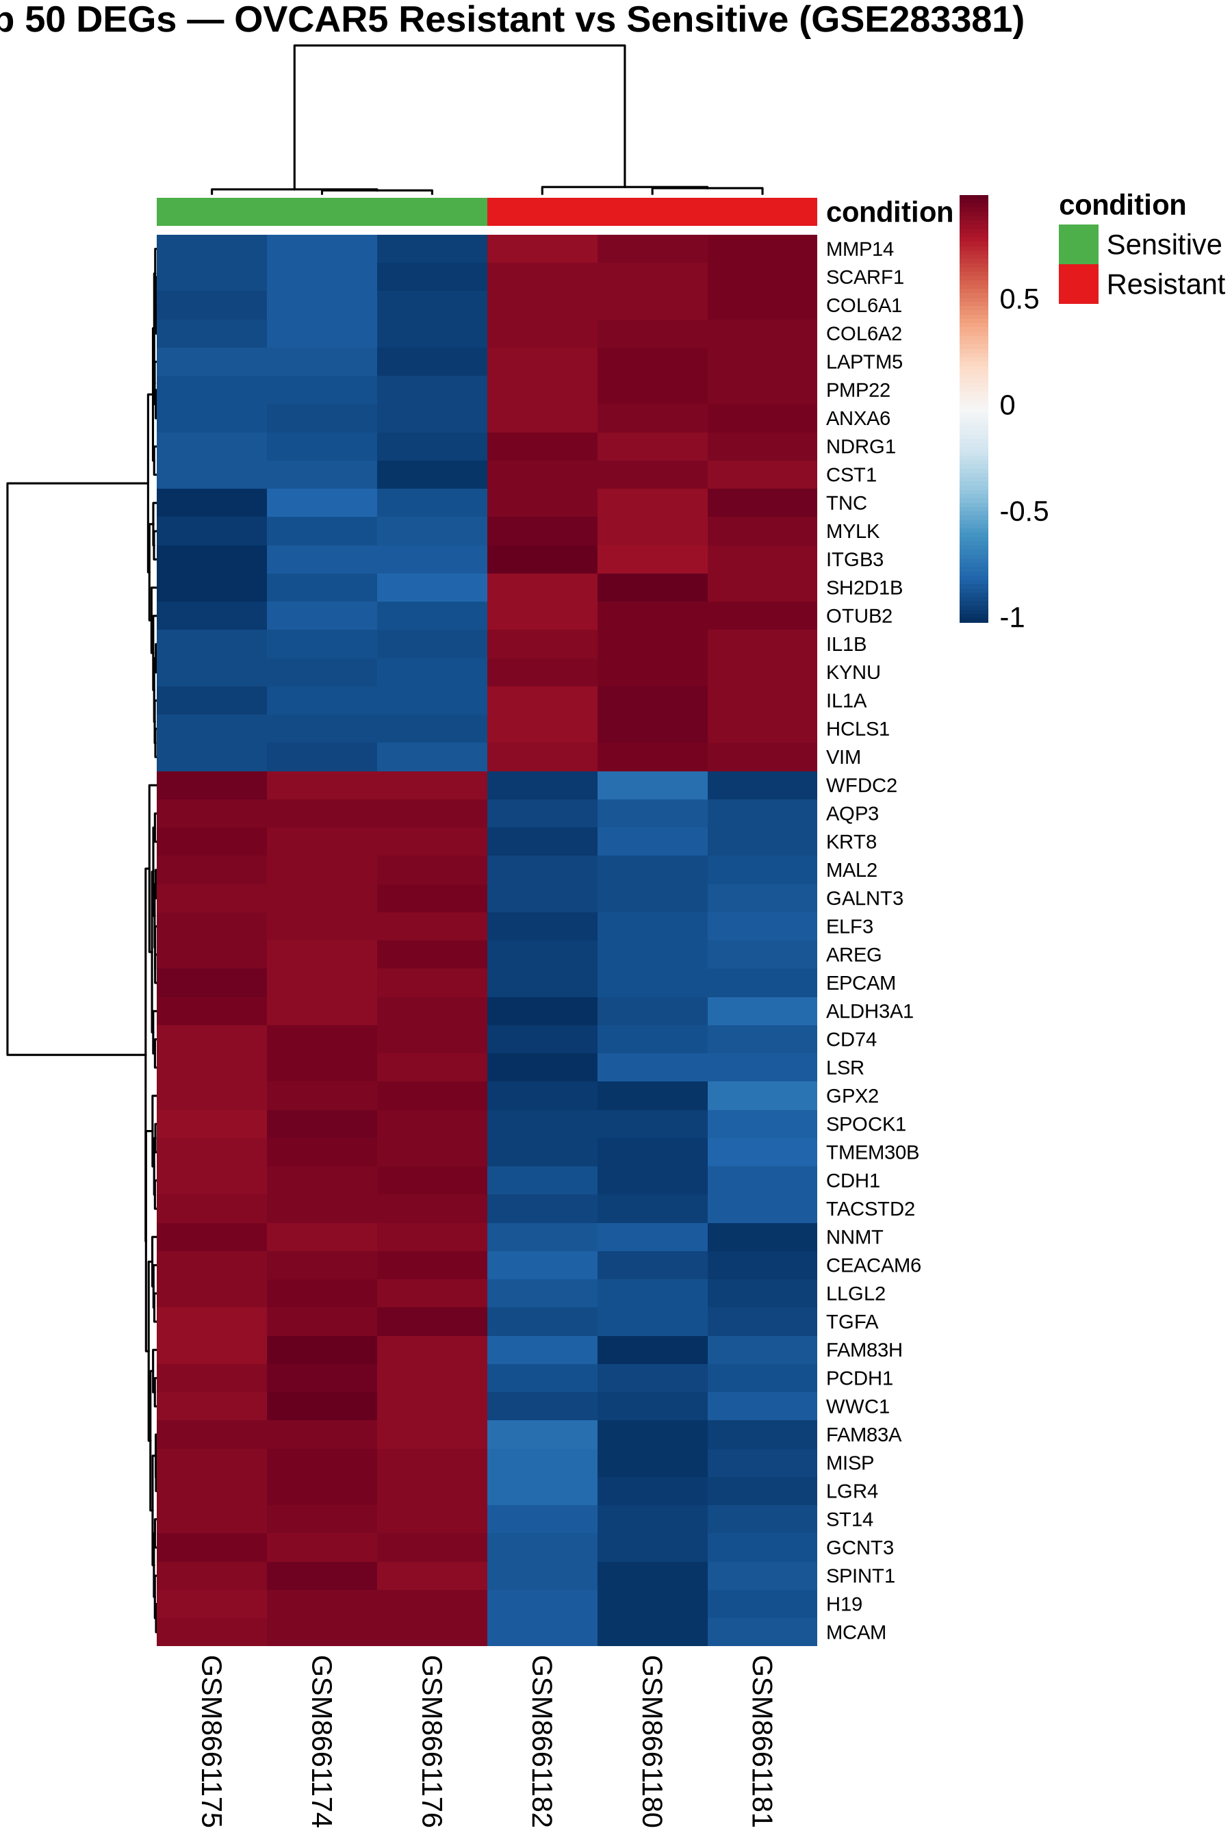
Figure 4. Heatmap of the top differentially expressed genes in OVCAR5.

4.3 Cross-dataset overlap
Intersecting the two DEG sets yielded 913 genes differentially expressed in both datasets: 198 up-regulated in both, 220 down-regulated in both, and 495 with opposite direction of change (Figure 5). The consistently regulated genes define a core signature independent of cell-line background. The Spearman correlation of shared log2 fold changes was approximately −0.04 (Figure 6): a low value that is biologically meaningful rather than a failure, because SKOV-3 and OVCAR5 acquire resistance through different programmes, so even shared genes are not expected to change by the same magnitude.
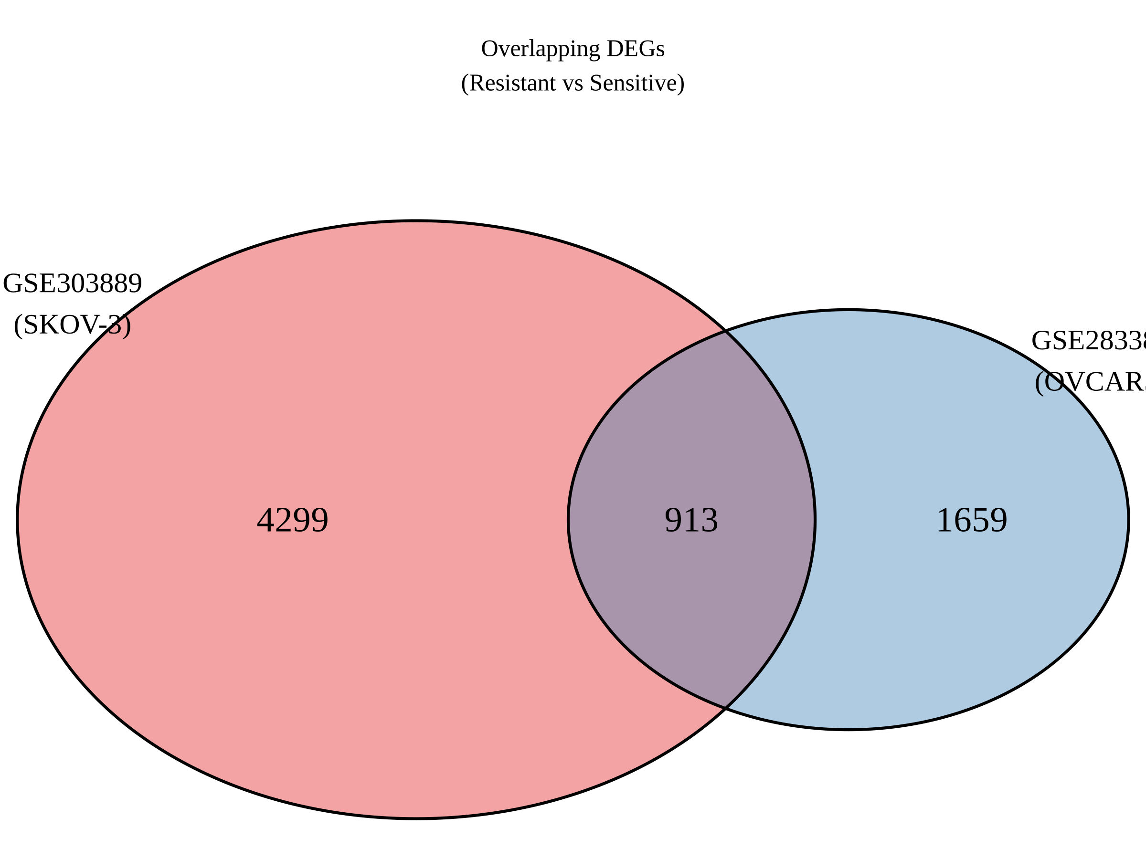
Figure 5. Venn diagram of overlapping DEGs between the two datasets.
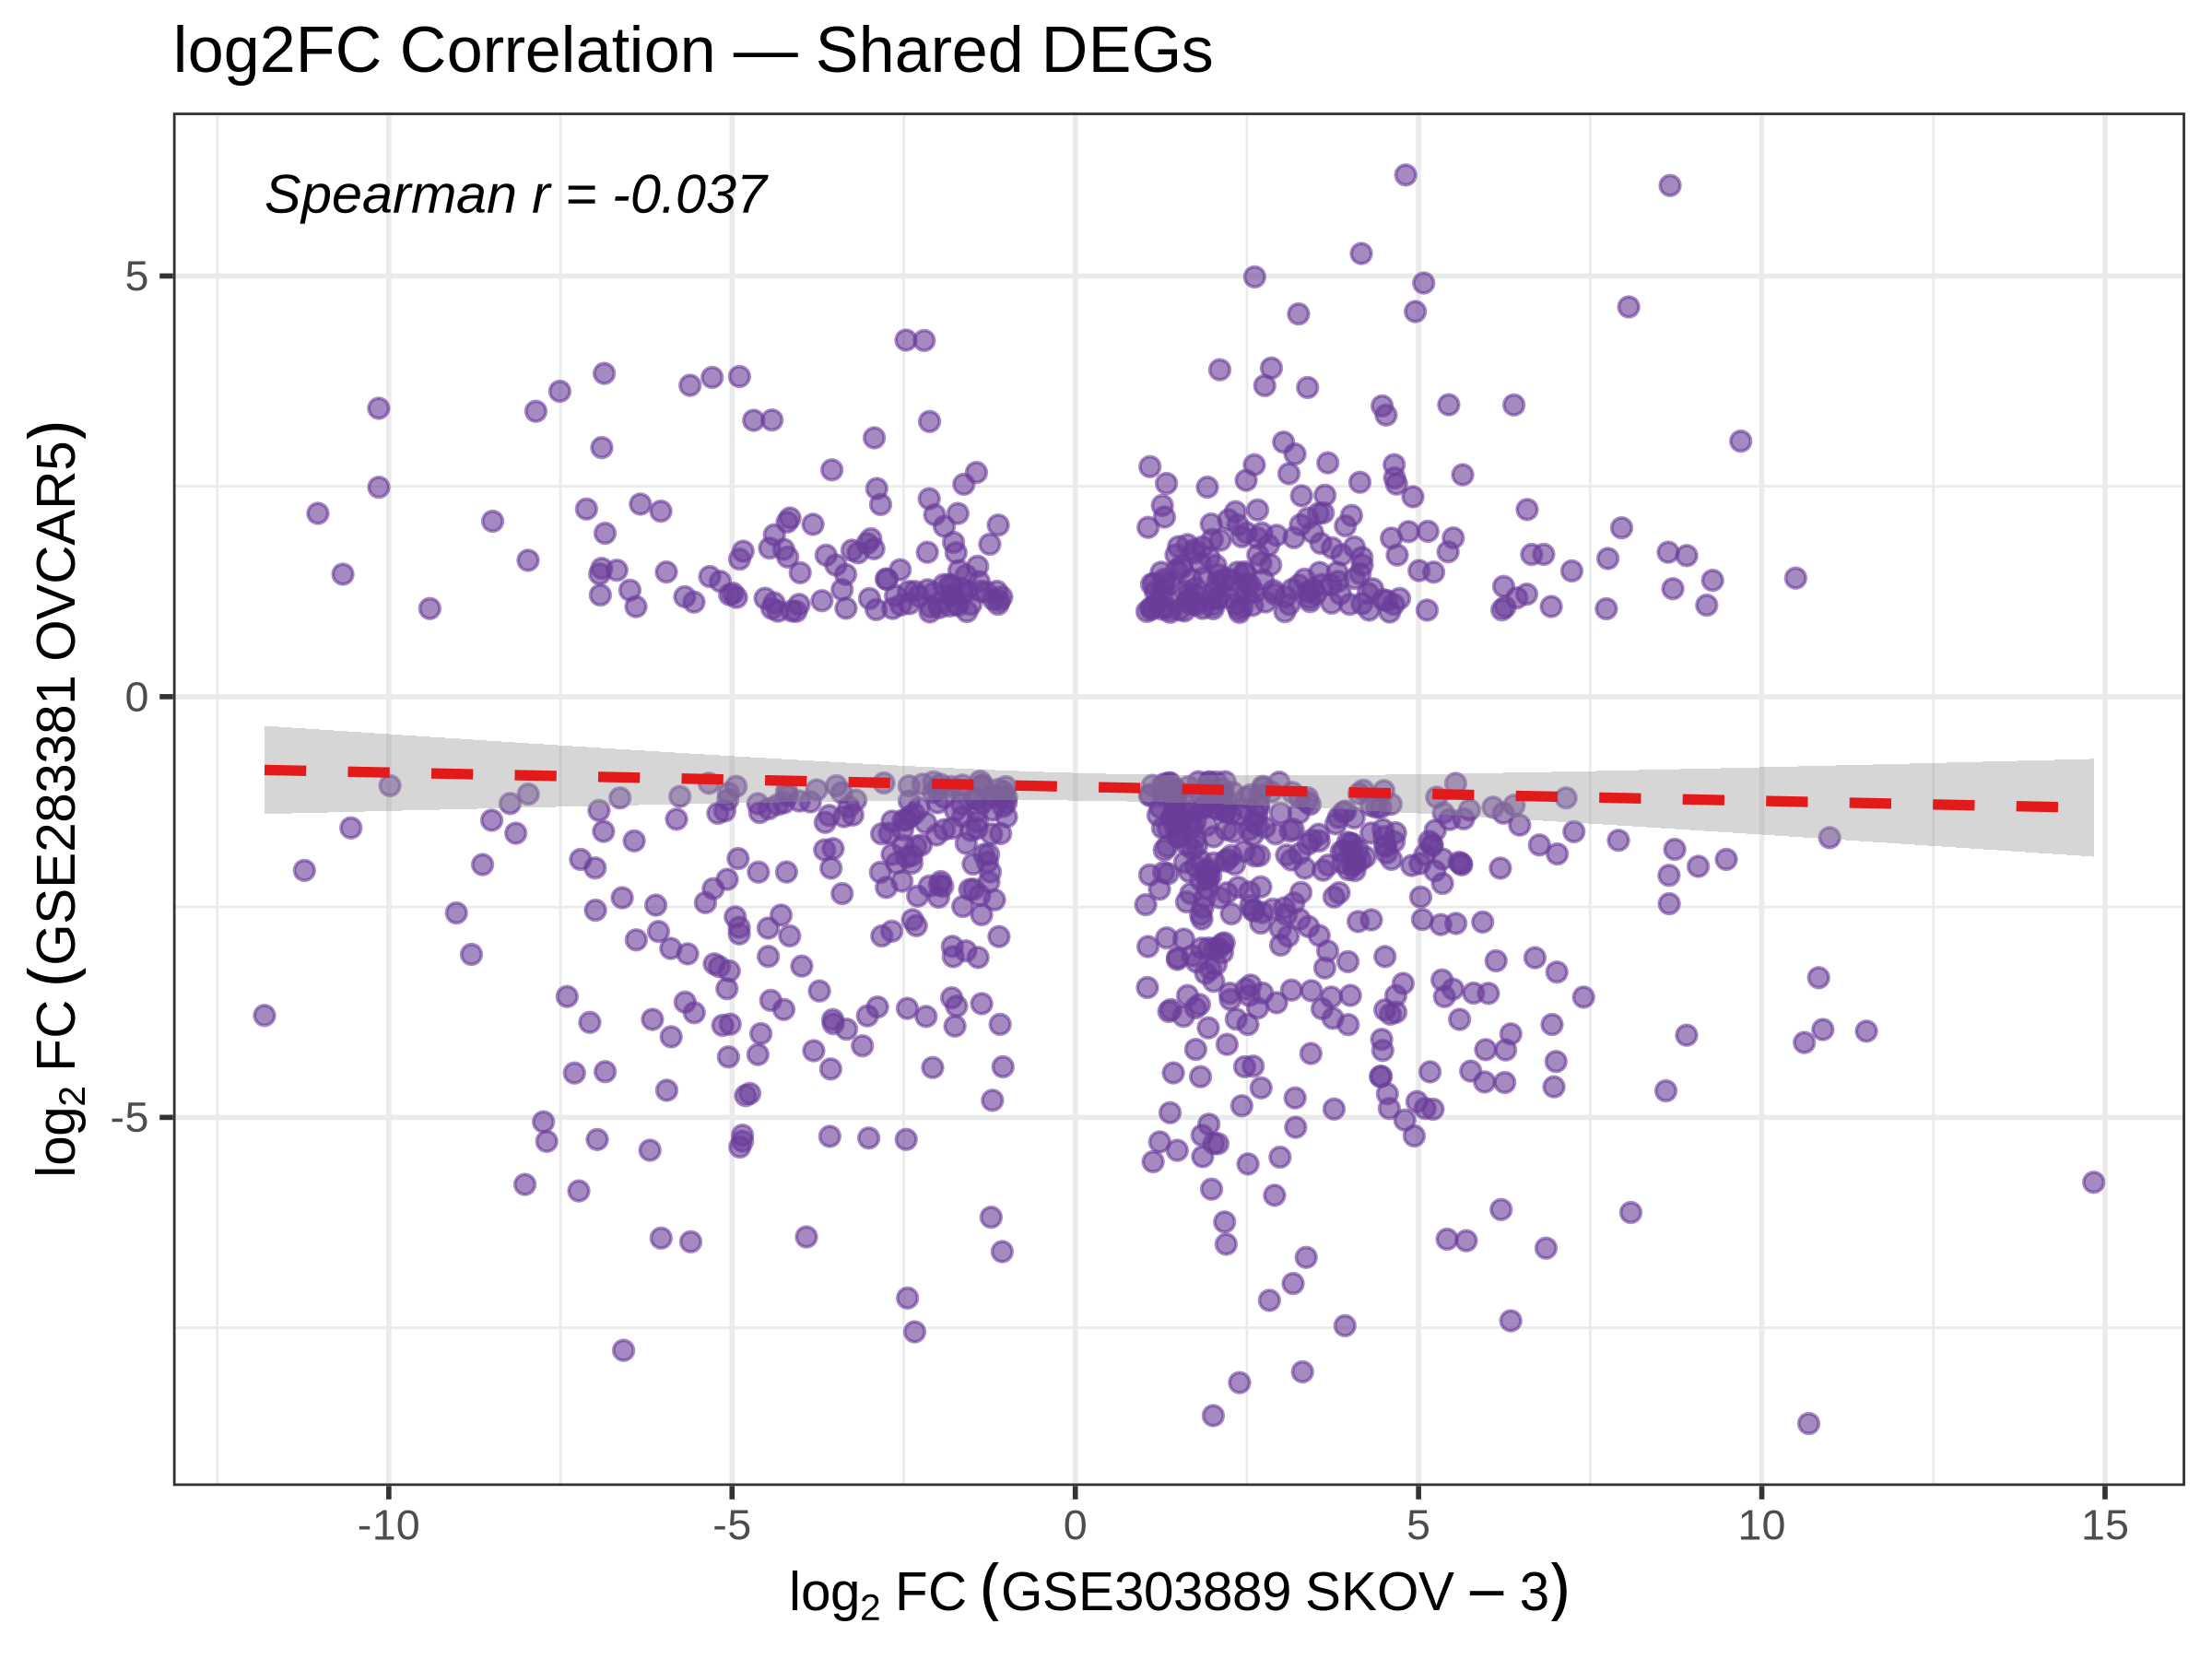
Figure 6. Correlation of log2 fold changes for shared DEGs (Spearman r ≈ −0.04).

4.4 Gene Ontology enrichment
GO enrichment of the shared DEGs was dominated by extracellular and adhesion terms (Figure 7; Table 2), including cell–substrate adhesion, extracellular matrix organisation, extracellular structure organisation, ossification and axon guidance. This is the expected functional signature of EMT and ECM remodelling, and it is consistent with the literature reviewed in Section 2.
GO term | Ontology | Count | Adjusted p
extracellular matrix | CC | 65 | 1.46e-15
external encapsulating structure | CC | 65 | 1.46e-15
transmembrane receptor protein tyrosine kinase activity | MF | 17 | 1.51e-07
basement membrane | CC | 19 | 1.25e-06
transmembrane receptor protein kinase activity | MF | 17 | 5.66e-06
growth factor binding | MF | 22 | 7.48e-06
PDZ domain binding | MF | 17 | 7.48e-06
protein tyrosine kinase activity | MF | 22 | 9.28e-06
basal plasma membrane | CC | 31 | 8.37e-05
basal part of cell | CC | 32 | 8.59e-05
Table 2. Top Gene Ontology terms enriched among shared DEGs.

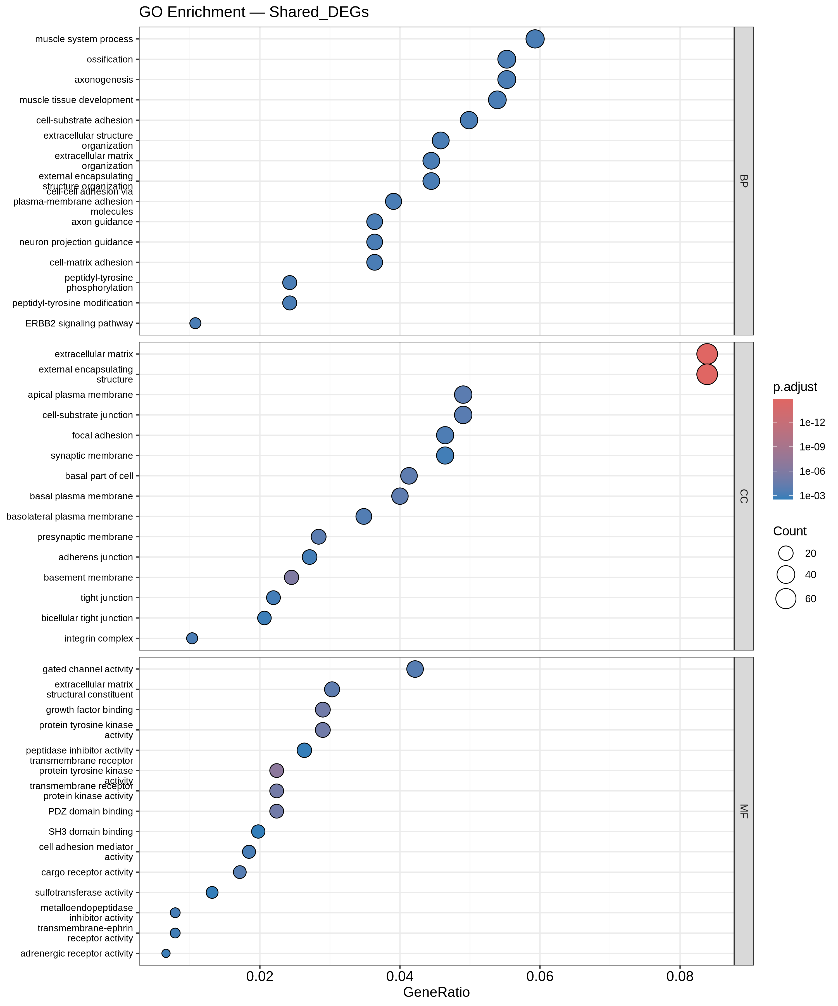
Figure 7. Gene Ontology enrichment dot plot for shared DEGs.

4.5 KEGG pathway enrichment
KEGG enrichment of the shared DEGs highlighted cytoskeletal remodelling, PI3K-Akt signalling, cadherin and integrin signalling, axon guidance, Hippo signalling and focal adhesion (Figure 8; Table 3). These pathways converge on survival, adhesion and cytoskeletal dynamics — coherent with the GO results and with known resistance mechanisms.
KEGG pathway | Count | Adjusted p
Cytoskeleton in muscle cells | 26 | 1.80e-03
Dilated cardiomyopathy | 16 | 1.80e-03
PI3K-Akt signaling pathway | 34 | 2.07e-03
Cadherin signaling | 36 | 2.48e-03
Integrin signaling | 19 | 2.48e-03
Axon guidance | 20 | 7.30e-03
Hippo signaling pathway | 18 | 7.30e-03
Focal adhesion | 21 | 8.17e-03
MAPK signaling pathway | 27 | 9.09e-03
Calcium signaling pathway | 24 | 9.09e-03
Table 3. Top KEGG pathways enriched among shared DEGs.

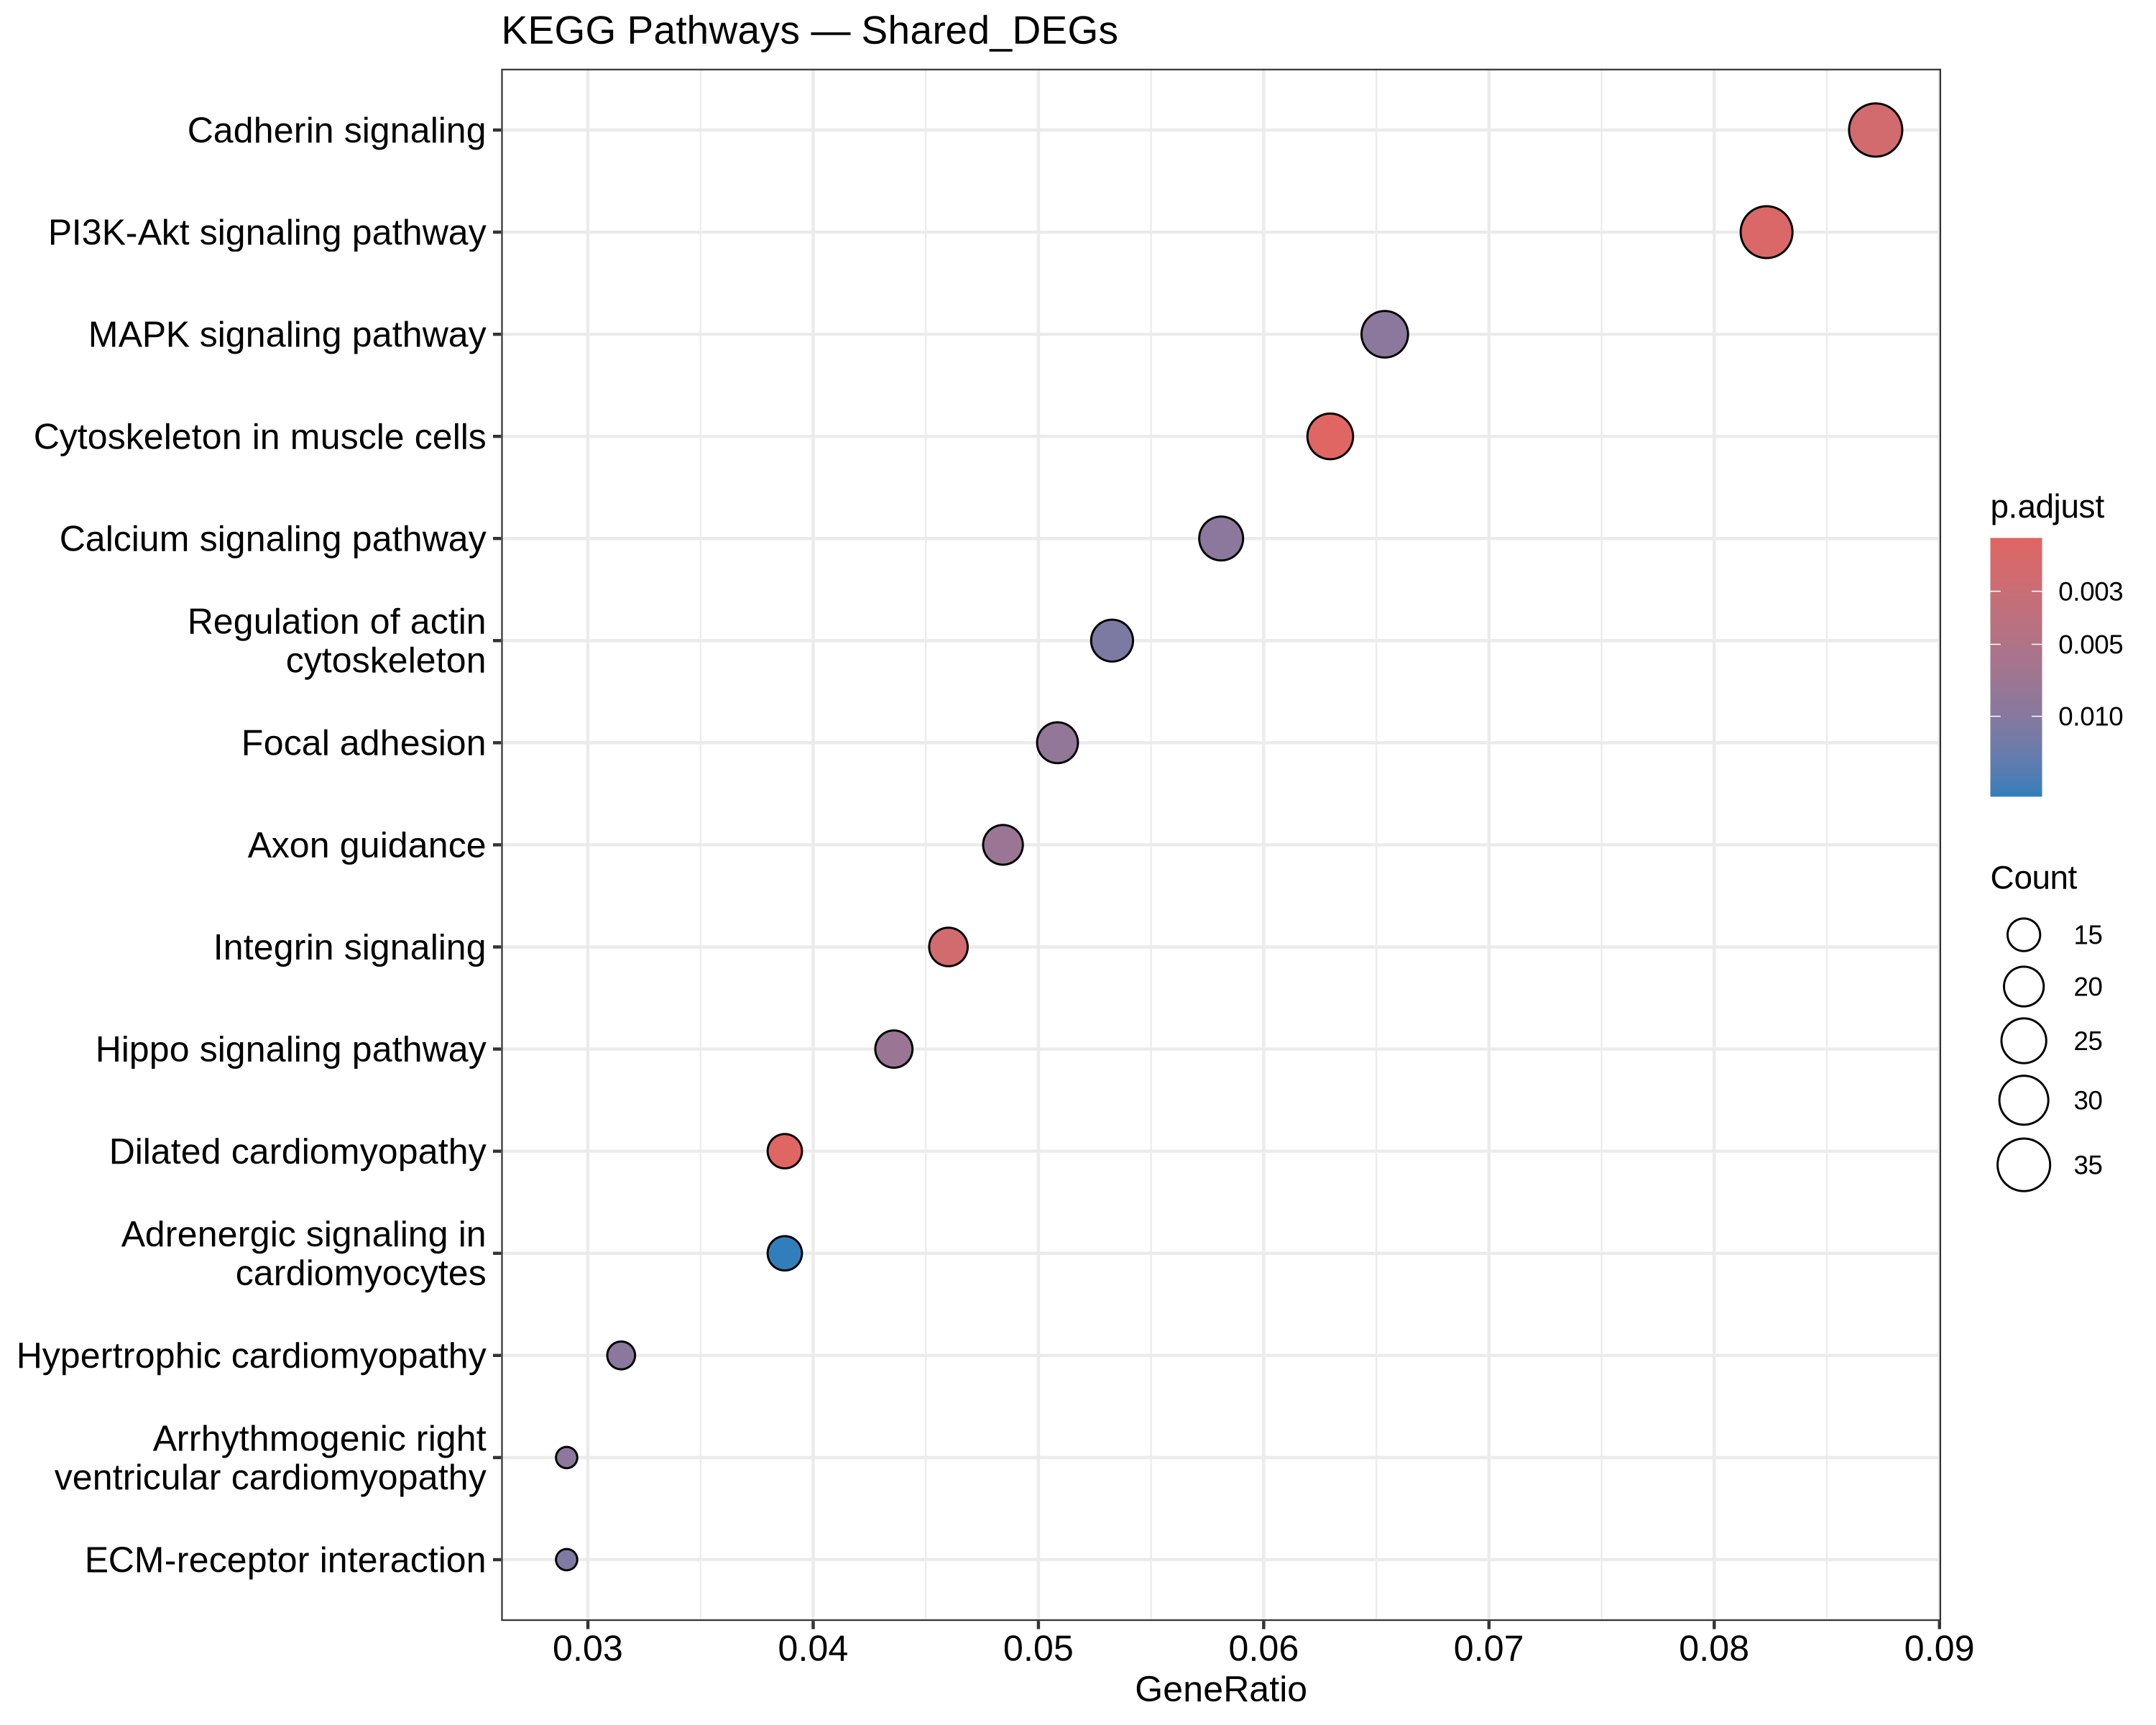
Figure 8. KEGG pathway enrichment dot plot for shared DEGs.

4.6 Within-cell-line LOOCV
Under within-cell-line LOOCV, all three classifiers separated resistant from sensitive samples almost perfectly at small feature-set sizes, with performance degrading slightly for random forest and SVM as K increased (Table 4). The minimum across the entire grid was accuracy 0.833 and ROC-AUC 0.889. Because this scheme no longer pools the two cell lines and recomputes preprocessing per fold, it is a legitimate within-study reference — but it is likely optimistic relative to true generalisation, since cell-line background itself is highly separable.
Model | K | Accuracy | ROC-AUC
LogisticRegression | 20 | 1.000 | 1.000
LogisticRegression | 50 | 1.000 | 1.000
LogisticRegression | 100 | 1.000 | 1.000
LogisticRegression | 200 | 1.000 | 1.000
LogisticRegression | 500 | 1.000 | 1.000
RandomForest | 20 | 1.000 | 1.000
RandomForest | 50 | 1.000 | 1.000
RandomForest | 100 | 0.917 | 1.000
RandomForest | 200 | 0.917 | 0.972
RandomForest | 500 | 0.917 | 1.000
SVM | 20 | 1.000 | 1.000
SVM | 50 | 1.000 | 1.000
SVM | 100 | 0.833 | 0.972
SVM | 200 | 0.833 | 0.972
SVM | 500 | 0.833 | 0.889
Table 4. Within-cell-line LOOCV performance (K = number of selected genes).

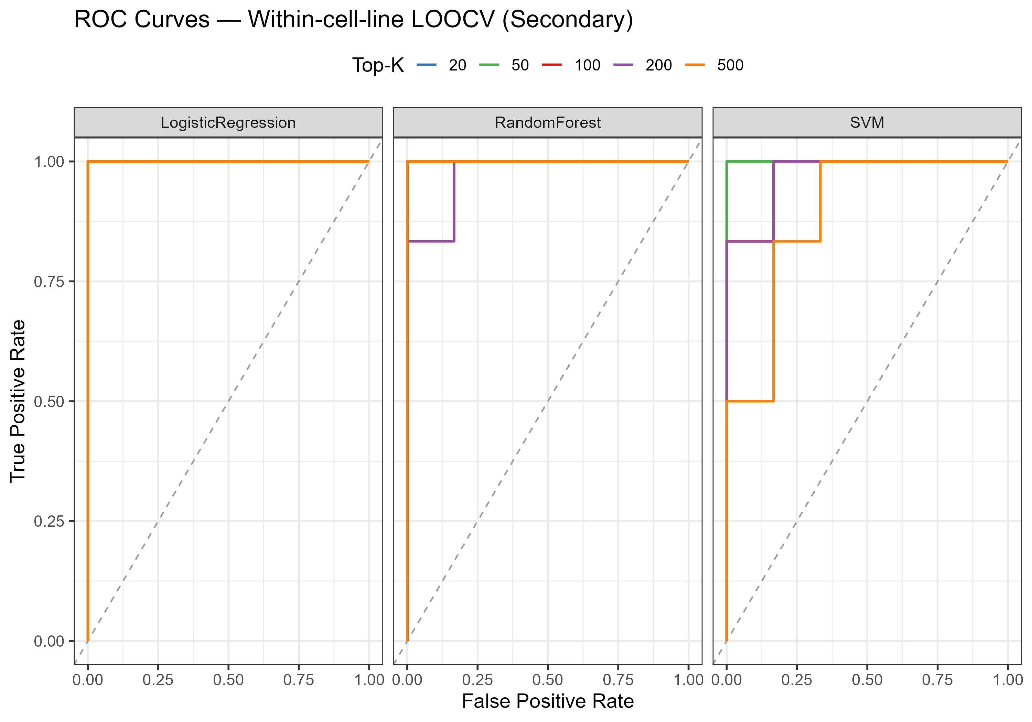
Figure 9. ROC curves for within-cell-line LOOCV.

4.7 Cross-dataset external validation — target_z
Under the batch-corrected target_z scheme, a small SKOV-3-derived signature transferred to OVCAR5, with all three models reaching ROC-AUC 1.0 at K = 20 (logistic regression and SVM also at K = 50). The reverse direction, OVCAR5→SKOV3, remained close to chance (AUC ≈ 0.44–0.78). Performance collapsed as K grew, a classic n << p overfitting signature given only six training samples (Table 5).
Model | K | Train→Test | Accuracy | ROC-AUC
LogisticRegression | 20 | OVCAR5->SKOV3 | 0.500 | 0.556
LogisticRegression | 50 | OVCAR5->SKOV3 | 0.333 | 0.444
LogisticRegression | 100 | OVCAR5->SKOV3 | 0.500 | 0.556
RandomForest | 20 | OVCAR5->SKOV3 | 0.333 | 0.556
RandomForest | 50 | OVCAR5->SKOV3 | 0.500 | 0.611
RandomForest | 100 | OVCAR5->SKOV3 | 0.500 | 0.444
SVM | 20 | OVCAR5->SKOV3 | 0.500 | 0.556
SVM | 50 | OVCAR5->SKOV3 | 0.500 | 0.444
SVM | 100 | OVCAR5->SKOV3 | 0.500 | 0.556
LogisticRegression | 20 | SKOV3->OVCAR5 | 1.000 | 1.000
LogisticRegression | 50 | SKOV3->OVCAR5 | 1.000 | 1.000
LogisticRegression | 100 | SKOV3->OVCAR5 | 0.667 | 0.556
RandomForest | 20 | SKOV3->OVCAR5 | 1.000 | 1.000
RandomForest | 50 | SKOV3->OVCAR5 | 1.000 | 1.000
RandomForest | 100 | SKOV3->OVCAR5 | 0.833 | 0.778
SVM | 20 | SKOV3->OVCAR5 | 1.000 | 1.000
SVM | 50 | SKOV3->OVCAR5 | 1.000 | 1.000
SVM | 100 | SKOV3->OVCAR5 | 0.500 | 0.556
Table 5. External validation under target_z (selected K values).

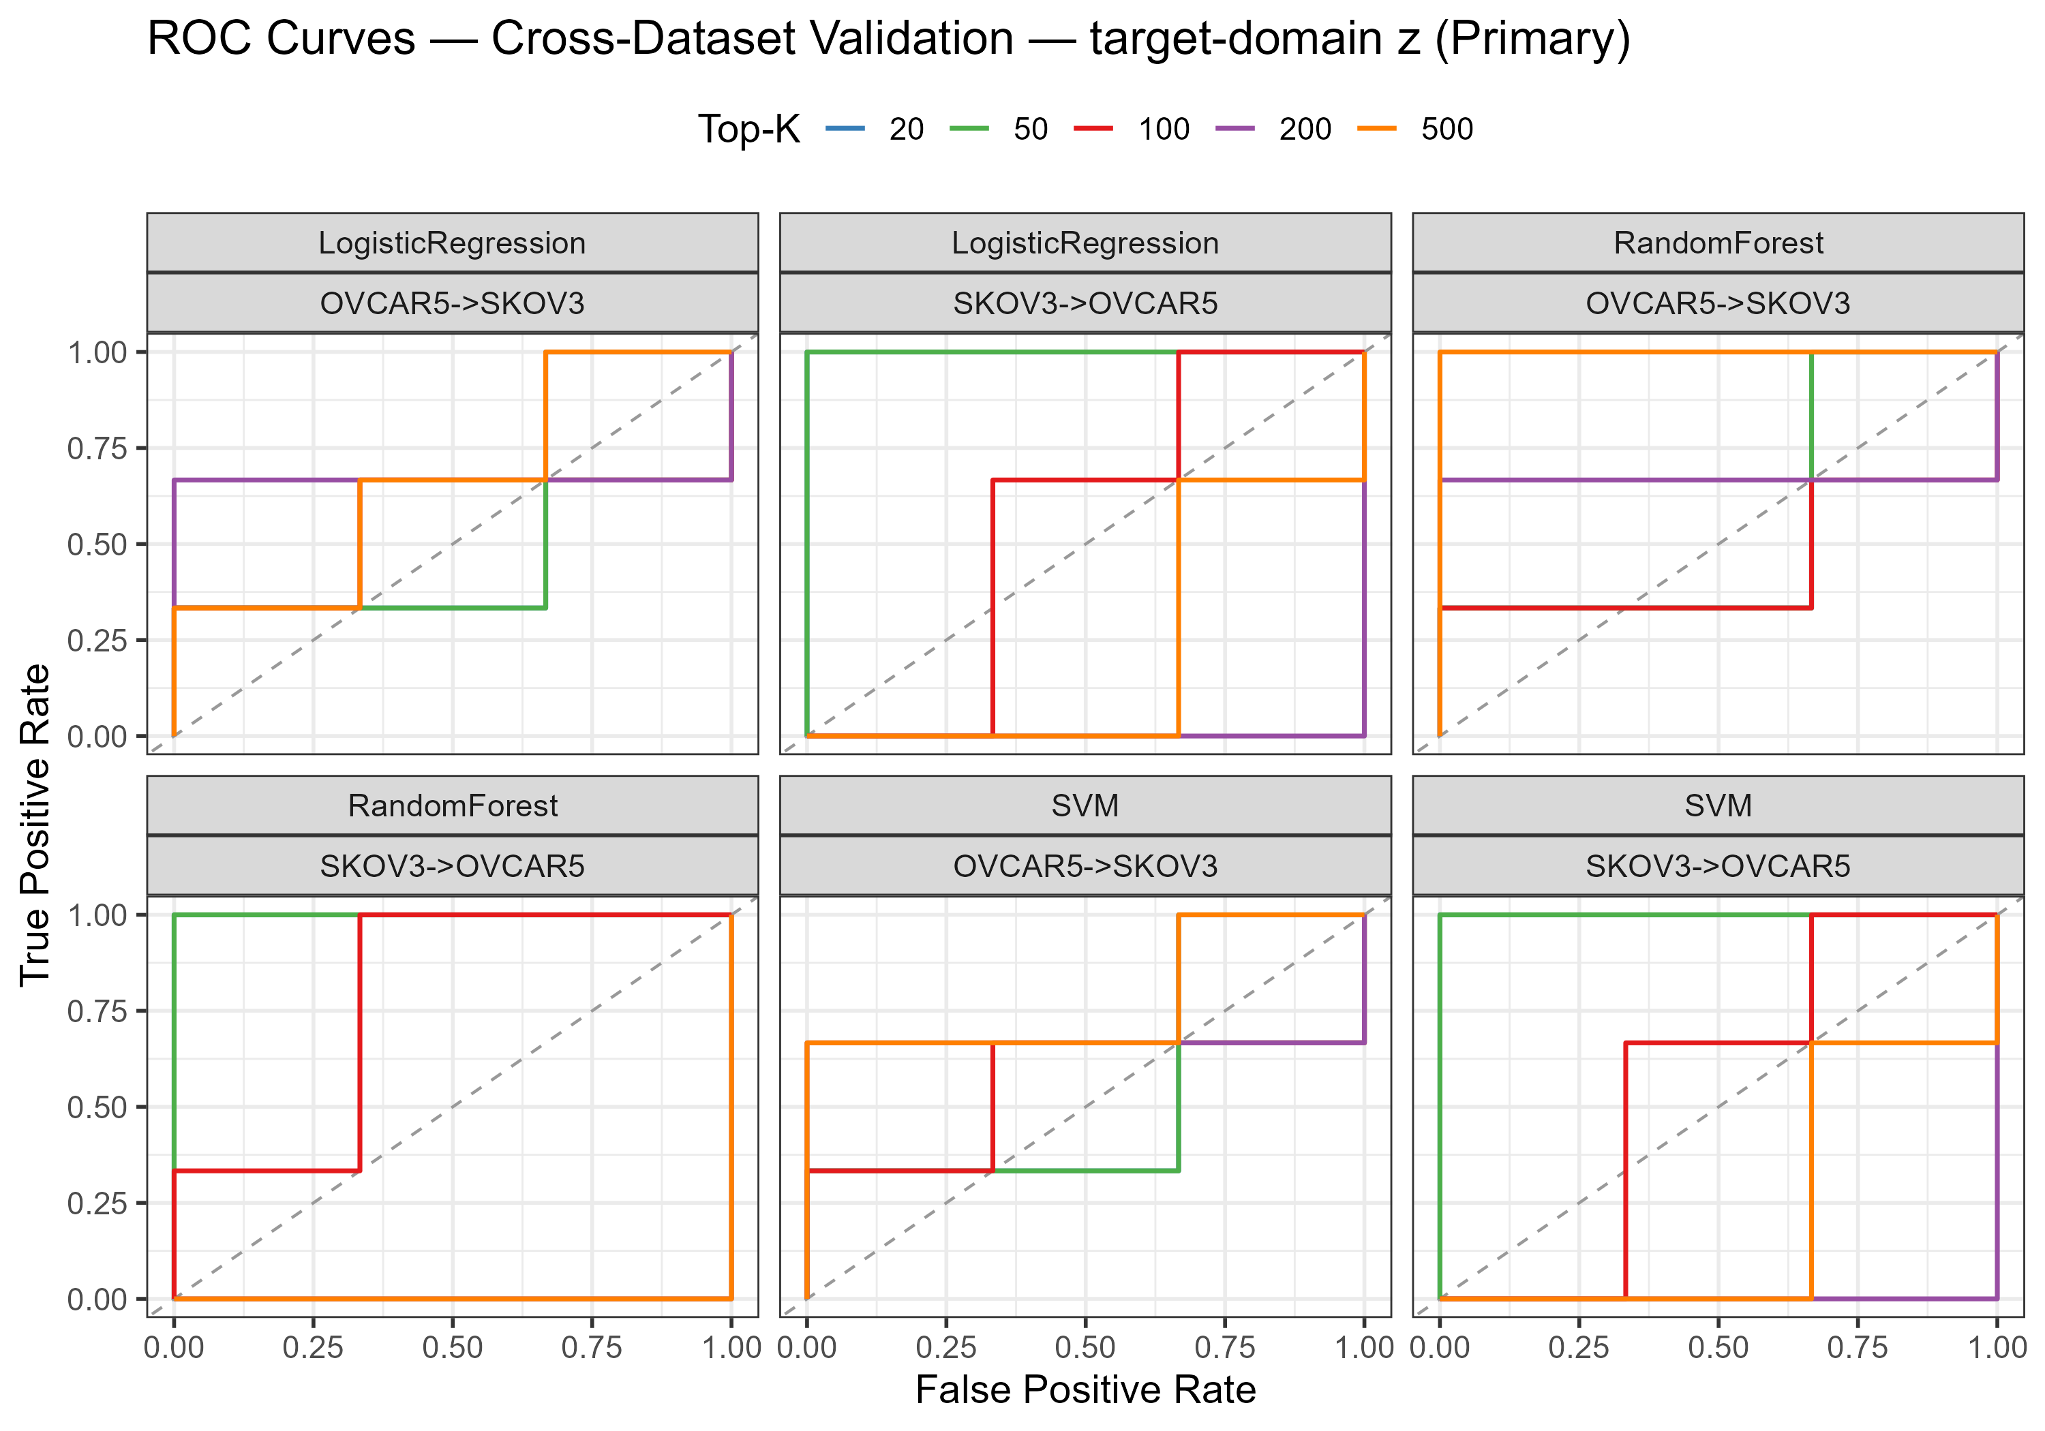
Figure 10. External validation ROC curves (target_z, per direction).
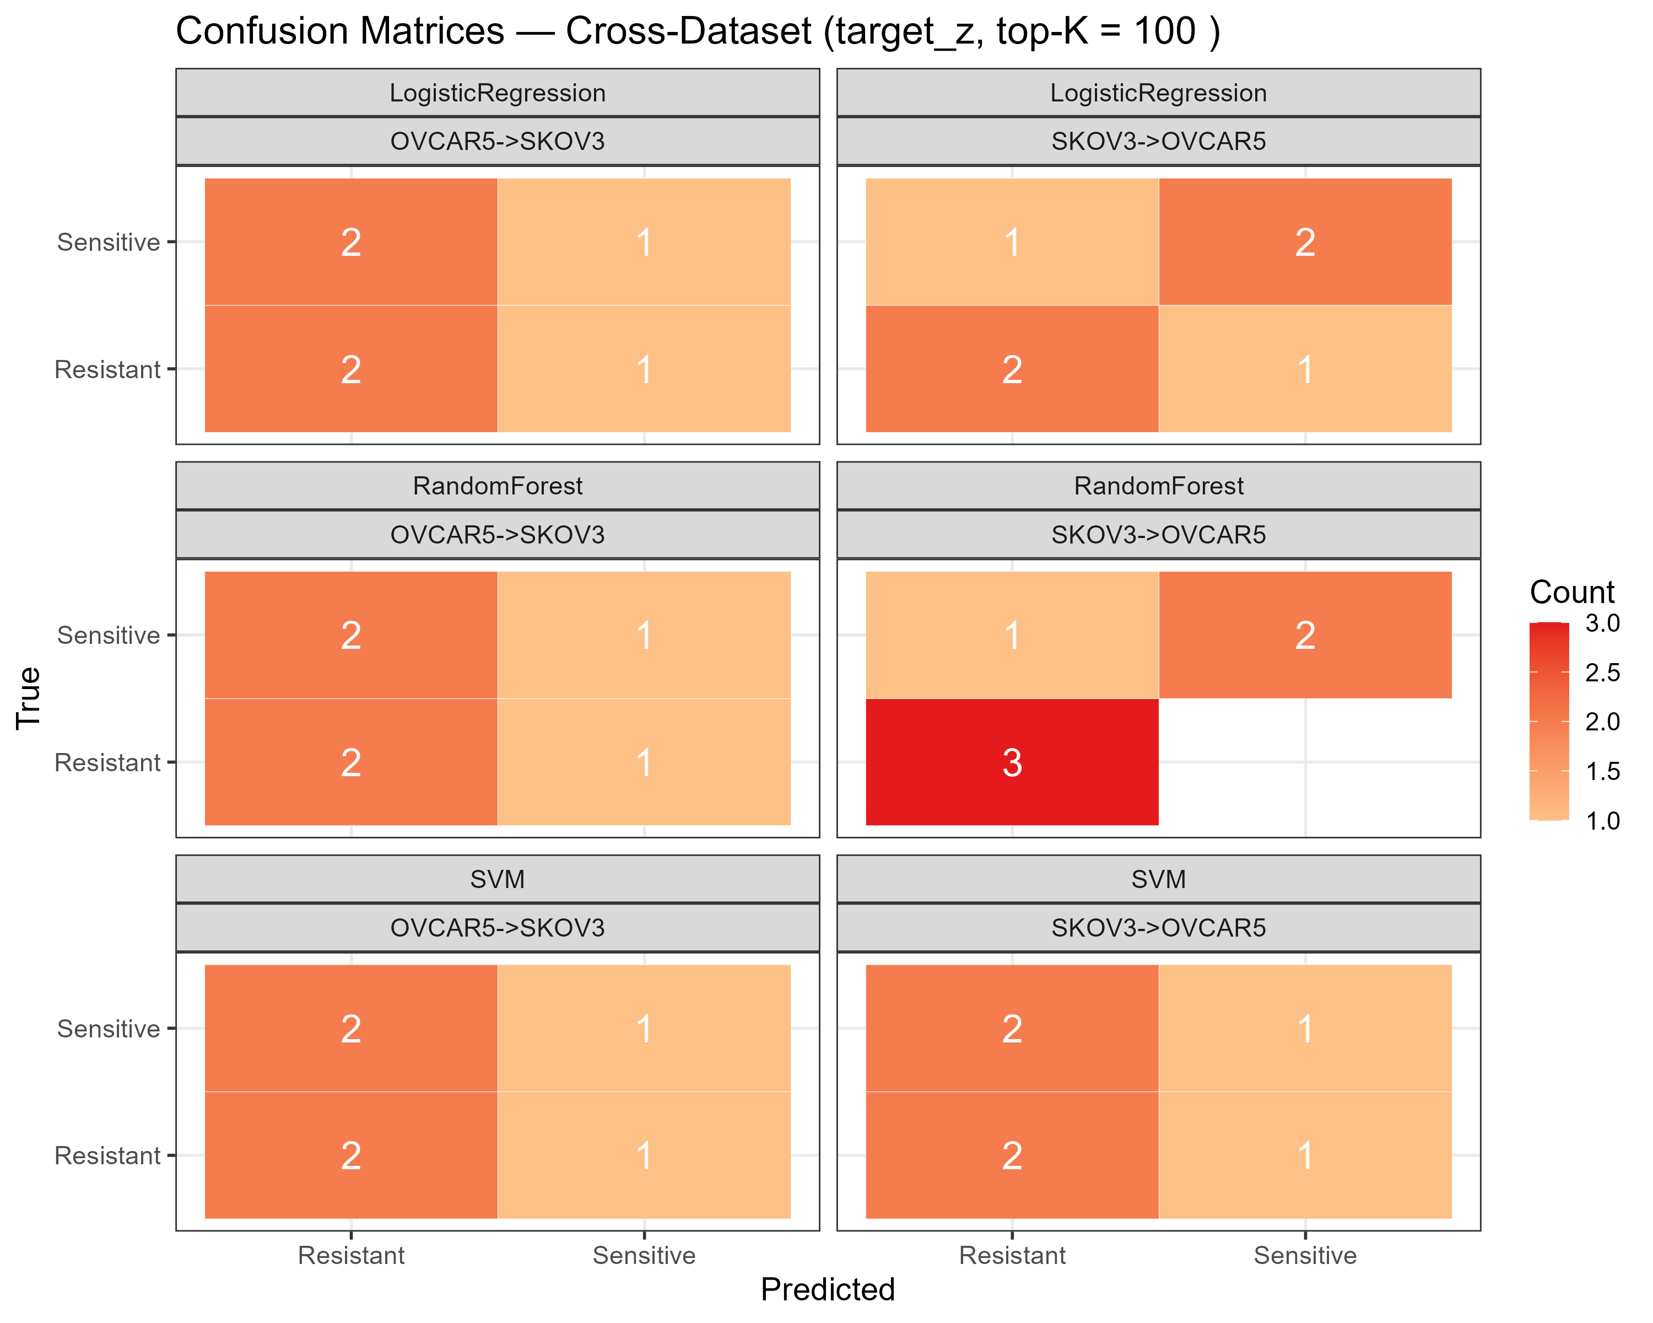
Figure 11. External confusion matrices (target_z).

4.8 Cross-dataset external validation — train_stats (strict)
Under the strictly non-transductive train_stats scheme, in which the held-out cell line is standardised with the training line's statistics, the mean ROC-AUC across the 3 × 5 × 2 grid was 0.61. 12 of 30 cells reached AUC 1.0, but these were not consistent across K, model or direction. Accuracy never reached 1.0 (maximum 0.83, median 0.50) because the miscalibrated probabilities cluster on one side of the 0.5 threshold; AUC is therefore the meaningful metric. This leak-free result is the honest estimate of cross-model transfer.
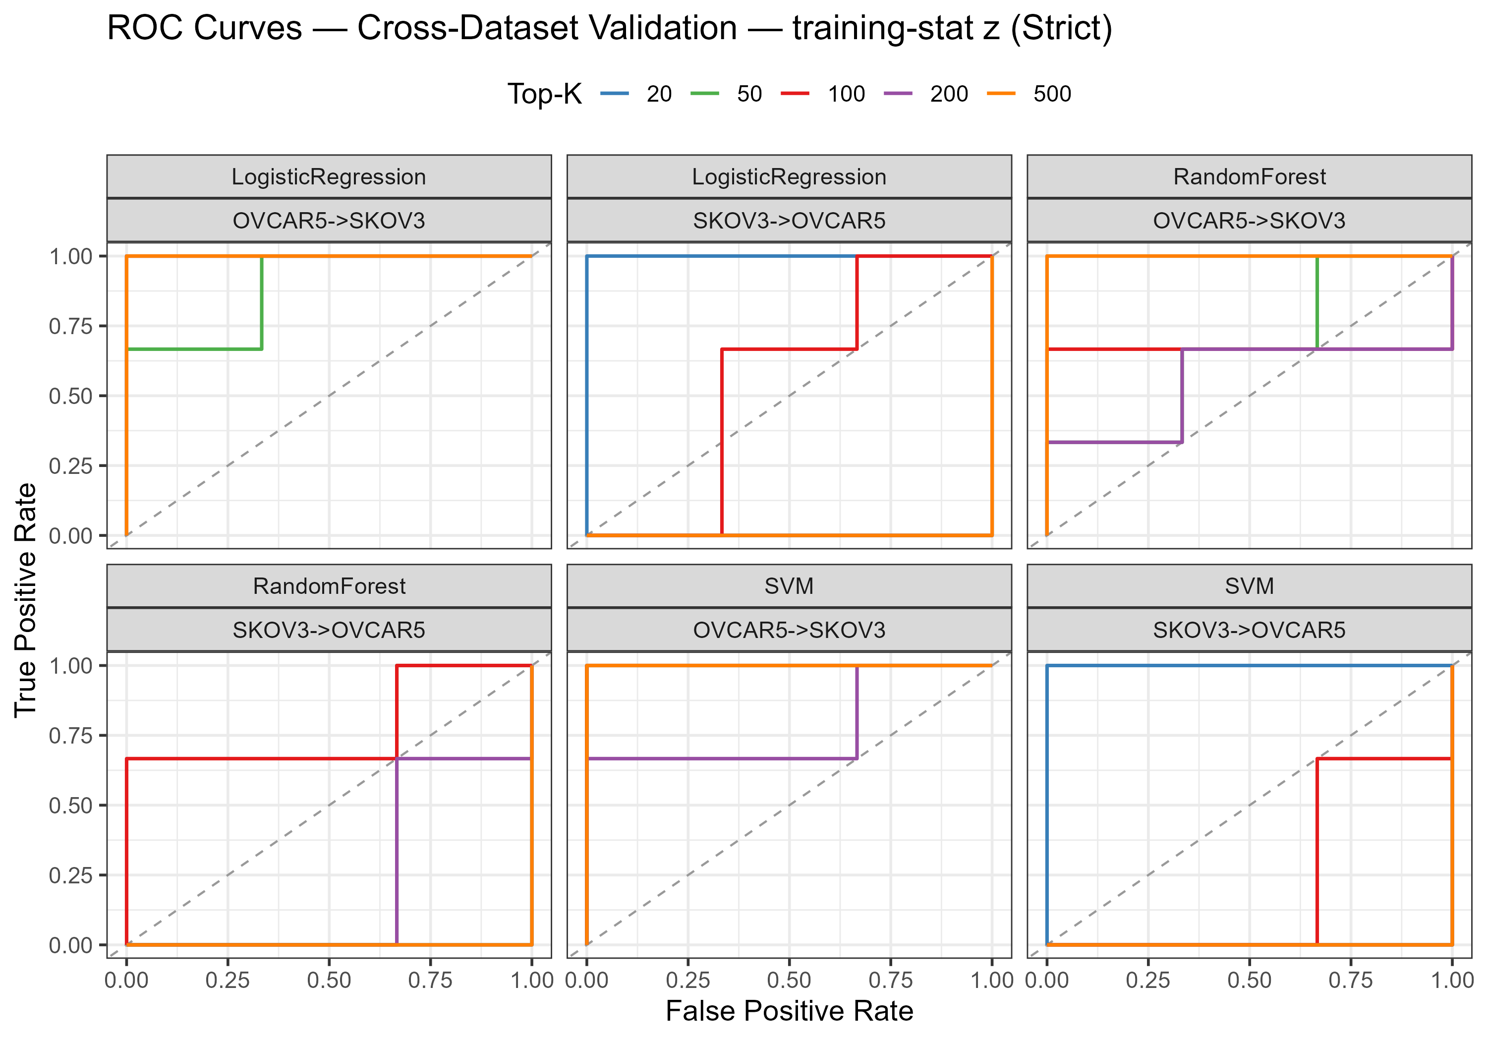
Figure 12. External validation ROC curves (strict train_stats scheme).

4.9 Feature importance and panel construction
Across the grid of models and K values, a stable set of genes was selected repeatedly from the full 57,357-gene space (Figure 13). MAL2 and GALNT6 were the most consistently selected, followed by LDOC1, SH2D4A and FBXL21P. Because the selection frequency is dominated by the SKOV3→OVCAR5 direction, the panel is best regarded as a set of candidates for follow-up rather than a validated, directionally consistent signature.
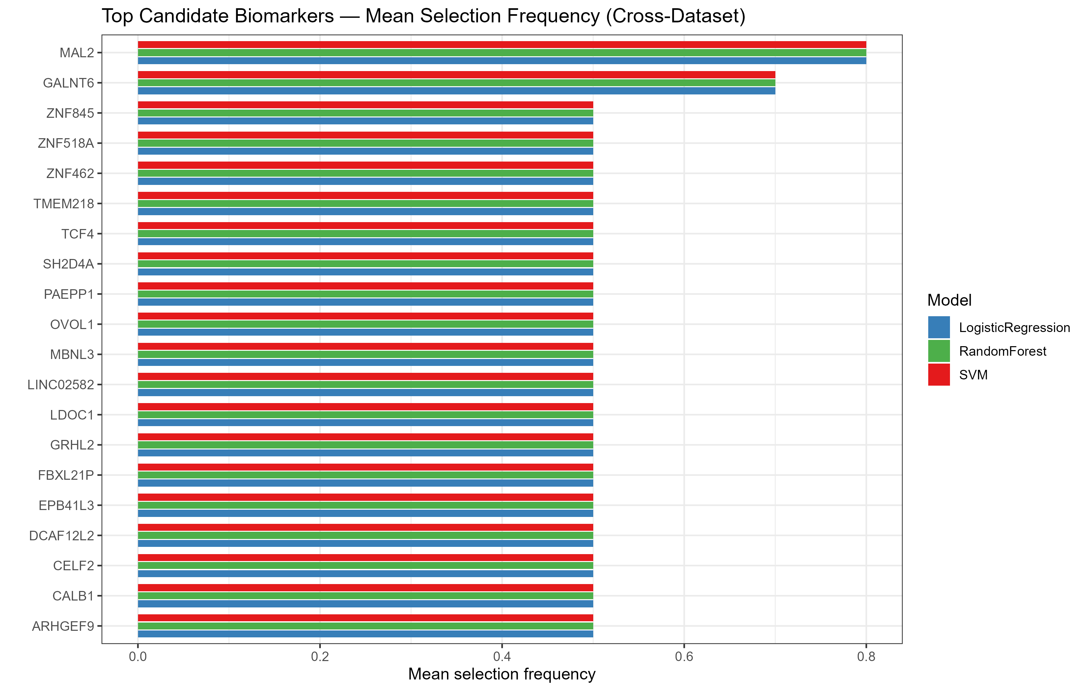
Figure 13. Feature-selection frequencies across models and K values.

5. Result
This section consolidates the headline outcomes. Detailed per-stage analysis is presented in Section 4; here the results are presented as summary tables and the key figures that support them.

5.1 Summary of differential expression
Dataset | Cell line | Genes tested | Significant DEGs | Up | Down
GSE303889 | SKOV-3 | 22,372 | 5,212 | 2,983 | 2,229
GSE283381 | OVCAR5 | 20,959 | 2,572 | 912 | 1,660
Table 6. Differential expression summary (FDR < 0.05, |log2FC| > 1).

5.2 Cross-dataset core signature
Category | Count
Shared up-regulated | 198
Shared down-regulated | 220
Opposite direction (mixed) | 495
Total shared DEGs | 913
Table 7. Composition of the cross-dataset core signature.

Representative shared DEGs (first 15 of the overlap list): NEURL1, MAL2, DAPK1, CACNG4, ANGPT2, FAM167A, OXTR, ZNF185, HR, INHBA, DTX4, HBEGF, ZNF114, MPP7, LOXL4.

5.3 Enrichment results
The top GO terms and KEGG pathways are summarised in Tables 2 and 3. Across both ontologies, the recurring themes are extracellular matrix organisation, cell adhesion, cytoskeletal remodelling and PI3K-Akt/integrin/focal-adhesion signalling — a coherent resistance phenotype centred on EMT.

5.4 Machine-learning performance summary
Validation | Scheme | Best / range | Interpretation
Within-cell-line LOOCV | — | Acc 0.833–1.000; AUC 0.889–1.000 | Near-complete within-study separation
External (SKOV3→OVCAR5) | target_z | AUC up to 1.00 at small K | Transferable signal at K = 20–50
External (OVCAR5→SKOV3) | target_z | AUC ≈ 0.44–0.78 | No reliable reverse transfer
External (all cells) | train_stats | Mean AUC 0.61 | Leak-free; partial transfer only
Table 8. Machine-learning performance summary across validation schemes.

5.5 Candidate biomarker panel
Rank | Gene | Selected (of 15 slots) | Mean |log2FC|
1 | MAL2 | 15 | 6.6
2 | GALNT6 | 15 | 6.0
3 | LDOC1 | 15 | 13.1
4 | SH2D4A | 15 | 11.9
5 | FBXL21P | 15 | 11.3
6 | EPB41L3 | 15 | 11.1
7 | TMEM218 | 15 | 10.9
8 | CALB1 | 15 | 9.7
9 | LINC02582 | 15 | 9.7
10 | CELF2 | 15 | 9.0
11 | DCAF12L2 | 15 | 9.0
12 | ZNF845 | 15 | 8.2
13 | TCF4 | 15 | 7.8
14 | PAEPP1 | 15 | 7.8
15 | GRHL2 | 15 | 6.8
16 | MBNL3 | 15 | 6.8
17 | ARHGEF9 | 15 | 6.5
18 | ZNF462 | 15 | 6.4
19 | ZNF518A | 15 | 6.2
20 | OVOL1 | 15 | 5.9
Table 9. Top-20 candidate biomarkers ranked by cross-dataset selection frequency (tie-broken by mean |log2FC|).

5.6 Integrated result
Two independent cisplatin-resistance models both undergo extensive transcriptomic reprogramming (5,212 and 2,572 DEGs), sharing 913 consistently regulated genes that centre on EMT and ECM biology. Supervised classifiers distinguish the phenotypes almost perfectly within a cell line, but cross-dataset transfer is only partial and strongly asymmetric, and weakens further under strict, leak-free normalisation. A compact panel of repeatedly selected genes provides concrete candidates for experimental follow-up.

6. Discussion

6.1 Biological interpretation
The enrichment results and the gene-level changes tell a consistent story. The shared signature is dominated by loss of epithelial adhesion molecules (CDH1/E-cadherin, EpCAM) and gain of ECM and mesenchymal components (collagens such as COL1A1/COL5A2/COL6A1, and matrix metalloproteinases such as MMP14). This is the canonical EMT programme, and it appeared across both models despite their differing resistance mechanisms. In the OVCAR5 model, the inflammatory axis (IL1A/IL1B) was prominent, consistent with inflammasome-driven resistance. NDRG1, a validated hub gene in independent ovarian cancer datasets, and KYNU, a kynurenine-pathway enzyme implicated in immune evasion, provide literature-anchored nodes within the derived signature. SERPINE1, an invasion effector, further connects the signature to ECM remodelling and metastasis.

6.2 Proposed mechanistic model
Taken together, the results support the following working model. Cisplatin exposure causes DNA damage that is accompanied by chronic inflammation (IL1A/IL1B) and immune-evasive metabolic signalling (KYNU). Cells evade apoptosis (via reduced DAPK1-type signalling and altered BCL2 balance), remodel the extracellular matrix (collagens, MMP14), and activate integrin/focal-adhesion signalling, which in turn promotes Wnt/β-catenin activity and a full EMT (CDH1 and EPCAM loss). The resulting phenotype combines drug efflux, stemness and invasion to produce stable cisplatin resistance. PI3K-Akt signalling acts as a recurring survival node throughout.

6.3 Machine-learning interpretation
The machine-learning results must be read with their design in mind. Within-cell-line LOOCV is near-perfect, but this largely reflects the fact that the two cell lines are intrinsically separable; it is a useful sanity check, not evidence of a deployable classifier. The meaningful test is cross-dataset generalisation. Here a small SKOV-3-derived signature transfers to OVCAR5 at K = 20–50 under batch-corrected normalisation, but the reverse direction does not, and performance collapses as K grows — the expected consequence of tuning many features on six training samples. When normalisation is made strictly non-transductive, the transfer weakens or disappears (mean AUC ≈ 0.61). The honest conclusion is that a small, model-specific signal exists but does not constitute a generalised, deployable signature at this sample size.

6.4 Comparison with the literature
The recurrence of EMT, ECM remodelling and adhesion pathways aligns this work with established findings that CDH1 silencing and collagen up-regulation accompany platinum resistance, and that PI3K-Akt, integrin, focal-adhesion and cadherin signalling are convergent resistance nodes. The prominent inflammatory and metabolic signals in the OVCAR5 model reflect its documented pyrimidine-dependency and inflammasome biology. The low cross-dataset correlation of log2 fold changes is itself consistent with the mechanistic heterogeneity reported for ovarian cancer resistance, and argues for treating single-dataset signatures with caution.

6.5 Limitations
- Small sample size (n = 12; six per cell line): the study is exploratory and cannot support clinical or diagnostic claims.
- High dimensionality relative to sample size (n << p): large feature sets overfit, and efficient methods are required; only small K values are reliable.
- External performance depends materially on the normalisation scheme; only the strict train_stats result is fully leak-free, and it is modest.
- Cell-line models do not capture tumour heterogeneity, the immune microenvironment or patient-level variability.
- The two datasets share cancer type and drug but differ in resistance mechanism, which limits the size of the shared signature and the symmetry of transfer.
- No wet-lab validation of the candidate panel was performed.

6.6 Future work
- Add independent datasets and more biological replicates to stabilise cross-dataset generalisation and enable patient-derived validation.
- Benchmark batch-correction methods (ComBat, quantile normalisation) and evaluate pathway-level or module-based features rather than individual genes.
- Experimentally validate leading candidates (MAL2, GALNT6, NDRG1) and the EMT/ECM axis in resistant cell lines.
- Extend the interactive dashboard with network visualisation and survival-outcome integration where clinical data are available.

7. Conclusion
This project delivered a reproducible, end-to-end transcriptomic and machine-learning analysis of cisplatin resistance in ovarian cancer using two independent public RNA-seq datasets. Differential expression analysis revealed extensive reprogramming in both models, and cross-dataset validation isolated a core signature of consistently regulated genes. Functional enrichment converged on extracellular matrix remodelling, cell adhesion and the PI3K-Akt, focal-adhesion, integrin and cadherin pathways, with epithelial–mesenchymal transition as the dominant shared mechanism — in agreement with the published literature.
Supervised classifiers separated resistant from sensitive samples almost perfectly within a cell line, but cross-dataset transfer was partial, strongly asymmetric and weakened under strictly leak-free normalisation. This honest result underscores the importance of leakage control and external validation in small high-dimensional studies. A 30-gene candidate biomarker panel, headed by MAL2 and GALNT6, was nominated for experimental follow-up together with literature-anchored candidates such as NDRG1. Beyond the biological findings, the project provides a reproducible pipeline, publication-quality figures and an interactive dashboard that can be adapted to other cancers, drugs and datasets.

8. References
[1] Cardenas H, Wang Y, Zhao G, Hao DX, Isac AM, Hernandez V, Kim U, Qiang W, Zhang HF, Matei D. Metabolic dependency on de novo pyrimidine synthesis is a targetable vulnerability in platinum-resistant ovarian cancer. Cancer Res. 2026;86(2):387–401. doi:10.1158/0008-5472.CAN-25-0043.
[2] Zhu Y, Chen X, Tang R, Li G, Yang J, Hong S. Comprehensive analysis of hub genes associated with cisplatin-resistance in ovarian cancer and screening of therapeutic drugs through bioinformatics and experimental validation. J Ovarian Res. 2024;17(1):142. doi:10.1186/s13048-024-01461-w.
[3] de Souza JC, Pimenta TM, Martins BDS, Padilha JMS, Butzene SMS, Marçal MG, Rangel LBA. Inflammasome activation contributes to cisplatin resistance in ovarian cancer. J Ovarian Res. 2025;18(1):294. doi:10.1186/s13048-025-01852-7.
[4] Alghamian Y, Soukkarieh C, Abbady AQ, Murad H. Investigation of role of CpG methylation in some epithelial mesenchymal transition gene in a chemoresistant ovarian cancer cell line. Sci Rep. 2022;12(1):7494. doi:10.1038/s41598-022-11634-6.
[5] Zeller C, Dai W, Steele NL, Siddiq A, Walley AJ, Wilhelm-Benartzi CS, Rizzo S, van der Zee A, Plumb JA, Brown R. Candidate DNA methylation drivers of acquired cisplatin resistance in ovarian cancer identified by methylome and expression profiling. Oncogene. 2012;31(42):4567–4576. doi:10.1038/onc.2011.611.
[6] Januchowski R, Świerczewska M, Sterzyńska K, Wojtowicz K, Nowicki M, Zabel M. Increased expression of several collagen genes is associated with drug resistance in ovarian cancer cell lines. J Cancer. 2016;7(10):1295–1310. doi:10.7150/jca.15371.
[7] Yu PN, Yan MD, Lai HC, Huang RL, Chou YC, Lin WC, Yeh LT, Lin YW. Downregulation of miR-29 contributes to cisplatin resistance of ovarian cancer cells. Int J Cancer. 2014;134(3):542–551. doi:10.1002/ijc.28399.
[8] Chen S, Yang G, Shi Q, Wan N, Lin R, Wang L, Hu X, Zhuang X, Yu L, Sui M. Frizzled 6 endows high-grade serous ovarian cancer with stem-like properties and chemoresistance. Mol Carcinog. 2024;63(10):2001–2012. doi:10.1002/mc.23789.
[9] Tersigni C, Onori M, Buzzonetti A, et al. Diagnostic performance of circulating EpCAM+ and CD45+ extracellular vesicles in platinum-sensitivity in high-grade serous ovarian cancer: a pilot study. J Ovarian Res. 2025;18(1):93. doi:10.1186/s13048-025-01656-9.
[10] Wang F, Yue QF, Zhang Y, Lei FL. Synergistic overcoming of cisplatin resistance in ovarian cancer by combined Astragalus membranaceus and cisplatin treatment: network pharmacology and experimental validation. BMC Complement Med Ther. 2025;25(1):337. doi:10.1186/s12906-025-05066-8.
[11] Velmurugan P, Parsanathan R, Shankari G, et al. Pharmacological modulation of the tryptophan-kynurenine pathway by the intervention of indoleamine 2,3-dioxygenase 2 (IDO2) and kynureninase (KYNU) in ovarian cancer. Curr Med Chem. 2026 (Epub). doi:10.2174/0109298673450210260701040244.
[12] Heng B, Bilgin AA, Lovejoy DB, et al. Differential kynurenine pathway metabolism in highly metastatic aggressive breast cancer subtypes: beyond IDO1-induced immunosuppression. Breast Cancer Res. 2020;22(1):113. doi:10.1186/s13058-020-01351-1.
[13] Mrkvicova A, Chmelarova M, Peterova E, Havelek R, Baranova I, Kazimirova P, Rudolf E, Rezacova M. The effect of sodium butyrate and cisplatin on expression of EMT markers. PLoS One. 2019;14(1):e0210889. doi:10.1371/journal.pone.0210889.
[14] Chiang YC, Chang MC, Chen PJ, Wu MM, Hsieh CY, Cheng WF, Chen CA. Epigenetic silencing of BLU through interfering apoptosis results in chemoresistance and poor prognosis of ovarian serous carcinoma patients. Endocr Relat Cancer. 2013;20(2):213–227. doi:10.1530/ERC-12-0117.
[15] Edgar R, Domrachev M, Lash AE. Gene Expression Omnibus: NCBI gene expression and hybridization array data repository. Nucleic Acids Res. 2002;30(1):207–210. doi:10.1093/nar/30.1.207.
[16] Barrett T, Wilhite SE, Ledoux P, et al. NCBI GEO: archive for functional genomics data sets—update. Nucleic Acids Res. 2013;41(Database issue):D991–D995. doi:10.1093/nar/gks1193.
[17] Love MI, Huber W, Anders S. Moderated estimation of fold change and dispersion for RNA-seq data with DESeq2. Genome Biol. 2014;15(12):550. doi:10.1186/s13059-014-0550-8.
[18] Wu T, Hu E, Xu S, et al. clusterProfiler 4.0: A universal enrichment tool for interpreting omics data. Innovation (Camb). 2021;2(3):100141. doi:10.1016/j.xinn.2021.100141.
[19] Yu G, Wang LG, Han Y, He QY. clusterProfiler: an R package for comparing biological themes among gene clusters. OMICS. 2012;16(5):284–287. doi:10.1089/omi.2011.0118.
[20] Kanehisa M, Goto S. KEGG: Kyoto Encyclopedia of Genes and Genomes. Nucleic Acids Res. 2000;28(1):27–30. doi:10.1093/nar/28.1.27.
[21] Friedman J, Hastie T, Tibshirani R. Regularization paths for generalized linear models via coordinate descent. J Stat Softw. 2010;33(1):1–22. doi:10.18637/jss.v033.i01.
[22] Wright MN, Ziegler A. ranger: A fast implementation of random forests for high dimensional data in C++ and R. J Stat Softw. 2017;77(1):1–17. doi:10.18637/jss.v077.i01.
[23] Meyer D, Dimitriadou E, Hornik K, Weingessel A, Leisch F. e1071: Misc Functions of the Department of Statistics, Probability Theory and Its Applications. R package.
[24] Blighe K, Rana S, Lewis M. EnhancedVolcano: Publication-ready volcano plots with enhanced colouring and labeling. R package (Bioconductor).
[25] Kolde R. pheatmap: Pretty Heatmaps. R package.
[26] Carlson M. org.Hs.eg.db: Genome wide annotation for Human. R package (Bioconductor).
[27] Varma S, Simon R. Bias in error estimation when using cross-validation for model selection. BMC Bioinformatics. 2006;7:91. doi:10.1186/1471-2105-7-91.
[28] Ambroise C, McLachlan GJ. Selection bias in gene extraction on the basis of microarray gene-expression data. Proc Natl Acad Sci USA. 2002;99(10):6562–6566. doi:10.1073/pnas.102102699.
[29] Guyon I, Elisseeff A. An introduction to variable and feature selection. J Mach Learn Res. 2003;3:1157–1182.

Appendix A. Data availability
All datasets are publicly available from the NCBI Gene Expression Omnibus under accessions GSE303889 and GSE283381. Analysis code, result tables, figures and the interactive dashboard are contained within the project repository.

Appendix B. Key output files
Output | Description
results/dataset{1,2}/DEG_table_full.csv | All genes with DESeq2 statistics
results/dataset{1,2}/DEGs_{up,down,significant}.csv | Significant DEG lists
results/comparison/overlapping_DEGs.csv | Cross-dataset shared DEGs
results/enrichment/*.csv / *.png | GO and KEGG enrichment tables and plots
results/ml/expression_matrix.rds | 12 × 57,357 ML feature matrix
results/ml/ml_metrics_summary.csv | Metrics per model / K / validation / scheme
results/ml/external_by_direction.csv | Primary external metrics per direction
results/ml/biomarker_panel.csv | Ranked candidate biomarker panel
results/ml/*.png | ROC, confusion-matrix and feature-importance figures
backend/app.py + static/index.html | FastAPI backend and web dashboard

Appendix C. Software
Component | Version / notes
R | 4.4.2
DESeq2, EnhancedVolcano | Bioconductor (differential expression)
clusterProfiler, org.Hs.eg.db | Bioconductor (enrichment)
glmnet, ranger, e1071 | Machine-learning models
ggplot2, pheatmap, VennDiagram | Visualisation
Python 3.11, FastAPI, python-docx | Dashboard backend and report generation

