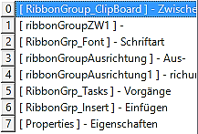

|  |  |
| --- | --- |
| Gruppe | Tools |
|  |  |
|  |  |
|  |  |
|  |  |
|  |  |