islandora_workflow User Documentation
This guide is meant as an introduction to the islandora_workflow module not as a complete system profile.

Table of Contents
islandora_workflow User Documentation 1
Setup 2
Permissions 2
Settings 2
Collection Level Permissions 4
Roles 4
Users 5
The Workflow 7
The workflow tab 7
The overview tab 8
Objects not in workflow 8
Assigning objects to users 9
Notes 9
Emails 10

Setup
This section will guide you through how to set up the module after installation.

Permissions
To be able to set user specific collection level permissions without restriction you need to set the 'authenticated user' roles permissions to 'islandora_workflow_Submitter', 'islandora_workflow_Editor' and 'islandora_workflow_Manager'. Also, anyone who is to edit other users permissions will need the permission 'access administration pages'.
Do not set the 'islandora_workflow_Administrator' permission for the 'authenticated user' role. If you do anyone who logs into the site will be able to access the workflow for every object. Other roles must have module permissions set so that they can have collection level permissions associated with them. See the section Collection Level Permissions for more details.

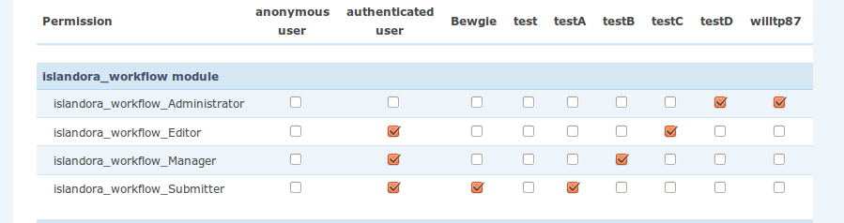Illustration 1: Module Permissions

Settings
Workflow can [not implemented yet] be enforced through the use of XACML. There is a settings toggle for this. This toggle is volatile, it may cause many problems. We highly recommend only changing it at install time. The default setting is disabled.
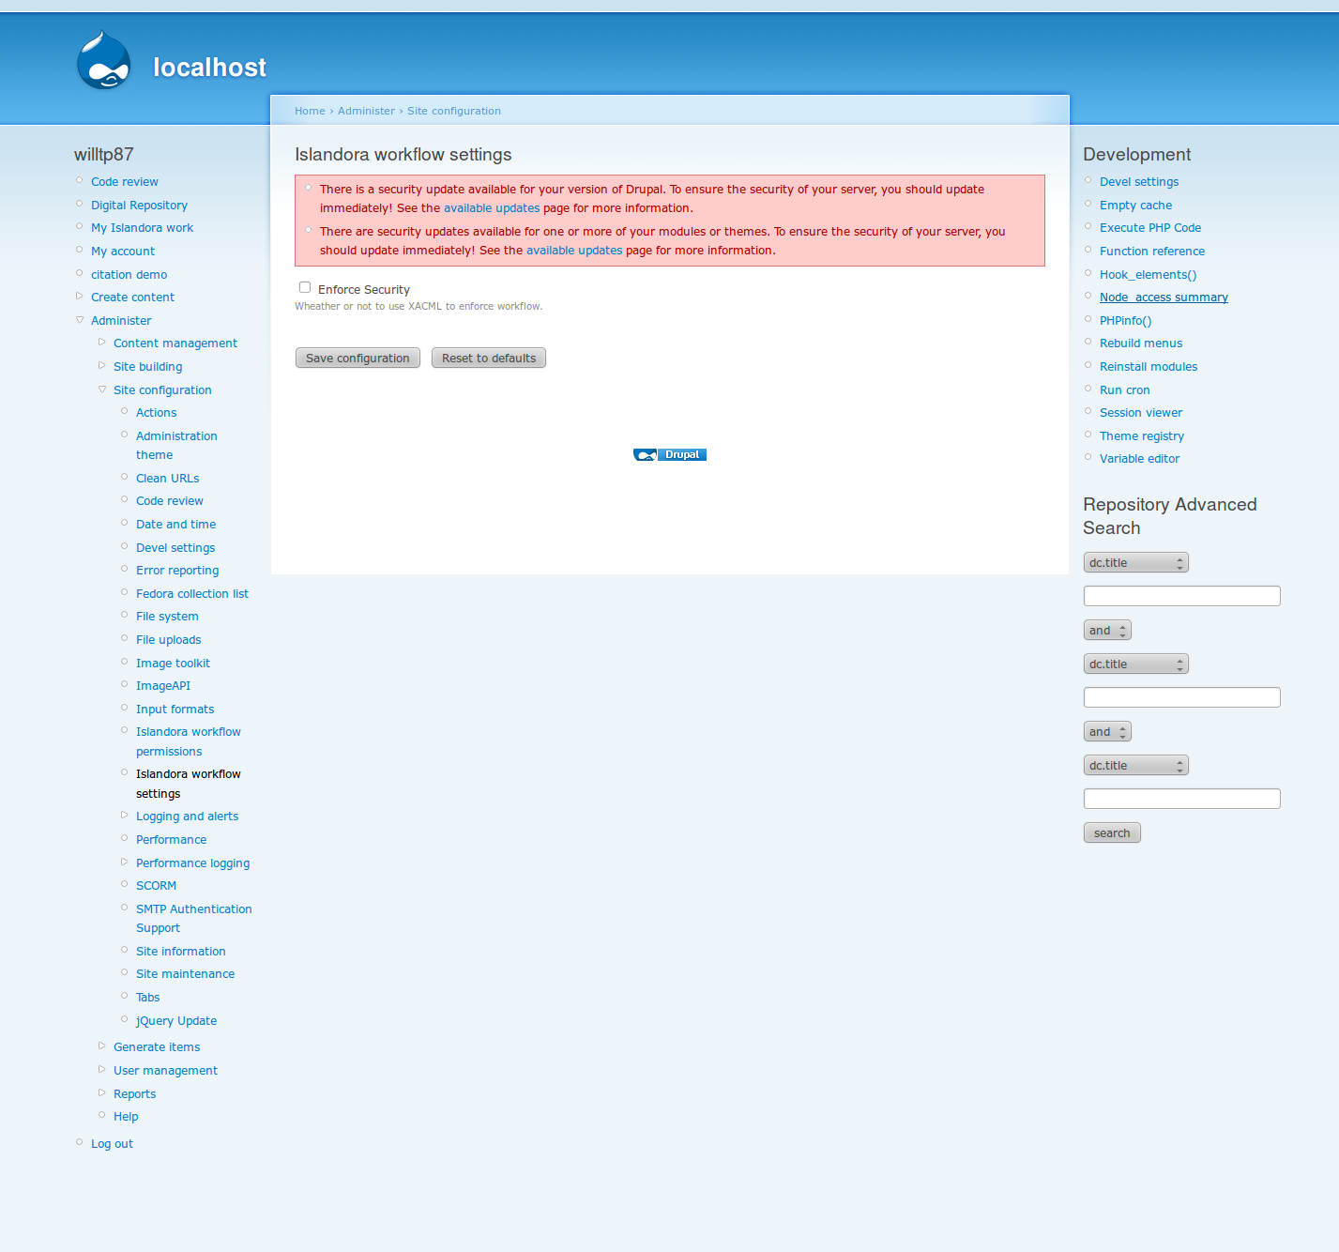Illustration 2: Module Settings

Collection Level Permissions
Collection level permissions for users and roles can be set at admin/settings/islandora_workflow_perms. All collection mangers can set the permissions for other users and roles regarding their collections if they have the Drupal permission 'access administration pages'. They should be careful of unsetting their own collection specific permissions.
For a user to see the 'My Islandora Work' link they will need some collection level permission set. If a user has two levels or more of permissions on the same collection the highest level takes precedence.
Only permissions on the currently selected collection can be changed. To select a different collection for altering permissions click the drop down at the top of the form, select the collection, and then click on the button 'Select Collection'
To change the permission level for a role or user hit the drop down beside the role or user and select the new permission then hit the 'Update' button. Multiple users or roles permission levels can be updated at the same time. To clear any changes you have made since the last update hit the 'Restore' button.

Roles
Collection level permissions can be set for roles. If a role like 'authenticated user' has a permission of submitter for a specific collection all users who have the role 'authenticated user' will be submitters on that collection.
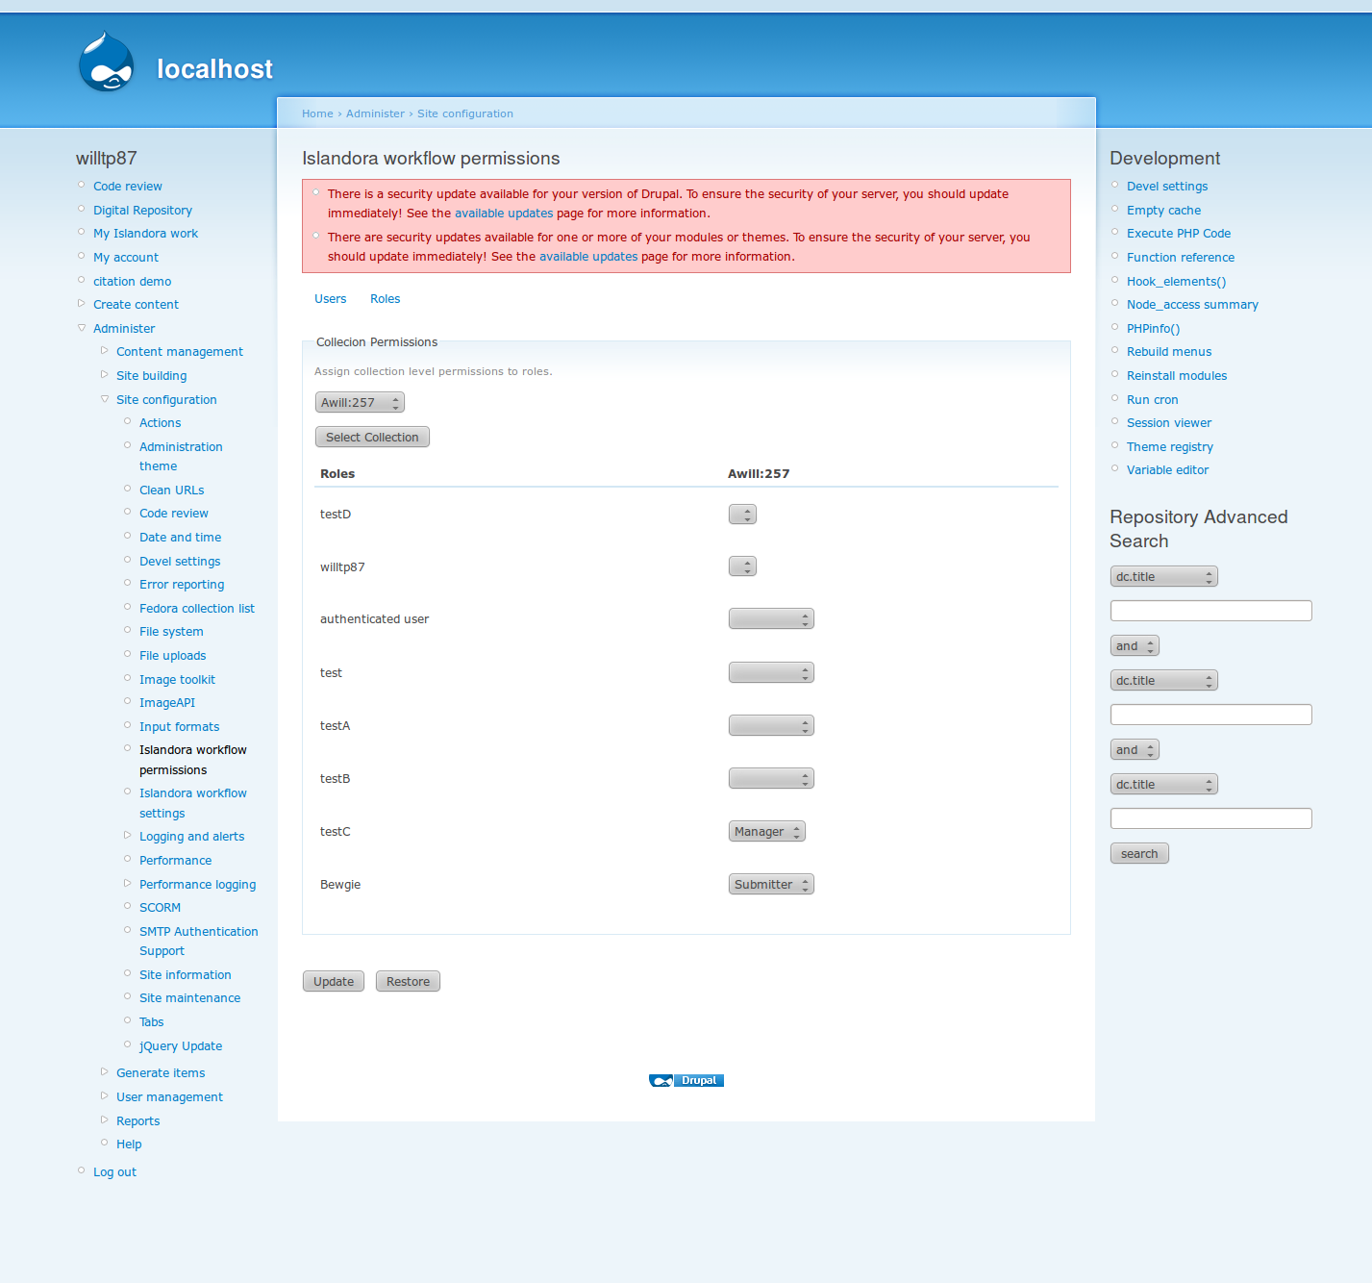Illustration 3: Collection Permissions for Drupal Roles

Users
Collection level permissions can be set for individual Drupal users. These finer grained permissions make it so that an individual user rather than a group of users can be given any level of access to any collection in special cases.
Using this scheme allows collection managers to setup access to their collections however they need to with minimal intervention from the site administrator. It sidesteps the need to create a new Drupal role, give it permissions, and assign it to one individual user all of which requires a Drupal admin.
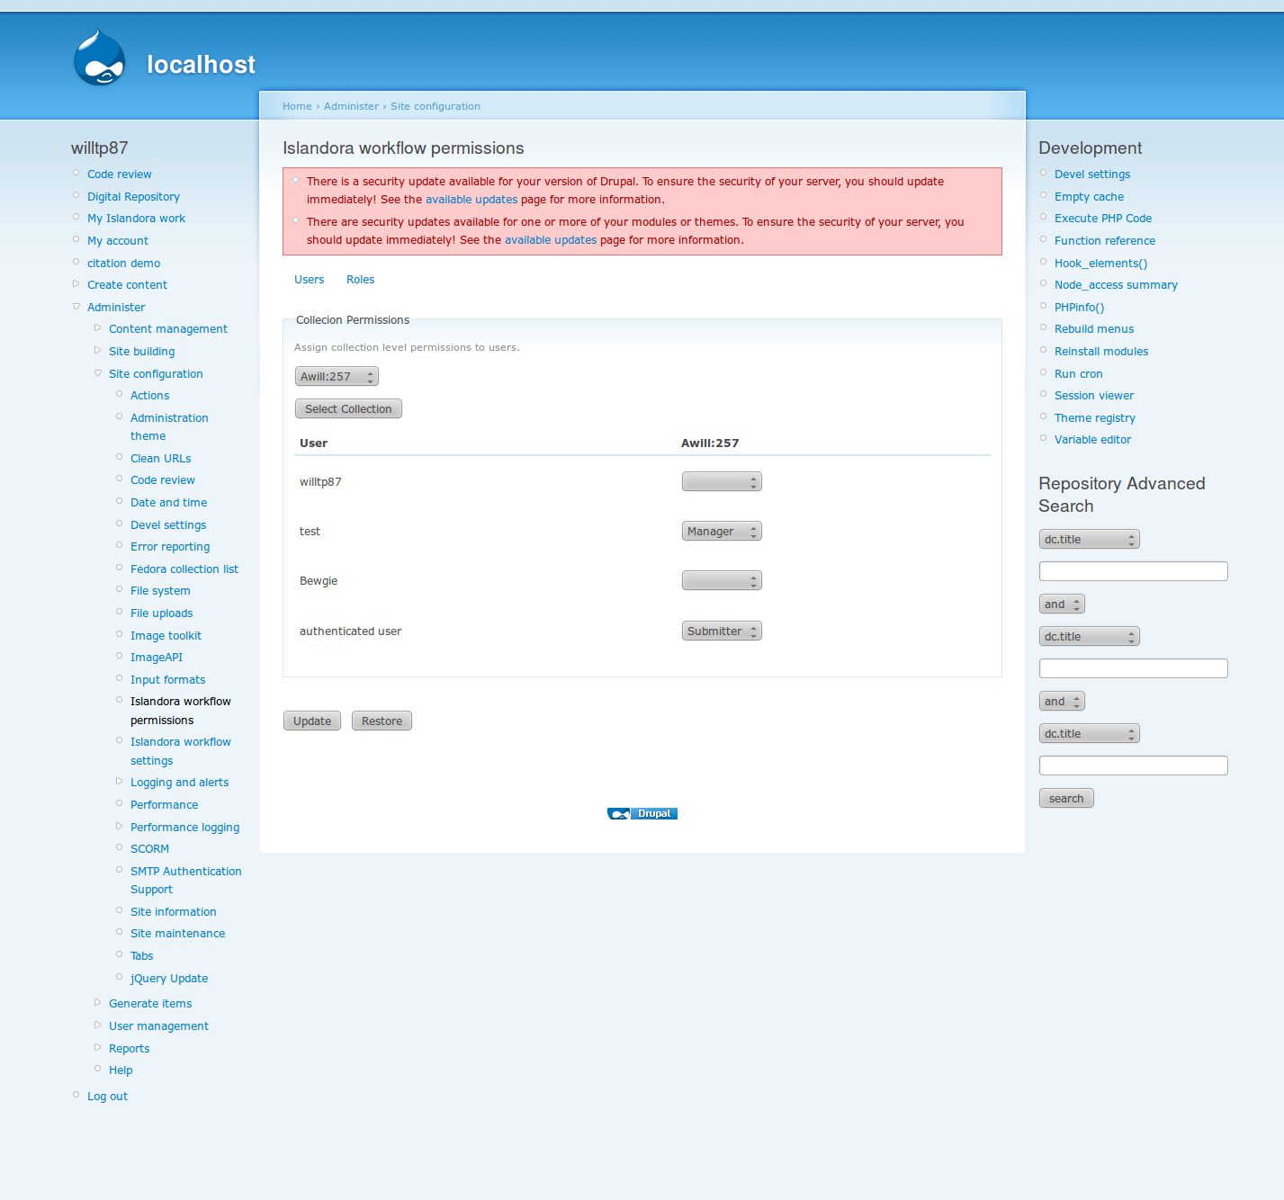Illustration 4: Collection Permissions for Drupal Users

The Workflow
For a Drupal user to see the main workflow page they must both have appropriate module and collection level permissions. To modify the workflow state of an object select the object by checking the box beside it and then hit the appropriate button at the bottom of the page. Multiple objects can be operated on at once in this manner.
Please note the pagination controls near the bottom of the form. There may be many objects in these lists and this will help you to view them. The objects are ordered first by collection pid and then by object pid. You may also jump to the islandora page for an object by clicking on it's title.

The workflow tab
Here a user will see all objects that fall within a workflow state that is applicable to a permission set that they have on a collection.
Only the user's highest permission level on a collection is taken into consideration. For instance if a user has three roles one having submitter, another editor and the last a manger role all on the same collection only those objects that are applicable to a manager's workflow will appear here.
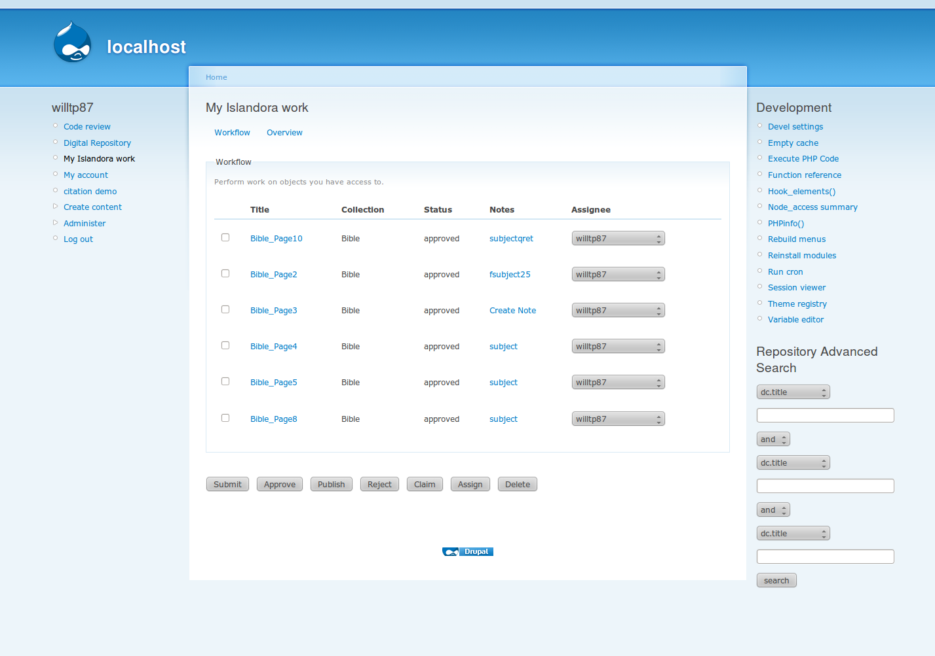Illustration 5: My Islandora work (admin) Workflow Tab

The overview tab
This tab is meant to provide a broader picture to the user than what they see in the workflow tab. For instance someone who is a submitter on a collection will be able to see all the objects that they have submitted over time, while a manger will see all the members of the collection.
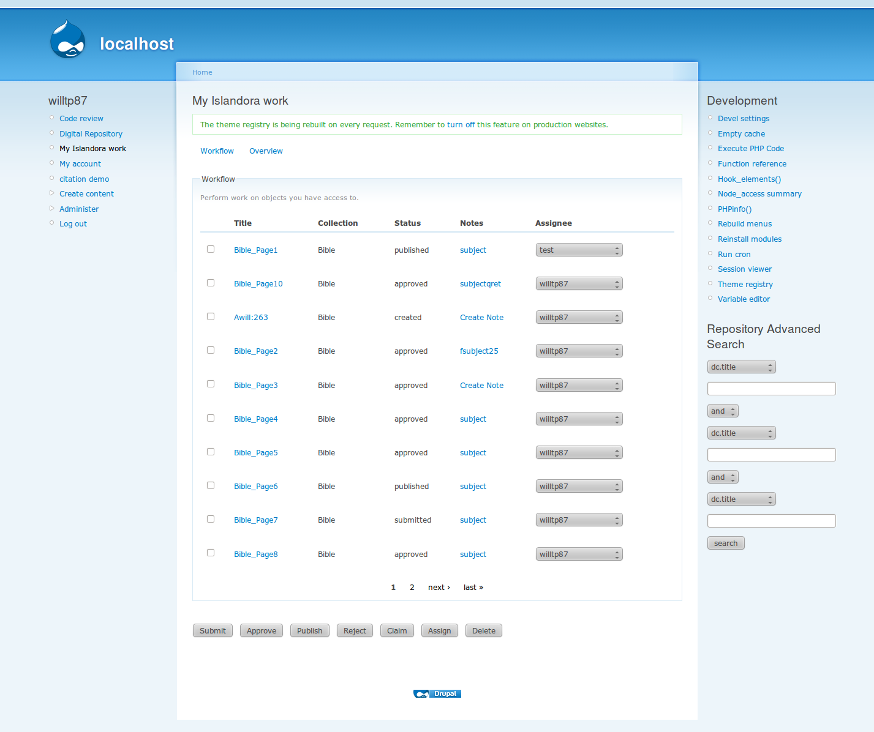Illustration 6: My Islandora work (Admin) Overview Tab

Objects not in workflow
Currently if an object exists in the collection and does not have a workflow state it will appear like 'Awill:263':

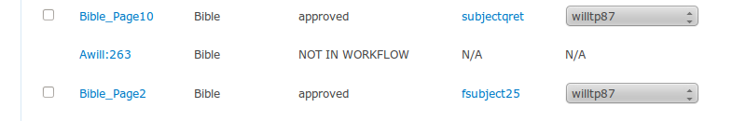Illustration 7: An object that is not in workflow, only visible to Admins/Managers

Assigning objects to users
To assign an object to another user click the checkbox on the left side of the object to select it and select the user from the drop down on the right side of the object. Then hit the 'Assign' button.

Notes
In the workflow object list you can notice a link under the header 'Subject'. This links to the page below. The link will be the contents of the subject field, and if there is no note yet it will be 'Create Note'. Once on the page below the contents of the note can both be seen and both the content and the subject can be altered.
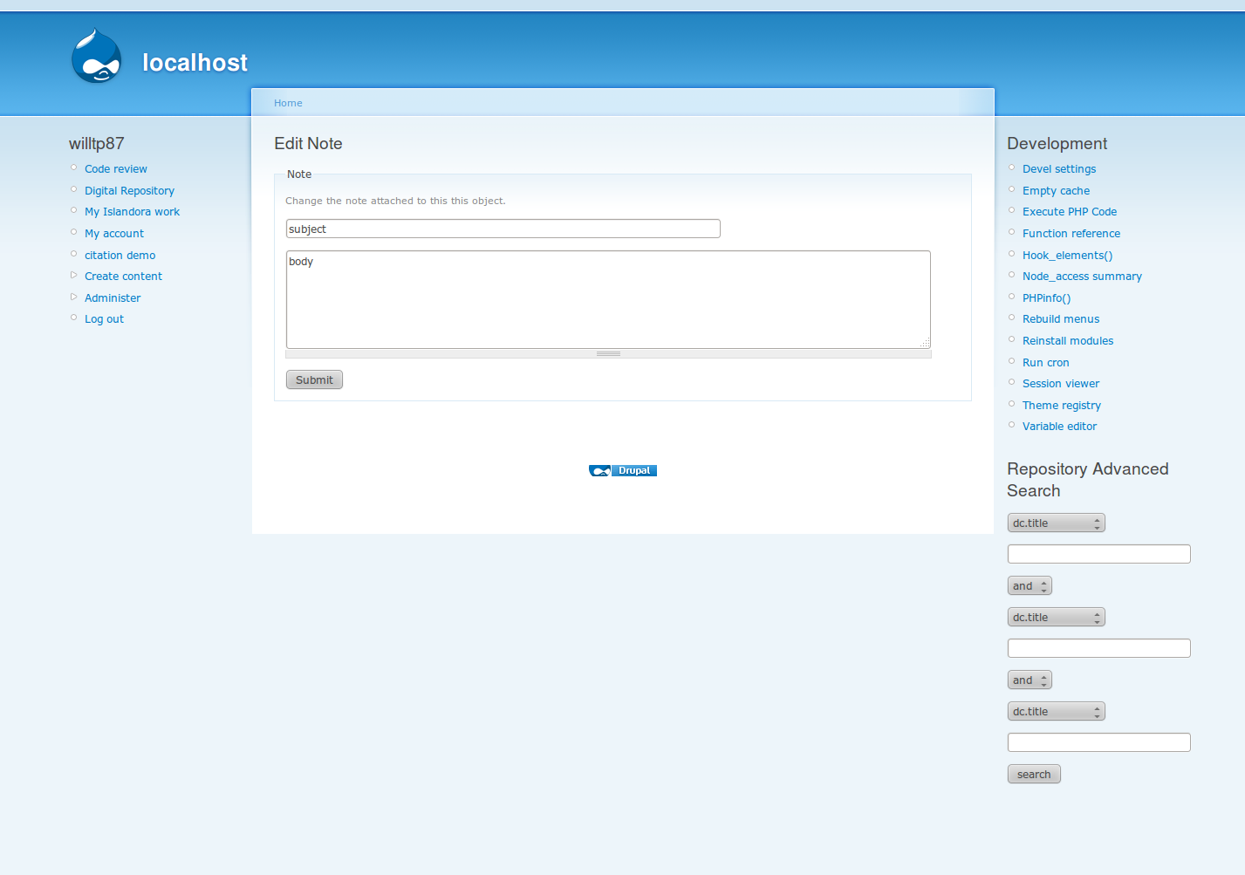Illustration 8: Object Note Creation/Editing

Emails
At each step of the workflow and after assigning an object to a new user the system will automatically send out an email to the new assignee or users who are in the next step of the workflow for that object's collection.

