**Welcome to diseases Indicator**

**What is cholera?**

**Cholera is an intestinal bacterial infection that spreads through contaminated water. It can cause severe diarrhea and dehydration. Modern sewage and water treatment technologies have essentially eliminated cholera in most industrialized countries. The condition still exists in Africa, Southeast Asia, and parts of the Caribbean, particularly Haiti.right up arrow As evidenced by the 2010 cholera outbreak in Haiti, in the immediate aftermath of the devastating earthquake there, the risk of a cholera outbreak is highest when poverty, war, or natural disasters leave people living in crowded conditions, without access to clean water and proper sanitation.right up arrow It’s not just the residents of these areas who are affected during an outbreak. Visitors can be at risk for catching the disease, as well. Although most cases aren’t severe and can be treated, the condition can lead to death for those who don’t get the proper care.**

**What are the symptoms of cholera?**

**About 1 in 10 people with cholera will experience severe symptoms, which, in the early stages, include:**

* **profuse watery diarrhea, sometimes described as “rice-water stools”**
* **vomiting**
* **thirst**
* **leg cramps**
* **restlessness or irritability**
* **Fever.**

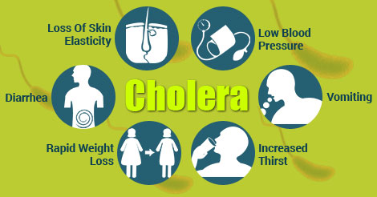

**How does the cholera spread?**

**The cholera bacteria is passed through feces (poop). It is spread by eating or drinking food or water contaminated by the feces (poop) of an infected person. This occurs more often in underdeveloped countries lacking proper water supplies and sewage disposal. It is not likely that cholera is spread directly from one person to another.Pandemics. The first cholera pandemic occurred in the Bengal region of India, near Calcutta (now Kolkata), starting in 1817 through 1824. The disease dispersed from India to Southeast Asia, the Middle East, Europe, and Eastern Africa through trade routes**

**What can I do to protect myself and prevent the spread of disease?**

**If you think your water may not be safe—treat it with a chlorine product, boil it, treat with bleach, or filter it.Treat with Chlorine Product**

**Be sure you drink and use safe water:-**

**\* Use bottled water to brush your teeth, wash and prepare food, and make ice or beverages.**

**\* If bottled water is not available, use water that has been properly boiled, chlorinated, or filtered using a filter that can remove bacteria.**

**\* Use bottled water with unbroken seals**

**Wash your hands often with soap and safe water:-**

**\* Before, during, and after preparing food.**

**\* Before and after eating food or feeding your children.**

**\* After using the toilet.**

**Use toilets:-**

**\* Use toilets or safely managed sanitation facilities to get rid of feces (poop). This includes disposal of children’s poop.**

**\* Wash hands with soap and safe water after going to the bathroom.**

**Boil it, cook it, peel it, or leave it:-**

**\* Avoid raw vegetables and fruits that cannot be peeled.**

**\* Eat foods that have been thoroughly cooked and are still hot and steaming. Be sure to cook seafood, especially shellfish, until it is very hot all the way through.**

**\* Cook food well, keep it covered, eat it hot, and peel fruits and vegetables.**

**Clean up safely:-**

**\* Clean food preparation areas and kitchenware with soap and treated water and let dry completely before reuse.**

**\* Bathe and wash clothes or diapers 30 meters (100 feet) away from drinking water sources.**

**\* Clean and disinfect toilets and surfaces contaminated with poop: clean the surface with a soap solution to remove solids; then disinfect using a solution of 1 part household bleach to 9 parts water.**