**Welcome to diseasesIndicator**

**What is Diarrhea?**

**Diarrhea is loose, watery stools (bowel movements). You have diarrhea if you have loose stools three or more times in one day. Acute diarrhea is diarrhea that lasts a short time. It is a common problem. It usually lasts about one or two days, but it may last longer. Then it goes away on its own. Diarrhea lasting more than a few days may be a sign of a more serious problem. Chronic diarrhea -- diarrhea that lasts at least four weeks -- can be a symptom of a chronic disease. Chronic diarrhea symptoms may be continual, or they may come and go.**

**What are the symptoms of Diarrhea?**

**Diarrhea can range from a mild, temporary condition to a potentially life threatening one. Common causes include viruses, bacteria, and parasites.**

* **Belly (abdominal) cramps.**
* **Stomach pain.**
* **Swelling (bloating)**
* **Upset stomach (nausea)**
* **Urgent need to go to the bathroom.**
* **Fever.**
* **Bloody stools.**
* **Loss of body fluids (dehydration)**

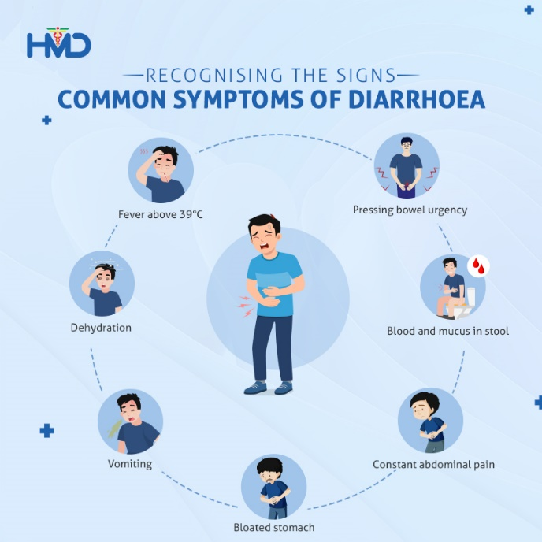

**How does the diarrhea spread?**

**Most cases of acute diarrhoea are potentially infectious to others. Viruses are easily spread, mainly through direct contact with vomit or faeces from an infected person, or through contact with a contaminated object or surface. Occasionally, the virus may be transmitted by airborne particles generated from vomiting and diarrhoea. People can reduce their chances of getting infected by carefully washing their hands after going to the toilet and before handling food. People looking after a person with the virus must also wash their hands thoroughly. Alcohol-based handwash solutions, available from pharmacies, have been shown to be better at reducing the spread of infection than soap and water, and are less drying to the skin.**

**What can I do to protect myself and prevent the spread of disease?**

**You can reduce your chances of being infected or spreading diarrhea by taking some simple precautions:**

* **Drink only bottled water, even for tooth brushing.**
* **Avoid eating food from street vendors.**
* **Avoid ice made with tap water.**
* **Eat only those fruits or vegetables that are cooked or can be peeled.**
* **Be sure that all foods you eat are thoroughly cooked and served steaming hot.**
* **Pre-packaged food is usually safe to consume (check expiration date)**
* **Never eat raw or undercooked meat or seafood.**
* **Obtain hepatitis A and typhoid vaccinations prior to travel, if indicated for that region.**