NMAM INSTITUTE OF TECHNOLOGY, NITTE
[Department of Information Science and Engineering]

OPERATING SYSTEMS
PROGRAMMING ASSIGNMENT REPORT
AI-Assisted Synchronization Algorithms with Program-Generated HTML Simulation
Readers-Writers Problem and Dining Philosophers Problem
(Semaphore-based and Monitor-based implementations in Java)

SUBMITTED BY

Name | Disha S Rao
Registration / USN | NNM24IS076
Course | Operating Systems
GitHub Repository | https://github.com/disha-rao/OS-Synchronization-Assignment

SUBMITTED TO

Dr Jason Elroy Martis
Associate Professor
Dept Information Science and Engineering,Nitte

1. Problem Statement and Synchronization Objective
Modern operating systems run many processes and threads at the same time, and these often share data. When access to shared data is not coordinated, the result depends on the unpredictable order in which the scheduler interleaves the threads. This produces race conditions (for example a lost update when two threads execute counter = counter + 1 together), deadlock and starvation [1][2]. This assignment studies two classical synchronization problems and solves each of them twice, once with semaphores and once with a monitor, giving four separate Java programs.

1.1 Objective
- Implement the Readers-Writers problem with semaphores and with a monitor (lock plus condition variables).
- Implement the Dining Philosophers problem for exactly four philosophers with semaphores and with a monitor, addressing deadlock prevention and starvation.
- Make every program generate its own HTML simulation from the events recorded during its execution, so that the animation is a replay of a real run and not a hand-made drawing.
- Test the programs and explain race conditions, mutual exclusion, deadlock and starvation in relation to each solution.

1.2 The Readers-Writers problem
A shared data object (here an integer counter) is accessed by several concurrent threads. Readers only read it; writers modify it. Many readers may read together without harm, but a writer needs exclusive access. The synchronization requirements are: (i) any number of readers may be inside the critical section at once; (ii) at most one writer may write at a time; (iii) a writer and a reader, or two writers, must never be inside together; and (iv) the policy must be examined for starvation, because favouring one class may postpone the other [1][3].

1.3 The Dining Philosophers problem (four philosophers)
Four philosophers sit at a round table with one fork between each pair of neighbours (four forks). Each alternately thinks and eats, and needs both adjacent forks to eat. The forks are the shared, non-shareable resources. If every philosopher picks up the left fork first, all four may hold one fork and wait forever for the other, which is a deadlock [4]. A correct solution must prevent or avoid this and must be examined for starvation.
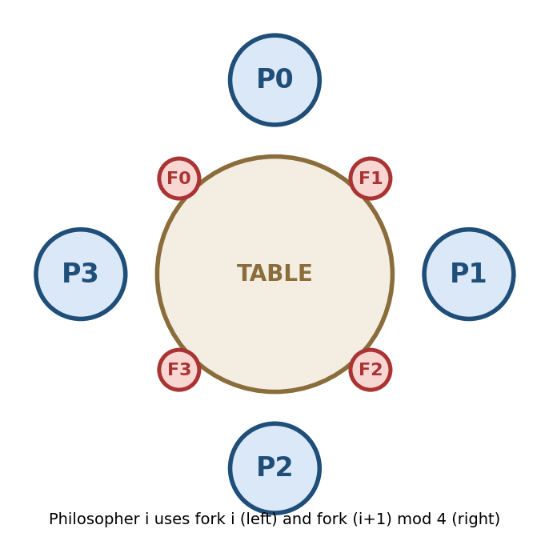
Figure 1: Seating arrangement and fork numbering used in the programs

1.4 Overview of the four implementations
No. | Problem | Technique | Source file
1 | Readers-Writers | Semaphores (mutex, resourceLock, optional turnstile) | ReadersWritersSemaphore.java
2 | Readers-Writers | Monitor (ReentrantLock + 2 conditions) | ReadersWritersMonitor.java
3 | Dining Philosophers (4) | Semaphores (4 fork semaphores + room = 3) | DiningPhilosophersSemaphore.java
4 | Dining Philosophers (4) | Monitor (state array + condition per philosopher) | DiningPhilosophersMonitor.java
Table 1: The four programs
Build and run (Java 17 or newer; tested with OpenJDK 21)
javac -d out $(find . -name "*.java")
java -cp out ReadersWritersSemaphore [readers] [writers] [rounds] [seed] [outputHtml]
java -cp out ReadersWritersMonitor [readers] [writers] [rounds] [seed] [outputHtml]
java -cp out DiningPhilosophersSemaphore [meals] [seed] [outputHtml]
java -cp out DiningPhilosophersMonitor [meals] [seed] [outputHtml]
Listing 1: Compilation and execution (defaults: 4 readers, 2 writers, 3 rounds, 3 meals, seed 42)
Java was chosen because it offers threads, a ready-made counting semaphore (java.util.concurrent.Semaphore), and explicit locks with named condition variables (ReentrantLock, Condition) that serve as the monitor abstraction permitted by the assignment [7]. No external library is needed.

2. Readers-Writers Problem

2.1 Semaphore-Based Implementation
Source: readers_writers/semaphore/ReadersWritersSemaphore.java; output: generated_html/readers_writers_semaphore.html.
Shared resource and critical section
The shared resource is the SharedResource object (an integer counter) together with the variable readCount, the number of readers currently inside. A reader's critical section is resource.read() plus the simulated reading time; a writer's critical section is resource.slowIncrement(...), which reads, sleeps and writes back the value plus one. The sleep widens the race window so that broken synchronization would be exposed almost certainly.
Table 2: Semaphores of the Readers-Writers semaphore solution
Semaphore | Initial | Purpose
mutex | 1 (binary) | Protects readCount; only one reader at a time may change it.
resourceLock | 1 (binary, fair) | Key to the shared resource. A writer holds it alone; the group of readers holds it together (taken by the first reader, returned by the last).
turnstile | 1 (binary, fair) | Optional gate (FAIR_TO_WRITERS = true): blocks new readers while a writer waits, removing writer starvation.

acquire() is the wait (P) operation: it decrements the semaphore and blocks if no permit is available. release() is the signal (V) operation: it increments the semaphore and wakes one blocked thread [1][7]. The readers act as a group: the first reader locks the resource for all readers, and the last reader unlocks it.
READER WRITER
------ ------
mutex.acquire() resourceLock.acquire()
readCount = readCount + 1 ... WRITE (exclusive access) ...
if (readCount == 1) resourceLock.release()
resourceLock.acquire()
mutex.release()
... READ (shared access) ...
mutex.acquire()
readCount = readCount - 1
if (readCount == 0)
resourceLock.release()
mutex.release()
Listing 2: Classical semaphore solution (readers have priority) [3]
// READER entry (recorded while still holding mutex, see Section 4)
trace.state(name, "WAITING", "wants to read");
mutex.acquire(); readCount++;
if (readCount == 1) resourceLock.acquire(); // FIRST reader locks for all
trace.state(name, "READING", "entered critical section", resource.read());
mutex.release(); // other readers may follow
// ... critical section: resource.read(); Thread.sleep(...) ...
// READER exit
mutex.acquire(); readCount--;
trace.state(name, "IDLE", "finished reading"); // recorded BEFORE the release
if (readCount == 0) resourceLock.release(); // LAST reader unlocks
mutex.release();
Listing 3: Reader entry, critical and exit sections
Correctness, deadlock and starvation
- Writer vs. readers: while any reader is inside, the reader group holds resourceLock, so a writer blocks; while a writer is inside, the first arriving reader blocks on resourceLock.
- Writer vs. writer: only one thread can own the binary semaphore resourceLock.
- Concurrent readers: after the first reader has taken resourceLock, later readers only increment readCount and pass.
- Deadlock: none. All semaphores are requested in the same order and the only thread that waits while holding mutex (the first reader) waits for resourceLock, which a writer always releases because it needs no further semaphore.
- Starvation: possible in the default reader-priority mode, because if new readers keep arriving readCount never returns to 0 and a writer may wait indefinitely. Setting FAIR_TO_WRITERS = true activates the turnstile, and the fair (FIFO) semaphores additionally serve waiting threads in arrival order [3].

2.2 Monitor-Based Implementation
Source: readers_writers/monitor/ReadersWritersMonitor.java; output: generated_html/readers_writers_monitor.html. The monitor is the class ReadWriteMonitor. Its single ReentrantLock guarantees that only one thread executes a monitor procedure at a time, and its two Condition objects act as named condition variables [5][7].
Table 3: State and condition variables of the Readers-Writers monitor
Monitor element | Kind | Meaning
activeReaders | int | Number of readers currently reading.
writing | boolean | True while a writer is writing.
waitingWriters | int | Writers that want to write; gives writers priority over new readers.
okToRead | Condition | Readers wait here while a writer is active or waiting.
okToWrite | Condition | Writers wait here while any reader or writer is active.

void startRead(String name) throws InterruptedException {
lock.lock(); // ENTER monitor
try {
while (writing || waitingWriters > 0) // writer active OR waiting
okToRead.await(); // releases lock while sleeping
activeReaders++;
trace.state(name, "READING", "entered critical section", resource.read());
} finally { lock.unlock(); } // LEAVE monitor
}
void endWrite(String name, int newValue) {
lock.lock();
try {
writing = false;
if (waitingWriters > 0) okToWrite.signal(); // writer priority
else okToRead.signalAll(); // all readers may enter
} finally { lock.unlock(); }
}
Listing 4: Selected monitor procedures (simplified; startWrite and endRead follow the same pattern)
Condition variables. A condition variable represents a reason for waiting. await() atomically releases the monitor lock and joins the condition queue; on wake-up the thread re-acquires the lock. For this reason await() is always inside a while loop and never an if: the state may have changed in between, and spurious wake-ups are permitted by the Java specification [7]. When the last reader leaves, exactly one writer is woken (okToWrite.signal()); when a writer leaves, either the next writer is woken or all waiting readers are released together with signalAll(), so they read concurrently.

3. Dining Philosophers Problem

3.1 Semaphore-Based Implementation
Source: dining_philosophers/semaphore/DiningPhilosophersSemaphore.java; output: generated_html/dining_philosophers_semaphore.html. Philosopher i uses fork i (left) and fork (i+1) mod 4 (right). The forks are the shared resources; eating is the critical section.
Table 4: Semaphores of the Dining Philosophers semaphore solution
Semaphore | Initial | Purpose
fork[0..3] | 1 each | One binary semaphore per fork: 1 = on the table, 0 = held by a philosopher.
room | 3 (N - 1) | Counting semaphore acting as a ticket for the table: at most three philosophers may try to pick up forks at the same time; the fourth blocks on room.

Deadlock prevention
A naive left-then-right solution deadlocks when all four philosophers take their left fork simultaneously, a circular wait [4][6]. The room semaphore limits the competing philosophers to N - 1 = 3. The philosopher outside holds no fork (forks are taken only after room is acquired), so a chain of waiting philosophers always ends at a free fork or at a philosopher who is eating. A cycle would need all four philosophers, but only three are inside. The eating philosopher finishes, releases his forks and leaves the room, which lets the others continue.
room.acquire(); // at most 3 pass; the 4th BLOCKS here
fork[left].acquire(); // wait() on left fork
trace.fork(left, id, name + " picked up left fork F" + left);
Thread.sleep(50 + rnd.nextInt(100)); // makes interleaving visible (not a substitute for sync)
fork[right].acquire(); // wait() on right fork
trace.fork(right, id, name + " picked up right fork F" + right);
trace.state(name, "EATING", "has both forks"); // CRITICAL SECTION
Thread.sleep(400 + rnd.nextInt(400));
trace.state(name, "RELEASING", "finished eating"); // recorded BEFORE the release
fork[left].release(); fork[right].release(); // signal() both forks
room.release(); // leave the room
Listing 5: One eating cycle of a philosopher (semaphore version)
Starvation considerations. All semaphores are created in fair mode (new Semaphore(n, true)), so waiting threads are served in FIFO order and cannot be overtaken indefinitely. Each philosopher's meals are counted and checked at the end of the run; in every execution all philosophers ate the requested number of meals. FIFO queues together with the deadlock-free structure give bounded waiting in practice, although this is not a formal proof for every possible schedule [3].

3.2 Monitor-Based Implementation
Source: dining_philosophers/monitor/DiningPhilosophersMonitor.java; output: generated_html/dining_philosophers_monitor.html. The design follows Dijkstra's well-known solution [4]: a philosopher asks the monitor for both forks at once, and the monitor lets him eat only if neither neighbour is eating. Because the two forks are granted atomically, no philosopher ever holds one fork while waiting for another, so the hold-and-wait condition is removed [6].

Table 5: Elements of the Dining Philosophers monitor
Element | Meaning
state[i] | State of philosopher i inside the monitor: THINKING, HUNGRY or EATING.
self[i] | One condition variable per philosopher; philosopher i sleeps on it while hungry but unable to eat.
lock | The fair monitor lock (ReentrantLock); only one thread is active in the monitor at a time.

private void test(int i) { // called only while holding the lock
if (state[i] == S.HUNGRY && state[leftOf(i)] != S.EATING
&& state[rightOf(i)] != S.EATING) {
state[i] = S.EATING; // grant BOTH forks atomically
trace.fork(i, i, ...); trace.fork((i+1) % N, i, ...);
self[i].signal(); // wake philosopher i if sleeping
}
}
void pickUp(int i) { lock.lock(); try {
state[i] = S.HUNGRY; test(i);
while (state[i] != S.EATING) self[i].await(); // wait on own condition
} finally { lock.unlock(); } }
void putDown(int i) { lock.lock(); try {
state[i] = S.THINKING; /* forks free again */
test(leftOf(i)); test(rightOf(i)); // maybe a neighbour can eat now
} finally { lock.unlock(); } }
Listing 6: The three monitor procedures (simplified)
Correctness. Two neighbouring philosophers can never be EATING together, because test requires both neighbours not to be eating and the state array changes only under the lock; since fork i is shared exactly by philosophers i-1 and i, no fork has two users. Deadlock freedom: a philosopher obtains both forks in one atomic step or none. Starvation: the solution is deadlock-free but not starvation-free in theory, since a philosopher whose two neighbours eat alternately can stay hungry forever. Random eating and thinking times make this extremely unlikely and every run completed all meals; a ticket or queue giving priority to the longest-waiting philosopher would remove the risk [1][3].

4. Event Recording and HTML Simulation Generation
The assignment requires the visualization to be generated from the execution data of the synchronization program itself. All four programs therefore share one pipeline, designed before the algorithms were written.

4.1 Shared helper classes
- `SharedResource` - the integer counter of the Readers-Writers programs. Its methods are deliberately not synchronized. After the run the program compares the final value with writers x rounds; equality shows that mutual exclusion among writers held, a smaller value reveals a race condition.
- `TraceRecorder` - a thread-safe recorder (its public methods are synchronized). Each call stores a JSON event with a millisecond timestamp and also prints it to the console as execution evidence.
- `HtmlGenerator` - holds a fixed HTML/CSS/JavaScript template, replaces the placeholder __TRACE__ with the JSON array of recorded events, writes the file to generated_html/ and opens it in the default browser.
{"t":1680,"type":"state","actor":"W1","state":"WRITING","msg":"entered critical section","value":1}
{"t":668, "type":"fork","fork":1,"owner":1,"msg":"P1 picked up left fork F1"} // owner -1 = free
Listing 7: The two event kinds (state event and fork event)

4.2 The ordering rule
An event is recorded while the thread still holds the semaphore or monitor lock that makes it true. A reader records READING right after gaining access and records IDLE just before releasing the resource. If an event were recorded after the release, another thread could already have entered and logged its own event first, and the trace would show an impossible overlap. This rule guarantees that the order of events in the trace is a valid order of what really happened.

4.3 Replay in the browser
The generated page contains the line const TRACE = [ ... ] with the real events of the run. A common JavaScript player provides the event log, a timeline with one coloured lane per thread, and the controls Play/Pause, Step, Reset (replay), speed (0.25x to 4x) and a scrub bar; clicking a log line jumps to that event [8]. A problem-specific module draws the scene: reader and writer cards with the shared-resource box and waiting queue (Readers-Writers), or a round table with four philosophers and four forks in SVG (Dining Philosophers). The displayed state is never stored; it is rebuilt by applying events 0..i with applyEvent, which also checks the safety invariants.
function applyEvent(s, e) {
if (e.type !== "state") return;
s.actors[e.actor] = e.state; // new state of this thread
if (e.value !== undefined) s.value = e.value; // shared counter
const r = ACTORS.filter(a => s.actors[a] === "READING").length;
const w = ACTORS.filter(a => s.actors[a] === "WRITING").length;
if (w > 1 || (w >= 1 && r >= 1)) s.violation = true; // mutual exclusion broken!
}
Listing 8: Replaying one recorded event and checking the invariant
For Dining Philosophers the same mechanism records fork ownership and raises a DEADLOCK banner if all four forks are held and nobody is eating. In all runs of the correct programs neither banner appeared. Because the whole animation is a function of the recorded events, a run with different timing produces a different animation, so nothing in the HTML tells a pre-written story. Running the program again regenerates the file, which makes the HTML reproducible from program execution.

5. Execution Traces / State Sequences
The excerpts below are real console output of the submitted programs (the same events embedded in the HTML files). Each line has the form [time in ms] actor state message. Thread scheduling is non-deterministic, so exact numbers vary between runs, but the properties discussed hold in every run.

5.1 Readers-Writers, semaphore version (4 readers, 2 writers, 3 rounds, seed 42)
[ 4166 ms] W1 WAITING wants to write (round 3)
[ 4247 ms] R4 IDLE finished reading value 4, readers left inside = 3
[ 4400 ms] R3 IDLE finished reading value 4, readers left inside = 2
[ 4446 ms] R1 IDLE finished reading value 4, readers left inside = 1
[ 4450 ms] R2 IDLE finished reading value 4, readers left inside = 0
[ 4450 ms] W2 WRITING entered critical section (exclusive access)
[ 5037 ms] W2 IDLE finished writing, new value = 5
[ 5038 ms] W1 WRITING entered critical section (exclusive access)
[ 5622 ms] W1 IDLE finished writing, new value = 6
Final shared value = 6 (expected 6) -> CORRECT: no lost update
Listing 9: Trace of Program 1 (end of the run)
W1 starts waiting at 4166 ms while readers are inside and is not admitted. Only when the last reader R2 leaves (4450 ms) does the resource become free and W2 enters in the same millisecond. W1 enters only at 5038 ms, after W2 has finished. State sequence: {four readers reading} -> {nobody} -> {W2 writing} -> {W1 writing}. A writer is never inside together with a reader or another writer, and the counter rises 4 -> 5 -> 6, matching the expected 2 writers x 3 rounds.

5.2 Readers-Writers, monitor version (3 readers, 2 writers, 1 round, seed 7)
[ 303 ms] R3 READING entered critical section, readers inside = 1
[ 387 ms] W2 WAITING wants to write
[ 549 ms] R1 WAITING wants to read
[ 678 ms] R2 WAITING wants to read
[ 788 ms] R3 IDLE finished reading, readers left inside = 0
[ 790 ms] W2 WRITING entered critical section (exclusive access)
[ 1294 ms] W1 WRITING entered critical section (exclusive access)
[ 1856 ms] R1 READING entered critical section, readers inside = 1
[ 1857 ms] R2 READING entered critical section, readers inside = 2
Listing 10: Trace of Program 2 (selected lines)
The trace shows the writer-priority policy. W2 waits from 387 ms while R3 reads. Readers R1 (549 ms) and R2 (678 ms) arrive later but wait, because a writer is already waiting, although a reader-priority solution would have admitted them at once. W2 enters at 790 ms and W1 is served before the waiting readers (1294 ms). Only after W1 finishes does okToRead.signalAll() wake both readers, which then read concurrently (readers inside = 2).

5.3 Dining Philosophers, semaphore version (4 philosophers, 1 meal, seed 7)
[ 656 ms] P1 ACQUIRING entered the room, trying to take forks F1 and F2
[ 668 ms] Fork F1 -> P1 (P1 picked up left fork F1)
[ 713 ms] Fork F0 -> P0 (P0 picked up left fork F0)
[ 797 ms] Fork F2 -> P1 (P1 picked up right fork F2)
[ 799 ms] Fork F3 -> P3 (P3 picked up left fork F3)
[ 800 ms] P1 EATING has both forks F1 and F2 and eats
[ 867 ms] P2 HUNGRY waiting for a place at the table
[ 1413 ms] Fork F1 -> FREE (P1 put down left fork F1)
[ 1414 ms] Fork F1 -> P0 (P0 picked up right fork F1)
[ 1415 ms] P0 EATING has both forks F0 and F1 and eats
[ 1416 ms] P2 ACQUIRING entered the room, trying to take forks F2 and F3
Listing 11: Trace of Program 3 (selected lines)
At 799 ms three philosophers (P1, P0, P3) are inside the room: P0 holds F0 and waits for F1, P3 holds F3 and waits for F0. P1 then obtains F2 and eats, so the waiting chain P3 -> P0 -> P1 ends at an eating philosopher and is not a cycle. P2 becomes hungry at 867 ms but cannot enter the room, so he cannot take F2 or F3 and close the cycle. When P1 releases at 1413 ms, F1 passes directly to P0, and P1 leaving the room admits P2 at 1416 ms.

5.4 Dining Philosophers, monitor version (4 philosophers, 1 meal, seed 7)
[ 645 ms] P1 ACQUIRING monitor grants both forks F1 and F2 at once
[ 676 ms] P1 EATING has both forks F1 and F2 and eats
[ 707 ms] P0 HUNGRY asks the monitor for both forks
[ 783 ms] P3 HUNGRY asks the monitor for both forks
[ 784 ms] P3 ACQUIRING monitor grants both forks F3 and F0 at once
[ 787 ms] P3 EATING has both forks F3 and F0 and eats
[ 1234 ms] P1 RELEASING finished eating, putting forks down
[ 1570 ms] P3 RELEASING finished eating, putting forks down
Listing 12: Trace of Program 4 (selected lines)
P1 receives both forks in one step. P0 becomes hungry while its neighbour P1 eats, so test(0) fails and P0 sleeps on self[0]. P3 is granted F3 and F0 at once, because its neighbours P2 and P0 are not eating. P1 and P3 eat simultaneously, which is allowed because they are not neighbours and share no fork. With four forks, at most two non-adjacent philosophers can eat at the same time, and no philosopher ever holds a single fork.

6. Synchronization Concepts

6.1 Race Condition
A race condition exists wherever two threads access the same data without ordering and at least one of them writes [1][2]. In the Readers-Writers programs the potential races are on the counter in SharedResource and, in the semaphore version, on readCount. slowIncrement splits the increment into read, delay and write, widening the window so that a race would be exposed with very high probability. readCount is protected by mutex; the counter is protected by resourceLock (semaphore version) or by the monitor conditions (monitor version). In the philosophers programs the shared items are the forks (protected by fork semaphores) and the state array (protected by the monitor lock). The trace recorder itself is also shared and is protected by synchronized methods.
Negative experiment. To prove that the final-value check really detects a race, a temporary copy of Program 1 had resourceLock.acquire() and release() removed from the writer. It was run with 4 readers, 3 writers and 3 rounds (expected value 9):
Seed | Expected value | Actual value | Verdict
1 | 9 | 4 | Race condition: 5 updates lost
2 | 9 | 4 | Race condition: 5 updates lost
3 | 9 | 5 | Race condition: 4 updates lost
Table 6: Result of the broken (unsynchronized writers) variant
Several writers read the same old value during the sleep and each wrote back old value plus one. The correct program always ended with the expected value. The broken copy is only a test artefact and is not part of the submission.

6.2 Mutual Exclusion
Program | What is mutually exclusive | Mechanism
1 RW semaphore | Writer vs. readers; writer vs. writer; updates of readCount | resourceLock (group lock for readers) and mutex
2 RW monitor | Writer vs. readers; writer vs. writer | Monitor lock plus conditions on writing / activeReaders
3 DP semaphore | Each fork is used by one philosopher | fork[i] binary semaphores
4 DP monitor | Neighbouring philosophers never eat together, so each fork has one user | state[] checked in test() under the monitor lock
Table 7: Mutual-exclusion mechanisms
The HTML player verifies the property independently: it rebuilds the state after every event and shows a red "MUTUAL EXCLUSION VIOLATED" banner if a writer overlaps a reader or another writer. This banner never appeared for the correct programs.

6.3 Deadlock
A deadlock requires all four Coffman conditions: mutual exclusion, hold and wait, no preemption and circular wait [6]. Preventing any one of them is sufficient. Both Readers-Writers solutions are deadlock-free because the lock order is fixed and a lock is held only while waiting for one that is always released. In the semaphore philosophers solution, mutual exclusion, hold-and-wait and no-preemption exist (a philosopher holds one fork while waiting for the other), but circular wait is broken by the room semaphore (at most N - 1 = 3 competitors). In the monitor solution hold-and-wait is broken because both forks are granted together. All programs terminated normally in every execution, and the deadlock detector in the animation (all forks held, nobody eating) never fired.

6.4 Starvation
Program | Policy | Who may starve | Remedy
1 RW semaphore | Readers priority | Writers, if readers keep arriving | FAIR_TO_WRITERS = true adds the turnstile
2 RW monitor | Writers priority | Readers, if writers keep arriving | Alternate turns or limit consecutive writers
3 DP semaphore | Fair FIFO semaphores, room = 3 | Practically nobody; FIFO gives bounded overtaking | Already fair; meals are counted
4 DP monitor | Eat if neither neighbour eats | A philosopher with two alternately eating neighbours | Queue or ticket numbers for the longest-waiting philosopher
Table 8: Starvation analysis
Deadlock means that nobody can proceed; starvation means that the system keeps progressing while one thread is postponed indefinitely. Bounded waiting, the third requirement of the critical-section problem, is the property that rules starvation out [1].

7. Comparison of Semaphore and Monitor Approaches
Both families were implemented for the same two problems, which allows a comparison based on actual code instead of theory alone [1][2][5].
Aspect | Semaphore approach | Monitor approach
Abstraction level | Low level: an integer with wait and signal | High level: shared data, procedures, lock and condition variables in one unit
Mutual exclusion | Programmer must pair acquire and release correctly everywhere | Automatic: only one thread is inside the monitor at a time
Waiting for a condition | Encoded indirectly through counters and extra semaphores (readCount, turnstile, room) | Explicit and readable: while (condition) await()
Typical errors | Forgotten release, wrong order (deadlock), unbalanced counts | if instead of while; missing signal causes a lost wake-up
Readers-Writers code | Two or three semaphores plus a counter; "first reader locks, last unlocks" is subtle | Three state variables and two conditions; rules read directly as conditions
Dining Philosophers code | Four fork semaphores plus room; one fork acquired after the other | State array and one condition per philosopher; both forks granted atomically
Deadlock handling | Limit entry to N - 1 (circular wait removed) | Atomic acquisition (hold-and-wait removed)
Policy control | Hidden in the order of semaphore operations | Visible in the conditions and in which condition is signalled
Performance | Very light weight; good for simple resource counting | Slightly more overhead from lock and condition handling; negligible here
Table 9: Comparison of semaphores and monitors
Summary. Semaphores are the more primitive tool and can express every synchronization pattern, but correctness depends on the careful placement of each operation and the intention is not written in the code. Monitors keep the shared state and the access rules together, which made both monitor programs easier to read, reason about and modify; for example, switching the Readers-Writers monitor from writer priority to reader priority only requires changing one condition. Their drawbacks are the dependence on language or library support and the discipline of the while loop. In Java, ReentrantLock with Condition supplied the monitor abstraction without difficulty [7].

8. Results and Observations

8.1 Readers-Writers
Program | Events | Run time | Result
1. RW semaphore (4 readers, 2 writers, 3 rounds) | 60 | about 5.6 s | Final value 6 = expected 6; no violation banner
2. RW monitor (4 readers, 2 writers, 3 rounds) | 60 | about 6.5 s | Final value 6 = expected 6; no violation banner
Table 10: Results of the default Readers-Writers executions
- Mutual exclusion held: in every run, the writers' WRITING segments in the timeline never overlap READING segments or each other, and the final counter equalled writers x rounds.
- Reader concurrency observed: up to four readers were inside the critical section at the same time in the semaphore version, and two readers entered together after signalAll() in the monitor version.
- Policy difference visible: the semaphore version let readers keep the resource until the last one left (reader priority); the monitor version made new readers wait behind a waiting writer (writer priority).
- Negative experiment: removing the writers' lock lost 4 to 5 updates in all three runs (Table 6), so the final-value check is effective.

8.2 Dining Philosophers
Program | Events | Run time | Result
3. DP semaphore (4 philosophers, 3 meals) | 112 | about 9 s | Terminated; every philosopher ate 3 times; no deadlock banner
4. DP monitor (4 philosophers, 3 meals) | 112 | about 6 s | Terminated; every philosopher ate 3 times; no deadlock banner
Table 11: Results of the default Dining Philosophers executions
- No deadlock: both programs terminated, which would be impossible after a deadlock, and the animation's detector never fired.
- No starvation observed: the meal counters showed that all four philosophers reached the requested number of meals.
- Different eating patterns: the semaphore version showed philosophers holding a single fork while waiting for the second (a window that the room limit makes safe); the monitor version never showed a philosopher holding only one fork.
- Concurrency in eating: at most two non-adjacent philosophers (P0 and P2, or P1 and P3) ate at the same time.
Testing methods and limitations
The programs were tested by (i) functional runs with seeds 42 and 7, (ii) the final-value check, (iii) the termination and meal-count checks, (iv) the invariant checks inside the HTML player, (v) opening the generated files in a headless browser to confirm that no JavaScript errors occur, and (vi) the negative experiment. Known limitations: thread scheduling is non-deterministic, so the seed fixes only the random delays and not the event order; the HTML is a replay generated after the run, not a live view; RELEASING has near-zero width in the monitor philosophers timeline; and the default policies are not starvation-free for every possible schedule.

9. HTML Simulation Screenshots
Each program writes its own HTML file into generated_html/. The pages show the state of every thread, the shared resource or fork ownership, an event log and a timeline with colour coding that is consistent across cards, tables and lanes. Controls: Play/Pause, Step, Reset, speed selector and scrub bar.
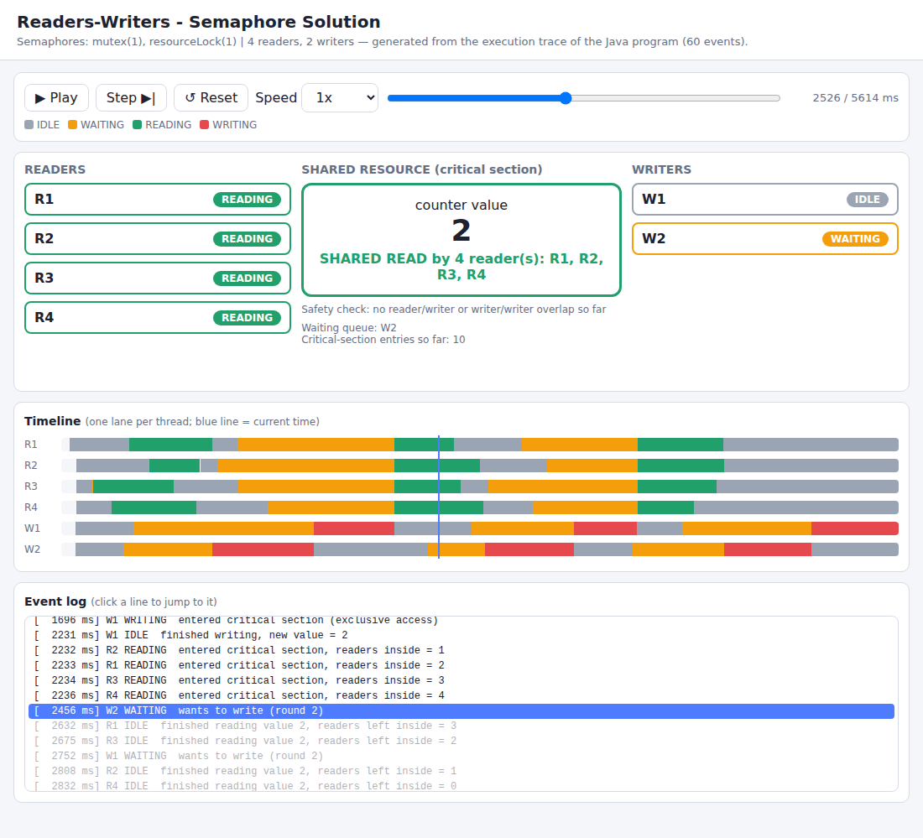
Figure 3: Program 1 - Readers-Writers (semaphores). Four readers read concurrently while writer W2 waits; counter = 2 ("SHARED READ by 4 reader(s)").
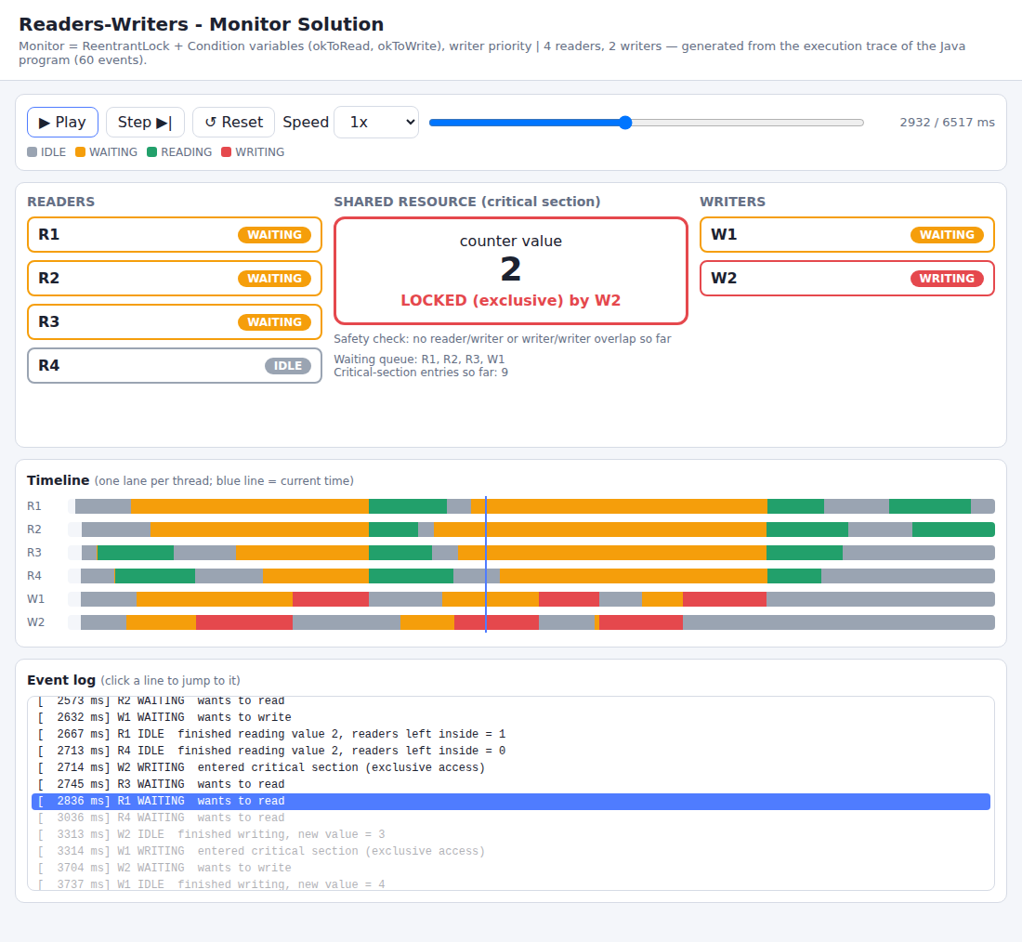
Figure 4: Program 2 - Readers-Writers (monitor). W2 holds the resource exclusively (LOCKED) while R1, R2, R3 and W1 wait; the safety check shows no overlap.
In Figures 3 and 4 the writers' red WRITING segments never overlap the readers' green READING segments, and the two writers never overlap each other, which is visual evidence of mutual exclusion.
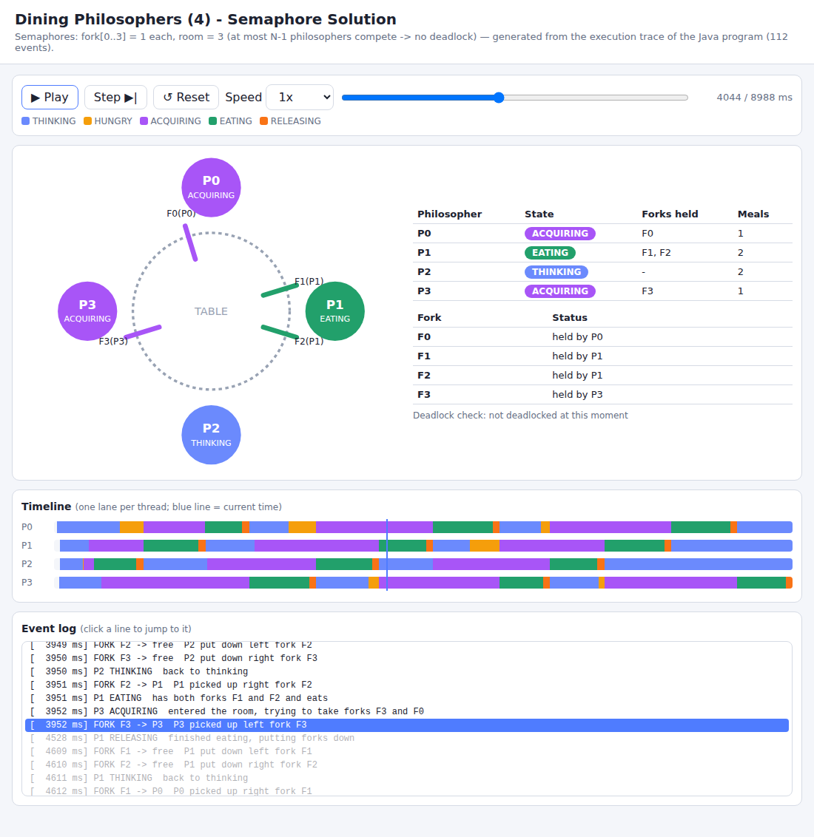
Figure 5: Program 3 - Dining Philosophers (semaphores). P1 eats with forks F1 and F2; P0 and P3 are acquiring forks; P2 is thinking.
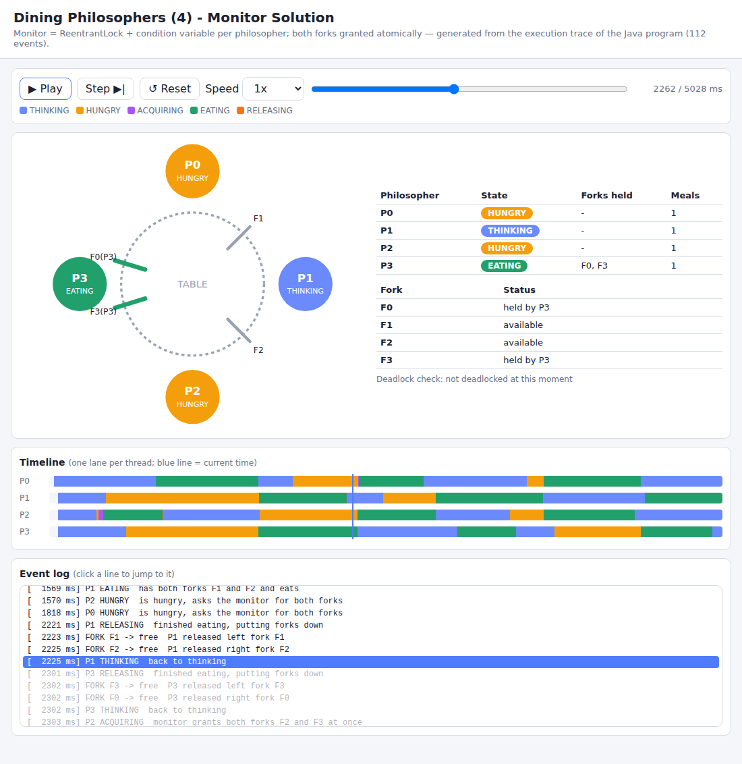
Figure 6: Program 4 - Dining Philosophers (monitor). Fork ownership and philosopher states generated from the monitor's trace.
In Figure 5, P1 is EATING and holds F1 and F2, P0 and P3 are ACQUIRING with one fork each, and the fork table and deadlock check confirm that the system is not deadlocked. In both philosopher timelines, no two neighbouring philosophers have overlapping EATING segments.

10. AI Usage Summary
The assignment permits and encourages AI assistance, provided the student tests, understands and documents the result [9]. This section summarizes the use of AI; the detailed prompt log is kept in the repository at ai_prompts/prompts.md.
Table 12: AI usage summary
Item | Description
AI tool used | Claude (Anthropic) as a programming and documentation assistant.
Initial prompt | The assignment PDF was provided with the request to read it carefully, produce all required files, write the four Java programs with the program-generated HTML animation, prepare the documentation content, and add explanatory comments to the code.
Follow-up prompts | Requests to make the animation open and play automatically when the program finishes, to give step-by-step run instructions, and to produce and later restructure this report in Word format.
Manual work by the student | Compiled and ran each program several times, compared the traces, changed parameters, read and annotated the code, took screenshots, created the GitHub repository with several commits, and prepared for the viva.
Verification | Compilation without warnings, execution of all four programs, final-value and termination checks, the negative experiment of Section 6.1, and rendering of the HTML in a browser.

Reflection on errors, limitations and improvements
The following pitfalls were identified in the AI-assisted design:
- Order of recording and releasing. Releasing a semaphore first and recording the event afterwards lets another thread log its event first, so the trace seems to show a writer starting before the last reader finished although the program was correct. The fix was to record each event while the lock is still held (Section 4.2).
- Test of the test. A passing final-value check does not prove that the check can detect errors, so the negative experiment of Section 6.1 was added.
- Limited visibility of fast operations. With very short delays concurrency is hardly visible, so delays were made long enough and small pauses were added between picking up the two forks, while making clear that they never replace synchronization.
- Instantaneous monitor states. RELEASING is instantaneous in the monitor philosophers program; this is documented in Section 3.2 instead of being hidden.

11. References
[1] A. Silberschatz, P. B. Galvin and G. Gagne, Operating System Concepts, Wiley - chapters on process synchronization, classical synchronization problems and monitors.
[2] A. S. Tanenbaum and H. Bos, Modern Operating Systems, Pearson - section on classical IPC problems (Dining Philosophers, Readers-Writers).
[3] A. B. Downey, The Little Book of Semaphores, Green Tea Press - Readers-Writers (turnstile solution) and Dining Philosophers.
[4] E. W. Dijkstra, "Hierarchical ordering of sequential processes", Acta Informatica, 1971 - origin of the Dining Philosophers problem.
[5] C. A. R. Hoare, "Monitors: an operating system structuring concept", Communications of the ACM, 17(10), 1974.
[6] E. G. Coffman, M. Elphick and A. Shoshani, "System deadlocks", ACM Computing Surveys, 3(2), 1971 - the four deadlock conditions.
[7] Oracle, Java SE 21 API documentation: java.util.concurrent.Semaphore, java.util.concurrent.locks.ReentrantLock and Condition. https://docs.oracle.com/en/java/javase/21/docs/api/
[8] Mozilla Developer Network (MDN) Web Docs - JavaScript, SVG and requestAnimationFrame. https://developer.mozilla.org/
[9] Claude (Anthropic) - AI assistant used for code and documentation drafting; see the prompt log ai_prompts/prompts.md.

12. Academic Integrity Declaration
The following declaration is included as required by the assignment:
"I declare that I have personally tested and understood the submitted programs. I have disclosed the AI tools and external resources used in developing this assignment. I can explain the synchronization logic, generated HTML simulation, and modifications made to the code. I have not knowingly submitted another student's work or unacknowledged third-party material as my own."
The AI tool used in this assignment (Claude, developed by Anthropic) is disclosed in Section 10 and in the prompt log at ai_prompts/prompts.md. All books, documentation and websites consulted are listed in Section 11.
Signature: ______________________  Date: ___________________________ | Name: Disha S Rao  USN: NNM24IS076

