-NAME : - DISHA PRAJAPATI

Assignment Module 10:

Infrastructure Security and WAN Technologies

- A Cisco Catalyst switch connects to what should be individual user PCs. Each port has the same port security configuration, configured as follows:
interface range gigabit Ethernet 0/1 - 24
switchport mode access
switchport port-security
switchport port-security mac-address sticky
Which of the following answers describe the result of the port security configuration created with these commands? (Choose two)
A. Prevents unknown devices with unknown MAC addresses from sending data through the switch ports.
B. If a user connects a switch to the cable, prevents multiple devices from sending data through the port.
C. Will allow any one device to connect to each port, and will save that device’s MAC address into the startup-config.
D. Will allow any one device to connect to each port, but will not save that device’s MAC address into the startup-config.
ANS :-
[B] If a user connects a switch to the cable, prevents multiple devices from sending data through the port.
[D] Will allow any one device to connect to each port, but will not save that device’s MAC address into the startup-config.
- Only one device is allowed per port; multiple devices are blocked.
- The device is allowed, but its MAC address is not automatically saved in the startup-config.

- What is the Administrative Distance of internal EIGRP routes?
A. 170
B. 90
C. 20
D. 1
E. 110
F. 120

ANS :- [B] 90
- Internal EIGRP routes have AD 90
- When a subnet mask is presented in binary, what do the binary 1s represent?
A. The network portion of an associated address
B. The host portion of the subnet mask
C. The number of wildcard bits in the subnet mask
D. The number of wildcard bits in the address
E. The network portion of the subnet mask
F. The host portion of an associated address
ANS :- [E] The network portion of the subnet mask
- Binary 1s show the network portion of the subnet mask
- Which switch would STP choose to become the root bridge in the selection process?
A. 32768: 11-22-33-44-55-66
B. 32768: 22-33-44-55-66-77
C. 32769: 11-22-33-44-55-65
D. 32769: 22-33-44-55-66-78
ANS :- [A] 32768: 11-22-33-44-55-66
- Lowest Bridge ID (priority + MAC) wins
- Which of the following devices is used by the service provider to provide WAN services?
A. Router
B. Core router
C. WAN switch
D. CSU/DSU
ANS :- [C] WAN switch
- Used by ISP to provide WAN services.
- Your Cisco IOS router is acting as a DHCP server. Which command will display the addresses that have been handed out to clients on the LAN?
A. show ip dhcp assignments
B. show ip dhcp address
C. show ip dhcp conflicts
D. show ip dhcp bindings
E. show ip dhcp pool
ANS :- [D] show ip dhcp bindings
- Shows leased IP addresses.

- Which of the following commands would you use to enable EIGRP only on those interfaces with an IP address from 10.1.1.0 through 10.1.1.63?
A. network 10.1.1.0 0.0.0.63
B. network 10.1.1.0/63
C. router eigrp 10.1.1.0 0.0.0.63
D. network 10.0.0.0 0.0.0.255
ANS :- [A] network 10.1.1.0 0.0.0.63
- Correct network command with wildcard mask

- R3 has a static route configured that points toward the service provider. What command could you use to have R3 advertise an OSPFv3 default route to the internal network, regardless of whether R3 had its default static route?
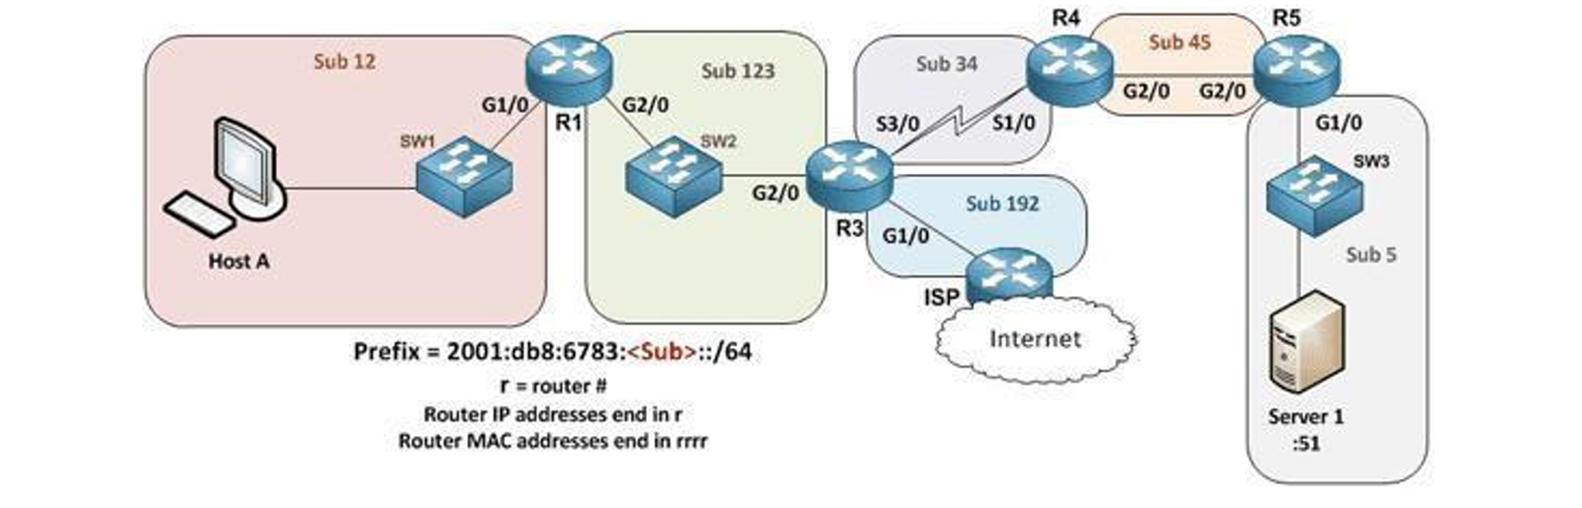
A. The decision to advertise a default route depends on the static route always being present on R3.
B. The default behavior is to redistribute any default IPv6 routes into OSPFv3, so no action is required.
C. Each of the other routers needs a static default route that leads to R3.
D. Use the default-information originate always in interface mode for G1/0 on R3.
E. Have R3 use the command default-information originate always in OSPFv3 router configuration mode.
ANS :- [E] Have R3 use the command default-information originate always in OSPFv3 router configuration mode.
- default-information originate always in OSPFv3 mode.
- You are configuring dynamic NAT on your Cisco IOS router. Which command is used to verify the interfaces that are being used as the outside interface and the inside interface?
A. show interfaces
B. show ip route
C. show ip nat translations
D. show ip interface brief
E. show ip interface
F. show ip nat statistics
ANS :- [E] show ip interface
- Shows NAT inside/outside status.

10. When using the “show EtherChannel summary” command, what does the “u” flag signify?
A. Waiting to be aggregated
B. Suspended
C. In use
D. Unsuitable for bundling
ANS :- [C] In use
- Port-channel is up and working.
11.Which command could you enter to encrypt passwords?
A. enable secret
B. username {username} secret {password}
C. service password-encryption
D. All of the above
E. None of the above
ANS :- [D] All of the above
- All encrypt passwords in different ways.
12.You are setting up a Cisco IOS router as a DHCP server. Which command is used to identify the IPv4 addresses that will be in the DHCP pool?
A. network
B. dns-server
C. default-router
D. ip dhcp excluded-address
E. lease
F. ip dhcp pool
G. domain-name
ANS :- [A] network
- Defines IP range of DHCP pool.
13.Which of the following statements are true regarding the processing of ACLs that have been applied to router interfaces? (Choose two)
A. Inbound ACLs will be processed before the routing table lookup occurs
B. Inbound ACLs will be processed after the routing table lookup has occurred
C. Outbound ACLs will be processed after the routing table lookup has occurred
D. Outbound ACLs will be processed before the routing table lookup occurs
ANS :-
[A] Inbound ACLs will be processed before the routing table lookup occurs
AND
[C] Outbound ACLs will be processed after the routing table lookup has occurred
- Inbound ACL before routing lookup
- Outbound ACL after routing lookup
14.Imagine you configured OSPFv2 in a small lab network. Which of the following answers list a condition that could keep the routers in your lab from learning all the routes to all the IPv4 routes in your small lab network? (Choose two)
A. An ACL could be blocking router advertisements.
B. Two neighbouring routers that connect to the same link have been configured with the same OSPF area and with the same IPv4 subnet mask.
C. Any physical layer problem that would prevent two neighbouring routers from being able to ping each other’s IPv4 addresses in the subnet that exists between the two routers.
D. Two neighboring routers that connect to the same link have been configured with the same OSPF process ID on the router ospf command.
ANS :-
[A] An ACL could be blocking router advertisements
AND
[C] Any physical layer problem that would prevent two neighbouring routers from being able to ping each other’s IPv4 addresses in the subnet that exists between the two routers.
- ACL can block OSPF packets
- Physical issues stop neighbor formation
15.Which statements describe neighbor discovery functionality in IPv6? (Choose two)
A. Determines the link layer address of a neighbor
B. Finds neighbor switches on the link
C. Is achieved by using Dynamic Host Configuration Protocol for IPv6, or DHCPv6 with IPv6 multicast
D. Queries for duplicate addresses
ANS :-
[A] Determines the link layer address of a neighbor
AND
[D] Queries for duplicate addresses
- Finds MAC address
- Checks duplicate addresses (DAD)
16.Which IPv6 prefix will the typical enterprise network receive from the service provider?
A. /52
B. /56
C. /64
D. /32
E. /48
F. /60
ANS :- [E] /48
- Commonly assigned to enterprises.
17.How should a switch be configured so that it could be accessed remotely?
A. Assign a password and privilege level
B. Apply the access control list (ACL) to the virtual terminal (vty) lines
C. Configure a gateway for the switch
D. Generate a certificate
ANS :- [C] Configure a gateway for the switch
- Default gateway needed for remote access.
18.Refer to the exhibit. A network technician is asked to design a small network with redundancy. The exhibit represents this design, with all hosts configured in the same VLAN. What conclusions can be made about this design?
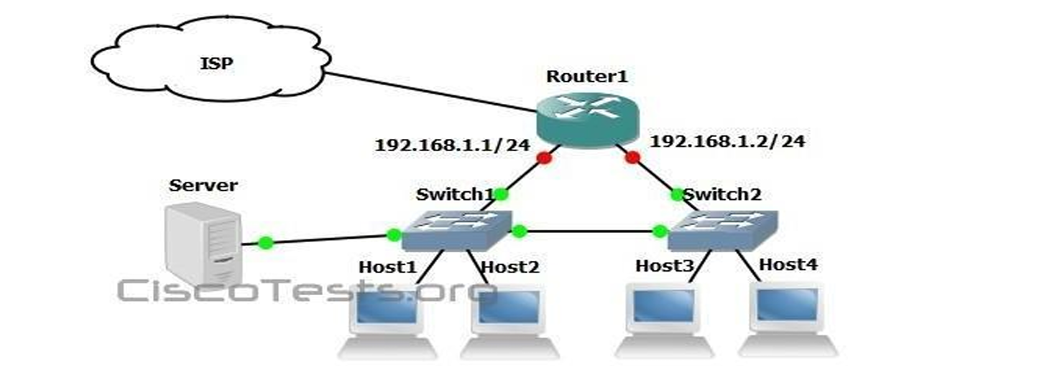
A. This design will function as intended.
B. Spanning-tree will need to be used.
C. The router will not accept the addressing scheme.
D. The connection between switches should be a trunk.
E. The router interfaces must be encapsulated with the 802.1Q protocol.
ANS :-
[B] Spanning-tree will need to be used.
and
[D] The connection between switches should be a trunk
- STP is required
- Inter-switch link should be a trunk

