**DAILY ASSESSMENT FORMAT**

|  |  |  |  |
| --- | --- | --- | --- |
| **Date:** | **23/06/2020** | **Name:** | **Disha** |
| **Course:** | **C++ Programming** | **USN:** | **4AL17EC29** |
| **Topic:** | * **Data types** * **arrays** * **pointer** | **Semester & Section:** | **6th sem ‘A’ sec** |
| **Github Repository:** |  |  |  |

|  |
| --- |
| **FORENOON SESSION DETAILS** |

**Image of session**

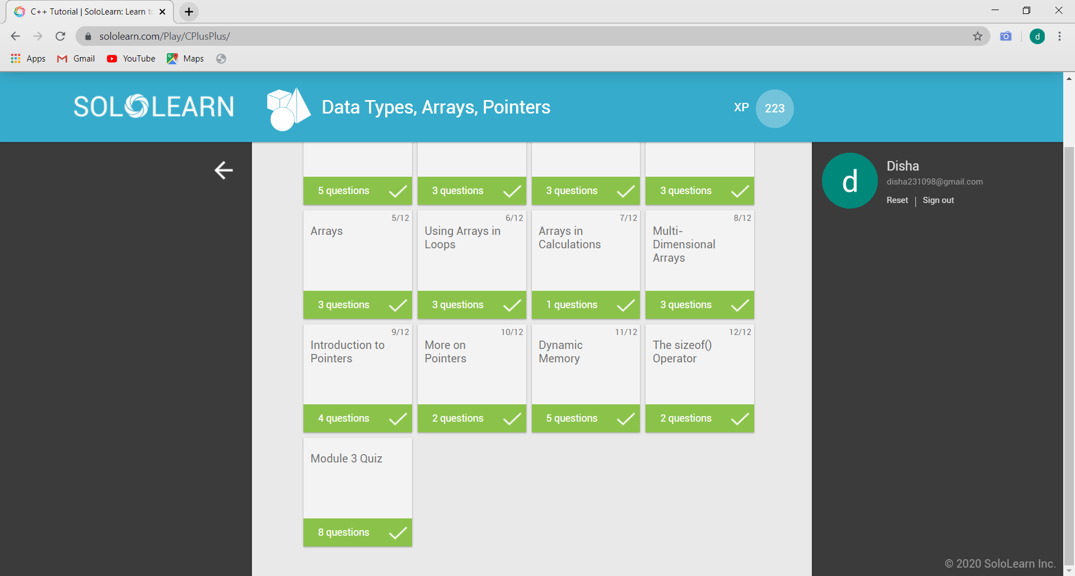

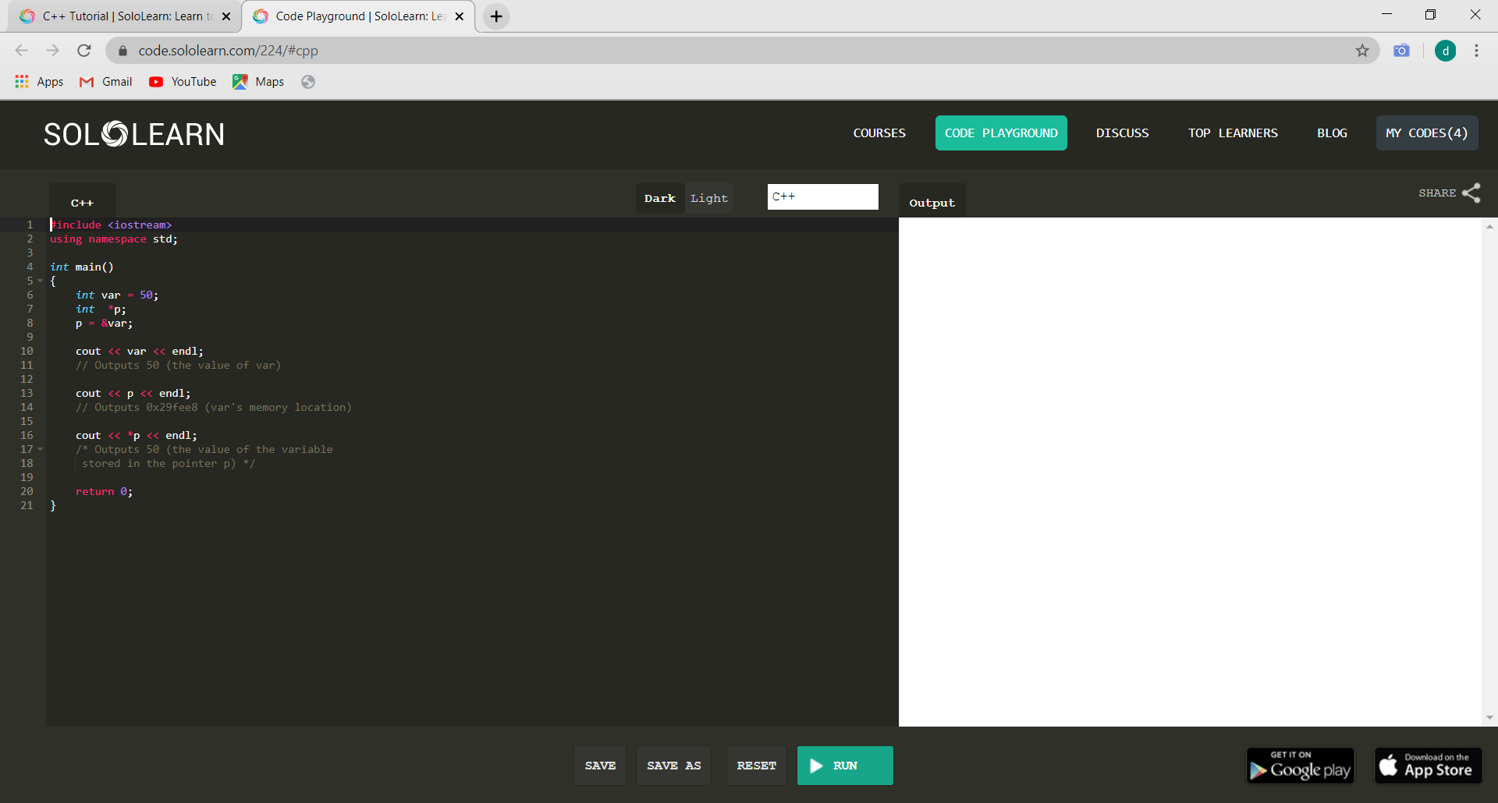

# **Data Types:**

A data type specifies the type of data that a variable can store such as integer, floating, character etc.

There are 4 types of data types in C++ language.

1.Basic Data Type-int, char, float, double, etc

2.Derived data type-arrays, pointer etc.

3.Enumeration Data Type- enum

4.User defined data type-structure

## **Basic Data Types:**

The basic data types are integer-based and floating-point based. C++ language supports both signed and unsigned literals. The memory size of basic data types may change according to 32 or 64 bit operating system.

**Arrays:**

Like other programming languages, array in C++ is a group of similar types of elements that have contiguous memory location.

In C++ std::array is a container that encapsulates fixed size arrays. In C++, array index starts from 0. We can store only fixed set of elements in C++ array.

## **Advantages of C++ Array**

* Code Optimization (less code)
* Random Access
* Easy to traverse data
* Easy to manipulate data
* Easy to sort data etc.

## **Disadvantages of C++ Array**

* Fixed size

## **Array Types:**

There are 2 types of arrays in C++ programming:

1. Single Dimensional Array
2. Multidimensional Array

**Single Dimensional Array:**

#include <iostream>

using namespace std;

int main()

{

   int arr[5]={10, 0, 20, 0, 30};  //creating and initializing array

        for (int i = 0; i < 5; i++)

        {

     cout<<arr[i]<<"\n";

        }

}

**Multidimensional Arrays:**

The multidimensional array is also known as rectangular arrays in C++. It can be two dimensional or three dimensional. The data is stored in tabular form (row ∗ column) which is also known as matrix.

#include <iostream>

using namespace std;

int main ()

{

int test [3][3] ; //declaration of 2D array

test [0][0] = 5; //initialization

test [0][1] =10;

test [1][1] =15;

test [1][2] =20;

test [2][0] =30;

test [2][2] =10;

//traversal

for (int i = 0; i < 3; ++i)

{

for (int j = 0; j < 3; ++j)

{

cout<< test[i][j] <<" ";

}

cout<<"\n"; //new line at each row

}

return 0;

}

# **Pointers:**

The pointer in C++ language is a variable, it is also known as locator or indicator that points to an address of a value.

**Advantage of pointer**

* Pointer reduces the code and improves the performance, it is used to retrieving strings, trees etc. and used with arrays, structures and functions.
* We can return multiple values from function using pointer.
* It makes you able to access any memory location in the computer's memory.

**Usage of pointer**

There are many usage of pointers in C++ language.

**1) Dynamic memory allocation**

In c language, we can dynamically allocate memory using malloc() and calloc() functions where pointer is used.

**2) Arrays, Functions and Structures**

Pointers in c language are widely used in arrays, functions and structures. It reduces the code and improves the performance.

## Pointer Program to swap 2 numbers without using 3rd variable

#include <iostream>

using namespace std;

int main()

{

int a=20,b=10,∗p1=&a,∗p2=&b;

cout<<"Before swap: ∗p1="<<∗p1<<" ∗p2="<<∗p2<<endl;

∗p1=∗p1+∗p2;

∗p2=∗p1-∗p2;

∗p1=∗p1-∗p2;

cout<<"After swap: ∗p1="<<∗p1<<" ∗p2="<<∗p2<<endl;

   return 0;

}