Security and Privacy for Machine Learning
Internal Assessment 1 — Problem Formulation and Preliminary Implementation

PrivBench-Adult
A Unified Privacy–Utility Evaluation of Differential, Local, Syntactic and Compressive Privacy for Tabular Machine Learning

Student name | Disha Kataria
Roll number | 16014223034
Programme | B.Tech Honours — Semester VII
Course | Security and Privacy for Machine Learning
Course faculty | Ashwini Dalvi
Department | Department of Information Technology
Institute | K. J. Somaiya School of Engineering
Submission date | 22/10/2026

Contents
Executive Summary 4
Rubric compliance map 4
1. Problem Definition and Module Mapping 5
1.1 Background and motivation 5
1.2 Problem statement 5
1.3 Significance 5
1.4 Objectives 5
1.5 Scope 6
1.6 Expected outcomes 6
1.7 Module-wise concept mapping 6
2. Conceptual Understanding 6
2.1 Threat model 6
2.2 Concept notes 7
2.3 Methodology and workflow 8
2.4 Justification for concept selection 9
2.5 Treatment of concepts 9
3. Dataset Identification and Preliminary Preparation 9
3.1 Dataset and suitability 9
3.2 Source details 10
3.3 Schema and attribute roles 10
3.4 Preliminary preparation log 10
3.5 Initial exposure analysis 11
3.6 Known dataset limitations 11
4. Initial Implementation 12
4.1 Tools and libraries 12
4.2 Code structure 12
4.3 Key implementation choices 12
4.4 Inputs, processing and outputs 13
4.5 Execution instructions 13
4.6 Output log (excerpt) 13
4.7 Verification 14
5. Preliminary Evaluation and Documentation 14
5.1 Evaluation measures 14
5.2 Baseline results (non-private models) 14
5.3 Privacy exposure of the raw data 15
5.4 Preliminary DP-SGD results 15
5.5 Central versus local DP for histogram release 16
5.6 Preliminary k-anonymity 16
5.7 Preliminary compressive privacy (PCA) 17
5.8 Preliminary observations 17
5.9 Known limitations at IA-1 17
5.10 Proposed evaluation plan for IA-2 18
5.11 Individual contribution statement 18
Acknowledgement 18
References 18

Executive Summary
Organisations increasingly train machine-learning (ML) models on personal records, and a growing set of privacy techniques claims to make this safe: differential privacy (DP) at training time, local DP at collection time, k-anonymity at publication time and compressive (lossy-projection) privacy at feature-release time. These techniques act at different stages of the data pipeline, offer different kinds of guarantee and are usually evaluated in isolation with incomparable metrics. A practitioner therefore cannot answer a simple question: for a given utility target, which mechanism, at which stage, actually reduces which privacy risk?
This project builds PrivBench-Adult, a unified evaluation framework in which one representative mechanism from each of Modules 2–5 is plugged into the same data pipeline, trained with the same model and attacked with the same Module-1 attack suite (membership inference, attribute inference and re-identification). The study uses the public UCI Adult census dataset (45,222 records after cleaning).
IA-1 status. The problem, objectives, scope and five-module mapping are fixed; the dataset is acquired, hashed, cleaned and split; all five modules have working code with 30 passing unit tests; and preliminary experiments have produced the first baseline evidence:
- Non-private baselines reach 84.9% test accuracy (MLP). A fully grown random forest leaks membership (MIA advantage 0.172), and leakage grows in a small-data regime (MLP: 0.159).
- 26.5% of records are unique on seven quasi-identifiers, and the sensitive attribute sex can be inferred with 83.1% accuracy even after the column is deleted, owing to proxies such as relationship.
- A from-scratch DP-SGD with a Rényi-DP accountant (validated against Opacus to 4 decimal places) keeps 85.0% accuracy at ε = 1.
- At equal ε = 1, local-DP histograms are 280× less accurate than central-DP histograms: the price of removing the trusted curator.

Rubric compliance map
Table 1. Mapping of IA-1 assessment stages to sections of this report.
IA-1 stage | Where addressed | Evidence
1. Problem definition & module mapping | Section 1 | Problem statement, objectives, scope, outcomes, Table 2 (module mapping)
2. Conceptual understanding | Section 2 | Concept notes, threat model, Figure 1 (workflow), treatment classification, justification
3. Dataset identification & preparation | Section 3 | Source/licence table, SHA-256 hashes, preparation log, schema, limitations
4. Initial implementation | Section 4 | Code structure, tools, design choices, execution instructions, run log, unit tests
5. Preliminary evaluation & documentation | Section 5 | Baseline results, observations, limitations, IA-2 evaluation plan, contribution statement

1. Problem Definition and Module Mapping

1.1 Background and motivation
Removing names from a dataset is not anonymisation. Sweeney showed that 87% of Americans are unique on {ZIP, birth date, sex} [11]; Narayanan and Shmatikov de-anonymised Netflix users from sparse ratings [22]; and trained models themselves leak whether a person was in the training set (membership inference [19, 20]). Data-protection law now makes such leakage a compliance issue, e.g. India's Digital Personal Data Protection Act 2023 [31] and the EU GDPR [32]. The research community answered with a family of techniques, but each is typically presented with its own threat model and metric: ε for DP, k for anonymisation, reconstruction error for compressive privacy. They are rarely compared against the same attacker on the same data.

1.2 Problem statement
Problem statement. Given a tabular dataset of personal records used to train a binary classifier (income > 50K), determine — under one common data pipeline, one utility model and one attack suite — how much privacy protection (against membership inference, sensitive-attribute inference and re-identification) and how much utility loss each of four privacy-preserving mechanisms produces when applied at its natural pipeline stage: local DP at collection, k-anonymity at publication, DP-SGD at training and compressive projection at feature release; and identify whether a combination of mechanisms gives a better privacy–utility trade-off than any single one.

1.3 Significance
- Practical decision support. Engineers must choose where in a pipeline to spend a privacy budget. A side-by-side, attack-based comparison is directly actionable.
- Exposes mismatched guarantees. Syntactic methods (k-anonymity) protect identity but not attributes; DP protects membership but not population-level inference. A unified attack suite makes such gaps measurable rather than rhetorical.
- Reproducible teaching artefact. All five course modules become runnable, tested code on a real dataset, executable on a laptop CPU in minutes.

1.4 Objectives
Table 2. Project objectives and success criteria.
ID | Objective | Measurable success criterion
O1 | Quantify the privacy exposure of the raw data and of non-private models | MIA AUC/advantage, QI uniqueness, attribute-inference accuracy reported with ≥3 seeds
O2 | Implement one mechanism per module (M2–M5) from first principles | Unit-tested implementations; DP accountant matches a reference library
O3 | Evaluate every mechanism with the same model and attack suite | One results table covering utility + all applicable attacks
O4 | Characterise each privacy–utility trade-off across its parameter (ε, k, m) | Trade-off curves with mean ± sd across seeds
O5 | Propose and test a combined mechanism | Hybrid configuration compared to the single mechanisms at matched ε

1.5 Scope
Table 3. Project scope.
In scope | Out of scope (with reason)
Tabular binary classification on UCI Adult | Images/text/LLMs — different threat surface; compute-heavy
Membership, attribute and re-identification attacks | Model inversion / reconstruction of training images (not meaningful for tabular one-hot data)
DP-SGD (central), GRR/OUE/PM (local), Mondrian k-anonymity + l-diversity, PCA/DCA projections | Cryptographic PPDM (secure multi-party computation, homomorphic encryption) — discussed analytically only
Laptop-CPU reproducibility; NumPy/scikit-learn only | Federated learning deployment, GPU-scale models

1.6 Expected outcomes
- A tested, open, reproducible Python framework (src/privml) covering all five modules.
- A provenance-documented, hashed dataset and preprocessing pipeline.
- Privacy–utility curves and a unified comparison table across mechanisms.
- Evidence-based guidance on which mechanism to apply at which pipeline stage.
- A research-manuscript draft (IA-2) describing the framework and the proposed hybrid.

1.7 Module-wise concept mapping
Table 4. Mapping of the problem to all five course modules (IA-1 version; refined in IA-2).
Module | Concepts used | Role in this project | Treatment
M1 Privacy considerations in ML | Threat models; membership inference; attribute inference; re-identification via quasi-identifiers; proxy attributes; privacy metrics | Defines what is being protected and supplies the attack suite used to measure leakage of every mechanism | Implemented + evaluated
M2 Differential privacy for ML | ε/δ-DP, sensitivity, Laplace & Gaussian mechanisms, composition, DP-SGD, Rényi-DP accounting | Protects the training stage; provides a formal, worst-case guarantee | Implemented + evaluated
M3 Local differential privacy | Randomised response, GRR, OUE, Piecewise mechanism, unbiased frequency estimation | Protects the collection stage when no trusted curator exists | Implemented + evaluated
M4 Privacy-preserving data mining | Quasi-identifiers, k-anonymity (Mondrian), l-diversity, t-closeness, information loss | Protects the publishing stage (release of a sanitised microdata table) | Implemented + evaluated
M5 Compressive privacy | Lossy dimensionality reduction (PCA), utility-supervised DCA, privacy-aware projection | Protects the feature-release stage: only a low-dimensional projection leaves the owner | Implemented (PCA) + planned (DCA variants)

2. Conceptual Understanding

2.1 Threat model
The data owner holds records x = (age, workclass, education-num, marital-status, occupation, relationship, race, sex, capital-gain, capital-loss, hours-per-week, native-country) with label y = 1[income > 50K]. The adversary follows Kerckhoffs's principle: they know the mechanism and its parameters, and they hold a small auxiliary sample from the same distribution (modelled by the 10% public split). Three adversary goals are considered:
Table 5. Threat model: adversaries evaluated in this project.
Attack | Adversary observes | Goal | Success metric
Membership inference (MIA) | Trained model's output on a target record | Decide whether the target was in the training set | ROC-AUC, advantage = max(TPR−FPR), TPR at 1% FPR
Attribute inference | Released record / representation (sex column possibly removed) | Infer the target's sex | Attacker accuracy and balanced accuracy vs. prior
Re-identification (linkage) | Released table + target's quasi-identifiers from an external source | Single out the target's record | Unique fraction, average prosecutor risk 1/|EC|

2.2 Concept notes

Module 1 — Privacy considerations in ML
Principle. Privacy risk in ML arises at every stage: collection, storage/publication, training and deployment. Over-fitted models assign lower loss to training points, which the loss-threshold MIA of Yeom et al. [20] exploits: predict member if ℓ(f(x), y) < τ. Assumptions: the attacker can query the model and knows the true label. Advantages: empirical attacks measure leakage in the units that matter to an individual. Limitations: an attack only gives a lower bound on leakage; a weak attack does not prove privacy.

Module 2 — Differential privacy
A randomised mechanism M is (ε, δ)-DP if for all neighbouring datasets D, D′ (differing in one record) and all output sets S:
Pr[M(D) ∈ S] ≤ e^ε · Pr[M(D′) ∈ S] + δ
The Laplace mechanism adds Lap(Δ₁/ε) noise to a query of L1-sensitivity Δ₁. DP-SGD [2] trains a model privately: each step Poisson-samples records with rate q, clips every per-example gradient to norm C, sums, adds N(0, σ²C²I) and updates. Privacy over T steps is tracked with Rényi DP [3, 4]; for integer order α the per-step RDP of the sub-sampled Gaussian is
ε_RDP(α) = 1/(α−1) · log Σₖ₌₀^α C(α,k) (1−q)^(α−k) q^k exp((k²−k)/(2σ²))
which composes additively over T steps and is converted to (ε, δ)-DP [5]. Assumptions: a trusted curator holds the raw data. Advantages: a formal guarantee that holds against any attacker, including future ones; composition. Limitations: utility cost at small ε, and disparate impact on minority groups [28]; the guarantee says nothing about population-level inferences.

Module 3 — Local differential privacy
Each user perturbs their own value before sending it, so even the collector is not trusted. Generalised randomised response (GRR) [6, 7] reports the true value with probability p = e^ε/(e^ε + k − 1) and any other value otherwise; an unbiased frequency estimate is f̂ᵥ = (ĉᵥ/n − q)/(p − q). Optimised unary encoding (OUE) [8] is better for large domains (k > 3e^ε + 2). Numeric values use the Piecewise mechanism [9]. Advantages: no trusted party; deployed at scale (e.g. RAPPOR [10]). Limitations: estimation error grows as O(√n) rather than O(1), and multi-attribute records must split the budget across attributes.

Module 4 — Privacy-preserving data mining
A table is k-anonymous if every record is indistinguishable from at least k−1 others on its quasi-identifiers (QIs) [11]. Mondrian [12] achieves this by recursive median partitioning of the QI space. k-anonymity does not stop homogeneity attacks (all records in a class share the sensitive value), which motivates l-diversity [13] and t-closeness [14]. Information loss is measured with the Normalised Certainty Penalty (NCP) [15]. Advantages: the output is truthful microdata, interpretable by analysts. Limitations: no formal guarantee against background knowledge; it protects identity, not attributes.

Module 5 — Compressive privacy
Compressive privacy [17, 18] releases a lossy projection Z = W⊤(x − μ) with m ≪ d dimensions instead of the record itself. PCA keeps directions of maximal variance (utility-agnostic); Discriminant Component Analysis (DCA) keeps directions maximising the utility-class discriminant ratio, i.e. the top generalised eigenvectors of (S_B + ρ′I)w = λ(S_W + ρI)w. Advantages: data minimisation at source; cheap; composable with DP. Limitations: the guarantee is empirical (no ε), and a linear projection cannot remove non-linear information.

2.3 Methodology and workflow
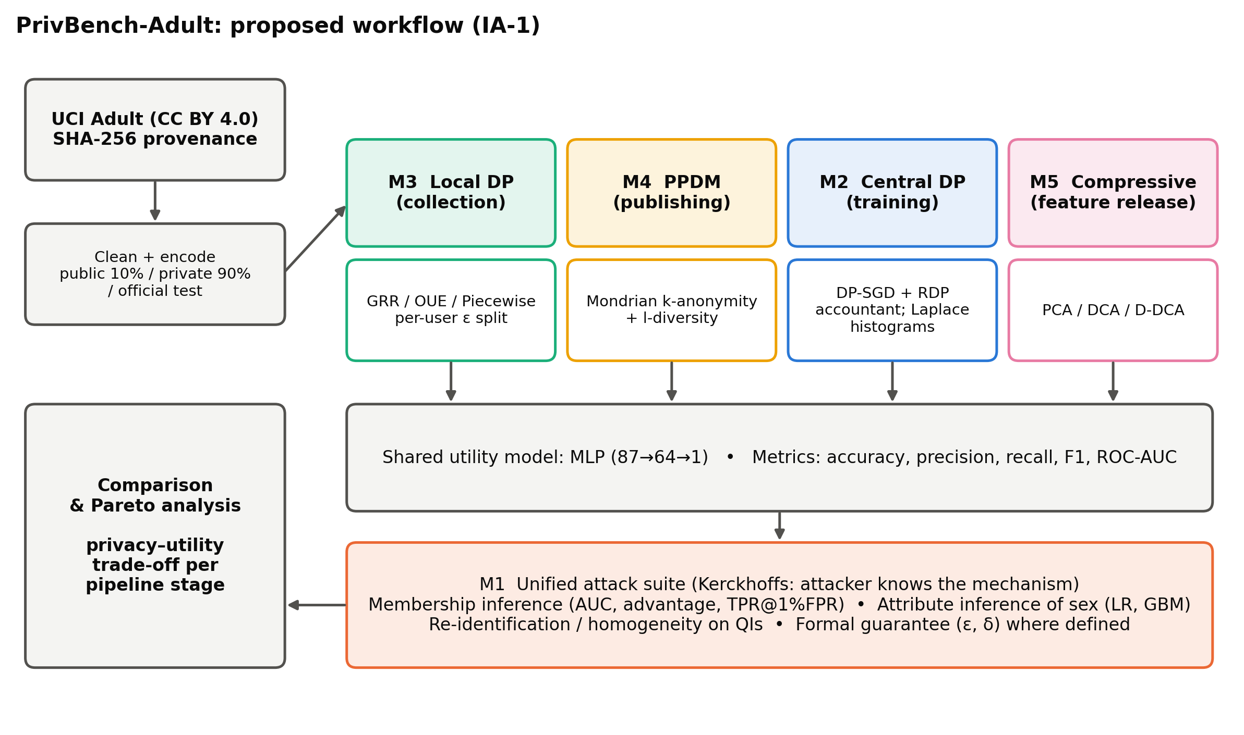
Figure 1. Proposed workflow. Each module protects a different pipeline stage; all feed the same utility model and the same Module-1 attack suite, which makes results directly comparable.
- Step 1 — Data. Download, hash, clean and split UCI Adult into public (10%), private-train (90%) and official test sets. Fit the encoder on the public split only.
- Step 2 — Baseline exposure. Measure QI uniqueness and attribute inference on raw data; train non-private LR/RF/MLP and attack them.
- Step 3 — Mechanisms. Apply each module's mechanism at its stage, sweeping its privacy parameter.
- Step 4 — Common evaluation. Train the same MLP on each protected output; report utility (accuracy, precision, recall, F1, AUC) and all applicable attacks.
- Step 5 — Synthesis. Compare trade-off curves and propose a combined mechanism.

2.4 Justification for concept selection
Table 6. Justification for the concepts and techniques selected.
Choice | Alternatives considered | Why this choice
DP-SGD + RDP accountant | Output perturbation, objective perturbation, PATE | Model-agnostic, standard in practice, tight accounting; PATE needs many teachers and unlabelled public data
GRR, OUE, Piecewise (LDP) | Basic RR, RAPPOR, Duchi et al. | GRR/OUE are the optimal frequency oracles for small/large domains [8]; PM is unbiased with bounded output [9]
Mondrian k-anonymity + l-diversity | Datafly, Incognito, t-closeness enforcement | Multidimensional partitioning gives far lower information loss than single-dimension generalisation; l-diversity directly targets homogeneity
PCA / DCA projections | Autoencoders, adversarial representation learning | Closed-form, deterministic, interpretable, and central to Kung's compressive-privacy framework [17]
Loss-threshold MIA | Shadow-model MIA [19], LiRA [21] | Strong for tabular models, assumption-light and cheap enough to run on every configuration

2.5 Treatment of concepts
Table 7. How each concept is treated (✔ = in IA-1; IA-2 = planned for IA-2).
Concept | Implemented | Demonstrated | Experimentally evaluated | Analytical
MIA, attribute inference, re-identification (M1) | ✔ |  | ✔
Laplace mechanism / DP histogram (M2) | ✔ | ✔ | ✔
DP-SGD + RDP accountant (M2) | ✔ |  | ✔
Gaussian mechanism (M2) | ✔ | ✔
GRR, OUE frequency oracles (M3) | ✔ |  | ✔
Piecewise mechanism, LDP record collection (M3) | ✔ |  | IA-2
Mondrian k-anonymity, l-diversity (M4) | ✔ | ✔ | ✔
t-closeness (M4) | measured |  |  | ✔
Secure multi-party computation / HE (M4) |  |  |  | ✔
PCA (M5) | ✔ |  | ✔
DCA and privacy-aware projection (M5) | ✔ |  | IA-2

3. Dataset Identification and Preliminary Preparation

3.1 Dataset and suitability
UCI Adult (Census Income) [23, 24] contains demographic and employment records extracted from the 1994 US Current Population Survey. It is suitable because (i) it contains genuine personal attributes, including classic quasi-identifiers (age, sex, race, marital status, native country) and a sensitive attribute (sex), which enables all three attack types; (ii) it is the most common benchmark in the DP, LDP and k-anonymity literature, so results can be compared with published work; (iii) it is openly licensed; and (iv) at ~45k records it is large enough for DP-SGD to be meaningful and small enough for laptop experiments.

3.2 Source details
Table 8. Dataset source and provenance record (machine-readable copy: data/provenance.json).
Field | Value
Name | Adult (Census Income)
Landing page | https://archive.ics.uci.edu/dataset/2/adult
Download URL | https://archive.ics.uci.edu/static/public/2/adult.zip
DOI | 10.24432/C5XW20
Creators | Barry Becker, Ronny Kohavi (extracted from the 1994 US Census database)
Publisher | UCI Machine Learning Repository, University of California, Irvine
Licence | Creative Commons Attribution 4.0 International (CC BY 4.0)
Original collection | 1994 Current Population Survey (US Census Bureau); extraction by Becker (1996) with filters AGI>100, AFNLWGT>1, AHRSWK>0
Version | UCI static release id 2 (donated 1996-04-30)
Retrieved on / method | 2026-10-20 — HTTPS download of the official UCI archive by scripts/01_prepare_data.py (urllib)
SHA-256 (adult.zip) | 7537312dd56c2b98035880805ce99e68183a30ee468aa5329d6df0fbb3cc21bb

3.3 Schema and attribute roles
Table 9. Attribute schema and roles.
Attribute | Type | Role in this study
age | numeric (17–90) | feature; quasi-identifier
workclass | categorical (7) | feature; quasi-identifier
education-num | numeric (1–16) | feature; quasi-identifier
marital-status | categorical (7) | feature; quasi-identifier
occupation | categorical (14) | feature
relationship | categorical (6) | feature; strong proxy of sex
race | categorical (5) | feature; quasi-identifier
sex | binary | feature; quasi-identifier; sensitive attribute for attribute inference
capital-gain / capital-loss | numeric | feature
hours-per-week | numeric (1–99) | feature
native-country | categorical (41) | feature; quasi-identifier
income | binary | utility label (>50K = 1); sensitive value for l-diversity
fnlwgt, education | — | dropped (census sampling weight; duplicate of education-num)

3.4 Preliminary preparation log
All steps are executed by scripts/01_prepare_data.py; the log below is copied verbatim from its output and stored in data/provenance.json.
Table 10. Data preparation log.
# | Step
1 | Loaded raw files: train=32561 rows, test=16281 rows, 15 columns
2 | train: 2399 rows with missing values ('?') in {'workclass': 1836, 'occupation': 1843, 'native-country': 583}
3 | test: 1221 rows with missing values ('?') in {'workclass': 963, 'occupation': 966, 'native-country': 274}
4 | Dropped incomplete rows: train 32561->30162, test 16281->15060
5 | Exact duplicate rows in train: 23 (kept: duplicates are distinct census respondents with identical attributes)
6 | Dropped columns ['fnlwgt', 'education']; binarised target income>50K -> 1
7 | Positive rate: train 0.2489, test 0.2457
8 | Split official train into public=3016 / private=27146 (seed 0); official test kept as test=15060
9 | Encoded feature dimension: 87 (5 standardised numeric + one-hot categoricals)

Table 11. Dataset size before and after preparation.
Quantity | Original | After preparation
Training rows | 32,561 | 30,162 (public 3,016 + private 27,146)
Test rows | 16,281 | 15,060
Attributes | 14 + label | 12 features + label (87 after one-hot encoding)
Positive rate (>50K) | — | train 0.2489, test 0.2457
Male share | — | 0.6757

Why a public split? 10% of the official training file is set aside as public data. The encoder's means/standard deviations and the compressive projections are fitted on it, so no statistic of the private training data leaks through preprocessing (a common, often-ignored leak in DP pipelines). The attacker's auxiliary data is drawn from the same split.

3.5 Initial exposure analysis
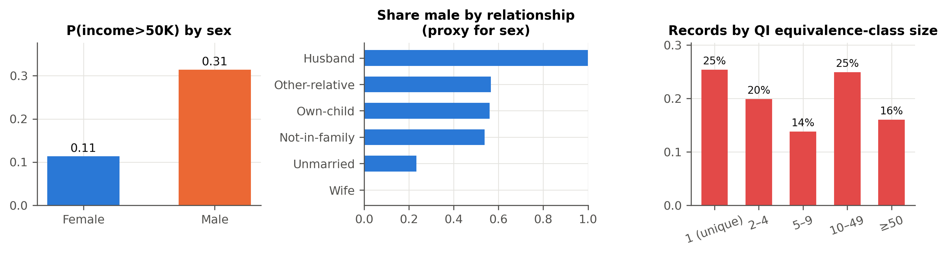
Figure 2. Left: income rate differs strongly by sex. Centre: relationship is a near-deterministic proxy of sex (Husband → male, Wife → female). Right: a quarter of records are unique on seven QIs.

3.6 Known dataset limitations
- Collected in 1994 in the US; distributions are dated and not representative of other populations [25].
- Records with missing values (7.4% of rows) were dropped; this may bias the sample towards respondents with complete employment information.
- The dataset is already public, so the experiments simulate a private dataset; absolute risk numbers describe the methodology, not harm to real respondents.
- Sex is recorded as binary; this reflects the source and limits the attribute-inference analysis.

4. Initial Implementation

4.1 Tools and libraries
Table 12. Tools and libraries.
Tool | Version | Used for
Python | 3.12.4 | Language
NumPy | 2.x | MLP, DP-SGD, LDP mechanisms, projections
SciPy | 1.18 | log-sum-exp & log-gamma for the accountant; generalised eigensolver
pandas | 2.2 | Data handling, Mondrian tables, result CSVs
scikit-learn | 1.8 | LR / RF baselines, gradient-boosting attacker, metrics
matplotlib | 3.9 | Figures
pytest | 9.0 | Unit tests
Opacus | 1.5.2 | Only as an external reference to validate the accountant (not a runtime dependency)

4.2 Code structure
Table 13. Repository structure.
Path | Purpose
scripts/01_prepare_data.py | Download UCI archive, SHA-256 hashing, cleaning, provenance record
scripts/02_run_ia1.py | IA-1 preliminary experiments P1–P6
scripts/03_run_ia2.py | IA-2 full experiments E1–E8 (--quick for smoke test)
scripts/04_make_figures.py | All figures from the result CSVs
scripts/05_build_reports.py | Regenerates these Word reports from results
src/privml/data.py | Schema, cleaning, public/private/test splits, encoder fitted on public split
src/privml/attacks.py | M1: membership inference, attribute inference, re-identification risk
src/privml/dp.py | M2: Laplace/Gaussian mechanisms, DP histogram, RDP accountant, DP-SGD
src/privml/ldp.py | M3: GRR, OUE, Piecewise mechanism, LDP record perturbation
src/privml/ppdm.py | M4: Mondrian k-anonymity, l-diversity, NCP, homogeneity, t-closeness
src/privml/compressive.py | M5: PCA, DCA, Desensitised DCA (D-DCA), reconstruction error
src/privml/models.py | NumPy MLP with closed-form per-example gradients; LR/RF baselines
src/privml/experiments.py | Experiment definitions shared by IA-1 and IA-2 runners
tests/ | 30 unit tests (accountant vs Opacus, estimator unbiasedness, k-anonymity, gradients)

4.3 Key implementation choices
- DP-SGD without a deep-learning framework. For a one-hidden-layer MLP the per-example gradient norm has a closed form: ‖∇ℓᵢ‖² = ‖xᵢ‖²‖δᵢ‖² + ‖δᵢ‖² + eᵢ²‖hᵢ‖² + eᵢ², where eᵢ = pᵢ − yᵢ, hᵢ is the hidden activation and δᵢ = eᵢw₂ ⊙ 1[aᵢ > 0]. The clipped sum is Xᵀ(c ⊙ Δ). This avoids materialising per-example weight matrices and runs a 20-epoch DP-SGD in ~1.5 s on a CPU. It also removed an incompatibility between the installed PyTorch build and NumPy 2.
- Poisson sub-sampling (each record included independently with probability q) is used so that the implementation matches the assumption of the RDP accountant exactly.
- Accountant validated externally. ε values for four (q, σ, T) settings match Opacus 1.5.2 to four decimal places (tests/test_dp.py).
- Noise calibration by bisection. calibrate_sigma finds the smallest σ meeting a target ε.
- Set-valued generalisation for categorical QIs in Mondrian (Adult has no published hierarchies), encoded as fractional multi-hot vectors so models can train on anonymised data.
- Seeds everywhere. Every random step takes an explicit seed; results are reported over seeds.

4.4 Inputs, processing and outputs
Table 14. Inputs, processing steps and outputs of each component.
Component | Input | Processing | Output
Data preparation | UCI archive (URL) | hash → parse → drop missing → drop 2 columns → split | clean CSVs, provenance.json
Encoder | public split | standardise 5 numeric, one-hot 7 categorical | 87-dim feature matrix
Baselines | private-train features/labels | fit LR, RF, MLP | models
DP-SGD | features, labels, target ε, δ | calibrate σ, Poisson sample, clip, noise, SGD | private MLP + (ε, δ, σ, steps)
Histogram release | categorical column, ε | Laplace (central) or GRR/OUE perturb + debias (local) | estimated frequencies
Mondrian | raw table, k, (l) | recursive median / set splits on 7 QIs | equivalence classes, generalised table
PCA | public features, m | eigen-decomposition of covariance | projection W (87×m)
Attack suite | model or released data | loss-threshold MIA; GBM/LR attribute attacker; class-size risk | privacy metrics

4.5 Execution instructions
# 1. install dependencies (Python 3.10+)
pip install -r requirements.txt

# 2. download, hash and clean the dataset (~10 s)
python scripts/01_prepare_data.py

# 3. run the IA-1 preliminary experiments (~1 min)
python scripts/02_run_ia1.py

# 4. make figures and run the unit tests
python scripts/04_make_figures.py
python -m pytest

4.6 Output log (excerpt)
[ 0.2s] Data: public=3016 private=27146 test=15060 d=87
[ 0.2s] === P1 baselines ===
[ 21.7s] --- P1 baselines done in 21.5s
[ 21.7s] saved p1_baselines.csv (18 rows)
[ 21.7s] === P2 raw-data exposure ===
[ 23.0s] --- P2 raw-data exposure done in 1.3s
[ 23.0s] saved p2_exposure.csv (5 rows)
[ 23.0s] === P3 DP-SGD (preliminary) ===
[ 48.9s] --- P3 DP-SGD (preliminary) done in 25.9s
[ 48.9s] saved p3_dpsgd.csv (18 rows)
[ 48.9s] === P4 central vs local histogram ===
[ 50.4s] --- P4 central vs local histogram done in 1.5s
[ 50.4s] saved p4_marginals.csv (420 rows)
[ 50.4s] === P5 k-anonymity (preliminary) ===
[ 54.9s] --- P5 k-anonymity (preliminary) done in 4.5s
[ 54.9s] saved p5_kanon.csv (2 rows)
[ 54.9s] === P6 PCA compression (preliminary) ===
[ 56.4s] --- P6 PCA compression (preliminary) done in 1.5s
[ 56.4s] saved p6_pca.csv (3 rows)
[ 56.4s] IA-1 run complete

4.7 Verification
python -m pytest runs 30 unit tests, all passing. They check: the accountant against Opacus; ε monotonicity and σ calibration; analytic per-example gradients against finite differences; Laplace noise scale; unbiasedness of the GRR, OUE and Piecewise estimators; that Mondrian output is a disjoint k-anonymous partition with max risk ≤ 1/k; that l-diversity removes homogeneous classes; that D-DCA removes a linear privacy signal on synthetic data; that the MIA detects a memorising model; and that dataset hashes match the provenance record.

5. Preliminary Evaluation and Documentation

5.1 Evaluation measures
Table 15. Evaluation measures.
Dimension | Metric | Interpretation
Utility | Accuracy, precision, recall, F1 (positive = >50K), ROC-AUC | F1 matters because only ~25% of records are positive
Membership privacy | MIA ROC-AUC; advantage = max(TPR−FPR); TPR at 1% FPR | 0.5 / 0 / 0.01 = no leakage
Attribute privacy | Attacker accuracy and balanced accuracy on sex | 0.5 balanced accuracy = no leakage
Identity privacy | Fraction unique on QIs; average & max prosecutor risk | max risk ≤ 1/k under k-anonymity
Disclosure (M4) | Homogeneity rate; t-closeness | share of records whose income is revealed
Information loss | NCP (M4); normalised reconstruction MSE (M5) | 0 = no loss
Formal guarantee | (ε, δ) for DP/LDP mechanisms | smaller ε = stronger guarantee

5.2 Baseline results (non-private models)
Table 16. Non-private baselines (mean ± sd over 3 seeds). Small-data regime = random 1,000-record training subset with a high-capacity MLP (256 hidden units, 200 epochs).
Model | Accuracy | F1 | AUC | MIA AUC | MIA adv. | Train loss | Test loss
LR (n=27,146) | 0.847 ± 0.000 | 0.659 | 0.903 | 0.503 ± 0.009 | 0.014 | 0.326 | 0.331
RF (n=27,146) | 0.841 ± 0.001 | 0.654 | 0.889 | 0.603 ± 0.008 | 0.172 | 0.106 | 0.404
MLP (n=27,146) | 0.849 ± 0.002 | 0.674 | 0.907 | 0.508 ± 0.010 | 0.022 | 0.297 | 0.326
LR (n=1,000) | 0.846 ± 0.000 | 0.659 | 0.895 | 0.502 ± 0.015 | 0.032 | 0.301 | 0.331
RF (n=1,000) | 0.836 ± 0.003 | 0.641 | 0.875 | 0.640 ± 0.012 | 0.256 | 0.093 | 0.371
MLP (n=1,000) | 0.822 ± 0.003 | 0.619 | 0.869 | 0.552 ± 0.015 | 0.159 | 0.076 | 0.631

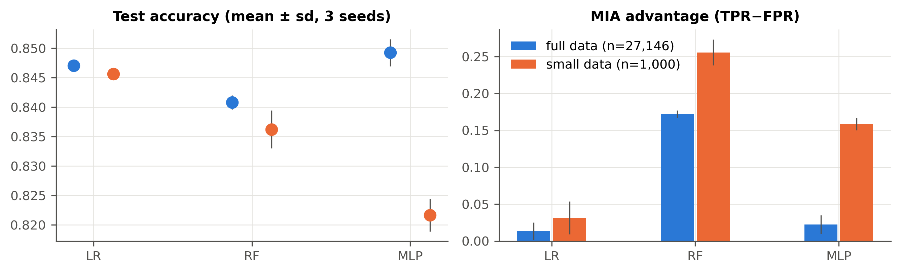
Figure 3. Baseline utility and membership-inference advantage.
With the full training set, LR and the MLP generalise well (train/test loss gap ≈ 0.03), and average-case MIA is near chance (AUC ≈ 0.508). The fully grown random forest memorises its training data (train loss 0.106 vs test 0.404) and leaks membership (advantage 0.172). In the small-data regime the MLP's advantage rises to 0.159 and the RF's to 0.256: leakage is driven by the generalisation gap, consistent with Yeom et al. [20].

5.3 Privacy exposure of the raw data
Table 17. Exposure of the unprotected data.
Analysis | Result
Records unique on 7 QIs | 26.5%
Average prosecutor re-identification risk | 0.381
Number of QI equivalence classes | 10,340
Infer sex — all features, linear attacker | 100.0%
Infer sex — sex column dropped, linear attacker | 84.3%
Infer sex — sex column dropped, GBM attacker | 83.1%
Majority-class prior for sex | 67.4%

Two Module-1 lessons follow immediately: (i) removing direct identifiers does not anonymise — one in four records can be singled out by linkage; (ii) deleting a sensitive column ("fairness/privacy through unawareness") is weak protection, because proxies retain most of the signal (83.8% balanced accuracy versus 50% for no information).

5.4 Preliminary DP-SGD results
Table 18. DP-SGD on the full training set (δ = 1e-5, 20 epochs, batch 256, C = 1; mean of 3 seeds).
Target ε | σ | Accounted ε | Accuracy | F1 | MIA AUC | MIA adv.
0.5 | 3.446 | 0.500 | 0.848 | 0.659 | 0.503 | 0.016
1 | 1.931 | 1.000 | 0.850 | 0.665 | 0.503 | 0.014
2 | 1.193 | 2.000 | 0.851 | 0.665 | 0.503 | 0.014
4 | 0.852 | 3.995 | 0.851 | 0.666 | 0.503 | 0.014
8 | 0.665 | 7.999 | 0.851 | 0.665 | 0.503 | 0.015
∞ (clip only) | 0 | ∞ | 0.851 | 0.665 | 0.503 | 0.015

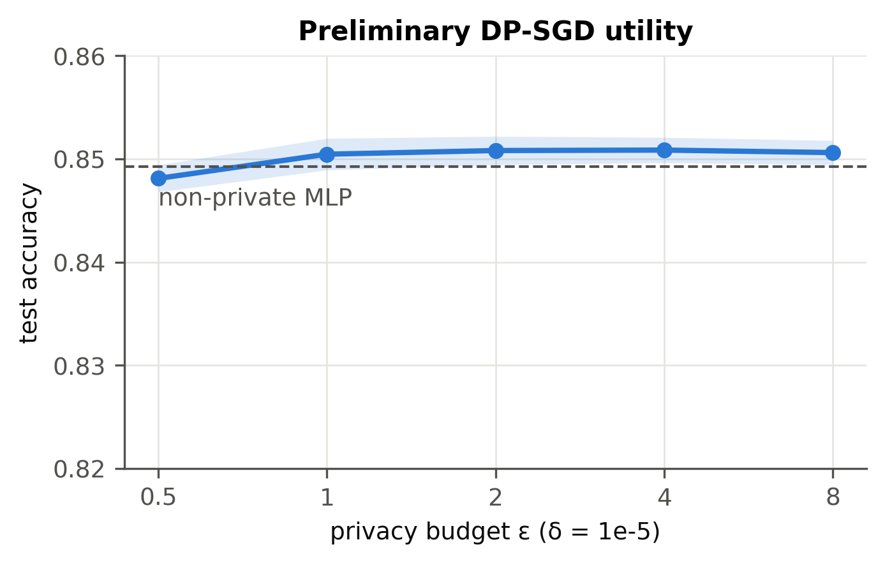
Figure 4. Preliminary DP-SGD utility versus privacy budget.
Worked example of the accounting: with n = 27,146, batch 256 ⇒ q = 0.00943, T = round(20/q) = 2,121 steps. For ε = 1 the bisection returns σ = 1.931; the accountant gives ε = 1.0000 at δ = 10⁻⁵.

5.5 Central versus local DP for histogram release
Table 19. Mean L1 error of the 14-category occupation histogram (20 repetitions).
ε | Central Laplace | Local GRR | Local OUE | GRR / central
0.1 | 0.00551 | 2.2494 | 1.4546 | 408×
0.25 | 0.00221 | 0.8390 | 0.5773 | 380×
0.5 | 0.00110 | 0.3788 | 0.3105 | 343×
1 | 0.00055 | 0.1544 | 0.1469 | 280×
2 | 0.00028 | 0.0535 | 0.0608 | 194×
4 | 0.00014 | 0.0132 | 0.0261 | 96×
8 | 0.00007 | 0.0017 | 0.0160 | 25×

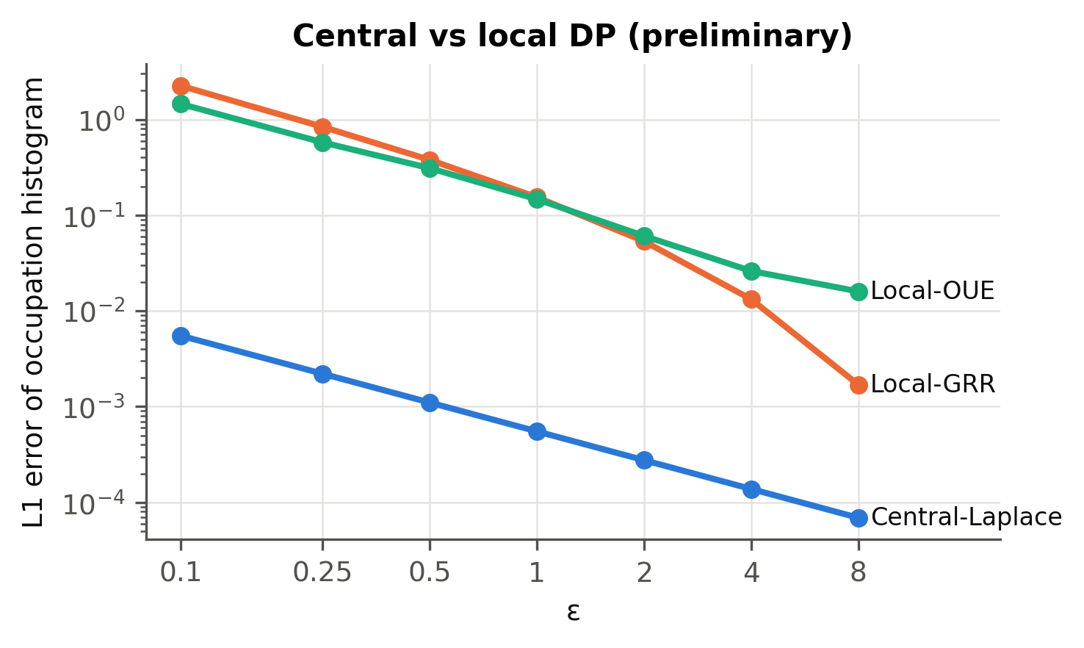
Figure 5. Central vs. local DP error (log–log).
Central DP is two to three orders of magnitude more accurate at the same ε. Between the local oracles, OUE wins for ε ≤ 1 and GRR for ε ≥ 2, matching the theoretical cross-over k = 3e^ε + 2 (for k = 14 the cross-over is ε ≈ 1.3) [8].

5.6 Preliminary k-anonymity
Table 20. Mondrian k-anonymity on the 7 QIs (private training split).
k | Classes | NCP | Homogeneity rate | Unique fraction | Avg risk | Max risk
5 | 2663 | 0.018 | 39.6% | 0.0% | 0.098 | 0.200
10 | 1474 | 0.032 | 30.2% | 0.0% | 0.054 | 0.100

Table 21. First records of the 10-anonymous release (generalised QIs shown as ranges/sets).
age | workclass | education-num | marital-status | race | sex | native-country | income
32-37 | Private | 11-16 | {Married-AF-spouse,Married-spouse-absent,Separated,Widowed} | White | Female | United-States | 0
55 | Private | 9 | Married-civ-spouse | White | Male | United-States | 1
27-37 | State-gov | 11-13 | Never-married | White | Female | United-States | 0
43-45 | Private | 9 | Never-married | White | Male | {Poland,United-States} | 0
21-26 | Self-emp-not-inc | 9 | Married-civ-spouse | White | Male | United-States | 0
22-31 | Federal-gov | 11-13 | Never-married | White | Male | {Japan,United-States} | 0
52-54 | Self-emp-not-inc | 9 | Married-civ-spouse | White | Male | United-States | 0
52-54 | Private | 10 | Divorced | White | Female | {Germany,Italy,United-States} | 0

Mondrian removes all unique records with little information loss (NCP 0.032 at k = 10). However, 30.2% of records sit in classes where every member has the same income, so their income is disclosed despite k-anonymity — the homogeneity attack that motivates l-diversity in IA-2.

5.7 Preliminary compressive privacy (PCA)
Table 22. PCA on all 87 features: sensitive-attribute leakage from the projection.
m | Reconstruction NMSE | Infer sex (LR) bal. acc. | Infer sex (GBM) bal. acc.
5 | 0.355 | 0.784 | 0.860
10 | 0.186 | 1.000 | 0.996
20 | 0.071 | 1.000 | 0.998

Utility-agnostic PCA is not privacy-preserving: at m ≥ 10 the sex column survives the projection almost intact (balanced accuracy ≈ 1.0). Compression alone only helps when m is very small, which also destroys utility. A projection that is explicitly penalised for retaining the sensitive attribute is required.

5.8 Preliminary observations
Table 23. Preliminary observations and their consequences.
# | Observation | Consequence for IA-2
O1 | Average-case MIA on well-generalising models is near chance; leakage concentrates in high-capacity / small-data settings | Add a small-data regime to every DP experiment; report TPR at 1% FPR
O2 | DP-SGD costs < 0.3 points of accuracy for ε ≥ 0.5 on Adult | Extend the ε grid down to 0.05 to expose the real trade-off
O3 | k-anonymity removes uniqueness but leaves high homogeneity | Evaluate l-diversity; measure attribute inference on anonymised data
O4 | PCA retains the sensitive attribute | Design a privacy-aware projection (Desensitised DCA) and a hybrid with DP
O5 | Local DP loses ~100–1000× accuracy vs central DP in histograms | Measure the effect on model training with LDP-collected records

5.9 Known limitations at IA-1
- Only three seeds; confidence intervals are wide for small effects.
- Hyper-parameters of DP-SGD (lr = 0.05, C = 1, 20 epochs) were chosen by a brief sanity run; tuning on private data has its own privacy cost [27] and is not yet accounted for.
- The loss-threshold MIA is a lower bound on leakage; stronger attacks (LiRA [21]) may find more.
- LDP record collection, DCA variants and the hybrid have code but no experiments yet.

5.10 Proposed evaluation plan for IA-2
Table 24. Evaluation plan for IA-2.
Exp. | Question | Design | Metrics
E1 | How much do non-private models leak? | LR / RF / MLP, full and small data, 5 seeds | utility, MIA
E2 | Privacy–utility curve of DP-SGD | ε ∈ {0.05 … 8, ∞}, both regimes, 5 seeds | utility, MIA, σ
E3 | Sensitivity to DP-SGD hyper-parameters | clip C, learning rate, epochs at ε = 1 | accuracy
E4 | Cost of removing the trusted curator | Laplace vs GRR vs OUE, 4 attributes, 50 reps | L1, MSE
E5 | Can we train on LDP-collected records? | ε_total ∈ {1 … 128}, with/without label perturbation | utility, MIA, attribute inference
E6 | k-anonymity and l-diversity trade-off | k ∈ {2 … 250}, l ∈ {none, 2} | NCP, risk, homogeneity, utility, attribute inference
E7 | Can a projection hide sex but keep income? | PCA / DCA / D-DCA, m ∈ {2 … 40}, γ sweep | utility, LR & GBM attribute inference, reconstruction
E8 | Does compression help DP-SGD? | D-DCA → DP-SGD vs DP-SGD across ε | utility, MIA, attribute inference

5.11 Individual contribution statement
This is an individual project. I defined the problem and threat model, selected the dataset and documented its provenance, and designed the unified evaluation methodology. I implemented the src/privml package — the data pipeline with a public split, the attack suite, the RDP accountant and DP-SGD (including the closed-form per-example gradients of the NumPy MLP), the GRR/OUE/Piecewise mechanisms, Mondrian k-anonymity with l-diversity, and the PCA/DCA projections — together with the unit tests, experiment scripts, figures and this report. Third-party libraries are used only for standard components (NumPy/SciPy linear algebra, scikit-learn baselines and attackers, matplotlib); Opacus was used solely as an external check of the accountant.

Acknowledgement
I acknowledge the use of Claude (Anthropic), an AI assistant, for support with code development and report preparation.

References
[1] C. Dwork and A. Roth, “The Algorithmic Foundations of Differential Privacy,” Foundations and Trends in Theoretical Computer Science, vol. 9, no. 3–4, pp. 211–407, 2014.
[2] M. Abadi, A. Chu, I. Goodfellow, H. B. McMahan, I. Mironov, K. Talwar and L. Zhang, “Deep learning with differential privacy,” in Proc. ACM CCS, 2016, pp. 308–318.
[3] I. Mironov, “Rényi differential privacy,” in Proc. IEEE CSF, 2017, pp. 263–275.
[4] I. Mironov, K. Talwar and L. Zhang, “Rényi differential privacy of the sampled Gaussian mechanism,” arXiv:1908.10530, 2019.
[5] B. Balle, G. Barthe, M. Gaboardi, J. Hsu and T. Sato, “Hypothesis testing interpretations and Rényi differential privacy,” in Proc. AISTATS, 2020.
[6] S. L. Warner, “Randomized response: A survey technique for eliminating evasive answer bias,” J. American Statistical Association, vol. 60, no. 309, pp. 63–69, 1965.
[7] P. Kairouz, K. Bonawitz and D. Ramage, “Discrete distribution estimation under local privacy,” in Proc. ICML, 2016.
[8] T. Wang, J. Blocki, N. Li and S. Jha, “Locally differentially private protocols for frequency estimation,” in Proc. USENIX Security, 2017, pp. 729–745.
[9] N. Wang, X. Xiao, Y. Yang, J. Zhao, S. C. Hui, H. Shin, J. Shin and G. Yu, “Collecting and analyzing multidimensional data with local differential privacy,” in Proc. IEEE ICDE, 2019, pp. 638–649.
[10] Ú. Erlingsson, V. Pihur and A. Korolova, “RAPPOR: Randomized aggregatable privacy-preserving ordinal response,” in Proc. ACM CCS, 2014.
[11] L. Sweeney, “k-anonymity: A model for protecting privacy,” Int. J. Uncertainty, Fuzziness and Knowledge-Based Systems, vol. 10, no. 5, pp. 557–570, 2002.
[12] K. LeFevre, D. J. DeWitt and R. Ramakrishnan, “Mondrian multidimensional k-anonymity,” in Proc. IEEE ICDE, 2006.
[13] A. Machanavajjhala, D. Kifer, J. Gehrke and M. Venkitasubramaniam, “l-diversity: Privacy beyond k-anonymity,” ACM TKDD, vol. 1, no. 1, 2007.
[14] N. Li, T. Li and S. Venkatasubramanian, “t-closeness: Privacy beyond k-anonymity and l-diversity,” in Proc. IEEE ICDE, 2007.
[15] J. Xu, W. Wang, J. Pei, X. Wang, B. Shi and A. W.-C. Fu, “Utility-based anonymization using local recoding,” in Proc. ACM KDD, 2006.
[16] R. Agrawal and R. Srikant, “Privacy-preserving data mining,” in Proc. ACM SIGMOD, 2000.
[17] S. Y. Kung, “Compressive privacy: From information/estimation theory to machine learning,” IEEE Signal Processing Magazine, vol. 34, no. 1, pp. 94–112, 2017.
[18] S. Y. Kung, “A compressive privacy approach to generalized information bottleneck and privacy funnel problems,” Journal of the Franklin Institute, vol. 355, no. 4, pp. 1846–1872, 2018.
[19] R. Shokri, M. Stronati, C. Song and V. Shmatikov, “Membership inference attacks against machine learning models,” in Proc. IEEE S&P, 2017.
[20] S. Yeom, I. Giacomelli, M. Fredrikson and S. Jha, “Privacy risk in machine learning: Analyzing the connection to overfitting,” in Proc. IEEE CSF, 2018.
[21] N. Carlini, S. Chien, M. Nasr, S. Song, A. Terzis and F. Tramèr, “Membership inference attacks from first principles,” in Proc. IEEE S&P, 2022.
[22] A. Narayanan and V. Shmatikov, “Robust de-anonymization of large sparse datasets,” in Proc. IEEE S&P, 2008.
[23] B. Becker and R. Kohavi, “Adult” [Dataset], UCI Machine Learning Repository, 1996. doi:10.24432/C5XW20.
[24] R. Kohavi, “Scaling up the accuracy of naive-Bayes classifiers: A decision-tree hybrid,” in Proc. KDD, 1996.
[25] F. Ding, M. Hardt, J. Miller and L. Schmidt, “Retiring Adult: New datasets for fair machine learning,” in Proc. NeurIPS, 2021.
[26] A. Yousefpour et al., “Opacus: User-friendly differential privacy library in PyTorch,” arXiv:2109.12298, 2021.
[27] N. Papernot and T. Steinke, “Hyperparameter tuning with Rényi differential privacy,” in Proc. ICLR, 2022.
[28] E. Bagdasaryan, O. Poursaeed and V. Shmatikov, “Differential privacy has disparate impact on model accuracy,” in Proc. NeurIPS, 2019.
[29] S. Ravfogel, Y. Elazar, H. Gonen, M. Twiton and Y. Goldberg, “Null it out: Guarding protected attributes by iterative nullspace projection,” in Proc. ACL, 2020.
[30] N. Natarajan, I. S. Dhillon, P. Ravikumar and A. Tewari, “Learning with noisy labels,” in Proc. NeurIPS, 2013.
[31] Government of India, The Digital Personal Data Protection Act, 2023 (Act No. 22 of 2023).
[32] European Parliament and Council, Regulation (EU) 2016/679 (General Data Protection Regulation), 2016.

